# Practical handbook for A-level Biology

Version 1.2



This is the **Biology** version of this Practical handbook.

**Sections I to O are particularly useful for students and could be printed as a student booklet by schools.**

The information in this document is correct, to the best of our knowledge as of August 2015. This document is expected to be revisited throughout the lifetime of the specification. Please check you have the latest version by visiting our website.

Thank you to all the teachers and associates who have commented on previous versions of this document. We’re grateful for all the feedback and hope that your comments have been acted on.

**Changes for version 1.1**

|  |  |  |
| --- | --- | --- |
| **Section** | **Change** | **Notes** |
| Front page | Version 1.0 to 1.1 |  |
| F. Cross-board statement on CPAC | Extensive updates. | CPAC criteria will also be updated in the specifications in September 2015. |
| H. Cross-board apparatus and techniques and AQA required practical activities | Addition of clarification around “or” statements in the apparatus and techniques list. | For the endorsement all students must have experienced use of each of the alternatives in the apparatus and techniques list. For written exams, we suggest that teachers treat “or” statements as “and” statements. |
| J. Significant figures | Added paragraph on equipment measuring to half a unit. | Values should be quoted as .0 or .5, with uncertainty of ±0.3 |
| K. Uncertainties | Clarification added to “measuring length” section  Stopwatch example slightly changed. | Initial value uncertainty applies to instruments where the user can set the zero.  Previously implied reaction time ~1 s. |
| N. Statistical tests in Biology | Section added on teaching statistics in Biology. | Includes information on teaching statistics during the first (AS) year of the course. |
| P. Practical ladders and exemplar experiments: Biology | In required practical 10, the risk assessment, trialling and additional information statements have been moved from the Student Sheet to the Teachers’ Notes. |  |

**Changes for version 1.2**

|  |  |  |
| --- | --- | --- |
| K. Uncertainties | Expanded following teacher feedback. |  |

**Contents**

|  |  |  |
| --- | --- | --- |
| **Section** |  | **Page** |
| A | Introduction |  |
|  | **Information about practical work for teachers** |  |
| B | Practical work in reformed A-level Biology, Chemistry and Physics |  |
| C | Practical skills assessment in question papers |  |
| D | Guidelines for supporting students in practical work | 18 |
| E | Use of lab books |  |
| F | Cross-board statement on CPAC |  |
| G | Evidence for the endorsement | 30 |
| H | Cross-board apparatus and techniques and AQA required practical activities | 32 |
|  | **Guidelines for teachers and students** |  |
| I | Tabulating data | 35 |
| J | Significant figures |  |
| K | Uncertainties |  |
| L | Graphing |  |
| M | Biological drawing | 53 |
| N | Statistical tests in Biology |  |
| O | Glossary of terms |  |
|  | **Guidance on the required practical activities** |  |
| P | Practical ladders and exemplar experiments: Biology | 66 |

**Key**

There have been a number of changes to how practical work will be assessed in the new A-levels. Some of these have been AQA specific, but many are by common agreement between all the exam boards and Ofqual.



The symbol signifies that **all boards** have agreed to this.



The symbol is used where the information relates to **AQA only**.

## Introduction

Practical work brings science to life, helping students make sense of the universe around them. That’s why we’ve put practical work at the heart of our Biology, Chemistry and Physics A-levels. Practical science allows scientific theory to transform into deep knowledge and understanding – scientific thinking. Through investigation, students uncover the important links between their personal observations and scientific ideas.

“In the best schools visited, teachers ensured that pupils understood the ‘big ideas’ of science. They made sure that pupils mastered the investigative and practical skills that underpin the development of scientific knowledge and could discover for themselves the relevance and usefulness of those ideas.”

Ofsted report

Maintaining curiosity in science

November 2013, No. 130135

**The purpose of this Practical handbook**

This handbook has been developed to support you in advancing your students to fluency in science.

Over the years, there have been many rules developed for practical work in Biology, Chemistry and Physics. Some have been prescriptive, some have been intended as guidance. Although we have always attempted to be consistent within subjects, differences have emerged over time. Worse, a student taking Biology may also be taking Physics and find themselves confronted with contradictory rules and guidance.

This practical handbook is an attempt to harmonise the rules and guidance for Biology, Chemistry and Physics. There are occasions where these will necessarily be different, but we will try to explain why on the occasions where that happens.

The new A-level specifications accredited for first teaching in September 2015 bring with them a complete change in the way practical work is assessed. No longer will teachers have to force their students to jump through hoops set up by exam boards or worry about how much help they are giving students and whether it’s allowed or not.

We have worked with teachers and examiners to produce this handbook. This is an evolving document, but one that we hope you will be able to use with your students, whether they’re doing A-level Biology, Chemistry or Physics, or a combination of subjects, to improve their practical skills: in the classroom, in the laboratory, in exams, for the endorsement and on to university or the workplace. The latest version will always be on our website.

Unless specified, all guidance is common to Biology, Chemistry and Physics at both AS and A-level and subject specific examples are for illustration only. However, the extent to which a particular aspect is assessed will differ. Teachers should refer to the specifications and specimen materials on our website for more information.

**The purpose of practical work**

There are three interconnected, but separate reasons for doing practical work in schools. They are:

|  |
| --- |
| 1. To support and consolidate **scientific concepts** (knowledge and understanding).  This is done by applying and developing what is known and understood of abstract ideas and models. Through practical work we are able to make sense of new information and observations, and provide insights into the development of scientific thinking. |
| 2. To develop **investigative skills.** These transferable skills include:   1. devising and investigating testable questions 2. identifying and controlling variables 3. analysing, interpreting and evaluating data. |
| 3. To build and master **practical skills** such as:   1. using specialist equipment to take measurements 2. handling and manipulating equipment with confidence and fluency 3. recognising hazards and planning how to minimise risk. |

By focusing on the reasons for carrying out a particular practical, teachers will help their students understand the subject better, to develop the skills of a scientist and to master the manipulative skills required for further study or jobs in STEM subjects.

The reformed A-levels in Biology, Chemistry and Physics separate the ways in which practical work is assessed. This is discussed in the next section.

**Fluency in science practical work**

At the beginning of a year 12 course, students will need support and guidance to build their confidence. This could involve, for example, breaking down practicals into discrete sections or being more explicit in instructions. Alternatively, a demonstration of a key technique followed by students copying may support students’ development. This could be a better starting point than ‘setting students loose’ to do it for themselves.

Progression in the mastery of practical skills and techniques shows increasing independence and confidence

Phase 1:

**Demonstrate**

“Teacher shows me and I copy”

Phase 2:

**Practise with support**

“I do it myself but I may need to ask teacher every now and again and if it goes wrong I’m stuck.”

Phase 3:

**Practise without support**

“I can have a go and get quite a way without any support or guidance but there are times when I might need to check a few details.”

Phase 4:

**Fluent**

“No problem!

I can help my friends if necessary.”

Note: Safety is always the responsibility of the teacher. No student should be expected to assess risks and then carry out their science practical without the support and guidance of their teacher.

## Practical work in reformed A-level Biology, Chemistry and Physics

**Statement on practical work by Glenys Stacey, Chief Regulator at Ofqual, April 2014**

Practical work and experimentation is at the heart of science. It matters to science students, their teachers and their future universities and employers. But A-level students do not always have the chance to do enough of it.

Practical work counts for up to 30 per cent of the final grades and the vast majority of students get excellent marks for it, but still many enter university without good practical skills.

It is possible to do well in science A-levels without doing sufficient or stretching hands-on science, and other pressures on schools can make it difficult for science teachers to carve out enough time and resource to do it if students can get good A-level grades in any event. That is not right – so why is it so?

Students are assessed and marked on their performance in set tasks, but these are generally experiments that are relatively easy to administer and not particularly stretching. It has proved extremely difficult to get sufficient variety and challenge in these experiments, and so students do well even if they have not had the opportunity to do enough varied and stretching experimentation, and learn and demonstrate a variety of lab skills. What to do?

In future, science A-level exams will test students’ understanding of experimentation more so than now. Those who have not had the chance to design, conduct and evaluate the results from a good range of experiments will struggle to get top grades in those exams. They will also be required to carry out a minimum of twelve practical activities across the two year course – practical activities specific to their particular science, and that are particularly valued in higher education. Students will receive a separate grade for their practical skills (a pass/fail grade).

These reforms should place experimentation and practical skills at the heart of science teaching, where they should be, and students going to university to study a science are more likely to go well prepared. They will also change the game for science teachers, enabling them to teach science in a more integrated and stimulating way with more hands on science and to say with justification that without sufficient time and effort put into lab work, their students will struggle to get the grades they deserve.

Glenys Stacey, Chief Regulator

The reformed AS and A-level specifications will have **no** direct assessment of practical work that contributes to the AS or A-level grades.

There are **two** elements to the practical work that students must carry out in their study of A-level Biology, Chemistry and Physics:



**Apparatus and techniques (see section G)**

These have been agreed by all exam boards, so all students will have experienced similar practical work after following a science A-level course.

Examples:

Use of light microscope at high power and low power, including use of a graticule

Purify a solid product by recrystallization

Use laser or light source to investigate characteristics of light



**12 required practical activities (see section G)**

These have been specified by AQA. They cover the apparatus and techniques for each subject – so teachers do not have to worry about whether they are all covered.

Examples:

Use of aseptic techniques to investigate the effect of antimicrobial substances on microbial growth

Carry out simple test-tube reactions to identify cations and anions in aqueous solution

Determination of g by a free-fall method.

These will be assessed in two ways:

1. Questions in the written papers, assessed by AQA (see section C)



Questions in exam papers

12 required practicals

Cross-board agreement on required apparatus and techniques

1. The practical endorsement, directly assessed by teachers (see section F)

Teachers will assess their students’ competence at carrying out practical work. They will assess each student on at least 12 different occasions. These could be the 12 required practicals, or could be during other practical work.

At the end of the course, teachers will decide whether or not to award a pass in the endorsement of practical skills. The teacher must be confident that the student has shown a level of mastery of practical work good enough for the student to go on to study science subjects at university.

**Students who miss a required practical activity**

Students’ practical skills in at least 12 practicals

12 required practical activities

Teacher devised practical experiences

5 competencies:

1. Follows written instructions

2. Applies investigative approaches and methods when using instruments and equipment

3. Safely uses a range of practical equipment and materials

4. Makes and records observations

5. Researches, references and reports

Endorsement of practical skills

**1. Written exam papers**

The required practical activities are part of the specification. As such, exam papers could contain questions about the activities and assume that students understand those activities. A student who misses a particular practical activity may be at a disadvantage when answering questions in the exams.

It will often be difficult to set up a practical a second time for students to catch up. Teachers will need to decide on a case by case basis whether they feel it is important for the student to carry out that particular practical. This is no different from when teachers make decisions about whether to re-teach a particular topic if a student is away from class when it is first taught.

**2. Endorsement**

To fulfil the requirements of the endorsement, every student must carry out 12 practicals. A student who misses one of the required practicals must carry out another practical to be able to gain the endorsement.

In most cases, this can be any experiment of A-level standard. However, students must have experienced use of each of the apparatus and techniques. In some cases, a particular apparatus and technique is only covered in one required practical activity. If a student misses that activity, the teacher will need to provide an opportunity for the student to carry out a practical that includes that activity. The list below shows the apparatus and techniques that are covered by one activity only and alternatives to the required practical.

Note: there is a possibility that the student could be asked questions about the required activity in written papers that would not be fully understood by carrying out the alternative. This should be considered when deciding whether to repeat the required activity.

**Biology** 

|  |  |  |
| --- | --- | --- |
| **If a student misses this required practical activity…** | **…they won’t have covered this apparatus and technique.** | **Other practicals within an A-level Biology course involving this skill** |
| 2. Preparation of stained squashes of cells from plant root tips; set-up and use of an optical microscope to identify the stages of mitosis in these stained squashes and calculation of a mitotic index | d. use of light microscope at high power and low power, including use of a graticule | Examination of permanent mounts of any tissue, related to specification content, in which students use both high- and low-power objectives of an optical microscope and use a stage micrometer and eyepiece graticule to measure the actual size of cells. |
| 7. Use of chromatography to investigate the pigments isolated from leaves of different plants, eg leaves from shade-tolerant and shade-intolerant plants or leaves of different colours | g. separate biological compounds using thin layer/paper chromatography or electrophoresis | Separation of any aqueous mixture related to specification content, eg, sugars or amino acids, by paper or thin layer chromatography.  Extraction of 'chlorophyll' from a plant or alga and separation of its constituent pigments by paper or thin layer chromatography. Separation of DNA fragments by electrophoresis. |
| 12. Investigation into the effect of a named environmental factor on the distribution of a given species | k. use sampling techniques in fieldwork | Use of random quadrats to investigate the pattern of distribution of a named sessile organism. Examples include daisies in a school playing field, epiphytes on the bark of a tree and limpets on a rocky shore. Use of the mark-release-recapture technique to estimate the size of a population of woodlice in a garden or school playground. |

## Practical skills assessment in question papers

The AS and A-level papers will contain the following types of questions which relate to practical work:

1. **Questions set in a practical context, where the question centres on the science, not the practical work.**

**Example (A-level Biology Specimen Paper 1)**

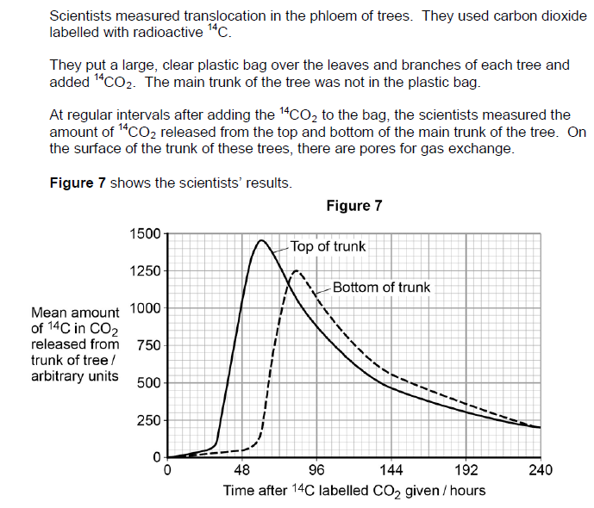

These questions are set in the context of practical work that has been carried out.

However, the questions relate more to the basic Biology behind the situation, or mathematical skills.

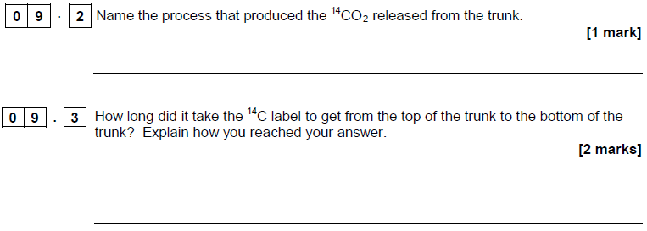

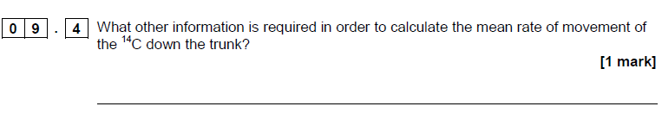

**Example (AS Chemistry Specimen Paper 1)**

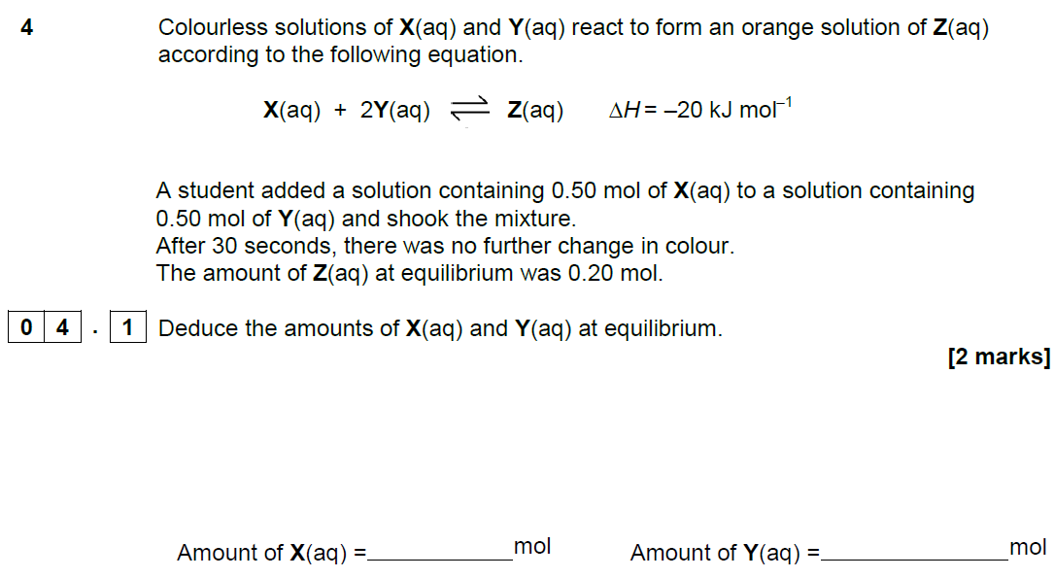

This question requires an understanding of the underlying chemistry, not the practical procedure undertaken.

**Example (A-level Physics Specimen Paper 3)**

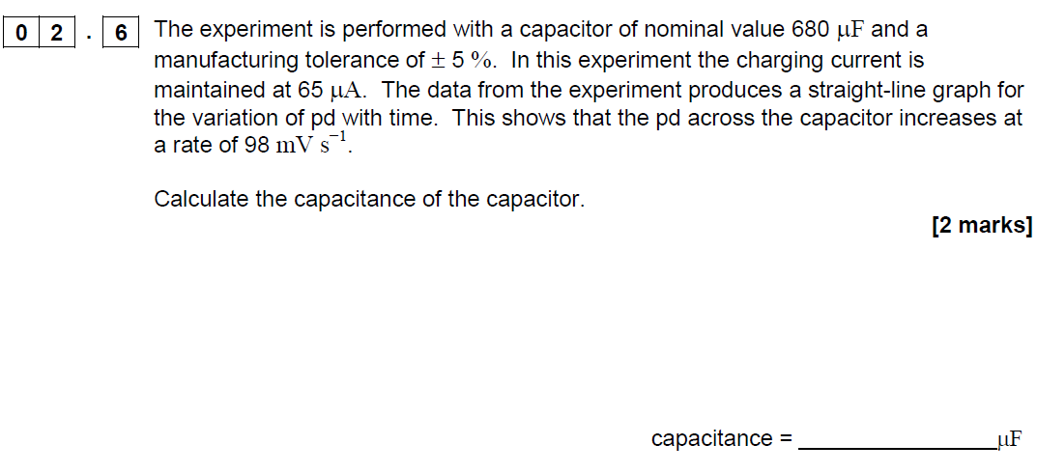

This question is set in a practical context, and particular readings need to be used to calculate the answer, but the specific practical set-up is not important.

1. **Questions that require specific aspects of a practical procedure to be understood in order to answer a question about the underlying science.**

**Example (A-level Biology Specimen Paper 2)**

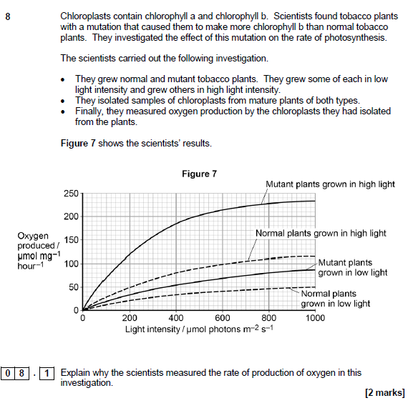

This question requires the students to understand how oxygen production can be used as a proxy measure for photosynthesis, but no other details of the practical procedure are important.

**Example (AS Chemistry Specimen Paper 2)**

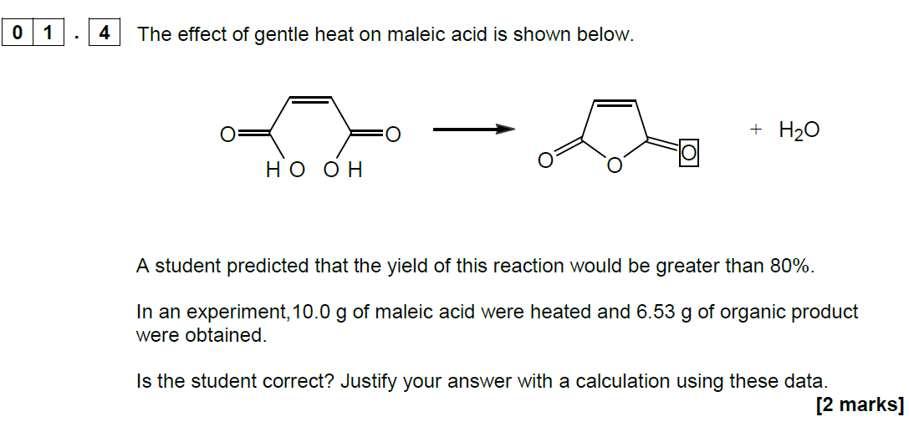

To answer this question, the student must understand the process of yield calculation (which will have been gained through practical work), but again the details of the practical procedure are unimportant.

1. **Questions directly on the required practical procedures.**

**Example (AS Biology Specimen Paper 1)**

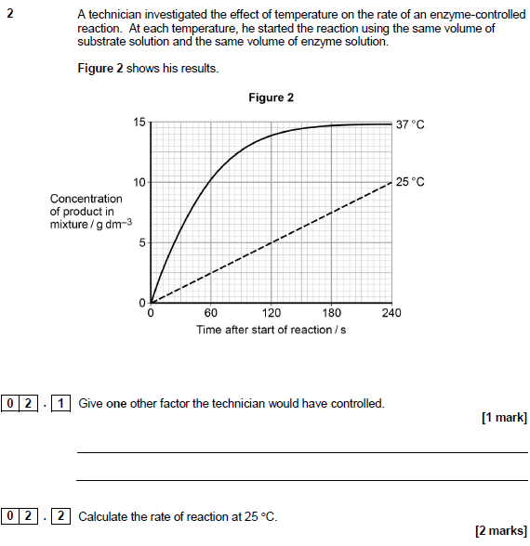

Similarly, in this example, the students should have done a very similar experiment.

The first question is simple recall of the factors involved in the rate of enzyme controlled reactions.

The second requires the calculation of a gradient, which is a skill students will have learned through their practical and other work.

**Example (A-level Chemistry Specimen Paper 3)**

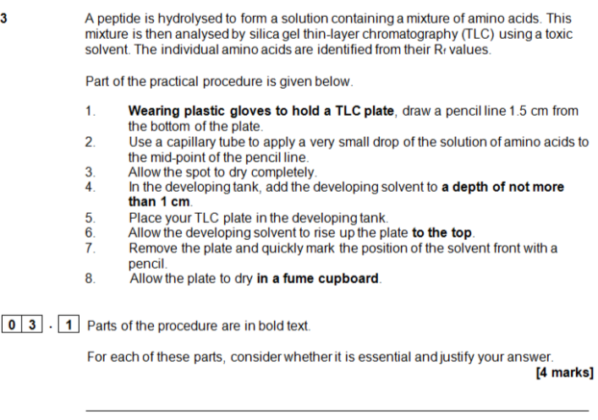

Students who have completed the related required practical will have a greater understanding of each of the steps in the procedure and will be able to explain each in turn.

This type of question is likely to be fairly rare, to avoid predictable assessments.

1. **Questions applying the skills from the required practical procedures and the apparatus and techniques list.**

**Example (A-level Chemistry Specimen Paper 3)**

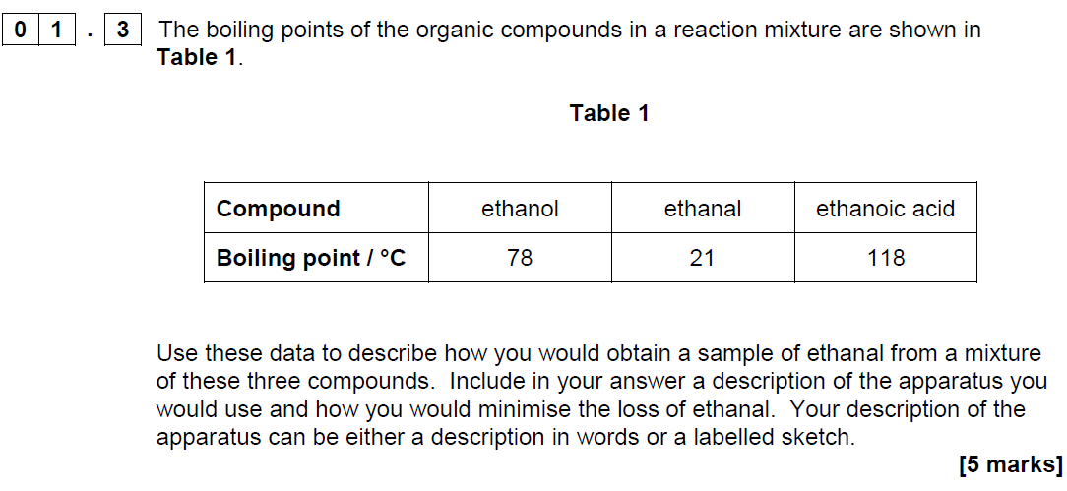

This question expects students to understand distillation which is one of the required practicals. It is not necessary for students to have carried out this precise experiment to understand the requirements.

**Example (AS Physics Specimen Paper 2)**

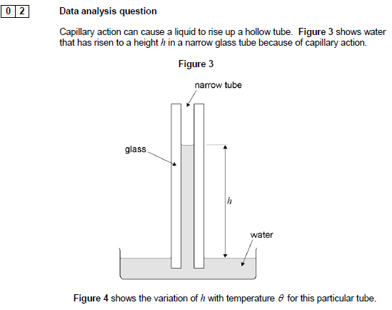

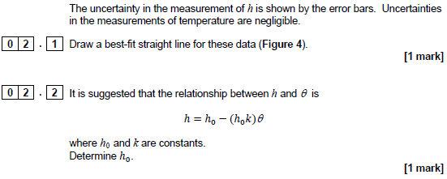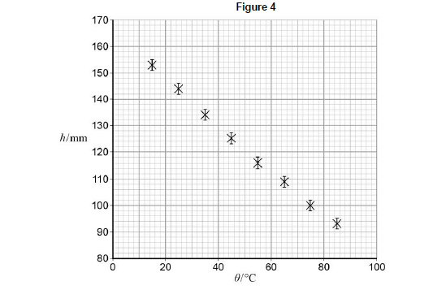

This question requires students to apply the skills of data analysis that they will have gained through their practical work in the required practicals and apply it to an unusual situation.

## Guidelines to supporting students in practical work

Developed in collaboration with NFER and CLEAPSS

**Clarify the importance of keeping a lab book or other records of practical work**

Explain that students need a record of their achievements to guide their learning. Lab books also can be an opportunity to develop a skill used both by scientists and in business. They allow students to accurately and clearly record information, ideas and thoughts for future reference which is a very useful life skill.

**Warn students against plagiarism and copying**

Explain that the use of acknowledged sources is an encouraged and acceptable practice, but trying to pass off other people’s work as their own is not, and will not help them learn.

**Explain the learning criteria for each skill**

This will help students learn and allow them to know when they have met the criteria. The student lab book contains the criteria, but they own the process and have the responsibility for collecting appropriate evidence of success.

**Use clearly defined learning outcomes**

For example, if you are running a practical session to teach students how to use a microscope and staining techniques safely and efficiently, then make sure they know why they are learning this. This will also make it much easier for them to know when they have met the criteria.

**Start with simple tasks initially**

Students need to become confident with the apparatus and concepts of practical work before they can proceed to more complicated experiments. It may be more effective to start with simple manipulation skills and progress to the higher order skills.

**Teach practical work in your preferred order**

Teach the skills as you see fit and suit your circumstances – the assessment process is aimed to be flexible and help you teach practical work, not to dictate how it should be done.

**Use feedback**

Research shows that feedback is the best tool for learning in practical skills. Students who normally only receive marks as feedback for work will need to be trained in both giving and receiving comment-based feedback. Provided it is objective, focused on the task and meets learning outcomes, students will quickly value this feedback.

Feedback is essential to help students develop skills effectively. Allowing self and peer review will allow time for quality feedback as well as provide powerful learning tools. However, this is a decision for teachers. The scheme is designed to be flexible while promoting best practice.

**Don’t give marks**

We have deliberately moved away from banded criteria and marks to concentrate on the mastery of key practical competencies. The purpose of marking should be changed to emphasise learning. Students should find it easier to understand and track their progress, and focus their work. We would expect most students, with practice and the explicit teaching of skills and techniques, to succeed in most competencies by the end of the course.

**Give feedback promptly**

Feedback does not need to be lengthy, but it does need to be done while the task is fresh in the students’ mind. Not everything needs written feedback but could be discussed with students, either individually or as a class. For example, if a teacher finds that many students cannot calculate percentage change, the start of the next lesson could be used for a group discussion about this.

**Use peer assessment**

The direct assessment of practical work is designed to allow teachers to integrate student-centred learning (including peer review), into day-to-day teaching and learning. This encourages critical skills. Research indicates these are powerful tools for learning. For example, teachers could ask students to evaluate each other’s data objectively. The students could identify why some data may be useful and some not. This can be a very good way of getting students to understand why some conventions are used, and what improves the quality of results. This also frees up marking time to concentrate on teaching.

**Use group work**

This is a very useful skill, allowing students to build on each other’s ideas. For example, planning an experiment can be done as a class discussion. Alternatively, techniques such as snowballing can be used, in which students produce their own plan then sit down in a small group to discuss which are the best collective ideas. From this, they revise their plan which is then discussed to produce a new ‘best’ plan.

## Use of lab books

Students do **not** need to write up every practical that they do in detail. However, it is good practice to have a record of all they do. A lab book could contain this record. It is a student’s personal book and may contain a range of notes, tables, jottings, reminders of what went wrong, errors identified and other findings. It is a live document that can function as a learning journal.

Lab books are **not** a requirement of the CPAC endorsement or the AQA AS and A-level specifications in Biology, Chemistry or Physics. They are highly valued by colleagues in higher education and are an easy way for students to demonstrate their mastery of Competence 5 “Researches, references and reports”.

Each institution has its own rules on lab book usage. The following guidelines are an amalgam of guidelines from a selection of companies and universities that use lab books. They are designed to help students and teachers in preparing to use lab books for university but do not represent the only way that books could be used for A-level sciences. Teachers will wish to vary or ignore the following points to suit their purposes.

**The purpose of a lab book**

A lab book is a complete record of everything that has been done in the laboratory. As such it becomes important both to track progress of experiments, but also, in industry and universities, to prove who developed an idea or discovered something first.

A lab book is a:

* source of data that can be used later by the experimenter or others
* complete record of what has been done so that experiments could be understood or repeated by a competent scientist at some point in the future
* tool that supports sound thinking and helps experimenters to question their results to ensure that their interpretation is the same one that others would come to
* record of why experiments were done.

**Type of book**

A lab book is often a hard-backed book with bound pages. Spiral bound notebooks are not recommended as it is too easy to rip a page out and start again. It is generally advisable that a lab book has a cover that won’t disintegrate the moment it gets slightly wet.

**Style**

Notes should be recorded as experiments are taking place. They should not be a “neat” record written at a later date from scraps of paper. However, they should be written clearly, in legible writing and in language which can be understood by others.

Many lab books are used in industry as a source of data, and so should be written in indelible ink.

To ensure that an observer can be confident that all data are included when a lab book is examined, there should be no blank spaces. Mistakes should be crossed out and re-written. Numbers should not be overwritten, erased, nor should Tippex be used. Pencil should not be used for anything other than graphs and diagrams.

**Each page should be dated**

Worksheets, graphs, printed information, photographs and even flat “data” such as chromatograms or TLC plates can all be stuck into a lab book. They should not cover up any information so that photocopying the page shows all information in one go. Anything glued in should lie flat and not be folded.

**Content**

Generally, lab books will contain:

* title and date of experiment
* notes on what the objectives of the experiment
* notes on the method, including all details (eg temperatures, volumes, settings of pieces of equipment) with justification where necessary
* sketches of how equipment has been set up can be helpful. Photographs pasted in are also acceptable
* data and observations input to tables (or similar) while carrying out the experiment
* calculations – annotated to show thinking
* graphs and charts
* summary, discussions and conclusions
* cross-references to earlier data and references to external information.

This list and its order are not prescriptive. Many experiments change as they are set up and trials run. Often a method will be given, then some data, then a brief mention of changes that were necessary, then more data and so on.

## Cross-board statement on CPAC



**Common Practical Assessment Criteria (CPAC)**

The assessment of practical skills is a compulsory requirement of the course of study for A-level qualifications in biology, chemistry and physics. It will appear on all students’ certificates as a separately reported result, alongside the overall grade for the qualification. The arrangements for the assessment of practical skills are common to all awarding organisations. These arrangements include:

* A minimum of 12 practical activities to be carried out by each student which, together, meet the requirements of Appendices 5b (Practical skills identified for direct assessment and developed through teaching and learning) and 5c (Use of apparatus and techniques) from the prescribed subject content, published by the Department for Education. The required practical activities will be defined by each awarding organisation in their specification;
* Teachers will assess students using Common Practical Assessment Criteria (CPAC) issued jointly by the awarding organisations. The CPAC are based on the requirements of Appendices 5b and 5c of the subject content requirements published by the Department for Education, and define the minimum standard required for the achievement of a pass;
* Each student will keep an appropriate record of their practical work, including their assessed practical activities;
* Students who demonstrate the required standard across all the requirements of the CPAC will receive a ‘pass’ grade;
* There will be no separate assessment of practical skills for AS qualifications;
* Students will answer questions in the AS and A level examination papers that assess the requirements of Appendix 5a (Practical skills identified for indirect assessment and developed through teaching and learning) from the prescribed subject content, published by the. Department for Education. These questions may draw on, or range beyond, the practical activities included in the specification.



|  |  |
| --- | --- |
| Competency | Practical mastery |
|  | In order to be awarded a Pass a student must, by the end of the practical science assessment, consistently and routinely meet the criteria in respect of each competency listed below. A student may demonstrate the competencies in any practical activity undertaken as part of that assessment throughout the course of study.  Student may undertake practical activities in groups. However, the evidence generated by each student must demonstrate that he or she independently meets the criteria outlined below in respect of each competency. Such evidence:  a. will comprise both the student’s performance during each practical activity and his or her contemporaneous record of the work that he or she has undertaken during that activity, and  b. must include evidence of independent application of investigative approaches and methods to practical work. |
| 1. Follows written procedures | a. Correctly follows written instructions to carry out experimental techniques or procedures. |
| 2. Applies investigative approaches and methods when using instruments and equipment | a. Correctly uses appropriate instrumentation, apparatus and materials (including ICT) to carry out investigative activities, experimental techniques and procedures with minimal assistance or prompting.  b. Carries out techniques or procedures methodically, in sequence and in combination, identifying practical issues and making adjustments when necessary.  c. Identifies and controls significant quantitative variables where applicable, and plans approaches to take account of variables that cannot readily be controlled.  d. Selects appropriate equipment and measurement strategies in order to ensure suitably accurate results. |
| 3. Safely uses a range of practical equipment and materials | a. Identifies hazards and assesses risks associated with these hazards, making safety adjustments as necessary, when carrying out experimental techniques and procedures in the lab or field.  b. Uses appropriate safety equipment and approaches to minimise risks with minimal prompting. |

|  |  |
| --- | --- |
| 4. Makes and records observations | a. Makes accurate observations relevant to the experimental or investigative procedure.  b. Obtains accurate, precise and sufficient data for experimental and investigative procedures and records this methodically using appropriate units and conventions. |
| 5. Researches, references and reports | a. Uses appropriate software and/or tools to process data, carry out research and report findings.  b. Cites sources of information demonstrating that research has taken place, supporting planning and conclusions. |

## Extra information on the endorsement

The information below is based on the cross-board agreements, but is not a cross-board agreed wording.

**‘Consistently and routinely’**

Teachers should be confident that their students can demonstrate a particular competence going forwards. This means that demonstrating a competence once is unlikely to be enough, but there is no stipulated number of times that each competence must be demonstrated. The teacher should use professional judgement when holistically assessing their students at the end of the course.

**Observing differences in standard over time**

There is an expectation that students will increase in their skills and abilities in practical work throughout a two – year course. A monitor attending a school in the earlier part of the course would expect to see students working at a lower level than the same students would be working at by the end of the course.

There are many different ways of tracking students’ skills development towards competence. Monitors will not expect to see any particular method of tracking or showing this development during visits. Monitors will discuss tracking with teachers in order to become confident that the teachers understand the standard expected at the end of the course and that their planning supports students’ skills progression.

**Demonstrations**

Demonstrations cannot be substituted for any of the required practical activities. Teachers can demonstrate experiments before students carry out the experiment. However, if CPAC 1 is being assessed, the instructions must not simply repeat what was shown in the demonstration.

**The link between the apparatus and techniques and CPAC**

All students should have experienced use of each of the apparatus and techniques. Their competence in practical work will be developed through the use of these apparatus and techniques. However, students are not being assessed on their abilities to use a particular piece of equipment, but on their general level of practical competence.

**Simulations**

Simulations are not acceptable for use in the place of the apparatus and techniques.

**Helping students during practical work**

Teachers can help students during practical work, but the amount of guidance will be dependent on the criteria being assessed. For example, if a student was being assessed on CPAC 4, and needed to be reminded on the basics of safety, they could not be assessed as passing.

It may be appropriate to help students if the equipment or the technique is new or unusual.

The amount of help would depend on when in the course the practical work was taking place. For example, at the beginning of year 12 the teacher would be likely to be giving a lot of guidance, and tasks would include a lot of scaffolding. By the end of year 13, there is likely to be minor prompting to help students as they become more confident and competent.

**Language used by students**

In written exams, students are expected to use scientific language that corresponds to the glossary of terms in this handbook. Whilst doing practical work, students should be encouraged to use the correct terms (such as discussing if results are ‘accurate’, ‘precise’, ‘repeatable’ etc), but should not be penalised for using incorrect vocabulary verbally. This is because the assessment is about the students’ abilities in practical work, not their use of terms.

**Certificates**

Students will either have ‘Pass’ or ‘Not classified’ recorded on their certificate for the endorsement.

**Carry forward and retakes**

Students may carry forward the outcome of practical assessments if they resit their exams. They cannot retake the practical science assessment without retaking exams. This is because practical skills should be developed as part of teaching and learning of the whole subject and the assessment is designed to assess students demonstrating the skills over a period, not just as a one-off.

**Reasonable adjustments**

The JCQ document Access Arrangements and Reasonable Adjustments sets out arrangements for access arrangements for all assessments.

The arrangements applicable to the endorsement must not compromise the objectives of the assessment. So, for example, it is likely to be reasonable for a student to have a reader or extra time while being assessed against CPAC 1. Students would be demonstrating their ability to follow instructions in the form the students were used to receiving them in.

CPAC 2 and 3 make reference to the use of instruments, equipment and materials. The use of a practical assistant for a student with very poor motor coordination or a severe visual impairment could potentially compromise the purpose of the assessment (to develop manipulative skills).

Teachers should work with the special educational needs coordinator to determine which arrangements are appropriate and reasonable.

The AQA website will be updated as further guidance becomes available.

## Monitoring visits

AQA are committed to making the monitoring process a supportive one. One teacher from the cross board trial stated: “I felt like I should have felt a bit more nervous… but I realised it wasn’t an Ofsted. It was an opportunity for my students to show off their learning and the teachers to show their teaching. It wasn’t a big stick. It could be positive and be helpful for the teachers in putting pressure on their SLTs to make resources available.”

All schools will be monitored for one subject by one of the boards in the first two years of the course. For example, if a school is taking Biology with AQA, while Chemistry and Physics with other boards, AQA would only visit the Biology department, or another board may visit Chemistry or Physics. Larger schools and colleges (who tend to have separate departments) will be visited three times. AQA’s first visits will be between January and April 2016 or September 2016 and January 2017, leaving enough time for repeat visits if there is an issue identified.

Monitors will be looking to confirm two things:

* that schools are **compliant** with the **rules**
* that teachers are **assessing** students at the correct **standard**.

Training on the standard will be available from September 2015 and will be online and free.

Cross-board agreed process and code of conduct

**Process**

**Training**

The Lead teacher must undertake training and disseminate information as directed by their exam board.

**Notice of monitoring**

Each exam board is expected to give centres at least 2 weeks’ notice of monitoring visits.

Where possible, exam boards may take into account centres’ timetables, but on some occasions it will be necessary for centres to make arrangements to allow the monitor to observe a practical lesson.

Materials required by the monitor on the day of the visit:

1. Documented plans to carry out sufficient practical activities which meet the requirements of CPAC, incorporating skills and techniques detailed in appendix 5, over the course of the A level;
2. a record of each practical activity undertaken and the date when this was completed;
3. a record of the criteria being assessed in that practical activity;
4. a record of student attendance;
5. a record of which student met the criteria and which did not;
6. student work showing evidence required for the particular task with date;
7. any associated materials provided for the practical activity eg written instructions given.

A timetable for the day and lists of people who the monitor will meet will also be required.

Notes on evidence

Evidence 1. Although there is an expectation that planning to cover the full requirements of the endorsement should take place, these plans may be in outline form if viewed in the first year of the course.

Evidence 2 – 6. Will only be available after particular activities have taken place. The monitor should take a proportionate view on whether sufficient practical activities have taken place.

Evidence 7. A similarly proportionate view should be taken on this requirement.

**Before the day of monitoring**

Exam board / monitor will communicate expectations with the centre, explaining the process, evidence required, the staff and students who will be observed or spoken to, and making arrangements for the day.

**On the day of monitoring**

The timings of the monitoring visit will be discussed with the centre and will be dependent on the number of students.

Monitors will be expected to:

* meet the Lead teacher for the endorsement of practical work for the subject being visited
* observe a lesson including a practical activity (which may or may not be one of the required practicals) during which students are assessed against the competencies
* discuss the teacher’s assessment of the students in the class
* meet students and discuss the practical work that students have been doing (this may take place during the lesson if appropriate)
* view the work of students from lesson and other classes as per cross-board agreement
* view teachers’ records of assessment of practical work
* follow all rules and procedures as required by the school.

Monitors may undertake formal or informal monitoring for an A-level subject where teachers are using the monitor’s exam board and have requested or agreed to such monitoring.

Monitors will under no circumstances:

* attempt to persuade teachers who are not currently teaching for the monitors’ exam board to change exam boards
* attempt to persuade teachers to change exam boards for GCSE or other courses
* collect information about teachers’ names and exam boards for subjects not taking exams with the monitor’s board
* meet teachers for A-level subjects where the board used is not the monitor’s board except where training is on another qualification where the teacher uses the monitor’s board (for example, when a teacher uses different boards for GCSE and A-level)
* accept any sort of gifts from the school or teachers
* make notes that could be constituted as a “lesson observation”, or feedback any judgement on teaching to the teacher or school
* make audio, video or photographic records of students without prior explicit permission being granted by the senior leadership of the school and the parents of the students involved
* remove any original students’ work from the centre at the end of the visit
* expect teachers to be using a particular method of planning, teaching or assessment.

**Feedback**

The monitor will not give a formal judgement during the visit. Feedback will be received by the centre following review by the exam board’s Lead monitor within two weeks of the visit.

**Follow up actions**

On occasion, the monitor may require supplementary evidence. These will generally be any actions that can take place remotely (for example, emailing or sending evidence or documents to the monitor).

**Non-compliant centres**

Centres that have not met the required standard will be reported to JCQ for follow up, which may include a follow up visit for the subject and/or monitoring for the other subjects.

**Safety**

At all times the monitor should comply with health and safety regulations and the instructions of the teacher unless they would put the monitor at risk. The safety of students is the responsibility of the teacher. In particular, monitors should not be left alone with classes, especially where practical work is taking place.

**Quality of teaching**

The monitor is **not** monitoring the quality of teaching.

**Working with students**

Monitors must be accompanied at all times whilst in schools and working with students.

## Evidence for the endorsement

Centres will be visited by a monitor who will agree with teachers a date for their visit. They are likely to watch practical work taking place, and discuss with the teacher present their views of the competencies exhibited by the students. There should be no need to coach students for this visit, as it is the teachers’ abilities to assess practical work that are being monitored, not the students’ performance.

The following minimum documentation requirements have been agreed by the awarding bodies, and would be expected to be available to the monitor to view. There is currently no requirement for any of the following to be sent into the exam board.

1. Documented plans to carry out sufficient practical activities which meet the requirements of CPAC, incorporating skills and techniques detailed in appendix 5, over the course of the A level;
2. a record of each practical activity undertaken and the date when this was completed;
3. a record of the criteria being assessed in that practical activity;
4. a record of student attendance;
5. a record of which student met the criteria and which did not;
6. student work showing evidence required for the particular task with date;
7. any associated materials provided for the practical activity eg written instructions given.



There are many ways of fulfilling these requirements. AQA believe that teachers should have the ability to choose the methods they use to collect this documentation. Different schools and colleges will find different ways to track this information depending on local needs. AQA will be providing exemplar methods of tracking this information, but will not be requiring teachers to use specific forms. Monitors will be trained by AQA and will accept the following methods, or alternatives which contain the required information.

1. documented plans to carry out sufficient practical activities which meet the requirements of CPAC, incorporating skills and techniques detailed in appendix 5, over the course of the A level;

Note: Appendix 5 here refers to the DfE subject criteria. The apparatus and techniques are listed in appendices 7 and 8 of the combined specifications on the AQA website, and the next section in this handbook.

Teachers may wish to keep this information in the following ways:

* Long-term schemes of work which include the required practicals (and any other practicals where teachers will be assessing students’ competencies)
* Timetables or lists of dates of each of the practicals
* Sheets stuck in the front of students’ lab books.

1. a record of each practical activity undertaken and the date when this was completed;
2. a record of the criteria being assessed in that practical activity;

These records could be kept:

* In long-term scheme of work, there may be bullet points after each practical identifying the competencies to be completed
* On student sheets, the competences that the teacher will be assessing could be detailed
* On tracking spread sheets.

1. a record of student attendance;

This could be done via normal school systems if teachers feel that cross-referencing between SIMS or similar and their schemes of work allows them to be confident that all students have done each experiment.

Alternative methods could include:

* Tracking spread sheets
* Teacher mark books
* On sheets stuck at the front of students’ lab books.

1. a record of which student met the criteria and which did not;

Examples of how this could be recorded:

* Tracking spread sheets
* On individual pieces of work / lab book pages
* A overview page per student at the front of lab books.

1. student work showing evidence required for the particular task with date;

Teachers must be confident that they are able to assess the quality of students’ work in accordance with the relevant CPAC criteria. For example:

* In lab books (allowing all practical work to be kept in one place)
* In students’ folders, interspersed with their theory work (allowing the link between practical and theory to be highlighted)
* In computer-based systems
* On individual sheets collected at the end of practical sessions
* In pre-printed workbooks.

In each case, teachers must be able to locate students’ work if a monitor visits the centre and asks to see the work.

1. any associated materials provided for the practical activity eg written instructions given.

This could include:

* Notes in lesson plans or schemes of work
* Worksheets or workbooks
* Notes made on tracking sheets.

These materials should allow a monitor to understand how much guidance students were given. For example, they could show that teachers gave students full details of an experiment, which would limit the ability of the students from demonstrating the ability to apply investigative approaches.

## Cross-board apparatus and techniques and AQA required practical activities

The apparatus and techniques lists for Biology, Chemistry and Physics are common to all boards. Students taking any specification in these subjects are expected to have had opportunities to use the apparatus and develop and demonstrate the techniques.

The required practical activities in each subject are specific to AQA. We have written our specifications so that AS is co-teachable with the A-level specification. Therefore the first six required practicals are included in both specifications and the second six are A-level only.

Carrying out the 12 required practicals in the full A-level will mean that students will have experienced the use of each of the expected apparatus and techniques. Teachers are encouraged to develop students’ abilities by inclusion of other opportunities for skills development, as exemplified in the right-hand column of the content section of the specification.

Teachers are encouraged to vary their approach to the required practical activities. Some are more suitable for highly structured approaches that develop key techniques. Others allow opportunities for students to develop investigative approaches.

This list is not designed to limit the practical activities carried out by students. A rich practical experience for students will include more than the 12 required practical activities. The explicit teaching of practical skills builds students’ competence. Many teachers will also use practical approaches to the introduction of content knowledge in the course of their normal teaching. Students’ work in these activities can also contribute towards the endorsement of practical skills.

For the endorsement all students must have experienced use of each of the alternatives in the apparatus and techniques list. **For written exams, we suggest that teachers treat “or” statements as “and” statements.**

So, for example, in chemistry, students can pass the **endorsement** if they have colorimeter or potometer.

To best prepare students for **exams**, teachers should ensure that all students understand both of the alternatives so they can answer questions on practical work that involve any of these methods. Therefore, all “or” statements in the apparatus and techniques list should be viewed as “and” statements for the exams.

**Biology apparatus and techniques** 

|  |  |
| --- | --- |
|  | Apparatus and techniques |
| AT a | use appropriate apparatus to record a range of quantitative measurements (to include mass, time, volume, temperature, length and pH) |
| AT b | use appropriate instrumentation to record quantitative measurements, such as a colorimeter or potometer |
| AT c | use laboratory glassware apparatus for a variety of experimental techniques to include serial dilutions |
| AT d | use of light microscope at high power and low power, including use of a graticule |
| AT e | produce scientific drawing from observation with annotations |
| AT f | use qualitative reagents to identify biological molecules |
| AT g | separate biological compounds using thin layer/paper chromatography or electrophoresis |
| AT h | safely and ethically use organisms to measure:   * plant or animal responses * physiological functions |
| AT i | use microbiological aseptic techniques, including the use of agar plates and broth |
| AT j | safely use instruments for dissection of an animal organ, or plant organ |
| AT k | use sampling techniques in fieldwork |
| AT l | use ICT such as computer modelling, or data logger to collect data, or use software to process data |

**Biology required activities (1-6 AS), (1-12 A-level)** 

|  |  |
| --- | --- |
| Required activity | Apparatus and technique reference |
| 1. Investigation into the effect of a named variable on the rate of an enzyme-controlled reaction | a, b, c, f, l |
| 2. Preparation of stained squashes of cells from plant root tips; set-up and use of an optical microscope to identify the stages of mitosis in these stained squashes and calculation of a mitotic index | d, e, f |
| 3. Production of a dilution series of a solute to produce a calibration curve with which to identify the water potential of plant tissue | c, h, j, l |
| 4. Investigation into the effect of a named variable on the permeability of cell-surface membranes | a, b, c, j, l |
| 5. Dissection of animal or plant gas exchange or mass transport system or of organ within such a system | e, h, j |
| 6. Use of aseptic techniques to investigate the effect of antimicrobial substances on microbial growth | c, i |
| 7. Use of chromatography to investigate the pigments isolated from leaves of different plants eg leaves from shade-tolerant and shade- intolerant plants or leaves of different colours | b, c, g |
| 8. Investigation into the effect of a named factor on the rate of dehydrogenase activity in extracts of chloroplasts | a, b, c |
| 9. Investigation into the effect of a named variable on the rate of respiration of cultures of single-celled organisms | a, b, c, i |
| 10. Investigation into the effect of an environmental variable on the movement of an animal using either a choice chamber or a maze | h |
| 11. Production of a dilution series of a glucose solution and use of colorimetric techniques to produce a calibration curve with which to identify the concentration of glucose in an unknown ‘urine’ sample | b, c, f |
| 12. Investigation into the effect of a named environmental factor on the distribution of a given species | a, b, h, k, l |

## Tabulating data



It is important to keep a record of data whilst carrying out practical work. Tables should have clear headings with units indicated using a forward slash before the unit.

|  |  |
| --- | --- |
| **Temperature**  **/ °C** | **Length**  **/ mm** |
| 10.0 | 53 |
| 20.0 | 25 |
| 30.0 | 12 |

Although using a forward slash is the standard format, other formats are generally acceptable. For example:

|  |  |  |  |  |
| --- | --- | --- | --- | --- |
| **Volume in cm3** | **Time taken in s** |  | **Time (hours)** | **Number of cells** |
| 15 | 23 |  | 0 | 1 |
| 25 | 45 |  | 6 | 45 |
| 35 | 56 |  | 12 | 304 |

It is good practice to draw a table before an experiment commences and then enter data straight into the table. This can sometimes lead to data points being in the wrong order. For example, when studying the temperature at which an enzyme works best, a student may do a number of experiments at 25, 30, 35, 40 and 45 °C, and then investigate the area between 30 and 40 further by adding readings at 31, 32, 33, 34, 36, 37, 38 and 39 °C. Whilst this is perfectly acceptable, it is generally a good idea to make a fair copy of the table in ascending order of temperature to enable patterns to be spotted more easily. Reordered tables should follow the original data if using a lab book, data should not be noted down in rough before it is written up.

It is also expected that the independent variable is the left hand column in a table, with the following columns showing the dependent variables. These should be headed in similar ways to measured variables. The body of the table should not contain units.

**Tabulating logarithmic values**

When the logarithm is taken of a physical quantity, the resulting value has no unit. However, it is important to be clear about which unit the quantity had to start with. The logarithm of a distance in km will be very different from the logarithm of the same distance in mm.

These should be included in tables in the following way:

|  |  |  |
| --- | --- | --- |
| **Reading number** | **time / s** | **log (time / s)** |
| 1 | 2.3 | 0.36 |
| 2 | 3.5 | 0.54 |
| 3 | 5.6 | 0.75 |

## Significant figures

Data should be written in tables to the same number of significant figures. This number should be determined by the resolution of the device being used to measure the data or the uncertainty in measurement. For example, a sample labelled as “1 mol dm–3 acid” should not be recorded in a table of results as 1.0 mol dm–3.

There is sometimes confusion over the number of significant figures when readings cross multiples of 10. Changing the number of decimal places across a power of ten retains the number of significant figures **but changes the accuracy.** The same number of decimal places should therefore generally be used, as illustrated below.

|  |  |  |
| --- | --- | --- |
| 0.97 |  | 99.7 |
| 0.98 |  | 99.8 |
| 0.99 |  | 99.9 |
| 1.00 |  | 100.0 |
| 1.10 |  | 101.0 |

It is good practice to write down all digits showing on a digital meter.

Calculated quantities should be shown to the number of significant figures of the data with the least number of significant figures.

Example:

Calculate the size of an object if the magnification of a photo is ×25 and it is measured to be 24.6 mm on the photo.

$size of real object= \frac{size of image}{magnification}$

$size of real object= \frac{24.6 ×{10}^{-3}}{25}$

$size of real object= 9.8 × {10}^{-4}$

Note that the size of the real object can only be quoted to two significant figures as the magnification is only quoted to two significant figures.

Equipment measuring to half a unit (eg a thermometer measuring to 0.5 °C) should have measurements recorded to one decimal place (eg 1.0 °C, 2.5 °C). The uncertainty in these measurements would be ±0.25, but this would be rounded to the same number of decimal places (giving measurements quoted with uncertainty of (1.0 ± 0.3) °C etc).

## Uncertainties

**Sources of uncertainties**

Students should know that every measurement has some inherent uncertainty.

The important question to ask is whether an experimenter can be confident that the true value lies in the range that is predicted by the uncertainty that is quoted. Good experimental design will attempt to reduce the uncertainty in the outcome of an experiment. The experimenter will design experiments and procedures that produce the least uncertainty and to provide a realistic uncertainty for the outcome.

In assessing uncertainty, there are a number of issues that have to be considered. These include

* the resolution of the instrument used
* the manufacturer’s tolerance on instruments
* the judgments that are made by the experimenter
* the procedures adopted (eg repeated readings)
* the size of increments available (eg the size of drops from a pipette).

Numerical questions will look at a number of these factors. Often, the resolution will be the guiding factor in assessing a numerical uncertainty. There may be further questions that would require candidate to evaluate arrangements and procedures. Students could be asked how particular procedures would affect uncertainties and how they could be reduced by different apparatus design or procedure

A combination of the above factors means that there can be no hard and fast rules about the actual uncertainty in a measurement. What we can assess from an instrument’s resolution is the **minimum** possible uncertainty. Only the experimenter can assess the other factors based on the arrangement and use of the apparatus and a rigorous experimenter would draw attention to these factors and take them into account.

**Readings and measurements**

It is useful, when discussing uncertainties, to separate measurements into two forms:

|  |  |  |
| --- | --- | --- |
| **Readings** |  | **Measurements** |
| the values found from a single judgement when using a piece of equipment |  | the values taken as the difference between the judgements of two values. |

Examples:

When using a thermometer, a student only needs to make one judgement (the height of the liquid). This is a reading. It can be assumed that the zero value has been correctly set.

For stop watches and rulers, both the starting point and the end point of the measurement must be judged, leading to two uncertainties.

The following list is not exhaustive, and the way that the instrument is used will determine whether the student is taking a reading or a measurement.

|  |  |
| --- | --- |
| **Reading (one judgement only)** | **Measurement (two judgements required)** |
| thermometer | ruler |
| pH meter | protractor |
| top pan balance | stop watch |
| measuring cylinder | analogue meter |
| volumetric flask |  |

The uncertainty in a **reading** when using a particular instrument is **no smaller** than plus or minus half of the smallest division or greater. For example, a temperature measured with a thermometer is likely to have an uncertainty of ±0.5 °C if the graduations are 1 °C apart.

Students should be aware that readings are often written with the uncertainty. An example of this would be to write a voltage as (2.40 ± 0.01) V. It is usual for the uncertainty quoted to be the same number of significant figures as the value. Unless there are good reasons otherwise (eg an advanced statistical analysis), students at this level should quote the uncertainty in a measurement to the same number of decimal places as the value.

**Measurement example: length**

When measuring length, **two** uncertainties must be included: the uncertainty of the placement of the zero of the ruler and the uncertainty of the point the measurement is taken from.

As both ends of the ruler have a ±0.5 scale division uncertainty, the measurement will have an uncertainty of ±1 division.

area of uncertainty

object

|  |  |  |  |  |  |  |  |  |  |  |  |
| --- | --- | --- | --- | --- | --- | --- | --- | --- | --- | --- | --- |
|  |  |  |  |  |  |  |  |  |  |  |  |
|  |  |  |  |  |  |  |  |  |  |  |  |
|  |  |  |  | ruler | | |  |  |  |  |  |

For most rulers, this will mean that the uncertainty in a measurement of length will be ±1 mm.

This “initial value uncertainty” will apply to any instrument where the user can set the zero (incorrectly), but would not apply to equipment such as balances or thermometers where the zero is set at the point of manufacture.

**In summary**

* **The uncertainty of a reading (one judgement) is at least ±0.5 of the smallest scale reading.**
* **The uncertainty of a measurement (two judgements) is at least ±1 of the smallest scale reading.**

The way measurements are taken can also affect the uncertainty.

**Measurement example: the extension of a spring**

Measuring the extension of a spring using a metre ruler can be achieved in two ways.

1. Measuring the total length unloaded and then loaded.





Four readings must be taken for this: The start and end point of the unloaded spring’s length and the start and end point of the loaded spring’s length.

The minimum uncertainty in each measured length is ±1 mm using a meter ruler with 1 mm divisions (the actual uncertainty is likely to be larger due to parallax in this instance). The extension would be the difference between the two readings so the minimum uncertainty would be ±2 mm.

2. Fixing one end and taking a scale reading of the lower end.



Two readings must be taken for this: the end point of the unloaded spring’s length and the end point of the loaded spring’s length. The start point is assumed to have zero uncertainty as it is fixed.

The minimum uncertainty in each reading would be ±0.5 mm, so the minimum extension uncertainty would be ± 1 mm.

Even with other practical uncertainties this second approach would be better.

Realistically, the uncertainty would be larger than this and an uncertainty in each reading of 1 mm or would be more sensible. This depends on factors such as how close the ruler can be mounted to the point as at which the reading is to be taken.

**Other factors**

There are some occasions where the resolution of the instrument is not the limiting factor in the uncertainty in a measurement.

Best practice is to write down the full reading and then to write to fewer significant figures when the uncertainty has been estimated.

Examples:

A stopwatch has a resolution of hundredths of a second, but the uncertainty in the measurement is more likely to be due to the reaction time of the experimenter. Here, the student should write the full reading on the stopwatch (eg 12.20 s), carry the significant figures through for all repeats, and reduce this to a more appropriate number of significant figures after an averaging process later.

If a student measures the length of a hair, it is very difficult to hold the hair completely straight against the ruler. The uncertainty in the measurement is likely to be higher than the ±1 mm uncertainty of the ruler. Depending on the number of “kinks” in the wire, the uncertainty could be reasonably judged to be nearer ± 2 or 3 mm.

**Uncertainties in given values**

Often exam papers contain values. In all such cases assume the uncertainty to be ±1 in the last significant digit. For example, if an exam stated “a person excreted 1660 mg of creatinine in 24 hours”, uncertainty would be assumed to be ±10 mg of creatinine. The uncertainty may be lower than this but without knowing the details of the experiment and procedure that lead to this value there is no evidence to assume otherwise.

**Multiple instances of measurements**

Some methods of measuring involve the use of multiple instances in order to reduce the uncertainty. For example, measuring the thickness of several leaves together, rather than just one leaf. The uncertainty of each measurement will be the uncertainty of the whole measurement divided by the number of leaves. This method works because the percentage uncertainty on the thickness of a single leaf is the same as the percentage uncertainty for the thickness of multiple leaves.

For example:

Thickness of 10 leaves: (31.2 ± 0.1) mm

Mean thickness of one leaf: (0.31 ± 0.01) mm

**Repeated measurements**

Repeating a measurement is a method for reducing the uncertainty.

With many readings one can also identify those that are exceptional (that are far away from a significant number of other measurements). Sometimes it will be appropriate to remove outliers from measurements before calculating a mean. On other occasions, particularly in Biology, outliers are important to include. For example, it is important to know that a particular drug produces side effects in one person in a thousand.

If measurements are repeated, the uncertainty can be calculated by finding half the range of the measured values.

For example:

|  |  |  |  |  |
| --- | --- | --- | --- | --- |
| **Repeat** | 1 | 2 | 3 | 4 |
| **Mass gain /g** | 1.23 | 1.32 | 1.27 | 1.22 |

1.32 – 1.22 = 0.10 therefore

Mean mass gain: (1.26 ± 0.05) g

**Percentage uncertainties**

The percentage uncertainty in a measurement can be calculated using:

$percentage uncertainty= \frac{uncertainty }{value} x 100\%$

The percentage uncertainty in a repeated measurement can also be calculated using:

$percentage uncertainty= \frac{uncertainty }{mean value} x 100\%$

**Uncertainties in exams**

Wherever possible, questions in exams will be clear on whether students are being asked to calculate the uncertainty of a reading, a measurement, or given data.

Where there is ambiguity, mark schemes will allow alternative sensible answers and credit clear thinking.

It is important that teachers read the Reports on the examination following each series to understand common mistakes to help their students improve in subsequent years.

**Uncertainties in practical work**

Students are expected to develop an understanding of uncertainties in measurements through their practical work. Teachers may use students’ assessments of uncertainties in measurements, and their recording, as evidence towards several of the endorsement criteria. Teachers will decide on each occasion what acceptable uncertainty values are, and the ways in which they expect students to record these.

Examples:

CPAC 2: Students should be attempting to reduce the uncertainties in experiments. This could be by choosing appropriate equipment (CPAC 2a), or by choosing procedures such as repeating readings that reduce overall uncertainties (CPAC 2d).

CPAC 4: Students’ records should take into account uncertainties. For example, students should be making sensible decisions about the number of significant figures to include, particularly in calculated values.

CPAC 5: Students could comment on the uncertainties in their measurements. For example, students could comment on whether the true value (eg for a concentration, or the acceleration due to gravity) lies within their calculated range of uncertainty. With some measurements, students may compare their value with those from secondary sources, contributing evidence for CPAC 5b.

**Combining uncertainties**

Percentage uncertainties should be combined using the following rules:

|  |  |  |
| --- | --- | --- |
| **Combination** | **Operation** | **Example** |
| **Adding or subtracting values $a= b+c$** | Add the absolute uncertainties  Δa = Δb + Δc | Length of leaf on day 1 = (5.0 ± 0.1) cm  Length of leaf on day 2 = (7.2 ± 0.1) cm  Difference in length = (2.2 ± 0.2) cm |
| **Multiplying values $a= b ×c$** | Add the percentage uncertainties  εa = εb + εc | Voltage = (15.20 ± 0.1) V  Current = (0.51 ± 0.01) A  Percentage uncertainty in voltage = 0.7%  Percentage uncertainty in current = 1.96%  Power = Voltage × current = 7.75 W  Percentage uncertainty in power = 2.66%  Absolute uncertainty in power = ± 0.21 W |
| **Dividing values $a= \frac{b}{c}$** | Add the percentage uncertainties  εa = εb + εc | Mass of salt solution= (100 ± 0.1) g  Mass of salt = (20.0 ± 0.5) g  Percentage uncertainty in mass of solution = 0.1%  Percentage uncertainty in mass of salt = 2.5%  Percent composition by mass = $\frac{mass of salt}{mass of solution} × 100\%$ = 0.2%  Percentage uncertainty of percentage = 2.6%  Absolute uncertainty = ±0.005% |
| **Power rules $a= b^{c}$** | Multiply the percentage uncertainty by the power  εa = c × εb | Radius of circle = (6.0 ± 0.1) cm  Percentage uncertainty in radius = 1.6%  Area of circle = πr2 = 113.1 cm2  Percentage uncertainty in area = 3.2%  Absolute uncertainty = ± 3.6 cm2  (Note – the uncertainty in π is taken to be zero) |

Note: Absolute uncertainties (denoted by Δ) have the same units as the quantity.

Percentage uncertainties (denoted by ε) have no units.

Uncertainties in trigonometric and logarithmic functions will not be tested in A-level exams.

## Graphing

Graphing skills can be assessed both in written papers for the A-level grade and by the teacher during the assessment of the endorsement. Students should recognise that the type of graph that they draw should be based on an understanding of the data they are using and the intended analysis of the data. The rules below are guidelines which will vary according to the specific circumstances.

**Please note**: The Society of Biology suggests that even straight lines on graphs should be referred to as a curve. This convention is not used in the following pages to ensure clarity.

**Labelling axes**

Axes should always be labelled with the quantity being measured and the units. These should be separated with a forward slash mark:

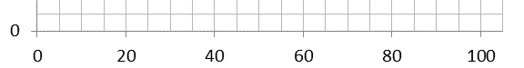

time / seconds



length / mm

Axes should not be labelled with the units on each scale marking.

**Data points**

Data points should be marked with a cross. Both 🞪 and 🞣 marks are acceptable, but care should be taken that data points can be seen against the grid.

Error bars can take the place of data points where appropriate.

**Scales and origins**

Students should attempt to spread the data points on a graph as far as possible without resorting to scales that are difficult to deal with. Students should consider:

* the maximum and minimum values of each variable
* the size of the graph paper
* whether 0.0 should be included as a data point
* how to draw the axes without using difficult scale markings (eg multiples of 3, 7, 11 etc)
* In exams, the plots should cover **at least half** of the grid supplied for the graph.

This graph has well-spaced marking points and the data fills the paper.

Each point is marked with a cross (so points can be seen even when a line of best fit is drawn).

This graph is on the limit of acceptability. The points do not quite fill the page, but to spread them further would result in the use of awkward scales.

At first glance, this graph is well drawn and has spread the data out sensibly.

However, if the graph were to later be used to calculate the equation of the line, the lack of a y-intercept could cause problems. Increasing the axes to ensure all points are spread out but the y-intercept is also included is a skill that requires practice and may take a couple of attempts.

**Lines of best fit**

Lines of best fit should be drawn when appropriate. Students should consider the following when deciding where to draw a line of best fit:

* Are the data likely to have an underlying equation that it is following (for example, a relationship governed by a physical law)? This will help decide if the line should be straight or curved.
* Are there any anomalous results?
* Are there uncertainties in the measurements? The line of best fit should fall within error bars if drawn.

There is no definitive way of determining where a line of best fit should be drawn. A good rule of thumb is to make sure that there are as many points on one side of the line as the other. Often the line should pass through, or very close to, the majority of plotted points. Graphing programs can sometimes help, but tend to use algorithms that make assumptions about the data that may not be appropriate.

Lines of best fit should be continuous and drawn with a thin pencil that does not obscure the points below and does not add uncertainty to the measurement of gradient of the line.

Not all lines of best fit go through the origin. Students should ask themselves whether a 0 in the independent variable is likely to produce a 0 in the dependent variable. This can provide an extra and more certain point through which a line must pass. A line of best fit that is expected to pass through (0,0), but does not, would imply some systematic error in the experiment. This would be a good source of discussion in an evaluation.

**Dealing with anomalous results**

At GCSE, students are often taught to automatically ignore anomalous results. At A-level students should think carefully about what could have caused the unexpected result. For example, if a different experimenter carried out the experiment. Similarly, if a different solution was used or a different measuring device. Alternatively, the student should ask if the conditions the experiment took place under had changed (for example at a different temperature). Finally, whether the anomalous result was the result of an accident or experimental error. In the case where the reason for an anomalous result occurring can be identified, the result should be ignored. In presenting results graphically, anomalous points should be plotted but ignored when the line of best fit is being decided.

Anomalous results should also be ignored where results are expected to be the same (for example in when repeat readings of pH are taken of the same sample).

Where there is no obvious error and no expectation that results should be the same, anomalous results should be included. This will reduce the possibility that a key point is being overlooked.

Please note: when recording results it is important that all data are included. Anomalous results should only be ignored at the data analysis stage.

It is best practice whenever an anomalous result is identified for the experiment to be repeated. This highlights the need to tabulate and even graph results as an experiment is carried out.

**Scatter graphs**

Often, especially in Biology, we find a relationship between two continuous variables but cannot infer that the relationship is causal. For example, in the UK there is a relationship between the number of ice cream cornets bought by children and the incidence of sunburn. We could plot values for these two continuous variables as a graph but it would not be valid to join the plotted points. We use a scatter graph to investigate correlations. A line of best fit indicates a positive correlation or negative correlation or absence of correlation.

**Dot – to – dot graphs**

In Biology, it is generally accepted that, where the interim values of a continuously changing variable are not known, data points should be joined by straight lines.

**Histograms**

As with a line graph and scatter graph, a histogram is used to show the distribution of a continuous variable. In this case, the data for the dependent variable are arranged into non-overlapping groups. These groups could cover an equal span of data, eg, 0.0 to 4.9, 5.0 to 9.9, 10.0 to 14.9, or an unequal span of data, eg, 0 to 0.9, 1 to 3.9, 4 to 7.9, 8 to 8.9.

These groups are arranged on the x-axis with widths scaled to represent each span of data. When the dependent variable is plotted, the area under each rectangle is equal to the frequency of the observations in that interval.

In a histogram, the bars touch.



**Bar charts**

Line graphs and histograms are used when the data are continuous. In contrast, bar charts are used when the data are discontinuous because they are:

* categoric - only certain values can exist (eg reading at week 1, reading at week 2 etc) or
* nominal – there is no ordering of the categories (eg red flowers, pink flowers and white flowers of *Antirrhinum*).

Since these data are not continuous, the intervals on the x-axis should show this and, unlike a histogram, the rectangles must not touch.



**Measuring gradients**

When finding the gradient of a line of best fit, students should show their working by drawing a triangle on the line. The hypotenuse of the triangle should be at least half as big as the line of best fit.

The line of best fit here has an equal number of points on both sides. It is not too wide so points can be seen under it.

The gradient triangle has been drawn so the hypotenuse includes more than half of the line.

In addition, it starts and ends on points where the line of best fit crosses grid lines so the points can be read easily (this is not always possible).

Δx

$$gradient= \frac{∆y}{∆x}$$

**The equation of a straight line**

Students should understand that the following equation represents a linear relationship.

$$y=mx+c$$

Where y is the dependent variable, m is the gradient, x is the independent variable and c is the y-intercept.

Δy

Δx

y-intercept

## Biological drawing

The purpose of drawing in the teaching of Biology is the development of observational skills. A student must look very closely at a specimen in order to draw it accurately and must have sound knowledge of the component structures in order to choose what to draw and what to omit from the drawing.

Drawings should always be in pencil. Fine detail cannot be represented accurately unless the pencil has a sharp point.

The outlines of any structures should be drawn but there should be no colouring or shading. The relative sizes of the structures drawn should be accurate. Construction lines or frames could be used to solve this problem. If the relative size of any structure has been exaggerated, e.g., because an actual cell wall was too thin to be able to draw its outline using two pencil lines, a note should be added to the drawing to explain this.

If required, the drawn structures should be labelled with brief annotations about their functions or interrelationships.

The drawing should have an explanatory title and an indication of the real size of the structures drawn or of the magnification used.

During an AS or A-level Biology course, students are likely to make three types of drawing.

* **Cell drawing**

The purpose of this drawing is to show accurately the components of individual cells observed using an optical microscope. The drawing should be detailed but should not show more than two or three cells.

* **Tissue map**

The purpose of a tissue map is to show the location and extent of tissues in an organ or in a whole organism. Cellular detail of any of the tissues should not be shown. Instead, the outline of each tissue should be drawn. This often presents a problem, since cell differentiation is seldom discrete. Students must use their background knowledge and understanding to interpret what they see.

* **Body plan**

Following dissection, a morphological drawing should provide a lifelike representation of the main body parts exposed by the dissection.

**Common errors in biological drawing**

The table shows errors that commonly occur when students begin to practise drawings of biological material. Each would reduce the value of the drawing and result in loss of credit being awarded. Most result from lack of attention or care and are easily solved.

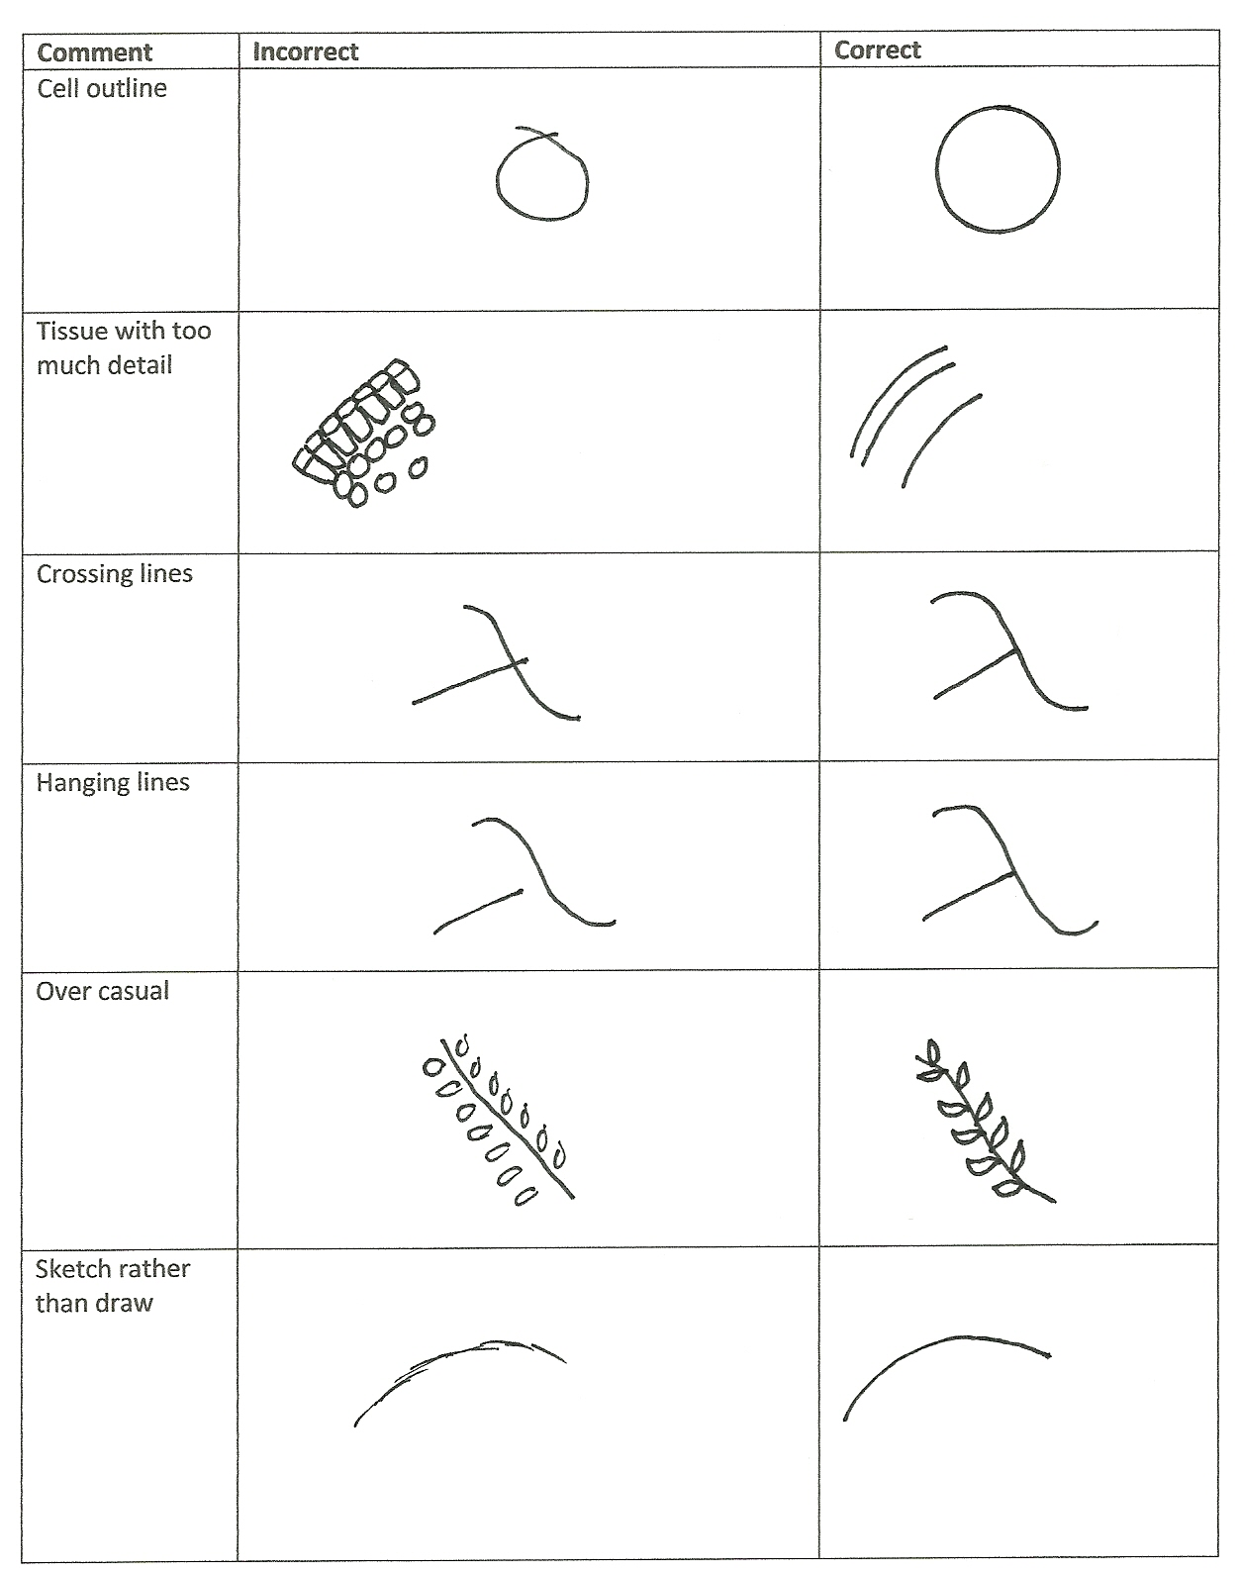

## Statistical tests in Biology

During development of the new specification, there was general agreement amongst examiners, teachers and representatives from higher education & industry that there is no value in students calculating test statistics manually as in most commercial and academic institutions computers are used to carry out the numerical calculations. Consequently, we expect that most students will often use electronic devices to calculate test statistics during their classwork.

In written examinations, students might be asked to perform simple calculations such as fining a mean value. Students will **not** be asked to perform a calculation using a statistical test. It will be important for students to understand how to select a statistical test that is appropriate for given data and to be able interpret the results of such a statistical test. Students could also be asked to explain their choices and interpretation.

Students taking A-level Biology should be familiar with the language of statistics and understand the need to devise random sampling procedures that avoid observer bias.

Students will be expected to be familiar with the following types of statistics.

* **Descriptive statistics** that provide an understanding of the data.
* **Inferential statistics** that enable inferences about a population based on the sample of data that has been collected.

Teachers should decide the best method of teaching students the use of statistical tests. In some circumstances, the full numerical analysis may be appropriate so that students understand the information needed for a particular test. In other circumstances, using computers to carry out the analysis followed by discussion of the findings will be sufficient.

**Descriptive statistics**

At A-level, we will assume that populations and samples show a normal distribution. This enables students to use a **mean** and **standard deviation** **of the mean** to describe data. Students could calculate mean values and their standard deviations during class work but will **not** be asked to calculate a standard deviation in a written examination. They should appreciate the advantage of using standard deviation in preference to the range of values, the latter being overly influenced by outlying values.

When calculating the mean value from a **sample**, the mean is represented as **x̄** (pronounced x-bar). It is the sum of all the values, divided by the number of values, ie,

$x̄= \frac{Σx}{n}$.

The standard deviation (SD) gives an indication of the spread of values around the mean of those values. It is found using the formula

$$SD=√\frac{{Σ\left(x- \bar{x}\right)}^{2}}{n-1}$$

In interpreting the values of standard deviations, students should realise that ± 2 standard deviations from the mean includes over 95% of the data. Whilst not strictly valid, this allows students to use the presence or absence of overlap of the standard deviations of different means as an indication of whether differences in the means are likely to be due to chance.

In addition to the mean, students should be confident in identifying and using the **median** and **mode** as ‘averages’.

95% Confidence intervals (95% CI): since students will calculate a standard deviation, teachers could introduce them to the **standard error of the mean** (SE). This gives an indication of how close the mean of a sample might be to the mean of the population from which the sample was taken or to the mean of another sample from the same population. It is calculated by dividing the standard deviation of the mean by the square root of the sample size, ie

$SE=\frac{SD}{√n}$

Since the true population mean ± 1.96 SE will include 95% of the sample means, the standard error enables students to use 95% confidence intervals.

To calculate the 95% confidence interval, we multiply the standard error of each mean by 1.96. Subtracting this value from the mean gives the lower 95% confidence limit and adding it to the sample mean gives the upper 95% confidence limit.

$95\% CI= \bar{x} ±SE$**× $1.96$**

We can use the 95% confidence interval to state that:

* we are 95% confident that the true mean value of the population from which the sample was taken lies between the upper and lower confidence limits
* if the intervals of two calculated means do not overlap, we are 95% confident that these means are different.

**Inferential statistics**

Students should be aware that inferential statistics are used to test a theory, known as a hypothesis. Perhaps, counter-intuitively, the hypothesis is usually that there is **no** difference between the samples being studied, ie is a **null hypothesis**. The table shows how hypotheses can be turned into null hypotheses.

|  |  |
| --- | --- |
| **Hypothesis** | **Null hypothesis** |
| Chickens fed maize supplemented by lipid produce more male offspring than those fed maize alone. | There is no difference between the number of male and female offspring of chickens fed maize supplemented by lipid and those fed maize alone. |
| There are fewer slugs in dry areas | There is no difference between the number of slugs found in wet and dry areas |
| Tobacco plants exhibit a higher rate of growth when planted in soil rather than peat | Tobacco plants do not exhibit a higher rate of growth when planted in soil rather than peat. |

Once we have a null hypothesis, we design an experiment to try to disprove it. Thus, the result of a statistical test either disproves or fails to disprove (supports or fails to support) that null hypothesis; it can never prove a hypothesis to be true.

Significance levels: given the results of an experiment, we need to know if any difference between the results we predicted from our null hypothesis and those we obtained could be due to chance. If this difference is likely to be due to chance, it is said to be ‘non-significant’ and the null hypothesis cannot be rejected. On the other hand, if this difference is not likely to be due to chance, it is said to be significant and the null hypothesis can be rejected.

Each statistical test is associated with a table that enable us to calculate a significance level. For convenience, students can assume that if the probability (P) of the results being due to chance is equal to, or less than, 1 in 20 (P ≤ 0.05), the difference **is** **significant**.

Choice of statistical test: no single statistical test is suitable for all data. The mathematical requirements of this Biology specification include three statistical tests: the chi-squared (χ2)test, the Student’s *t*-test and a correlation coefficient. Although students might use data from their practical work to perform a calculation using one of these tests, they will **not** be asked to do so in a written examination. They can, however, be asked to choose which test would be appropriate for different types of data, and/or to justify the choice. The following decision-making flowchart can be used to decide which of the three tests is appropriate for given data.

**Flowchart for deciding which statistical test to use**

Decide if you are looking for:

associations between data

or

differences between samples

Yes

Looking for Correlation

association? coefficient

No

Yes

Comparing Chi-squared

frequencies? test

No

Student’s *t*-test

**Further guidance on teaching statistics in Biology**

The Department for Education criteria for A-level Biology (*GCE AS and A-level subject content for biology, chemistry, physics and psychology*) include the following mathematical skills that are relevant to statistics.

|  |  |  |
| --- | --- | --- |
| **Code** | Mathematical skill | Exemplification of mathematical skill in the  context of biology |
| MS 1.9 | Select and use a statistical test | Students may be tested on their ability to select and use:  • the chi-squared test to test the significance of the difference between observed and expected results  • the Student’s t-test  • the correlation coefficient. |
| MS  1.10 | Understand measures of dispersion, including standard deviation and range | Students may be tested on their ability to:  • calculate the standard deviation  • understand why standard deviation might be a more useful measure of dispersion for a given set of data, eg where there is an outlying result. |

The description of these skills has been included verbatim in AQA’s specification for AS and   
A-level Biology. Since these statements are not in bold type, they could all potentially be examined in both AS and A-level papers.

In teaching the AQA Biology AS and A-level specifications, we recommend that ‘the correlation coefficient’ with which students become familiar is **Spearman’s rank**, as in the legacy specification. Ultimately, though, the choice is left to the teacher. Consequently, if a question in a written test requires students to recognise that a correlation coefficient is the appropriate statistical test to use with given data, the answers ‘Spearman’s rank’, ‘correlation coefficient’ or any named correlation coefficient will be credited.

In written examinations, students might be asked to perform simple calculations such as finding a mean value. **Students will not be asked to perform a calculation using a statistical test** (or to calculate the standard deviation of a mean). This policy reflects the recognition by examiners and teachers that the tariff in the legacy ISA and EMPA does not reflect the time spent in performing such calculations. We would expect students to perform such calculations during their class work, however. Whilst teachers might feel there is some value in students performing these calculations manually, we anticipate that most students will use electronic devices. The use of such devices also reflects the general agreement of representatives from higher education and from industry that there is little value in students calculating test statistics manually as in most commercial and academic institutions computers are used to carry out the numerical calculations.

In preparing for written examinations, it will be important for students to understand how to select a statistical test that is appropriate for given data and be able interpret the results of such a statistical test. Students could also be asked to justify their choices and interpretation.

Although the subject criteria do not differentiate between AS and A-level, AQA papers will expect progression in the understanding of statistical tests in AS and A-level exams.

Traditionally, statistics have been taught as part of the second (A2) year of the course. We are confident that the inclusion of statistics in first year (co-teachable AS) can be managed within the class time and that sound understanding by students can be achieved with very little effect on teaching time.

|  |  |
| --- | --- |
| **In AS exams, students could be expected to:** | **In A-level exams, students could also be expected to:** |
| **formulate** a null hypothesis   * for the experiments they perform during their class work * when given appropriate information, for experiments carried out by others. | **evaluate** the null hypothesis of another investigator. |
| **devise** and **justify** an appropriate table in which to record their raw data. |  |
| **devise** and **justify** an appropriate way to represent their processed data graphically. | **evaluate** the way in which another investigator has represented processed data. |
| **select,** and **justify** the selection of, an appropriate statistical test for data they will subsequently collect themselves or data that might be collected by others. The statistical tests are restricted to   * **chi-squared test** when the data are categoric * the **Student’s *t* test** when comparing the mean values of two sets of data * a **correlation coefficient** when examining an association between two sets of data. | **evaluate** the choice of a statistical test made by another investigator. |
| **interpret** a given probability value in terms of the probability of the difference between observed data and expected data (chi-squared test), the difference between the means of two samples (Student’s *t* test) or a correlation between two variables (correlation coefficient) being due to chance. | **interpret** a given probability value in terms of acceptance or rejection of a null hypothesis, using 0.05 as the critical probability value  **evaluate** the conclusions from the same data made by another commentator  **show an understanding** of ‘degrees of freedom’ so that, when given appropriate information, a student can use a given result of a statistical test to find the correct probability value from an abridged table of values |

**Teaching statistics at AS**

There are many opportunities for students to be introduced to statistical concepts during their AS course. In particular, the start of every investigative practical presents an opportunity for students to:

* formulate a null hypothesis that is appropriate for the investigation they will perform, eg temperature (the independent variable) has no effect on the rate of an enzyme-catalysed reaction (the dependent variable)
* devise an appropriate way to tabulate the raw data they will collect
* devise an appropriate way to represent their processed data graphically.

The following examples show how the choice and justification of appropriate statistical tests could be included in class work during an AS Biology course. Students could also be encouraged to calculate, and interpret the result of, their chosen statistical test. These are intended only as a guide to areas in which the statistical tests could be used and are **not** specification requirements.

|  |  |
| --- | --- |
| **Section** | **Opportunities for skills development** |
| 3.1.4.2  **Required practical 1** | Students could select and use an appropriate statistical test to find the significance of differences in the rates of reaction following use of a continuous variable (eg pH, temperature, enzyme concentration or substrate concentration) or of a discontinuous variable (eg presence and absence of an enzyme inhibitor). |
| 3.2.1.1 | Students could select and use an appropriate statistical test to find the significance of different mean numbers of a particular organelle (eg mitochondria or chloroplasts) in different types of cells. |
| 3.2.2  **Required practical 2** | Students could select and use an appropriate statistical test to find the significance of differences in the number of cells undergoing mitosis at two close, but different, distances from the root tip. |
| 3.3.2 | Students could select and use an appropriate statistical test to find the significance of a correlation between data about an environmental variable and data about the incidence of a particular lung disease. |
| 3.3.4.1 | Students could select and use an appropriate statistical test to find the significance of a correlation between data about an environmental variable and data about the incidence of a particular cardiovascular disease. |
| 3.3.4.2 | Students could select and use an appropriate statistical test to find the significance of differences in the number of stomata on the upper and lower surfaces of leaves of a single plant species or on the lower surfaces of leaves of different plant species. |
| 3.3.4  **Required practical 6** | Students could select and use an appropriate statistical test to find the significance of differences in the effect of different antibiotics on the growth of a species of bacterium of or a single antibiotic on the growth of more than one species of bacterium. |
| 3.4.7 | Students could select and use an appropriate statistical test to find the significance of differences in the mean values they have collected or been given. |



## Glossary of terms

The following subject specific vocabulary provides definitions of key terms used in AQA's AS and A-level Biology, Chemistry and Physics specifications.

#### Accuracy

A measurement result is considered accurate if it is judged to be close to the true value.

#### Calibration

Marking a scale on a measuring instrument.

This involves establishing the relationship between indications of a measuring instrument and standard or reference quantity values, which must be applied.

For example, placing a thermometer in melting ice to see whether it reads 0 °C, in order to check if it has been calibrated correctly.

#### Data

Information, either qualitative or quantitative, that have been collected.

#### Errors

See also uncertainties.

#### measurement error

The difference between a measured value and the true value.

#### anomalies

These are values in a set of results which are judged not to be part of the variation caused by random uncertainty.

#### random error

These cause readings to be spread about the true value, due to results varying in an unpredictable way from one measurement to the next.

Random errors are present when any measurement is made, and cannot be corrected. The effect of random errors can be reduced by making more measurements and calculating a new mean.

#### systematic error

These cause readings to differ from the true value by a consistent amount each time a measurement is made.

Sources of systematic error can include the environment, methods of observation or instruments used.

Systematic errors cannot be dealt with by simple repeats. If a systematic error is suspected, the data collection should be repeated using a different technique or a different set of equipment, and the results compared.

#### zero error

Any indication that a measuring system gives a false reading when the true value of a measured quantity is zero, eg the needle on an ammeter failing to return to zero when no current flows.

A zero error may result in a systematic uncertainty.

#### Evidence

Data that have been shown to be valid.

#### Fair test

A fair test is one in which only the independent variable has been allowed to affect the dependent variable.

#### Hypothesis

A proposal intended to explain certain facts or observations.

#### Interval

The quantity between readings eg a set of 11 readings equally spaced over a distance of 1 metre would give an interval of 10 centimetres.

#### Precision

Precise measurements are ones in which there is very little spread about the mean value.

Precision depends only on the extent of random errors – it gives no indication of how close results are to the true value.

#### Prediction

A prediction is a statement suggesting what will happen in the future, based on observation, experience or a hypothesis.

#### Range

The maximum and minimum values of the independent or dependent variables;

For example a range of distances may be quoted as either:

'From 10 cm to 50 cm' or

'From 50 cm to 10 cm'

#### Repeatable

A measurement is repeatable if the original experimenter repeats the investigation using same method and equipment and obtains the same results.

#### Reproducible

A measurement is reproducible if the investigation is repeated by another person, or by using different equipment or techniques, and the same results are obtained.

#### Resolution

This is the smallest change in the quantity being measured (input) of a measuring instrument that gives a perceptible change in the reading.

#### Sketch graph

A line graph, not necessarily on a grid, that shows the general shape of the relationship between two variables. It will not have any points plotted and although the axes should be labelled they may not be scaled.

#### True value

This is the value that would be obtained in an ideal measurement.

#### Uncertainty

The interval within which the true value can be expected to lie, with a given level of confidence or probability eg “the temperature is 20 °C ± 2 °C, at a level of confidence of 95%”.

#### Validity

Suitability of the investigative procedure to answer the question being asked. For example, an investigation to find out if the rate of a chemical reaction depended upon the concentration of one of the reactants would not be a valid procedure if the temperature of the reactants was not controlled.

#### Valid conclusion

A conclusion supported by valid data, obtained from an appropriate experimental design and based on sound reasoning.

#### Variables

These are physical, chemical or biological quantities or characteristics.

#### categoric variables

Categoric variables have values that are labels eg names of plants or types of material or reading at week 1, reading at week 2 etc.

#### continuous variables

Continuous variables can have values (called a quantity) that can be given a magnitude either by counting (as in the case of the number of shrimp) or by measurement (eg light intensity, flow rate etc).

#### control variables

A control variable is one which may, in addition to the independent variable, affect the outcome of the investigation and therefore has to be kept constant or at least monitored.

#### dependent variables

The dependent variable is the variable of which the value is measured for each and every change in the independent variable.

#### independent variables

The independent variable is the variable for which values are changed or selected by the investigator.

#### nominal variables

A nominal variable is a type of categoric variable where there is no ordering of categories (eg red flowers, pink flowers, blue flowers)

## Practical ladders and exemplar experiments: Biology

During the development of our A-levels in Biology, Chemistry and Physics, we spoke to hundreds of teachers. Teachers helped us to develop every part of the specification and assessments including the content and layout of the specification, what is examined on which paper, and question types. Teachers also helped us to decide which practical activities to include in our 12 required practicals for each subject.

Both in development, and in our launch meetings, teachers asked us for full, comprehensive instructions on how to carry out each of the 12 required practicals. In response, we have included a **sample** method for each practical on the next few pages. These have been prepared so that a reasonably equipped school can cover the required activity with their students. It gives **one possible version** of the experiment that teachers could use. They will help inform planning the time required and ensuring schools have the right equipment. Many are based on existing ISA and EMPA tasks as we know that they work well and schools have been using them for a number of years in the current specifications.

This document should **only** be seen as a starting point. We do not intend to stifle innovation and would encourage teachers to try different methods. Students will not be examined on the specific practical work exemplified within this section but on the skills and understanding they build up through their practical work. Teachers can vary all experiments to suit their and their students’ needs.

**Using set methods to assess students’ competence for the endorsement**

Students who are given a method which is fully developed, with full, clear instructions, will be able to demonstrate some competencies (eg following written instructions), but not others (eg researching and reporting).

We have developed ‘ladders’ which will help you to modify each of the given practicals to allow your students greater freedom to develop and demonstrate these wider practical skills. Each ladder identifies how slight modifications to the way the experiment is presented can change the focus of the experiment and allow students to demonstrate more independence. In turn they will allow you to be more confident in your judgement of the students’ abilities for the endorsement of practical skills.

**Investigation**

Students do **not** need to carry out a full investigation. To achieve the endorsement, teachers must be confident that students can carry out practicals using ‘investigative approaches’. In some practicals, teachers will wish to give full instructions for every stage in the activity. In other activities, teachers will give students some choice over how they carry out the activity, for example choosing the apparatus or the conditions for the experiment. On other occasions, teachers will wish to give students choice over how they analyse the data.

This approach means that students will be able to demonstrate all aspects of investigation over the A-level course without the practical problems associated with a full investigation.

**Safety**

At all times, the teacher is responsible for safety in the classroom. Teachers should intervene whenever they see unsafe working. Risk assessments should be carried out before working, and advice from CLEAPSS and other organisations should be followed.

It is appropriate to give students at A-level more independence when making decisions about safety. They should be taught how to assess risks and how to write risk assessments when appropriate. They should also understand the appropriate use of safety equipment and how to put measures in place to reduce the risks.

**PRACTICAL 1**

|  |  |  |  |  |  |
| --- | --- | --- | --- | --- | --- |
| **Required practical** | | **Investigation into the effect of a named variable on the rate of an enzyme-controlled reaction** | | | |
| **Apparatus and techniques covered**  (Not full statements) | | a. use appropriate apparatus to record a range of quantitative measurements  b. use appropriate instrumentation to record quantitative measurements  c. use laboratory glassware apparatus for a variety of experimental techniques  f. use qualitative reagents to identify biological molecules  l. use ICT such as data logger to collect data or use software to process data | | | |
| **Indicative apparatus** | | Laboratory glassware, enzyme (eg amylase, lipase, protease, carbohydrase), appropriate substrate(s), heating apparatus, thermometers or data logging equipment, pH meters, volumetric flasks, top pan balances. | | | |
|  | **Amount of choice**  **Increasing independence** | | | | |
|  | Least choice | | Some choice | Many choices | Full investigation |
| Teacher chooses the enzyme and the factor to be varied. Students vary the factor and measure the outcomes. Experiments fully specified in terms of equipment and method. | | Teacher allows a limited choice of enzyme and/or factor. Students vary the factor and measure the outcomes. Experiment probably fully specified by teacher. | Teacher allows a choice of enzyme and/or factor.  Students have a number of experimental procedures to choose from, and then follow that procedure. | Student decides on a question.  Student researches methods for carrying out the experiment then chooses equipment and materials, justifying all choices. |
| **Opportunities for observation and assessment of competencies** | | | | | |
| Follow written procedures | **🗸🗸🗸** Students follow written method. | | **🗸🗸🗸** Students follow written method. | **🗸🗸🗸** Students follow a method they have researched. | **🗸🗸🗸** Students follow a method they have researched. |
| Applies investigative approaches and methods when using instruments and equipment | **🗸** Students must correctly use the appropriate equipment. | | **🗸**Students must correctly use the appropriate equipment. | **🗸🗸** Students must correctly use the appropriate equipment. | **🗸🗸🗸** Students must choose an appropriate approach, equipment and techniques and identify correct variables for measurement and control. |
| Safely uses a range of practical equipment and materials | **🗸** Students must safely use the equipment. | | **🗸** Students must safely use the equipment. | **🗸🗸** Students minimise risks with minimal prompting. | **🗸🗸🗸** Students must carry out a full risk assessment and minimise risks. |
| Makes and records observations | **🗸** Students record observations in specified ways. | | **🗸** Students record observations in specified ways. | **🗸** Students record observations in specified ways. | **🗸🗸🗸** Students must choose the most effective way of recording observations. |
| Researches, references and reports | **🗸** Students compare results with ideal and identify reasons for differences. | | **🗸🗸** Students compare results with ideal and between students and identify reasons for differences. | **🗸🗸** Students compare results with ideal and between students and identify reasons for differences. | **🗸🗸🗸** Students must research alternatives in order to plan their work. Reporting covers the planning, carrying out and an analysis of their results. |

🗸🗸🗸: Very good opportunity 🗸🗸: Good opportunity 🗸: Slight opportunity 🗶: No opportunity

**Work Sheet**

**A-level Biology required practical No. 1**

**Student Sheet**

**Investigation into the effect of a named variable on the rate of an enzyme-controlled reaction**

**The effect of temperature on the rate of the reaction catalysed by trypsin**

Casein is a protein found in milk. Trypsin is an enzyme that digests casein. When trypsin is added to a dilute solution of milk powder, the casein is digested and the solution goes clear.

**Method**

You are provided with the following:

* 0.5% trypsin solution
* 3% solution of milk powder
* pH 7 buffer solution
* a large beaker to use as a water bath
* test tubes
* test-tube rack
* stopwatch
* marker pen
* pipettes or syringes
* thermometer.

You are required to find the rate of reaction at **five** different temperatures. Your teacher will tell you whether you are going to investigate all the temperatures yourself or whether you will get some results from other students in your class.

You should read these instructions carefully before you start work.

1. Using a marker pen write an ‘X’ on the glass halfway down one side of each of three test tubes.
2. Add 10 cm3 of the solution of milk powder to each of these three test tubes.
3. Add 2 cm3 of trypsin solution to 2 cm3 of pH 7 buffer in another set of three test tubes.
4. Stand the three test tubes containing the solution of milk powder and the three test tubes containing trypsin and buffer in a water bath at 20 °C.
5. Leave all six tubes in the water bath for 10 minutes.
6. Add the trypsin and buffer solution from one test tube to the solution of milk powder in another test tube and mix thoroughly.
7. Put the test tube back into the water bath.
8. Repeat steps 6 and 7 using the other test tubes you set up.
9. Time how long it takes for the milk to go clear. Do this by measuring the time taken to first see the ‘X’ through the solution.
10. Record the time for each of the three experiments.
11. Using the same method, find out how long it takes the trypsin to digest the protein in the solution of milk powder at 30 °C, 40 °C, 50 °C, 60 °C.
12. Record your data in a suitable table.
13. Process your data and draw a graph of your processed data.

**A-level Biology required practical No. 1**

**Teachers’ Notes (this investigation is based on ISA BIO3T/P09)**

**Investigation into the effect of a named variable on the rate of an enzyme-controlled reaction**

**The effect of temperature on the rate of the reaction catalysed by trypsin**

**Materials**

In addition to access to general laboratory equipment, each student needs:

* 30 cm3 of 0.5% trypsin solution
* 100 cm3 of 3% solution of milk powder (fat-free)
* 30 cm3 of pH 7 buffer solution
* a large beaker to use as a water bath
* test tubes (6 for each temperature they test)
* test-tube rack
* stopwatch
* marker pen (must be waterproof)
* graduated pipettes or syringes capable of measuring up to 10 cm3
* thermometer (to cover range 0 °C to 100 °C)
* large beakers to use as water baths
* access to hot and cold water to set up water baths.

In this investigation students will require data from five different temperatures 20 °C, 30 °C, 40 °C,

50 °C, 60 °C. Students could carry out the experiment at each temperature individually or different members of the class could carry out the experiment at different temperatures and pool the data.

If the investigation is to meet AT b then a colorimeter could be used to measure progress of the reaction. The following changes would need to be made to the method.

1. Leave all six tubes in the water bath for 10 minutes. While you are waiting set up a colorimeter. Use the trypsin solution as a blank to calibrate the colorimeter to zero absorbance.
2. Add the trypsin and buffer solution from one test tube to the solution of milk powder in another test tube and mix thoroughly.
3. Put the test tube back into the water bath. Time the reaction for **exactly** 4 minutes. Pour the contents of the tube into a cuvette and measure the absorbance **immediately**.
4. Repeat steps 6 and 7 using the other test tubes you set up.
5. Record the absorbance for each of the three experiments.

**The lower the absorbance reading the more casein has been broken down.**

**This experiment also allows students to do other investigations where they can choose variables such as pH and concentration of trypsin.**

**Risk assessment**

Risk assessment and risk management are the responsibility of the centre.

**Trialling**

The practical should be trialled before use with students.

**Additional notes**

* Enzymes, particularly proteases (such as trypsin) can produce allergic reactions in sensitive people. The proteases also break down proteins in the skin and eyes. Care to avoid spillages, eye protection should be worn, and wash off any splashes to skin immediately. Hazcard 33 gives the hazards, risks and control measures for the concentrate and solid and also dilute solutions used by students.
* Water temperatures higher than 50 °C can cause scalding. Take care with hot water baths.

**PRACTICAL 2**

|  |  |  |  |  |  |
| --- | --- | --- | --- | --- | --- |
| **Required practical** | | **Preparation of stained squashes of cells from plant root tips; set up and use of and optical microscope to identify the stages of mitosis in these stained squashes and calculation of a mitotic index** | | | |
| **Apparatus and techniques covered**  (Not full statements) | | d. use of light microscope at high power and low power, including use of graticule  e. produce scientific drawing from observation with annotations  f. use qualitative reagents to identify biological molecules | | | |
| **Indicative apparatus** | | Microscope, (Bench lamp if using microscope with mirror instead of built in light), 100 ml beaker, 5 M hydrochloric acid, microscope slide and cover slip, Toluidene blue stain, filter paper, mounted needle, scalpel, distilled water, watch glass, forceps, Eyepiece graticule, Stage micrometer, pre-prepared slides of cells in mitosis (for comparison). | | | |
|  | **Amount of choice**  **Increasing independence** | | | | |
|  | Least choice | | Some choice | Many choices | Full investigation |
| Teacher chooses the plant and the cells to be measured. Students measure the cells. Experiments fully specified in terms of equipment and method. | | Teacher allows a limited choice of plant and cells to be measured. Students choose the cells and measure them. Experiment probably fully specified by teacher. | Teacher allows student to grow variety of roots to use to observe and to measure root tip cells.  Students have a choice of staining procedures to choose from, and then follow that procedure. | Student decides on a question.  Student researches methods for carrying out the experiment then chooses equipment, materials, justifying all choices. |
| **Opportunities for observation and assessment of competencies** | | | | | |
| Follow written procedures | **🗸🗸🗸** Students follow written method. | | **🗸🗸🗸** Students follow written method. | **🗸🗸🗸** Students follow a method they have chosen. | **🗸🗸🗸** Students follow a method they have researched. |
| Applies investigative approaches and methods when using instruments and equipment | **🗸🗸** Students must correctly use the appropriate equipment. | | **🗸🗸**Students must correctly use the appropriate equipment. | **🗸🗸** Students must correctly use the appropriate equipment. | **🗸🗸🗸** Students must choose an appropriate approach, equipment and techniques and identify correct variables for measurement and control. |
| Safely uses a range of practical equipment and materials | **🗸🗸** Students must safely use the equipment. | | **🗸🗸** Students must safely use the equipment. | **🗸🗸** Students minimise risks with minimal prompting. | **🗸🗸🗸** Students must carry out a full risk assessment and minimise risks. |
| Makes and records observations | **🗸🗸🗸** Students record observations in drawings and measurements. | | **🗸🗸🗸** Students record observations in drawings and measurements. | **🗸🗸🗸** Students record observations in drawings and measurements. | **🗸🗸🗸** Students must choose the most effective way of recording observations. |
| Researches, references and reports | **🗸** Students compare results with pre- prepared slides. | | **🗸🗸**Students compare results with pre-prepared slides and between students and identify reasons for differences. | **🗸🗸** Students compare results with pre-prepared slides and between students and identify reasons for differences. | **🗸🗸🗸** Students must research alternatives in order to plan their work. Reporting covers the planning, carrying out and an analysis of their results. |

🗸🗸🗸: Very good opportunity 🗸🗸: Good opportunity 🗸: Slight opportunity 🗶: No opportunity

**A-level Biology required practical No. 2**

**Student Sheet**

**Preparation of stained squashes of cells from plant root tips; set up and use of and optical microscope to identify the stages of mitosis in these stained squashes and calculation of a mitotic index**

**Root tip squash using onion root meristem tissue**

You are provided with the following:

* 100 ml beaker
* hydrochloric acid (5 mol dm–3)
* microscope slide and cover slip
* toluidene blue stain
* filter paper
* mounted needle
* scalpel
* distilled water
* watch glass
* forceps
* root tip of onion or garlic
* microscope and light source.

You are required to prepare a microscope slide of the meristem tissue from an onion root. You will add a stain to the material which allows you to see the chromosomes. You will look at the slide under the microscope to identify any cells showing stages of mitosis. You will then calculate the mitotic index.

**Safety**

corrod

Hydrochloric acid (5 mol dm–3) is corrosive and should be handled with caution. Eye protection must be worn.

The beaker must be stood on a bench mat. Do not carry the beaker with acid in it.

**NB** Do not leave root tips for investigation lying about on the bench top prior to staining. Cut your root tip immediately before you put it into the acid. This will stop any reactions and hopefully some cells will be in a stage of division.

You should read these instructions carefully before you start work.

**Making your slide**

1. Stand the beaker on a bench mat before adding approximately 10 ml of hydrochloric acid

(5 mol dm–3)

1. Place about 2 cm of root tip in the acid and leave for 15 minutes.
2. Set up your microscope while you are waiting.
3. Rinse the root tip in distilled water in the watch glass.
4. Cut off the root tip (1 mm) and place on a microscope slide.
5. Cover the section with toluidene blue stain and macerate with the mounted needle to separate the cells.
6. Continue to macerate until the tissue is well broken and the cells are stained dark blue.
7. Add a cover slip and with gentle finger pressure ‘spread’ the material and blot at the same time by using a folded filter paper between finger and slide.
8. Look carefully at all slides for cells undergoing mitosis. Chromosomes should stain dark blue. Repeat for several fields of view.
9. Record your data in a suitable table.
10. Calculate the mitotic index.

**A-level Biology required practical No. 2**

**Teachers’ Notes**

**Preparation of stained squashes of cells from plant root tips; set up and use of and optical microscope to identify the stages of mitosis in these stained squashes and calculation of a mitotic index**

**Root tip squash using onion root meristem tissue**

**Materials**

In addition to access to general laboratory equipment, each student needs access to:

* 100 ml beaker
* hydrochloric acid (5 mol dm–3)
* microscope slide and cover slip
* toluidene blue stain
* filter paper
* mounted needle
* scalpel
* distilled water
* watch glass
* forceps
* root tip of onion or garlic
* microscope and light source.

**Technical information**

**Reagents**:

* 5 M hydrochloric acid (10 ml per student)
* toluidine blue (0.05%) at pH 4; made in McIlvaine buffer; keep in fridge

*Buffer formulae*

*Citric acid 0.1 M 21 g dm–3; 61.45 cm3*

*Na2HPO4 0.2 M 35 g dm–3; 38.55 cm3*

Alternatively use pH buffer tablets to make up buffer.

**Root tip of onion, garlic or shallot** – prepare 1 to 2 weeks in advance. Stand on top of a McCartney bottle full of water in a dark cupboard until roots are about 5 cm long. Prepare plenty as some may not produce many roots.

In this investigation each student will need to prepare a microscope slide of the meristem tissue from an onion root. They will add toluidene blue stain to the material which allows them to see the chromosomes. They will look at the slide under the microscope to identify any cells showing stages of mitosis. They will then calculate the mitotic index.

**Risk assessment**

Risk assessment and risk management are the responsibility of the centre.

**Trialling**

The practical should be trialled before use with students.

**Safety**

Hydrochloric acid (5 mol dm–3) is corrosive and should be handled with caution.

(It is essential to use very concentrated acid to ensure the cells die quickly)

You may wish to dispense the acid to students once they have the beaker on a bench mat to avoid students walking around the room with such concentrated acid.

**NB** Do not leave root tips for investigation lying about on the bench top prior to staining. Cut the root tip immediately before you put it into the acid. This will stop any reactions and hopefully some cells will be in the stage of division.

It is a good idea to put the roots into the acid for the students. The reason being that it is very difficult to tell which roots on the onion have already had the tips removed.

**Toluidene blue** is used as the stain in this investigation as it gives reliable results and does not require any heating of the slide to make the chromosomes visible. Other stains are available but you should check if heating is required.

It would be advisable for students to have already seen prepared slides of root tips before carrying out the practical. One problem students may have is preparing a slide which does not contain meristem cells – they need to know that cells behind the meristem elongate and are no longer dividing. As it is easy to confuse the two ends of the piece of root get students to mount both ends of the piece of root. Once under the microscope it is easy to tell which cells are from the root tip meristem. These cells are small and square with the nucleus in the centre. The other end will have elongated cells with the nucleus off centre.

It would be a good idea to have some pre-prepared slides available as students may not be successful in preparing a slide which contains cells with stages of mitosis and so would not be able to calculate the mitotic index.

Mitotic index = Number of cells in stages of mitosis ÷ total number of cells

**PRACTICAL 3**

|  |  |  |  |  |  |  |  |
| --- | --- | --- | --- | --- | --- | --- | --- |
| **Required practical** | | **3. Production of a dilution series of a solute to produce a calibration curve with which to identify the water potential of plant tissue** | | | | | |
| **Apparatus and techniques covered**  (Not full statements) | | c. use laboratory glassware apparatus for a variety of experimental techniques to include serial dilutions  h. safely and ethically use organisms to measure plant physiological functions  J. safely use instruments for dissection of a plant organ  l. use ICT such as data logger to collect data or use software to process data | | | | | |
| **Indicative apparatus** | | Large potato tuber (or other suitable plant organ), sodium chloride (NaCl) solution (or sucrose solution),  Distilled water, boiling tubes, water bath, thermometer,  graduated pipette and pipette filler, white tile, scalpel, ruler, stop clock, digital balance, forceps. | | | | | |
|  | **Amount of choice**  **Increasing independence** | | | | | | |
|  | Least choice | | Some choice | | Many choices | | Full investigation |
| Teacher chooses the solute and the concentrations to be produced, providing details of volumes of stock solution and water. Teacher chooses the plant organ and details of how to cut to size. Students prepare the solutions and measure the change in mass of plant material. Experiments fully specified in terms of equipment and method. | | Teacher provides a stock solution of known concentration. Students choose the concentrations and determine the volumes of solution and water to produce these concentrations. Teacher chooses the plant organ and details of how to cut to size. Students prepare the solutions and measure the change in mass of plant material. Experiment probably fully specified by teacher. | | Teacher allows a choice of solute and plant organ.  Students choose the concentrations and determine the volumes of solution and water to produce these concentrations. Students choose the plant organ and details of how to cut to size. Students prepare the solutions and measure the change in mass of plant material. Outline procedure provided by teacher. | | Student decides on a plant tissue of which to find the water potential.  Student researches methods for carrying out the experiment then chooses equipment, materials, justifying all choices. |
| **Opportunities for observation and assessment of competencies** | | | | | | | |
| Follow written procedures | **🗸🗸🗸** Students follow written method. | | **🗸🗸🗸** Students follow written method. | **🗸🗸🗸** Students follow a method they have researched. | | **🗸🗸🗸** Students follow a method they have researched. | |
| Applies investigative approaches and methods when using instruments and equipment | **🗸** Students must correctly use the appropriate equipment. | | **🗸🗸**Students must correctly use the appropriate equipment and calculate correct volumes to produce serial dilution. | **🗸🗸🗸** Students must correctly use the appropriate equipment and identify correct variables for measurement and control. | | **🗸🗸🗸** Students must choose an appropriate approach, equipment and techniques, identify correct variables for measurement and control. | |
| Safely uses a range of practical equipment and materials | **🗸🗸** Students must safely use the equipment. | | **🗸🗸** Students must safely use the equipment. | **🗸🗸** Students minimise risks with minimal prompting. | | **🗸🗸🗸** Students must carry out a full risk assessment and minimise risks. | |
| Makes and records observations | **🗸** Students record change in mass in specified ways. | | **🗸🗸** Students record concentrations of solute and change in mass in specified ways. | **🗸🗸** Students record concentrations of solute and change in mass in specified ways. | | **🗸🗸🗸** Students must choose the most effective way of recording observations. | |
| Researches, references and reports | **🗸** Students compare results with ideal and identify reasons for differences. | | **🗸🗸** Students compare results with ideal and between students and identify reasons for differences. | **🗸🗸** Students compare results with ideal and between students and identify reasons for differences. | | **🗸🗸🗸** Students must research alternatives in order to plan their work. Reporting covers the planning, carrying out and an analysis of their results. | |

🗸🗸🗸: Very good opportunity 🗸🗸: Good opportunity 🗸: Slight opportunity 🗶: No opportunity

**A-level Biology required practical No. 3**

**Student Sheet**

**Production of a dilution series of a solute to produce a calibration curve with which to identify the water potential of plant tissue**

**Determining the water potential of potato tuber cells**

You are provided with the following:

* large potato tuber
* potato chip cutter
* 1 mol dm–3 sucrose solution
* distilled water
* boiling tube rack
* six boiling tubes,
* marker pen
* thermometer
* 10 cm3 graduated pipette and pipette filler
* White tile
* scalpel or small kitchen knife
* ruler
* paper towels
* timer
* digital balance
* forceps.

You should read these instructions carefully before you start work.

**Preparing the dilution series**

1. Label six boiling tubes 0, 0.2, 0.4, 0.6, 0.8 and 1.0 mol dm–3 sucrose.
2. Use the 1.0 mol dm–3 sucrose solution and water to make up 20 cm3 of sucrose solution of each of the following concentrations:

0.2 mol dm–3

0.4 mol dm–3

0.6 mol dm–3

0.8 mol dm–3

1.0 mol dm–3

Complete **Table 1** to show the volumes of 1.0 mol dm–3 sucrose solution and water that you used to make up each concentration.

1. Stand the boiling tubes containing the sucrose solutions in a water bath set at 30 °C. Use a thermometer to check the temperatures in all tubes reaches 30 °C.
2. Using the chipper, cut six chips from your potato tuber. Make sure you remove any peel on the potatoes. Use a ruler, scalpel and tile to cut all of the chips to the same length. Blot the potato chips dry with a paper towel, ie roll each chip until it no longer wets the paper towel and dab each end until dry. **Do not squeeze the chips***.* Put each potato chip onto a clean square of paper towel which you have numbered in the same way as the boiling tubes.
3. Weigh each potato chip. Record these initial masses in a suitable table.
4. At the water bath, set the stop clock to zero. Quickly transfer each potato chip from its square of paper towel to its own boiling tube with the same number.
5. After precisely 20 minutes, remove the chips from the boiling tubes. Blot the chips dry, as before. Then reweigh them. Record these final masses in your table.
6. Calculate the change in mass and then calculate the percentage change in mass.
7. Plot a graph of your processed data and use this to determine the concentration of sucrose which is which has the same water potential as the potato tuber cells.

**Table 1**

|  |  |  |  |  |  |  |
| --- | --- | --- | --- | --- | --- | --- |
| Concentration of sucrose solution /  mol dm–3 | **0** | **0.2** | **0.4** | **0.6** | **0.8** | **1.0** |
| Volume of  1.0 mol dm–3 sucrose solution / cm3 | **0** |  |  |  |  | **20** |
| Volume of water / cm3 | **20** |  |  |  |  | **0** |

**A-level Biology required practical No. 3**

**Teachers’ Notes (this investigation is based on BIO3T/P14)**

**Production of a dilution series of a solute to produce a calibration curve with which to identify the water potential of plant tissue**

In addition to access to general laboratory equipment, each student needs:

* large potato tuber
* access to a potato chip cutter
* 1 mol dm–3 sucrose solution
* distilled water
* boiling tube rack
* six boiling tubes
* thermometer
* 10 cm3 graduated pipette and pipette filler
* White tile
* scalpel or small kitchen knife
* ruler
* paper towels
* timer
* access to a digital balance (3 decimal places if possible, but 2 decimal places will give results)
* forceps
* access to an electric water bath set at 30 °C or large beaker to use as a water bath.

This investigation can be changed to allow students more freedom to select variables for themselves eg the concentrations used, size of potato chip, length of time in solution etc.

The experiment also works with sodium chloride as the solute and other plant material can be used.

A potato chipper is used to prevent wastage and to ensure constant cross-sectional area of chip. The chippers are easily available from hardware stores. Cork borers can be used to produce the chips. The teacher should consider whether scalpels are the most appropriate instrument to cut potatoes, rather than small kitchen knives (if available). If scalpels are used the teacher should demonstrate safe use and supervise the activity closely. Similar care should be taken when cutting plant tissue using cork borers.

The chips have been left intact to speed up the weighing process. However students could increase surface area by slicing the chips.

A water bath is used to speed up the diffusion of water in and out of the potato tissue. Good results can be obtained at 30 °C within 20 minutes although if time allows 30 minutes would be better.

**Risk assessment**

Risk assessment and risk management are the responsibility of the centre.

**Trialling**

The practical should be trialled before use with students.

**PRACTICAL 4**

|  |  |  |  |  |  |
| --- | --- | --- | --- | --- | --- |
| **Required practical** | | **Investigation into the effect of a named variable on the permeability of cell-surface membranes** | | | |
| **Apparatus and techniques covered**  (Not full statements) | | a. use appropriate apparatus to record a range of quantitative measurements  b. use appropriate instrumentation to record quantitative measurements  c. use laboratory glassware apparatus for a variety of experimental techniques  j. safely use instruments for dissection of a plant organ  l. use ICT such as data logger to collect data or use software to process data | | | |
| **Indicative apparatus** | | Beetroot (or other suitable source of cells), white tile, scalpel, ruler, mounted needle, boiling tubes, distilled water, graduated pipette and pipette filler, water bath, thermometer, stop clock, colorimeter and cuvettes. | | | |
|  | **Amount of choice**  **Increasing independence** | | | | |
|  | Least choice | | Some choice | Many choices | Full investigation |
| Teacher chooses the values of named variable to be investigated and the type of cell to be used. Teacher decides on method to be used to determine the effect of named variable. Students control the variable and measure the outcomes. Experiments fully specified in terms of equipment and method. | | Teacher allows a limited choice of values of named variable. Teacher chooses type of cell to be used. Students choose values of named variable and measure the outcomes. Experiment probably fully specified by teacher. | Teacher allows a choice of named variable. Teacher chooses type of cell to be used.  Students have a number of experimental procedures to choose from, and then follow that procedure. | Student decides on a named variable and a type of cell to investigate.  Student researches methods for carrying out the experiment then chooses equipment and materials, justifying all choices. |
| **Opportunities for observation and assessment of competencies** | | | | | |
| Follow written procedures | **🗸🗸🗸** Students follow written method. | | **🗸🗸🗸** Students follow written method. | **🗸🗸🗸** Students follow a method they have chosen. | **🗸🗸🗸** Students follow a method they have researched. |
| Applies investigative approaches and methods when using instruments and equipment | **🗸🗸** Students must correctly use the appropriate equipment. | | **🗸🗸**Students must correctly use the appropriate equipment. | **🗸🗸🗸** Students must correctly use the appropriate equipment. | **🗸🗸🗸** Students must choose an appropriate approach, equipment and techniques and identify correct variables for measurement and control. |
| Safely uses a range of practical equipment and materials | **🗸🗸** Students must safely use the equipment. | | **🗸🗸** Students must safely use the equipment. | **🗸🗸** Students minimise risks with minimal prompting. | **🗸🗸🗸** Students must carry out a full risk assessment and minimise risks. |
| Makes and records observations | **🗸** Students record observations in specified ways. | | **🗸** Students record observations in specified ways. | **🗸** Students record observations in specified ways. | **🗸🗸🗸** Students must choose the most effective way of recording observations. |
| Researches, references and reports | 🗶 | | **🗸** Students compare results between students and identify reasons for differences. | **🗸🗸** Students compare results between students and identify reasons for differences. | **🗸🗸🗸** Students must research alternatives in order to plan their work. Reporting covers the planning, carrying out and an analysis of their results. |

🗸🗸🗸: Very good opportunity 🗸🗸: Good opportunity 🗸: Slight opportunity 🗶: No opportunity

**A-level Biology required practical No. 4**

**Student Sheet**

**Investigation into the effect of a named variable on the permeability of cell-surface membranes**

**The effect of alcohol concentration on the leakage of pigment from beetroot cells**

**Introduction**

Beetroot contains high concentrations of betalin. This is a purple pigment found inside the vacuoles of the cells. The pigment cannot move across undamaged plasma membranes. You will investigate the effect of alcohol concentration on the amount of pigment leaking through beetroot plasma membranes.

In **Part 1** of the investigation, you will produce a set of standards. In **Part 2** you will use these standards to compare the colour of the solutions obtained when beetroot discs have been soaked in different concentrations of alcohol.

**Method**

You are provided with:

* stock solution of beetroot extract
* five concentrations of alcohol labelled 100%, 80%, 60%, 40%, 20%
* discs cut from a beetroot and rinsed thoroughly in water
* graduated pipettes or syringes
* test tubes
* bungs to fit some of the test tubes
* thermometer
* large beaker to use as a water bath
* stopwatch
* test-tube rack
* small beakers
* permanent marker pen
* water.

You should read these instructions carefully before you start work.

**Part 1 Making the colour standards**

1. Use the extract and water to prepare a series of six test tubes containing 5 cm3 of different concentrations of extract. The concentrations should be equally spaced and cover a range from pure water (0%) to pure extract (100%). These will be your colour standards.
2. Label these standards 0, 2, 4, 6, 8, 10.
3. Complete **Table 1** to show the concentration of extract in each tube.
4. Complete **Table 1** to show how you made the colour standards in **Part 1** of the investigation.

**Table 1**

|  |  |  |  |  |  |  |
| --- | --- | --- | --- | --- | --- | --- |
| Volume of beetroot  extract / cm3 |  |  |  |  |  |  |
| Volume of water / cm3 |  |  |  |  |  |  |
| Concentration of extract / % | 0 |  |  |  |  | 100 |
| Absorbance reading from colorimeter |  |  |  |  |  |  |

**Part 2 The Investigation**

1. Set up a water bath at 30 °C.
2. With a second set of test tubes add 2 cm3 of 100% alcohol to a test tube and put a bung in the tube.
3. Label the tube with the alcohol concentration.
4. Repeat steps 5 and 6 with alcohol concentrations of 80%, 60%, 40% and 20%.
5. Put the tubes of alcohol in the water bath until temperature of the alcohol reaches 30 °C.
6. Blot 10 discs of beetroot with a paper towel to remove excess water.
7. Gently put two discs of beetroot in each of the five tubes. Replace the bungs as soon as possible after doing so.
8. Leave the tubes in the water bath for 5 minutes. Shake the tubes gently once every minute. Then remove the tubes from the water bath.
9. Immediately pour each solution into a clean test tube, being careful to label the tubes appropriately. Throw the beetroot discs away.
10. Compare each of your solutions with the colour standards you made in **Part 1**. Note which standard has the same colour as each of your solutions. If the colour of the solution falls between two of the values you can use the intermediate number. For example, if the colour value is between 2 and 4, record the colour value 3.
11. Record your results in a suitable table.

**A-level Biology required practical No. 4**

**Teachers’ Notes (this investigation is based on ISA BIO3T/Q10)**

**Investigation into the effect of a named variable on the permeability of cell-surface membranes**

**The effect of alcohol concentration on the leakage of pigment from beetroot cells**

**Materials**

In addition to access to general laboratory equipment, each student needs:

* 20 cm3 stock solution of beetroot extract
* approximately 30 cm3 100% alcohol (ethanol and methanol work equally well)
* 5 cm3 of each concentrations of alcohol labelled 80%, 60%, 40%, 20%.
* approximately 25 evenly sized discs of fresh beetroot tissue, rinsed thoroughly in several changes of water and left in water. Cork borer 6 mm works well, discs approximately 2 mm thick.
* 10 cm3 graduated pipettes or syringes
* test tubes
* bungs to fit some of the test tubes
* thermometer
* large beaker to use as a water bath
* stopwatch or timer
* test-tube rack
* 2 × 100 cm3 beakers
* permanent marker pen
* water
* paper towels to blot discs.

**Technical information**

A stock solution of beetroot extract should be prepared in the following way (quantities per student). Measure 20 cm3 of the 100% alcohol into a beaker and add 20 discs of beetroot tissue. Leave the discs for 10 minutes, shaking the beaker every minute. Remove the beetroot discs leaving a concentrated solution of betalin.

**Notes on alternative methods.**

The method used in the original ISA did not require students to use a colorimeter. However, if colorimeters are available the investigation can be altered as follows.

**Part 1 Making the colour standards**

1. Use the extract and water to prepare a series of six test tubes containing 5 cm3 of different concentrations of extract. The concentrations should be equally spaced and cover a range from pure water (0%) to pure extract (100%). These will be your colour standards.
2. Set up a colorimeter. Use water to calibrate the colorimeter to zero absorbance. Measure the absorbance of each of the standards you have prepared.
3. Complete **Table 1** to show the concentration of extract in each tube and the absorbance.
4. Complete **Table 1** to show how you made the colour standards in **Part 1** of the investigation.

**Table 1**

|  |  |  |  |  |  |  |
| --- | --- | --- | --- | --- | --- | --- |
| Volume of beetroot  extract / cm3 |  |  |  |  |  |  |
| Volume of water / cm3 |  |  |  |  |  |  |
| Concentration of extract / % | 0 |  |  |  |  | 100 |
| Absorbance reading from colorimeter |  |  |  |  |  |  |

1. Plot a graph of concentration of extract against absorbance.

Changes to rest of method - point 13.

1. Measure the absorbance of each of your solutions with the colorimeter. Use the graph to read concentration of extract for each sample. Record your results in a suitable table.

**Notes on alternative variables**

The above investigation works well if detergent is used instead of alcohol. A clear washing up liquid must be used as coloured liquids will interfere with results. Dilute the detergent 50:50 with water to make the ‘100%’ stock solution’.

A similar experiment can also be done with temperature as the variable.

**Risk assessment**

Risk assessment and risk management are the responsibility of the centre.

* If students cut their own discs care should be taken with use of cork borers and scalpels.

Small kitchen knives could be used if available.

* Hazcard 40A covers safety issues with ethanol. No naked flames in laboratory, and ensure good ventilation to remove effects of any spillages. Wear eye protection.

**Trialling**

The practical should be trialled before use with students.

**PRACTICAL 5**

|  |  |  |  |  |  |
| --- | --- | --- | --- | --- | --- |
| **Required practical** | | **5. Dissection of animal or plant gas exchange or mass transport system or of organ within such a system** | | | |
| **Apparatus and techniques covered**  (Not full statements) | | e. produce scientific drawing from observation with annotations  h. safely and ethically use organisms to measure: plant or animal responses, physiological functions  j. safely use instruments for dissection of an animal organ, or plant organ | | | |
| **Indicative apparatus** | | Sheep’s heart (or other suitable organ or system), dissection kit, dissection board, magnifying lens, dissection pins. | | | |
|  | **Amount of choice**  **Increasing independence** | | | | |
|  | Least choice | | Some choice | Many choices | Full investigation |
| Teacher chooses the system or organ to be dissected. Students dissect the organ using instructions given by teacher.  Students draw and label the finished dissection. | | Teacher chooses the system or organ to be dissected. Students choose how to dissect the system or organ.  Students draw and label the finished dissection. | Teacher allows a choice of system or organ to be dissected.  Students choose how to dissect the system or organ.  Students draw and label the finished dissection. | Student decides on a system or organ to investigate.  Student researches methods for carrying out the dissection then chooses equipment, materials, justifying all choices.  Student draws the finished dissection and fully annotates the drawing. |
| **Opportunities for observation and assessment of competencies** | | | | | |
| Follow written procedures | **🗸**Students follow written method or diagrams. | | **🗸** Students follow own method. | **🗸** Students follow a method they have researched. | **🗸🗸** Students follow a method they have researched. |
| Applies investigative approaches and methods when using instruments and equipment | **🗸🗸** Students must correctly use the dissecting equipment. | | **🗸🗸 🗸**Students use dissecting equipment to investigate the system or organ. | **🗸🗸 🗸** Students use dissecting equipment to investigate the system or organ of their choice. | **🗸🗸🗸**  Students must choose an appropriate system or organ to investigate. Use of dissecting equipment and techniques allow the student to discover how this system or organ functions. |
| Safely uses a range of practical equipment and materials | **🗸🗸** Students must safely use the equipment. | | **🗸 🗸**Students must safely use the equipment. | **🗸🗸** Students minimise risks with minimal prompting. | **🗸🗸🗸** Students must carry out a full risk assessment and minimise risks. |
| Makes and records observations | **🗸 🗸**Students record observations in annotated drawing. | | **🗸🗸** Students record observations in annotated drawing. | **🗸 🗸**Students record observations in annotated drawings. | **🗸🗸🗸** Students must choose the most effective way of recording observations. |
| Researches, references and reports | **🗸** Students compare own drawing with published drawings and identify reasons for differences. | | **🗸** Students compare own drawing with published drawings and identify reasons for differences. | **🗸** Students compare own drawing with published drawings and identify reasons for differences. | **🗸🗸** Students must research alternatives in order to plan their work. Reporting covers the planning, carrying out and final annotated drawing. |

🗸🗸🗸: Very good opportunity 🗸🗸: Good opportunity 🗸: Slight opportunity 🗶: No opportunity

**A-level Biology required practical No. 5**

**Student Sheet**

**Dissection of animal or plant gas exchange or mass transport system or of organ within such a system**

**Heart Dissection**

You are provided with the following:

* a sheep’s heart
* dissecting tray and board
* dissecting instruments
* labels and pins.

You should read these instructions carefully before you start work.

1. Before you cut the heart examine its external features.

* Identify the coronary arteries.
* Run water into the top of the heart and see if you can see the valves in the aorta and pulmonary arteries close.
* Squeeze the heart gently and these valves should open and the water will come out.

2. Cut down each side of the heart to open up the left atrium and left ventricle and the right atrium and right ventricle.

* Look for the tendinous cords holding the atrio-ventricular valves, and lift the weight of the heart by holding one of these cords over a dissecting needle.
* Look how thin the atrio-ventricular valves are.
* Examine the thickness of the walls of the ventricles.
* Which side is thicker, and why?
* Look at the walls of the atria, they are much thinner, can you think why?
* Push the handle of the dissecting needle up behind the atrio-ventricular valves. You should notice that the aorta and pulmonary arteries cross over.

3. Make some little flags from pins and sticky labels and label the parts of the heart that you can identify. Make sure they are legible and visible as you look down on your dissection.

Ask your tutor to check your labeling and take a photograph so you can include it in your notes.

Packing away:

* Remove all pins and discard labels.
* Place pins and dissecting instruments in the beaker with disinfectant.
* Place the heart in the yellow disposal bag on the trolley.

Use the disinfectant spray to clean the dissecting board and bench, using paper towels to dry them. Dispose of the towels in the yellow disposal bag along with your plastic gloves.

**A-level Biology required practical No. 5**

**Teachers’ Notes**

**Dissection of animal or plant gas exchange or mass transport system or of organ within such a system**

**Heart Dissection**

**Materials**

* a sheep’s heart (better if these are obtained from the abattoir than butcher’s shop as more of the arteries and veins and atria are likely to be present)
* dissecting tray and board
* dissecting instruments (essentials are scalpel, scissors, mounted needles)
* labels and pins
* disinfectant in a large beaker and disinfectant spray and paper towels.

**Health and Safety**

Lab coats should be worn by all students handling the hearts. Gloves are not necessary, but if used the teacher should ensure that they are removed immediately after the work and disposed of with the paper towels/heart remains.

Ensure cuts to skin are covered with waterproof dressings, and everyone involved in the heart dissection washes their hands thoroughly with bactericidal hand wash after the activity.

* Dissecting instruments are sharp and should be handled with care at all times. Dispose of used instruments into beaker of disinfectant. 1% VirKon or 70% IDA/ethanol (for metal instruments) should be used as the disinfectant. All instruments and surfaces used should be washed thoroughly with detergent solution, and only afterwards disinfected if considered necessary. All organic matter should be removed from instruments and surfaces immediately after the dissection.
* Dissected hearts should be carefully wrapped and placed in a bin directly collected by refuse collectors on the day of refuse collection. The hearts should be stored in a freezer (or fridge if only for 2–3 days) until disposal.

This method allows students to explore the organ and its functions rather than follow a strict dissection protocol. Using pins and labels helps the teacher assess whether the student can identify the different sections of heart. Students could use this practical for drawing skills instead of a photograph being taken.

Similar approaches can be used with respiratory system dissections. Rubbing tubing can be inserted into the trachea to inflate the lungs.

**Risk assessment**

Risk assessment and risk management are the responsibility of the centre.

**Trialling**

The practical should be trialled before use with students.

**PRACTICAL 6**

|  |  |  |  |  |  |
| --- | --- | --- | --- | --- | --- |
| **Required practical** | | **6. Use of aseptic techniques to investigate the effect of antimicrobial substances on microbial growth** | | | |
| **Apparatus and techniques covered**  (Not full statements) | | c. use laboratory glassware apparatus for a variety of experimental techniques  i. use microbiological aseptic techniques, including the use of agar plates and broth | | | |
| **Indicative apparatus** | | McCartney bottle containing suitable bacteria in broth, Bunsen burner, disinfectant, prepared agar plates, glass spreader, ethanol, sterile 1 cm3 pipette and filler, forceps, Multodisk antibiotic ring (or chosen antimicrobial agent). | | | |
|  | **Amount of choice**  **Increasing independence** | | | | |
|  | Least choice | | Some choice | Many choices | Full investigation |
| Teacher chooses the microbe and antimicrobial substance(s) to be investigated. Students prepare agar plates with the microbe and antimicrobial substance(s) and measure the outcomes. Experiments fully specified in terms of equipment and method. | | Teacher allows a limited choice of antimicrobial substance(s). Students prepare agar plates with the microbe and chosen antimicrobial substance(s) and measure the outcomes.  Experiment probably fully specified by teacher. | Teacher allows a choice of microbe and antimicrobial substance(s).  Students have a limited number of experimental procedures to choose from, and then follow that procedure and measure the outcomes. | Student decides on a question.  Student researches methods for carrying out the experiment then chooses equipment and materials, justifying all choices. |
| **Opportunities for observation and assessment of competencies** | | | | | |
| Follow written procedures | **🗸🗸🗸** Students follow written method. | | **🗸🗸🗸** Students follow written method. | **🗸🗸🗸** Students follow a method they have chosen. | **🗸🗸🗸** Students follow a method they have researched. |
| Applies investigative approaches and methods when using instruments and equipment | **🗸🗸** Students must correctly use the appropriate equipment and aseptic technique. | | **🗸🗸**Students must correctly use the appropriate equipment and aseptic technique. | **🗸🗸 🗸**Students must correctly use the appropriate equipment and aseptic technique. | **🗸🗸🗸** Students must choose an appropriate approach, equipment and aseptic techniques and identify correct variables for measurement and control. |
| Safely uses a range of practical equipment and materials | **🗸🗸** Students must safely use the equipment. | | **🗸 🗸**Students must safely use the equipment. | **🗸🗸** Students minimise risks with minimal prompting. | **🗸🗸🗸** Students must carry out a full risk assessment and minimise risks. |
| Makes and records observations | **🗸** Students record observations in specified ways. | | **🗸** Students record observations in specified ways. | **🗸🗸** Students record observations in suitable ways. | **🗸🗸🗸** Students must choose the most effective way of recording observations. |
| Researches, references and reports | **🗸** Students compare results with published data and identify reasons for differences. | | **🗸🗸** Students compare results with published data and between students and identify reasons for differences. | **🗸🗸** Students compare results with published data and between students and identify reasons for differences. | **🗸🗸🗸** Students must research alternatives in order to plan their work. Reporting covers the planning, carrying out and an analysis of their results. |

🗸🗸🗸: Very good opportunity 🗸🗸: Good opportunity 🗸: Slight opportunity 🗶: No opportunity

**A-level Biology required practical No. 6**

**Student Sheet**

**Use of aseptic techniques to investigate the effect of antimicrobial substances on microbial growth**

**Aseptic technique producing bacterial plates and use of mast ring of antibiotics**

**Method**

You are provided with the following:

* plastic sheet to work on.
* McCartney bottle containing *Bacillus megaterium* bacteria
* Bunsen burner
* a beaker containing disinfectant
* disinfectant spray
* a prepared agar plate
* paper towels
* a chinagraph pencil or other marker
* a sterile disposable plastic spreader
* autoclave tape
* ethanol
* sterile 1 cm3 pipette and filler
* forceps
* Multodisk antibiotic ring.

You should read these instructions carefully before you start work.

1. Spray the bench with the disinfectant and wipe down with paper towels. Place the sterile plastic sheet on the cleaned bench.
2. Place the Bunsen burner on a heat proof mat and light it.
3. Place the agar plate, the McCartney bottle and the spreader next to the Bunsen burner.
4. Write your name, the date and the name of the bacteria on the underside of the agar plate.
5. Wash your hands.
6. Remove a sterile 1 cm3 pipette from the foil and place the filler onto it.
7. Flame the neck of the McCartney bottle.
8. Dip the pipette into the bottle and remove 0.3 cm3 of the bacterial culture.
9. Flame the neck of the bottle again and replace the lid.
10. Lift the lid of the agar plate at an angle facing the Bunsen burner with your left hand. With your right hand, squeeze the contents of the pipette onto the surface of the agar.
11. Replace the lid of the agar plate and place the pipette into the beaker of disinfectant.
12. Take the sterile plastic spreader in your right hand. Facing the Bunsen, lift the lid of the agar plate and use the spreader to make sure that the bacteria are evenly spread around the surface of the agar.
13. Replace the lid of the plate place the spreader into the beaker of disinfectant.

The disks you will be using have eight arms, each arm containing a different anti-bacterial agent. These are coded as follows:

|  |  |  |  |
| --- | --- | --- | --- |
| Code | Anti-bacterial agent | Code | Anti-bacterial agent |
| STR | Streptomycin | CHL | Chloramphenicol |
| SFZ | Sulphafurazole | ERY | Erythromycin |
| TET | Tetracycline | CXT | Cefoxitin |
| AMP | Ampicillin | PEN | Penicillin |

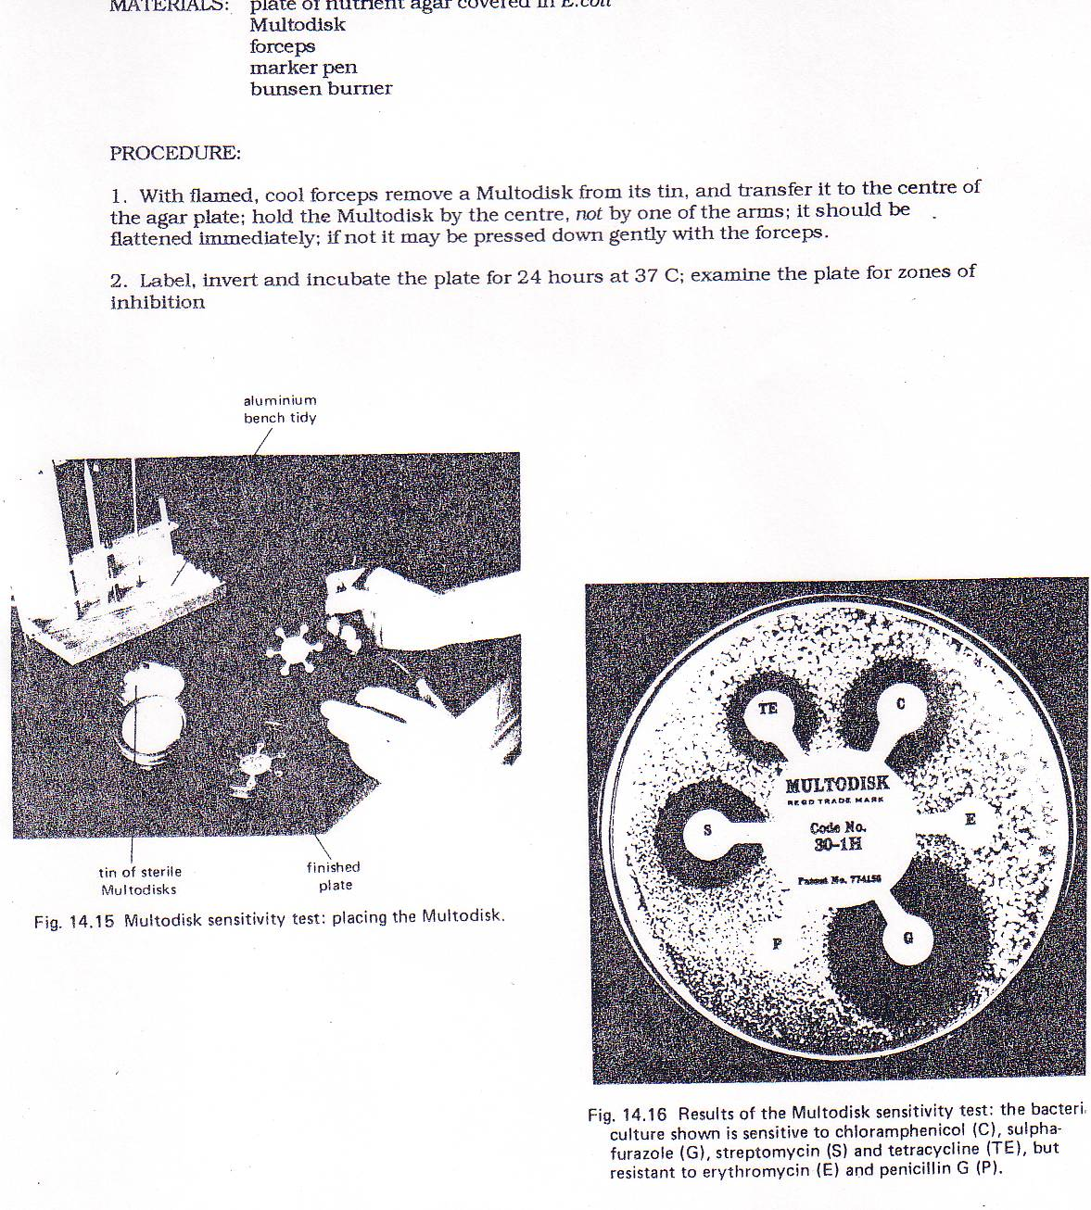

**Placing the antibiotic ring**

1. Take a pair of forceps. Only handle the Multodisk with the forceps.

2. Remove a Multodisk from its tin and transfer it to the centre of the agar plate.

**Do not** hold the disk by one of its arms.

3. Carefully flatten the Multodisk onto the surface of the plate, using the forceps.

Place the forceps into the beaker of disinfectant.

4. Hold the lid of the plate in place with two pieces of tape.

5. Place your plate upside down in an incubator at 25 °C for 48 hours.

6. Now wash your hands.

* **After incubation, Caution - plates must not be opened after they have been incubated**

7. Examine your plate and try to identify the colonies which have not been able to grow near the Multodisk arm(s). These are called zone(s) of inhibition. Turning the plate upside down and using a ruler measure the diameter of the zones of inhibition. Calculate the area of the zone of inhibition using the formula

Area of zone = πr2  (Use 3.14 as )

8. Record your results in a suitable table.

**A-level Biology required practical No. 6**

**Teachers’ Notes**

**Use of aseptic techniques to investigate the effect of antimicrobial substances on microbial growth**

**Aseptic technique producing bacterial plates and use of mast ring of antibiotics**

**Materials**

* Students should work on a surface that has been placed in 1% VirKon for at least 10 minutes before the practical. A laminated piece of paper, plastic sheet or a ceramic/glass tile could be used as the surface and this should be placed in a bowl of VirKon for at least 10 minutes before the activity.
* McCartney bottle containing *Bacillus megaterium* bacteria in nutrient broth
* Bunsen burner
* a beaker containing disinfectant (1% VirKon)
* disinfectant spray
* a prepared agar plate
* paper towels
* a chinagraph pencil or other marker
* a sterile disposable plastic spreader (Alternatively, glass spreaders that have been sterilised with dry heat at 160 °C for 2 hours could be used. The spreaders should have been wrapped before sterilisation, and remain in their wrappings until point of use).
* autoclave tape
* ethanol
* sterile 1 cm3 pipette and filler (glass pipettes can be sterilised with dry heat 160 °C for 2 hours. The pipettes should have been wrapped before sterilisation, and remain in their wrappings until point of use).
* forceps
* Multodisk antibiotic ring.

In this practical students practice aseptic technique to produce a bacterial lawn and then use Multodisk antibiotic ring to see which antibiotics this bacterium is sensitive to.

You must demonstrate the aseptic technique fully to students before they carry out the investigation.

The bacterium used is relatively harmless and grows well. **The bacterial culture must be of a microbe not considered hazardous and must be prepared using very good aseptic technique that will ensure that it has not been contaminated with environmental microbes.**

Other bacteria could be used and other antimicrobial substances could be used to inhibit growth. Sterile filter paper discs can be dipped in suitable substances and placed on the bacterial lawn.

**Technical information**

**Nutrient broth**

13 g nutrient broth powder to 1 dm3 distilled water. Stir well and distribute into McCartney bottles – approximately 10 cm3 per bottle. Sterilise by autoclaving at 121 °C for 15 minutes. Once cooled introduce an inoculating loop of bacteria from a slope and incubate at 30 °C overnight.

**Agar plates**

28 g nutrient agar powder to 1 dm3 distilled water in a large beaker. Heat in the microwave until it boils and looks completely transparent (this can be done on a hot plate). Pour into medical flat bottles and sterilise by autoclaving at 121 °C for 15 minutes. Allow to cool to 50 °C for pouring into sterile Petri dishes, using aseptic technique. One medical flat bottle will make about 5 agar plates.

If the agar solidifies before being poured, melt it again by putting the bottles in a pan of water and bringing it to the boil. Agar will melt again at about 90 °C.

The agar plates will keep for several weeks if wrapped in cling film and stored upside down.

* Broths and agar plates must be disposed of by sterilisation after use **with steam at 121 °C for 15 minutes** before disposal.
* The plastic surface should be replaced in 1% VirKon after the activity.
* All pipettes used should be placed in 1% VirKon after use.

**Risk assessment**

Risk assessment and risk management are the responsibility of the centre.

**Trialling**

The practical should be trialled before use with students.

**PRACTICAL 7**

|  |  |  |  |  |  |
| --- | --- | --- | --- | --- | --- |
| **Required practical** | | **Use of chromatography to investigate the pigments isolated from leaves of different plants e.g. leaves from shade-tolerant and shade intolerant plants or leaves of different colours** | | | |
| **Apparatus and techniques covered**  (Not full statements) | | c. use laboratory glassware apparatus for a variety of experimental techniques  g. separate biological compounds using thin layer/paper chromatography | | | |
| **Indicative apparatus** | | Suitable leaves, chromatography paper (or TLC sheets), suitable solvent, glass rod, boiling tube and bung. | | | |
|  | **Amount of choice**  **Increasing independence** | | | | |
|  | Least choice | | Some choice | Many choices | Full investigation |
| Teacher chooses the type of leaf and solvent to be used. Students set up chromatograms using extracts from the leaves. Students measure Rf values for pigments from each leaf. Experiments fully specified in terms of equipment and method. | | Teacher allows a limited choice of type of leaf to use. Students set up chromatograms using extracts from the leaves. Students measure Rf values for pigments from each leaf. Experiment probably fully specified by teacher. | Teacher allows a choice of type of leaf to use and a choice of solvents.  Students set up chromatograms using extracts from the chosen leaves, using chosen solvent. Students measure Rf values for pigments from each leaf.  Outline procedure and equipment provided by teacher. | Student decides on a question.  Student researches methods for carrying out the experiment then chooses equipment, materials, justifying all choices. |
| **Opportunities for observation and assessment of competencies** | | | | | |
| Follow written procedures | **🗸🗸🗸** Students follow written method. | | **🗸🗸🗸** Students follow written method. | **🗸🗸** Students follow an outline method. | **🗸🗸🗸** Students follow a method they have researched. |
| Applies investigative approaches and methods when using instruments and equipment | **🗸** Students must correctly use the appropriate equipment. | | **🗸**Students must correctly use the appropriate equipment. | **🗸🗸** Students must correctly use the appropriate equipment. | **🗸🗸🗸** Students must choose an appropriate approach, equipment and techniques and identify correct variables for measurement and control. |
| Safely uses a range of practical equipment and materials | **🗸🗸** Students must safely use the equipment. | | **🗸🗸** Students must safely use the equipment. | **🗸🗸** Students minimise risks with minimal prompting. | **🗸🗸🗸** Students must carry out a full risk assessment and minimise risks. |
| Makes and records observations | **🗸** Students make measurements to calculate Rf values. | | **🗸** Students make measurements to calculate Rf values. | **🗸** Students make measurements to calculate Rf values. | **🗸🗸🗸** Students must choose the most effective way of recording observations. |
| Researches, references and reports | **🗸** Students compare results with published Rf values for that solvent and identify reasons for differences. | | **🗸🗸** Students compare results with published Rf for that solvent values and between students and identify reasons for differences. | **🗸🗸** Students compare results with published Rf values for that solvent and between students and identify reasons for differences. | **🗸🗸🗸** Students must research alternatives in order to plan their work. Reporting covers the planning, carrying out and an analysis of their results using comparisons with published Rf values. |

🗸🗸🗸: Very good opportunity 🗸🗸: Good opportunity 🗸: Slight opportunity 🗶: No opportunity

**A-level Biology required practical No. 7**

**Student Sheet**

**Use of chromatography to investigate the pigments isolated from leaves of different plants eg leaves from shade-tolerant and shade intolerant plants or leaves of different colours**

**An Investigation of pigments present in leaves**

**Introduction**

In plants, chlorophyll is the main pigment that absorbs light energy during photosynthesis. Most plants have other photosynthetic pigments as well and these are not green. You will be using a technique called chromatography to separate chlorophyll and other pigments from two different leaves, A and B.

**Method**

You are provided with the following:

* boiling-tube rack
* two boiling tubes with bungs
* small glass measuring cylinder
* solvent
* chromatography paper
* glass rod
* two leaves, A and B
* cork borer
* tile on which to use cork borer
* ruler
* pencil
* drawing pins
* marker pen
* sticky tape.

**Safety**

Wear eye protection and work in a well-ventilated room or fume cupboard.

You should read these instructions carefully before you start work.

1. Set up two boiling tubes at the start of the investigation. Add 3 cm3 of solvent to each of the two boiling tubes. Put a bung in the top of each tube and stand them upright in a rack. Label the tubes A and B.
2. Take a piece of chromatography paper that fits into the boiling tube, as shown in the diagram. Rule a pencil line 2 cm from the bottom of the filter paper. This line is called the origin. Write leaf A at the top of the chromatography paper in pencil.
3. Cut a disc from leaf A with a cork borer. Try to avoid the veins and midrib of the leaf when you do this.
4. Place the leaf disc on the chromatography paper at the centre of the line marking the origin. Crush the disc into the paper with the end of a glass rod. The crushed leaf disc should leave a stain on the chromatography paper.
5. Pin the chromatography paper to the bung with a drawing pin, and then put the chromatography paper into the tube labelled A as shown in **Figure 1**. Make sure the end of the chromatography paper is in the solvent and that the solvent does not come above the origin. Put the tube carefully back into the rack and do not move it again.

**Figure 1**

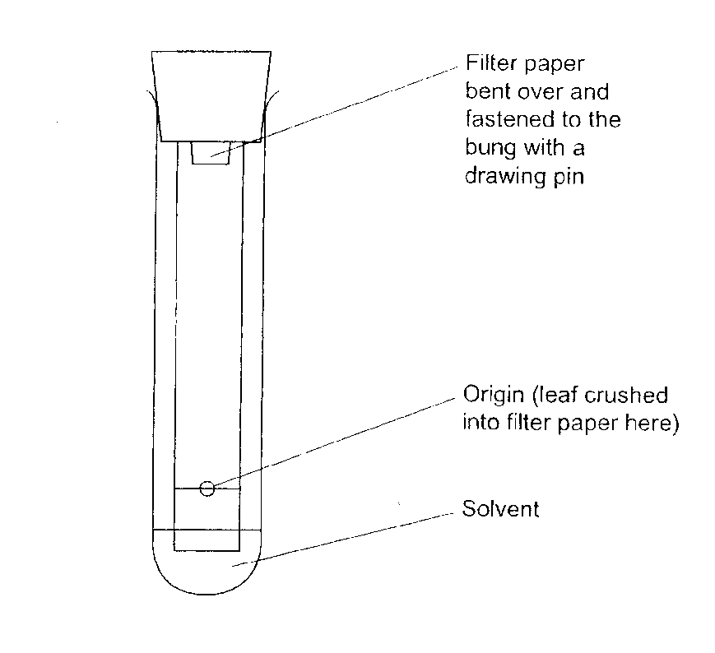

1. Let the solvent run up the chromatography paper until it almost reaches the top of the paper. Remove the chromatography paper from the tube and immediately draw a pencil line to show how far the solvent moved up the paper. This line marks the solvent front.
2. Replace the bung in the tube.
3. The filter paper with its coloured spots is called a chromatogram. Let the chromatogram dry. Using a pencil, draw round each coloured spot on the chromatogram.
4. Repeat step 2 with the second piece of paper but write B at the top of the chromatography paper.
5. Repeat steps 3–8 with leaf B.

Calculate the Rf value for each of the pigment spots on each chromatogram.

Rf value = Distance moved by pigment from origin to centre of pigment spot

Distance from origin to solvent front

**A-level Biology required practical No. 7**

**Teachers’ Notes (this investigation is based on BIO6T/P12)**

**Use of chromatography to investigate the pigments isolated from leaves of different plants eg leaves from shade-tolerant and shade intolerant plants or leaves of different colours**

**An Investigation of pigments present in leaves**

**Materials**

Each student needs:

* boiling-tube rack
* two boiling tubes with bungs
* 10 cm3 glass measuring cylinder
* 10 cm3 solvent
* chromatography paper cut to size to fit the boiling tubes as shown in the diagram. The paper must not touch the sides of the tube. Good quality filter paper can be used but chromatography paper gives better results.
* glass rod to crush leaf tissue into the paper
* two leaves, A and B. These can be different colours or from shade-tolerant and shade-intolerant plants. Autumn leaves can be used to give different colours. The best results come from leaves with a thin cuticle.
* cork borer – or a hole punch could be used to produce the leaf discs
* tile on which to use cork borer
* ruler with millimetre measurements
* pencil
* drawing pins
* marker pen
* sticky tape.

**Technical information**

**Solvent**: Propanone: petroleum ether (b.p. 100–120 °C) in ratio of 1:9. This should be supplied to students in a stoppered bottle and labelled ‘Solvent’.

* Hazcard 85A relates to propanone, highly flammable and causes serious eye irritation (may cause drowsiness).
* Hazcard 45A relates to Petroleum sprit, highly flammable, dangerous to the environment.
* Ensure good ventilation in laboratory, no naked flames and wear eye protection. For disposal see Hazcards.

The method given is simple and works well. It avoids the need to grind leaves to extract pigment.

You may want to consider thin layer chromatography instead (CLEAPSS video, <https://www.youtube.com/watch?v=1ZSgwonXhkU>). The safety issues with thin layer chromatography are considerably less due to the much smaller scale.

The chromatograms will fade very quickly, particularly in the light. It is advisable to mark the spots immediately to calculate the Rf values.

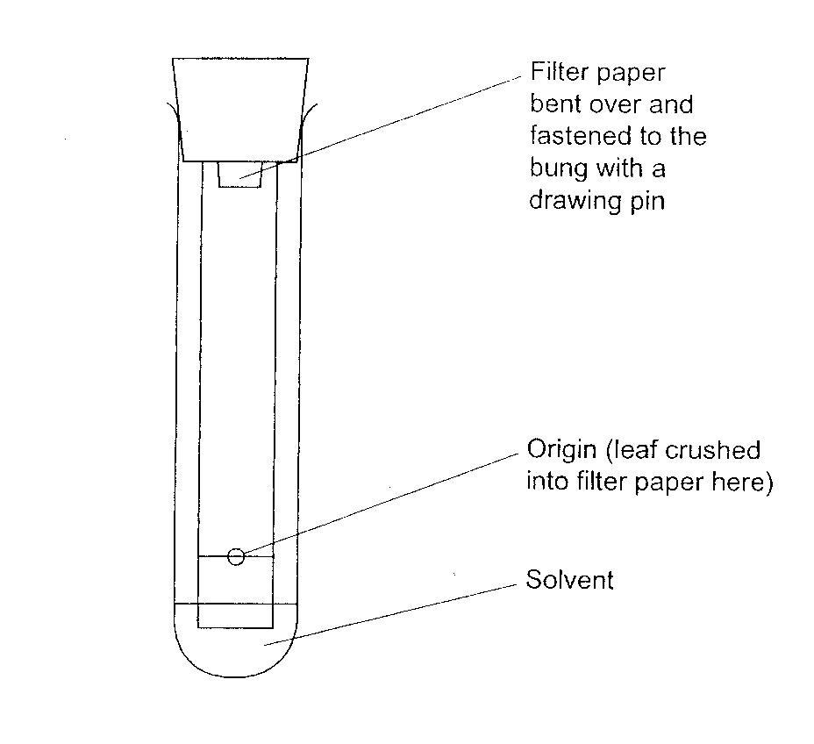

**Risk assessment**

Risk assessment and risk management are the responsibility of the centre.

**Trialling**

The practical should be trialled before use with students.

**PRACTICAL 8**

|  |  |  |  |  |  |
| --- | --- | --- | --- | --- | --- |
| **Required practical** | | **Investigation into the effect of a named factor on the rate of dehydrogenase activity in extracts of chloroplasts** | | | |
| **Apparatus and techniques covered**  (Not full statements) | | a. use appropriate apparatus to record a range of quantitative measurements  b. use appropriate instrumentation to record quantitative measurements, such as colorimeter  c. use laboratory glassware apparatus for a variety of experimental techniques | | | |
| **Indicative apparatus** | | Spinach leaves, blender, ice, isolation medium, DCPIP, beakers, test tubes, lamp, aluminium foil, timer, colorimeter, cuvettes. | | | |
|  | **Amount of choice**  **Increasing independence** | | | | |
|  | Least choice | | Some choice | Many choices | Full investigation |
| Teacher chooses the factor to be varied. Students vary the factor and measure hydrogenase activity using DCPIP colour change. Experiments fully specified in terms of equipment and method. | | Teacher allows a limited choice of factors to be varied. Students vary the factor and measure hydrogenase activity using DCPIP colour change. Experiment probably fully specified by teacher. | Teacher allows a choice of factors to be varied and methods of measuring hydrogenase activity.  Students have a number of experimental procedures to choose from, and then follow that procedure. | Student decides on a question.  Student researches methods for carrying out the experiment then chooses equipment, materials, justifying all choices. |
| **Opportunities for observation and assessment of competencies** | | | | | |
| Follow written procedures | **🗸🗸🗸** Students follow written method. | | **🗸🗸🗸** Students follow written method. | **🗸🗸🗸** Students follow a method they have chosen. | **🗸🗸🗸** Students follow a method they have researched. |
| Applies investigative approaches and methods when using instruments and equipment | **🗸🗸** Students must correctly use the appropriate equipment. | | **🗸🗸**Students must correctly use the appropriate equipment. | **🗸🗸🗸** Students must correctly use the appropriate equipment. | **🗸🗸🗸** Students must choose an appropriate approach, equipment and techniques and identify correct variables for measurement and control. |
| Safely uses a range of practical equipment and materials | **🗸🗸** Students must safely use the equipment. | | **🗸 🗸**Students must safely use the equipment. | **🗸🗸 🗸**Students minimise risks with minimal prompting. | **🗸🗸🗸** Students must carry out a full risk assessment and minimise risks. |
| Makes and records observations | **🗸** Students record observations in specified ways. | | **🗸** Students record observations in specified ways. | **🗸🗸** Students record observations in specified ways. | **🗸🗸🗸** Students must choose the most effective way of recording observations. |
| Researches, references and reports | **🗸** Students compare results with ideal and identify reasons for differences. | | **🗸🗸** Students compare results with ideal and between students and identify reasons for differences. | **🗸🗸** Students compare results with ideal and between students and identify reasons for differences. | **🗸🗸🗸** Students must research alternatives in order to plan their work. Reporting covers the planning, carrying out and an analysis of their results. |

🗸🗸🗸: Very good opportunity 🗸🗸: Good opportunity 🗸: Slight opportunity 🗶: No opportunity

**A-level Biology required practical No. 8**

**Student Sheet**

**Investigation into the effect of a named factor on the rate of dehydrogenase activity in extracts of chloroplasts**

**The effect of ammonium hydroxide on the time taken for chloroplasts to decolourise DCPIP**

In this investigation you will use a chloroplast suspension and a blue dye called DCPIP to monitor the rate of dehydrogenase activity. DCPIP goes from blue to colourless when it accepts electrons released by the chlorophyll.

**Method**

You are provided with the following:

* spinach leaves
* access to a blender
* measuring cylinder
* muslin (or material for filtering)
* filter funnel
* 3 beakers
* ice
* isolation medium (cold)
* DCPIP solution (cold)
* distilled water (cold)
* ammonium hydroxide solution (cold)
* test tubes
* test-tube rack
* syringes (1cm3 and 5 cm3 )
* piece of aluminium foil
* lamp
* marker pen
* timer.

You should read these instructions carefully before you start work.

1. Put about 50 cm3 of isolation medium into a beaker.
2. Tear 8 spinach leaves into small pieces and put the pieces into the isolation medium in the beaker. Do not put pieces of the midrib or the leaf stalk into the beaker.
3. Half fill a large beaker with ice and place a small beaker on top of the ice.
4. Put 3 layers of muslin over the top of the filter funnel and wet it with the isolation medium. Rest the filter funnel in the small beaker on the ice.
5. Pour the spinach and isolation medium into the blender and blend for about 15 seconds. Pour the blended mixture back into the beaker.
6. Pour a little of your blended mixture through the muslin in the filter funnel. Carefully fold and squeeze the muslin to assist the filtering process. Repeat until most of the blended mixture has been filtered. Label this filtrate which is in the small beaker on ice as ‘chloroplast suspension’.
7. Label five test tubes A, B, C, X and Y. Stand these five tubes in the ice in the large beaker. Position the lamp about 10 cm from the beaker so that all tubes are illuminated. Turn on the lamp.
8. Set up tubes A and B as follows:

**Tube A**

Put 5 cm3 DCPIP solution + 1 cm3 water + 1 cm3 chloroplast suspension in the tube. Immediately wrap the tube completely in aluminium foil to exclude light.

**Tube B**

Put 5 cm3 DCPIP solution + 1 cm3 water + 1 cm3 isolation medium in the tube.

Tubes A and B are control experiments. Leave both tubes until the end of your investigation.

1. Set up tube C as follows:

**Tube C**

Put 6 cm3 water + 1 cm3 chloroplast suspension in the tube.

Tube C is for you to use as a standard to help you to determine when any colour change is complete.

1. Set up tube X as follows:

**Tube X**

Put 5 cm3 DCPIP solution + 1 cm3 water in the tube.

Add 1 cm3 chloroplast suspension to tube X, quickly mix the contents and start the timer. Record in seconds how long it takes for the contents of tube X to change colour from blue-green to green. This is when all signs of blue have disappeared. Use tube C to help you determine when the colour change is complete.

1. Repeat step 10 four more times.
2. Set up tube Y as follows:

**Tube Y**

Put 5 cm3 DCPIP solution + 1 cm3 ammonium hydroxide in the tube.

Add 1 cm3 chloroplast suspension to tube Y, quickly mix the contents and start the timer. Record in seconds how long it takes for the contents of tube Y to change colour from blue-green to green. This is when all signs of blue have disappeared. Use tube C to help you determine when the colour change is complete. However if this has not taken place within 300 seconds (5 minutes), record the colour at this point.

1. Repeat step 12 four more times.
2. Record your data in a suitable table.
3. At the end of your investigation, record the colour of the mixtures in tubes A and B.

**A-level Biology required practical No. 8**

**Teachers’ Notes (this investigation is based on BIO6T/P11)**

**Investigation into the effect of a named factor on the rate of dehydrogenase activity in extracts of chloroplasts**

**The effect of ammonium hydroxide on the time taken for chloroplasts to decolourise DCPIP**

This investigation uses ammonium hydroxide as the named factor as it is readily available and can be used to mimic the effect of weed killer.

**Materials**

In addition to general laboratory apparatus each student needs:

* 8 spinach leaves
* access to a blender
* measuring cylinder (50 cm3 or 100 cm3)
* muslin (or material for filtering J-cloth style dishcloths are suitable)
* filter funnel
* 3 beakers (1 large, 2 small)
* ice – to half fill the large beaker
* isolation medium (cold)
* DCPIP solution (cold)
* distilled water (cold)
* ammonium hydroxide solution (cold) (1.0 mol dm–3)
* test tubes
* test-tube rack
* syringes (4 × 1 cm3 and 2 × 5 cm3 )
* piece of aluminium foil large enough to completely wrap test tube
* lamp
* marker pen
* timer.

**Technical information**

**Spinach leaves** – these should be left in the light for a few hours before the investigation begins, but do not allow the leaves to get too hot.

**Phosphate buffer solution (per 500 cm3)**

Dissolve 4.48 g Na2HPO4.12H2O and 1.7 g KH2PO4 in 500 cm3 distilled water.

Keep cool until required.

**Isolation medium (per 250 cm3)**

Dissolve 34.23 g sucrose and 0.19 g KCl in phosphate buffer solution and make up to 250cm3 with phosphate buffer solution. Keep cool until required.

**DCPIP solution** **(per 250 cm3)**

Dissolve 0.01 g DCPIP and 0.93 g KCl in phosphate buffer solution and make up to 250 cm3 with phosphate buffer solution. Keep cool until required.

**Ammonium hydroxide solution (1.0 mol dm–3)**

Keep cool until required.

The method given does not use a colorimeter and requires students to use a standard to compare colour by eye. Better results will be achieved using a colorimeter as the changes are difficult to see.

To use a colorimeter the following changes need to be made at certain steps:

1. Set up tube C as follows:

**Tube C**

Put 6 cm3 water + 1 cm3 chloroplast suspension in the tube.

Tube C is for you to use as a standard.

Set up the colorimeter and use the mixture in tube C to set the absorbance to zero.

1. Set up tube X as follows:

**Tube X**

Put 5 cm3 DCPIP solution + 1 cm3 water in the tube.

Add 1 cm3 chloroplast suspension to tube X, quickly mix the contents and start the timer. After exactly 2 minutes measure the absorbance of the mixture in the colorimeter.

1. Repeat step 10 four more times.
2. Set up tube Y as follows:

**Tube Y**

Put 5 cm3 DCPIP solution + 1 cm3 ammonium hydroxide in the tube.

Add 1 cm3 chloroplast suspension to tube Y, quickly mix the contents and start the timer. After exactly 2 minutes measure the absorbance of the mixture in the colorimeter.

1. Repeat step 12 four more times.

If a colour change is not detected in the time scale suggested then the DCPIP can be diluted further or the time can be increased.

**Risk assessment**

Risk assessment and risk management are the responsibility of the centre.

**Trialling**

The practical should be trialled before use with students.

**Additional information**

* Take care with use of mercury containing light bulbs. Consult CLEAPSS guidance if breakages occur.
* Take care with the very bright lights (>1000 lumens) needed for this practical to work. The light will not damage the retina, but the long lasting afterimage can worry. Students should be cautioned not to look directly at the light.
* Take care with water next to electrical connections.

**PRACTICAL 9**

|  |  |  |  |  |  |
| --- | --- | --- | --- | --- | --- |
| **Required practical** | | **Investigation into the effect of a named variable on the rate of respiration of cultures of single-celled organisms** | | | |
| **Apparatus and techniques covered**  (Not full statements) | | a. use appropriate apparatus to record a range of quantitative measurements  b. use appropriate instrumentation to record quantitative measurements  c. use laboratory glassware apparatus for a variety of experimental techniques  i. use microbiological aseptic techniques | | | |
| **Indicative apparatus** | | Yeast suspension, glucose solution, methylene blue indicator solution, test tubes, graduated pipettes and fillers, water bath, timer (or could measure volume of gas given off using a manometer). | | | |
|  | **Amount of choice**  **Increasing independence** | | | | |
|  | Least choice | | Some choice | Many choices | Full investigation |
| Teacher chooses the organism and the factor to be varied. Students vary the factor and measure the rate of respiration. Experiments fully specified in terms of equipment and method. | | Teacher allows a limited choice of factors to be varied. Students vary the factor and measure the rate of respiration. Experiment probably fully specified by teacher. | Teacher allows a choice of factor.  Students have a number of experimental procedures to choose from, and then follow that procedure. | Student decides on a question.  Student researches methods for carrying out the experiment then chooses equipment, materials, justifying all choices. |
| **Opportunities for observation and assessment of competencies** | | | | | |
| Follow written procedures | **🗸🗸🗸** Students follow written method. | | **🗸🗸🗸** Students follow written method. | **🗸🗸🗸** Students follow a method they have chosen. | **🗸🗸🗸** Students follow a method they have researched. |
| Applies investigative approaches and methods when using instruments and equipment | **🗸** Students must correctly use the appropriate equipment. | | **🗸**Students must correctly use the appropriate equipment. | **🗸🗸** Students must correctly use the appropriate equipment. | **🗸🗸🗸** Students must choose an appropriate approach, equipment and techniques and identify correct variables for measurement and control. |
| Safely uses a range of practical equipment and materials | **🗸** Students must safely use the equipment. | | **🗸** Students must safely use the equipment. | **🗸🗸** Students minimise risks with minimal prompting. | **🗸🗸🗸** Students must carry out a full risk assessment and minimise risks. |
| Makes and records observations | **🗸** Students record measurements in specified ways and calculate rate of respiration. | | **🗸** Students record measurements in specified ways and calculate rate of respiration. | **🗸** Students record measurements in specified ways and calculate rate of respiration. | **🗸🗸🗸** Students must choose the most effective way of recording measurements and calculating rate of respiration. |
| Researches, references and reports | **🗸** Students compare results between students and identify reasons for differences. | | **🗸🗸** Students compare results between students and identify reasons for differences. | **🗸🗸** Students compare results with ideal and between students and identify reasons for differences. | **🗸🗸🗸** Students must research alternatives in order to plan their work. Reporting covers the planning, carrying out and an analysis of their results. |

🗸🗸🗸: Very good opportunity 🗸🗸: Good opportunity 🗸: Slight opportunity 🗶: No opportunity

**A-level Biology required practical No. 9**

**Student Sheet**

**Investigation into the effect of a named variable on the rate of respiration of cultures of**

**An investigation of the effect of temperature on respiration in yeast**

Yeast is a single-celled fungus. It can respire aerobically and anaerobically. During aerobic respiration, the transport of electrons is linked to the synthesis of ATP. In this investigation these electrons will be accepted by a substance called methylene blue. When methylene blue accepts electrons, it changes from blue to colourless.

**Method**

You are provided with the following:

* yeast and glucose mixture
* methylene blue
* test tubes
* test-tube rack
* beaker to act as water bath
* a way of changing the temperature of the water bath
* graduated pipettes or syringes
* marker pen
* thermometer
* timer.

You should read these instructions carefully before you start your investigation.

1. Use the beaker to set up a water bath at 35 °C.
2. Label five test tubes 1 to 5.
3. Shake the yeast and glucose mixture.
4. Add 2 cm3 of the yeast and glucose mixture to all five tubes.
5. Place all five tubes in the water bath and leave them until the contents reach 35 °C. Make sure the water bath stays at 35 °C
6. Add 2 cm3 methylene blue to test tube 1.
7. Immediately shake this tube for 10 seconds and replace the tube in the water bath. Note the time and do not shake this tube again.
8. Record how long it takes for the blue colour to disappear in the tube.
9. Repeat steps 6 to 8 for the other four tubes.
10. Your teacher will tell you which other temperatures to use. Repeat steps 1 to 9 at each temperature.

**A-level Biology required practical No. 9**

**Teachers’ Notes (this investigation is based on BIO6T/Q12)**

**Investigation into the effect of a named variable on the rate of respiration of cultures of single-celled organisms**

**An investigation of the effect of temperature on respiration in yeast**

**Materials**

* yeast and glucose mixture
* methylene blue
* test tubes
* test-tube rack
* beaker to act as water bath
* a way of changing the temperature of the water bath eg Bunsen burner or supplies of hot or cold water. The experiment needs to be in a glass beaker so colour change can be observed so an electric water bath is not really suitable.
* 2 cm3 graduated pipettes or syringes
* marker pen
* thermometer
* timer.

**Technical information**

Make up a solution of 1 g glucose in 100 cm3 water. Just before use, raise the temperature of this solution to 30 °C and add 5 g dried yeast. Shake to suspend the yeast in the glucose solution. Use an open-topped flask or beaker as bubbling will occur (if bubbling does not occur, check that the yeast used is not old).

**Methylene blue solution**

Make a stock solution of 1 g methylene blue and 0.6 g sodium chloride dissolved in 100 cm3 water.

For the solution to be used in the investigation, take 0.1 cm3 of the stock solution and add it to

100 cm3 water.

Decolourisation of the methylene blue should occur within approximately 5 minutes when the experiment is conducted at 35°C. If it is taking longer than this the methylene blue solution can be diluted further.

**Risk assessment**

Risk assessment and risk management are the responsibility of the centre.

**Trialling**

The practical should be trialled before use with students.

* It is advised to trial this experiment using the batch of yeast and methylene blue that will be used by students as yeast can vary considerably. Trials need to establish the safest range of temperatures that is effective. It is not necessary to use very high temperatures to get results as it is not the aim of the experiment to find the optimum temperature.

This method for investigating rate of respiration in single celled organisms is simple and needs little apparatus. Rate of anaerobic respiration can be investigated using a respirometer if this apparatus is available.

**PRACTICAL 10**

|  |  |  |  |  |  |
| --- | --- | --- | --- | --- | --- |
| **Required practical** | | **Investigation into the effect of an environmental variable on the movement of an animal using either a choice chamber or a maze** | | | |
| **Apparatus and techniques covered**  (Not full statements) | | h. safely and ethically use organisms to measure animal responses. | | | |
| **Indicative apparatus** | | Maggots or woodlice, paper maze or choice chamber, anhydrous calcium chloride, black paper, bench lamp. | | | |
|  | **Amount of choice**  **Increasing independence** | | | | |
|  | Least choice | | Some choice | Many choices | Full investigation |
| Teacher chooses the animal and the environmental variable. Students control the variable and observe the behaviour. Experiments fully specified in terms of equipment and method. | | Teacher allows a limited choice of environmental variable. Students control the variable and observe the behaviour. Experiment probably fully specified by teacher. | Teacher allows a choice of environmental variable and method of observing behaviour.  Students have a number of experimental procedures to choose from, and then follow that procedure. | Student decides on a question.  Student researches methods for carrying out the experiment then chooses equipment and materials, justifying all choices. |
| **Opportunities for observation and assessment of competencies** | | | | | |
| Follow written procedures | **🗸🗸🗸** Students follow written method. | | **🗸🗸🗸** Students follow written method. | **🗸🗸🗸** Students follow a method they have chosen. | **🗸🗸🗸** Students follow a method they have researched. |
| Applies investigative approaches and methods when using instruments and equipment | **🗸** Students must correctly use the appropriate equipment. | | **🗸**Students must correctly use the appropriate equipment. | **🗸🗸** Students must correctly use the appropriate equipment. | **🗸🗸🗸** Students must choose an appropriate approach, equipment and techniques and identify correct variables for measurement and control. |
| Safely uses a range of practical equipment and materials | **🗸** Students must safely use the equipment and treat animals ethically. | | **🗸** Students must safely use the equipment and treat animals ethically. | **🗸🗸** Students minimise risks with minimal prompting and treat animals ethically. | **🗸🗸🗸** Students must carry out a full risk assessment to minimise risks and treat animals ethically. |
| Makes and records observations | **🗸** Students record observations in specified ways. | | **🗸** Students record observations in specified ways. | **🗸** Students record observations in specified ways. | **🗸🗸🗸** Students must choose the most effective way of recording observations. |
| Researches, references and reports | **🗸** Students compare results between students and identify reasons for differences. | | **🗸🗸** Students compare results between students and identify reasons for differences. | **🗸🗸** Students compare results with ideal and between students and identify reasons for differences. | **🗸🗸🗸** Students must research alternatives in order to plan their work. Reporting covers the planning, carrying out and an analysis of their results. |

🗸🗸🗸: Very good opportunity 🗸🗸: Good opportunity 🗸: Slight opportunity 🗶: No opportunity

**A-level Biology required practical No. 10**

**Student Sheet**

**Investigation into the effect of an environmental variable on the movement of an animal using either a choice chamber or a maze**

**Using choice chambers to investigate responses in invertebrates to light/dark and humid/dry conditions**

**Method**

You are provided with the following:

* a choice chamber with nylon mesh fabric
* silica gel
* humidity test strips (cobalt chloride strips which have been dried – blue when dry and pink when moist)
* paper towels
* water
* black paper
* Sellotape
* maggots (or woodlice)
* beaker
* teaspoon
* forceps.



**Control experiment**

1. Set up the choice chamber with nothing in the base quarters.
2. Place 12 maggots in the chamber through the central hole, using the teaspoon.
3. Wait 4 minutes then record the number of maggots in the left and right halves of the choice chamber. Record your results.

If the left and right halves have no effect on the distribution of the maggots the expected results would be six in each half, but this will not always occur because of chance distribution. If your results are not 6 in each half do a statistical test on your results to discover the probability of them occurring by chance. If this test shows a greater than 5% probability of the results occurring by chance then you can proceed with the experiment.

**The effect of light**

1. Cover half the choice chamber with black paper to make it dark.
2. Place 12 maggots in the chamber through the central hole, using the teaspoon.
3. Wait 4 minutes and then record the number of maggots in the dark and the light halves.

If light has no effect on the distribution of maggots the expected results would be six in each half. Now do a statistical test on your results to find the probability of them occurring by chance.

**The effect of humidity**

1. Place damp paper towel in one half of the choice chamber and silica gel in the other. Use the humidity test strips to ensure that a humidity gradient exists in the chamber before adding the maggots. Use the forceps to place the humidity test strip.
2. Place 12 maggots in the chamber through the central hole.
3. Wait 4 minutes and then record the number of maggots in the humid and the dry halves.

**The effect of light and humidity**

In reality living organisms do not have simple choices between one pair of contrasting environmental factors. If you have time do a final experiment with the choice between dark and dry, dark and humid, light and dry, light and humid. Again test the probability of your results occurring by chance with a statistical test.

**Alternative practical using a maze**

**Turning behaviour in maggots**

You are provided with the following:

* a maze printed on card
* scissors
* glue
* maggots
* cotton wool buds
* a plastic teaspoon.

You should read these instructions carefully before you start work.

1. Cut out pieces **A**, **B** and **C** from the card by cutting along all the solid lines.
2. Fold along the dashed and dotted lines, keeping dashes on the inside and dots on the outside.
3. Glue the tabs to form the maze shown in **Figure 1**.

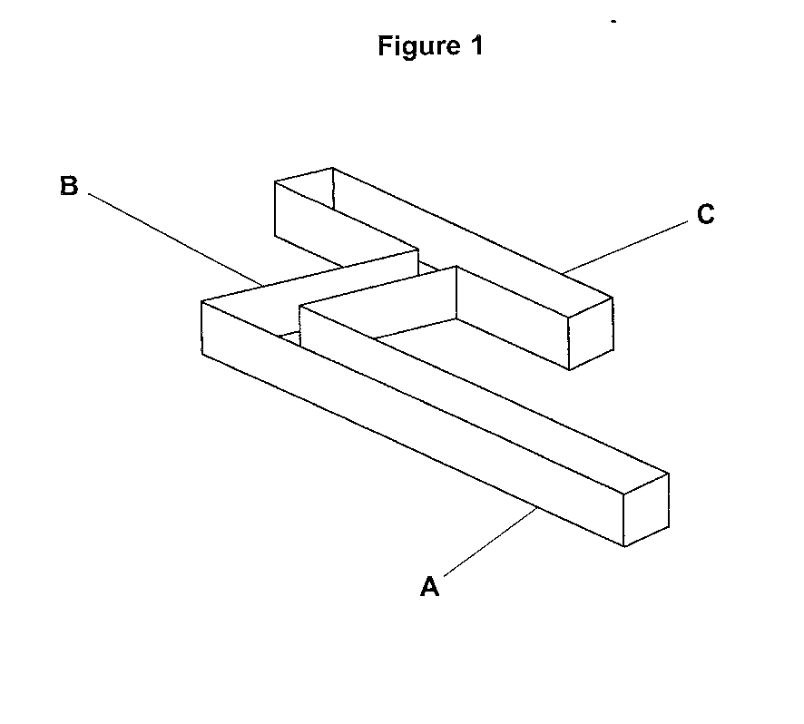

1. Cut out the barrier (piece **D**) and place it at the position shown in **Figure 2**.

**Figure 2**



1. Place a maggot at point X using the plastic teaspoon.
2. Record in a table whether the maggot turns left or right when it reaches the junction at Y.
3. Remove the maggot from the maze.
4. Wipe the inside of the maze with a cotton wool bud.
5. Repeat steps 5 to 8 until you have results for 10 maggots.
6. If a maggot stops moving, remove it from the maze and carry out another trial.

This experiment should give equal numbers turning left and right. This section of the maze could be used to investigate the effect of variables such as light by covering one side of the maze with black paper and then the other.

**Turn alternation in maggots**

Many animals show behaviour called turn alternation. This means if the animal is forced to turn in

one direction it is more likely to turn in the opposite direction next time it has a choice. The maze can be uses to allow you to investigate whether maggots show turn alternation.

1. Use the maze you made in Task 1, with barrier **D** removed.



1. Place a maggot at point Z in the maze.
2. Record whether the maggot turns left or right when it reaches the junction at Y.
3. Repeat steps 2 and 3 until another 9 times.
4. Record your data in a suitable table.

**A-level Biology required practical No. 10**

**Teachers’ Notes**

**Investigation into the effect of an environmental variable on the movement of an animal using either a choice chamber or a maze**

**Using choice chambers to investigate responses in invertebrates to light/dark and humid/dry conditions**

**Materials**

In addition to general laboratory equipment each student needs:

* a choice chamber with nylon mesh fabric
* silica gel or calcium chloride (dehydrating agent)
* humidity test strips (cobalt chloride strips which have been dried – blue when dry and pink when moist)
* paper towels
* water
* black paper and scissors to cut to shape.
* Sellotape
* maggots (or woodlice)
* beaker to hold maggots or woodlice
* teaspoon.

A simple experiment if choice chambers are available. Care should be taken that the damp paper towel does not touch the nylon mesh fabric.

**Alternative practical using a maze (based on BIO6X 2011)**

**Turning behaviour in maggots**

**Materials**

* a maze printed on card
* scissors
* glue
* maggots
* cotton wool buds
* a plastic teaspoon.

Diagram taken from BIO6X 2011



**Risk assessment**

Risk assessment and risk management are the responsibility of the centre.

**Trialling**

The practical should be trialled before use with students.

**Additional notes**

The Bluebottle adult flies hatching from the maggots are classed as statutory nuisance animals by DEFRA (listed in document “Nuisance Insects and Climate Change” March 2009). The maggots should therefore be killed (eg by placing in a freezer for a week) before wrapping securely and placing in a bin collected directly by refuse collectors. Animals that have been used in experimental work are regarded as animal by-products and as such should not enter the food chain. For disposal, the flies should be killed as described above, and placed in the normal refuse.

See Hazcard 25 for cobalt chloride papers, and found in self-indicating silica gel, causes skin sensitisation. The chemical is also potentially carcinogenic by inhalation. Students should use forceps to place the cobalt chloride paper in the choice chamber. Students should not directly handle the papers or self-indicating silica gel.

**PRACTICAL 11**

|  |  |  |  |  |  |
| --- | --- | --- | --- | --- | --- |
| **Required practical** | | **Production of a dilution series of a glucose solution and use of colorimetric techniques to produce a calibration curve with which to identify the concentration of glucose in an unknown ‘urine’ sample** | | | |
| **Apparatus and techniques covered**  (Not full statements) | | b. use appropriate instrumentation to record quantitative measurements, such as a colorimeter  c. use laboratory glassware apparatus for a variety of experimental techniques to include serial dilutions  f. use qualitative reagents to identify biological molecules | | | |
| **Indicative apparatus** | | glucose solution, distilled water, Clinistix, Benedicts solution, graduated pipettes and fillers, test tubes, water bath, colorimeter and cuvettes | | | |
|  | **Amount of choice**  **Increasing independence** | | | | |
|  | Least choice | | Some choice | Many choices | Full investigation |
| Teacher chooses the concentration of standard glucose solution and values for serial dilution. Volumes of glucose solution and water are given for serial dilution. Students produce dilutions and after reacting with Benedict’s reagent produce a calibration curve. Unknown ‘urine’ sample is reacted with Benedict’s reagent and the value of glucose concentration is read from the calibration curve. Experiments fully specified in terms of equipment and method. | | Teacher provides concentration of standard glucose solution but students decide on values for serial dilution. Students produce dilutions and after reacting with Benedict’s reagent produce a calibration curve. Unknown ‘urine’ sample is reacted with Benedict’s reagent and the value of glucose concentration is read from the calibration curve.  Experiment probably fully specified by teacher. | Student decides on range of glucose concentrations for calibration curve.  Students produce dilutions and after reacting with Benedict’s reagent produce a calibration curve. Unknown ‘urine’ sample is reacted with Benedict’s reagent and the value of glucose concentration is read from the calibration curve.  Teacher provides outline method only. | Student is presented with the urine of suspected diabetic.  Student researches methods for finding out the concentration of glucose in the urine, then chooses equipment and materials, justifying all choices. |
| **Opportunities for observation and assessment of competencies** | | | | | |
| Follow written procedures | **🗸🗸🗸** Students follow written method. | | **🗸🗸🗸** Students follow written method. | **🗸🗸** Students follow an outline method | **🗸🗸🗸** Students follow a method they have researched. |
| Applies investigative approaches and methods when using instruments and equipment | **🗸🗸** Students must correctly use the appropriate equipment. | | **🗸🗸**Students must correctly use the appropriate equipment. | **🗸🗸** Students must correctly use the appropriate equipment. | **🗸🗸🗸** Students must choose an appropriate approach, equipment and techniques and, identify correct variables for measurement and control. |
| Safely uses a range of practical equipment and materials | **🗸** Students must safely use the equipment. | | **🗸** Students must safely use the equipment. | **🗸🗸** Students minimise risks with minimal prompting. | **🗸🗸🗸** Students must carry out a full risk assessment and minimise risks. |
| Makes and records observations | **🗸** Students record colorimeter readings and plot calibration curve. | | **🗸** Students record colorimeter readings and plot calibration curve. | **🗸** Students record colorimeter readings and plot calibration curve. | **🗸🗸🗸** Students must choose the most effective way of recording measurements and producing calibration curve. |
| Researches, references and reports | **🗸** Students compare results with normal glucose concentrations and identify reasons for differences. | | **🗸🗸** Students compare results with normal glucose concentrations and identify reasons for differences. | **🗸🗸** Students compare results with normal glucose concentrations and identify reasons for differences. | **🗸🗸🗸** Students must research alternatives in order to plan their work. Reporting covers the planning, carrying out and an analysis of their results in relation to normal glucose concentrations. |

🗸🗸🗸: Very good opportunity 🗸🗸: Good opportunity 🗸: Slight opportunity 🗶: No opportunity

**A-level Biology required practical No. 11**

**Student Sheet**

**Production of a dilution series of a glucose solution and use of colorimetric techniques to produce a calibration curve with which to identify the concentration of glucose in an unknown ‘urine’ sample**

Sugar in the urine is one of the first indications of diabetes.

**Method**

You are provided with the following:

* 10 mmol dm–3 glucose standard.
* distilled water
* urine samples from Tom, Dick and Harry
* Benedict’s solution
* graduated pipettes (2 and 1 cm3) and pipette filler
* test tubes
* test-tube rack
* water bath set at 90 °C
* colorimeter and cuvettes.

**Prepare urine samples for testing**

1. Label the test tubes with the name of the patient and add 2 cm3 urine samples from each patient.
2. To each test tube add 2 cm3 Benedict’s solution. Mix the contents of the tube.

**Prepare the glucose calibration curve**

1. Label six test tubes 0 to 10 mmol dm–3 as shown in the table below.
2. Dilute the glucose standard (10 mmol dm–3) with water in the labelled test tubes and complete the table to show volumes used to achieve each concentration.

|  |  |  |  |  |  |  |
| --- | --- | --- | --- | --- | --- | --- |
| **Concentration of final solution**  **/ mmol dm–3** | **0.0** | **2.0** | **4.0** | **6.0** | **8.0** | **10.0** |
| **Amount of water /**  **cm3** | 2.0 |  |  |  |  |  |
| **Amount of glucose**  **standard / cm3** | 0.0 |  |  |  |  |  |

1. Add 2 cm3 of Benedict's solution to each tube. Mix the contents of each tube.
2. Place all the test tubes into the water bath together (including the tubes with the urine samples) and time for four minutes. Allow to cool before taking readings from the colorimeter.
3. Use the contents of the 0.0 mmol dm–3 glucose solution tube, which you have heated with Benedict's, as a blank to calibrate the colorimeter to zero absorbance. Place the remaining samples in cuvettes into the colorimeter and read the absorbance.
4. Record your results in a table and plot a graph of the absorbance of the known concentrations of glucose.
5. Using the graph and the absorbance values obtained for the urine samples read off from the graph the concentration of glucose in the urine samples.
6. Record your results in a suitable table.

**A-level Biology required practical No. 11**

**Teachers’ Notes**

**Production of a dilution series of a glucose solution and use of colorimetric techniques to produce a calibration curve with which to identify the concentration of glucose in an unknown ‘urine’ sample**

**Materials**

* glucose standard
* distilled water
* urine samples from Tom, Dick and Harry
* Benedict’s solution
* graduated pipettes (2 and 1 cm3) and pipette filler
* test tubes
* test-tube rack
* water bath set at 90 °C
* colorimeter and cuvettes.

**Technical Information**

**Glucose standard solution 10 mmol dm–3**

1.8 g glucose in 1 dm3 water

**Urine samples (these can be varied)**

**Tom** 0 mmol dm–3 glucose solution

**Dick** 5 mmol dm–3 glucose solution

**Harry** 8 mmol dm–3 glucose solution

Add weak tea to the water used to make the urine samples to colour the samples.

**Benedict’s solution**

Although results can be obtained using qualitative Benedict’s solution, more reliable results can be achieved using Quantitative Benedict’s. CLEAPSSRecipe Sheet 12 gives the instructions for making up the quantitative chemical.

If the solutions are too dark when reacted with Benedict’s to use in the colorimeter, dilute the glucose standard but still label it as 10 mmol dm–3

**Risk assessment**

Risk assessment and risk management are the responsibility of the centre.

**Trialling**

The practical should be trialled before use with students.

**Additional notes**

Eye protection should be worn should be worn when using Benedict’s solution.

**PRACTICAL 12**

|  |  |  |  |  |  |
| --- | --- | --- | --- | --- | --- |
| **Required practical** | | **12. Investigation into the effect of a named environmental factor on the distribution of a given species** | | | |
| **Apparatus and techniques covered**  (Not full statements) | | a. use appropriate apparatus to record a range of quantitative measurements  b. use appropriate instrumentation to record quantitative measurements,  h. safely and ethically use organisms to measure: plant or animal distribution  k. use sampling techniques in fieldwork  l. use ICT such as data logger to collect data or use software to process data | | | |
| **Indicative apparatus** | | Tape measures, random number tables, species identification chart, quadrats (could use point quadrat). | | | |
|  | **Amount of choice**  **Increasing independence** | | | | |
|  | Least choice | | Some choice | Many choices | Full investigation |
| Teacher chooses the species and the environmental factor to be investigated. Students use random sampling to investigate the distribution of the species. Experiments fully specified in terms of equipment and method. | | Teacher allows a limited choice of environmental factors. Students use random sampling to investigate the distribution of the species. Experiment probably fully specified by teacher. | Teacher allows a choice of species and environmental factors.  Students use random sampling to investigate the distribution of the species.  Outline method provided by teacher. | Student decides on a question.  Student researches methods for carrying out the experiment then chooses equipment, materials, justifying all choices. |
| **Opportunities for observation and assessment of competencies** | | | | | |
| Follow written procedures | **🗸🗸🗸** Students follow written method. | | **🗸🗸🗸** Students follow written method. | **🗸🗸**Students follow an outline method. | **🗸🗸🗸** Students follow a method they have researched. |
| Applies investigative approaches and methods when using instruments and equipment | **🗸** Students measure the environmental variable then use random sampling to investigate the distribution of the species. | | **🗸** Students measure the environmental variable then use random sampling to investigate the distribution of the species. | **🗸🗸** Students measure the environmental variable then use random sampling to investigate the distribution of the species. | **🗸🗸🗸** Students must choose an appropriate approach, equipment and techniques to identify the species and measure the environmental variable and investigate distribution of chosen species. |
| Safely uses a range of practical equipment and materials | **🗸** Students must safely use the equipment and handle species ethically. | | **🗸** Students must safely use the equipment and handle species ethically. | **🗸🗸** Students minimise risks with minimal prompting and handle species ethically. | **🗸🗸🗸** Students must carry out a full risk assessment and minimise risks and handle species ethically. |
| Makes and records observations | **🗸** Students record distribution of species in specified ways. | | **🗸** Students record distribution of species in specified ways. | **🗸** Students record distribution of species in specified ways. | **🗸🗸🗸** Students must choose the most effective way of recording observations. |
| Researches, references and reports | **🗸** Students compare results between students and identify reasons for differences. | | **🗸🗸** Students compare results between students and identify reasons for differences. | **🗸🗸** Students compare results between students and identify reasons for differences. | **🗸🗸🗸** Students must research alternatives in order to plan their work. Reporting covers the planning, carrying out and an analysis of their results. |

🗸🗸🗸: Very good opportunity 🗸🗸: Good opportunity 🗸: Slight opportunity 🗶: No opportunity

**A-level Biology required practical No. 12**

**Student Sheet**

**Investigation into the effect of a named environmental factor on the distribution of a given species**

**Investigation into distribution of dandelions in a lawn not treated with herbicide and a lawn treated with herbicide using a point quadrat**

**Method**

You are provided with the following:

* point frame (also called a point quadrat or pin frame)
* 2 tape measures.

You should read these instructions carefully before you start work.

1. Before going to the lawn, generate 10 sets of random co-ordinates.
2. Go to the lawn where one site is an herbicide-treated lawn and the other an untreated lawn. (Your teacher will tell you which area is treated) Make sure you can identify a dandelion plant by the shape of its leaves.
3. Lay out the tapes at right angles and place the point quadrat at the first set of co-ordinates.
4. Use the pointers in the point frame to record the dandelions at this position.

Look at the plants hit by the points and attempt to identify them. As each pointer is lowered, you must record any dandelion that is “hit” by the pointer, in the tally chart.

Repeat this at the position determined by each set of co-ordinates.

1. Take 100 pointer samples in each site, ie 10 placements of the point quadrat.
2. Carry out the data collection from the two sites. Then add up the total number of dandelion plants in each of the two sites.
3. Percentage cover of dandelions = no. of dandelion plants hit × 100

total no. of pointer samples

**A-level Biology required practical No. 12**

**Teachers’ Notes**

**Investigation into the effect of a named environmental factor on the distribution of a given species**

**Investigation into distribution of dandelions in a lawn not treated with herbicide and a lawn treated with herbicide using a point quadrat**

**Materials**

* point frame (also called a point quadrat or pin frame)
* 2 tape measures.

The investigation given is a very simple exercise which can be done just using a grass verge. Sampling experiments can be difficult in city centre environments but using a small patch of lawn and treating one half with lawn weed killer allows this investigation to be carried out.

The instructions given use a point quadrat but a square quadrat could be used and dandelions counted within the square.

**Technical information**

Any suitable lawn weed killer can be used. Instructions should be followed for safety and for time needed for effect to be seen. The weed killer may need to be used up to 2 weeks before the students do the investigation.

**Alternative investigations**

Similar methods of determining distribution can be used but the environmental factor can be changed eg light intensity (under trees and in the open), trampling (near and away from a path across grass land).

Suitable species to investigate for light intensity are ivy, nettle, bramble, dog’s mercury, and for trampling plantain, daisy, dandelion.

**Risk assessment**

Risk assessment and risk management are the responsibility of the centre.

**Trialling**

The practical should be trialled before use with students.