**3.6 Organisms respond to changes in their internal and external environments**

**Recall Activities**

These are activities to develop your recall of information you covered in the previous topics that are linked to respiration. You should do this before you start the work on respiration. Once you have done the recall activity quickly check your info/answers using your student booklets and notes from that topic.

**Topics covered**: Biological molecules, cells, transport across membrane

|  |  |  |  |
| --- | --- | --- | --- |
| **Topic** | **Recall activities** | **Understanding**  *Please write down any questions you have when completing this activity.* | **Completed** |
| **Cells** | On the MWB/scrap paper, draw a phospholipid bilayer labelling all the main components |  |  |
| On the MWB/scrap paper define facilitated diffusion, active transport and co-transport. Draw simple diagrams to demonstrate each type of movement |  |  |
| On the MWB/scrap paper describe how the structure of different cells relate to their function |  |  |
| **Transport** | On a scrap piece of paper/MWB sketch a diagram of the heart labelling the chambers, valves, main arteries and veins |  |  |
| On a scrap piece of paper/MWB describe the movement of water in a plant. Describe the movement of the products of photosynthesis in a plant |  |  |

[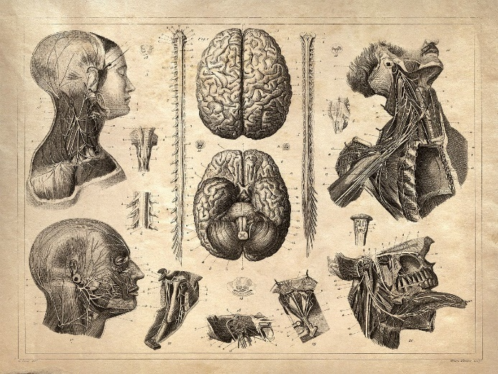](https://www.google.com/url?sa=i&url=https%3A%2F%2Fwww.pinterest.com%2Fpin%2F79798224619941281%2F&psig=AOvVaw2KNCVT_hYIJkcmx29avkLw&ust=1594390872591000&source=images&cd=vfe&ved=0CAIQjRxqFwoTCMjP0v6uwOoCFQAAAAAdAAAAABAE)

**Specification Content Checklist**

|  |  |  |  |  |
| --- | --- | --- | --- | --- |
| **Key info** | **Topic:** Organisms respond to changes in their internal and external environments  **Synoptic Link:** Cells, transport across membranes, mass transport in animals and plants | | | |
| **Step 1** | **Use the tutorial (GOL), presentation (GOL), video links and text book to complete the pack.** | | | |
| **Step 2** | **Specification Content Checklist** | **I understand this** | **I can recall this** | **I need to revisit this** |
| **3.6.1.1 Survival and response**  Organisms increase their chance of survival by responding to changes in their environment. |  |  |  |
| In flowering plants, specific growth factors move from growing regions to other tissues, where they regulate growth in response to directional stimuli. |  |  |  |
| The effect of different concentrations of indoleacetic acid (IAA) on cell elongation in the roots and shoots of flowering plants as an explanation of gravitropism and phototropism in flowering plants. |  |  |  |
| Taxes and kineses as simple responses that can maintain a mobile organism in a favourable environment. |  |  |  |
| The protective effect of a simple reflex, exemplified by a three neurone simple reflex. Details of spinal cord and dorsal and ventral roots are not required. |  |  |  |
| **Required practical 10**  Investigation into the effect of an environmental variable on the movement of an animal using either a choice chamber or a maze. |  |  |  |
|  | **3.6.1.2 Receptors**  The Pacinian corpuscle should be used as an example of a receptor  to illustrate that:  • receptors respond only to specific stimuli  • stimulation of a receptor leads to the establishment of a generator potential |  |  |  |
|  | The basic structure of a Pacinian corpuscle |  |  |  |
|  | Deformation of stretch-mediated sodium ion channels in a Pacinian corpuscle leads to the establishment of a generator potential |  |  |  |
|  | The human retina in sufficient detail to show how differences in sensitivity to light, sensitivity to colour and visual acuity are explained by differences in the optical pigments of rods and cones and the connections rods and cones make in the optic nerve |  |  |  |
|  | **3.6.1.3 Control of heart rate**  Myogenic stimulation of the heart and transmission of a subsequent wave of electrical activity.  The roles of the sinoatrial node (SAN), atrioventricular node (AVN) and Purkyne tissue in the bundle of His |  |  |  |
|  | The roles and locations of chemoreceptors and pressure receptors and the roles of the autonomic nervous system and effectors in controlling heart rate |  |  |  |
| **Step 3** | **In lesson:** you will be undertaking activities to develop your understanding of the specification content and able to add to your notes.  **Revision:** make sure that you have resources available to re-learn and memorise the subject content above | | | |

**Survival and Response**

For the nervous system to carry out its function effectively it is dependent upon a continuous input of information from inside the body and from the environment. This input is detected by sensory receptors and relayed to effectors. That is, responses to all stimuli involve the reception of information and its transfer from the receptor to an effector via the nervous system.

What is a stimulus?

___________________________________________________________________________________________________________________________________________________________________________________________________________________________________________________

What detects stimuli?

__________________________________________________________________________________________________________________________________________________________________

What is the role of the different parts of the nervous system?

**Receptor:**

**Co-ordinator**:

**Effector:**

What are the two different means of communication in organisms and how do they differ?

______________________________________________________________________________________________________________________________________________________

The sequence of events can be summarised as:

Stimulus receptor coordinator effector response

One particularly obvious category of response to the environment in organisms is *movement*. This is one of the most fundamental ways for a plant or an animal to enhance survival. It's no wonder then, that much of this response is solidly built-in and automated, like a **reflex**.

There are 4 main examples of response: **taxis, kinesis, tropism** and **reflex**.

1. **Taxes**

What is a taxis?

______________________________________________________________________________________________________________________________________________________

What is meant by positive taxis?

______________________________________________________________________________________________________________________________________________________

What is meant by negative taxis?

______________________________________________________________________________________________________________________________________________________

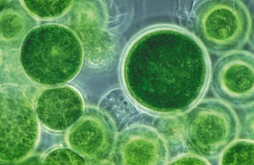

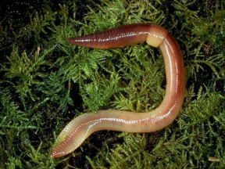Give some examples of taxes

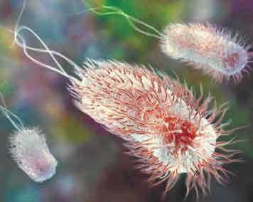

1. **Kinesis**

What is kinesis?

______________________________________________________________________________________________________________________________________________________

Give an example of kinesis

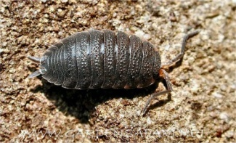

[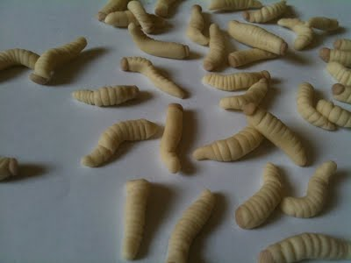](http://www.thealevelbiologist.co.uk/survival-and-response/maggo.jpg?attredirects=0)**Maggot movement - Taxis and Kinesis**

What happens it you expose a maggot to an extreme temperature?

If a maggots are placed in an extreme temperature, they move faster in random directions until they happen to get to a favourable condition. This is called **kinesis**.

However, if there's a freshly decomposing, nicely rotten carcass lying around, emanating a stream of increasingly concentrated chemicals they move specifically towards the ever-increasing chemical concentration from a carcass. This is **taxis**.

Therefore, the kinesis i.e. moving randomly will bein response to a stressful stimulus and taxis i.e s is moving specifically towards/away from a stimulus.

1. **Tropisms**

The **direct stimuli** which contribute to plant survival (such as light, nutrients, gravity) are responded to by **positive** or **negative** tropisms.

Tropisms get their names based on the stimulus they refer to.

[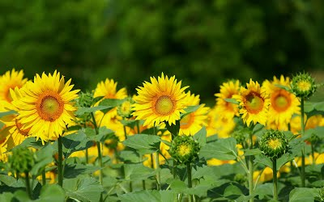](http://www.thealevelbiologist.co.uk/survival-and-response/sun-flower_01847.jpg?attredirects=0)

What type of tropism is being displayed by these sunflowers?

Plant shoots also exhibit **negative geotropism/ gravitropism** which means they grow *away from* the strongest gravitational pull i.e. the ground.

What type of tropism would plant roots display and why? (You should name 3 types of tropism and state whether they are positive or negative)

___________________________________________________________________________________________________________________________________________________________________________________________________________________________________________________

_________________________________________________________________________________

All these ensure plants respond to their environment in a way that best maximises their survival prospects.

**Plant Growth Factors**

Plants have no nervous system. Plants respond to external stimuli via hormone-like substances called Plant growth factors.

* Exert their influence by affecting growth
* 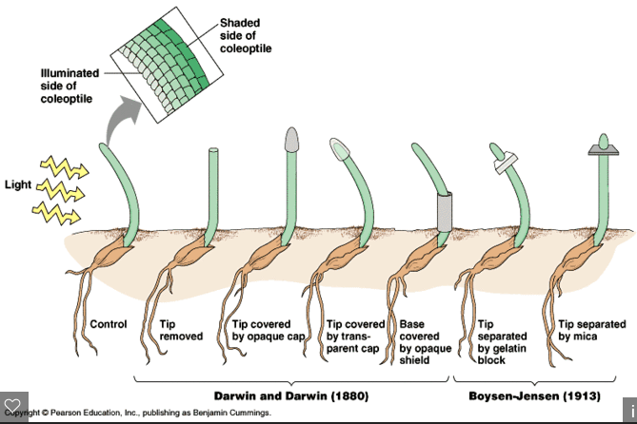Some plant growth factors affect the tissues that release them rather than acting on a distant target organ.

**Phototropism in flowering plants**

<https://www.youtube.com/watch?v=HR9KHW-e0pY>

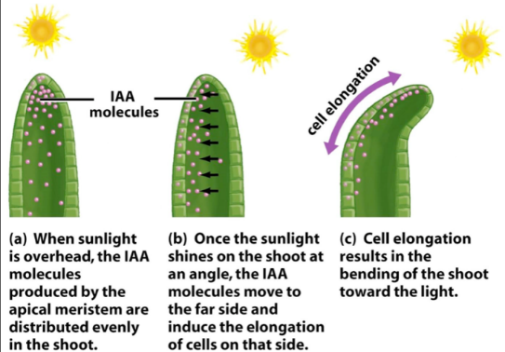

How does the plant growth factor **indoleacetic acid (IAA)** bring about **phototropism** in plants?

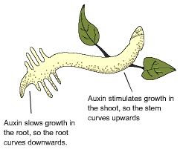

How does IAA affect root growth in response to light?

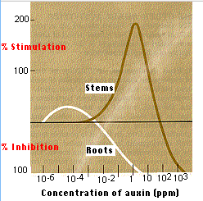

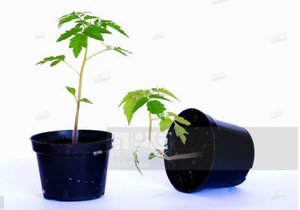**Gravitropism in flowering plants** <https://www.youtube.com/watch?v=pi3P3uJOsN4>

Gravity leads to a change in the distribution of IAA carrier proteins that export IAA from cells

How does IAA affect root growth in response to gravity?

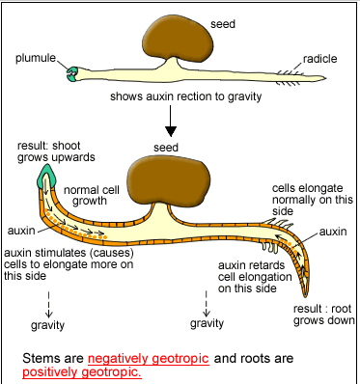

How do shoots respond to gravity?

**Role of IAA in elongation growth**

IAA is produces in root and shoot tips. It is then transported in one direction away from the tip. IAA increases a plant cell’s plasticity (ability to stretch) of their cell walls. The response only occurs in young cell walls where cells are able to elongate. As the cells mature they develop greater rigidity so older parts of the root or shoot will not be able to respond.

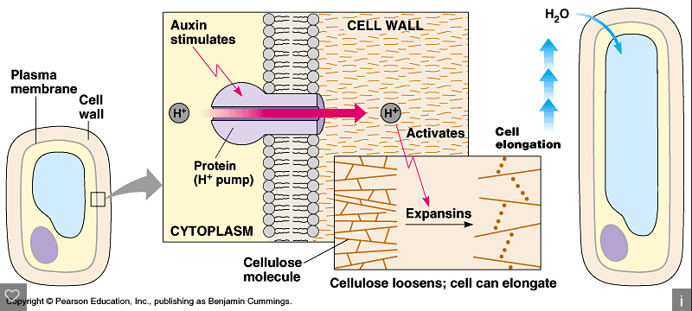

The way in which IAA increases the plasticity of cells is called the acid growth hypothesis. Hydrogen ions are actively transported from the cytoplasm into the spaces in cell walls causing the cell walls to become more plastic allowing the cell to elongate by expansion.

**Summary Questions:**

1. Explain how the movement of IAA in shoots helps a plant survive.
2. Suggest two advantages to a plant having roots that respond to gravity by growing in the direction of its force.
3. Consider the following facts about IAA:
4. They are easily made synthetically
5. They are readily absorbed by plants
6. They are not easily broken down
7. They are lethal to some plants in low concentrations
8. Narrow-leaved plants are less easily killed then broad-leaved plants

Suggest ways in which these facts might be relevant to agricultural practice.

1. **Reflex Arc**

This is the simplest type of nervous response to a stimulus.

**Nervous organisation**

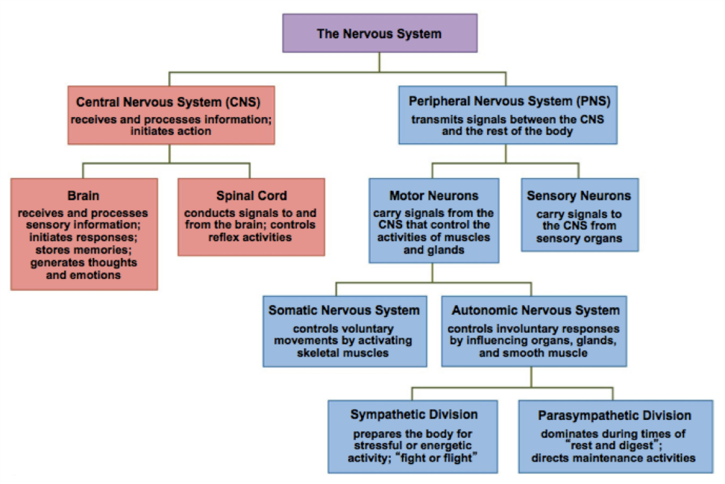

The **central nervous system (CNS)** is made up of the brain and spinal cord.

The **peripheral nervous system (PNS)** is divided into:

1. Sensory neurones which ______________________________________________________________________________________________________________________________________________________
2. Motor neurones which

______________________________________________________________________________________________________________________________________________________

The motor nervous system can be further subdivided:

1. The voluntary nervous system which

______________________________________________________________________________________________________________________________________________________

1. The autonomic nervous system which

______________________________________________________________________________________________________________________________________________________

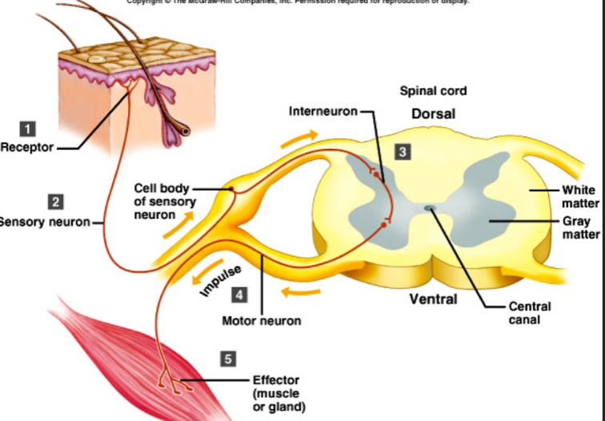**The Spinal cord**

* A column of nervous tissue that runs along the back and lies inside the vertebral column for protection. Emerging at intervals along the spinal cord are pairs of nerves.

**Reflex Arc**

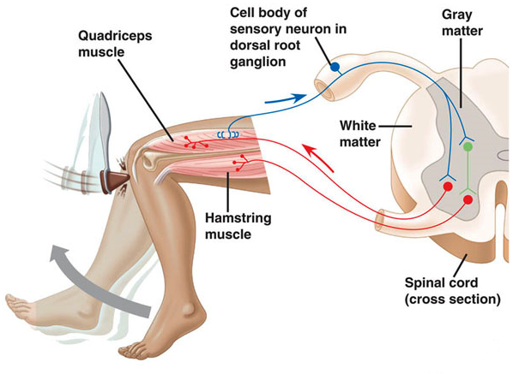

The protective effect of a simple reflex, exemplified by a three neurone simple reflex. Details of spinal cord and dorsal and ventral roots are not required.

The reflex arc is the basis for protective, involuntary actions.

Watch this animation about reflex arcs <http://www.sumanasinc.com/webcontent/animations/content/reflexarcs2.html>

(a) What are REFLEX ACTIONS and why are they so useful?

(b) Name a couple of EXAMPLES of reflex actions.

The pathway of neurones involved in a **reflex** is known as a **reflex arc**

Label the diagram below which shows the neurones involved in a reflex arc.

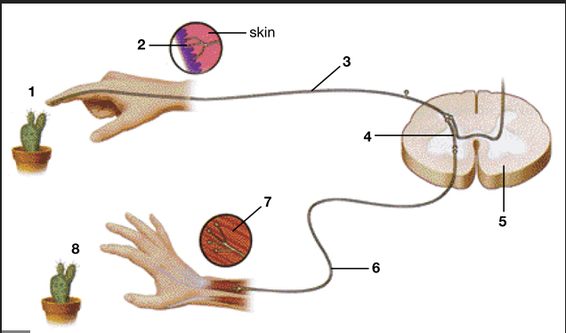1 …………………………………………………………

2 …………………………………………………………

3 …………………………………………………………

4 …………………………………………………………

5 …………………………………………………………

6 …………………………………………………………

7 …………………………………………………………

8 …………………………………………………………

Although many reflexes are protective, actions such as blinking, coughing and swallowing are also coordinated by reflexes.

With any reflex action there is also a pathway for impulses to be sent to the brain via ascending nerve fibres that originate at synapses in the grey matter of the spinal cord. The brain may store this information or it may relate the information with sense data from, say, the eyes. As a result of receiving this extra information impulses may be sent from the brain to modify the response. Sometimes the response is over-ridden by the brain along inhibitory nerve fibres.

**Summary activities**:

1. Fill in the gaps

If a hand touches a hot object a pain……………..…. in the skin sends an action potential along a ……..…… neurone. This enters the spine through the dorsal root. The impulse is passed to a ……..………..…….. neurone which lies totally within the grey matter region of the spinal tissue. This in turn passes the impulse to a ……..…… neurone which leaves the spine by way of the ventral root. It takes the impulse to a ……..….……. which will ……………………. so removing the arm from the source of pain.

1. Why are reflex arcs so important?
2. Complete the summary table below

|  |  |  |  |  |
| --- | --- | --- | --- | --- |
|  | Definition | Purpose | Example | Advantage |
| **Taxes** |  |  |  |  |
| **Kinesis** |  |  |  |  |
| **Tropism** |  |  |  |  |
| **Refex arc** |  |  |  |  |

**Receptors**

**The Pacinian Corpuscle – receptors in the skin**

A Pacinian corpuscle is a sensory receptor which responds to changes in mechanical pressure.

* It is specific to a single type of stimulus
* It produces a generator potential by acting as a transducer

Why are sensory receptors known as transducers?

____________________________________________________________________________________________________________________________________________________________________________________________________________________________________________________________________________________________________________________________________

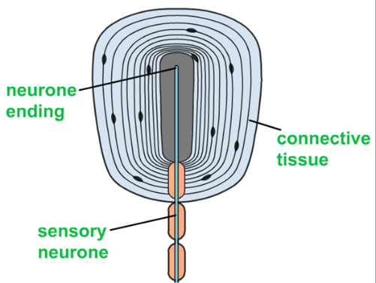**Structure and function of a Pacinian corpuscle**

**The Pacinian corpuscle**named by its Italian discoverer Filippo Pacini is a 1 mm diameter skin receptor which enables us to perceive mechanical stimuli such as **pressure** and **vibration**. This is the receptor responsible for our awareness off smooth vs rough surfaces, shallow vs intense tactile sensation, etc. They are found deep in the skin and are most abundant on the fingers, the soles of the feet and the external genitalia. They also occur in joints, ligaments and tendons. They are the largest of the skin's receptors and are believed to provide instant information about how and where we move.

A Pacinian corpuscle is made up of a single sensory neurone in the centre of a layer of tissues, each separated by a gel.

1. What happens to the connective tissue when pressure is applied to the skin around the Pacinian corpuscle?

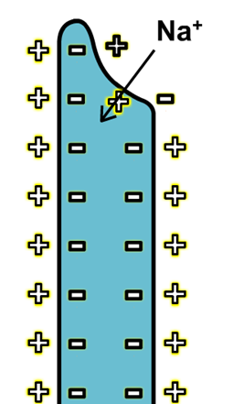______________________________________________________________________________________________________________________________________________________

1. The Pacinian corpuscle has a special type of sodium channel in its plasma membrane. What is this channel called?

__________________________________________

1. What happens when pressure is applied to the Pacinian corpuscle?

______________________________________________________

______________________________________________________

1. What happens when the sodium channels are opened? ___________________________________________________________________________
2. What then happens to the potential of the membrane and what is produced?

______________________________________________________________________________________________________________________________________________________

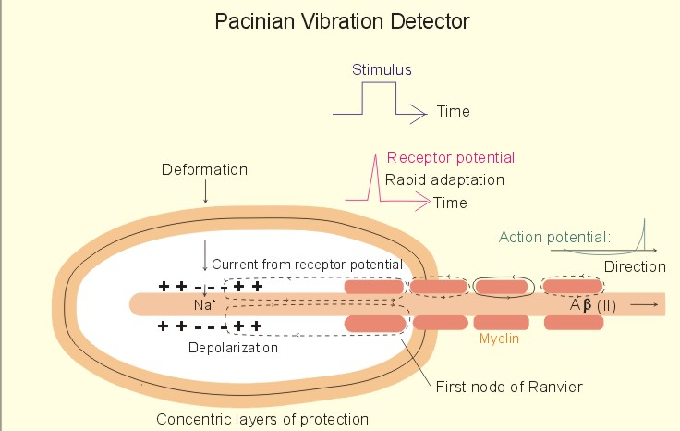

The generator potential in turn creates an action potential (nerve impulse) that passes along the neurone and then, via other neurones, to the central nervous system.

**Receptors in the eye**

Light receptor cells are found on the retina of the eye.

1. 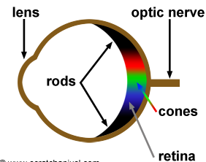What are the two main types of receptors?

_______________________________________________

_______________________________________________

1. How do they differ in their distribution and sensitivity?

_______________________________________________

_______________________________________________

___________________________________________________________________________

___________________________________________________________________________

___________________________________________________________________________

1. 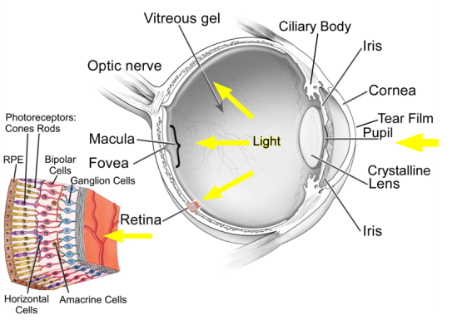Both Rod and Cone cells act as transducers. What does this mean?

_______________________________________________

_______________________________________________

_______________________________________________

_______________________________________________

_______________________________________________

**Rod cells**

1. How is a generator potential produced in a Rod cell?

_________________________________________________________________________

_________________________________________________________________________

_________________________________________________________________________

_________________________________________________________________________

1. Why are there many rod cells connected to a single sensory neurone in the optic nerve?

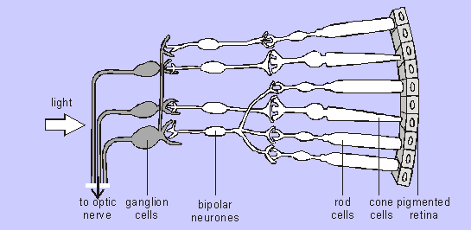

____________________________________________

____________________________________________

____________________________________________

____________________________________________

____________________________________________

____________________________________________

1. What is the consequence of many rod cells linking to a single bipolar cell?

_________________________________________________________________________

_________________________________________________________________________

_________________________________________________________________________

_________________________________________________________________________

**Cone cells**

1. How many different types of cone cells are there?

_________________________________________________________________________

_________________________________________________________________________

1. What pigment is broken down leading to the generation of a generator potential?

_________________________________________________________________________

_________________________________________________________________________

1. Each cone cell is attached to their own separate bipolar cell. What is the consequence of this?

_________________________________________________________________________

_________________________________________________________________________

_________________________________________________________________________

_________________________________________________________________________

Summary table of differences between Rod and Cone cells

|  |  |  |
| --- | --- | --- |
|  | Rod Cells | Cone cells |
| Shape |  |  |
| Distribution |  |  |
| Visual acuity |  |  |
| Light intensity |  |  |
| Types |  |  |
| Connection to bipolar cells |  |  |

**Control of Heart Rate**

**Autonomic nervous system**

Much of the sensory information reaching our Central nervous system comes from receptors in our bodies responding to internal stimuli. The autonomic nervous system is responsible for this.

This controls the involuntary activities of the internal muscles and glands. It has two divisions:

1. **Sympathetic nervous system**

_________________________________________________________________________

_________________________________________________________________________

_________________________________________________________________________

_________________________________________________________________________

1. **Parasympathetic nervous system**

_________________________________________________________________________

_________________________________________________________________________

_________________________________________________________________________

_________________________________________________________________________

Label the heart diagram below

[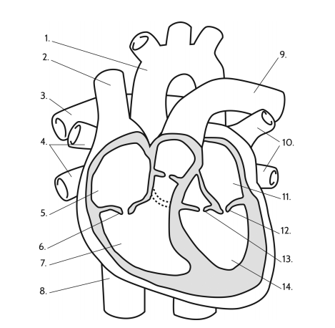](https://www.google.com/url?sa=i&url=https%3A%2F%2Fquizlet.com%2F440880720%2Fheart-diagram-handout-16b-diagram%2F&psig=AOvVaw1fleVgr0kJbLoo1yak6e-L&ust=1594403058392000&source=images&cd=vfe&ved=0CAIQjRxqFwoTCJjTnLHcwOoCFQAAAAAdAAAAABAK)

The muscle of the heart is known as **cardiac** muscle. The contractions are initiated within the muscle itself rather than from a nerve impulse from outside and so is called **myogenic.**

**Electrical activity of the heart**

**Fill in the gaps below and write the numbers 1-4 from the diagram on the right into the correct places within the paragraph**

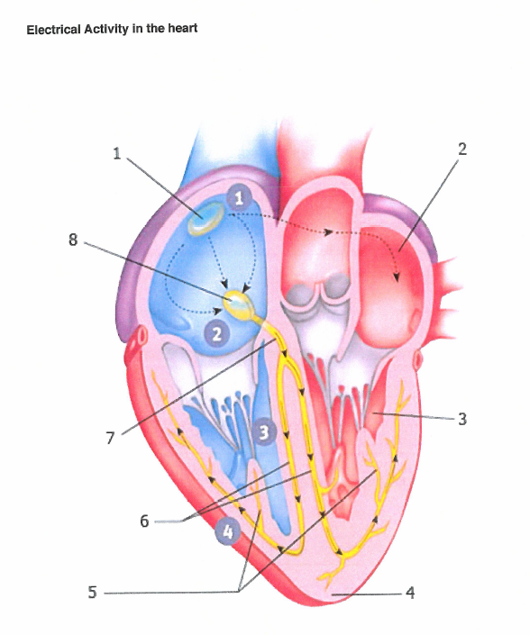The mammalian heart is made up of a special type of muscle called ------------------ muscle. This muscle has the ability to contract and relax without any stimulation and is therefore said to be -------------. The heart beat is initiated in an area of the right atrium called the -----------------------------------. The wave of excitation passes across both atria until it reaches an area of tissue called the --------------------. This in turn passes the wave to a group of fibres called the ---------------------------- and then the -------------------- ------------------- which transfer the wave to the tip of the ventricles. This causes the ventricles to ----------------- from the base upwards and forces blood to flow out of the heart through the aorta and the ------------------.

**Modifying the resting heart rate**

The resting heart rate of a typical adult human is around 70 beats per minute. This rate needs to be altered to meet demands for oxygen.

1. Changes to the heart rate are controlled by a region of the brain. What is it called?

___________________________________________________________________

There are two centres concerned with heart rate.

1. A centre that **increases heart rate,** which is linked to the sinoatrial node by the ______________________________________________
2. A centre that decreases heart rate, which is linked to the sinoatrial node by the ______________________________________________

Which of these centres is stimulated depends upon the nerve impulses they receive from two types of receptor, which respond to stimuli of either **chemical** or **pressure** changes in the blood.

**Control by chemoreceptors**

Chemoreceptors are found in the wall of carotid arteries (the arteries that serve the brain)

These are sensitive to pH in the blood.

* CO2 levels increase so pH of the blood is ______________
* Chemoreceptors in wall of carotid arteries and the aorta detect the change and send an impulse to the ______________________
* This centre _______________ impulses sent to SAN via sympathetic nervous system
* Rate of production of excitation wave increased
* Heart rate is _______________
* Blood flow increased so CO2 removed by lungs
* pH of blood returns to normal
* Chemoreceptors in wall of carotid arteries and the aorta detect the change
* Frequency of nerve impulses to medulla oblongata ________________
* Heart rate ________________

**Control by pressure receptors**

Pressure receptors are found in the wall of carotid arteries and the aorta. They respond to changes in blood pressure.

1. Outline the steps that occur when blood pressure is higher than normal what happens?

_________________________________________________________________________

_________________________________________________________________________

_________________________________________________________________________

_________________________________________________________________________

_________________________________________________________________________

_________________________________________________________________________

_________________________________________________________________________

_________________________________________________________________________

_________________________________________________________________________

_________________________________________________________________________

_________________________________________________________________________

_________________________________________________________________________

1. Outline the steps that occur when blood pressure is lower than normal what happens?

_________________________________________________________________________

_________________________________________________________________________

_________________________________________________________________________

_________________________________________________________________________

_________________________________________________________________________

_________________________________________________________________________

_________________________________________________________________________

_________________________________________________________________________

_________________________________________________________________________

_________________________________________________________________________

_________________________________________________________________________

_________________________________________________________________________

