**3.6.2 Nervous coordination**

**Recall Activities**

These are activities to develop your recall of information you covered in the previous topics that are linked to nervous coordination. You should do this before you start the work on this topic. Once you have done the recall activity quickly check your info/answers using your student booklets and notes from that topic.

**Topics covered**: Biological molecules, cells, transport across membranes

|  |  |  |  |
| --- | --- | --- | --- |
| **Topic** | **Recall activities** | **Understanding**  *Please write down any questions you have when completing this activity.* | **Completed** |
| **Biological molecules** | On the MWB/scrap paper, draw a series of diagrams to explain the induced fit model of enzyme activity. Then describe the difference between competitive and non-competitive inhibitors |  |  |
| On the MWB/scrap paper, make a list of the common inorganic ions found in organisms. State their function and how the cross cell membranes |  |  |
| **Cells** | On the MWB/scrap paper, draw a phospholipid bilayer labelling all the main components |  |  |
| On the MWB/scrap paper define facilitated diffusion, active transport and co-transport. Draw simple diagrams to demonstrate each type of movement |  |  |
| On the MWB/scrap paper draw a diagram of a eukaryotic cell, label the organelles and state their function |  |  |

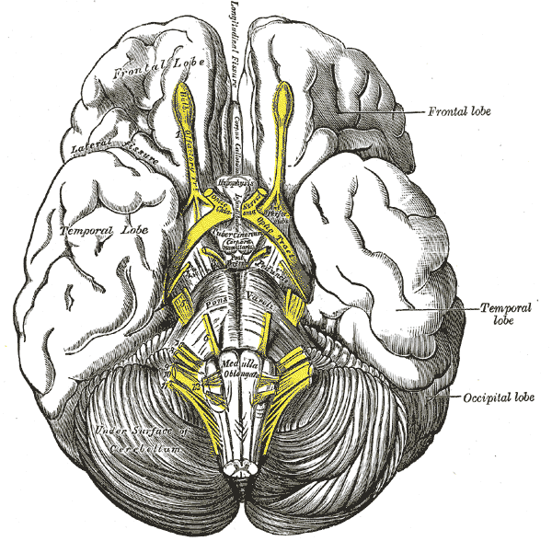

**Specification Content Checklist**

|  |  |  |  |  |
| --- | --- | --- | --- | --- |
| **Key info** | **Topic: Nervous coordination**  **Synoptic Link:** Biological molecules, cells, transport across membranes | | | |
| **Step 1** | **Use the tutorial (GOL), presentation (GOL), video links and text book to complete the pack.** | | | |
| **Step 2** | **Specification Content Checklist** | **I understand this** | **I can recall this** | **I need to revisit this** |
| **3.6.2.1 Nerve impulses**  The structure of a myelinated motor neurone. |  |  |  |
| The establishment of a resting potential in terms of differential membrane permeability, electrochemical gradients and the movement of sodium ions and potassium ions. |  |  |  |
| Changes in membrane permeability lead to depolarisation and the generation of an action potential. The all-or-nothing principle. |  |  |  |
| The passage of an action potential along non-myelinated and myelinated axons, resulting in nerve impulses. |  |  |  |
| The nature and importance of the refractory period in producing discrete impulses and in limiting the frequency of impulse transmission. |  |  |  |
| Factors affecting the speed of conductance: myelination and saltatory conduction; axon diameter; temperature. |  |  |  |
| **3.6.2.2 Synaptic transmission**  The detailed structure of a synapse and of a neuromuscular junction. |  |  |  |
| The sequence of events involved in transmission across a cholinergic synapse in sufficient detail to explain:   * unidirectionality * temporal and spatial summation * inhibition by inhibitory synapses. |  |  |  |
| A comparison of transmission across a cholinergic synapse and across a neuromuscular junction. |  |  |  |
| Use information provided to predict and explain the effects of specific drugs on a synapse. |  |  |  |
| **Step 3** | **In lesson:** you will be undertaking activities to develop your understanding of the specification content and able to add to your notes.  **Revision:** make sure that you have resources available to re-learn and memorise the subject content above | | | |

## Principles of coordination

There are two main forms of coordination in animals – the nervous system and the hormonal system.

## Hormonal coordination

**Hormones** do not belong to one particular chemical group. Some are **amines**, nitrogen-containing molecules, others are **protein** and **polypeptide** in origin. A few are **steroids** that are derived from fats and lipids.

These chemicals messengers are passed in very small amounts, directly into the bloodstream by glands that collectively form the **endocrine system**. Once in the bloodstream the hormones are carried to all parts of the body. They bring about specific effects in the behaviour and development of animals.

The basic similarities between the nervous and the endocrine systems are that they provide the body with methods to communicate with its internal and external environments in order to coordinate responses. They both employ chemicals to transmit messages and respond to stimulus caused by changes in their environments.

However there are differences in:

* response times
* how they work

The responses of the nervous system, are usually instantaneous. Hormones are transported all over the body via the blood, so response times will vary. Puberty is the stage in human development when children become adults. This transition takes years to complete and is controlled mainly by the hormones oestrogen, progesterone and testosterone that are **steroids** in origin.

Hormones are like 'impulses' from the glands. In order to stimulate a particular response, more than one hormone may need to be released.

The pituitary gland, found at the base of the brain, influences the activity of the other endocrine glands. It is controlled by the information it receives from the brain. This gland produces a large number of hormones that influence the activity of other glands. Hormones target specific cells. These target cells have molecular receptors on their surface membranes, (like on post-synaptic membranes). The shape and size of these receptors ensures that only certain hormones can be attached, they fit like two pieces of the same puzzle.

The way hormones work depends on the type of hormone.

* The attachment of the hormone to the receptor triggers the production of a second chemical inside the cell that completes the function. This is the action of **proteins** and **polypeptides**.
* **Steroids** like oestrogen bond with the receptor forming a new compound that has the ability to pass through the cell membrane. In this way it is able to effect changes directly.
* Sometimes the action of bonding with the receptor alters the permeability of the cell membrane allowing other molecules to enter the cell. Insulin, a **polypeptide**, acts in this way. The cell membrane is depolarised allowing glucose molecules to enter for cell respiration.

## Nervous coordination in mammals

The ability to respond to stimuli is a fundamental characteristic of living organisms. Organisms with a central nervous system (CNS) are well adapted to cope with changes in the external environment and within the body. The nervous system has three distinct functions:

* collection of information about changes in its environment, both internal and external
* processing this information and often relating it to previous experiences
* acting on this information by coordinating the response of the organism

One remarkable feature is the speed of the response which is virtually instantaneous.

The central nervous system is composed of specialised cells called **nerve cells** or **neurones**. These cells are bound together by connective tissue to form nerve fibres. These neurones are stimulated by changes in their environment to transmit information to and from the central nervous system. This is done by a series of electrical impulses passing along the length of a neurone.

The endocrine and nervous systems work independently to carry out unique functions by different methods with some similar elements. However, they do work together to control and co-ordinate the internal environment of the animal

Complete the table below comparing the hormonal and nervous system

|  |  |
| --- | --- |
| Hormonal system | Nervous system |
| Communication is by chemicals called hormones |  |
| Transmission is by the blood system |  |
|  | Transmission is very rapid |
|  | Nerve impulses travel to specific parts of the body |
| Response is widespread |  |
| Response is slow |  |
| Response is long lasting |  |
|  | Effect is temporary and reversible |

**3.6.2.1 Nerve Impulses**

* The structure of a myelinated motor neurone.
* The establishment of a resting potential in terms of differential membrane permeability, electrochemical gradients and the movement of sodium ions and potassium ions.
* Changes in membrane permeability lead to depolarisation and the generation of an action potential.
* The all-or-nothing principle. The passage of an action potential along non-myelinated and myelinated axons, resulting in nerve impulses.
* The nature and importance of the refractory period in producing discrete impulses and in limiting the frequency of impulse transmission.
* Factors affecting the speed of conductance: myelination and saltatory conduction; axon diameter; temperature.

**Neurones**

Neurones are highly specialised cells that generate and transmit nerve impulses.

There are three types of **neurones,** classified according to their function:

Describe each type of neurone below:

1. Sensory neurone

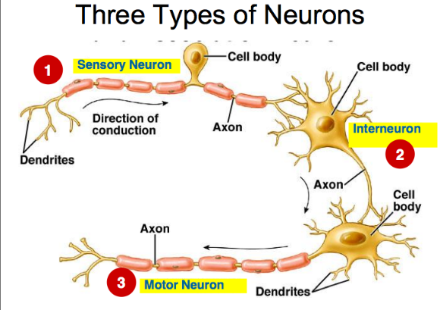_____________________________________________

_____________________________________________

_____________________________________________

1. Intermediate neurone

_____________________________________________

_____________________________________________

_____________________________________________

1. Motor neurone

______________________________________________________________________________________________________________________________________________________

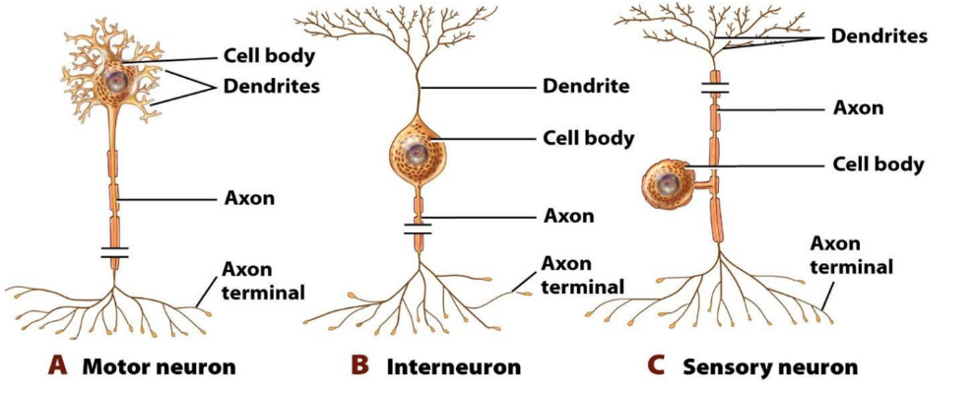

**Draw and label a motor neurone**: (Labels - dendrites, cell body, nucleus, axon, myelin sheath, Schwann cell, nodes of Ranvier, nerve/axon endings) Show the direction of nerve transmission.

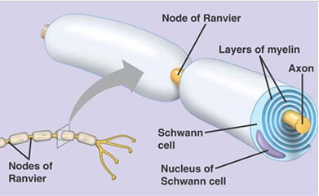

Complete the table below to describe and explain the function of each part of a motor neurone

|  |  |
| --- | --- |
| Cell body |  |
| Dendrites |  |
| Nucleus |  |
| Axon |  |
| Myelin sheath |  |
| Schwann cell |  |
| Nodes of Ranvier |  |
| Axon terminal |  |

**The Nerve Impulse**

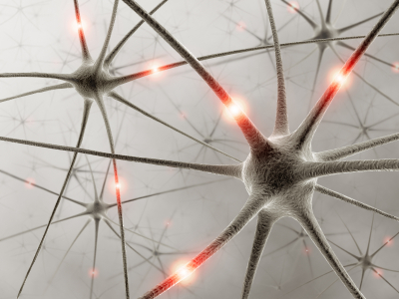

* A nerve impulse can be defined as a self-propagating wave of electrical activity that travels along the axon membrane.
* It is a temporary reversal of the electrical potential difference across the axon membrane. The reversal is between the two states, the **resting potential** and the **action potential.**

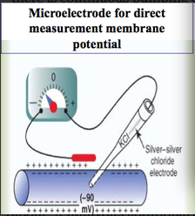How can nerve impulses be recorded and measured? Name the apparatus used.

**Background information**: When neurones are at rest they have various ‘ + ’ and ‘ - ‘ ions both inside and outside the cell. The MOVEMENT OF IONS across membranes is determined by their ELECTROCHEMICAL GRADIENT. This is a little complex, but you need to remember that it is made up of:

* The ELECTRICAL GRADIENT and
* The CONCENTRATION GRADIENT.

The full ‘story’ is quite complex BUT when at rest there are many ‘+’ and ‘- ‘ ions both INSIDE & OUTSIDE of the membrane including:

* **Na+** (*a key ion*)
* **K+** (a key ion)
* Cl-
* Negative protein molecules

Charged ions like **K+** and **Na+** (the two ions that are of PARTICULAR IMPORTANCE in neurone action) cannot simply diffuse in and out of cells – *what stops them?*

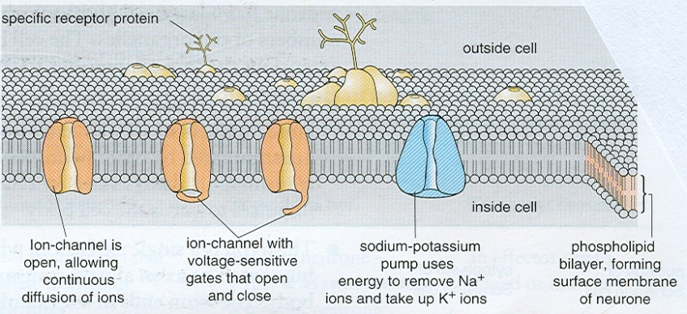Ions can pass in / out of cells through 3 types of channels (*see fig. below*).

What is the name of the type of protein (involved in the 3 channel types below) that spans the whole cell membrane?

*Describe each channel type*:

* **PERMANENTLY OPEN CHANNELS**:
* **VOLTAGE SENSITIVE GATES**:
* **ACTIVE CHANNELS** (Passive or active?): (e.g. Na+ / K+ pump – in answer explain how it works)

**Neurone membranes are excitable. The membrane potential can change according to ion distribution.**

**Resting Potential**

* The resting potential is the potential difference between the inside and the outside of a membrane when a nerve impulse is not being conducted.
* Resting potentials are typically minus values, the minus indicating the inside is negative with respect to the outside. The membrane is said to be polarised.

When the neurone is AT REST there is an overall charge difference between the inside & outside of the neurone of ………………… mV

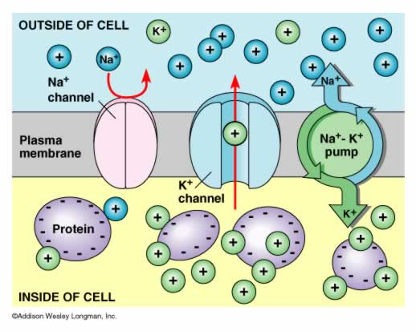The outside of the membrane has a net … … charge whilst the inside has a ………………………………………. charge.

**Remember resting potential = Inside Negative (relative to outside of membrane)**

How does the membrane become polarised?

1.

2.

3.

4.

5.

6.

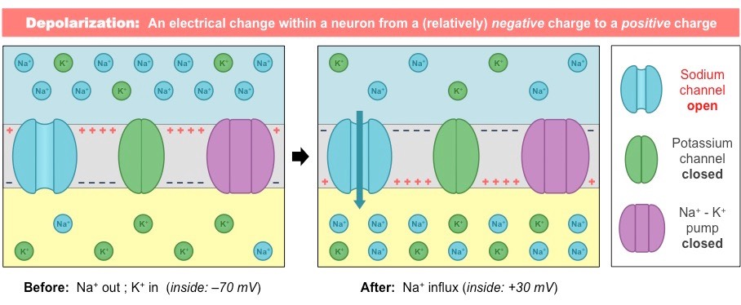

**What causes the transmission of a nerve impulse?**

* When a stimulus of sufficient size is detected by a receptor in the nervous system, its energy causes a temporary reversal of the charges either side this part of the axon membrane.
* 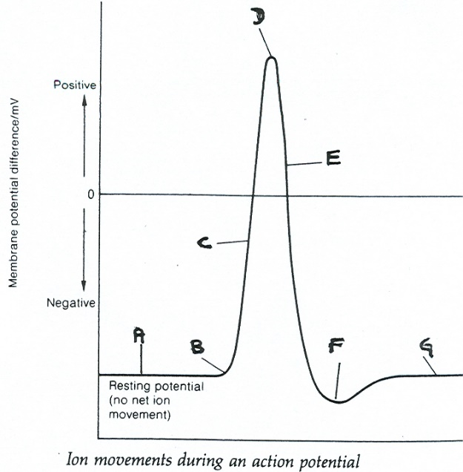If the stimulus is great enough a neurone is stimulated and the electrical potential of its cell membrane is altered, it is **depolarised**. Depolarisation changes the permeability of the membrane towards sodium ions at the site of the stimulation causing a sudden influx of sodium ions into the axon. Now the overall charge inside the cell is more positive. This is known as the **action potential**.
* When a neurone transmits a nerve impulse it starts by becoming **DEPOLARISED** and then it **REPOLARISES** again. If the electrical changes occurring inside a tiny portion of neurone membrane are measured (by an *oscilloscope* over about 3 – 4ms this is the result:

|  |  |
| --- | --- |
| Part of the graph: | Description what is occurring at each part of the graph: (mention the **two key ions** **Na+** & **K+** and the **three different channels** *plus* *when they open and shut*) |
| A |  |
| B |  |
| C |  |
| D |  |
| E |  |
| F | (include reference to HYPERPOLARISATION) |
| G |  |

**Movement of nerve impulses (action potentials) along neurones:**

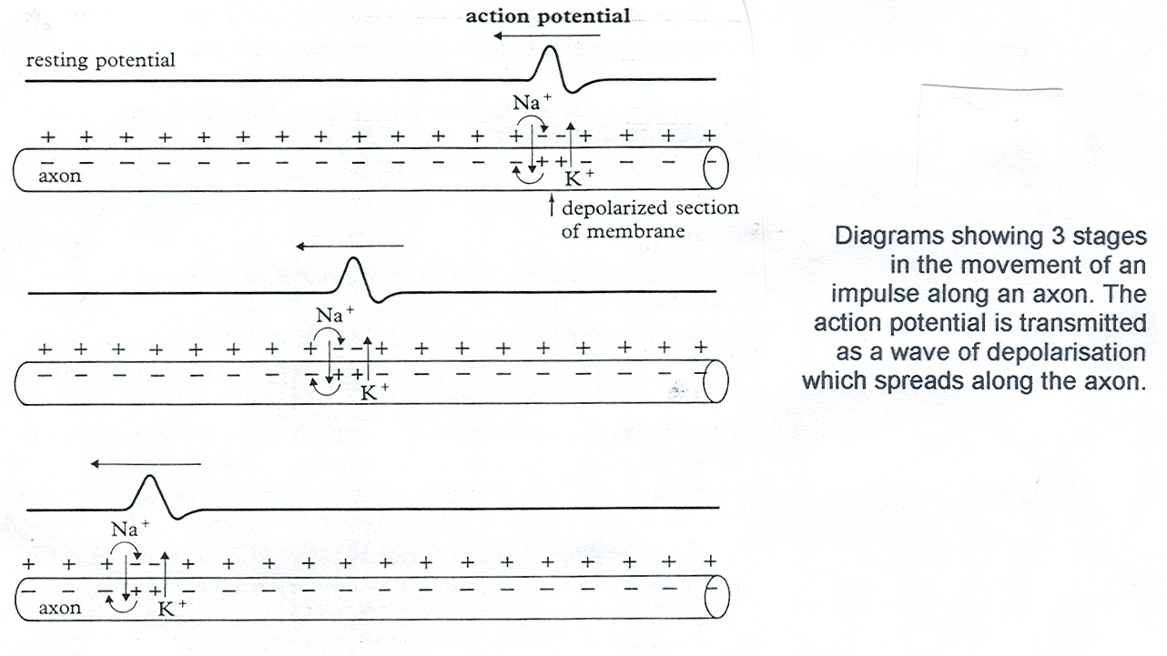A ‘nerve impulse’ (or wave of ACTION POTENTIALS) passes down an axon as shown in the following diagram:

If a STIMULUS is sufficient (reaches the **THRESHOLD POTENTIAL**) to cause an ACTION POTENTIAL it causes the next section of the neurone to start depolarising – a WAVE of ACTION POTENTIALS pass along the neurone – a bit like a line of upright dominoes falling if one is pushed.

Study the diagram AND the illustration below and then complete the gaps in the passage:

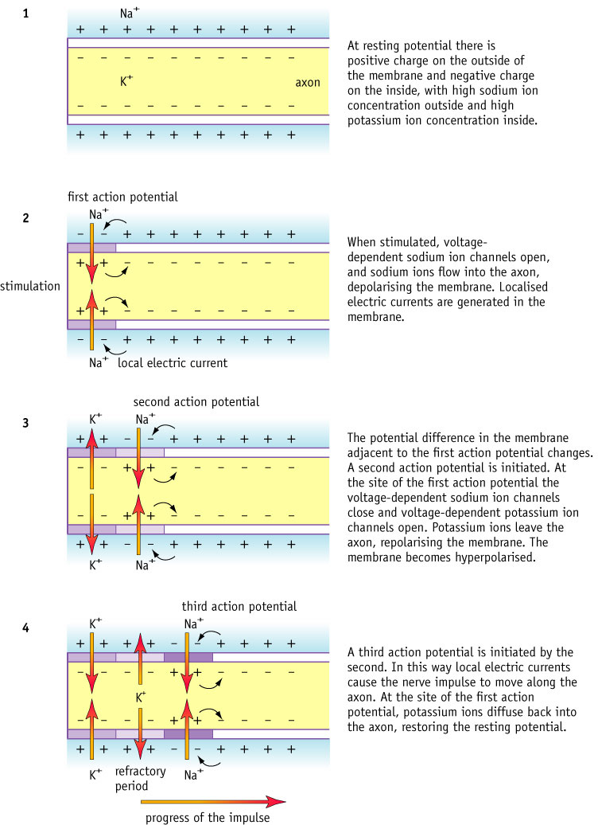 

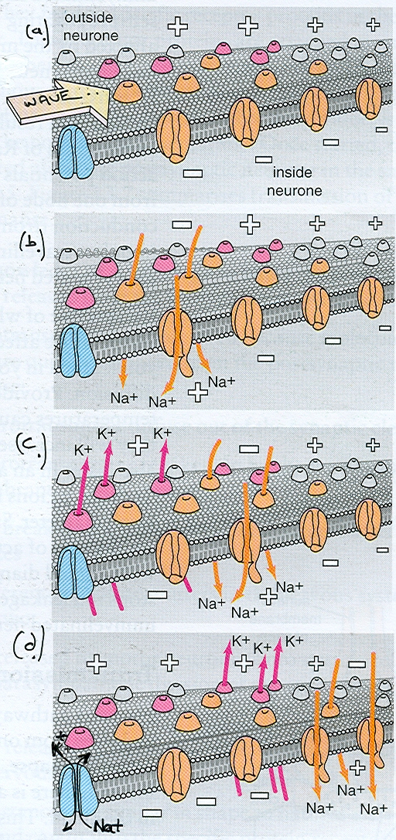**Nerve impulses – a summary**

When neurons are at rest there is a potential difference between the inside and outside of a neurone known as the ……… ………………… ……………………. This is achieved as the result of the movement of ions with an excess of ………..… ions on the *outside* of the neurone and ………………………… ions *within* the neurone (this situation is maintained by the …………………….…... pump. When the neurone is at rest this results in the outside of the neurone having a net ………..……charge and the inside a ………..………… charge. When an ‘impulse’ (better termed an ………….…….. ………….……) passes along a neurone there is a sudden influx of ………………. ions into the neurone (by the process of ………..…… ). They enter because the voltage sensitive …………… ………….…….. open for a short while. Almost as soon as these ………….…….ions enter then the ………………….………voltage sensitive gates shut again, whilst the …… ……………. voltage sensitive gates open allowing ………….. ions to leave the axon (by process of ………..…. ); this marks the beginning of the ……………….…… phase (also known as the …………….………………………. period). Finally these gates also shut and the resting potential balance of Na+ and K+ is restored by the actions of the active ………………………….. pump. This pumps three sodium ions out for every 2 potassium ions that are pumped in to the axon. The total period before the neurone is fully repolarised is known as the …….…………………………. period. The action potential disturbs the adjacent membrane and here the …….……………. voltage sensitive gates open. As a result of these actions, a step-by-step …….……. of …………………………. passes along the axon. Action potentials do not move ‘backwards’ as, for a short time, during the ……… ……………………period the ……...…. voltage sensitive gates remain closed (for about ………10……………. milliseconds).

**Speed of neurone transmission:**

Myelinated neurones transmit action potentials at a speed of 100 metres per second. In unmyelinated neurones the transmission speed is only one to three metres per second.

Why does Myelination speed up the rate of transmission? Refer to saltatory conduction.

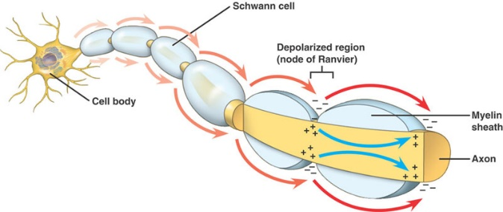

Explain how each of the following also effect the speed of transmission of impulses along neurons depends upon three factors which are:

1. **Temperature:**
2. **Axon diameter:**

**The all or nothing principle (law)**

What is meant by a “threshold” stimulus?

This is called the ……………………………………….……. law.

Study the graph above and then answer the questions that follow:

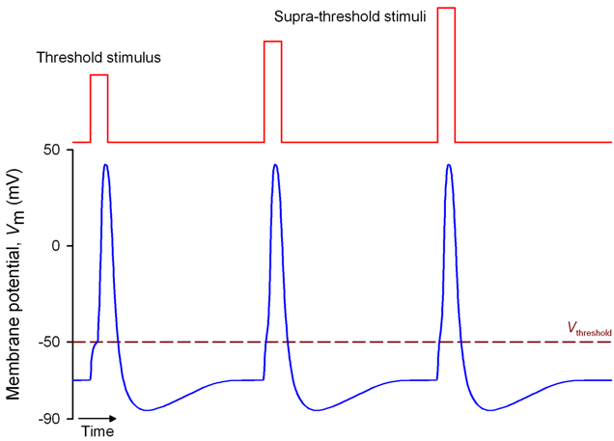If a stimulus **exceeds** the “threshold” stimulus can you get a bigger impulse?

If a stimulus creates a generator potential which is **sub-threshold**, will it cause an action potential?

**Frequency of nerve impulses & refractory period**

How can an organism detect the size of a stimulus if all action potentials are roughly the same size?

What are the three purposes of the refractory period?

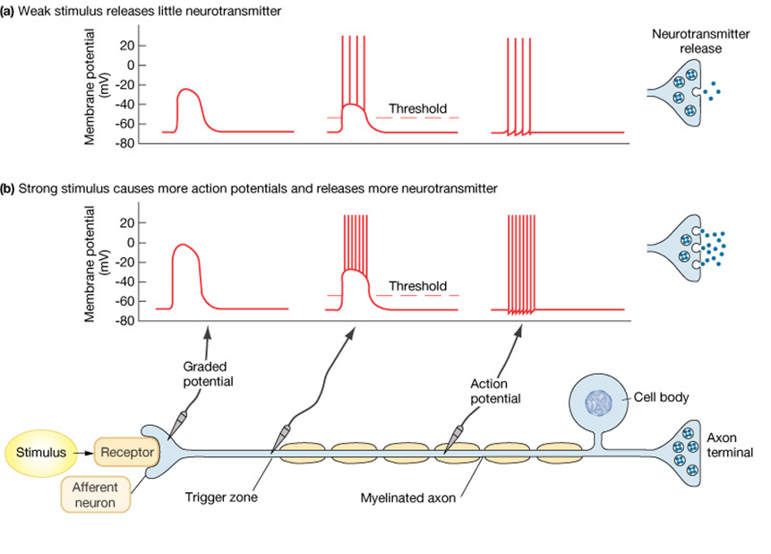

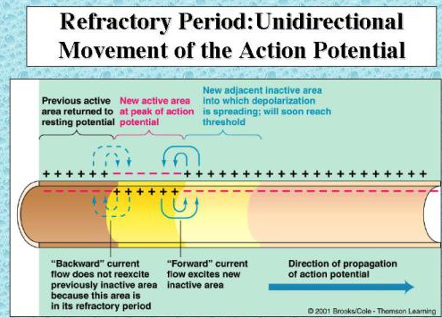Why can **ACTION POTENTIALS** only move in **ONE DIRECTION** down a neurone?

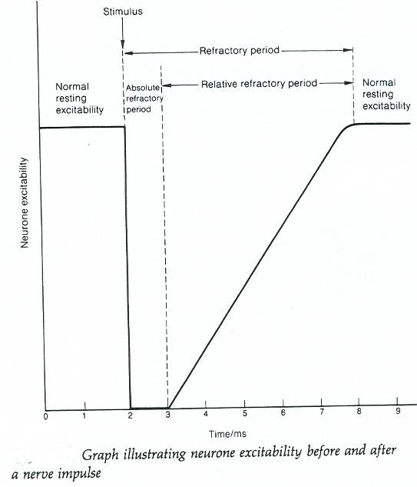**Why is the** **frequency** of transmission of **action potentials** limited (make clear reference to **REFRACTORY PERIOD** in your answer)?

**3.6.2.2 Synaptic transmission**

Neurones are not in direct contact with each other but are separated by ting gaps (20um) called synapses.

Synapses convey action potentials between neurones and from a neurone to an effector. They are involved in linking together different neurones and therefore coordinating activities.

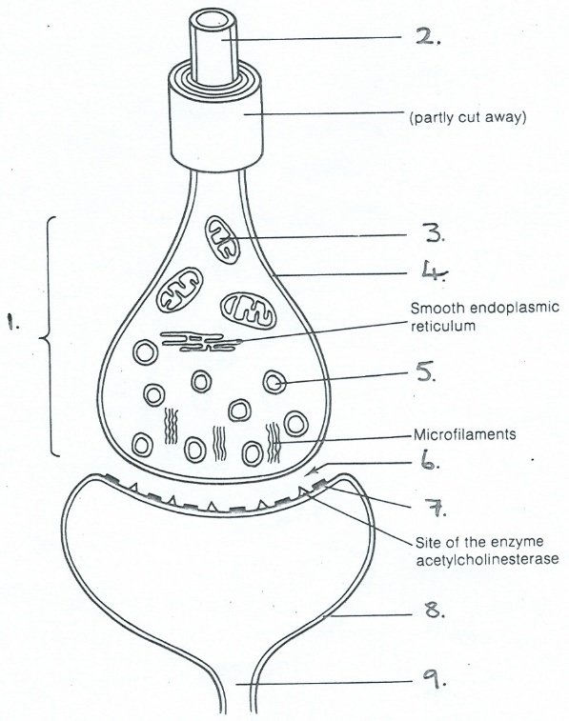**Structure of a cholinergic synapse**

Label the parts of the synapse shown before:

1. ..
2. ....
3. ..
4. ..
5. ..
6. ..
7. ..
8. ..
9. ..

Once the nerve impulse has passed to the end of the axon, the axon terminal, it needs to be transferred to another neurone or tissue. At the end of each axon terminal is a bulbous structure called a **synaptic knob**. The synaptic knob contains many structures common to living cells. In addition they have **synaptic vesicles**. These vesicles contain a chemical that assists the transfer of the impulse, a **neurotransmitter** called **acetylcholine**. The **pre-synaptic membrane** binds to the end of the adjacent neurone. Large protein molecules called **receptor molecules** are found on the surface of the postsynaptic membrane. There is a gap between the two structures about 20 nm wide known as the **synaptic cleft**.

What is the name of the chemicals which transmit the nerve impulse across the synapse?

Where are they made and then stored?

***Write the correct statement number for the following cholinergic synaptic actions in the correct box under the diagrams in the table below***

***(Note: the actions have been jumbled AND for some boxes you need more than 1 statement)***

1. calcium ions diffuse into pre-synaptic knob by facilitated diffusion;

2. Na+ ion channels open in post-synaptic membrane allowing sodium ions to diffuse rapidly along a concentration gradient

3. a breakdown enzyme (e.g. acetylcholinesterase) in the post-synaptic membrane splits the transmitter (into ethanoic acid & choline); & products are reabsorbed into the pre-synaptic knob;

4. an impulse arrives at the pre-synaptic knob;

5. depolarisation of the post-synaptic membrane occurs and an action potential is initiated;

6. Energy (ATP) is used to reform transmitter (acetylcholine) in the pre-synaptic knob (from ethanoic acid & choline); This is stored in a synaptic vesicle for future use. Sodium ion protein channels close in the absence of acetylcholine in the receptor sites.

7. gated calcium ion protein channels in the pre-synaptic membrane open;

8. synaptic vesicles of neurotransmitter (e.g. acetylcholine) move to & fuse with the pre-synaptic membrane then release transmitter into the synaptic cleft;

9. after diffusing across the synaptic cleft, Acetylcholine molecules bind to receptor sites on the sodium ion protein channels in the membrane of the post synaptic neurone.

|  |  |  |
| --- | --- | --- |
| scan00191 | scan00202 | scan00223 |
| Statement no/nos: | Statement no/nos: | Statement no/nos: |
| scan00234 | scan00245 | scan00256 |
| Statement no/nos: | Statement no/nos: | Statement no/nos: |

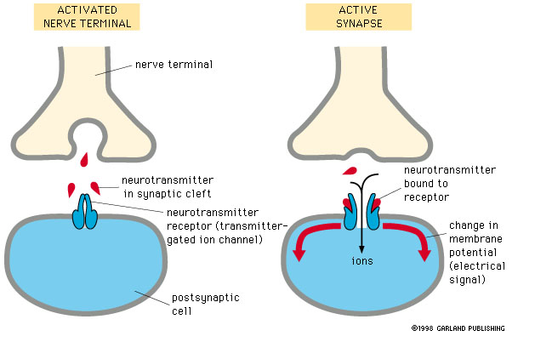Give five SYNAPSE FUNCTIONS:

**Acetylcholine**, when released, is quickly destroyed by enzymes in the synaptic cleft, so its effect is limited and the merging of impulses is prevented. If insufficient acetylcholine is released, the postsynaptic membrane will not be stimulated. The enzyme which destroys acetylcholine is called **cholinesterase.** The resulting choline and ethanoic acid diffuse back across the synaptic cleft to reform acetylcholine. ATP is required to re-form transmitter molecules and store them in vesicles.

**Features of synapses**

* Why can synapses send messages in ONE DIRECTION ONLY?
* What can happen to cause the POST SYNAPTIC neurone to reach the THRESHOLD if INSUFFICIENT TRANSMITTER (sub-threshold stimuli) is released from a single PRE-SYNAPTIC NEURONE (in answer mention the concept of **SUMMATION**)?

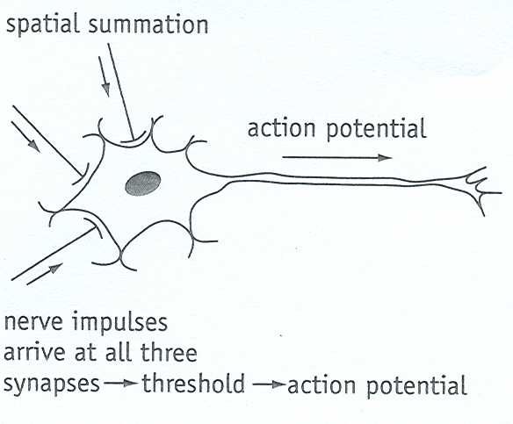Before answering study the diagram below:

Explain what is meant by temporal (over time) summation.

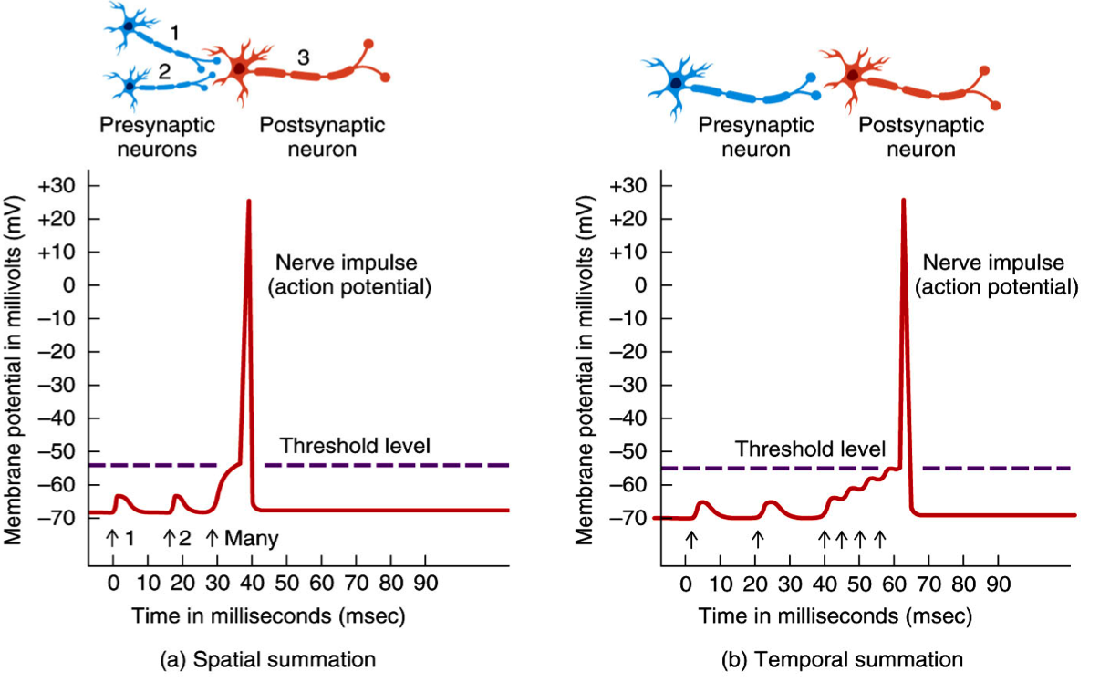

**Neuromuscular Junctions**

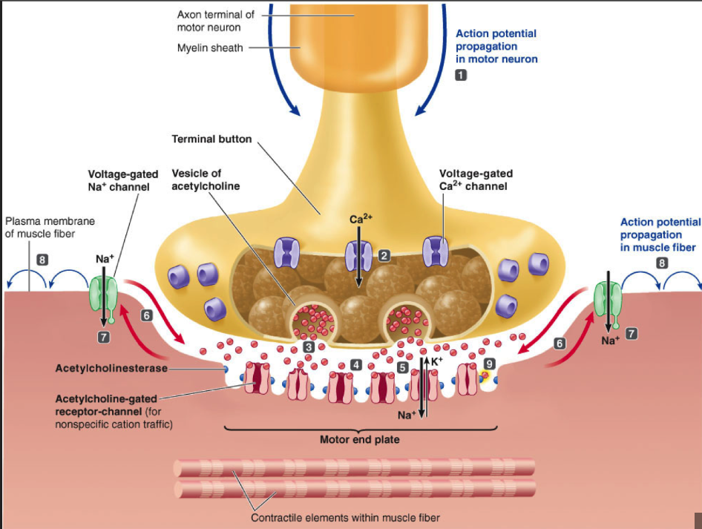This is the point when a motor neurone meets a skeletal muscle fibre. There are many of these junctions along a muscle fibre to ensure that the contraction of the muscle is fast and coordinated. All muscle fibres supplied by a single motor neurone act together as a single functional unit known as a motor unit. This arrangement gives control over the force that the muscle exerts. If only a slight force is needed, only a few units are stimulated. If a greater force is required, a larger number of units are stimulated.

* The motor nerve terminal contains synaptic vesicles, filled with neurotransmitter, which release their transmitter into the synaptic cleft at multiple specialised sites called active zones, in response to action potential firing.
* Released transmitter acts at receptors on the muscle membrane, which occur in high‐density clusters at the peaks of muscle membrane infoldings called junctional folds.
* Junctional folds are unique to the neuromuscular junction, increasing the reliability of transmission by localisation of acetylcholine receptors to the crests of the folds and enhancing the effect of depolarisation by localisation of sodium channels in the troughs.
* Schwann cells are essential for the development and maintenance of the neuromuscular junction and play important roles in the remodelling and regeneration of damaged neuromuscular junctions.
* Acetylcholinesterase in the synaptic cleft hydrolyses acetylcholine and limits the temporal and spatial effects of released of acetylcholine, ensuring precision of muscle control.
* Transmitter binding causes two types of electrical signals in skeletal muscle, miniature endplate potentials caused by the spontaneous release of a single vesicle of acetylcholine and larger endplate potentials. Endplate potentials are caused by activity‐dependent release of multiple transmitter‐filled vesicles and trigger action potential firing in, and thus contraction of, the muscle fibre.

***We will cover how a muscle fibre contracts in the next booklet.***

|  |  |
| --- | --- |
| Neuromuscular junction | Cholinergic synapse |
| Only excitatory | May be excitatory or inhibitory |
|  |  |
|  |  |
|  |  |
|  |  |
|  |  |

**Types of synapse**

**Excitatory synapses**

* Binding of neurotransmitter to postsynaptic neurone
* opens Na+ gated channels
* 🡪 Na+ diffuses **IN**
* 🡪depolarisation
* 🡪 action potentials
* so nerve impulses can continue around the nerve circuit.

**Inhibtory Synapse**

These synapses make it ***less likely*** that a new action potential will be created on the postsynaptic neurone.

* Binding of neurotransmitter to postsynaptic neurone opens Cl- and K+ gated channels
* 🡪 K+ diffuses **OUT** or Cl- diffuse IN
* 🡪 inside of neurone becomes even more – ve and so impossible to depolarise
* 🡪 no action potentials
* so nerve impulses cannot continue around the nerve circuit.

**Functions of Synapses**

* Synapses allow a single impulse from one neurone to initiate a new impulse in a number of different neurones at a synapse. This allows a single stimulus to create a number of simultaneous responses.
* Synapses allow a number of impulses to be combined at a synapse. This allows nerve impulses from receptors reacting to different stimuli to contribute to a single response.

**Effects of Drugs**

A **psychoactive drug** is a chemical substance that acts primarily on the central nervous system where it alters brain function resulting in temporary changes in perception, mood, consciousness and behaviour.

Most of these drugs were originally developed to be used therapeutically as medication. Because psychoactive substances bring about subjective changes in consciousness and mood that the user may find pleasant (e.g. euphoria) or advantageous (e.g. increased alertness), many psychoactive substances are abused, that is, used outside of the guidance of a medical professional and for reasons other than their original purpose. With sustained use physical dependence may develop, making the cycle of abuse even more difficult to interrupt.

Examples of psychoactive drugs include tobacco, cannabis, amphetamines, ecstasy, cocaine, heroin etc.

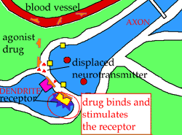**Interference with Synapse Action by Foreign Chemicals:**

Some substances can ENHANCE or BLOCK synaptic transmissions:

* **Excitory Drugs** – stimulate nervous system creating more action potentials in post-synaptic membranes

|  |  |  |
| --- | --- | --- |
| Synaptic disrupting type: | Explanation of term: | Specific example of action |
| Excitory |  |  |
| Inhibitory |  |  |

* **Inhibitory drugs** – create fewer action potentials in post-synaptic membranes

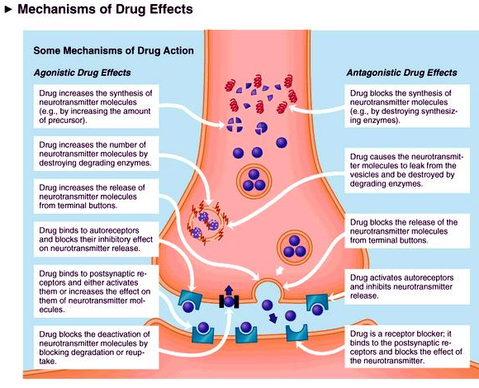

**The Effects of drugs on synapses**

The effect of a drug on the synapse depends on the type of transmitter

* A drug could inhibit the action of an excitory neurotransmitter and so fewer action potentials generated so a particular effect reduced
* A drug could inhibit an inhibitory neurotransmitter so more action potentials generated so a particular effect enhanced

If a drug is taken over a period of time then the synapse may be modified to adjust to its use. For example, if the drug blocks particular receptors at synapses, then new receptors may be made to make up for the ones that are no longer in use. This means that more drug has to be taken to have the same effect. This is known as tolerance to the drug. An increasing tolerance indicates an increase in dependency on the drug. Dependency occurs when, as a result of changes to the CNS, the individual can no longer manage without the drug. A distinction may be made between physical dependency and psychological dependency.

* Physical dependency occurs because there have been changes in the structure and the way the neurones of the brain work. If the individual stops taking the drug they suffer from withdrawal symptoms. Withdrawal from heroin produce some of the worst withdrawal symptoms.
* Psychological dependency is due to what is happening in the brain as a result of taking the drug. The individual does not experience withdrawal symptoms but they constantly crave the drug, in a similar way in which a person feels when they are very hungry or thirsty.

## The effect of drugs on synaptic transmissions

Discovering the chemical structure of neurotransmitters has given chemists an understanding of the action of drugs and poisons on the nervous system. There are many drugs that are known to influence the functioning of synaptic transmissions. An example is nicotine found in tobacco products. Nicotine is only one of 3500 different compounds found in tobacco smoke.

*Nicotine* Nicotine is part of a group of nitrogen-containing chemicals called **alkaloids**. Alkaloids have hydrocarbon-based skeletons, i.e. they contain mainly carbon and hydrogen atoms and are found in plants. Examples of other alkaloids are caffeine, morphine and cocaine.

Nicotine mimics the action of neurotransmitter chemicals like acetylcholine. Both molecules are based on hydrocarbon skeletons but the important fact about these structures is that they contain a nitrogen atom with a positive charge. This makes the structures very reactive in the part of the molecule that has the charge. Acetylcholine receptors on post-synaptic membranes will accept nicotine because it has a similar arrangement of is atoms and similar charge on the nitrogen atom.

When tobacco is burned, small droplets of tar containing nicotine are inhaled and find their way to the lungs and eventually to the alveoli or air sacs. Nicotine is a weak base (pH 8.5); its pH is adjusted when it enters the airway to match the pH of body fluids (pH 7.4).

It is rapidly absorbed through the fine membrane of the air sac and the mouth into the bloodstream. From this point nicotine is distributed very quickly throughout the body, taking about eight seconds to reach the brain. In the brain it creates a burst of activity amongst the acetylcholine receptors to give a feeling of pleasure.

The initial concentration of nicotine is high after one inhalation. It takes about 45 minutes for this concentration to be reduced by half. At low concentrations it acts as a stimulant at higher levels it acts as an inhibitor, i.e. it will prevent neurone stimulation.

When nicotine is bound to the postsynaptic receptor, it depolarises the membrane triggering the influx of sodium ions from surrounding tissues. This initiates a wave of action potentials as before.

However nicotine is not removed by hydrolysis so the stimulation is maintained, i.e. the flow of ions is maintained and other nerve transmissions cannot get through. Eventually nicotine is broken down mainly in the liver by **oxidation**, in a number of stages with the assistance of enzymes.

This over-stimulation happens at all axons exposed to nicotine and it has an effect on all organs and functions. One adverse effect of the over-stimulation of nerve fibres is the constriction of blood vessels, at the same time stimulating the heart making it beat faster and increasing the blood pressure.

As the level of nicotine falls the affected neurones have a chance to recover. However it is likely that long-term use of nicotine is likely to result will result in chronic illness or death as there will always be permanent tissue as well as nerve damage.