Name: ………………………………..

**3.6.3 Skeletal Muscle**

**Recall Activities**

These are activities to develop your recall of information you covered in the previous topics that are linked to skeletal muscles. You should do this before you start the work on this topic. Once you have done the recall activity quickly check your info/answers using your student booklets and notes from that topic.

**Topics covered**: Biological molecules, cell structure, transport across membrane, respiration

|  |  |  |  |
| --- | --- | --- | --- |
| **Topic** | **Recall activities** | **Understanding**  *Please write down any questions you have when completing this activity.* | **Completed** |
| **Biological molecules** | On the MWB/scrap paper, draw an ATP molecule. Draw the hydrolysis and condensation reaction between ADP and Pi. |  |  |
| **Cells** | On the MWB/scrap paper define facilitated diffusion and active transport. Draw simple diagrams to demonstrate each type of movement |  |  |
| On the MWB/scrap paper describe how the structure of different cells relate to their function |  |  |
| **Respiration** | On a scrap piece of paper/MWB draw a flow diagram of anaerobic respiration in animals |  |  |

[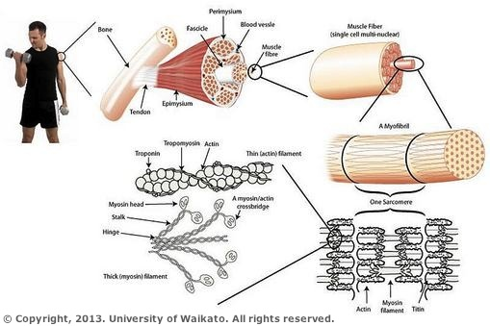](https://www.google.co.uk/url?sa=i&rct=j&q=&esrc=s&source=images&cd=&cad=rja&uact=8&ved=0ahUKEwjuq569jJfRAhUFzRQKHeSbC38QjRwIBw&url=http://sciencelearn.org.nz/Contexts/Sporting-Edge/Sci-Media/Images/Muscle-structure&bvm=bv.142059868,d.ZWM&psig=AFQjCNES9ed003bdju5gnsRFgQpElQMwWA&ust=1483021623255504)

**Specification Content Checklist**

|  |  |  |  |  |
| --- | --- | --- | --- | --- |
| **Key info** | **Topic: Skeletal mucles**  **Synoptic Link:** Biological molecules, cells, respiration | | | |
| **Step 1** | **Use the tutorial (GOL), presentation (GOL), video links and text book to complete the pack.** | | | |
| **Step 2** | **Specification Content Checklist** | **I understand this** | **I can recall this** | **I need to revisit this** |
| Muscles act in antagonistic pairs against an incompressible skeleton. |  |  |  |
| Gross and microscopic structure of skeletal muscle. The ultrastructure of a myofibril. |  |  |  |
| The roles of actin, myosin, calcium ions and ATP in myofibril contraction. |  |  |  |
| The roles of calcium ions and tropomyosin in the cycle of actinomyosin bridge formation. (The role of troponin is not required.) |  |  |  |
| The roles of ATP and phosphocreatine in muscle contraction. |  |  |  |
| The structure, location and general properties of slow and fast skeletal muscle fibres. |  |  |  |
| **Step 3** | **In lesson:** you will be undertaking activities to develop your understanding of the specification content and able to add to your notes.  **Revision:** make sure that you have resources available to re-learn and memorise the subject content above | | | |

**Structure of Skeletal Muscle**

**Types of muscle**

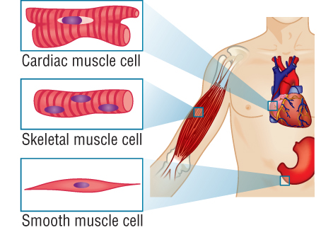

**Skeletal muscle** (striated, voluntary, striped)

This is always attached to the skeleton, and is under voluntary control via the motor neurones of the somatic nervous system. It can be subdivided into red (slow) muscle and white (fast) muscle.

**Cardiac Muscle**

This is a special type of red skeletal muscle. It looks and works much like skeletal muscle, but is not attached to skeleton, and is not under voluntary control.

**Smooth Muscle**

This is found in internal body organs such as the wall of the gut, the uterus, blood arteries, the iris, and glandular ducts. It is under involuntary control via the autonomic nervous system or hormones. Smooth muscle usually forms a ring, which tightens when it contracts, so there is no need of a skeleton to pull against.

**Questions**

1. Complete the labels in the diagram below

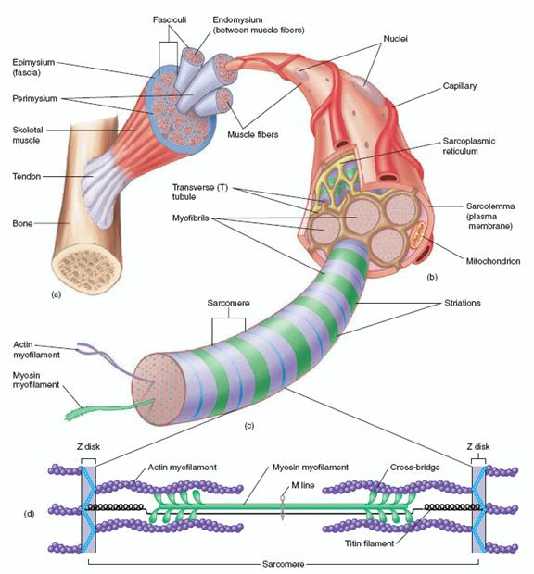

1. 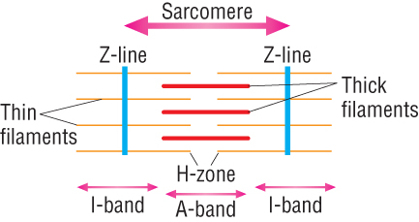Complete the diagrams of the transverse sections of the sarcomere below to show the arrangement of protein filaments (actin and myosin).

[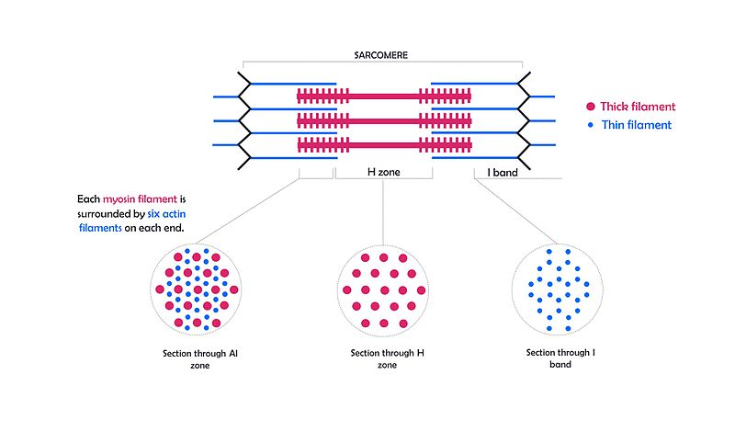](https://upload.wikimedia.org/wikipedia/commons/3/35/Transverse_sections_through_part_of_a_myofibril.jpg)

1. Suggest a reason why there are numerous mitochondria in the sarcoplasm.

………………………………………………………………………………………………………………………………………………………………………………………………………………………………………………………………………………………………………………………………………………………………………………………………………………………………………………………………

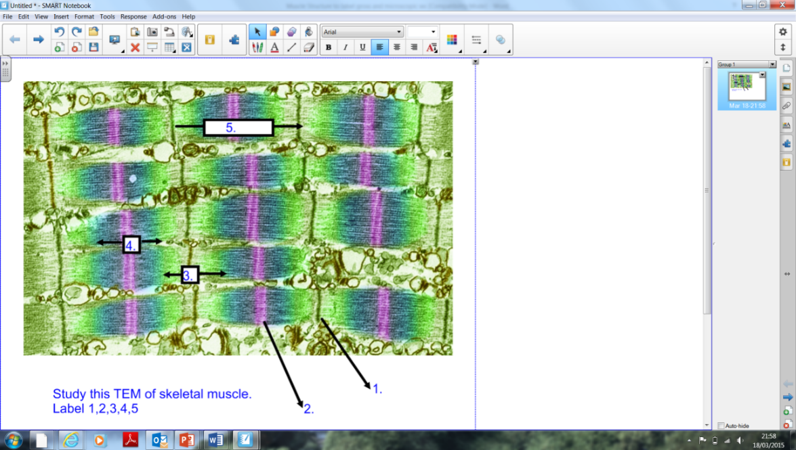

1. Study the TEM image below and name the structures numbered 1-5.

1 ………………………………………..

2 ………………………………………..

3 ………………………………………..

4 ………………………………………..

5 ………………………………………..

1. 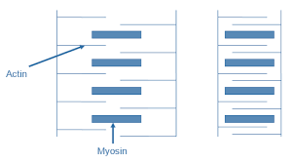Label the protein present in the filaments below.
2. What are the dark and light bands called?

Light band: ……………………………………………………………………

Dark band: …………………………………………………………………….

1. Annotate the figure below to explain the relationship between a muscle, muscle fibres, myofibrils, actin and myosin filaments and a sarcomere.



**Muscles under a light microscope**.

* Using high magnification draw a tissue diagram of a muscle fibre
* Label the diagram
* Using an eye piece graticule, calculate the actual size of a sarcomere

**Different Types of Muscle Fibres**

Complete the table below using the phrases to help.

|  |  |
| --- | --- |
| **Slow twitch fibres** | **Fast twitch fibres** |
|  |  |
|  |  |
|  |  |
|  |  |
|  |  |
|  |  |
|  |  |

* Contract more rapidly
* Contract more slowly
* Endurance role
* Intense exercise
* Redder in colour (large store of myoglobin)
* Less red in colour
* Thicker and more numerous myosin
* Less myosin
* Aerobic respiration dominates ( lots of mitochondria)
* Anaerobic respiration dominates (fewer mitochondria)
* Good supply of glycogen
* Small amounts of glycogen
* More blood vessels to supply oxygen and glucose
* Less blood vessels

**Glossary of Key Terms**

|  |  |
| --- | --- |
| **Key word** | **Definition** |
| Slow twitch/ fast twitch fibres |  |
| Isotropic |  |
| Anisotropic |  |
| Myofibrils |  |
| Myosin |  |
| Actin |  |
| Myoglobin |  |
| Sarcoplasm |  |
| Sarcomere |  |

**Neuromuscular Junction**

Using the animation from the skeletal muscle presentation to make notes on the stages below.

Label the following on the diagrams:

*Motor neurone, muscle fibre, Ca2+ channels, vesicle of acetylcholine, presynaptic membrane, post synaptic membrane, T-tubule, sarcomere shortens*

|  |  |  |  |
| --- | --- | --- | --- |
|  | 1 |  | 2 |
|  | 3 |  | 4 |
|  | 5 |  | 6 |
|  | 7 |  |  |

**Evidence for Sliding Filament Mechanism**

When muscles contract:

The I-band ………………………………..

The Z-line move closer together so the sarcomere ………………………..

The H-zone …………………………………..

The A-band ………………………………..

The A-band represents the width of the myosin filaments and therefor this indicates that the filaments are not in themselves becoming shorter so there must be another mechanism taking place.

**Structure of Actin and Myosin**

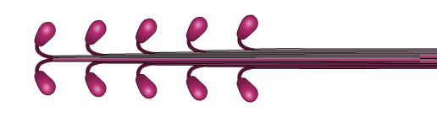

**Myosin filament**

fibrous protein made up of several hundred molecules

**Myosin head**

globular protein

The **myosin** filament is formed from a number of myosin proteins wound together. Each ends in a myosin head, which contains an ATPase.

The **actin** filament is formed from globular protein whose molecules are arranged in long chains that are twisted into a helix.

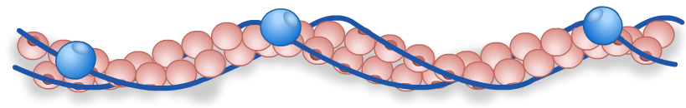

**Troponin –** not needed for your spec

**Tropomyosin –** long thin threads that are wound around the actin filament

**Myosin head binding site**

**Actin sub-unit**

**Muscle Contraction**

The figure below shows an outline of the sliding filament theory. To complete the diagram

you should:

i colour in the key first, then colour the same molecules in the main diagram. The colour

codes are given for each molecule involved in the cycle

**ii** annotate the diagram with notes, explaining what is happening at each stage

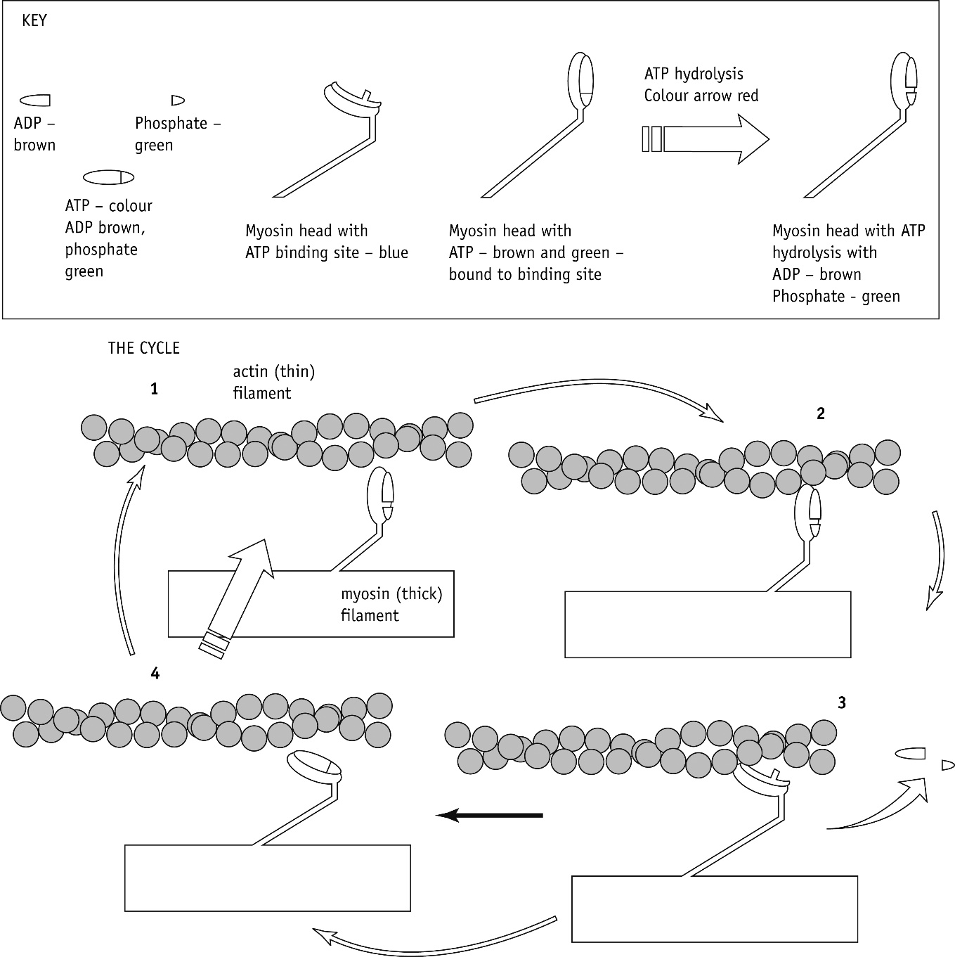**iii** add an arrow to the diagram at the correct stage to show the direction of movement of the

actin filament.

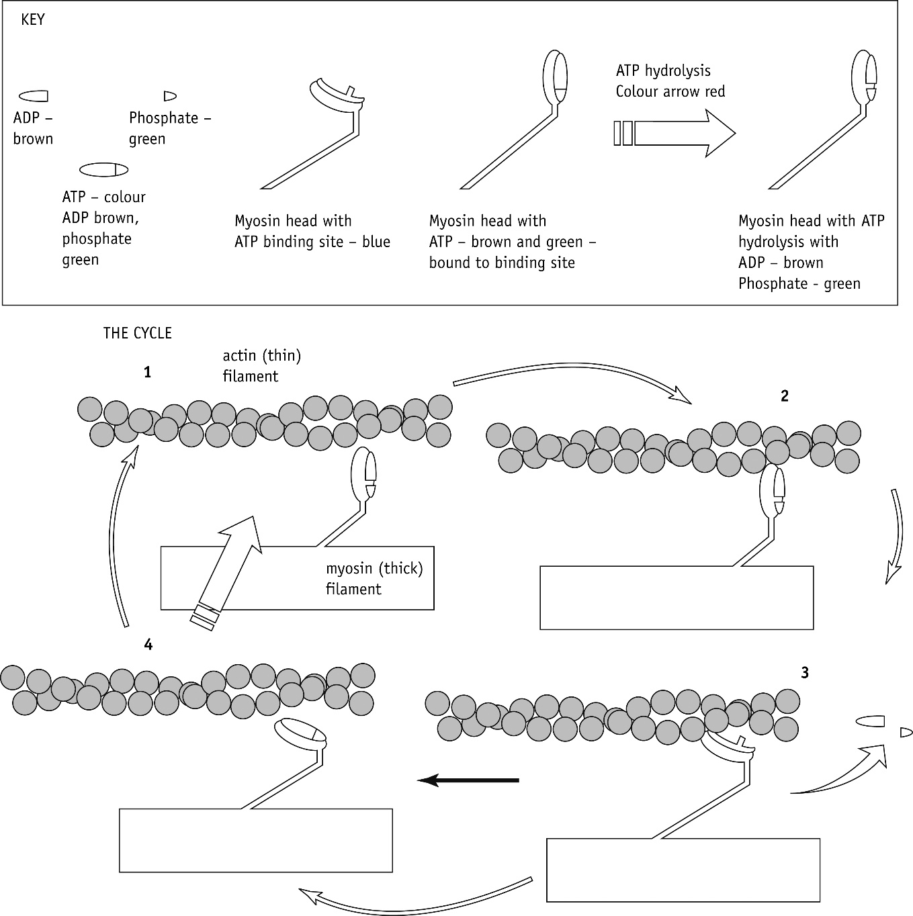

Sequence the events in the correct order to explain how a muscle contracts (A-H)

|  |  |
| --- | --- |
|  | Ca2+ activate ATPase which hydrolyses ATP to ADP providing energy for the myosin head to return to its original position. |
|  | Ca2+ cause tropomyosin molecules to pull away from the binding sites on the actin filament |
|  | An action potential travels into the T-tubules within the muscle fibre. |
|  | The myosin head (with ADP) reattaches further along the actin filaments and the cycle is repeated as long as there is Ca2+. |
|  | ADP molecules attached to myosin heads allow them to bind to the actin filament and form a cross-bridge |
|  | The action potential opens Ca2+ channels on the endoplasmic (sarcoplasmic) reticulum and Ca2+ diffuse into sarcoplasm down a concentration gradient. |
|  | An ATP attaches to the myosin head causing it to detach from the actin. |
|  | Once attached the myosin heads changes angle, pulling the actin filament along and releases an ADP molecule. |

**Muscle Relaxation**

* When nervous stimulation ceases, Ca2+ are actively transported back into the endoplasmic reticulum.
* Tropomyosin blocks the actin filament again
* Myosin heads can’t bind any more, the muscle relaxes
* Antagonistic muscles can pull actin filaments out from between myosin.

**Energy supply during muscle contraction**

List the 3 ways in which ATP can be supplied to skeletal muscles.

1.

2.

3.

**Antagonistic Muscles**

Attached to bone by tendons (collagen) – transmit muscle force to the bone

Skeleton provides leverage

Relaxed muscle is compliant (can be stretched)

Since muscles can only pull (not push), they work in pairs called antagonistic muscles. Muscles are either relaxed or contracted.

Contracted muscle exerts a pulling force, causing it to shorten or generate force

The muscle that bends (flexes) the joint is called the flexor muscle

The muscle that straightens (extends) the joint is called the extensor muscle.

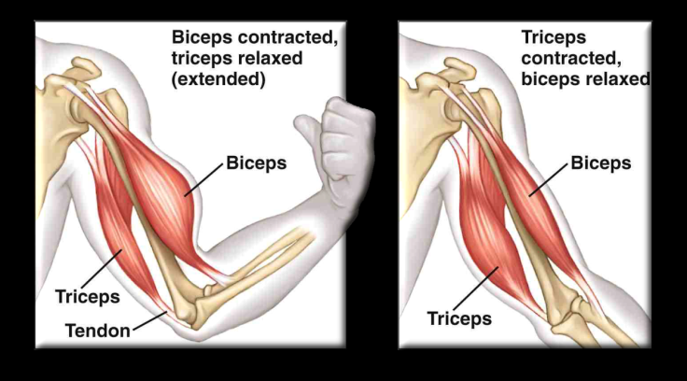

**Elbow joint extended**

Extensor muscles contracted

Flexor muscles relaxed

**Elbow joint flexed**

Flexor muscles contracted

Extensor muscled relaxed