**3.6.4 Homeostasis is the maintenance of a stable internal environment**

**Recall Activities**

These are activities to develop your recall of information you covered in the previous topics that are linked to homeostasis. You should do this before you start the work on this topic. Once you have done the recall activity quickly check your info/answers using your student booklets and notes from that topic.

**Topics covered**: Biological molecules, transport across membranes, mass transport in animals, digestion

|  |  |  |  |
| --- | --- | --- | --- |
| **Topic** | **Recall activities** | **Understanding**  *Please write down any questions you have when completing this activity.* | **Completed** |
| **Biological molecules** | On the MWB/scrap paper, draw alpha and beta glucose |  |  |
| On the MWB/scrap paper, draw simplified diagrams to show the structure of proteins |  |  |
| On the MWB/scrap paper define osmosis and draw a diagram showing how water moves across membranes in differing water potentials. |  |  |
| **Digestion** | On the MWB/scrap paper, draw a diagram of the protein channels involved in co-transport of amino acids from the lumen of the ileum into the blood |  |  |
| **Mass transport** | On the MWB/scrap paper, draw a diagram of simplified diagram of the human circulatory system labelling the main arteries and veins |  |  |

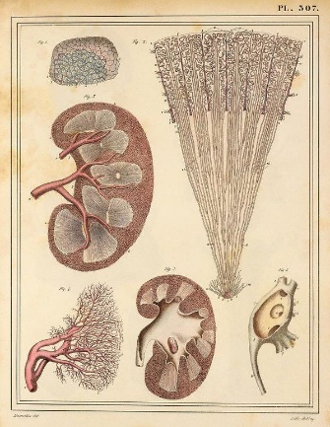

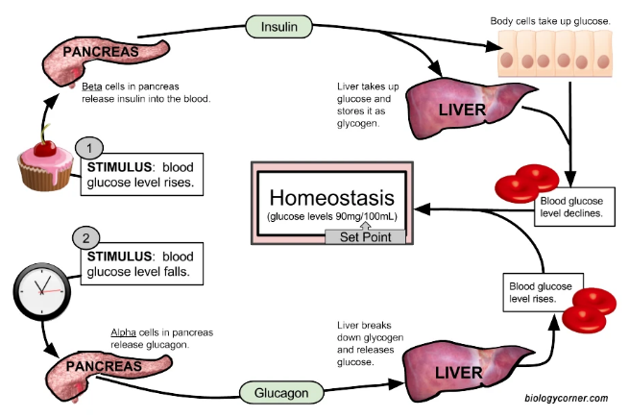

**Specification Content Checklist**

|  |  |  |  |  |
| --- | --- | --- | --- | --- |
| **Key info** | **Topic: Homeostasis**  **Synoptic Link:** Biological molecules, transport across membranes, mass transport in animals, digestion | | | |
| **1** | **Use the tutorial (GOL), presentation (GOL), video links and text book to complete the pack.** | | | |
| **Step 2** | **Specification Content Checklist** | **I understand this** | **I can recall this** | **I need to revisit this** |
| **3.6.4.1 Principles of homeostasis and negative feedback**  Homeostasis in mammals involves physiological control systems that maintain the internal environment within restricted limits. |  |  |  |
| The importance of maintaining a stable core temperature and stable blood pH in relation to enzyme activity. |  |  |  |
| The importance of maintaining a stable blood glucose concentration in terms of availability of respiratory substrate and of the water potential of blood. |  |  |  |
| Negative feedback restores systems to their original level. |  |  |  |
| The possession of separate mechanisms involving negative feedback controls departures in different directions from the original state, giving a greater degree of control. |  |  |  |
|  | **Control of blood glucose concentration**  The factors that influence blood glucose concentration. |  |  |  |
|  | The role of the liver in glycogenesis, glycogenolysis and gluconeogenesis. |  |  |  |
|  | The action of insulin by:   * attaching to receptors on the surfaces of target cells * controlling the uptake of glucose by regulating the inclusion of channel proteins in the surface membranes of target cells * activating enzymes involved in the conversion of glucose to glycogen. |  |  |  |
|  | The action of glucagon by:   * attaching to receptors on the surfaces of target cells * activating enzymes involved in the conversion of glycogen to glucose * activating enzymes involved in the conversion of glycerol and amino acids into glucose. |  |  |  |
|  | The second messenger model of adrenaline and glucagon action, involving adenylate cyclase, cyclic AMP (cAMP) and protein kinase. |  |  |  |
|  | The causes of types I and II diabetes and their control by insulin and/or manipulation of the diet. |  |  |  |
|  | **Required practical 11:** Production of a dilution series of a glucose solution and use of colorimetric techniques to produce a calibration curve with which to identify the concentration of glucose in an unknown ‘urine’ sample. |  |  |  |
|  | **3.6.4.3 Control of blood water potential**  Osmoregulation as control of the water potential of the blood. |  |  |  |
|  | The roles of the hypothalamus, posterior pituitary and antidiuretic hormone (ADH) in osmoregulation. |  |  |  |
|  | The structure of the nephron and its role in:   * the formation of glomerular filtrate * reabsorption of glucose and water by the proximal convoluted tubule * maintaining a gradient of sodium ions in the medulla by the loop of Henle * reabsorption of water by the distal convoluted tubule and collecting ducts. |  |  |  |
| **Step 3** | **In lesson:** you will be undertaking activities to develop your understanding of the specification content and able to add to your notes.  **Revision:** make sure that you have resources available to re-learn and memorise the subject content above | | | |

**3.6.4.1: Principles of homeostasis and negative feedback**

Define homeostasis

What is meant by **the internal environment** of an organism?

______________________________________________________________________________________________________________________________________________________

List seven factors that must be controlled in the body of a mammal.

1._________________________________________________

2._________________________________________________

3._________________________________________________

4._________________________________________________

5._________________________________________________

6._________________________________________________

7._________________________________________________

Why is homeostasis important?

______________________________________________________________________________________________________________________________________________________

Examples of homeostasis:

1. __________________________________________________________________________________________________________________________________________
2. __________________________________________________________________________________________________________________________________________
3. __________________________________________________________________________________________________________________________________________

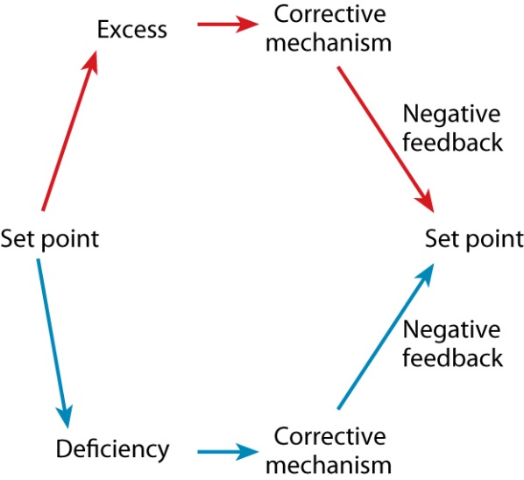**Negative Feedback**

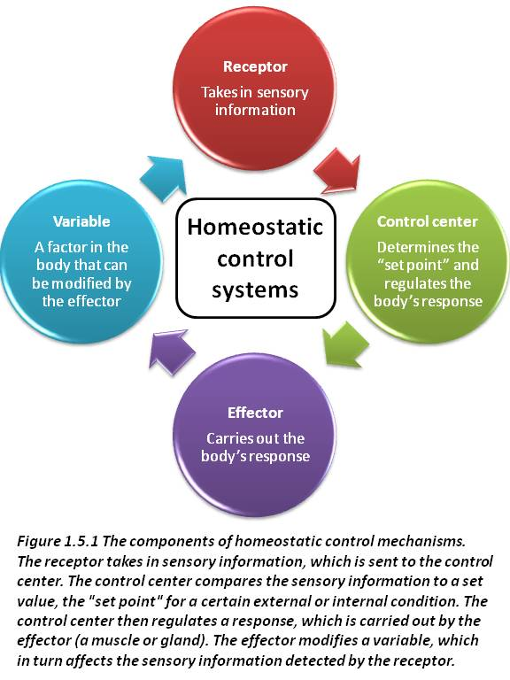

Negative feedback is a primary mechanism of homeostasis. When there is a change in a monitored physiological variable a response is triggered to counteract the initial fluctuation, restoring it to its normal level.

Negative feedback is necessary to provide the optimum conditions for the body. It prevents a runaway situation and ensures a more or less constant internal environment.

If negative feedback cannot occur then the body will not function correctly. For example, if the body does not produce insulin then blood sugar levels will be too high, sugar will be excreted and blood cells will not flow so easily and so cholesterol will be deposited and cells will not receive their supply of nutrients and oxygen.

[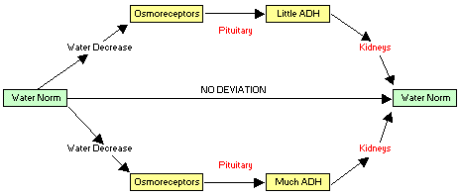](http://www.google.co.uk/url?sa=i&rct=j&q=&esrc=s&frm=1&source=images&cd=&cad=rja&docid=2Eb6Vjlk0QfLcM&tbnid=NDrjT5qLr7PjTM:&ved=0CAUQjRw&url=http://www.biology-online.org/4/2_water_homeostasis.htm&ei=kEYXUt_NG6KM0AWZ5YHADA&psig=AFQjCNG-0O5WbZxc8lDaukT8kfq-_E-MKA&ust=1377343474870679)

[*negative feedback podcast*](https://www.youtube.com/watch?v=CLv3SkF_Eag)

What are the three parts of a feedback system?

1._________________________________________________

2._________________________________________________

3._________________________________________________

Describe the parts of the negative feedback loop responsible for maintaining a steady body temperature.

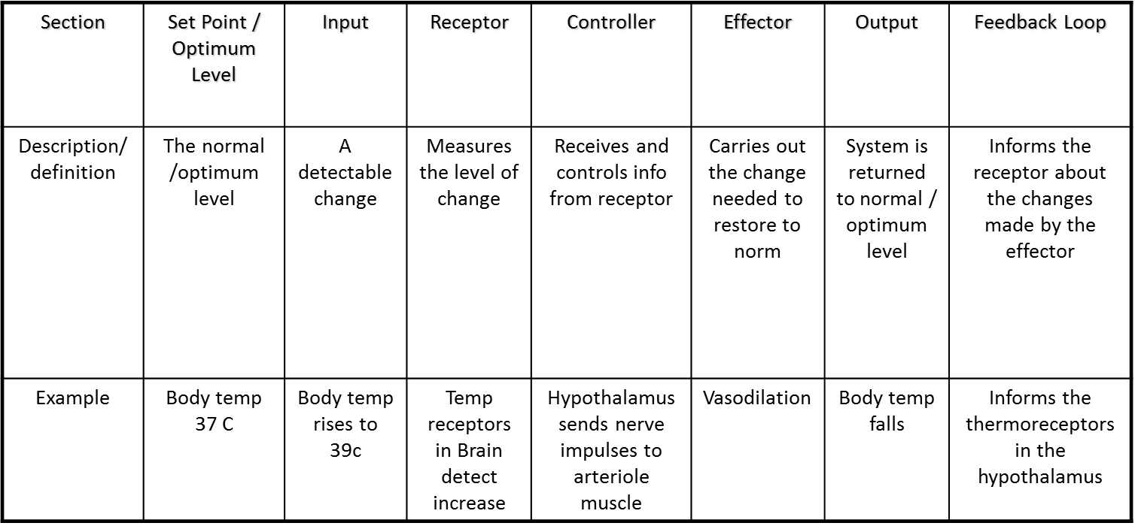

**Positive Feedback:**

Why are examples of positive feedback rare in biology?

_________________________________________________________________________________________________________________________________________________________________________________________________________________________________

**3.6.4.2: Control of blood glucose**

Your normal blood glucose level is _________________

What could alter it?

____________________________________________________________________________________________________________________________________________________________________________________________________________________________________________________________________________________________________________

**The role of the pancreas:**

1)_________________________________________________________________________

2)_________________________________________________________________________

3)_________________________________________________________________________

Blood glucose levels have to be kept within a small range, otherwise there are adverse effects on health

|  |  |  |
| --- | --- | --- |
|  | High blood glucose | Low blood glucose |
| Effects on health |  |  |

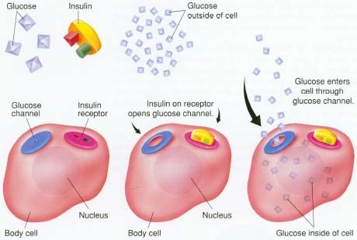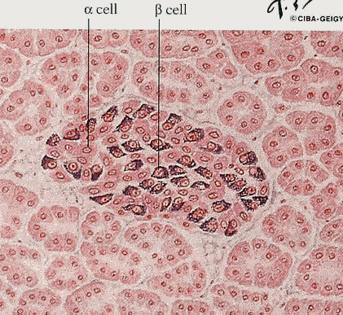

Describe the effect that insulin has on cells:

____________________________________________________________________________________________________________________________________________________________________________________________________________________________________________________________________________________________________________

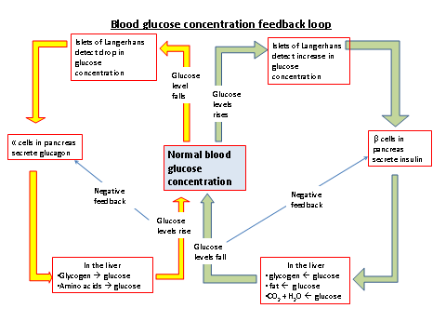

|  |  |  |  |
| --- | --- | --- | --- |
|  | Glycogenesis | Glycogenolysis | Gluconeogenesis |
| When does it happen? |  |  |  |
| What reactions are involved? |  |  |  |
| What is the effect on blood glucose concentration? |  |  |  |

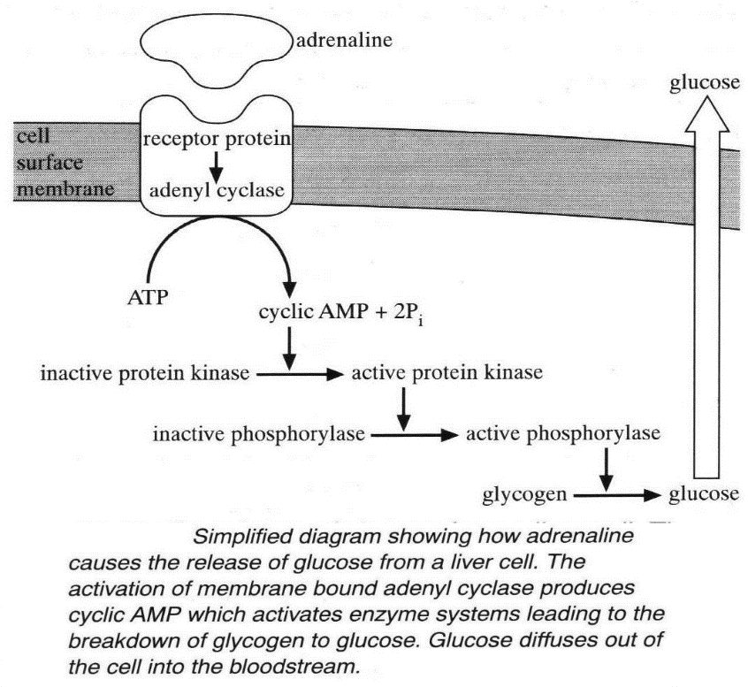The Second Messenger Model:

1. Second Messenger Flow Diagram:
2. Name the 1st messenger molecule in this system.

__________________________________________

1. What other hormone could also act as the 1st messenger?

__________________________________________

1. Name the 2nd messenger in this system.

__________________________________________

1. What is the advantage of using a 2nd messenger?

__________________________________________________________________________________

__________________________________________________________________________________

1. What is an advantage of glucagon being broken down within minutes of being secreted?

__________________________________________________________________________________

1. Why is it necessary to prevent blood glucose levels

  a) getting too high?

__________________________________________________________________________________

b) Getting too low?

__________________________________________________________________________________

Summary Table:

|  |  |
| --- | --- |
| **Increased Blood Glucose** | **Decreased Blood Glucose** |
| Caused by | Caused by |
| Responses | Responses |

**Diabetes:**

What are the symptoms of diabetes?

____________________________________________________________________________________________________________________________________________________________________________________________________________________________________________________________________________________________________________

Complete the table to summarise the differences between type 1 and type 2 diabetes:

|  |  |  |
| --- | --- | --- |
|  | Type 1 | Type 2 |
| Cause |  |  |
| Who it affects |  |  |
| How is it managed? |  |  |

**3.6.4.3: Control of Blood Water Potential**

Extension reading BSR vol 16 2nd November 2003 “The kidney”

Study the diagrams below and state exactly where the kidneys are located in the human body.

______________________________________________________________________________________________________________________________________________________

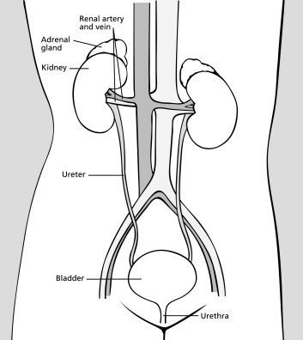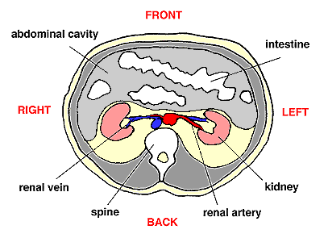

**Kidney Dissection Lab**

In this lab activity fresh sheep kidneys will be dissected. Hygiene is crucial when dealing with fresh specimens. Gloves will be provided and hand washing with soap and warm water must be performed before leaving the class. You will need to draw diagrams of your kidney during the dissection. Consider having one gloved hand to touch the kidney, leaving your writing hand free to write.

**Aim:** to dissect a sheep’s kidney to observe the internal structures

**Method:**

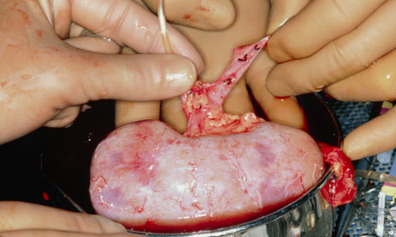**Part 1:** *before you make any cuts…*

1. Place the kidney on the dissecting tray. Examine its external features. It should be possible to locate and identify three tubes entering or leaving the kidney.
2. Draw a labelled diagram (on the next page) of the external features of the kidney.

Diagram 1: _______________________________________________________

|  |
| --- |
|  |

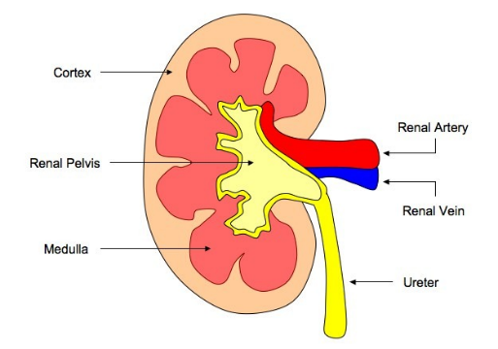**Part 2:**

1. Use a scalpel to cut the kidney in half lengthways by making an incision just to one side of the tubes. Examine each of the cut surfaces. Try to identify the internal structures shown the diagram to the right.
2. Draw a labelled diagram (below) of the internal structures of the kidney. Include comments about the differences in appearance of the cortex and the medulla.

Diagram 2: _______________________________________________________

|  |
| --- |
|  |

**Part 3:**

1. Dispose of your dissected kidney in the appropriate manner.
2. Dispose of your gloves and then wash your hands

**Extension**

If you finish early, research and answer the following questions in your workbook:

1. List three kidney diseases
2. Dialysis is often used to treat kidney diseases. Describe how dialysis works.
3. How often does a kidney disease patient need to have dialysis?
4. Patients with kidney diseases are often on a transplant list. Imagine you had a kidney disease and were receiving dialysis. Why might you hope to get an organ donation?

Give two reasons why kidneys are important.

1._________________________________________________________________________ _________________________________________________________________________

2._________________________________________________________________________ _________________________________________________________________________

The two main parts of the kidney are the cortex and the _________________________.

The basic functional unit of a kidney is known as a __________________.

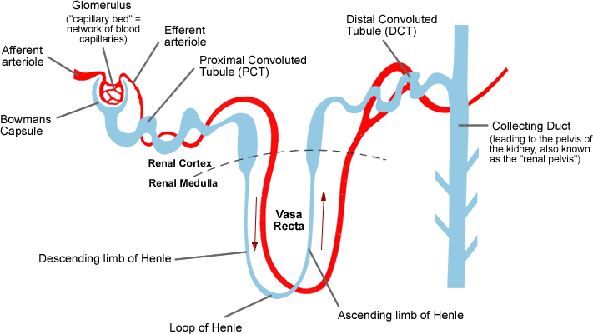

The nephron spans both the cortex and the medulla.

Complete the table to show which parts of the nephron are located in the cortex and which parts are located in the medulla. Some parts may span both.

|  |  |  |
| --- | --- | --- |
| Parts of the nephron in the CORTEX | Parts of the nephron in the MEDULLA | Parts of the nephron spanning both CORTEX AND MEDULLA |
|  |  |  |
|  |  |  |
|  |  |  |
|  |  |  |

List the four functions of the kidney and the part of the nephron which carries out the function.

1._________________________________________________

2._________________________________________________

3._________________________________________________

4._________________________________________________

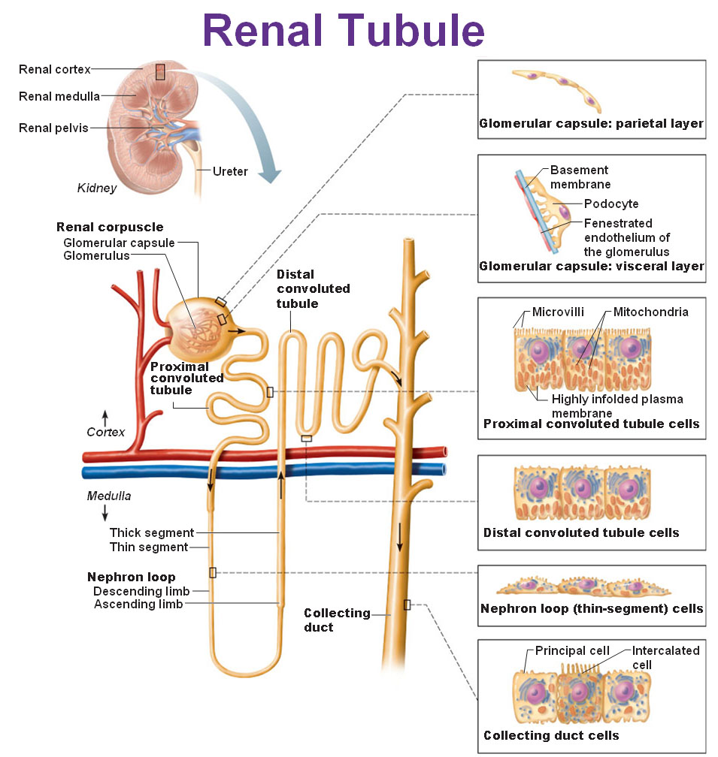

Which blood vessel supplies the kidney?

________________________________

How do the contents of this blood vessel differ to the contents of the vein leaving the kidney?

________________________________

________________________________

________________________________

________________________________

________________________________

________________________________

________________________________

________________________________

________________________________

The renal artery subdivides to form numerous smaller arterioles.

What is the name given to the arteriole taking blood TO the nephron?

___________________________________________________________________________

How does the structure of the arteriole supplying the nephron differ to that of the arteriole taking blood away from the nephron?

_________________________________________________________________________________________________________________________________________________________________________________________________________________________________

How is the arrangement and structure of the blood vessels inside the Bowmans capsule suited to the process of ultrafiltration?

______________________________________________________________________________________________________________________________________________________

What develops as a result of this difference in structure of the two arterioles?

______________________________________________________________________________________________________________________________________________________

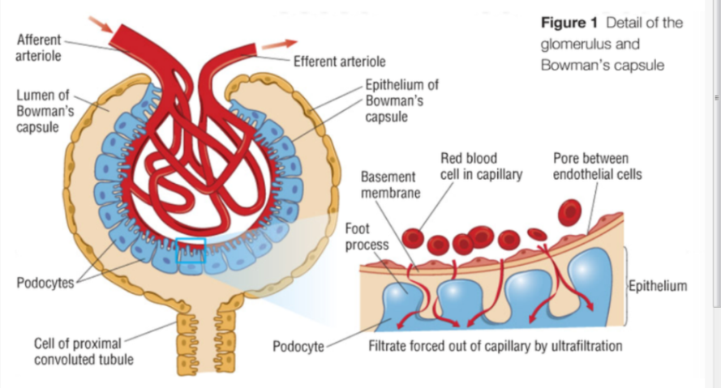Each capillary in the glomerulus is surrounded and supported by a very special type of cell called a **podocyte**

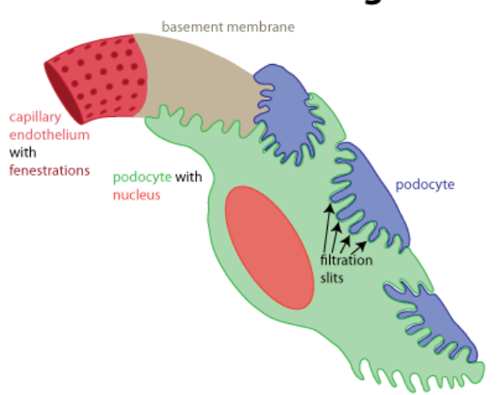

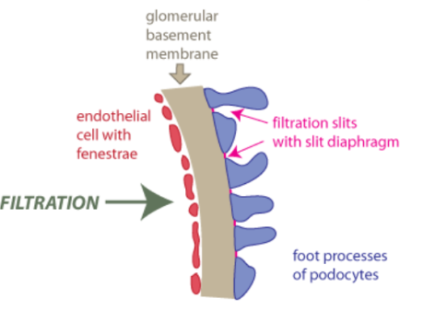

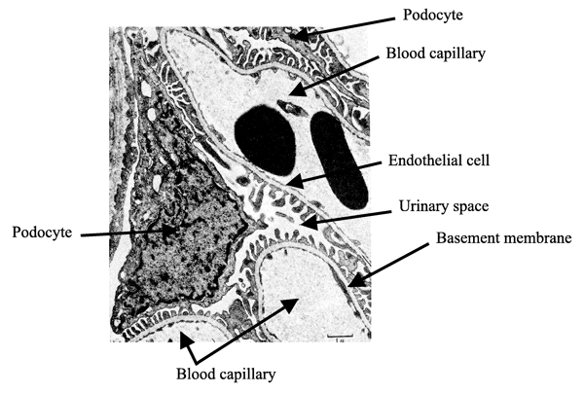Study the electron micrograph carefully. Which structure lies between the podocytes and the endothelial cells of the capillaries?

____________________________

This structure is very important because it is the TRUE FILTER of the nephron.

Complete the table to show which components of the blood leave as a result of Ultra filtration and which remain in the blood.

|  |  |
| --- | --- |
| Chemicals that leave the blood by ultrafiltration | Chemicals and structures that do not leave the blood by ultrafiltration |
|  |  |
|  |  |
|  |  |
|  |  |
|  |  |
|  |  |

Give the definition of ultrafiltration.

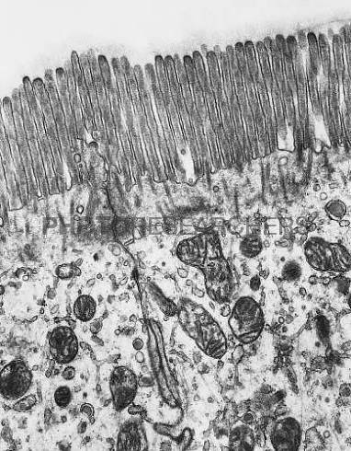Selective reabsorption by the cells of the proximal convoluted tubule.

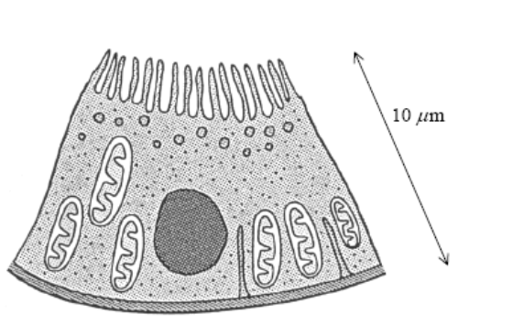

Name four materials that are reabsorbed by the cells of the proximal convoluted tubule?

1._________________________________________________

2._________________________________________________

3._________________________________________________

4._________________________________________________

Is the reabsorption of water active or passive?

__________________________________________________

Is the reabsorption of glucose and sodium ions active or passive?

__________________________________________________

Look at the micrograph of a cell of the proximal convoluted tubule and list two adaptations that are easy to see.

1._______________________________________________

2._______________________________________________

List two other adaptations of the cells.

1._________________________________________________________________________ _________________________________________________________________________

2._________________________________________________________________________ _________________________________________________________________________

Once glucose and amino acids have been taken up into the cells of PCT how do they get into the blood of the vasa recta? Give a reason for your answer.

_________________________________________________________________________________________________________________________________________________________________________________________________________________________________

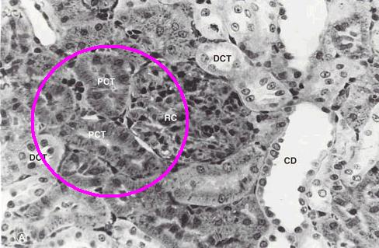

The cells of the Distal convoluted tubule are very similar to those of the Proximal convoluted tubule but there is one important difference. Look at the electron micrograph and see if you can spot the difference.

Difference________________________

_________________________________

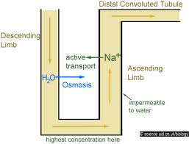

**The loop of Henlé**

In which part of the kidney is the loop of Henlé found?

_______________________

What is the shape of the loop of Henlé?

________________________________________________

How do the descending and ascending limbs differ in their structure?

______________________________________________________________________________________________________________________________________________________

How does this difference in structure affect their functioning?

_________________________________________________________________________________________________________________________________________________________________________________________________________________________________

Complete the table to show how does the blood (NOT FILTRATE) leaving the glomerulus differ to that which enters it?

|  |  |  |
| --- | --- | --- |
|  | Blood entering the glomerulus | Blood leaving the glomerulus |
| Water potential |  |  |
| glucose |  |  |
| Amino acids |  |  |
| urea |  |  |
| Sodium ions |  |  |

Name the method by which water leaves the loop of Henlé.

________________________________________________

What happens to the water potential of the tissue fluid of the Medulla when sodium ions move out of the ascending loop of Henlé?

_________________________________________________________________________________________________________________________________________________________________________________________________________________________________

What happens to the water potential of the filtrate when sodium ions move out of it?

______________________________________________________________________________________________________________________________________________________

What happens to the water potential of the filtrate when water moves out of it?

___________________________________________________________________________

___________________________________________________________________________

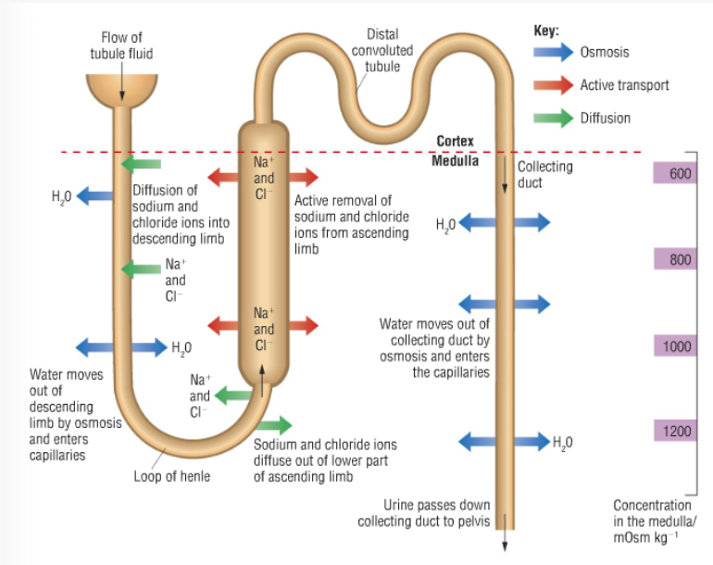

How do sodium ions move out of the filtrate at the apex of the loop of Henlé and why?

______________________________________________________________________________________________________________________________________________________

How do sodium ions move out of the loop of Henlé near the distal convoluted tubule? Give a reason why?

_________________________________________________________________________________________________________________________________________________________________________________________________________________________________

What is meant by the counter current multiplier mechanism/effect?

____________________________________________________________________________________________________________________________________________________________________________________________________________________________________________________________________________________________________________

***Extension reading BSR vol 12 May 2000 “Homeostasis”***

What is an endocrine gland?

______________________________________________________________________________________________________________________________________________________

Give an example of an endocrine gland?

______________________________________________________________________________________________________________________________________________________

The kidney under the influence of a hormone called Anti-diuretic hormone brings about osmoregulation.

What is the trigger for the stimulation of the POSTERIOR LOBE OF THE PITUITARY GLAND?

______________________________________________________________________________________________________________________________________________________

What structures detect this change?

___________________________________________________________________________

Where are these structures located and what do they do in response to the change?

_________________________________________________________________________________________________________________________________________________________________________________________________________________________________

Which hormone does the posterior lobe of the pituitary gland store?

__________________________________________________

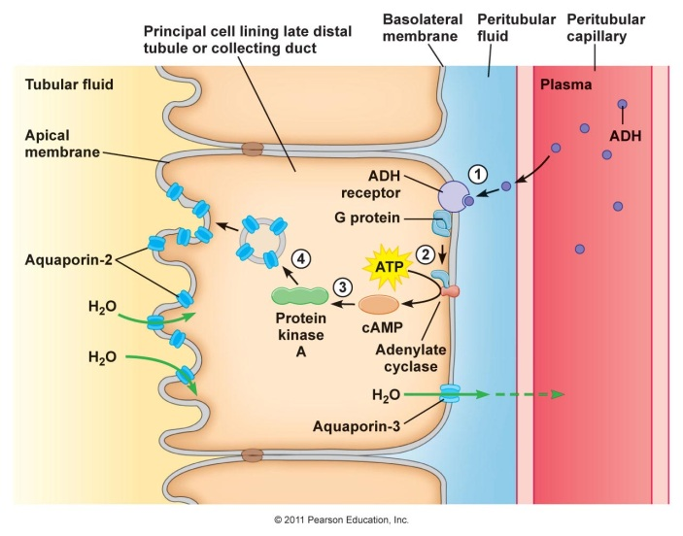

Study the diagram and describe the effect of the presence of Antidiuretic hormone in the blood/tissue fluid that reaches the collecting duct.

____________________________________________________________________________________________________________________________________________________________________________________________________________________________________________________________________________________________________________

___________________________________________________________________________

What will cause the posterior pituitary gland to stop releasing

___________________________________________________________________________

What term is used in the diagram below is the equivalent of “water potential”?

___________________________________________________________________________

What do the up arrows mean?

______________________________________________________________________________________________________________________________________________________

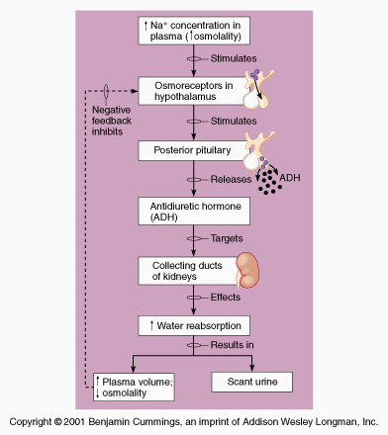

Diagram v. micrograph – you must be able to recognise the structures in the micrograph.

Observe your own slide to identify all the structures in the kidney

