**Q1.**

The resting potential of a neurone is maintained by the unequal distribution of ions inside and outside the plasma membrane. The diagram shows the plasma membrane of a neurone and the three different proteins that are involved in maintaining the resting potential.

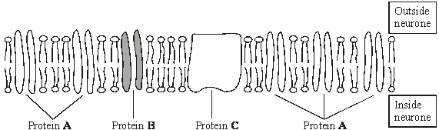

(a)     Protein **C** requires ATP to function. Describe the role of protein **C**.

___________________________________________________________________

___________________________________________________________________

___________________________________________________________________

___________________________________________________________________

**(2)**

(b)     (i)      Proteins **A** and **B** differ from each other. Explain why different proteins are required for the diffusion of different ions through the membrane.

______________________________________________________________

**(2)**

(ii)     The plasma membrane of the neurone is more permeable to potassium ions than to sodium ions. Give the evidence from the diagram that supports this observation.

______________________________________________________________

______________________________________________________________

______________________________________________________________

______________________________________________________________

**(1)**

**(Total 5 marks)**

**Q2.**

During an action potential, the permeability of the cell-surface membrane of an axon changes. The graph shows changes in permeability of the membrane to sodium ions (Na+) and to potassium ions (K+) during a single action potential.

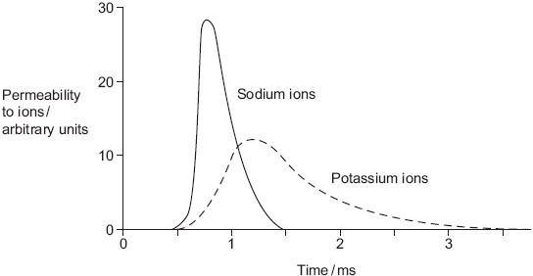

(a)     Explain the shape of the curve for sodium ions between 0.5 ms and 0.7ms.

___________________________________________________________________

___________________________________________________________________

___________________________________________________________________

___________________________________________________________________

___________________________________________________________________

**(3)**

(b)     During an action potential, the membrane potential rises to +40 mV and then falls. Use information from the graph to explain the fall in membrane potential.

___________________________________________________________________

___________________________________________________________________

___________________________________________________________________

___________________________________________________________________

___________________________________________________________________

**(3)**

(c)     After exercise, some ATP is used to re-establish the resting potential in axons. Explain how the resting potential is re-established.

___________________________________________________________________

___________________________________________________________________

___________________________________________________________________

**(2)**

**(Total 8 marks)**

**Q3.**

The diagram shows the change in the charge across the surface membrane of a non-myelinated axon when an action potential is produced.

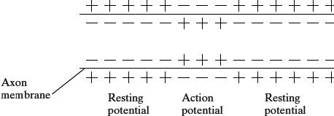

(a)     Describe how the change shown in the diagram occurs when an action potential is produced.

___________________________________________________________________

___________________________________________________________________

___________________________________________________________________

___________________________________________________________________

**(2)**

(b)     Explain what causes the conduction of impulses along a non-myelinated axon to be slower than along a myelinated axon.

___________________________________________________________________

___________________________________________________________________

___________________________________________________________________

___________________________________________________________________

___________________________________________________________________

___________________________________________________________________

**(3)**

**(Total 5 marks)**

**Q4.**

(a)     The following statements are about events during an action potential.

**A** Potassium ions diffuse out across the neurone membrane.

**B** Sodium ions diffuse in across the neurone membrane.

**C** Sodium ion channels open.

**D** Active transport of sodium and potassium ions restores resting potential.

**E** Potassium ion channels open.

**F** Hyperpolarisation of the membrane occurs.

(i)      Which of the events, **A** to **F**, starts depolarisation?

Put the correct letter in the box.



**(1)**

(ii)      Which of the events, **A** to **F**, requires the hydrolysis of ATP?

Put the correct letter in the box.



**(1)**

(b)     Synaptophysin is a protein involved in the production of synaptic vesicles.

Scientists can use the presence or absence of synaptophysin to identify presynaptic and postsynaptic membranes in synapses.

Explain why they are able to use synaptophysin for this purpose.

___________________________________________________________________

___________________________________________________________________

**(1)**

(c)     Dopamine is a neurotransmitter. Production of too much dopamine is associated with schizophrenia. A drug used to treat schizophrenia binds to dopamine receptors in synapses. This binding does not lead to the formation of an action potential.

(i)      Suggest why the drug used to treat schizophrenia is able to bind to the same receptor as dopamine.

______________________________________________________________

______________________________________________________________

**(1)**

(ii)      Suggest why binding of the drug does **not** lead to production of an action potential.

______________________________________________________________

______________________________________________________________

______________________________________________________________

______________________________________________________________

**(2)**

**(Total 6 marks)**

**Q5.**

Secretion of neurotransmitters into a synaptic cleft may produce an action potential in a postsynaptic neurone.

(i)      Explain how the release of acetylcholine at an excitatory synapse reduces the membrane potential of the postsynaptic membrane.

___________________________________________________________________

___________________________________________________________________

___________________________________________________________________

___________________________________________________________________

**(2)**

(ii)      Explain what causes transmission at a synapse to occur in only one direction.

___________________________________________________________________

___________________________________________________________________

___________________________________________________________________

___________________________________________________________________

**(2)**

(iii)     GABA is a neurotransmitter which inhibits the production of action potentials.  
The diagram and the graph show how the release of GABA from a presynaptic membrane affects the membrane potential of a postsynaptic membrane.

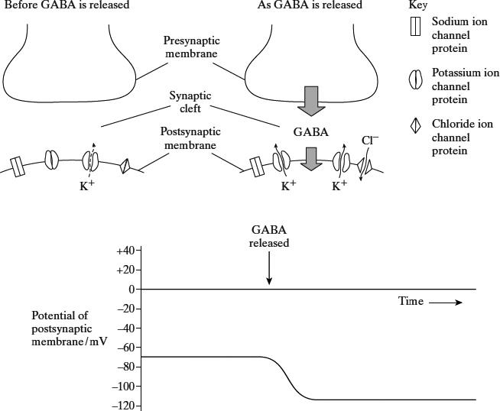

When the postsynaptic membrane is stimulated by acetylcholine, an action potential is less likely if GABA is released at the same time. Explain why.

___________________________________________________________________

___________________________________________________________________

___________________________________________________________________

___________________________________________________________________

___________________________________________________________________

___________________________________________________________________

___________________________________________________________________

___________________________________________________________________

**(4)**

**(Total 8 marks)**

**Q6.**

Acetylcholine is a neurotransmitter which binds to postsynaptic membranes and stimulates the production of nerve impulses. GABA is another neurotransmitter. It is produced by certain neurones in the brain and spinal cord. GABA binds to postsynaptic membranes and inhibits the production of nerve impulses. The diagram shows a synapse involving three neurones.

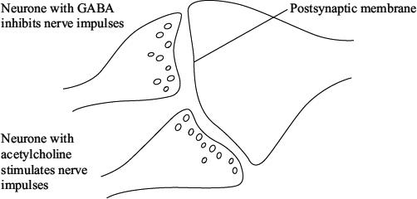

(a)     Describe the sequence of events leading to the release of acetylcholine and its binding to the postsynaptic membrane.

___________________________________________________________________

___________________________________________________________________

___________________________________________________________________

___________________________________________________________________

___________________________________________________________________

___________________________________________________________________

___________________________________________________________________

**(4)**

(b)     The binding of GABA to receptors on postsynaptic membranes causes negatively charged chloride ions to enter postsynaptic neurones. Explain how this will inhibit transmission of nerve impulses by postsynaptic neurones.

___________________________________________________________________

___________________________________________________________________

___________________________________________________________________

___________________________________________________________________

___________________________________________________________________

**(3)**

(c)     Epilepsy may result when there is increased neuronal activity in the brain.

(i)      One form of epilepsy is due to insufficient GABA. GABA is broken down on the postsynaptic membrane by the enzyme GABA transaminase. Vigabatrin is a new drug being used to treat this form of epilepsy. The drug has a similar molecular structure to GABA. Suggest how Vigabatrin may be effective in treating this form of epilepsy.

______________________________________________________________

______________________________________________________________

______________________________________________________________

______________________________________________________________

**(2)**

(ii)     A different form of epilepsy has been linked to an abnormality in GABA receptors. Suggest and explain how an abnormality in GABA receptors may result in epilepsy.

______________________________________________________________

______________________________________________________________

______________________________________________________________

______________________________________________________________

______________________________________________________________

**(3)**

(d)     During an epileptic seizure muscular contractions may occur. In which part of the brain would neuronal activity produce muscular contractions of the right leg?

___________________________________________________________________

___________________________________________________________________

___________________________________________________________________

**(2)**

**(Total 14 marks)**