**Q1.**(a)     A sarcomere is made up of different molecules.

Complete the table by naming the molecule that carries out the function described.

|  |  |  |
| --- | --- | --- |
|  | **Function** | **Name** |
|  | Attaches to Z line at the end of the sarcomere |  |
|  | Breaks down ATP |  |
|  | Covers binding site on actin in relaxed myofibril |  |

**(3)**

(b)     The diagram shows the arrangement of actin and myosin in a sarcomere.

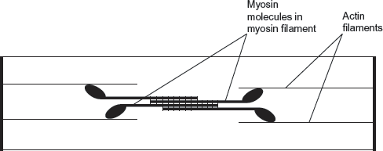

One form of muscle disease is caused by a mutated allele of a gene. This leads to production of myosin molecules that are unable to bind to other myosin molecules.

If myosin molecules are unable to bind to other myosin molecules, this prevents muscle contraction.  
Use the diagram and your knowledge of how muscles contract to suggest why.

........................................................................................................................

........................................................................................................................

........................................................................................................................

........................................................................................................................

........................................................................................................................

........................................................................................................................

**[Extra space]** ................................................................................................

........................................................................................................................

........................................................................................................................

**(3)**

**(Total 6 marks)**

**Q2.**          The diagram shows two relaxed sarcomeres from skeletal muscle.

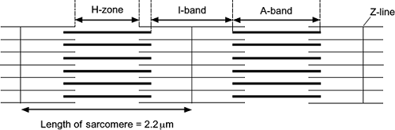

(a)     When the sarcomeres contract, what happens to the length of

(i)      the I-band

...............................................................................................................

**(1)**

(ii)     the A-band?

...............................................................................................................

**(1)**

(b)     The length of each sarcomere in the diagram is 2.2 μm. Use this information to calculate the magnification of the diagram. Show your working.

                                                    Magnification .....................................

**(2)**

(c)     People who have McArdle’s disease produce less ATP than healthy people. As a result, they are not able to maintain strong muscle contraction during exercise. Use your knowledge of the sliding filament theory to suggest why.

........................................................................................................................

........................................................................................................................

........................................................................................................................

........................................................................................................................

........................................................................................................................

........................................................................................................................

*(Extra space)* .................................................................................................

........................................................................................................................

**(3)**

**(Total 7 marks)**

**Q3.          Figure 1** shows a diagram of part of a muscle myofibril.

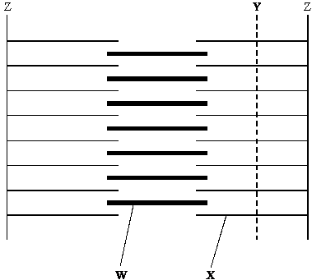

**Figure 1**

(a)     Name the protein present in the filaments labelled **W** and **X**.

**W** ..................................................................................................................

**X** ...................................................................................................................

**(1)**

(b)     **Figure 2** shows the cut ends of the protein filaments when the myofibril was cut at position **Y**. **Figure 3** shows the protein filaments when the myofibril was cut at the same distance from a Z line at a different stage of contraction.

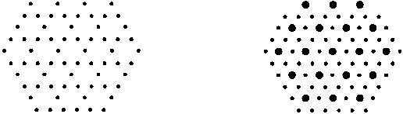

**Figure 2                                                                    Figure 3**

Explain why the pattern of protein filaments differs in **Figure 2** and **Figure 3**.

......................................................................................................................

......................................................................................................................

......................................................................................................................

......................................................................................................................

**(2)**

(c)     Describe the role of calcium ions in the contraction of a sarcomere.

......................................................................................................................

......................................................................................................................

......................................................................................................................

......................................................................................................................

......................................................................................................................

......................................................................................................................

......................................................................................................................

......................................................................................................................

**(4)**

**(Total 7 marks)**

**Q4.**(a)    Describe the part played by each of the following in myofibril contraction.

(i)      Tropomyosin

...............................................................................................................

...............................................................................................................

...............................................................................................................

...............................................................................................................

...............................................................................................................

**(2)**

(ii)     Myosin

...............................................................................................................

...............................................................................................................

...............................................................................................................

...............................................................................................................

...............................................................................................................

**(2)**

(b)     The table shows features of fast and slow muscle fibres.

|  |  |  |  |
| --- | --- | --- | --- |
|  | **Feature** | **Fast muscle fibre** | **Slow muscle fibre** |
|  | Type of respiration | Mainly anaerobic | Mainly aerobic |
|  | Glycogen | High concentration | Low concentration |
|  | Capillaries | Few | Many |

Use information from the table to suggest and explain **one** advantage of:

(i)      the high glycogen content of fast muscle fibres

...............................................................................................................

...............................................................................................................

...............................................................................................................

...............................................................................................................

**(2)**

(ii)     the number of capillaries supplying slow muscle fibres.

...............................................................................................................

...............................................................................................................

...............................................................................................................

...............................................................................................................

**(2)**

**(Total 8 marks)**

**Q5.**Slow and fast skeletal muscles both contain slow and fast muscle fibres but in different proportions. The proportion can be determined by observing stained sections of muscle under a microscope. The stain used reacts with an ATPase enzyme. Muscle fibres containing a lot of this ATPase stain brown. Fibres containing little ATPase stain yellow.

The diagram shows stained muscle fibres in a section taken from a muscle.

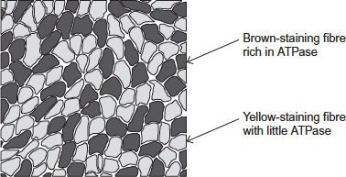

(a)     Both slow and fast muscle fibres contain ATPase.

Explain why.

........................................................................................................................

........................................................................................................................

........................................................................................................................

........................................................................................................................

**(2)**

(b)     The tissue in the diagram came from muscle with a high proportion of brown-staining fibres. Was the tissue removed from slow or fast skeletal muscle?

Explain your answer.

........................................................................................................................

........................................................................................................................

........................................................................................................................

**(1)**

(c)     The muscle tissue in the diagram had been stained for viewing with a microscope.

What is the evidence that it had been stained for viewing with an optical (light) microscope? Explain your answer.

........................................................................................................................

........................................................................................................................

........................................................................................................................

........................................................................................................................

**(2)**

**(Total 5 marks)**