**Q1.**

Homeostatic mechanisms maintain a constant environment in the body.

(a)     The graph shows changes in plasma glucose concentration that occurred in a person who went without food for some time.

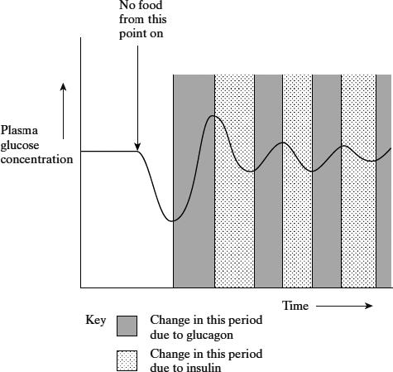

Use evidence from the graph to explain the role of negative feedback in the control of plasma glucose concentration.

___________________________________________________________________

___________________________________________________________________

___________________________________________________________________

___________________________________________________________________

___________________________________________________________________

___________________________________________________________________

___________________________________________________________________

___________________________________________________________________

___________________________________________________________________

___________________________________________________________________

___________________________________________________________________

**(5)**

(b)     How does maintaining a constant body temperature allow metabolic reactions in cells to proceed with maximum efficiency?

___________________________________________________________________

___________________________________________________________________

___________________________________________________________________

___________________________________________________________________

___________________________________________________________________

___________________________________________________________________

___________________________________________________________________

___________________________________________________________________

___________________________________________________________________

___________________________________________________________________

**(5)**

**(Total 10 marks)**

**Q2.**

(a)  Neonatal diabetes is a disease that affects newly born children. The disease is caused by a change in the amino acid sequence of insulin.

This change prevents insulin binding to its receptor. Explain why this change prevents insulin binding to its receptor.

___________________________________________________________________

___________________________________________________________________

___________________________________________________________________

___________________________________________________________________

___________________________________________________________________

___________________________________________________________________

**(2)**

Phosphoinositide 3-kinase (PI3K) is an enzyme in several metabolic processes.

The figure below shows the role of PI3K in the control of blood glucose concentration.

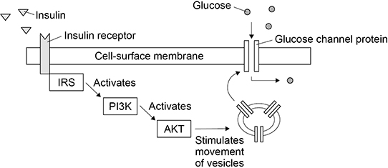

(b)  A decrease in the activity of PI3K can cause type II diabetes.

Use the figure above to explain why.

___________________________________________________________________

___________________________________________________________________

___________________________________________________________________

___________________________________________________________________

___________________________________________________________________

___________________________________________________________________

___________________________________________________________________

___________________________________________________________________

**(3)**

(c)  Using your knowledge of the kidney, explain why glucose is found in the urine of a person with untreated diabetes.

___________________________________________________________________

___________________________________________________________________

___________________________________________________________________

___________________________________________________________________

___________________________________________________________________

___________________________________________________________________

___________________________________________________________________

___________________________________________________________________

___________________________________________________________________

**(3)**

**(Total 8 marks)**

**Q3.**

(a)  Describe the role of glucagon in gluconeogenesis.

Do **not** include in your answer details on the second messenger model of glucagon action.

___________________________________________________________________

___________________________________________________________________

___________________________________________________________________

___________________________________________________________________

___________________________________________________________________

___________________________________________________________________

___________________________________________________________________

**(2)**

(b)  The gene that codes for glucagon is 9.531 kilobases in length. The DNA helix makes one complete turn every 10 base pairs. Every complete turn is 3.4 nm in length.

Use this information to calculate the length in micrometres (µm) of the gene for glucagon. Give your answer to 3 significant figures.

Answer = _____________________________________ µm

**(2)**

Metformin is a drug commonly used to treat type II diabetes. Metformin’s ability to lower the blood glucose concentration involves a number of mechanisms including:

•   increasing a cell’s sensitivity to insulin

•   inhibiting adenylate cyclase.

(c)  Explain how increasing a cell’s sensitivity to insulin will lower the blood glucose concentration.

___________________________________________________________________

___________________________________________________________________

___________________________________________________________________

___________________________________________________________________

___________________________________________________________________

___________________________________________________________________

___________________________________________________________________

**(2)**

(d)  Explain how inhibiting adenylate cyclase may help to lower the blood glucose concentration.

___________________________________________________________________

___________________________________________________________________

___________________________________________________________________

___________________________________________________________________

___________________________________________________________________

___________________________________________________________________

___________________________________________________________________

___________________________________________________________________

___________________________________________________________________

___________________________________________________________________

___________________________________________________________________

**(3)**

**(Total 9 marks)**

**Q4.**

There are two types of diabetes: type 1 and type 2.

•        People with type 1 diabetes do not produce enough insulin.

•        People with type 2 diabetes do produce insulin but have cells which do not respond to insulin.

Doctors use a glucose tolerance test to help diagnose people with diabetes. They start each test after a person has not eaten overnight. They measure a person’s blood glucose concentration.

The person then drinks a solution containing 75 g of glucose. The doctors measure the person’s blood glucose concentration 2 hours later. During the test, the person remains at rest.

**Figure 1** shows three diagnoses that can be made from the results of the test.

**Figure 1 – glucose tolerance test results and diagnoses**

|  |  |  |
| --- | --- | --- |
| **Blood glucose concentration after 2 hours / mg 100 cm–3** | **Diagnosis** | **Comments** |
| ≤ 110 | Non-diabetic | Low risk for future diabetes |
| Between 140 and 200 | Pre-diabetic | High risk for future diabetes. Some doctors recommend that the upper value should be lowered to 180 mg 100 cm–3 |
| ≥ 200 | Diabetic | Confirm by doing a second test |

A researcher monitored the mean blood glucose concentration of a non-diabetic, a pre-diabetic and a diabetic after they had each eaten a midday meal.

His results are shown in **Figure 2**.

**Figure 2**

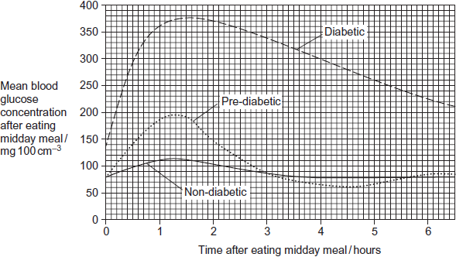

(a)     People with type 1 diabetes are described as being insulin-dependent.  
Suggest why they are described as insulin-dependent.

___________________________________________________________________

___________________________________________________________________

___________________________________________________________________

**(1)**

(b)     Some people with type 2 diabetes have cells which do **not** respond to insulin.  
Explain how this leads to a reduced ability to regulate blood glucose concentration.

___________________________________________________________________

___________________________________________________________________

___________________________________________________________________

___________________________________________________________________

___________________________________________________________________

___________________________________________________________________

**(3)**

(c)     During a glucose tolerance test the person remains at rest.  
Why is it important that the person remains at rest?

___________________________________________________________________

___________________________________________________________________

___________________________________________________________________

___________________________________________________________________

___________________________________________________________________

**(2)**

(d)     Use **Figure 2** to calculate how many times the maximum mean blood glucose concentration of the pre-diabetic is greater than the maximum of the non-diabetic person. Show your working.

Answer =____________________

**(2)**

(e)     Give **three** differences between the method used by the researcher to obtain the results in **Figure 2** and the method doctors use to carry out a glucose tolerance test.

1. _________________________________________________________________

___________________________________________________________________

2. _________________________________________________________________

___________________________________________________________________

3. _________________________________________________________________

___________________________________________________________________

**(3)**

(f)     Some doctors have recommended that the upper value used in the glucose tolerance test should be lowered to 180 mg 100 cm–3.  
Using information from **Figure 1** and **Figure 2**, suggest why.

___________________________________________________________________

___________________________________________________________________

___________________________________________________________________

___________________________________________________________________

___________________________________________________________________

___________________________________________________________________

**(3)**

**(Total 14 marks)**

**Q5.**

(a)  Describe how ultrafiltration occurs in a glomerulus.

___________________________________________________________________

___________________________________________________________________

___________________________________________________________________

___________________________________________________________________

___________________________________________________________________

___________________________________________________________________

___________________________________________________________________

___________________________________________________________________

___________________________________________________________________

___________________________________________________________________

**(3)**

(b)  Glucose and water are reabsorbed by the proximal convoluted tubule of a nephron.

Put a tick (**✓**) in the box next to the correct ways in which glucose and water are reabsorbed.

|  |  |
| --- | --- |
| Glucose by active transport and water against a water potential gradient |  |
| Glucose by diffusion and water down a water potential gradient |  |
| Glucose by facilitated diffusion and active transport and water against a water potential gradient |  |
| Glucose by facilitated diffusion and active transport and water down a water potential gradient |  |

**(1)**

(c)  The equation shows the relationship between urine concentration in arbitrary units (*y*) and mean length of the loop of Henle in mm (*x*).

*y* = 0.72*x* + 4

Calculate the mean length of the loop of Henle in an organism that produces urine with a concentration of 16.56 arbitrary units.

Answer = _________________________ mm

**(1)**

(d)  Scientists investigated the relationship between the thickness of the kidney medulla of different species of mammals and the concentration of their urine.

The graph shows their results.

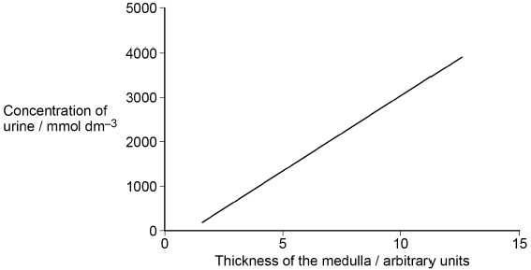

Explain the pattern shown by the results in the graph above.

___________________________________________________________________

___________________________________________________________________

___________________________________________________________________

___________________________________________________________________

___________________________________________________________________

___________________________________________________________________

___________________________________________________________________

___________________________________________________________________

___________________________________________________________________

___________________________________________________________________

___________________________________________________________________

___________________________________________________________________

**(3)**

**(Total 8 marks)**

**Q6.**

The graph shows changes in the amounts of water, glucose and sodium ions as fluid passes along a kidney tubule from the renal capsule to the collecting duct.

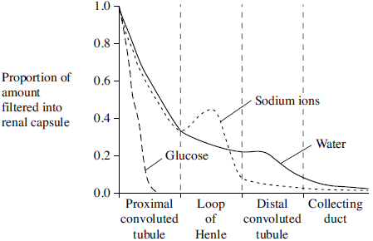

(a)     Which hormone causes the decrease in the water content in the distal convoluted tubule?

___________________________________________________________________

**(1)**

(b)     Explain the change in the amount of glucose.

___________________________________________________________________

___________________________________________________________________

___________________________________________________________________

___________________________________________________________________

**(2)**

(c)     Explain the shape of the curve for sodium ions in the loop of Henle.

___________________________________________________________________

___________________________________________________________________

___________________________________________________________________

___________________________________________________________________

___________________________________________________________________

___________________________________________________________________

**(3)**

**(Total 6 marks)**

**Q7.**

Furosemide and CVT are drugs used to remove excess fluid from the body. Scientists investigated the effect of these drugs on the volume of urine produced by human volunteers. The scientists used the following method.

•        They divided volunteers into three groups, **A**, **B** and **C** at random.

•        They gave all the volunteers the same food for 3 days.

•        After 3 days, they gave the volunteers in group **A** a tablet containing furosemide, the volunteers in group **B** a tablet containing CVT and the volunteers in group **C** a placebo (a tablet that did **not** contain either drug).

•        They then found the mean volume of urine produced by each group in the 4 hours after taking the tablets.

Some of the results the scientists obtained are shown in **Table 1**.

A value of ± 2 standard deviations from the mean includes over 95% of the data.

|  |  |
| --- | --- |
| **Table 1** | |
| **Group** | **Mean volume of urine produced in 4 hours / cm3 (± 2 standard deviations)** |
| **A**  (furosemide) | 1980  (± 152) |
| **B**  (CVT) | 1201  (± 119) |
| **C**  (placebo) | 312  (± 57) |

(a)     All the volunteers were given the same food for 3 days.

Suggest and explain **one** reason why they were given the same food.

___________________________________________________________________

___________________________________________________________________

___________________________________________________________________

___________________________________________________________________

___________________________________________________________________

___________________________________________________________________

___________________________________________________________________

___________________________________________________________________

**(2)**

(b)     Using **Table 1**, what can you conclude about the effectiveness of furosemide and CVT in the removal of excess fluid from the body?

___________________________________________________________________

___________________________________________________________________

___________________________________________________________________

___________________________________________________________________

___________________________________________________________________

___________________________________________________________________

**(2)**

(c)     Furosemide is sometimes used to treat high blood pressure.

Suggest how furosemide would cause a decrease in blood pressure.

___________________________________________________________________

___________________________________________________________________

___________________________________________________________________

___________________________________________________________________

**(1)**

(d)     Furosemide inhibits the absorption of sodium and chloride ions from the filtrate produced in the nephrons.

Explain how furosemide causes an increase in the volume of urine produced.

___________________________________________________________________

___________________________________________________________________

___________________________________________________________________

___________________________________________________________________

___________________________________________________________________

___________________________________________________________________

___________________________________________________________________

___________________________________________________________________

**(3)**

The scientists also measured the mean rate of flow of blood plasma into the kidneys.

The results the scientists obtained are shown in **Table 2**.

|  |  |
| --- | --- |
| **Table 2** | |
| **Group** | **Mean rate of flow of blood plasma into the kidneys / cm3 min–1** |
| **A**  (furosemide) | 380 |
| **B**  (CVT) | 342 |
| **C**  (placebo) | 295 |

(e)     The mean rate of flow of blood plasma is 60% of the mean rate of blood flow into the kidneys.

How much greater is the flow of blood into the kidneys with furosemide than with group **C** (placebo) over the 4 hours of the investigation? Give your answer in cm3.

Answer = ____________________ cm3

**(1)**

**(Total 9 marks)**

**Q8.**

Osmoreceptors are specialised cells that respond to changes in the water potential of the blood.

(a)     Give the location of osmoreceptors in the body of a mammal.

___________________________________________________________________

___________________________________________________________________

**(1)**

(b)     When a person is dehydrated, the cell volume of an osmoreceptor decreases.  
Explain why.

___________________________________________________________________

___________________________________________________________________

___________________________________________________________________

___________________________________________________________________

**(2)**

(c)     Stimulation of osmoreceptors can lead to secretion of the hormone ADH. Describe and explain how the secretion of ADH affects urine produced by the kidneys.

___________________________________________________________________

___________________________________________________________________

___________________________________________________________________

___________________________________________________________________

___________________________________________________________________

___________________________________________________________________

___________________________________________________________________

___________________________________________________________________

**(4)**

The efficiency with which the kidneys filter the blood can be measured by the rate at which they remove a substance called creatinine from the blood. The rate at which they filter the blood is called the glomerular filtration rate (GFR).

In 24 hours, a person excreted 1660 mg of creatinine in his urine. The concentration of creatinine in the blood entering his kidneys was constant at 0.01 mg cm–3.

(d)     Calculate the GFR in cm3 minute–1.

Answer = ____________________

**(1)**

(e)     Creatinine is a breakdown product of creatine found in muscle tissues. Apart from age and gender, give **two** factors that could affect the concentration of creatinine in the blood.

1. _________________________________________________________________

2. _________________________________________________________________

**(1)**

**(Total 9 marks)**

**Q9.**

(a)     Humans can produce urine which is more concentrated than their blood plasma.

(i)      Explain the role of the loop of Henle in the absorption of water from the filtrate.

______________________________________________________________

______________________________________________________________

______________________________________________________________

______________________________________________________________

______________________________________________________________

______________________________________________________________

______________________________________________________________

______________________________________________________________

______________________________________________________________

______________________________________________________________

**(6)**

(b)     A species of crayfish lives in fresh water. This crayfish does not have kidneys but it does have an organ which excretes nitrogenous waste and controls the amount of water in its body. The diagram shows this excretory organ.

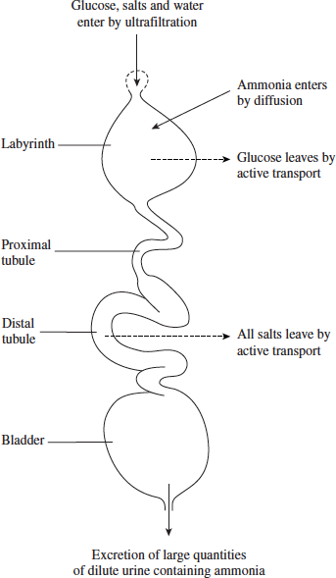

(i)      Describe how excretion in this organ differs from excretion in a human nephron.

______________________________________________________________

______________________________________________________________

______________________________________________________________

______________________________________________________________

______________________________________________________________

______________________________________________________________

**(3)**

(ii)     Suggest how the production of large amounts of dilute urine enables the crayfish to survive in fresh water.

______________________________________________________________

______________________________________________________________

______________________________________________________________

______________________________________________________________

**(2)**

**(Total 15 marks)**