**Examples of Successful Annotation, Tips and Techniques**



|  |
| --- |
| The purpose of annotating your own work is to explain *why* you chose the design techniques you’ve used and whether or not the work is successful. Explain if/how your work meets the design brief requirements and point out any messages/symbolism. |
| There are several *styles* of annotating. Use the one that best suits you. Your annotations will be assessed on their QUALITY not QUANTITY. Although be aware there may be a minimum word count for some tasks. |
| Example 1 is written in full sentences.  Notice it is written in the first person (use of ‘I’).  1. I have placed the white border behind the beetroot leaves so they are not completely contained; this shows their wildness and strength of flavour. I used a manmade metal background to contrast with the natural leaves and to enhance the message of ‘manmade versus natural’. I have used freehand typography with a curved baseline to represent the human aspect of food production. |
| Example 2 is not written in full sentences and therefore does not contain the use of ‘I’.  2. Red and white string creates leading line – guides viewer’s eye into focal point; the beetroot leaf. Simple sans serif typography lists facts about beetroot. The capital letters are right aligned with border – this is neat and clinical, contrasts irregularity of nature. Message = ‘manmade versus natural’. |
| Example 3 only describes what actions the student took in creating the work.  This is not valuable as annotation.  3. I placed my metal texture photograph in the background using Photoshop and lightened the front leaf to create contrast. The white border is neat and includes freehand typography, which I created using the graphics tablet. |

***As well as the quality of what you are writing, be aware of the design and layout of your annotations. Rather than standard paragraphs of text, try some of these styles and create your own…***

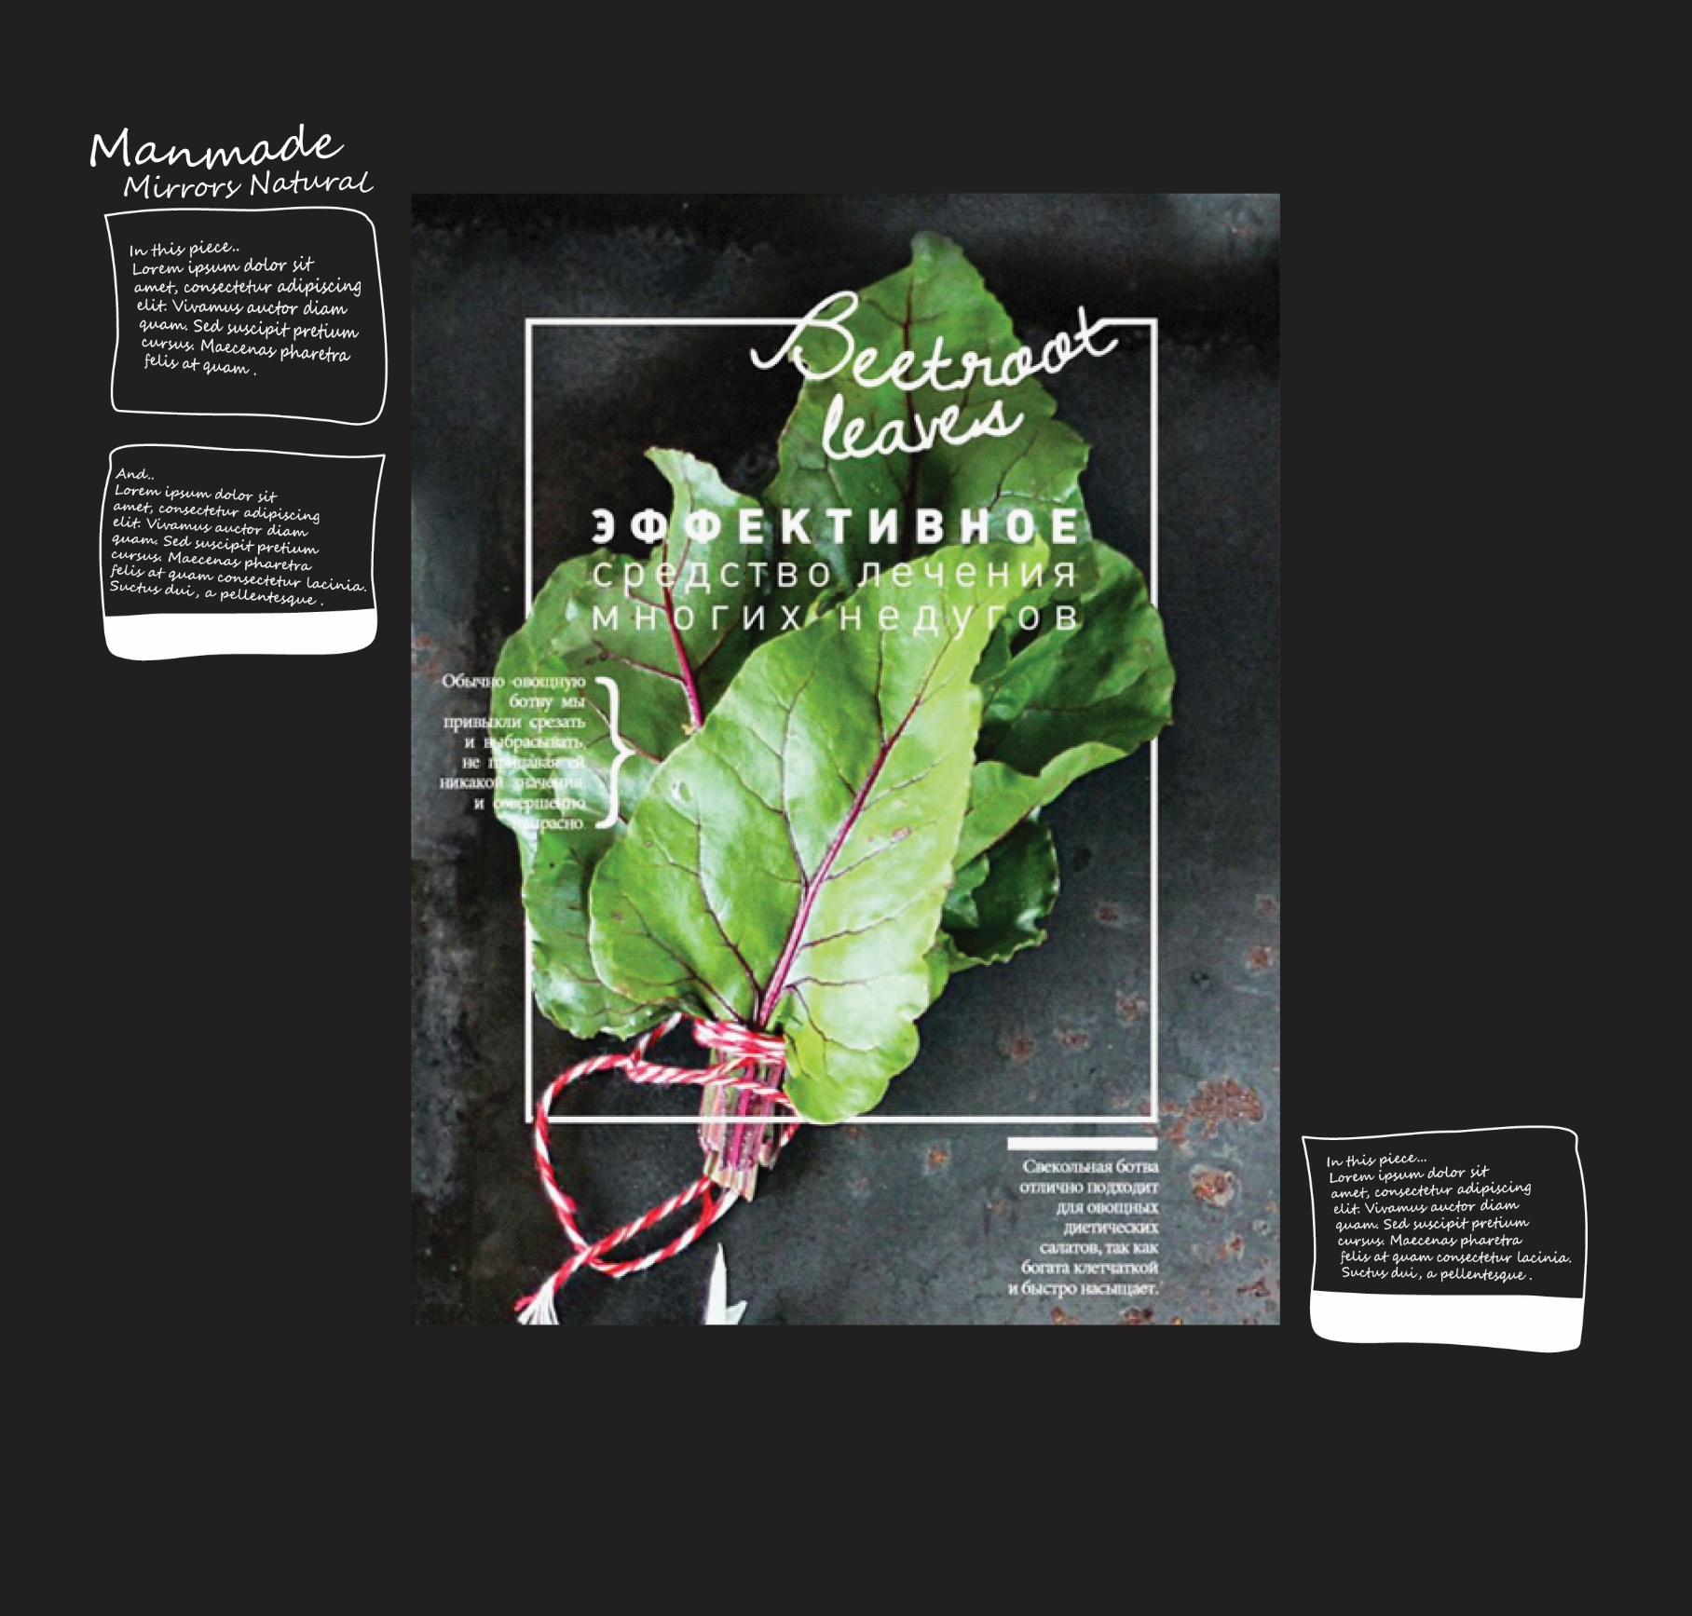

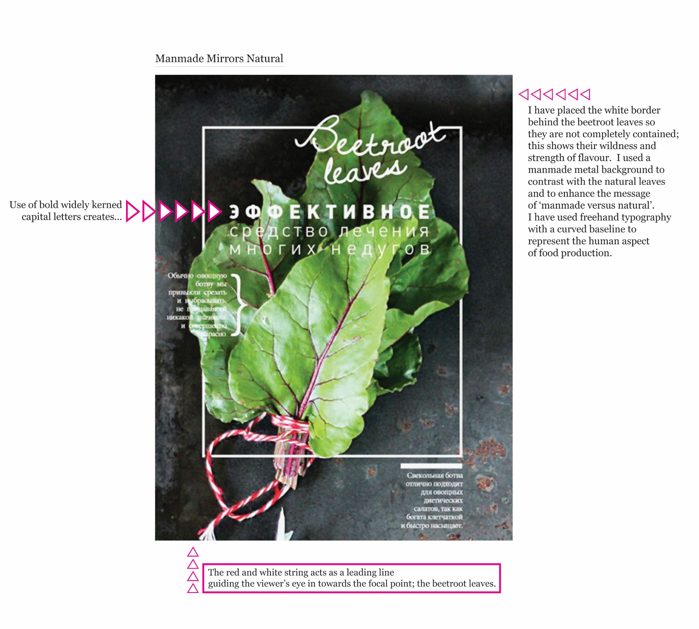

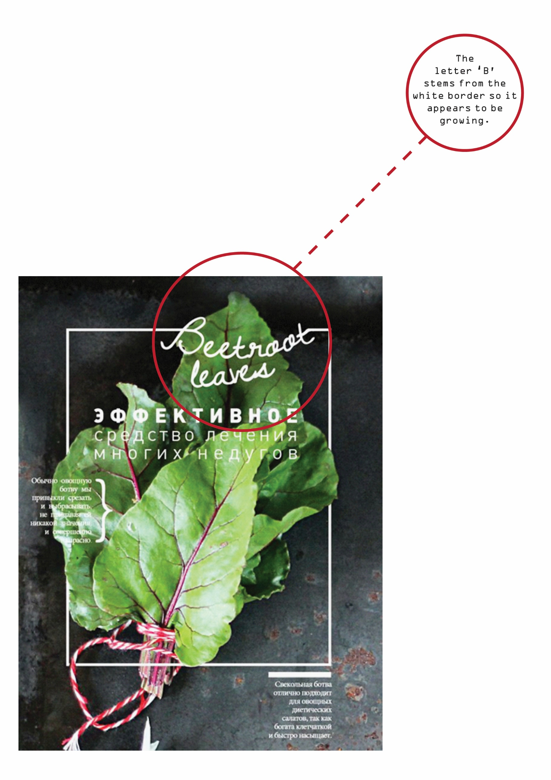

***The below examples contain irrelevant subject matter but the layouts may inspire ideas for how you could present your annotations.***

