**3.6.1 Receptors**

Survival and Coordination

* Organisms increase their chances of survival by responding to changes in their

environment. These changes are factors in the environment which we call

stimuli, which include:

* + Temperature
  + Light intensity/wavelength/duration
  + Chemicals e.g. pH/smell
* Summary of Stimulus Response Model [(Simple Stimuli Trigger Fixed Behaviour animation)](http://www.sumanasinc.com/webcontent/anisamples/nonmajorsbiology/behaviors.html)
* Stimulus A change in the environment.

Detector Cells which detect stimuli. These convert energy form one form e.g. light, heat, sound into an electrical impulse/release of hormone.

* Coordinator Information passes to the coordinator. Coordinates

the response (usually the brain and spinal cord = central nervous system CNS

* Effector Information sent to effector, cells which bring about

a response (usually muscles or glands).

* Response Change in the organism to stimuli.
* To detect these changes requires **Detectors** e.g. photoreceptors detect light and are in the retina of the eye. Once a stimulus is detected by a receptor, a nerve impulse is transmitted to the **Coordinator** (Central Nervous System CNS – Brain or spinal cord)
* The Coordinator then transmits an impulse to the **Effector** (either a muscle or

a gland) which then produces the **Response**.

* The nerve pathway to and from the coordinator will involve specific types of nerves and their individual neurones (nerve cells):
  + To CNS from receptor– **Sensory** neurone
  + From Sensory to Motor neurone – **Relay** neurone
  + From CNS to effector – **Motor** neurone
* This pathway from stimulus to response may be used in a **reflex action** or in

learned behaviour. A reflex is a rapid, automatic and involuntary action to a stimulus which is the same response every time) [(Reflex Arcs tutorial)](http://www.sumanasinc.com/webcontent/anisamples/nonmajorsbiology/reflexarcs.html)

* Rapid – only 3 neurones are involved with 2

synapses (more synapses means more delay)

* Automatic/involuntary - higher brain centres are not involved e.g.

cerebral cortex

* Always the same - the same nerve pathway is involved every

time

White matter

Dorsal root ganglion

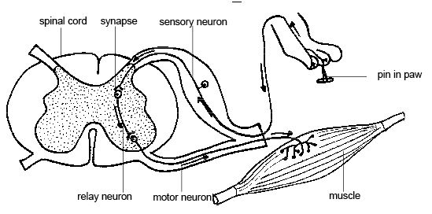

Meninges

Grey

matter

* White matter includes axons, dendrons and myelin sheath, but there are no cell bodies, hence white colour
* Grey matter includes cell bodies with no myelin sheath
* Comparing Nervous/Endocrine systems

|  |  |  |
| --- | --- | --- |
| Property/Feature | Nervous system | Endocrine System |
| Speed of action | Fast | Slow |
| Duration of response | Short lived | Long term |
| Mechanism of travel | Nerves | Blood vessels |
| Nature of information | Electrical | Chemical |
| Method of transfer | Direct | Broadcast |

**Kinesis and Taxis**

Nearly all animals are mobile at some point in their life. For some lower animals, movement is undirected and random, such as a Paramecium blundering about its environment. Such undirected orientation is called kinesis. In contrast to kinesis, taxis is the term for movement in response to some stimulus. Taxis involves more complex behavior than kinesis, and is generally what we think of when we think of movement.

Different taxes (plural of taxis) result in response to different types of stimuli. Each of these forms of taxis can be described by simply adding a prefix to the word taxis. The table below shows the most common forms of taxis.

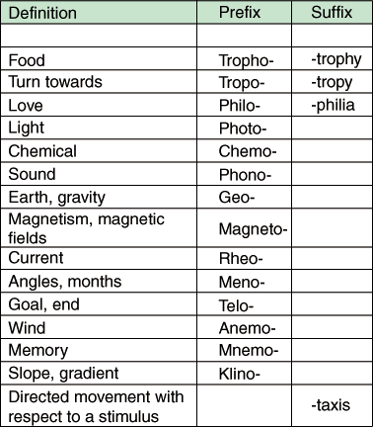

*Figure %: Important Taxes*

From these terms we can describe almost any directed movement. For instance, phototaxis would be movement in response to light. Chemotaxis means movement in response to a chemical. Any combination of these words can be used. Movements toward a stimulus are positive taxes, while movements away from the stimulus are negative taxes.

#### Tropisms

Tropisms are responses to stimuli that result in the long-term growth of the plant toward or away from the stimulus. This growth results from cell elongation occurring at different rates on different sides of the plant, so that the plant bends in one direction. Phototropism, a reaction to light, causes the plant to bend toward the light source. Gravitotropism, a response to gravity, causes parts of a plant to grow either upward or downward. If a plant is placed on its side, its shoot will begin to grow upward (against gravity) and roots will follow the pull of gravity to grow downward.

#### Auxins

The primary function of the auxin hormones (**indoleacetic acid)** is to elongate plant cells in the stem. For instance, auxins are the hormones responsible for phototropism, the growth of a plant toward the light. Phototropism results from the rapid elongation of cells on the dark side of the plant, which causes the plant to bend in the opposite direction. The acid growth hypothesis explains this occurrence by speculating that auxins trigger proton pumps in cell membranes, lowering the pH in the cell wall to such an extent that the hydrogen bonds holding its cellulose fibers together break apart. These broken bonds give the cell wall greater flexibility and expandability, so that more water can enter the cell by diffusion, causing the cell itself to elongate.

**Reflex Arc**

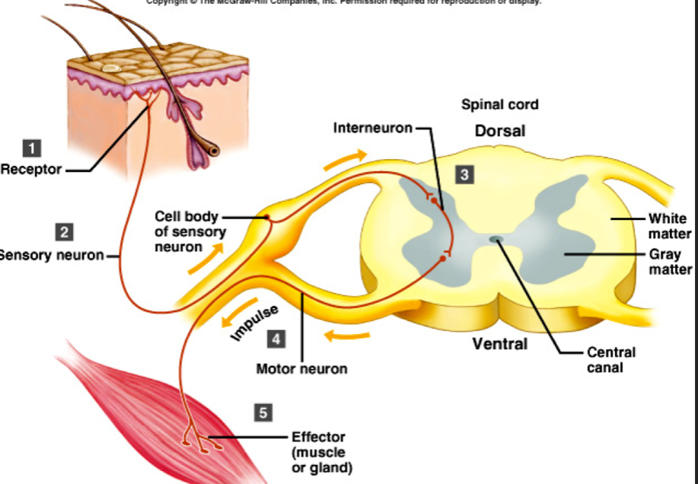The protective effect of a simple reflex, exemplified by a three neurone

simple reflex.

The reflex arc is the basis for protective, involuntary actions.

#### http://biologymad.com/NervousSystem/pacinianc.jpgThe Pacinian Corpuscle

Pacinian corpuscles are **pressure receptors**. They are located in the skin and also in various internal organs. Each is connected to a sensory neuron. Pacinian corpuscles are fast-conducting, bulb-shaped receptors located deep in the dermis. They consist of the ending of a single neurone surrounded by **lamellae**. They are the largest of the skin's receptors and are believed to provide instant information about how and where we move. They are also sensitive to vibration. Pacinian corpuscles are also located in joints and tendons and in tissue that lines organs and blood vessels.

Pressure on the skin changed the shape of the Pacinian corpuscle. This changes the shape of the **pressure sensitive sodium channels** in the membrane, making them open. Sodium ions diffuse in through the channels leading to depolarisation called a **generator potential**. The greater the pressure the more sodium channels open and the larger the generator potential. If a threshold value is reached, an action potential occurs and nerve impulses travel along the sensory neurone. The frequency of the impulse is related to the intensity of the stimulus.

### 

### Rods and Cones

The rods and cones serve two different functions as shown in this table:

|  |  |
| --- | --- |
| **Rods** | **Cones** |
| Outer segment is rod shaped | Outer segment is cone shaped |
| 109 cells per eye, distributed throughout the retina, so used for peripheral vision. | 106 cells per eye, found mainly in the fovea, so can only detect images in centre of retina. |
| Good sensitivity – can detect a single photon of light, so are used for night vision. | Poor sensitivity – need bright light, so only work in the day. |
| Only 1 type, so only monochromatic vision. | 3 types (red sensitive, green sensitive and blue sensitive), so are responsible for colour vision. |
| Many rods usually connected to one bipolar cell, so **poor** **acuity** (i.e. rods are not good at resolving fine detail). | Each cone usually connected to one bipolar cell, so **good** **acuity** (i.e. cones are used for resolving fine detail such as reading). |

**Visual Acuity**

Visual acuity the amount of detail that can be seen. The cones are responsible for high visual acuity (high resolution). Although there are far more rods than cones, we use cones most of the time because they have fine discrimination and can resolve colours. To do this we constantly move our eyes so that images are focused on the small area of the retina called the **fovea**. You can only read one word of a book at a time, but your eyes move so quickly that it appears that you can see much more. Spatially, much more clarity is perceived in cones than for the rods. This is because one cone cell synapses to one bipolar cell which in turn synapses onto one ganglion cell as the information is relayed to the visual cortex. The more densely-packed the cone cells, the better the visual acuity. In the fovea of human eyes there are 160 000 cones per mm2, while hawks have 1 million cones per mm2, so they really do have far better acuity.

**Convergence**

Many rods can synapse onto one bipolar cell. A ray of light reaching one rod may not be enough to stimulate an action potential along a nerve pathway. Several rods link to one bipolar cell so that enough transmitter molecules at reach the threshold level. This depolarisation results in an action potential in the bipolar cell. This is summation, as a result of rod cell teamwork!

### Visual Transduction

**Visual transduction** is the process by which light initiates a nerve impulse. The structure of a rod cell is:

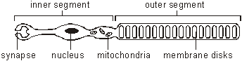

The detection of light is carried out on the membrane disks in the outer segment. These disks contain thousands of molecules of **rhodopsin**, the photoreceptor molecule. Rhodopsin consists of a membrane-bound protein called **opsin** and a covalently-bound prosthetic group called **retinal**. Retinal is made from vitamin A, and a dietary deficiency in this vitamin causes night-blindness (poor vision in dim light). Retinal is the light-sensitive part, and it can exists in 2 forms: a *cis* form and a *trans* form:

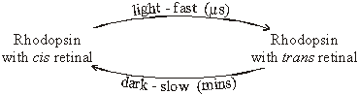

In the dark retinal is in the *cis* form, but when it absorbs a photon of light it quickly switches to the *trans* form. This changes its shape and therefore the shape of the opsin protein as well. This process is called **bleaching**. The reverse reaction (*trans* to *cis* retinal) requires an enzyme reaction and is very slow, taking a few minutes. This explains why you are initially blind when you walk from sunlight to a dark room: in the light almost all your retinal was in the *trans* form, and it takes some time to form enough *cis* retinal to respond to the light indoors.

The final result of the bleaching of the rhodopsin in a rod cell is a nerve impulse through a sensory neurone in the optic nerve to the brain. However the details of the process are complicated and unexpected. Rod cell membranes contain a special sodium channel that is controlled by rhodopsin. Rhodopsin with *cis* retinal opens it and rhodopsin with *trans* retinal closes it. This means in the dark the channel is open, allowing sodium ions to flow in and causing the rod cell to be depolarised. This in turn means that rod cells release neurotransmitter in the dark. However the synapse with the bipolar cell is an **inhibitory synapse**, so the neurotransmitter **stops** the bipolar cell making a nerve impulse. In the light everything is reversed, and the bipolar cell is depolarised and forms a nerve impulse, which is passed to the ganglion cell and to the brain. Fortunately you don’t have to remember this, but you should be able to understand it.

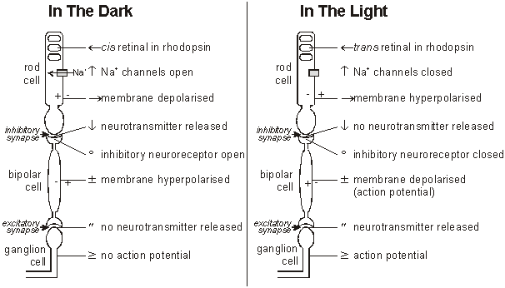

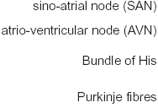**Control of Heart rate**

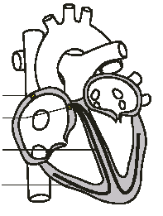

There is a complicated sequence of events at each heartbeat called the cardiac cycle. Cardiac muscle is **myogenic**, which means that it can contract on its own, without needing nerve impulses. Contractions are initiated within the heart by the **sino-atrial node** (SAN, or pacemaker) in the right atrium. This extraordinary tissue acts as a clock, and contracts spontaneously and rhythmically about once a second, even when surgically removed from the heart. The cardiac cycle consists of three stages:

*N.B. You must be able to explain the movement of blood in relation to the pressure changes (created by volume changes) occurring in the chambers and blood vessels of the heart. Remember these rules:

* + - * Fluids move from a HIGH to LOW pressure
      * Small volume = large pressure
      * Large volume = small pressure
* Atrial systole The SAN contracts and transmits electrical impulses

throughout the atria, which both contract simultaneously, pumping blood into the ventricles. The ventricles are electrically insulated from the atria by a thin layer of connective tissue, so they do not contract at this time:

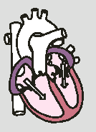

* + - * Chamber Atria
      * Volume decreases
      * Pressure increases
      * Pressure gradient Atria to ventricles
      * Valves Atrioventricular valves

open

* Ventricular systole

The electrical impulse passes to the ventricles via the

**atrioventricular node** ,(AVN), the **bundle of His** and the **Purkyne/Purkinje fibres**, in the walls of the septum. These are specialised fibres that do not contract but pass the electrical impulse to the base of the ventricles, with a short but important delay of about 0.1s, allowing the atria to empty.

The ventricles contract shortly after the atria, from the apex up, squeezing blood upwards into the arteries. The blood can't go into the atria because of the atrioventricular valves, which are forced shut with a loud “lub”:

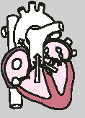

* + - * Chamber Ventricles
      * Volume decreases
      * Pressure increases
      * Pressure gradient Ventricles to arteries
      * Valves Atrioventricular valves

Close

* Diastole The atria and the ventricles relax, while the atria fill with blood.

The semi lunar valves in the arteries close as the arterial blood pushes against them, making a "dup" sound, the atrioventricular vavles open:

* + - * 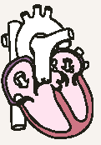Chamber Atria and ventricles
      * Volume increases
      * Pressure decreases
      * Pressure gradient Veins to atria
      * Valves Semi lunar valves

close, atrioventricular

valves open

* PCG (phonocardiogram) is a recording of the sounds the heart makes. The cardiac muscle itself is silent and the sounds are made by the valves closing. The first sound (lub) is the atrioventricular valves closing and the second (dub) is the semi-lunar valves closing.
* ECG (electrocardiogram - [ECG animation](http://medstat.med.utah.edu/kw/ecg/animations/ecg.html)) is a recording of the electrical activity of the heart. There are characteristic waves of electrical activity marking each phase of the cardiac cycle. Changes in these ECG waves can be used to help diagnose problems with the heart.
* 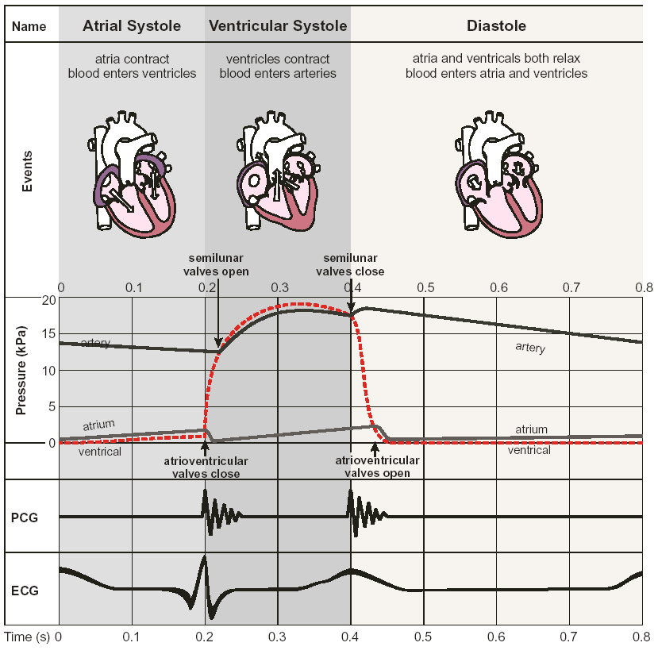*N.B. Heart rate can be altered by the nervous system or hormones e.g.

adrenaline

3.6.2 Nervous Coordination

* 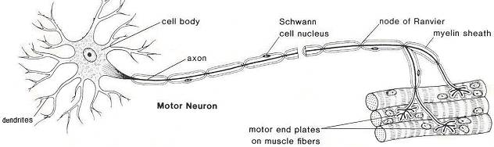The structure of a Myelinated Neurone
  + Function of Motor Neurone components:
* Dendrites - receive impulses from other nerve cells and carry the impulse towards the cell body
* Cell body
* nucleus
* axon – transmits impulse current
* Nodes of Ranvier – increases rate of impulse current due to Saltatory Conduction
* nerve/axon endings
* Myelin sheath (Schwann cell):
* **Myelination is the process where Schwann cells** lie alongside the neurone

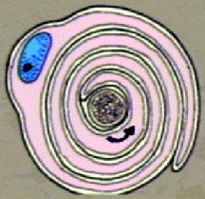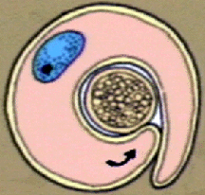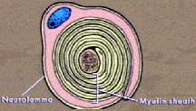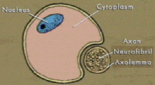and during development extend their membranes around the axon. Schwann cells are made up from a type of phospholipid called Myelin which:

* **Insulates** the neurone so its impulse is unaffected by other neurones’ transmission in the same nerve
* **Speeds up** transmission of the impulse along the neurone by **Saltatory Conduction**

**The Nerve Impulse**

* Mini electrodes can be placed inside the cytoplasm of the axon (**Axonplasm**) and on the surface of the membrane. These were then linked via an amplifier to a cathode ray oscilloscope (CRO) [(The Squids Giant Axons video)](http://www.youtube.com/watch?v=omXS1bjYLMI):

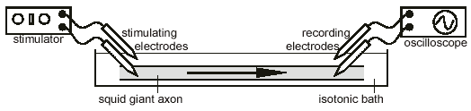

* The **Resting Potential** is **the Potential Difference** between the inside and the outside of the membrane when an impulse in not being conducted
* At Resting Potential the **Potential Difference** (P.D.) is **-70mv** i.e. the **Inside** of the membrane has a **Net Negative Charge** relative to the outside – the membrane is **Polarised**

**+ _ + + _ + +**

**_ + + + _ +**

**_ + _**

**+ _ _**

**Axon of**

**neurone**

**(negatively**

**charged) + _ + + _ + _ +**

**_ + + + +**

**Membrane of neurone Extracellular fluid**

**(positively charged)**

* Generating Resting Potential
  + **Na+/K+ pump** (**trans-membrane proteins**) – **Active transport** of Positive ions. **3 Na+ Out** for every **2K+ In**. Net movement of **Positive ions Out**
  + **Na+/K+ Leakage channel** (**trans-membrane proteins**) – **Passive** movement of ions. **X100 more K+ leak Out than Na+ leak in**. Membrane **is more permeable** to K+ than Na+ - Partial Permeability. Net movement of Positiveions Out

Na+ Na+ Na+  K+

A) B)

Neurone

Membrane

K+ K+ Na+

* Action Potential
* Na+/K+ Gated protein channels are **Closed** when resting, only open when P.D. rises to a **Threshold Value** of **-55 mv**

+40 mv

Na+ K+

0 mv

-70 mv

* Depolarisation [(tetrodotoxin and zombification)](http://www.youtube.com/watch?v=HC4qZ3ZUEhs)[(Tetrodotoxin - Na ion gated channel blocker)](http://en.wikipedia.org/wiki/Tetrodotoxin#Toxicity)
* Stimulus reaches resting neurone, **Na+ gated channels** **Open** at point of **Stimulus**, **Na+ flow IN**
* If sufficient Na+ in, more Na+ gated channels will open. This causes **Reduction in P.D.** called **Depolarisation**
* **NA+** **Diffuse** in down a **Concentration and Electrical Gradient**, due to overall negative charge inside axon
* **P.D. Rises to +40 mv,** inside axon has more positive charges than outside

Na+ K+ closed +40 mv

Na+ open

0 mv

-70 mv (1)

* Repolarisation
* **Na+ gated channels Close**, **K+ gated channels Open**, **K+ Diffuse Out** down **a Concentration and Electrical Gradient**, due to overall positive charge inside axon
* P.D. falls back to –70 mv due to loss of positive ions, called **Repolarisation**
* K+ gated channels remain open a fraction of a millisecond longer so P.D. dips below –70 mv, called **Hyperpolarisation**
* Resting Potential is restored by **Na+/K+ pumps and Leakage Channels**

K+ open +40 mv

Na+ closed (2)

(3)

0 mv

K+ -70 mv (1)

* Brief period of time after returning to Resting Potential **where Na+ gated channels cannot open**, called **Refractory Period**

**The importance of the Threshold Value**

* A stimulus must be above a certain **Threshold Value** (-55mv) to trigger an Action Potential. If this is not achieved the neurone remains **in Resting Potential**
* All action potentials are the same **Size**. This is called the **‘All or Nothing’** response i.e. once the action potential is triggered by reaching the threshold value. To distinguish between a weak and strong stimulus e.g. the intensity of two light sources, it is the **Frequency** of action potentials which conveys this:
  + Strong stimulus – **many** action potentials per sec (high frequency)
  + Weak stimulus – **few** action potentials per sec (low frequency)

**The importance of the Refractory Period**

* The Refractory Period between action potentials in neurones allows:
* **Discrete/separate impulses** to pass along a neurone per stimulus. Without this period different stimuli could be sent within the same impulse and could merge together
* 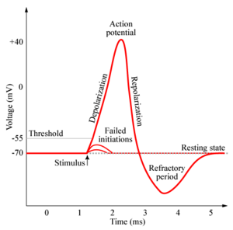 It also ensures that the movement of action potentials is in **One direction only!**

**Transmission of the Nerve Impulse**

* Action potential propagation along **unmyelinated** neurones involves Na+ moving into the axon causing a **Local Current**. The Na+ Diffuses a short distance along the axon, called **Impulse Current**, triggering the **next region** of the axon to **Depolarise** i.e. reach -55mv to trigger next action potential, so the impulse travels along the neurone as a **wave of depolarisation**:
  + **Local Current** – Na+ moving across membrane of axon
  + **Impulse Current** – Na+ moving along axon
  + Stimulus ++++++++++++++++++++++++++++++++++++++++

(threshold value

-55mv, first - + + - - - - - - - - - - - - - - - - - - - - - - - - - - - - - -

action potential) ++++++++

* + Na+ current + - - - - -++++++++++++++++++++++++++++++++++

flows forward

-+++++ - - - - - - - - - - - - - - - - - - - - - - - - - - - - -

++++ +

* + Next region of +++++++ - - - - +++++++++++++++++++++++++++++

membrane is

depolarised - - - - ++++ - - - - - - - - - - - - - - - - - - - - - -

+ + + +

* Action potential propagation along **myelinated** neurones involves local currents/action potentials being set up at the **Nodes of Ranvier**, the Na+ diffuses to the next node where the next action impulse is initiated. This movement of action potential from node to node is called **Saltatory Conduction**

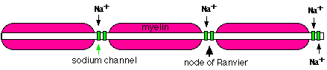

* Myelinated neurones conduct **quicker impulses** because:
  + Depolarisation only needs to happen at nodes of ranvier
  + So **depolarisation** can **leap from node to node** (**saltatory conduction**)
  + Therefore myelination speeds up the rate of transmission of impulses by **increasing the distance** over which the **local currents** can bring about depolarisation.
* This means the neurones are **more Energy Efficient** as ions are only exchanged at the nodes, so **less ATP is required for the Na+/K+ pumps** to generate the resting potential.
* **Larger diameter neurones** conduct **quicker impulses** (greater velocity) than narrower ones due to achieving a **Higher Surface Area** over which exchange of ions takes place.

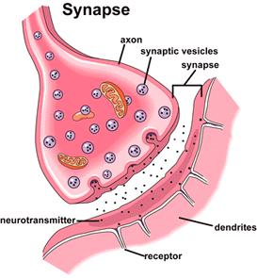**The Synapse** [(Synapse animation)](http://highered.mcgraw-hill.com/olcweb/cgi/pluginpop.cgi?it=swf::535::535::/sites/dl/free/0072437316/120107/anim0015.swf::Chemical%20Synapse) [(Synaptic Transmission tutorial)](http://www.adobe.com/shockwave/download/triggerpages_mmcom/default.html)

* Neurones do not touch to transmit impulses – there is a junction or **Synapse** with a 20nm wide **Synaptic Cleft**
* The following events lead to an impulse being transmitted from one neurone to another:
  + An **Action Potential** arrives at the **Presynaptic membrane** causing **Depolarisation** of the membrane, which **causes Ca2+ gated channels to Open**
  + Ca2+ **Diffues into** the Presynaptic Knob
  + Causing the Neurotransmitter (**Acetylcholine/Noradrenaline**) containing **Vesicle** to move and **Fuse with the Presynaptic Membrane** (only found in presynaptic knob ensuring nerve impulses travel in one direction only)
  + Releasing the **Acetylcholine** neurotransmitter into the **Synaptic Cleft** by **Exocytosis**
  + Where it then **Diffuses across synaptic cleft**
  + **Acetylcholine binds to Protein Receptors** in the **Post Synaptic Membrane**
  + Causing **Na+ Gated Channels to Open**, **Na+ flow in through channels**
  + Causing Post Synaptic Membrane to become **Depolarised**, resulting in an **Action Potential**
  + If depolarisation reaches -55mV an Impulse is **Propagated** in **Post Synaptic Neuron**
  + However, to prevent continuous nerve impulse transmission the neurotransmitter (Acetylcholine) is **Hydrolysed** by an enzyme (**Acetylcholinesterase**), into acetic acid and choline
  + The components of the neurotransmitter then **Diffuse back** to the Presynaptic Knob where **Energy from the Hydrolysis of ATP** (from many **Mitochondria**) is used to **Resynthesise** and **Package** the neurotransmitter
* Synapses therefore have the following functions:
  + Transmit **impulses between neurones**
  + Ensure impulses travel in **one direction only**
  + Filter out **background/low level** stimuli
  + Protect against **over stimulation**
* Drugs and Synapses
  + Drugs may inhibit synaptic transmission or promote continuous nerve impulse transmission (Amplification):
* Inhibition of transmission – Inhibitory drugs
* Continuous transmission (Amplification) – Excitory drugs
* Psychoactive drugs such as cocaine and cannabis affect synapses in the brain

|  |  |
| --- | --- |
| Inhibition of transmission of impulse to post synaptic membrane | Amplification transmission of impulse to post synaptic membrane |
| Molecule has **similar shape** to that of neurotransmitter and **blocks receptor site of protein** – neurotransmitter cannot bind, therefore Na+ channels are not opened | Molecule acts as **non-competitive inhibitor** on Acetylcholinesterase, therefore Na+ channels remain open **e.g. organophosphorus insecticides** |