Types of Muscle

There are three types of muscle:

1. *Skeletal Muscle* – This is muscle attached to bone and its primary function is movement. It contracts rapidly and is attached to bones by inelastic tendons. When the muscle contracts it pulls on the skeleton causing the bone to which it’s attached to move.
2. *Smooth Muscle* – This is found in the walls of tubular organs such as the arteries or the gut. It contracts slowly.
3. *Cardiac Muscle* – This is found only in the heart.

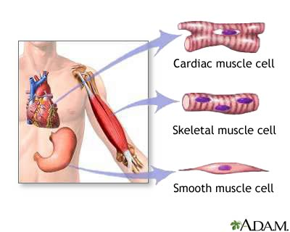

Features of Skeletal Muscle Contraction

* Muscles contract (become shorter) and relax (return to their original length).
* Actin filaments sliding over myosin ones cause the force of contraction.
* The sliding filament mechanism generates force in one direction.
* An opposing force is needed to pull the filaments apart and restore the muscle to its original length. Muscles can only pull, not push.
* An antagonistic muscle supplies the opposing force and skeletal muscles work in antagonistic pairs; one muscle extends the joint and in doing so, restores the other to its original length.

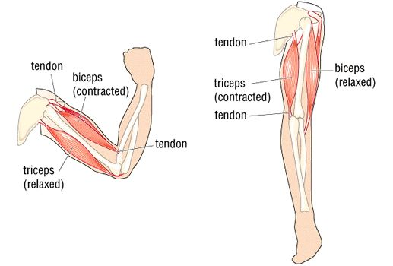

When the biceps are contracted and the arm is in the bend position, the triceps are relaxed.

When the arm is straight, the triceps contract causing the biceps to relax.

Structure of Skeletal Muscle

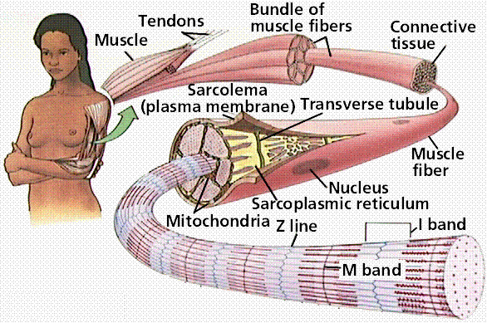

Arrangement

Tendons at each end of the muscle connect it to the bone.

The muscle is made up of bundles of muscle fibres, bound together by connective tissue.

Each muscle fibre is a single muscle cell, surrounded by a cell surface membrane. The separate cells have become fused together into muscle fibres. These muscle fibres share nuclei and cytoplasm, called **sarcoplasm**. This is found around the circumference of the fibre. Within the sarcoplasm is a large concentration mitochondria and endoplasmic reticulum.

Muscle fibres contain structures known as myofibrils, which contain two types of myofilament, actin and myosin.

There are also numerous **myofibrils**, which are composed of repeated contractile units known as **sarcomeres**.

Filament Arrangement

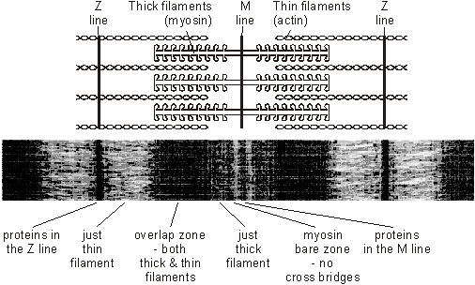

Each myofibril is arranged into a number of sarcomeres, joined together end to end and parallel to other sarcomeres in other myofibrils.

The vertical Z lines are discs holding the actin filaments in position, running across the myofibril and denoting the beginning and end of the sarcomere.

The actin filaments are thin and run horizontally through the sarcomere from the Z line towards the centre but do not reach the centre in relaxed muscle.

The thicker myosin filaments also run horizontally in between the thinner actin filaments in the middle of the sarcomere but do not reach the end in relaxed muscle.

|  |  |  |
| --- | --- | --- |
| Area | Number per Sarcomere | Function |
| Z line | 2 | The discs holding the actin in place and denoting the start and end of the sarcomere |
| I Band | 2 | This is a light band as there are only thin actin filaments present. |
| A-Band | 1 | This is a very dark area that contains both actin and myosin as they overlap each other. |
| H-Zone | 1 | This section in the middle contains only myosin, and hence is slightly lighter than the A-Band. |

***Microscopic Structure of Skeletal Muscle***

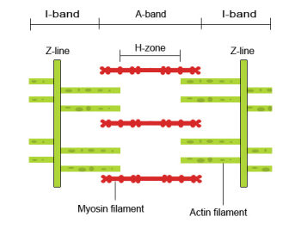

Myosin Filament

Actin Filament

*Arrangement of actin and myosin filaments*

Myofibrils appear striped due to their alternating **light-coloured** and **dark-coloured bands**.

* **Light bands – Isotropic bands, I-bands**

Appear lighter because the actin and myosin filaments do not overlap in this region

* **Dark bands – Anisotrophic bands, A-bands**

Appear darker because the actin and myosin filaments overlap in this region

At the **centre** of each **A-band** is a **lighter-coloured** region called the **H-zone**. At the **centre** of each **I-band** is a **line** called the **Z-line**.

* **Sarcomere** – the distance between adjacent Z-lines

When a muscle **contracts**, the **sarcomeres shorten** and the pattern of light and dark bands changes.

Skeletal Muscle Proteins

Myosin

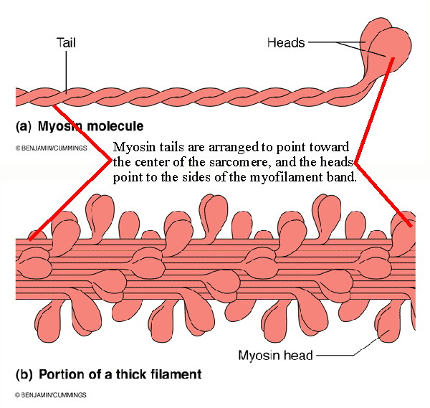

The tails of myosin molecules wrap around each other to form the thick filament whilst the globular heads protrude in all directions to form the actinomyosin bridges with actin.

Actin

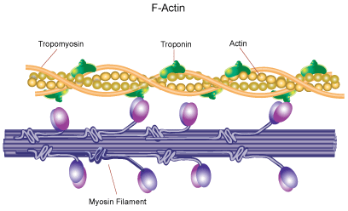

Each actin filament is made of two helical strands of globular actin molecules that twist around each other to form the actin filament.

Actin filaments are associated with two accessory proteins:

* *Tropomyosin* - a rod shaped fibrous protein that link end to end to form two helical strands wrapped around the actin filament.
* *Troponin –* binds toCa2+ and moves tropomyosin out of the way.

Skeletal Muscle Contraction

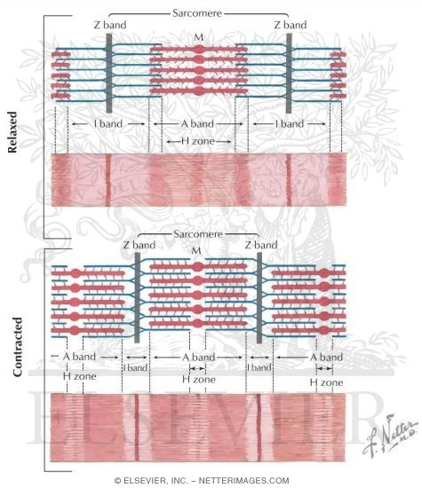

|  |  |
| --- | --- |
| Structure | Change |
|  |  |
| Sarcomere | This becomes shorter due to the actin filaments overlapping myosin ones. Actin filaments from either end have overlapped each other. |
|  |  |
| Z Lines | They move closer together. |
|  |  |
| A-Band | The length remains the same as the length of myosin remains the same. |
|  |  |
| I-Band | Becomes shorter as much of the actin has overlapped with myosin and moved into the A-band. Thus there is a reduced area of only actin. |
|  |  |
| H-Zone | Becomes shorter or disappears as actin overlaps with myosin. There is a reduced area of only myosin. |

***Neuromuscular Junctions***

* **Neuromuscular Junction** – the point at which a motor neurone meets a skeletal muscle fibre

There are **many** such junctions along the muscle. If there were only one junction of this type it would take time for a wave of contraction to travel across the muscle, in which case not all the fibres would contract simultaneously and the movement would be slow.

As **rapid muscle contraction** is frequently essential for survival there are many neuromuscular junctions spread throughout the muscle. This ensures that the contraction of a muscle is **rapid** and **powerful** when it is **simultaneously stimulated** by **action potentials**.

All muscle fibres supplied by a **single motor neurone** act together as a **single functional unit** and are known as a **motor unit**. This arrangement gives **control** over the **force** that the muscle exerts. If only slight force is needed, only a few units are stimulated. If a **greater force** is required, a **larger number of units** are stimulated.

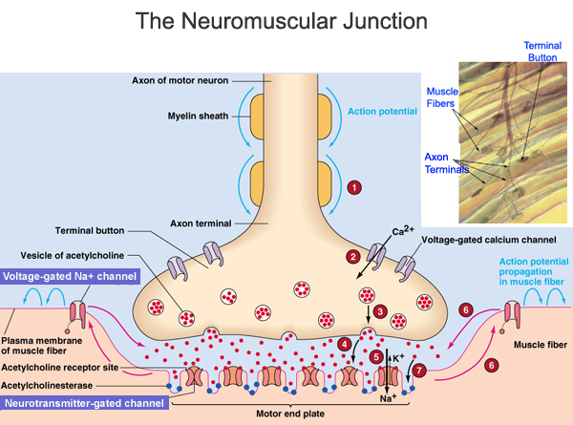

Sliding Filament Theory

When an action potential reaches the neuromuscular junction acetylcholine is released causing depolarisation of the muscle cell in the same way as a nerve cell.

The action potential spreads down the muscle fibre via a system of T-tubules that branch throughout the sarcoplasm. They are in contact with the sarcoplasmic reticulum.

The action potential opens the Ca2+ channels in the sarcoplasmic reticulum and Ca2+ flood into the muscle down a concentration gradient. The calcium ions bind to troponin, causing tropomyosin molecules, which were blocking the binding sites on actin to pull away.

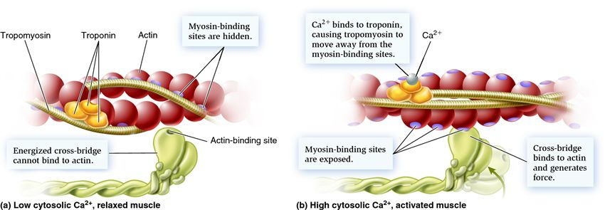

The myosin heads attached to ADP + Pi can now bind to the actin filament and form a cross bridge, starting the cross bridge cycle:

* 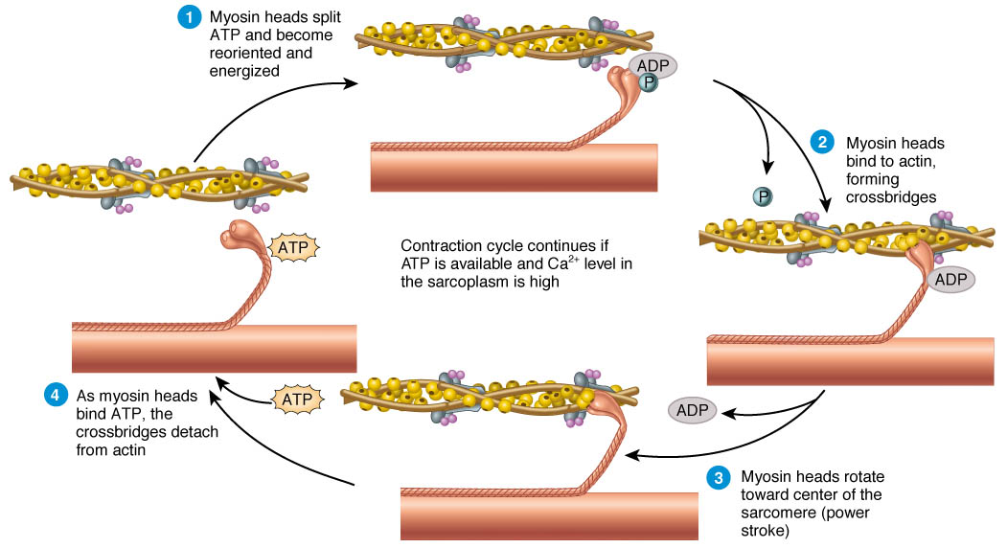Myosin heads combined with ADP and Pi bind to the actin filament.
* Once attached the myosin heads change their angle, pulling the actin filament along and releasing the ADP and Pi.
* An ATP molecule now attaches to each myosin head causing detachment from the actin filament.
* The enzyme ATPase, which is activated by the presence of Ca2+, and located in the myosin head hydrolyses ATP to ADP + Pi providing energy for the myosin head to return to its original position.
* The myosin head now reattaches itself further along the actin filament and the cycle is repeated.

Once nervous stimulation ceases, Ca2+ are actively transported back into the sarcoplasmic reticulum, which means that tropomyosin blocks the actin filament again and myosin heads are unable to bind to actin filaments and contraction stops.

The Role of ATP and Phosphocreatine

The energy required for muscle contraction is supplied by the hydrolysis of ATP:

ATP 🡪 ADP + Pi

ATP is required for:

* The myosin heads to change back to their original shape.
* The re-absorption of Ca2+ into the sarcoplasmic reticulum by active transport.

ATP supplies energy for muscle contractions but during times of intense exercise ATP reserves run out after three seconds. After this, ATP is rapidly resynthesised using phosphate derived from phosphocreatine.

Phosphocreatine 🡪 Creatine + Phosphate

Phosphocreatine cannot supply energy directly but can regenerate ATP. It is stored in muscle cells and acts as a reserve supply of phosphate ions, which immediately combine with ADP.

The phosphocreatine store is replenished using phosphate from ATP when the muscle is relaxed.



This system can provide enough energy working at maximum for 10 seconds. After this ATP is supplied from glycolysis.

This produces lactic acid as it is anaerobic, lactic build up is a painful problem. After one minute ATP supplies come from full aerobic respiration with production by oxidative phosphorylation.

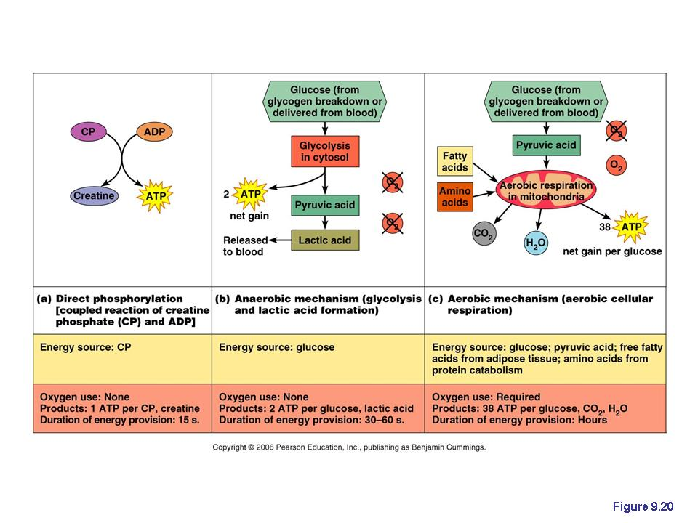

Slow & Fast Twitch Muscle Fibres

A nerve impulse is the trigger for muscle contraction but the length of time a contraction occurs depends on the length of time Ca2+ remain in the sarcoplasm. This time is different in slow and fast twitch fibres:

* Slow fibres have less sarcoplasmic reticulum and hence Ca2+ remain in the sarcoplasm longer.
* Slow twitch fibres have more mitochondria, which provide ATP for sustained contraction via aerobic respiration.
* Slow twitch fibres have more myoglobin than fast twitch fibres. Myoglobin has a higher affinity for oxygen than haemoglobin in blood and so is efficient at extracting oxygen from the blood.

Slow twitch fibres are responsible for sustained muscle contraction, mostly maintaining body posture whilst fast twitch fibres are responsible for shorter acting powerful contractions involved in locomotion.

Different people may have different proportions of fast and slow twitch fibres in their muscles, which may predispose them to be good at endurance or sprinting etc.

|  |  |  |
| --- | --- | --- |
| Feature | Fast Twitch Fibres | Slow Twitch Fibres |
|  |  |  |
| Role | Powerful, rapid contractions | Endurance contractions |
|  |  |  |
| Diameter of Fibres | Large | Small |
|  |  |  |
| Number of Capillaries | Few | Many |
|  |  |  |
| Number of Mitochondria | Few | Many |
|  |  |  |
| Speed of Contraction | Fast | Slow |
|  |  |  |
| Rate of Pumping Ca2+ | Fast | Slow |
|  |  |  |
| ATPase Activity | High (hydrolysed quickly) | Low (hydrolysed slowly) |
|  |  |  |
| ATP Source | Anaerobic Respiration | Aerobic Respiration |
|  |  |  |
| Glycogen Content | High (for immediate use) | Low (uses glucose) |
|  |  |  |
| Myoglobin Content | Low | High |
|  |  |  |
| Rate of Fatigue | Fast | Slow |
|  |  |  |
| Location | Arms & Legs, Bird Wings | Back & Neck |