3.6.4 Homeostasis is the maintenance of a stable internal environment

**3.6.4.1 Principles of homeostasis and negative feedback**

**Principles**

HOMEOSTASIS is the MAINTENANCE OF A CONSTANT INTERNAL ENVIRONMENT.

Homeostatic mechanisms in the body need to monitor both the internal and external environments and respond to any changes in order to maintain important factors such as pH, temperature, glucose, salt and water concentrations, within their normal range.

A simple homeostatic system involves the following components:

Feedback Systems

* Negative feedback reverses the effect of the stimulus.

Negative Feedback

* Positive feedback enhances the effect of the stimulus

Most feedback systems are negative as they are detecting fluctuations from the normal level and then bringing about corrective action to bring the condition back to normal.

Positive Feedback

Importance of Homeostasis

1. Enzymes are extremely sensitive to changes in pH and temperature. Deviations from optimum conditions could result in them being denatured or having a reduced efficiency. Other biological proteins such as channel or carrier proteins may also be affected by temperature and pH.

Synoptic Questions:

* Explain in as much detail as possible why enzyme activity is reduced when temperature falls.
  + Enzyme and substrate have less kinetic energy.
  + Fewer collisions.
  + Fewer enzyme-substrate complexes form.
  + Therefore less product is made.
* Explain in as much detail as possible why enzyme activity may stop when temperature becomes very high.
  + Enzyme is denatured.
  + Bonds stabilising tertiary structure are broken.
  + Therefore the shape of the active site is lost.
  + The enzyme is no longer complimentary to the substrate.
  + Therefore no enzyme-substrate complexes form.
* Explain in as much detail as possible how the activity of an enzyme or a membrane protein may be affected by changes in pH.
  + Change in pH can alter the charge on the R groups of the amino acids in the active site of an enzyme and in the binding site of a membrane protein.
  + Altering bond formation and tertiary structure.
  + Altering the shape of the active site of an enzyme and the binding site of a membrane protein.

1. Cells may be affected by changes in the surrounding water potential of the blood/tissue fluid.

Synoptic Questions:

* Explain in as much detail as possible the consequences of having too much glucose or ions in the blood.
  + Lowers the water potential of the blood.
  + Therefore water moves by osmosis from cells into the blood.
  + This causes cells to shrink and become dehydrated.
* Explain in as much detail as possible the consequences of the blood becoming too dilute.
  + Increases the water potential of the blood.
  + Therefore water moves by osmosis out of the blood in cells.
  + This causes the cells to swell and burst.

1. Glucose is an essential substrate for cellular respiration and so blood glucose concentration must not become too low for this reason.

**Temperature Control**

The process by which an animal regulates its temperature is called THERMOREGULATION.

Animals can gain heat from:

* Metabolism 🡪 many metabolic reactions produce heat as a by-product.
* The environment by conduction, convection or radiation.

Animals can lose heat by:

* Transfer to the environment by conduction, convection or radiation.
* Evaporation of water.

Ectotherms

Ectotherms have a limited ability to regulate their own internal temperature so their body temperature is largely determined by the environmental temperature. Therefore they must use behavioural mechanism to gain or lose heat in order to control their body temperatures.

* During the day, ectotherms bask in the sun to warm their bodies up, and will orientate themselves to expose the maximum surface to the sun. They also press their bodies against the ground to obtain heat from the ground by conduction.
* At the hottest part of the day, ectotherms hide under stones or bury themselves in the sand to prevent themselves from overheating. They also raise their bodies from the ground to minimise contact with hot surfaces.
* At night they retreat to burrows to reduce heat loss to the environment.

Endotherms

Endotherms control their body temperature independently of the environment and so are able to be active over a far wider range of environmental temperatures and can therefore exploit a much wider range of habitats. Maintenance of internal body temperature requires a lot of energy and therefore a lot of food so endotherms generally have to eat a lot more food than ectotherms.

In endotherms, heat is gained by:

* Respiration which produces thermal energy.
* The environment by conduction, convection or radiation.

In endotherms, heat is lost by:

* Infrared radiation from the skin.
* Evaporation of water from the skin.
* Conduction and convection to the environment.
* Warm substances leaving the body such as air breathed out or the loss of urine.

In mammals temperature regulation is controlled by the HYPOTHALAMUS.

This is constantly monitoring the temperature of the blood when it flows through it and it also receives information about the external temperature from receptors in the skin. The hypothalamus responds to this information and makes adjustments to the heat-producing or heat-losing activities of the body.

There are two regions of the hypothalamus;

* The HEAT-LOSS CENTRE which is at the front of the hypothalamus.
* The HEAT-GAIN CENTRE which is at the back of the hypothalamus.

Cooling Mechanisms in Endotherms

(This refers to the human thermoregulatory systems)

Body temperature will rise when the external temperature exceeds 37°C and heat is gained from the environment and also when the body generates excess heat in the muscles during exercise.

Therefore preventative measures are taken so that the core temperature does not rise above 37°C.

* The hypothalamus cells monitor the temperature of the blood.
* The hypothalamus also receives impulses from temperature receptors in the skin.
* An increase in body temperature stimulates the heat loss centre which acts as the co-ordinator.
* Nervous impulses are sent along motor neurones to effectors which bring about the appropriate responses to aid cooling.

**Heat loss by radiation:**

* Sympathetic nerves from the heat loss centre in the hypothalamus send impulses to arterioles in the skin.
* Arterioles which supply the capillaries dilate whilst the bypass arterioles constrict which increases the blood flow through the capillaries.
* More heat is transferred to the environment by radiation, VASODILATION.
* Amount of heat loss by radiation may be further increased by behavioural means, e.g. removing clothing.

**Heat loss by evaporation:**

* Sweat glands are stimulated by sympathetic nerves from the heat loss centre in the hypothalamus. They secrete sweat.
* This liquid then passes up the duct leading from the gland to the pore which opens onto the surface of the skin.
* As the liquid evaporates from the skin, surface heat energy is lost from the skin.
* This only works efficiently in low humidity conditions as in high humidity the air is already saturated with water vapour making it more difficult for the water to evaporate.
* Some fur covered mammals do not have sweat glands and they lose heat by evaporation by thermal panting. Water from the surface of the mouth and tongue evaporates using heat energy from the blood vessels lining them. The wet air is moved out of the mouth and dryer air is brought in through the nose.
* Small mammals lick themselves all over and the saliva evaporates from the body producing a cooling effect. This is only effective for small mammals with a high surface area to volume ratio.
* Larger mammals with a mall surface area to volume ratio tend to spend a lot of time in water, transferring heat to the water by conduction. When they come out of the water the skin is further cooled by evaporation.

**Heat loss by convection:**

* Heat loss centre in the hypothalamus send impulses to the hair erector muscles which relax making the hairs lie flat against the skin.
* This increases air movement over the skin speeding up heat loss by convection.

There is also a decreased rate of respiration in the brown fat cells so less heat is generated.

Warming Mechanisms in Endotherms

It is essential for endotherms to be able to respond rapidly to falling external temperatures.

Peripheral cold receptors in the skin detect that the environmental temperature is lower than body temperature and they send impulses to the heat gain centre in the hypothalamus. This co-ordinates the body’s response to cold by inhibiting the activity of the heat loss centre and by sending impulses to a range of effectors which bring about responses to cause heat gain.

**Vasoconstriction:**

* Heat gain centre in the hypothalamus sends impulses to the arterioles supplying the capillaries to constrict and the bypass shunt vein to dilate.
* This reduces the rate of blood flow through the surface capillaries and reduces heat loss by radiation.

**Hair erection:**

* Heat gain centre in the hypothalamus sends impulses to the hair erector muscles to contract.
* This pulls the hairs upright and traps a layer of air next the skin.
* This still air is a poor conductor of heat and so acts as a layer of insulation.

**Shivering:**

* Heat gain centre in the hypothalamus sends impulses to the skeletal muscles causing them to contract spasmodically.
* These muscles have a higher rate of respiration to provide energy for the contractions so a lot of thermal energy is produced.

**Increased metabolic activity:**

* Brown fat cells have a high concentration of mitochondria which are specialised to release the energy produced as heat.
* At a low body temperature, the heat gain centre in the hypothalamus sends impulses to the brown fat cells via sympathetic nerves.
* This increases their rate of respiration which generates more heat.
* Hibernating animals use brown fat tissue to generate heat to prevent them from freezing to death.

**Hormones:**

* Adrenaline acts on the liver causing glycogen to be converted to glucose.
* This gives a short term increase in the rate of respiration and heat is transferred to the blood flowing through the liver.
* If a mammal is exposed to cold temperatures for several weeks, the hypothalamus increases its output of thyrotropin releasing hormone.
* This causes the thyroid gland to enlarge and secrete more thyroxine which increases the basal metabolic rate increasing the rate of respiration and therefore heat generated.

**3.6.4.2 Control of blood glucose concentration**

The main factors which affect blood glucose levels are:

* Diet 🡪 Glucose is released from the digestion of carbohydrates.
* Exercise
* Action of hormones 🡪 Insulin reduces blood glucose concentration whilst glucagon and adrenaline increase it.

**When blood glucose levels rise:**

* If blood glucose levels rise above the normal range, it is detected by the β-cells in the islets of Langerhans.
* The β-cells produce the hormone INUSLIN.
* The insulin is released into the blood stream where it mainly affects the muscle, liver and adipose (fat) cells.
* The insulin molecules bind to an exposed glycoprotein receptor on the cell surface membrane as they have the correct complementary shape.
* This sends a chemical signal to the vesicles in the cytoplasm which contain glucose carrier proteins.
* The vesicles move to the cell surface membrane and fuse with it.
* The increased number of glucose carrier proteins increases the rate of glucose uptake by the cell.
* Various enzymes are then activated which lead to:
  + An increase in the rate of cellular respiration and the use of glucose as a respiratory substrate.
  + An increase in the rate of conversion of glucose to fat in adipose cells.
  + An increase in the rate of conversion of glucose to glycogen in liver and muscle cells, **GLYCOGENESIS.**
* This reduces the level of glucose in the blood.

**When blood glucose levels fall** (**Second messenger model**)**:**

* If blood glucose levels fall below the normal range, it is detected by the α-cells in the islets of Langerhans.
* The α-cells produce the hormone GLUCAGON.
* The glucagon binds to a receptor in the cell surface membrane of Liver cells as they possess the correct complementary binding protein.
* This activates **Adenyl cyclase** which converts ATP into cAMP.
* This initiates a series of reactions which activate **protein kinase** which catalyses the breakdown of glycogen to glucose phosphate. This process is called **GLUCOGENOLYSIS**
* Glucagon also activates other enzymes which catalyse the conversion of amino acids and glycerol into glucose-6-phosphate, **GLUCONEOGENESIS**.
* The glucose is then released back into the blood so that the blood glucose level increases back to the normal range.

**Action of Adrenaline:**

Adrenaline works in a similar way to glucagon by the second messenger model which increases blood glucose levels by;

* Causing the breakdown of glycogen in the liver, boosting blood glucose concentrations.
* Inactivating an enzyme which causes glucose to be converted into glycogen.

Diabetes

Symptoms of Diabetes;

* Since insulin is not being produced, blood glucose levels may rise to dangerously high levels, HYPERGLYCAEMIA.
* The kidneys which normally reabsorb all of the glucose passing into the nephrons, cannot cope and so some glucose is excreted in the urine, GLYCOSURIA.
* Extra water and salt follow the glucose and the sufferer therefore urinates a lot and feels thirsty.
* Uptake of glucose by body cells is very slow so the sufferer feels very tired.
* Cells start to metabolise fats and proteins leading to a build up of ketones in the blood which lower the pH and cause pear-drop smelling breath.
* The combination of dehydration, salt loss and low blood pH can lead to coma and death.

**Type I Diabetes**

* Symptoms usually appear in young people below the age of 20.
* The β-cells in the pancreas fail to produce insulin which can be caused by a mutation or autoimmune disease.
* It is treated by insulin injection.
  + Insulin cannot be taken orally as it is a protein and would be digested by proteases in the stomach before it could be absorbed.
* Sufferers must monitor their diet and blood glucose levels very carefully and inject the correct amount of insulin.
* If the blood glucose levels drop then they will suffer from HYPOGLCAEMIA.
  + Symptoms of a ‘hypo’ include shaking, sweating, blurred vision and loss of concentration.
  + When these symptoms have been realised, the sufferer must eat some sugars immediately to bring their blood glucose levels back up. This is important because if they don’t then they could fall into a coma as the brain cells do not have enough glucose to respire.
* If the blood glucose levels rise too high they will suffer from HYPERGLYCAEMIA which can also lead to a coma due to dehydration, salt loss and low blood pH.

**Type II Diabetes**

* Develops later in life, usually over the age of 40.
* Often caused by the gradual loss of the responsiveness of cells to insulin but can also be due to an insulin deficiency.
* Often associated with obesity.
* The symptoms of type II diabetes are similar to those of type I diabetes.
* Treatment usually involves diet and exercise management. If diet and exercise management become inadequate then many oral drugs can be used which are designed to increase insulin output by the pancreas, decrease glucose released from the liver, increase the sensitivity of cells to insulin, decrease the absorption of carbohydrates from the intestine and slow the emptying of the stomach to delay the presentation of carbohydrates for digestion and absorption in the small intestine.
* If these treatments become inadequate then sufferers must also take insulin injections.

**3.6.4.3 Control of blood water potential**

[(The Mammalian Kidney tutorial)](http://www.sumanasinc.com/webcontent/anisamples/majorsbiology/kidney.html)

* Metabolism refers to the total number of reactions in the body which includes:
  + - Anabolic reactions – Build larger molecules
    - Catabolic reactions – Break down larger molecules
* Metabolic waste is the by-products of these reactions. Some of these may be toxic i.e. could kill organisms if not removed. **Urea** is the nitrogenous waste from the metabolism of excess amino acids. The urea is potentially toxic so must be excreted!
* Formation of urea
  + - Excess amino acids cannot be stored and so inside **Liver** cells these excess amino acids are metabolised as shown below
    - **Deamination** removes the amino group from an amino acid and an H is added to it to form **Ammonia**, NH3. This ammonia now enters into a cycle of reactions called the **Ornithine cycle**

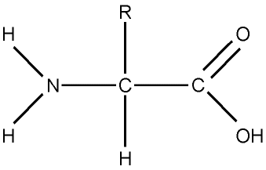

The remains of the amino acid forms an **organic acid** that is respired in the Kreb’s Cycle

NH3

* Ornithine accepts NH3 and CO2 to form citrulline. This molecule accepts another NH3 from excess amino acids and so converts to arginine. In a hydrolysis reaction i.e. water is added, then **Urea** is formed:
  + - Kidney structure
* The kidneys remove urea and other toxic wastes from the blood, forming a dilute solution called urine in the process. The two kidneys have a very extensive blood supply and the whole blood supply passes through the kidneys every 5 minutes, ensuring that waste materials do not build up
* The **renal artery** carries blood (high O2/high urea)to the kidney, while the **renal vein** carries blood (low O2/low urea), away from the kidney. The urine formed passes down the ureter to the bladder:

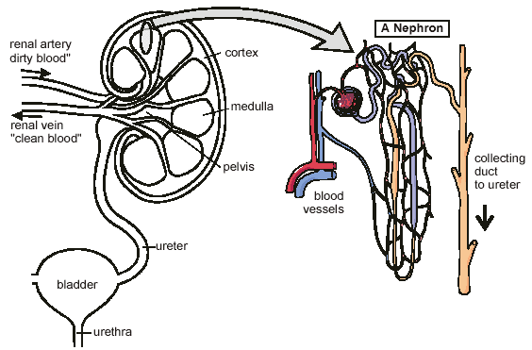

* Inside each kidney each artery divides into arterioles and forms **Glomeruli** (single **Glomerulus**) – knots of capillary networks where urea is filtered from the blood
* 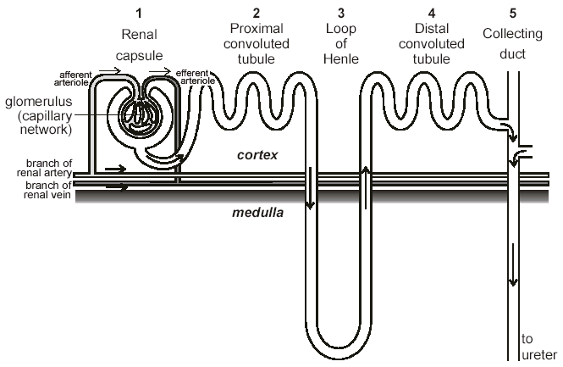In each kidney there are 1 – 1.5 million tiny tubes called **Nephrons** which filter the blood:
* **Ultrafiltration (Renal capsule)**
* The renal artery splits into numerous **arterioles**, each feeding a **nephron**. The arteriole splits into numerous capillaries, which form a knot called a **Glomerulus**
* The Glomerulus is enclosed by the **Bowman’s capsule**- the first part of the nephron. The arteriole leading into the **Glomerulus** (the **afferent** arteriole) is **wider** than the one leading out (the **efferent** arteriole), and a **high blood pressure within the renal artery**, so there is **higher hydrostatic blood pressure** in the capillaries of the **Glomerulus** than **osmotic pressure in the opposite direction**
* This pressure **forces** small soluble molecules (water, glucose, mineral ions and urea) through the capillary pores and into the Bowman’s capsule – called **ultrafiltration**.

**Formation of glomerular filtrate by ultrafiltration**

# 

**Lumen of capsule**

**blood**

**plasma**

**red blood**

**cell**

**fenestra in basement podocyte cell glomerular filtrate**

**endothelium membrane**

* + Blood cells and large plasma proteins cannot exit due to the **Basement Membrane** surrounding the capillary, it acts as a **molecular sieve, as it has very small pores within it**. The glomerular filtrate contains:
* Water
* Glucose
* Na Cl
* Urea
* Amino Acids
  + - The movement of the filtrate out of the glomerulus is resisted by the :
      * Capillary epithelial cells
      * Connective tissue and epithelial cells of the blood capillary
      * epithelial cells of the renal capsule
      * hydrostatic pressure of the fluid in the renal capsule space
      * the low water potential of the blood in the glomerulus
    - This resistance would be enough to prevent the filtrate from leaving the glomerular capillaries but there are adaptations which reduce this barrier to the flow of filtrate
* The capsule walls are formed from a single layer of flattened epithelial cells with large gaps between them, called **podocyte cells**, so that all small soluble molecules are squeezed out of the blood to form a filtrate in the renal capsule.
* The endothelium of the glomerular capillaries has spaces up to 100nm wide between its cells.

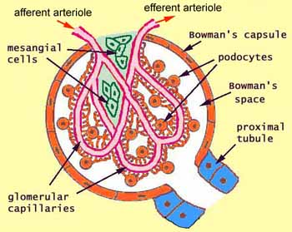

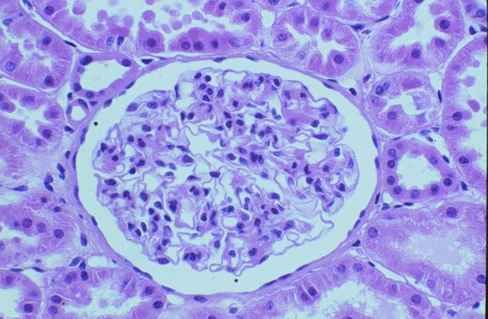

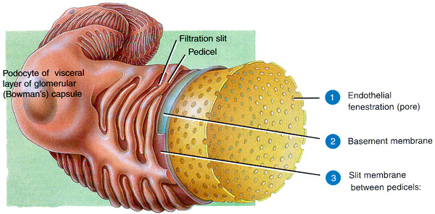

* + - **Selective Reabsorption (Proximal convoluted tubule)** 
      * The purpose of the PCT is to reabsorb 85% of filtrate back into the blood!
* Reabsorb water by osmosis **\*N.B. Most water reabsorbed here**
* Reabsorb all glucose and amino acids by active transport
* Reabsorb Na+ Cl- by facilitated diffusion and active transport
* Not to reabsorb urea

i.e. this is the selective nature – urea is not absorbed

* Reabsorbing water by osmosis
* The blood leaving the Glomerulus has a **very low ** because it has retained **the large soluble plasma proteins** and very little water after ultrafiltration
* In the glomerular filtrate there is a **high ** due to much water and fewer solutes compared to the blood
* So water moves by **osmosis** from the filtrate into the blood
  + Reabsorption of sodium ions (Na+)
    - * **Sodium ions** are actively transported out of the cells lining the proximal convoluted tubule into blood capillaries which carry them away. This lowers the sodium concentration of the sodium ions in these cells so that sodium ions will diffuse from the lumen of the proximal convoluted tubule into the epithelial cells through carrier proteins down a concentration gradient by **facilitated diffusion**.
* Reabsorbing glucose, amino acids and chloride ions
* Glucose, amino acids and chloride ions are **transported along with sodium ions** by specific protein carriers into the epithelial cells (This is **co-transport**) generating a high concentration of these molecules within the cell.
* Glucose and amino acids move then by **Facilitated diffusion** into the blood as there is a concentration gradient which is maintained by the flow of blood

Epithelial cells are adapted to this

function in the following ways:

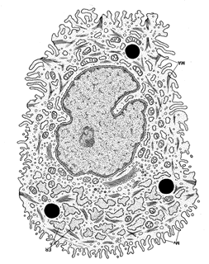

Many mitochondria

Microvilli

* + - * **Microvilli** – to **increase SA** for absorption
      * **Many mitochondria** – provide energy, from ATP hydrolysis for active transport of molecules
* Large number of **carrier proteins/channel proteins** in the membranes for active transport/facilitated diffusion
  + - Capillaries are **close to cells**, therefore there is a short diffusion pathway, increasing the rate of absorption
    - Infoldings at their bases to give a large surface area to transfer reabsorbed substances into blood capillaries

**Maintenance of a gradient of sodium ions by the loop of Henle**

* Loop of Henle

The loop has two limbs, the **descending and ascending limb**. The ascending limb is more permeable to salts (Na+) and impermeable to water. The ascending limb has thick walls. The descending limb is thinner and narrower and is permeable to water.

* From the top of the ascending limb Na+ ions are **actively transported** into the medullary tissue fluid (MTF). This uses ATP provided by the many mitochondria in the cells in the wall of the loop of Henle.
* These extra solutes **lower the ** of the MTF
* So that it is lower than the filtrate in the descending limb
* Therefore water molecules move by osmosis from the filtrate to the MTF (and **small concentration of Na+** move into the descending limb by facilitated diffusion)
* Therefore the **filtrate** becomes **more concentrated** (** lowers)** as it moves down the **descending limb**
* This results in the solute concentration at any part of the loop is always **lower** in the ascending limb compared to the descending limb – called the **Counter Current Multiplier Mechanism**
* Water passes out of the **Collecting Duct** and into the medulla by osmosis due to the low **wp** generated by the loop of Henle, resulting in very concentrated urine

**Key**

### Water moving by osmosis

Na+ Cl- moving by active transport

Na+ moving by Facilitated diffusion

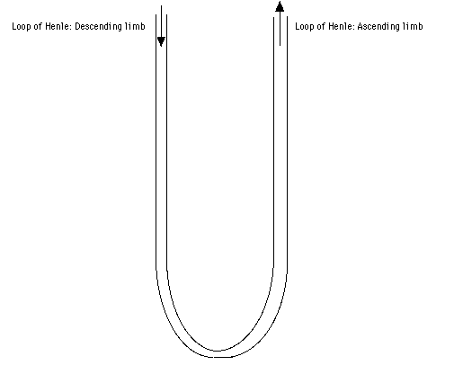

 1200 kPa

 1100 kPa

 900 kPa

 1100 kPa

 1000 kPa

 600 kPa

 450 kPa

 600 kPa

 500 kPa

 90 kPa

 200 kPa

 100 kPa

 200 kPa

* Environment and length of loop of Henle
* The length of the loop is related to the environment of mammals; the longer the loop of Henle the more concentrated urine is, therefore it has a lower water potential.
* This means that mammals living in deserts:
  + Will have **longer** loops of Henle
  + **Counter Current Multiplier Mechanism**
  + Creates a **region of very low  **around the loop
  + Therefore more water is absorbed from the **collecting duct**
  + Producing very **concentrated urine**

Badger Camel

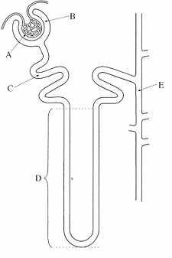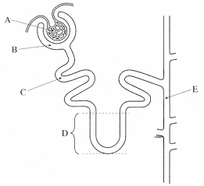

1. Different animals excrete nitrogenous waste in different forms depending upon the environment they live in:
2. 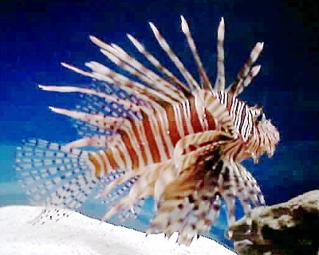Fish excrete **ammonia**:
3. Ammonia is a small, very soluble and **highly toxic** so must be excreted immediately
4. It cannot be stored and requires **large volumes of water** to dilute it down to non-toxic levels for it to be excreted safely
5. 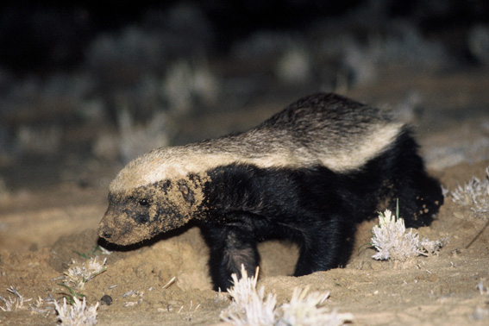Mammals excrete **urea**:
6. Urea is much **less toxic** than ammonia and therefore can be **stored** for a period of time in the tissues.
7. As it is less toxic it **require less water** to dilute it down to safe levels
8. Although producing urea is energetically expensive it is an **adaptation to life on land**, and helps prevent dehydration.

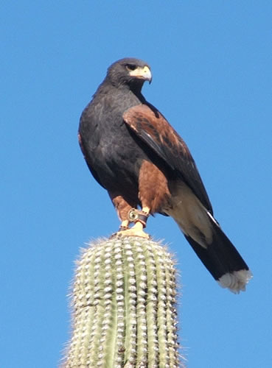

1. Retiles, Birds and Insects excrete **uric acid**:
2. Uric acid is virtually **non-toxic** and can therefore be stored for long periods of time.
3. **Very little water** is needed to safely excrete it and it is removed from the bodies as a white paste.
4. Although very energetically expensive it allows these animals to survive in **very arid environments**.
5. Other advantages for birds are that because very little water is needed to dilute uric acid, a **smaller volume** of uric acid is present in **bird eggs** and a **smaller mass in flying birds**!

**The distal convoluted tubule (DCT)**

Cells lining the walls of the DCT have many mitochondria and microvilli so can absorb material rapidly from the filtrate by active transport. The main role of the DCT is to make final adjustments to the water and salts that are reabsorbed and to control the pH of the blood by selecting which ions to reabsorb. The permeability of the cells in the walls of the DCT can be altered by various hormones.

**Counter current multiplier**

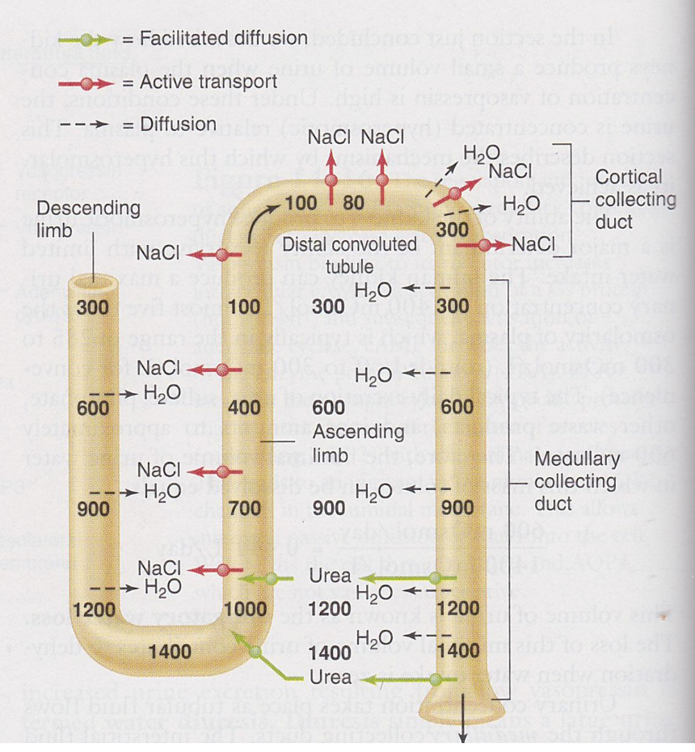

The filtrate in the Loop of Henle and the collecting duct are flowing in opposite directions to each other. This means that the filtrate in the collecting duct with a lower water potential meets interstitial fluid that has an even lower water potential. This means that while the water potential gradient between the collecting duct and the interstitial fluid in the medulla is small is does exist for the whole length of the collecting duct. There is therefore a steady flow of water into the interstitial fluid, so around 80% of water enters the interstitial fluid and hence the blood. If the two flows were in the same direction less water would enter the blood.

**The role of hormones in osmoregulation**

ADH and water reabsorption in the DCT and Collecting Duct

* + - Urine leaves the loop of Henle and flows through the Distal Convoluted Tubule (DCT) and Collecting Duct, which takes urine to the Pelvis and Ureter
    - The walls of the DCT and Collecting Duct are relatively **impermeable to water**, so the urine leaves the body virtually unchanged from the ascending limb of the Loop of Henle
    - On hot days more water is lost from the blood with increased sweating, therefore the blood has a lower  A smaller volume of urine is produced on these days due to more water being reabsorbed into the blood in the DCT and Collecting duct
    - **Osmoreceptors** in brain’s **Hypothalamus** detect a lower blood , then send impulses to the **Posterior Lobe of the Pituitary Gland** which secretes **Anti Diuretic Hormone (ADH)** into blood
    - The target cells are the **epithelial cells** that make up the wall of the DCT and Collecting Duct
    - ADH molecules bind to protein receptors on the cell-surface membrane of these epithelial cells leading to the activation of an enzyme called **phosphorylase** within the cell
    - The activation of phosphorylase causes vesicles within the cell to move to, and fuse with the its cell-surface membrane
    - These vesicles contain aquaporins (water channel proteins) which when inserted into the cell membrane of the epithelial cells in the wall of the collecting duct making these epithelial cells to water much more permeable to water.
    - ADH **increases the permeability** of these cells to water, so:
  + Water moves from the urine into the MTF by osmosis
  + Due to the ionic gradient existing in the MTF next to the DCT and Collecting Duct
  + The water from the MTF enters the blood raising the  of the blood
  + As the reabsorbed water came from the blood originally this process will not in itself increase the water potential of the blood, only prevent it from getting lower. The osmoreceptors in the hypothalamus also send nerve impulses to the thirst centre of the brain, to encourage the individual to seek out and drink more water.
  + The osmoreceptors detect the increase in  are no longer stimulated so send fewer impulses to the pituitary gland and no ADH is secreted so cells lining the collecting duct revert to former state.
* Stimulus Response model

Blood  rises Osmoreceptors in hypothalamus posterior lobe of pituitary

(stimulus) (receptor) (coordinator)

ADH not secreted

Blood   falls epithelial cells of collecting duct less permeable

NormalBlood  (response) (effector)

Blood   rises epithelial cells of collecting duct more permeable

ADH secreted

Blood   falls Osmoreceptors in hypothalamus posterior lobe of pituitary

