3.3.3 Digestion and absorption

* Autotrophs use simple inorganic materials to manufacture complex organic

compounds (plants and bacteria that photosynthesise convert CO2 and O2.

* **Photosynthesis** is the process by which green plants build up complex organic molecules such as sugars, from carbon dioxide and water. The source of energy for this process comes from sunlight which is absorbed by chlorophyll and related pigments. Algae and certain types of bacteria can also photosynthesise using energy from sunlight.
* **Chemosynthesis** is a process carried out by autotrophic bacteria. They use the energy derived from special methods of respiration to synthesise organic food.
* Heterotrophs cannot make their own organic food. They have to consume complex organic food material produced by autotrophs. Since they eat or consume ready-made food they are known as consumers.
* **Holozoic feeders**

This includes nearly all animals. They take their food into their bodies and break it down by the process of digestion. Most carry out this process inside the body within a specialised digestive system.

* + Saprophytic Digestion
  + Saprophytic feeders are fungi and bacteria that use dead organic compounds as food, therefore are heterotrophs. To digest that food, saprophytes/saprobionts:
    - * Secrete enzymes
      * Onto the organic material for EXTRACELLULAR DIGESTION
      * Digestion hydrolyses bonds in organic material e.g. protein, starch, cellulose, sucrose
      * This produces small soluble molecules e.g. amino acids, glucose
      * Which are absorbed by diffusion
* Fungi are made up from tiny threads called HYPHAE – enzymes are secreted

from the tips of the hyphae:

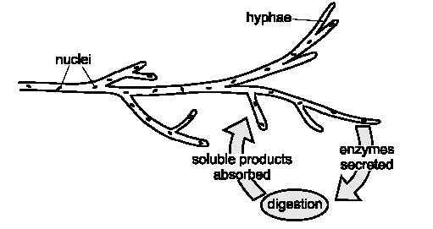

# Human digestion

* Humans, like all animals, use holozoic nutrition, which consists of these stages:
  + Ingestion- taking large pieces of food into the body through the mouth
  + Digestion- breaking down large insoluble food molecules into small soluble food molecules by mechanical and chemical means
  + Absorption- taking up the soluble digestion products into the blood
  + Egestion- eliminating the undigested food
* Do not confuse **egestion**, which is the elimination of material from a body cavity, with **excretion**, which is the elimination of waste material produced from within the body's cells.

**Ingestion**

* Teeth are important in the **mechanical digestion** of food. Chewing food is important as it makes it easier to swallow and also **increases the surface area for enzyme action**.
* Humans are omnivores, that is they eat they both plant and animal material. The teeth are not particularly specialised but having four different types of teeth to carry out different functions reflects a mixed diet. In total humans have 32 teeth.

**Digestion**

* In humans the site of ingestion/digestion/absorption is the GUT, which is a long tube that extends from the mouth to the anus, together with a number of associated glands.
* In simple organisms, feeding on only one type of food, the gut is

undifferentiated, however in more advanced organisms the digestive system is made up of different tissues doing different jobs.



* Structure of the gut

The lining wall of the alimentary canal appears different in different parts of the gut, reflecting their different jobs.

* The human alimentary canal consists of buccal cavity, tongue, salivary

glands, oesophagus, stomach, duodenum, ileum, colon, rectum, anus and

associated organs; liver and pancreas:

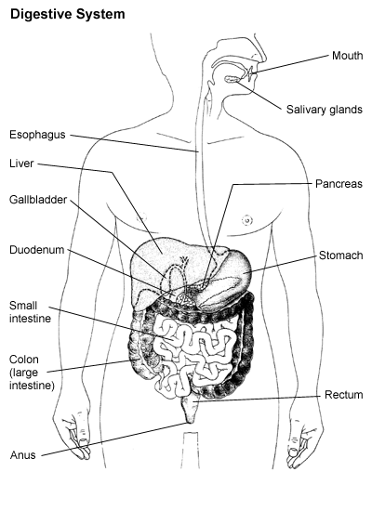

Enzymes’ site of production, their substrates and products

* + - There are a number of different glands which produce digestive secretions, which contain enzymes.
    - Some of these glands are found in the wall of the gut with the secretions passing directly into the gut cavity. Other glands are found outside the gut with the secretions passing along ducts into the gut cavity.
  + There are 3 food types to digest:
    - * Carbohydrates
      * Protein
      * Lipid

**Carbohydrates**

* **Digestion of Starch**

Amylase Maltase

* Starch Maltose Glucose
  + Amylase is produced in the mouth. It hydrolyses alternate glycosidic bonds of the starch to produce maltose
  + Maltase, which is produced in the ileum, hydrolyses maltose to -glucose
* In humans food in the mouth is mixed with saliva which contains **salivary amylase.**
* This starts hydrolysing starch to maltose. It also contains mineral salts to help maintain a neutral pH – the optimum for the amylase enzyme to work at.
* The food is swallowed and enters the stomach, where the conditions are acidic. **Amylase is denatured** so no more starch is hydrolysed.
* The food is then passed into the small intestine where it mixes with pancreatic juice -secreted from the pancreas
* Pancreatic juice contain **pancreatic amylase**. This continues with the hydrolysis of starch to maltose. Alkaline salts are produced by both the pancreas and the intestinal wall to maintain pH at around neutral so the amylase can function at its optimum.
* Muscles in the intestinal wall push food along to the ileum. The epithelial cells lining the ileum produce the enzyme **maltase**. The maltase not released but is part of the cell-surface membranes of the epithelial cells that line the ileum. This is known as a **membrane-bound disaccharidase**. The maltase hydrolyses the maltose from starch to -glucose.

**Digestion of Sucrose**

* Sucrase hydrolyses the single glycosidic bond in the sucrose molecule
* This is also known as a **membrane-bound disaccharidase**.
* This hydrolysis produces glucose and fructose

**Digestion of Lactose**

* Lactase hydrolyses the single glycosidic bond in the lactose molecule
* This is also known as a **membrane-bound disaccharidase**.
* This hydrolysis produces glucose and galactose

**Lipids**

* These are NOT polymers!
* Lipids are hydrolysed by **lipases**.
* Lipases are enzymes produced in the **pancreas** that hydrolyse the ester bond found in triglycerides to form fatty acids and monoglycerides.
* A monoglyceride is a glycerol molecule with a single fatty acid molecule attached.
* Lipids are first split up into tiny droplets called **micelles** by **bile salts**, which are produced by **the liver**.
* This process is called emulsification and increases the surface area of the lipid so the action of the lipase is speeded up.

Bile Lipase

Emulsification

* Lipids Lipids Monoglyceride
* (large (micelles)

globules )

* Bile Emulsifies large fat droplets to small droplets
* To increase surface area for lipase action
* Bile also neutralises acidic stomach contents
* *N.B. Bile is not an enzyme!
* One end of the bile salt molecule is soluble in fat but not in water. The other end is soluble in water but not in fat.
* Bile salts arrange themselves with their lipophilic ends in fat droplets, leaving their lipophobic ends sticking out.
* This prevents fat droplets from sticking to other fat droplets and forming large droplets, leaving only tiny ones (micelles)

Protein

* + - Proteins are digested by a group of enzymes called **peptidases** which are secreted by the **pancreas** into the ileum.
    - **Endopeptidases** hydrolyse the peptide bonds between amino acids in the central region of a protein molecule forming a series of peptide molecules
    - **Exopeptidases** hydrolyse the peptide bonds on the terminal amino acids of the peptide molecules formed by endopeptidases. In this way they progressively release dipeptides and single amino acids.
    - **Dipeptidases** hydrolyse the bond between the two amino acids of a dipeptide. Dipeptidases are **membrane- bound** being part of the cell surface membrane of the epithelial cells lining the ileum.

Endopeptidase Exopeptidase

* Protein Polypeptide Amino

Acids

* Enzyme site of production and action

|  |  |  |  |  |
| --- | --- | --- | --- | --- |
| Enzyme/chemical | Site of production | Site of action | Substrate | Product |
| Amylase | Salivary glands | Mouth | Starch | Maltose |
| Pancreas | Duodenum |
| Endopeptidase | Gastric glands | Stomach | Protein | Polypeptides |
| Pancreas | Duodenum |
| Exopeptidase  Dipeptidase | Epithelial cells at tips of villi | Ileum | Polypeptides  Dipeptides | Amino Acids |
| Maltase  Sucrase  Lactase | Epithelial cells at tips of villi | Ileum | Maltose  Sucrose  lactose | Glucose |
| Lipase | Pancreas | Duodenum | Lipids | Fatty Acids + Glycerol |
| Bile | Liver | Duodenum | Large Lipid Globules | Small Lipid Globules |

**Regional specialisations**

* The Mouth
  + **Mechanical digestion** begins in the mouth when food is chewed using the **teeth**
  + Saliva is important for lubricating the food before it is swallowed. Saliva contains **Amylase** which breaks down **starch to maltose**. After chewing the ball of food is swallowed and **mucus lubricates** its passage down the **oesophagus**.

* The stomach
  + The muscles of the stomach wall contract rhythmically and mix up the food with **gastric juice** secreted by glands in the stomach wall. Gastric juice contains acid that gives the stomach contents a **pH of 2.0**
  + The acid has the following roles:
    - * Provides optimum pH for endopeptidases
      * Acid helps to break bonds between monomers
      * Kills bacteria
  + Gastric juice also contains **endopeptidase** enzymes which hydrolyse the **protein to polypeptides**
  + **Mucus** is important in forming a lining to protect the **stomach wall** from the **enzymes and acid** as well as assisting in the movement of food within the stomach.

* The small intestine
  + The small intestine is divided into two regions, the **duodenum** and the **ileum:**
  + **The duodenum** makes up the first 20cm of the small intestine and receives secretions from both the **liver** and the **pancreas**

* + **Bile salts** are produced in the liver and stored in the **gall bladder** from where it passes into the **duodenum** via the **bile duct**. It contains no enzymes but the **bile salts** are important in **emulsifying** the lipids present in the food
  + **The pancreas** secretes **pancreatic juice** into the **duodenum** through the **pancreatic duct**. It contains a number of different enzymes:
    - * **Endopeptidases** which hydrolyse **protein to polypeptides**.
      * **Amylase** which breaks down any remaining **starch to maltose**.
      * **Lipase** which hydrolyse **lipids into fatty acids and glycerol**.
  + The walls of the duodenum contain **glands** that secrete an **alkaline juice and mucus**. The alkaline juice helps to keep the contents of the small intestine at the correct pH for enzyme action, and the mucus is for lubrication and protection.

* + In **the ileum** enzymes secreted by cells at the tips of the villi complete digestion:
    - * **maltase** hydrolyses **maltose** into **two glucose molecules**
      * **Sucrase** hydrolyses **sucrose** into **glucose and fructose molecules**
      * **lacase** hydrolyses **lactose** into **glucose and galactose molecules**
      * **endopeptidases and exopeptidases** complete the digestion of **polypeptides to amino acids**.
      * **Dipeptidases which hydrolyse dipeptides to amino acids**

**Absorption**

Absorption of the end products of digestion takes place in the ileum, the

 surface area of which is increased by villi and microvilli:

* **Villi** and **microvilli** increases the **Surface Area**
* Epithelium **one cell thick** provides a **short diffusion pathway**
* They contain **muscle** and so are able to move. This helps to **maintain the concentration gradient** as their movement mixes the contents of the ileum.
* **Circulating blood** in blood capillaries within the villi maintains a **concentration gradient.**

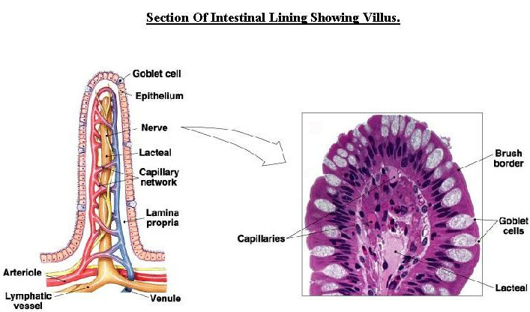

* Mechanisms for Absorption
  + - * Monosaccharides
* Glucose, fructose and galactose are absorbed by **diffusion and co-transport** into **capillaries** and then travel via the **hepatic portal vein** to the **liver**
* Glucose is absorbed from the blood by cells, for energy release in respiration, and any excess is converted to fat for storage
* Proteins
* Amino acids are absorbed by **diffusion and co-transport** into capillaries and then travel via the **hepatic portal vein** to the liver
* Amino acids are absorbed for protein synthesis; excess cannot be stored so undergoes **deamination**, whereby the removed amino groups are converted to urea and the deaminated remainder is converted to carbohydrate and stored

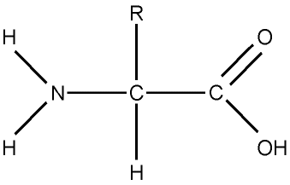

The remains of the amino acid forms an **organic acid** that is respired in the Kreb’s Cycle (aerobic respiration)

NH3 – converted to urea and excreted via the kidney

* Triglycerides
* Monoglycerides and fatty acids stay associated with bile salts as **micelles**. When micelles come into contact with the epithelial cells lining the ileum they break down into monoglycerides and fatty acids. As these are non-polar molecules they can easily **diffuse** across the cell membrane into the epithelial cells.
* Once inside the epithelial cell they are transported to the **Endoplasmic reticulum** where they are recombined to form **triglycerides.**  They then move to the Golgi body where they are associated with cholesterol and lipoproteins to form structures called **chylomicrons**.
* Chylomicrons move out of the epithelial cells **by exocytosis**.
* They enter lymphatic capillaries called **lacteals** that are found in the **centre of each villus**
* From here chylomicrons pass through the **lymphatic system** to the blood stream opening at the **thoracic duct**
* Lipids are used for membranes and hormones, and the excess is stored as fat
* Water and mineral salts
* Most water is reabsorbed, along with soluble nutrients, in the small intestine. The colon absorbs the remaining water, together with vitamins (secreted by micro-organisms in the colon) in order to produce solidified faeces.



Co-transport

Co-transport

**Egestion**

* Residues of undigested cellulose, bacteria and sloughed cells pass along the colon to be egested as faeces *N.B. Cellulose fibres are needed to provide bulk and stimulate peristalsis