**Q1.**

In one species of squirrel, *Sciurus carolinensis*, fur colour is controlled by one gene, with two codominant alleles. **CG** represents the allele for grey fur colour, and **CB**

represents the allele for black fur colour.

The table below shows the three possible phenotypes.

|  |  |
| --- | --- |
| **Genotype** | **Phenotype** |
| **CGCG** | Grey fur |
| **CGCB** | Brown-black fur |
| **CBCB** | Black fur |

(a)  In a population of 34 *S. carolinensis*, 2 had black fur.

Use the Hardy–Weinberg equation to estimate how many squirrels in this population had brown-black fur. Show your working.

Answer _______________

**(2)**

(b)  The actual number of squirrels in this population that had brown-black fur was 16.

Use all of the information to calculate the **actual** frequency of the **CG** allele.

Do **not** use the Hardy–Weinberg equation in your calculation.

Give your answer to 2 decimal places.

Answer _______________

**(1)**

(c)  *S. carolinensis* were first introduced to the UK from North America in the 1870s. They are now widely distributed across the UK.

*S. carolinensis* from both North America and the UK show exactly the same genotypic and phenotypic variation. An identical mutation causing black fur has also been found in several other species closely related to *S. carolinensis*.

Use this information to deduce which **one** of the following conclusions is most likely true.

Tick (**✓**) **one** box.

|  |  |  |
| --- | --- | --- |
| **A** | The mutation that caused black fur happened after *S. carolinensis* was introduced to the UK from North America. |  |
| **B** | The mutation that caused black fur happened in a common ancestor of *S. carolinensis* and other closely related species. |  |
| **C** | The mutation that caused black fur happened independently in *S. carolinensis* and all other closely related species. |  |
| **D** | The phenotypic variation shown in *S. carolinensis* and other closely related species is caused by genetic drift. |  |

**(1)**

The mutation that caused the **CB** allele was due to a 24 base-pair deletion from the **CG** allele.

(d)  The protein coded for by the **CB** allele is 306 amino acids long.

Calculate the percentage reduction in size of the protein coded for by the **CB** allele compared with the protein coded for by the **CG** allele.

Give your answer to 3 significant figures and show your working.

Answer _______________

**(2)**

In *S. carolinensis*, fur colour depends on the distribution and relative amounts of light pigments and dark pigments in the hairs of the fur. The figure below shows how the protein produced from the **CG** allele can result in the production of a light pigment or a dark pigment.

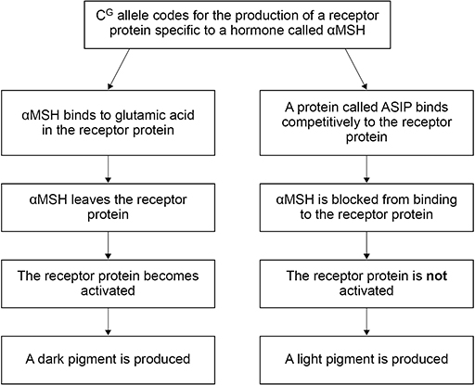

The deletion mutation in the **CB** allele results in the production of a receptor protein that does not have glutamic acid. The lack of glutamic acid in the receptor protein has the same effect as αMSH leaving the receptor protein.

(e)  Use the figure above and this information to suggest why *S. carolinensis* with the genotype **CBCB** have black fur rather than grey fur.

___________________________________________________________________

___________________________________________________________________

___________________________________________________________________

___________________________________________________________________

___________________________________________________________________

___________________________________________________________________

___________________________________________________________________

___________________________________________________________________

**(3)**

**(Total 9 marks)**

**Q2.**

Malaria is a disease that is spread by insects called mosquitoes. In Africa, DDT is a pesticide used to kill mosquitoes, to try to control the spread of malaria.

Mosquitoes have a gene called *KDR*. Today, some mosquitoes have an allele of this gene, *KDR minus*, that gives them resistance to DDT. The other allele, *KDR plus*, does not give resistance.

Scientists investigated the frequency of the *KDR minus* allele in a population of mosquitoes in an African country over a period of 10 years.

The figure below shows the scientists’ results.

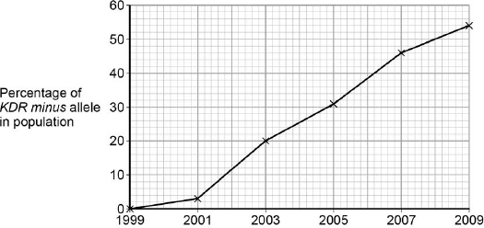

          Year

(a)     Use the Hardy–Weinberg equation to calculate the frequency of mosquitoes heterozygous for the *KDR* gene in this population in 2003.

Show your working.

Frequency of heterozygotes in population in 2003 ____________________

**(2)**

(b)     Suggest an explanation for the results in the figure above.

___________________________________________________________________

___________________________________________________________________

___________________________________________________________________

___________________________________________________________________

___________________________________________________________________

___________________________________________________________________

**(4)**

**(Total 6 marks)**

**Q3.**

The Hardy-Weinberg equation is

*p*2 + 2*pq* + *q*2 =1

The Hardy-Weinberg equation can be used to estimate the frequency of a recessive allele in a population. Haemochromatosis is a condition caused by a recessive allele.  
In one country, 1 in every 400 people was found to have haemochromatosis.

Describe how you would use the Hardy-Weinberg equation to calculate the frequency of people who are healthy but carriers (heterozygotes) of the allele for haemochromatosis.

_______________________________________________________________________

_______________________________________________________________________

_______________________________________________________________________

_______________________________________________________________________

_______________________________________________________________________

_______________________________________________________________________

**(Total 3 marks)**

**Q4.**

Sea otters were close to extinction at the start of the 20th century. Following a ban on hunting sea otters, the sizes of their populations began to increase. Scientists studied the frequencies of two alleles of a gene in one population of sea otters. The dominant allele, **T**, codes for an enzyme. The other allele, **t**, is recessive and does not produce a functional enzyme.

In a population of sea otters, the allele frequency for the recessive allele, **t**, was found to be 0.2.

(a)     (i)      Use the Hardy-Weinberg equation to calculate the percentage of homozygous recessive sea otters in this population. Show your working.

Answer ____________________ %

**(2)**

(ii)     What does the Hardy-Weinberg principle predict about the frequency of the **t** allele after another 10 generations?

______________________________________________________________

______________________________________________________________

**(1)**

(b)     Several years later, scientists repeated their study on this population. They found that the frequency of the recessive allele had decreased.

(i)      A statistical test showed that the difference between the two frequencies of the **t** allele was significant at the P = 0.05 level.

Use the terms **probability** and **chance** to help explain what this means.

______________________________________________________________

______________________________________________________________

______________________________________________________________

______________________________________________________________

______________________________________________________________

**(2)**

(ii)     What type of natural selection appears to have occurred in this population of sea otters? Explain how this type of selection led to a decrease in the frequency of the recessive allele.

Type of selection ________________________________________________

Explanation ____________________________________________________

______________________________________________________________

______________________________________________________________

______________________________________________________________

**(2)**

**(Total 7 marks)**

**Q5.**

Warfarin is a substance which inhibits blood clotting. Rats which eat warfarin are killed due to internal bleeding. Some rats are resistant to warfarin as they have the allele **WR**.

Rats have three possible genotypes:

**WRWR** resistant to warfarin  
**WRWS** resistant to warfarin  
**WSWS**     susceptible (not resistant) to warfarin.

In addition, rats with the genotype **WRWR** require very large amounts of vitamin K in their diets. If they do not receive this they will die within a few days due to internal bleeding.

(a)     How can resistance suddenly appear in an isolated population of rats which has never before been exposed to warfarin?

___________________________________________________________________

___________________________________________________________________

**(1)**

(b)     A population of 240 rats was reared in a laboratory. They were all fed on a diet containing an adequate amount of vitamin K. In this population, 8 rats had the genotype **WSWS**, 176 had the genotype **WRWS** and 56 had the genotype **WRWR**.

(i)      Use these figures to calculate the actual frequency of the allele **WR** in this population. Show your working.

Answer ____________________

**(2)**

(ii)     The diet of the rats was then changed to include only a small amount of vitamin K. The rats were also given warfarin. How many rats out of the population of 240 would be likely to die within a few days?

______________________________________________________________

**(1)**

(c)     In a population of wild rats, 51% were resistant to warfarin.

(i)      Use the Hardy-Weinberg equation to estimate the percentage of rats in this population which would be heterozygous for warfarin resistance. Show your working.

Answer ____________________ %

**(3)**

(ii)     If all the susceptible rats in this population were killed by warfarin, more susceptible rats would appear in the next generation. Use a genetic diagram to explain how.

**(2)**

(iii)     The graph shows the change in the frequency of the **WS** allele in an area in which warfarin was regularly used. Describe and explain the shape of the curve.

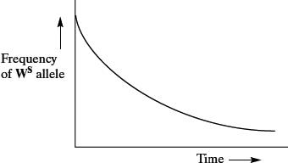

______________________________________________________________

______________________________________________________________

______________________________________________________________

______________________________________________________________

______________________________________________________________

______________________________________________________________

______________________________________________________________

______________________________________________________________

**(4)**

(iv)    Give **two** assumptions that must be made when using the Hardy-Weinberg equation.

1. ____________________________________________________________

______________________________________________________________

2. ____________________________________________________________

______________________________________________________________

**(2)**

**(Total 15 marks)**

**Q6.**

Lactose is the main sugar in milk and is hydrolysed by the enzyme lactase. Lactase is essential to newborn mammals as milk is their only source of food. Most mammals stop producing lactase when they start feeding on other food sources. Humans are an exception to this because some continue to produce lactase as adults. The ability to continue producing lactase is known as lactase persistence (LP) and is controlled by a dominant allele. A number of hypotheses based on different selection pressures have been put forward to explain LP in humans.

(a)     One hypothesis for LP in humans suggests that the selective pressure was related to some human populations farming cattle as a source of milk.

Describe how farming cattle as a source of milk could have led to an increase in LP.

___________________________________________________________________

___________________________________________________________________

___________________________________________________________________

___________________________________________________________________

___________________________________________________________________

___________________________________________________________________

___________________________________________________________________

___________________________________________________________________

___________________________________________________________________

___________________________________________________________________

**(4)**

(b)     Use the information provided to explain why the number of people showing LP would **rapidly** increase once selection for this condition had been established.

___________________________________________________________________

___________________________________________________________________

___________________________________________________________________

___________________________________________________________________

___________________________________________________________________

___________________________________________________________________

**(2)**

(c)     Lactase persistence is caused by a mutation in DNA. This mutation does not occur in the gene coding for lactase.

Suggest and explain how this mutation causes LP.

___________________________________________________________________

___________________________________________________________________

___________________________________________________________________

___________________________________________________________________

___________________________________________________________________

**(2)**

**(Total 8 marks)**

**Q7.**

Guppies are small fish. Female guppies are dull in colour. Male guppies can be bright or dull in colour.

Scientists investigated the effect of female brain size on choosing a mate. They used laboratory-bred female guppies with large brains and with small brains.

They set up a fish tank as shown in the diagram below.

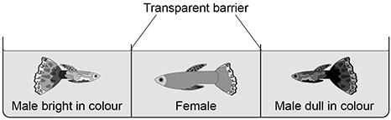

They observed each female for 10 minutes and recorded which male they were attracted towards. They repeated this with 45 large-brained females and 45 small-brained females.

(a)     Suggest **three** possible limitations of this investigation.

1 _________________________________________________________________

___________________________________________________________________

___________________________________________________________________

2 _________________________________________________________________

___________________________________________________________________

___________________________________________________________________

3 _________________________________________________________________

___________________________________________________________________

**(3)**

Guppies with large brains are better at identifying predators.

The scientists found that **only** female guppies with large brains were attracted to male guppies bright in colour.

(b)     Suggest and explain the advantage of this behaviour to the population of guppies.

___________________________________________________________________

___________________________________________________________________

___________________________________________________________________

___________________________________________________________________

___________________________________________________________________

___________________________________________________________________

___________________________________________________________________

___________________________________________________________________

___________________________________________________________________

___________________________________________________________________

**(3)**

(c)     Describe how the behaviour of female guppies could result in sympatric speciation.

___________________________________________________________________

___________________________________________________________________

___________________________________________________________________

___________________________________________________________________

___________________________________________________________________

___________________________________________________________________

___________________________________________________________________

___________________________________________________________________

___________________________________________________________________

___________________________________________________________________

**(3)**

**(Total 9 marks)**

**Q8.**

(a)     On islands in the Caribbean, there are almost 150 species of lizards belonging to the genus *Anolis*. Scientists believe that these species evolved from two species found on mainland USA. Explain how the Caribbean species could have evolved.

___________________________________________________________________

___________________________________________________________________

___________________________________________________________________

___________________________________________________________________

___________________________________________________________________

___________________________________________________________________

___________________________________________________________________

___________________________________________________________________

___________________________________________________________________

___________________________________________________________________

___________________________________________________________________

___________________________________________________________________

**(6)**

**(Total 6 marks)**