**Q1.**          (a)     Explain what is meant by the ecological term community

........................................................................................................................

........................................................................................................................

........................................................................................................................

........................................................................................................................

**(1)**

(b)     Scientists investigated the distribution of three species of fish in a lake. They recorded the range of depths where each species was found. The table shows their results.

|  |  |  |
| --- | --- | --- |
|  | **Species of fish** | **Range of depths /m** |
|  | White bass | 0 to 8.4 |
|  | Walleye | 6.8 to 10.0 |
|  | Sauger | 7.2 to 14.6 |

(i)      Use information from the table to give the range of depths at which all three species of fish may be found living together.

                                  Answer ............................................................ m

**(1)**

(ii)     Suggest and explain **one** advantage to the fish of occupying different depths in the lake.

...............................................................................................................

...............................................................................................................

...............................................................................................................

...............................................................................................................

...............................................................................................................

**(2)**

(c)     The graph shows the relationship between the depth and the temperature of the water in the lake.

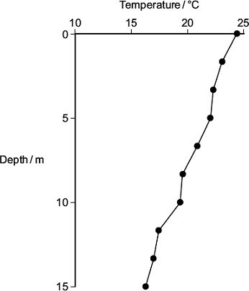

A student concluded that the temperature of the water in the lake determined the depth at which the species of fish were found. Use the table and the graph to evaluate this conclusion.

........................................................................................................................

........................................................................................................................

........................................................................................................................

........................................................................................................................

........................................................................................................................

........................................................................................................................

*(Extra space)* .................................................................................................

........................................................................................................................

........................................................................................................................

**(3)**

**(Total 7 marks)**

**Q2.**          Woods can be coppiced to provide a continuous supply of useful logs and poles. Coppicing involves cutting down some trees in a wood to leave stumps. New shoots grow from the stumps. After about 15 years, these trees can be coppiced again.

Because coppicing produces a wood with patches of light and shade, the diversity of plants and animals in a coppiced wood is high.

Ecologists investigated the effect of coppicing on the flowering of wild daffodils growing in a wood in Cumbria. Some areas of the wood were coppiced and some areas were not. The graph shows some results from this investigation.

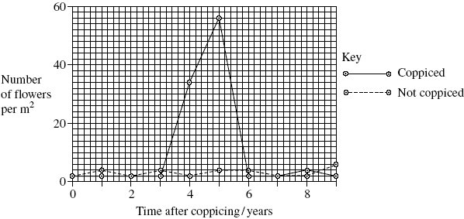

(a)     You could collect data for the coppiced plots by using quadrats.

(i)      Describe how you would place the quadrats at random.

.............................................................................................................

.............................................................................................................

.............................................................................................................

.............................................................................................................

**(2)**

(ii)     Describe how you would decide the number of quadrats to use in order to collect representative data.

.............................................................................................................

.............................................................................................................

.............................................................................................................

.............................................................................................................

**(2)**

(b)     Members of the public visit this wood to see wild daffodils in flower. Explain how the information in the graph could help the owners to manage the wood so that there were many wild daffodils in flower every year.

.............................................................................................................

.............................................................................................................

.............................................................................................................

.............................................................................................................

.............................................................................................................

**(2)**

(c)     The ecologists analysed the relationship between the number of daffodils in flower in the whole wood and data collected from a nearby weather station for the previous year.

They used the Spearman rank correlation test. The table shows their results.

|  |  |  |  |
| --- | --- | --- | --- |
| **Month** | **Climatic factor** | **Correlation coefficient** | **Statistical significance** |
| July | Total rainfall | + 0.65 | significant |
| August | Total rainfall | + 0.74 | significant |
| July | Monthly mean temperature | – 0.78 | significant |
| August | Monthly mean temperature | – 0.65 | significant |

The ecologists concluded that a wet, cool summer produces good flowering the following spring. Do you support this conclusion? Use the data in the table to explain your answer.

......................................................................................................................

......................................................................................................................

......................................................................................................................

......................................................................................................................

......................................................................................................................

**(2)**

**(Total 8 marks)**

**Q3.**          The vegetation on a large heap of waste from an old mine was investigated. The table shows the results of the measurements of certain factors in 1m2 frame quadrats placed on the south-facing slope.

|  |  |  |  |  |
| --- | --- | --- | --- | --- |
| **Quadrat** | **Angle of slope / °** | **Vegetation cover / %** | **Moisture content of soil / %** | **pH of soil** |
| 1  2  3  4  5  6 | 45  30  25  12  7  1 | 60  70  68  100  85  100 | 17.2  14.6  20.3  23.5  21.0  21.2 | 5.6  4.2  5.2  7.1  5.4  6.8 |

(a)     Which of the factors measured are abiotic?

......................................................................................................................

**(1)**

(b)     Describe how the investigators could obtain the value for vegetation cover in each quadrat.

......................................................................................................................

......................................................................................................................

......................................................................................................................

**(2)**

(c)     The correlation between vegetation cover and soil moisture content was tested statistically. These two factors were found to be positively correlated, and p < 0.05. Explain what this result means.

......................................................................................................................

......................................................................................................................

......................................................................................................................

**(2)**

**S** (d)     At first the waste heap had no plants growing on it. Some of the first plants to colonise it were small herbaceous plants. Explain **one** way in which colonisation by herbaceous plants could change the physical environment.

......................................................................................................................

......................................................................................................................

......................................................................................................................

......................................................................................................................

**(2)**

**(Total 7 marks)**

**Q4.**          The young of frogs and toads are called tadpoles. Ecologists investigated the effect of predation on three species of tadpole. They set up four artificial pond communities.

Each community contained

•        200 spadefoot toad tadpoles

•        300 spring peeper frog tadpoles

•        300 southern toad tadpoles.

The ecologists then added a different number of newts to each pond. Newts are predators. **Figure 1** shows the effect of increasing the number of newts on the percentage survival of the tadpoles of each species.

**Figure 1**

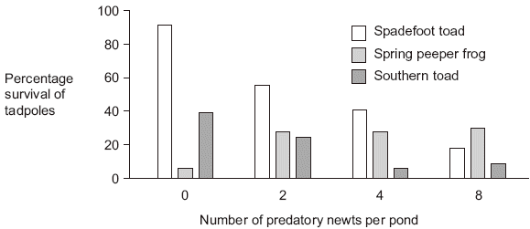

(a)     (i)      Describe the effect of an increase in the number of newts on the percentage survival of the tadpoles of each of the **toad** species.

.............................................................................................................

.............................................................................................................

.............................................................................................................

.............................................................................................................

.............................................................................................................

**(2)**

(ii)     Suggest an explanation for the effect of an increase in the number of newts on the percentage survival of the tadpoles of spring peeper frogs.

.............................................................................................................

.............................................................................................................

.............................................................................................................

.............................................................................................................

.............................................................................................................

**(2)**

**Figure 2** shows how the masses of the tadpoles were affected in each pond during the investigation.

**Figure 2**

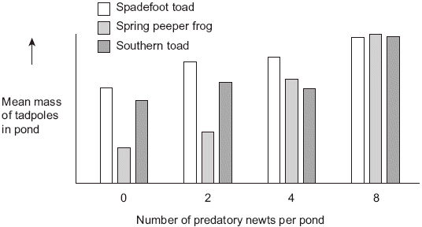

(b)     Using the information provided in **Figure 1** explain the results obtained in **Figure 2**.

......................................................................................................................

......................................................................................................................

......................................................................................................................

......................................................................................................................

......................................................................................................................

**(2)**

**(Total 6 marks)**

**Q5.**Ecologists used a method called proportional sampling to estimate the population size of an animal species. This method is based on assumptions. Two of the assumptions are given below.

1.        They know the size of the area, **A**, where the animal population lives.

2.        The animals are uniformly distributed in this area.

To carry out the method, the ecologists:

•        chose a region of known size, **R**, inside area **A**

•        counted the number of animals in region **R**. They called this number **S**

•        assumed that the number, **S**, would be in proportion to the size of the total population, **P**, in area **A**.

(a)     Proportional sampling can be used to estimate the population size of a species that is uniformly distributed.

(i)      What is a **species**?

...............................................................................................................

...............................................................................................................

...............................................................................................................

**(1)**

(ii)     What is meant by **uniformly distributed**?

...............................................................................................................

...............................................................................................................

...............................................................................................................

**(1)**

(b)     Use the letters **A**, **R** and **S** to write an equation showing how proportional sampling is used to estimate the total size of a population, **P**. Show your working.

**P** = .............................................................................

**(2)**

(c)     Population size can be estimated using proportional sampling or mark-release-recapture.

(i)      How do the assumptions made in proportional sampling differ from those made in mark-release-recapture?

...............................................................................................................

...............................................................................................................

...............................................................................................................

...............................................................................................................

...............................................................................................................

**(2)**

(ii)     Give **one** assumption about the animals caught that is made in both methods.

...............................................................................................................

...............................................................................................................

...............................................................................................................

**(1)**

**(Total 7 marks)**

**Q6.**          Climatic factors, such as temperature and rainfall, vary greatly over short distances across mountain ranges. In an investigation, populations of the plant, *Achillea lanulosa*, were sampled from several sites on a transect across a mountain range. At each sampling site, seeds were collected at random. Each batch of seeds was germinated and grown to maturity under the same experimental conditions.

The diagram shows

•        a profile indicating the position and altitude of the sampling sites

•        the mean height of mature plants grown from each sample of seeds

•        the standard deviation of heights of the mature plants grown from each sample of seeds.

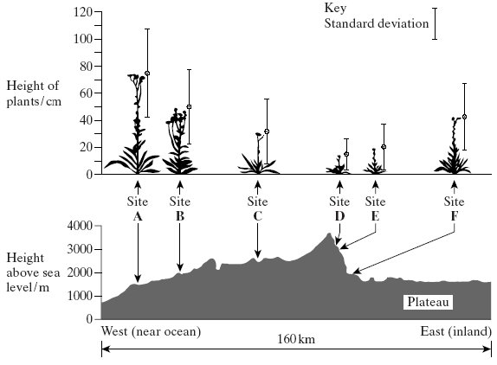

(a)     (i)      Give **one** limitation of using a line transect to collect these data.

.............................................................................................................

.............................................................................................................

**(1)**

(ii)     Suggest how plants should be chosen at each sampling site to avoid bias and to be representative.

.............................................................................................................

.............................................................................................................

.............................................................................................................

.............................................................................................................

**(2)**

(b)     (i)      What information does the bar representing standard deviation give about the plants in a sample?

.............................................................................................................

.............................................................................................................

**(1)**

(ii)     Describe what the results show about the variation of the height of the plants in relation to altitude.

.............................................................................................................

.............................................................................................................

.............................................................................................................

.............................................................................................................

**(2)**

**S**       (iii)     There was a significant difference between the mean heights of the plants grown from seeds taken from sites **A** and **D**. Describe the evidence from the information given which shows that this is likely to be due to genetic differences between the two populations.

.............................................................................................................

.............................................................................................................

**(1)**

**(Total 7 marks)**

**Q7.**          (a)     The diagram shows a number of stages in an ecological succession in a lake.

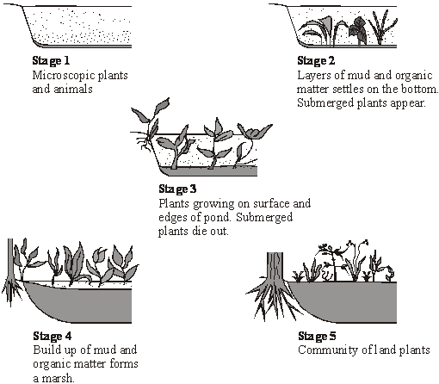

Explain how the diagrams illustrate the features of an ecological succession.

......................................................................................................................

......................................................................................................................

......................................................................................................................

......................................................................................................................

......................................................................................................................

......................................................................................................................

......................................................................................................................

......................................................................................................................

......................................................................................................................

......................................................................................................................

......................................................................................................................

......................................................................................................................

**(6)**

(b)     Several small rivers flow into this lake. These rivers flow through forested areas.  
Explain how deforestation might affect the process of succession in the lake.

......................................................................................................................

......................................................................................................................

......................................................................................................................

**(2)**

**S**       (c)     **Stage 5** illustrates the final stage of succession which is known as the climax community. During this stage the number of different species in the habitat and the size of each population remain fairly constant. Explain what limits the size of populations in a climax community.

......................................................................................................................

......................................................................................................................

......................................................................................................................

......................................................................................................................

......................................................................................................................

......................................................................................................................

......................................................................................................................

......................................................................................................................

......................................................................................................................

......................................................................................................................

......................................................................................................................

......................................................................................................................

**(5)**

**(Total 13 marks)**

**Q8.**A student investigated an area of moorland where succession was occurring. She used quadrats to measure the percentage cover of plant species, bare ground and surface water every 10 metres along a transect. She also recorded the depth of soil at each quadrat. Her results are shown in the table.

|  |  |  |  |  |  |  |
| --- | --- | --- | --- | --- | --- | --- |
|  |  | **Percentage cover in each quadrat A to E** | | | | |
|  |  | **A** | **B** | **C** | **D** | **E** |
|  | Bog moss | 55 | 40 | 10 | – | – |
|  | Bell heather | – | – | – | 15 | 10 |
|  | Sundew | 10 | 5 | – | – | – |
|  | Ling | – | – | – | 15 | 20 |
|  | Bilberry | – | – | – | 15 | 25 |
|  | Heath grass | – | – | 30 | 10 | 5 |
|  | Soft rush | – | 30 | 20 | 5 | 5 |
|  | Sheep’s fescue | – | – | 25 | 35 | 30 |
|  | Bare ground | 20 | 15 | 10 | 5 | 5 |
|  | Surface water | 15 | 10 | 5 | – | – |
|  | Soil depth / cm | 3.2 | 4.7 | 8.2 | 11.5 | 14.8 |

– Indicates zero percentage cover.

(a)     Explain how these data suggest that succession has occurred from points **A** to **E**  along the transect.

........................................................................................................................

........................................................................................................................

........................................................................................................................

........................................................................................................................

.................................................................................................. ......................

........................................................................................................................

*(Extra space)*.................................................................................................

........................................................................................................................

........................................................................................................................

**(3)**

(b)     The diversity of animal species is higher at **E** than **A**. Explain why.

........................................................................................................................

........................................................................................................................

........................................................................................................................

........................................................................................................................

.................................................................................................. ......................

**(2)**

(c)     The student used the mark-release-recapture technique to estimate the size of the population of sand lizards on an area of moorland. She collected 17 lizards and marked them before releasing them back into the same area. Later, she collected 20 lizards, 10 of which were marked.

(i)      Give **two** conditions for results from mark-release-recapture investigations to be valid.

1.............................................................................................................

...............................................................................................................

2.............................................................................................................

...............................................................................................................

**(2)**

(ii)     Calculate the number of sand lizards on this area of moorland. Show your working.

Answer = .....................................

**(2)**

**(Total 9 marks)**