Genes and alleles <http://learn.genetics.utah.edu/content/basics/inheritance/>

* In 1886 Gregor Mendel suggested that the characteristics of organisms were determined by ‘units’ which were handed on from generation to generation. These ‘units’ have been identified as genes which were carried on and transmitted by chromosomes.
* Genes have 3 main characteristics:
* They can separate and combine
* They can mutate
* They code for the production of specific polypeptides
* One gene is the portion of DNA bases on a chromosome which codes for one polypeptide. Alleles are alternative forms of genes occupying a similar ‘gene position’ or Locus on homologous chromosomes.

A LOCUS – where the gene is found e.g. fur colour in mice

Black fur allele (B) White fur allele (b)

Pair of homologous chromosomes

* Genetic Terms
  + Gene -A sequence of bases on a DNA molecule that codes for a protein (polypeptide) which results in a characteristic, e.g. a gene for eye colour
  + Allele – A different version of a gene. There can be many different alleles of a single gene but most plants and animals, including humans, only carry two alleles of each gene, one from each parent. The order of bases in each allele is slightly different. They code for different versions of the same characteristic. Only one allele of a gene can occur at the locus of any one chromosome.
  + Genotype- the genetic constitution of an organism, the combination of alleles found in an individual
  + Phenotype- the appearance of an organism determined by its Genotype
  + Dominant allele -The allele that is always expressed in the organism’s Phenotype e.g. T for tall
  + Recessive allele- The allele that is only expressed in the phenotype when present as a pair of recessive alleles (homozygous recessive) e.g. t for short
  + Codominant – Alleles that are both expressed in the phenotype – neither one is recessive
  + Locus – The fixed position of a gene on a chromosome. Alleles of genes are found at the same locus on each chromosome in a pair
  + Homozygous-if both alleles are the same e.g. TT or tt
  + Heterozygous-if alleles are different e.g. Tt
  + Carrier – A person carrying an allele which is not expressed in the phenotype but that can be passed on to offspring
  + Gene expression -the transcription and translation of a gene, resulting in a functional protein which is part of an individuals phenotype
  + F1 -First generation
  + F2 -Second generation

Monohybrid crosses

* Mendel’s 1st law of inheritance “The characteristics of an organism are determined by factors (alleles) which occur in pairs. Only one of the pair of factors (alleles) can be present in a single gamete” This is also known of as the law of segregation
* The inheritance of one gene (two alleles) from a homologous pair of chromosomes is called monohybrid inheritance.

R r

* Capital letters represent dominant alleles e.g. R
* Lower case letters represent recessive alleles e.g. r
  + RR = homozygous dominant
  + Rr = heterozygous
  + rr = homozygous recessive
* Let R = dominant allele for Round peas
* Let r = recessive allele for wrinkled peas

# Monohybrid Crosses – Set out genetic crosses in the following way

* Cross 1: Cross pollinate homozygous round pea plants with homozygous wrinkled pea plants (**pure breeding**)

Parental Phenotypes: round x wrinkled

Parental Genotypes: RR x rr

Gamete genotypes: R R x r r* At meiosis the homologous

chromosomes/alleles are separated

|  |  |  |
| --- | --- | --- |
|  | R | R |
| r | Rr | Rr |
| r | Rr | Rr |

## Offspring genotype: all Rr (heterozygous)

Offspring phenotype: all round peas (F1)

and ratio

* Cross 2: Cross pollinate/interbreed heterozygous round pea plants (F1)

Parental Phenotypes: round x round

Parental Genotypes: Rr x Rr

Gamete genotypes: R r x R r

|  |  |  |
| --- | --- | --- |
|  | R | r |
| R | RR | Rr |
| r | Rr | rr |

## Offspring genotype: RR/Rr/rr

Offspring phenotype: Round/wrinkled (F2)

and ratio 3:1 always!

* Cross 3 (**Test cross**): Useful cross to find out if an individual with the dominant characteristic/phenotype e.g. Round pea, is homozygous RR or heterozygous Rr:
  + Take the Unknown plant genotype i.e. RR or Rr and cross with homozygous recessive genotype (rr). Set out the two crosses – what feature will you look for to determine whether genotype is RR or Rr?
  + If genotype is RR, all phenotypes will be Dominant:

|  |  |  |
| --- | --- | --- |
|  | R | R |
| r | Rr | Rr |
| r | Rr | Rr |

* + If genotype is Rr, 50% phenotypes will be Dominant, 50% phenotypes will be recessive:

|  |  |  |
| --- | --- | --- |
|  | R | r |
| r | Rr | rr |
| r | Rr | rr |

Co-dominance

* Both alleles are expressed in the phenotype, neither are dominant. To show these crosses, there is a different way of showing the alleles:
  + There is a capital letter for the **Characteristic**
  + Capital letters for alleles are placed **superscript** on the characteristic letter
  + E.g. Colour of petals in carnations – red, white, pink
    - Let C = colour
    - Let CR= red allele
    - Let CW= white allele
* Cross 1: Cross pollinate red flower plant with white flower plant

Parental Phenotypes: red x white

Parental Genotypes: CR CR x CW CW

Gamete genotypes: CR  CR x CW CW

|  |  |  |
| --- | --- | --- |
|  | CR | CR |
| CW | CR CW | CR CW |
| CW | CR CW | CR CW |

Often called F1, hybrids

## Offspring genotype: all CR CW

Offspring phenotype: all PINK

and ratio

* Cross 2: Cross pollinate pink with pink flower plant (F1 hybrids)

Parental Phenotypes: pink x pink

Parental Genotypes: CR CW x CR CW

Gamete genotypes: CR  CW x CR CW

|  |  |  |
| --- | --- | --- |
|  | CR | CW |
| CR | CR CR | CR CW |
| CW | CR CW | CW CW |

Often called F2, hybrids

## Offspring genotype: CR CR/CRCW/CWCW

Offspring phenotype: red/pink/white

and ratio 1:2:1

Inheritance of Sex

* One pair of the homologous pairs of chromosomes are the sex chromosomes which carry the genes coding for male and female sexual characteristics. The non sex chromosomes are called autosomes.
* Humans 23 homologous chromosomes, the first 22 are autosomes the 23rd pair are the sex chromosomes:
* X = female sexual characteristics
* Y = male sexual characteristics
* Females are XX (homogametic) and produce ova that always have X chromosome present.
* Males are XY (heterogametic) i.e. sperm produced can either have X or Y chromosomes:
  + X sperm girl
  + Y sperm boy
* Cross 1: Cross male and female

Parental Phenotypes: male x female

Parental Genotypes: XY x XX

Gamete genotypes: X Y x X X

|  |  |  |
| --- | --- | --- |
|  | X | Y |
| X | XX | XY |
| X | XX | XY |

## Offspring genotype: XX/XY

Offspring phenotype: Male/Female

and ratio 1:1

**Dihybrid Crosses**

* Mendel’s 2nd law of inheritance “Each member of an allele pair may combine randomly with either of another pair”
* The inheritance of two genes (four alleles) from different homologous pairs of chromosomes is called dihybrid inheritance.
* Consider the inheritance of two genes:

A a Two pairs of homologous

Chromosomes

genotype Aa Bb

B b

* At meiosis the pairs of homologous chromosomes are separated, **one** of each pair into one of the two gametes formed. But there is **RANDOM/INDEPENDENT ASSORTMENT** of chromosomes so all the allele combinations are possible:

Aa Bb

**Possible gametes** = AB or Ab or aB or ab

|  |  |  |
| --- | --- | --- |
|  | A | a |
| B | AB | aB |
| b | Ab | ab |

* Cross 1: Homozygous dominant for both characteristics of pea plants, Round and big, crossed with homozygous recessive, wrinkled and small.
  + Let R = round allele (dominant) r = wrinkled allele(recessive)
  + Let B = big allele (dominant) b = small allele (recessive)

Parental Phenotypes: round and big x wrinkled and small

Parental Genotypes: RR BB x rr bb

Gamete genotypes: RB RB RB RB x rb rb rb rb

|  |  |  |  |  |
| --- | --- | --- | --- | --- |
|  | RB | RB | RB | RB |
| rb | Rr Bb | Rr Bb | Rr Bb | Rr Bb |
| rb | Rr Bb | Rr Bb | Rr Bb | Rr Bb |
| rb | Rr Bb | Rr Bb | Rr Bb | Rr Bb |
| rb | Rr Bb | Rr Bb | Rr Bb | Rr Bb |

## Offspring genotype: all Rr Bb

Offspring phenotype: all round and big peas

and ratio

* Cross 2: Interbreed F1  heterozygotes

Parental Phenotypes: round and big x round and big

Parental Genotypes: Rr Bb x Rr Bb

Gamete genotypes: RB Rb rB rb x RB Rb rB rb

|  |  |  |  |  |
| --- | --- | --- | --- | --- |
|  | RB | Rb | rB | rb |
| RB | RR BB | RR Bb | Rr BB | Rr Bb |
| Rb | RR Bb | RR bb | Rr Bb | Rr bb |
| rB | Rr BB | Rr Bb | rr BB | rr Bb |
| rb | Rr Bb | Rr bb | rr Bb | ­­­­rr bb |

## Offspring genotype: RR BB, RR Bb, Rr BB, Rr Bb, RR bb, Rr bb, rr BB, rr Bb, rr bb

Offspring phenotype: round and big/round and small/wrinkled and big/wrinkled and small

and ratio 9:3:3:1

* Cross 3: Cross heterozygous roundness (Rr) and small peas (bb) with wrinkled (rr) and heterozygous big peas (Bb).

Parental Phenotypes: round and small x wrinkled and big

Parental Genotypes: Rr bb x rr Bb

Gamete genotypes: Rb Rb rb rb x rB rb rB rb *N.B. Don’t

include replicate gametes, just the different genotypes

|  |  |  |
| --- | --- | --- |
|  | Rb | rb |
| rb | Rr bb | rr bb |
| rB | Rr Bb | rr Bb |

## Offspring genotype: Rr Bb/ Rr bb / rr bb / rrBb

Offspring phenotype: round and big/round and small/wrinkled and big/wrinkled and small

and ratio 1:1:1:1

## **Multiple Alleles**

## [**http://learn.genetics.utah.edu/content/basics/blood/**](http://learn.genetics.utah.edu/content/basics/blood/)

* Human ABO group is controlled by the immunoglobulin gene I
  + The immunoglobulin gene has 3 alleles IA, IB, I0
  + alleles IA  leads to the production of antigen A
  + alleles IB  leads to the production of antigen B
  + alleles IO  does not lead to the production of either antigen
* 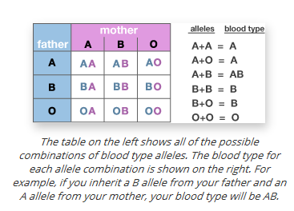Only 2 alleles can be present in a diploid cell → IAIB is codominant, I0 recessive

**Chi squared test (x2)**

Looking at Mendel’s heterozygous dihybrid cross the **expected** ratio of phenotypes in the offspring is 9:3:3:1. This ratio represents the probability of getting these phenotypes.

|  |  |  |  |  |
| --- | --- | --- | --- | --- |
|  | Observed Seed Phenotype | | | |
| round and big | round and small | wrinkled and big | wrinkled and small |
| Totals | 315 | 108 | 101 | 32 |
| Phenotype Ratio | 9 | 3 | 3 | 1 |

The Chi squared test (x2) is used to **compare** the **observed** results with those **expected**. It is a way of estimating the **probability** that **differences between observed and expected results** are due to **chance alone** and not some **other factor** influencing the results:

* + Start with your **Null Hypothesis** e.g. An exposed shore and sheltered shore have the same diversity of invertebrates within them
  + Have your **Alternate Hypothesis** e.g. exposed shore will have a lower diversity of invertebrates compared to sheltered shore (due to the effects of wind/wave action)
* Calculate the expected values (E), by dividing the total number of phenotype of seed by the number of possible types e.g.
  + Expected seed phenotype ‘round and big’ = 315 + 108 + 101 + 32 x 9

16

= 313

* Fill these in the ‘Expected’ column in the table
* Calculate the difference between the observed (O) and expected (E) results
* Square the differences
* Use the formula to calculate x2

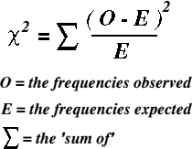

|  |  |  |  |  |  |
| --- | --- | --- | --- | --- | --- |
| Seed Phenotype | Observed (O) | Expected (E) | Difference (O-E) | (O-E)2 | (O-E)2  E |
| round and big | 315 | 313 | 2.0 | 4 | 0.01 |
| round and small | 108 | 104 | 4.0 | 16 | 0.15 |
| wrinkled and big | 101 | 104 | -3.0 | 9 | 0.08 |
| wrinkled and small | 32 | 35 | -3.0 | 9 | 0.26 |
| x2 | | | | | = 0.50 |

* + Calculate Degrees of Freedom (DF): **Number of Categories – 1/(n-1)**

e.g. 4 – 1 = 3

* Using the x2 table it is deemed that if the **probability** (P) is **5% or lower** (P<5%),e.g. 2%/1%, the deviation is said to be **significant** i.e. the deviation is **not due to chance alone** and some **other factor** is influencing the results

|  |
| --- |
|  |

* e.g. Looking along the row for 3 DF it can be seen that x2 = 0.50 is between 0.445 and 1.32. Reading along the probability row we see our value lies between 0.5 (50%) and 0.25(75%). This means the probability that chance alone could have produced the deviation is between 0.5 (50%) and 0.25(75%). In the chi squared test the critical value is 0.05 (5%). If the probability that the deviation is due to chance is equal to or greater than 0.05 (5%), the deviation is said to be not significant and the null hypothesis would be accepted.
* Therefore in this case the deviation from the 9:3:3:1 ratio is not significant and is due to chance alone, and you would accept your null hypothesis!

*N.B. if the deviation had been **significant** (ie the probability that chance alone could have produced the deviation is less than 5%) you would **reject** your **null hypothesis!**

# Sex linked inheritance

* Some alleles are carried on the **X chromosome** (and not on the Y chromosome), so are described as **sex linked**.
* The **Y chromosome** is much **smaller** than the X and carries **very few genes**, therefore in the male any **recessive genes** carried on the X chromosome will express themselves in the phenotype because the genes are unpaired i.e. on X not on Y, and so there is **no dominant gene** present
* This special form of inheritance is called **sex-linkage**. An example of sex-linkage is **Haemophilia** (failure to clot blood):
  + Haemophilia is a potentially lethal condition. The gene that codes for **Factor VIII**, an important protein involved in blood clotting is a sex linked gene located on the X chromosome.
  + The inability of the blood to clot leads to slow and persistent bleeding.
* The 23rd pair of chromosomes are the sex chromosomes, XX for females (homologous), XY for males (**not** homologous):

X Y X X H = normal

blood

clotting

h = haemophilia

Non

h homologous h H

* Sex linked disorder genetic diagrams use the allele letter superscript on the X chromosomes:
  + XH XH
  + XH Xh
  + XhXh
  + XH Y
  + Xh Y
* Cross 1: A man without haemophilia has children with a woman who is a carrier (heterozygous haemophilia). Will any of their children have haemophilia?

Parental Phenotypes: normal man x woman carrier

Parental Genotypes: XH Y x XH Xh

Gamete genotypes: XH Y x XH  Xh

|  |  |  |
| --- | --- | --- |
|  | XH | Y |
| XH | XH XH | XH Y |
| Xh | XH Xh | Xh Y |

## Offspring genotype: XH XH/ XH Xh / XH Y / Xh Y

Offspring phenotype: normal woman /normal man/haemophiliac male

and ratio 2:1:1

* Cross 2: A man with haemophilia has children with a woman who is a carrier (heterozygous haemophilia). Will any of their children have haemophilia?

Parental Phenotypes: haemophiliac man x woman carrier

Parental Genotypes: Xh Y x XH Xh

Gamete genotypes: Xh Y x XH  Xh

|  |  |  |
| --- | --- | --- |
|  | Xh | Y |
| XH | XH Xh | XH Y |
| Xh | Xh Xh | Xh Y |

## Offspring genotype: XH Xh/ Xh Xh / XH Y / Xh Y

Offspring phenotype: normal woman/haemophiliac woman/normal male/haemophiliac male

and ratio 1:1:1:1

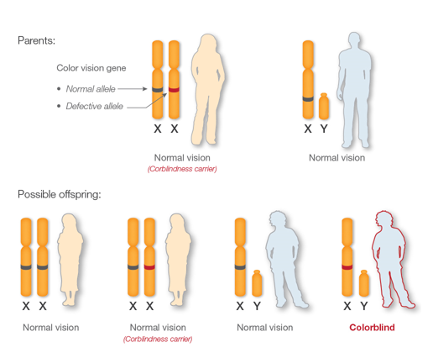

Another way of showing genetic diagrams (often sex linked disorders) is by a **pedigree diagram**:

Normal male Normal female

Affected male Affected female

* Q. What evidence is there that the disorder is recessive?

*N.B. Look for an affected child with normal parents

A. Both sets of parents are normal, and yet their children are affected! If the allele for disorder were dominant, than at least one of the parents would be affected!

* Q. What evidence is there that this is not sex linked?

*N.B. Look for an affected female with a normal father

### A. Do not say: “Female is affected”

Do say: ”For female to be affected she must receive an allele for disorder

from **both parents**. Father is **unaffected**, therefore **not** sex linked!”

Autosomal Linkage

Linkage occurs when **2 different genes** occur on the **same chromosome**; therefore genes on the same chromosome will tend to be **inherited together** because they move together during meiosis and appear in the same gamete:

Aa Bb aa bb

Genes A+B/a+b A a a a

are linked together B b b b Parents

as they are on same

chromosome

A a a a

B b b b

Gametes

A a a a

B b b b F1

Aa Bb aa bb Genotype

1 : 1 Phenotype ratio

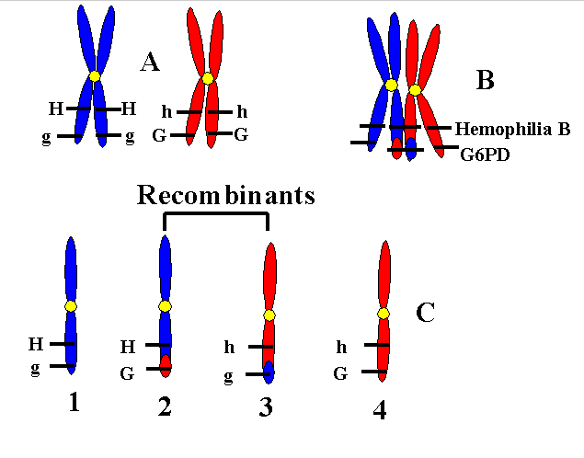Recombination of DNA occurs when alleles are exchanged as part of **crossing over**. The **further apart** the 2 genes on a chromosome are, there **more chance** there is of **crossing over** taking place and the genes being **separated**.

**Epistasis**

In epistasis the phenotypic expression of a gene at one locus alters that of a gene at a second locus.

Epistasis is the interaction of different gene loci so that the allele of one gene masks or suppresses the expressions of the alleles of other genes.

Epistasis is not inherited, it is an interaction between two gene loci. It reduces phenotype variation.

The genes involved can control the expression of one phenotypic characteristic in one of two ways:

1. They may work against each other (antagonistically) resulting in masking.

2. They may work together in a complementary fashion.

**Working antagonistically**

The homozygous presence of a recessive allele may prevent the expression of another allele at a second locus.

The alleles at the first locus are epistatic to the alleles at the second locus, which are described as hypostatic.

**Recessive epistasis**

Example - the inheritance of flower colour in Salvia

• Two gene loci, A/a and B/b, on different chromosomes are involved.

• A pure-bred pink Salvia, genotype AAbb, was crossed with a pure-bred white Salvia, genotype aaBB. All the F1 generation, genotype AaBb, had purple flowers.

• Interbreeding the F1 results in purple, pink and white flowers in the ratio 9:3:4 in the F2 generation.

• The homozygous aa is epistatic to both alleles of the gene B/b. Neither the allele, B for purple nor the allele, b for pink can be expressed if there is no dominant allele, A, present.

**Dominant epistasis**

This occurs when a dominant allele at one gene locus masks the expression of the alleles at second gene locus.

Example - fruit colour in summer squash

• Two gene loci, D/d and E/e, are involved.

• The presence of one D allele results in white fruits regardless of the alleles present at the second locus (E/e).

• In homozygous dd individuals, the presence of one E allele produces yellow fruits and the presence of two e alleles produces green fruits.

• If two white double heterozygotes (DeEe) are crossed, the offspring show the following phenotype ratio: 12 white: 3 yellow: 1 green.

**Working in a complementary fashion**

Example - white flowered sweet peas

• Two strains of white sweet peas (ccRR x CCrr) are crossed.

• All the F1 plants had purple flowers. When the F1 were interbred, the F2 generation had purple and white flowers in the the ratio 9:7.

• This means that at least one dominant allele needs to be present for both gene loci (C-R-) for flowers to be purple. All other combinations produce white flowers.

• This is because the homozygous recessive condition at either locus masks the expression of the dominant allele at the other locus.

The way the two gene loci may produce these results is if they complement each other - if one gene codes for an intermediate colourless pigment and the second locus codes for an enzyme that converts the intermediate compound to the final purple pigment.