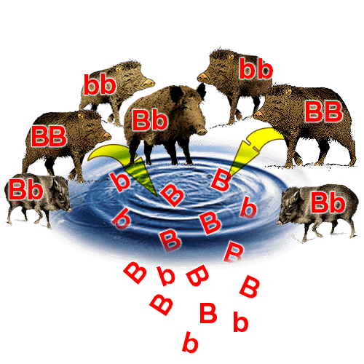**3.7.2 Population and evolution notes**

Population genetics

Population genetics is concerned with determining the **relative proportions of the various genotypes** present in a population, from which can be calculated the **relative proportions of alleles** in the population, called the **allele frequency. All of the alleles within a population is called the Gene Pool**.

**The Hardy-Weinberg Principle**

How could we keep track of the frequency of each allele for a given trait when we have a dominant-recessive interaction? More specifically, how could we account for the visible dominant traits as homozygous or heterozygous, since both look the same?

This is where the **Hardy-Weinberg principle** comes in. Firstly, there are criteria for when this principle may be applied to a population:

**1. Random mating** must take place.

**2. No migration** must occur either inwards or outwards of the population. (The population is isolated)

**3. No mutations** must arise in the population.

**4. No natural selection** must take place due to one trait being better or worse adapted to the environment.

**5.** The **population is large**

It's apparent that this is simply rarely, if ever, the case in a real wild population. However, the Hardy-Weinberg principle is useful at predicting allele frequencies in a reliable mathematical model.

The *frequency* of the dominant allele is noted **p** while that of the recessive allele is noted **q**. Both must necessarily account for the whole population, therefore:

**p + q = 1**

The values are frequencies, so they are noted as *percentages*. 1 is 100% while 0.5 is 50% and 0.05 is 5%, etc.

**Worked exercise**

If we know that the frequency of the allele for dark fur in a population of koala bears is 0.2, and this allele is dominant over the one for light fur, work out the frequency of the allele for light fur in the population.

**p = 0.2**

**p + q = 1**

Therefore, **0.2 + q = 1** so **q = 1 - 0.2**

q = 0.8 or 80%.

Now the *allele frequency* has been worked out, how could we work out the actual **phenotype** of the koala bears in the population. How many are actually dark-furred? How many of the dark-furred ones are homozygous?

For this we use the same equation as before, but **squared**: (p + q)2

This is equivalent to **p2 + 2pq + q2 = 1**

Where **2pq** is the frequency of **heterozygotes**, and **p2** and **q2** the frequencies of **homozygous dominant** and **homozygous recessive** respectively.

We want to know how many koala bears have dark fur. We know that the allele frequency for dark fur is 0.2, so 0.22 is the percentage of homozygous dark fur individuals; = 0.04 (4%).

This trait being dominant, the heterozygotes must also have dark fur. The frequency of heterozygous dark fur is 2pq = 2*0.2*0.8 = 0.32 (32%).

**So overall, there are (0.4 + 0.32) 0.36 or 36% dark-furred koala bears in the population.**

This leaves the remaining 64% with light fur. Note the contrast between the light *phenotype* only being 64% while the *allele frequency* for light fur is 80%. If the allele were dominant over dark fur, the frequency would be *higher* rather than *lower*.

Variation

If a species is to survive a constantly changing environment and to colonise new environments sources of **variation** are needed.

The **genotype** of an organism gives it the **potential** to show a particular **characteristic**. The degree to which the characteristic is shown can be affected by the organism’s **environment**.

* Types of variation

Characteristics can be show **2 types** of variation depending on the number of genes coding for them:

* **Continuous variation** A characteristic controlled by **many genes** (polygenic effect) shows **gradual change** in the population from one extreme to the other e.g. **height**

Frequency

Height of student

# Discontinuous variation A characteristic controlled by one or two genes shows clear cut differences in the population e.g. tongue rolling controlled by one gene/two alleles: RR + Rr = tongue roller, rr = non roller

Frequency

Rollers non rollers

* Non-heritable Variation i.e. environmental factors

The environment has a role in determining phenotypic variation e.g. a human may inherit genes which give it a theoretical maximum height but poor diet may limit this e.g.

* + Women in Victorian times had an average height of 4ft 10” even though they had the same genotype for height as women today. There has been no evolution of taller women, but due to environmental factors such as more food, better medical facilities the phenotype expression has changed a great deal!
  + This **non-heritable variation** is largely responsible for **continuous variation**
* Heritable Variation i.e. inherited variation

The environment has no affect on **discontinuation variation**. Inherited variation results in genetic changes i.e. to genotype of an organism, by:

* **Crossing over** between homologous chromosomes during **Prophase I of meiosis**
* **Random/independent assortment** of chromosomes in **Metaphase I of meiosis**
* Random fertilisation **of haploid gametes** from two parental genotypes –
* **Mutation**

**Sexually reproducing organisms increase variation by all three methods**

Natural Selection and The Theory of Evolution

Evolution is the process by which new species are formed from pre-existing ones over a period of time. Darwin’s observations of variation within a population lead to the development of **Natural Selection**:

* + Darwin recognized that **species changed**
  + Proposing the theory of **natural selection** to explain why it happened
  + Organisms **overproduce offspring**
  + So that there is a **large variation of genotypes** in population
  + However, **numbers on the population remain constant**
  + Therefore there is a **high mortality rate**
  + Because **changes to environmental conditions** bring new **selection pressures** i.e. a factor which increases the chances of a beneficial allele being passed onto the next generation e.g. **competition**/**predation/disease**
  + Only those individuals with **beneficial alleles** have a **selective advantage** e.g. **white fur in arctic**, therefore are **more likely to survive**
  + These individuals then **reproduce**
  + Offspring are likely to **inherit the beneficial alleles, therefore characteristic**
  + This process **repeats generation after generation**
  + Therefore the **beneficial allele frequency increases** within the **gene pool**
  + e.g. Darwin found **adaptive radiation** in the finch population of the Galapagos islands**,** which describes the evolutionary **diversification** of many species from a **single common ancestor**

Some species have evolved high reproduction rates to ensure a sufficiently large population survives to breed and reproduce the next generation. Other species have evolved lower reproduction rates but higher levels of parental care. This reduces death rates and enables these species to maintain their population size.

Antibiotic Resistance

The widespread use of antibiotics has lead to the development of resistance in many species of bacteria. The resistance has arisen due to random mutations producing generally recessive alleles and are not expressed when in combination with a dominant allele. However, due to repeated exposure to antibiotics has lead to more bacteria surviving and passing on resistant alleles.

* + Some bacteria have developed a gene which codes for the synthesis of the enzyme Penicillinase, which causes penicillin to be ineffective.
  + In the presence of penicillin non resistant bacteria are destroyed, therefore there is a selective advantage favouring the resistant bacteria.

**Effects of different forms of selection on evolution**

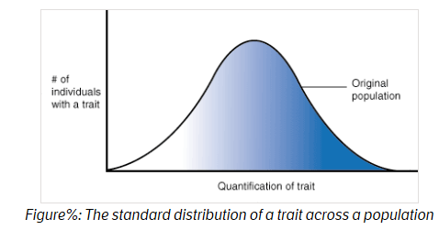Natural selection can take many forms. To make talking about this easier, we will consider the distribution of traits across a population in graphical form. In we see the normal bell curve of trait distribution. For example, if we were talking about height as a trait, we would see that without any selection pressure on this trait, the heights of individuals in a population would vary, with most individuals being of an average height and fewer being extremely short or extremely tall. However, when selection pressures act on a trait, this distribution can be altered.

**Stabilising selection**

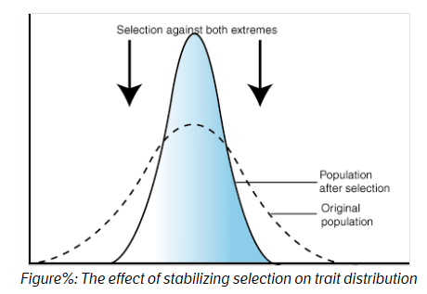When selective pressures select against the two extremes of a trait, the population experiences stabilizing selection. For example, plant height might be acted on by stabilizing selection. A plant that is too short may not be able to compete with other plants for sunlight. However, extremely tall plants may be more susceptible to wind damage. Combined, these two selection pressures select to maintain plants of medium height. The number of plants of medium height will increase while the numbers of short and tall plants will decrease.

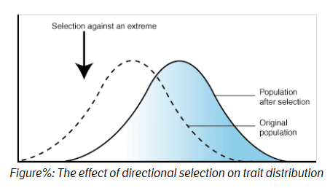**Directional Selection**

In directional selection, one extreme of the trait distribution experiences selection against it. The result is that the population's trait distribution shifts toward the other extreme. In the case of such selection, the mean of the population graph shifts. Using the familiar example of giraffe necks, there was a selection pressure against short necks, since individuals with short necks could not reach as many leaves on which to feed. As a result, the distribution of neck length shifted to favor individuals with long necks.

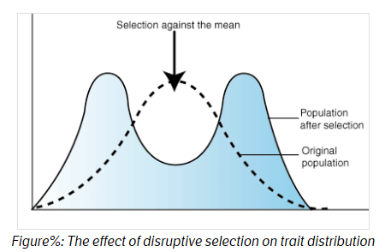**Disruptive Selection**

In disruptive selection, selection pressures act against individuals in the middle of the trait distribution. The result is a bimodal, or two-peaked, curve in which the two extremes of the curve create their own smaller curves. For example, imagine a plant of extremely variable height that is pollinated by three different pollinators, one that was attracted to short plants, another that preferred plants of medium height and a third that visited only the tallest plants. If the pollinator that preferred plants of medium height disappeared from an area, medium height plants would be selected against and the population would tend toward both short and tall, but not medium height plants. Such a population, in which multiple distinct forms or morphs exist is said to be polymorphic.

**Isolation & Speciation**

Speciation is the evolution of a new species from existing ones.

Populations are groups of interbreeding individuals of the same species occupying the same habitat. A species is a group of organisms that:

* + Can **interbreed** to produce **Fertile** offspring
  + Do not normally interbreed with any other group of organisms

* N.B. If two similar individuals breed and produce infertile offspring (**hybrid**) then parents must be of a different species e.g. mule (horse and donkey) or Liger/Tion (tiger and lion)

Within each population there are breeding sub-units called **demes**; new species arise when a barrier, called the **isolating mechanism**, to reproduction occurs, preventing genes being exchanged between the two demes e.g.:

* **Geographical/allopatric isolation** occurs when the population is physically split, preventing interbreeding between demes e.g. river/mountain

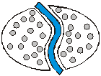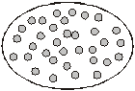

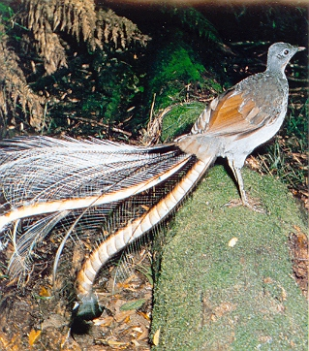

* **Behavioral isolation** in animals with elaborate courtship behavior, where the steps in the display of one deme fails to attract the response of a partner in another deme e.g. lyre bird [(Lyrebird video)](http://www.youtube.com/watch?v=VjE0Kdfos4Y)
* **Reproductive/sympatric isolation** within a population occurs when organisms inhabiting the same area become reproductively isolated e.g. **flowering times**
* **Mechanical isolation** occurs when the **genitalia** of the two groups may become incompatible
* **Hybrid inviability** – despite fertilization taking place, the development of the embryo may not occur
* **Hybrid sterility** – Hybrids form from the fusion of gametes from different species are often sterile because they cannot produce viable gametes. Eg If a horse (2n=64) mates with a donkey (2n =62) the resultant mule has 63 chromosomes. These cannot pair up appropriately during prophase 1 of meiosis and so viable gametes cannot be formed.

If the isolation is long term, the two groups will be so different that two new species will form incapable of breeding to produce fertile offspring because:

* The populations become **isolated** e.g. geographical



* Therefore the populations **cannot interbreed**
* 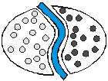**Different mutations** occur in each population, giving rise to **different alleles**
* There are **different environmental conditions** in each population
* There are **different selection pressures** in each population
* Therefore, **different gene pools** develop

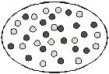

* Leading to **changes in phenotype**

**Genetic Drift**

Factors which can alter the frequency of genes in a population, and therefore the gene pool are:

* + Mutation
  + Genetic Drift
  + Natural Selection

Sometimes variation in the gene pool may occur by chance, which is called **Random Genetic Drift**:

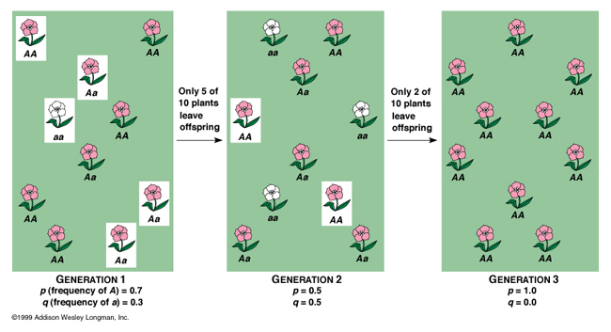

* + An important evolutionary mechanism in **small**/isolated populations
  + If an allele is present in 1% of a population of 1000, only 10 individuals will carry the allele
  + If by chance these 10 individuals fail to mate and pass on the allele to the next generation, it may be lost from the gene pool altogether
  + Alternatively, if these 10 individuals were isolated from the rest of the population, the isolated **founder population** forming will have a very different gene frequency!