Coercion & Control

The restriction of individual liberty was an important element of Napoleon’s policy of consolidating and maintaining his grip on power

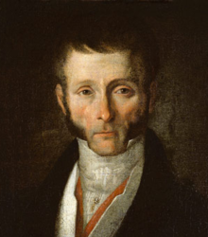
Joseph Fouché
The main figure of the general police was Joseph Fouché. He:
- Organised surveillance
- Gathered intelligence on those suspected of being a threat to security
He was one of the most feared men throughout the revolutionary and Napoleonic period. He was infamous for his ruthlessness; during the terror he masterminded several mass killings. However, under Napoleon he directed more of a secret police. Their main roles were to:
- Impose censorship
- Watch out for any opponents to the government
- Search for army deserters
- Organise raids on areas where they might be hiding

Local Government
On the 17th February 1800 a law was passed which reformed local government. A new role was brought in which was known as the prefect. Each department in a government would have a prefect and sub-prefects. They acted as agents for the government, appointed by Napoleon and answered solely to him. This allowed state control as the prefects were expected to monitor public opinion and report any suspicious political activity.
The prefects had a system of house arrest for anyone who was considered a danger to state security. Workers were also kept under surveillance as Napoleon didn’t want any more resurgency of sans-culotte activity.
On 1st December 1803, Napoleon introduced a livret which was a work book used by every employer allowing personal details to be kept.

Why it worked
Since people watched so closely there was little opposition and the only way to gain power was to get close to the government. The only real means of opposing was to refuse conscription and desert to join the bands of brigands.

