**Q1.**The gravitational constant, *G*, is a constant of proportionality in Newton’s law of gravitation. The permittivity of free space, *ε*0, is a constant of proportionality in Coulomb’s law.

When comparing the electrostatic force acting on a pair of charged particles to the gravitational force between them, the product *ε*0*G* can appear in the calculation.

Which is a unit for *ε*0*G*?

|  |  |
| --- | --- |
| **A** | C2 kg–2 |
| **B** | C2 m–2 |
| **C** | F kg2 N–1 m–2 |
| **D** | it has no unit |

**(Total 1 mark)**

**Q2.** Columns **A** **and B** show some of the results from an experiment in which the current *I* through a component X was measured for various values of the potential difference *V* applied across it.

|  |  |  |  |
| --- | --- | --- | --- |
| **column A** | **column B** | **column C** | **column D** |
| potential difference *V* / V | current *I*/ mA | (*V* – 0.55) / V | In(*I* / mA) |
| 0.70 | 12.5 |  |  |
| 0.75 | 17.0 |  |  |
| 0.80 | 22.0 |  |  |
| 0.85 | 29.0 |  |  |
| 0.90 | 39.0 |  |  |
| 0.95 | 51.5 |  |  |

(a) Draw a diagram of a circuit which could have been used to obtain these results.

**(2)**

(b) (i) Calculate the resistance of X when the potential difference is 0.70 V.

.............................................................................................................

.............................................................................................................

(ii) By considering **one** other value of potential difference, explain whether or not X is an ohmic conductor.

.............................................................................................................

.............................................................................................................

.............................................................................................................

.............................................................................................................

**(3)**

(c) It is suggested that for potential differences greater than 0.55 V, the current voltage relationship for X is of the form.

*I* = *A* e*k*(*V*–0.55) where *A* and *k* are constants.

(i) Complete **column C** and **column D** in the table above

(ii) Plot a graph of ln(*I* /mA ) on the *y*-axis against (*V* – 0.55) on the *x*-axis.

(iii) Use your graph to determine the constants *k* and *A*.

.............................................................................................................

.............................................................................................................

.............................................................................................................

.............................................................................................................

.............................................................................................................

.............................................................................................................

.............................................................................................................

.............................................................................................................

.............................................................................................................

(iv) On the basis of your graph, discuss the validity of the above relationship.

.............................................................................................................

.............................................................................................................

.............................................................................................................

.............................................................................................................



**(10)**

**(Total 15 marks)**

**Q3.** A student conducted an investigation using the apparatus shown below.

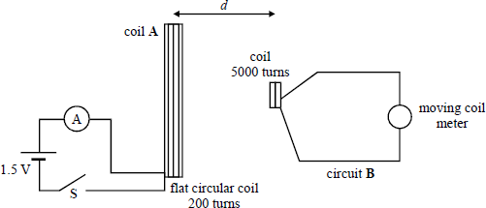

Switch **S** was closed and the current in coil **A** was allowed to reach its maximum value. When the switch **S** was opened, the maximum voltage *V* in circuit **B** was measured for different positions of the 5000 turn coil along the axis of coil **A**.

The maximum voltage *V* was measured using a moving coil meter marked in mm divisions, a deflection of 25 mm representing a potential difference of 0.01 V.

The distance *d* between the centres of the coils was measured using a metre rule.

The student thought that the maximum voltage might be inversely proportional to *d*3.

All the data collected by the student is shown below.

|  |  |  |
| --- | --- | --- |
| **Meter deflection / mm** | ***V*/V** | ***d*/m** |
| 121 | 0.0484 | 0.080 |
| 72 | 0.0288 | 0.098 |
| 32 | 0.0128 | 0.152 |
| 14 | 0.0056 | 0.201 |
| 7 | 0.0028 | 0.249 |

(a) (i) Determine the percentage uncertainties in *V* and *d* for the third set of data.

**(2)**

(ii) Use the data to test the student’s theory. Show your method and state your conclusions clearly.

**(3)**

(b) Coil **A** had an average diameter of 0.070 m. It was made of wire that had an area of cross-section of 6.6 × 10–7 m2. The maximum current recorded by the ammeter was 0.45 A. Determine the resistivity of the wire that was used to wind the coil.

**(3)**

(c) Suggest changes you could make to the apparatus and procedure to improve the experiment. Justify the changes you would make. You can gain up to 2 marks in this question for good written communication.

**(6)**

**(Total 14 marks)**

**Q4.**(a) (i) Explain what is meant by *gravitational field strength*.

...........................................................................................................................................

...........................................................................................................................................

...........................................................................................................................................

**(1)**

(ii) Describe how you would measure the gravitational field strength close to the surface of the Earth.

Draw a diagram of the apparatus that you would use.

...............................................................................................................

...............................................................................................................

...............................................................................................................

...............................................................................................................

...............................................................................................................

...............................................................................................................

...............................................................................................................

...............................................................................................................

...............................................................................................................

...............................................................................................................

**(6)**

(b) (i) The Earth’s gravitational field strength (*g*) at a distance (*r*) of 2.0 × 107 m from its centre is

1.0 N kg–1. Complete the table with the 3 further values of *g*.

|  |  |  |  |  |
| --- | --- | --- | --- | --- |
| *g*/N kg–1 | 1.0 |  |  |  |
| *r*/107 m | 2.0 | 4.0 | 6.0 | 8.0 |

**(2)**

(ii) Below is a grid marked with *g* and *r* values on its axes. Draw a graph showing the variation of *g* with *r* for values of *r* between 2.0 × 107 m and 10.0 × 107 m.

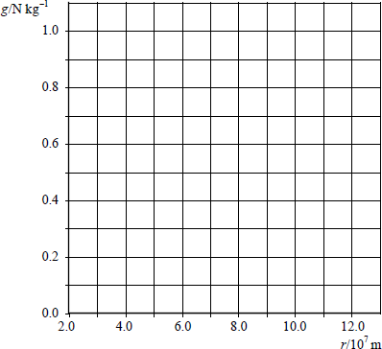

**(2)**

(iii) Estimate the energy required to raise a satellite of mass 800 kg from an orbit of radius

4.0 × 107 m to one of radius 10.0 × 107 m.

**(3)**

**(Total 14 marks)**

**Q5.** A detector and counter are used to measure the count rate from a gamma source.

1. Complete the graph to show how the corrected count rate will vary with the distance, *d*, between the source and the detector. One point has been plotted. To complete the graph accurately, you should perform a suitable calculation to determine the position of one other point on the graph.

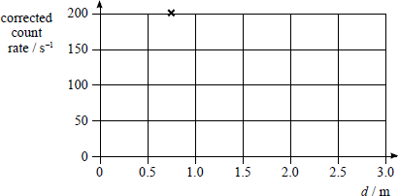

**(2)**

(b) (i) State what is meant by *corrected* count rate.

...............................................................................................................

...............................................................................................................

**(1)**

(ii) State **one** means by which you would ensure that the measurement of count rate is accurate.

...............................................................................................................

...............................................................................................................

**(1)**

**(Total 5 marks)**

**Q6.** A freshly prepared radioactive source that emits negatively charged beta particles (β–) has an activity of 120 Bq and a half-life of 12 h.

(a) (i) State the effect on the proton number *Z* and the nucleon number *A* when a β– particle is emitted.

...............................................................................................................

...............................................................................................................

**(2)**

(ii) Sketch, on the axes below, a graph that shows how the activity varies during the two days after the source was prepared.

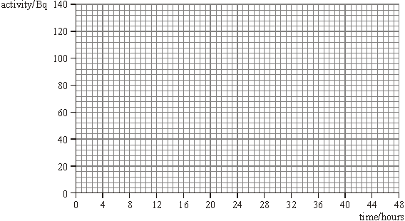

**(3)**

(b) (i) The total energy released in each decay is 5.5 × 10–13 J.  
Calculate the initial energy produced each second by the source.

initial energy ..................................... J

**(1)**

(ii) **Figure 1** shows the energy spectrum for the beta particles emitted in the decay.

It shows that different energy beta particles are possible.

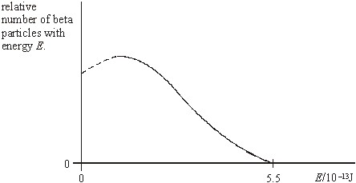

**Figure 1**

Explain why all the beta particles that are emitted do not have 5.5 × 10–13 J of energy.

...............................................................................................................

...............................................................................................................

...............................................................................................................

...............................................................................................................

...............................................................................................................

**(3)**

(c) The probability of one of the radioactive atoms decaying each second is 1.6 × 10–5.

How many radioactive atoms are present when the activity is 120 Bq?

number of radioactive atoms ...................................

**(1)**

(d) A scientist undertaking an investigation places the freshly prepared source close to a Geiger-Müller tube as shown in **Figure 2** and records a count rate of 50 counts per second.

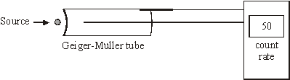

**Figure 2**

State and explain **two** reasons why the measured count rate is lower than the activity of the source.

.........................................................................................................................................

.........................................................................................................................................

.........................................................................................................................................

.........................................................................................................................................

**(2)**

**(Total 12 marks)**

**Q7.** The table below gives the values for the activity of a radioactive isotope over a period of a few minutes.

|  |  |  |  |  |  |  |
| --- | --- | --- | --- | --- | --- | --- |
| **time/s** | 0 | 60 | 120 | 180 | 240 | 300 |
| **activity/Bq** | 480 | 366 | 280 | 214 | 163 | 124 |

1. Complete the graph on the next page by plotting the remaining points and drawing an appropriate curve.

(b) Use the graph to determine the half-life of the isotope.

half-life ......................................

**(3)**

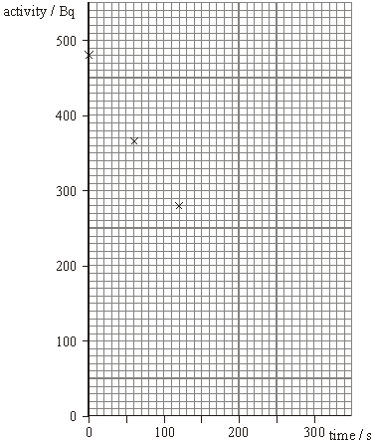

**(3)**

(c) Initially there were 1.1 × 105 atoms of the isotope present. Calculate the decay probability of the isotope.

decay probability.......................................

**(2)**

**(Total 8 marks)**

**Q9.** Conductive paper, sometimes called *Teledeltos* paper, is produced by coating one surface of the paper with a thin layer of graphite paint. To investigate its electrical properties, pieces of the paper can be joined to a conventional wired circuit using copper electrodes and bulldog clips, as shown below.

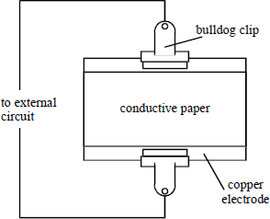

It is known that the paper obeys Ohm’s Law providing the current through it does not exceed 200 mA. The company that manufactures it estimates that under typical laboratory conditions, the resistivity of the paint is between 1.0 × 10−5 Ωm and 5.0 × 10−5 Ωm.

Design an experiment that investigates some characteristic of the conductive paper.

You should consider the following in your answer.

* The variables you intend to measure and how to ensure that they are measured accurately.
* The factors you will need to control and how you will do this.
* The expected outcome of the experiment that you design.
* How any difficulties in performing the experiment could be overcome.

**(Total 8 marks)**

**Q10.** A student attempted to determine the *half-life* of a radioactive substance, which emits *α* particles, by placing it near a suitable counter. He recorded *C*, the number of counts in 30 s, at various times, *t*, after the start of the experiment.

The results given in the table were obtained.

|  |  |  |  |  |  |  |  |
| --- | --- | --- | --- | --- | --- | --- | --- |
| *t* / minute | 0 | 10 | 20 | 30 | 40 | 50 | 60 |
| number of counts in 30 s, *C* | 60 | 42 | 35 | 23 | 18 | 14 | 10 |
| ln *C* |  |  |  |  |  |  |  |

(a) Explain what is meant by *half-life*.

..............................................................................................................................

..............................................................................................................................

**(1)**

(b) Complete the table.

**(1)**

(c) On the grid on the next page

(i) plot ln C against *t*,

(ii) draw the best straight line through your points,

(iii) determine the gradient of your graph.

...............................................................................................................

...............................................................................................................

...............................................................................................................

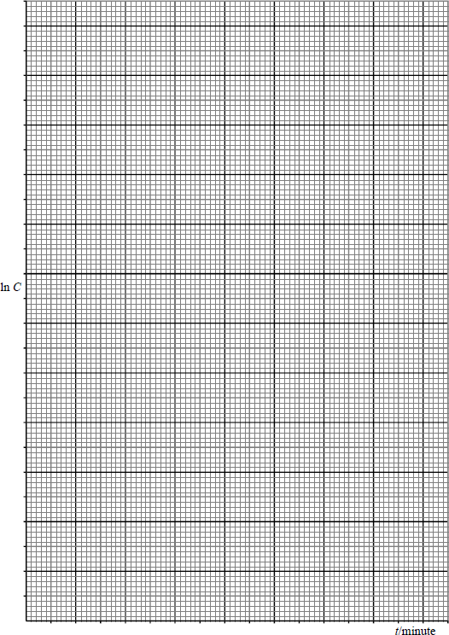

(d) (i) Show that the decay constant of the substance is equal to the magnitude of the gradient of your graph.

...............................................................................................................

...............................................................................................................

...............................................................................................................

**(5)**

(ii) Calculate the half-life of the substance.

...............................................................................................................

...............................................................................................................

...............................................................................................................

**(3)**

(e) This particular experiment is likely to lead to an inaccurate value for the half-life. Suggest **two** ways in which the accuracy of the experiment could be improved.

........................................................................................................................

........................................................................................................................

........................................................................................................................

........................................................................................................................

**(2)**

(f) The age of a piece of bone recovered from an archaeological site may be estimated by 14C dating. All living organisms absorb 14C but there is no further intake after death. The proportion of 14C is constant in living organisms.

A 1 g sample of bone from an archaeological site has an average rate of decay of 5.2 Bq due to 14C. A 1 g sample of bone from a modern skeleton has a rate of decay of 6.5 Bq. The counts are corrected for background radiation.

Calculate the age, in years, of the archaeological samples of bone.

half-life of 14C = 5730 years

..........................................................................................................................................

..........................................................................................................................................

..........................................................................................................................................

..........................................................................................................................................

..........................................................................................................................................

..........................................................................................................................................

**(4)**

**(Total 16 marks)**

**Q11.** An alternating current (a.c.) source is connected to a resistor to form a complete circuit. The trace obtained on an oscilloscope connected across the resistor is shown.

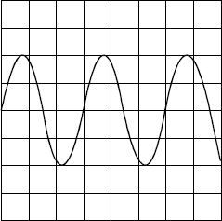

The oscilloscope settings are: Y sensitivity 4.0 V per division,

time base 1.0 ms per division.

(a) Determine the peak voltage of the a.c. source.

........................................................................................................................

........................................................................................................................

(b) Hence calculate the r.m.s. voltage.

........................................................................................................................

........................................................................................................................

(c) Determine the time period of the a.c. signal.

........................................................................................................................

........................................................................................................................

(d) Hence calculate the frequency of the a.c. signal.

........................................................................................................................

........................................................................................................................

**(Total 4 marks)**

**Q12.** Two students discuss how the intensity of the illumination provided by a spotlight varies with the distance along the axis of the lamp.

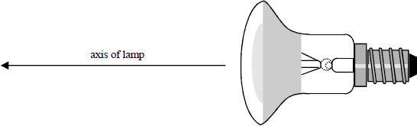

Student A argues that the lamp should be regarded as a point source so the intensity of illumination should vary as the inverse-square of the distance along the axis from the lamp. Student B disagrees, pointing out that the lamp incorporates a reflector that produces a narrow concentrated beam. Therefore, he reasons, the intensity must decrease exponentially with the distance along the axis from the lamp. Researching the problem, the students discover the calibration graph, shown below, that shows how the resistance of a light dependent resistor (LDR) varies with the intensity of the illumination falling on it.

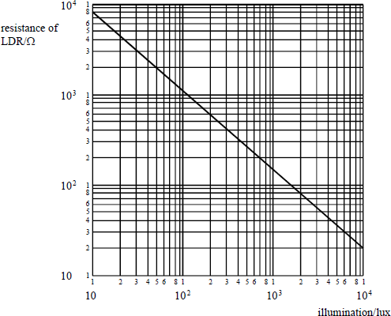

Design an experiment that the students could perform to test their theories.

You should assume that a well-equipped physics laboratory is available to you.  
You are advised to draw a suitable diagram of the arrangement you intend to use as part of your answer.

You should also include the following in your answer:

* The quantities you intend to measure and how you will measure them.
* How you propose to use your measurements to settle the argument between the students.
* The factors you will need to control and how you will do this.
* How you could overcome any difficulties in obtaining reliable results.

**(Total 8 marks)**

**Q13.** A student investigated how the extension of a rubber cord varied with the force used to extend it. She measured the extension for successive increases of the force and then for successive decreases. The diagram below shows a graph of her results.

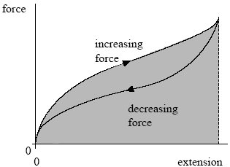

(a) (i) Give a reason why the graph shows the rubber cord does not obey Hooke’s law.

.............................................................................................................

.............................................................................................................

**(1)**

(ii) Give a reason why the graph shows the rubber cord does not exhibit plastic behaviour.

.............................................................................................................

.............................................................................................................

**(1)**

(iii) What physical quantity is represented by the area shaded on the graph between the loading curve and the extension axis?

.............................................................................................................

.............................................................................................................

**(1)**

(b) Describe, with the aid of a diagram, the procedure and the measurements you would make to carry out this investigation.

The quality of your written answer will be assessed in this question.

......................................................................................................................

......................................................................................................................

......................................................................................................................

......................................................................................................................

......................................................................................................................

......................................................................................................................

......................................................................................................................

......................................................................................................................

......................................................................................................................

......................................................................................................................

**(6)**

**(Total 9 marks)**

**Q14.** (a) The circuit shown in **Figure 1** may be used to determine the internal resistance of a battery. An oscilloscope is connected across the battery as shown. **Figure 2** represents the screen of the oscilloscope.

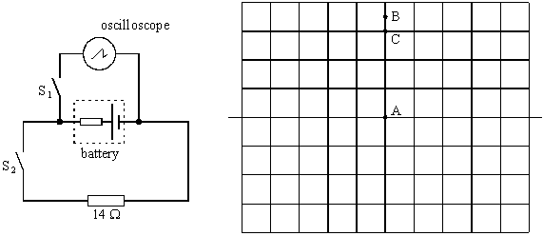

**Figure 1** **Figure 2**

The time base of the oscilloscope is switched off throughout the experiment. Initially the switches S1 and S2 are both open. Under these conditions the spot on the oscilloscope screen is at A.

(i) Switch S1 is now closed, with S2 remaining open. The spot moves to B. State what the deflection AB represents.

.............................................................................................................

(ii) Switch S1 is kept closed and S2 is also closed. The spot moves to C. State what the deflection AC represents.

.............................................................................................................

(iii) The vertical sensitivity of the oscilloscope is 0.50 V div–1. Calculate the current through the 14 Ω resistor with both switches closed.

.............................................................................................................

.............................................................................................................

.............................................................................................................

(iv) Hence, calculate the internal resistance of the battery.

.............................................................................................................

.............................................................................................................

.............................................................................................................

**(6)**

(b) The oscilloscope is now connected to an alternating voltage source of rms value 3.5 V.

(i) Calculate the peak value of the alternating voltage.

..............................................................................................................

.............................................................................................................

(ii) Draw on **Figure 3** what you would expect to see on the oscilloscope screen, if the time base is still switched off and the voltage sensitivity is altered to 2.0 V div–1.



**Figure 3**

**(3)**

**(Total 9 marks)**

**Q15.** An oscilloscope is connected to a sinusoidal ac source as shown in **Figure 1**.  
The frequency and the voltage output of the ac source can be varied.

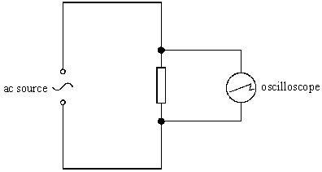

**Figure 1**

At a certain frequency the ac signal has an rms output of 7.1 V. **Figure 2** shows the trace obtained on the screen of the oscilloscope when one horizontal division corresponded to a time of 5.0 ms.

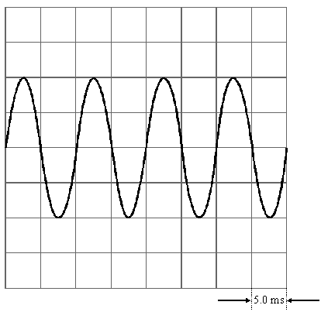

**Figure 2**

(a) Calculate, for the signal shown in **Figure 2**,

(i) the peak voltage,

.............................................................................................................

.............................................................................................................

(ii) the frequency.

.............................................................................................................

.............................................................................................................

**(3)**

(b) The voltage output and frequency of the signal are now changed so that the peak voltage is 80 V and the frequency is 200 Hz.

State which **two** controls on the oscilloscope have to be altered so that **four** full cycles again appear on the screen but the peak to peak distance occupies the **full** screen.

Determine the values at which these two controls have to be set.

control 1: …...................................................................................................

value of the setting: ......................................................................................

......................................................................................................................

......................................................................................................................

control 2: …...................................................................................................

value of setting: ............................................................................................

......................................................................................................................

......................................................................................................................

**(5)**

**(Total 8 marks)**

**Q16.** The circuit in **Figure 1** shows a sinusoidal ac source connected to two resistors, R1 and R2, which form a potential divider. Oscilloscope 1 is connected across the source and oscilloscope 2 is connected across R2.

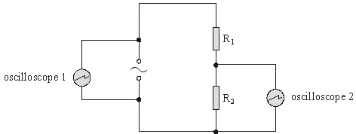

**Figure 1**

1. **Figure 2** shows the trace obtained on the screen of oscilloscope 1. The time base of the oscilloscope is set at 10 ms per division and the voltage 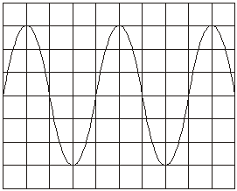sensitivity at 15 V per division.

**Figure 2**

For the ac source, calculate

(i) the frequency,

.............................................................................................................

.............................................................................................................

(ii) the rms voltage.

.............................................................................................................

.............................................................................................................

.............................................................................................................

**(4)**

(b) The resistors have the following values: R1 = 450 Ω and R2 = 90 Ω.  
Calculate

(i) the r.m.s. current in the circuit,

.............................................................................................................

.............................................................................................................

(ii) the r.m.s. voltage across R2.

.............................................................................................................

.............................................................................................................

**(2)**

(c) Oscilloscope 2 is used to check the calculated value of the voltage across R2. The screen of oscilloscope 2 is identical to that of oscilloscope 1 and both are set to the same time base. Oscilloscope 2 has the following range for voltage sensitivity: 1 V per division, 5 V per division, 10 V per division and 15 V per division.  
State which voltage sensitivity would give the most suitable trace. Explain the reasons for your choice.

......................................................................................................................

......................................................................................................................

......................................................................................................................

......................................................................................................................

......................................................................................................................

**(3)**

**(Total 9 marks)**

**Q17.** (a) can decay into by a β– followed by an α decay, or by an α followed by a β– decay. One or more of the following elements is involved in these decays:



Write out decay equations showing each stage in both of these decays.

|  |  |
| --- | --- |
| **First decay path** | **Second decay path** |
|  |  |

**(6)**

(b) (i) Describe how you would perform an experiment that demonstrates that gamma radiation obeys an inverse square law.

.............................................................................................................

.............................................................................................................

.............................................................................................................

.............................................................................................................

.............................................................................................................

.............................................................................................................

.............................................................................................................

.............................................................................................................

.............................................................................................................

.............................................................................................................

(ii) Explain why gamma radiation obeys an inverse square law but alpha and beta radiation do not.

.............................................................................................................

.............................................................................................................

.............................................................................................................

.............................................................................................................

.............................................................................................................

**(9)**

**(Total 15 marks)**

**Q18.** The diagram below shows an ac waveform that is displayed on an oscilloscope screen.

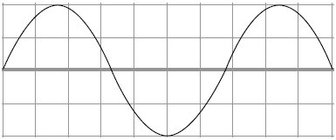

The time base of the oscilloscope is set at 1.5 ms per division and the y-gain at 1.5 V per division.

(a) For the ac waveform shown,

(i) Calculate the frequency

.............................................................................................................

.............................................................................................................

.............................................................................................................

answer ............................................ Hz

**(3)**

(ii) Calculate the peak voltage

.............................................................................................................

.............................................................................................................

.............................................................................................................

answer ........................................... V

**(2)**

(iii) the rms voltage

.............................................................................................................

.............................................................................................................

answer ............................................ V

**(2)**

(b) State and explain the effect on the oscilloscope trace if the time base is switched off.

......................................................................................................................

......................................................................................................................

......................................................................................................................

......................................................................................................................

**(2)**

**(Total 9 marks)**

**Q19.** An alternating current (ac) source is connected to a resistor to form a complete circuit. The trace obtained on an oscilloscope connected across the resistor is shown in the diagram below.

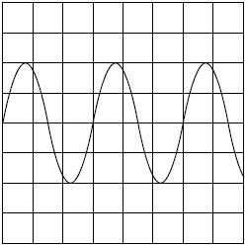

The oscilloscope settings are: Y gain 5.0 V per division

time base 2.0 ms per division.

(i) Calculate the peak voltage of the ac source.

answer = ....................................... V

**(1)**

(ii) Calculate the rms voltage.

answer = ....................................... V

**(1)**

(iii) Calculate the time period of the ac signal.

answer = ..................................... ms

**(1)**

(iv) Calculate the frequency of the ac signal.

answer = ...................................... Hz

**(2)**

**(Total 5 marks)**

**Q20.** (a) The exposure of the general public to background radiation has changed substantially over the past 100 years.

State **one** source of radiation that has contributed to this change.

.............................................................................................................................

.............................................................................................................................

**(1)**

(b) A student measures background radiation using a detector and determines that background radiation has a mean count-rate of 40 counts per minute. She then places a γ ray source 0.15 m from the detector as shown below.

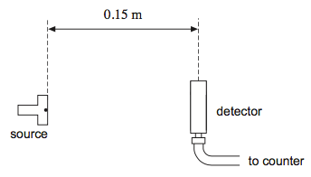

With this separation the average count per minute was 2050.

The student then moves the detector further from the γ ray source and records the count-rate again.

(i) Calculate the average count-rate she would expect to record when the source is placed 0.90 m from the detector.

count-rate = ........................ min–1

**(3)**

(ii) The average count per minute of 2050 was determined from a measurement over a period of 5 minutes. Explain why the student might choose to record for longer than 5 minutes when the separation is 0.90 m.

...................................................................................................................

...................................................................................................................

...................................................................................................................

...................................................................................................................

**(1)**

(iii) When the detector was moved to 0.90 m the count-rate was lower than that calculated in part **(b)(i)**. It is suggested that the source may also emit β particles.

Explain how this can be checked.

...................................................................................................................

...................................................................................................................

...................................................................................................................

...................................................................................................................

...................................................................................................................

...................................................................................................................

...................................................................................................................

...................................................................................................................

...................................................................................................................

**(2)**

**(Total 7 marks)**

**Q21.** (a) A sample of conducting putty is rolled into a cylinder which is 6.0 × 10–2 m long and has a radius of 1.2 × 10–2 m.

resistivity of the putty = 4.0 × 10–3 Ωm.

Calculate the resistance between the ends of the cylinder of conducting putty.  
Your answer should be given to an appropriate number of significant figures.

answer = ...................................... Ω

**(4)**

(b) Given the original cylinder of the conducting putty described in part (a), describe how you would use a voltmeter, ammeter and other standard laboratory equipment to determine a value for the resistivity of the putty.

Your description should include

* + a labelled circuit diagram,
  + details of the measurements you would make,
  + an account of how you would use your measurements to determine the result,
  + details of how to improve the precision of your measurements.

The quality of your written communication will be assessed in this question.

......................................................................................................................

......................................................................................................................

......................................................................................................................

......................................................................................................................

......................................................................................................................

......................................................................................................................

......................................................................................................................

......................................................................................................................

......................................................................................................................

......................................................................................................................

......................................................................................................................

......................................................................................................................

**(8)**

**(Total 12 marks)**

**Q22.**The decay of a radioactive substance can be represented by the equation

A = A0e–λt

where A = the activity of the sample at time t

A0 = the initial activity at time t = 0

λ = the decay constant

The half life, T½ of the radioactive substance is given by

T½ =

An experiment was performed to determine the half-life of a radioactive substance which was a beta emitter. The radioactive source was placed close to a detector. The total count for exactly 5 minutes was recorded. This was repeated at 20 minute intervals. The results are shown in the table below.

|  |  |  |  |  |
| --- | --- | --- | --- | --- |
| **time, *t* / minutes** | **total count, *C*, recorded in 5 minutes** | **count rate, *R* / counts minute–1** | **corrected count rate, *RC* / counts minute–1** | **ln (*RC* / minute–1)** |
| 0 | 1016 | 203 | 183 | 5.21 |
| 20 | 892 | 178 | 158 | 5.06 |
| 40 | 774 | 155 | 135 | 4.90 |
| 60 | 665 | 133 | 113 | 4.73 |
| 80 | 608 | 122 | 102 | 4.62 |
| 100 | 546 | 109 | 89 | 4.49 |

(a) A correction has been made to the count rate, *R*, to give the corrected count rate, *RC*.  
Explain why this correction has been made and deduce its value from the table.

.........................................................................................................................

.........................................................................................................................

.........................................................................................................................

**(2)**

(b) Draw an appropriate straight line through the plotted points on the graph on the next page.

**(1)**

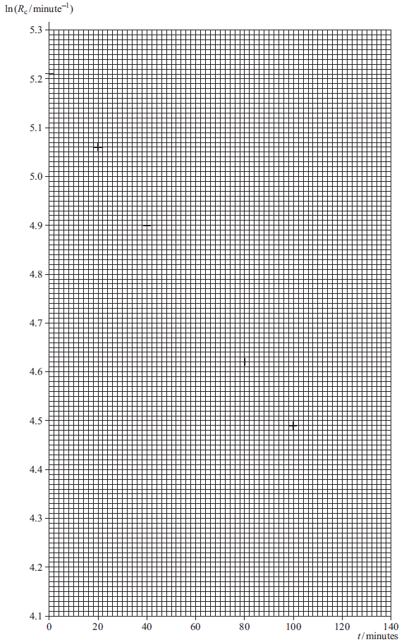

(c) Determine the gradient *G* of your graph.

.........................................................................................................................

.........................................................................................................................

.........................................................................................................................

.........................................................................................................................

.........................................................................................................................

.........................................................................................................................

**(3)**

(d) Use your graph to determine the half-life in minutes of the radioactive substance used in this experiment.

.........................................................................................................................

.........................................................................................................................

.........................................................................................................................

.........................................................................................................................

half-life, *T*½ .......................................... minutes

**(2)**

(e) Due to the nature of a radioactive decay there will be an uncertainty in the total count recorded. What type of error is this called?

.........................................................................................................................

**(1)**

(f) (i) It can be shown that the error in the total count *C*, is given by

uncertainty in total count *C* = ± √*C*

Using data from the table, calculate the uncertainty **in the smallest total count, *C***.

...............................................................................................................

...............................................................................................................

**(1)**

(ii) Hence calculate the percentage uncertainty **in the smallest total count, *C***.

...............................................................................................................

...............................................................................................................

...............................................................................................................

**(1)**

(iii) Another student performed the same experiment with identical equipment but took total counts over a 1 minute period rather than a 5-minute period. The total count, *C*, at 140 minutes was equal to 84 counts. Estimate the percentage uncertainty in this total count, and hence explain the advantage of using a larger time.

...............................................................................................................

...............................................................................................................

...............................................................................................................

...............................................................................................................

...............................................................................................................

...............................................................................................................

**(2)**

**(Total 13 marks)**

**Q23.** The voltage produced by a solar cell may be assumed to be proportional to the light intensity incident on it. A student uses a solar cell in an experiment to determine the half value thickness for glass i.e the thickness of glass that reduces the output voltage by half. The student uses a varying number *N* of microscope slides between a light source and the solar cell and measures the output voltage *V* for each value of *N*. The graph below was produced from the student’s data.

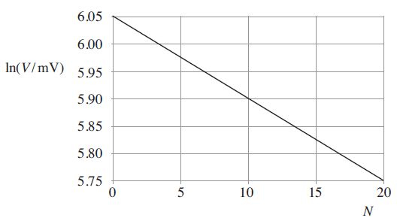

Assuming that the output voltage of the solar cell is directly proportional to the light intensity incident upon it, the student intends to determine the half-value thickness of glass, i.e. the thickness of glass that would reduce the output voltage by half.

(a) Use the information provided in the student’s graph to calculate *N*0.5, the value of *N* equivalent to the half-value thickness of the glass.

.........................................................................................................................

.........................................................................................................................

.........................................................................................................................

.........................................................................................................................

.........................................................................................................................

.........................................................................................................................

.........................................................................................................................

**(3)**

(b) To determine the half-value thickness of the glass in mm, the student needs to make one additional measurement.

(i) Identify the measurement the student needs to make and explain how this is used to determine the half-value thickness of the glass.

...............................................................................................................

...............................................................................................................

...............................................................................................................

...............................................................................................................

The student uses a micrometer screw gauge to make the additional measurement.

(ii)     Identify **one** procedure that can be used to reduce the effect of random errors when making the measurement.

...............................................................................................................

...............................................................................................................

...............................................................................................................

...............................................................................................................

(iii)    Identify **one** procedure that can be used to detect, and hence correct, for possible systematic errors in the measurements made with the micrometer screw gauge.

...............................................................................................................

...............................................................................................................

...............................................................................................................

...............................................................................................................

**(3)**

The student uses a travelling microscope to learn more about the properties of the glass slides.

The eyepiece of the microscope is arranged to move vertically up or down above a scrap of newspaper showing a photograph.  
The photograph is composed of dots which are only clearly visible when viewed through the microscope. By adjusting the position of the microscope the student brings the dots into focus and then reads the position of the microscope, *R*0, using the vernier scale.  
The student then places a stack of 12 slides over the photograph and refocuses the microscope. She records the new reading, *R*1.  
Finally, she places the photograph on top of the slides, refocuses the microscope, and records the new reading *R*2.

The sequence of operations is illustrated below.

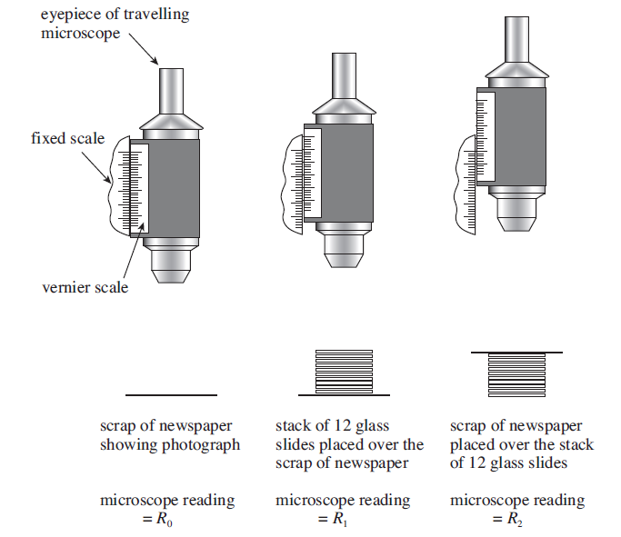

The readings made by the student are shown in the table below.

|  |  |  |
| --- | --- | --- |
| *R*0/mm | *R*1/mm | *R*2/mm |
| **2.74** | **7.31** | **17.02** |

(c) Assuming that the slides have identical dimensions, use the readings to determine the thickness of one glass microscope slide.

.........................................................................................................................

.........................................................................................................................

**(1)**

(d) Determine *n*, the refractive index of the glass, given by *n* = .

.........................................................................................................................

.........................................................................................................................

**(1)**

(e) The uncertainty in each of the readings *R*0, *R*1 and *R*2, is 0.04 mm.

(i) State the uncertainty in *R*2 – *R*0.

...............................................................................................................

(ii) State the uncertainty in *R*2 – *R*1.

...............................................................................................................

(iii) Hence calculate the percentage uncertainty in *n*.

...............................................................................................................

...............................................................................................................

...............................................................................................................

...............................................................................................................

...............................................................................................................

...............................................................................................................

**(3)**

**(Total 11 marks**

**Q24.**In an experiment, a set of light emitting diodes LEDs that emitted light of different colours was used. The minimum pd *V*min for light to be emitted by each diode was measured. The results are given in the table, together with the average wavelength *λ* of the light emitted by each diode and the corresponding frequencies *f* for some of the LEDs. Some points are plotted on the graph of *V*min against *f*.

|  |  |  |  |
| --- | --- | --- | --- |
| **colour** | **wavelength *λ*/nm** | **frequency *f* / 1014 Hz** | **minimum pd *V*min /*V*** |
| infrared | 940 | 3.19 | 0.92 |
| red | 665 | 4.51 | 1.54 |
| orange | 625 | 4.80 | 1.54 |
| yellow | 595 | 5.04 | 1.78 |
| green | 565 |  | 1.87 |
| blue | 470 |  | 2.37 |

(a) Complete the table.

**(1)**

(b) Complete the graph on the next page by plotting the missing two points and drawing a straight line of best fit.

**(2)**

(c) (i) Determine the gradient of the graph.

...............................................................................................................

...............................................................................................................

...............................................................................................................

...............................................................................................................

...............................................................................................................

...............................................................................................................

**(3)**

**Graph of minimum pd against frequency**

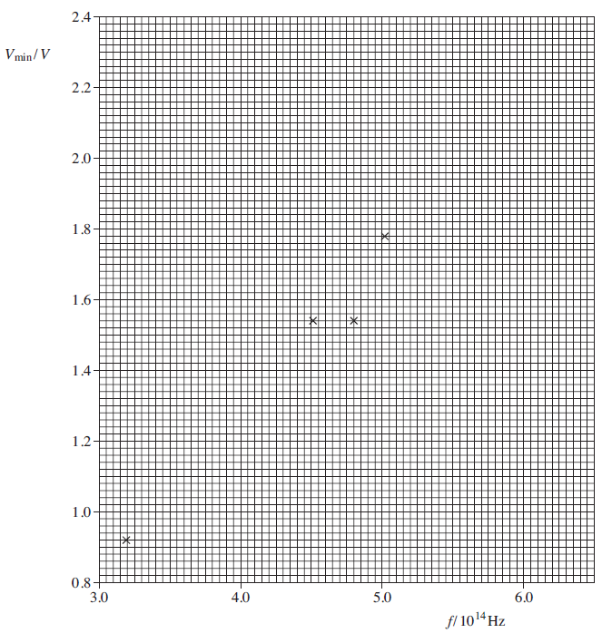

(ii) Discuss the reliability of your value for the gradient.

...............................................................................................................

...............................................................................................................

...............................................................................................................

...............................................................................................................

**(2)**

(d) Theory predicts that the energy lost by the electron in passing through the LED is the energy of the emitted photon. Hence

*eVmin = hf*

where *h* is the Planck constant and *e* = 1.60 × 10−19 C.

(i) Find a value for *h* by using the general equation of a straight line, *y = mx + c*, and your answer to part (c)(i).

...............................................................................................................

...............................................................................................................

...............................................................................................................

...............................................................................................................

...............................................................................................................

**(3)**

(ii) The accepted value for *h* = 6.63 × 10−34 J s. Calculate the percentage difference between the value calculated in part (d)(i) and the accepted value.

...............................................................................................................

...............................................................................................................

...............................................................................................................

...............................................................................................................

**(1)**

(iii) The precision of the voltmeter was ± 0.01V. Calculate the percentage uncertainty this produces in the value of *V*min for the infrared radiation.

...............................................................................................................

...............................................................................................................

...............................................................................................................

**(1)**

(iv) A student assumes that the percentage difference calculated in part (d)(ii) is due only to the uncertainty in *V*min, as determined in part (d)(iii), and the uncertainty in the frequency. Using this assumption calculate the uncertainty in the value of the infrared frequency quoted in the table.

...............................................................................................................

...............................................................................................................

...............................................................................................................

**(3)**

**(Total 16 marks)**

**Q25.** In an experiment an unknown load, of weight, *W*, was supported by two strings kept in tension by equal masses, *m*, hung from their free ends, with each string passing over a frictionless pulley. The arrangement was symmetrical and is shown in **Figure 1**.

**Figure 1**

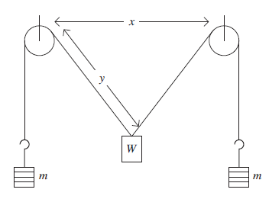

The distance *x* was kept constant throughout the experiment. The length *y* was measured for different values of *m*.

The distance between the strings at the pulleys, *x* = 0.500 m

(a) **Figure 2** shows the three forces acting through the point at which the strings are attached to the load. The weight of the load is *W* and the tension in each string is *mg*, where *g* is gravitational field strength.

**Figure 2**

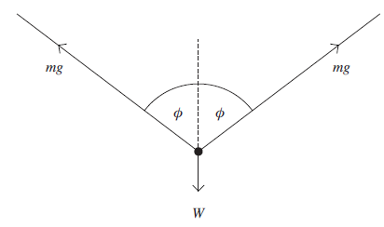

(i) By resolving the forces vertically show that

where *φ* is the angle between each string and the vertical.

...............................................................................................................

...............................................................................................................

...............................................................................................................

...............................................................................................................

**(1)**

(ii) Draw the line of best fit through the points plotted on the graph on the next page.

**(1)**

(b) (i) Determine the gradient of your graph.

...............................................................................................................

...............................................................................................................

...............................................................................................................

...............................................................................................................

...............................................................................................................

...............................................................................................................

**(3)**

(ii) The equation for the straight line is   
Given that *g* = 9.81Nkg–1, determine a value for *W*.

...............................................................................................................

...............................................................................................................

...............................................................................................................

...............................................................................................................

**(2)**

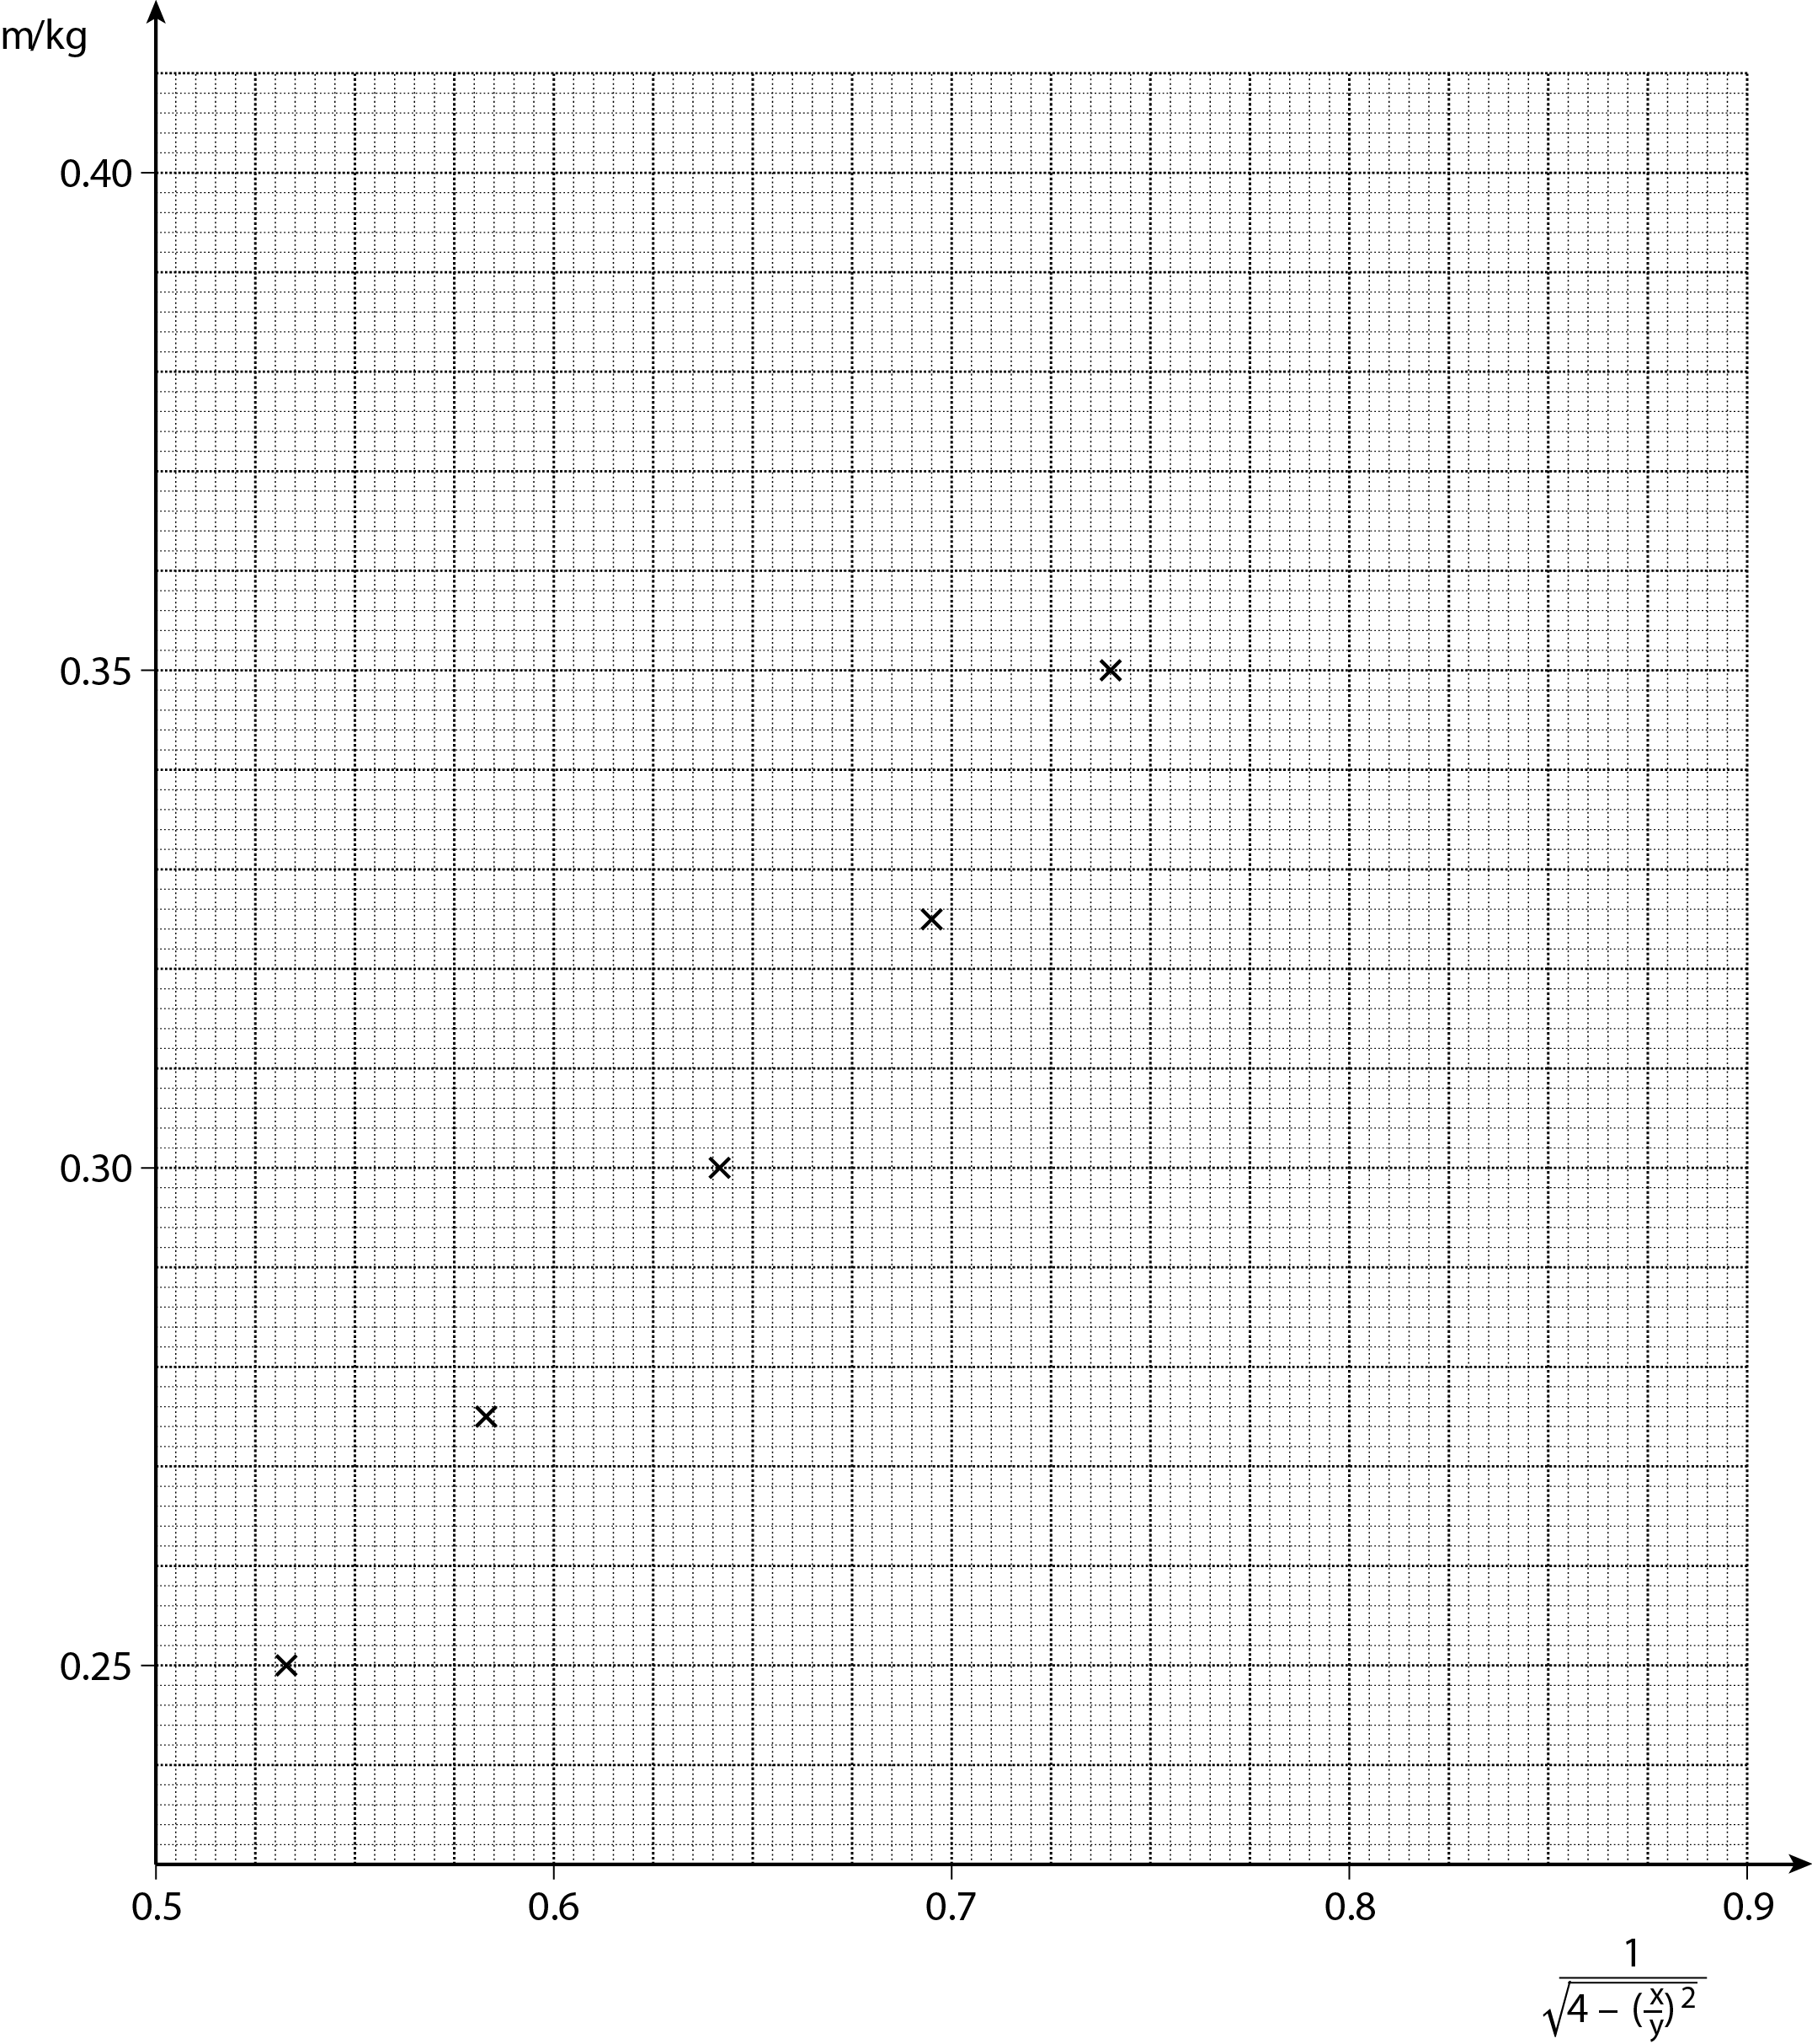

(c) When *m* was 0.300 kg, *y* was 0.400 m.

Calculate the percentage uncertainty in for *m* = 0.300 kg.

.........................................................................................................................

.........................................................................................................................

.........................................................................................................................

.........................................................................................................................

.........................................................................................................................

.........................................................................................................................

.........................................................................................................................

.........................................................................................................................

**(3)**

(d) (i) Explain the term *systematic error*.

.........................................................................................................................

.........................................................................................................................

.........................................................................................................................

.........................................................................................................................

**(1)**

(ii) In practice, there may be a systematic error in this experiment because of friction in the pulleys.  
When the measurements were taken, increasing values of *m* were used. State and explain how friction in the pulleys would have affected the measured values of *y*.

.........................................................................................................................

.........................................................................................................................

.........................................................................................................................

.........................................................................................................................

.........................................................................................................................

**(2)**

**(Total 13 marks)**

**Q26.** The term **ultrasound** refers to vibrations in a material that occur at frequencies too high to be detected by a human ear. When ultrasound waves move through a solid, both longitudinal and transverse vibrations may be involved. For the longitudinal vibrations in a solid, the speed *c* of the ultrasound wave is given by



where *E* is the Young modulus of the material and *ρ* is the density. Values for *c* and *ρ* are given in the table below.

|  |  |  |
| --- | --- | --- |
| **Substance** | ***c* / m s−1** | ***ρ* / kg m−3** |
| glass | 5100 | 2500 |
| sea water | 1400 | 1000 |

Ultrasound waves, like electromagnetic radiation, can travel through the surface between two materials. When all the energy is transmitted from one material to the other, the materials are said to be **acoustically matched**. This happens when *ρc* is the same for both materials.

(a) Calculate the magnitude of the Young modulus for glass.

Young modulus = ...............................

**(1)**

(b) State your answer to (a) in terms of SI fundamental units.

**(1)**

(c) The passage states that ’when ultrasound waves move through a solid both longitudinal and transverse vibrations may be involved’.

State the difference between longitudinal and transverse waves.

........................................................................................................................

........................................................................................................................

........................................................................................................................

........................................................................................................................

**(2)**

(d) Show that when two materials are acoustically matched, the ratio of their Young moduli is equal to the ratio of their speeds of the ultrasound waves.

**(2)**

(e) The wave speed in a material X is twice that in material Y. X and Y are acoustically matched.

Determine the ratio of the densities of X and Y.

X = ............................... Y = ...............................

**(1)**

(f) Ultrasound waves obey the same laws of reflection and refraction as electromagnetic waves.

Using data from **Table 1**, discuss the conditions for which total internal reflection can occur when ultrasound waves travel between glass and sea water.

........................................................................................................................

........................................................................................................................

........................................................................................................................

........................................................................................................................

........................................................................................................................

........................................................................................................................

........................................................................................................................

........................................................................................................................

**(3)**

**(Total 10 marks)**

**Q27.** Which of the following gives a correct unit for ?

|  |  |  |
| --- | --- | --- |
| **A** | N |  |
| **B** | N kg–1 |  |
| **C** | N m |  |
| **D** | N m–2 |  |

**(Total 1 mark)**

**Q28.**This question is about capacitor charging and discharging.

A student designs an experiment to charge a capacitor using a constant current. The figure below shows the circuit the student designed to allow charge to flow onto a capacitor that has been initially discharged.

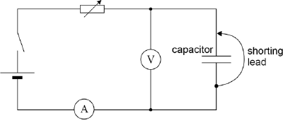

The student begins the experiment with the shorting lead connected across the capacitor as in the figure above. The variable resistor is then adjusted to give a suitable ammeter reading. The shorting lead is removed so that the capacitor begins to charge. At the same instant, the stop clock is started.

The student intends to measure the potential difference (p.d.) across the capacitor at 10 s intervals while adjusting the variable resistor to keep the charging current constant.

The power supply has an emf of 6.0 V and negligible internal resistance. The capacitor has a capacitance of 680 µF. The variable resistor has a maximum resistance of 100 kΩ.

(a) The student chooses a digital voltmeter for the experiment. A digital voltmeter has a very high resistance.

Explain why it is important to use a voltmeter with very high resistance.

........................................................................................................................

........................................................................................................................

........................................................................................................................

**(1)**

(b) Suggest **one** advantage of using an analogue ammeter rather than a digital ammeter for this experiment.

........................................................................................................................

........................................................................................................................

........................................................................................................................

**(1)**

(c) Suggest a suitable full scale deflection for an analogue ammeter to be used in the experiment.

full scale deflection = ............

**(2)**

(d) The diagram shows the reading on the voltmeter at one instant during the experiment. The manufacturer gives the uncertainty in the meter reading as 2%.

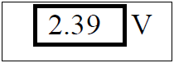

Calculate the absolute uncertainty in this reading.

uncertainty = ............V

**(1)**

(e) Determine the number of different readings the student will be able to take before the capacitor becomes fully charged.

number = ............

**(3)**

(f) The experiment is performed with a capacitor of nominal value 680 µF and a manufacturing tolerance of ± 5 %. In this experiment the charging current is maintained at 65 µA. The data from the experiment produces a straight-line graph for the variation of pd with time. This shows that the pd across the capacitor increases at a rate of 98 mV s–1.

Calculate the capacitance of the capacitor.

capacitance = ............µF

**(2)**

(g) Deduce whether the capacitor is within the manufacturer’s tolerance.

........................................................................................................................

........................................................................................................................

........................................................................................................................

**(1)**

(h) The student decides to confirm the value of the capacitance by first determining the time constant of the circuit when the capacitor **discharges** through a **fixed** resistor.

Describe an experiment to do this. Include in your answer:

* + a circuit diagram
  + an outline of a procedure
  + an explanation of how you would use the data to determine the time constant.

........................................................................................................................

........................................................................................................................

........................................................................................................................

........................................................................................................................

........................................................................................................................

........................................................................................................................

........................................................................................................................

........................................................................................................................

........................................................................................................................

........................................................................................................................

........................................................................................................................

**(4)**

**(Total 15 marks)**

**Q29.** Which line, **A** to **D**, gives correct units for both magnetic flux and magnetic flux density?

|  |  |  |
| --- | --- | --- |
|  | magnetic flux | magnetic flux density |
| **A** | Wb m−2 | Wb |
| **B** | Wb | T |
| **C** | Wb m−2 | T m−2 |
| **D** | T m−2 | Wb m−2 |

**(Total 1 mark)**

**Q30.** The fission of one nucleus of uranium 235 releases 200 MeV of energy. What is the value of this energy in J?

**A** 3.2 × 10−25 J

**B** 3.2 × 10−17 J

**C** 3.2 × 10−11 J

**D** 2.0 × 106 J

**(Total 1 mark)**

**Q31.** In parts (i) and (ii) circle the letter that corresponds to the correct answer.

(i) The resistance of a negative temperature coefficient (ntc) thermistor

**A** increases as temperature increases.

**B** is constant at temperatures below 0 °C.

**C** increases as temperature decreases.

**D** falls to zero when a critical temperature is reached.

**(1)**

(ii) The unit of potential difference can be expressed as

**A** C s–1

**B** J C–1

**C** V A–1

**D** J A–1

**(1)**

**(Total 2 marks)**

**Q32.** A student investigates the variation of electric potential with distance along a strip of conducting paper of length *l* and of uniform thickness. The strip tapers uniformly from a width 4*w* at the broad end to 2*w* at the narrow end, as shown in **Figure 1**. A constant pd is applied across the two ends of the strip, with the narrow end at positive potential, *Vl*, and the broad end at zero potential. The student aims to produce a graph of pd against distance *x*, measured from the broad end of the strip.

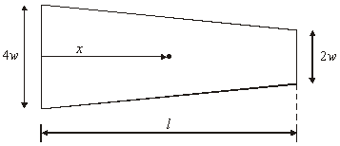

**Figure 1**

(a) Draw a labelled circuit diagram which would be suitable for the investigation.

**(2)**

(b) The student obtained some preliminary measurements which are shown below.

|  |  |  |  |  |
| --- | --- | --- | --- | --- |
| pd, *V*/V | 0 | 2.1 | 4.5 | 7.2 |
| Distance, *x*/m | 0 | 0.100 | 0.200 | 0.300 |

By reference to the physical principles involved, explain why the increase of *V* with *x* is greater than a linear increase.

......................................................................................................................

......................................................................................................................

......................................................................................................................

......................................................................................................................

......................................................................................................................

......................................................................................................................

......................................................................................................................

......................................................................................................................

**(4)**

(c) The potential, *V*, at a distance *x* from the broad end is given by

*V* = *k* – 1.44*V*lln (2*l* – *x*),

where *Vl* is the potential at the narrow end, and *k* is a constant.

(i) The student’s results are given below. Complete the table.  
*l* = 0.400 m

|  |  |  |  |
| --- | --- | --- | --- |
| distance *x*/m | potential *V*/V | (2*l* – *x*)/m | ln (2*l* – *x*) |
| 0.100 | 2.1 | 0.700 | – 0.357 |
| 0.200 | 4.5 |  |  |
| 0.270 | 6.4 |  |  |
| 0.330 | 8.3 |  |  |
| 0.360 | 9.3 |  |  |
| 0.380 | 10.1 |  |  |



(ii) Plot a graph of *V* against ln (2*l* – *x*) and explain whether or not it confirms the equation.

.............................................................................................................

.............................................................................................................

.............................................................................................................

.............................................................................................................

.............................................................................................................

.............................................................................................................

.............................................................................................................

.............................................................................................................

.............................................................................................................

(iii) Use the graph to calculate *Vl*.

.............................................................................................................

.............................................................................................................

**(10)**

**(Total 16 marks)**

**Q33.** Two grids of parallel ruled lines can be used to produce Moiré fringe patterns, as shown below.

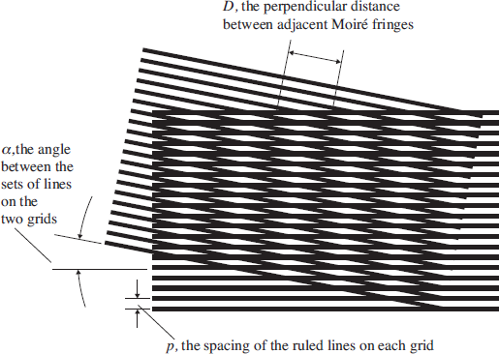

A student obtains two diffraction gratings thought to be identical with a line spacing of about

3 × 10–6 m. The student finds that when these are placed together and viewed against a white background a Moiré fringe pattern is observed when one grating is rotated slightly. For small angles, the distance between the Moiré interference fringes, *D*, is given by the approximate equation, *D* ≃ , where *α* is in degrees.  
By assuming that *p* = 3.0 × 10–6 m, the student uses this equation in a spreadsheet to find *D* for values of *α* up to 16°.

The student's results are shown below.

|  |  |
| --- | --- |
| ***α* / °** | ***D* / mm** |
| 2   4   6   8 10 12 14 16 | 0.0855 0.0428 0.0285 0.0214 0.0171 0.0143 0.0122 0.0107 |

The student intends to view the Moiré fringes through a microscope to check the spreadsheet results for *D* by measuring *D* using the microscope directly.  
The vernier scale on the microscope can measure to the nearest 0.01 mm.

1. Explain using suitable calculations why this microscope is not suitable to check the results of the spreadsheet calculation.

........................................................................................................................

........................................................................................................................

........................................................................................................................

........................................................................................................................

........................................................................................................................

........................................................................................................................

........................................................................................................................

........................................................................................................................

**(4)**

(b) The equation for *D* can be rearranged to give *p* ≃ .

The student suggests that if a better microscope can be provided and *α* can be set to produce values of *D* greater than 0.10 mm, the value of *p* can be found experimentally. Discuss whether the student’s suggestion is sensible.

........................................................................................................................

........................................................................................................................

........................................................................................................................

........................................................................................................................

**(2)**

(c) The theoretical separation of the Moiré fringes when *α* = 2°, shows *D* = 0.0859 mm. Calculate the percentage difference between this value and the student's spreadsheet result for *D* when *α* = 2°.

........................................................................................................................

........................................................................................................................

........................................................................................................................

........................................................................................................................

**(2)**

**(Total 8 marks)**