**Q1.**(a)     Describe how you could use cell fractionation to isolate chloroplasts from leaf tissue.

........................................................................................................................

........................................................................................................................

........................................................................................................................

........................................................................................................................

........................................................................................................................

........................................................................................................................

**(Extra space)** .................................................................................................

........................................................................................................................

**(3)**

The figure below shows a photograph of a chloroplast taken with an electron microscope.

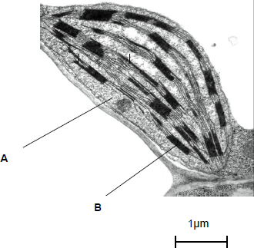

© Science Photo Library

(b)     Name the parts of the chloroplast labelled **A** and **B**.

Name of **A** .....................................................................................................

Name of **B** .....................................................................................................

**(2)**

(c)     Calculate the length of the chloroplast shown in the figure above.

Answer ................................................

**(1)**

(d)     Name **two** structures in a eukaryotic cell that **cannot** be identified using an optical microscope.

1 .....................................................................................................................

2 .....................................................................................................................

**(1)**

**(Total 7 marks)**

**Q2.**Scientists tested a claim that modified citrus pectin (MCP) increased the production of antibodies by the immune system.

•        They divided a large number of mice into five groups.

•        They gave the mice in each group a different amount of MCP in their food.

•        The scientists then stimulated antibody production in the mice. They did this by injecting them with a solution containing sheep red blood cells.

The results are shown in the graph.

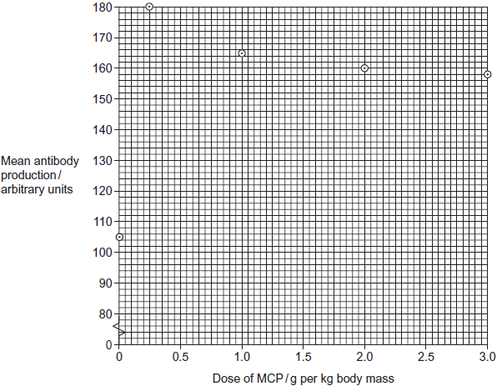

(a)     The data obtained in this investigation have been plotted on a graph. How would you join the points? Give a reason for your answer.

........................................................................................................................

........................................................................................................................

........................................................................................................................

**(1)**

(b)     Use the graph to describe the effect of MCP on mean antibody production.

........................................................................................................................

........................................................................................................................

........................................................................................................................

........................................................................................................................

........................................................................................................................

**(2)**

(c)     Calculate the percentage increase in antibody production from when there was no MCP in the diet to when the dose is 1.0 g per kg.

Answer ....................................................%

**(2)**

(d)     The dose of MCP given to the mice was calculated in g per kg body mass. Explain why the dose was calculated per unit mass.

........................................................................................................................

........................................................................................................................

**(1)**

(e)     Explain how antibodies were produced when the mice were injected with sheep red blood cells.

........................................................................................................................

........................................................................................................................

........................................................................................................................

........................................................................................................................

........................................................................................................................

........................................................................................................................

(Extra space) .................................................................................................

........................................................................................................................

........................................................................................................................

**(3)**

(f)      A newspaper suggested that these data show that taking MCP will give people increased resistance to disease. With reference to the data give **two** reasons why this conclusion may **not** be valid.

1 .....................................................................................................................

........................................................................................................................

2 .....................................................................................................................

........................................................................................................................

**(2)**

**(Total 11 marks)**

**Q3.**            The diagram shows a single-celled organism called *Chlamydomonas*.

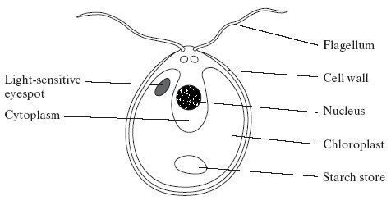

(a)     *Chlamydomonas* lives in fresh-water ponds. It uses its flagella to swim towards light of moderate intensity but away from very bright light. Using information in the diagram, explain the advantage of this behaviour.

......................................................................................................................

......................................................................................................................

......................................................................................................................

......................................................................................................................

**(2)**

(b)     A *Chlamydomonas* cell has two flagella. These flagella contain a single sort of protein. A flagellum consists of a bundle of 242 filaments. Each filament consists of 7500 protein molecules. Each protein molecule contains 900 amino acid units.

(i)      What would be the minimum number of nucleotides in the coding region of the mRNA used to synthesise this protein?

.............................................................................................................

**(1)**

(ii)     In an investigation, a culture of *Chlamydomonas* was treated in a way that caused them to lose their flagella without any other damage to the cells. The flagella grew back to their original length in 60 minutes.

How many amino acid molecules would be incorporated into each growing flagellum per minute? Show your working.

Answer .........................................

**(2)**

(c)     The researchers investigated the rate at which the flagella grew in three different media.

1.      A medium containing actinomycin D, which prevents transcription by binding to the guanine in DNA

2.      A medium containing puromycin, which prevents translation by attaching to ribosomes

3.      A control medium

The results are shown in the graph.

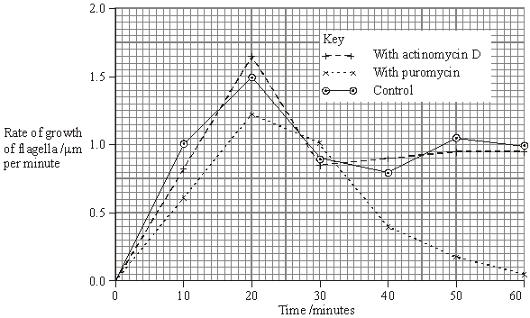

(i)      Describe how the rate of growth was affected by puromycin.

.............................................................................................................

.............................................................................................................

.............................................................................................................

.............................................................................................................

**(2)**

(ii)     The researchers concluded

1.       that the cells used mRNA that is already present in the cytoplasm for the regrowth of the flagella;

2.       that some of the regrowth uses protein molecules already present in the cell.

Explain the evidence for each of these conclusions.

1 ..........................................................................................................

.............................................................................................................

.............................................................................................................

.............................................................................................................

2 ..........................................................................................................

.............................................................................................................

.............................................................................................................

.............................................................................................................

**(4)**

**(Total 11 marks)**

**Q4.**          The diagram shows the stages in one cycle that results in movement of an actin filament in a muscle sarcomere.

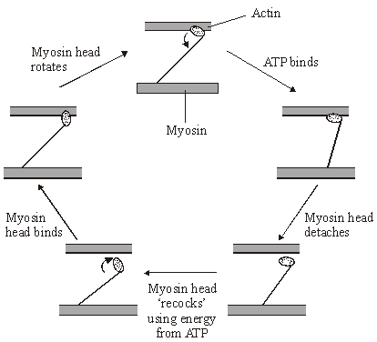

(a)     Describe how stimulation of a muscle by a nerve impulse starts the cycle shown in the diagram.

......................................................................................................................

......................................................................................................................

......................................................................................................................

......................................................................................................................

......................................................................................................................

......................................................................................................................

**(3)**

(b)     Each cycle requires hydrolysis of one molecule of ATP and moves one actin filament 40  nm. During contraction of a muscle sarcomere, a single actin filament moves 0.6 µm. Calculate how many molecules of ATP are required to produce this movement.

Answer ................................................................

**(2)**

(c)     After death, cross bridges between actin and myosin remain firmly bound resulting in rigor mortis. Using information in the diagram, explain what causes the cross bridges to remain firmly bound.

......................................................................................................................

......................................................................................................................

......................................................................................................................

......................................................................................................................

**(2)**

**(Total 7 marks)**

**M1.**(a)     1.      How to break open cells and remove debris;

2.      Solution is cold / isotonic / buffered;

3.      Second pellet is chloroplast.

**3**

(b)     1.      **A** stroma;

2.      **B** granum.

*Accept thylakoid*

**2**

(c)      μm

**1**

(d)     **Two** of the following for **one** mark:

Mitochondrion / ribosome / endoplasmic reticulum / lysosome / cell-surface membrane.

**1 max**

**[7]**

**M2.**(a)     Straight lines point to point as not possible to predict intermediate values / values between points;

**1**

(b)     Increases then levels / falls;  
Maximum antibody production 180 units / at dose of 0.25 g per kg;

**2**

(c)     Two marks for correct answer of 57.14 / 57.1;;  
One mark for incorrect answer in which candidate clearly divides difference in antibody production / 60 by 105;

**2**

(d)     Takes into account different masses of mice / allows comparison;

*Accept different weights of mice.  
Do not accept different size.*

**1**

(e)     Sheep red blood cells have antigens (on their surface);  
Antigens are proteins foreign to mice / are non-self;  
Stimulate B cells to produce antibodies;

**3**

(f)     Response only observed in mice;  
Disease organisms not investigated;  
Not all disease caused by pathogens / cured by antibodies;

*i.e. not tested on humans*

**2 max**

**[11]**

**M3.**         (a)     chloroplast, so cell photosynthesises and moves to optimum / best light intensity for photosynthesis;  
avoids damage due to bright light;

**2**

(b)     (i)      2700

**1**

(ii)      = 27 225 000 / 27 × 106 = *2 marks*

*(allow 1 mark for principle: )*

**2**

(c)     (i)      rate slightly slower / not affected in first 20 / 30 minutes / lower  
peak than control;  
then decreases / much lower (than control);

*(allow 1 mark for increase in first 20 / 30 minutes, then decreased, if not compared with control / normal)*

*(disqualify flagellum grows longer)*

**2**

(ii)     1.       actinomycin has no effect (on growth of flagella);  
          even though mRNA production / transcription prevented;

*(accept references to ‘expt 1’)*

2.       (re)growth little affected by puromycin at first;  
protein synthesis inhibited, so likely to be using proteins  
present;

**4**

**[11]**

**M4.**          (a)     calcium ions;  
bind to / displace tropomysin; *(allow troponin)*reveal binding site on actin;  
myosin binds to exposed sites on actin / actomyosin formed /   
cross bridges form between actin and myosin;  
activates ATPase;

**3 max**

(b)     distance single actin filament moves divided by distance moved  
using 1 ATP;  
15 ATP;

**2**

(c)     respiration stops / no ATP produced;  
ATP required for separation of actin and myosin / cross bridges;

**2**

**[7]**

**E2.**(a)     Relatively few candidates appeared to be aware that points on a graph should be joined with straight lines if it is felt that the position of intermediate points cannot be predicted reliably. Given that this decision had been made by candidates in drawing their graphs in stage 2, this was somewhat surprising.

(b)     Although many candidates were able to describe how the curve rose to a maximum value at 180 units or a dose of 0.25 g per kg, a significant number missed the point plotted for a zero dose. Other candidates misread the second point as representing a dose of 0.5 g per kg.

(c)     It remains disappointing that so few candidates can calculate percentage increase or decrease. There were many incorrect answers to this question, frequently from otherwise sound candidates.

(d)     Most candidates appeared to appreciate that calculating the dose per unit mass allowed differences in mass to be considered and a comparison to be made. Many responses, however, failed to gain credit because of the vague use of terms such as “bigger mice” and “size” rather than mass.

(e)     It would appear that some candidates had been taught about the immune response in much greater detail than required by the specification. This additional detail tended to confuse rather than help the candidates and reduced their marks for this question. It was relatively uncommon to see three marks awarded for what should have been a straightforward account. Common errors made by less able candidates involved the confusion of antibody and antigen or failing to identify the antigens as being on the surface of the sheep red blood cells.

(f)     Most candidates correctly pointed out that this investigation was carried out on mice and, therefore, the results might not apply to humans but only the better candidates were able to suggest a second valid reason.

**E3.**          (a)     Although more demanding than the others, it was pleasing to find that many candidates performed well on this question, and that a considerable number gained at least 6 or 7 marks. In particular, an encouraging number managed to get to grips with part (c).

Surprisingly, this was rather poorly answered by many candidates. Often this was because they failed to use the diagram, and, for example, quite often the presence of the chloroplast was not related to photosynthesis. Very few suggested that the movements might position the cells in the optimum light intensity for photosynthesis. The commonest suggestion was that moving away from very bright light would avoid damage, more often to the eyespot than the chlorophyll. Some equated bright light with heat and suggested it would denature enzymes. Others were sidetracked into accounts of avoiding predators or referred to physiological processes that could not be seen in the diagram. Quite a few suggested that bright light was avoided so that the cells would not make too much starch or sugar and burst.

(b)     (i)      This proved more discriminating than expected, and only the better candidates simply multiplied the 900 amino acids by three.

(ii)     There was a good proportion of correct answers, and many more made a sufficiently sensible attempt to gain a mark for the principle. Some gave a figure for two flagella, rather than for each flagellum, and others made errors with the number of zeros or the indices.

(c)     (i)      A good proportion of candidates gained both marks for this part, but quite a large number failed to compare the results for puromycin with those for the control. The latter group simply described the curve for puromycin. Some weaker candidates misinterpreted the graph and stated that the flagella stopped growing longer after 20 minutes.

(ii)     This question was targeted at the more able candidates and the examiners were looking for a precise explanation of the evidence. It was, however, pleasing to note that large numbers of candidates were able to make the links between transcription and mRNA production and between translation and protein synthesis. Better candidates did point out that actinomycin D had no significant effect on regrowth of the flagella and that therefore the cells must be using existing mRNA. Fewer specified that the rate of regrowth declined after about 20 minutes in the presence of puromycin, so only some of the regrowth could be attributed to proteins already present in the cells.

**E4.**          This question was well answered.

(a)     Even the weakest candidates realised that calcium ions were involved, and the majority were able to explain fully the changes which occur before actin is able to bind with myosin.

(b)     Many candidates gained full marks. The most common errors related to the inability to convert ìm to nm. A significant number did not attempt to answer the question.

(c)     Many candidates scored full marks. A significant number did not read the question carefully enough and wrote about the role of ATP in the recocking of the myosin head.