**Q1.**(a)     Describe and explain how the countercurrent system leads to efficient gas exchange across the gills of a fish.

........................................................................................................................

........................................................................................................................

........................................................................................................................

........................................................................................................................

........................................................................................................................

........................................................................................................................

*(Extra space)* .................................................................................................

........................................................................................................................

........................................................................................................................

**(3)**

(b)     Amoebic gill disease (AGD) is caused by a parasite that lives on the gills of some species of fish. The disease causes the lamellae to become thicker and to fuse together.

AGD reduces the efficiency of gas exchange in fish. Give **two** reasons why.

1 .....................................................................................................................

........................................................................................................................

2 .....................................................................................................................

........................................................................................................................

**(2)**

(c)     The table below shows some features of gas exchange of a fish at rest.

|  |  |  |
| --- | --- | --- |
|  | Volume of oxygen absorbed by the gills from each dm3 of water / cm3 | 7 |
|  | Mass of fish / kg | 0.4 |
|  | Oxygen required by fish / cm3 kg–1 hour–1 | 90 |

(i)      Calculate the volume of water that would have to pass over the gills each hour to supply the oxygen required by the fish. Show your working.

.......................................................... dm3

**(2)**

(ii)     The volume of water passing over the gills increases if the temperature of the water increases. Suggest why.

...............................................................................................................

...............................................................................................................

...............................................................................................................

**(1)**

**(Total 8 marks)**

**Q2.**          (a)     The diagram represents the flow of water and blood through the gills of a fish. The figures give relative oxygen concentrations.

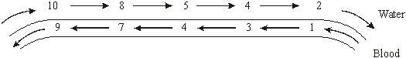

Use the information in diagram to explain the advantage of the countercurrent flow.

......................................................................................................................

......................................................................................................................

......................................................................................................................

......................................................................................................................

......................................................................................................................

**(2)**

(b)     In the ventilation cycle of a fish, water enters the mouth cavity and then passes through the gills into the opercular cavity. The graph shows the difference in pressure between the mouth cavity and the opercular cavity.

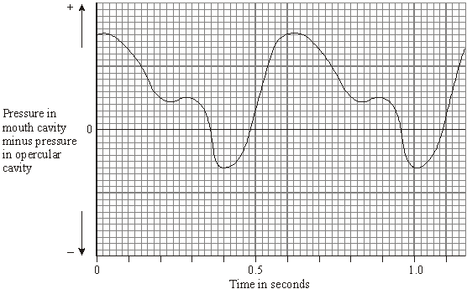

Calculate the number of ventilation cycles per minute of the fish. Show your working.

Answer ......................................

**(2)**

**(Total 4 marks)**

(b)     Name the phase during which DNA replication occurs.

......................................................................................................................

**(1)**

(c)     Bone marrow cells divide rapidly. As a result of a mutation during DNA replication, a bone marrow cell may become a cancer cell and start to divide in an uncontrolled way. A chemotherapy drug that kills cells when they are dividing was given to a cancer patient. It was given once every three weeks, starting at time 0. The graph shows the changes in the number of healthy bone marrow cells and cancer cells during twelve weeks of treatment.

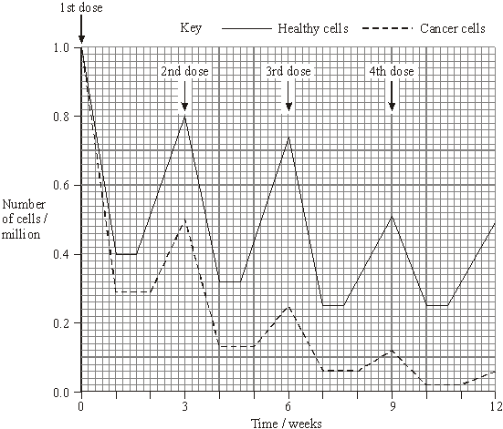

(i)      Using the graph calculate the number of cancer cells present at week 12 as a percentage of the original number of cancer cells. Show your working.

Answer ......................................%

**(2)**

(ii)     Suggest **one** reason for the lower number of cancer cells compared to healthy cells at the end of the first week.

.............................................................................................................

**(1)**

(iii)     Describe **two** differences in the effect of the drug on the cancer cells, compared with healthy cells in the following weeks.

1 ..........................................................................................................

.............................................................................................................

2 ..........................................................................................................

.............................................................................................................

**(2)**

**(Total 8 marks)**

**Q4.**          (a)     The table shows some data for a shrew and an elephant.

|  |  |  |  |
| --- | --- | --- | --- |
|  |  | **Shrew** | **Elephant** |
|  | **Body mass** | 10 g | 5000 kg |
|  | **Volume of oxygen taken up per hour** | 20 cm3 | 52.5 dm3 |

The rate of oxygen uptake for the shrew is 2 cm3g–1h–1. Calculate the volume of oxygen taken up per gram of body tissue per hour in the elephant.  
Show your working.

Answer ................................... cm3g–1h–1

**(2)**

(b)     The graph shows the oxyhaemoglobin dissociation curves for these mammals.

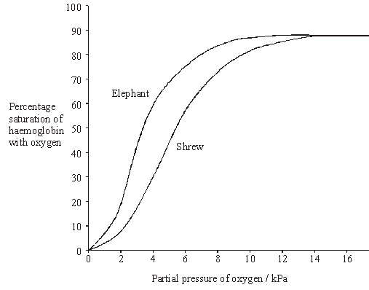

The tissues of the shrew have a higher rate of oxygen consumption per gram of body tissue than the elephant. There is an advantage to the shrew in having haemoglobin with a dissociation curve in the position shown. Explain this advantage.

......................................................................................................................

......................................................................................................................

......................................................................................................................

......................................................................................................................

......................................................................................................................

......................................................................................................................

**(3)**

**(Total 5 marks)**

**Q5.**A student investigated the rate of anaerobic respiration in yeast. She put 5 g of yeast into a glucose solution and placed this mixture in the apparatus shown in the figure below.  
She then recorded the total volume of gas collected every 10 minutes for 1 hour.

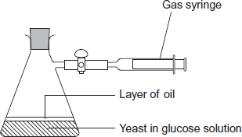

(a)     Explain why a layer of oil is required in this investigation.

........................................................................................................................

........................................................................................................................

**(1)**

(b)     The student’s results are shown in the following table.

|  |  |  |
| --- | --- | --- |
|  | **Time / minutes** | **Total volume of gas collected / cm3** |
|  | 10 | 0.3 |
|  | 20 | 0.9 |
|  | 30 | 1.9 |
|  | 40 | 3.1 |
|  | 50 | 5.0 |
|  | 60 | 5.2 |

(i)      Calculate the rate of gas production in cm3 g–1 min–1 during the first 40 minutes of this investigation. Show your working.

Answer = ................... cm3 g–1 min–1

**(2)**

(ii)     Suggest why the rate of gas production decreased between 50 and 60 minutes.

...............................................................................................................

...............................................................................................................

**(1)**

(iii)    Yeast can also respire aerobically. The student repeated the investigation with a fresh sample of yeast in glucose solution, but without the oil. All other conditions remained the same.  
Explain what would happen to the volume of gas in the syringe if the yeast were only respiring aerobically.

...............................................................................................................

...............................................................................................................

...............................................................................................................

...............................................................................................................

**(2)**

(c)     Respiration produces more ATP per molecule of glucose in the presence of oxygen than it does when oxygen is absent. Explain why.

........................................................................................................................

........................................................................................................................

........................................................................................................................

........................................................................................................................

**(2)**

**(Total 8 marks)**

**Q6.**Doctors investigated the effect of the smoking habits of men on their non-smoking wives.

The doctors recruited 540 non-smoking women aged 40 or older. They divided these women into groups according to the smoking habits of their husbands.  
After 14 years, the doctors recorded how many of the wives had died and their cause of death.

They used these data to determine the relative risk of a wife dying from a particular disease according to her husband’s smoking habit.

In this comparison, they gave the relative risk to the wife of a non-smoker as 1.00. A value greater than 1.00 shows an increased risk compared to the wife of a non-smoker.

The results are shown in the table below.

|  |  |  |  |  |
| --- | --- | --- | --- | --- |
|  | **Cause of death** | **Relative risk of wife dying** | | |
|  | **Husband non-smoker** | **Husband smokes 1 to 19 cigarettes /day** | **Husband smokes more than 19 cigarettes / day** |
|  | Lung cancer | 1.00 | 1.61 | 2.08 |
|  | Emphysema | 1.00 | 1.29 | 1.49 |
|  | Cervical cancer | 1.00 | 1.15 | 1.14 |
|  | Stomach cancer | 1.00 | 1.02 | 0.99 |
|  | Heart disease | 1.00 | 0.97 | 1.03 |

A journalist concluded from these data that if a husband smoked, it greatly increased the risk of his wife dying of certain diseases. Evaluate this statement.

..................................................................................................................................

..................................................................................................................................

..................................................................................................................................

..................................................................................................................................

..................................................................................................................................

..................................................................................................................................

..................................................................................................................................

..................................................................................................................................

*(Extra space)* ...........................................................................................................

..................................................................................................................................

..................................................................................................................................

..................................................................................................................................

**(Total 4 marks)**

**Q7.**Omega-3 fatty acids are found in cows’ milk. Scientists investigated changes in the concentration of omega-3 fatty acids in milk when cows were moved from eating grass in fields to eating corn in cattle sheds. The following figure shows the results of one investigation.

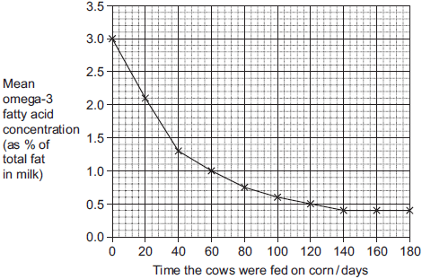

(a)     The concentration of omega-3 fatty acids in milk changed when cows were fed on corn instead of grass. Describe how.

........................................................................................................................

........................................................................................................................

........................................................................................................................

........................................................................................................................

**2)**

(b)     (i)      Calculate the rate of decrease in the mean omega-3 fatty acid concentration between 0 and 40 days.  
Show your working.

Answer.......................................................% per day

**(2)**

(ii)     The omega-3 fatty acid concentration is expressed as a percentage of total fat.  
Explain the advantage of this.

...............................................................................................................

...............................................................................................................

...............................................................................................................

...............................................................................................................

**(2)**

(iii)    One farmer concluded from the graph that feeding cows on corn reduces the omega-3 fatty acid content in milk. Evaluate this conclusion.

...............................................................................................................

...............................................................................................................

...............................................................................................................

...............................................................................................................

...............................................................................................................

...............................................................................................................

...............................................................................................................

...............................................................................................................

Extra space ...........................................................................................

...............................................................................................................

...............................................................................................................

...............................................................................................................

**(4)**

**(Total 10 marks)**

**Q8.**Triglycerides are taken into the body as part of a balanced diet. These triglycerides contain fatty acids including omega-3 fatty acids. It has been discovered that omega-3 fatty acids are associated with health benefits. The benefits include faster development of nerve cells and clearer vision. Omega-3 fatty acids are also associated with protection from heart disease, arthritis and cancer.

The following figure shows how omega-3 and other fatty acids are taken in and used by the bodies of animals including humans.

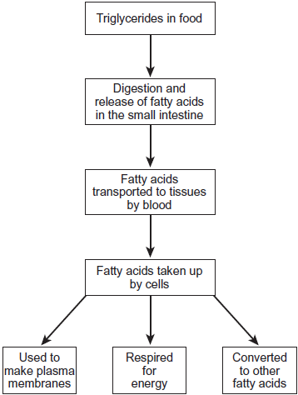

Use the information in the figure to explain **two** ways in which fatty acids are important in the formation of new cells.

1. .............................................................................................................................

.................................................................................................................................

.................................................................................................................................

.................................................................................................................................

2. .............................................................................................................................

.................................................................................................................................

.................................................................................................................................

........................................................................................................................**(Total 4 marks)**

**M1.**(a)     1.      Water and blood flow in opposite directions;

*Accept: diagram if clearly annotated*

2.      Maintains concentration / diffusion gradient / equilibrium not reached / water always next to blood with a lower concentration of oxygen;

*Must have the idea of ‘maintaining’ or ‘always’ in reference to concentration / diffusion gradient*

*Accept: constant concentration / diffusion gradient*

3.      Along whole / length of gill / lamellae;

*Accept: gill plate / gill filament*

**3**

(b)     1.      (Thicker lamellae so) greater / longer diffusion distance / pathway;

***Q*** *Neutral: ‘thicker’ diffusion pathway*

2.      (Lamellae fuse so) reduced surface area;

*Accept: reduced SA:VOL*

**2**

(c)     (i)      Correct answer of **5.1** or **5.14(2857)** (dm3) = 2 marks;;

*Allow 1 mark max for an answer of* ***5*** *if the correct answer of* ***5.1*** *or* ***5.14(2857)*** *is* ***not*** *shown*

One mark for incorrect answers that show **36** or **0.4 × 90** or **90 ÷ 7;**

**2**

(ii)     1.      Increased metabolism / respiration / enzyme activity;

*Accept: enzymes work more efficiently*

2.      Less oxygen (dissolved in water);

*Neutral: references to increased kinetic energy (of water molecules)*

**1 max**

**[8]**

**M2.**          (a)     (diffusion) gradient will be maintained all the way along the gill / the amount of oxygen in the water is always higher than in the blood / the numbers in the water are always higher than in the blood;  
more oxygen will diffuse into the blood;

**2**

(b)     100 cycles per minute;

*(principle of 60 / x or 0.6 seen gains one mark)*

**2**

**[4]**

**M3.**          (a)     (i)      (D) B E A C;

**1**

(ii)     metaphase;

**1**

(b)     interphase / S phase;

**1**

(c)     (i)      0.06 × 100;  
6(%);

*(correct answer 2 marks)*

**2**

(ii)     more(cancer cells) killed, cancer cells divide more (often)  
(so are more likely to be killed, more susceptible);

**1**

(iii)     longer time to recover;  
reduced rate of mitosis / divide more slowly /   
increased doubling time;

**2**

**[8]**

**M4.**          (a)     0.01 / 0.0105;

*(allow 1 mark for 52 500 / 5 000 000)*

**2**

(b)     (at the tissues at low pp oxygen) the shrew’s haemoglobin is less  
saturated with oxygen / has reduced affinity;  
oxyhaemoglobin dissociates more readily / haemoglobin releases  
oxygen more readily / more oxygen released;  
allowing greater demand / respiration rate;

**3**

**[5]**

**M5.**(a)     Prevents oxygen being taken up / entering / being absorbed;

*Accept: any idea of no contact with oxygen.*

*Neutral: for anaerobic respiration / anaerobic conditions.*

*Neutral: prevents entry of air.*

*Reject: prevents entry of oxygen and another named gas.*

**1**

(b)     (i)      0.0155 / 0.016 = 2 marks;;

0.0775 / 0.077 / 0.078 / 0.08 = 1 mark

/ 0.62 = 1 mark

**2**

(ii)     Glucose decreases / is a limiting factor / increase in ethanol / yeast / cells die / toxins build up;

*Accept: glucose is used up.*

**1**

(iii)    1.      (Stays the) same / level / (relatively) constant;

2.      Same volume / amount of oxygen uptake and carbon dioxide release;

*Note: if m.p.1 is awarded m.p 2 can be obtained without referring to ‘same volume / amount’.*

**2**

(c)     1.      Oxygen is final / terminal (electron) acceptor / oxygen combines with electrons and protons;

2.      Oxidative phosphorylation / electron transport chain provides (most) ATP / only glycolysis occurs without oxygen / no Krebs / no link reaction;

**2**

**[8]**

**M6.**FOR

1.      (If the husband smokes) there’s a greater risk of dying from lung cancer / emphysema / cervical cancer;

2.      The more the husband smokes, the greater the risk of dying from lung cancer / emphysema;

3.      Suitable use of figures from the table to illustrate answer;

AGAINST

4.      Little difference in risk of dying of stomach / heart disease;

5.      Other factor (than husband smoking) / named factor might cause death;

6.      Only one sample / further studies needed;

**4 max**

**[4]**

**M7.**(a)     (Omega-3 concentration) falls more rapidly at first;  
Levels out at 140 days / concentration of 0.4%;

**2**

(b)     (i)      Two marks for correct answer of 0.04 or 0.043;;

One mark for incorrect answer which clearly identifies total fall of 1.7;

**2**

(ii)     To take into account variation in fat content of milk / fat content varies from cow to cow;  
Allows comparison;

**2**

(iii)    The graph shows a decrease with time feeding on corn;  
No control group;  
Might have fallen anyway / might decrease with time rather than with time spend feeding on corn;  
Other factors / other named factor might also have changed;  
Only one investigation so might not be representative;

**4 max**

**[10]**

**M8.**Fatty acids used to make phospholipids;  
Phospholipids in membranes;  
More phospholipids more membranes made;

**2 max**

Fatty acids respired to release energy;  
More triglycerides more energy released;  
Energy used for cell production / production of named cell component;

*Do not allow credit for ‘making’ energy*

**2 max**

**[4]**

**M9.**(a)     1.      Carbohydrate / sugar / named carbohydrate;

2.      Minerals / named mineral ion;

*Accept alternatives for mineral such as inorganic substances / ions. Accept symbol for ion. Accept incorrect symbols providing that answers are not ambiguous.*

3.      Amino acids / protein;

4.      Vitamins;

**2 max**

(b)     1.      Shake / stir / mix;

2.      Even distribution of yeast / cells;

*Accept other terms with a similar meaning for both points*

**2**

(c)     Two marks for correct answer of 20 / 20.2 / 20.22;;

One mark for incorrect answer in which student clearly shows increase as 8.912 – 7.413 or as 1.499;

*Ignore references to 106*

**2**

(d)     1.      More competition;

2.      Less oxygen;

3.      Less glucose / sugar / carbohydrate / respiratory substrate;

4.      Ethanol / alcohol becomes toxic / inhibits respiration / inhibits reproduction;

5.      Fall in pH;

**2 max**

**[8]**

**E1.**Parts (a), (b) and (c)(i) proved to be good discriminators.

(a)     60% of students scored at least two marks. This was usually for appreciating that water and blood flow in opposite directions to maintain a concentration or diffusion gradient. However, relatively few students mentioned that this occurs along the whole length of the gill. Those who scored zero often gave an account of how the gills are adapted for efficient gas exchange, or did not convey the importance of *maintaining* a concentration or diffusion gradient. There were also some lengthy descriptions of ventilation in fish. It should be noted that this topic is not included in the specification content for BIOL2.

(b)     70% of students scored full marks for linking thicker lamellae to a greater diffusion distance and the fusion of lamellae to a reduced surface area. However, some failed to pick up a second mark due to a lack of precision; for example, ‘less diffusion occurs’ and ‘the diffusion pathway is thicker’.

(c)    (i)      A third of students obtained the correct answer of **5.14** and scored both marks outright. However, many students obtained the principle mark for showing 90 × 0.4 or 90 ÷ 7 in their method.

(ii)     Very few students obtained the marks by suggesting that an increase in the temperature of the water would increase the fish’s metabolism, or rate of respiration, or cause less oxygen to dissolve in the water. The majority of students referred to an increase in kinetic energy, or that water molecules would be moving faster.

**E2.**          There were mixed responses to this question on ventilation in fish.

(a)     Few candidates gained full marks. Many of them simply stated that the diffusion gradient was maintained, or failed to appreciate that the fish obtain more oxygen.

(b)     Many candidates gained two marks for the number of ventilation cycles in a minute. The most common mistake was 2 cycles per minute.

**E3.**          This proved to be a discriminating question with only the very best candidates gaining maximum marks.

(a)     Only very weak candidates failed to gain both marks.

(b)     A specification term well answered.

(c)     A small number of candidates could not read the figure from the graph, 0.6 being the most common error. As in the past, some students did not know to calculate the percentage. This inability did not necessarily correlate to the performance on the rest of the paper. Parts (ii) and (iii) were often answered very superficially, in terms of more cells being killed, without reference to the stem of the question or any interpretation of information given in the graph.

**E4.**          (a)     Many candidates obtained the correct answer and were awarded both marking points. The problems encountered by the others usually involved converting the units. Most had the right numbers but the decimal point was in the wrong place in nearly half of them. A small proportion of candidates reversed numerator and denominator.

(b)     Most candidates were on the right lines here but few expressed themselves well enough to get all three marks. There were many poorly expressed answers which often failed to make the necessary comparative statement. Shrews living at high altitudes and flying shrews featured in a number of scripts as did the Bohr shift, despite the information given. Generally candidates understood the principle but experienced difficulties expressing it.

          It is worth noting that the better candidates usually produced succinct answers which gained all three marks.

**E5.**(a)    Almost three out of four students appreciated that the layer of oil prevented the entry of oxygen. Answers which simply stated that this layer prevented aerobic respiration taking place were not credited as this was not considered to be a full explanation.

(b)    (i)      Only a third of students provided a fully correct answer for two marks. Approximately 20% of students gained one mark for carrying out a partially correct calculation, which did not include the step of dividing by five to obtain the rate per gram. Other errors included adding together the four volumes of gas at 10, 20, 30 and 40 minutes before the total was divided by 40, or students noted the volume of gas of 0.3 cm3 produced at 10 minutes and subtracted this from the 3.1 cm3 produced after 40 minutes, before any division was attempted.

(ii)     The majority of students gained this mark by stating that glucose was decreasing in the flask. The increase in ethanol killing the yeast cells was also often stated. Incorrect responses usually referred to lack of oxygen or, less often, the yeast being used up.

(iii)    Approximately one out of every three students gained both marks by stating that the oxygen used was equal to the carbon dioxide produced and that the volume in the syringe would remain the same. However, not all students explained why the volume would remain the same and were awarded one mark. Invariably, students who stated that the volume would change, by either increasing or decreasing, scored zero.

(c)     Many students gained one mark for stating that only glycolysis would occur in the absence of oxygen. Three out of every five students then explained the specific role of oxygen in the electron transport system, or described where ATP is produced in aerobic respiration. Some responses gave a full, detailed account of the Krebs cycle, electron transport chain and how ATP is produced. These answers often required additional pages.

**E6.**Students did not score highly on this question. They often failed to interpret the question and use the data appropriately. Few students quoted correct figures and many failed to realise that the figures for stomach cancer and heart disease showed little difference. Many wrote in terms of contracting the disease rather than dying from it, as referred to in the resource. Others vaguely referred to ‘certain diseases’ and therefore failed to gain credit. In many cases, students simply repeated answers they had learned from past papers. These answers often gained one mark for referring to the idea that other factors are involved.

**E7.**(a)     Many centres gave credit to descriptions which only indicated that the omega-3 concentration fell but made no reference to the rapidity of fall. Similarly credit was given to any answer which stated that the concentration reached 0.4% at 140 days, even if there was no mention of the concentration levelling out.

(b)     (i)      The calculation was carried out correctly by many, and two marks were scored. A large number gained one mark for correctly identifying a fall of 1.7.

(ii)     It was rare to see more than one mark awarded. This was almost universally for the idea of being able to make comparisons between the cattle or milk. Often any reference to a comparison was awarded credit.

(iii)    A large majority of candidates recognised that the graph showed the omega-3 concentration decreasing with time. A variety of suggestions was offered to account for the decrease, but few suggested that the concentration might have fallen anyway.

**E8.**Some excellent responses were seen. Candidates were able to establish a link between fatty acids and the phospholipid content of the membranes. Many candidates were aware that fatty acids could be respired and the energy released could be used appropriately. Some centres awarded credit when responses indicated that energy was for respiration or when energy was made during respiration. It was rare to see any evidence of the third marking point.