**Q1.**(a)     Describe how you could use cell fractionation to isolate chloroplasts from leaf tissue.

........................................................................................................................

........................................................................................................................

........................................................................................................................

........................................................................................................................

........................................................................................................................

........................................................................................................................

**(Extra space)** .................................................................................................

........................................................................................................................

**(3)**

The figure below shows a photograph of a chloroplast taken with an electron microscope.

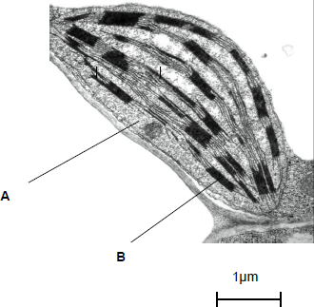

© Science Photo Library

(b)     Name the parts of the chloroplast labelled **A** and **B**.

Name of **A** .....................................................................................................

Name of **B** .....................................................................................................

**(2)**

(c)     Calculate the length of the chloroplast shown in the figure above.

Answer ................................................

**(1)**

(d)     Name **two** structures in a eukaryotic cell that **cannot** be identified using an optical microscope.

1 .....................................................................................................................

2 .....................................................................................................................

**(1)**

**(Total 7 marks)**

**Q2.**Different extracts may be added to milk to make cheese. All of these extracts contain chymosin.

•        Animal rennet comes from calves and lambs. Rennet from these young animals contains between 80 and 95% chymosin. It also contains between 5 and 20% of another protein-digesting enzyme called pepsin.

•        Vegetarian rennet comes from fungi. It contains 100% chymosin.

•        Recombinant chymosin comes from bacteria which have had an animal gene for chymosin inserted in them. It contains 100% chymosin.

Scientists investigated the effect of temperature on the time these different extracts took to coagulate milk. Their results are shown below.

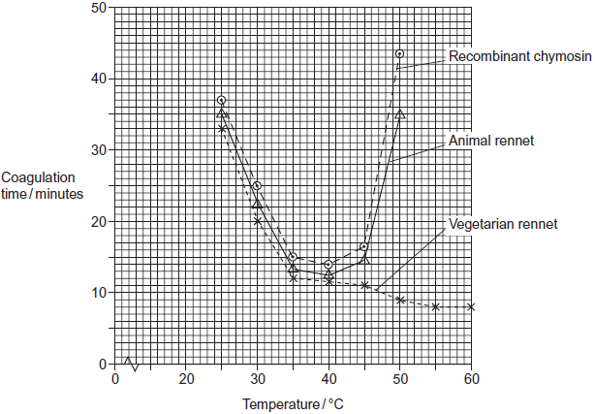

(a)     Suggest **two** disadvantages of using animal rennet rather than recombinant chymosin as a source of chymosin for making cheese.

1 .....................................................................................................................

........................................................................................................................

2 .....................................................................................................................

........................................................................................................................

**(2)**

(b)     The shape of the curve for recombinant chymosin is similar to the shape of the curve for animal rennet. Suggest why.

........................................................................................................................

........................................................................................................................

........................................................................................................................

**(1)**

(c)     (i)      Describe how the coagulation time for vegetarian rennet is different from that for animal rennet.

...............................................................................................................

...............................................................................................................

...............................................................................................................

**(1)**

(ii)     Calculate the percentage reduction in coagulation time between 45 °C and 60 °C for vegetarian rennet. Show your working.

Answer ....................................................%

**(2)**

(d)     Explain the shape of the curve for animal rennet above 45 °C.

........................................................................................................................

........................................................................................................................

........................................................................................................................

........................................................................................................................

........................................................................................................................

........................................................................................................................

(Extra space) .................................................................................................

........................................................................................................................

........................................................................................................................

**(3)**

**(Total 9 marks)**

**Q3.**The body markings of cheetahs vary, in particular the pattern of bands on their tails. Cheetahs are solitary animals but the young stay with their mother until they are between 14 and 18 months old.

Scientists investigated the banding pattern on the tails of cheetahs living in the wild.

•        They drove a car alongside a walking cheetah and used binoculars to study the tail pattern.

•        They gave each cheetah a banding pattern score based on the width of the dark and light bands on the end of the tail.

•        They scored the width of the bands on the right and left side of the tail using a 5 point scale of width.

A typical pattern on the right side of one cheetah’s tail is shown in **Figure 1**.

**Figure 1**

|  |  |  |  |  |  |  |  |
| --- | --- | --- | --- | --- | --- | --- | --- |
|  | Band number | 1 | 2  3 | 4 | 5 | 6 | 7 |



|  |  |  |  |  |  |  |  |
| --- | --- | --- | --- | --- | --- | --- | --- |
|  | Band width score | 3 | 1  1 | 4 | 3 | 3 | 3 |

The scientists collected data from each cheetah on four separate occasions. **Figure 2** shows the data for one of the cheetahs.

**Figure 2**

|  |  |  |  |  |  |  |  |  |
| --- | --- | --- | --- | --- | --- | --- | --- | --- |
|  | **Side of tail** | **Mean band width score (± standard deviation)** | | | | | | |
|  | **Band 1** | **Band 2** | **Band 3** | **Band 4** | **Band 5** | **Band 6** | **Band 7** |
|  | Right | 3.00  (± 0.82) | 1.00  (± 0.00) | 1.00  (± 0.00) | 3.75  (± 0.50) | 2.75  (± 0.50) | 3.00  (± 0.00) | 3.00  (± 0.00) |
|  | Left | 3.75  (± 0.50) | 3.25  (± 0.50) | 2.00  (± 0.50) | 3.00  (± 0.00) | 2.00  (± 0.00) | 2.50  (± 0.50) | 3.00  (± 0.50) |

(a)     The scientists only used data from cheetahs which were fully grown. Suggest why.

........................................................................................................................

........................................................................................................................

**(1)**

(b)     The scientists estimated the width of the bands on the same cheetah on four separate occasions. They did not always get the same score.

(i)      Give **two** pieces of evidence from **Figure 2** which show that the scientists sometimes obtained different scores for the same band.

1 ............................................................................................................

...............................................................................................................

2 ............................................................................................................

...............................................................................................................

**(2)**

(ii)     The method the scientists used resulted in them getting different scores for the same band. Suggest why.

...............................................................................................................

...............................................................................................................

**(1)**

(c)     What is the evidence from **Figure 2** that the dark and light bands do **not** form rings of equal width around the tail?

........................................................................................................................

........................................................................................................................

**(1)**

(d)     The scientists found the difference in banding pattern between

•        offspring in the same family

•        cheetahs chosen randomly.

Explain how scientists could use this information to show that some variation in tail banding was genetic.

........................................................................................................................

........................................................................................................................

........................................................................................................................

........................................................................................................................

........................................................................................................................

........................................................................................................................

(Extra space) .................................................................................................

........................................................................................................................

........................................................................................................................

**(3)**

**(Total 8 marks)**

**Q4.**Scientists investigated the effect of lipase and a 3% bile salts solution on the digestion of triglycerides. The graph below shows their results.

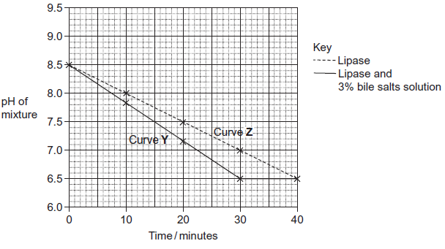

(a)     Describe what curve **Y** shows about the effect of lipase and bile salts on the pH of the mixture.

.........................................................................................................................

.........................................................................................................................

.........................................................................................................................

.........................................................................................................................

.........................................................................................................................

**(2)**

(b)     The concentration of lipase did not change during the course of the investigation.  
Explain why.

.........................................................................................................................

.........................................................................................................................

.........................................................................................................................

**(1)**

(c)     One of the scientists decided to repeat the investigation at a temperature 10°C below the original temperature.  
Describe how you would expect his plotted curve to be different from curve **Z**.

.........................................................................................................................

.........................................................................................................................

**(1)**

**(Total 4 marks)**

**Q5.**          (a)     A plant cell was observed with an optical microscope. Describe how the length of the cell could be estimated.

......................................................................................................................

......................................................................................................................

......................................................................................................................

......................................................................................................................

**(2)**

(b)     The water potential of a plant cell is –400 kPa. The cell is put in a solution with a water potential of –650 kPa. Describe and explain what will happen to the cell.

......................................................................................................................

......................................................................................................................

......................................................................................................................

......................................................................................................................

......................................................................................................................

......................................................................................................................

**(3)**

(c)     A group of students investigated the effect of sucrose concentration on the change in length of cylinders of tissue cut from a young carrot. They measured the initial lengths of the carrot cylinders, then placed one in each of a number of sucrose solutions. After 18 hours, they removed the carrot cylinders and measured their final lengths. Some of the results are shown in the table.

|  |  |  |
| --- | --- | --- |
|  | **Concentration of sucrose / mol dm–3** | **Percentage decrease in length of carrot cylinder** |
|  | 0.4 | 4.2 |
|  | 0.5 | 8.7 |
|  | 0.6 | 13.0 |
|  | 0.7 | 16.8 |
|  | 0.8 | 18.1 |
|  | 0.9 | 18.1 |
|  | 1.0 | 18.1 |

(i)      The carrot cylinders were left for 18 hours in the sucrose solutions. Explain why they were left for a long time..............................................................................................................

.............................................................................................................

**(1)**

(ii)     Explain how you would use a graph to predict the concentration of sucrose that would result in no change in length of the carrot cylinders.

.............................................................................................................

.............................................................................................................

.............................................................................................................

.............................................................................................................

**(2)**

(iii)     Young carrots store sugars in their tissues but, in older carrots, some of this is converted to starch. How would using cylinders of tissue from older carrots affect the results obtained for a sucrose solution of 0.6 mol dm–3? Give a reason for your answer.

.............................................................................................................

.............................................................................................................

.............................................................................................................

.............................................................................................................

**(2)**

**(Total 10 marks)**

**M1.**(a)     1.      How to break open cells and remove debris;

2.      Solution is cold / isotonic / buffered;

3.      Second pellet is chloroplast.

**3**

(b)     1.      **A** stroma;

2.      **B** granum.

*Accept thylakoid*

**2**

(c)      μm

**1**

(d)     **Two** of the following for **one** mark:

Mitochondrion / ribosome / endoplasmic reticulum / lysosome / cell-surface membrane.

**1 max**

**[7]**

**M2.**(a)     (Rennet) has less / variable amount of chymosin;

Limited supply (of rennet) available;

Pepsin may digest curd / protein / has another

protein- digesting enzyme;

(Animal) rennet unacceptable by vegetarians / vegans / against religious beliefs / harms animals;

*Accept use of figures e.g. 80-90% for first mark point.*

**2 max**

(b)     Both contain chymosin / both derived from animal gene;

**1**

(c)     (i)      (Coagulation time) is reduced / is more active;

**1**

(ii)     2 marks for correct answer of 27% / 27.3%;;

1 mark for incorrect answer in which candidate has shown fall in coagulation time as 3 (minutes) or 11 -8;

**2 max**

(d)     1.      (Enzyme) denatured / loss of tertiary structure / hydrogen bonds broken;

2.      Shape of active site changes / no longer complementary;

3.      Less / no substrate binds / fewer / no enzyme-substrate complexes formed;

**3**

**[9]**

**M3.**(a)     Banding pattern changes as cheetah gets older / difficult to judge as tail is short / fluffy;

**1**

(b)     (i)      Mean not (always) a whole number;  
Standard deviation not (always) zero;

**2**

(ii)     Movement of tail / angle of sight / confused it with another band / subjective estimation;

*Accept reference to* ***Figure 1***

*E.g. Bands 2 and 3 have same thickness but look different*

**1**

(c)     Band width not the same on both sides of tail;

**1**

(d)     Offspring of the same family will be more similar genetically;  
As have same mother (and father) / parent;  
Expect to see more differences in randomly chosen cheetahs;

**3**

**[8]**

**M4.**(a)     pH goes down and levels out;  
after 30 min / pH 6.5;

**2**

(b)     Enzyme not used up in reaction;

**1**

(c)     Curve will be less steep:

*Only accept answers relating to curve* ***not*** *rate of reaction*

**1**

**[4]**

**M5.**          (a)     Measure diameter of field with ruler; And proportion taken up by the cell; or Measure length with (eyepiece) graticule / eyepiece scale;  
Calibrated against stage micrometer / something of known length;

*Reject divide apparent length by magnification*

**2**

(b)     Membrane / cytoplasm shrinks / pulls away from cell wall / cell plasmolysed / goes flaccid; Water moves down water potential gradient / to lower / more negative water potential; By osmosis;

**3**

(c)     (i)      Reaches equilibrium / no further / maximum change in length;

*Reject osmosis takes time*

**1**

(ii)     Line / curve of best fit; Extrapolate (and read off) / find where it crosses x-axis;

**2**

(iii)     Greater decrease / length smaller; More water removed;  
Greater difference in water potential / cell with higher / less negative water potential; Starch is insoluble / has no effect on osmosis

**max 2**

**[10]**

**E2.**(a)     Most candidates gained a mark for realising that rennet has less chymosin. Many of these candidates gained the second mark by mentioning the presence of another protein-digesting enzyme in the rennet. There were a few correct references to vegetarians but answers relating to ethical considerations often lacked focus and were too generalised.

(b)     Many candidates failed to gain this mark as their answers suggested that the animal gene was present in chymosin.

(c)     (i)      Candidates had little difficulty gaining this mark, clearly recognising that vegetarian rennet reduces the coagulation time or has greater activity.

(ii)     Approximately 60% of candidates obtained both marks for this calculation. Between 5 to 10% gained one mark for an incorrect answer which indicated that the fall in coagulation time was 3 minutes.

(d)     Although a significant number of candidates gained three marks, this question still provided some discrimination. A large percentage of candidates did not specify which type of bond breaks during denaturation or incorrectly referred to peptide bonds being broken. Similarly, the idea of the shape of the active site being altered was not always evident. Nevertheless, the overall high quality of the answers demonstrated that enzyme activity is generally well understood by most candidates.

**E3.**(a)     There was widespread recognition that tail band width would be likely to change with age.

(b)     In part (a), many candidates lacked the mathematical understanding to appreciate that a mean which had a value with decimal places suggested that measurements of the same band must differ. Likewise, they did not appreciate that a standard deviation with a value other than zero indicated variation in the measurements of the same band. However in part (b), having read the description of the procedure, most recognised that viewing an animal's tail through binoculars from a moving vehicle was likely to give rise to inconsistent data.

(c)     Most candidates correctly used the data about the width of bands from the left and right sides of the tail as evidence that rings of equal width were not found.

(d)     The most frequently awarded mark was for showing an understanding that unrelated animals would be expected to show more variation than animals from the same family. It was less usual to find a link to the idea that members of one family are genetically closely related, or a reference to the animals’ parentage.

**E5.**          (a)     It was apparent from the answers that few candidates were conversant with section 10.1 of the specification which refers to the requirement for practical microscopy including the estimation of size. Most simply measured the image without explaining how, and then used a formula to relate magnification and observed length to real length.

(b)     The answers were generally sound and many of the better candidates correctly related the water potential gradient to osmotic movement from the cell and plasmolysis. There was, however, evidence of less certainty about this topic than has been shown in the past, in particular with the direction of water movement. Candidates are free to discuss values of water potential either in terms of higher and lower values or as being less negative or more negative, respectively. They would be well advised, however, to stay with the same approach throughout. Combining both tends to lead to contradiction and an inevitable failure to gain credit.

(c)     There were few references in part (i) either to achieving equilibrium or to allowing a maximum change in length. Most candidates referred somewhat imprecisely to osmosis taking a long time or being slow. Candidates should be familiar from their practical work with the use of graphs as analytical tools. There was, however, a frequent misconception in part (ii) that the sucrose concentration equating with no change in length was where the curve levelled out, suggesting that many candidates failed to examine the data with sufficient care before attempting the question. What was required here was the drawing of a curve of best fit and extrapolating this to obtain the required value. Candidates found part (iii) difficult especially when they abandoned osmosis in favour of diffusion or hydolysis of starch. However, most candidates were able to gain some credit for recognising that starch was insoluble even if they subsequently failed to link sufficient steps in the reasoning to produce a coherent explanation.