**Q1.**A student investigated an area of moorland where succession was occurring. She used quadrats to measure the percentage cover of plant species, bare ground and surface water every 10 metres along a transect. She also recorded the depth of soil at each quadrat. Her results are shown in the table.

|  |  |  |  |  |  |  |
| --- | --- | --- | --- | --- | --- | --- |
|  |  | **Percentage cover in each quadrat A to E** | | | | |
|  |  | **A** | **B** | **C** | **D** | **E** |
|  | Bog moss | 55 | 40 | 10 | – | – |
|  | Bell heather | – | – | – | 15 | 10 |
|  | Sundew | 10 | 5 | – | – | – |
|  | Ling | – | – | – | 15 | 20 |
|  | Bilberry | – | – | – | 15 | 25 |
|  | Heath grass | – | – | 30 | 10 | 5 |
|  | Soft rush | – | 30 | 20 | 5 | 5 |
|  | Sheep’s fescue | – | – | 25 | 35 | 30 |
|  | Bare ground | 20 | 15 | 10 | 5 | 5 |
|  | Surface water | 15 | 10 | 5 | – | – |
|  | Soil depth / cm | 3.2 | 4.7 | 8.2 | 11.5 | 14.8 |

– Indicates zero percentage cover.

(a)     Explain how these data suggest that succession has occurred from points **A** to **E**  along the transect.

........................................................................................................................

........................................................................................................................

........................................................................................................................

........................................................................................................................

.................................................................................................. ......................

........................................................................................................................

*(Extra space)*.................................................................................................

........................................................................................................................

........................................................................................................................

**(3)**

(b)     The diversity of animal species is higher at **E** than **A**. Explain why.

........................................................................................................................

........................................................................................................................

........................................................................................................................

........................................................................................................................

.................................................................................................. ......................

**(2)**

(c)     The student used the mark-release-recapture technique to estimate the size of the population of sand lizards on an area of moorland. She collected 17 lizards and marked them before releasing them back into the same area. Later, she collected 20 lizards, 10 of which were marked.

(i)      Give **two** conditions for results from mark-release-recapture investigations to be valid.

1.............................................................................................................

...............................................................................................................

2.............................................................................................................

...............................................................................................................

**(2)**

(ii)     Calculate the number of sand lizards on this area of moorland. Show your working.

Answer = .....................................

**(2)**

**(Total 9 marks)**

**Q2.**          (a)     Explain what is meant by the ecological term community

........................................................................................................................

........................................................................................................................

........................................................................................................................

........................................................................................................................

**(1)**

(b)     Scientists investigated the distribution of three species of fish in a lake. They recorded the range of depths where each species was found. The table shows their results.

|  |  |  |
| --- | --- | --- |
|  | **Species of fish** | **Range of depths /m** |
|  | White bass | 0 to 8.4 |
|  | Walleye | 6.8 to 10.0 |
|  | Sauger | 7.2 to 14.6 |

(i)      Use information from the table to give the range of depths at which all three species of fish may be found living together.

                                  Answer ............................................................ m

**(1)**

(ii)     Suggest and explain **one** advantage to the fish of occupying different depths in the lake.

...............................................................................................................

...............................................................................................................

...............................................................................................................

...............................................................................................................

...............................................................................................................

**(2)**

(c)     The graph shows the relationship between the depth and the temperature of the water in the lake.

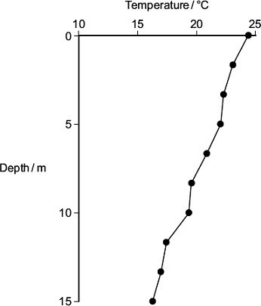

A student concluded that the temperature of the water in the lake determined the depth at which the species of fish were found. Use the table and the graph to evaluate this conclusion.

........................................................................................................................

........................................................................................................................

........................................................................................................................

........................................................................................................................

........................................................................................................................

........................................................................................................................

*(Extra space)* .................................................................................................

........................................................................................................................

........................................................................................................................

**(3)**

**(Total 7 marks)**

**Q3.**Phenylketonuria is a disease caused by mutations of the gene coding for the enzyme PAH. The table shows part of the DNA base sequence coding for PAH. It also shows a mutation of this sequence which leads to the production of non-functioning PAH.

|  |  |  |  |  |  |  |  |  |  |  |  |  |  |
| --- | --- | --- | --- | --- | --- | --- | --- | --- | --- | --- | --- | --- | --- |
|  | DNA base sequence coding for PAH | C | A | G | T | T | C | G | C | T | A | C | G |
|  | DNA base sequence coding for non-functioning PAH | C | A | G | T | T | C | C | C | T | A | C | G |

(a)     (i)      What is the maximum number of amino acids for which this base sequence could code?

   
  
**(1)**

(ii)     Explain how this mutation leads to the formation of non-functioning PAH.

...............................................................................................................

...............................................................................................................

...............................................................................................................

...............................................................................................................

...............................................................................................................

...............................................................................................................

(*Extra space*) ........................................................................................

...............................................................................................................

...............................................................................................................

**(3)**

PAH catalyses a reaction at the start of two enzyme-controlled pathways.  
The diagram shows these pathways.

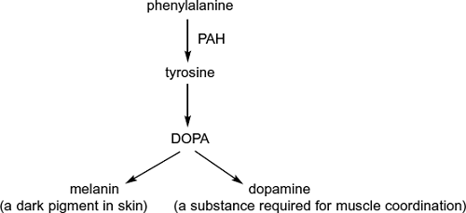

(b)     Use the information in the diagram to give **two** symptoms you might expect to be visible in a person who produces non-functioning PAH.

1 .....................................................................................................................

2 .....................................................................................................................

**(2)**

(c)     One mutation causing phenylketonuria was originally only found in one population in central Asia. It is now found in many different populations across Asia. Suggest how the spread of this mutation may have occurred.

........................................................................................................................

........................................................................................................................

........................................................................................................................

**(1)**

**Q4.**Lettuce growers investigated the best conditions for germinating lettuce seeds. They soaked lettuce seeds for 8 hours in distilled water at different temperatures. They then germinated some of the seeds at 20°C and some at 35°C. The table shows their results.

|  |  |  |  |
| --- | --- | --- | --- |
|  | **Temperature at which seeds were soaked / ºC** | **Percentage of seeds which germinated** | |
|  | **at 20°C** | **at 35°C** |
|  | 20 | 100 | 89 |
|  | 25 | 100 | 43 |
|  | 30 | 41 | 1 |
|  | 35 | 21 | 0 |

(a)     Use the information above to describe and explain the effect of temperature on lettuce seed germination.

.........................................................................................................................

.........................................................................................................................

.........................................................................................................................

.........................................................................................................................

.........................................................................................................................

.........................................................................................................................

*(Extra space)* ....................................................................................................

.........................................................................................................................

.........................................................................................................................

**(3)**

(b)     Explain why the lettuce growers measured germination as a percentage.

.........................................................................................................................

.........................................................................................................................

**(1)**

**(Total 4 marks)**

**Q5.**          The table shows some differences between three varieties of banana plant.

|  |  |  |  |  |
| --- | --- | --- | --- | --- |
|  |  | Variety **A** | Variety **B** | Variety **C** |
|  | Number of chromosomes in a leaf cell | 22 | 33 | 44 |
|  | Growth rate of fruit / cm3 week–1 | 2.9 | 6.9 | 7.2 |
|  | Breaking strength of leaf / arbitrary units | 10.8 | 9.4 | 7.8 |

(a)     (i)      How many chromosomes are there in a male gamete from variety **C**?



**(1)**

(ii)     Variety **B** cannot produce fertile gametes. Use information in the table to explain why.

.............................................................................................................

.............................................................................................................

.............................................................................................................

.............................................................................................................

.............................................................................................................

**(2)**

          In some countries very strong winds may occur. Banana growers in these countries choose to grow variety **B**.

(b)     (i)      Use the data in the table to explain why banana growers in these countries choose to grow variety **B** rather than variety **A**.

.............................................................................................................

.............................................................................................................

.............................................................................................................

**(1)**

(ii)     Use the data in the table to explain why banana growers in these countries choose to grow variety **B** rather than variety **C**.

.............................................................................................................

.............................................................................................................

.............................................................................................................

**(1)**

(c)     Banana growers can only grow new variety **B** plants from suckers. Suckers grow from cells at the base of the stem of the parent plant.

Use your knowledge of cell division to explain how growing variety **B** on a large scale will affect the genetic diversity of bananas.

......................................................................................................................

......................................................................................................................

......................................................................................................................

......................................................................................................................

......................................................................................................................

**(2)**

**(Total 7 marks)**

**Q6.**          (a)     When first hatched, the young of some species of fish are less than 2 mm long.  
Explain how these young fish get enough oxygen to their cells without having gills.

......................................................................................................................

......................................................................................................................

......................................................................................................................

......................................................................................................................

**(2)**

(b)     Mackerel are fast swimming fish whereas toadfish only swim slowly. The table shows some features of the gills of these fish.

|  |  |  |
| --- | --- | --- |
|  | **Thickness of lamellae / µm** | **Number of lamellae per mm of gill length** |
| Mackerel | 5 | 32 |
| Toadfish | 35 | 8 |

Use evidence from the table to explain how mackerel are able to swim faster than toadfish.

......................................................................................................................

......................................................................................................................

......................................................................................................................

......................................................................................................................

......................................................................................................................

**(3)**

**(Total 5 marks)**

**Q7.**          This question should be written in continuous prose, where appropriate.  
Quality of Written Communication will be assessed in the answer.

(a)     Explain how the ventilation mechanism of a fish and the structure of its gills result in the efficient uptake of oxygen from water.

......................................................................................................................

......................................................................................................................

......................................................................................................................

......................................................................................................................

......................................................................................................................

......................................................................................................................

......................................................................................................................

......................................................................................................................

......................................................................................................................

......................................................................................................................

......................................................................................................................

......................................................................................................................

......................................................................................................................

......................................................................................................................

......................................................................................................................

**(6)**

**Table 1** compares some features of water and air.

|  |  |  |
| --- | --- | --- |
| **Feature** | **Water** | **Air** |
| Relative density | 1000 | 1 |
| Maximum concentration of oxygen / cm3 dm–3 | 9 | 130 |

**Table 1**

**Table 2** shows some features of gas exchange in a fish and in a mammal.

|  |  |  |
| --- | --- | --- |
| **Feature** | **Fish** | **Mammal** |
| Percentage of oxygen extracted from water or air | 80 | 25 |
| Oxygen consumption at rest / cm3 kg–1 hour–1 | 100 | 200 |

**Table 2**

(b)     (i)      The fish has a body mass of 0.2 kg. Calculate the volume of water it will need to pass over its gills each hour to supply the oxygen required when resting. Show your working.

Answer ............................................ dm3 / hour–1

**(2)**

(ii)     Ventilation in mammals involves movement of air to and from the gas exchange surface in a tidal pattern. Using information in the tables, explain why it is easier to move water over the gas exchange surface of a fish in one direction rather than in a tidal pattern.

.............................................................................................................

.............................................................................................................

.............................................................................................................

.............................................................................................................

**(2)**

(c)     A rise in the temperature of water decreases the amount of oxygen dissolved in the water. As the water temperature rises, the rate of ventilation in a fish also rises. Explain the advantage of this.

......................................................................................................................

......................................................................................................................

......................................................................................................................

......................................................................................................................

**(2)**

**(Total 12 marks)**

**Q8.**          The Solomon Islands are situated in the Pacific Ocean. The nearest large land mass is Australia, which is about 1500 km away. The biggest islands are mountainous, with large areas of tropical forest and a wide range of habitats. Some islands have a very high species diversity, and many species are endemic, that is they occur only in the Solomon Islands.

The table shows the total number of species on the islands in four vertebrate classes and the percentage which are endemic.

|  |  |  |
| --- | --- | --- |
| **Vertebrate class** | **Total number of species** | **Endemic species / %** |
| Mammals Birds Reptiles Amphibians | 53 223 61 17 | 36 20 16 53 |

(a)     How many reptile species are endemic?

......................................................................................................................

**(1)**

(b)     Suggest an explanation for the high proportion of endemic species on the Solomon Islands.

......................................................................................................................

......................................................................................................................

......................................................................................................................

......................................................................................................................

......................................................................................................................

......................................................................................................................

**(3)**

**(Total 4 marks)**

**Q9.**   In an investigation, the effects of caffeine on performance during exercise were measured. One group of athletes (**A**) was given a drink of decaffeinated coffee. Another group (**B**) was given a drink of decaffeinated coffee with caffeine added. One hour later the athletes started riding an exercise bike and continued until too exhausted to carry on. Three days later the same athletes repeated the experiment, with the drinks exchanged.

(a)     (i)      The researchers added caffeine to decaffeinated coffee. Explain why they did not just use normal coffee.

.............................................................................................................

.............................................................................................................

**(1)**

(ii)     The performance of the athletes might have been influenced by how they expected the caffeine to affect them. How could the researchers avoid this possibility?

.............................................................................................................

.............................................................................................................

**(1)**

During the exercise the concentrations of glycerol and fatty acids in the blood plasma were measured. The results are shown in the table.

|  |  |  |  |
| --- | --- | --- | --- |
| **Drink** | **Mean time to exhaustion /minutes** | **Mean  concentration of blood glycerol/ mmol dm–3** | **Mean concentration of blood fatty acids/ mmol dm–3** |
| With caffeine | 90.2 | 0.20 | 0.53 |
| Without caffeine | 75.5 | 0.09 | 0.31 |

(b)     (i)      Describe the effect of caffeine on exercise performance.

.............................................................................................................

.............................................................................................................

**(1)**

(ii)     Suggest **one** explanation for the higher glycerol and fatty acid concentrations in the blood plasma of the athletes after they were given caffeine.

.............................................................................................................

.............................................................................................................

.............................................................................................................

.............................................................................................................

**(2)**

(c)     The researchers measured the volumes of carbon dioxide exhaled and oxygen inhaled during the exercise. From the results they calculated the respiratory quotient (RQ), using the formula



When a person is respiring carbohydrate only, RQ = 1.0

When a person is respiring fatty acids only, RQ = 0.7

(i)      The basic equation for the respiration of glucose is

C6H12O6 + 6O2 → 6CO2 + 6H2O

Explain why the RQ for glucose is 1.0.

.............................................................................................................

.............................................................................................................

.............................................................................................................

.............................................................................................................

**(2)**

(ii)     The researchers found that, when the athletes were given the drink containing caffeine, their mean RQ was 0.85. When given the drink without caffeine their mean RQ was 0.92.

The researchers concluded that when the athletes had caffeine they used glycogen more slowly than when they did not have caffeine, and that the store of glycogen in their muscles was used up less quickly during the exercise.

Explain the evidence from the information above and from the table which supports these conclusions.

.............................................................................................................

.............................................................................................................

.............................................................................................................

.............................................................................................................

.............................................................................................................

.............................................................................................................

**(3)**

**(Total 10 marks)**

**Q10.**          (a)     The mammals form a class called the Mammalia within the animal kingdom. The grey wolf is a species of mammal. **Figure 1** shows the groups within the Mammalia to which the wolf (labelled **W**) belongs.

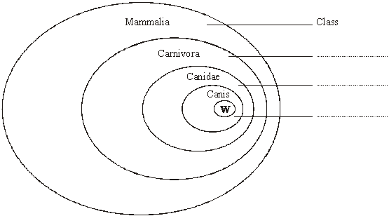

**Figure 1**

(i)      Label **Figure 1** to show the names of the groups.

**(2)**

(ii)     The lion, *Panthera leo*, belongs to another group in the Carnivora, called the Felidae. Add this information to **Figure 1**, using the letter L to represent the lion species.

**(1)**

(b)     The diagrams show two systems of classification of mammals. **Figure 2** shows a simple hierarchy. **Figure 3** shows a phylogenetic system.

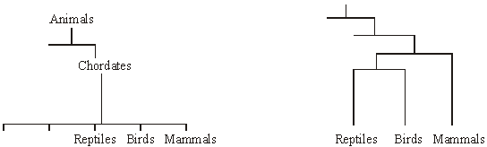

**Figure 2**                                                                    **Figure 3**

(i)      What is meant by a hierarchy?

.............................................................................................................

.............................................................................................................

**(1)**

(ii)     By reference to **Figures 2** and **3**, explain how a phylogenetic system differs from a simple hierarchy.

.............................................................................................................

.............................................................................................................

.............................................................................................................

.............................................................................................................

.............................................................................................................

.............................................................................................................

**(3)**

**(Total 7 marks)**

**Q11.**          The diagram shows the pathways in the heart for the conduction of electrical impulses during the cardiac cycle.

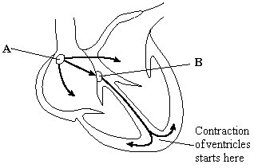

(a)     The table shows the blood pressure in the left atrium, the left ventricle and the aorta at different times during part of a cardiac cycle.

|  |  |  |  |
| --- | --- | --- | --- |
|  | **Blood pressure / kPa** | | |
| **Time / s** | **Left atrium** | **Left ventricle** | **Aorta** |
| 0.0 | 0.5 | 0.4 | 10.6 |
| 0.1 | 1.2 | 0.7 | 10.6 |
| 0.2 | 0.3 | 6.7 | 10.6 |
| 0.3 | 0.4 | 17.3 | 16.0 |
| 0.4 | 0.8 | 8.0 | 12.0 |

(i)      At which time is blood flowing into the aorta?

.............................................................................................................

**(1)**

(ii)     Between which times are the atrioventricular valves closed?

.............................................................................................................

**(1)**

(b)     The maximum pressure in the left ventricle is higher than the maximum pressure in the right ventricle. What causes this difference in pressure?

......................................................................................................................

......................................................................................................................

**(1)**

(c)     The information below compares some features of different blood vessels.

|  |  |  |  |  |
| --- | --- | --- | --- | --- |
|  | | **Blood vessel** | | |
|  | | **Artery** | **Capillary** | **Vain** |
| **Property** | Mean diameter of vessel | 4.0 mm | 8.0 μm | 5.0 mm |
| Mean thickness of wall | 1.0 mm | 0.5 μm | 0.5 mm |
|  | | **Relative thickness (shown by length of bar)** | | |
| **Tissues present in wall** | Endothelium |  |  |  |
| Elastic tissue |
| Muscle |

Use the information to explain how the structures of the walls of arteries, veins and capillaries are related to their functions.

......................................................................................................................

......................................................................................................................

......................................................................................................................

......................................................................................................................

......................................................................................................................

......................................................................................................................

......................................................................................................................

......................................................................................................................

......................................................................................................................

......................................................................................................................

......................................................................................................................

......................................................................................................................

**(6)**

**(Total 9 marks)**

**Q12.**          (a)     The diagram shows a section through the heart at one stage of the cardiac cycle.

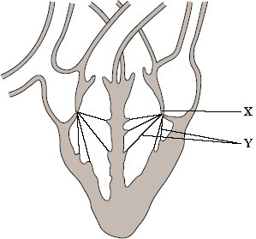

(i)      Name the structure labelled **X**.

.............................................................................................................

**(1)**

(ii)     Suggest how the structures labelled **Y** help to maintain the flow of blood in one direction through the heart.

.............................................................................................................

.............................................................................................................

.............................................................................................................

.............................................................................................................

**(2)**

(b)     The chart shows the actions of the atria and the ventricles during a complete cardiac cycle. Different stages have been given letters and a time scale added.

|  |  |  |  |  |  |  |  |  |  |
| --- | --- | --- | --- | --- | --- | --- | --- | --- | --- |
|  | **Stage** | | | | | | | | |
|  | **A** | **B** | | | **C** | | | | |
| **Atria** | Contracting | Relaxing | | | | | | | |
| **Ventricles** | Relaxing | Contracting | | | | Relaxing | | | |
|  |  |  |  |  | |  |  |  |  |
|  |  |  |  |  |  |  |  |  |  |

0.0              0.1           0.2               0.3             0.4          0.5           0.6           0.7           0.8

Time / seconds

(i)      Give the letter of the stage which is shown in the diagram of the heart.

.............................................................................................................

**(1)**

(ii)     The heart beats for one minute at the rate shown by the chart. Calculate the total time the ventricles are relaxed during one minute. Show your working.

Answer ....................................... seconds

**(2)**

**(Total 6 marks)**

**Q13.**          Students investigated the response of beetle larvae to light. They marked sectors on a large circular sheet of cardboard. A lamp with a 100 W bulb was placed close to the cardboard sheet at position **X**. The larvae were released, one at a time, in the centre of the sheet. The direction in which each larva moved was determined by recording the sector into which it first crawled.

The results of 300 trials are shown in the diagram. The length of the bars indicates the number of larvae moving into each sector.

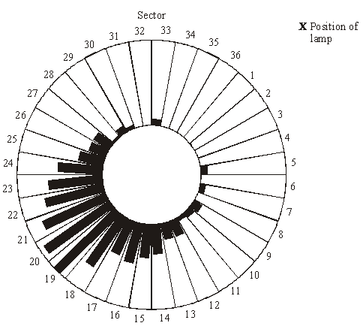

(a)     The students concluded that the larvae respond by moving away from light.

(i)      What is the evidence for this conclusion?

.............................................................................................................

.............................................................................................................

**(1)**

(ii)     Suggest **one** precaution that would ensure the response really was due to light.

.............................................................................................................

.............................................................................................................

**(1)**

(iii)     The larvae moved to a wide range of different sectors. Suggest an explanation for this.

.............................................................................................................

.............................................................................................................

**(1)**

(b)     The sector which gave the median result was sector 20. Explain how the median result would be calculated.

......................................................................................................................

......................................................................................................................

......................................................................................................................

......................................................................................................................

......................................................................................................................

**(2)**

**(Total 5 marks)**

**Q14.**          (a)     The graph shows the number of deaths from influenza per year in a developed country.

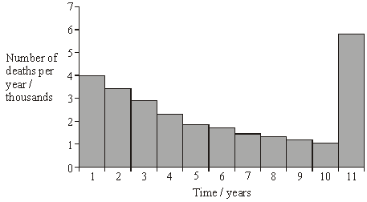

(i)      Suggest an explanation for the change in the number of deaths from influenza during the first 10 years.

.............................................................................................................

.............................................................................................................

**(1)**

(ii)     Suggest an explanation for the large increase in the number of deaths from influenza in year 11.

.............................................................................................................

.............................................................................................................

.............................................................................................................

.............................................................................................................

**(2)**

(b)     The diagram shows some of the structures on the outside of an influenza virus.

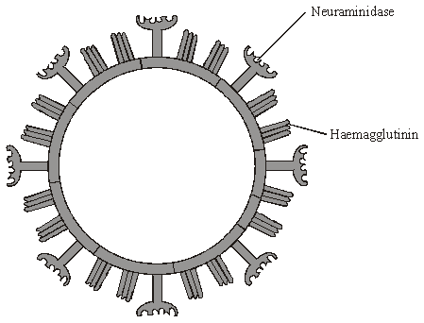

Haemagglutinin and neuraminidase are protein molecules. Haemagglutinin binds to receptor molecules on the surface of epithelial cells in the breathing system.  
Neuraminidase is an enzyme which breaks down molecules in the surface membrane of epithelial cells and allows the viruses to be released from the cells.

(i)      Describe how T lymphocytes recognise and respond to the influenza virus.

.............................................................................................................

.............................................................................................................

.............................................................................................................

.............................................................................................................

**(2)**

(ii)     Describe how B lymphocytes respond to the influenza virus.

.............................................................................................................

.............................................................................................................

.............................................................................................................

.............................................................................................................

**(2)**

(c)     New drugs have recently become available for treating influenza. One type is a neuraminidase inhibitor. Explain how this type of drug would act as a treatment for influenza.

......................................................................................................................

......................................................................................................................

......................................................................................................................

......................................................................................................................

**(2)**

**(Total 9 marks)**

**Q15.**         The table shows the numbers of adult butterflies in two areas of the same tropical forest. In the logged area some trees had been cut down for timber. In the virgin forest no trees had been cut down. The two areas were the same size.

|  |  |  |  |  |
| --- | --- | --- | --- | --- |
|  | **Logged forest** | | **Virgin forest** | |
| **Butterfly species** | **Number** | ***n*(*n*–1)** | **Number** | ***n*(*n*–1)** |
| *Eurema tiluba* | 72 | 5112 | 19 | 342 |
| *Cirrochroa emalea* | 43 | 1806 | 132 | 17292 |
| *Partenos sylvia* | 58 | 3306 | 14 | 182 |
| *Neopithecops zalmora* | 6 | 30 | 79 | 6162 |
| *Jamides para* | 37 | 1332 | 38 | 1406 |
| Total | 216 | 11586 | 282 | 25384 |

(a)     Describe a method for finding the number of one of the species of butterfly in the virgin forest.

......................................................................................................................

......................................................................................................................

......................................................................................................................

......................................................................................................................

**(2)**

(b)     The index of diversity of a forest can be calculated using the equation



Calculate the index of diversity for the virgin forest. Show your working.

Answer ......................................

**(2)**

(c)     What does the table show about the effects of logging on the butterfly populations?

......................................................................................................................

......................................................................................................................

......................................................................................................................

**(2)**

**(Total 6 marks)**

**Q16.**         Caterpillars damage crop plants by eating the leaves. There is a virus which kills caterpillars within a few days of infecting them. A genetically engineered form of the virus has been produced which contains a gene from a scorpion. This gene codes for production of a toxin specific to insects.

In an investigation, sample areas of crop were treated with either the normal or the genetically engineered virus. The bar chart shows the damage caused by caterpillars to the leaves of the crop plants.

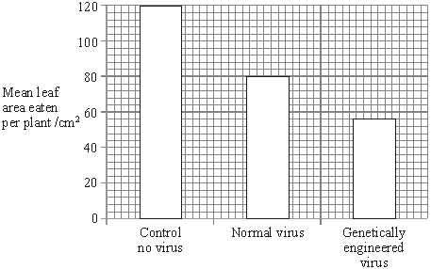

(i)      How much more effective is the genetically engineered virus than the normal virus? Show your working.

Answer ........................................

**(2)**

(ii)     Explain why the area of leaf eaten is less when caterpillars are infected with the genetically engineered virus rather than with the normal virus.

......................................................................................................................

......................................................................................................................

......................................................................................................................

......................................................................................................................

**(2)**

**(Total 4 marks)**

**Q17.**          (a)     The photograph shows part of the gill of a fish as seen through a light microscope. It is magnified × 400.

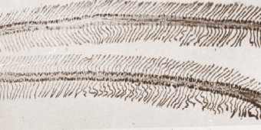

(i)      Explain how the structure of the gill makes oxygen uptake efficient.

.............................................................................................................

.............................................................................................................

.............................................................................................................

.............................................................................................................

**(2)**

(ii)     Water containing dissolved oxygen flows over the gill in the opposite direction to the blood flow inside. Explain why this arrangement is important for efficient oxygen uptake.

.............................................................................................................

.............................................................................................................

.............................................................................................................

.............................................................................................................

**(2)**

(b)     There is a one-way flow of water over the gills of a fish whereas there is a two-way flow of air in the lungs of a mammal. Suggest **one** advantage to a fish of this one-way flow of water over its gills.

......................................................................................................................

......................................................................................................................

**(1)**

**(Total 5 marks)**

**Q18.**          Some strains of the bacterium that causes gonorrhoea are resistant to antibiotics. This makes the disease difficult to treat. One way of testing the effectiveness of antibiotics is to use discs of paper soaked in antibiotic. These are placed in the centre of an agar plate covered by bacteria. A clear zone forms around the disc if the antibiotic is effective.

The table shows some results of an investigation into the effect of four different antibiotics on gonorrhoea bacteria.

|  |  |  |
| --- | --- | --- |
| **Antibiotic** | **Diameter of clear zone / mm** | **Minimum diameter of clear zone if antibiotic is effective / mm** |
| **A** | 47 | 52 |
| **B** | 30 | 28 |
| **C** | 22 | 40 |
| **D** | 33 | 34 |

(a)     Give **two** reasons why it would be important to use sterile techniques during this investigation.

1 ...................................................................................................................

......................................................................................................................

2 ...................................................................................................................

......................................................................................................................

**(2)**

(b)     (i)      The antibiotic reached the bacteria by diffusion. Suggest why an effective antibiotic may produce only a small clear zone.

.............................................................................................................

.............................................................................................................

**(1)**

(ii)     Which antibiotic used in the investigation would be most useful for treating gonorrhoea? Explain your answer.

Antibiotic ...............................................................

Explanation .........................................................................................

.............................................................................................................

**(2)**

**(Total 5 marks)**

**Q19.**          (a)     Explain why the replication of DNA is described as semi-conservative.

......................................................................................................................

......................................................................................................................

......................................................................................................................

......................................................................................................................

**(2)**

(b)     Bacteria require a source of nitrogen to make the bases needed for DNA replication. In an investigation of DNA replication some bacteria were grown for many cell divisions in a medium containing 14N, a light form of nitrogen. Others were grown in a medium containing 15N, a heavy form of nitrogen. Some of the bacteria grown in a 15N medium were then transferred to a 14N medium and left to divide once.

DNA was isolated from the bacteria and centrifuged.

The DNA samples formed bands at different levels, as shown in the diagram.

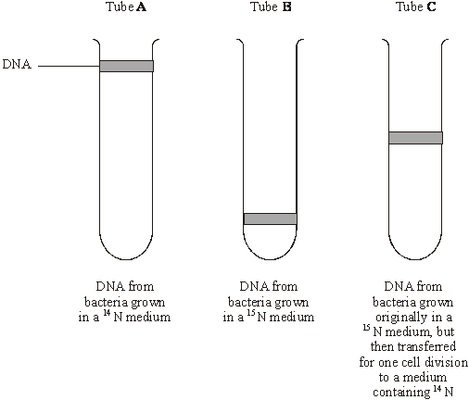

(i)      What do tubes **A** and **B** show about the density of the DNA formed using the two different forms of nitrogen?

.............................................................................................................

.............................................................................................................

**(1)**

(ii)     Explain the position of the band in tube **C**.

.............................................................................................................

.............................................................................................................

.............................................................................................................

.............................................................................................................

**(2)**

(c)     In a further investigation, the DNA of the bacterium was isolated and separated into single strands. The percentage of each nitrogenous base in each strand was found. The table shows some of the results.

|  |  |  |  |  |
| --- | --- | --- | --- | --- |
|  | **Percentage of base present** | | | |
| **DNA sample** | Adenine | Cytosine | Guanine | Thymine |
| Strand 1 | 26 |  | 28 | 14 |
| Strand 2 | 14 |  |  |  |

Use your knowledge of base pairing to complete the table.

**(2)**

**(Total 7 marks)**

**Q20.**          (a)     **Figure 1** shows part of a myofibril from skeletal muscle.

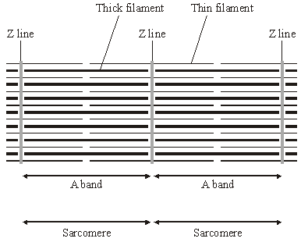

**Figure 1**

(i)      Describe **two** features, visible in the diagram, which show that the myofibril is contracted.

1 ..........................................................................................................

.............................................................................................................

2 ..............................................................…........................................

.............................................................................................................

**(2)**

(ii)     Explain the role of calcium ions and ATP in bringing about contraction of a muscle fibre.

Calcium ions ................................................................................……

.............................................................................................................

.............................................................................................................

ATP .....................................................................................................

.............................................................................................................

.............................................................................................................

**(3)**

(b)     **Figure 2** shows the structure of a neuromuscular junction.  The vesicles contain acetylcholine.

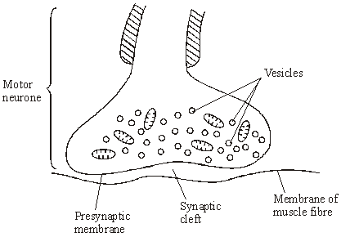

**Figure 2**

(i)      An action potential is generated at the cell body of the motor neurone.  
Explain how this action potential passes along the motor neurone to the neuromuscular junction.

.............................................................................................................

.............................................................................................................

.............................................................................................................

.............................................................................................................

.............................................................................................................

.............................................................................................................

**(3)**

(ii)     When the action potential arrives at the neuromuscular junction, it results in the secretion of acetylcholine into the synaptic cleft. Explain how.

.............................................................................................................

.............................................................................................................

.............................................................................................................

.............................................................................................................

.............................................................................................................

.............................................................................................................

**(3)**

(c)     Between the ages of 20 and 50, 10% of total muscle mass is lost. Between the ages of 50 and 80, a further 40% of the original total muscle mass is lost. Most of the muscle lost consists of fast fibres.

(i)      Plot a graph on the grid below to show the percentage of muscle mass remaining between the ages of 20 and 80. Assume that the rate of muscle loss in each age range is constant.



**(3)**

(ii)     Explain why explosive exercises, such as sprinting and weightlifting, will be more affected by this muscle loss than aerobic exercises, such as jogging.

.............................................................................................................

.............................................................................................................

**(1)**

**(Total 15 marks)**

**Q21.** Lung cancer, chronic bronchitis and coronary heart disease (CHD) are associated with smoking. **Tables 1** and **2** give the total numbers of deaths from these diseases in the UK in 1974.

**Table 1 Men**

|  |  |  |  |
| --- | --- | --- | --- |
| **Age/years** | **Number of deaths (in thousands)** | | |
|  | lung cancer | chronic bronchitis | coronary heart disease |
| 35 - 64 | 11.5 | 4.2 | 31.7 |
| 65 - 74 | 12.6 | 8.5 | 33.3 |
| 75+ | 5.8 | 8.1 | 29.1 |
| Total (35 - 75+) | 29.9 | 20.8 | 94.1 |

**Table 2 Women**

|  |  |  |  |
| --- | --- | --- | --- |
| **Age/years** | **Number of deaths (in thousands)** | | |
|  | lung cancer | chronic bronchitis | coronary heart disease |
| 35 – 64 | 3.2 | 1.3 | 8.4 |
| 65 – 74 | 2.6 | 1.9 | 18.2 |
| 75+ | 1.8 | 3.5 | 42.3 |
| Total (35 – 75+) | 7.6 | 6.7 | 68.9 |

(i)      Using an example from the tables, explain why it is useful to give data for men and women separately.

......................................................................................................................

......................................................................................................................

......................................................................................................................

**(2)**

(ii)     Data like these are often given as percentages of people dying from each cause.

Explain the advantage of giving these data as percentages.

......................................................................................................................

......................................................................................................................

......................................................................................................................

......................................................................................................................

**(2)**

**(Total 4 marks)**

**Q22.**          People considered ‘at risk’ are offered a vaccination against influenza each year. The bar chart shows the number of people in the UK population aged 65 and over and the percentage of those who were vaccinated against influenza each winter.

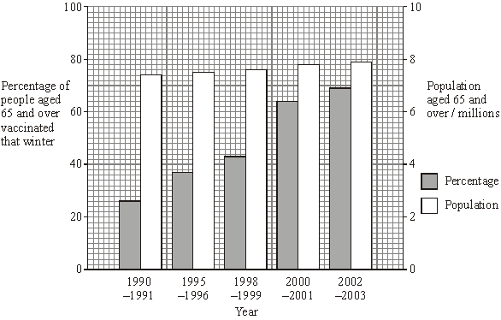

(a)     Suggest **one** reason to explain the change in the percentage of people aged 65 and over being vaccinated.

......................................................................................................................

......................................................................................................................

**(1)**

(b)     (i)      Calculate the change in the total number of people aged 65 and over being vaccinated between 1990/91 and 2000/01. Show your working.

Answer .................................

**(2)**

(ii)     A student suggested that some people aged 65 and over were being vaccinated every year. Explain how the information in the bar chart supports this suggestion.

.............................................................................................................

.............................................................................................................

.............................................................................................................

.............................................................................................................

.............................................................................................................

**(2)**

(iii)     Suggest why it is advisable for people to be vaccinated against influenza every year.

.............................................................................................................

.............................................................................................................

.............................................................................................................

.............................................................................................................

**(2)**

(c)     An influenza virus consists of a protein coat surrounding nucleic acid. The influenza vaccine consists only of the protein coat of the virus. Explain how the influenza vaccine produces immunity in the body.

......................................................................................................................

......................................................................................................................

......................................................................................................................

......................................................................................................................

**(2)**

**(Total 9 marks)**

**Q23.**          A gene was broken into fragments using enzyme **Z**. The mixture of fragments produced was then separated by electrophoresis.

(a)     What type of enzyme is enzyme **Z**?

......................................................................................................................

**(1)**

The table shows the number of base pairs present in the fragments.

|  |  |
| --- | --- |
| **Fragment** | **Number of base pairs (× 103)** |
| 1 | 4.65 |
| 2 | 5.72 |
| 3 | 10.71 |
| 4 | 2.39 |
| 5 | 5.35 |
| 6 | 7.53 |

The diagram shows the electrophoresis gel used. The mixture of fragments was placed at the start point marked **S** and the process started. The boxes indicate the positions reached by the different fragments.

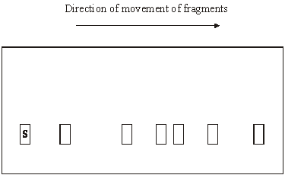

(b)     Explain why base pairs are a suitable way of measuring the length of a piece of DNA.

......................................................................................................................

......................................................................................................................

......................................................................................................................

......................................................................................................................

**(2)**

(c)     (i)      Write **6** above the appropriate box on the diagram to show the position you would expect fragment **6** to have reached.

**(1)**

(ii)     Explain how you arrived at your answer.

.............................................................................................................

.............................................................................................................

**(1)**

(d)     Enzyme **Z** recognises a particular sequence of bases in the gene. How many times does this sequence appear in the DNA of this gene?

......................................................................................................................

**(1)**

**(Total 6 marks)**

**Q24.**          An investigation was carried out into the effect of carbon dioxide concentration and light intensity on the rate of photosynthesis in a species of plant.

(a)     The temperature was kept constant during this investigation. Explain why.

......................................................................................................................

......................................................................................................................

**(2)**

(b)     The table shows the effect of increasing carbon dioxide concentration on the rate of photosynthesis in maize.

|  |  |
| --- | --- |
| **Carbon dioxide concentration / arbitrary units** | **Rate of photosynthesis / arbitrary units** |
| 30 | 10 |
| 60 | 20 |
| 100 | 30 |
| 150 | 40 |
| 230 | 50 |
| 300 | 60 |
| 400 | 60 |

Describe and explain the effect of increasing carbon dioxide concentration on the rate of photosynthesis.

......................................................................................................................

......................................................................................................................

......................................................................................................................

......................................................................................................................

......................................................................................................................

......................................................................................................................

**(3)**

**(Total 5 marks)**

**Q25.**          (a)     The table shows the membrane potential of an axon at rest and during the different phases of an action potential. Complete the table by writing in each box whether the sodium ion (Na+) channels and potassium ion (K+) channels are open or closed.

|  |  |  |  |  |
| --- | --- | --- | --- | --- |
|  |  | **Resting** | **Starting to depolarise** | **Repolarising** |
|  | **Membrane potential/mV** | –70 | –50 | –20 |
|  | **Na+ channels in axon membrane** |  |  |  |
|  | **K+ channels in axon membrane** |  |  |  |

**(2)**

(b)     Describe how the resting potential is established in an axon by the movement of ions across the membrane.

......................................................................................................................

......................................................................................................................

......................................................................................................................

......................................................................................................................

**(2)**

**S**       (c)     Sodium and potassium ions can only cross the axon membrane through proteins.

Explain why.

......................................................................................................................

......................................................................................................................

......................................................................................................................

......................................................................................................................

**(2)**

**(Total 6 marks)**

**Q26.**Some of the catalase produced by *Aspergillus niger* is intracellular and some is extracellular.

Intracellular enzymes stay inside the cells that produce them. Extracellular enzymes are secreted from the cells that produce them.

Another group of scientists grew a different strain of *A. niger*.

•        *A. niger* grows from tiny structures called spores. The scientists kept the spores in an isotonic medium at a low temperature until they needed them.

•        They put spores of *A. niger* into a 500 cm3 flask containing a sterile medium. The medium contained starch.

•        They measured the total amount of catalase and the amount of extracellular catalase produced by the fungus over a period of 100 hours.

The graph shows their results.

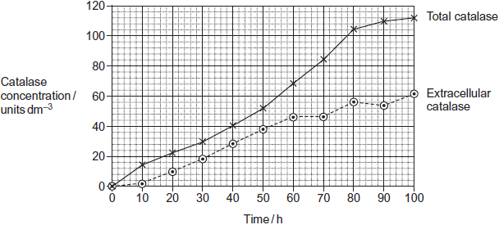

(a)     (i)      The scientists kept the spores in an isotonic medium until they were needed.  
Suggest why it was important that the medium was isotonic.

...............................................................................................................

...............................................................................................................

...............................................................................................................

...............................................................................................................

...............................................................................................................

**(2)**

(ii)     The scientists kept the spores at a low temperature until they were needed.  
Suggest why.

...............................................................................................................

...............................................................................................................

...............................................................................................................

**(1)**

(b)     Starch is a source of carbon, hydrogen and oxygen for the fungus. Name one other chemical element that must be in the culture medium before *A. niger* can synthesise catalase. Give the reason for your answer.

Chemical element ...........................................................................................

Reason ...........................................................................................................

........................................................................................................................

........................................................................................................................

........................................................................................................................

**(2)**

(c)     To get reliable results in this investigation, the medium must be sterile.  
Explain why.

........................................................................................................................

........................................................................................................................

........................................................................................................................

........................................................................................................................

........................................................................................................................

**(2)**

(d)     (i)      At what time was the concentration of intracellular catalase highest?

...............................................................................................................

**(1)**

(ii)     Between what times was the rate of total catalase production highest?

...............................................................................................................

**(1)**

(e)     Technologists prefer to manufacture extracellular enzymes rather than intracellular enzymes. This is because intracellular enzymes are more expensive to purify than extracellular enzymes. Suggest why intracellular enzymes are more expensive to purify.

........................................................................................................................

........................................................................................................................

........................................................................................................................

........................................................................................................................

........................................................................................................................

**(2)**

**(Total 11 marks)**

**Q27.**          (a)     The flow chart shows the main stages in aerobic respiration.

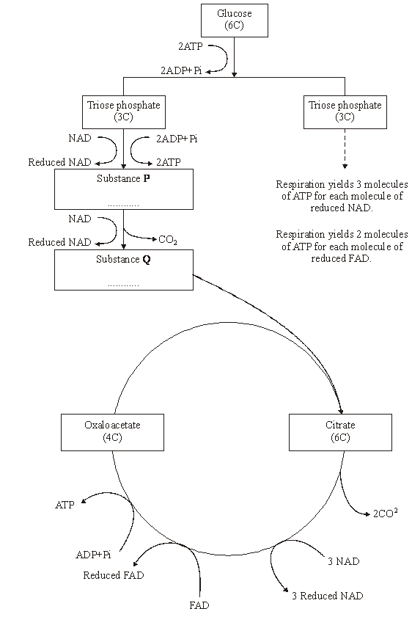

(i)      Complete the flow chart by writing, in the appropriate boxes, the number of carbon atoms in substance **P** and the name of substance **Q**.

**(2)**

(ii)     Some ATP is formed in the cytoplasm and some in the mitochondria. Use the information given to calculate the number of molecules of ATP formed in a mitochondrion from one molecule of glucose in aerobic respiration. Show how you arrived at your answer.

Answer.....................................

**(2)**

(iii)     In the presence of oxygen, respiration yields more ATP per molecule of glucose than it does in the absence of oxygen. Explain why.

.............................................................................................................

.............................................................................................................

.............................................................................................................

.............................................................................................................

.............................................................................................................

.............................................................................................................

**(3)**

(b)     Anabaena is a prokaryote found inside the leaves of a small fern. Anabaena can produce ammonia from nitrogen (nitrogen fixation). This reaction only takes place in the anaerobic conditions found in cells called heterocysts. Heterocysts are thick-walled cells that do not contain chlorophyll. The drawing shows the relationship between *Anabaena* and the fern.

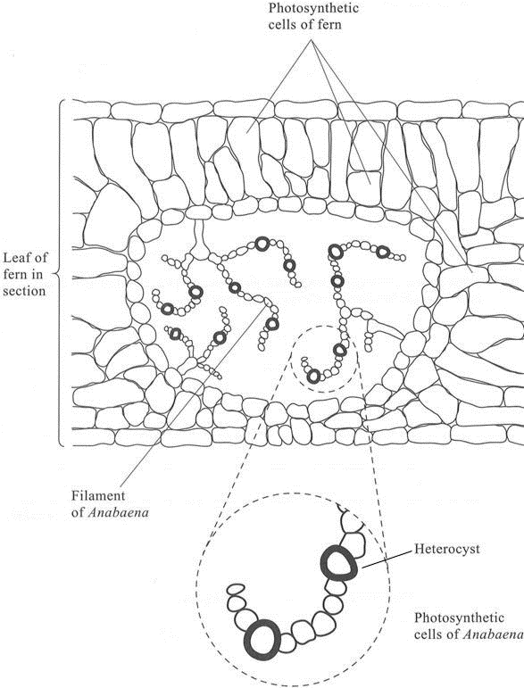

(i)      Suggest how the features of the heterocysts improve the efficiency of the process of nitrogen fixation.

.............................................................................................................

.............................................................................................................

.............................................................................................................

.............................................................................................................

.............................................................................................................

.............................................................................................................

**(3)**

(ii)     In China, the fern is cultivated and ploughed into fields to act as an organic fertiliser. Explain how ploughing the fern plants into the soil results in an improvement in the growth of the rice crop grown in these fields.

.............................................................................................................

.............................................................................................................

.............................................................................................................

.............................................................................................................

.............................................................................................................

.............................................................................................................

.............................................................................................................

.............................................................................................................

.............................................................................................................

.............................................................................................................

**(5)**

**(Total 15 marks)**

**Q28.Figure 1** shows the effect of wavelength on the percentage of light absorbed by the chlorophyll from these seaweeds.

**Figure 1**

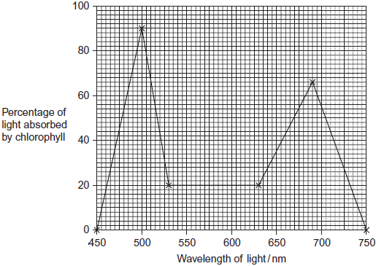

Some scientists investigated the growth of these seaweeds in artificial conditions.

They investigated the effect of different lamps on the rate of photosynthesis of the seaweeds.

•        Lamp **P** produced light containing all wavelengths of visible light. (450 to 750 nm)

•        Lamp **Q** only produced light of wavelength 460 nm.

The scientists measured photosynthesis by recording the rate of oxygen production. Their results are shown in **Figure 2**.

**Figure 2**

|  |  |  |  |
| --- | --- | --- | --- |
|  |  | **Mean rate of photosynthesis / arbitrary units ( ± standard deviation)** | |
|  | **Species** | Lamp **P**  Light of all wavelengths of  visible light | Lamp **Q**  Light of wavelength 460nm |
|  | *Ulva pertusa* | 1300.9 ( ± 125.4) | 776.6 ( ± 105.6) |
|  | *Mastocarpus yendoi* | 318.9 ( ± 69.5) | 299.6 ( ± 83.2) |

(a)     Between 500 and 700 nm, what range of wavelengths of light is absorbed least by chlorophyll?

........................................................................................................................

**(1)**

(b)     The scientists measured the oxygen produced by the light-dependent reaction of photosynthesis. Name **two** other substances produced by the light-dependent reaction.

1 .....................................................................................................................

2 .....................................................................................................................

**(2)**

(c)     (i)      The scientists measured the rate of photosynthesis of the seaweeds in this investigation in terms of oxygen produced.  
Suggest the units they should use.

...............................................................................................................

**(2)**

(ii)     This investigation was carried out in bright light. Explain why reducing the light intensity would affect the amount of oxygen released by the seaweeds.

...............................................................................................................

...............................................................................................................

...............................................................................................................

...............................................................................................................

...............................................................................................................

...............................................................................................................

(Extra space) ........................................................................................

...............................................................................................................

...............................................................................................................

**(3)**

(d)     In this investigation, the scientists kept the temperature at 15 °C. A student suggested that repeating the investigation at 20 °C would not affect the amount of oxygen released by the seaweed. Evaluate this suggestion.

........................................................................................................................

........................................................................................................................

........................................................................................................................

........................................................................................................................

........................................................................................................................

........................................................................................................................

(Extra space) .................................................................................................

........................................................................................................................

........................................................................................................................

**(3)**

(e)     (i)      Did the type of lamp used affect the rate of photosynthesis in *M. yendoi*? Explain the evidence for your answer.

...............................................................................................................

...............................................................................................................

...............................................................................................................

...............................................................................................................

...............................................................................................................

**(2)**

(ii)     The different lamps resulted in different rates of photosynthesis by *U. pertusa*. Explain why there was a higher rate of photosynthesis when the seaweed was illuminated with lamp **P**.

...............................................................................................................

...............................................................................................................

...............................................................................................................

...............................................................................................................

...............................................................................................................

...............................................................................................................

(Extra space) ........................................................................................

...............................................................................................................

...............................................................................................................

**(3)**

**(Total 16 marks)**

**Q30.**Scientists investigated the effect of lipase and a 3% bile salts solution on the digestion of triglycerides. The graph below shows their results.

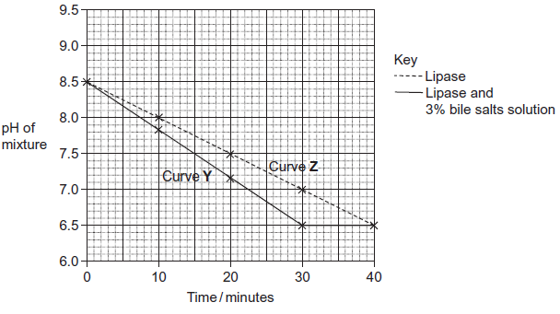

The scientists also incubated triglycerides with different concentrations of bile salts. After 30 minutes they measured the diameter of the triglyceride droplets. They used the results to calculate the mean radius of the droplets at each concentration. The table below shows their results.

|  |  |  |  |  |  |  |  |
| --- | --- | --- | --- | --- | --- | --- | --- |
|  | Concentration of bile salts /% | 0 | 1 | 2 | 3 | 4 | 5 |
|  | Mean radius of triglyceride droplet / μm | 6 | 5 | 4 | 3 | 2 | 1 |

(a)     Describe how you would use a microscope to find the mean diameter of triglyceride droplets on a slide.

.........................................................................................................................

.........................................................................................................................

.........................................................................................................................

.........................................................................................................................

.........................................................................................................................

.........................................................................................................................

*(Extra space)* ..................................................................................................

.........................................................................................................................

.........................................................................................................................

**(3)**

(b)     (i)      The ratio of mean radius of triglyceride droplets in bile salts at a concentration of 0% to the mean radius in bile salts at a concentration of 3% is 2 : 1.

What is the ratio of their surface areas? Show your working.

You can calculate the surface area of a droplet from the formula

A = 4*π*r2

Where  A = surface area  
    r = radius  
   *π* = 3.14

**(2)**

(ii)     Use the data in the table to explain the difference between curves **Y** and **Z** in the graph.

...............................................................................................................

...............................................................................................................

...............................................................................................................

...............................................................................................................

...............................................................................................................

...............................................................................................................

*(Extra space)* ........................................................................................

...............................................................................................................

...............................................................................................................

**(3)**

**(Total 8 marks)**

**Q31.**Scientists investigated the effect of lipase and a 3% bile salts solution on the digestion of triglycerides. The graph below shows their results.



(a)     Describe what curve **Y** shows about the effect of lipase and bile salts on the pH of the mixture.

.........................................................................................................................

.........................................................................................................................

.........................................................................................................................

.........................................................................................................................

.........................................................................................................................

**(2)**

(b)     The concentration of lipase did not change during the course of the investigation.  
Explain why.

.........................................................................................................................

.........................................................................................................................

.........................................................................................................................

**(1)**

(c)     One of the scientists decided to repeat the investigation at a temperature 10°C below the original temperature.  
Describe how you would expect his plotted curve to be different from curve **Z**.

.........................................................................................................................

.........................................................................................................................

**(1)**

**(Total 4 marks)**

**M1.**(a)     1.      Decrease in (percentage cover) of bare ground / water linked to more plants / species / increase in plant coverage;

*Allow* ***one maximum mark*** *for answers which describe all three changes* ***without*** *a suitable explanation for any change*

*Must be idea of more / increase not just change in species / plants*

2.      Change in diversity / number of plant / species / named (species) as abiotic conditions altered / due to competition / more soil / less hostile;

*Accept pioneer species replaced due to competition*

*Accept description of change in species*

*Accept ‘more suitable’ = less hostile*

3.      Increase in depth of soil as plants die / humus formed;

**3**

(b)     1.      Greater variety of food / more food sources;

*‘More food’ = neutral*

2.      More / variety of habitats / niches;

*Ignore ‘more homes’ or reference to ‘shelters’*

**2**

(c)     (i)      1.      Marking is not removed / marking does not affect survival / predation;

2.      Limited / no immigration / emigration;

*Accept ‘migration’ and descriptions of immigration / emigration*

*2. and 4. Increase / decrease in population is not sufficient – there must be a reason*

3.      Sufficient time for (marked) individuals to mix (within the population);

*Accept – ‘For mixing to occur between samples’*

4.      No / little births / deaths / breeding;

5.      Sampling method is the same;

*Ignore ‘random sampling’*

**2 max**

(ii)     Correct answer of ...34 = 2 marks;

***Allow one mark*** *for an answer of 51 as candidate has misinterpreted the second sample as being = 30*

Incorrect answer but shows correct formula in words or numbers  
e.g. 17 × 20 ÷ 10;

*Reject correct formula multiplied by 100*

**2**

**[9]**

**M2.**          (a)     All / group of species / all / group of populations / all the organisms;

*Accept equivalent terms for group.*

*Answers which only refer to organisms must have idea of* ***all*** *the organisms not just a group of organisms*

*Reject answers which include ‘environment’ or abiotic factors as part of the definition*

**1**

(b)     (i)     7.2 - 8.4 (metres);

*Accept answer of 1.2*

**1**

(ii)     1.      Food / prey / oxygen;

*Do not accept ‘resource’ for mark point 1 unless this is qualified as food / prey / oxygen*

2.      Less / no competition;

*Reference to light and CO2 as a resource negates mark point 2*

*Ignore intraspecific / interspecific for mark point 2*

**2**

(c)     1.      Increase in depth linked to decrease in temperature / decrease in depth linked to increase in temperature;

*Accept increase or decrease in temperature is related to ‘higher depth’ or ‘lower depth’ due to ambiguity of these terms*

2.      Correlation / relationship between temperature and fish distribution does not indicate a causal effect;

*Ignore any reference to correlation unless it is clearly in context of temperature and fish distribution*

3.      Overlap in ranges / different fish / species occupy same depth;

*Temperature does not determine fish distribution is not sufficient for idea of causal effect*

4.      Other abiotic / biotic / named factor involved;

*Reject: ‘casual’ for mark point 2*

*Reject ‘other factors’ for mark point 4 unless further qualified*

**3 max**

**[7]**

**M3.**(a)     (i)      4;

**1**

(ii)     1.      Change in amino acid / (sequence of) amino acids / primary structure;

*1. Reject = different amino acids are 'formed'*

2.      Change in hydrogen / ionic / disulphide bonds alters tertiary structure / active site (of enzyme);

*2. Alters 3D structure on its own is not enough for this marking point.*

3.      Substrate not complementary / cannot bind (to enzyme / active site) / no enzyme- substrate complexes form;

**3**

(b)     1.      Lack of skin pigment / pale / light skin / albino;

2.      Lack of coordination / muscles action affected;

**2 max**

(c)     Founder effect / colonies split off / migration / interbreeding;

*Allow description of interbreeding e.g. reproduction between individuals from different populations*

**1**

**[7]**

**M4.**(a)     Increased soaking temperature decreases germination in seeds (germinated) at 35°C / soaking and germinating at 35°C results in failure (to germinate);

Soaking at 20°C and 25°C has no effect on seeds germinated at 20°C;

(Soaking above 30°C) may denature enzymes / proteins;

*In 3rd marking point:  
Accept description of denaturation  
Reject breakage of peptide bonds*

**3 max**

(b)     So that they could compare different numbers of seedlings;

**1**

**[4]**

**M5.**          (a)     (i)      22;

**1**

(ii)     1.      Odd number of chromosomes / 33 chromosomes (in leaf cell);

2.      Chromosomes cannot pair / cannot undergo meiosis / would result in half chromosomes / cannot form haploid cells;

**2**

(b)     (i)      Fast growth / produces crop fast / produces large crop;

*Do not insist on relative statement.*

*Accept similar terms for fast. E.g. “better” growth*

*Do not accept unqualified references to profit.*

**1**

(ii)     Leaves less likely to break / higher breaking strength;

**1**

(c)     Low genetic diversity because they are produced by mitosis;

Will all have the same DNA / genes / alleles / will be genetically identical / will be clones;

***OR***

Low genetic diversity because they are not produced by meiosis;

No crossing over / independent segregation / will not be genetically different;

*Independent segregation is the specification term. Accept other such as random assortment.*

**2**

**[7]**

**M6.**          (a)     exchange / diffusion across body surface / skin;  
short diffusion pathway / distance / large SA:V ratio;

**2**

(b)     large numbers of lamellae so large SA;  
lamellae thin so short (diffusion) pathway to blood / capillaries;  
high rate of oxygen uptake for respiration / energy release;

*(accept more oxygen)*

**3**

**[5]**

**M7.**          (a)     *(explanation must be linked to structures to gain second mark for each linked pair)*

|  |  |
| --- | --- |
| filaments / lamellae ; | large SA; |
| gill plates or secondary lamellae; |  |
| large number of capillaries; | to remove oxygen / to maintain a gradient; |
| thin epithelium; | short diffusion pathway; |
| pressure changes; | to bring in more water / to maintain gradient; |
| countercurrent flow (or description); | exchange / diffusion along whole length / concentration gradient maintained / equilibrium not achieved / blood always meets water with higher oxygen concentration; |

**6**

(b)     (i)      requires 20 cm3 of oxygen / extracts 7.2 cm3 of oxygen /

*reject if referring to volume of water*

**;

2.7 / 2.8 (dm3h–1);

*(correct answer award 2 marks)*

**2**

(ii)     high (relative) density / heavy;  
requires large input of energy as difficult to push back out;

**2**

(c)     (*for each pair second point must be linked to first*)  
to provide same amount of oxygen;   
need to have more water flowing over gills;  
OR  
metabolic rate / respiration increases (with increase in temperature);  
so more oxygen required;

**2 max**

**[12]**

**QWC 1**

**M8.**          (a)     10

*(reject: 9.76)*

**1**

(b)     isolation (on islands);  
variety of habitats / conditions different from origin / other islands;  
differing pathways of natural selection;  
leading to organisms too different to interbreed.

**3 max**

**[4]**

**M9.**          (a)     (i)      in case normal coffee differs in some other way /   
to control concentration of caffeine;

**1**

(ii)     not telling them what the drink contained / purpose of experiment;

**1**

(b)     (i)      able to continue for longer; *(not just increases performance)  
(disqualify if also refers to fatty acids and glycerol)*

**1**

(ii)     breakdown of fats;  
at increased rate / by mobilisation of fat stores;

**2**

(c)     (i)      idea that volumes of oxygen and carbon dioxide the same;  
reference to equal moles, or quotient as 1 divided by 1 / or 6 by 6;

**2**

(ii)     glycogen is a carbohydrate / broken down to glucose, linked to RQ;  
with no caffeine, RQ nearer 1.0 / less carbon dioxide exhaled and  
more oxygen inhaled (or vice versa) / with caffeine higher proportion of fats / fatty acids respired;  
increased time to exhaustion suggests slower use of glycogen:

**3**

**[10]**

**M10.**          (a)     (i)      Order, Family, Genus.

*(all correct = 2 marks; 2 correct = 1 mark)*

**2**

(ii)     3 concentric circles in Carnivora, labelled Felidae, Panthera and L;

**1**

(b)     (i)      large groups split into smaller groups (which do not overlap);

**1**

(ii)     (phylogenetic) based on evolutionary history;  
shows ancestry of groups / points of divergence / example,   
e.g. reptiles and birds separated after mammals / reptiles  
and birds more closely related than mammals;  
(hierarchical) based on shared characteristics (seen today);

**3**

**[7]**

**M11.**          (a)     (i)      0.3 s;

**1**

(ii)     0.2 - 0.4 s;

**1**

(b)     thicker / more muscle in the left ventricle;

**1**

(c)     Artery

1. thickest wall, enabling it to carry blood at high pressure / withstand  
    pressure surges;  
2. most elastic tissue, which smoothes out flow / maintains pressure;  
3. most muscle which maintains pressure;  
4. muscle in wall to control blood flow;

Vein

5. thin wall does not have to withstand high pressure;

Capillary

6. thin wall, allowing diffusion / exchange;  
7. only endothelium present, allowing short diffusion pathway;

All vessels

8. have endothelium that reduces friction;

**6 max**

**[9]**

**M12.**          (a)     (i)      atrioventricular valve / (bi)cuspid valve / mitral valve;

**1**

(ii)     (valves close) due to high blood pressure / when ventricles contract;

Y prevent valve from being inverted / restricts / stops valve movement;

*(allow AV valve, disqualify tricuspid)*

**2**

(b)     (i)      B;

**1**

(ii)     5 × 60 = 37.5 s  
8

*correct method*

**1**

*correct answer*

**2**

**[6]**

**M13.**          (a)     (i)      majority of larvae move to sectors on opposite side to lamp;  
*(reject largest number / most in sector 19)*

**1**

(ii)     use heat filter in front of lamp

*(allow lamp not too close);*

*rotate card and lamp to eliminate magnetic field;  
alter direction of larval head when releasing;  
(reject general references to keeping variables constant)*

**1 max**

(iii)     wide beam from lamp;  
variability of organisms;  
positioning of larvae variable;

**1 max**

(b)     idea of middle value;  
method of determining middle value in rank order, e.g. sector in which  
300 / 2 occurs;

**2**

**[5]**

**M14.**          (a)     (i)      fall in deaths due to rise in number of people with immunity / better care / targeting vaccination at vulnerable;

**1**

(ii)     mutation of virus / new strain;  
mutant form not recognised by memory cells (*allow antibodies*);

**2 max**

(b)     (i)      T lymphocyte receptors recognise shape of haemagglutinin /   
neuraminidase / viral antigen;  
clone (*once only*);  
destroy virus;

**2 max**

(ii)     clone (*once only*);  
produce antibodies;  
effect of antibody e.g. stimulation of phagocytosis /   
precipitation of toxins;

**2**

(c)     alter shape of active site of neuraminidase / block active site;  
virus unable to leave host cells;

**2**

**[9]**

**M15.**          (a)     suitable method of capture;  
mark individuals and release;  
count percentage recaptured / use Lincoln index / equation;

**2 max**

(b)     

*(accept 3.1 / 3.122)*

**2**

(c)     decrease in total numbers of butterflies;  
*(reject population)*change in proportion of species / example(s);  
increase in diversity in logged forest / calculation(4.01);

**2 max**

**[6]**

**M16.**          (i)      normal virus reduces area eaten by 40cm2genetically engineered reduces by 64 cm264 – 40 = 24

= 60% more effective

1 mark for principle of calculation;  
60% more effective = 2 marks;

or

= 1.6 times more effective

1 mark for principle of calculation;  
1.6 times more effective = 2 marks;

*(if only difference in area eaten given, 1 mark)*

**2**

(ii)     toxin kills the caterpillars faster than just the virus;  
so less time for leaves to be eaten / energy for eating;

**2**

**[4]**

**M17.**          (a)     (i)      one feature;

then linked Explanation;

(many) filaments / lamellae / secondary lamellae;

so large surface area;

large number of capillaries; (NOT “good blood supply”)

maintains a diffusion gradient / removes oxygen;

thin epithelium / lamellae wall;

short diffusion pathway;

**2**

(ii)     maintains diffusion / concentration gradient / equilibrium  
not reached;

diffusion occurs across whole length (of lamellae / gill);

**2**

(b)     less energy needed / continuous flow of water or O2;

**1**

**[5]**

**M18.**          (a)     To prevent contamination of apparatus with other microorganisms / bacteria;  
To prevent personal contact with bacteria;  
To prevent release of bacteria into air;

**max 2**

(b)     (i)      Diffuses slowly;

**1**

(ii)     B;  
Produces inhibition zone greater than the minimum diameter;

**2**

**[5]**

**M19.**          (a)     each strand copied / acts as a template;  
(daughter) DNA one new strand and one original / parent strand;

**2**

(b)     (i)      15N / tube **B** (DNA), more / greater density;

*(reject heavier)*

**1**

(ii)     DNA with one heavy and one light strand;  
new / synthesised strand, made with 14N / light strand;

**2**

(c)     32;  
28 32 26;

**2**

**[7]**

**M20.**          (a)     (i)      H band not visible / reduced / little / no thick filament / myosin only region / ends of thin filaments / actin close together;  
I band not visible / reduced / little / no thin filament / actin only region;  
A band occupies nearly all sarcomere / thick filament / myosin close to Z line;  
Large zone of thick-thin overlap;

**max 2**

(ii)     *Calcium ions:*Bind to troponin;  
Remove blocking action of tropomyosin /   
expose myosin binding sites;

*ATP:*Allows myosin to detach from actin / to break cross bridge;  
*[allow attach and detach]*Releases energy to recock / swivel / activate myosin head / drive power stroke;

**max 3**

(b)     (i)      Depolarisation of axon membrane / influx of Na+ establishes local  
currents;  
Change permeability to Na+ / open Na+  gates of adjoining region;  
Adjoining region depolarises / influx of Na+;

**3**

(ii)     Depolarisation of (presynaptic) membrane;  
Ca2+  channels open / increased permeability to Ca2+ causing influx of Ca2+ ;  
Vesicles move towards / fuse with presynaptic membrane;

*[If ions mentioned once assume candidate is referring to ions throughout; if no mention of ions penalise once only]*

**3**

(c)     (i)      1.  Correct axes labelled, correct orientation, linear scale;  
2.  Key points (100%, 90% and 50%) plotted correctly;  
3.  Plots joined by straight lines;

*[allow reasonable hand-drawn straight lines]*

**3**

(ii)     Fast fibres used (in explosive exercise);

*[allow reverse for slow fibres]*

**1**

**[15]**

**M21.**          (i)     Because there are big differences;  
any correct named example e.g. lung cancer / bronchitis much lower  
in women than in men;

**2**

(ii)     easier to compare if sample size effectively the same;  
different numbers of people in each group;

**2**

**[4]**

**M22.**          (a)     Publicity about vaccination / better health education / risks of ‘flu epidemics;

*(Accept: now free on NHS (though only since 2000) / better awareness / more commonly available)*

**1**

(b)     (i)      1990: 26% of 7.4million = 1.92million *and* 2000: 64% of 7.8 million = 4.99million;  
increase = 3.07 million;

**2**

*(Correct reading of all 4 figures from graph = 1)*

*(Correct answer but no ‘millions’ = 1)*

*(Correct method resulting from wrong graph reading = 1)*

(ii)     Over 50% of population being vaccinated;  
But only from 2000 onwards;  
*(Principle of more people being vaccinated each year = 1)*

**2**

(iii)     Different strain / type of virus each year / virus mutates;  
With different antigens;  
Influenza antibodies / memory cells (rapidly) destroyed / need replacing;

**max 2**

(c)     (Protein coat) carries antigens which stimulates B-cells / production of antibodies;  
Production of memory cells;

**2**

**[9]**

**M23.**          (a)     Endonuclease / restriction enzyme;

**1**

(b)     DNA made of base pairs;  
Each base pair is same length / occupies same distance  
along backbone;

**2**

(c)     (i)      Second blank box from left labelled 6;

**1**

(ii)     Distance moved depends on length / number of base pairs /   
second longest fragment / second shortest distance identified;

**1**

(d)     5;

**1**

**[6]**

**M24.**          (a)     Temperature affects photosynthesis; Affects enzyme activity;  
So that any change in photosynthesis rate is result of carbon dioxide / light intensity;

**max 2**

(b)     Carbon dioxide increases rate of photosynthesis;  
Up to max;  
Something else / correct suggestion is a limiting factor;

**3**

**[5]**

**M25.**          (a)     closed open closed;  
closed closed open;

**2**

(b)     active transport / pump of Na+ out of axon;  
diffusion of K+ out of axon / little diffusion of Na+ into the axon;

**2**

(c)     can not pass through phospholipid bilayer;  
because water soluble / not lipid soluble / charged / hydrophilic /   
hydrated;

**2**

**[6]**

**M26.**(a)     (i)      1.      Water potential same (inside and outside) / no  
         water potential gradient;

*Accept symbol Ψ or abbreviation WP as alternatives to water potential.*

2.      Water does not enter / leave spores;

3.      By osmosis / prevents osmotic damage;

*Answer must refer to osmosis.*

**2 max**

(ii)     Prevents growth (before ready) / stops growth of (other) microorganisms / slows enzyme action / prevents enzymes being denatured;

**1**

(b)     1.      Nitrogen / N / sulfur / S;

2.      Catalase is a protein / catalase is made up of amino acids / enzymes are proteins / enzymes are made up of amino acids;

*Specific reference needed to proteins or amino acids.*

**2**

(c)     1.      Prevents contamination by (other) microorganisms;

*Accept alternatives such as microbes, bacteria, other fungi.*

2.      Which also produce the enzyme / catalase / which would produce substances that affect catalase;

**2**

(d)     (i)      90 hours;

*Hours must be specified in answer to (c)*

**1**

(ii)     70 – 80 (hours);

*Allow with no reference to units.*

*Incorrect units negates answer.*

**1**

(e)     1.      Extra steps (with intracellular enzymes);

2.      Cells have to be broken open;

3.      Cell walls / bits of cells have to be removed / separated from enzyme;

4.      Needs to be separated from all the other enzymes in the cell;

**2 max**

**[11]**

**M27.**          (a)     (i)      **P** = 3;

**Q** = acetylcoenzyme A;

**2**

(ii)     36 ATP, however derived = 2 marks

30 ATP, however derived = 1 mark

**2**

(iii)     *Correct statement in the context of aerobic respiration or  
anaerobic respiration concerning*:

Oxygen as terminal hydrogen / electron acceptor allowing operation of electron transport chain / oxidative phosphorylation;

Fate of pyruvate;

Significance of ATP formed in glycolysis;

**3**

(b)     (i)      Thick walls exclude oxygen;

Produced by photosynthetic cells (of fern and *Anabaena*);

Contain no chlorophyll so do not photosynthesise;

Do not produce oxygen;

Oxygen would inhibit nitrogen fixation process;

**max. 3**

(ii)     Decomposers / bacteria / fungi / saprobionts (in fields);

Convert protein / organic nitrogen (in cells of fern) into  
ammonium ions (*allow ammonia*);

Ammonium ions (ammonia) converted to nitrite, then converted to nitrate;

*Allow 1 mark for NH3 / NH NO3*

By nitrifying bacteria / correctly named;

Nitrate used to form protein / amino acids in rice;

**5**

**[15]**

**M28.**(a)     530 to 630;

**1**

(b)     1.      Reduced NADP;

*Accept NADPH or rNADP*

2.      ATP;

*Reduced NAD is incorrect*

**2**

(c)     (i)      1.      Unit of volume and unit of time;

*Accept any reasonable unit of volume*

*E.g. cm3 or ml*

*Accept any reasonable unit of time*

*E.g. s, min or h*

2.      Unit of area / mass;

*Accept any reasonable unit of area or mass*

*E.g. cm2 or g*

*Symbols should be correct. Do not accept m for minutes.*

**2**

(ii)     1.      (Light intensity) limiting factor;

2.      Fewer electrons (released) from chlorophyll;

3.      Less photolysis therefore (less) oxygen from water;

**3**

(d)     Will not affect (no mark):

1.      Photolysis / splitting of water does not use enzymes;

Will affect (no mark):

2.      May increase respiration;

3.      Respiration uses oxygen;

**3**

(e)     (i)      1.      Overlap in standard deviations;

2.      Unlikely that any difference is significant;

**2**

(ii)     1.      **P** / visible light has more wavelengths;

2.      **Q** has only light of wavelength 460 nm;

3.      Wavelengths over 460 nm can also be used for photosynthesis / wavelengths over 460 nm can also be absorbed;

**3**

**[16]**

**M29.**(a)     Diet including saturated fats leads to higher plasma cholesterol concentrations;  
Higher in all age groups;  
But sample size is very small;  
Standard deviations overlap / suggest wide variation;

**3 max**

(b)     The sex of individual is a risk factor for high cholesterol;  
To remove a / one variable / to establish a fair test;

**2**

(c)     Monkeys and humans closely related therefore similar conclusions might be drawn;  
High concentrations of plasma cholesterol lead to an increased risk of cardiovascular disease in humans;  
Don’t know if diet has the same effect in monkeys (as in humans) / could have different effects because not the same species;

**3**

**[8]**

**M30.**(a)     Measure with eyepiece graticule / scale;  
Calibrate with stage micrometer / scale on slide / object of known size;   
Repeats and calculate the mean;  
***OR***Use a ruler to estimate the field diameter under microscope;  
How many droplets go across the field;  
Repeats and calculate mean;

*Accept references to radius*

**3**

(b)     (i)      Two mark for correct answer of 4 : 1;;  
One mark for incorrect answer but working shows that candidate has clearly attempted to compare values of r2 / 62 and 32 / 36 and 9;

*Idea of comparing ratios  
A ratio of 1 : 4 should gain 1 mark*

**2**

(ii)     Small droplets have a larger surface area to volume ratio;

More surface for lipase (to act), leading to faster digestion of triglycerides;

Fatty acids are produced more quickly so pH will drop more quickly in curve Y / with bile salts / less fatty acids in curve Z / without bile salts so pH drop more slowly;

**3**

**[8]**

**M31.**(a)     pH goes down and levels out;  
after 30 min / pH 6.5;

**2**

(b)     Enzyme not used up in reaction;

**1**

(c)     Curve will be less steep:

*Only accept answers relating to curve* ***not*** *rate of reaction*

**1**

**[4]**

**M32.**(a)     1.      Carbohydrate / sugar / named carbohydrate;

2.      Minerals / named mineral ion;

*Accept alternatives for mineral such as inorganic substances / ions. Accept symbol for ion. Accept incorrect symbols providing that answers are not ambiguous.*

3.      Amino acids / protein;

4.      Vitamins;

**2 max**

(b)     1.      Shake / stir / mix;

2.      Even distribution of yeast / cells;

*Accept other terms with a similar meaning for both points*

**2**

(c)     Two marks for correct answer of 20 / 20.2 / 20.22;;

One mark for incorrect answer in which student clearly shows increase as 8.912 – 7.413 or as 1.499;

*Ignore references to 106*

**2**

(d)     1.      More competition;

2.      Less oxygen;

3.      Less glucose / sugar / carbohydrate / respiratory substrate;

4.      Ethanol / alcohol becomes toxic / inhibits respiration / inhibits reproduction;

5.      Fall in pH;

**2 max**

**[8]**

**E1.**(a)     Very few students gained all three marks as most students failed to use all the relevant data to show that succession had occurred. The vast majority of students gained one mark for linking the change in species to a change in abiotic conditions, more soil or a less hostile environment. Approximately a third of students gained a second mark for explaining that the increase in depth of soil was caused by the death / decay of plants. Only the better answers then linked the decrease in bare ground / surface water to the presence of more plant species.

(b)      Approximately forty percent of students scored zero on this question, as they simply described how succession provided a less hostile environment for all species of organisms. Most students obtaining a single mark explained that the increase in plant species would provide more niches / habitats. However, less than a third of students then explained that the increase in plant diversity would provide more food sources.

(c)     (i)      The vast majority of students gained at least one mark for this question and almost thirty percent gained both marks. Common correct responses referred to the method of marking organisms not affecting their survival, no immigration / emigration and the need to allow time for marked organisms to reintegrate into the population. Random sampling on its own was not credited, neither were references to the population not increasing or decreasing unless there was further qualification.

(ii)     The vast majority of students correctly calculated the number of sand lizards to gain both marks. A minority of students obtained an answer of 51, having interpreted the second sample size as being 30 rather than 20, and were awarded one mark.

**E2.**          (a)     Four out of five students were able to provide a suitable definition of the ecological term community. Incorrect responses were often definitions relating to a population or ecosystem.

(b)     (i)      Almost two thirds of students correctly provided the range of depths, 7.2 to 8.4, at which all three species of fish may be found living together. The most common incorrect response was 6.8 to 8.4.

(ii)     The vast majority of students obtained both marks for this question often by referring to competition for food. Students gaining one mark usually described competition for an unspecified ‘resource’.

(c)     Most students gained one mark for a description of the decreasing temperature with increasing depth of water. Approximately half of these students then gained another mark for describing either the overlap of the ranges of the fish or the idea that another named factor could be involved. Very few students mentioned both of these ideas to obtain 3 marks. Some students merely described the depth ranges and temperatures at which each of the three species of fish were found or referred to the unknown sample size or lack of statistical tests. Although a significant number of students referred to correlation not indicating causation, this was more often than not described in an incorrect context.

**E3.**(a)     (i)      Over 90% of students correctly determined that base sequence could code for a maximum number of four amino acids.

(ii)     The vast majority of students gained at least one mark, often by mentioning a change in the sequence in amino acids. However, a significant number of students incorrectly referred to 'different amino acids being formed'. Most students gained a second mark for explaining that the active site/ tertiary structure would be altered. Over 50% of students gained maximum marks either by linking this to enzyme-substrate complexes not being formed or to changes in hydrogen bonds.

(b)     Most students had little difficulty in using the information to give two symptoms of phenylketonuria and gained both marks.

(c)     The majority of students obtained this mark, often by referring to migration or by describing interbreeding. However, over a third of students failed to gain credit and often accounted for the spread of phenylketonuria by horizontal or vertical gene transfer.

**E4.**(a)     Students had to relate the high percentage of red light to the rate of photosynthesis. Credit was not given if this was only related to the rate of bubble production. Some seemed confused by the data for white light and described how this lamp had the most even distribution of colours and was, therefore, ‘most similar’ to white light. This did not gain credit.

(b)     Most students gained this mark.

**E5.**          (a)     Most candidates correctly identified the number of chromosomes in a male gamete in part (i) and appreciated in part (ii) that a chromosome number of 33 could not lead to viable gametes. Not all were certain as to the reason for this, however. One frequent misconception was that it is not possible to have a gamete with an odd number of chromosomes. Weaker candidates often attempted to explain why the gametes that would be produced were unable to form a zygote. Their answers were often further marred by poor use of technical language. There was much confusion between the terms chromosome, gamete and zygote.

(b)     There were some excellent answers to both parts of this question. Both parts again required candidates to use the data in the table and it was clear that some failed to take sufficient care with this. The breaking strength of the leaf, for example, was not uncommonly expressed as the strength of the plant or even the breaking strength of the banana fruit. Candidates should be advised to use the wording provided in table headings and graph labels wherever possible.

(c)     It was clear that some candidate’s knowledge of cell division failed to extend to the use of such terms as mitosis and meiosis. The quality of many answers was also influenced by poor understanding of technical terms. Thus different varieties of bananas were not infrequently referred to as species and genetic diversity was equated with species diversity. Consequently what should have been a simple answer linking mitosis to genetically identical offspring not often involved irrelevant accounts of competition and speciation.

**E6.**          (a)     Many candidates scored one mark most commonly for recognition of the short diffusion pathway, which was often related to the SA:V ratio. Surprisingly few answers then went on to relate this to exchange occurring across the body surface.

(b)     Again, only the very weakest candidates failed to gain the surface area mark, usually omitting to link the increased surface area to number of lamellae present. Only the better candidates explained fully the short diffusion pathway in relation to the blood capillaries. Poor expression with reference to respiration and ‘synthesising energy’ appeared in a number of weaker answers.

**E7.**          (a)     There were some excellent answers to this question with many candidates gaining full marks. Examiners were looking for each feature being linked to how it fulfils its function. Marks were therefore lost by candidates who failed to specify the functional advantage of a described feature. Imprecise descriptions including ‘thin gills’ and ‘good blood supply’ also failed to gain credit. The countercurrent principle was well understood and most candidates were aware of filaments and lamellae, but very few included details of secondary lamellae or gill filaments.

(b)     The calculation was beyond most candidates, with very few even attempting it. Some did calculate 20 cm³ but then gave it as the actual answer. A majority of candidates realised water is denser than air, but only the better candidates linked this to energy input. Very few referred to difficulty in pushing the water back out. Some candidates associated tidal movement with decreased efficiency of the countercurrent mechanism.

(c)     This question was not well answered, most candidates giving vague descriptions of ‘more oxygen being absorbed’. Only the very best candidates appreciated the increased amount of water flowing resulted in the same amount of oxygen being extracted.

**E8.**          (a)     A surprisingly high proportion of candidates failed to calculate the percentage correctly, and those who did often did not round off their answer, thus suggesting that a fraction of a species existed.

(b)     Few candidates showed appreciation of the role of isolation in the production of new species that would be unique to the Solomon Islands. Most focused on one aspect only. For example, some described adaptation to the range of habitats without discussing speciation. Others pointed out the problems of interbreeding without considering how the endemic species might have arisen in the first place.

**E9.**          It was pleasing to find a higher proportion of candidates performing well on this question than had been anticipated, and a considerable number gained at least 6 or 7 marks. In particular, an encouraging number managed to get to grips with part (c), although often the weakest candidates made no attempt.

(a)     Most candidates answered both parts well.

(b)     (i)      The majority gained a mark, but a significant number merely stated that caffeine improved performance without describing how. Some recited all the results from the table, including the glycerol and fatty acid concentrations, and were disqualified from the mark.

(ii)     A good proportion recognised that the glycerol and fatty acids would have been derived from the breakdown of fats, for which they gained credit. Very few appreciated that the fats would be likely to have come from fat stores in the body rather than from, for example, the caffeine. A number proposed explanations in terms of more fats or fatty acids being ‘needed’ in order to be able to exercise for longer.

(c)     (i)      Many realised that the equation showed that the volume of oxygen absorbed was the same as the volume of carbon dioxide given out. Not all went on to explain how this ratio gave an RQ value of 1.0. It was encouraging, however, to see that many candidates explained their answer in terms of moles. Inevitably, a proportion of candidates ignored the equation altogether and suggested, for example, that a value of 1.0 was chosen because glucose is what is normally used in respiration.

(ii)     Many of the better candidates provided good explanations, citing the evidence that the RQ being closer to 0.7 when caffeine was taken, showed that fatty acids were being respired. Fewer actually pointed out that glycogen would be broken down to glucose, and that an RQ closer to 1.0 would suggest that the glycogen stores would be used more rapidly. Credit was awarded for those who pointed out that the longer time to exhaustion would in itself suggest that glycogen stores were being used more slowly. Weaker candidates often ignored reference to the data and tried to offer explanations based on time spent on anaerobic respiration, or the overall rate of respiration being slower after drinking coffee. Many confused glycerol and glycogen, or assumed they were the same substance.

**E10.**          Classification continues to be a problem area for many, and candidates from many centres appeared to have little knowledge or understanding of the principles.

(a)     (i)      Often the only marks obtained in the question were for naming the groups. Despite the fact that similar questions have been asked before, a considerable number of candidates could not remember the names, and quite often resorted to giving only the first letter from the mnemonic, or offering an alternative such as ‘field’ for family or ‘group’ for genus.

(ii)     Only the better candidates completed this successfully, suggesting that even those who knew the names of the groups did not understand the principles. It was, for example, quite common to spread the names ‘Felidae’, ‘Panthera’ and ‘leo’ into three separate circles, instead of forming a new set of circles within the Carnivora.

(b)     Candidates from some centres gave good answers based on the section in the specification. Many, however, simply based their answers on what they could glean from the diagrams. A common answer to part (i) was that in a hierarchy organisms are placed in groups, but without reference to the idea of sub-division into smaller groups. In part (ii), many simply described the different appearance of the diagrams; comments about the phylogenetic system ‘having more layers’ or being ‘more complex’ or ‘like a staircase’ were common. It was often suggested that the phylogenetic system is ‘based on genetics’ without further qualification, presumably using the name as a guide. A surprising number of weak candidates thought that the diagrams represented food webs.

**E11.**          This question was well answered with many attaining very high marks.

(a)     (i)      This was well done, with many candidates giving the correct answer.

(ii)     It is surprising that many candidates had difficulty applying their understanding of the cardiac cycle to interpret the data provided, as only the more able candidates gave the correct response. Ranges of 0.2 – 0.3 or 0.3 – 0.4 were frequently given rather than the correct maximum range of 0.2 – 0.4.

(b)     This question was well answered, although there were many answers referring to blood from the left ventricle going all round the body rather than giving the cause of the difference in pressure as asked. Candidates failed to gain credit here by not specifying more muscle, but writing in rather more general terms of ‘bigger’ or ‘stronger’.

(c)     This question was well answered by only the better candidates. Many answers simply gave an explanation of how the structures of the blood vessels are related to their function, without any reference to the information provided in the table. Many candidates gave a good explanation of how the structure of capillaries is related to their function but the structure and function of arteries and veins was less well understood. Some candidates incorrectly thought that veins actively pump blood back to the heart using their muscle layer. Answers frequently referred to the thick wall of arteries, but only the most able candidates gave answers relating the amount of muscle or elastic tissue to the function of these vessels. Although reference was made to elastic tissue smoothing out blood flow or maintaining pressure, it was rarely linked to more or thicker elastic or muscle tissue in the arteries as seen in the table. Many candidates also failed to gain marks because they wrote about thick or thin vessels and compared the diameter of the lumens when the question required a comparison of the walls.

**E12.**          (a)     Part (i) was correctly answered by most candidates. A common error was naming the structure as a semi-lunar valve. Most candidates were able to score half marks in part (ii) by correctly explaining how the valve closes. Only the most able candidates were able to explain how the heart cords prevented the valve opening the wrong way. Many candidates answered the question by referring only to the valve with no reference to structure Y. Weaker answers confused the cords with the valve

(b)     The majority of candidates correctly identified the heart as being in stage B in part (i). While many candidates scored full marks in part (ii), a very common error was the failure to recognise that the ventricles were contracting for 0.5 seconds in a cycle that lasts for 0.8 seconds and, consequently, an incorrect answer of 30 seconds was relatively common.

**E13.**          Many candidates performed well on this question, although it also discriminated quite well in showing those who had not fully absorbed how the investigation was carried out before embarking on their answers.

(a)     (i)      The majority of candidates recognised that most of the larvae had moved to sectors in the opposite direction to the light. Those who carelessly stated that the majority had moved to sector 19 were not credited.

(ii)     Many candidates merely suggested ‘controls’, such as repeating the experiment in the dark or moving the light to other side, or general procedures, such as turning off other lights. These measures, however, would not eliminate the possibility that some other factor than the light itself was the stimulus for the movement. Better candidates did recognise that a heat filter would rule out heat from the lamp as a possible factor.

(iii)     A large number of candidates had not appreciated that the larvae were released one at a time in 300 separate trials. Consequently they suggested that the larvae were being forced into neighbouring sectors by overcrowding. The most common acceptable explanation was based on the idea of variability between larvae. None suggested the practical point that a lamp would give a wide beam.

(b)     It was pleasing to discover that a good number of candidates did understand in principle how to find a median. Some found difficulty in expressing their answer, and many chose a very laborious method involving writing down the results of all 300 trials and then crossing out from either end of their list until they got to the middle. Weaker candidates proposed a wide range of unsuitable mathematical procedures, such as subtracting ‘the highest sector from the lowest and dividing by two’. One candidate’s method even involved multiplying by the wattage of the lamp.

**E14.**          (a)     (i)      Build up of immunity in the community or advances in care were examples of acceptable responses. Again, ‘vaccination’, unqualified, was the most common answer and, again, this received no credit.

(ii)     Most candidates gained one mark for stating that a mutant form or new strain was involved. Relatively few went on to complete the explanation in terms of non-recognition by memory cells.

(b)     Weaker candidates continue to confuse the actions of T and B lymphocytes. However, even these candidates know that both types of cell clone in response to infection. References to phagocytosis by T lymphocytes were, unfortunately, quite common.

(c)     Few candidates read the information given and therefore answered in terms of viruses being unable to enter cells. Those who answered correctly in terms of leaving the cell could rarely explain inhibition, rather merely re-stating that it would occur.

**E15.**          (a)     Surprisingly few candidates suggested a suitable method of trapping butterflies, but many could suggest mark, release and recapture as a method of estimating the population and gained one mark. Few candidates could then go on to explain how the data collected would be used to estimate a population.

(b)     This calculation was done well by many candidates, although some did a lot of extra work and did not use the information given. A minority of candidates could not even begin to attempt the calculation.

(c)     This question discriminated well. Better candidates calculated the index of diversity and correctly stated that diversity increased with logging. Weaker candidates could explain the effects on one or more species of butterfly, but they often missed the mark for stating that the number of butterflies decreased because they incorrectly used the term species (fewer species of butterflies) or population (the butterfly population decreases).

**E16.**          (i)      There were very few correct answers. Most candidates worked out the percentage differences between the control and the normal virus and between the control and the genetically engineered virus. They then subtracted one from the other. This approach was awarded one mark. Others ignored the control data completely and worked out the percentage difference between the effects of the two viruses. This approach was not credited. A small number of candidates did not attempt the calculation at all.

(ii)     Many candidates obtained one mark for the idea that the genetically engineered virus reduced the (total) time that caterpillars could eat the leaves. Fewer linked this specifically to the effect of the toxin from the scorpion.

**E17.**          The quality of the answers here were very centre-specific.

(a)     Candidates frequently scored high marks in part (i), but some candidates failed to mention a specific feature. The most common answer was that filaments or lamellae increased the surface area. In part (ii), the idea of maintaining the gradient was often recognised, but not over the whole length of the gill.

(b)     There was only an occasional reference to energy or that there would be a continuous flow. There were many vague answers to ‘it being less efficient’.

**E18.**          In part (a), there were large numbers of answers which lacked specificity, such as preventing the bacteria escaping. There were the inevitable references to ‘fair tests’ and suggestions that bacteria entering the dish might somehow negate the effect of the antibiotics. In (b)(i), many poor answers were seen. Few commented on slow diffusion. Many simply stated that an antibiotic with a small clear zone could still be effective. In part (ii), most candidates identified **B** and gave a suitable answer. A few candidates chose **A** because it had the biggest clear zone, and some even gave a named antibiotic such as streptomycin or chloramphenicol.

**E19.**          This question produced a large spread of marks. Inaccurate use of terminology compromised the marks gained by many candidates in parts (a) and (b).

(a)     Generally this part was poorly done. Most candidates seemed unaware that both strands were replicated.  Answers lacked clarity because candidates used the word ‘strand’ loosely when trying to explain DNA replication. They seemed aware that DNA is a double helix but not that this is a double polynucleotide or that the polynucleotides are the strands and the double helix a molecule.

(b)     Again, the imprecise use of the word ‘strand’ revealed a lack of understanding of DNA replication. The most common error described half the new DNA strand as 14N and half 15N.

(c)     The vast majority of candidates could apply their knowledge of base pairing to complete the table correctly.

**E20.**          (a)     In part (i), rather too many candidates failed to refer to the diagram in their answers. “The sarcomere has shortened” was the most common example of a factually correct statement which failed to answer the question. The role of ATP continued to cause confusion. There were many answers describing the role of ATP as attracting the myosin to the actin, clearly beyond the bounds of any degree of uncertainty.

(b)     Part (i) was the only question on the paper that was universally badly answered, with over 90% of candidates scoring one or zero. It was not easy to determine whether candidates were misinterpreting the question or simply did not understand how the impulse is propagated. Part (ii) produced better responses with many candidates gaining all three marks. Candidates who used incorrect charges on the ions, e.g. Ca+ or Ca2-, failed to gain marks and would have been better off writing the words ‘calcium ions’. Another common error was to have the calcium ions being released as opposed to entering.

(c)     Although well answered, the graph in part (i) brought up several issues. Candidates making errors in graphs should be encouraged to obtain an additional sheet of graph paper from the invigilators and attach it to their script. Several candidates failed to gain marks because their final offering was not discernable from several previous attempts. Candidates should also be encouraged to use sharp pencils and rulers in constructing graphs. A level biology follows IOB guidelines on the construction of graphs and in this case failure to join the plots with straight lines was not rewarded. In this question, straight lines were required by the data presented in the stem anyway. In (ii), most candidates gave a correct response.

**E21.**          In part (i) most candidates were aware that there are differences in the figures for men and women. However, despite being asked to use an example from the tables, many failed to do so. In part (ii) many candidates were aware that percentages lead to ease of comparison, but few referred to differing sample sizes.

**E22.**          Part (a) was well known by most candidates. However, in (b)(i), very few gained both marks for the correct answer. Many gave a percentage instead of a number. Where the answer was wrong, it was very difficult for examiners to give credit for correct methodology because most candidates showed little organised working. Many candidates misread the graph, for example reading 74 million instead of 7.4. In (ii), most candidates could see that the percentage being vaccinated was rising each year, while the population was growing more slowly. In (iii), there were many vague answers referring to building up immunity, without any detail of how. Some simply stated that it was a good idea for elderly people to be vaccinated because they are the most at-risk age group. In part (c), there were many good answers, though many candidates referred to this being an attenuated vaccine.

**E23.**          **Unit 2**

(a)     Most had no trouble here in identifying endonuclease.

(b)     This was badly done since few mentioned or implied that DNA was made of base pairs and that these occupied the same distance along the backbone. Many made it obvious that they meant the distance from one chain to the other or went on to write about the distances in the electrophoresis gel.

(c)     Although the correct box was often located, the second from the right was almost as commonly given. Appropriate justification for the choice was rewarded in (ii) although many candidates suggested fragment 6 was the fifth rather than the second largest.

(d)     All figures were given here with 5 only rarely chosen, 6 being most common.

**Unit 3**

In part (a), restriction enzyme was correctly identified by almost all candidates. However, part (b) attracted very poor answers. Few commented that DNA is composed of base pairs, or that all base pairs have the same length. Many simply re-stated the question. In (c) (i), most candidates correctly identified the box, but a significant number identified the penultimate box. These candidates explained in (c)(ii) that the *longest* fragments moved furthest. Although they had the correct idea that DNA separates according to length, they had the relationship the wrong way round. In (d), there were few correct answers. Most gave 6.

**E24.**         (a)     Candidates were aware that temperature would affect the rate of photosynthesis. Almost all believed that it would increase the rate of photosynthesis. Only a very small minority expressed this in terms of enzyme activity. Many arguments were simplistically presented as making it a ”fair test’. It was a rare event for candidates to express their answers in terms of allowing the experimenter to identify that change was the result of carbon dioxide concentrations or light intensity. Many arguments related to only having one independent variable.

(b)     Candidates regularly scored three or two marks. The only part of the argument sometimes missing was not suggesting that there was a different limiting factor after 300 units.

**E25.**          **Unit 6**

(a)     This part of the question was well answered with many candidates gaining full credit.

(b)     More than half the candidates correctly identified Na+ ions as being pumped out of the axon.

There were many detailed responses which referred to the three out to two in ratio of Na+ and K+ pumped across the membrane for each molecule of ATP hydrolysed, but as these failed to mention the diffusion of K+, they only scored one of the two marks available.

(c)     Approximately half of the candidates referred to the phosphophid bilayer and gained one mark.

The ‘large size of ions’ was the most frequently given property of ions that necessitated the involvement of proteins. This answer was incorrect.

**Unit 7**

(a)     Many understood how the membrane potential was related to the opening and closing of ion channels for Na+ and K+. A common error was to assume that the condition of the ion channel for K+ was simply the converse of the ion channel for Na+.

(b)     Many gave an incomplete account of how the resting potential was established with answers relating to either the active pumping of Na+ out of the axon or the passive diffusion of K+ out due to the greater permeability of the membrane to the latter.

(c)     Some thought this section related to active transport of ions through proteins rather than to facilitated diffusion. Others thought Na+ and K+ ions were too large to pass through the membrane (although the same candidates sometimes believed, in question **7**, that chylomicrons could diffuse through the cell membrane). Better candidates related the polar or charged nature of the ions to their inability to pass through the phospholipid bilayer.

**E26.**(a)     (i)      The many students who understood the concept of water potential were able to gain maximum credit here.

(ii)     Many students appeared of the opinion that this was another question centred on water potential. Others sought, more appropriately, to link this to enzyme action and growth. Not all of these students, however, appeared to understand that cooling an enzyme does not lead to its denaturation.

(b)     Those students who could identify a chemical element as such and understood the protein nature of enzymes generally answered this question well. Some, who clearly appreciated the underlying principle, were handicapped by poor expression. Thus, it was not unusual to read such statements as “enzymes contain protein” or “proteins are turned into enzymes”.

(c)     Most answers centred round the idea of contamination but relatively few students amplified this basic statement with a reference to other microorganisms.

(d)     Most students gave appropriate values from the graph although there were occasional errors involving units. It was not unusual to find the time given in seconds rather than hours.

(e)     One of the key ideas in answering questions in examinations is that of adding value. Students were provided with the information that “intracellular enzymes stay inside the cells that produce them” and “intracellular enzymes are more expensive to produce”. The many students who took four or more lines to write that because intracellular enzymes stay inside the cells that produce them they are more expensive to purify therefore gained no credit.

**E27.**          (a)     Too many candidates saw two empty boxes in the flowchart in (i) and either wrote the names of both substances in the boxes or the number of carbon atoms in each substance. This clearly is the result of not reading the question carefully. Those who did answer the question set, usually scored both marks. In part (ii) good candidates realised that all ATP is produced in mitochondria, except that produced in glycolysis. They therefore arrived at the correct answer of 36 ATP by deducting 2 from the net total yield of 38 ATP per molecule of glucose, or by deducting 4 from the total production of 40 ATP. Others did arrive at the correct answer by working out where each molecule of ATP was produced, but many attempting this method did so in a disorganised way and so made errors in calculation. In (iii) most candidates knew that, in the absence of oxygen, some of the reactions of respiration could not take place, but many were unable to describe the extent of anaerobic respiration. Well prepared candidates were able to state clearly that only glycolysis would take place and, therefore, the ATP production of the Krebs cycle and electron transport chain would be lost. They also often

(b)     Despite being given specific information in part (i) concerning the features of the heterocysts (thick walls and the absence of chlorophyll), and the requirements of nitrogen fixation (anaerobic conditions) candidates too often invented other features and reasons other than maintaining anaerobic conditions for those features. Disappointingly few candidates confined themselves to answers based on excluding oxygen and not producing oxygen, which would inhibit the process of nitrogen fixation. There were some excellent answers to part (ii) from candidates who appreciated that nitrogen-containing compounds in the rice plants would be the starting point for the reactions of the nitrogen cycle, and duly described the roles of decomposition and nitrification accurately and logically. Some realised that the decomposers would produce carbon dioxide as a result of their respiration and that this could be used in photosynthesis by the leaves of the rice plants. However, too many just assumed that the ammonia produced by the heterocysts would be released into the soil, apparently unused by the fern and, in their answers, took this as the starting point for the nitrogen cycle. This clearly shows less appreciation of the situation as described.

**E28.**(a)     Most students correctly identified the relevant wavelength of light.

(b)     It was relatively uncommon to encounter errors in the answers to this question, but there were occasional references to inappropriate substances.

(c)     (i)      Very few students appeared to appreciate that rate required a unit of volume and a unit of time, while the comparison meant that, additionally, there should have been a unit of area or mass. In addition, students are expected either to write units out in full or to use the correct symbols for the units concerned. Given the specification requirement that “students should be encouraged to carry out practical and investigative work throughout the course” the poor standard of the answers to this question was most disappointing.

(ii)     Responses to this question frequently lacked appropriate detail, offering little more than a passing reference to the need for light for photosynthesis. A mark allocation of three should have indicated that rather more was required.

(c)     This question required students to evaluate the suggestion and, as such, should have evoked responses that both supported and negated the idea. The more able students appreciated that photolysis, or the light-dependent reaction, was not directly controlled by enzymes but frequently failed to consider the role of temperature on respiration and its effect on oxygen release.

(d)     (i)      Less able students identified this question as inviting a repetition of the conclusions they reached as a result of the statistical test that they had carried out earlier, and failed to make use of data relating to standard deviation in Figure 2.

(ii)     Most students commented appropriately about the difference in light emitted by the two lamps but were less successful in explaining how this influenced the rate of photosynthesis in *Ulva pertusa*.