**Q1.**(a)     Describe how you could make a temporary mount of a piece of plant tissue to observe the position of starch grains in the cells when using an optical (light) microscope.

........................................................................................................................

........................................................................................................................

........................................................................................................................

........................................................................................................................

........................................................................................................................

........................................................................................................................

........................................................................................................................

........................................................................................................................

**(Extra space)** ................................................................................................

........................................................................................................................

........................................................................................................................

**(4)**

The figure below shows a microscopic image of a plant cell.

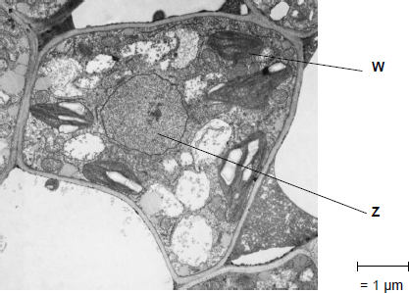

© Science Photo Library

(b)     Give the name and function of the structures labelled **W** and **Z**.

Name of **W** .......................................................................................................

Function of **W** ...................................................................................................

Name of **Z** ........................................................................................................

Function of **Z** ....................................................................................................

**(2)**

(c)     A transmission electron microscope was used to produce the image in the figure above.   
Explain why.

........................................................................................................................

........................................................................................................................

........................................................................................................................

........................................................................................................................

........................................................................................................................

**(2)**

(d)     Calculate the magnification of the image shown in the figure in part (a).

Answer = ...................................

**(1)**

**(Total 9 marks)**

**Q2.**          An agar plate was flooded with a culture of a species of bacterium usually found in the mouth. Four sterile paper discs, **A**, **B**, **C** and **D**, each containing a different brand of mouthwash, were then placed on the agar plate. The drawing shows the appearance of the plate after it had been incubated at 37°C for three days.

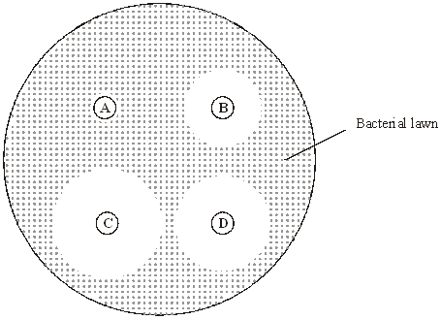

(a)     Describe the aseptic techniques that would be used when flooding the agar plate with bacteria.

......................................................................................................................

......................................................................................................................

......................................................................................................................

......................................................................................................................

......................................................................................................................

......................................................................................................................

**(3)**

(b)     The effectiveness of a mouthwash can be measured by calculating the total area of a paper disc and the clear zone around it. The area of a circle is given by *πr*2, where *r* is the radius of the circle. Calculate how many times more effective mouthwash **C** is than mouthwash **B**. Show your working.

Mouthwash **C** is .................................... times more effective than mouthwash **B**.

**(2)**

**S**       (c)     Several factors affect the rate at which the antiseptic in the mouthwash from each paper disc diffuses through the agar. Describe the effect of **three** named factors on this rate.

1 ...................................................................................................................

......................................................................................................................

2 ...................................................................................................................

......................................................................................................................

3 ...................................................................................................................

......................................................................................................................

**(3)**

**(Total 8 marks)**

**Q3.**          A student investigated the rate of gas exchange in aerobically respiring seeds using the apparatus shown in the diagram. She carried out two experiments.

•        In Experiment **1**, she put potassium hydroxide solution in the beaker. Potassium hydroxide solution absorbs carbon dioxide.

•        In Experiment **2**, she put water in the beaker.

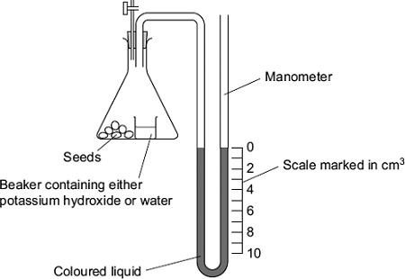

(a)     Both experiments were carried out at the same temperature. Explain why.

........................................................................................................................

........................................................................................................................

........................................................................................................................

........................................................................................................................

........................................................................................................................

**(2)**

(b)     (i)      The level of coloured liquid in the right-hand side of the manometer tube went down during Experiment **1**. Explain why.

...............................................................................................................

...............................................................................................................

...............................................................................................................

...............................................................................................................

...............................................................................................................

...............................................................................................................

*(Extra space)* .......................................................................................

...............................................................................................................

...............................................................................................................

**(3)**

The results from both experiments are shown in the table.

|  |  |  |
| --- | --- | --- |
| **Experiment** | **Solution in beaker** | **Fall in volume of coloured liquid in right-hand side of manometer / cm3** |
| **1** | Potassium hydroxide | 5 |
| **2** | Water | 1 |

(ii)     Use these results to calculate the volume of carbon dioxide produced during Experiment **1**.

                                                  Answer = ..................................... cm3

**(1)**

(c)     The student repeated Experiment 1 using seeds which were respiring anaerobically.  
What would happen to the level of coloured liquid in the right-hand side of the manometer tube? Explain your answer.

........................................................................................................................

........................................................................................................................

........................................................................................................................

........................................................................................................................

........................................................................................................................

**(2)**

**(Total 8 marks)**

**Q4.**          **S**       Gorter and Grendel investigated the structure of the surface membrane of cells. They extracted the phospholipids from the surface membranes of red blood cells in 1 cm3 of blood and placed them in the apparatus shown in **Figure 1**.

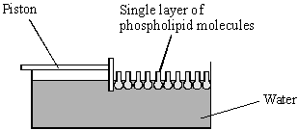

**Figure 1**

The piston was pushed across the surface of the water until the phospholipid molecules were tightly packed into a single layer. The area covered by the phospholipid molecules was measured. This area was compared with the estimated surface area of the red blood cells from which phospholipids were extracted.

Gorter and Grendel obtained the data shown in the table.

|  |  |
| --- | --- |
| Number of red blood cells per cm3 of blood | 4.74 × 109 |
| Estimated mean surface area of one red blood cell | 99.4 μm2 |
| Surface area of membrane phospholipids extracted from 1cm3 of blood | 0.92 m2 |

(a)     Explain what these data suggest about the arrangement of phospholipids in the surface membranes of red blood cells. Support your explanation with suitable calculations.

Show your working.

......................................................................................................................

......................................................................................................................

......................................................................................................................

......................................................................................................................

......................................................................................................................

......................................................................................................................

**(3)**

(b)     **Figure 2** shows a red blood cell and a white blood cell.

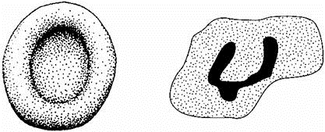

Red blood cell                                  White blood cell

**Figure 2**

Explain why red blood cells were used in this investigation rather than white blood cells.

......................................................................................................................

......................................................................................................................

......................................................................................................................

......................................................................................................................

**(2)**

**(Total 5 marks)**

**Q5.**          (a)     The diagram shows the fluid-mosaic model of a cell surface membrane.

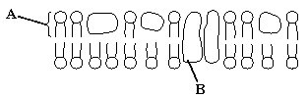

(i)      Name the molecules labelled **A** and **B**.

**A** .........................................................................................................

**B** .........................................................................................................

**(1)**

(ii)     How does the bilayer formed by substance **A** affect entry and exit of substances into and out of a cell?

.............................................................................................................

.............................................................................................................

.............................................................................................................

.............................................................................................................

**(2)**

(b)     A dialysis machine contains artificial membranes which enable urea to be removed from the blood of a person with kidney failure. The diagram shows a dialysis machine.

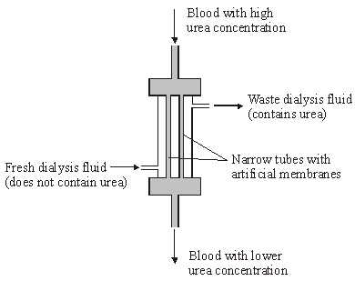

(i)      By what process does urea pass from the blood into the dialysis fluid?

.............................................................................................................

**(1)**

(ii)     Suggest **two** reasons for keeping the fluid in the dialysis machine at 40 °C rather than room temperature.

1 .................................................................................................…….

.............................................................................................................

2 ...........................................................................................................

.............................................................................................................

**(2)**

(iii)     The blood and the dialysis fluid flow in opposite directions in the dialysis machine. Explain the advantage of this.

.............................................................................................................

.............................................................................................................

.............................................................................................................

.............................................................................................................

**(2)**

(iv)    Blood flows through the dialysis machine at a rate of 200 cm3 per minute.  
Calculate the total volume which passes through the machine in 5 hours.  
Give your answer in dm3 and show your working.

Answer .................................... dm3

**(2)**

**(Total 10 marks)**

**Q6.**          The diagram shows a cross-section of an artery.

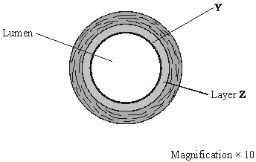

(a)     Name the layer labelled **Y**.

......................................................................................................................

**(1)**

(b)     Layer **Z** contains a high proportion of elastic tissue.

Describe the advantage of having elastic tissue in the wall of an artery.

......................................................................................................................

......................................................................................................................

......................................................................................................................

......................................................................................................................

**(2)**

(c)     Calculate the cross-sectional area of the lumen of the artery shown in the diagram. Show your working.

The area of a circle is given by π*r*2, where *r* is the radius of a circle (π = 3.14).

Answer ................................... mm2

**(3)**

**(Total 6 marks)**

**Q7.** The drawing shows an electron micrograph of a section through part of an alveolus from a lung.

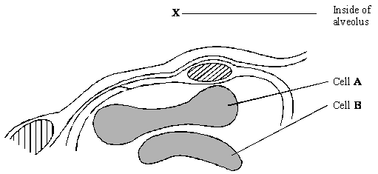

(a)     Describe the path of a molecule of oxygen from the air in the alveolus at **X** to the plasma membrane of cell **A**.

......................................................................................................................

......................................................................................................................

**(1)**

(b)     Cell **A** is a eukaryotic cell. Give **two** features that may be found in a prokaryotic cell which are not found in cell **A**.

1 ...................................................................................................................

......................................................................................................................

2 ...................................................................................................................

......................................................................................................................

**(2)**

(c)     Cells **A** and **B** are biconcave discs. Explain **one** advantage of a biconcave disc over a spherical cell of the same volume in transporting oxygen.

......................................................................................................................

......................................................................................................................

......................................................................................................................

......................................................................................................................

**(2)**

(d)     The diameter of a human red blood cell is 7 µm.

(i)      Calculate the magnification of the drawing. Show your working.

Magnification = ...............................

**(2)**

(ii)     In calculating the magnification, what assumption did you have to make about how the section was cut?

.............................................................................................................

.............................................................................................................

**(1)**

**(Total 8 marks)**

**Q8.**          The table shows the relative thickness of layers in the walls of an artery and a vein.

|  |  |  |  |
| --- | --- | --- | --- |
|  | **Layer in wall** | **Thickness / µm** | |
|  |  | **Artery** | **Vein** |
|  | Endothelium | 20 | 20 |
|  | Smooth muscle | 490 | 240 |
|  | Elastic tissue | 370 | 240 |
|  | Connective tissue | 120 | 120 |

(a)     Explain why a vein may be described as an organ.

......................................................................................................................

......................................................................................................................

**(1)**

(b)     (i)      Use information from the table to suggest the thickness of a capillary wall.   
Give the reason for your answer.

.............................................................................................................

.............................................................................................................

**(1)**

(ii)     The diameter of the artery was 4 mm. Calculate the diameter of the lumen of this artery. Show your working.

Answer .................................

**2)**(c)     Explain how the elastic tissue in the wall helps to even out the pressure of blood flowing through the artery.

......................................................................................................................

......................................................................................................................

......................................................................................................................

......................................................................................................................

**(2)**

**(Total 6 marks)**

**Q9.**Catalase is used in a number of industrial processes. It is normally obtained from a fungus called *Aspergillus niger*. Scientists produced a mutant strain of *A*. *niger* called K30. They wanted to know if this mutant strain produced more catalase than the normal strain of *A*. *niger*.

•        The scientists grew samples of the normal strain of the fungus and of the K30 strain on jelly in separate Petri dishes. The jelly contained a blue substance which is turned colourless by catalase.

•        They incubated the dishes for 3 days then measured the diameter of the colourless zone around the fungus.

•        They calculated the ratio of the diameter of the colourless zone to the diameter of the fungus.

The diagram shows the dishes after incubation.

**Normal  
strain**

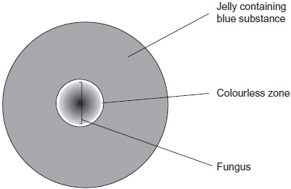

**K30 strain**

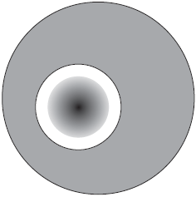

(a)     The scientists grew both strains of fungi on dishes kept at 30 °C. Keeping the dishes at a temperature of 15 °C would affect the results. Use your knowledge of kinetic energy to explain why.

........................................................................................................................

........................................................................................................................

........................................................................................................................

........................................................................................................................

........................................................................................................................

**(2)**

(b)     (i)      The scientists gave their results as ratios. Explain the advantage of giving the results of this investigation as a ratio.

...............................................................................................................

...............................................................................................................

...............................................................................................................

...............................................................................................................

...............................................................................................................

**(2)**

(ii)      For the normal strain the ratio of the diameter of the colourless zone to the diameter of the fungus was 1.1 : 1.

Calculate the ratio of the diameter of the colourless zone to the diameter of the fungus for the K30 strain. Show your working.

Ratio = ...................................................

**(2)**

(c)     The catalase produced by the K30 strain of the fungus is mainly an extracellular enzyme. This means that the fungus secretes catalase from its cells into the jelly in the Petri dish.

Describe and explain the evidence from the investigation which shows that the catalase is an extracellular enzyme.

........................................................................................................................

........................................................................................................................

........................................................................................................................

........................................................................................................................

........................................................................................................................

**(2)**

**(Total 8 marks)**

**Q10.**          (a)     What is an antigen?

......................................................................................................................

......................................................................................................................

......................................................................................................................

**(2)**

(b)     Describe how B-lymphocytes respond when they are stimulated by antigens.

......................................................................................................................

......................................................................................................................

......................................................................................................................

......................................................................................................................

......................................................................................................................

......................................................................................................................

......................................................................................................................

......................................................................................................................

**(4)**

(c)     The diagram shows some components of a human immunodeficiency virus (HIV).

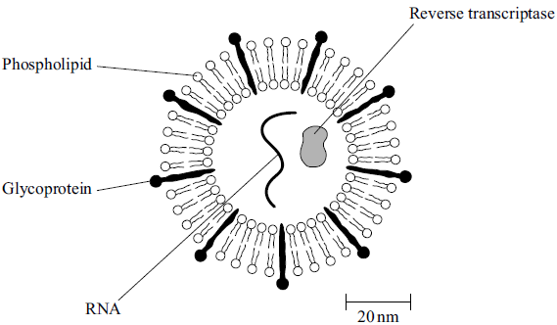

(i)      Suggest which labelled component of the virus is most likely to act as an antigen. Give a reason for your answer.

Component .........................................................................................

Reason ...............................................................................................

.............................................................................................................

**(1)**

(ii)     A cell that HIV infects is 15 µm in diameter. Calculate how many times larger in diameter this cell is than an HIV particle. Show your working.

Answer ...................................... times larger

**(2)**

**(Total 9 marks)**

**Q11.**          The drawing shows part of the lower leaf epidermis of sorghum.

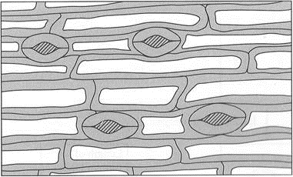



(a)     Calculate the number of stomata per mm2 of the leaf surface. Show your working.

Answer ....................................... stomata per mm2

**(2)**

(b)     Sorghum has few stomata per mm2 of leaf surface area. Explain how this is an adaptation to the conditions in which sorghum grows.

......................................................................................................................

......................................................................................................................

......................................................................................................................

......................................................................................................................

......................................................................................................................

......................................................................................................................

**(3)**

**(Total 5 marks)**

**Q12.**Scientists investigated the effect of lipase and a 3% bile salts solution on the digestion of triglycerides. The graph below shows their results.

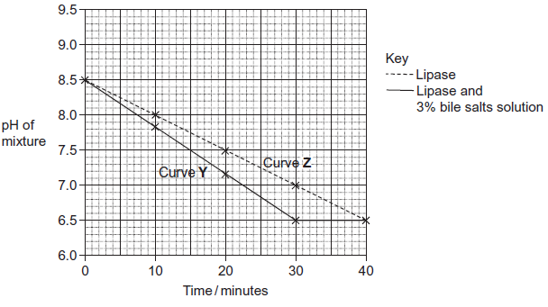

The scientists also incubated triglycerides with different concentrations of bile salts. After 30 minutes they measured the diameter of the triglyceride droplets. They used the results to calculate the mean radius of the droplets at each concentration. The table below shows their results.

|  |  |  |  |  |  |  |  |
| --- | --- | --- | --- | --- | --- | --- | --- |
|  | Concentration of bile salts /% | 0 | 1 | 2 | 3 | 4 | 5 |
|  | Mean radius of triglyceride droplet / μm | 6 | 5 | 4 | 3 | 2 | 1 |

(a)     Describe how you would use a microscope to find the mean diameter of triglyceride droplets on a slide.

.........................................................................................................................

.........................................................................................................................

.........................................................................................................................

.........................................................................................................................

.........................................................................................................................

.........................................................................................................................

*(Extra space)* ..................................................................................................

.........................................................................................................................

.........................................................................................................................

**(3)**

(b)     (i)      The ratio of mean radius of triglyceride droplets in bile salts at a concentration of 0% to the mean radius in bile salts at a concentration of 3% is 2 : 1.

What is the ratio of their surface areas? Show your working.

You can calculate the surface area of a droplet from the formula

A = 4*π*r2

Where  A = surface area  
    r = radius  
   *π* = 3.14

**(2)**

(ii)     Use the data in the table to explain the difference between curves **Y** and **Z** in the graph.

...............................................................................................................

...............................................................................................................

...............................................................................................................

...............................................................................................................

...............................................................................................................

...............................................................................................................

*(Extra space)* ........................................................................................

...............................................................................................................

...............................................................................................................

**(3)**

**(Total 8 marks)**

**M1.**(a)     1.      Add drop of water to (glass) slide;

2.      Obtain thin section (of plant tissue) and place on slide / float on drop of water;

3.      Stain with / add iodine in potassium iodide.

*3.    Allow any appropriate method that avoids trapping air bubbles*

4.      Lower cover slip using mounted needle.

**4**

(b)     1.      **W** – chloroplast, photosynthesis;

2.      **Z** – nucleus, contains DNA / chromosomes / holds genetic information of cell.

**2**

(c)     1.      High resolution;

2.      Can see internal structure of organelles.

**2**

(d)     Length of bar in mm × 1000.

**1**

**[9]**

**M2.**          (a)     sterilisation of equipment (*once*);  
use of pipette / syringe to transfer culture suspension to plate;  
use of spreader / shake ;  
detail regarding lid, e.g. keeping over plate during transfer / spreading;

**3 max**

(b)     2.25 = 2 marks  
(*general principle (1.52 ÷ 12) gains 1 mark*)

**2**

(c)     increased temperature increases rate;  
increased concentration increases rate;  
increased molecule size decreases rate;

*(allow increased distance decreases rate)*

**3 max**

**[8]**

**M3.**          (a)     1.      Affects enzymes;

*‘respiration involves enzymes’ = two marks*

2.      Affects respiration;

*Ignore reference to controlling a variable*

                 Or

3.      Affects volume / pressure of gases;

*Mark point 4 can only be awarded if mark point 3 has been credited*

4.      Affects readings;

**2 max**

(b)     (i)     1.      Oxygen taken up / used (by seeds);

*Reject air is taken up for mark point 1*

2.      Carbon dioxide (given out) is absorbed by solution / potassium hydroxide;

3.      Decrease in volume / pressure (inside flask);

*Reference to vacuum negates mark point 3*

**3**

(ii)     4;

**1**

(c)     1.      Remains the same;

2.      No oxygen uptake / used;

*Any reference to ‘carbon dioxide* ***not*** *being produced’ disqualifies mark point 2*

**2**

**[8]**

**M4.**          (a)     phospholipids in a double layer / area covered is twice total surface area of red blood cells;   
evidence of calculation of number × surface area (4.74 × 109 × 99.4 μm2 ) /

calculation of area of 1 cell 

0.471 m2 ≈ 0.5 × 0.92 m2 / 194 μm ≈ 2 × 99.4;

**3**

(b)     EITHER feature + explanation  
red blood cells do not contain organelles / nucleus;   
so only surface membrane / no internal membranes in macerate;  
OR  
red blood cells have simple / regular / spherical shape;  
so easy to calculate surface area;  
OR  
*any two features, e.g.*simple / regular shape;  
all same size;

**2**

**[5]**

**M5.**          (a)     (i)      **A** = phospholipid

**B** = protein;

*(both correct)*

**1**

(ii)     allows movement of lipid soluble / non-polar molecules / named  
e.g. water / gases;  
prevents movement of water soluble / polar molecules / named  
e.g. ions / amino acids;  
idea of selection / membrane partially / differentially permeable /   
large molecules do not move through, small molecules do;

*(accept semi-permeable)*

**2 max**

(b)     (i)      diffusion

*(reject facilitated)*

**1**

(ii)     higher rate of exchange / diffusion;  
prevents cooling of the blood / prevents increase in viscosity;

**2**

(iii)     concentration gradient maintained / equilibrium never achieved;  
blood always meets fluid with lower concentration of urea;  
diffusion / exchange along the whole length of surface;

**2 max**

(iv)    0.2 × 60 = 12 dm3 h-1;

*(principle: volume per hour)*

12 × 5 = 60 dm3;

*(correct answer 2 marks)*

**2**

**[10]**

**M6.**          (a)     endothelium / tunica intima *(accept endothelial cells)*;

**1**

(b)     elastic tissue allows recoil  
(*reject* *if wording implies a muscle e.g. contract / relax)(ignore expand)*;  
maintains blood pressure / constant / smooth blood flow  
*(not increases blood pressure)*;

**2**

(c)     measuring radius / 12 mm / 12.5 mm / 1.2 cm / 1.25 cm;  
correct calculation / 3.14 × 12 x 12 = 452 / 3.14 x 12.5 x 12.5 = 490 / 491;

*allow for magnification ÷100 = 4.52 / 4.9;*

*(allow 1 mark for correct calculation using incorrect radius)*

**3**

**[6]**

**M7.**          (a)     Epithelium of alveolus, capillary wall / epithelium / endothelium, plasma;

**1**

(b)     Cell wall;  
Capsule;  
Flagellum;  
Mesosomes;  
Plasmid;  
Genetic material / DNA / nucleoid;  
Ribosomes;

*Accept references to size only if some idea of range is given*

**max 2**

(c)     Large (surface) area;  
For diffusion;  
     or  
Short distance to centre of cell / to all haemoglobin;  
For diffusion;

**2**

(d)     (i)      Correct answer of approximately 7800 / 8000 = 2 marks  
Incorrect answer but clearly derived by  
dividing diameter of cell A by 7                        = 1 mark

**2**

(ii)     Idea of cut through maximum diameter / middle;

**1**

**[8]**

**M8.**          (a)     made of (different) tissues / specified tissues;

**1**

(b)     (i)      20 µm as it consists of endothelium only / does not contain muscle,  
connective tissues and elastic tissue;

*(consider other answers and credit understanding.)*

**1**

(ii)     1 mark        calculation derived from diameter - (2 × wall thickness) /   
                   answer of 3mm;  
2 marks      2mm / 2000µm;

**2**

(c)     stretches as a result of high pressure / surge of blood;  
then recoils;

**2**

**[6]**

**M9.**(a)     ***EITHER***

*Answer either based on*

1.      Molecules move at slower speeds;

*2 diffusion or*

2.      Decreases rate of diffusion;

*4 enzymes.*

***OR***

3.      Molecules move at slower speed;

4.      Fewer collisions between enzymes and substrates / fewer enzyme-substrate complexes formed;

*Accept converse answers if clearly in context of “If it stayed at 30 C”.*

**2 max**

(b)     (i)      1.      Allows comparison;  
2. Different amounts of fungus added / fungus is different size at start;

**2**

(ii)     Two marks for correct answer in range 1.7 : 1 to 1.3 : 1;;

*Answer must be expressed this way round and must give the diameter of the fungus as 1.*

One mark for unsimplified answer in range 29 : 19 to 27 : 21;

*Calculations are based on tolerance limits for measurements of ± 1 mm. If the actual measurements are other than 28 and 20, marking guidelines should be adjusted accordingly.*

**2**

(c)     1.      Colourless zone around fungus / colourless zone outside fungus;

2.      No fungus growing here / must be enzyme here;

*Accept any alternative wording clearly relating to colourless zone.*

**2**

**[8]**

**M10.**          (a)     molecule / part of molecule / protein / glycoprotein / named molecule;  
that stimulates an immune response / eq;

**2**

(b)     divide by mitosis / form clones; produce plasma cells; (plasma cells)   
make antibodies;  
(plasma cells) produce memory cells;

**4**

(c)     (i)      glycoprotein AND  
different shape to body proteins / RNA and reverse transcriptase  
inside virus / phospholipids same as body’s / on the surface  
of the virus;

**1**

(ii)     187.5;;

*Accept 187 – 188*

*1 mark for HIV = 80nm;*

**2 max**

**[9]**

**M11.**          (a)     235–240;;  
*(one mark for an answer between 200-300  
based on 2 - 3 stomata in 0.01mm2Alternatively, one mark for calculating the area of the  
rectangle correctly as 0.016 – 0.017mm2)*

**2**

(b)     grows in arid / dry conditions;  
less surface area;  
(rate of) transpiration / water loss would be reduced;

**3**

**[5]**

**M12.**(a)     Measure with eyepiece graticule / scale;  
Calibrate with stage micrometer / scale on slide / object of known size;   
Repeats and calculate the mean;  
***OR***Use a ruler to estimate the field diameter under microscope;  
How many droplets go across the field;  
Repeats and calculate mean;

*Accept references to radius*

**3**

(b)     (i)      Two mark for correct answer of 4 : 1;;  
One mark for incorrect answer but working shows that candidate has clearly attempted to compare values of r2 / 62 and 32 / 36 and 9;

*Idea of comparing ratios  
A ratio of 1 : 4 should gain 1 mark*

**2**

(ii)     Small droplets have a larger surface area to volume ratio;

More surface for lipase (to act), leading to faster digestion of triglycerides;

Fatty acids are produced more quickly so pH will drop more quickly in curve Y / with bile salts / less fatty acids in curve Z / without bile salts so pH drop more slowly;

**3**

**[8]**

**E2.**          (a)     A majority of candidates failed to refer to ‘…when flooding the agar plate with bacteria’ required by the question. Thus, the examiner was given long accounts of mopping benches with disinfectant, autoclaving of dishes and safe disposal of dishes. Reference to use of a spreader was comparatively rare.

(b)     Many candidates achieved the correct answer, but few realised that ‘π‘ cancelled out and went on to do unnecessarily long calculations.

(c)     Many candidates realised that factors such as concentration, temperature and molecule size would affect the rate, but failed to state how the rate would be affected by these. Weaker candidates gave explanations in terms of bacteria, or of the strength of the antiseptic.

**E3.**          (a)      A significant number of students failed to explain adequately why both experiments were carried out at the same temperature. Their responses were often limited to having a ‘fair test’ or controlling a variable. Students who provided more details often gained a mark for mentioning that temperature affects enzyme-controlled reactions. Better students specifically referred to respiration and obtained the second mark point.

(b)     (i)      This question provided a good spread of marks. The most common scoring point was the absorption of carbon dioxide by potassium hydroxide. Many students gained a second mark for the uptake of oxygen by the seeds. Better students obtained maximum marks by stating that a decrease in volume or pressure in the flask would cause the level of the coloured liquid to go down in the right-hand side of the manometer tube. However, a significant number of students failed to gain this mark as they only referred to a change in pressure or stated that a vacuum was produced. Some students suggested that photosynthesis was taking place with the seeds absorbing carbon dioxide and producing oxygen.

(ii)     Rather surprisingly relatively few students provided the correct answer of 4. The most common incorrect answer was 5, although a full range of numerical values from 0 to 15 was noted by examiners.

(c)      Approximately one in four students gained both marks. These students often clearly explained that no oxygen would be used by the seeds and, as any carbon dioxide produced would be absorbed by the potassium hydroxide, the level of liquid would not change. A third of students gained one mark often for stating that no oxygen uptake would occur. Some students negated this mark point by suggesting that carbon dioxide is not produced during anaerobic respiration. A minority of students suggested ethanol would affect the level of coloured liquid in the tube.

**E4.**          (a)     A majority of candidates did not attempt to calculate the total surface area of the red blood cells. Most of those who made the attempt had difficulty with units or with standard form, consequently only a handful successfully completed the calculation and were able to make the correct deduction from the data.

(b)     Most candidates obtained at least one of the two marks, but relatively few could relate the feature they described to measurement of membrane surface area.

**E5.**          (a)     The molecules in the membrane were well identified with many candidates qualifying the type of protein present. There was some confusion in (ii) over the distinction between the movement of water-soluble molecules and water itself with some candidates failing to appreciate that water can move across the membrane in the same way as other very small molecules such as oxygen. A small number of candidates still referred to the membrane as *semi-permeable* and should be encouraged to follow the Institute of Biology recommended terminology of *partially permeable* whenever possible.

(b)     This question produced a wide spread of marks. Most candidates identified the process of diffusion and went on to recognise an increase in rate related to temperature but very few referred to the cooling effect on the blood. Only more able candidates were able to apply the principles of countercurrent flow to the novel situation and gain both marks in part (iii). Many candidates correctly related volume to time in the calculation but were then unable to express this in the correct units, indicating problems with cm³ and dm³.

**E6.**          (a)     Few candidates gave the correct answer, with a strong centre-dependent effect. Candidates’ incorrect answers included endodermis, epithelium, mucosa, muscle layer or pericycle.

(b)     Most candidates were able to describe the role of the elastic tissue in maintaining blood pressure, or in smoothing the flow of blood by elastic recoil. In some poorly expressed answers, the role of elastic tissue was too similar to that for a muscle for a mark to be awarded. The concept of ‘contraction’ was used loosely by some candidates, whilst others had the misconception that elastic tissue is able to contract.

(c)     Most candidates measured the diameter of the artery lumen accurately but many then used this in the calculation, rather than the radius. Only the most able candidates made allowance for the magnification (factor) given in the diagram. For many candidates a correct calculation was the only mark achieved for this question. Only the most able candidates were able to gain all three marks because they allowed for the magnification given in the diagram.

**E7.**          (a)     Only the best candidates interpreted the diagram correctly and, having done this, were able to describe the pathway in appropriate biological language. There were rather too many references to walls and membranes to be sure of understanding. In addition, there was some interpretation of the question as requiring a reference to the mechanism involved. This resulted in some lengthy explanations of the process of diffusion.

(b)     Common correct answers were the possession of a capsule and a cell wall, but there was a disappointing number of incorrect responses. These tended to arise either because the candidate sought to compare a prokaryotic cell with an unspecified eukaryotic cell, or because references were made to features such as nuclei and mitochondria which were absent from prokaryotic cells. Many of the responses made in this question clearly highlighted the perils of failing to read the question carefully.

(c)     Candidates who explained the advantage of a disc shape in terms of increased surface area encountered few problems in equating this property to diffusion. Others were less successful, either because they were unable to explain the flattened shape of the cell in terms of a short diffusion pathway, or because they constructed inappropriate arguments based on the amount of haemoglobin present or the flexibility of the cells.

(d)     Despite the frequency of such calculations in Unit tests, candidates met with only limited success in part (i). This part of the question gave rise to two problems which created particular difficulties. Candidates had to select the right measurement to represent the diameter and they had to convert this measurement to micrometres. Both tasks presented major hurdles to those of more limited ability. Further difficulties arose from a failure to calculate magnification from the data provided. Part (ii), however, was generally answered well, although there were those who sought to offer explanations based on resolution or the orientation of the specimen, perhaps relying on uncertain memories of previous mark schemes.

**E8.**          (a)     Answers emphasised that the term “organ” is better defined in terms of structure than function.

Answers such as that an organ has a “specific function” are true of all levels of organisation from molecule to system.

(b)     (i)      Required candidates to draw on the information in the table and their understanding of the structure of capillary walls to suggest the required figure. Better candidates had no difficulty in arriving at an answer of 20 µm. Those candidates who appreciated that this was considerably larger than the value they might have expected were also given credit, as long as their responses were suitably explained.

(ii)     Incorrect answers were frequent, commonly resulting from either the inability to convert micrometres to millimetres, or to a failure to appreciate that the wall completely surrounds the lumen.

(c)     Produced numerous answers which were based on the use of inappropriate terminology.

Candidates should be advised to refer to elastic tissue stretching and recoiling, reserving the terms contracting and relaxing for muscle.

**E9.**(a)     Students were provided with “kinetic energy” as a starting point for their answers to this question and therefore should not have expected credit merely for stating that it decreased. They were expected to go beyond this and link the decrease in kinetic energy to the slower speed of molecular movement and, if they approached the question from an enzyme standpoint, fewer collisions between enzymes and substrates. In general, there was a clear understanding of principles but responses often lacked the necessary detail to secure full credit.

(b)     (i)      While it was widely appreciated that the use of ratios allowed comparisons to be made, fewer students could explain why their use was important in the context of this investigation. The key feature was that it took into account differences in the initial amount of fungus, not just the amount of fungus.

(ii)     The majority of students used the model provided and expressed the results of their calculations appropriately.

(c)     It was again clear from the responses to this question that many of the less able students experienced difficulties with a question that required explanation. It was apparent to the moderating team that while most understood the relatively simple idea underpinning the question only the better students were able to explain this logically and unambiguously.

**E10.**          (a)     This generally proved a good opening question, but weaker responses were less specific about the nature of the ‘chemical’, or just referred to a ‘substance’ that stimulates an immune response.

(b)     It was not uncommon to see all marks achieved. Better candidates appreciated that the B-lymphocytes would divide by mitosis, or produce clones, and then produced an accurate description of the production of antibody-secreting plasma cells and memory cells. Weaker responses discussed the role of T-lymphocytes, pathogens, plasmids or assumed that memory cells already existed.

(c)     While many could correctly identify the glycoprotein as the component, the reason provided was often unconvincing. At a simple level, glycoproteins were on the surface of the virus -not the cell - but few identified that difference in shape, from body proteins, would enable recognition of the antigen. An accurate calculation was rarely seen with few able to achieve both marks and some did not attempt it. Lack of clear working meant that it was not possible to award any credit in many cases.

**E11.**          (a)     Very few candidates correctly worked out the area as 0.0167mm2 and many seemed to have a basic problem with calculating areas. It was common to see 0.1 x 0.1 = 0. l mm2. Many candidates failed to gain credit by carrying out calculations that were not clearly identified. A common approach was to estimate the number of stomata in an area 0. 1mm x 0. 1mm, which gained credit if done correctly. Many gave answers that were clearly incorrect, such as 20-25 or even 0.25!

(b)     Most candidates picked up the 2 marking points but some failed to gain the second point by incorrectly stating that ‘fewer stomata prevent water loss’. Few answers referred to the idea of there being a reduced surface area.