**Q1.**(a)     Contrast the processes of facilitated diffusion and active transport.

........................................................................................................................

........................................................................................................................

........................................................................................................................

........................................................................................................................

........................................................................................................................

........................................................................................................................

**(Extra space)** ................................................................................................

........................................................................................................................

........................................................................................................................

**(3)**

Students investigated the uptake of chloride ions in barley plants. They divided the plants into two groups and placed their roots in solutions containing radioactive chloride ions.

•        Group **A** plants had a substance that inhibited respiration added to the solution.

•        Group **B** plants did not have the substance added to the solution.

The students calculated the total amount of chloride ions absorbed by the plants every 15 minutes. Their results are shown in the figure below.

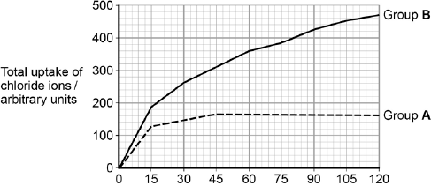  
                  Time / minutes

(b)     Calculate the ratio of the mean **rate** of uptake of chloride ions in the first hour to the **rate** of uptake of chloride ions in the second hour for group **B** plants.

Ratio = ................................... :1

**(2)**

(c)     Explain the results shown in the figure above.

........................................................................................................................

........................................................................................................................

........................................................................................................................

........................................................................................................................

........................................................................................................................

........................................................................................................................

........................................................................................................................

........................................................................................................................

........................................................................................................................

**(Extra space)** ................................................................................................

........................................................................................................................

........................................................................................................................

........................................................................................................................

**(4)**

**(Total 9 marks)**

**Q2.**Scientists measured the rate of respiration in **three** parts of an ecosystem.

They did this by measuring carbon dioxide released into the air by:

•        leaves of plants

•        stems and roots of plants

•        non-photosynthetic soil organisms.

The table below shows the scientists’ results for these three parts of the ecosystem.

|  |  |  |  |
| --- | --- | --- | --- |
|  | **Part of ecosystem** | **Mean rate of carbon dioxide production / cm3 m−2 s−1** | **Percentage of total carbon dioxide production measured by the scientists** |
|  | Leaves of plants | 0.032 | 25.0 |
|  | Stems and roots of plants | 0.051 |  |
|  | Non- photosynthetic soil organisms | 0.045 |  |

(a)     Complete the table to show the percentage of total carbon dioxide production by each part of the ecosystem.

Show your working.

**(2)**

(b)     A student who looked at the data in the table concluded that plants carry out more respiration than non-photosynthetic organisms in the ecosystem.

Use the information provided to suggest why these data may **not** support the student’s conclusion.

........................................................................................................................

........................................................................................................................

........................................................................................................................

........................................................................................................................

**(2)**

(c)     What measurements would the scientists have made in order to calculate the rate of carbon dioxide production?

........................................................................................................................

........................................................................................................................

........................................................................................................................

........................................................................................................................

**(2)**

(d)     The scientists calculated the mean rate of carbon dioxide production of the leaves using measurements of carbon dioxide release in the dark.

Explain why they did **not** use measurements taken in the light.

........................................................................................................................

........................................................................................................................

........................................................................................................................

........................................................................................................................

**(2)**

Another group of scientists measured the mean rate of respiration in soil under trees and soil not under trees in the same wood. They also measured the mean rate of photosynthesis in the trees.

They took measurements at different times of day during the summer.

The figure below shows the scientists’ results.

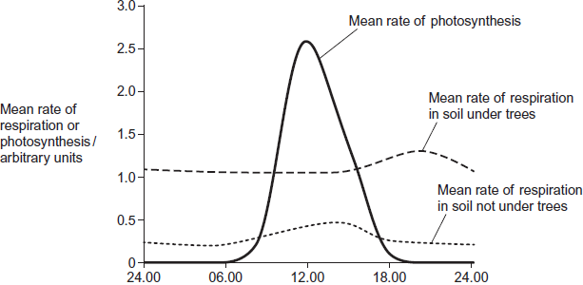  
          Time of day

(e)     (i)      Describe **two** ways in which the mean rate of respiration in soil under trees is different from soil not under trees.

1 ............................................................................................................

...............................................................................................................

2 ............................................................................................................

...............................................................................................................

**(2)**

(ii)     Suggest **one** explanation for the differences in the mean rate of respiration in soil under trees and soil not under trees between 06.00 and 12.00.

...............................................................................................................

...............................................................................................................

...............................................................................................................

...............................................................................................................

**(2)**

(f)     The scientists suggested that the rise in the mean rate of photosynthesis was the cause of the rise in the mean rate of respiration in soil under trees.

(i)      Suggest how the rise in the mean rate of photosynthesis could lead to the rise in the mean rate of respiration in soil under trees.

...............................................................................................................

...............................................................................................................

...............................................................................................................

...............................................................................................................

**(2)**

(ii)     Suggest why there is a delay between the rise in the mean rate of photosynthesis and the rise in the mean rate of respiration.

...............................................................................................................

...............................................................................................................

**(1)**

**(Total 15 marks)**

**Q3.**Woodlice use gills for gas exchange. These gills are situated on the outside of the animal so water loss occurs from the gill surface. When a number of woodlice occur together they often form a ‘clump’ with individual woodlice touching each other.

A student investigated the effect of clumping on the rate of water loss from the woodlice. The student divided the 12 woodlice into two groups. He allowed the woodlice in group A to clump together, but kept the woodlice in group B separate from each other.

The following table shows the mean mass of the woodlice in each group.

|  |  |  |  |
| --- | --- | --- | --- |
|  | **Time / minutes** | **Mean mass of woodlice / g** | |
|  | Group **A** | Group **B** |
|  | 0 | 0.180 | 0.175 |
|  | 20 | 0.170 | 0.130 |
|  | 40 | 0.165 | 0.110 |
|  | 60 | 0.160 | 0.090 |
|  | 80 | 0.160 | 0.080 |

(a)     (i)      Calculate the percentage loss in the mean mass of the woodlice in Group **A** during the investigation. Show your working.

Answer ......................................

**(2)**

(ii)     Woodlice in Group **B** had a greater percentage loss in mean mass during the investigation than woodlice in Group **A**. Explain why.

...............................................................................................................

...............................................................................................................

...............................................................................................................

...............................................................................................................

...............................................................................................................

...............................................................................................................

(Extra space) ........................................................................................

...............................................................................................................

...............................................................................................................

**(3)**

(iii)    It would be useful to give the loss in mean mass as a percentage in this investigation.  
Explain why.

...............................................................................................................

...............................................................................................................

**(1)**

**(Total 6 marks)**

**Q4.**During the last 50 years, there have been changes in the climate of the UK. One of the main changes is temperature. The data in the following resources all relate to southern England.

**Figure 1** shows the mean temperatures for January and February combined.

**Figure 1**

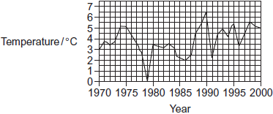

**Figure 2** shows the mean temperatures for March.

**Figure 2**



Birds, such as chaffinches, have been recorded as breeding earlier. Chaffinches build nests. When the nest is complete, the female lays eggs until she has produced a full clutch of 4 to 6 eggs. After the eggs hatch, the parent birds feed the young on insects.

**Figure 3** shows the mean date on which chaffinches laid their first egg.

**Figure 3**

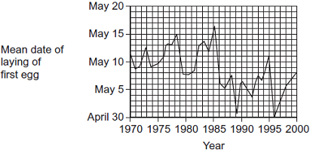

The data from which this graph was drawn were collected by volunteers. They used standard record cards. The volunteers used one record card for each nest they found. Each card was used to record

•        the geographical location

•        the habitat in which the nest site was situated

•        the date of each visit to the nest by the volunteer

•        the number of eggs present in the nest at each visit.

Visits were made to the nests at least once every 5 days.

(a)     Do the data in **Figure 1** and **Figure 2** support the idea that there has been a rise in the mean temperatures in southern England between 1970 and 2000? Explain your answer.

........................................................................................................................

........................................................................................................................

........................................................................................................................

........................................................................................................................

........................................................................................................................

**(2)**

(b)     Describe briefly how you would use a statistical test to find whether there is a significant correlation between mean March temperature and the date when chaffinches laid their first egg.

........................................................................................................................

........................................................................................................................

........................................................................................................................

........................................................................................................................

........................................................................................................................

........................................................................................................................

(Extra space) .................................................................................................

........................................................................................................................

........................................................................................................................

**(3)**

(c)     In chaffinches, the date of laying the first egg is determined by a number of factors. These include day length and temperature. What is the advantage to the bird of egglaying being determined by

(i)      daylength

...............................................................................................................

...............................................................................................................

...............................................................................................................

...............................................................................................................

...............................................................................................................

**(2)**

(ii)     temperature?

...............................................................................................................

...............................................................................................................

...............................................................................................................

...............................................................................................................

...............................................................................................................

**(2)**

(d)     Scientists found that there was a correlation between mean annual temperature and the date when chaffinches laid the first egg. Can you conclude that higher temperatures cause earlier laying of the first egg?  
Explain your answer.

........................................................................................................................

........................................................................................................................

........................................................................................................................

........................................................................................................................

........................................................................................................................

**(2)**

(e)     How does the way in which the data were collected affect the conclusions which can be drawn from **Figure 3**?

........................................................................................................................

........................................................................................................................

........................................................................................................................

........................................................................................................................

........................................................................................................................

**(2)**

**(Total 13 marks)**

**Q5.**Scientists tested a claim that modified citrus pectin (MCP) increased the production of antibodies by the immune system.

•        They divided a large number of mice into five groups.

•        They gave the mice in each group a different amount of MCP in their food.

•        The scientists then stimulated antibody production in the mice. They did this by injecting them with a solution containing sheep red blood cells.

The results are shown in the graph.

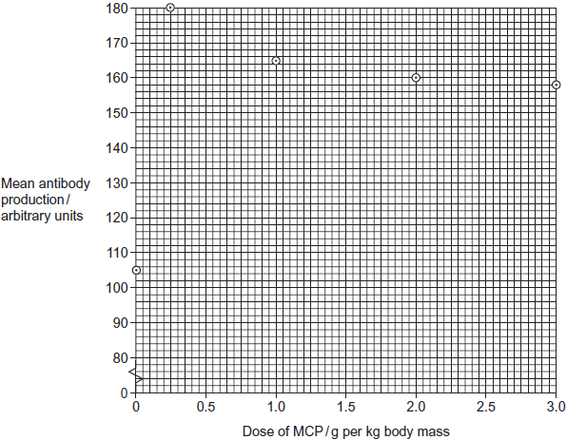

(a)     The data obtained in this investigation have been plotted on a graph. How would you join the points? Give a reason for your answer.

........................................................................................................................

........................................................................................................................

........................................................................................................................(1)

(b)     Use the graph to describe the effect of MCP on mean antibody production.

........................................................................................................................

........................................................................................................................

........................................................................................................................

........................................................................................................................

........................................................................................................................

**(2)**

(c)     Calculate the percentage increase in antibody production from when there was no MCP in the diet to when the dose is 1.0 g per kg.

Answer ....................................................%

**(2)**

(d)     The dose of MCP given to the mice was calculated in g per kg body mass. Explain why the dose was calculated per unit mass.

........................................................................................................................

........................................................................................................................

**(1)**

(e)     Explain how antibodies were produced when the mice were injected with sheep red blood cells.

........................................................................................................................

........................................................................................................................

........................................................................................................................

........................................................................................................................

........................................................................................................................

........................................................................................................................

(Extra space) .................................................................................................

........................................................................................................................

........................................................................................................................

**(3)**

(f)      A newspaper suggested that these data show that taking MCP will give people increased resistance to disease. With reference to the data give **two** reasons why this conclusion may **not** be valid.

1 .....................................................................................................................

........................................................................................................................

2 .....................................................................................................................

........................................................................................................................

**(2)**

**(Total 11 marks)**

**Q6.**Herbicides are substances that kill weeds. Three farmers wanted to know which herbicide to use to control weeds in fields of barley. They chose eleven fields of barley and used a different herbicide in each field. Four weeks later they collected, counted and weighed the weeds in each field. Their results are shown in **Figure 1** and **Figure 2**.

**Figure 1**

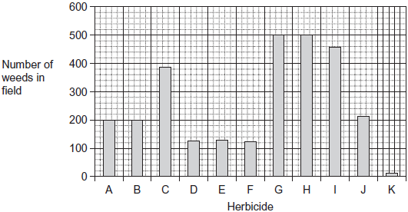

**Figure 2**

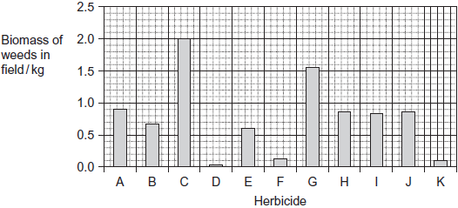

(a)     Describe the difference in biomass of **each** of the weed plants in fields treated with herbicides **G** and **H**. Explain how you arrived at your answer.

........................................................................................................................

........................................................................................................................

........................................................................................................................

........................................................................................................................

........................................................................................................................

**(2)**

(b)     The farmers decided that **K** would be the best herbicide to use.  
Explain why herbicide **K** would give a higher crop yield.

........................................................................................................................

........................................................................................................................

........................................................................................................................

........................................................................................................................

........................................................................................................................

**(2)**

(c)     The farmers carried out their investigation during the summer.  
Suggest **one** advantage and **one** disadvantage of carrying out this investigation during the summer.

Advantage ......................................................................................................

........................................................................................................................

Disadvantage .................................................................................................

........................................................................................................................

**(2)**

(d)     One of the farmers told a local newspaper reporter of their findings. The newspaper published an article with the following headline: “Local farmers show scientists the way to bigger crop yields.” Was this headline justified? Explain your answer.

........................................................................................................................

........................................................................................................................

........................................................................................................................

........................................................................................................................

........................................................................................................................

........................................................................................................................

........................................................................................................................

........................................................................................................................

........................................................................................................................

........................................................................................................................

Extra space ...................................................................................................

........................................................................................................................

........................................................................................................................

........................................................................................................................

........................................................................................................................

**(5)**

**(Total 11 marks)**

**M1.**(a)     1.      Facilitated diffusion involves channel or carrier proteins whereas active transport only involves carrier proteins;

2.      Facilitated diffusion does not use ATP / is passive whereas active transport uses ATP;

3.      Facilitated diffusion takes place down a concentration gradient whereas active transport can occur against a concentration gradient.

*Since ‘contrast’, both sides of the differences needed*

**3**

(b)     3.3:1.

*Correct answer = 2 marks*

*If incorrect, allow 1 mark for 470–360 / 60 for rate in second hour*

**2**

(c)     1.      Group **A** – initial uptake slower because by diffusion (only);

2.      Group **A** – levels off because same concentrations inside cells and outside cells / reached equilibrium;

3.      Group **B** – uptake faster because by diffusion plus active transport;

4.      Group **B** fails to level off because uptake against gradient / no equilibrium to be reached;

5.      Group **B** – rate slows because few / fewer chloride ions in external solution / respiratory substrate used up.

**4 max**

**[9]**

**M2.**(a)

|  |  |  |  |
| --- | --- | --- | --- |
|  | **Part of ecosystem** | **Mean rate of carbon dioxide production /  cm3 m−2 s−1** | **Percentage of total carbon dioxide production measured by the scientists** |
|  | Leaves of plants | 0.032 | 25.0 |
|  | Stems and roots of plants | 0.051 | **39.8** |
|  | Non- photosynthetic soil organisms | 0.045 | **35.2** |

2 correct = 2 marks;;

Adding rates to get 0.128 = 1;

*If rounded to 40 and 35 in table;*

*•    but working shows decimal points, then award 2 marks   
•    but no working shown, then 1 max*

**2 max**

(b)     1.      Data only include (heterotrophic) soil organisms;

2.      Doesn’t include animals (above ground) / other (non-soil) organisms;

3.      Doesn’t take into account anaerobic respiration;

*Award points in any combination*

*Accept for 1 mark idea that CO2 for leaves doesn’t take into account photosynthesis – not told in dark until part (d)*

**2 max**

(c)     **All three** of following = 2 marks;;

**Two** of them = 1 mark;

Volume of carbon dioxide given off

(From known) area / per m2 / m-2

In a known / set time

*Ignore ‘amount’ / concentration of CO2*

*Accept per second / per unit time*

**2**

(d)     1.      (In the light) photosynthesis / in the dark no photosynthesis;

2.      (In light,) carbon dioxide (from respiration) being used / taken up (by photosynthesis);

**2**

(e)     (i)      (Rate of respiration)

*Assume “it” means soil under trees*

1.      In soil under trees (always) higher;

*Accept converse for soil not under trees*

*Accept ‘in the shade’ means under the trees*

2.      In soil under trees does not rise between 06.00 and 12.00 / in the middle of the day / peaks at 20:00-21.00 / in the evening;

3.      In soil **not** under trees, peaks at about 14:00-15:00 / in middle of day;

*2. and 3. No mm grid, so accept ‘between 18.00 and 24.00’ or ‘between 12.00 and 18.00’*

**2 max**

(ii)     (Between 06.00 and 12.00, (No Mark))

Respiration higher in soil under tree, (No mark)

*Do not mix and match mark points*

*No list rule*

1.      Tree roots carry out (a lot of) respiration;

2.      More / there are roots under tree;

*Accept converse for soil not under trees*

***OR***

3.      More food under trees;

4.      So more active / greater mass of / more organisms (carrying out respiration);

*Accept converse for soil not under trees*

***OR***

Soil not under trees respiration increases (No mark)

5.      Soil in sunlight gets warmer;

6.      Enzymes (of respiration) work faster;

*Accept converse for soil under trees*

**2 max**

(f)      (i)      1.      Photosynthesis produces sugars;

2.      Sugars moved to roots;

*Do not penalise named sugars other than sucrose*

3.      (Sugars) are used / required for respiration;

**2 max**

(ii)     Takes time to move sugars to roots;

*Look for movement idea in (i) – can carry forward to (ii)*

**1**

**[15]**

**M3.**(a)     11.1;;

Allow one mark for calculating loss in mass as 0.02g and calculating a percentage;

*Accept 11.11 / 11 but not 11.0*

**2**

(b)     1.      (More mass loss) linked to losing more water;

2.      Gills (more) exposed to air / covered (less) by other woodlice so greater surface area (exposed);

3.      (Not clumped) so lower humidity (around each woodlouse) so greater evaporation / diffusion (of water);

*Assume ‘They’ refers to woodlice in group B*

**3**

(c)     Initial masses different;

**1**

**[6]**

**M4.**(a)     Shows trend of mean temperature rise;  
Higher temperatures more frequent since 1984 (in January and February);  
Considerable variation in temperature from year to year;  
Which may be due to chance;

*No mark for yes or no Do not penalise candidates who state there is no trend*

**2 max**

(b)     Construct null nypothesis;  
Use Spearman rank (and calculate test statistic);  
Look up in table (to find critical value of P = 0.05 / 5 %);  
Use figure (in table) to accept or reject null hypothesis;

**3 max**

(c)     (i)      (Particular daylength) always occurs at same time of year / valid example;  
Birds do not start laying eggs when period of warm weather occurs early in year;  
Synchronises breeding behaviour;  
Sufficient foraging time for food collection for young;

**2 max**

(ii)     Birds able to respond to changing climate;  
Food availability (mainly) determined by temperature;  
As insect / invertebrate development temperature-dependent;

**2 max**

(d)     A correlation does not indicate a causal relationship;  
As may be due to another factor / named factor;

**2**

(e)     Visits could be up to 5 days apart;  
Date of egg-laying may be inaccurate by 5+ days;

**2**

**[13]**

**M5.**(a)     Straight lines point to point as not possible to predict intermediate values / values between points;

**1**

(b)     Increases then levels / falls;  
Maximum antibody production 180 units / at dose of 0.25 g per kg;

**2**

(c)     Two marks for correct answer of 57.14 / 57.1;;  
One mark for incorrect answer in which candidate clearly divides difference in antibody production / 60 by 105;

**2**

(d)     Takes into account different masses of mice / allows comparison;

*Accept different weights of mice.  
Do not accept different size.*

**1**

(e)     Sheep red blood cells have antigens (on their surface);  
Antigens are proteins foreign to mice / are non-self;  
Stimulate B cells to produce antibodies;

**3**

(f)     Response only observed in mice;  
Disease organisms not investigated;  
Not all disease caused by pathogens / cured by antibodies;

*i.e. not tested on humans*

**2 max**

**[11]**

**M6.**(a)     Greater when treated with herbicide **G**;

Same number but total biomass larger;

*Can be shown by figures*

**2**

(b)     Fewer weeds left to produce seeds;  
Less contamination of crop (by weeds); / fewer weeds to separate from crop; / less competition (between crop and weeds);

**2**

(c)     **Advantage**Weeds growing fast / photosynthesising fast so effect will be seen /   
will have large effect;

**Disadvantage**No information about winter / other seasons /   
weeds not growing fast /   
could kill (beneficial) insects /   
crop may be harvested before effects noticeable;

*One mark for advantage and  
one mark for disadvantage*

**2**

(d)     **Limitations of investigation**1. No control / untreated field;  
2. Amount of herbicide may be different;  
3. May be differences between fields; Eg soil Nutrients / fertiliser added Type of weed Microclimates  
4. May be different number of weeds (at start);

**Limitations of results**5. No replicates / one set of data;  
6. Field size may vary / not specified;

**Scientific Research**7. Scientific research / example of scientific research has led to greater yield;

*When marking please number the marking points*

*e.g.  means a mark award for point 5*

**5 max**

**[11]**

**E2.**(a)    About three quarters of students obtained both marks for the calculation in this part. Some students only scored one mark because of incorrect rounding of numbers in their calculations or answers.

(b)     This part proved far more challenging than intended. It was hoped that students would note that only (plants and) non-photosynthetic soil organisms are mentioned in the study and point out that there are lots of other organisms / animals that are not mentioned. The examiners accepted statements that carbon dioxide from leaves did not take into account effects of photosynthesis, because students were not told until (d) that measurements were taken in the dark. Quite a few students treated the leaves of plants and the stems and roots of plants as separate organisms, rather than different parts of the same organisms. Nearly three quarters of students failed to score any marks.

(c)     To obtain two marks in this part, students had to identify three measurements: volume of carbon dioxide, from a given / known area, in a set time. If they identified two of these, they obtained one mark. A quarter of students obtained two marks and about half failed to score. There were many vague references to *amount* of carbon dioxide and *time* unqualified and many students missed out area altogether.

(d)     This part was done well by many students and three quarters obtained both marks. They were able to state that there is no photosynthesis in the dark and photosynthesis would take up carbon dioxide. Some students were confused about whether it was photosynthesis or respiration that produces carbon dioxide, or uses it.

(e)    (i)       Most students noted that respiration in soil under trees is always higher in this part. Over a third went on to describe a difference in the peak times of respiration in soil under trees and soil not under trees. Although a 2 mm grid was not given on the graph, the examiners expected some attempt to describe time frames, rather than just *earlier* or *later*.

(ii)     Correct answers to this part usually revolved around respiration in soil not under trees increasing because the soil gets warmer in sunshine and this leads to faster enzyme activity. Very few looked back to the table and noted the high rate of respiration in roots of plants, of which there would be a lot under trees. Many students thought that photosynthesis by the trees would make more oxygen available in the soil under the trees. Others thought that photosynthesis by the soil not under the trees would increase during the day.

(f)      As the final interpretive question on the final paper, this part was intended to be challenging and so it proved. Very few students appear to appreciate the relationship between photosynthesis and respiration in plants in terms of respiratory substrate. This was tested last year and proved challenging then. Students should appreciate that plants make their own respiratory substrates via photosynthesis. Those students who did score in this part did understand this. Given that many students treated leaves and roots of plants as separate organisms in (b), it was perhaps not surprising that very few students suggested it takes time for sugars to travel from leaves to roots. Some got ‘close’ by suggesting it took time for oxygen from photosynthesis to travel to the roots.

**E3.**(a)     Most candidates could complete this calculation correctly although errors in rounding and missing out the division by the original were seen.

(b)     Most candidates gave good responses with three marks not uncommon. Errors observed included discussion of temperature / respiratory rate / gas exchange changing due to clumping, and woodlice taking in water from other woodlice. Some candidates tried to use their knowledge of spiracles to answer this question rather than use the information they had been given about woodlice having gills.

(c)     Answers were often not related to differences in the initial mass.

**E4.**(a)     Candidates recognised that temperatures were generally higher and also suggested that the temperature fluctuated. This question was usually marked at the correct level. It was less common for candidates to identify that the trend in the data may have been due to chance.

(b)     This was well understood with the vast majority scoring two or more marks. It was marked at the correct level by most centres. Most commonly the null hypothesis was absent in responses. Many accounts provided extensive unnecessary detail about calculating the test statistic. This was often incorrectly given credit.

(c)     (i)      Only a very small number of candidates established valid links between egg-laying and daylength. Very few candidates realised that daylength was related to a particular time of year. Too many answers which did not correspond to points on the marking guidelines were credited by centres. Credit was also often incorrectly given for synchronising egg-laying rather than breeding behaviour.

(ii)     Candidates had more success with the relationship of egg-laying and temperature. They established links with availability of food and an increase in insect numbers. Many candidates, however, discussed body temperature and survival of young and this was incorrectly credited by some centres. Others answered in terms of temperature affecting egg hatching.

(d)     This was well answered by the vast majority and marked at the correct level.

(e)     Many candidates were able to use the data supplied to suggest that the date of egg-laying would be imprecise. Many answers were linked to the collection of data by volunteers, candidates considering that as a consequence the data were unreliable and the conclusions that could be drawn were debatable. Again answers not meeting the requirements of those in the marking guidelines, such as ‘don’t know when the eggs were laid’, were credited.

**E5.**(a)     Relatively few candidates appeared to be aware that points on a graph should be joined with straight lines if it is felt that the position of intermediate points cannot be predicted reliably. Given that this decision had been made by candidates in drawing their graphs in stage 2, this was somewhat surprising.

(b)     Although many candidates were able to describe how the curve rose to a maximum value at 180 units or a dose of 0.25 g per kg, a significant number missed the point plotted for a zero dose. Other candidates misread the second point as representing a dose of 0.5 g per kg.

(c)     It remains disappointing that so few candidates can calculate percentage increase or decrease. There were many incorrect answers to this question, frequently from otherwise sound candidates.

(d)     Most candidates appeared to appreciate that calculating the dose per unit mass allowed differences in mass to be considered and a comparison to be made. Many responses, however, failed to gain credit because of the vague use of terms such as “bigger mice” and “size” rather than mass.

(e)     It would appear that some candidates had been taught about the immune response in much greater detail than required by the specification. This additional detail tended to confuse rather than help the candidates and reduced their marks for this question. It was relatively uncommon to see three marks awarded for what should have been a straightforward account. Common errors made by less able candidates involved the confusion of antibody and antigen or failing to identify the antigens as being on the surface of the sheep red blood cells.

(f)     Most candidates correctly pointed out that this investigation was carried out on mice and, therefore, the results might not apply to humans but only the better candidates were able to suggest a second valid reason.

**E6.**(a)     There were many excellent and clearly focused answers to this question.

(b)     Most candidates were able to point out that the herbicide would reduce the number of weeds and suggest that this would lead to reduced competition for a specified resource.

(c)     Candidates found this question challenging. In discussing advantages, arguments were often based inappropriately on the rate of growth of the crop rather than that of the weeds. Acceptable disadvantages were seldom suggested and many answers were based on incorrect climatic generalisations.

(d)     Many candidates wrote lengthy answers that focused on experimental design in general terms rather than on the design of this particular investigation. Such responses usually identified the lack of a control, small sample size and the possibility of confounding variables. Those who followed the procedure through, and considered each step carefully, were often able to make further points.