**Q1.**           The diagram shows a single-celled organism called *Chlamydomonas*.

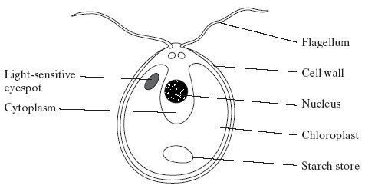

(a)     *Chlamydomonas* lives in fresh-water ponds. It uses its flagella to swim towards light of moderate intensity but away from very bright light. Using information in the diagram, explain the advantage of this behaviour.

......................................................................................................................

......................................................................................................................

......................................................................................................................

......................................................................................................................

**(2)**

(b)     A *Chlamydomonas* cell has two flagella. These flagella contain a single sort of protein. A flagellum consists of a bundle of 242 filaments. Each filament consists of 7500 protein molecules. Each protein molecule contains 900 amino acid units.

(i)      What would be the minimum number of nucleotides in the coding region of the mRNA used to synthesise this protein?

.............................................................................................................

**(1)**

(ii)     In an investigation, a culture of *Chlamydomonas* was treated in a way that caused them to lose their flagella without any other damage to the cells. The flagella grew back to their original length in 60 minutes.

How many amino acid molecules would be incorporated into each growing flagellum per minute? Show your working.

Answer .........................................

**(2)**

(c)     The researchers investigated the rate at which the flagella grew in three different media.

1.      A medium containing actinomycin D, which prevents transcription by binding to the guanine in DNA

2.      A medium containing puromycin, which prevents translation by attaching to ribosomes

3.      A control medium

The results are shown in the graph.

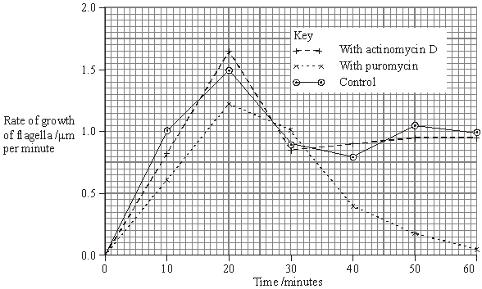

(i)      Describe how the rate of growth was affected by puromycin.

.............................................................................................................

.............................................................................................................

.............................................................................................................

.............................................................................................................

**(2)**

(ii)     The researchers concluded

1.       that the cells used mRNA that is already present in the cytoplasm for the regrowth of the flagella;

2.       that some of the regrowth uses protein molecules already present in the cell.

Explain the evidence for each of these conclusions.

1 ..........................................................................................................

.............................................................................................................

.............................................................................................................

.............................................................................................................

2 ..........................................................................................................

.............................................................................................................

.............................................................................................................

.............................................................................................................

**(4)**

**(Total 11 marks)**

**Q2.**            The drawing shows part of a plant cell as seen with an electron microscope.

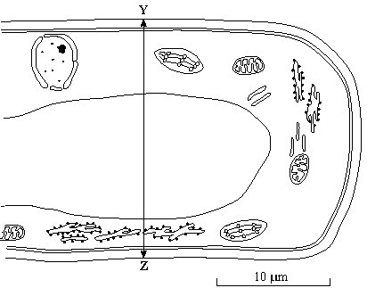

(i)      Give **two** features shown in the drawing which are evidence that this cell is eukaryotic.

1 ...................................................................................................................

......................................................................................................................

2 ...................................................................................................................

......................................................................................................................

**(2)**

(ii)     Calculate the actual width of the cell from **Y** to **Z**. Give your answer in micrometres (µm) and show your working.

Answer ..................................... µm

**(2)**

(iii)     Give **one** way in which a typical animal cell differs from the cell shown in the drawing.

......................................................................................................................

......................................................................................................................

**(1)**

**(Total 5 marks)**

**M1.**         (a)     chloroplast, so cell photosynthesises and moves to optimum / best light intensity for photosynthesis;  
avoids damage due to bright light;

**2**

(b)     (i)      2700

**1**

(ii)      = 27 225 000 / 27 × 106 = *2 marks*

*(allow 1 mark for principle: )*

**2**

(c)     (i)      rate slightly slower / not affected in first 20 / 30 minutes / lower  
peak than control;  
then decreases / much lower (than control);

*(allow 1 mark for increase in first 20 / 30 minutes, then decreased, if not compared with control / normal)*

*(disqualify flagellum grows longer)*

**2**

(ii)     1.       actinomycin has no effect (on growth of flagella);  
          even though mRNA production / transcription prevented;

*(accept references to ‘expt 1’)*

2.       (re)growth little affected by puromycin at first;  
protein synthesis inhibited, so likely to be using proteins  
present;

**4**

**[11]**

**M2.**          (i)      named organelle e.g. nucleus / nuclear envelope; vacuole;  
chloroplast; RER; mitochondrion; no membrane bound organelles;

*(only award if no organelles named)  
(reject ribosomes, cell membrane, cell wall)*

ref to large(r) size

**2 max**

(ii)     

20.4 – 21.8

*(correct answer 2 marks)*

**2**

(iii)     no cell wall (permanent) / (large) vacuole / chloroplasts / smaller;

*(accept microvilli)*

**1 max**

**[5]**

**E1.**          (a)     Although more demanding than the others, it was pleasing to find that many candidates performed well on this question, and that a considerable number gained at least 6 or 7 marks. In particular, an encouraging number managed to get to grips with part (c).

Surprisingly, this was rather poorly answered by many candidates. Often this was because they failed to use the diagram, and, for example, quite often the presence of the chloroplast was not related to photosynthesis. Very few suggested that the movements might position the cells in the optimum light intensity for photosynthesis. The commonest suggestion was that moving away from very bright light would avoid damage, more often to the eyespot than the chlorophyll. Some equated bright light with heat and suggested it would denature enzymes. Others were sidetracked into accounts of avoiding predators or referred to physiological processes that could not be seen in the diagram. Quite a few suggested that bright light was avoided so that the cells would not make too much starch or sugar and burst.

(b)     (i)      This proved more discriminating than expected, and only the better candidates simply multiplied the 900 amino acids by three.

(ii)     There was a good proportion of correct answers, and many more made a sufficiently sensible attempt to gain a mark for the principle. Some gave a figure for two flagella, rather than for each flagellum, and others made errors with the number of zeros or the indices.

(c)     (i)      A good proportion of candidates gained both marks for this part, but quite a large number failed to compare the results for puromycin with those for the control. The latter group simply described the curve for puromycin. Some weaker candidates misinterpreted the graph and stated that the flagella stopped growing longer after 20 minutes.

(ii)     This question was targeted at the more able candidates and the examiners were looking for a precise explanation of the evidence. It was, however, pleasing to note that large numbers of candidates were able to make the links between transcription and mRNA production and between translation and protein synthesis. Better candidates did point out that actinomycin D had no significant effect on regrowth of the flagella and that therefore the cells must be using existing mRNA. Fewer specified that the rate of regrowth declined after about 20 minutes in the presence of puromycin, so only some of the regrowth could be attributed to proteins already present in the cells.

**E2.**          Cell structure was generally well understood, although some candidates assumed that cell walls are a feature of eukaryotic cells and are absent from prokaryotes. The calculation was attempted by the majority of candidates, most of whom measured the scale bar and gained at least one mark.