**Q1.**Species richness and an index of diversity can be used to measure biodiversity within a community.

(a)     What is the difference between these two measures of biodiversity?

........................................................................................................................

........................................................................................................................

**(1)**

Scientists investigated the biodiversity of butterflies in a rainforest. Their investigation lasted several months.

The scientists set one canopy trap and one understorey trap at five sites.

•        The canopy traps were set among the leaves of the trees 16–27 m above ground level.

•        The understorey traps were set under trees at 1.0–1.5 m above ground level.

The scientists recorded the number of each species of butterfly caught in the traps. The table below summarises their results.

|  |  |  |  |  |
| --- | --- | --- | --- | --- |
|  | **Species of butterfly** | **Mean number of butterflies** | | **P value** |
|  | **In canopy** | **In understorey** |
|  | *Prepona laertes* | 15 | 0 | < 0.001 |
|  | *Archaeoprepona demophon* | 14 | 37 | < 0.001 |
|  | *Zaretis itys* | 25 | 11 | > 0.05 |
|  | *Memphis arachne* | 89 | 23 | < 0.001 |
|  | *Memphis offa* | 21 | 3 | < 0.001 |
|  | *Memphis xenocles* | 32 | 8 | < 0.001 |

(b)     The traps in the canopy were set at 16–27 m above ground level. Suggest why there was such great variation in the height of the traps.

........................................................................................................................

........................................................................................................................

**(1)**

(c)     By how many times is the species diversity in the canopy greater than in the understorey? Show your working.

Use the following formula to calculate species diversity.

*d* = 

where *N* is the total number of organisms of all species and *n* is the total number of organisms of each species.

Answer = ...................................

**(3)**

(d)     The scientists carried out a statistical test to see if the difference in the distribution of each species between the canopy and understorey was due to chance. The P values obtained are shown in the table.

Explain what the results of these statistical tests show.

........................................................................................................................

........................................................................................................................

........................................................................................................................

........................................................................................................................

........................................................................................................................

**(Extra space)** ................................................................................................

........................................................................................................................

........................................................................................................................

**(3)**

**(Total 8 marks)**

**Q2.**Scientists investigated the effect of relative humidity on the activity of woodlice. They set up a Petri dish as shown in **Figure 1**.

In the bottom half they put a substance which absorbs water. Different concentrations of this substance produced different humidities in the air above the mesh.

**Figure 1**

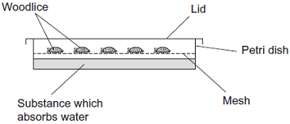

The scientists

•        placed 10 woodlice in the top half of the dish

•        replaced the lid and left the apparatus for 15 minutes in the laboratory

•        recorded the number of woodlice **not** moving during the next 30 seconds

•        repeated the experiment to obtain data for 100 woodlice

•        repeated the experiment at different humidities.

The results are shown in **Figure 2**.

**Figure 2**

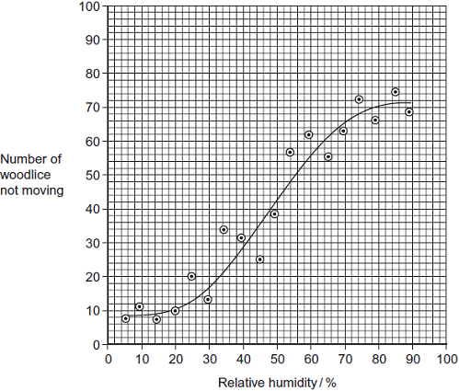

(a)     The woodlice were left for 15 minutes before their movement was recorded. Give **two** reasons for this.

1 .....................................................................................................................

........................................................................................................................

2 .....................................................................................................................

........................................................................................................................

**(2)**

(b)     It is **not** possible to conclude that the change in the behaviour of the woodlice shown in **Figure 2** is caused by changes in humidity. Explain why.

........................................................................................................................

........................................................................................................................

........................................................................................................................

........................................................................................................................

........................................................................................................................

**(2)**

(c)     The points in **Figure 2** do not all fall on the curve. Suggest why.

........................................................................................................................

........................................................................................................................

........................................................................................................................

........................................................................................................................

........................................................................................................................

........................................................................................................................

(Extra space) .................................................................................................

........................................................................................................................

........................................................................................................................

**(3)**

**(Total 7 marks)**

**Q3.**Australian scientists investigated one aspect of competition between wheat and ryegrass.

•        They crushed up some wheat plants and mixed the crushed plants with distilled water.

•        Water-soluble substances in the crushed plants dissolved in the distilled water. The scientists called this solution the *full-strength* extract.

•        The scientists then made a series of dilutions of the full-strength extract.

•        They put ryegrass seeds into each dilution and recorded how many seeds germinated (started to grow). If the seeds germinated, they measured the lengths of the roots of the seedlings.

•        They presented their results as percentages of a control experiment.

The graph shows the effects of different concentrations of the extract on the germination of ryegrass and on the length of the roots of the seedlings that grew from them.

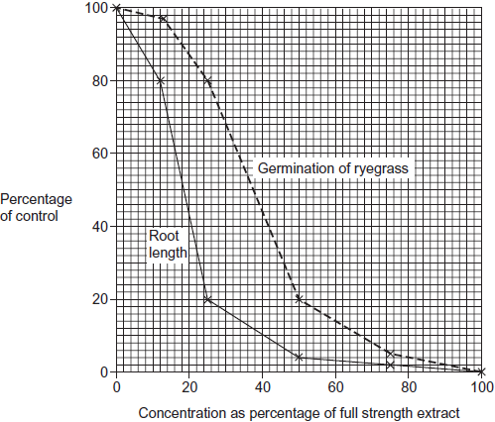

(a)     Describe the control that the scientists set up in this investigation.

........................................................................................................................

........................................................................................................................

**(1)**

(b)     The scientists found a positive correlation between the inhibition of germination and the concentration of the extract.

(i)      Describe how they could find out whether this correlation was significant.

...............................................................................................................

...............................................................................................................

...............................................................................................................

...............................................................................................................

...............................................................................................................

**(2)**

(ii)      Explain why a correlation does **not** mean that the extract caused inhibition of germination.

...............................................................................................................

...............................................................................................................

...............................................................................................................

**(1)**

(c)     The scientists concluded that wheat plants produce substances that help them to compete with ryegrass.

(i)      Give evidence from the investigation to support this conclusion.

...............................................................................................................

...............................................................................................................

...............................................................................................................

...............................................................................................................

...............................................................................................................

**(2)**

(ii)     Why might their conclusion **not** be valid?

...............................................................................................................

...............................................................................................................

...............................................................................................................

...............................................................................................................

...............................................................................................................

...............................................................................................................

(Extra space) ........................................................................................

...............................................................................................................

...............................................................................................................

**(3)**

**(Total 9 marks)**

**Q4.**During the last 50 years, there have been changes in the climate of the UK. One of the main changes is temperature. The data in the following resources all relate to southern England.

**Figure 1** shows the mean temperatures for January and February combined.

**Figure 1**

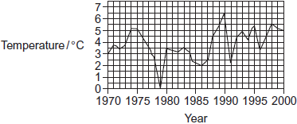

**Figure 2** shows the mean temperatures for March.

**Figure 2**



Birds, such as chaffinches, have been recorded as breeding earlier. Chaffinches build nests. When the nest is complete, the female lays eggs until she has produced a full clutch of 4 to 6 eggs. After the eggs hatch, the parent birds feed the young on insects.

**Figure 3** shows the mean date on which chaffinches laid their first egg.

**Figure 3**

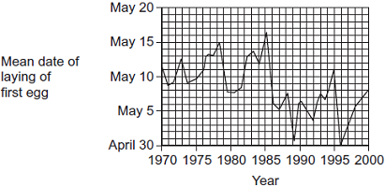

The data from which this graph was drawn were collected by volunteers. They used standard record cards. The volunteers used one record card for each nest they found. Each card was used to record

•        the geographical location

•        the habitat in which the nest site was situated

•        the date of each visit to the nest by the volunteer

•        the number of eggs present in the nest at each visit.

Visits were made to the nests at least once every 5 days.

(a)     Do the data in **Figure 1** and **Figure 2** support the idea that there has been a rise in the mean temperatures in southern England between 1970 and 2000? Explain your answer.

........................................................................................................................

........................................................................................................................

........................................................................................................................

........................................................................................................................

........................................................................................................................

**(2)**

(b)     Describe briefly how you would use a statistical test to find whether there is a significant correlation between mean March temperature and the date when chaffinches laid their first egg.

........................................................................................................................

........................................................................................................................

........................................................................................................................

........................................................................................................................

........................................................................................................................

........................................................................................................................

(Extra space) .................................................................................................

........................................................................................................................

........................................................................................................................

**(3)**

(c)     In chaffinches, the date of laying the first egg is determined by a number of factors. These include day length and temperature. What is the advantage to the bird of egglaying being determined by

(i)      daylength

...............................................................................................................

...............................................................................................................

...............................................................................................................

...............................................................................................................

...............................................................................................................

**(2)**

(ii)     temperature?

...............................................................................................................

...............................................................................................................

...............................................................................................................

...............................................................................................................

...............................................................................................................

**(2)**

(d)     Scientists found that there was a correlation between mean annual temperature and the date when chaffinches laid the first egg. Can you conclude that higher temperatures cause earlier laying of the first egg?  
Explain your answer.

........................................................................................................................

........................................................................................................................

........................................................................................................................

........................................................................................................................

........................................................................................................................

**(2)**

(e)     How does the way in which the data were collected affect the conclusions which can be drawn from **Figure 3**?

........................................................................................................................

........................................................................................................................

........................................................................................................................

........................................................................................................................

........................................................................................................................

**(2)**

**(Total 13 marks)**

**Q5.**Woodlice use gills for gas exchange. These gills are situated on the outside of the animal so water loss occurs from the gill surface. When a number of woodlice occur together they often form a ‘clump’ with individual woodlice touching each other.

A student investigated the effect of clumping on the rate of water loss from the woodlice. The student divided the 12 woodlice into two groups. He allowed the woodlice in group A to clump together, but kept the woodlice in group B separate from each other.

The following table shows the mean mass of the woodlice in each group.

|  |  |  |  |
| --- | --- | --- | --- |
|  | **Time / minutes** | **Mean mass of woodlice / g** | |
|  | Group **A** | Group **B** |
|  | 0 | 0.180 | 0.175 |
|  | 20 | 0.170 | 0.130 |
|  | 40 | 0.165 | 0.110 |
|  | 60 | 0.160 | 0.090 |
|  | 80 | 0.160 | 0.080 |

(a)     (i)      Calculate the percentage loss in the mean mass of the woodlice in Group **A** during the investigation. Show your working.

Answer ......................................

**(2)**

(ii)     Woodlice in Group **B** had a greater percentage loss in mean mass during the investigation than woodlice in Group **A**. Explain why.

...............................................................................................................

...............................................................................................................

...............................................................................................................

...............................................................................................................

...............................................................................................................

...............................................................................................................

(Extra space) ........................................................................................

...............................................................................................................

...............................................................................................................

**(3)**

(iii)    It would be useful to give the loss in mean mass as a percentage in this investigation.  
Explain why.

...............................................................................................................

...............................................................................................................

**(1)**

**(Total 6 marks)**

**Q6.**Herbicides are substances that kill weeds. Three farmers wanted to know which herbicide to use to control weeds in fields of barley. They chose eleven fields of barley and used a different herbicide in each field. Four weeks later they collected, counted and weighed the weeds in each field. Their results are shown in **Figure 1** and **Figure 2**.

**Figure 1**

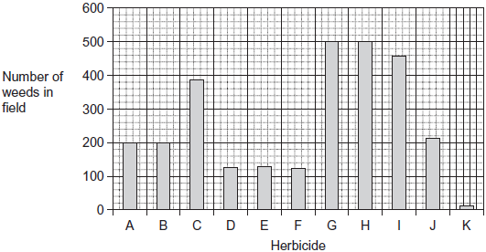

**Figure 2**

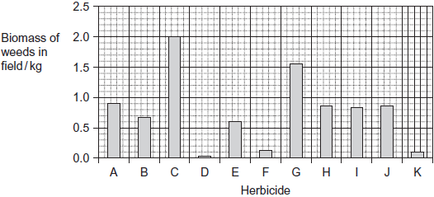

(a)     Describe the difference in biomass of **each** of the weed plants in fields treated with herbicides **G** and **H**. Explain how you arrived at your answer.

........................................................................................................................

........................................................................................................................

........................................................................................................................

........................................................................................................................

........................................................................................................................

**(2)**

(b)     The farmers decided that **K** would be the best herbicide to use.  
Explain why herbicide **K** would give a higher crop yield.

........................................................................................................................

........................................................................................................................

........................................................................................................................

........................................................................................................................

........................................................................................................................

**(2)**

(c)     The farmers carried out their investigation during the summer.  
Suggest **one** advantage and **one** disadvantage of carrying out this investigation during the summer.

Advantage ......................................................................................................

........................................................................................................................

Disadvantage .................................................................................................

........................................................................................................................

**(2)**

(d)     One of the farmers told a local newspaper reporter of their findings. The newspaper published an article with the following headline: “Local farmers show scientists the way to bigger crop yields.” Was this headline justified? Explain your answer.

........................................................................................................................

........................................................................................................................

........................................................................................................................

........................................................................................................................

........................................................................................................................

........................................................................................................................

........................................................................................................................

........................................................................................................................

........................................................................................................................

........................................................................................................................

Extra space ...................................................................................................

........................................................................................................................

........................................................................................................................

........................................................................................................................

........................................................................................................................

**(5)**

**(Total 11 marks)**

**M1.**(a)     Species richness measures only number of (different) species / does not measure number of individuals.

**1**

(b)     Trees vary in height.

**1**

(c)     1.      Index for canopy is 3.73;

2.      Index for understorey is 3.30;

3.      Index in canopy is 1.13 times bigger;

*If either or both indices incorrect, allow correct calculation from student’s values.*

**3**

(d)     1.      For *Zaretis itys*, difference in distribution is probably due to chance / probability of being due to chance is more than 5%;

2.      For all species other than *Zaretis itys*, difference in distribution is (highly) unlikely to be due to chance;

3.      Because P < 0.001 which is highly significant / is much lower than 5%.

**3**

**[8]**

**M2.**(a)     Time to establish humidity to that required / time for substance to absorb water;

So that behaviour typical of humidity;

Woodlice no longer affected by handling;

*Allow acclimatisation idea*

**2 max**

(b)     Correlation does not show causal link;

May be due to other factors / named factor;

*Do not accept casual*

**2 max**

(c)     1.      It is a line of best fit;

2.      Variation in woodlice / a named difference in woodlice;

*E.g. age, species, sex*

3.      Variation in environmental conditions / change in a named environmental condition;

*E.g. Temperature / vibration / sound / light*

**3**

**[7]**

**M3.**(a)     Same number of ryegrass seedlings in distilled water;

**1**

(b)     (i)      Produce null hypothesis;

Carry out Spearman Rank correlation test / find correlation coefficient;

Use values to show P < critical value / find probability of results being due to chance;

*Accept valid example*

*E.g. There is no correlation between inhibition of germination and the concentration of the extract.*

**2 max**

(ii)     May be another factor / named factor (that also inhibits germination);

*e.g. amount of water in extract*

**1**

(c)     (i)      Extract inhibits ryegrass germination / extract stops ryegrass starting to grow;

Inhibition of root length / causes ryegrass to have shorter roots;

**2**

(ii)     Scientists crushed plants to get extract;

Plants might not secrete substances in the extract into the soil;

These substances might get broken down in the soil;

Wheat and ryegrass might not grow at the same time / wheat plants might not produce substance when ryegrass is growing;

Concentration of extract in the soil might be different from that in solution;

**3 max**

**[9]**

**M4.**(a)     Shows trend of mean temperature rise;  
Higher temperatures more frequent since 1984 (in January and February);  
Considerable variation in temperature from year to year;  
Which may be due to chance;

*No mark for yes or no Do not penalise candidates who state there is no trend*

**2 max**

(b)     Construct null nypothesis;  
Use Spearman rank (and calculate test statistic);  
Look up in table (to find critical value of P = 0.05 / 5 %);  
Use figure (in table) to accept or reject null hypothesis;

**3 max**

(c)     (i)      (Particular daylength) always occurs at same time of year / valid example;  
Birds do not start laying eggs when period of warm weather occurs early in year;  
Synchronises breeding behaviour;  
Sufficient foraging time for food collection for young;

**2 max**

(ii)     Birds able to respond to changing climate;  
Food availability (mainly) determined by temperature;  
As insect / invertebrate development temperature-dependent;

**2 max**

(d)     A correlation does not indicate a causal relationship;  
As may be due to another factor / named factor;

**2**

(e)     Visits could be up to 5 days apart;  
Date of egg-laying may be inaccurate by 5+ days;

**2**

**[13]**

**M5.**(a)     11.1;;

Allow one mark for calculating loss in mass as 0.02g and calculating a percentage;

*Accept 11.11 / 11 but not 11.0*

**2**

(b)     1.      (More mass loss) linked to losing more water;

2.      Gills (more) exposed to air / covered (less) by other woodlice so greater surface area (exposed);

3.      (Not clumped) so lower humidity (around each woodlouse) so greater evaporation / diffusion (of water);

*Assume ‘They’ refers to woodlice in group B*

**3**

(c)     Initial masses different;

**1**

**[6]**

**M6.**(a)     Greater when treated with herbicide **G**;

Same number but total biomass larger;

*Can be shown by figures*

**2**

(b)     Fewer weeds left to produce seeds;  
Less contamination of crop (by weeds); / fewer weeds to separate from crop; / less competition (between crop and weeds);

**2**

(c)     **Advantage**Weeds growing fast / photosynthesising fast so effect will be seen /   
will have large effect;

**Disadvantage**No information about winter / other seasons /   
weeds not growing fast /   
could kill (beneficial) insects /   
crop may be harvested before effects noticeable;

*One mark for advantage and  
one mark for disadvantage*

**2**

(d)     **Limitations of investigation**1. No control / untreated field;  
2. Amount of herbicide may be different;  
3. May be differences between fields; Eg soil Nutrients / fertiliser added Type of weed Microclimates  
4. May be different number of weeds (at start);

**Limitations of results**5. No replicates / one set of data;  
6. Field size may vary / not specified;

**Scientific Research**7. Scientific research / example of scientific research has led to greater yield;

*When marking please number the marking points*

*e.g.  means a mark award for point 5*

**5 max**

**[11]**

**E2.**(a)     Poor levels of expression spoilt some responses – allowing time for ‘adaptation’ or ‘equilibration’ of woodlice to humidity was not uncommon. Several candidates did not appreciate that the humidity was uniform in the Petri dish so suggested that it gave woodlice time to ‘find’ an appropriate humidity.

(b)     The majority of candidates achieved the second mark point, that correlation may be the result of other factors. Surprisingly few candidates made the statement that correlation does not mean that there is a causal link.

(c)     Very few candidates scored all three marks here, the most common mark awarded was for the curve of best fit. Many candidates appreciated that the woodlice show variation but very few could describe how environmental factors may vary or change.

**E3.**(a)     Almost all candidates referred to carrying out the procedure using distilled water but very few indicated that the same number of ryegrass seedlings would be required.

(b)     Maximum credit was usually scored in part (a) with candidates correctly choosing the Spearman rank correlation test and indicating either that they would use this to test a null hypothesis or determine the probability of obtaining results by chance. Part (b) was, almost without exception, answered correctly.

(c)     Most candidates scored at least one of the two available marks for part (a) by identifying either the reduced germination of ryegrass or the reduced root growth. There were few convincing answers to part (b), however, and most candidates approached this question by unjustified criticism of the experimental approach.

**E4.**(a)     Candidates recognised that temperatures were generally higher and also suggested that the temperature fluctuated. This question was usually marked at the correct level. It was less common for candidates to identify that the trend in the data may have been due to chance.

(b)     This was well understood with the vast majority scoring two or more marks. It was marked at the correct level by most centres. Most commonly the null hypothesis was absent in responses. Many accounts provided extensive unnecessary detail about calculating the test statistic. This was often incorrectly given credit.

(c)     (i)      Only a very small number of candidates established valid links between egg-laying and daylength. Very few candidates realised that daylength was related to a particular time of year. Too many answers which did not correspond to points on the marking guidelines were credited by centres. Credit was also often incorrectly given for synchronising egg-laying rather than breeding behaviour.

(ii)     Candidates had more success with the relationship of egg-laying and temperature. They established links with availability of food and an increase in insect numbers. Many candidates, however, discussed body temperature and survival of young and this was incorrectly credited by some centres. Others answered in terms of temperature affecting egg hatching.

(d)     This was well answered by the vast majority and marked at the correct level.

(e)     Many candidates were able to use the data supplied to suggest that the date of egg-laying would be imprecise. Many answers were linked to the collection of data by volunteers, candidates considering that as a consequence the data were unreliable and the conclusions that could be drawn were debatable. Again answers not meeting the requirements of those in the marking guidelines, such as ‘don’t know when the eggs were laid’, were credited.

**E5.**(a)     Most candidates could complete this calculation correctly although errors in rounding and missing out the division by the original were seen.

(b)     Most candidates gave good responses with three marks not uncommon. Errors observed included discussion of temperature / respiratory rate / gas exchange changing due to clumping, and woodlice taking in water from other woodlice. Some candidates tried to use their knowledge of spiracles to answer this question rather than use the information they had been given about woodlice having gills.

(c)     Answers were often not related to differences in the initial mass.

**E6.**(a)     There were many excellent and clearly focused answers to this question.

(b)     Most candidates were able to point out that the herbicide would reduce the number of weeds and suggest that this would lead to reduced competition for a specified resource.

(c)     Candidates found this question challenging. In discussing advantages, arguments were often based inappropriately on the rate of growth of the crop rather than that of the weeds. Acceptable disadvantages were seldom suggested and many answers were based on incorrect climatic generalisations.

(d)     Many candidates wrote lengthy answers that focused on experimental design in general terms rather than on the design of this particular investigation. Such responses usually identified the lack of a control, small sample size and the possibility of confounding variables. Those who followed the procedure through, and considered each step carefully, were often able to make further points.