Meiosis [(Meiosis animation)](http://highered.mcgraw-hill.com/olcweb/cgi/pluginpop.cgi?it=swf::535::535::/sites/dl/free/0072437316/120074/bio19.swf::Stages%20of%20Meiosis) [(Meiosis tutorial)](http://www.sumanasinc.com/webcontent/anisamples/majorsbiology/meiosis.html)

* Humans have 23 pairs of homologous chromosomes. The total number of chromosomes is called the **diploid** (2n) number (46 in humans). Sex cells, or gametes, have half the diploid number; this is called **haploid** number (n). So human gametes have 23 chromosomes
* Meiosis cell division is used to create **gametes** from somatic body cells and ensures that the gametes have:
  + **Haploid (half) number of chromosomes** (Caused by 2 cell divisions)
  + **Variation in Genotype** (Caused by **Random Assortment**/**Crossing Over**)
* Interphase
* Chromosomes not visible (chromatin), DNA replicates itself so that there are now 4 copies of each chromosome (2 maternal/2 paternal)

Meiosis takes place in a series of Phases over 2 cell divisions:

* Prophase I
  + - **DNA condenses** and chromosomes become **visible**
    - Nuclear membrane breaks down
  + One chromosome has become two **sister chromatids** held together by the **centromere**
  + **Homologous chromosomes** pair up

forming **Bivalents**. Each bivalent consists

of 4 chromatids, made up from 2

chromosomes which replicated

**Bivalent**

themselves

* + Chromosomes **entwine** forming **chiasmata**
    - **Crossing over** occurs by **breaking of maternal and**

**paternal DNA** which is then interchanged

* Metaphase I
  + - Centrioles move to opposite poles of cell
    - **Spindle fibres** are produced
    - **Bivalents** move to the **equator**
    - Chromosomes attach to the spindle at

**Centromeres**

* + - **Random Assortment** occurs
* Anaphase I
  + - **Centromeres divide,** sister chromatids

separate

* + - **Spindle fibres contract** pulling

**chromosomes** to **opposite poles**

* Telophase I
  + - Spindle fibre breaks down
    - Cell enters prophase II
* Prophase/Metaphase II



* + - A new spindle forms at right angles

to the first

* + - Each of the pair of sister

chromatids (chromosomes) move to

the equator of the cell

* + - Each chromosome attaches to the

Spindle fibre by the **centromere**

* Anaphase II

* + - The **centromeres** divide
    - The **spindle fibres contract** to pull

the two chromatids to the opposite

poles

* Telophase II
  + - The chromosomes **lengthen** becoming **chromatin**
    - The spindle fibre **breaks down**
    - Nuclear membrane **reforms**
    - **Cytokinesis** occurs resulting in **4 haploid cells** being formed which show **genetic variation**



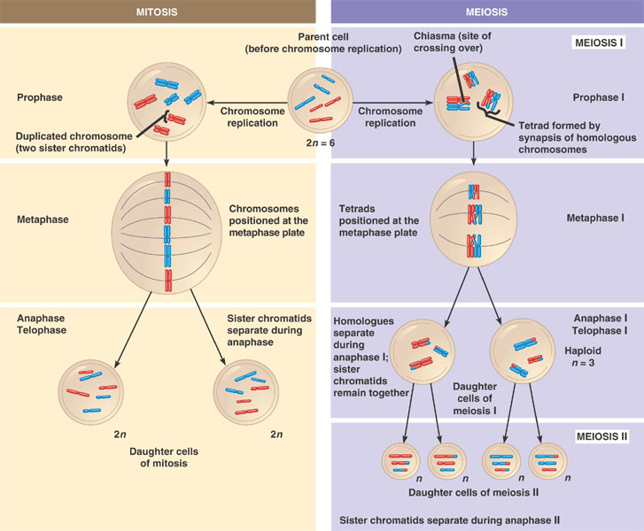

* Significance of meiosis
* Meiosis generates variety via:

|  |  |
| --- | --- |
| Meiosis feature | Detail |
| Haploid gametes for random fertilisation | During sexual reproduction the **genotype of one parent is mixed with that of the other when haploid gametes randomly fuse** |
| Random/Independent Assortment | The different pairs of **homologous chromosomes** arrange themselves on the spindle fibre during **metaphase I** of meiosis. When they **separate** they do so **independently** of each other, so daughter cells have **different combinations** of maternal and paternal chromosomes |
| Crossing Over | **Crossing over** during **chiasmata** in **prophase I** of meiosis causes equal parts of homologous chromosomes may be **exchanged**  producing **new combinations** and **separation of linked genes** |

* + Random/independent assortment detail [(Independent Assortment of Alleles animation)](http://www.sumanasinc.com/webcontent/anisamples/majorsbiology/independentassortment.html)

Crossing over generates variation within gametes; another is random assortment of the chromosome pairs in Metaphase I when they move to the equator:

* + e.g. look at the two homologous pairs of chromosomes with one gene locus on each:

R r

T t

* + DNA replicates

R R r r

T T t t

* + Each pair now moves to the equator of the cell, but there is independent assortment which means each pair is randomly arranged giving two possibilities:

R R r r R R r r

OR

T T t t t t T T

* + After meiosis I the pairs separate to opposite poles:

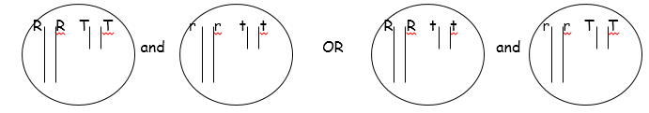

* + Then after Meiosis II the chromatids are pulled apart to form the haploid cells:

