**3.8.1 & 3.8.2 Control of Gene Expression**

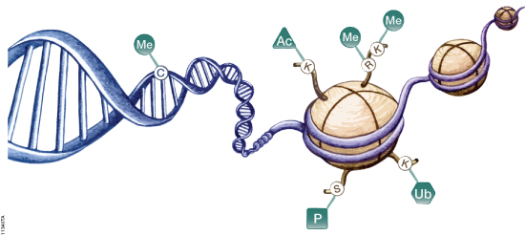

**Recall Activities**

These are activities to develop your recall of information you covered in the previous topics that are linked to gene expression. You should do this before you start the work on this topic. Once you have done the recall activity quickly check your info/answers using your student booklets and notes from that topic.

**Topics covered**: Biological molecules, cells and genetic information.

|  |  |  |  |
| --- | --- | --- | --- |
| **Topic** | **Recall activities** | **Understanding**  *Please write down any questions you have when completing this activity.* | **Completed** |
| **Biological molecules** | On the MWB/scrap paper, draw a nucleotide and then DNA |  |  |
| On the MWB/scrap paper, explain the differences between RNA & DNA |  |  |
| **Genetic information** | On the MWB/scrap paper, draw a chromosome and label it to include, gene, exon, intron, histone, locus and non-coding sequences |  |  |
| On the MWB/scrap paper, outline the differences between prokaryotic and eukaryotic DNA |  |  |
| On the MWB/scrap paper, draw a diagram and annotate the process of protein synthesis |  |  |
| On the MWB/scrap paper, explain how mutations occur in base sequences (deletion and substitution) |  |  |

**Specification Content Checklist**

|  |  |  |  |  |
| --- | --- | --- | --- | --- |
| **Key info** | **Topic: Gene Expression**  **Synoptic Link:** Biological molecules, cells and genetic information | | | |
| **Step 1** | **Use the tutorial (GOL), presentation (GOL), video links and textbook to complete the pack.** | | | |
| **Step 2** | **Specification Content Checklist** | **I understand this** | **I can recall this** | **I need to revisit this** |
| **3.8.1 Alteration of the sequence of bases in DNA can alter the structure of proteins.**  Understand that gene mutations might arise during DNA replication. They include addition, deletion, substitution, inversion, duplication and translocation of bases. |  |  |  |
| Explain that Gene mutations occur spontaneously. The mutation rate is increased by mutagenic agents. Mutations can result in a different amino acid sequence in the encoded polypeptide. |  |  |  |
| Explain that:   * Some gene mutations change only one triplet code. Due to the degenerate nature of the genetic code, not all such mutations result in a change to the encoded amino acid. * Some gene mutations change the nature of all base triplets downstream from the mutation, i.e., result in a frame shift. |  |  |  |
| **3.8.2 Gene expression is controlled by a number of features.**  Understand that totipotent cells can divide and produce any type of body cell and that during development, totipotent cells translate only part of their DNA, resulting in cell specialisation |  |  |  |
| Understand that totipotent cells occur only for a limited time in early mammalian embryos. |  |  |  |
| Explain that Pluripotent cells are found in embryos; multipotent and unipotent cells are found in mature mammals and can divide to form a limited number of different cell types.   * Pluripotent stem cells can divide in unlimited numbers and can be used in treating human disorders. * Unipotent cells, exemplified by the formation of cardiomyocytes. * Induced pluripotent stem cells (IPS cells) can be produced from adult somatic cells using appropriate protein transcription factors. |  |  |  |
| Be able to evaluate the use of stem cells in treating human disorders. |  |  |  |
| Understand that in eukaryotes, transcription of target genes can be stimulated or inhibited when specific transcriptional factors move from the cytoplasm into the nucleus. |  |  |  |
| Explain the role of the steroid hormone, oestrogen, in initiating transcription |  |  |  |
| Understand that epigenetics involves heritable changes in gene function, without changes to the base sequence of DNA. These changes are caused by changes in the environment that inhibit transcription by:   * increased methylation of the DNA or * decreased acetylation of associated histones. |  |  |  |
| Explain the relevance of epigenetics on the development and treatment of disease, especially cancer. |  |  |  |
| Understand that in eukaryotes and some prokaryotes, translation of the mRNA produced from target genes can be inhibited by RNA interference (RNAi). |  |  |  |
| Explain the main characteristics of benign and malignant tumours. |  |  |  |
| Understand the role of the following in the development of tumours:   * tumour suppressor genes and oncogenes * abnormal methylation of tumour suppressor genes and oncogenes * increased oestrogen concentrations in the development of some breast cancers. |  |  |  |
| **Step 3** | **In lesson:** you will be undertaking activities to develop your understanding of the specification content and able to add to your notes.  **Revision:** make sure that you have resources available to re-learn and memorise the subject content above | | | |

**3.8.1 Alteration of the sequence of bases in DNA can alter the structure of proteins.**

Mutation can have a number of causes:

* ___________________________________________________________
* ___________________________________________________________
* ___________________________________________________________

What are mutagens? Give two examples.

__________________________________________________________________________________________________________________________________________________________________

Mutations involve a change in the sequence of bases in DNA, which in turn can affect the amino acid sequence of the protein for which the DNA codes. Using your knowledge from year 1 content complete the questions below.

**Point mutations**, which affect a small section of DNA, can take a number of forms. Complete the section below to show the difference types of point mutations

Substitution

TTCGAACTTAAG 🡪

Insertion

TTCGAACTTAAG 🡪

Deletion

TTCGAACTTAAG 🡪

What is a “frame shift” mutation and why is it so damaging?

___________________________________________________________________________________________________________________________________________________________________________________________________________________________________________________

|  |  |  |  |  |
| --- | --- | --- | --- | --- |
|  | No Mutation | Silent | Non-sense | Mis-sense |
| DNA level | TTC |  |  |  |
| mRNA level | AAG |  |  |  |
| Protein level | Lys |  |  |  |

How is it possible to have a mutation that has no effect on an organism’s phenotype?

* ________________________________________________________
* ________________________________________________________

[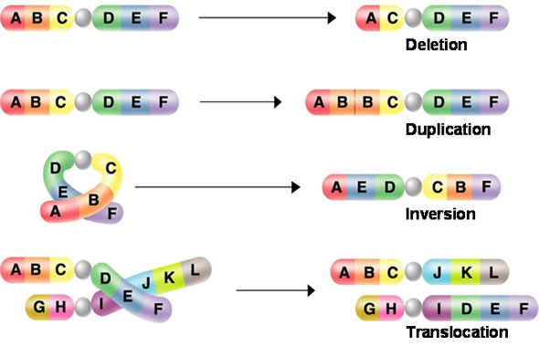](https://www.google.co.uk/url?sa=i&rct=j&q=&esrc=s&source=images&cd=&cad=rja&uact=8&ved=0ahUKEwjtt_j6_uvSAhXB7hoKHfVtAasQjRwIBw&url=https://socratic.org/questions/what-are-four-types-of-chromosomal-mutations&psig=AFQjCNG3JTGBjDiZAs-GEpaB0eUviyOzcQ&ust=1490336682228361)What are chromosome mutations?

________________________________________________________

________________________________________________________

________________________________________________________

________________________________________________________

________________________________________________________

**3.8.2 Gene expression is controlled by a number of features.**

All cells in the human body are derived from the zygote. Yet body cells do not all have the ability to turn into other cell types.

This is due to **cell differentiation**.

Cells express different genes controlling their development into particular cell types.

Not all genes are expressed in all cells. Some encode essential processes and are always transcribed, e.g.:

__________________________________________________________________________________________________________________________________________________________________

Whereas some control only tissue specific proteins that do not have to be transcribed in all cells, e.g.

__________________________________________________________________________________________________________________________________________________________________

All cells are derived by mitosis and so contain the same instructions, yet they develop differently and differentiate, i.e., they become specialised for particular functions.

Once differentiated they lose:

* + ____________________________________________________
  + ____________________________________________________

During the process of differentiation cellular features are changed:

* + ____________________________________________________
  + ____________________________________________________
  + ____________________________________________________

In mammals’ differentiation is generally not reversible. However, it can be reversed in plants.

Cells that can differentiate are called:

* + ____________________________________________________
  + ____________________________________________________

**What is a Stem Cell**

Stem cells are different from other cells of the body because stem cells can both:

1. _______________________________________________________

AND

1. _______________________________________________________

|  |  |
| --- | --- |
| Potency |  |
| Totipotent |  |
| Pluripotent |  |
| Multipotent |  |
| Unipotent |  |

Complete the diagram below.

stem cell

**Stem Cell Keywords**

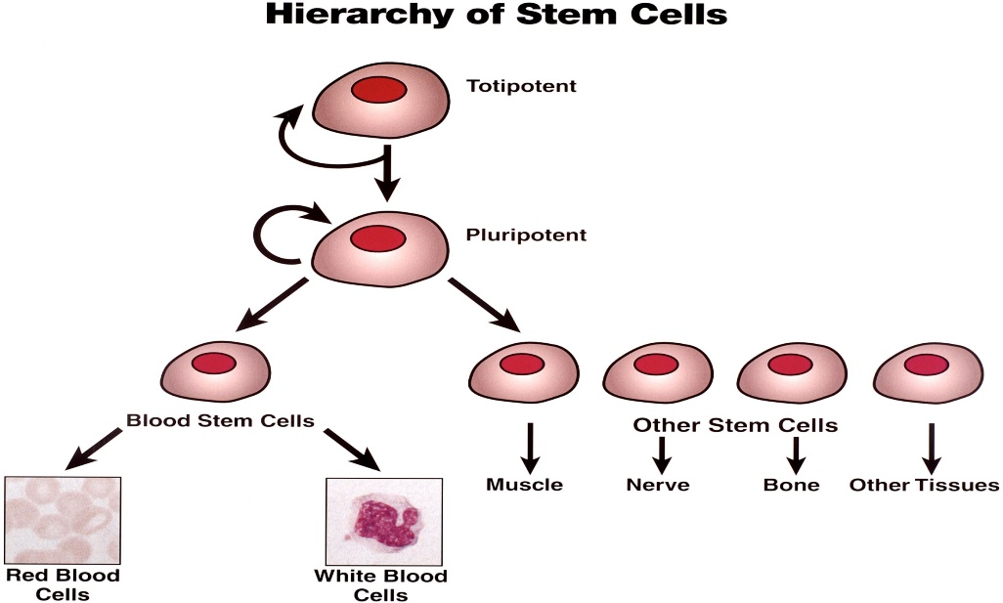

Totipotent

Pluripotent cells

Multipotent stem cells

Unipotent

Principles of multipotent stem cells. Complete the diagram below to explain how specialised cells form.



What is the importance of having multipotent cells in our bodies?

__________________________________________________________________________________________________________________________________________________________________

__________________________________________________________________________________________________________________________________________________________________

Give an example of unipotent stem cells.

__________________________________________________________________________________________________________________________________________________________________

How can embryonic stem cells be used for medical applications?

__________________________________________________________________________________________________________________________________________________________________

__________________________________________________________________________________________________________________________________________________________________

**Sources of Stem Cells:**

* Embryonic Stem Cells

_______________________________________________________________________________

* Umbilical Cord Stem Cells

_______________________________________________________________________________

* Placental Stem Cells

_______________________________________________________________________________

* Adult Stem Cells

______________________________________________________________________________________________________________________________________________________________

[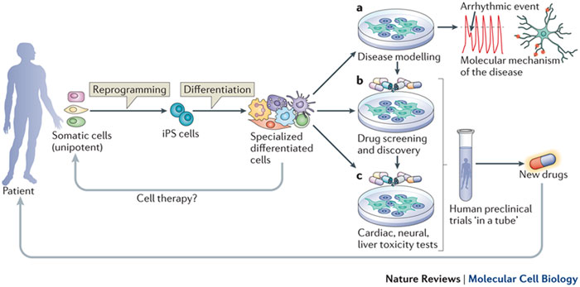](http://www.google.co.uk/url?sa=i&rct=j&q=&esrc=s&source=images&cd=&cad=rja&uact=8&ved=0ahUKEwju5NLYuOPSAhUsBsAKHacbAhcQjRwIBw&url=http://www.nature.com/nrm/journal/v13/n11/fig_tab/nrm3448_F1.html&bvm=bv.149760088,bs.1,d.cGc&psig=AFQjCNG-WU-pxqGNYnRHGMKrcE69MlyacA&ust=1490042921110509)

**Induced Pluripotent Stem Cells (IPS cells)**

Summarise the process of formation of IPS cells and the advantages of these stem cells over embryonic stem cells.

__________________________________________________________________________________________________________________________________________________________________

__________________________________________________________________________________________________________________________________________________________________

__________________________________________________________________________________________________________________________________________________________________

__________________________________________________________________________________________________________________________________________________________________

**Evaluation of use of stem cells.**

Complete the table below.

|  |  |
| --- | --- |
| Issue | Explanation |
| Benefits of using stem cells |  |
|  |
|  |
| Risks/Issues of using stem cells |  |
|  |
|  |
| Social issues |  |
|  |
|  |
| Ethical Issues |  |
|  |
|  |

**Regulation of transcription and translation**

**Recap Questions**

1. Describe the structure of a DNA nucleotide.

______________________________________________________________________________________________________________________________________________________

1. Where does transcription take place?

______________________________________________________________________________________________________________________________________________________

1. Define an exon?

______________________________________________________________________________________________________________________________________________________

1. Name the enzyme involved in joining adjacent RNA nucleotides in transcription

______________________________________________________________________________________________________________________________________________________

1. Why is the genetic code described as degenerate?

______________________________________________________________________________________________________________________________________________________

1. Name 4 types of mutations

______________________________________________________________________________________________________________________________________________________

What are transcription factors?

___________________________________________________________________________________________________________________________________________________________________________________________________________________________________________________

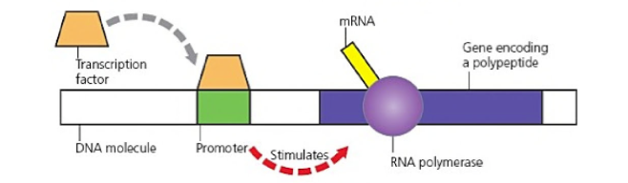

|  |  |
| --- | --- |
| Activators | Repressors |
|  |  |

Complete the flow diagram to show how oestrogen regulates transcription:

|  |
| --- |
| 1. |
| 2. |
| 3. |
| 4. |
| 5. |
| 6. |

**Epigenetics**

**Does your DNA define you? Read the article below then answer the summary questions.**

**What is epigenetics?**

The human genome is made of DNA sequences made of four bases, containedwithin the 23 chromosomes of the nucleus. The Human Genome Project has showed that there are around 20,000 **genes** encoded in the genome so if each cell in the body has the same DNA molecules so what makes a skin cell a skin cell and not a liver cell?

The development of an organism and the subsequent specialisation of each cell of the human body is controlled by sets of **chemical reactions** that switch parts of the genome **on and off at specific times and places** so that different genes are expressed at different times; this is achieved through the **addition of chemical tags** to DNA itself or to the proteins DNA is associated with. **Epigenetics** is the study of these reactions and the factors that influence them.

Epigenetic changes are caused by environmental factors such as diet, pollution, lifestyle such as smoking and alcohol, radiation and exposure to chemicals. These changes can **alter patterns of gene expression** so that genes can be on when they should be off or off when they should be on.

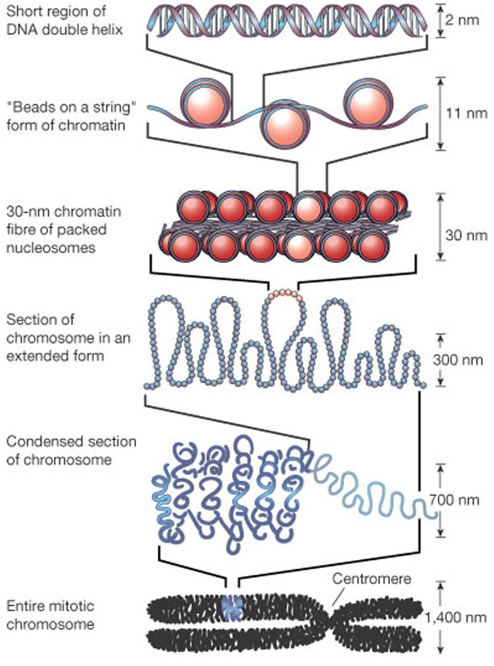**Packaging of DNA**

* Since DNA is so long, it needs to be **packaged** small enough that it can enter the nucleus. For this to happen, it initially associates with proteins called histones which have a **globular head and tail domain**. It is this tail domain that becomes modified with **chemical tags** that alter the pattern of gene expression.
* **8** histone proteins (2 of each one: H2A, H2B, H3 and H4) interact with each other and strands of DNA wrap around the outside  to create a nucleosome.
* Arrays of nucleosomes form **chromatin** which keeps being folded and compacted until it forms a **1400 nm wide mitotic chromosome**.

**Types of modifications**

There are different types of modifications that can occur:

1. **DNA methylation:** Methylation is the addition of a chemical tag called a methyl group (CH3) to the DNA molecule itself. As the groups of these accumulate on **cytosine** nucleotides in genes, the gene becomes silenced.
2. **Histone modifications:** DNA is wrapped around proteins called histones which allow DNA to be packaged into the nucleus of cells. Histones have a tail which can be modified by chemical tags such as acetyl groups. This affects the packaging of the genome i.e. whether it is compact or loose, which will affect the pattern of which genes can be expressed.

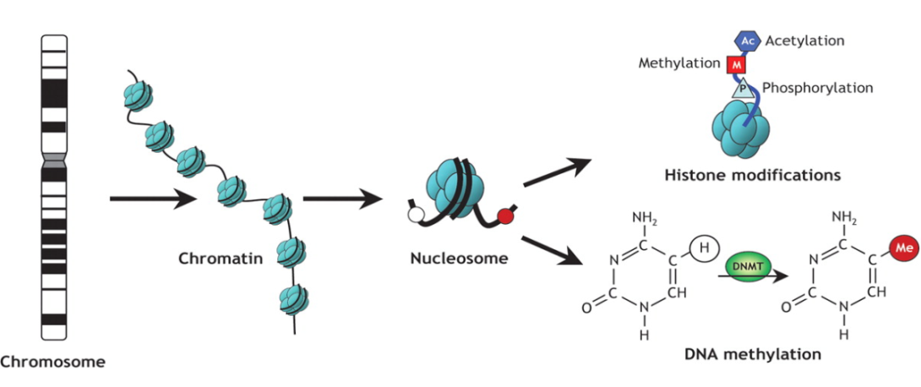

**Epigenetics and disease**

* The basic model for disease is that a mutation leads to the initiation and development of disease. However, very few genetic abnormalities have been found to be associated with disease.
* Epigenetics provides the mechanism through which the **environment can change the cell without causing mutations** in genes to cause the induction of a particular disease.
* Since epigenetic alterations can alter which genes are expressed, changes can be **associated with particular diseases** such as **cancer** when **tumour-suppressor genes** which protect against cancer have more methyl tags on (hypermethylated) meaning that they are expressed less.
* Evidence suggests that certain modifications can be **passed from generation to generation** with potential diseases showing up in the offspring of the individuals who were initially exposed.

**Epigenetic therapy**

Now we have more understanding of the epigenome and how it is related to health and disease, this knowledge can be exploited to help develop drugs which change gene expression profiles. Since epigenetic modifications are reversible, it is possible that cells which show abnormal patterns of gene expression can be pushed back to normal patterns of expression using drugs.

**Histone modifications:** The most common drugs affecting histone modifications are HDAC (histone deacetylase) inhibitors. These act by blocking the enzyme which removes acetyl groups causing condensation of DNA and stopping gene expression. By blocking this process, HDAC inhibitors turn on gene expression.

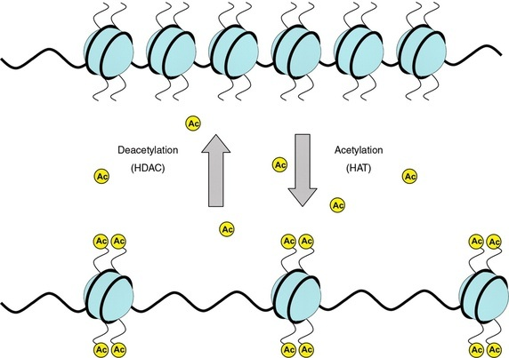

**Questions**

1. What epigenetic changes would be associated with an **increase** in gene expression?

____________________________________________________________________________________________________________________________________________________________

1. List the environmental factors that have been linked to epigenetic changes.

____________________________________________________________________________________________________________________________________________________________

1. How are epigenetic changes thought to be linked to cancer (how can they cause uncontrolled cell division)?

____________________________________________________________________________________________________________________________________________________________

1. “Epigenetics involves permanent changes to the DNA that can be passed on from parent to offspring”.

Evaluate this statement. Are any parts of it true/accurate?

____________________________________________________________________________________________________________________________________________________________

____________________________________________________________________________________________________________________________________________________________

____________________________________________________________________________________________________________________________________________________________

**For inaccessible genes**



|  |  |
| --- | --- |
| Histones |  |
| DNA |  |
| DNA Histone Complex |  |
| Chromatin Type |  |
| Genes |  |

**For accessible genes:**

|  |  |
| --- | --- |
| Histones |  |
| DNA |  |
| DNA Histone Complex |  |
| Chromatin Type |  |
| Genes |  |

**RNA interference**

_____________________________________________

_____________________________________________

_____________________________________________

_____________________________________________

_____________________________________________

_____________________________________________

_____________________________________________

_____________________________________________

_____________________________________________

_____________________________________________

_____________________________________________

_____________________________________________

_____________________________________________

_____________________________________________

_____________________________________________

_________________________________________________________________________________

_________________________________________________________________________________

_________________________________________________________________________________

_________________________________________________________________________________

_________________________________________________________________________________

**Describe simply what RNA interference is and what it does:**

**Give an example of how this technique could be used medically:**

Summary Questions

|  |  |  |
| --- | --- | --- |
| **1** | **Where do transcription factors move from and to?** |  |
| **2** | **What are transcription factors made from?** |  |
| **3** | **Where do transcription factors bind?** |  |
| **4** | **Why are some transcription factors called activators?** |  |
| **5** | **Why are some transcription factors called repressors?** |  |
| **6** | **Describe how transcription factors are important in the synthesis of proteins** |  |
| **7** | **Explain how an activated oestrogen receptor affects a target cell** |  |
| **8** | **What does siRNA stand for?** |  |
| **9** | **What is RNAi?** |  |
| **10** | **Why may siRNA be useful in treating some disease?** |  |

**Gene expression and cancer**

|  |  |
| --- | --- |
| **Benign Tumours** | **Malignant Tumours** |
|  |  |

There are two types of genes that are commonly linked to the development of cancer.

1. ______________________________________________________________________________

2. ______________________________________________________________________________

Explain how mutations of tumour suppressor genes can lead to a tumour developing.

__________________________________________________________________________________________________________________________________________________________________

__________________________________________________________________________________________________________________________________________________________________

Explain how mutations of proto-oncogenes can lead to a tumour developing.

__________________________________________________________________________________________________________________________________________________________________

__________________________________________________________________________________________________________________________________________________________________

__________________________________________________________________________________________________________________________________________________________________

How can methylation of DNA cause cancer?

__________________________________________________________________________________________________________________________________________________________________

__________________________________________________________________________________________________________________________________________________________________

_________________________________________________________________________________

Using the pictures below, describe how each situation can lead to tumour growth.

Hypermethylation of a tumour suppressor gene:

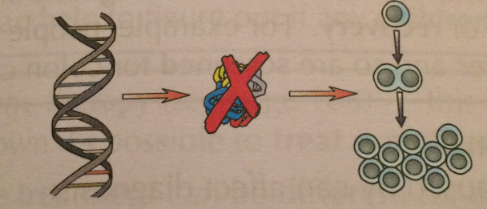

Hypomethylation of a proto-oncogene

