**Human Genome Project** [( BBC Horizon 2010: 1/6 Miracle Cure? A Decade of the Human Genome)](http://www.youtube.com/watch?v=ytMH4FGV4F4) [(BBC Horizon 2010: 2/6 Miracle Cure? A Decade of the Human Genome)](http://www.youtube.com/watch?v=3Mu9Qv-lSrU&feature=related) [(BBC Horizon 2010: 3/6 Miracle Cure? A Decade of the Human Genome)](http://www.youtube.com/watch?v=0enUQ2dxq9Q&feature=related)[(BBC Horizon 2010: 4/6 Miracle Cure? A Decade of the Human Genome)](http://www.youtube.com/watch?v=26V3zNoAJqA&feature=related) [(BBC Horizon 2010: 5/6 Miracle Cure? A Decade of the Human Genome)](http://www.youtube.com/watch?v=QXcPTKyx5e8&feature=related) [(BBC Horizon 2010: 6/6 Miracle Cure? A Decade of the Human Genome)](http://www.youtube.com/watch?v=pUjtwobYdCo&feature=related)

The genome refers to **all the DNA**, including its **genes**, in an organism. The main aims of the human genome project are to:

* Determine the **sequence** of **bases** (Adenine, Thymine, Cytosine and Guanine) in all human DNA
* **Identify** all the **genes** formed by the bases
* Find the **locus** of all genes on all 23 chromosomes
* Store this information on a **database**
* Consider the **ethical, social, legal issues** which arise from obtaining and storing this information

The main benefit of the project is that the information identifies which genes (sections of DNA) on particular chromosomes are responsible for different inhertited diseases. There are 2 main types of gene tests which can be carried out:

* **Mutated base sequences DNA probes** (short sequences of DNA bases

which are **complementary** to the muatated sequence) can be added to patients blood. If the mutated sequence is present, the probe will **bind** to it and **label** the mutation.

* **DNA sequence comparison** The **patient’s DNA sequence of a gene** is

compared to the **DNA sequence of a normal gene.**

Genetic testing can be used for:

* **Carrier screening** which identifies **unaffected parents** who carry a **recessive allele** (heterozygous e.g. Cc) for an inherited disease, that requires **homozygous recessive genotype** (cc) to be expressed e.g. **cystic fibrosis**
* **Pre-symtomatic testing** for predicting adult onset disorders e.g. **Huntington’s disease**
* **Pre-symtomatic testing** for estimating the risk of developing adult onset cancers e.g. **breast cancer**, and **Alzheimer’s disease**
* Genetic counselling and screening

If a family has a history of inhertied diseases, unaffected family members can receive **genetic counselling** for **advice** on the **risk** of bearing an **affected child**. The advice will be based on:

* + Whether there is a **history** of the disorder in the **family**
  + Whether the **parents** are **closely related**
  + The **frequency of the allele** in the **general population**

Once it is established that there **is a risk** of passing on a **defective allele** there are means of investigating whether the **embryo** is affected **before it is born.** On the basis of these tests the parents can decide whether or not to have the pregnancy terminated:

* + **Blood test** for detecting **cystic fibrosis**
  + **Amniocentesis** involves withdrawing some **amniotic fluid** which contains **embryonic cells** which can be analysed using a microscope
  + **Chorionic villus sampling** involves removing foetal tissue (8-10 weeks) where the cells are cultured and examined under the microscope

**Social, ethical and legal concerns** with **gene testing/gene therapy** include:

* + Causes **anxiety**
  + There are concerns that the risks of **discrimination** and **social stigmatization** could outweigh the benefits of testing.
  + Some believe that if **prenatal tests** are carried out, finding **defective alleles** will lead to an **increase** in the number of **abortions**
  + Who should have access to personal genetic information and how will it be used i.e. **employers/health insurance**

**Genetic Engineering**

Genetic engineering/Recombinant DNA technology is a technique used to extract and transfer genes from one organism (**Donor**) to another organism **(Recipient**), to produce a Gene**tically Modified Organism** (GMO) with a **new genotype**.

Genes (specific sequences of DNA) from the donor can be inserted into the recipient organism so that the gene codes for the synthesis of **gene products** (proteins/hormones) that are useful in medicine or agriculture e.g. bacteria producing human insulin.

* Definitions
  + **Donor DNA**  a gene that **is isolated** for **insertion**
  + **Plasmids** circular loops of DNA found in bacteria which acts as a

**vector**

* + **Restriction**  enzymes which **cut DNA molecules** between specific

**endonucleases** base sequences called **restrictions sites**

* + **DNA ligases**  enzymes which **joins sections of DNA together (splices)**
  + **Sticky ends**  the **two ends** of the **‘cut’ DNA segment**, which comprise

of **unpaired bases**

* + **Recombinant DNA** DNA which formed when a piece of **‘foreign’ DNA** is

**incorporated** into the circular DNA (**plasmid**) from a bacterium

* + **Reverse**  enzymes which use **mRNA** as a **template** for making a

**transcriptases** **DNA molecule**

* + **Clone** a population of **genetically identical** cells or organisms

Recombinant Gene technology [Genetic Engineering Activity\Genetic Engineering activity - instructions.doc](\\\\godalming.ac.uk\\dfs\\Users\\Staff\\djh\\stuff for Georgie\\Genetic Engineering Activity\\Genetic Engineering - activity.doc)

To explain the principles of using gene technology to produce useful molecules on a large scale, the production of **human insulin** is described:

* + **Identification and isolation of gene from donor DNA**
    - **Human insulin** producing gene must be **identified**
    - Using a **gene probe**
    - The gene is cut out (**isolated**) from the donor DNA using **Restriction Endonucleases** enzymes
    - Each specific Restriction Endonuclease cuts the DNA at a specific base sequence called the **restriction site** e.g. the Endonuclease EcoR1 ‘cuts’ at the DNA base sequence **AATT**:
    - The unpaired DNA bases at the ‘cut’ are called **‘sticky ends’**

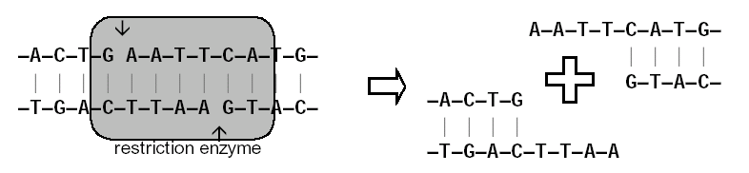

‘Sticky ends’

**Isolation of mRNA to reverse transcribe cDNA**

* Finding correct piece of DNA containing the desired gene is difficult and cell only has 2 strands of DNA.
* In cytoplasm of cells large numbers of mRNA molecules.
* In pancreatic cells the functional mRNA for insulin in large quantities in cytoplasm.
* This mRNA can be extracted.
* A group of viruses called retroviruses (e.g. HIV) contain an enzyme called **reverse transcriptase.**
* Reverse Transcriptase makes DNA from an RNA template – it does the opposite of transcription.
* **The cDNA only contains Exons**

**The gene machine**

* It is now possible to manufacture genes in a laboratory.

1. The amino acid sequence of a desired protein is determined
2. The mRNA sequence can then be worked out by looking up the mRNA codons and the DNA triplets are worked out
3. This sequence is fed into a computer
4. The sequence is checked for biosafety and biosecurity to ensure it meets international standards
5. The computer designs a series of small, overlapping strands of nucleotides, called oligonucleotides, which can be assembled into the desired gene
6. In an automated process, each of the oligonucleotides is assembled by adding one nucleotide at a time in the required sequence
7. The oligonucleotides are joined together to make a gene containing only exons
8. The gene is replicated using PCR (polymerase chain reaction)
9. The complementary strand is synthesised using PCR to make a double stranded gene. This is then multiplied
10. Using sticky ends the gene can be inserted into a bacterial plasmid.
11. The genes are checked using standard sequencing techniques and those with errors are rejected

These artificial genes can be produced in a short period of time and **only contain exons** so can be transcribed and translated by prokaryotic cells

* + Inserting the gene into a vector
    - To insert the gene into a bacterium a **vector** is used e.g. **plasmid** from ***E.coli*** bacteria
    - These plasmids contain a **marker gene** which codes for **antibiotic resistance** to antibiotic **ampicillin**
    - Plasmid DNA is cut using the same **Restriction Endonucleases** enzymes
    - Resulting in sticky ends being produced in plasmid DNA
    - **Insulin gene is mixed** with the cut plasmids
    - The sticky ends on insulin (donor) and plasmid are **complementary**, **base pairing occurs**
    - **DNA Ligase** enzymes joins the **sections of DNA** from donor and plasmid together
    - Forming **Recombinant DNA**

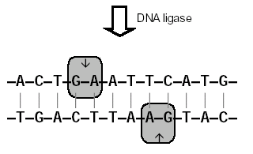

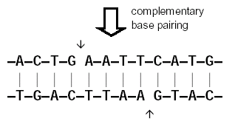

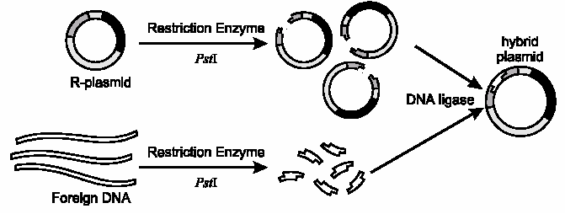

* + Marker genes
    - When bacteria and plasmids are mixed together only a **small number of bacteria** take up the **recombinant plasmids**:



* + - It is important to insert the DNA fragment into a plasmid containing 2 marker genes.
    - 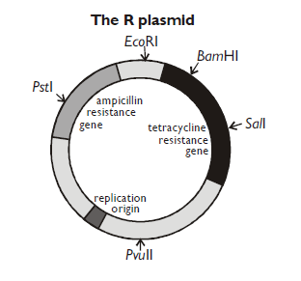In the example shown the ampicillin resistant gene is used to identify bacteria which have taken up a plasmid
    - The tetracycline resistance gene is disrupted when the restriction enzymes cuts open the plasmid.
    - The bacteria which contain the recombinant plasmids can be **indentified by the antibiotic resistant marker genes which now no longer works.**
    - All the bacteria are cultured on an agar plate containing the antibiotic ampicillin, only those containing the plasmid will survive:

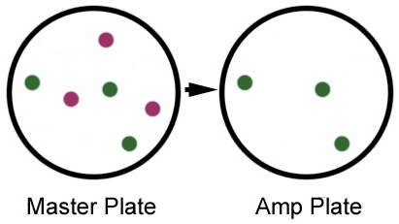

Bacteria with a plasmid

Bacteria with no plasmid

* + - The bacteria that survived on the Amp plate are isolated and grown in separate test tubes. A sample of each bacteria are then cultured on an agar plate containing the antibiotic tetracycline, only those containing the non recombinant plasmid will survive, if the bacteria contain the recombinant plasmid thay will not grow on the tetracycline agar.

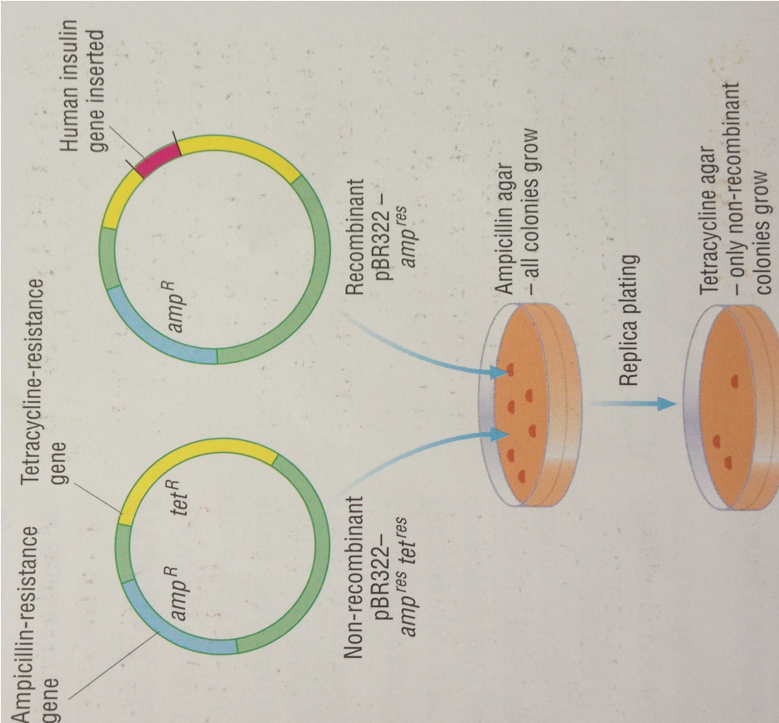

* + Manufacture of insulin
    - The identified genetically modified bacteria are cultured on a large scale in an industrial **fermenter**, producing cloned cells , where they all synthesise the human insulin
    - The human insulin is then extracted and **purified**
* Advantages of recombinant DNA technology
* The quantity production of **complex proteins or peptides** which cannot be made by other methods
* The production of **higher yielding crops** with superior **keeping qualities**
* The health benefits for treating **genetic diseases**
* Disadvantages of recombinant DNA technology
* it is **technically complicated** and therefore **very expensive** on an **industrial scale**
* there are **difficulties** involved in **identifying the genes** of value in a huge genome
* synthesis of required protein may involve **several genes**
* treatment of human DNA with restriction enzyme produces **millions of fragments which are of no use**
* not all **eukaryote genes** will express themselves in **prokaryote cells**
* **bacteria** readily **exchange genetic material**
* deliberate use of **antibiotic resistant genes in *E. coli*** means that these genes could **be accidentally transferred to human pathogens**
* the possibility of transfer of DNA with linked pathogenic genes, for example, oncogenes increasing cancer risks

# Gene therapy and Cystic Fibrosis

* Cystic Fibrosis

Somebody **without** Cystic Fibrosis has **normal** **carrier protein** called **Cystic Fibrosis Transmembrane Regulator (CFTR)** is found in the **cell membrane** of **epithelial cells**, where it:

* **Actively transports** Cl- out of the cells and onto the mucus on the surface of the cells
* **Na+ are attracted** into the mucus, **lowering the mucus ** 
* Therefore **water moves out** of the cell by **osmosis** and into the **mucus** making it **watery**

Cystic Fibrosis sufferers CFTR allele has been mutated (**deletion mutation on autosome**), which results in the CFTR carrier protein lacking just one amino acid, meaning that it is no longer functional:

* **CFTR doesn’t** actively transport Cl- out of the cells and onto the mucus on the surface of the cells
* Na+ are **not attracted** into the mucus, therefore the **mucus ** **remains high**
* Therefore **water doesn’t move out** of the cell by **osmosis**; the **mucus is thick and sticky.**

Sufferers produce **thick sticky mucus** from the **epithelial cells** lining body systems causing problems:

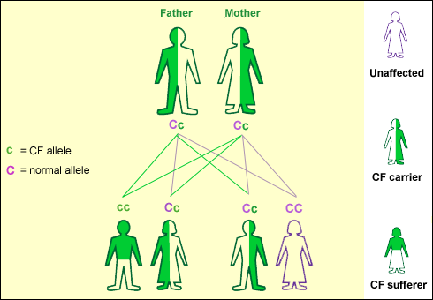

* + **Pancreatic duct** becomes **blocked** preventing **pancreatic enzymes** from being secreted into the **duodenum**, therefore food digestion is **incomplete** and there is a limited absorption of food!
  + 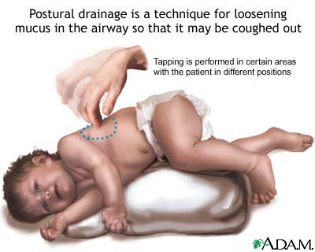**Bronchioles and alveoli** of the lungs become clogged causing congestion and **difficulty in breathing**. The mucus is difficult to move, therefore trapped bacteria/viruses cause **reoccurring infections** e.g. **bronchitis/pneumonia.** To relive stress with breathing, frequent daily chest physiotherapy massage is needed to keep the bronchi/bronchioles open!

There are many inherited diseases that are caused by faulty alleles of genes. The aim of gene therapy is to treat genetic diseases by replacing the defective alleles in the patient’s cells with copies of the normal allele. Gene therapy can be carried at two points in somebody’s life:

* + **Somatic cell therapy** targets the cells in the affected tissues of a

**child/adult**. The individual has symptoms of the disease relieved but these genetic changes would **not be inherited by offspring** as the **gametes** are not altered!

The **CFTR gene** has been **identified and cloned**. The gene therapy technique involves:

* The **normal CFTR allele** is **inserted into liposomes** (minute spheres of phospholipid)
* An **aerosol inhaler** is used to add the **normal allele** to the **epithelial cells** which line the **lungs**

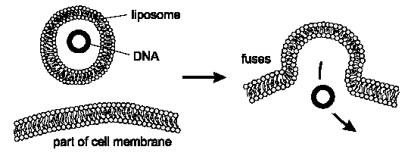

* The liposomes **fuse** with the **phospholipid bilayer** of the cell membrane and the **DNA enters the cells**.
* The epithelial cells with the normal CFTR allele **express** the **normal CFTR protein**; symptoms are alleviated!
  + **Germ line therapy** introduces normal genes into **‘germ line cells’** i.e.

**sperm/ovum**, therefore this enables genetic corrections to be **inherited!**

**Genetically Modified Plants**

A **genetically modified/transgenic organism**, is one which has had its genotype altered producing a new strain. Most transgenic organisms are bacteria; however genes can be transferred into plants, using the following technique:

* Certain species of bacteria attack damaged plants by inserting genes from their plasmids into the plant cell chromosomes, which stimulates the growth of a tumour

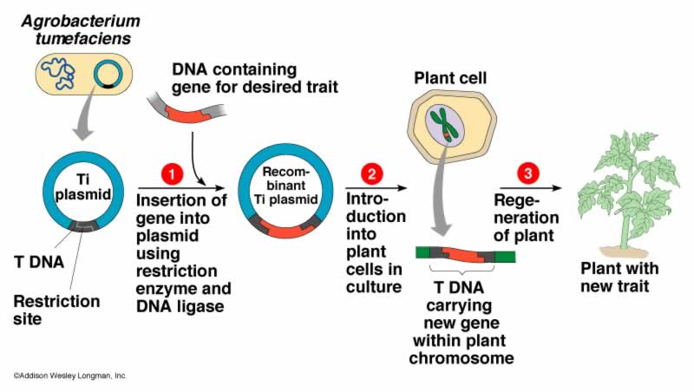

* The tumour forming genes in the plasmids can be replaced with ‘useful’ genes, forming **Genetically Modified (GM)** plants e.g.
* **Herbicide gene transferred to Soya bean plants** – this allows the herbicide to be sprayed on the soya bean plant without affecting it, but it does kill weed species
* **Ripening ‘blocker’ enzyme transferred to tomato plants** – tomatoes ripen as they produce an **enzyme** which **breaks down pectin** in their **cell walls**. However due to tomatoes being transported long distances, the **ripe tomatoes** are **easily damaged** and not fit for sale. A gene has been transferred to tomato plants which when expressed, **blocks and delays** the production of the enzyme. These **‘Flavr Savr’** tomato plants produce tomatoes which have a **longer shelf life**!
* Benefits of GM crops
* Superior keeping qualities i.e. shelf life
* Higher yield
* Substantial reduction in pesticide use on crops engineered for resistance to fungal pathogens and insect attack
* Concerns relating to GM crops
* Dispersal of pollen from crops engineered for herbicide resistance to wild relatives e.g. soya bean plant
* GM crops contain **‘marker genes’** which are easy to detect to determine if the plant has taken up the introduced gene. However these marker genes can confer **antibiotic resistance** to **bacteria in the intestine!**
* A reduction in biodiversity may occur GM companies may only offer a limited number of species for growth

**Genetic Fingerprinting**

A person’s DNA profile is also called their ‘DNA Fingerprint’, which is unique! Since somatic body cells/tissue contain all the same DNA tissues such as blood, hair, skin or semen can be used to determine someone’s genetic fingerprint i.e. for use in **forensic science** and **paternity suits!**

**Exons** are regions of DNA that code for proteins. Between exons are regions of **non coding DNA** called **introns** which contain blocks of repeated nucleotides called **short tandem repeats (STRs).** It is the **number of times** that these blocks of **STRs** are repeated that produces the **variation** in individuals.

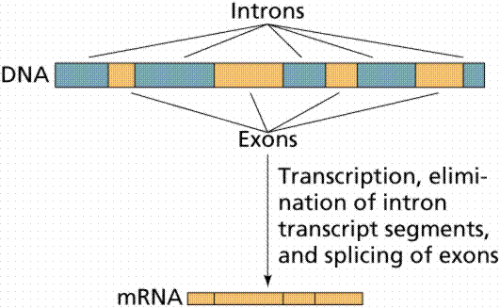

Genetic fingerprints are produced using the following technique:

* The DNA is extracted from the tissue and **cut** into **small fragments** using **Restriction Endonucleases**
* The DNA fragments are separated using **electrophoresis** ([Gel Electrophoresis animation](http://www.tvdsb.on.ca/westmin/science/sbioac/genetics/Electro.htm)):
* The DNA fragments are placed into **one end** of a trough containing gel and exposed to an **electric current**
* Since the **DNA fragments are negatively charged**, they are attracted towards the **positive terminal**
* The **smaller** the fragments the **faster** they move
* The DNA becomes **separated** into bands according to the **size** of the fragments

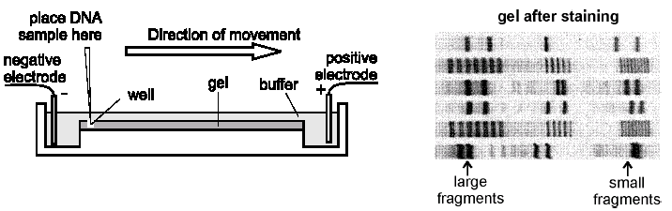

* The trough is covered in a **nylon membrane** and the DNA fragments are transferred to the membrane by a process called **Southern blotting**
* **Radioactive DNA probes** are used to attach to specific sections of the fragments (unbound probes are washed off)
* The nylon membrane with fragments attached are placed under **x-ray film** and the radioactive probes **expose the film**
* This **autoradiograph** reveals a pattern of dark and light bands which are **unique to people**, hence called their genetic fingerprint

Genetic fingerprints can be used to settle **paternity disputes**:

* **White blood cells** are taken from the **mother** and **possible father**
* The bands of the **mother** are **subtracted** from the child’s genetic fingerprint
* If the **man** is the father, he **must possess all the remaining bands** in the child’s genetic fingerprint!

Child Mother Man Child Mother Man

Paternal Father Not paternal father

* Gene amplification using the Polymerase Chain Reaction (PCR) ([PCR animation](http://spine.rutgers.edu/cellbio/flash/pcr.htm)) [(PCR video)](http://www.lsic.ucla.edu/ls3/tutorials/gene_cloning.html)

At a crime scene a **small sample** of DNA may be found e.g. **single hair/small spot of blood**. In order to carry out **numerous laboratory tests** a **larger sample** of DNA is required.

PCR can be use to **replicate** **billions** of **copies of a specific fragment of DNA**, which **enables tests** to be carried out **accurately** and **more rapidly** regardless of the **age of the sample**!

PCR is **semi-conservative replication** in a test tube. The sample of DNA is dissolved in a **buffer** solution and mixed with:

* + **DNA Polymerase**
  + **DNA nucleotides**
  + **Primers** (short pieces of DNA which act as signals to DNA Polymerase to start copying
  + The process comprises of the following stages:
    - The original DNA (target DNA) is **denatured** i.e. hydrogen bonds break between DNA strands), by **heating to 95oC**, separating into two single strands of DNA

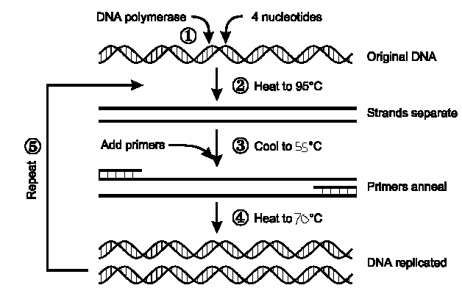

* + - The solution is **cooled to 55oC** triggering the **primers to join** (anneal) to the complementary base sequence on each of the single strands of DNA
    - The solution is **heated to 70oC** which is the **optimum temperature** for **DNA Polymerase** (from a species of thermophillic bacteria), which catalyses the **synthesis of a complementary strand** for each of the single strands of DNA, producing 2 identical double strands of DNA!
    - The process is repeated, doubling the quantity of DNA produced each time:

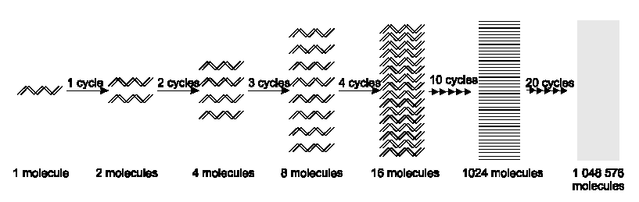

* Genetic banks raises issue of privacy

Genetic fingerprinting information is stored for forensic science, paternity studies etc… But who has access to it? If potential employers or insurance companies accessed the information it could lead to job losses or very high health insurance premiums!