**Q1.**

The Amish are a group of people who live in America. This group was founded by 30 Swiss people, who moved to America many years ago. The Amish do not usually marry people from outside their own group.

One of the 30 Swiss founders had a genetic disorder called Ellis-van Creveld syndrome. People with this disorder have heart defects, are short and have extra fingers and toes. Ellis-van Creveld syndrome is caused by a faulty allele.

In America today, about 1 in 200 Amish people are born with Ellis-van Creveld syndrome. This disorder is very rare in people in America who are not Amish.

(a)     In America today, there are approximately 1250 Amish people who have Ellis-van Creveld syndrome. Use the information provided to calculate the current Amish population of America.

Amish population ____________________

**(1)**

(b)     The faulty allele that causes Ellis-van Creveld syndrome is the result of a mutation of a gene called *EVC.* This mutation leads to the production of a protein that has one amino acid missing.

(i)      Suggest how a mutation can lead to the production of a protein that has one amino acid missing.

______________________________________________________________

______________________________________________________________

______________________________________________________________

______________________________________________________________

______________________________________________________________

**(2)**

(ii)     Suggest how the production of a protein with one amino acid missing may lead to a genetic disorder such as Ellis-van Creveld syndrome.

______________________________________________________________

______________________________________________________________

______________________________________________________________

______________________________________________________________

______________________________________________________________

**(2)**

**(Total 5 marks)**

**Q2.**

Sickle cell disease (SCD) is a group of inherited disorders. People with SCD have sickle-shaped red blood cells. A single base substitution mutation can cause one type of SCD. This mutation causes a change in the structure of the beta polypeptide chains in haemoglobin.

(a)  Explain how a single base substitution causes a change in the structure of this polypeptide.

Do **not** include details of transcription and translation in your answer.

___________________________________________________________________

___________________________________________________________________

___________________________________________________________________

___________________________________________________________________

___________________________________________________________________

___________________________________________________________________

___________________________________________________________________

___________________________________________________________________

**(3)**

Haematopoietic stem cell transplantation (HSCT) is a long-term treatment for SCD. In HSCT, the patient receives stem cells from the bone marrow of a person who does not have SCD. The donor is often the patient’s brother or sister. Before the treatment starts, the patient’s faulty bone marrow cells have to be destroyed.

(b)  Use this information to explain how HSCT is an effective long-term treatment for SCD.

___________________________________________________________________

___________________________________________________________________

___________________________________________________________________

___________________________________________________________________

___________________________________________________________________

___________________________________________________________________

___________________________________________________________________

___________________________________________________________________

**(3)**

A new long-term treatment for SCD involves the use of gene therapy.

The diagram shows some of the stages involved in this treatment in a child with SCD.

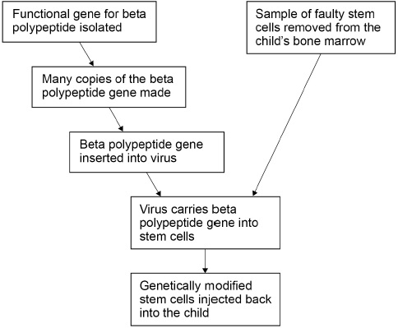

(c)  Some scientists have concluded that this method of gene therapy will be a more effective long-term treatment for SCD than HSCT. Use all the information provided to evaluate this conclusion.

___________________________________________________________________

___________________________________________________________________

___________________________________________________________________

___________________________________________________________________

___________________________________________________________________

___________________________________________________________________

___________________________________________________________________

___________________________________________________________________

___________________________________________________________________

___________________________________________________________________

**(3)**

**(Total 9 marks)**

**Q3.**

Chronic lymphocytic leukaemia (CLL) is a cancer that affects some B cells of a person’s immune system.

Rituximab is a drug used to treat CLL. It binds to a protein called CD20 on the surface of B cells. If enough Rituximab binds to a B cell, it can kill the cell. Rituximab kills **both** healthy **and** cancerous B cells. The body then produces new B cells.

The amount of CD20 on the surface of B cells varies from one person to another. Doctors investigated the relationship between the amount of CD20 on the B cells of a patient and the percentage of B cells destroyed by Rituximab.

The graph shows the doctors’ results. Each cross is the result for one patient.

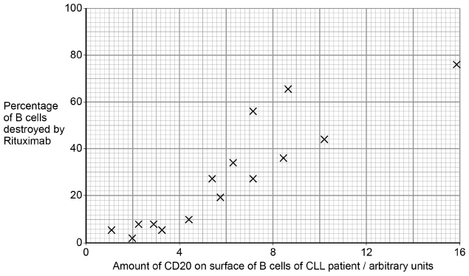

(a)     What statistical test could the scientists have used to determine whether there was a significant relationship between the amount of CD20 on the surface of B cells and the percentage of B cells destroyed by Rituximab?

Give a reason for your answer.

Name of test ________________________________________________________

Reason ____________________________________________________________

___________________________________________________________________

___________________________________________________________________

___________________________________________________________________

**(1)**

(b)     From these data, what can you conclude about the effectiveness of Rituximab in treating patients with CLL?

Do **not** include considerations of statistical analyses in your answer.

___________________________________________________________________

___________________________________________________________________

___________________________________________________________________

___________________________________________________________________

___________________________________________________________________

___________________________________________________________________

___________________________________________________________________

___________________________________________________________________

___________________________________________________________________

___________________________________________________________________

___________________________________________________________________

___________________________________________________________________

___________________________________________________________________

___________________________________________________________________

___________________________________________________________________

**(3)**

Approximately 11 percent of people with CLL also have mutations of a gene called *NOTCH1*. This leads to production of a non-functional transcription factor associated with CD20 production.

The doctors determined the median percentage of B cells destroyed by Rituximab in people with CLL who had the *NOTCH1* mutation and those who did not.

The doctors’ results are shown in the table.

|  |  |
| --- | --- |
|  | **Median percentage of B cell destroyed by Rituximab** |
| In people with CLL who had the *NOTCH1* mutation | **4** |
| In people with CLL who did **not** have *NOTCH1* mutation | **22** |

(c)     Human blood contains (approximately) 1.0 × 109 B cells per dm3.

Use the median values in the table to calculate the difference between the number of B cells per dm3 in the blood of people treated with Rituximab with the *NOTCH1* mutation and people without the *NOTCH1* mutation.

Express your answer in standard form. Show your working.

____________________ cells per dm3

**(2)**

(d)     Use all of the information to suggest how the mutation of *NOTCH1* led to the difference in the percentage of B cells destroyed by Rituximab.

___________________________________________________________________

___________________________________________________________________

___________________________________________________________________

___________________________________________________________________

___________________________________________________________________

___________________________________________________________________

___________________________________________________________________

___________________________________________________________________

___________________________________________________________________

___________________________________________________________________

___________________________________________________________________

___________________________________________________________________

___________________________________________________________________

___________________________________________________________________

**(3)**

**(Total 9 marks)**

**Q4.**

(a)     Define what is meant by epigenetics.

___________________________________________________________________

___________________________________________________________________

___________________________________________________________________

___________________________________________________________________

___________________________________________________________________

**(2)**

(b)     In eukaryotes, transcription of target genes can be stimulated or inhibited when specific transcriptional factors move from the cytoplasm into the nucleus.

Oestrogen, methyl groups and acetyl groups are control factors that can play a role in initiating transcription.

Complete the table to show features of these control factors.

Put a tick (✔) in the box if the control factor shows the feature.

|  |  |  |
| --- | --- | --- |
|  | **Feature** | |
| **Control factor** | **Binds with DNA** | **Binds with protein** |
| Oestrogen |  |  |
| Methyl groups |  |  |
| Acetyl groups |  |  |

**(2)**

(c)     Explain how increased methylation could lead to cancer.

___________________________________________________________________

___________________________________________________________________

___________________________________________________________________

___________________________________________________________________

___________________________________________________________________

___________________________________________________________________

**(3)**

(d)     Give **one** way in which benign tumours differ from malignant tumours.

___________________________________________________________________

___________________________________________________________________

___________________________________________________________________

**(1)**

**(Total 8 marks)**

**Q5.**

Myelodysplastic syndromes (MDS) are a group of malignant cancers. In MDS, the bone marrow does not produce healthy blood cells.

Haematopoietic stem cell transplantation (HSCT) is one treatment for MDS. In HSCT, the patient receives stem cells from the bone marrow of a person who does not have MDS. Before the treatment starts, the patient’s faulty bone marrow is destroyed.

(a)  For some patients, HSCT is an effective treatment for MDS.

Explain how.

___________________________________________________________________

___________________________________________________________________

___________________________________________________________________

___________________________________________________________________

___________________________________________________________________

___________________________________________________________________

___________________________________________________________________

___________________________________________________________________

___________________________________________________________________

**(3)**

(b)  MDS can develop from epigenetic changes to tumour suppressor genes. In some patients, the drug AZA has reduced the effects of MDS. AZA is an inhibitor of DNA methyltransferases. These enzymes add methyl groups to cytosine bases.

Suggest and explain how AZA can reduce the effects of MDS in some patients.

___________________________________________________________________

___________________________________________________________________

___________________________________________________________________

___________________________________________________________________

___________________________________________________________________

___________________________________________________________________

___________________________________________________________________

**(3)**

Scientists investigated the effectiveness of AZA in patients with MDS. A total of 360 patients were randomised in the ratio of 1:1 to receive AZA or conventional drugs (control).

The figure below shows the scientists’ results.

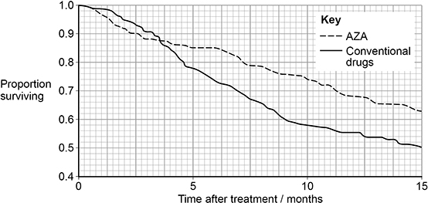

(c)  The control patients were treated with conventional drugs.

Give **two** reasons why.

1  _________________________________________________________________

___________________________________________________________________

2  _________________________________________________________________

___________________________________________________________________

**(2)**

(d)  Use the figure above and the information provided to calculate the difference in the number of patients surviving at 10 months after treatment with AZA compared with conventional drugs.

Answer _______________

**(2)**

**(Total 10 marks)**

**Q6.**

Hepatitis B is a life-threatening liver infection caused by the hepatitis B virus (HBV).

**Figure 1** shows the structure of HBV.

**Figure 1**

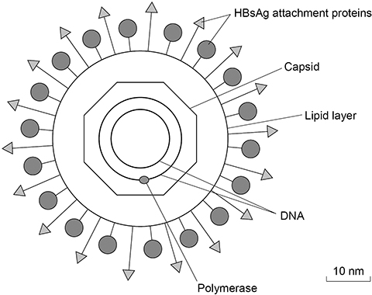

(a)  HBV infects a liver cell. The liver cell is 25 µm in diameter.

Use **Figure 1** to calculate how many times larger in diameter this cell is than HBV. You should use the lipid layer to measure the diameter of HBV.

Answer _______________ times larger

**(2)**

Scientists investigated the effectiveness of two types of RNA interference (RNAi) molecules on reducing HBV replication. These molecules were:

•   short hairpin RNA (shRNA)

•   long hairpin RNA (IhRNA).

The scientists infected mouse liver cells with HBV and transferred either shRNA or lhRNA into these cells. Then they determined the concentration of the attachment proteins, HBsAg, in these cells.

The concentration of HBsAg is a measure of HBV replication.

**Figure2** shows the scientists’ results.

The error bars represent ±2 standard deviations from the mean, which includes over 95% of the data.

**Figure 2**

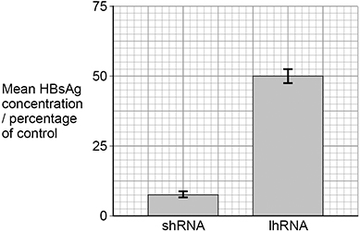

(b)  One method of transferring RNAi molecules into cells involves combining these molecules with a lipid. Suggest why this increases uptake of RNAi molecules into cells.

___________________________________________________________________

___________________________________________________________________

**(1)**

(c)  Using all the information provided, evaluate the use of the two types of RNAi in treating hepatitis B in humans.

Do **not** refer in your answer to how RNAi reduces HBV replication.

___________________________________________________________________

___________________________________________________________________

___________________________________________________________________

___________________________________________________________________

___________________________________________________________________

___________________________________________________________________

___________________________________________________________________

___________________________________________________________________

___________________________________________________________________

___________________________________________________________________

___________________________________________________________________

**(5)**

**(Total 8 marks)**

**Q7.**

(a)     In the UK in 2016, there were 525 048 deaths. Cancer caused 30.4% of all deaths. Throat cancer caused 5% of all deaths from cancer.

Calculate the mean number of people who died of throat cancer per month in 2016.

Show your working.

Answer _______________ people per month

**(2)**

Increased methylation of the promoter region of a tumour suppressor gene causes one type of human throat cancer.

In this type of throat cancer, cancer cells are able to pass on the increased methylation to daughter cells. The methylation is caused by an enzyme called DNMT.

Scientists have found that a chemical in green tea, called EGCG, is a competitive inhibitor of DNMT. EGCG enables daughter cells to produce messenger RNA (mRNA) from the tumour suppressor gene.

(b)     Suggest how EGCG allows the production of mRNA in daughter cells.

___________________________________________________________________

___________________________________________________________________

___________________________________________________________________

___________________________________________________________________

___________________________________________________________________

___________________________________________________________________

___________________________________________________________________

___________________________________________________________________

**(3)**

The scientists investigated the effect of different amounts of EGCG on the growth rate of the throat cancer cells grown *in vitro*. Their results are shown in the graph below.

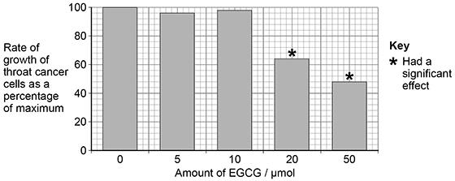

(c)     A reporter who reviewed all of this work concluded that drinking green tea could be a cure for cancer.

Suggest **three** reasons why his conclusion might **not** be valid.

1 _________________________________________________________________

___________________________________________________________________

2 _________________________________________________________________

___________________________________________________________________

3 _________________________________________________________________

___________________________________________________________________

**(3)**

**(Total 8 marks)**

**Q8.**

(a)     There are different types of gene mutation.

Put a tick (**✓**) in the box next to the statement which describes **incorrectly** the effect of the mutation in an exon of a gene.

|  |  |
| --- | --- |
| A substitution may not result in a change to the encoded amino acid. |  |
| An inversion will result in a change in the number of DNA bases. |  |
| A deletion will result in a frame shift. |  |
| An addition will result in a frame shift. |  |

**(1)**

(b)     Describe how alterations to tumour suppressor genes can lead to the development of tumours.

___________________________________________________________________

___________________________________________________________________

___________________________________________________________________

___________________________________________________________________

___________________________________________________________________

___________________________________________________________________

___________________________________________________________________

___________________________________________________________________

___________________________________________________________________

___________________________________________________________________

___________________________________________________________________

___________________________________________________________________

**(3)**

(c)     A type of malignant tumour cell divides every 8 hours.

Starting with one of these cells, how many tumour cells will be present after 4 weeks?

Assume none of these cells will die.

Give your answer in standard form.

Answer = ____________________

**(2)**

**(Total 6 marks)**