**Q1.** A husband and wife wanted to know whether they were carriers of the mutated form of a gene. This mutation is a deletion that causes a serious inherited genetic disorder in people who are homozygous.

A geneticist took samples of DNA from the husband and the wife. He used a DNA probe to look for the deletion mutation. The DNA probe was specific to a particular base sequence in an exon in the gene. Exons are the coding sequences in a gene.

The geneticist compared the couple’s DNA with that of a person known not to carry this mutation.

The chart shows the geneticist’s results.

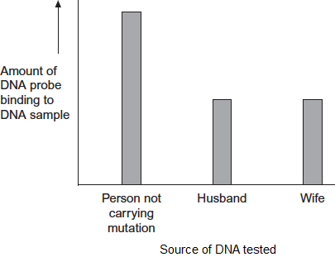

(a)     The geneticist told the couple they were both carriers of the mutated gene.  
Explain how he reached this conclusion.

___________________________________________________________________

___________________________________________________________________

___________________________________________________________________

___________________________________________________________________

___________________________________________________________________

___________________________________________________________________

**(3)**

(b)     The DNA probe the geneticist used was for an exon in the DNA, **not** an intron. Explain why.

___________________________________________________________________

___________________________________________________________________

___________________________________________________________________

___________________________________________________________________

___________________________________________________________________

___________________________________________________________________

**(3)**

(c)     To make the DNA probe, the geneticist had to find the base sequence of the normal gene. Once he had copies of the gene, what methods would he use to find the base sequence of the gene?

___________________________________________________________________

___________________________________________________________________

___________________________________________________________________

___________________________________________________________________

___________________________________________________________________

**(2)**

**(Total 8 marks)**

**Q2.** *Mycobacterium tuberculosis* causes tuberculosis. The DNA of *M. tuberculosis* contains a direct repeat (DR) region. The DR region consists of 43 different, non-coding base sequences called spacers. Each spacer is found in a specific place in the DR region.

In different strains of *M. tuberculosis*, some of these spacers have been lost.

(a)     (i)      The DR region consists of non-coding base sequences.

What is meant by a non-coding base sequence?

______________________________________________________________

______________________________________________________________

**(1)**

(ii)      Name the process by which the base sequence of a spacer is lost from a DR region.

______________________________________________________________

______________________________________________________________

**(1)**

Scientists investigated the DR regions of different strains of *M. tuberculosis*. They produced a DNA probe for each of the 43 spacer sequences. Each probe was:

•        labelled with a fluorescent marker that gave off light if the probe attached to its complementary spacer

•        attached to a particular square on a slide.

They obtained samples of the DR region from each strain. These were cut into small single-stranded DNA fragments. The fragments from each strain were added to a slide with the DNA probes attached. The diagram below shows their results for one strain of *M. tuberculosis* with 20 of the probes.

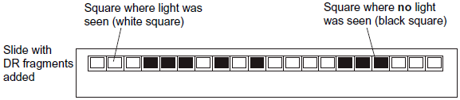

(b)     The scientists cloned the DR region DNA *in vitro* before testing for the presence of spacers.

Give the name of the method they used to clone the DNA *in vitro*.

___________________________________________________________________

**(1)**

(c)     Explain how the use of DNA probes produced the results in the diagram.

___________________________________________________________________

___________________________________________________________________

___________________________________________________________________

___________________________________________________________________

___________________________________________________________________

___________________________________________________________________

___________________________________________________________________

**(3)**

(d)     Doctors can use the method with DNA probes to identify the specific strain of *M. tuberculosis* infecting a patient. This is very important when there is an outbreak of a number of cases of tuberculosis in a city.

Suggest and explain why it is important to be able to identify the specific strain of *M. tuberculosis* infecting a patient.

___________________________________________________________________

___________________________________________________________________

___________________________________________________________________

___________________________________________________________________

___________________________________________________________________

___________________________________________________________________

**(2)**

**(Total 8 marks)**

**Q3.** Plasmids can be used as vectors to insert lengths of foreign DNA into bacteria. The diagram shows how this is achieved.

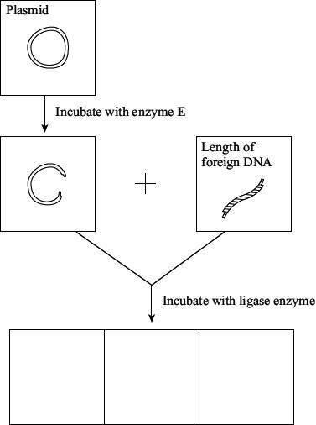

(a)     Name enzyme **E**.

___________________________________________________________________

**(1)**

(b)     Cut plasmids and lengths of foreign DNA can join. What features of their ends allows them to join?

___________________________________________________________________

___________________________________________________________________

___________________________________________________________________

___________________________________________________________________

**(2)**

(c)     Draw **three** different structures that could be formed by incubating cut plasmids and lengths of foreign DNA with ligase. Use the spaces provided on the diagram.

**(3)**

**(Total 6 marks)**

**Q4.** People suffering from pituitary dwarfism do not make enough human growth hormone (HGH). They can be treated using injections of HGH.

A geneticist wants to transform the bacterium, *Escherichia coli*, to make HGH by adding the gene coding for HGH.

The geneticist could obtain the *HGH* gene using any one of three methods.

1.      Use restriction enzymes to cut out a fragment of DNA containing the *HGH* gene from a human genome.

2.      Convert mRNA for HGH into cDNA using reverse transcriptase.

3.      Create the *HGH* gene using a ‘gene machine’.

(a)     The geneticist decided **not** to use restriction enzymes to cut out a fragment of DNA containing the *HGH* gene from a human genome. She made this decision because only methods 2 and 3 would produce DNA that *E. coli* could use to make HGH.

Explain why only methods 2 and 3 would produce DNA that *E. coli* could use to make HGH.

___________________________________________________________________

___________________________________________________________________

___________________________________________________________________

___________________________________________________________________

___________________________________________________________________

**(2)**

(b)     The geneticist concluded it would be faster to create the *HGH* gene using a gene machine than by using reverse transcriptase to convert mRNA for HGH into cDNA.

Suggest why the geneticist reached this conclusion.

___________________________________________________________________

___________________________________________________________________

**(1)**

(c)     After obtaining copies of the *HGH* gene, the geneticist will attempt to insert them into plasmid vectors.

Describe how the geneticist would attempt to insert copies of the *HGH* gene into these plasmids.

___________________________________________________________________

___________________________________________________________________

___________________________________________________________________

___________________________________________________________________

___________________________________________________________________

**(3)**

(d)     The geneticist plans to use the plasmids containing the *HGH* gene to try to transform cells of *E. coli*. She knows that some *E. coli* might not take up the plasmid.

To enable her to identify which bacteria have taken up the plasmid with the *HGH* gene, the plasmids she intends to use contain a gene that codes for a green fluorescent protein (GFP). Bacteria that contain this plasmid glow green under UV light.

Suggest **one** advantage of using this gene for GFP to identify bacteria that have taken up plasmids.

___________________________________________________________________

___________________________________________________________________

**(1)**

The diagram below shows part of the plasmid containing the gene that codes for GFP. It also shows the roles of two genes that control the GFP gene.

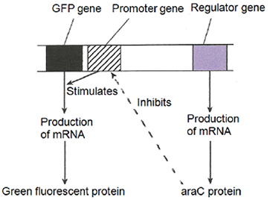

(e)      Arabinose is a sugar that can bind to the araC protein.

Use information in the diagram to suggest why the geneticist must include arabinose in the agar on which she hopes to grow *E. coli* containing the transgenic plasmids.

___________________________________________________________________

___________________________________________________________________

___________________________________________________________________

___________________________________________________________________

**(2)**

**(Total 9 marks)**

**Q5.** A gene was broken into fragments using enzyme **Z**. The mixture of fragments produced was then separated by electrophoresis.

(a)     What type of enzyme is enzyme **Z**?

___________________________________________________________________

**(1)**

The table shows the number of base pairs present in the fragments.

|  |  |
| --- | --- |
| **Fragment** | **Number of base pairs (× 103)** |
| 1 | 4.65 |
| 2 | 5.72 |
| 3 | 10.71 |
| 4 | 2.39 |
| 5 | 5.35 |
| 6 | 7.53 |

The diagram shows the electrophoresis gel used. The mixture of fragments was placed at the start point marked **S** and the process started. The boxes indicate the positions reached by the different fragments.

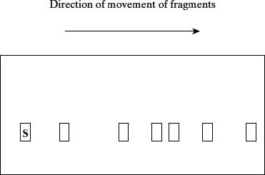

(b)     Explain why base pairs are a suitable way of measuring the length of a piece of DNA.

___________________________________________________________________

___________________________________________________________________

___________________________________________________________________

**(2)**

(c)     (i)      Write **6** above the appropriate box on the diagram to show the position you would expect fragment **6** to have reached.

**(1)**

(ii)     Explain how you arrived at your answer.

______________________________________________________________

**(1)**

(d)     Enzyme **Z** recognises a particular sequence of bases in the gene. How many times does this sequence appear in the DNA of this gene?

___________________________________________________________________

**(1)**

**(Total 6 marks)**

**Q6.** (a)  Describe and explain how the polymerase chain reaction (PCR) is used to amplify a DNA fragment.

___________________________________________________________________

___________________________________________________________________

___________________________________________________________________

___________________________________________________________________

___________________________________________________________________

___________________________________________________________________

___________________________________________________________________

___________________________________________________________________

**(4)**

The figure below shows the number of DNA molecules produced using a PCR.

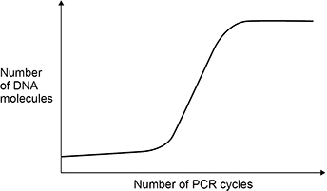

(b)  Explain the shape of the curve in the figure above.

___________________________________________________________________

___________________________________________________________________

___________________________________________________________________

___________________________________________________________________

**(2)**

**(Total 6 marks)**

**Q7.** One way to detect and measure accurately the amount of RNA in a tissue sample is by RT-PCR (reverse transcriptase-polymerase chain reaction).

RT-PCR uses a reaction mixture containing:

•   the sample for testing

•   reverse transcriptase

•   DNA nucleotides

•   primers

•   DNA polymerase

•   fluorescent dye.

The principle behind this method is shown in **Figure 1**.

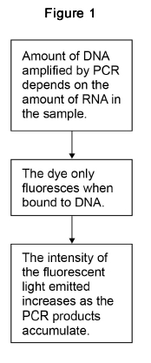

(a)     Explain the role of reverse transcriptase in RT-PCR.

___________________________________________________________________

___________________________________________________________________

**(1)**

(b)     Explain the role of DNA polymerase in RT-PCR.

___________________________________________________________________

___________________________________________________________________

**(1)**

(c)     Any DNA in the sample is hydrolysed by enzymes before the sample is added to the reaction mixture.

Explain why.

___________________________________________________________________

___________________________________________________________________

___________________________________________________________________

___________________________________________________________________

**(2)**

(d)     **Figure 2** shows the results from using RT-PCR to detect RNA in two different samples, **A** and **B**.

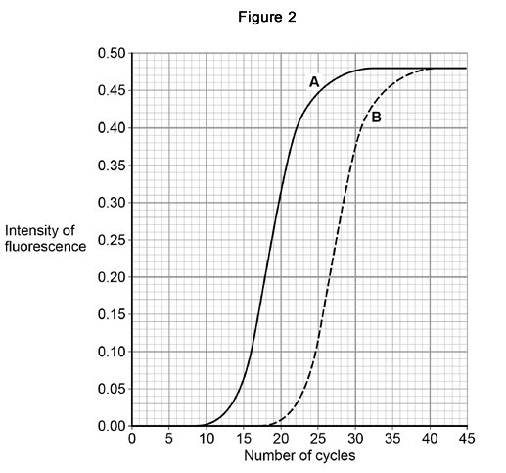

A quantitative comparison can be made of the amount of RNA in samples **A** and **B**. This involves determining the number of cycles required to reach 50% maximum concentration of DNA (**C**).

The amount of RNA in a sample can be measured as: 

Use this information to calculate the ratio for RNA content in sample **A** : RNA content in sample **B**.

Answer ___________

**(2)**

(e)     Suggest **one** reason why DNA replication stops in the polymerase chain reaction.

___________________________________________________________________

___________________________________________________________________

**(1)**

(f)     Scientists have used the RT-PCR method to detect the presence of different RNA viruses in patients suffering from respiratory diseases.

The scientists produced a variety of primers for this procedure.

Explain why.

___________________________________________________________________

___________________________________________________________________

___________________________________________________________________

___________________________________________________________________

**(2)**

**(Total 9 marks)**

**Q8.** Scientists wanted to measure how much mRNA was transcribed from allele **A** of a gene in a sample of cells. This gene exists in two forms, **A** and **a**.

The scientists isolated mRNA from the cells. They added an enzyme to mRNA to produce cDNA.

(a)     Name the type of enzyme used to produce the cDNA.

___________________________________________________________________

**(1)**

The scientists used the polymerase chain reaction (PCR) to produce copies of the cDNA. They added a DNA probe for allele **A** to the cDNA copies. This DNA probe had a dye attached to it. This dye glows with a green light **only** when the DNA probe is attached to its target cDNA.

(b)     Explain why this DNA probe will only detect allele **A**.

___________________________________________________________________

___________________________________________________________________

___________________________________________________________________

**(2)**

(c)     The scientists used this method with cells from two people, **H** and **G**.  
One person was homozygous, **AA**, and the other was heterozygous, **Aa**.  
The scientists used the PCR and the DNA probe specific for allele **A** on the cDNA from both people.

The figure shows the scientists’ results.

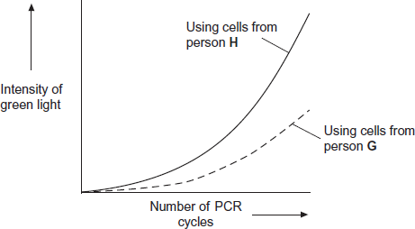

(i)      Explain the curve for person **H**.

______________________________________________________________

______________________________________________________________

______________________________________________________________

______________________________________________________________

______________________________________________________________

**(3)**

(ii)     Which person, **H** or **G**, was heterozygous, **Aa**? Explain your answer.

______________________________________________________________

______________________________________________________________

______________________________________________________________

______________________________________________________________

**(2)**

**(Total 8 marks)**

**Q9.** *Agrobacterium tumefaciens* is a bacterium that is often used in recombinant DNA technology to produce transformed plants that benefit humans.

*A. tumefaciens* contains a plasmid which can be used as a vector to transfer a desired gene into plant cells. These plant cells may then develop into plants which produce the protein coded for by the desired gene.

The diagram outlines this process.

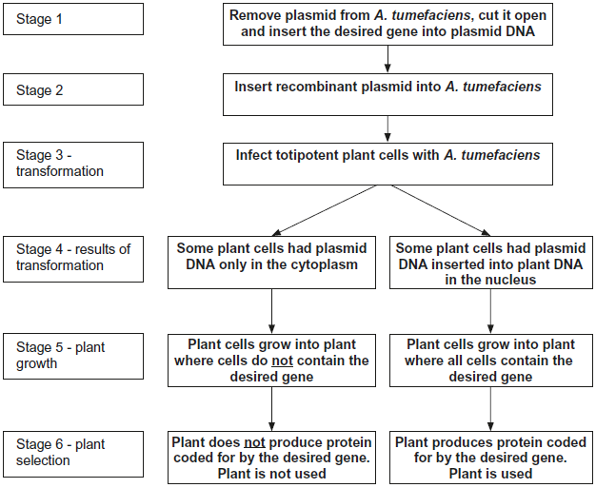

(a)     (i)      In stage 1, an enzyme is used to cut open the plasmid.

Name the type of enzyme used to cut open the plasmid.

______________________________________________________________

**(1)**

(ii)      In stage 1, another enzyme is used to insert the desired gene into the plasmid DNA.

Name the type of enzyme used to insert the gene into the plasmid.

______________________________________________________________

**(1)**

(b)     In stage 4, some plant cells had plasmid DNA only in their cytoplasm. In other plant cells, the plasmid DNA had become inserted into plant DNA in the nucleus.

In stage 5, only cells with plasmid DNA inserted into the plant DNA in the nucleus grew into plants where all the cells contained the desired gene.

Explain why some of the plants in stage 5 contained the desired gene in all of their cells and others did not.

___________________________________________________________________

___________________________________________________________________

___________________________________________________________________

___________________________________________________________________

___________________________________________________________________

___________________________________________________________________

**(3)**

(c)     The **desired gene** in the diagram was from an insect. In stage 6, the plant containing this gene was able to use it to synthesise an insect protein.

The plant is able to synthesise the insect protein. Explain why this is possible.

___________________________________________________________________

___________________________________________________________________

___________________________________________________________________

___________________________________________________________________

___________________________________________________________________

___________________________________________________________________

**(3)**

**(Total 8 marks)**

**Q10.** (a)  What is a DNA probe?

___________________________________________________________________

___________________________________________________________________

___________________________________________________________________

___________________________________________________________________

**(2)**

DNA probes are used to detect specific base sequences of DNA.

The process is shown in **Figure 1**.

**Figure 1**

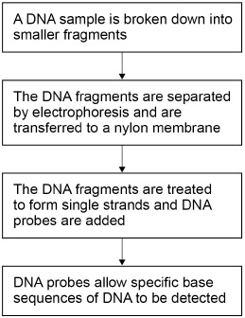

(b)  Describe how the DNA is broken down into smaller fragments.

___________________________________________________________________

___________________________________________________________________

___________________________________________________________________

___________________________________________________________________

___________________________________________________________________

**(2)**

(c)  The DNA on the nylon membrane is treated to form single strands. Explain why.

___________________________________________________________________

___________________________________________________________________

**(1)**

A scientist used DNA probes and electrophoresis to screen four volunteers for five different viral DNA fragments.

**Figure 2** shows the results the scientist obtained. The lanes numbered 2 to 5 represent the four volunteers.

**Figure 2**

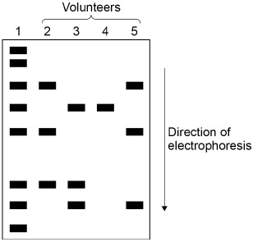

(d)  Lane 1 of **Figure 2** enabled the size of the different viral fragments to be determined.

Suggest and explain how.

___________________________________________________________________

___________________________________________________________________

___________________________________________________________________

___________________________________________________________________

___________________________________________________________________

**(2)**

The lengths of the viral DNA fragments were:

•   600 base pairs

•   250 base pairs

•   535 base pairs

•   300 base pairs

•   500 base pairs.

(e)  Which volunteers had at least one of the viral DNA fragments with 250 base pairs or 535 base pairs?

___________________________________________________________________

**(1)**

**(Total 8 marks)**