**3.8.3 & 3.8.4 Gene Technologies Extra Question Pack**

**Q1.** In Europe, viruses have infected a large number of frogs of different species. The viruses are closely related and all belong to the Ranavirus group.

Previously, the viruses infected only one species of frog.

(a)     Suggest and explain how the viruses became able to infect other species of frog.

___________________________________________________________________

___________________________________________________________________

___________________________________________________________________

___________________________________________________________________

___________________________________________________________________

___________________________________________________________________

**(2)**

(b)     Name **two** techniques the scientists may have used when analysing viral DNA to determine that the viruses were closely related.

1 _________________________________________________________________

2 _________________________________________________________________

**(1)**

(c)     Determining the genome of the viruses could allow scientists to develop a vaccine.

Explain how.

___________________________________________________________________

___________________________________________________________________

___________________________________________________________________

___________________________________________________________________

___________________________________________________________________

___________________________________________________________________

**(2)**

(d)     Describe how the B lymphocytes of a frog would respond to vaccination against Ranavirus.

You can assume that the B lymphocytes of a frog respond in the same way as B lymphocytes of a human.

Do **not** include details of the cellular response in your answer.

___________________________________________________________________

___________________________________________________________________

___________________________________________________________________

___________________________________________________________________

___________________________________________________________________

___________________________________________________________________

___________________________________________________________________

___________________________________________________________________

___________________________________________________________________

**(3)**

**(Total 8 marks)**

**Q2.** Guillain–Barré syndrome is a rare disease in which the immune system

damages the myelin sheath of neurones. Myelin sheath damage can cause a

range of symptoms, for example numbness, muscular weakness and muscular

paralysis. Sometimes, neurones of the autonomic nervous system are

affected, causing heart rate irregularities.                     5

Huntington’s disease is a disorder caused when a protein called huntingtin

damages the brain. Huntingtin is produced because of a dominant, mutant

allele.

The first successful drug trial to reduce concentrations of huntingtin in the

human brain involved 46 patients. The patients received the drug for 4        10

months. The concentration of huntingtin was reduced in all the patients.

The drug was injected at the base of the spine into the cerebrospinal fluid

bathing the brain and spinal cord. The drug contains single-stranded DNA

molecules. These single-stranded molecules inhibit the mRNA needed to

produce huntingtin.

Symptoms of Huntington’s disease can start at any time, but usually develop

between 30 and 50 years of age. The likelihood and age when symptoms start

are linked to the number of CAG base sequence repeats in the gene for

Huntington’s disease. However, recent studies have suggested that

epigenetics may also affect the age when symptoms first start.           15

(a)  Damage to the myelin sheath of neurones can cause muscular paralysis (lines 2–4).

Explain how.

___________________________________________________________________

___________________________________________________________________

___________________________________________________________________

___________________________________________________________________

___________________________________________________________________

___________________________________________________________________

___________________________________________________________________

___________________________________________________________________

___________________________________________________________________

___________________________________________________________________

___________________________________________________________________

___________________________________________________________________

**(3)**

(b)  Sometimes Guillain–Barré syndrome causes heart rate irregularities (lines 4–5).

Suggest and explain why.

___________________________________________________________________

___________________________________________________________________

___________________________________________________________________

___________________________________________________________________

___________________________________________________________________

___________________________________________________________________

___________________________________________________________________

___________________________________________________________________

___________________________________________________________________

___________________________________________________________________

**(3)**

(c)  The first successful drug trial to reduce concentrations of huntingtin in the brain used single-stranded DNA molecules (lines 13–14).

Suggest and explain how this drug could cause a reduction in the concentration of the protein huntingtin.

___________________________________________________________________

___________________________________________________________________

___________________________________________________________________

___________________________________________________________________

___________________________________________________________________

___________________________________________________________________

___________________________________________________________________

___________________________________________________________________

___________________________________________________________________

___________________________________________________________________

___________________________________________________________________

**(3)**

(d)  Scientists from the first successful drug trial to reduce concentrations of huntingtin (lines 9–11) reported that the drug is not a cure for Huntington’s disease.

Suggest **two** reasons why the drug should not be considered a cure.

Do **not** include repeats of the drug trial in your answer.

1  _________________________________________________________________

___________________________________________________________________

2  _________________________________________________________________

___________________________________________________________________

**(2)**

(e)  Suggest **two** reasons why people had the drug injected into the cerebrospinal fluid (lines 12–13) rather than taking a pill containing the drug.

1  _________________________________________________________________

___________________________________________________________________

2  _________________________________________________________________

___________________________________________________________________

**(2)**

(f)   Suggest and explain **one** way epigenetics may affect the age when symptoms of Huntington’s disease start.

___________________________________________________________________

___________________________________________________________________

___________________________________________________________________

___________________________________________________________________

___________________________________________________________________

___________________________________________________________________

**(2)**

**(Total 15 marks)**

**Q3.** Alzheimer’s disease (AD) is a non-reversible brain disorder that develops over a

number of years. At the start of 2014 the number of Americans with AD was

estimated to be 5.4 million. Every 30 seconds another person in America

develops AD.

5        In the brain of a person with AD there is a lower concentration of acetylcholine.

This affects communication between nerve cells and initially results in memory

loss and confusion. Some of the symptoms of AD that are associated with

communication between nerve cells are reduced by taking the drug donepezil.

Donepezil inhibits the enzyme acetylcholinesterase.

10      A gene mutation called E280A found on chromosome 14 causes early-onset AD

at a mean age of 49 years. The age at which the E280A mutation is expressed

to cause AD varies.

Yaramul is a town in a historically isolated region of the Andes Mountains. The

population of this town has the highest frequency of the E280A mutation in the

15      world. The origin of the E280A mutation in this population has been traced back

to a common ancestor in the 17th century. Natural selection has not reduced

the frequency of the E280A mutation in the population.

This autosomal dominant mutation involves a change in triplet 280 from GAA to

GCA. Scientists analysed chromosome 14 from 102 individuals from Yaramul.

20      They recorded a sample size of 204 and detected 75 E280A mutations but only

74 potential AD cases. The scientists identified individuals with the mutation by

whole genome sequencing. They had decided that a DNA probe would not be a

suitable method to detect the E280A mutation.

(a)     Assuming no one with AD died in 2014, calculate the annual percentage increase in AD cases in America for 2014 (lines 2–4).

Answer = ____________________ %

**(2)**

(b)     Explain how donepezil could improve communication between nerve cells (lines 7–9).

___________________________________________________________________

___________________________________________________________________

___________________________________________________________________

___________________________________________________________________

___________________________________________________________________

___________________________________________________________________

___________________________________________________________________

___________________________________________________________________

**(3)**

(c)     Suggest and explain **two** reasons why there is a high frequency of the E280A mutation in Yaramul (lines 13–15).

1. _________________________________________________________________

___________________________________________________________________

___________________________________________________________________

2. _________________________________________________________________

___________________________________________________________________

___________________________________________________________________

**(2)**

(d)     Explain why natural selection has **not** reduced the frequency of the E280A mutation in the population (lines 16–17).

___________________________________________________________________

___________________________________________________________________

___________________________________________________________________

___________________________________________________________________

**(2)**

(e)     The age at which the E280A mutation is expressed to cause AD can vary (lines 11–12).

Suggest and explain **one** reason for this.

___________________________________________________________________

___________________________________________________________________

___________________________________________________________________

___________________________________________________________________

___________________________________________________________________

**(2)**

(f)      One scientific study which analysed chromosome 14 involved 102 individuals. The scientists recorded a sample size of 204. In this sample they detected 75 E280A mutations but only 74 potential AD cases (lines 19–21).

Suggest explanations for the figures the scientists recorded.

___________________________________________________________________

___________________________________________________________________

___________________________________________________________________

___________________________________________________________________

___________________________________________________________________

**(2)**

(g)     Suggest why a DNA probe for the mutated triplet was **not** considered a suitable method for detection of the E280A mutation (lines 22–23).

___________________________________________________________________

___________________________________________________________________

___________________________________________________________________

___________________________________________________________________

___________________________________________________________________

**(2)**

**(Total 15 marks)**

**Q4.** (a)     Cystic fibrosis can be caused by any one of several mutant alleles of the cystic fibrosis gene. The most common of these mutant alleles accounts for about 70% of cases of cystic fibrosis. The use of gene probes can identify individuals carrying this allele. Gene probes are single strands of DNA which are radioactively labelled. They have a base sequence that is complementary to a mutant allele. The main stages in using a gene probe are shown in the diagram.

|  |
| --- |
| Sample of DNA extracted from a person’s tissue and heated to separate the strands |

**↓**

|  |
| --- |
| Radioactive gene probe added to the DNA |

**↓**

|  |
| --- |
| Excess probe washed away |

**↓**

|  |
| --- |
| Sample tested for radioactivity |

Using the information given, explain how the use of a gene probe could enable the presence of a mutant allele of the cystic fibrosis gene to be detected.

___________________________________________________________________

___________________________________________________________________

___________________________________________________________________

___________________________________________________________________

___________________________________________________________________

___________________________________________________________________

___________________________________________________________________

___________________________________________________________________

**(4)**

(b)     Sheep have been genetically engineered to produce alpha-1-antitrypsin which is used to treat cystic fibrosis. Use your knowledge of this process to explain **one** argument for and **one** against using sheep in this way.

For

___________________________________________________________________

___________________________________________________________________

Against

___________________________________________________________________

___________________________________________________________________

**(2)**

**(Total 6 marks)**

**Q5.** ‘Take-all’ is a disease of wheat caused by a fungus. It can cause serious damage to the crop.

There is no gene for resistance to this fungus in wheat. There is, however, a gene for resistance to this fungus present in oats.

The diagram shows how this gene might be transferred to wheat.

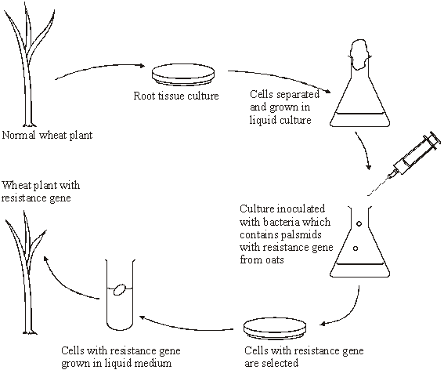

(a)     (i)      The wheat plant with the resistance gene contains recombinant DNA. What is *recombinant* DNA?

______________________________________________________________

______________________________________________________________

**(1)**

(ii)     The plasmids act as vectors for the resistance gene. What is a *vector*?

______________________________________________________________

______________________________________________________________

**(1)**

(iii)     Suggest how cells with the resistance gene might be selected.

______________________________________________________________

______________________________________________________________

______________________________________________________________

______________________________________________________________

**(2)**

(b)     A laboratory has oat plants containing the resistance gene and a supply of plasmids.

Describe how bacteria may be produced which have the resistance gene in their plasmids.

___________________________________________________________________

___________________________________________________________________

___________________________________________________________________

___________________________________________________________________

___________________________________________________________________

___________________________________________________________________

___________________________________________________________________

___________________________________________________________________

___________________________________________________________________

___________________________________________________________________

___________________________________________________________________

___________________________________________________________________

**(6)**

**(Total 10 marks)**

**Q6.** *Hin*dlll is an enzyme that cuts DNA into smaller fragments.  
The enzyme cuts DNA at the specific base sequence shown in **Figure 1**.

**Figure 1**

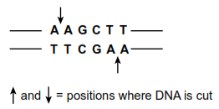

(a)     What general name is given to enzymes such as *Hin*dlll?

___________________________________________________________________

**(1)**

(b)     *Hin*dlll produces DNA fragments with sticky ends.

(i)      Use information from **Figure 1** to give the base sequence of one of these sticky ends.

______________________________________________________________

**(1)**

(ii)     Sticky ends are useful in genetic engineering. Explain how.

______________________________________________________________

______________________________________________________________

______________________________________________________________

______________________________________________________________

**(2)**

(c)     Scientists prepared a sample containing many identical molecules of DNA.  
The DNA molecules were linear (non-circular).

They divided the sample into two portions.  They treated one portion with *Hin*dlll but did not treat the other portion. They then carried out gel electrophoresis on each portion.

The results are shown in **Figure 2.**

**Figure 2**

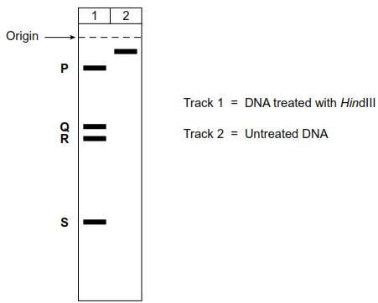

(i)      The lengths of the fragments produced from the DNA treated with *Hin*dIII were 287, 1232, 1550 and 4943 base pairs.  
How many base pairs are there in fragment **P**?

**P** = ____________________  base pairs

**(1)**

(ii)     How many times did the base sequence, **AAGCTT** occur in the DNA?  
                                                                  **TTCGAA**

______________________________________________________________

**(1)**

(iii)     In a certain genetic condition, **one** of these **AAGCTT** sequences is changed.

**TTCGAA**

Predict what effect this would have on the appearance of the gel in Track **1** of **Figure 2**.

______________________________________________________________

______________________________________________________________

______________________________________________________________

______________________________________________________________

**(2)**

**(Total 8 marks)**

**Q7.** Scientists manufactured large quantities of human insulin using genetic engineering.  
They started by isolating mRNA from pancreas cells. From this they produced DNA which coded for insulin.

(a)     (i)      Suggest **two** reasons why it was better to start with mRNA from pancreas cells rather than with the DNA from these cells.

1. ____________________________________________________________

______________________________________________________________

2. ____________________________________________________________

______________________________________________________________

**(2)**

(ii)     The scientists used two enzymes, **Enzyme 1** and **Enzyme 2**, to produce DNA from mRNA.

The reactions catalysed by these enzymes are shown below.

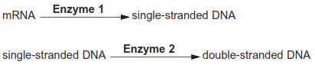

Name enzymes **1** and **2**.

**Enzyme 1** _____________________________________________________

**Enzyme 2** _____________________________________________________

**(2)**

(iii)     In a double-stranded DNA molecule, the two strands are held together by weak bonds.

Name this type of bond.

______________________________________________________________

**(1)**

(b)     The scientists used the polymerase chain reaction (PCR) to make copies of the DNA.

The diagram shows the stages of the PCR.

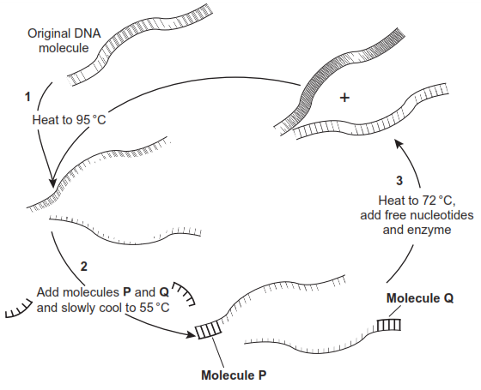

(i)      **P** and **Q** are short lengths of  single-stranded DNA.

What name is given to molecules such as **P** and **Q**?

______________________________________________________________

**(1)**

(ii)     The mixture is cooled from 95°C to 55°C at step **2**.

Explain why.

______________________________________________________________

______________________________________________________________

**(1)**

(iii)     Explain the function of  molecules **P** and **Q.**

______________________________________________________________

______________________________________________________________

______________________________________________________________

______________________________________________________________

(*Extra space*) ___________________________________________________

______________________________________________________________

**(2)**

(iv)    How many copies of  each original DNA molecule would be present after 5 cycles of  PCR?



**(1)**

**(Total 10 marks)**

**Q8.** (a)     Plasmids can be modified by genetic engineering and inserted into bacteria. These bacteria can then make useful substances normally made by another organism. Explain how modified plasmids are made by genetic engineering and how the use of markers enable bacteria containing these plasmids to be detected.

___________________________________________________________________

___________________________________________________________________

___________________________________________________________________

___________________________________________________________________

___________________________________________________________________

___________________________________________________________________

___________________________________________________________________

___________________________________________________________________

___________________________________________________________________

___________________________________________________________________

___________________________________________________________________

___________________________________________________________________

___________________________________________________________________

___________________________________________________________________

**(6)**

(b)     In gene therapy, genes are introduced into a person who has defective genes which do not produce an important substance. Three experiments were done to compare techniques for introducing an important substance into a person with defective genes.

1.   The substance was injected directly.

2.   Harmless viruses carrying genes coding for the substance were injected.

3.   The genes were put into a protein capsule which was inserted into the tissues.

The graph shows results of the experiments.

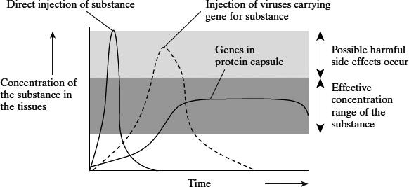

*Takahiro Ochiya et al, Biomaterials for Gene Delivery: Studies on Metastasis,   
(National Cancer Centre, Research Institute, Tokyo, Japan) 1999*

(i)      Describe the results of the three experiments.

______________________________________________________________

______________________________________________________________

______________________________________________________________

______________________________________________________________

______________________________________________________________

______________________________________________________________

**(3)**

(ii)     Using the information in the graph, suggest **one** advantage and **one** disadvantage of the capsule method compared to the others.

Advantage ____________________________________________________

______________________________________________________________

Disadvantage __________________________________________________

______________________________________________________________

**(2)**

**(Total 11 marks)**

**Q9.** The polymerase chain reaction is a process which can be carried out in a laboratory to replicate DNA. The diagram shows the main stages involved in the polymerase chain reaction.

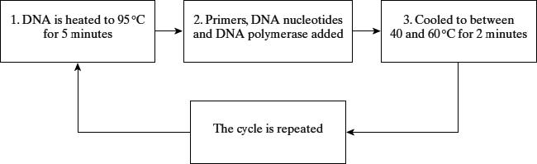

(a)     Explain why DNA is heated to 95 °C.

___________________________________________________________________

___________________________________________________________________

**(1)**

(b)     What is the role of

(i)      a primer in this process;

______________________________________________________________

______________________________________________________________

**(1)**

(ii)     DNA polymerase?

______________________________________________________________

______________________________________________________________

**(1)**

(c)     (i)      How many DNA molecules will have been produced from one molecule of DNA after 6 complete cycles?

______________________________________________________________

**(1)**

(ii)     Suggest **one** use of the polymerase chain reaction.

______________________________________________________________

______________________________________________________________

**(1)**

(d)     Give **two** ways in which the polymerase chain reaction differs from the process of transcription.

1. _________________________________________________________________

___________________________________________________________________

2. _________________________________________________________________

___________________________________________________________________

**(2)**

**(Total 7 marks)**

**Q10.** (a)     *Agrobacterium* is a bacterium used in genetic engineering of plants. The diagram shows stages in the transfer of a gene into a plant.

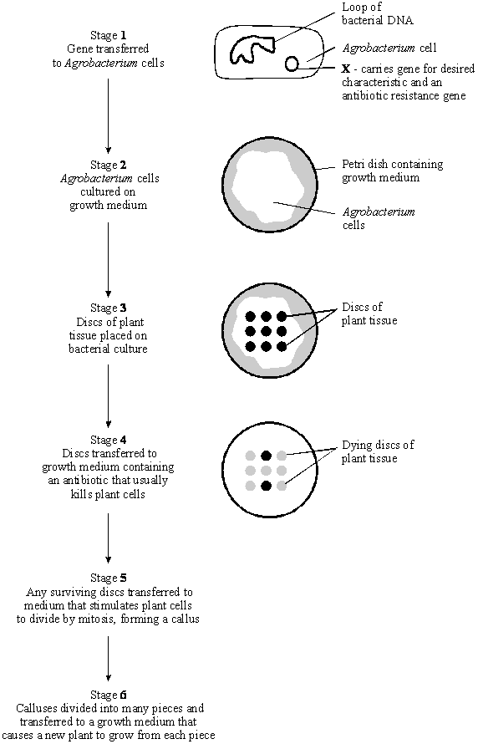

(i)      Name structure **X** in stage **1**.

______________________________________________________________

**(1)**

(ii)     In stage **2**, explain why the bacteria are cultured before the plant tissue is added.

______________________________________________________________

______________________________________________________________

**(1)**

(iii)     In stage **4**, explain why the growth medium contains antibiotic.

______________________________________________________________

______________________________________________________________

______________________________________________________________

______________________________________________________________

**(2)**

(iv)    Suggest why stages **5** and **6** are necessary for the commercial production of genetically engineered plants.

______________________________________________________________

______________________________________________________________

______________________________________________________________

______________________________________________________________

**(2)**

(b)     (i)      A toxin that kills insects can be sprayed directly onto the leaves of crop plants. A gene has now been transferred into crop plants that makes their leaves produce this toxin.

Explain **one** advantage to farmers of growing the genetically engineered crop plants, rather than spraying leaves with the toxin.

______________________________________________________________

______________________________________________________________

**(1)**

(ii)     Suggest **one** reason why some people are concerned that the toxin gene might get transferred to wild plants that are related to the crop plants.

______________________________________________________________

______________________________________________________________

**(1)**

**(Total 8 marks)**

**Q11.** Plants transport sucrose from leaves to other tissues for growth and storage. SUT1 is a sucrose co-transporter protein.

Scientists investigated whether the cells of tobacco plant leaves used SUT1 to transport sucrose to other tissues.

(a)  The scientists used a radioactively labelled DNA probe to show that the cells of tobacco plant leaves contained the *SUT1* gene.

Describe how they would do this.

Do **not** include PCR in your answer.

___________________________________________________________________

___________________________________________________________________

___________________________________________________________________

___________________________________________________________________

___________________________________________________________________

___________________________________________________________________

___________________________________________________________________

___________________________________________________________________

___________________________________________________________________

___________________________________________________________________

___________________________________________________________________

___________________________________________________________________

**(4)**

(b)  To study the role of SUT1 in tobacco plants, scientists reduced the expression of the *SUT1* gene.

When the *SUT1* gene is transcribed, the SUT1 mRNA produced is called ‘sense’ SUT1 mRNA. The scientists genetically modified plants by inserting an **extra** gene so that this **also** allowed the production of ‘antisense’ SUT1 mRNA.

The scientists had two types of tobacco plants:

•   type **A** – plants that were genetically modified

•   type **B** – plants that were **not** genetically modified.

Suggest how the production of ‘antisense’ SUT1 mRNA in type **A** plants would reduce the expression of the *SUT1* gene.

___________________________________________________________________

___________________________________________________________________

___________________________________________________________________

___________________________________________________________________

___________________________________________________________________

___________________________________________________________________

___________________________________________________________________

___________________________________________________________________

___________________________________________________________________

___________________________________________________________________

___________________________________________________________________

___________________________________________________________________

**(4)**

(c)  The scientists hypothesised that lower rates of sucrose transport from leaves would cause reduced growth.

To test this hypothesis, the scientists provided leaves of type **A** and type **B** plants with labelled carbon dioxide (14CO2). To estimate sucrose transport out of leaves, they measured the percentage of 14C remaining in the leaves for 16 hours.

The figure below shows their results.

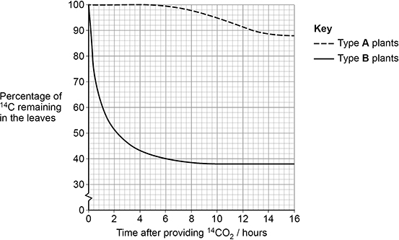

Calculate the ratio of percentage of 14C remaining in leaves of type **B** to type **A** plants 16 hours after providing 14CO2

Answer _______________

**(1)**

(d)  In type **B** plants, the percentage of 14C remaining in the leaves does not reach zero per cent, as shown in the figure above.

Suggest **two** reasons why.

1  _________________________________________________________________

___________________________________________________________________

2  _________________________________________________________________

___________________________________________________________________

**(2)**

The scientists measured physiological differences between type **A** plants and type **B** plants.

The table below shows the scientists’ results as they presented them.

|  |  |  |
| --- | --- | --- |
| **Physiological factor** | **Type of tobacco plant** | |
| **Type A** | **Type B** |
| Rate of sucrose transport from leaf cells / µmol m–2 s–1 | 0.1 | 3.7 |
| Leaf sucrose concentration  / mmol m–2 | 22 | 4 |
| Ratio of shoot:root dry mass | 6:1 | 2:1 |
| Rate of photosynthesis /  µmol glucose m–2 s–1 | 4 | 14 |

Sucrose is able to inhibit the production and activity of rubisco in leaves of a plant. Type **A** plants have decreased dry mass compared with type **B** plants.

(e)  Use all the information to suggest **and** explain how the physiological factors in the table above would contribute to the decreased dry mass observed in type **A** plants.

___________________________________________________________________

___________________________________________________________________

___________________________________________________________________

___________________________________________________________________

___________________________________________________________________

___________________________________________________________________

___________________________________________________________________

___________________________________________________________________

___________________________________________________________________

___________________________________________________________________

___________________________________________________________________

___________________________________________________________________

**(4)**

**(Total 15 marks)**

**Q12.** Read the following passage.

|  |  |
| --- | --- |
|  | Herpes viruses cause cold sores and, in some cases, genital warts. Scientists are well  on the way to producing an antibody which will counteract herpes infection. This antibody works  by sticking to the virus and blocking its entry into cells. It has proved very effective in animal  tests. |
| 5 | One drawback with this approach, however, is that antibodies are at present produced using  hamster ovary cells. This method is expensive and only produces limited amounts. A new  technique is being developed to produce antibodies from plants. It involves introducing the  DNA which codes for the required antibody into crop plants such as maize. |

          Use information from the passage and your own knowledge to answer the questions.

(a)     (i)      What is an antibody?

______________________________________________________________

______________________________________________________________

______________________________________________________________

______________________________________________________________

**(2)**

(ii)     Describe how antibodies are produced in the body following a viral infection.

______________________________________________________________

______________________________________________________________

______________________________________________________________

______________________________________________________________

______________________________________________________________

______________________________________________________________

______________________________________________________________

______________________________________________________________

______________________________________________________________

______________________________________________________________

______________________________________________________________

**(6)**

(b)     Describe how the antibody gene could be isolated from an animal cell and introduced into a crop plant such as maize (lines 7-8).

___________________________________________________________________

___________________________________________________________________

___________________________________________________________________

___________________________________________________________________

___________________________________________________________________

___________________________________________________________________

___________________________________________________________________

___________________________________________________________________

**(4)**

(c)     Taking a course of these antibodies from plants to treat a herpes infection would not produce long-term protection against disease. Explain why.

___________________________________________________________________

___________________________________________________________________

___________________________________________________________________

___________________________________________________________________

**(2)**

(d)     Explain **one** advantage of using antibodies from plants to treat a disease, rather than antibodies produced in an experimental animal (lines 5-6).

___________________________________________________________________

___________________________________________________________________

**(1)**

**(Total 15 marks)**

**Q13.** Read the following passage.

Shark-fin soup is an expensive delicacy. To provide the basic ingredient, fishermen catch the  
sharks, hack the fins off and throw the dead bodies back into the ocean. But sharks are slow  
to mature and produce only a few offspring at a time, so they are vulnerable to overfishing.  
Monitoring the shark-fin trade is difficult, as once a fin has been cut off, it can be extremely

5        difficult to work out precisely from which species it was taken.

The DNA from different species of sharks shows some differences in base sequence. This has  
enabled a new genetic fingerprinting technique to be developed. This technique would allow  
conservationists and fisheries managers to assess which of the 400 shark species are most  
threatened by the trade in shark fins.

10       An identification process has been developed using a range of “primers”. These are short

pieces of single-stranded DNA that are complementary to a particular sequence of DNA.  
Each primer is specific to the DNA of one shark species.

The primers are added to DNA taken from a shark’s fin and the polymerase chain reaction is  
carried out. Only two primers, one at each end of a certain piece of DNA, will bind. The piece

15      of DNA between the primers is replicated by the polymerase chain reaction. The primers that

bind are specific to a particular species of shark and the length of the DNA fragment  
replicated differs for each species. When this DNA is run in an electrophoresis gel it produces  
a single band, enabling the researchers to identify which species of shark is involved.

Use information from the passage and your own knowledge to answer the questions.

(a)     (i)      Explain why the DNA for each species of shark shows differences in base sequence (line 6).

______________________________________________________________

______________________________________________________________

______________________________________________________________

______________________________________________________________

**(2)**

(ii)     Each primer is specific to the DNA of one shark species (line 12).

Explain why a particular primer will only bind to the DNA of one species.

______________________________________________________________

______________________________________________________________

______________________________________________________________

______________________________________________________________

**(2)**

(iii)     The length of the replicated DNA fragment is different for each species.

Explain why this is important in identifying the shark species involved.

______________________________________________________________

______________________________________________________________

______________________________________________________________

______________________________________________________________

______________________________________________________________

______________________________________________________________

**(3)**

(b)     In conventional DNA fingerprinting, a series of bands is produced on the electrophoresis gel, resembling the rungs of a ladder. When the DNA in this new genetic fingerprinting technique is run in an electrophoresis gel it produces just one of these ‘rungs’.

Explain the reason for the difference in the number of ‘rungs’ produced.

___________________________________________________________________

___________________________________________________________________

___________________________________________________________________

___________________________________________________________________

**(2)**

(c)     Describe the polymerase chain reaction.

___________________________________________________________________

___________________________________________________________________

___________________________________________________________________

___________________________________________________________________

___________________________________________________________________

___________________________________________________________________

___________________________________________________________________

___________________________________________________________________

___________________________________________________________________

___________________________________________________________________

___________________________________________________________________

___________________________________________________________________

**(6)**

**(Total 15 marks)**

Mark schemes

**Q1.**

(a)  1.      Mutation in the viral DNA/RNA/genome/genetic material;

*Accept named examples mutations*

2.      Altered (tertiary structure of the) viral attachment protein;

*Accept ‘antigen’ for ‘attachment protein’*

*Accept causes antigenic variability*

3.      Allows it/attachment protein/virus to bind (to receptors of other species);

*Accept descriptions of binding eg is complementary*

**2 max**

(b)     For **one** mark, accept any **two** of the following:

•   The polymerase chain reaction

•   Genetic/DNA fingerprinting

•   (Gel) electrophoresis

•   DNA/genome sequencing;

*Accept PCR for polymerase chain reaction*

*Accept autoradiography*

*Accept DNA hybridisation*

*Accept compare DNA/base sequence for ‘DNA sequencing’*

*Ignore compare mRNA base sequence*

*Ignore compare amino acid sequence*

*Ignore DNA probes*

**1**

(c)     1.      (The scientists) could identify proteins (that derive from the genetic code)

**OR**

(The scientists) could identify the proteome;

2.      (They) could (then) identify potential antigens (to use in the vaccine);

*Reject if answer suggests vaccine contains antibodies*

**2**

(d)     1.      B cell (antibody) binds to (viral) specific/complementary receptor/antigen;

*Accept B cell forms antigen-antibody complex*

2.      B cell clones

**OR**

B cell divides by mitosis;

3.      Plasma cells release/produce (monoclonal) antibodies (against the virus);

4.      (B/plasma cells produce/develop) memory cells;

*Accept B cell undergoes clonal selection/expansion*

**3 max**

**[8]**

**Q2.**

(a)  1.   (Refers to) saltatory conduction

**OR**

(Nerve) impulses/depolarisation/ions pass to other neurones

**OR**

Depolarisation occurs along whole length (of axon);

*Accept suitable description that refers to (transmission) from node to node (of Ranvier).*

*Accept action potential for depolarisation.*

*1 and 2. Accept action potentials for impulses.*

*1, 2 and 3. Reject first mark awarded if answer refers to messages/signals for impulses. Reject even if impulse/s also referred to.*

2.   (Nerve) impulses slowed/stopped;

3.   (Refers to) neuromuscular junction

**OR**

(Refers to) sarcolemma;

**3**

(b)  1.   Slower/fewer impulse(s) along sympathetic/parasympathetic (pathway/neurones);

*Accept action potentials for impulses.*

*Reject no impulses.*

*1, 2 and 3. Ignore ‘information’ but reject first mark awarded if answer refers to messages/signals for impulses. Reject even if impulse/s also referred to.*

2.   (Impulses) from cardiac centre

**OR**

(Impulses) from medulla;

3.   To SAN;

**3**

(c)  1.   It/DNA is complementary to (m)RNA;

*Accept (transcription) results in complementary (m)RNA.*

*Ignore miRNA/siRNA/transcriptional factors.*

2.   Binds to mRNA (for huntingtin);

3.   Prevents translation;

*Ignore transcription.*

**3**

(d)  1.   Small sample size

**OR**

Only 46;

2.   Only four-months

**OR**

short period (of trial);

3.   Huntingtin/protein reduced

**OR**

Huntingtin/protein still produced

**OR**

Huntingtin/protein not removed;

*Accept huntington for huntingtin.*

*Ignore miRNA/siRNA/transcriptional factors.*

4.   Allele/gene/mutation/mRNA (for Huntington’s) still present

**OR**

(May be) temporary

**OR**

Drug treatment repeated;

5.   Brain already damaged

**OR**

Brain damage may continue;

**2 max**

(e)  1.   (Drug/DNA) will directly/quickly reach brain

**OR**

(Cerebrospinal) fluid bathes the brain;

2.   (Drug/DNA) not destroyed by acid

**OR**

(Drug/DNA) not digested (by enzymes);

*Reject protein is digested.*

*Ignore location of enzymes.*

*Accept Drug/DNA denatured.*

**2**

(f)

***Mark in pairs*** *but if no mark credited allow one mark for any reference to transcription or gene expression being affected.*

1.   (Increased) methylation of DNA/gene/allele;

*Reject acetylation of DNA.*

*Accept gene expression for transcription but ignore gene switched on/off.*

*Ignore methylation of histones.*

*Accept DNA-histone complex as equivalent to histone(s).*

2.   Inhibits/prevents transcription;

**OR**

3.   Decreased methylation of DNA/gene/allele;

4.   Stimulates/allows transcription;

**OR**

5.   Decreased acetylation of histone(s);

6.   Inhibits transcription;

**OR**

7.   Increased acetylation of histone(s);

8.   Stimulates/allows transcription;

**2 max**

**[15]**

**Q3.**

(a)     1.      Correct answer of 19.4 / 19.41%

**OR**

19.47 / 19.5% = **2 marks**;

2.      Incorrect answer but shows increase of

1,048,320 **OR** 1,051,200 = one mark;

*Accept: 19.46% for one mark.*

**2**

(b)     1.      Less / no acetylcholine broken down;

2.      Acetylcholine attaches to receptors;

3.      (More) Na+ enter to reach threshold / for depolarisation / action potential / impulse;

*1.      Accept: more acetylcholine present / remains.*

*1 and 2. Accept: remains attached for longer = 2 marks.*

*3.      Must be sodium ions.*

**3**

(c)     1.      Isolated **so** inbreeding / low genetic diversity / small gene pool;

2.      Allele inherited (through generations) from (common) ancestor;

*1.      Ignore: Founder effect.*

*1.      Accept: no interbreeding with other populations.*

*1.      Reject: interbreeding within the population.*

**2**

(d)     1.      AD / symptoms develops late / at 49;

2.      Have already reproduced;

*Note: ‘It’ is not equivalent to AD / symptom as the question stem relates to the mutation.*

**2**

(e)     1.      Epigenetics / environment / named factor e.g. stress, alcohol, toxins, diet, exercise, smoking;

2.      methylation (of genes)

**OR**

acetylation (of histones);

*1.      Ignore: gender and lifestyle.*

*2.      If further details are provided the context must be correct e.g. increased methylation or decreased acetylation inhibit gene expression / transcription.*

**2**

(f)      1.      One person was homozygous dominant / has two dominant alleles = **2 marks**;

2.      For one mark has two alleles / chromosomes;

*1.      Accept; homozygous dominant genotype e.g. ‘one person has AA’ for 2 marks.*

*2.      Accept: is diploid or has two copies of the gene.*

**2**

(g)     1.      (GCA / triplet) is common / found in other places;

2.      Would not know if it was the mutation / allele / gene

**OR**

Produces ‘false positives’

*1.      Accept: Probe will bind elsewhere.*

**2**

**[15]**

**Q4.**

(a)     probe will attach (to mutant allele);  
attaches to one DNA strand;  
as a result of complementary base pairing;  
radioactivity detected on film / X-ray / by autoradiography  
(if mutant allele present);

**4**

(b)     *for*gene is only active in mammary cells / only affects milk / easy to  
obtain product / product produced in large amounts / gene passed to  
offspring;

**1**

*against*long term effects not known / qualified reference to animal exploitation  
e.g. use of embryos / effect of inserted gene on other sheep  
tissues / genes;

**1**

**[6]**

**Q5.**

(a)     (i)      contains genes / nucleotides / sections of DNA / artificial  
DNA from two species / 2 types of organisms;

**1**

(ii)     carries gene / DNA (into the other organism / gene carrier);

**1**

(iii)     expose cells to the fungus;  
non-resistant ones die, resistant ones survive;  
OR identify by adding marker gene / gene probe / (qualified)  
marker probe; description of positive result  
e.g. radioactivity / fluorescence / complementary base pairing;

**2**

(b)     EITHER      1 cut desired gene (from DNA) of oat plant;  
                   2 using restriction endonuclease / restriction enzyme;  
OR             1 use mRNA from oat which will code for resistance;  
                   2 and use reverse transcriptase to form desired DNA;  
OR             1 make artificial DNA with correct sequence of bases;  
                   2 using DNA polymerase;  
                   3 cut plasmid open;  
                   4 with (same) restriction endonuclease / restriction enzyme;  
                   5 ref. sticky ends / unpaired bases attached;  
                   6 use (DNA) ligase to join / ref. ligation;  
                   7 return plasmid to (bacterial) cells;  
                   8 use of Ca2+ / calcium salts / electric shock;  
                   (if ref. to ‘insulin’ allow 5 max.)

**max 6**

**[10]**

**Q6.**

(a)     Restriction enzyme / restriction endonuclease;

**1**

(b)     (i)      A-G-C-T  /  T-C-G-A;

*Allow A-G-C-T-T / T-T-C-G-A*

**1**

(ii)     Joining two pieces of DNA;

By complementary binding/complementary base-pairing;

**2**

(c)     (i)      4943;

**1**

(ii)     3;

**1**

(iii)     2 bands disappear / only 3 bands;

New band formed at heavier position/nearer to origin/higher up;

**2**

**[8]**

**Q7.**

(a)     (i)      Amount of mRNA > amount of DNA / multiple copies of mRNA;

Insulin mRNA/the specific mRNA is found in pancreas cells;

Introns / non-coding information present in DNA / these removed  
in mRNA / corr. ref. post-transcriptional modification;

**2 max**

(ii)     Enzyme 1 = reverse transcriptase;

Enzyme 2 = (DNA)-polymerase;

**2**

(iii)     Hydrogen (bonds) / H-(bonds);

**1**

(b)     (i)      Primers;

**1**

(ii)     To allow H-bond re-formation / to allow joining of primers/P  
(and Q) to (single-stranded) DNA / converse re. high temp.  
breaks H-bonds / prevents joining;

**1**

(iii)     To mark region of DNA to be ‘copied’ / to show enzyme where  
to start;

(Enzyme) needs starting strand onto which to attach nucleotides;

*Allow idea of extending pre-existing chain*

**2**

(iv)    32;

**1**

**[10]**

**Q8.**

(a)     isolate wanted gene / DNA from another organism / mRNA from cell / organism;  
using restriction endonuclease / restriction enzyme / reverse transcriptase to get DNA and produce sticky ends;  
use ligase to join wanted gene to plasmid;  
also include marker gene e.g. antibiotic resistance;  
add plasmid to bacteria to grow (colonies)then (replica) plate onto medium where the marker gene is expressed;  
bacteria / colonies not killed have antibiotic resistance gene and (probably) the wanted gene;

**6**

(b)     (i)      injection, rapid rise and fall;  
virus, slower rise and longer in effective / harmful range;  
capsule slowest rise, longest in effective / harmful range;  
injection and virus give harmful concentrations but capsule does  
not;

**3 max**

(ii)     advantage e.g.:  
substance never reaches harmful levels / no side effect / less likely to harm the organism, longer relief from symptoms / less frequent treatment needed / longer effective range / longer but without harmful side effects;

**1 max**

disadvantage e.g.:  
takes longer to take effect;

**1**

**[11]**

**Q9.**

(a)     to separate the two strands / break hydrogen bonds;

**1**

(b)     (i)      enables replication / sequencing to start (*allow keeps strands  
separate*);

**1**

(ii)     joins DNA nucleotides (*not complementary bases*);

**1**

(c)     (i)      64;

**1**

(ii)     replication of DNA from crime scene / tissue sample /   
for DNA sequencing / gene cloning;

**1**

(d)     (transcription uses) RNA polymerase;  
RNA nucleotides / uracil;  
one (template) strand / PCR both strands;  
start / stop codons;  
(*accept enzyme separates strands*)

**2 max**

**[7]**

**Q10.**

(a)     (i)      plasmid;

**1**

(ii)     the bacteria divide / grow, producing many copies of desired   
gene / plasmid;  
OR  
the bacteria divide / grow to cover the agar;

**1**

(iii)     plant tissue that has antibiotic resistance survives;  
identifies plant tissue which has desired gene / plasmid;

**2**

(iv)    to clone plants / produce genetically identical plants with   
gene / characteristic;  
and produce large numbers / quickly;

**2**

(b)     (i)      (*one reasonable suggestion*),  
e.g. toxin present all the time;  
save costs of buying / application of spray;  
no spray drift onto other fields / insects;

**1 max**

(ii)     (*one reasonable suggestion*),  
e.g. killing of harmless / useful insects that feed on wild plants;  
damage to food chains starting with wild plants;

**1 max**

**[8]**

**Q11.** (a)     1.      Extract DNA and add restriction endonucleases/restriction enzymes;

2.      Separate fragments using electrophoresis;

3.      (Treat DNA to) form single strands

**OR**

(Treat DNA to) expose bases;

*Ignore method used to separate strands*

4.      The probe will bind to/hybridise/base pair with the *SUT1*/gene;

5.      Use autoradiography (to show the bound probe);

*Accept use photographic or X ray film (to show the bound probe)*

*X rays alone is not sufficient*

**4 max**

(b)     1.      Antisense mRNA is complementary to 'sense' mRNA;

2.      Antisense mRNA would bind/base pair to (sense) mRNA;

**OR**

Double stranded (m)RNA forms;

3.      Ribosomes would not be able to bind;

4.      Preventing/less translation (of mRNA)

**OR**

Preventing/less production of SUT1 (protein);

*Accept descriptions of translation*

**4**

(c)



*Accept any suitable rounding*

**1**

(d)     1.      Some (14CO2) used to make cellulose/cell walls;

*Accept some becomes lipids/ proteins/DNA/RNA/ nucleotides*

2.      Some (14CO2) converted into starch (which remains in the leaf);

*Accept some (14CO2) converted into glucose*

3.      Not all (14CO2) fixed/used in photosynthesis;

**OR**

Not enough RuBP (to combine with all of the 14CO2);

*Accept descriptions of this*

4.      Some used to reform RuBP

**OR**

Some (is still) in glycerate 3-phosphate/GP/triose phosphate/in the Calvin cycle;

**2 max**

(e)     1.      Reduced *SUT1* expression/less SUT 1 (protein) means less sucrose exported (so concentration increases in leaves);

2.      (Increased sucrose in leaves) inhibits rubisco, so less 14CO2 fixed into GP;

**OR**

(Increased sucrose in leaves) inhibits rubisco, so less 14CO2 combines with RuBP;

**OR**

(Increased sucrose in leaves) inhibits rubisco, so less Calvin cycle/light independent reaction/s;

*Accept less rubisco or less active rubisco for ‘inhibits rubisco’*

3.      Less sucrose transported to roots, so roots do not develop/grow (as shown by larger shoot to root dry mass ratio);

4.      Roots less developed so fewer minerals available for growth

*Accept: roots less developed so less water available for photosynthesis*

5.      Less growth means less dry mass;

*Accept: less photosynthesis/light independent reaction/s means less dry mass;*

**4 max**

**[15]**

**Q12.** (a)     (i)      protein / immunoglobulin;  
specific to antigen;  
idea of ‘fit’ / complementary shape;

**2 max**

(ii)     1. virus contains antigen;  
2. virus engulfed by phagocyte / macrophage;  
3. presents antigen to B-cell;  
4. memory cells / B-cell becomes activated;  
5. (divides to) form clones;  
6. by mitosis;  
7. plasma cells produce antibodies;  
8. antibodies specific to antigen;  
9. correct reference to T-cells / cytokines;

**6 max**

(b)     1. antibody gene located using gene probe;  
2. cut using restriction enzyme;  
3. at specific base pairs;  
4. leaving sticky ends / unpaired bases;  
5. cut maize / DNA / vector using same restriction enzyme;  
6. join using DNA ligase;  
7. introduce vector into maize / crop / recombinant DNA into maize;

**4 max**

(c)     passive / person is not making own antibodies / antibodies not replaced;  
memory cells not produced;

**2**

(d)     fewer ethical difficulties / less risk of infection;

**1**

**[15]**

**Q13.** (a)     (i)      Different genes / characteristics / features;  
Reference to mutations;  
Or  
Base sequence determines protein;  
Different species have different protein sequences;

**max 2**

(ii)     Primer has different DNA sequence;  
DNA specific / complementary base-pairing;

**2**

(iii)     Electrophoresis separates DNA;  
(So they can be) identified by position on gel;  
Smaller / shortest fragments travel furthest / quicker / or  
reverse argument;

**3**

(b)     (*conventional*) Many lengths / all DNA / (*new*) one length;  
Each rung is DNA of one / specific length;

**2**

(c)     1 Heat DNA;  
2 Breaks hydrogen bonds / separates strands;  
3 Add primers;  
4 Add nucleotides;  
5 Cool;  
6 (to allow) binding of nucleotides / primers;  
7 DNA polymerase;  
8 Role of (DNA) polymerase;  
9 Repeat cycle many times;

**max 6**

**[15]**