**Q1.**Nutritionists investigated the relationship between eating oily and non-oily fish and the incidence of asthma. They analysed the diets of children with asthma and the diets of children without asthma.

The pie charts show the results.

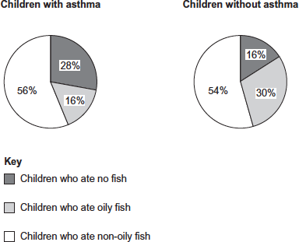

(a)     What conclusions can you make from the data?

........................................................................................................................

........................................................................................................................

........................................................................................................................

........................................................................................................................

........................................................................................................................

........................................................................................................................

........................................................................................................................

........................................................................................................................

**[Extra space]** ................................................................................................

........................................................................................................................

**(3)**

(b)     Describe how you could use the emulsion test to show the presence of oil in a sample of fish.

........................................................................................................................

........................................................................................................................

........................................................................................................................

........................................................................................................................

........................................................................................................................

........................................................................................................................

........................................................................................................................

........................................................................................................................

**[Extra space]** ................................................................................................

........................................................................................................................

**(3)**

**(Total 6 marks)**

**Q2.**          (a)     **Figure 1** shows the structure of a molecule of glycerol and a molecule of fatty acid.

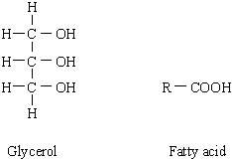

**Figure 1**

Draw a diagram to show the structure of a triglyceride molecule.

**(2)**

(b)     Explain why triglycerides are **not** considered to be polymers.

......................................................................................................................

......................................................................................................................

**(1)**

(c)     **Figure 2** shows two types of fat storage cell. Mammals living in cold conditions have more brown fat cells than mammals living in tropical conditions.

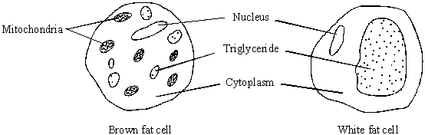

**Figure 2**

Using evidence from **Figure 2** to support your answer, suggest how the function of brown fat cells differs from that of white fat cells.

......................................................................................................................

......................................................................................................................

......................................................................................................................

......................................................................................................................

......................................................................................................................

......................................................................................................................

**(3)**

**(Total 6 marks)**

**Q3.**          (a)     Name the substance that muscles use as their immediate energy source.

.....................................................................................................................

**(1)**

(b)     Sports scientists investigated the change in energy sources used during exercise.  
They measured the percentage of energy obtained from carbohydrate and the percentage of energy obtained from fat in two groups of athletes.  
•    **Group A** exercised at different intensities for the same time.  
•    **Group B** exercised at the same intensity for different times.  
They calculated the intensity of the exercise as a percentage of VO2 max.  
VO2 max is the maximum volume of oxygen the athletes can take in per minute.

The results for **Group A** are shown in **Figure 1** and the results for **Group B** are shown in **Figure 2**.

**Figure 1**

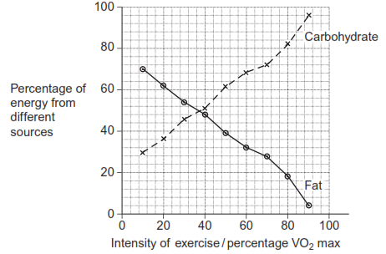

**Figure 2**

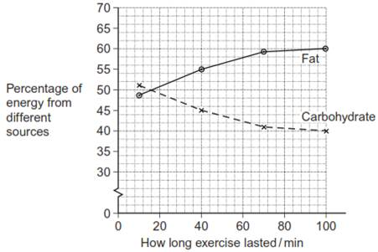

(i)      Calculate the ratio of the percentage of energy from carbohydrate to the percentage of energy from fat when the intensity of exercise is 70% VO2 max. Show your working.

 Answer ..................................................................................................

**(2)**

(ii)     A person wishes to lose some body fat by exercising. What sort of exercise would be most effective? Use the information in **Figures 1** and **2** to explain your answer.

.............................................................................................................

.............................................................................................................

.............................................................................................................

.............................................................................................................

.............................................................................................................

.............................................................................................................

(*Extra space*) .......................................................................................

.............................................................................................................

.............................................................................................................

**(3)**

**(Total 6 marks)**

**Q4.**            In an investigation, the effects of caffeine on performance during exercise were measured. One group of athletes (**A**) was given a drink of decaffeinated coffee. Another group (**B**) was given a drink of decaffeinated coffee with caffeine added. One hour later the athletes started riding an exercise bike and continued until too exhausted to carry on. Three days later the same athletes repeated the experiment, with the drinks exchanged.

(a)     (i)      The researchers added caffeine to decaffeinated coffee. Explain why they did not just use normal coffee.

.............................................................................................................

.............................................................................................................

**(1)**

(ii)     The performance of the athletes might have been influenced by how they expected the caffeine to affect them. How could the researchers avoid this possibility?

.............................................................................................................

.............................................................................................................

**(1)**

During the exercise the concentrations of glycerol and fatty acids in the blood plasma were measured. The results are shown in the table.

|  |  |  |  |
| --- | --- | --- | --- |
| **Drink** | **Mean time to exhaustion /minutes** | **Mean  concentration of blood glycerol/ mmol dm–3** | **Mean concentration of blood fatty acids/ mmol dm–3** |
| With caffeine | 90.2 | 0.20 | 0.53 |
| Without caffeine | 75.5 | 0.09 | 0.31 |

(b)     (i)      Describe the effect of caffeine on exercise performance.

.............................................................................................................

.............................................................................................................

**(1)**

(ii)     Suggest **one** explanation for the higher glycerol and fatty acid concentrations in the blood plasma of the athletes after they were given caffeine.

.............................................................................................................

.............................................................................................................

.............................................................................................................

.............................................................................................................

**(2)**

(c)     The researchers measured the volumes of carbon dioxide exhaled and oxygen inhaled during the exercise. From the results they calculated the respiratory quotient (RQ), using the formula



When a person is respiring carbohydrate only, RQ = 1.0

When a person is respiring fatty acids only, RQ = 0.7

(i)      The basic equation for the respiration of glucose is

C6H12O6 + 6O2 → 6CO2 + 6H2O

Explain why the RQ for glucose is 1.0.

.............................................................................................................

.............................................................................................................

.............................................................................................................

.............................................................................................................

**(2)**

(ii)     The researchers found that, when the athletes were given the drink containing caffeine, their mean RQ was 0.85. When given the drink without caffeine their mean RQ was 0.92.

The researchers concluded that when the athletes had caffeine they used glycogen more slowly than when they did not have caffeine, and that the store of glycogen in their muscles was used up less quickly during the exercise.

Explain the evidence from the information above and from the table which supports these conclusions.

.............................................................................................................

.............................................................................................................

.............................................................................................................

.............................................................................................................

.............................................................................................................

.............................................................................................................

**(3)**

**(Total 10 marks)**

**Q5.**          The diagrams show four types of linkage, **A** to **D**, which occur in biological molecules.

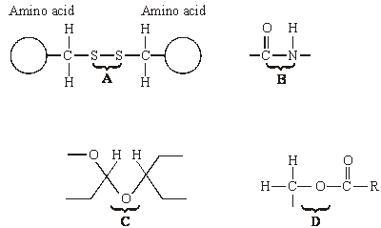

(a)     Name the chemical process involved in the formation of linkage **B**.

......................................................................................................................

**(1)**

(b)     Give the letter of the linkage which

(i)      occurs in a triglyceride molecule;

.............................................................................................................

**(1)**

(ii)     might be broken down by the enzyme amylase;

.............................................................................................................

**(1)**

(iii)     may occur in the tertiary, but not the primary structure of protein.

.............................................................................................................

**(1)**

(c)     Describe how a saturated fatty acid differs in molecular structure from an unsaturated fatty acid.

......................................................................................................................

......................................................................................................................

......................................................................................................................

......................................................................................................................

**(2)**

**(Total 6 marks)**

**Q6.**          (a)     Starch and protein are biologically important polymers.

(i)      Explain what is meant by a polymer.

.............................................................................................................

.............................................................................................................

**(1)**

(ii)     Give **one** example of a biologically important polymer other than starch or protein.

.............................................................................................................

**(1)**

(b)     In an investigation, the enzyme amylase was mixed in a test tube with a buffer solution and a suspension of starch. The amylase broke down the starch to maltose. When all the starch had been broken down, a sample was removed from the test tube and tested with biuret reagent.

(i)      Explain why a buffer solution was added to the amylase-starch mixture.

.............................................................................................................

.............................................................................................................

.............................................................................................................

**(2)**

(ii)     What colour would you expect the sample to go when tested with biuret reagent?

.............................................................................................................

**(1)**

(iii)     Give an explanation for your answer to part (ii)

.............................................................................................................

.............................................................................................................

.............................................................................................................

**(2)**

**(Total 7 marks)**

**Q7.**Scientists investigated the effect of lipase and a 3% bile salts solution on the digestion of triglycerides. The graph below shows their results.

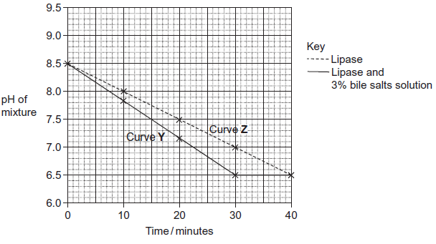   
(a)     Describe what curve **Y** shows about the effect of lipase and bile salts on the pH of the mixture.

.........................................................................................................................

.........................................................................................................................

.........................................................................................................................

.........................................................................................................................

.........................................................................................................................

**(2)**

(b)     The concentration of lipase did not change during the course of the investigation.  
Explain why.

.........................................................................................................................

.........................................................................................................................

.........................................................................................................................

**(1)**

(c)     One of the scientists decided to repeat the investigation at a temperature 10°C below the original temperature.  
Describe how you would expect his plotted curve to be different from curve **Z**.

.........................................................................................................................

.........................................................................................................................

**(1)**

**(Total 4 marks)**

**Q8.**          (a)     Dietary recommendations are that lipid intake should make up 30% of energy intake. The recommended energy intake for most women aged 19-49 is 8100 kJ day–1.The energy content of lipid is 37.8 kJ g–1. Calculate the recommended lipid intake per day for these women. Show your working.

Answer ................................................... g

**(2)**

In humans, triglycerides are the main form of dietary lipids. They are digested in the gut and the products of digestion are absorbed by the small intestine.

**S**       (b)     Describe a biochemical test that could be performed on a sample of food to determine whether it contained triglycerides.

......................................................................................................................

......................................................................................................................

......................................................................................................................

......................................................................................................................

**(2)**

(c)     The diagram shows the events that occur in the absorption of monoglycerides and fatty acids. These molecules enter the epithelial cells of the small intestine by diffusion. Once inside they are reassembled into triglycerides in organelle **Q**. The triglyceride molecules are formed into chylomicrons in organelle **T**. Chylomicrons are made from many triglyceride molecules surrounded with protein molecules. The chylomicrons leave the cell and enter vessel **S**.

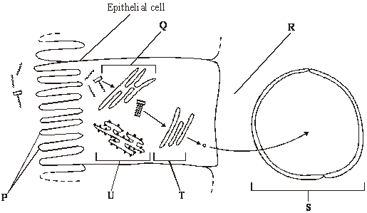

**S**       (i)      Explain the importance of the structures labelled **P**.

.............................................................................................................

.............................................................................................................

**(1)**

(ii)     Name

**R**; .......................................................................................................

**S**. ........................................................................................................

**(2)**

**S**       (iii)     Describe the role played by organelle **U** in the formation of chylomicrons.

.............................................................................................................

.............................................................................................................

.............................................................................................................

.............................................................................................................

**(2)**

      (iv)    Suggest how the chylomicrons leave the epithelial cell. Give a reason for your answer.

.............................................................................................................

.............................................................................................................

.............................................................................................................

.............................................................................................................

**(2)**

**(Total 11 marks)**

**Q9.**Omega-3 fatty acids are also found in fish. Scientists investigated the concentration of omega-3 fatty acids from wild-caught and farmed fish. Their results are shown in the figure below.

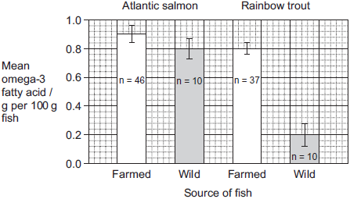

The bars show standard deviation; n is the sample size.

It is **not** possible to conclude from the data that the concentration of omega-3 fatty acids in the farmed salmon is higher than that of the wild salmon. Use the data to explain why.

.................................................................................................................................

.................................................................................................................................

.................................................................................................................................

.................................................................................................................................

**(Total 2 marks)**

**Q10.**Triglycerides are taken into the body as part of a balanced diet. These triglycerides contain fatty acids including omega-3 fatty acids. It has been discovered that omega-3 fatty acids are associated with health benefits. The benefits include faster development of nerve cells and clearer vision. Omega-3 fatty acids are also associated with protection from heart disease, arthritis and cancer.

The following figure shows how omega-3 and other fatty acids are taken in and used by the bodies of animals including humans.

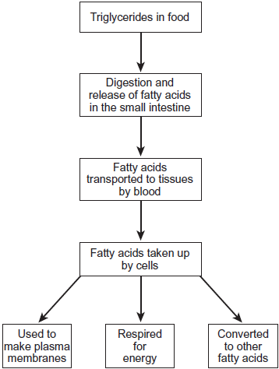

Use the information in the figure to explain **two** ways in which fatty acids are important in the formation of new cells.

1. .............................................................................................................................

.................................................................................................................................

.................................................................................................................................

.................................................................................................................................

2. .............................................................................................................................

.................................................................................................................................

.................................................................................................................................

.................................................................................................................................

**(Total 4 marks)**

**Q11.**Omega-3 fatty acids are found in cows’ milk. Scientists investigated changes in the concentration of omega-3 fatty acids in milk when cows were moved from eating grass in fields to eating corn in cattle sheds. The following figure shows the results of one investigation.

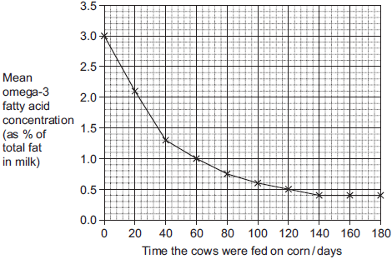

(a)     The concentration of omega-3 fatty acids in milk changed when cows were fed on corn instead of grass. Describe how.

........................................................................................................................

........................................................................................................................

........................................................................................................................

........................................................................................................................

**(2)**

(b)     (i)      Calculate the rate of decrease in the mean omega-3 fatty acid concentration between 0 and 40 days.  
Show your working.

Answer.......................................................% per day

**(2)**

(ii)     The omega-3 fatty acid concentration is expressed as a percentage of total fat.  
Explain the advantage of this.

...............................................................................................................

...............................................................................................................

...............................................................................................................

...............................................................................................................

**(2)**

(iii)    One farmer concluded from the graph that feeding cows on corn reduces the omega-3 fatty acid content in milk. Evaluate this conclusion.

...............................................................................................................

...............................................................................................................

...............................................................................................................

...............................................................................................................

...............................................................................................................

...............................................................................................................

...............................................................................................................

...............................................................................................................

Extra space ...........................................................................................

...............................................................................................................

...............................................................................................................

...............................................................................................................

**(4)**

**(Total 10 marks)**

**Q12.**(a)     Describe how you would test a piece of food for the presence of lipid.

........................................................................................................................

........................................................................................................................

........................................................................................................................

**(2)**

The figure below shows a phospholipid.

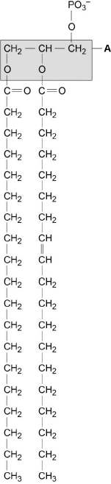  
**X**         **Y**

(b)     The part of the phospholipid labelled **A** is formed from a particular molecule. Name this molecule.

........................................................................................................................

**(1)**

(c)     Name the type of bond between **A** and fatty acid **X**.

........................................................................................................................

**(1)**

(d)     Which of the fatty acids, **X** or **Y**, in the figure above is unsaturated? Explain your answer.

........................................................................................................................

........................................................................................................................

........................................................................................................................

........................................................................................................................

**(1)**

Scientists investigated the percentages of different types of lipid in plasma membranes from different types of cell. The table shows some of their results.

|  |  |  |  |  |
| --- | --- | --- | --- | --- |
|  | **Type of lipid** | **Percentage of lipid in plasma membrane by mass** | | |
|  | **Cell lining ileum of mammal** | **Red blood cell of mammal** | **The bacterium *Escherichia coli*** |
|  | Cholesterol | 17 | 23 | 0 |
|  | Glycolipid | 7 | 3 | 0 |
|  | Phospholipid | 54 | 60 | 70 |
|  | Others | 22 | 14 | 30 |

(e)     The scientists expressed their results as **Percentage of lipid in plasma membrane by mass**. Explain how they would find these values.

........................................................................................................................

........................................................................................................................

........................................................................................................................

........................................................................................................................

**(2)**

Cholesterol increases the stability of plasma membranes. Cholesterol does this by making membranes less flexible.

(f)     Suggest **one** advantage of the different percentage of cholesterol in red blood cells compared with cells lining the ileum.

........................................................................................................................

........................................................................................................................

........................................................................................................................

**(1)**

(g)     *E. coli* has no cholesterol in its cell-surface membrane. Despite this, the cell maintains a constant shape. Explain why.

........................................................................................................................

........................................................................................................................

........................................................................................................................

........................................................................................................................

**(2)**

**(Total 10 marks)**

**Q13.**Newborn babies can be fed with breast milk or with formula milk. Both types of milk contain carbohydrates, lipids and proteins.

•        Human breast milk also contains a bile-activated lipase. This enzyme is thought to be inactive in milk but activated by bile in the small intestine of the newborn baby.

•        Formula milk does not contain a bile-activated lipase.

Scientists investigated the benefits of breast milk compared with formula milk.

(a)     The scientists used kittens (newborn cats) as model organisms in their laboratory investigation.

Other than ethical reasons, suggest **two** reasons why they chose to use cats as model organisms.

1 .....................................................................................................................

........................................................................................................................

2 .....................................................................................................................

........................................................................................................................

**(2)**

(b)     Before starting their experiments, the scientists confirmed that, like human breast milk, cat’s milk also contained bile-activated lipase.

To do this, they added bile to cat’s milk and monitored the pH of the mixture.

Explain why monitoring the pH of the mixture could show whether the cat’s milk contained lipase.

........................................................................................................................

........................................................................................................................

........................................................................................................................

........................................................................................................................

**(2)**

The scientists then took 18 kittens. Each kitten had been breastfed by its mother for the previous 48 hours.

The scientists divided the kittens randomly into three groups of six.

•        The kittens in group **1** were fed formula milk.

•        The kittens in group **2** were fed formula milk plus a supplement containing bile-activated lipase.

•        The kittens in group **3** were fed breast milk taken from their mothers.

Each kitten was fed 2 cm3 of milk each hour for 5 days.

The scientists weighed the kittens at the start of the investigation and on each day for 5 days.

The figure below shows the scientists’ results.

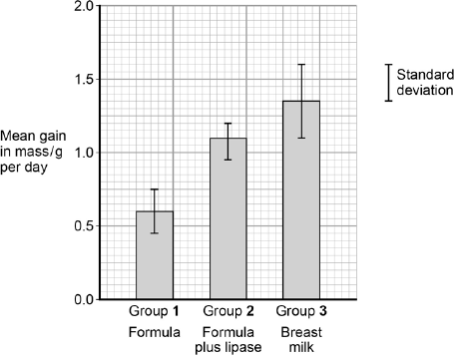  
Type of milk given to kittens

(c)     What can you conclude from the figure about the importance of bile-activated lipase in breast milk?

........................................................................................................................

........................................................................................................................

........................................................................................................................

........................................................................................................................

........................................................................................................................

........................................................................................................................

**(Extra space)** ................................................................................................

........................................................................................................................

........................................................................................................................

**(3)**

**(Total 7 marks)**

**Q14.**(a)     The table shows some substances found in cells. Complete the table to show the properties of these substances. Put a tick in the box if the statement is correct.

|  |  |  |  |  |  |
| --- | --- | --- | --- | --- | --- |
|  |  | **Substance** | | | |
|  | **Statement** | Starch | Glycogen | Deoxyribose | DNA helicase |
|  | Substance contains only the elements carbon, hydrogen and oxygen |  |  |  |  |
|  | Substance is made from amino acid monomers |  |  |  |  |
|  | Substance is found in both animal cells and plant cells |  |  |  |  |

**(4)**

(b)     The diagram shows two molecules of β-glucose.

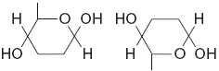

On the diagram, draw a box around the atoms that are removed when the two β-glucose molecules are joined by condensation.

**(2)**

(c)     (i)      Hydrogen bonds are important in cellulose molecules. Explain why.

.............................................................................................................

.............................................................................................................

.............................................................................................................

.............................................................................................................

**(2)**

(ii)     A starch molecule has a spiral shape. Explain why this shape is important to its function in cells.

.............................................................................................................

.............................................................................................................

.............................................................................................................

**(1)**

**(Total 9 marks)**

**Q15.**          (a)     Omega-3 fatty acids are unsaturated. What is an unsaturated fatty acid?

......................................................................................................................

......................................................................................................................

......................................................................................................................

......................................................................................................................

**(2)**

(b)     Scientists investigated the relationship between the amount of omega-3 fatty acids eaten per day and the risk of coronary heart disease. The graph shows their results.

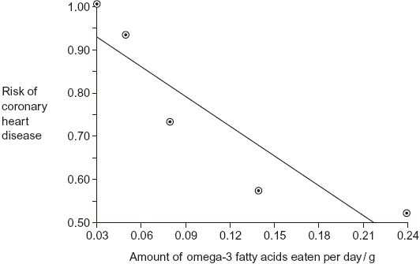

Do the data show that eating omega-3 fatty acids prevents coronary heart disease? Explain your answer.

......................................................................................................................

......................................................................................................................

......................................................................................................................

......................................................................................................................

......................................................................................................................

......................................................................................................................

......................................................................................................................

**(3)**

(c)     Olestra is an artificial lipid. It is made by attaching fatty acids, by condensation, to a sucrose molecule. The diagram shows the structure of olestra. The letter **R** shows where a fatty acid molecule has attached.

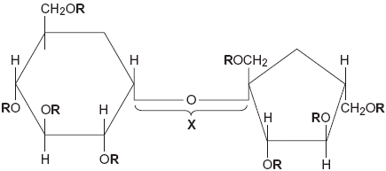

(i)      Name bond **X**.

.............................................................................................................

**(1)**

(ii)     A triglyceride does **not** contain sucrose or bond **X**. Give **one** other way in which the structure of a triglyceride is different to olestra.

.............................................................................................................

.............................................................................................................

**(1)**

(iii)     Starting with separate molecules of glucose, fructose and fatty acids, how many molecules of water would be produced when one molecule of olestra is formed?



**(1)**

**(Total 8 marks)**

**Q16.**(a)     Some seeds contain lipids. Describe how you could use the emulsion test to show that a seed contains lipids.

........................................................................................................................

........................................................................................................................

........................................................................................................................

........................................................................................................................

........................................................................................................................

........................................................................................................................

........................................................................................................................

(*Extra space*) .................................................................................................

........................................................................................................................

........................................................................................................................

**(3)**

(b)     A triglyceride is one type of lipid. The diagram shows the structure of a triglyceride molecule.

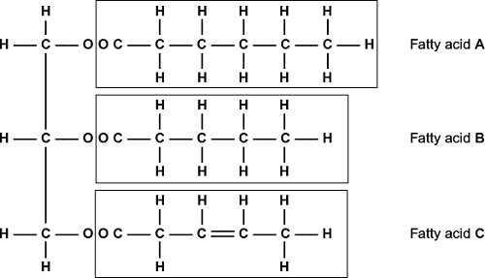

(i)      A triglyceride molecule is formed by condensation. From how many molecules is this triglyceride formed?



**(1)**

(ii)     The structure of a phospholipid molecule is different from that of a triglyceride.  
Describe how a phospholipid is different.

...............................................................................................................

...............................................................................................................

...............................................................................................................

...............................................................................................................

...............................................................................................................

**(2)**

(iii)    Use the diagram to explain what is meant by an unsaturated fatty acid.

...............................................................................................................

...............................................................................................................

...............................................................................................................

...............................................................................................................

...............................................................................................................

**(2)**

**(Total 8 marks)**

**M1.**(a)     1.      Fewer children / less likely that children with asthma eat fish;

*Accept converse.*

2.      Fewer children / less likely that children with asthma eat oily fish;

*MP1 and 2 − Allow use of numbers.*

3.      Little / only 2% / no difference in (children with or without asthma who eat) non-oily fish.

*Do not accept arguments related to amount of fish eaten*

**3**

(b)     1.      (Shake with) ethanol / alcohol;

*1. Accept named alcohol*

2.      Then add (to) water;

*2. Order must be correct*

3.      White / milky / cloudy (layer indicates oil).

*3. Ignore forms emulsion as in stem*

*3. Ignore precipitate*

**3**

**[6]**

**M2.**          (a)     3 fatty acids attached;   
ester bond correct;

*(H on glycerol component, O attached to carbon, R at other end)*

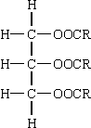

**2**

(b)     not made of monomers / many repeating units;

**1**

(c)     (many) mitochondria present in brown fat cells;   
mitochondria release heat / energy;(*ignore ATP*)  
white fat cells for fat storage / reduced fat storage in brown fat cells;

**3**

**[6]**

**M3.**          (a)     ATP

**1**

(b)     (i)      2.57:1/2.6:1/18:7;Correct answer however derived scores two marks72:28 scores one markCorrect working from wrong figures scores 1 mark

*Accept*

*0.4 / 0.39 / 0.389 / 0.3889*

**2 max**

(ii)     Low intensity;At low intensity/below 40% mainly fat used / at high intensity/  
above 40% mainly carbohydrate used;Long duration exercise;Percentage fat used increases with time / percentage  
carbohydrate used decreases with time;

**3**

**[6]**

**M4.**          (a)     (i)      in case normal coffee differs in some other way /   
to control concentration of caffeine;

**1**

(ii)     not telling them what the drink contained / purpose of experiment;

**1**

(b)     (i)      able to continue for longer; *(not just increases performance)  
(disqualify if also refers to fatty acids and glycerol)*

**1**

(ii)     breakdown of fats;  
at increased rate / by mobilisation of fat stores;

**2**

(c)     (i)      idea that volumes of oxygen and carbon dioxide the same;  
reference to equal moles, or quotient as 1 divided by 1 / or 6 by 6;

**2**

(ii)     glycogen is a carbohydrate / broken down to glucose, linked to RQ;  
with no caffeine, RQ nearer 1.0 / less carbon dioxide exhaled and  
more oxygen inhaled (or vice versa) / with caffeine higher proportion of fats / fatty acids respired;  
increased time to exhaustion suggests slower use of glycogen:

**3**

**[10]**

**M5.**          (a)     (i)      condensation;

**1**

(b)     (i)      **D**;

**1**

(ii)     **C**;

**1**

(iii)     **A**;

**1**

(c)     absence of a double bond;  
in the (hydrocarbon) chain;  
unable to accept more hydrogen / saturated with hydrogen;

**2 max**

**[6]**

**M6.**          (a)     (i)      (Molecule) made up of many identical / similar molecules / monomers / subunits;

*Not necessary to refer to similarity with monomers.*

**1**

(ii)     Cellulose / glycogen / nucleic acid / DNA / RNA;

**1**

(b)     (i)      To keep pH constant;  
A change in pH will slow the rate of the reaction / denature  
the amylase / optimum for reaction;

**2**

(ii)     Purple / lilac / mauve / violet;  
*Do not allow blue or pink.*

**1**

(iii)     Protein present / the enzyme / amylase is a protein;  
Not used up in the reaction / still present at the end of  
the reaction;

**2**

**[7]**

**M7.**(a)     pH goes down and levels out;  
after 30 min / pH 6.5;

**2**

(b)     Enzyme not used up in reaction;

**1**

(c)     Curve will be less steep:

*Only accept answers relating to curve* ***not*** *rate of reaction*

**1**

**[4]**

**M8.**          (a)     Two marks for correct answer of 64.285 / 64.3 / 64;

*(allow 1 mark for (8100 / 100 × 30) / 37.8)*

**2**

(b)     dissolve in / add ethanol then mix with water;  
emulsion / white colour indicates triglycerides present;

**2**

(c)     (i)      increase the surface area for absorption;

*(ignore wrong ref. to name)*

**1**

(ii)     **R** = tissue fluid / interstitial fluid / extracellular fluid / intercellular space;  
**S** = lymph(atic) vessel / lymph capillary / lacteal;

**2**

(iii)     proteins are synthesised by **U**;  
involvement of ribosomes;  
protein isolation / transport (inside RER);  
vesicle formation;

**2 max**

(iv)    exocytosis / description of;  
because of size / too large to leave by other methods;

**2**

**[11]**

**M9.**Standard deviation shows there is overlap of the 2 data sets;  
Small sample of wild salmon so may not be representative of population;

**[2]**

**M10.**Fatty acids used to make phospholipids;  
Phospholipids in membranes;  
More phospholipids more membranes made;

**2 max**

Fatty acids respired to release energy;  
More triglycerides more energy released;  
Energy used for cell production / production of named cell component;

*Do not allow credit for ‘making’ energy*

**2 max**

**[4]**

**M11.**(a)     (Omega-3 concentration) falls more rapidly at first;  
Levels out at 140 days / concentration of 0.4%;

**2**

(b)     (i)      Two marks for correct answer of 0.04 or 0.043;;

One mark for incorrect answer which clearly identifies total fall of 1.7;

**2**

(ii)     To take into account variation in fat content of milk / fat content varies from cow to cow;  
Allows comparison;

**2**

(iii)    The graph shows a decrease with time feeding on corn;  
No control group;  
Might have fallen anyway / might decrease with time rather than with time spend feeding on corn;  
Other factors / other named factor might also have changed;  
Only one investigation so might not be representative;

**4 max**

**[10]**

**M12.**(a)     1.      Dissolve in alcohol, then add water;

2.      White emulsion shows presence of lipid.

**2**

(b)     Glycerol.

**1**

(c)     Ester.

**1**

(d)     **Y** (no mark)

Contains double bond between (adjacent) carbon atoms in hydrocarbon chain.

**1**

(e)     1.      Divide mass of each lipid by total mass of all lipids (in that type of cell);

2.      Multiply answer by 100.

**2**

(f)     Red blood cells free in blood / not supported by other cells so cholesterol helps to maintain shape;

*Allow converse for cell from ileum – cell supported by others in endothelium so cholesterol has less effect on maintaining shape.*

**1**

(g)     1.      Cell unable to change shape;

2.      (Because) cell has a cell wall;

3.      (Wall is) rigid / made of peptidoglycan / murein.

**2 max**

**[10]**

**M13.**(a)     **Two** suitable suggestions;

E.g.

1.      (Are mammals so) likely to have same physiology / reactions as humans;

2.      Small enough to keep in laboratory / produce enough milk to extract;

3.      (Can use a) large number.

*Ignore references to ethical issues*

**2 max**

(b)     1.      Hydrolysis of lipids produces fatty acids;

2.      Which lower pH of mixture.

**2**

(c)     1.      (Bile-activated lipase / it) increases growth rate (of kittens);

2.      Results for formula with lipase not (significantly) different from breast milk / are (significantly) different from formula milk alone;

3.      Showing addition of (bile-activated) lipase is the likely cause (of increased growth);

4.      Lipase increases rate of digestion of lipids / absorption of fatty acids.

**3 max**

**[7]**

**M14.**(a)

|  |  |  |  |  |
| --- | --- | --- | --- | --- |
|  |  |  |  |  |
|  |  |  |  |  |
|  |  |  |  |  |

*One mark for each correct column*

*Mark ticks only and ignore crosses*

**4**

(b)     1.      Two marks for box round two hydrogens and one of the oxygens from OH groups on carbons 1 and 4;;

2.      One mark from incorrect answer involving any two hydrogens and an oxygen from carbons 1 and 4;

*Do not award marks if all atoms concerned are on same carbon atom or are on carbon atoms other than 1 and 4 or where the answer does not have two hydrogen and one oxygen*

**2**

(c)     (i)      1.      Holds chains / cellulose molecules together / forms cross links between chains / cellulose molecules / forms microfibrils, providing strength / rigidity (to cellulose / cell wall);

2.      Hydrogen bonds strong in large numbers;x

*Principles here are first mark for where hydrogen bonds are formed and second for a consequence of this.*

*Accept microfibres*

**2**

(ii)     Compact / occupies small space / tightly packed;

*Answer indicates depth required. Answers such as “good for storage”, “easily stored” or “small” are insufficient.*

**1**

**[9]**

**M15.**          (a)     Double bond(s);

(Bonds) between carbon;

*C=C bond(s) = 2 marks*

*‘No’ C=C bond(s) disqualifies 1 mark only*

*Accept: does not contain maximum number of H for 1 mark*

*Neutral: contains C=O bonds*

**2**

(b)     Graph shows negative correlation / description given;

Correlation does not mean causation / prevention / shows lower risk not prevention;

May be due to another factor / example given;

*Neutral: refs. to methodology e.g. sample size / line of best fit*

***Q****: Do not allow ‘casual’ relationship*

**3**

(c)     (i)      Glycosidic;

*Accept: if phonetically correct*

*Reject: ester bond*

**1**

(ii)     Contains glycerol / three fatty acids / forms three ester bonds;

*Neutral: contains less fatty acids*

*Answers must refer to a triglyceride*

*Ignore refs. to incorrect bond names*

*Neutral: olestra has eight fatty acids / R groups*

*Reject: contains three glycerols*

**1**

(iii)    9;

**1**

**[8]**

**M16.**(a)     1.      Crush / grind;

2.      With ethanol / alcohol;

3.      Then add water / then add to water;

*2. Water must be added after ethanol for third mark.*

4.      Forms emulsion / goes white / cloudy;

*4. Do not accept carry out emulsion test.*

**3**

(b)     (i)      4 / four;

**1**

(ii)     1.      Phosphate / PO4;

*“It” refers to phospholipid.*

2.      Instead of one of the fatty acids / and two fatty acids;

*1. Accept minor errors in formula. Do not accept phosphorus / phosphorus group.*

**2**

(iii)    1.      Double bonds (present) / some / two carbons with only one hydrogen / (double bonds) between carbon atoms / not saturated with hydrogen;

*Answer refers to unsaturated unless otherwise clearly indicated.*

*May be shown in appropriate diagram.*

2.      In (fatty acid) **C**  / 3;

**2**

**[8]**

**E1.**(a)     Students had difficulty interpreting the data in the pie charts and so tended to score either very well or not at all. Misinterpreting the chart as representing how much fish the children had eaten, rather than the proportion of children who ate that type of fish was the root cause of this. A significant number of students also tried to link the data in the pie chart with how likely a child was to develop asthma. Those who understood the data in the pie charts usually went on to score two or three marks.

(b)     The majority of the students had clearly learned the emulsion test and gained all three marks. The most frequent errors were not adding to water, and not describing the emulsion as white, milky or cloudy. There was a significant number who added hydrochloric acid or sodium hydroxide, with about 10% failing to gain any marks.

**E2.**          (a)     Most candidates made an attempt to add three fatty acids to the glycerol but fewer could then draw the correct bonds.

(b)     The concept of a monomer was generally poorly understood, with glycerol and fatty acids often referred to as the only two monomers making up the triglyceride. Many candidates referred to the presence of different R groups being the reason for the molecule not being considered a polymer.

(c)     Very few candidates appreciated the white fat cell’s involvement in fat storage. Although most noted the mitochondria in the brown fat cell and associated this with respiration, the process was not linked to energy or heat release but often to active transport. Some candidates were confused over basic concepts involving energy, referring to ‘creating’ or ‘making’ energy.

**E3.**          In (a), nearly everyone knew ATP was the energy source, although a few did suggest glucose and one or two, rather disappointingly, suggested oxygen. In (b)(i), a surprising number of candidates were unaware of what is meant by a ratio and gave an answer based on percentage. Although some tolerance was allowed in reading the figures from the graph, too many were simply not careful enough in carrying out this task. Part (b)(ii) was a good discriminator. A good number noticed that fat usage was greatest at low intensity exercise and also after longer durations, but failed to put the two together to suggest low intensity, long- lasting exercise.

**E4.**          It was pleasing to find a higher proportion of candidates performing well on this question than had been anticipated, and a considerable number gained at least 6 or 7 marks. In particular, an encouraging number managed to get to grips with part (c), although often the weakest candidates made no attempt.

(a)     Most candidates answered both parts well.

(b)     (i)      The majority gained a mark, but a significant number merely stated that caffeine improved performance without describing how. Some recited all the results from the table, including the glycerol and fatty acid concentrations, and were disqualified from the mark.

(ii)     A good proportion recognised that the glycerol and fatty acids would have been derived from the breakdown of fats, for which they gained credit. Very few appreciated that the fats would be likely to have come from fat stores in the body rather than from, for example, the caffeine. A number proposed explanations in terms of more fats or fatty acids being ‘needed’ in order to be able to exercise for longer.

(c)     (i)      Many realised that the equation showed that the volume of oxygen absorbed was the same as the volume of carbon dioxide given out. Not all went on to explain how this ratio gave an RQ value of 1.0. It was encouraging, however, to see that many candidates explained their answer in terms of moles. Inevitably, a proportion of candidates ignored the equation altogether and suggested, for example, that a value of 1.0 was chosen because glucose is what is normally used in respiration.

(ii)     Many of the better candidates provided good explanations, citing the evidence that the RQ being closer to 0.7 when caffeine was taken, showed that fatty acids were being respired. Fewer actually pointed out that glycogen would be broken down to glucose, and that an RQ closer to 1.0 would suggest that the glycogen stores would be used more rapidly. Credit was awarded for those who pointed out that the longer time to exhaustion would in itself suggest that glycogen stores were being used more slowly. Weaker candidates often ignored reference to the data and tried to offer explanations based on time spent on anaerobic respiration, or the overall rate of respiration being slower after drinking coffee. Many confused glycerol and glycogen, or assumed they were the same substance.

**E5.**          (a)     The vast majority of candidates gained the mark, with only a few confusing hydrolysis with condensation.

(b)     Most candidates scored full marks, the most common error occurring in (ii) where the substrate of amylase was identified as protein.

(c)     The difference between the types of fatty acids was well understood in terms of double bonds but very few candidates then went on to mention the location of the bonds or describe saturation with reference to hydrogen. Weaker candidates identified the bonds involved as hydrogen and therefore failed to obtain any marks.

**E6.**          (a)     Imprecise expression frequently limited the marks awarded for part (i). Care clearly needed to be taken to avoid suggesting too few components, with answers such as that a polymer consisted of ‘two or more’ monomers. Those who did not make use of the term ‘monomer’ needed to indicate, in some way, the similarity of the constituents. They did not always do this. The most frequent reason for failing to gain credit for part (ii) was where candidates gave substances, such as haemoglobin and amylopectin, which were excluded by the wording of the question. Nevertheless, many candidates gave correct answers.

(b)     In part (i), most candidates recognised the importance of buffers in maintaining pH, although some associated them with temperature. Better candidates could generally develop the idea and usually gained a second mark through reference to denaturation. Unfortunately, some saw parts (ii) and (iii) as a trick and pointed out that since starch was not a protein, it would give a negative result. Others made the same error by simply failing to focus on the right component of the mixture. Perhaps more disturbing is the continued failure of so many candidates at this level to learn the relevant information relating to basic biochemical tests. There was again much confusion over test and result, apparent both here and in the answers to Question **4** (b).

**E8.**          **Unit 6**

(a)     Although the correct answer was given by many candidates, a significant minority made arithmetical errors or rounded their answers incorrectly.

(b)     The emulsion test was most frequently cited but the method was often not described correctly.

Many of these responses used water or ethanol as the sole reagent or cited an incorrect test. A small minority of candidates gave details of incubating with lipase and testing for pH change, these answers received the appropriate credit.

(c)     Microvilli were correctly identified and their function described by most candidates in part (i).

Part (ii) caused problems to the weaker candidates and the vast range of alternative answers generated by these candidates indicated that they had not understood the diagram. Part (iii) produced good responses from the candidates who correctly identified the rough endoplasmic reticulum, although a small proportion thought the structure was the Golgi body. Part (iv) was generally poorly answered. The most common incorrect response was facilitated diffusion.

Often these responses were given in answers which clearly indicated the size of the chylomicrons and it was interesting to observe the lack of coherent thinking displayed by many candidates.

**Unit 7**

(a)     Calculations of the recommended daily lipid intake were often incorrect, a common error being to disregard the given energy content of one gram of lipid. Some spoiled their answers by inappropriate rounding or by compounding rounding approximations in a two-stage calculation.

(b)     Many candidates did not know the details of the emulsion test for lipids. Benedict.s, the biuret test and the iodine test were all suggested.

(c)     In (i), most knew that the microvilli shown in the diagram would increase the surface area for absorption of the products of digestion. However, in (ii), the identification of **R** and **S** was rarely correct. **R**, the tissue fluid, was sometimes thought to be ‘cytoplasm’, a ‘blood vessel’, or merely a ‘space’. **S**, the lymph vessel or lacteal, was thought to be a ‘blood vessel’, a ‘lysosome’, even the ‘small intestine’. In part (iii), many recognised organelle **U** as the rough endoplasmic reticulum and knew that the protein part of the chylomicron would be made here, better candidates emphasising the part played by its ribosomes. Some correctly suggested a role in transport, perhaps mentioning vesicle formation. Others incorrectly thought triglycerides were synthesised here, despite the indication in the diagram that this was fulfilled by the smooth ER. It was evident in (iv) that many candidates had no appreciation of the size of the chylomicrons – despite having been given the information in the stem to section (d) that they were composed of many triglyceride molecules and were surrounded by proteins. Hence, ‘diffusion’, ‘facilitated diffusion’ and ‘active transport’ were not sensible answers. Better candidates knew that such large structures could only leave the cell by exocytosis.

**E9.**Many candidates pointed out that the standard deviations for the two samples were overlapping. Candidates who noted that the samples of fish were small often failed to indicate that samples this small wouldn’t necessarily be representative of the populations. Some centres incorrectly gave credit to any reference to standard deviation or small sample sizes. Many candidates appeared to believe that the different sizes of the groups were significant.

**E10.**Some excellent responses were seen. Candidates were able to establish a link between fatty acids and the phospholipid content of the membranes. Many candidates were aware that fatty acids could be respired and the energy released could be used appropriately. Some centres awarded credit when responses indicated that energy was for respiration or when energy was made during respiration. It was rare to see any evidence of the third marking point.

**E11.**(a)     Many centres gave credit to descriptions which only indicated that the omega-3 concentration fell but made no reference to the rapidity of fall. Similarly credit was given to any answer which stated that the concentration reached 0.4% at 140 days, even if there was no mention of the concentration levelling out.

(b)     (i)      The calculation was carried out correctly by many, and two marks were scored. A large number gained one mark for correctly identifying a fall of 1.7.

(ii)     It was rare to see more than one mark awarded. This was almost universally for the idea of being able to make comparisons between the cattle or milk. Often any reference to a comparison was awarded credit.

(iii)    A large majority of candidates recognised that the graph showed the omega-3 concentration decreasing with time. A variety of suggestions was offered to account for the decrease, but few suggested that the concentration might have fallen anyway.

**E14.**(a)     Although this question produced an even spread of marks across the entire ability range, the overall marks were disappointing for a question largely targeted at Grade E candidates. Many appeared uncertain as to the distribution of starch and glycogen, the identity of deoxyribose as a carbohydrate or of DNA helicase as an enzyme.

(b)     Most candidates were able to gain some credit for recognising that condensation involved the elimination of a molecule of water, although there were some who apparently failed to appreciate that water molecules contained two hydrogen atoms and an oxygen atom, or that condensation involved linking the molecules shown. The better candidates selected the appropriate atoms and gained both of the available marks.

(c)     In part (i), candidates were usually able to make an appropriate reference to the role of hydrogen bonds in strengthening either cellulose or the cell wall. Many, however, were uncertain as to the location of these bonds and produced answers referring to linking the β-glucose residues. Part (ii) was usually well answered and most candidates were able to discuss the compact shape of starch molecules. There were, however, some answers incorrectly based on the idea of a large surface area to volume ratio.

**E15.**          (a)     42% of candidates were aware that an unsaturated fatty acid contains carbon-carbon double bonds and gained full credit. However, most candidates gained one mark for the idea of double bonds. Weaker candidates often wrote about the health benefits of unsaturated fatty acids.

(b)     Nearly 60% of candidates gained at least two marks. This was typically for appreciating that the graph shows a reduced risk, not prevention, of coronary heart disease or that other factors may also reduce the risk. Many candidates also described the negative correlation. However, weaker candidates sometimes left this as ‘there is a correlation’.

(c)     (i)      Just over 60% of candidates correctly identified X as a glycosidic bond. Common incorrect responses seen were ‘peptide, ‘ester’, ‘ionic’, ‘covalent’ and ‘hydrogen’.

(ii)      Just over half of the candidates gained the mark for stating that a triglyceride contains glycerol or three fatty acids. However, some candidates clearly confused a triglyceride with a phospholipid and made reference to a phosphate group or two fatty acids. Weaker candidates were often let down by poor expression or a lack of detail. These candidates often referred to a triglyceride containing three glycerol molecules and some confused glycerol with glycogen.

(iii)     Only 20% of candidates gave the correct response 9.

**E16.**(a)     Students who were familiar with the emulsion test were often able to gain full credit. There was the inevitable confusion between this and other biochemical tests, and some of the less able students were of the opinion that a substance called "emulsion" should be added. Where students appreciated the need to add ethanol and water, they were not always certain about whether or not it was necessary to heat the mixture, or of the order in which ethanol and water should be added.

(b)     In their answers to part (i), the majority of students correctly suggested 4. Among the incorrect responses, there were frequent references to 3 and 6. Although many students gained both marks in part (ii), there was much irrelevant comment about hydrophobic and hydrophilic groups. It was also apparent that many of the less able students confused phospholipids and plasma membranes. It was expected that students would refer to the presence of phosphate in a phospholipid. Phosphorus was not considered to be an acceptable alternative. Part (iii) was generally answered well although saturated and unsaturated were occasionally confused. It was particularly pleasing to see that many students followed the instruction to use the diagram and described fatty acid **C** as being unsaturated.