**Q1.**          (a)     Describe how you would use a biochemical test to show that a solution contained protein.

......................................................................................................................

......................................................................................................................

......................................................................................................................

......................................................................................................................

**(2)**

The diagram shows the structure of two amino acid molecules, tyrosine and phenylalanine.

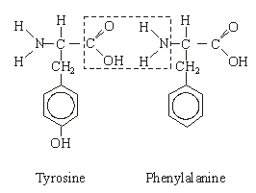

(b)     Copy from the diagram the R group in the phenylalanine molecule.

**(1)**

(c)     (i)      In the space below, draw the chemical bond formed when these two amino acids are joined by condensation. You need only draw the parts of the molecules shown in the box.

**(2)**

(ii)     Name this bond.

.............................................................................................................

**(1)**

(d)     Tyrosine can be made in the body by hydroxylating phenylalanine. Use the diagram to explain the meaning of *hydroxylating*.

......................................................................................................................

......................................................................................................................

**(1)**

**(Total 7 marks)**

**Q2.**          Alpha-1-antitrypsin is a protein that reduces the activity of enzymes that can damage lung tissue.  
Cigarette smoke contains hydrogen peroxide. Hydrogen peroxide reduces the activity of alpha-1-antitrypsin. Scientists investigated the effect of different concentrations of hydrogen peroxide on the activity of alpha-1-antitrypsin. The graph shows their results.

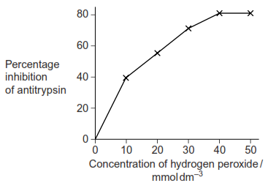

(a)     (i)      Hydrogen peroxide reacts with two amino acids in alpha-1-antitrypsin.  Explain how this reduces activity of the protein.

.............................................................................................................

.............................................................................................................

.............................................................................................................

.............................................................................................................

**(2)**

(ii)     Explain the results shown in the graph.

.............................................................................................................

.............................................................................................................

.............................................................................................................

.............................................................................................................

**(2)**

(b)     Long-term smokers are often short of breath. Use this information to explain why.

......................................................................................................................

......................................................................................................................

......................................................................................................................

......................................................................................................................

**(2)**

**(Total 6 marks)**

**Q3.**          Doctors investigated babies who were bottle-fed with baby-formula milk and suffered from colic. Colic is a condition that affects the gut and makes babies cry.

Each mother was given two solutions to add to her baby’s milk. One solution contained the enzyme lactase, the other did not. The mother did not know which solution contained lactase. The mother added one of the solutions to her baby’s milk for a week and recorded how long it cried each day. The mother then used the other solution for the second week.

The table shows the results.

|  |  |
| --- | --- |
|  | **Mean crying time / hours day–1** |
| **Milk with lactase** | 1.43 |
| **Milk without lactase** | 2.57 |

(a)     Suggest an explanation for the results.

.......................................................................................................................

.......................................................................................................................

.......................................................................................................................

.......................................................................................................................

**(2)**

(b)     The mothers were not told which solution contained lactase.

Suggest **one** reason why.

.......................................................................................................................

.......................................................................................................................

**(1)**

(c)     Suggest **one** variable the doctors would have to control in this study to make it a fair test. Explain your answer.

Variable ........................................................................................................

Explanation ...................................................................................................

.......................................................................................................................

.......................................................................................................................

**(2)**

(d)     The doctors concluded that adding lactase to milk was, ‘*A major breakthrough for babies with colic*.’

Evaluate the evidence for this conclusion.

.......................................................................................................................

.......................................................................................................................

.......................................................................................................................

.......................................................................................................................

.......................................................................................................................

.......................................................................................................................

*(Extra space) ................................................................................................*

.......................................................................................................................

.......................................................................................................................

**(3)**

**(Total 8 marks)**

**Q4.**          Antimicrobial proteins (AMPs), found in the skin of the African clawed frog, can kill bacteria. When AMPs are injected into humans, they are broken down by protease enzymes. Scientists have produced a number of AMPs that are not broken down by proteases. They did this by making these AMPs from man-made amino acids containing fluorine. The AMPs containing fluorine were found to be more effective in killing bacteria than AMPs without fluorine.

(a)     Name the type of reaction involved when a protease enzyme breaks down an AMP.

.......................................................................................................................

**(1)**

(b)     Suggest why protease enzymes cannot break down AMPs made from amino acids containing fluorine.

.......................................................................................................................

.......................................................................................................................

.......................................................................................................................

.......................................................................................................................

**(2)**

(c)     Scientists carried out an investigation to compare the effectiveness of AMPs containing fluorine and a frog AMP. They inoculated an agar plate with a culture of one species of bacterium. They cut four wells in the agar. They placed a frog AMP in one well. They put three different man-made AMPs containing fluorine in the other three wells. They incubated the plate for 48 hours. After incubation, there were clear areas around each well where the bacteria had not grown.

The appearance of the plate after incubation is shown below.

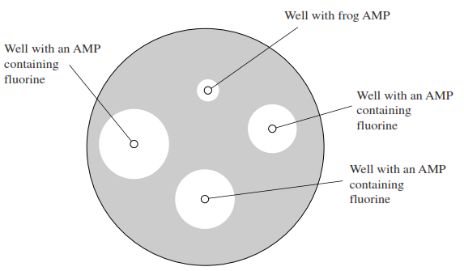

(i)      Give **one** example of aseptic technique that the scientists would have used during this investigation.

.............................................................................................................

.............................................................................................................

**(1)**

(ii)     What conclusions could the scientists draw from these results?

.............................................................................................................

.............................................................................................................

.............................................................................................................

.............................................................................................................

.............................................................................................................

.............................................................................................................

*(Extra space)*  .....................................................................................

.............................................................................................................

.............................................................................................................

**(3)**

**(Total 7 marks)**

**Q5.**          Sucrose is a disaccharide. It is formed from two monosaccharides **P** and **Q**. The diagram shows the structure of molecules of sucrose and monosaccharide **P**.

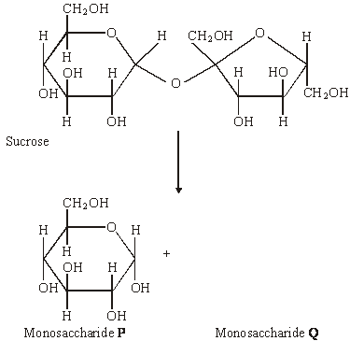

(a)     (i)      Name monosaccharide **Q**.

.............................................................................................................

**(1)**

(ii)     Draw the structure of a molecule of monosaccharide **Q** in the space above.

**(1)**

(b)     The enzyme sucrase catalyses the breakdown of sucrose into monosaccharides. What type of reaction is this breakdown?

......................................................................................................................

**(1)**

(c)     The diagram shows apparatus used in breaking down sucrose. The enzyme sucrase is fixed to inert beads. Sucrose solution is then passed through the column.

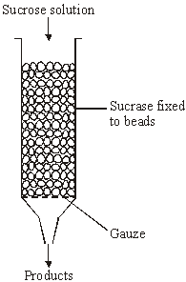

Describe a biochemical test to find out if the solution collected from the apparatus contains

(i)      the products;

.............................................................................................................

.............................................................................................................

.............................................................................................................

.............................................................................................................

**(2)**

(ii)     the enzyme.

.............................................................................................................

.............................................................................................................

.............................................................................................................

.............................................................................................................

**(2)**

**(Total 7 marks)**

**Q6.**          (a)     What is an enzyme?

......................................................................................................................

......................................................................................................................

......................................................................................................................

......................................................................................................................

**(2)**

The diagram shows stages during an enzyme-catalysed reaction.

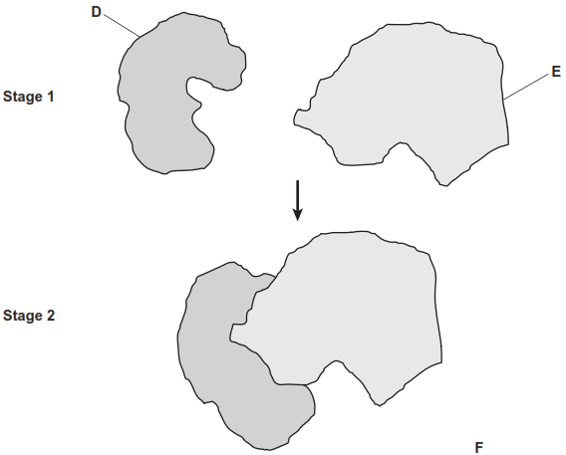

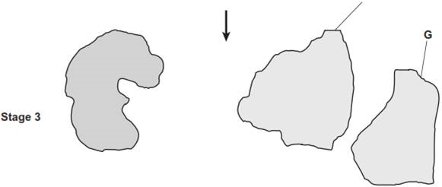

(b)     Using the letters in the diagram, describe what is happening in this reaction.

......................................................................................................................

......................................................................................................................

......................................................................................................................

......................................................................................................................

......................................................................................................................

......................................................................................................................

*(Extra space)* ...............................................................................................

......................................................................................................................

......................................................................................................................

......................................................................................................................

**(3)**

**(Total 5 marks)**

**Q7.**          The diagram shows part of the metabolic pathway involved in the clotting of blood in response to an injury.

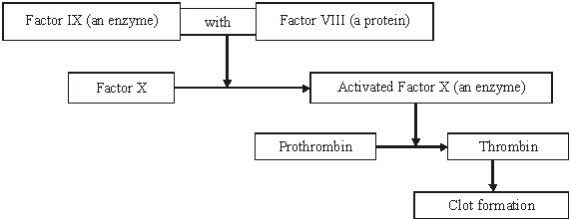

Haemophilia is a condition in which blood fails to clot. This is usually because of a mutant allele of the gene for Factor VIII.

(a)     Explain how mutation could lead to faulty Factor VIII.

......................................................................................................................

......................................................................................................................

......................................................................................................................

......................................................................................................................

**(2)**

(b)     Use information in the diagram to explain how faulty Factor VIII causes haemophilia.

......................................................................................................................

......................................................................................................................

......................................................................................................................

......................................................................................................................

**(2)**

(c)     A boy had haemophilia caused by faulty Factor IX. When his blood was mixed with blood from a haemophiliac with faulty Factor VIII, the mixture clotted. Suggest an explanation for clotting of the mixture.

......................................................................................................................

......................................................................................................................

......................................................................................................................

......................................................................................................................

**(2)**

**(Total 6 marks)**

**Q8.**         Gelatine is a protein. When a warm gelatine solution cools, it sets to form a jelly.  
Fresh pineapple juice contains an enzyme that digests protein.  
A student investigated the effect of pineapple juice on the setting of jelly.  
He set up three different tubes of warm gelatine solution and recorded which had set after three hours. The contents of each tube and his results are shown in the table.

|  |  |  |
| --- | --- | --- |
| **Tube** | **Contents of tube** | **Jelly formed** |
| **A** | 6 cm3  gelatine + 2 cm3  pineapple juice + 2 cm3  water | No |
| **B** | 6 cm3  gelatine + 2 cm3  pineapple juice + 2 cm3  hydrochloric acid | Yes |
| **C** | 6 cm3  gelatine + 2 cm3  boiled pineapple juice + 2 cm3  water | Yes |

(a)     Explain why 2 cm3 of  water was added to tubes **A** and **C**.

......................................................................................................................

......................................................................................................................

......................................................................................................................

......................................................................................................................

**(2)**

(b)     Explain the results of

tube **A** ..........................................................................................................

......................................................................................................................

......................................................................................................................

......................................................................................................................

tube **B** ..........................................................................................................

......................................................................................................................

......................................................................................................................

......................................................................................................................

**(4)**

(c)     What was the purpose of tube **C**?

......................................................................................................................

......................................................................................................................

......................................................................................................................

......................................................................................................................

......................................................................................................................

......................................................................................................................

*(Extra space) ...............................................................................................*

......................................................................................................................

......................................................................................................................

**(3)**

**(Total 9 marks)**

**Q10.**          This question should be written in continuous prose, where appropriate.

(a)     Explain how a resting potential is maintained in a neurone.

......................................................................................................................

......................................................................................................................

......................................................................................................................

......................................................................................................................

......................................................................................................................

......................................................................................................................

......................................................................................................................

......................................................................................................................

**(4)**

(b)     In an investigation, an impulse was generated in a neurone using electrodes. During transmission along the neurone, an action potential was recorded at one point on the neurone. When the impulse reached the neuromuscular junction, it stimulated a muscle cell to contract. The force generated by the contraction was measured. The results are shown in the graph.

The distance between the point on the neurone where the action potential was measured and the neuromuscular junction was exactly 18 mm.

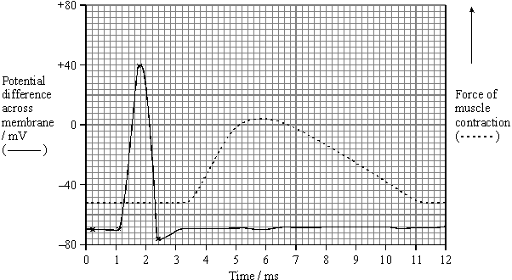

(i)      Use the graph to estimate the time between the maximum depolarisation and the start of contraction by the muscle cell.

Time ................................ ms

**(1)**

(ii)     Use your answer to part (i) to calculate the speed of transmission along this neurone to the muscle cell. Give your answer in mm per second.

Show your working.

Speed .................................. mm s–1

**(2)**

(iii)     Give **one** reason why the value calculated in part (ii) would be an underestimate of the speed of transmission of an impulse along a neurone.

.............................................................................................................

.............................................................................................................

**(1)**

Acetylcholine is the neurotransmitter at neuromuscular junctions.

(c)     Describe how the release of acetylcholine into a neuromuscular junction causes the cell membrane of a muscle fibre to depolarise.

......................................................................................................................

......................................................................................................................

......................................................................................................................

......................................................................................................................

......................................................................................................................

......................................................................................................................

**(3)**

(d)     Use your knowledge of the processes occurring at a neuromuscular junction to explain each of the following.

(i)      The cobra is a very poisonous snake. The molecular structure of cobra toxin is similar to the molecular structure of acetylcholine. The toxin permanently prevents muscle contraction.

.............................................................................................................

.............................................................................................................

.............................................................................................................

.............................................................................................................

**(2)**

(ii)     The insecticide DFP combines with the active site of the enzyme acetylcholinesterase. The muscles stay contracted until the insecticide is lost from the neuromuscular junction.

.............................................................................................................

.............................................................................................................

.............................................................................................................

.............................................................................................................

**(2)**

**(Total 15 marks)**

**Q11.**          Lactose is a disaccharide sugar which can be broken down by the enzyme lactase into two monosaccharides, glucose and galactose.

lactase

lactose+ water  glucose + galactose

(a)     The formula for galactose is C6H12O6. What is the formula for lactose?

......................................................................................................................

**(2)**

(b)     A solution containing the enzyme lactase was added to a lactose solution. The solution was incubated at 40 °C for one hour. Sample **A** was removed from the tube before incubation. Sample **B** was removed after one hour.

(i)      Describe a chemical test you could carry out on sample **A** to show that lactose is a reducing sugar.

.............................................................................................................

.............................................................................................................

.............................................................................................................

.............................................................................................................

**(2)**

(ii)     This chemical test was carried out on samples **A** and **B**. All experimental variables were the same in the testing of the two samples. Both tubes were left for ten minutes to allow the precipitate to settle. The diagram shows the result.

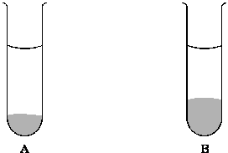

Is galactose a reducing sugar? ....................

Explain how the results in the diagram support your answer.

.............................................................................................................

.............................................................................................................

.............................................................................................................

.............................................................................................................

**(2)**

**(Total 6 marks)**

**Q12.**          (a)     CFTR is a transmembrane regulator protein.  Its molecules have 1480 amino acids. People with cystic fibrosis produce defective CFTR protein which is missing one amino acid from its structure.

(i)      What is the minimum number of bases on DNA which would code for the normal CFTR protein? Explain your answer.

Number of bases ...............................

.............................................................................................................

.............................................................................................................

.............................................................................................................

.............................................................................................................

**(2)**

(ii)     Which type of gene mutation produced the cystic fibrosis allele?  
Explain your answer.

.............................................................................................................

.............................................................................................................

.............................................................................................................

.............................................................................................................

**(2)**

(b)     The diagram shows part of the process of making normal and defective CFTR in a cell. A normal CFTR protein molecule has sugar molecules attached to it which make it functional.

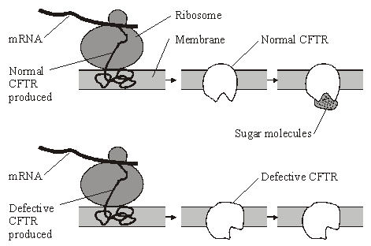

Describe how the information on mRNA is translated into CFTR at the ribosome.

......................................................................................................................

......................................................................................................................

......................................................................................................................

......................................................................................................................

......................................................................................................................

......................................................................................................................

......................................................................................................................

......................................................................................................................

**(4)**

**(Total 8 marks)**

**Q13.**          The diagrams show four types of linkage, **A** to **D**, which occur in biological molecules.

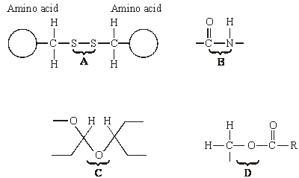

(a)     Name the chemical process involved in the formation of linkage **B**.

......................................................................................................................

**(1)**

(b)     Give the letter of the linkage which

(i)      occurs in a triglyceride molecule;

.............................................................................................................

**(1)**

(ii)     might be broken down by the enzyme amylase;

.............................................................................................................

**(1)**

(iii)     may occur in the tertiary, but not the primary structure of protein.

.............................................................................................................

**(1)**

(c)     Describe how a saturated fatty acid differs in molecular structure from an unsaturated fatty acid.

......................................................................................................................

......................................................................................................................

......................................................................................................................

......................................................................................................................

**(2)**

**(Total 6 marks)**

**Q14.**          Glaciers are masses of moving ice. When glaciers shrink, the thick covering of ice gradually disappears to leave behind bare land. Land exposed by a shrinking glacier in Alaska became covered by dense forest in 150 years.

(a)     Explain how succession resulted in the formation of the forest.

......................................................................................................................

......................................................................................................................

......................................................................................................................

......................................................................................................................

......................................................................................................................

......................................................................................................................

......................................................................................................................

......................................................................................................................

**(4)**

(b)     In areas of poor drainage the soil is waterlogged. In these areas the climax community is bog dominated by the moss, *Sphagnum*. Explain why bog is described as the climax community.

......................................................................................................................

......................................................................................................................

**(1)**

(c)     Waterlogged soils lack oxygen. Suggest why trees are unable to survive in waterlogged soils.

......................................................................................................................

......................................................................................................................

......................................................................................................................

......................................................................................................................

**(2)**

(d)     The water and soil in *Sphagnum* bogs are usually acidic. Suggest why *Sphagnum* is not fully decomposed after it dies.

......................................................................................................................

......................................................................................................................

......................................................................................................................

......................................................................................................................

......................................................................................................................

......................................................................................................................

......................................................................................................................

**(3)**

**(Total 10 marks)**

**Q15.**          In an investigation, the rate at which phenol was broken down by the enzyme phenol oxidase was measured in solutions with different concentrations of phenol. The experiment was then repeated with a non-competitive inhibitor added to the phenol solutions. The graph shows the results.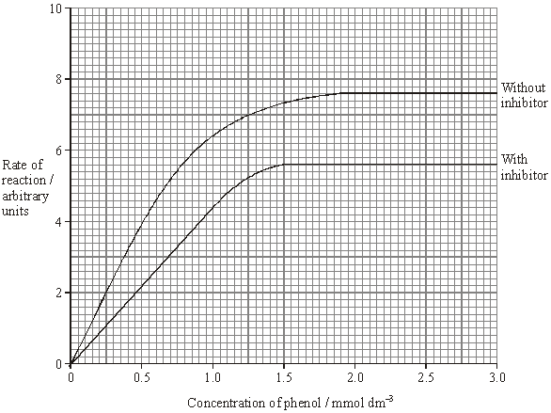

(a)     Explain why an increase in concentration of phenol solution from 2.0 to 2.5 mmol dm–3 has no effect on the rate of the reaction without inhibitor.

......................................................................................................................

......................................................................................................................

......................................................................................................................

......................................................................................................................

**(2)**

(b)     Explain the effect of the non-competitive inhibitor.

......................................................................................................................

......................................................................................................................

......................................................................................................................

......................................................................................................................

**(2)**

(c)     Calculate the percentage decrease in the maximum rate of the reaction when the inhibitor was added. Show your working.

Percentage decrease ...........................................

**(2)**

(d)     Draw a curve on the graph to show the results expected if a competitive inhibitor instead of a non-competitive inhibitor had been used.

**(1)**

**(Total 7 marks)**

**Q16.**          (a)     Explain how the shape of an enzyme molecule is related to its function.

......................................................................................................................

......................................................................................................................

......................................................................................................................

......................................................................................................................

......................................................................................................................

......................................................................................................................

**(3)**

(b)     Bacteria produce enzymes which cause food to decay. Explain how vinegar, which is acidic, can prevent the action of bacterial enzymes in some preserved foods.

......................................................................................................................

......................................................................................................................

......................................................................................................................

......................................................................................................................

......................................................................................................................

......................................................................................................................

**(3)**

**(Total 6 marks)**

**Q17.**          (a)     The graph shows the number of deaths from influenza per year in a developed country.

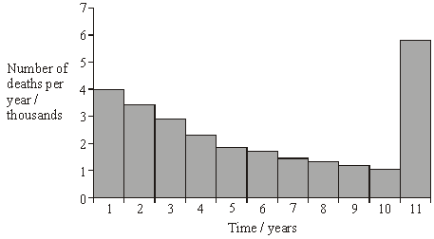

(i)      Suggest an explanation for the change in the number of deaths from influenza during the first 10 years.

.............................................................................................................

.............................................................................................................

**(1)**

(ii)     Suggest an explanation for the large increase in the number of deaths from influenza in year 11.

.............................................................................................................

.............................................................................................................

.............................................................................................................

.............................................................................................................

**(2)**

(b)     The diagram shows some of the structures on the outside of an influenza virus.

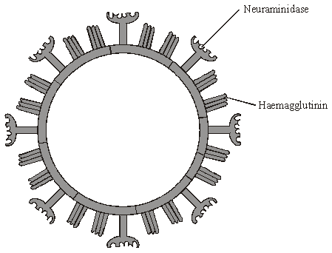

Haemagglutinin and neuraminidase are protein molecules. Haemagglutinin binds to receptor molecules on the surface of epithelial cells in the breathing system.  
Neuraminidase is an enzyme which breaks down molecules in the surface membrane of epithelial cells and allows the viruses to be released from the cells.

(i)      Describe how T lymphocytes recognise and respond to the influenza virus.

.............................................................................................................

.............................................................................................................

.............................................................................................................

.............................................................................................................

**(2)**

(ii)     Describe how B lymphocytes respond to the influenza virus.

.............................................................................................................

.............................................................................................................

.............................................................................................................

.............................................................................................................

**(2)**

(c)     New drugs have recently become available for treating influenza. One type is a neuraminidase inhibitor. Explain how this type of drug would act as a treatment for influenza.

......................................................................................................................

......................................................................................................................

......................................................................................................................

......................................................................................................................

**(2)**

**(Total 9 marks)**

**Q18.** Urease is an enzyme which hydrolyses urea to ammonia and carbon dioxide. The ammonia produces an alkaline solution.

In an experiment, a solution of urease was placed in tubing made from a partially permeable membrane. This tubing was put into a large test tube containing urea solution, as shown in the diagram. A control was set up with urease solution in the tubing and water outside.

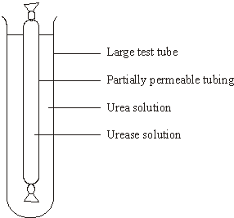

After 5 minutes, samples were taken from inside and outside the tubing in each of the test tubes. The samples were tested with an indicator that is yellow below pH 8.0 and blue above pH 8.0. The results are shown in the table.

|  |  |  |  |  |
| --- | --- | --- | --- | --- |
| **Tube** | **Contents** | | **Colour with indicator after 5 minutes** | |
|  | **Inside tubing** | **Outside tubing** | **Inside tubing** | **Outside tubing** |
| **A**  **B** | Urease solution  Urease solution | Urea solution  Water | Blue  Yellow | Yellow  Yellow |

(a)     Explain the result for tube **A**.

......................................................................................................................

......................................................................................................................

......................................................................................................................

......................................................................................................................

......................................................................................................................

......................................................................................................................

**(3)**

(b)     The solutions inside and outside the tubing in tube **B** were tested after 30 minutes for the presence of protein.

(i)      Describe how the presence of protein in a sample of a solution could be detected.

.............................................................................................................

.............................................................................................................

.............................................................................................................

.............................................................................................................

**(2)**

(ii)     What results of the tests for protein would you expect for tube **B**? In each case explain your answer.

Inside the tubing

.............................................................................................................

.............................................................................................................

.............................................................................................................

Outside the tubing

.............................................................................................................

.............................................................................................................

.............................................................................................................

**(2)**

(c)     Describe how you would carry out an investigation to find the optimum temperature for the activity of urease.

......................................................................................................................

......................................................................................................................

......................................................................................................................

......................................................................................................................

......................................................................................................................

......................................................................................................................

**(3)**

**(Total 10 marks)**

**Q19.**Mammals and fish remove nitrogenous waste from their bodies in different forms.

(a)     Name **two** polymers present in mammals and fish that contain nitrogen.

1 .....................................................................................................................

2 .....................................................................................................................

**(2)**

(b)     In a mammal urea is removed from the blood by the kidneys and concentrated in the filtrate.

(i)      Describe how urea is removed from the blood.

...............................................................................................................

...............................................................................................................

...............................................................................................................

...............................................................................................................

**(2)**

(ii)     Explain how urea is concentrated in the filtrate.

...............................................................................................................

...............................................................................................................

...............................................................................................................

...............................................................................................................

...............................................................................................................

...............................................................................................................

...............................................................................................................

...............................................................................................................

**(4)**

(c)     The diagram shows one way in which a person who has kidney disease can have the condition managed. In the process a fluid is put into the abdominal cavity. Exchange of materials takes place across the membrane that surrounds the abdominal cavity. This removes waste products from the blood. After five hours the fluid is drained out of the cavity and discarded. The cavity is then refilled with fresh fluid.

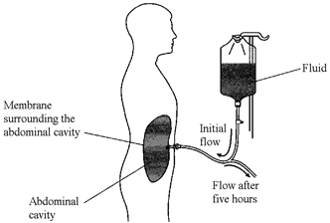

The table shows the concentration of solutes in the fresh fluid.

|  |  |  |
| --- | --- | --- |
|  | **Solute** | **Concentration / mmol dm−3** |
|  | Sodium ions (Na+) | 132 |
|  | Chloride ions (Cl−) | 96 |
|  | Calcium ions (Ca2+) | 1.25 |
|  | Magnesium ions (Mg2+) | 0.25 |
|  | Glucose | 76 |
|  | Urea | 0 |

(i)      By what process does urea enter the fluid in the abdominal cavity from the blood?

...............................................................................................................

**(1)**

(ii)     Explain why the fluid is changed every five hours.

...............................................................................................................

...............................................................................................................

**(1)**

(iii)    Fluid of the composition shown in the table is used instead of distilled water.  
Explain why.

...............................................................................................................

...............................................................................................................

...............................................................................................................

...............................................................................................................

**(2)**

**(Total 12 marks)**

**Q20.**          Pea plants are leguminous and have nodules on their roots which contain bacteria that are able to fix nitrogen. The diagram shows some of the processes involved in nitrogen fixation by these bacteria.

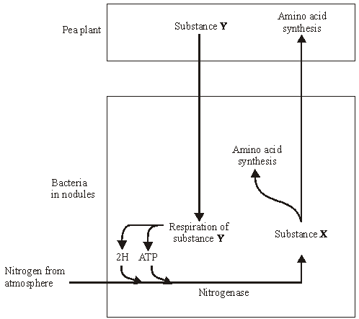

(a)     Name

(i)      substance **X**;

.............................................................................................................

**(1)**

(ii)     substance **Y**.

.............................................................................................................

**(1)**

**S**       (b)     Pea plants respire aerobically, producing ATP which can be used for amino acid synthesis. Describe the role of oxygen in aerobic respiration.

......................................................................................................................

......................................................................................................................

......................................................................................................................

......................................................................................................................

**(2)**

**S**       (c)     The bacteria respire anaerobically. This produces hydrogen and ATP used in nitrogen fixation. The hydrogen comes from reduced NAD. Explain how the regeneration of NAD in this way allows ATP production to continue.

......................................................................................................................

......................................................................................................................

......................................................................................................................

......................................................................................................................

**(2)**

**S**       (d)     The enzyme nitrogenase is specific to the reaction shown. Explain how **one** feature of the enzyme would contribute to this specificity.

          Feature

......................................................................................................................

          Explanation

......................................................................................................................

......................................................................................................................

......................................................................................................................

**(2)**

**S**       (e)     Sodium ions act as a non-competitive inhibitor of the enzyme nitrogenase. Explain how the presence of a non-competitive inhibitor can alter the rate of the reaction catalysed by nitrogenase.

......................................................................................................................

......................................................................................................................

......................................................................................................................

......................................................................................................................

......................................................................................................................

......................................................................................................................

**(3)**

**(Total 11 marks)**

**Q21.**          In an investigation into carbohydrase activity, the contents from part of the gut of a small animal were collected. The contents were added to starch solution at pH 7 and kept in a water bath at 25°C. At one-minute intervals, samples were removed and added to different test tubes containing dilute iodine solution. The colour intensity of each sample was determined. The graph shows the results.

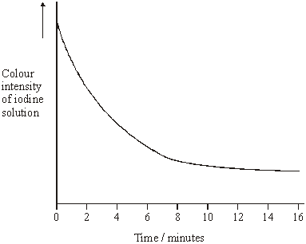

(a)     Explain the change in colour intensity.

......................................................................................................................

......................................................................................................................

......................................................................................................................

......................................................................................................................

**(2)**

(b)     Draw clearly labelled curves on the graph to show the expected result if the experiment was repeated

(i)      at 35 °C;

(ii)     at pH 2.

**(2)**

(c)     Explain how

(i)      raising the temperature to 35 °C affects carbohydrase activity;

.............................................................................................................

.............................................................................................................

.............................................................................................................

.............................................................................................................

.............................................................................................................

.............................................................................................................

.............................................................................................................

.............................................................................................................

(ii)     decreasing the pH affects carbohydrase activity.

.............................................................................................................

.............................................................................................................

.............................................................................................................

.............................................................................................................

.............................................................................................................

.............................................................................................................

.............................................................................................................

.............................................................................................................

.............................................................................................................

.............................................................................................................

**(7)**

**(Total 11 marks)**

**Q22.**          The diagram shows the structure of the amino acid serine.

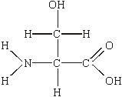

(a)     (i)      Draw a box on the diagram around the R group of serine and label the box with the letter **R**.

**(1)**

(ii)     Draw a circle around each of the parts of the serine molecule which would be removed when **two** other amino acid molecules join directly to it.

**(1)**

(b)     (i)      Which **two** substances are formed when two amino acid molecules join together?

1 ..........................................................................................................

2 ..........................................................................................................

**(1)**

(ii)     Name the type of bond formed between the joined pair of amino acid molecules.

.............................................................................................................

**(1)**

(c)     Explain how a change in the primary structure of a globular protein may result in a different three-dimensional structure.

......................................................................................................................

......................................................................................................................

......................................................................................................................

......................................................................................................................

......................................................................................................................

......................................................................................................................

**(3)**

**(Total 7 marks)**

**Q23.**          Two samples of the roots of pea plants were placed in solutions containing potassium ions. An inhibitor to prevent respiration was added to one solution. The concentrations of potassium ions in the two solutions were measured at regular intervals. The graph shows the results.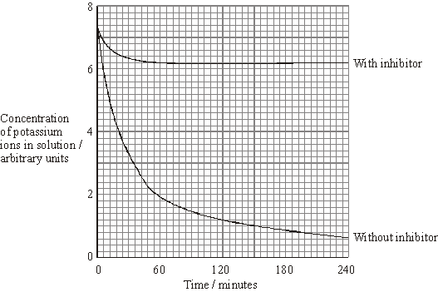

(a)     Explain the decrease in the concentrations of potassium ions in the two solutions between 0 and 30 minutes.

(i)      With inhibitor

.............................................................................................................

.............................................................................................................

.............................................................................................................

.............................................................................................................

**(2)**

(ii)     Without inhibitor

.............................................................................................................

.............................................................................................................

**(1)**

(b)     Explain why there is no further decrease in the concentration of potassium ions in the solution with the inhibitor after 60 minutes.

......................................................................................................................

......................................................................................................................

......................................................................................................................

......................................................................................................................

**(2)**

(c)     The substance malonate is an inhibitor of respiration. It has a structure very similar to the substrate of an enzyme that catalyses one of the reactions of respiration. Explain how malonate inhibits respiration.

......................................................................................................................

......................................................................................................................

......................................................................................................................

......................................................................................................................

**(2)**

**(Total 7 marks)**

**Q24.**          Ethylene glycol is a substance used in car anti-freeze. If it is accidentally swallowed it enters the liver cells where it is converted to poisonous oxalic acid. Ethanol inhibits the production of oxalic acid and can be used to treat patients who have swallowed anti-freeze.

In an investigation, the rate of reaction of an enzyme that makes oxalic acid was measured with and without ethanol present. The graph shows the results.

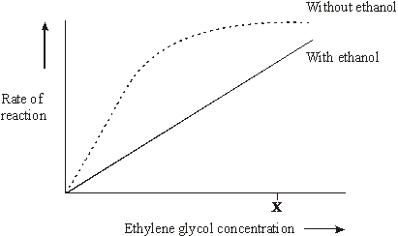

(i)      Increasing the concentration of ethylene glycol above **X** without ethanol present does not increase the rate of the reaction. Explain why.

......................................................................................................................

......................................................................................................................

......................................................................................................................

......................................................................................................................

**(2)**

(ii)      Use the information in the graph to explain how ethanol prevents oxalic acid production.

......................................................................................................................

......................................................................................................................

......................................................................................................................

......................................................................................................................

**(2)**

**(Total 4 marks)**

**Q25.**          Yarrow is a herbaceous plant which grows in California at altitudes from 1500 m to 3000 m. The mean height of the stems of plants growing at 3000 m is smaller than that of plants growing at 1500 m.

**S**       (a)     The higher the altitude, the lower the mean temperature. Explain how the lower temperature at high altitude reduces the growth of plants.

......................................................................................................................

......................................................................................................................

......................................................................................................................

......................................................................................................................

......................................................................................................................

**(4)**

**S**       (b)     The relative contribution of environmental and genetic factors on the growth of the plants was investigated. Samples of young plants were taken and grown outdoors in prepared plots at altitudes of 1500 m and 3000 m.

|  |  |  |
| --- | --- | --- |
| **Altitude at which young** | **Mean maximum height of stems of plants / cm** | |
| **plants were collected / m** | **Grown at 1500 m** | **Grown at 3000 m** |
| 1500 | 80.4 | 35.3 |
| 3000 | 31.5 | 24.7 |

Describe the evidence from the table that the variation in height is

(i)      partly genetically determined;

.............................................................................................................

.............................................................................................................

**(1)**

(ii)     partly environmentally determined.

.............................................................................................................

.............................................................................................................

**(1)**

**(Total 6 marks)**

**Q26.** When coal is mined by open-cast mining, the top layer of soil is first scraped off and stored in a large heap. Once mining has finished, the area can be reclaimed. Soil from this store is then spread back over the surface.

Some of the bacteria living in the soil store respire aerobically and some respire anaerobically. **Table 1** shows the numbers of aerobic and anaerobic bacteria found at different depths in a soil store.

|  |  |  |  |  |
| --- | --- | --- | --- | --- |
| **Depth / cm** | **Mean number of bacteria per gram of soil (× 107)** | | | |
| Aerobic bacteria | | Anaerobic bacteria | |
| after 1 month | after 6 months | after 1 month | after 6 months |
| 0 | 12.0 | 12.1 | 0.6 | 0.8 |
| 50 | 10.4 | 8.6 | 0.8 | 1.3 |
| 100 | 10.1 | 6.1 | 0.7 | 4.1 |
| 150 | 10.0 | 3.2 | 0.7 | 7.9 |
| 200 | 11.6 | 0.8 | 0.7 | 8.4 |
| 250 | 11.9 | 0.7 | 0.8 | 8.8 |
| 300 | 11.0 | 0.8 | 0.6 | 9.1 |

**Table 1**

(a)     Some of the soil used to determine bacterial numbers was collected from the surface of the soil store. Describe how you would ensure that this soil was collected at random.

......................................................................................................................

......................................................................................................................

......................................................................................................................

......................................................................................................................

**(2)**

(b)     (i)      Describe how the numbers of aerobic bacteria after 6 months change with depth.

.............................................................................................................

.............................................................................................................

.............................................................................................................

.............................................................................................................

**(2)**

(ii)     Explain the difference in the numbers of aerobic bacteria at a depth of 300 cm between 1 and 6 months.

.............................................................................................................

.............................................................................................................

.............................................................................................................

.............................................................................................................

**(2)**

(c)     Explain how the changes in bacterial numbers which take place at 150 cm illustrate the process of succession.

......................................................................................................................

......................................................................................................................

......................................................................................................................

......................................................................................................................

......................................................................................................................

......................................................................................................................

**(3)**

Dehydrogenase is an enzyme involved in aerobic respiration. Dehydrogenase activity in a soil sample can be used as a measure of the activity of aerobic bacteria. The graph shows the mean dehydrogenase activity of soil samples taken from the same depth in a soil store at different times. The bars on the graph represent two standard errors above and below the mean.

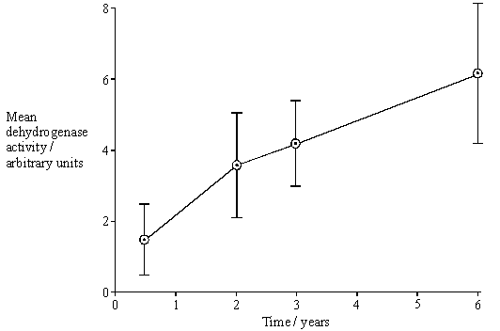

(d)     (i)      From what depth in the soil store would you expect these soil samples to have been taken? Use information from **Table 1** to explain your answer.

.............................................................................................................

.............................................................................................................

.............................................................................................................

.............................................................................................................

**(2)**

(ii)     How would you expect dehydrogenase activity to vary with depth after 6 months?

Use information from **Table 1** to explain your answer.

.............................................................................................................

.............................................................................................................

.............................................................................................................

.............................................................................................................

.............................................................................................................

.............................................................................................................

**(3)**

(e)     What do the error bars tell you about the difference between the mean dehydrogenase activity at 6 months and 3 years? Explain your answer in terms of probability and chance.

......................................................................................................................

......................................................................................................................

......................................................................................................................

......................................................................................................................

......................................................................................................................

......................................................................................................................

**(3)**

(f)      **Table 2** shows the dehydrogenase activity and the number of aerobic bacteria present in some soil samples.

|  |  |
| --- | --- |
| **Dehydrogenase activity / arbitrary units** | **Number of aerobic bacteria per gram of soil (× 107)** |
| 13.1 | 12.0 |
| 9.2 | 8.7 |
| 5.5 | 6.5 |
| 3.0 | 4.6 |
| 2.2 | 2.7 |
| 0.4 | 0.6 |

**Table 2**

A sample of soil was found to have dehydrogenase activity of 8.7 arbitrary units. Explain how you would use the data in **Table 2** to predict the likely number of aerobic bacteria in 1 g of this soil sample.

......................................................................................................................

......................................................................................................................

......................................................................................................................

......................................................................................................................

......................................................................................................................

......................................................................................................................

**(3)**

**(Total 20 marks)**

**Q27.**          (a)     The diagram shows a bacterial cell.

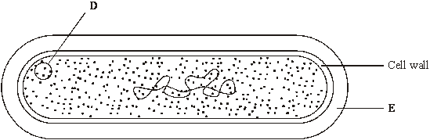

(i)      Name the parts labelled **D** and **E.**

**D** .........................................................................................................

**E** .........................................................................................................

**(2)**

(ii)     Give **one** function of the cell wall.

.............................................................................................................

.............................................................................................................

**(1)**

(b)     Name **two** structures present in eukaryotic cells that are not present in the cells of prokaryotes.

1 ...................................................................................................................

2 ...................................................................................................................

**(2)**

(c)     Several small pieces of a saprophytic fungus were placed on a starch agar plate. After 48 hours the iodine solution was poured over the starch agar. The result is shown in the diagram below.

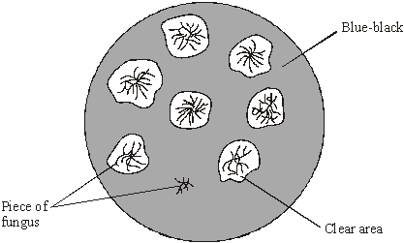

(i)      Explain why there is a clear area around most of the pieces of fungus.

.............................................................................................................

.............................................................................................................

.............................................................................................................

.............................................................................................................

**(2)**

(ii)     Suggest why one piece of fungus has no clear area round it.

.............................................................................................................

.............................................................................................................

**(1)**

**(Total 8 marks)**

**Q28.**          (a)     Amylase is an enzyme which hydrolyses starch to maltose. Some amylase and starch were mixed and the mixture incubated at 37 °C until the reaction was complete.

(i)      Sketch a curve on the axes below to show the progress of this reaction.

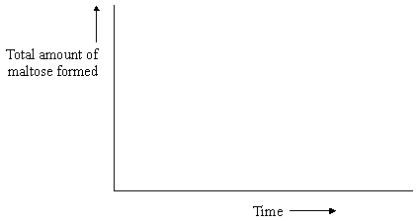

**(1)**

(ii)     Explain why the rate of the reaction decreases as the reaction progresses.

.............................................................................................................

.............................................................................................................

.............................................................................................................

**(2)**

The effect of temperature on the rate of reaction of an enzyme was investigated. A test tube containing the enzyme and a test tube containing the substrate were incubated separately at each of the temperatures being investigated. After 5 minutes, they were mixed and the rate of reaction was determined. The experiment was repeated but, this time, the enzyme and the substrate were left for 60 minutes before they were mixed. The results of the investigation are shown in the graph.

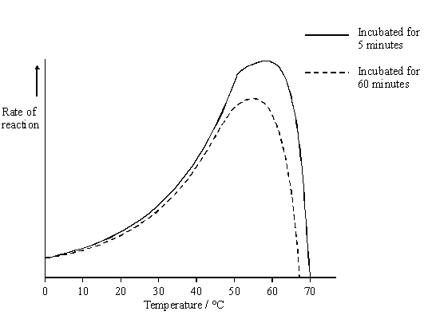

(b)     The enzyme solution used in this investigation was made by dissolving a known mass of enzyme in a buffer solution. Explain why a buffer solution was used.

......................................................................................................................

......................................................................................................................

**(1)**

(c)     (i)      Use the graph to describe how incubation time affects the rate of the reaction.

.............................................................................................................

.............................................................................................................

.............................................................................................................

.............................................................................................................

**(2)**

(ii)     The maximum rate of reaction with an incubation time of 60 minutes is less than the maximum rate of reaction with an incubation time of 5 minutes. Explain why.

.............................................................................................................

.............................................................................................................

.............................................................................................................

.............................................................................................................

.............................................................................................................

.............................................................................................................

**(3)**

(d)     Explain how inhibitors affect the rate of enzyme-controlled reactions.

......................................................................................................................

......................................................................................................................

......................................................................................................................

......................................................................................................................

......................................................................................................................

......................................................................................................................

......................................................................................................................

......................................................................................................................

......................................................................................................................

......................................................................................................................

......................................................................................................................

**(6)**

**(Total 15 marks)**

**Q29.**          The diagram represents an enzyme molecule and three other molecules that could combine with it.

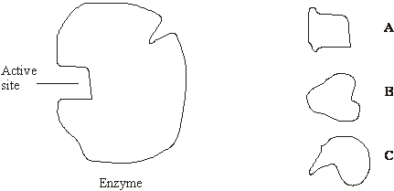

(a)     Which molecule is the substrate for the enzyme? Give a reason for your answer.

......................................................................................................................

......................................................................................................................

......................................................................................................................

**(1)**

(b)     Use the diagram to explain how a **non-competitive** inhibitor would decrease the rate of the reaction catalysed by this enzyme.

......................................................................................................................

......................................................................................................................

......................................................................................................................

......................................................................................................................

......................................................................................................................

......................................................................................................................

**(3)**

(c)     Lysozyme is an enzyme. A molecule of lysozyme is made up of 129 amino acid molecules joined together. In the formation of its active site, the two amino acids that are at positions 35 and 52 in the amino acid sequence need to be close together.

(i)      Name the bonds that join amino acids in the primary structure.

.............................................................................................................

**(1)**

(ii)     Suggest how the amino acids at positions 35 and 52 are held close together to form the active site.

.............................................................................................................

.............................................................................................................

.............................................................................................................

.............................................................................................................

**(2)**

**(Total 7 marks)**

**Q30.**          Lactose is a disaccharide found in milk. In the small intestine, it is digested into glucose and galactose by the enzyme lactase. Molecules of lactase are located in the plasma membranes of cells lining the small intestine.

(a)     What evidence in the paragraph suggests that galactose is a monosaccharide?

......................................................................................................................

......................................................................................................................

**(1)**

(b)     (i)      Name **one** other digestive enzyme that is located in the plasma membranes of cells lining the small intestine.

.............................................................................................................

**(1)**

(ii)     Give an advantage of lactase and other digestive enzymes being located in the plasma membranes of cells lining the small intestine, rather than being secreted into the lumen of the small intestine.

.............................................................................................................

.............................................................................................................

**(1)**

(c)     The absorption of galactose from the small intestine is reduced if the absorbing cells are treated with a respiratory inhibitor, such as cyanide. Suggest an explanation for this.

......................................................................................................................

......................................................................................................................

......................................................................................................................

......................................................................................................................

**(2)**

**(Total 5 marks)**

**Q31.**          Read the following passage.

Job’s Tears is a cereal plant which grows in the tropics. An unusual protein has been found in  
its grains. This protein is unusual because it has two functions. It acts as both an enzyme  
inhibitor and as an enzyme. As an inhibitor, the protein reduces the activity of starch-digesting  
enzymes. The protein acts as an enzyme by breaking down chitin, a polysaccharide found in

5     the walls of many fungi, to its monomers. Because of the resulting more negative water

potential in the cytoplasm of the fungus, this effectively leads to “death by osmosis” of any  
fungus attacking the grain.

Our knowledge of the relationship between protein structure and function has led to the  
development of the new technology of protein engineering. This involves changing the amino

10   acid sequence of a protein and altering its tertiary structure. Altering the tertiary structure

changes the protein’s properties. So far, we have been unable to produce a protein with more  
than one function such as that found in Job’s Tears. We have had success, though, in making  
some enzymes more stable and less prone to heat denaturation. We have done this by  
substituting amino acids and allowing the formation of additional chemical bonds.

Use information from the passage and your own knowledge to answer the following questions.

(a)     (i)      The protein found in Job’s Tears breaks down chitin (line 4). What type of chemical reaction is involved in breaking down chitin?

.............................................................................................................

**(1)**

(ii)     Breakdown of chitin leads to “death by osmosis” of fungi attacking the grain   
(lines 6 - 7). Explain how.

.............................................................................................................

.............................................................................................................

.............................................................................................................

.............................................................................................................

**(2)**

(iii)     This protein does not break down the cell walls of the Job’s Tears plant.  
Explain why.

.............................................................................................................

.............................................................................................................

**(1)**

(b)     Explain what is meant by the tertiary structure of a protein (line 10).

.............................................................................................................

.............................................................................................................

**(1)**

(c)     (i)      Explain how heating an enzyme leads to it being denatured.

.............................................................................................................

.............................................................................................................

.............................................................................................................

.............................................................................................................

**(2)**

(ii)     How can protein engineering make enzymes more stable and less prone to heat denaturation (line 13)?

.............................................................................................................

.............................................................................................................

.............................................................................................................

.............................................................................................................

**(2)**

(d)     Describe how the sequence of amino acids in part of the protein from Job’s Tears could enable this protein to act as an enzyme inhibitor.

......................................................................................................................

......................................................................................................................

......................................................................................................................

......................................................................................................................

......................................................................................................................

......................................................................................................................

......................................................................................................................

......................................................................................................................

......................................................................................................................

......................................................................................................................

......................................................................................................................

......................................................................................................................

**(6)**

**(Total 15 marks)**

**Q32.**          Homeostatic mechanisms maintain a constant environment in the body.

(a)     The graph shows changes in plasma glucose concentration that occurred in a person who went without food for some time.

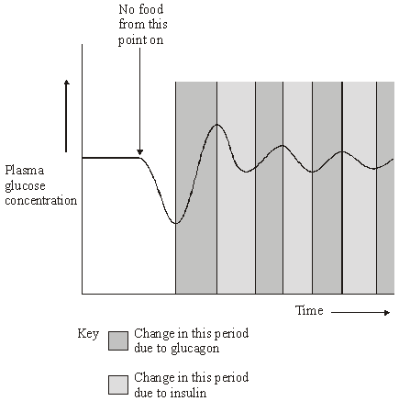

Use evidence from the graph to explain the role of negative feedback in the control of plasma glucose concentration.

......................................................................................................................

......................................................................................................................

......................................................................................................................

......................................................................................................................

......................................................................................................................

......................................................................................................................

......................................................................................................................

......................................................................................................................

......................................................................................................................

......................................................................................................................

......................................................................................................................

**(5)**

(b)     How does maintaining a constant body temperature allow metabolic reactions in cells to proceed with maximum efficiency?

......................................................................................................................

......................................................................................................................

......................................................................................................................

......................................................................................................................

......................................................................................................................

......................................................................................................................

......................................................................................................................

......................................................................................................................

......................................................................................................................

......................................................................................................................

**(5)**

**(Total 10 marks)**

**Q33.**          (a)     Haemoglobin is a protein with a quaternary structure. What is meant by a *quaternary* structure?

......................................................................................................................

......................................................................................................................

**(1)**

(b)     Explain how oxygen in a red blood cell is made available for respiration in active tissues.

......................................................................................................................

......................................................................................................................

......................................................................................................................

......................................................................................................................

......................................................................................................................

......................................................................................................................

**(3)**

(c)     Haemoglobin is broken down in the liver. One product of this breakdown is amino acids. Give **one** use in the body of these amino acids.

......................................................................................................................

......................................................................................................................

**(1)**

**(Total 5 marks)**

**Q34.**          (a)     Starch and protein are biologically important polymers.

(i)      Explain what is meant by a polymer.

.............................................................................................................

.............................................................................................................

**(1)**

(ii)     Give **one** example of a biologically important polymer other than starch or protein.

.............................................................................................................

**(1)**

(b)     In an investigation, the enzyme amylase was mixed in a test tube with a buffer solution and a suspension of starch. The amylase broke down the starch to maltose. When all the starch had been broken down, a sample was removed from the test tube and tested with biuret reagent.

(i)      Explain why a buffer solution was added to the amylase-starch mixture.

.............................................................................................................

.............................................................................................................

.............................................................................................................

**(2)**

(ii)     What colour would you expect the sample to go when tested with biuret reagent?

.............................................................................................................

**(1)**

(iii)     Give an explanation for your answer to part (ii)

.............................................................................................................

.............................................................................................................

.............................................................................................................

**(2)**

**(Total 7 marks)**

**Q35.**          Read the following passage.

The plasma membrane plays a vital role in microorganisms. It forms a barrier between the cell  
and its environment, controlling the entry and exit of solutes. This makes bacteria vulnerable  
to a range of antiseptics and antibiotics

When bacteria are treated with antiseptics, the antiseptics bind to the proteins in the

5     membrane and create tiny holes. Bacteria contain potassium ions at a concentration many

times that outside the cell. Because of the small size of these ions and their concentration in  
the cell, the first observable sign of antiseptic damage to the plasma membrane is the leaking  
of potassium ions from the cell. Some antibiotics damage the plasma membrane in a similar  
way. One of these is tyrocidin. This is a cyclic polypeptide consisting of a ring of ten amino

10   acids. Tyrocidin and other polypeptide antibiotics are of little use in medicine.

Other antibiotics also increase the rate of potassium movement from cells. It is thought that  
potassium ions are very important in energy release and protein synthesis, and a loss of  
potassium ions would lead to cell death. Gramicidin A coils to form a permanent pore passing  
through the plasma membrane. This pore enables potassium ions to be conducted from the

15   inside of the cell into the surrounding medium. Vanilomycin also facilitates the passage of

potassium ions from the cell. A molecule of vanilomycin forms a complex with a potassium  
ion and transports it across the membrane. The potassium ion is released on the outside and  
the vanilomycin is free to return and pick up another potassium ion. Vanilomycin depends on  
the fluid nature of the plasma membrane in order to function.

20   Polyene antibiotics have flattened ring-shaped molecules. The two sides of the ring differ from

each other. One side consists of an unsaturated carbon chain. This part is strongly  
hydrophobic and rigid. The opposite side is a flexible, strongly hydrophilic region. It has been  
shown that polyene antibiotics bind only to sterols. Sterols are lipids found in the membranes  
of eukaryotes but not in the membranes of prokaryotic organisms. It is thought that several

25   sterol-polyene complexes come together. The plasma membranes of eukaryotic cells treated

with these polyene antibiotics lose the ability to act as selective barriers and small ions and  
molecules rapidly leak out

          Use information in the passage and your own knowledge to answer the questions.

(a)     By what process do potassium ions normally enter a bacterial cell? Explain the evidence for your answer.

......................................................................................................................

......................................................................................................................

......................................................................................................................

......................................................................................................................

**(2)**

(b)     (i)      Draw a peptide bond showing how the COOH group of one amino acid joins to the NH2 group of another.

**(1)**

(ii)     How many peptide bonds are there in a molecule of tyrocidin (lines 9 - 10)?

.............................................................................................................

**(1)**

(c)     Experiments have shown that vanilomycin is unable to transport potassium ions across a membrane when it is cooled. Gramicidin A continues to facilitate the movement of potassium ions at these low temperatures. Explain these results.

......................................................................................................................

......................................................................................................................

......................................................................................................................

......................................................................................................................

......................................................................................................................

......................................................................................................................

**(3)**

(d)     Draw a simple diagram of one of the phospholipid layers to show how polyene antibiotics allow small ions and molecules to leak rapidly through a plasma membrane. Use the following symbols to represent the different molecules.

Note that the zigzag line on the symbol for the polyene antibiotic represents its hydrophobic region.

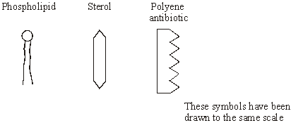

**(2)**

**(Total 9 marks)**

**M1.**          (a)     (i)      Biuret / alkali + copper sulphate;  
Lilac / purple / mauve / violet;

*Do not give credit for blue or pink. Ignore references to heating.*

**2**

(b)     R group of phenylalanine copied accurately;

**1**

(c)     (i)      Bond shown linking carbon and nitrogen;  
OH and H removed, =O and –H remaining;

**2**

(ii)     Peptide bond;

**1**

(d)     Addition of hydroxyl / OH group;

*Candidate must distinguish clearly between hydroxylation and hydrolysis*

**1**

**[7]**

**M2.**          (a)     (i)      Changes shape of antitrypsin;  
Reference to hydrogen/ionic/disulfide bonds;  
No longer attaches to/interacts/ reacts with trypsin;

*Accept protease*

**2**

(ii)     Higher the concentration of hydrogen peroxide, more amino acids/  
proteins affected;  
More antitrypsin molecules change shape;

**2**

(b)     (Longterm smokers) inhale a lot of hydrogen peroxide;  
Smokers have more active enzyme that damages lung tissue;  
Reducing gas exchange surface;

**2 max**

**[6]**

**M3.**          (a)     Lactose intolerance in babies/babies don’t make/have lactase;  
Lactose (in milk) causes colic/crying/discomfort;  
Lactase breaks down lactose/milk sugar;

**2 max**

(b)     To avoid prejudice/bias from mother (when recording crying);

*Accept for mother she/they/their*

*Accept to avoid mothers being concerned that their  
child has lactose intolerance. Q - Reject vague ref. to fair test/avoid bias with no ref. to mothers.*

**1**

(c)     **One** variable; with explanation;  
Example,  
Type of milk used;  
So same concentration of lactose;

Same age of children;  
Change in enzyme production with age;

Same age of children;  
Change in milk consumption with age;

Same volume of milk (per kg baby);

So same dosage (of lactose);

*Accept ref. to controlling other factors in diet*

*Reject time in the context of duration of investigation, given in stem*

*Accept e.g. time of feeding each day*

*Accept temperature of milk, related to action of lactase enzyme*

**2 max**

(d)     There is a decrease in crying;  
Could be other causes/symptoms of colic;  
Babies might cry for reasons besides colic/might have colic and  
not cry/can’t be sure they have colic, they can’t talk;  
Don’t know number of babies in trial/need a larger study;  
So don’t know how reliable mean is;  
Standard deviation not given/spread of data;  
So don’t know whether difference is significant;  
Babies still crying (for 1.43 hours);  
Recording by mothers might not be reliable;  
Longer running study to make sure effect (of lactase) lasts;

**3 max**

**[8]**

**M4.**          (a)     Hydrolysis;

*Accept breaking of peptide bonds*

**1**

(b)     Adding fluorine changes shape/different shape from other proteins;Do not fit active site (of protease);Induced fit not produced;

**2 max**

(c)     (i)      Suitable example;e.g. Flaming spreader/ use lid of Petri dish as umbrella/ clean  
bench with disinfectant/ sterilise agar in autoclave;

*Ignore references to wearing gloves, unless suitably qualified and unqualified references to ‘clean‘*

**1**

(ii)     All the AMPs killed/inhibited the bacteria/AMPs with fluorine more  
effective than frog AMP;Not All fluorine AMPs are equally effective;Diameter/area of clear zone indicates effectiveness;Only used one kind of bacterium/need to repeat using other bacteria;Need to repeat the investigation/only one plate used;Credit suitable measurements or calculations;

**3 max**

**[7]**

**M5.**          (a)     (i)      fructose;

**1**

(ii)     correctly drawn (OH group at bottom left);

**1**

(b)     hydrolysis;

**1**

(c)     (i)      heat with Benedict’s solution (*disqualify if HCl added*);  
orange / brown / brick red / green / yellow colour or precipitate;

**2**

(ii)     biuret test / NaOH + CuSO4;  
purple / violet / lilac / mauve;

**2**

**[7]**

**M6.**          (a)     Protein;

Catalyst;

*Accept speeds up a reaction (but is not changed by the reaction)*

(For reaction involving a) specific substrate;

Lowers activation energy;

**2 max**

(b)     Enzyme D binds/collides with substrate E;

*Ignore lock and key references*

Active site forms/changes shape to fit substrate/E;

*Max 2 if no reference to letters*

(By) induced fit;

(As) enzyme-substrate complex forms;

(Breaks down to give) products F and G;

Enzyme is unchanged (at end);

**3 max**

**[5]**

**M7.**          (a)     mutation changes the amino acid sequence / primary structure of Factor VIII protein;  
changes the tertiary structure / 3D shape;

**2**

(b)     (mutant) Factor VIII protein is non-functional / does not work with Factor IX;  
so no conversion of Factor X to active form and pathway blocked;

**2**

(c)     boy’s blood contains (active) Factor VIII;  
Factor VIII haemophiliac’s blood contains (active) Factor IX;  
the mixture has both Factors and so the pathway can  
complete / blood clots;

**2 max**

**[6]**

**M8.**          (a)     To keep concentrations of gelatine constant;

*Accept ‘to keep concentration constant’ for /  
mark if points 1 and 2 not made*

To keep concentration of pineapple extract constant;Tube 2 had HCI added / to give same volume as B;

**2 max**

(b)     Tube A

Enzyme (in pineapple) has digested gelatine;

*Allow enzyme ‘breaks down’ gelatine*

So no gelatine / protein to form a jelly;

Tube B

Enzyme denatured / inhibited / reference to hydrogen bonds /  
change of tertiary structure;By HCI / change of pH;

**4**

(c)     For comparison / as a control;To show that it is an enzyme in pineapple that digested gelatine /  
stopped gelatine setting in tube 1;Boiling denatures enzyme / Can be described but must be  
permanent change;Other components of pineapple still present;

**3 max**

**[9]**

**M9.**          ***General Principles for marking the Essay:***

Four skill areas will be marked: scientific content, breadth of knowledge, relevance and quality of language. The following descriptors will form a basis for marking.

**Scientific Content** (maximum 16 marks)

|  |  |  |
| --- | --- | --- |
| **Category** | **Mark** | **Descriptor** |
| **Good** | 16      14      12 | Most of the material reflects a comprehensive understanding of the principles involved and a knowledge of factual detail fully in keeping with a programme of A-level study. Some material, however, may be a little superficial. Material is accurate and free from fundamental errors but there may be minor errors which detract from the overall accuracy. |
|  |  |  |
| **Average** | 10    8    6 | Some of the content is of an appropriate depth, reflecting the depth of treatment expected from a programme of A-level study. Generally accurate with few, if any, fundamental errors. Shows a sound understanding of the key principles involved. |
|  |  |  |
| **Poor** | 4    2  0 | Material presented is largely superficial and fails to reflect the depth of treatment expected from a programme of A-level study. If greater depth of knowledge is demonstrated, then there are many fundamental errors. |

**Breadth of Knowledge** (maximum 3 marks)

|  |  |
| --- | --- |
| **Mark** | **Descriptor** |
| 3 | A balanced account making reference to most areas that might realistically be covered on an A-level course of study. |
| 2 | A number of aspects covered but a lack of balance. Some topics essential to an understanding at this level not covered. |
| 1 | Unbalanced account with all or almost all material based on a single aspect. |
| 0 | Material entirely irrelevant or too limited in quantity to judge. |

**Relevance** (maximum 3 marks)

|  |  |
| --- | --- |
| **Mark** | **Descriptor** |
| 3 | All material presented is clearly relevant to the title. Allowance should be made for judicious use of introductory material. |
| 2 | Material generally selected in support of title but some of the main content of the essay is of only marginal relevance. |
| 1 | Some attempt made to relate material to the title but considerable amounts largely irrelevant. |
| 0 | Material entirely irrelevant or too limited in quantity to judge. |

**Quality of language** (maximum 3 marks)

|  |  |
| --- | --- |
| **Mark** | **Descriptor** |
| 3 | Material is logically presented in clear, scientific English. Technical terminology has been used effectively and accurately throughout. |
| 2 | Account is logical and generally presented in clear, scientific English. Technical terminology has been used effectively and is usually accurate. |
| 1 | The essay is generally poorly constructed and often fails to use an appropriate scientific style and terminology to express ideas. |
| 0 | Material entirely irrelevant or too limited in quantity to judge. |

**[25]**

**Additional guidance for assessing Scientific Content and Breadth of Knowledge in Essays**

The following provides guidance about topics which might be included in the essays. It is not an exclusive list; the assessment of scientific content does not place restrictions on topics that candidates might refer to, provided they are

•        relevant;

•        at an appropriate depth for A level and

•        accurate.

It is not expected that candidates would refer to all, or even most, of the topics to gain a top mark; the list represents the variety of approaches commonly encountered in the assessment to the essays.

In both essays, topics either from the option modules or beyond the scope of the specification were also given credit where appropriate.

**How the structure of proteins in relation to their functions**.

1.       Structure (S)  
primary structure – peptide bond  
secondary structure  
tertiary structure. Globular - bonds between R groups give spherical shape – shape determines function – active sites and receptor sites  
(*allow quaternary structure – haemoglobin incorporates ions for oxygen transport*)

2.       Structural proteins (ST)  
fibrous – regular pattern of hydrogen bonds – coiling,   
(*e.g. keratin coils twist together to form rope-like structures – flexible and strong*)  
(*e.g. collagen – coils more tightly bound – more rigid*)

3.       Transport (T)  
channel – complementary shape – charges – gated  
carrier – complementary shape – can change shape  
active transport – phosphate group attached by energy from   
ATP – can change shape

4.       Enzymes (E)  
active site, enzyme-substrate complex  
activation energy reduction - explanation e.g. brings molecules closer

5.       Receptors (R)  
synapse  
insulin / glucagon  
ADH  
rhodopsin

6.       Muscle (M)  
actin thin – binding site  
myosin thick - cross bridges  
tropomyosin – block binding sites

**Breadth of knowledge**3 marks      Four or more of the above 6 areas  
2 marks      Three of the above 6 areas  
1 mark        Two of the above 6 areas

**M10.**          (a)     membrane relatively impermeable / less permeable to sodium ions / gated channels are closed / fewer channels;  
sodium ions pumped / actively transported out;  
by sodium ion carrier / intrinsic proteins;   
inside negative compared to outside / 3 sodium ions out for two potassium ions in;

*(if sodium mentioned but not in context of ions, negate 1 mark)*

**4**

(b)     (i)      1.6;

**1**

(ii)     18 ÷ 1.6 = 11.25;  
multiply by 1000 to convert from ms to s / 11 250;

*(correct method = 1 mark, i.e.  or × 1000)*

*(correct answer based on (b)(i) = 2 marks)*

**2**

(iii)     time for transmission / diffusion across the neuromuscular junction / synapse;  
time for muscle (fibrils) to contract;

**1 max**

(c)     movement by diffusion;  
binding to receptors on (post-synaptic) membrane;  
causing sodium channels to open / sodium ions to move in to muscle (cell);

**3**

(d)     (i)      toxin binds to / competes for / blocks the acetylcholine receptors;  
acetylcholine can not depolarise the membrane / the toxin does not cause depolarisation;

*(allow references to generating action potentials instead of depolarisation, do not allow references to impulses in muscles)*

**2**

(ii)     acetylcholinesterase is unable to breakdown acetylcholine;  
acetylcholine still available to depolarise the membrane /   
generate action potentials in the membrane;

**2**

**[15]**

**M11.**          (a)     C12 ; H22O11 ;

**2**

(b)     (i)      heat with Benedict’s;  
yellow / brown / orange / red;

**2**

(ii)     (yes)

*(may appear on second line)*

more precipitate in sample **B**;  
both sugars are reducing sugars / give a positive test;

**2**

**[6]**

**M12.**          (a)     (i)      number of bases = 4440

*allow 4446 if they refer to start / stop*

each amino acid coded for by triplet / three bases  
(so three times more bases than amino acids);

**2**

(ii)     deletion;  
(deletion) of three bases;  
because substitution / addition would change amino acid(s);

**2 max**

(b)     codon on mRNA;  
specific / complementary base pairing with;  
anti-codon on tRNA;  
specific tRNA for each amino acid;  
protein formed by condensation reactions /   
peptide bonds formed;

**4 max**

**[8]**

**M13.**          (a)     (i)      condensation;

**1**

(b)     (i)      **D**;

**1**

(ii)     **C**;

**1**

(iii)     **A**;

**1**

(c)     absence of a double bond;  
in the (hydrocarbon) chain;  
unable to accept more hydrogen / saturated with hydrogen;

**2 max**

**[6]**

**M14.**          (a)     pioneers / suitable example colonise land;  
example of change in environment;   
enables change in species;  
conditions change further / example to favour trees;

**4**

(b)     stable community / no further succession / final community;

**1**

(c)     roots unable to respire (aerobically);  
active transport of minerals / other metabolic effect stops;

**2**

(d)     action of bacteria / decomposers inhibited / fewer bacteria / decomposers;  
acid conditions inhibits enzymes / enzymes denatured / changes active site;  
H+ ions affect active site;  
anaerobic conditions;

**3 max**

**[10]**

**M15.**          (a)     maximum rate at which enzyme can combine with substrate / form enzyme-substrate complexes / substrate no longer limiting / enzyme is a limiting factor;  
(active site of) enzyme saturated with substrate (*disqualify active sites / enzymes* ‘*used up*’);

**2**

(b)     inhibitor attaches to enzyme away from the active site;  
changes shape of active site and prevents formation of enzyme-substrate complex;

**2**

(c)      x 100;

= 26.32%; *(accept 26% or 26.3%)*

*(correct answer = 2 marks)*

*(principle –  × 100 = 1 mark)*

**2**

(d)     curve below top curve (without inhibitor) joining to top curve / continues to increase to end of *x*-axis  
(*must not exceed or level out below ‘without inhibitor curve’ and must start from origin*);

**1**

**[7]**

**M16.**          (a)     specific 3D tertiary structure / shape;  
substrate complementary shape;

*(reject same shape)*

substrate (can bind) to active site / can fit into each active site;

**3**

(b)     (bacterial) active site / enzymes / proteins denatured /   
tertiary 3D structure disrupted / changed;  
(ionic) bonds broken;

*(reject peptide bonds)  
(ignore other bonds)*

no enzyme substrate complex formed / substrate no longer fits;

**3**

**[6]**

**M17.**          (a)     (i)      fall in deaths due to rise in number of people with immunity / better care / targeting vaccination at vulnerable;

**1**

(ii)     mutation of virus / new strain;  
mutant form not recognised by memory cells (*allow antibodies*);

**2 max**

(b)     (i)      T lymphocyte receptors recognise shape of haemagglutinin /   
neuraminidase / viral antigen;  
clone (*once only*);  
destroy virus;

**2 max**

(ii)     clone (*once only*);  
produce antibodies;  
effect of antibody e.g. stimulation of phagocytosis /   
precipitation of toxins;

**2**

(c)     alter shape of active site of neuraminidase / block active site;  
virus unable to leave host cells;

**2**

**[9]**

**M18.**          (a)     urea diffused into / entered the tubing and was hydrolysed / broken down (inside tubing);  
ammonia increases pH / makes (solution) more alkaline and indicator turns blue as pH above 8 / due to alkalinity / due to ammonia;  
idea that outside stays yellow because urease does not pass out;

**3**

(b)     (i)      add biuret solution / add sodium hydroxide + copper  
sulphate (solution);

*(disqualify heat / boil, but accept warm)*

violet / lilac / purple colour;

**2**

(ii)     inside: protein present, as enzyme is protein;  
outside: no protein, as urease / enzyme / protein unable to pass  
through membrane / out;

*(accept correct result of biuret test as indicator of protein)*

**2**

(c)     method to maintain range of temperatures, e.g. water baths;  
method to measure rate of activity - e.g. time taken to turn indicator blue;

*(principle - measure rate of activity over range of temperatures = 1 mark, if neither point)*

other conditions kept constant / named examples,  
e.g. volumes of solutions,  
starting pH, sample time;  
method of refining optimum, e.g. repeats at narrower range;

**3 max**

**[10]**

**M19.**(a)     any two named polymers [subsets = 1 max. (e.g. protein / haemoglobin)]

**2**

(b)     (i)      hydrostatic pressure / description of pressure;

causes ultrafiltration at Bowman's capsule / glomeruli / renal capsule;

through basement membrane;

enabled by small size of urea molecule;

**max 2**

(ii)     reabsorption of water;     [water out]

by osmosis;

at the PCT / descending LoH;

at the DCT / CD;

active transport of ions / glucose creates gradient (in context);

**max 4**

(c)     (i)      by (simple) diffusion;

*[reject facilitated]*

**1**

(ii)     to maintain concentration gradients / stop reaching equilibrium;

[idea of maintaining concentration gradients]

**1**

(iii)     ions, glucose and amino acids would diffuse into the dialysate;

because of their concentration gradients;

Causing deficiency in these substances;

**OR**

the WP of the dialysate would be higher / less negative than the WP of the surrounding tissues;

therefore osmosis would take place into the cells surrounding the abdominal cavity;

causing these cells to burst / damaging these cells / cannot be excreted;

**max 2**

**[12]**

**M20.**          (a)     (i)      ammonia / ammonium ions / compound;

**1**

(ii)     glucose;

**1**

(b)     final acceptor for hydrogen:  
to form water;

**2**

(c)     glycolysis can continue;  
NAD can accept more hydrogen;

**2**

(d)     secondary / tertiary structure;  
produces particular shape of active site;  
*or*(shape of) active site;  
complementary to shape of substrate;

**2**

(e)     sodium ions / non-competitive inhibitor binds to enzyme  
at a site other than active site;  
resulting in change of shape of active site / no longer complementary;  
substrate can no longer bind with the enzyme / enzyme-substrate  
complexes no longer formed;

**3**

**[11]**

**M21.**          (a)     colour results from starch-iodine reaction;  
decrease due to breakdown of starch by carbohydrase / enzyme;

**2**

(b)     (i)      curve drawn below curve on graph and starting at same point;

**1**

(ii)     curve drawn above curve on graph and starting at same point but  
finishing above;

*(allow curve or horizontal line)*

*(allow alternative curve for pH if explanation in (ii) is consistent)*

**1**

(c)     (i)      1. increase in temperature increases kinetic energy;  
2. increases collisions (between enzyme / active site and substrate) / increases formation of enzyme / substrate complexes;  
3. increases rate of breakdown of starch / rate of reaction / carbohydrase activity;

(ii)     4. (decrease in pH) increases H+ ions / protons which attach / attracted to amino acids;  
5. hydrogen / ionic bonds disrupted / broken which denatures enzyme / changes tertiary structure;  
6. changes shape / charge of active site so active site / enzyme unable to combine / fit with starch /  enzyme-substrate complex no longer able to form;  
7. decreases rate of breakdown of starch / rate of reaction / carbohydrase activity;

*(allow alternative explanation for pH if consistent with line   
drawn in (ii))*

**7**

**[11]**

**M22.**          (a)     (i)      box drawn around R group (i.e. CH2OH group)

*(allow circle if labelled R);*

**1**

(ii)     circle drawn around either of the Hs on NH2 group and circle drawn  
around the OH;

**1**

(b)     (i)      (di)peptide and water;

**1**

(ii)     peptide;

**1**

(c)     sequence of amino acids changes;  
tertiary structure changes / folds in a different way;  
bonds form in different places;  
(*Reject peptide bonds*)

**3**

**[7]**

**M23.**          (a)     (i)      absorbed by diffusion;  
no energy / ATP available / active transport requires energy / ATP;

**2 max**

*(disqualify energy made)*

*(allow energy reference in either (i) or (ii))*

(ii)     absorbed by active transport;

**1**

(b)     (absorption by) diffusion no longer occurs / diffusion / movement  
of ions equal in both directions;  
because no concentration / diffusion gradient / reached equilibrium;

**2**

(c)     malonate fits into / blocks active site of enzyme / complementary to active site;  
(prevents fitting neutral)  
competes with substrate / is a competitive inhibitor / prevents substrate  
forming enzyme-substrate complex;

**2**

**[7]**

**M24.**          (i)      active sites contain substrate / ethylene glycol;  
all active sites occupied / enzyme is limiting;

*(reject idea of active sites used up)*

**2**

(ii)      Ethanol is a similar shape to the substrate (ethylene glycol) /

complementary to active site;

*(reject “same shape”)*

ethanol is a competitive inhibitor / reduces enzyme-substrate complexes /   
prevents substrate (ethylene glycol) entering the active site;

*(reject “decreases rate of reaction”)*

**2**

**[4]**

**M25.**          (a)     lower enzyme activity;

decrease in rate of photosynthesis so less carbohydrate formed / named carbohydrate / lower translocation of sucrose / to growing point;  
lower respiration;  
lower rate of nutrient uptake / protein synthesis / cell division;

**4**

(b)     (i)      differ in height when plants from different altitudes grown   
in same environment;

**1**

(ii)     plants from 1500 / 3000m differ in height when grown at different

altitudes;

**1**

**[6]**

**M26.**          (a)     Tapes / string / axes laid out at right angles / grid area;  
Method of obtaining random co-ordinates;  
*Do not allow “Use random number generator”*

**2**

(b)     (i)      Decrease then remain constant;  
From 200 cm / over 150 cm;

**2**

(ii)     Oxygen decreasing because soil becomes more compacted / not  
replaced;  
Decrease in oxygen leads to fewer aerobes surviving;

**2**

(c)     Anaerobic bacteria replace aerobic as oxygen decreased by aerobic bacteria;  
Remove competition;  
Aerobic bacteria no longer able to survive in these conditions;

**3**

(d)     (i)      Near the surface / in top 50 cm;  
Table shows decrease with time at greater depths;

**2**

(ii)     Decrease;  
Fewer aerobic bacteria with depth;  
Oxygen concentration decreases / less oxygen at depth;

**3**

(e)     Probability greater than 95% / 0.95;  
Results are not due to chance / results are significant;  
Because bars do not overlap;

**3**

(f)      Plot as graph;  
Draw line of best fit;  
Read off appropriate value;

**3**

**[20]**

**M27.**          (a)     (i)      **D** plasmid / ribosome(s) / cytoplasm / storage granules;

*(accept any sensible structure)*

**E** (slime / mucous) capsule

*OR*

slime / mucous layer;

**2**

(ii)     protection / maintain shape / prevent lysis / strength / support;

**1**

(b)     two of the following:

nucleus;

OR

nuclear envelope / mitochondria / chloroplasts / sER / rER /

golgi apparatus / 80s ribosomes

linear DNA / chromosomes / lysosomes / vacuole / vescicles /   
cellulose cell wall;

**2 max**

(c)     (i)      starch digested / broken down;

by amylase / carbohydrase;

**2**

(ii)     any sensible suggestion e.g. no secretion of amylase /   
functional amylase /

piece of fungus might have died;

*(accept carbohydrase / enzyme for amylase)*

*(reject “no digestion” without qualification)*

**1**

**[8]**

**M28.**          (a)     (i)      Curve rising and levelling out;

**1**

(ii)     Substrate becomes limiting / falls / gets less;  
Fewer collisions / complexes formed;

**2**

(b)     To keep pH the same / optimum pH / so change in pH does not affect reaction;

**1**

(c)     (i)      For temperature up to 40 – 50 °C has no effect;  
Over temperature (of 40 – 50 °C) reduces rate of reaction;

*Note. Award one mark for general statement about the  
longer the incubation time, the slower the rate of reaction.*

**2**

(ii)     Bonds (holding tertiary structure) broken;  
More enzyme denatured / tertiary structure destroyed /   
active sites lose shape / no longer fit;  
Fewer enzyme-substrate complexes formed;

*Note. Award marks if clearly in the context of more denaturation. Allow credit here for converse relating to exposure for 5 minutes.*

**3**

(d)     Competitive  
2 Similarity of shape of inhibitor and substrate;  
3 Inhibitor can enter / bind with active site (of enzyme);

Non-competitive  
4 Affect / bind to enzyme other than at active site;  
5 Distorts shape of active site;

Inhibitors  
6 Prevent entry of / binding of substrate to active site;  
7 Therefore fewer / no enzyme-substrate complexes formed;

**6**

**[15]**

**M29.**          (a)     **A** and structure(of **A**) is complementary to that of the active site;

**1**

(b)     idea that non-competitive inhibitor(**C**) binds at a site not the active  
site; binding causes a change in the shape of the active site;  
substrate is no longer able to bind to the active site;

**3**

(c)     (i)     peptide;

**1**

(ii)     idea that amino acid chain folds / tertiary structure;  
named bond holding tertiary structure e.g. ionic disulphide hydrogen;

*{reject peptide)*

**2**

**[7]**

**M30.**          (a)     Digestion / hydrolysis / breakdown of a disaccharide into monosaccharides;  
OR  
(glucose and galactose form lactose) glucose is a monosaccharide;

**max 1**

(b)     (i)      Dipeptidase / disaccharidase / named disaccharidase;

**1**

(ii)     Enzymes not lost (with gut contents) / more effective absorption  
of products formed by these enzymes;

**1**

(c)     No ATP formed / no energy released by respiration;

*[reject “making” energy]*

Link ATP to active transport (of galactose) into cells;

**2**

**[5]**

**M31.**          (a)     (i)      Hydrolysis;

**1**

(ii)     Water enters fungus (by osmosis) which increases pressure inside fungus;  
Cell wall no longer strong enough / present so cannot withstand this;

**2**

(iii)     Cell wall (of plant) not made of chitin / made of cellulose;  
Enzyme is specific to chitin / will not break down cellulose;

**1**

(b)     Way in which the whole protein / polypeptide is folded / shape adopted by whole protein molecule / further folding of 2° structure;

*Do not credit unqualified reference to three-dimensional shape.  
Reject third level / third sort.*

**1**

(c)     (i)      More (kinetic) energy;  
Bonds / specified bonds (holding tertiary structure) break;

**2**

(ii)     Change amino acids;  
Allowing formation of more hydrogen bonds / disulphide bridges;

**2**

(d)     1.      Sequence of amino acids gives shape;

2.      This is tertiary structure;

3.      Has similar shape to substrate;

4.      Fits / competes for active site;

5.      Fits at site other than active site;

6.      Distorting active site;

7.      Therefore substrate will not fit (active site);

**max 6**

**[15]**

**M32.**          **Quality of Communication**

The answers to all sections of this question require the use of continuous prose.  
Quality of language should be considered in crediting points in the scheme. In order to gain credit, answers should be expressed logically and unambiguously, using scientific terminology where appropriate.

(a)     1.      Deviation of a value from norm initiates corrective mechanisms;

2.      fluctuations in plasma glucose concentration detected by hypothalmus / islet cells in pancreas;

3.      initial decrease, no food given (in plasma glucose) stimulates (increased) secretion of glucagon;

4.      increases (in plasma glucose) stimulate (increased) secretion of insulin from β cells as secretors;

5.      correct ref. to interconversion of glycogen / glucose / increased / decreased uptake of glucose by cells (as appropriate) / correct ref to change in membrane permeability;

**5**

(b)     1.      Body temp. / 37 °C  is optimum temp for enzymes;

2.      excess heat denatures enzymes / alters tertiary structure / alters shape of active site / enzyme so substrate cannot bind / eq;

3.      reactions cease / slowed;

4.      too little reduces kinetic energy of molecules / moleculesmove more slowly;

5.      fewer collisions / fewer ES complexes formed’

**5**

**[10]**

**M33.**          (a)     Structure resulting from aggregation of several polypeptide chanins / tertiary structures / eq:

**1**

(b)     Low pH / (more)H+ ; due to (increased) CO2 (increased) respiration;  
(ignore refs to buffering action of haemoglobin)  
(increased) dissociation of haemoglobin;  
Oxygen diffuses from r.b.c. to tissues;

**3**

(c)     Deaminated for use in respiration / used in protein synthesis / suitable e.g.;

**1**

**[5]**

**M34.**          (a)     (i)      (Molecule) made up of many identical / similar molecules / monomers / subunits;

*Not necessary to refer to similarity with monomers.*

**1**

(ii)     Cellulose / glycogen / nucleic acid / DNA / RNA;

**1**

(b)     (i)      To keep pH constant;  
A change in pH will slow the rate of the reaction / denature  
the amylase / optimum for reaction;

**2**

(ii)     Purple / lilac / mauve / violet;  
*Do not allow blue or pink.*

**1**

(iii)     Protein present / the enzyme / amylase is a protein;  
Not used up in the reaction / still present at the end of  
the reaction;

**2**

**[7]**

**M35.**          (a)    Rate of movement / diffusion proportional to concentration gradient /   
difference in concentration;  
High concentration of potassium ions inside cell compared to outside;  
*Must mention high concentration. Ignore reference to other factors if  
reasoning is appropriate.*

**2**

(b)     (i)      O  
 ||  
 C – N  
         |  
        H;

**1**

(ii)     10;

**1**

(c)     Action of vanilomycin depends on fluidity of membrane;  
Fluidity reduced / not fluid at low temperatures;  
Pore formed by gramicidin A remains in place / permanent;

**3**

(d)     Pore between sterol molecules lined with polyene antibiotic;  
Hydrophobic region next to sterol;

**2**

**[9]**

**E1.**          (a)     A surprisingly high proportion of candidates failed to identify the required reagent and either suggested the use of Benedict’s reagent or iodine as a test for proteins. Others selected the appropriate test but disqualified their answers by referring incorrectly to the addition of substances such as hydrochloric acid or sodium chloride. Those who based their answers on the appropriate test were usually able to describe the expected result.

(b)     The significant number of incorrect responses here suggested that many candidates were unable to apply their understanding of the general structure of an amino acid to the example shown. The most frequent incorrect responses involved writing out the complete structure of phenylalanine, giving the general formula of an amino acid, and copying the R-group from the tyrosine molecule.

(c)     In part (i), able candidates demonstrated their familiarity with the structure of a peptide bond. Others not infrequently failed to answer the question and wasted much time in writing out the full structure of both amino acids. Most of the errors arose through linking carbon to nitrogen by way of an oxygen atom. In part (ii) the bond was usually correctly identified but there were occasional incorrect references to dipeptide and polypeptide bonds as well as to glycosidic bonds.

(d)     There were good answers from candidates who made use of the stimulus material and described hydroxylation as the addition of an OH or hydroxyl group. Others referred rather imprecisely to the addition of oxygen and hydrogen; incorrectly to the removal of an OH group or, perhaps inevitably, confused hydroxylation and hydrolysis.

**E2.**          This question was poorly answered by many candidates, often because they did not understand the need to ‘explain’.

(a)     Answers to (i) were frequently a simple description of the graph. Others attempted to explain, but only stated that hydrogen peroxide decreased protein activity without referring to denaturation or changes in shape, and how this would render alpha-I- antitrypsin unable to bind to trypsin. The same description was often offered in (ii), where most candidates failed to score any marks. Some candidates understood that the more hydrogen peroxide there was, the more alpha-I-antitrypsin would be inhibited, but there was no reference to amino acids being affected or antitrypsin molecules changing shape.

(b)     Here, many candidates failed to use the information they were given, and simply wrote about the damage caused by smoking in general. Only the best candidates could explain that long-term smokers inhale more hydrogen peroxide, so they would have more active enzyme, resulting in a reduced gas exchange surface.

**E3.**          This question discriminated well across the ability range.

In part (a), there were good answers but about half of candidates *described* the results or displayed no apparent knowledge of lactose intolerance. Two-thirds of candidates gave a correct response in (b) relating to avoiding some form of bias on the part of the mother. Vague answers just mentioning bias, but not referring to the mother, were not given credit.

In (c), over half of the candidates were able to suggest a suitable variable but only half went on to give a suitable *explanation*. For example, a candidate might identify lactase concentration as a variable but would then just say that this would *affect* the experiment, with no idea of *how*. Part (d) discriminated in that only the better candidates obtained all four marks. Many candidates noted that the lactase treatment did appear to reduce crying. Better candidates then went on to look at the investigation critically. About a quarter obtained a second mark for identifying an unknown in the study, such as the number of babies involved or other reasons for crying. The best candidates looked at more than one of these unknowns.

**E4.**          (a)     Many candidates correctly identified this as a hydrolysis reaction, although a minority confused this with condensation.

(b)     Many candidates did not appreciate that the amino acids contained fluorine, and thought that the question referred to fluorine instead. Although many candidates scored both marks here, weaker candidates thought that the amino acids with fluorine did not have the correct active site to fit with the protease enzymes, showing poor understanding of the location of the active site.

(c)     In (i), there were many vague answers such as ‘check everything is clean’ ‘wear gloves’ or ‘heat all equipment in a Bunsen flame’. Some candidates did not understand the term ‘aseptic technique’ and suggested that the plates should be put into an incubator. However, good candidates were able to score well on this question. In (ii), most candidates scored at least one mark. Weaker candidates thought that the AMPs were growing on the plate, so answered that frog AMP does not grow as well as the others. Although many candidates did understand that the fluorine AMPs were more effective than the frog AMP and related this to the size of the inhibition zone, it was rare to see a comment about the different fluorine AMPs varying in effectiveness, or the fact that only one plate had been produced.

**E5.**          (a)     (i)      This question was well answered. Glucose was the commonest incorrect response.

(ii)     A significant number of candidates failed to gain the mark on this question. The most frequent error was to change the glycosidic bond to an H group instead of an OH group. A number failed to use the information in the diagram, drawing a glucose molecule or six-carbon ring. Inaccurate drawing was also a cause of candidates failing to gain the mark.

(b)     Condensation was the most common mistake, but most candidates correctly stated hydrolysis. Hydrolysation was occasionally given.

(c)     The responses to this question were surprisingly varied. Many candidates were either unfamiliar with reducing and non-reducing sugars and their respective tests, or misunderstood the action of the enzyme. Many gained a mark for the correct colour change but gave muddled accounts incorrectly describing the use of hydrochloric acid or omitting heat. Many candidates gave the Biuret test or stated the correct reagents. Answers suggesting the mixture should be heated were not penalised. The correct colour was usually given. The weakest candidates confused the two tests, and in some cases the test for starch was given.

**E6.**          This question was answered well by many candidates. In (a), nearly half of candidates obtained both marks for correctly describing what an enzyme is. It was pleasing in (b) to see that most candidates followed the instruction to use the letters in the diagram in their descriptions.

**E7.**          Quite a large number of candidates failed to perform well on this question because of poor use of language and terminology in parts (a) and (b).

(a)     Most candidates obtained the mark for the idea that the mutation alters the amino acid sequence in Factor VIII protein. Good candidates then related this to a change in the tertiary structure (or three-dimensional shape) of the protein. Poorer candidates made vague references to changes in the protein, or it not being able to work.

(b)     Most candidates scored one mark for the idea that the faulty Factor VIII leads to a failure of the activation of Factor X and blocking of the clotting pathway. Fewer candidates were able to give a reasonable description of Factor X not being activated, because non-functional Factor VIII cannot work with Factor IX. Weaker candidates misunderstood the diagram and thought that Factor IX and Factor VIII were used to make Factor X.

(c)     Only the best candidates understood that the blood from each haemophiliac contained the functional factor that the other lacked. Some who understood this only gained one mark because they simply stated that the mixture contained both factors. The examiners wanted a clear statement for the second mark that blood from the boy with faulty Factor IX contained working Factor VIII and the blood from the haemophiliac with faulty Factor VIII contained working Factor IX. A common misconception was that the mutations to the genes for Factor VIII and Factor IX would produce proteins that were able to interact, because they were both the products of mutation.

**E8.**          (a)     Many candidates scored well in part (i). Most candidates realised that people with coronary heart disease might have an abnormal heart rate, or that it might be harmful to their health to take a beta-blocker. In (ii), candidates frequently gained the marks by realising that other medicines might interfere with the action of the beta-blocker, or might change heart rate.

(b)     Most candidates were able to score both marks here. Better candidates understood the need to compare the beta-blocker curve with that for the placebo group.

(c)     Better candidates scored three marks here, usually for noticing that there was a small sample size, the age range of the participants was varied, the groups must have been unevenly matched or that the investigation was not repeated. Weaker candidates simply selected one of these factors, and repeated the point over and over. Others gave an apparently pre-prepared answer which did not relate to these data such as, “The experimenters need to consider age, sex and sample size”.

**E9.**          More candidates attempted the essay on proteins than that on variation. The majority of candidates provided a plan, but these varied greatly in their usefulness. Most candidates attempted to provide essays with a reasonable breadth of knowledge and understanding, but many included irrelevant material. The quality of written communication was generally poor, as was the quality of much of the handwriting.

Most candidates had obviously prepared an essay on proteins, but attempts at relating structure to function were generally weak except for enzymes.

Most essays began with a detailed account of the structure of proteins, but relation to function generally only began with tertiary structure and proteins. Only the best candidates were able to give good accounts relating structure to function in structural proteins. Although the ‘lock and key’ and ‘induced fit’ models of enzyme action are generally well understood, only the very best candidates related enzyme structure to reduction of activation energy.

Most candidates stated that proteins were used in transporting substances across membranes, but very few gave structural details of these proteins. Usually, there was very little difference between descriptions of membrane proteins and enzymes, the term ‘active sites’ being used in both. It was rare to see descriptions of both channel and carrier proteins, and even more rare to see explanations of active transport.

Most candidates included material on receptor proteins from module four, usually describing blood sugar control or synaptic transmission, but rarely relating relevant protein structure to function.

Surprisingly few candidates made any real attempt to describe the proteins used in muscle contraction. Whereas most candidates can describe muscle contraction in answers to module four questions, relating the structures of actin, myosin and tropomyosin to their functions was beyond most candidates.

**E10.**          (a)     Most candidates appreciated that the charge inside the neurone would be negative compared with the charge outside and they often gave a clear explanation about the pumping movement of sodium ions being the cause of this difference. The impermeable nature of the neurone membrane to the movement of sodium ions was less well understood and very few candidates gave an adequate explanation which compared the relative amounts of sodium ions on both sides of the membrane.

(b)     (i)      Surprisingly few candidates used the graph accurately to give the correct time between depolarisation and the beginning of muscle contraction; 1. 5 ms was a common error, which suggested candidates used the scale on the x axis carelessly. Those candidates who constructed lines on the graph to identify the time period usually got the right answer.

(ii)     Most candidates understood that speed was calculated as distance over time, but very few correctly converted ms to s.

(iii)     This proved to discriminate well. Many candidates gave a valid suggestion about the role of a neuromuscular junction or the time it takes for muscle filaments to move. Unfortunately, a significant number missed the point of the question and discussed different types of neurone, the presence of a myelin sheath, the diameter of neurones, or the distance between nodes of Ranvier.

(c)     A significant number of candidates began the description too early by including the detail about the movement of vesicles containing neurotransmitter towards the presynaptic membrane. Also, some failed to gain a mark by referring to the location of neurotransmitter receptors on the motor end plate rather than on a sarcolemma or a cell membrane. The depolarisation of a muscle fibre by the movement of calcium ions is a common misconception.

(d)     Both parts of this question were answered well by a large proportion of candidates.

**E11.**          (a)     Most candidates gained the idea of C12, but not the condensation of the two sugars involving the loss of the water molecule, C12H24O12 was therefore a common answer.

(b)     The Benedict’s test was well rehearsed, although heating was sometimes either omitted or just implied by use of a waterbath. Weaker candidates included the use of a hydrolysing agent as an initial stage in the test. The results of A and B were described by the better candidates in terms of amount of visible precipitate, but very few then attempted to explain the result.

**E12.**          (a)     (i)      Most candidates calculated the number of bases correctly. Many obtained a second mark for explaining that three bases on DNA (a triplet) code for each amino acid. A significant number did not get the second mark, because they stated or implied that bases are amino acids.

(ii)     This proved very difficult for many candidates. Quite a large number obtained one mark for suggesting a deletion mutation but only the best candidates went on to suggest the deletion of a triplet of bases. Some candidates continued a misconception evident in (i) and stated that an amino acid was deleted. Credit was given to candidates who suggested another type of mutation affecting a terminal amino acid.

(b)     There were many good answers to this question and many candidates obtained all four marks. Surprisingly few candidates made clear reference to complementary base-pairing between codon and anti-codon.

**E13.**          (a)     The vast majority of candidates gained the mark, with only a few confusing hydrolysis with condensation.

(b)     Most candidates scored full marks, the most common error occurring in (ii) where the substrate of amylase was identified as protein.

(c)     The difference between the types of fatty acids was well understood in terms of double bonds but very few candidates then went on to mention the location of the bonds or describe saturation with reference to hydrogen. Weaker candidates identified the bonds involved as hydrogen and therefore failed to obtain any marks.

**E14.**          (a)     Most candidates gained good marks on this question, although there was a tendency for candidates to produce well-rehearsed descriptions of succession without always applying their ideas to the particular example given in the question. As a result, marks were sometimes missed by the use of inappropriate references, such as incorrect examples of colonising plants. The point that further changes in conditions were needed to enable forest to develop was a common omission by candidates not gaining full marks. A number of candidates expressed themselves poorly, referring to shrubs turning into trees or smaller plants being replaced by bigger ones.

(b)     This question was generally well answered with very few candidates failing to gain the mark. Those who did not answer well often described the tolerance of Sphagnum without explaining the relevance of the term climax community.

(c)     This question was poorly answered with a number of very disappointing ideas being presented. Many candidates made the link between the lack of oxygen and inability of the tree to respire but failed to refer to roots; the mark for active transport was often gained. A significant number of candidates, however, incorrectly referred to the role of bacteria, attributing the lack of survival of trees to the inability of bacteria to produce nitrates in the absence of oxygen or the action of denitrifying bacteria. The weakest answers suggested oxygen was needed for photosynthesis, in some cases by the roots.

(d)     Most candidates gained at least one mark for appreciating the effect of acid conditions on decomposers and many correctly described the effect of pH on enzymes. Few candidates gained the third mark, with only a small minority referring to the anaerobic conditions.

**E15.**          (a)     Candidates appeared to understand the principle behind the question, with most making the link between the rate of reaction and saturation of active sites. There was some confusion about the limiting factor and lack of enzyme was often given as the reason for no further rise in the rate. Only the best candidates gave really clear explanations.

(b)     This was well answered and many candidates gained full marks. How non-competitive inhibitors work seems well understood. Those failing to gain marks lacked clarity about the binding site of the inhibitor, and a minority blurred the distinction between non-competitive and competitive inhibition.

(c)     This was poorly answered with many candidates unable to calculate a

percentage difference. A very common error was to calculate .

(d)     The graph was poorly drawn with only a minority producing an acceptable curve.

**E16.**          (a)     Vague descriptions and poor use of terminology marred many answers. Many candidates failed to recognise that it is the specificity of the tertiary structure that provides an enzyme with its uniqueness, and it was often suggested that the active site and the substrate are the same shape.

(b)     The majority of answers clearly linked denaturation to inability to form an enzyme/substrate complex. One mark was commonly inaccessible to candidates omitting to mention the breaking of bonds. A minority of candidates failed to use the information given and identified vinegar as an inhibitor and described the effects of competitive inhibition.

**E17.**          (a)     (i)      Build up of immunity in the community or advances in care were examples of acceptable responses. Again, ‘vaccination’, unqualified, was the most common answer and, again, this received no credit.

(ii)     Most candidates gained one mark for stating that a mutant form or new strain was involved. Relatively few went on to complete the explanation in terms of non-recognition by memory cells.

(b)     Weaker candidates continue to confuse the actions of T and B lymphocytes. However, even these candidates know that both types of cell clone in response to infection. References to phagocytosis by T lymphocytes were, unfortunately, quite common.

(c)     Few candidates read the information given and therefore answered in terms of viruses being unable to enter cells. Those who answered correctly in terms of leaving the cell could rarely explain inhibition, rather merely re-stating that it would occur.

**E18.**          (a)     Most candidates performed creditably on this question and many gained full or almost full marks. In general, candidates did appear to have absorbed the information provided before embarking on answering and the better candidates showed very good appreciation of experimental procedures, often giving more detailed explanations than was required by the mark scheme.

A majority gained full marks on this part. Most realised that the urea had diffused into the tubing, although a significant number suggested the urea entered by osmosis. The blue colour of the indicator inside the tubing was then usually correctly linked to the formation of an alkaline solution as a result of the production of ammonia. A number suggested that the carbon dioxide also contributed to the alkalinity. Some weaker candidates apparently thought that the solutions would be acid above pH 8.0, and therefore suggested that the urease had diffused out. Some attributed the yellow colour outside the tubing to carbon dioxide passing out, but it was pleasing to note that some of the better candidates added the explanation that the indicator stayed yellow outside because the timescale was too short for enough ammonia to pass out and raise the pH above 8.

(b)     (i)      Although a majority was familiar with the test for proteins, it was surprising that so many candidates suggested using Benedict’s or iodine solutions. Some of those who did opt for the biuret test wrongly suggested boiling the mixture.

(ii)     Most recognised that enzymes are proteins and that therefore the urease solution inside tubing would give a positive result with the protein test. Better candidates explained that there would be no protein outside the tubing as the urease would not diffuse through the membrane, but weaker candidates often merely said that water is not or does not contain protein.

(c)     There were many good answers to this question, but there were also many candidates who demonstrated very limited ability to plan a simple investigation. The examiners awarded one mark for a method of maintaining a suitable range of temperatures, such as using water baths, and one for a method of measuring the activity of the urease in order to determine the optimum temperature. Based on the information provided, the most obvious way of comparing activity at different temperatures seemed to be to measure the time taken for the indicator to turn blue, but relatively few chose this method. Many elected to use a colorimeter or standard solutions with some other indicator, or to collect the carbon dioxide. Any appropriate method was accepted. One mark was awarded for the basic principle of comparing the activity over a range of temperatures where a candidate failed to give any detail. The third mark was awarded for the idea of keeping other variables constant, or for refining the accuracy by narrowing the range of temperatures around the apparent optimum, although the latter point was rarely seen. Although not penalised, surprisingly large numbers used the same arrangement of tubing as in the original experiment, rather than just mixing urea and urease solutions. Weaker candidates often tried to use the biuret test as a method of measuring activity.

**E19.**(a)     Many candidates were unable to give two correct polymers. Answers given were extremely varied and included starch, ammonia and lipids. A significant number of candidates gave protein and haemoglobin and were awarded one mark.

(b)     Better candidates tended to write more concisely but still manage to gain most of the marks available. For part (ii) it was possible to answer the question and score full marks without describing all the events in the nephron.

(c)     (i)      This question was generally well answered.

(ii)     Credit was given to all candidates who conveyed the idea of maintaining the concentration gradients. Incorrect responses generally stated that urea would flow back into the bloodstream after five hours or, that after five hours, the concentration of urea would rise to dangerously toxic levels.

(iii)    Incorrect responses to this question showed some major misconceptions. It was clear from responses that some candidates assumed the kidneys were functioning normally in addition to the treatment or that the fluid was being administered into the kidneys.

**E20.**          (a)     (i)      Few candidates identified substance X as ammonium ions or ammonia. Nitrate was the most common incorrect answer.

(ii)     Most candidates correctly identified substance Y as gluscose.

(b)     Only the more able candidates successfully described the role of oxygen as the final hydrogen acceptor, producing water; many weaker candidates merely cited the equation for aerobic respiration. A surprising number of candidates responded incorrectly by discussing the role of oxygen in Krebs cycle or its use in lactic acid removal in muscles.

(c)     This question was not well answered. Candidates failed to read the question and few realised that only glycolysis is operating during anaerobic respiration. The importance of NAD in allowing glycolysis to continue was missed and candidates concentrated instead on the production of ATP in the electron transfer chain.

(d)     Most candidates recognised the active site as a feature of an enzyme that would contribute to its specificity; fewer scored the second mark explaining the significance of the active site by referring to its complementary shape.

(e)     This was generally well answered, with most candidates aware of the action of non-competitive inhibitors.

**E21.**          (a)     This was a well answered question with a significant number achieving full marks.

Most candidates gained one mark by recognising that the fall in intensity was the result of the breakdown of starch. A frequent omission, which lost a mark, was a failure to give the reaction of the starch with iodine as the reason for the colour change.

(b)     The curves were generally well drawn with candidates achieving both marks. Marks were lost by careless drawing of the origin which should start at the same point on the *y* axis as the existing line. Another error was to draw the pH line to meet the original after 16 minutes. A minority of candidates seemed to misunderstand the graph, drawing and labelling the pH 2 line below the original line and the 35° C line above it, but then correctly explained the effect of these changes in part (c).

(c)     This was a very well-answered question with candidates well prepared and able to make the main points, particularly in part (i). Thorough answers were often produced in part (ii) but there were more candidates unable to explain fully the effect of pH. There was less understanding of how a decrease in pH, resulting in an increase in *Yt* ions, affects the shape of the active site. A number of candidates, having given very good explanations, omitted to state the effect on the rate of activity which lost a mark if insufficient of the other marking points had been gained.

**E22.**          (a)     (ii)     Generally well answered with most candidates able to identify the R group. Fewer candidates correctly labelled an H and the OH group.

(b)     (i)      Most candidates correctly named one substance, but many were unable to name the second. References to polypeptide, protein and occasionally carbon dioxide, were frequent.

(ii)     This was well answered apart from occasional references to hydrogen bonds or dipeptide bonds. Some misread the question or and gave condensation or hydrolysis, as answers.

(c)     Many candidates gained full marks, but answers were often poorly expressed and extended into discussions about enzymes and active sites. Some weaker candidates confused amino acid sequence with base sequence and discussed the role of DNA.

**E23.**          (a)     (i)      Candidates found this question the most difficult with very few achieving good marks and a significant number only managing to gain marks in part (c).

(ii)     Many candidates were unable to link respiration with the uptake of potassium ions. Many appeared to believe that potassium ions are necessary for respiration or attempted to explain the data by suggesting that potassium ions act as the inhibitor of respiration by blocking active sites. Candidates recognising that inhibition of respiration prevented active transport often failed to explain the decrease in concentration of potassium ions in the presence of an inhibitor as diffusion. The decrease was often attributed to the presence of a store of ATP which allowed some active transport to occur. Weaker candidates misread the data assuming that it referred to the concentration in the roots and tried to explain it in terms of loss of potassium ions. Others simply described the curves without providing an explanation.

(b)     This proved to be the most demanding question in the paper. Candidates only performed well on this question if they had understood part (a). A number did recognise that the equilibrium had been reached but very few were able to explain that there was no net diffusion of ions due to the absence of a concentration gradient.

(c)     This was better answered. Many candidates understood and were able to explain competitive inhibition, although a lack of clarity due to poor expression did penalise some. A minority lost marks by describing non-competitive inhibition.

**E24.**          Both parts of the question discriminated well. In part (i), many candidates did not point out that the substrate entered the active site of the enzyme. A significant number stated that the enzyme/active site is 'used up'. In part (ii), few candidates scored two marks. Many knew the term competitive inhibitor, but did not explain it well. Several candidates thought ethanol was a non-competitive inhibitor or that oxalic acid inhibited the reaction.

**E25.**          (a)     Most candidates correctly described the effect of reduced temperature on enzyme activity.    Many of these failed to develop their answer further to explain the effect on physiological      processes and growth. Those that did often limited their answer to photosynthesis, and so were not able to score full marks. Some failed to read the question carefully and described the effect of factors other than temperature.

(b)     Poor expression and incomplete answers were both a major feature, with many candidates having the right idea, but not expressing their answer with sufficient clarity to score the marks.

**E26.**          (a)     Most candidates clearly appreciated that the samples would best be obtained by using random numbers to determine co-ordinates, although they were not always specific as to how these numbers would be generated. There were, however, frequent references to “throwing” a quadrat, a technique which does not give rise to a genuinely random distribution.

(b)     In part (i), candidates revealed considerable difficulty in recognising the trend of a decrease followed by stabilisation from a depth of around 200 cm. The most frequent response was to ignore the change in gradient and refer simply to the population falling. Where a genuine attempt was made to offer an explanation for the difference in numbers in part (ii), answers were usually correctly related to the decreasing concentration of oxygen available for respiration.

(c)     There was obvious confusion in the minds of some between the concepts of ecological succession and natural selection. While some of those who made this distinction produced excellent answers, others lost their way in rambling anthropomorphic accounts of bacteria “not finding conditions to their liking” or being “happier” with conditions at other depths. There were also many general references to “bacteria”. These lacked the necessary precision to gain significant credit.

(d)     Part (i) was generally well answered and there were many accounts based on correct references to the surface layers being the only ones where numbers of aerobic bacteria increased. Part (ii) also produced some sound responses although candidates were inclined to embellish their answers with irrelevant detail relating to the anticipated change with time. Once again, a failure to gain marks most commonly stemmed from imprecise use of the word “bacteria”. In both parts (c) and (d) there was a need to refer them as being either aerobic or anaerobic.

(e)     There was encouraging evidence of a good understanding of standard error and many candidates were able to show some appreciation of this demanding concept. However, answers were seldom targeted at explaining what the error bars revealed about the difference in activity at the times given. In spite of the wording of the last sentence of the question, the terms probability and chance were seldom incorporated into the explanation.

(f)      The most frequent approach to this part of the question was to produce a mass of figures supporting a complex but inappropriate calculation. With these data the best approach was to construct a graph and draw a line of best fit. The likely number of bacteria could then have been established by reading off the appropriate value from the curve.

**E27.**          (a)     There was evidence of some confusion concerning the drawing of the plasmid in this question. In order not to disadvantage the candidates, any reasonable structure was accepted. The most common answers were ribosomes and plasmid for **D**. Not many candidates knew capsule for **E**. Common incorrect answers were ‘cell wall’ and ‘membrane’.

(b)     Most candidates could give a function for the cell wall, but some gave vague statements such as ‘keeping the structure’.

(c)     Many candidates realised that starch had been digested, but few could name amylase as the specific enzyme. Many gave a credible explanation for the piece of fungus not having a clear area; the most common answer was that the fungus had died or was unable to secrete an enzyme to digest the starch. Answers stating the starch had not been digested were not accepted.

**E28.**          (a)     Although part (i) was generally well answered with the suggested curve showing an increase to a plateau, fewer candidates were able to offer a convincing explanation for the change in amount of product. Only the better candidates linked the reduction in substrate to a reduction in the formation of enzyme-substrate complexes. Candidates who confused substrate concentration and enzyme concentration produced arguments incorrectly based on a reduced rate of formation of enzyme-substrate complexes as a result of insufficient active sites.

(b)     Most candidates appeared familiar with the idea of buffers being used to maintain a constant pH. However, among the less able candidates, many linked the presence of a buffer to the maintenance of unspecified experimental conditions. Others offered generalised answers in which they merely stated that buffers allowed enzymes to work better.

(c)     Part (c) was targeted at the more able candidates and, in view of this, it was encouraging to note that the vast majority of candidates were able to discuss the situation described by the graph in general terms, identifying that an increased incubation time reduced the rate of reaction. There was, however, some imprecise wording, and it was not always clear as to which temperature was being discussed. It was clearly evident from part (ii) that many candidates held an extremely simplistic idea of denaturation. They obviously believed that all enzymes denature instantly once the temperature rises above 37 °C. Only in relatively rare cases was it clear that candidates appreciated that more enzymes would be denatured after 60 minutes incubation than after 5 minutes. Some answers obviously stemmed from misreading the question as referring to temperatures of 60 °C and 5 °C. There were also many spurious arguments related to increased kinetic energy provided by longer exposure to heat disrupting the substrate.

(d)     The idea of enzyme inhibitors was obviously unfamiliar to the few who gave answers relating to the effect of extremes of temperature and pH on rate of reaction, but, for most, this was clearly an opportunity to show their knowledge. These candidates produced convincing answers. A wide range of terms was used to describe competitive and non-competitive inhibitors but, despite this, there was clear evidence of a good understanding of the underlying mechanisms. When errors did occur they were usually associated with descriptions which implied that competitive inhibitors and substrates were identical rather than chemically similar.

**E29.**          This question relating to enzymes was answered well, even by relatively weak candidates.

(a)     Most candidates gained the mark for the complementary shapes of substrate and the active site of an enzyme, although there were some inaccurate statements such as, ‘they are the same shape’.

(b)     The majority of candidates were able to give good descriptions of non–competitive inhibition. There was much less confusion than in previous years. Many used the diagram well to explain their answers.

(c)     (i)      Most candidates were familiar with peptide bonds.

(ii)     The bonds were generally named correctly, but some candidates did not make reference to folding or tertiary structure.

**E30.**          (a)     It was common to see answers that referred to galactose as the single breakdown product of ll lactose and answers of this nature did not gain credit.

(b)     Part (i) tended to be well answered by candidates though part (ii) did not elicit the desired response in many instances. Many candidates answered in terms of surface area. Some candidates realised the enzymes would pass out of the body but identified this as an example of excretion. Unfortunately these candidates often made the same error in 2 (a) (i).

(c)     The assertion that mitochondria *made* energy prevented a significant number of candidates scoring one of the marks available. Many candidates scored both the marks available.

**E31.**          (a)     Most candidates correctly identified the breakdown of chitin as involving hydrolysis, but there were a number of references to condensation and to anabolism as well as weaker responses such as “enzyme reactions”. Those who gained credit for part (ii) generally indicated that water would enter the fungal hyphae, but seldom progressed to complete the explanation by referring to the resulting increase in pressure or to the weakened wall. There was much uncertainty over the direction of water movement while some candidates merely re-iterated information provided in the question, with comments such as that there would be a more negative water potential in the cytoplasm of the fungus and that this would lead to death by osmosis. There were many excellent answers to part (iii) either in terms of the presence of cellulose in the plant cell wall, or the specificity of the enzyme to chitin. Less convincing answers were couched in vague terms about “substances” or referred to cell walls “not fitting” the active site of the enzyme. A popularly held belief was that the cell walls are made of starch.

(b)     Candidates found it surprisingly difficult to describe the tertiary structure accurately and with sufficient precision as to distinguish it from other levels of protein organisation. Thus the term “3-D structure” used by many is equally appropriate to secondary structure. To gain success, candidates needed to define the shape of the entire protein molecule.

(c)     A significant proportion of candidates failed to analyse the requirements of part (i) with sufficient care and did not produce answers which explained how heating led to the denaturing of an enzyme. Too many answers focused on the effect of denaturation on enzyme activity. Consequently much that was written was largely irrelevant. Many candidates sought to answer part (ii) by simply restating information gleaned from the passage. Thus, although they were able to gain some credit for recognising that protein engineering involved the substitution of other amino acids, they failed to indicate how this would influence the bonds which maintained the tertiary structure. Particular difficulties resulted where candidates who had, presumably, completed either module 2 or 3 identified this question as one requiring discussion of either the immobilisation of enzymes or of genetic engineering. Candidates also showed a lack of understanding of the basic concept of a chemical bond. Thus there were numerous references to “replacing” amino acids with chemical bonds and to making use of “stronger hydrogen bonds”.

(d)     The theme of genetic engineering was also incorrectly identified by some as the key to this section. Such candidates frequently equated base sequences with amino acid sequences and attempted, with inevitably limited success, to incorporate transcription and translation into their answers. There were some excellent, well-constructed and detailed responses to this question from the more able of those candidates who adopted a sensible approach, and a significant number of these gained maximum credit. From the others there was often a disconcerting amount of loose and imprecise expression, frequently stemming from failure to grasp the concept of a protein which could act as an inhibitor of one protein and a catalyst of another reaction. There was clear evidence that more limited candidates are in need of further practice in explaining ideas clearly and unambiguously.

**E32.**          **BYA6**

          (a)     Many candidates understood the control of plasma glucose concentration in great detail and were able to reproduce this. However, the question did not simply ask ‘how is plasma glucose concentration maintained?’, but required an explanation of the role of negative feedback in this control. Better candidates realised the distinction and began their answers by explaining the concept of negative feedback and then related this concept to the events shown in the graph. Naturally, they included the method of action of the hormones, but their responses showed a better balance between supplying detail and explaining principles than those who simply answered, once again, the question they assumed had been asked on the basis of one or two key words. Candidates failed to gain marks through confusion between glucagon and glycogen, despite the former being clearly named on the graph. There was also some confusion between what detected the changes in plasma glucose concentration and what subsequently secreted the hormones. Only better candidates were aware of the effect of insulin in stimulating the absorption of glucose from the plasma.

(b)     In this question nearly all candidates knew that enzymes have an optimum temperature, but too many failed to relate this specifically to core body temperature. They were also frequently careless in their description of the effect of temperature on enzymes. The phrase ‘enzymes are denatured by extremes of temperature’ was all too common. Clearly an extreme temperature of –10°C does not denature enzymes. Candidates also need to be more precise in their descriptions of how and why reactions take place. Reactions, in this context, take place because *molecules* of the enzyme and substrate have sufficient kinetic energy to collide frequently and with sufficient energy. Finally, some candidates re-used the term ‘maximum efficiency’ used in the question, without explaining what this meant in terms of rate of reaction.

**BYA7**

(a)     Most candidates were able to state that the release of insulin was triggered by increased plasma glucose concentrations and glucagon was triggered by a decrease. The more able then correctly identified the sites of secretion and their effects on the interconversions between glucose and glycogen. It was disappointing to see few candidates using the graph as instructed by the question and many candidates scored one less mark than perhaps they would have if they had used the graph more. As is often the case, frequent instances of imaginative intermediate spelling of glycogen and glucagon were observed and these were usually too ambiguous to be credited by the examiners.

(b)     This question produced some very comprehensive answers. Candidates had a good knowledge of thermoregulation. Examiners did not credit the term ‘cold centre’ and this term tended to be used only by the weaker candidates. The detail of vasoconstriction was explained very clearly by approximately 50% of candidates. The other 50% had muddled thought on this topic, with constriction of capillaries and veins and movement of capillary networks towards the centre of the body appearing in their answers.

Candidates who did not realise that the question was about enzymes struggled to score marks. The majority of candidates gained some credit. One common error was to refer to the effects of temperature on enzyme activity without direction. Better answers gave the effects of low temperatures quite separately from the effects of high temperatures.

**E33.**          (a)     A good number of candidates knew that the quaternary structure of a haemoglobin molecule involved the association of four polypeptide chains. Some failed to gain the mark by stating that four *proteins* were associated and some just wrote four ‘units’, which was clearly insufficient. A few candidates suggested that the quaternary structure is the fourth dimension of protein structure.

(b)     There were some very good accounts of how hydrogen ions (produced as a result of the increased carbon dioxide concentration in active tissues) lead to the increased dissociation of oxyhaemoglobin; the oxygen so released diffuses down a concentration gradient from the cell, through the plasma and into the respiring cells.

(c)     Most candidates knew that the amino acids formed as a result of the breakdown of haemoglobin are used to synthesise new proteins. Some gave examples and some also knew that these amino acids may be deaminated and the keto acid formed used as a respiratory substrate. Some displayed a basic lack of understanding by suggesting that the amino acids could be used to from urea.

**E34.**          (a)     Imprecise expression frequently limited the marks awarded for part (i). Care clearly needed to be taken to avoid suggesting too few components, with answers such as that a polymer consisted of ‘two or more’ monomers. Those who did not make use of the term ‘monomer’ needed to indicate, in some way, the similarity of the constituents. They did not always do this. The most frequent reason for failing to gain credit for part (ii) was where candidates gave substances, such as haemoglobin and amylopectin, which were excluded by the wording of the question. Nevertheless, many candidates gave correct answers.

(b)     In part (i), most candidates recognised the importance of buffers in maintaining pH, although some associated them with temperature. Better candidates could generally develop the idea and usually gained a second mark through reference to denaturation. Unfortunately, some saw parts (ii) and (iii) as a trick and pointed out that since starch was not a protein, it would give a negative result. Others made the same error by simply failing to focus on the right component of the mixture. Perhaps more disturbing is the continued failure of so many candidates at this level to learn the relevant information relating to basic biochemical tests. There was again much confusion over test and result, apparent both here and in the answers to Question **4** (b).

**E35.**          (a)     Although most candidates were able to identify active transport as the process by which potassium ions normally enter bacterial cells, they enjoyed less success in using Fick’s law to explain the leakage of these ions when the plasma membrane was damaged.

(b)     Most candidates, in drawing the peptide bond in part (i), attempted to link the relevant groups, although they were not always certain as to the origin of the constituent atoms of the water molecule. In part (ii), candidates who sketched tyrocidin as a cyclic polypeptide generally, but by no means always, correctly determined the number of peptide bonds. Although nine was perhaps understandable as an incorrect response, it was difficult to identify the logic underlying the choice of two and five, which figured more frequently than might have been expected.

(c)     The answers to this part of the question were in the text, the key points being that transport by vanilomycin depended on the fluid nature of the membrane while Gramicidin A formed a permanent pore. Although many candidates offered comprehensive answers based on these ideas, others incorrectly identified one or other of the antibiotics concerned as an enzyme and, as a result, offered inappropriate explanations.

(d)     Candidates clearly found part (f) demanding and although there were those who recognised that a pore lined by molecules of the polyene antibiotic would provide the most likely solution, most failed to distinguish between the possible and the extremely unlikely.