**Q1.**Scientists investigated the effect of relative humidity on the activity of woodlice. They set up a Petri dish as shown in **Figure 1**.

In the bottom half they put a substance which absorbs water. Different concentrations of this substance produced different humidities in the air above the mesh.

**Figure 1**

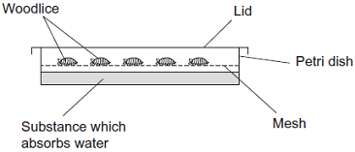

The scientists

•        placed 10 woodlice in the top half of the dish

•        replaced the lid and left the apparatus for 15 minutes in the laboratory

•        recorded the number of woodlice **not** moving during the next 30 seconds

•        repeated the experiment to obtain data for 100 woodlice

•        repeated the experiment at different humidities.

The results are shown in **Figure 2**.

**Figure 2**

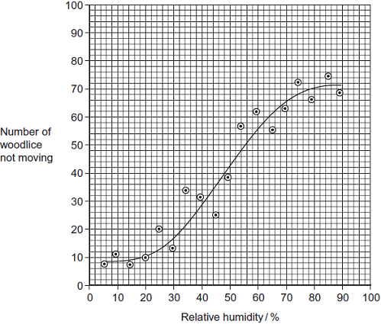

The movement of the woodlice in low relative humidity is an advantage to their survival.  
Explain how.

.................................................................................................................................

.................................................................................................................................

.................................................................................................................................

.................................................................................................................................

.................................................................................................................................

**(Total 2 marks)**

**Q2.**          Read the following passage.

Straw consists of three main organic substances – cellulose, hemicellulose and lignin.  
Cellulose molecules form chains which pack together into fibres. Hemicellulose is a small molecule formed mainly from five-carbon (pentose) sugar monomers. It acts as a cement holding cellulose fibres together. Like hemicellulose, lignin is a polymer, but it is not a carbohydrate. It covers the cellulose in the cell wall and supplies additional strength. In addition to these three substances, there are small amounts of other biologically important polymers present.

 The other main component of straw is water. Water content is variable but may be determined  
         by heating a known mass of straw at between 80 and 90°C until it reaches a constant mass.

10     The loss in mass is the water content.

Since straw is plentiful, it is possible that it could be used for the production of a range of organic substances. The first step is the conversion of cellulose to glucose. It has been suggested that an enzyme could be used for this process. There is a difficulty here, however.  
The lignin which covers the cellulose protects the cellulose from enzyme attack.

Use information from the passage and your own knowledge to answer the following questions.

(a)     (i)      Give **one** way in which the structure of a hemicellulose molecule is similar to the structure of a cellulose molecule.

.............................................................................................................

.............................................................................................................

**(1)**

(ii)     Complete the table to show **two** ways in which the structure of a hemicellulose molecule differs from the structure of a cellulose molecule.

|  |  |  |
| --- | --- | --- |
|  | **Hemicellulose** | **Cellulose** |
|  | ..........................................................  .......................................................... | ..........................................................  .......................................................... |
|  | ..........................................................  .......................................................... | ..........................................................  .......................................................... |

**(2)**

(b)     Name **one** biologically important polymer, other than those mentioned in the passage, which would be found in straw.

......................................................................................................................

**(1)**

(c)     Explain why the following steps were necessary in finding the water content of straw:

(i)      heating the straw *until it reaches constant mass* (line 9);

.............................................................................................................

.............................................................................................................

..............................................................................................

**(1)**

(ii)     not heating the straw above 90°C (line 9).

.............................................................................................................

.............................................................................................................

.............................................................................................................

.............................................................................................................

**(2)**

(d)     A covering of lignin protects cellulose from enzyme attack (line 14). Use your knowledge of the way in which enzymes work to explain why cellulose-digesting enzymes do not digest lignin.

......................................................................................................................

......................................................................................................................

......................................................................................................................

......................................................................................................................

**(2)**

(e)     Describe the structure of a cellulose molecule and explain how cellulose is adapted for its function in cells.

......................................................................................................................

......................................................................................................................

......................................................................................................................

......................................................................................................................

......................................................................................................................

......................................................................................................................

......................................................................................................................

......................................................................................................................

......................................................................................................................

......................................................................................................................

......................................................................................................................

......................................................................................................................

......................................................................................................................

......................................................................................................................

**(6)**

**(Total 15 marks)**

**M1.**Low humidity results in more woodlice moving;

So increased movement increased chance of leaving dry / unfavourable environment so reduce water loss / reduce evaporation;

**[2]**

**M2.**          (a)     (i)      both are polymers / polysaccharides / built up from many sugar units / both contain glycosidic bonds / contain (C)arbon, (H)ydrogen and (O)xygen;

**1**

(ii)     hemicellulose shorter / smaller than cellulose / fewer carbons;  
hemicellulose from pentose / five-carbon sugars and cellulose from  
hexose / glucose / six-carbon sugars;

*(only credit answers which compare like with like.)*

**2**

(b)     protein / nucleic acid / enzyme / RNA / DNA / starch / amylose / amylopectin polypeptide;

**1**

(c)     (i)      to make sure that all the water has been lost;

**1**

(ii)     only water given off below 90 °C;  
(above 90°C) other substances straw burnt / oxidised / broken down; and lost as gas / produce loss in mass;

**2**

(d)     enzymes are specific;  
shape of lignin molecules will not fit active site (of enzyme);  
*OR*shape of active site (of enzyme);  
will not fit molecule;

**2 max**

(e)     1. made from β-glucose;  
2. joined by condensation / removing molecule of water / glycosidic bond;  
3. 1 : 4 link specified or described;  
4. “flipping over” of alternate molecules;  
5. hydrogen bonds linking chains / long straight chains;  
6. cellulose makes cell walls strong / cellulose fibres are strong;  
7. can resist turgor pressure / osmotic pressure / pulling forces;  
8. bond difficult to break;  
9. resists digestion / action of microorganisms / enzymes;

*(allow maximum of 4 marks for structural features)*

**6 max**

**[15]**

**E1.**Many candidates were confused about low relative humidity environments and whether they were dry or moist. Also, many did not use the data from **Resource B** to state that more woodlice move in a low humidity environment. Several candidates linked low humidity to water on the gills and so decreased gas exchange.

**E2.**          (a)     (i)      Answers to parts of this question were not infrequently marred by lack of knowledge of the basic structure of cellulose as a polymer of β-glucose. Thus, although all that was required here was to note that both molecules were polymers, many disqualified their answers by referring to cellulose as also being a pentose.

(ii)     Limited question technique frequently restricted the credit available. Many candidates concentrated on functional rather than structural differences. As a consequence, the answer boxes were often so full that they rarely compared like with like and offered a valid comparison. Among the better, more focused, answers were some which unfortunately were a little too concise, referring to hemicellulose as a pentose and cellulose as a hexose. Questions requiring structural similarities are likely to remain a feature of BYA1. Candidates clearly need an effective strategy for answering them.

(b)     Starch and protein were correctly identified by many, but a range of incorrect responses included glycogen, phospholipid and various monosaccharides.

(c)     (i)      Answers suggested that, although candidates were clearly familiar with the term “constant mass”, they were by no means all conversant with the idea that it represented the point at which all water had been lost.

(ii)     There were many correct answers. Answers to this second part, such as “Going over 90 °C would start to boil the water so that we would be unable to calculate the water content” were frequent and suggested that candidates had failed to focus on the information provided in the second paragraph of the passage. The better candidates at whom this question was directed were generally able to point out, however, that high temperatures might lead to other substances being broken down and a consequent loss in mass.

(d)     Although most candidates were aware of the specific nature of enzyme action, they experienced varying degrees of difficulty in relating the general concepts involved to the context of this question. Those candidates who gained least credit were inclined to reword the question and offer an explanation in terms of the lignin covering. Others offered responses centred around lignin acting as an enzyme inhibitor. Better candidates clearly understood the concepts of molecular shape and fit and were able to apply them to this situation.

(e)     Answers to this part of the question ranged from those of the more able candidates who wrote clearly and logically about cellulose structure and function, often with a pleasing level of accuracy and detail, to those which did not gain credit. Among the latter were many who failed to attempt this part of the question and others who confused cellulose with other molecular components of plant cells such as starch and plasma membranes. There was much confusion between hydrogen bonds and glycosidic bonds, and between α-glucose and β-pleated sheets.

Other incorrect assertions which frequently arose were that cellulose is formed from alternating α- and β-glucose residues, and that it contains both 1-4 and 1-6 linkages. Many candidates correctly identified strength as one of the molecule’s properties and went further in discussing the importance of this in withstanding pressures resulting from osmosis. A frequent error, however, was to assign the function of energy storage to cellulose.