**Q1.**          The diagrams show four stages of mitosis.

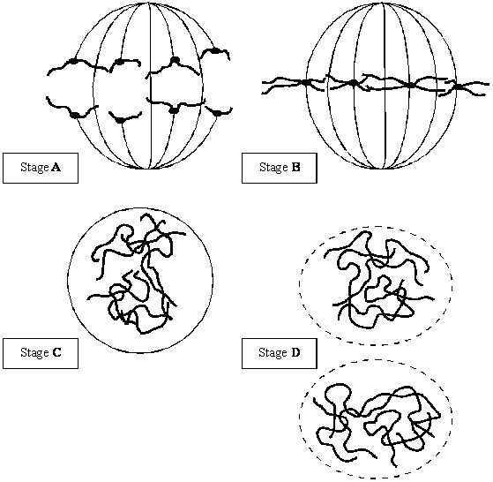

(a)     (i)      Name stage **A**.

.........................................................

**(1)**

(ii)     Starting with stage **C**, give the stages **A** to **D** in the correct order.

**C** ............   .............   .............

**(1)**

(iii)     Describe and explain the appearance of one of the chromosomes in stage **B**.

.............................................................................................................

.............................................................................................................

.............................................................................................................

.............................................................................................................

**(2)**

(b)     Colchicine is a substance that prevents the formation of the spindle in mitosis. Dividing cells were treated with colchicine. This stopped them dividing. After a few hours, the colchicine was removed and the cells began to divide again. The diagram shows the chromosomes from one of the treated cells at stage **B** after the cell began dividing again.

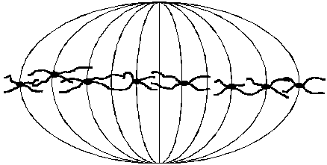

(i)      What has happened to the chromosome number?

.............................................................................................................

**(1)**

(ii)     Suggest an explanation for the change in the chromosome number.

.............................................................................................................

.............................................................................................................

**(1)**

**(Total 6 marks)**

**Q2.**          The bar chart shows the effects of smoking and alcoholic drinks on the risk of developing mouth cancer.

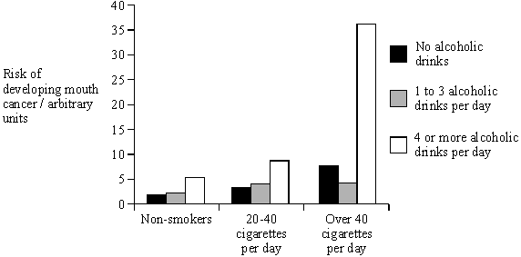

(i)      Describe the effects of smoking and drinking on the risk of developing mouth cancer.

......................................................................................................................

......................................................................................................................

......................................................................................................................

......................................................................................................................

......................................................................................................................

......................................................................................................................

**(3)**

(ii)      Suggest **one** reason why people who neither drink nor smoke sometimes develop mouth cancer.

......................................................................................................................

......................................................................................................................

**(1)**

**(Total 4 marks)**

**Q3.**          (a)     The diagram shows a chromosome at the start of mitosis.

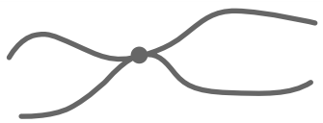

Describe and explain the appearance of the chromosome.

.......................................................................................................................

.......................................................................................................................

.......................................................................................................................

.......................................................................................................................

**(2)**

(b)     The photographs show two stages in mitosis.

Stage **A**                                                   Stage **B**

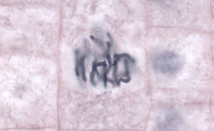 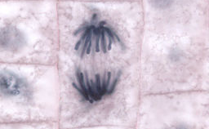

By Dr. phil.nat Thomas Geier, Fachgebiet Botanik der Forschungsanstalt Geisenheim.[CC-BY-SA-3.0], via Wikimedia Commons

Name stages **A** and **B**. Describe what is happening to the chromosomes in each stage.

(i)      Stage **A** ..........................................

.............................................................................................................

.............................................................................................................

.............................................................................................................

**(2)**

(ii)     Stage **B** ..........................................

.............................................................................................................

.............................................................................................................

.............................................................................................................

**(2)**

**(Total 6 marks)**

**Q4.**          The diagram shows two chromosomes in a cell undergoing mitosis.

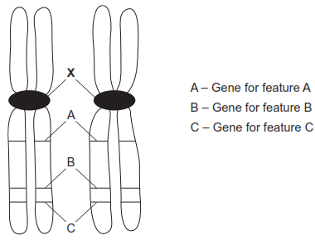

(a)     Name **X**.

......................................................................................................................

**(1)**

(b)     These are homologous chromosomes.  Give **two** pieces of evidence from the diagram that support this.

1 ...................................................................................................................

......................................................................................................................

2 ...................................................................................................................

......................................................................................................................

**(2)**

(c)     What will happen to these chromosomes in anaphase?

......................................................................................................................

......................................................................................................................

......................................................................................................................

......................................................................................................................

**(2)**

**(Total 5 marks)**

**Q5.**          (a)     The following statements describe stages of mitosis.

**A** chromosomes align at the centre of the cell attached to spindle fibres  
**B** chromatids are in groups at the poles  
**C** chromosomes become visible  
**D** chromatids move towards the poles

Complete the table by entering the appropriate letter.

|  |  |
| --- | --- |
| **Stage of mitosis** | **Letter of description of the stage** |
| Prophase |  |
| Metaphase |  |
| Anaphase |  |
| Telophase |  |

**(3)**

(b)     The graph shows changes in the mass of DNA in a cell during one cell cycle.  
Five stages have been identified on the graph.

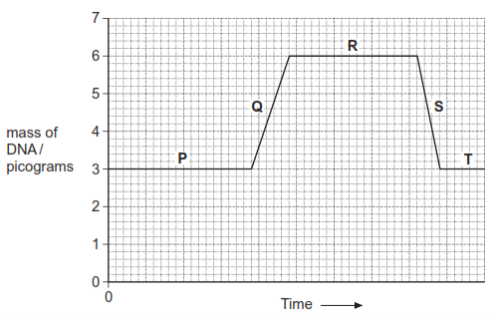

(i)      Which letter represents the stage when DNA is replicating?        

**(1)**

(ii)     Explain the change in the DNA content during stage **S**.

.............................................................................................................

.............................................................................................................

**(1)**

**(Total 5 marks)**

**Q6.**          An egg cell from a cow was fertilised in a laboratory and allowed to develop into an eight-celled embryo. This was split into four parts, each of which developed into a new embryo. This is shown in the diagram. The new embryos were later transferred into different surrogate cows.

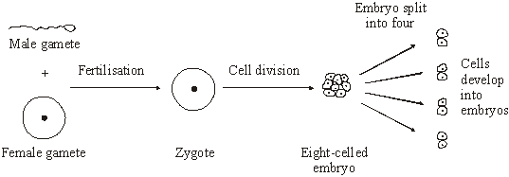

(a)     Explain why the new embryos produced are a clone.

......................................................................................................................

......................................................................................................................

......................................................................................................................

......................................................................................................................

**(2)**

(b)     If embryos with more than eight cells are split up, the separated cells fail to develop into new embryos. Suggest why.

......................................................................................................................

......................................................................................................................

**(1)**

(c)     Give **two** advantages to a farmer of using embryos produced by this procedure.

Advantage 1 .................................................................................................

......................................................................................................................

Advantage 2 …..............................................................................................

.......................................................................................................................

**(2)**

**(Total 5 marks)**

**Q7.**          The death rate from malignant skin tumours was investigated in the USA. The graph shows the results for fair-skinned men in different age groups.

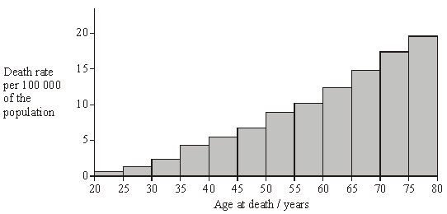

(a)     Describe what is meant by a *malignant tumour*.

......................................................................................................................

......................................................................................................................

......................................................................................................................

......................................................................................................................

......................................................................................................................

......................................................................................................................

**(3)**

(b)     Give **one** reason for the change in death rate from malignant skin tumours with increasing age.

......................................................................................................................

......................................................................................................................

**(1)**

(c)     The data for fair-skinned and dark-skinned people were collected separately.  
Explain why skin colour was a factor likely to affect the death rate.

......................................................................................................................

......................................................................................................................

......................................................................................................................

......................................................................................................................

**(2)**

**(Total 6 marks)**

**Q8.**          The diagram represents a cell from a fruit fly in which the diploid number is eight.

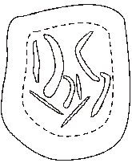

(a)     Draw a diagram to show

(i)      this cell during anaphase of mitosis;

**(2)**

(ii)     the chromosomes in a gamete produced from this cell by meiosis.

**(2)**

(b)     Explain why meiosis is important in sexual reproduction, apart from producing gametes that are genetically different.

......................................................................................................................

......................................................................................................................

......................................................................................................................

......................................................................................................................

**(2)**

**(Total 6 marks)**

**Q9.**          Research scientists can increase the nutritional value of potatoes by genetically engineering potato plants. A gene which results in increased protein production has been removed from cells of an amaranth plant and inserted into cells of a potato plant.

(a)     Describe how a gene could be removed from cells of an amaranth plant and inserted into cells of a potato plant.

......................................................................................................................

......................................................................................................................

......................................................................................................................

......................................................................................................................

......................................................................................................................

......................................................................................................................

......................................................................................................................

......................................................................................................................

......................................................................................................................

......................................................................................................................

......................................................................................................................

......................................................................................................................

**(6)**

(b)     Whole potato plants can be produced from genetically identical potato cells grown in a tissue culture. Use your knowledge of genes to suggest how different cells, such as leaf and root cells, can develop from genetically identical cells.

......................................................................................................................

......................................................................................................................

......................................................................................................................

......................................................................................................................

......................................................................................................................

......................................................................................................................

**(2)**

**(Total 8 marks)**

**Q10.**          (a)     The photographs show two stages in mitosis of a plant cell.

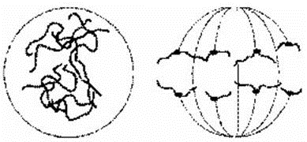

**A**                                                         **B**

Name stages **A** and **B**. In each case describe what is happening to the chromosomes.

(i)      Stage **A** ....................................

.............................................................................................................

.............................................................................................................

.............................................................................................................

**(2)**

(ii)     Stage **B** ....................................

.............................................................................................................

.............................................................................................................

.............................................................................................................

**(2)**

(b)     Describe **two** events during interphase which prepare a cell for mitosis.

1 ...................................................................................................................

......................................................................................................................

2 ...................................................................................................................

......................................................................................................................

**(2)**

**(Total 6 marks)**

**Q11.**          A clone of frogs was produced by nuclear transfer. This procedure is summarised in the diagram.

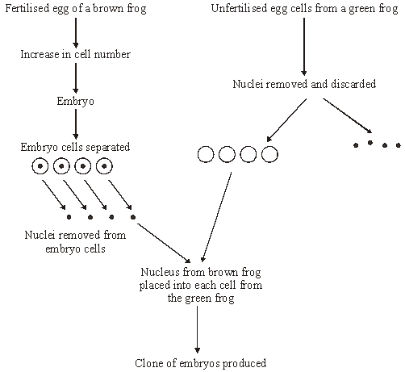

(a)     What is a clone?

......................................................................................................................

......................................................................................................................

**(1)**

(b)     Name the type of cell division occurring in a developing embryo.

......................................................................................................................

**(1)**

(c)     The embryo cells used are from an early stage of development. Explain why.

......................................................................................................................

......................................................................................................................

**(1)**

(d)     What would be the colour of the cloned offspring? Explain your answer.

.......................................................................................................................

......................................................................................................................

**(1)**

(e)     Give **two** differences between the nuclei removed from the embryo cells and the nuclei discarded from the unfertilised egg cells.

1 ...................................................................................................................

2 ...................................................................................................................

**(2)**

(f)      Only 30% of the cloned cells successfully developed into embryos.  
Suggest a reason for this low success rate.

......................................................................................................................

......................................................................................................................

**(1)**

**(Total 7 marks)**

**Q12.**          It is difficult to get rid of dandelions from a garden because small pieces of the root are able to grow into new plants if left behind in the soil. This is shown in the drawing.

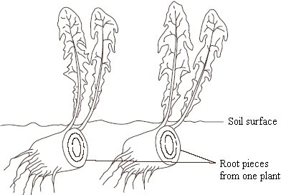

(a)     Explain why the plants produced form a clone.

......................................................................................................................

......................................................................................................................

......................................................................................................................

......................................................................................................................

**(2)**

(b)     Suggest **one** reason why the plants in a clone may not be identical in appearance.

......................................................................................................................

......................................................................................................................

**(1)**

(c)     Most plants produce seeds after fertilisation in sexual reproduction. However, dandelions produce small, windblown seeds without fertilisation taking place. Suggest **two** advantages to the dandelion of being able to reproduce from these seeds, as well as from pieces of root.

Advantage 1 .................................................................................................

......................................................................................................................

Advantage 2 …..............................................................................................

......................................................................................................................

**(2)**

**(Total 5 marks)**

**Q13.**          (a)     The drawing shows a stage of mitosis in an animal cell.

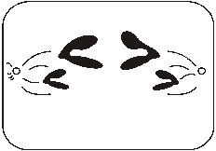

(i)      Name this stage of mitosis.

.............................................................................................................

**(1)**

(ii)     Describe and explain what happens during this stage which ensures that two genetically identical cells are produced.

.............................................................................................................

.............................................................................................................

.............................................................................................................

.............................................................................................................

**(2)**

(b)     The graph shows the relative amounts of DNA per cell during two successive cell divisions in an animal.

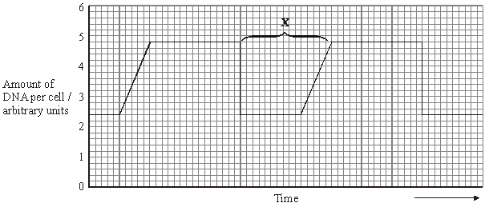

(i)      What stage of the cell cycle is shown by **X**?

.............................................................................................................

.............................................................................................................

**(1)**

(ii)     Apart from an increase in the amount of DNA, give **one** process which occurs during stage **X** which enables nuclear division to occur.

.............................................................................................................

.............................................................................................................

**(1)**

(iii)     How many units of DNA would you expect to be present in a gamete formed in this animal as a result of meiosis?

.............................................................................................................

**(1)**

(c)     The table shows the average duration of each stage of the cell cycle in the cells of a mammalian embryo.

|  |  |
| --- | --- |
| **Stage** | **Mean duration/ minutes** |
| Interphase | 12 |
| Prophase | 50 |
| Metaphase | 15 |
| Anaphase | 10 |
| Telophase | 42 |

Give **one** piece of evidence from the table which indicates that these cells are multiplying rapidly.

......................................................................................................................

......................................................................................................................

**(1)**

**(Total 7 marks)**

**Q14.**          (a)     Describe and explain how the structure of DNA results in accurate replication.

......................................................................................................................

......................................................................................................................

......................................................................................................................

......................................................................................................................

......................................................................................................................

......................................................................................................................

......................................................................................................................

......................................................................................................................

**(4)**

(b)     Describe the behaviour of chromosomes during mitosis and explain how this results in the production of two genetically identical cells.

......................................................................................................................

......................................................................................................................

......................................................................................................................

......................................................................................................................

......................................................................................................................

......................................................................................................................

......................................................................................................................

......................................................................................................................

......................................................................................................................

......................................................................................................................

......................................................................................................................

......................................................................................................................

......................................................................................................................

......................................................................................................................

......................................................................................................................

**(7)**

(c)     A cancerous tumour is formed by uncontrolled mitotic division. This results in a mass of cells with an inadequate blood supply. Drugs are being developed which only kill cells in a low oxygen environment. Suggest how these drugs could be useful in the treatment of cancer.

......................................................................................................................

......................................................................................................................

......................................................................................................................

......................................................................................................................

**(2)**

**(Total 13 marks)**

............................     ..............     ..............     ..............     ..............

(c)     Bone marrow cells divide rapidly. As a result of a mutation during DNA replication, a bone marrow cell may become a cancer cell and start to divide in an uncontrolled way. A chemotherapy drug that kills cells when they are dividing was given to a cancer patient. It was given once every three weeks, starting at time 0. The graph shows the changes in the number of healthy bone marrow cells and cancer cells during twelve weeks of treatment.

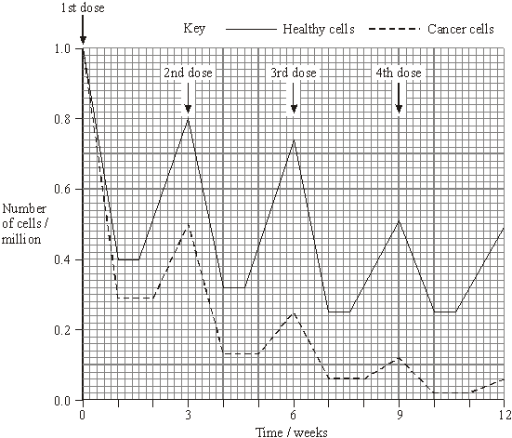

(i)      Using the graph calculate the number of cancer cells present at week 12 as a percentage of the original number of cancer cells. Show your working.

Answer ......................................%

**(2)**

(ii)     Suggest **one** reason for the lower number of cancer cells compared to healthy cells at the end of the first week.

.............................................................................................................

**(1)**

(iii)     Describe **two** differences in the effect of the drug on the cancer cells, compared with healthy cells in the following weeks.

1 ..........................................................................................................

.............................................................................................................

2 ..........................................................................................................

.............................................................................................................

**(2)**

**(Total 8 marks)**

**Q16.**A student investigated mitosis in the tissue from an onion root tip.

(a)     The student prepared a temporary mount of the onion tissue on a glass slide. She covered the tissue with a cover slip. She was then given the following instruction.

“Push down hard on the cover slip, but do not push the cover slip sideways.”

Explain why she was given this instruction.

........................................................................................................................

........................................................................................................................

........................................................................................................................

........................................................................................................................

**(2)**

The image below shows one cell the student saw in the onion tissue.

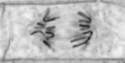

© Ed Reschke/Oxford Scientific/Getty Images

(b)     The student concluded that the cell in the image above was in the anaphase stage of mitosis.  
Was she correct? Give **two** reasons for your answer.

1 .....................................................................................................................

........................................................................................................................

2 .....................................................................................................................

........................................................................................................................

**(2)**

(c)     The student counted the number of cells she observed in each stage of mitosis.  
Of the 200 cells she counted, only six were in anaphase.

One cell cycle of onion root tissue takes 16 hours. Calculate how many minutes these cells spend in anaphase.

Show your working.

Answer = ................................... minutes

**(2)**

**(Total 6 marks)**

**Q17.**          (a)     Complete the table to describe some of the events during the cell cycle.

|  |  |  |
| --- | --- | --- |
|  | **Stage of cell cycle** | **Main event which takes place** |
|  | Metaphase |  |
|  |  | Chromosomes coil and shorten |
|  |  | Daughter chromosomes move to poles of the cell |
|  | S-phase |  |
|  |  | Nuclear envelope re-forms |

**(5)**

(b)     The diagram shows the life cycle of an organism. The numbers show how many chromosomes are present in one cell at each stage of the life cycle.

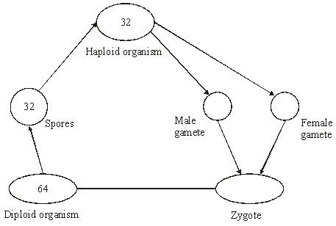

(i)      Name the type of cell division that must be involved in producing the spores.

.............................................................................................................

**(1)**

(ii)     How many chromosomes are there in a male gamete from this organism?

.............................................................................................................

**(1)**

**(Total 7 marks)**

**Q18.**          (a)     Some tumours are benign and some are malignant.

(i)      Give **one** way in which a benign tumour differs from a malignant tumour.

.............................................................................................................

**(1)**

(ii)     Describe **two** ways in which both types of tumour may cause harm to the body.

1 ..........................................................................................................

.............................................................................................................

2 ..........................................................................................................

.............................................................................................................

**(2)**

(b)     (i)      Explain the link between sunbathing and skin cancer.

.............................................................................................................

.............................................................................................................

.............................................................................................................

.............................................................................................................

**(2)**

(ii)     Suggest why fair-skinned people are at a greater risk of skin cancer than dark-skinned people when sunbathing.

.............................................................................................................

.............................................................................................................

**(1)**

(iii)     Suggest why people with a family history of cancer are at a greater risk of cancer than those with no family history of cancer.

.............................................................................................................

.............................................................................................................

**(1)**

**(Total 7 marks)**

**Q19.**          (a)     Give **one** process which occurs in the nucleus of a cell during interphase which is necessary before cell division can take place.

......................................................................................................................

**(1)**

(b)     The diagram shows the chromosomes from a cell with a diploid chromosome number of six.

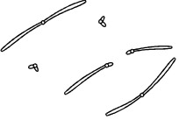

Draw a diagram to show the chromosomes from one of the resulting cells if

(i)      the cell divides by **mitosis**;

**(2)**

(ii)     the cell divides by **meiosis**.

**(2)**(c)     Explain **one** advantage of cells lining the human gut dividing very frequently.

......................................................................................................................

......................................................................................................................

**(1)**

**(Total 6 marks)**

**Q20.**          Division of the nucleus by meiosis produces haploid cells from a diploid cell. Nuclei produced by mitosis have the same number of chromosomes as the parent nucleus.

(a)     What is the biological importance of reducing the chromosome number when the cell divides by meiosis?

......................................................................................................................

......................................................................................................................

......................................................................................................................

......................................................................................................................

**(2)**

(b)     The table gives one difference between meiosis and mitosis. Complete the table by giving **three** further differences.

|  |  |  |  |
| --- | --- | --- | --- |
|  |  | **Meiosis** | **Mitosis** |
|  | 1 | Reduces the chromosome number | Maintains the same chromosome number as in the parent nucleus |
|  | 2 |  |  |
|  | 3 |  |  |
|  | 4 |  |  |

**(3)**

**(Total 5 marks)**

**Q21.**          The photograph shows cells from an onion root tip. The root tip has been squashed and stained to show the stages of mitosis.

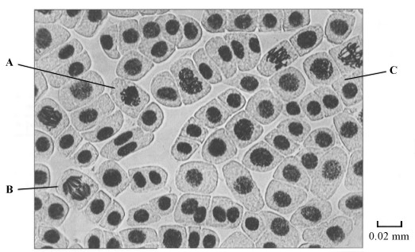

(a)     (i)      At what stage of mitosis is cell **A**?

.............................................................................................................

**(1)**

(ii)     What is the evidence that cell **B** is in anaphase?

.............................................................................................................

.............................................................................................................

**(1)**

(iii)     Cell **C** is in interphase. Give **two** processes which occur during interphase that enable cell division to occur.

1 ..........................................................................................................

.............................................................................................................

2 ..........................................................................................................

.............................................................................................................

**(2)**

(b)     Explain how you would calculate the magnification of the photograph.

......................................................................................................................

......................................................................................................................

**(1)**

(c)     The number of cells at each stage of mitosis was counted. The results are shown in the table.

|  |  |
| --- | --- |
| **Stage of mitosis** | **Number of cells** |
| Interphase | 123 |
| Prophase | 32 |
| Metaphase | 12 |
| Anaphase | 6 |
| Telophase | 27 |

One complete cell cycle takes 24 hours. The number of cells at each stage is proportional to the time spent at that stage. Calculate the length of time spent in metaphase. Show your working.

Answer ........................................................... hours

**(2)**

**(Total 7 marks)**

**Q22.**          The table shows some differences between three varieties of banana plant.

|  |  |  |  |  |
| --- | --- | --- | --- | --- |
|  |  | Variety **A** | Variety **B** | Variety **C** |
|  | Number of chromosomes in a leaf cell | 22 | 33 | 44 |
|  | Growth rate of fruit / cm3 week–1 | 2.9 | 6.9 | 7.2 |
|  | Breaking strength of leaf / arbitrary units | 10.8 | 9.4 | 7.8 |

(a)     (i)      How many chromosomes are there in a male gamete from variety **C**?



**(1)**

(ii)     Variety **B** cannot produce fertile gametes. Use information in the table to explain why.

.............................................................................................................

.............................................................................................................

.............................................................................................................

.............................................................................................................

.............................................................................................................

**(2)**

          In some countries very strong winds may occur. Banana growers in these countries choose to grow variety **B**.

(b)     (i)      Use the data in the table to explain why banana growers in these countries choose to grow variety **B** rather than variety **A**.

.............................................................................................................

.............................................................................................................

.............................................................................................................

**(1)**

(ii)     Use the data in the table to explain why banana growers in these countries choose to grow variety **B** rather than variety **C**.

.............................................................................................................

.............................................................................................................

.............................................................................................................

**(1)**

(c)     Banana growers can only grow new variety **B** plants from suckers. Suckers grow from cells at the base of the stem of the parent plant.

Use your knowledge of cell division to explain how growing variety **B** on a large scale will affect the genetic diversity of bananas.

......................................................................................................................

......................................................................................................................

......................................................................................................................

......................................................................................................................

......................................................................................................................

**(2)**

**(Total 7 marks)**

**Q23.**          A student investigated the stages of mitosis in a garlic root. The root tip was placed on a microscope slide with a stain. A cover slip was placed on top and the root tip was firmly squashed.

(a)     Explain why

(i)      a root tip was used;

.............................................................................................................

.............................................................................................................

**(1)**

(ii)     a stain was used;

.............................................................................................................

.............................................................................................................

**(1)**

(iii)     the root tip was firmly squashed.

.............................................................................................................

.............................................................................................................

**(1)**

(b)     The student examined the cells in the garlic root tip under the microscope, and obtained the following data.

|  |  |  |
| --- | --- | --- |
|  | **Stage** | **Number of cells** |
|  | Interphase | 872 |
|  | Prophase | 74 |
|  | Metaphase | 18 |
|  | Anaphase | 10 |
|  | Telophase | 8 |

(i)      Calculate the percentage of these cells in which the chromosomes are visible and would consist of a pair of chromatids joined together. Show your working.

Answer .........................................

**(2)**

(ii)     A different set of results was obtained when the count was repeated on another occasion with a different garlic root tip. Give **two** reasons for the difference in results.

1 ..........................................................................................................

.............................................................................................................

2 ..........................................................................................................

.............................................................................................................

**(2)**

**(Total 7 marks)**

**Q24.**          Read the following passage.

The idea that bacteria could be used as a cancer treatment originated over 100 years  
ago. A doctor noticed that some cancer patients with bacterial infections showed signs of recovery from the cancer. Attempts to use the bacteria as a treatment were  
disappointing, however. Experiments showed that the bacteria made an impressive

5        onslaught on tumours, but a ring of cancerous tissue around the edge usually  
survived.

Bacteria are once again being used in the war on cancer. Scientists have genetically  
engineered a harmless strain of *Clostridium* to carry the gene for an enzyme. This  
enzyme converts a harmless “prodrug” into an active drug which acts as a powerful

10      toxin. In people, this strain of *Clostridium* will only grow in tumours. Scientists hope  
that when they inject the prodrug into a cancer patient’s blood, the bacteria will  
convert it into an active drug. This will destroy tumours from the inside, leaving  
healthy tissues unharmed.

The idea of converting a harmless prodrug into an active drug that only kills cancer

15      cells is not new. Apart from the use of genetically modified *Clostridium*, other  
methods have been tried. One of these involved attaching an enzyme to an antibody  
that binds only to cancer cells. This enzyme then activates the drug. Unfortunately,  
different types of cancer require different antibodies, making the treatment expensive  
to develop. Scientists hope their bacterial approach will offer a way of delivering the

20      enzymes to any cancer cell.

(a)     Describe how scientists could genetically engineer *Clostridium* bacteria to produce the enzyme which activates the prodrug. (lines 7-8)

......................................................................................................................

......................................................................................................................

......................................................................................................................

......................................................................................................................

......................................................................................................................

......................................................................................................................

......................................................................................................................

......................................................................................................................

......................................................................................................................

......................................................................................................................

......................................................................................................................

......................................................................................................................

**(6)**

(b)     Explain why it is important to destroy all the cancer cells in a tumour.

......................................................................................................................

......................................................................................................................

......................................................................................................................

......................................................................................................................

**(2)**

(c)     Explain how the use of antibodies (lines 16-17) results in a drug only killing cancer cells.

......................................................................................................................

......................................................................................................................

......................................................................................................................

......................................................................................................................

......................................................................................................................

......................................................................................................................

**(3)**

(d)     Cancer drugs usually interfere with DNA replication. Use this information to explain why the cancer drugs are administered as prodrugs and not the active form.

......................................................................................................................

......................................................................................................................

......................................................................................................................

......................................................................................................................

......................................................................................................................

......................................................................................................................

......................................................................................................................

......................................................................................................................

**(4)**

**(Total 15 marks)**

**Q25.**          (a)     In which phase of the cell cycle does DNA replication take place?

......................................................................................................................

**(1)**

(b)     The diagrams show five stages of mitosis.

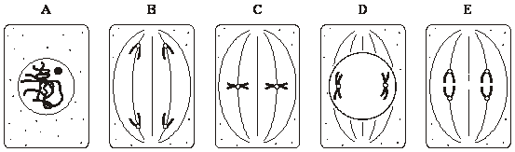

List the stages **A** to **E** in the correct sequence, beginning with the earliest stage.

.....................        .....................        .....................       .....................       .....................

**(1)**

(c)     Describe the role of the spindle during mitosis.

......................................................................................................................

......................................................................................................................

......................................................................................................................

......................................................................................................................

**(2)**

(d)     Meiosis also occurs during the life cycle of organisms. What is the importance of meiosis?

......................................................................................................................

......................................................................................................................

......................................................................................................................

......................................................................................................................

**(2)**

**(Total 6 marks)**

**Q26.**          (a)     Nucleus **A** and nucleus **B** come from the same organism. The diagram shows these nuclei immediately before division and the nuclei formed immediately after their division. The table gives information about some of the nuclei shown in the diagram.

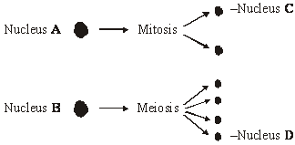

|  |  |  |
| --- | --- | --- |
| **Nucleus** | **Number of chromosomes** | **Mass of DNA / arbitrary units** |
| **A** | 8 | 600 |
| **B** | 8 | 600 |
| **C** |  |  |
| **D** |  |  |

          Complete the table for nuclei **C** and **D**.

**(2)**

(b)     A student investigated the process of meiosis by observing cells on a microscope slide. The cells on the slide had been stained.

(i)      Name an organ from which the cells may have been obtained.

.............................................................................................................

**(1)**

(ii)     Explain why a stain was used.

.............................................................................................................

.............................................................................................................

**(1)**

**(Total 4 marks)**

**Q27.**Scientists investigated the effect of bromelain on cancer cells. They took cells from skin cancers in mice and added them to a liquid growth medium in two dishes.

Four hours later they added a solution of bromelain to one of the dishes. They left the other dish as a control. They also added a substance to both dishes that is turned purple by respiring cells.

Both dishes were placed in an incubator. The scientists measured the intensity of the purple colour at intervals over a period of 100 hours.

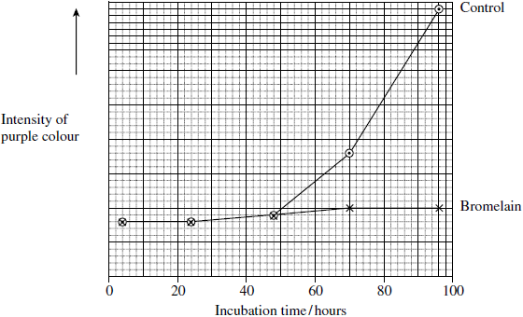

(a)     The scientists put the same number of skin tumour cells in each dish at the start of this investigation. Explain why it was important to put the same number of cells in each dish.

........................................................................................................................

........................................................................................................................

**(1)**

(b)     The scientists concluded that bromelain did not kill cancer cells but stopped them dividing. Does the graph support this conclusion? Explain your answer.

........................................................................................................................

........................................................................................................................

........................................................................................................................

........................................................................................................................

**(2)**

(c)     An article in a newspaper claimed that these data show that bromelain can be used to treat cancer.

Give **three** reasons why we should be careful about accepting this claim.

1 .....................................................................................................................

........................................................................................................................

2 .....................................................................................................................

........................................................................................................................

3 .....................................................................................................................

........................................................................................................................

**(3)**

(d)     The rate of cell division is important in investigations into cancer. Suggest why.

........................................................................................................................

........................................................................................................................

........................................................................................................................

........................................................................................................................

**(2)**

(e)     Scientists have investigated the effects of bromelain on cancer growth in humans. Suggest why they gave bromelain in addition to, rather than instead of, the usual treatment.

........................................................................................................................

........................................................................................................................

........................................................................................................................

........................................................................................................................

**(2)**

**(Total 10 marks)**

**Q28.**          The diagram shows a cell cycle.

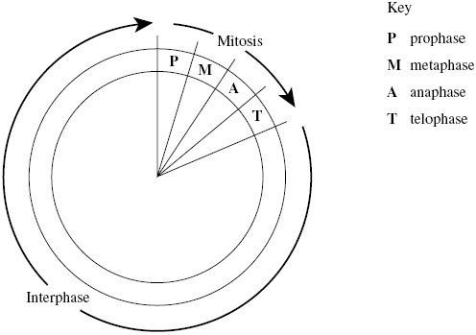

(a)     The table shows the number of chromosomes and the mass of DNA in different nuclei.

All the nuclei come from the same animal. Complete this table.

|  |  |  |
| --- | --- | --- |
| **Nucleus** | **Number of chromosomes** | **Mass of DNA / arbitrary units** |
| At prophase of mitosis | 26 | 60 |
| At telophase of mitosis |  |  |
| From a sperm cell |  |  |

**(4)**

(b)     If the DNA of the cell is damaged, a protein called p53 stops the cell cycle.

Mutation in the gene for p53 could cause cancer to develop. Explain how.

......................................................................................................................

......................................................................................................................

......................................................................................................................

......................................................................................................................

......................................................................................................................

......................................................................................................................

**(3)**

(c)     Drugs are used to treat cancer. At what phase in the cell cycle would each of the following drugs act?

(i)      A drug that prevents DNA replication

.............................................................................................................

**(1)**

(ii)     A drug that prevents spindle fibres shortening

.............................................................................................................

**(1)**

**(Total 9 marks)**

**Q29.**          Taxol is a drug used to treat cancer. Research scientists investigated the effect of injecting taxol on the growth of tumours in mice. Some of the results are shown in **Figure 1**.

**Figure 1**

|  |  |  |
| --- | --- | --- |
| **Number of days of treatment** | **Mean volume of tumour / mm3** | |
| **Control group** | **Group injected with taxol in saline** |
| 1 | 1 | 1 |
| 10 | 7 | 2 |
| 20 | 21 | 11 |
| 30 | 43 | 20 |
| 40 | 114 | 48 |
| 50 | 372 | 87 |

(a)     Suggest how the scientists should have treated the control group.

......................................................................................................................

......................................................................................................................

......................................................................................................................

......................................................................................................................

**(2)**

(b)     Suggest and explain **two** factors which should be considered when deciding the number of mice to be used in this investigation.

1 ...................................................................................................................

......................................................................................................................

2 ...................................................................................................................

......................................................................................................................

**(2)**

(c)     The scientists measured the volume of the tumours. Explain the advantage of using volume rather than length to measure the growth of tumours.

......................................................................................................................

......................................................................................................................

**(1)**

(d)     The scientists concluded that taxol was effective in reducing the growth rate of the tumours over the 50 days of treatment. Use suitable calculations to support this conclusion.

**(2)**

(e)     In cells, taxol disrupts spindle activity. Use this information to explain the results in the group that has been treated with taxol.

......................................................................................................................

......................................................................................................................

......................................................................................................................

......................................................................................................................

......................................................................................................................

......................................................................................................................

**(3)**

(f)      The research scientists then investigated the effect of a drug called OGF on the growth of tumours in mice. OGF and taxol were injected into different mice as separate treatments or as a combined treatment. **Figure 2** and **Figure 3** show the results from this second investigation.

**Figure 2**

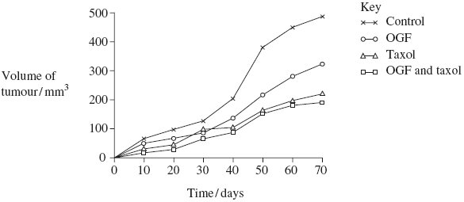

**Figure 3**

|  |  |
| --- | --- |
| **Treatment** | **Mean volume of tumour following 70 days treatment /mm3 (± standard deviation)** |
| OGF | 322 (± 28.3) |
| Taxol | 207 (± 22.5) |
| OGF and taxol | 190 (± 25.7) |
| Control | 488 (± 32.4) |

(i)      What information does standard deviation give about the volume of the tumours in this investigation?

.............................................................................................................

.............................................................................................................

**(1)**

(ii)     Use **Figure 2** and **Figure 3** to evaluate the effectiveness of the two drugs when they are used separately and as a combined treatment.

.............................................................................................................

.............................................................................................................

.............................................................................................................

.............................................................................................................

.............................................................................................................

.............................................................................................................

.............................................................................................................

.............................................................................................................

**(4)**

**(Total 15 marks)**

**Q30.**          Plant physiologists attempted to produce papaya plants using tissue culture. They investigated the effects of different concentrations of two plant growth factors on small pieces of the stem tip from a papaya plant. Their results are shown in the table.

|  |  |  |  |  |
| --- | --- | --- | --- | --- |
|  | **Concentration of auxin / μmol dm–3** | **Concentration of cytokinin / μmol dm–3** | | |
|  | 5 | 25 | 50 |
|  | 0 | No effect | No effect | Leaves produced |
|  | 1 | No effect | Leaves produced | Leaves produced |
|  | 5 | No effect | Leaves produced | Leaves and some plantlets produced |
|  | 10 | Callus produced | Leaves and some plantlets produced | Plantlets produced |
|  | 15 | Callus produced | Callus and some leaves produced | Callus and some leaves produced |

Callus is a mass of undifferentiated plant cells. Plantlets are small plants.

(a)     Explain the evidence from the table that cells from the stem tip are totipotent.

......................................................................................................................

......................................................................................................................

......................................................................................................................

......................................................................................................................

......................................................................................................................

**(2)**

(b)     Calculate the ratio of cytokinin : auxin that you would recommend to grow papaya plants by this method.

Answer .........................................................

**(2)**

(c)     (i)      Papaya plants reproduce sexually by means of seeds. Papaya plants grown from seeds are very variable in their yield. Explain why.

.............................................................................................................

.............................................................................................................

.............................................................................................................

.............................................................................................................

.............................................................................................................

**(2)**

(ii)     Explain the advantage of growing papaya plants from tissue culture rather than from seeds.

.............................................................................................................

.............................................................................................................

.............................................................................................................

**(1)**

**(Total 7 marks)**

**Q31.**          Yeast is a single-celled eukaryotic organism. When yeast cells are grown, each cell forms a bud. This bud grows into a new cell. This allows yeast to multiply because the parent cell is still alive and the new cell has been formed.

Scientists grew yeast cells in a culture. They counted the number of cells present and measured the total concentration of DNA in the culture over a period of 6 hours. Their results are shown in the graph.

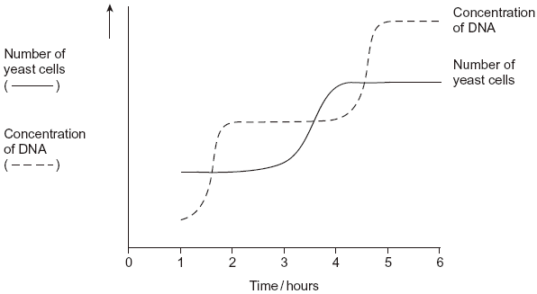

(a)     Use your knowledge of the cell cycle to explain the shape of the curve for the number of yeast cells

(i)      between 1 and 2 hours

.............................................................................................................

.............................................................................................................

**(1)**

(ii)     between 3 and 4 hours.

.............................................................................................................

.............................................................................................................

**(1)**

(b)     Use the curve for the concentration of DNA to find the length of a cell cycle in these yeast cells. Explain how you arrived at your answer.

Length of cell cycle ......................................................................................

Explanation ..................................................................................................

......................................................................................................................

......................................................................................................................

......................................................................................................................

**(3)**

**(Total 5 marks)**

**Q32.**In many parts of the world, crops have to be watered to grow enough food but fresh water is often in short supply.

Barley is a plant that grows a leafy shoot and then produces seed that is harvested for food.

Scientists investigated whether barley could be grown successfully using fresh water mixed with seawater. This would reduce the use of fresh water. However, seawater contains dissolved sodium chloride (salt).

The scientists grew barley in plots of equal size in the same large field. Each plot received one of four treatments.

**A**       No watering.

**B**       Watering with fresh water during growth and seed production.

**C**       Watering with a 1:1 mix of fresh water and seawater during growth and seed           production.

**D**       Watering with fresh water during growth and with a 1:1 mix of fresh water and seawater during seed production.

At the end of the investigation, the scientists measured the concentration of salt in the soil in each plot and the yield of barley seed harvested from each plot.

The scientists’ results are shown in the table below.

|  |  |  |  |
| --- | --- | --- | --- |
|  | **Watering treatment** | **Mean concentration of salt in soil / arbitrary units** | **Mean yield of barley seed / g** |
|  | **A** | 10.1 | 346 |
|  | **B** | 9.7 | 804 |
|  | **C** | 13.5 | 538 |
|  | **D** | 11.6 | 695 |

(a)     Watering treatment was the independent variable in this investigation.  
Explain what is meant by the **independent** variable.

........................................................................................................................

........................................................................................................................

........................................................................................................................

**(1)**

(b)     The same variety of barley was used in all the plots. Why was this important?

........................................................................................................................

........................................................................................................................

........................................................................................................................

........................................................................................................................

........................................................................................................................

**(2)**

(c)     When barley plants are growing, the number of cells increases.  
Name the process that increases the number of cells.

........................................................................................................................

**(1)**

(d)     What do the data in the table above show about the effect of watering barley with a mixture of fresh water and seawater?

........................................................................................................................

........................................................................................................................

........................................................................................................................

........................................................................................................................

........................................................................................................................

**(2)**

(e)     The scientists suggested that watering barley with diluted seawater might not be sustainable if repeated every year.  
Do these data support this suggestion?

........................................................................................................................

........................................................................................................................

........................................................................................................................

........................................................................................................................

........................................................................................................................

........................................................................................................................

(Extra space) .................................................................................................

........................................................................................................................

........................................................................................................................

**(3)**

**(Total 9 marks)**

**Q33.**(a)     The diagram shows a stage of mitosis in an animal cell.

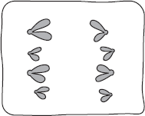

(i)      Name this stage.

...............................................................................................................

**(1)**

(ii)     Describe what happens during this stage that results in the production of two genetically identical cells.

...............................................................................................................

...............................................................................................................

...............................................................................................................

...............................................................................................................

...............................................................................................................

**(2)**

(b)     A sample of epithelial tissue from the small intestine of an animal was analysed.  
Some of the cells had 8.4 units of DNA, others had only 4.2 units.

(i)      Use your knowledge of the cell cycle to explain why some cells had 8.4 units of DNA and others had only 4.2 units.

...............................................................................................................

...............................................................................................................

...............................................................................................................

...............................................................................................................

...............................................................................................................

**(2)**

(ii)     How many units of DNA would you expect to be present in a gamete formed in this animal as a result of meiosis?



**(1)**

**(Total 6 marks)**

**Q34.**          The diagram shows a cell cycle.

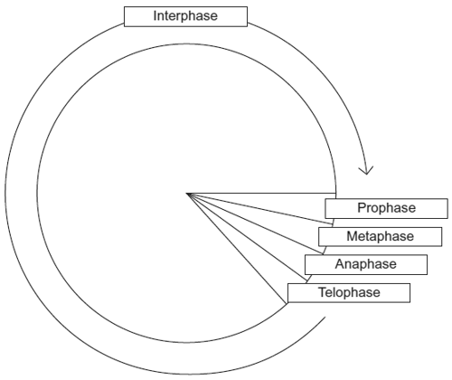

(a)     In prophase of mitosis, the chromosomes become visible. Describe what happens in

(i)metaphase

.............................................................................................................

.............................................................................................................

.............................................................................................................

.............................................................................................................

.............................................................................................................

**(2)**

(ii)anaphase.

.............................................................................................................

.............................................................................................................

.............................................................................................................

.............................................................................................................

.............................................................................................................

**(2)**

(b)     (i)      Cells lining the human intestine complete the cell cycle in a short time. Explain the advantage of these cells completing the cell cycle in a short time.

.............................................................................................................

.............................................................................................................

.............................................................................................................

**(1)**

(ii)     The time required for a cell to complete the cell cycle was 4 hours 18 minutes.

Calculate the time required in minutes for this cell to multiply to produce eight cells.  
Show your working.

Answer .....................................................

**(2)**

(c)Mikanolide is a drug that inhibits the enzyme DNA polymerase. Explain why this drug may be effective against some types of cancer.

......................................................................................................................

......................................................................................................................

......................................................................................................................

......................................................................................................................

......................................................................................................................

**(2)**

**(Total 9 marks)**

**Q35.**          (a)     Mitosis is important in the life of an organism. Give **two** reasons why.

........................................................................................................................

........................................................................................................................

........................................................................................................................

........................................................................................................................

........................................................................................................................

**(2)**

A biologist used a microscope to investigate plant tissue where some of the cells were dividing by mitosis. She examined 200 cells and counted the number of cells in interphase and in each stage of mitosis.

The table shows some of the cells she saw, and the percentage of cells in interphase and in two stages of mitosis, **A** and **B**.

|  |  |  |
| --- | --- | --- |
| **Stage of cell cycle** | | **Percentage of cells** |
| Interphase |  | 90 |
| Stage **A** |  | 3 |
| Stage **B** |  | 1 |

                                                                    Images by Edmund Beecher Wilson [Public domain], via Wikimedia Commons

(b)     (i)      Explain why the biologist chose to examine 200 cells.

...............................................................................................................

...............................................................................................................

...............................................................................................................

**(1)**

(ii)     Name Stage **A** and Stage **B**. Give the evidence from the photograph that you used to identify the stage.

Name of Stage **A** ...................................................................................

Evidence ...............................................................................................

...............................................................................................................

Name of Stage **B** ...................................................................................

Evidence ...............................................................................................

...............................................................................................................

**(4)**

(c)     In this tissue one complete cell cycle took 20 hours.  
Using information from the table, calculate the mean time for these cells to complete mitosis. Show your working.

                                                            Answer ......................................

**(2)**

**(Total 9 marks)**

**Q36.**(a)    Describe how DNA is replicated.

**(6)**

(b)     The graph shows information about the movement of chromatids in a cell that has just started metaphase of mitosis.

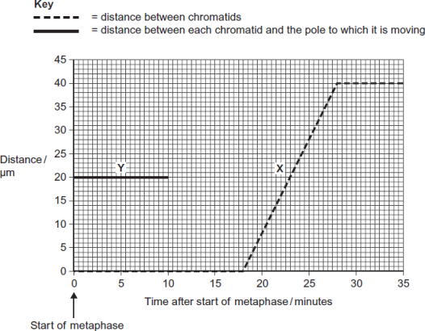

(i)      What was the duration of metaphase in this cell?

  minutes

**(1)**

(ii)     Use line **X** to calculate the duration of anaphase in this cell.

  minutes

**(1)**

(iii)    Complete line **Y** on the graph.

**(2)**

(c)     A doctor investigated the number of cells in different stages of the cell cycle in two tissue samples, **C** and **D.** One tissue sample was taken from a cancerous tumour. The other was taken from non-cancerous tissue. The table shows his results.

|  |  |  |  |
| --- | --- | --- | --- |
|  |  | **Percentage of cells in each stage of the cell cycle** | |
|  | **Stage of the cell cycle** | Tissue sample **C** | Tissue sample **D** |
|  | Interphase | 82 | 45 |
|  | Prophase | 4 | 16 |
|  | Metaphase | 5 | 18 |
|  | Anaphase | 5 | 12 |
|  | Telophase | 4 | 9 |

(i)      In tissue sample **C**, one cell cycle took 24 hours. Use the data in the table to calculate the time in which these cells were in interphase during one cell cycle. Show your working.

Time cells in interphase ...................................... hours

**(2)**

(ii)     Explain how the doctor could have recognised which cells were in interphase when looking at the tissue samples.

...............................................................................................................

...............................................................................................................

...............................................................................................................

**(1)**

(iii)    Which tissue sample, **C** or **D**, was taken from a cancerous tumour?   
Use information in the table to explain your answer.

...............................................................................................................

...............................................................................................................

...............................................................................................................

...............................................................................................................

...............................................................................................................

**(2)**

**(Total 15 marks)**

**Q37.**(a)    **Figure 1** shows one pair of homologous chromosomes.

**Figure 1**

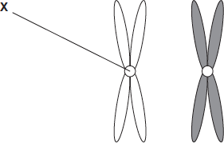

(i)      Name **X.**

...............................................................................................................

**(1)**

(ii)     Describe the role of **X** in mitosis.

...............................................................................................................

...............................................................................................................

...............................................................................................................

...............................................................................................................

...............................................................................................................

**(2)**

(iii)    Homologous chromosomes carry the same genes but they are **not** genetically identical.Explain why.

...............................................................................................................

...............................................................................................................

...............................................................................................................

**(1)**

(b)     **Figure 2** shows three pairs of homologous chromosomes in a cell at the end of cell division.

**Figure 2**



(i)      The appearance of each chromosome in **Figure 2** is different from those shown in **Figure 1.** Explain why.

...............................................................................................................

...............................................................................................................

...............................................................................................................

**(1)**

(ii)     Complete the diagram to show the chromosomes in one cell that could be produced from the cell in **Figure 2**  as a result of meiosis.



**(2)**

(iii)    Other than independent segregation, give **one** way in which meiosis allows the production of genetically different cells.

...............................................................................................................

...............................................................................................................

...............................................................................................................

**(1)**

**(Total 8 marks)**

**Q38.**The enzyme tyrosine kinase (TK) is found in human cells. TK can exist in a non-functional and a functional form. The functional form of TK is only produced when a phosphate group is added to TK.

This is shown in **Figure 1.**

**Figure 1**

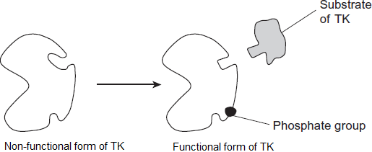

(a)     Addition of a phosphate group to the non-functional form of TK leads to production of the functional form of TK.

Explain how.

........................................................................................................................

........................................................................................................................

........................................................................................................................

........................................................................................................................

........................................................................................................................

**(2)**

(b)     The binding of the functional form of TK to its substrate leads to cell division. Chronic myeloid leukaemia is a cancer caused by a faulty form of TK. Cancer involves uncontrolled cell division.

**Figure 2** shows the faulty form of TK.

**Figure 2**

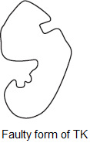

Suggest how faulty TK leads to chronic myeloid leukaemia.

........................................................................................................................

........................................................................................................................

........................................................................................................................

........................................................................................................................

........................................................................................................................

**(2)**

(c)     Imatinib is a drug used to treat chronic myeloid leukaemia. **Figure 3** shows how imatinib inhibits faulty TK.

**Figure 3**

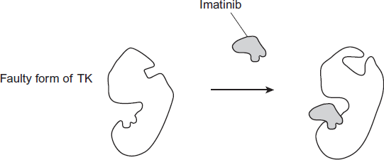

Using all of the information, describe how imatinib stops the development of chronic myeloid leukaemia.

........................................................................................................................

........................................................................................................................

........................................................................................................................

........................................................................................................................

........................................................................................................................

**(2)**

**(Total 6 marks)**

**Q39.**Metastatic melanoma (MM) is a type of skin cancer. It is caused by a faulty receptor protein in cell-surface membranes. There have been no very effective treatments for this cancer.

Dacarbazine is a drug that has been used to treat MM because it appears to increase survival time for some people with MM.

Doctors investigated the use of a new drug, called ipilimumab, to treat MM. They compared the median survival time (ST) for two groups of patients treated for MM:

•        a control group of patients who had been treated with dacarbazine

•        a group of patients who had been treated with dacarbazine and ipilimumab.

The ST is how long a patient lives after diagnosis.

The doctors also recorded the percentage of patients showing a significant reduction in tumours with each treatment.

The total number of patients in the investigation was 502.

The table below shows the doctors’ results.

|  |  |  |  |
| --- | --- | --- | --- |
|  | **Treatment** | **Median survival time (ST) /  months** | **Percentage of patients  showing significant  reduction in tumours** |
|  | Dacarbazine | 9.1 | 10.3 |
|  | Dacarbazine and  ipilimumab | 11.2 | 15.2 |

(a)     The doctors compared median survival times for patients in each group.

How would you find the median survival time for a group of patients?

........................................................................................................................

........................................................................................................................

........................................................................................................................

........................................................................................................................

**(2)**

(b)     In many trials of new drugs, a control group of patients is given a placebo that does not contain any drug.

The control group in this investigation had been treated with dacarbazine.  
Suggest why they had not been given a placebo.

........................................................................................................................

........................................................................................................................

**(1)**

(c)     A journalist who read this investigation concluded that ipilimumab improved the treatment of MM.

Do the data in the table support this conclusion? Give reasons for your answer.

........................................................................................................................

........................................................................................................................

........................................................................................................................

........................................................................................................................

........................................................................................................................

........................................................................................................................

........................................................................................................................

........................................................................................................................

**(Extra space)** ................................................................................................

........................................................................................................................

........................................................................................................................

........................................................................................................................

**(4)**

(d)     MM is caused by a faulty receptor protein in cell-surface membranes.  
Cells in MM tumours can be destroyed by the immune system.

Suggest why they can be destroyed by the immune system.

........................................................................................................................

........................................................................................................................

........................................................................................................................

........................................................................................................................

........................................................................................................................

........................................................................................................................

**(Extra space)** ................................................................................................

........................................................................................................................

........................................................................................................................

**(3)**

**(Total 10 marks)**

**Q40.**The figure below shows some cells from an onion root tip at different stages of the cell cycle.

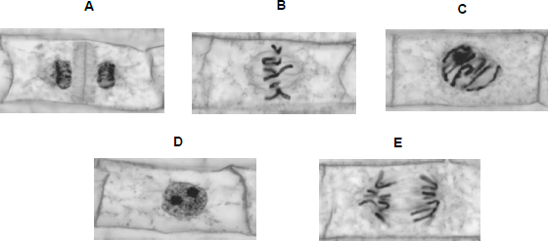

© Ed Reschke/Oxford Scientific/Getty Images

(a)     Place stages **A** to **E** in the correct order. Start with stage **D**.

**D**.............................................................................................................

**(1)**

To obtain these images, the onion root tip was cut off, stained and put on a microscope slide. A cover slip was placed on top. The root tip was then firmly squashed and viewed under an optical microscope.

(b)     Complete the table below to give **one** reason why each of these steps was necessary.

|  |  |  |
| --- | --- | --- |
|  | **Step** | **Reason** |
|  | Taking cells from the root tip |  |
|  | Firmly squashing the root tip |  |

**(2)**

The figure below shows how the amount of DNA per cell changed during interphase and meiosis in an animal.

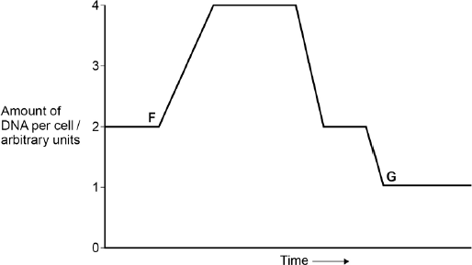

(c)     Explain how the behaviour of chromosomes causes these changes in the amount of DNA per cell between **F** and **G**.

........................................................................................................................

........................................................................................................................

........................................................................................................................

........................................................................................................................

........................................................................................................................

........................................................................................................................

**(Extra space)** ................................................................................................

........................................................................................................................

........................................................................................................................

**(3)**

(d)     What would happen to the amount of DNA per cell at fertilisation of cell **G?**

........................................................................................................................

........................................................................................................................

**(1)**

**(Total 7 marks)**

**M1.**          (a)     (i)      **A** anaphase;

**1**

(ii)     (**C**) **B**,**A**,**D**;

**1**

(iii)     (original) chromosome / DNA has been replicated;  
each chromosome consists of two chromatids /   
chromatids attached at centromere;

*(accept reference to condensed state of chromosomes)*

**2**

(b)     (i)      it has doubled / now 8;

**1**

(ii)     chromosome / DNA replication but no separation  
/ anaphase / cell division;

**1**

**[6]**

**M2.**          (i)      smoking and drinking increase risk;  
risk increases for nonsmokers with more alcohol;  
20-40 cigarettes increases risk;  
at all levels of alcohol consumption;  
4 or more drinks increase risk in all groups;  
worst risk with combination of 40+ cigarettes and 4 or more drinks;  
smoking and drinking together have a greater effect than either   
on its own;  
over 40 cigarettes and no alcohol greater than 1 or 2 alcoholic   
drinks / valid comment about anomaly;

**3 max**

(ii)      other environmental factor / e.g. passive smoking;  
genetic predisposition / inherited from parents;  
mutation;

**1 max**

**[4]**

**M3.**          (a)     DNA replicated/two DNA strands/molecules;Coiled/condensed/wound up (to make visible);Giving/made of (two) chromatids;Attached at centromere;

*Accept linear so eukaryote; with histone;*

*Accept have become shorter and fatter*

**2 max**

(b)     (i)      Stage **A**, anaphase/prophase;Chromatids/chromosomes moving to poles/chromosomes condensed/coiled/wound up;

*Points not linked but need correct description with stage in this case.*

*Accept prophase because the image could be interpreted as such*

**2**

(ii)     Stage **B**, metaphase;Chromosomes on equator/attaching to spindle;

*Points not linked Accept equator of cell Reject centre of cell Accept chromatids for chromosomes*

**2**

**[6]**

**M4.**          (a)     Centromere;

**1**

(b)     Same size;

Same shape;

Same genes;

In same sequence/locus/loci;

**2 max**

(c)     Chromatids separate;

(Chromatids) pulled to opposite ends of cell;

By spindle fibres;

Become part of new nuclei;

**2 max**

**[5]**

**M5.**          (a)     Sequence: C,A,D,B;

*1 mark per correct box to 3 max*

**3 max**

(b)     (i)      Q;

**1**

(ii)     Cell/nucleus has divided / is dividing (into two);

*Accept ‒ mitosis (occurring)*

*Ignore refs to chromosomes dividing*

**1**

**[5]**

**M6.**          (a)     produced by mitosis;  
genetically identical;

*(accept identical genes / same genotype / WNA / genetic information)(reject same genes, same genetic code)*

**2**

(b)     cells lost ability to control development / no longer totipotent /   
cells have differentiated / become specialised;

**1**

(c)     (many) offspring with favourable characteristics / high meat / milk yield;  
pedigree embryos into non-pedigree mothers / not risking pedigree  
mothers / rare breeds conserved;  
sex / gender selection;

**2 max**

**[5]**

**M7.**          (a)     mass of undifferentiated / unspecialised / totipotent cells;  
uncontrolled cell division;

*(not ‘repeated’)*

metastasis / (cells break off and) form new tumours /   
spread to other parts of body;

**3**

(b)     cancer takes time to develop / exposure when young but cancer  
triggered later; other organs destroyed before death occurs /   
metastasis affects other organs;  
immune system less effective in old people;  
longer time of exposure to UV / accumulation of mutagenic effect;

**1 max**

(c)     dark skin / melanin / pigment stops UV light / prevents burning;  
so less cancer risk in dark skinned people / less likely to develop tumours;

*(allow converse)*

**2**

**[6]**

**M8.**          (a)     (i)      8 ‘chromatids’ each side;  
spindle drawn;

**2**

(ii)     4 chromosomes;  
1 from each homologous pair;

**2**

(b)     produces haploid cells / chromosome number halved;  
fertilisation maintains the diploid / chromosome number (in next generation);

**2**

**[6]**

**M9.**          (a)   (cut out gene using an) endonuclease / restriction enzyme;  
reference to specificity / recognition site;  
sticky ends;  
use the same enzyme to cut;  
plasmid / virus / potato DNA;  
fixed by ligase;  
method of introducing vector e.g. micropipette / virus injects DNA /   
remove plant cell wall;

**6 max**

(b)     different genes are expressed;  
producing different enzymes / proteins;

**2**

**[8]**

**M10.**          (a)     (i)      prophase;  
chromosomes thickening / becoming visible;

**2**

(ii)     anaphase;  
chromatids / chromosomes moving to opposite poles /   
ends of spindles;

**2**

(b)     DNA replication;  
synthesis or proteins / build-up of energy stores / growth /   
increase in cytoplasm;  
replication of organelles / named example;

**2 max**

**[6]**

**M11.**          (a)     genetically identical cells / individuals;

**1**

(b)     mitosis;

**1**

(c)     no differentiation at this stage / same genes being expressed;

**1**

(d)     brown - genes / DNA / genetic ‘information’ from the nucleus (expressed);

**1**

(e)     embryo cell diploid, egg cell haploid;  
contain different alleles / forms of the colour gene;

**2**

(f)      damage to nucleus / cells during transfer;

**1**

**[7]**

**M12.**          (a)     mitosis;

genetically / genes / genotype identical;

*(reject same genes)*

*(ignore references to asexual reproduction)*

**2**

(b)     (different)  
environmental conditions / named environmental factor / mutation;

**1**

(c)     dispersal / prevent overcrowding / competition / colonise ;

increased number of (proven) offspring; *(not quicker)*

**2**

**[5]**

**M13.**          (a)     (i)      anaphase;

**1**

(ii)     sister / identical chromatids (separate);  
move to opposite poles / ends / sides;

**2**

(b)     (i)      interphase;

**1**

(ii)     ATP production / protein synthesis / replication of centrioles;

**1**

(iii)     1.2;

**1**

(c)     short duration of interphase;

**1**

**[7]**

**M14.**          (a)     1       two strands therefore semi-conservative replication (possible);

2       base pairing / hydrogen bonds holds strands together

3       hydrogen bonds weak / easily broken, allow strands to separate;

4       bases (sequence) (exposed so) act as template / can be copied;

5       A with T, C with G / complementary copy;

6       DNA one parent and one new strand;

**4 max**

(b)     1       chromosomes shorten / thicken / supercoiling;

2       chromosomes (each) two identical chromatids / strands / copies   
(due to replication);

3       chromosomes / chromatids move to equator / middle of the spindle / cell;

4       attach to individual spindle fibres;

5       spindle fibres contract / centromeres divide / repel;

6       (sister) chromatids / chromosomes (separate)   
move to opposite poles / ends of the spindle;

7       each pole / end receives all genetic information /   
identical copies of each chromosome;

8       nuclear envelope forms around each group of chromosomes /   
chromatids / at each pole;

**7 max**

(c)     cancer cells killed, normal body cells survive;

cancer cells low oxygen (as blood supply cannot satisfy demand);

**2**

**[13]**

**M15.**          (a)     (i)      (D) B E A C;

**1**

(ii)     metaphase;

**1**

(b)     interphase / S phase;

**1**

(c)     (i)      0.06 × 100;  
6(%);

*(correct answer 2 marks)*

**2**

(ii)     more(cancer cells) killed, cancer cells divide more (often)  
(so are more likely to be killed, more susceptible);

**1**

(iii)     longer time to recover;  
reduced rate of mitosis / divide more slowly /   
increased doubling time;

**2**

**[8]**

**M16.**(a)     1.      Push hard – spread / squash tissue;

2.      Not push sideways – avoid rolling cells together / breaking chromosomes.

*Neutral – to see cells clearly*

**2**

(b)     No (no mark)

Yes (no mark)

1.      Chromosomes / chromatids are (in two groups) at poles of spindle / at ends of spindle;

*Do not accept ‘ends of cell’*

2.      V-shape shows that (sister) chromatids have been pulled apart at their centromeres / that centromeres of (sister) chromatids have been pulled apart.

**2**

(c)     28.8 / 29.

*If incorrect, allow:*

* = 1 mark*

**2**

**[6]**

**M17.**          (a)     Chromosomes attach to equator / middle of cell / spindle;  
Prophase;  
Anaphase;  
DNA replication / synthesis / chromosome copying / duplication;  
Telophase;

**5**

(b)     (i)      Meiosis;

**1**

(ii)     32;

**1**

**[7]**

**M18.**          (a)     (i)      benign does not cause cancer /   
does not invade other tissues causing damage /   
with benign cancer, pieces which break off do not start new  
tumours elsewhere in body / metastasis;

**1**

(ii)     may damage organ concerned;  
may cause blockages / obstructions;  
may damage / exert pressure on other organs;

**max 2**

(b)     (i)      because sun’s radiation contains ultra violet radiation;  
this causes mutation of genes which control division;

**2**

(ii)     because fair skin has little melanin which protects  
against u.v. radiation;

**1**

(iii)     because cancer has genetic component / may have inherited   
(onco)gene / gene which gives predisposition to / causes cancer;

**1**

**[7]**

**M19.**          (a)     replication / duplication / doubling of chromosomes /   
replication of DNA / transcription of DNA;

**1**

(b)     (i)      cell to show correct number of chromosomes;   
correct shape and position of centromere;

**2**

(ii)     as (i) except everything halved – *Ignore crossing over*;  
(if mitosis and meiosis reversed, allow 1 if otherwise correct)

**2**

(c)     to replace cells;

**1**

**[6]**

**M20.**          (a)     Later fertilisation / cell fusion; (NOT just ‘sexual reproduction’)  
Restoring diploid / original number / not doubling chromosome number;

*ALLOW ref ‘½ + ½’*

**2**

(b)     Any three pairs from:

*need comparison of meiosis and mitosis each time*

|  |  |
| --- | --- |
| Meiosis | Mitosis |
| (Homologous) chromosomes associate in pairs | (Homologues) independent / do not pair (IGNORE ref. separation |
| Crossing-over / chiasmata formation | No crossing-over; |
| Two / (nuclear stages) divisions / → 4 offspring cells | One / (nuclear stage) division / → 2 offspring cells; |
| Genetically different (product) | Genetically identical (product); |

*IGNORE refs. To location*

**max 3**

**[5]**

**M21.**          (a)     (i)      Prophase;

**1**

(ii)     Chromosomes / chromatids moved apart;

**1**

(iii)     *A wide range of processes occurs during interphase. This list is by no means exhaustive, but we would expect to see answer such as:*

Increase in volume of cell / volume of cytoplasm / increase in mass / cell bigger; increase in number of organelles;  
synthesis of protein / named protein;  
DNA replication / increase / chromosomes copied;  
ATP synthesis / respiration;

**max 2**

(b)     Divide real length of bar (in mm) / 10 by 0.02;

**1**

(c)     12 / 200 × 24 / single error in otherwise correct method;  
1.44 hours (1 hour 26 min);

**2**

**[7]**

**M22.**          (a)     (i)      22;

**1**

(ii)     1.      Odd number of chromosomes / 33 chromosomes (in leaf cell);

2.      Chromosomes cannot pair / cannot undergo meiosis / would result in half chromosomes / cannot form haploid cells;

**2**

(b)     (i)      Fast growth / produces crop fast / produces large crop;

*Do not insist on relative statement.*

*Accept similar terms for fast. E.g. “better” growth*

*Do not accept unqualified references to profit.*

**1**

(ii)     Leaves less likely to break / higher breaking strength;

**1**

(c)     Low genetic diversity because they are produced by mitosis;

Will all have the same DNA / genes / alleles / will be genetically identical / will be clones;

***OR***

Low genetic diversity because they are not produced by meiosis;

No crossing over / independent segregation / will not be genetically different;

*Independent segregation is the specification term. Accept other such as random assortment.*

**2**

**[7]**

**M23.**          (a)     (i)      where mitosis / division / growing / occurs  
*(reject growing cells)*

**1**

(ii)     to distinguish chromosomes / chromosomes not visible  
without stain;

**1**

(iii)     to let light through / thin layer;

**1**

(b)     (i)      74 + 18 / 982;  
= 9.4% / 9%;

**2**

*(allow 1 mark for identifying prophase & metaphase i.e.92 or correct method using wrong figures)*

(ii)     genetic differences / different types of garlic;  
time of day;  
chance;  
age of root tip;  
water availability;  
temperature;  
nutrient availability;

*(environmental factors = 1 but cannot be awarded in addition to a named environmental factor)*

**2 max**

**[7]**

**M24.**          (a)     1       Cut gene out of cell / make gene using mRNA / obtain gene with restriction enzymes;

2       Cut DNA using restriction enzyme / plasmid cut with restriction enzyme;

3       Correct reference to sticky ends;

4       Join DNA using ligase / insert gene into vector;

5       Plasmid / named vector transferred to cell;

6       Method of transfer e.g. heat shock;

7       Reference to marker gene;

8       Select bacteria containing new gene;

**max 6**

(b)     Cells can metastasise / break off / spread to other parts of the body;

Remaining cells continue to divide forming a new tumour / secondary;

**2**

(c)     Antibodies specific;

Normal cells have different antigen / cancer cell has particular antigen;

Enzyme **only** present in cancer cells so drug **only** activated at / near cancer cells;

**3**

(d)     All cells contain DNA;  
Would stop / inhibit DNA replication in normal cells;  
Stops / inhibits cell division;  
Named example on growth / repair e.g. no new blood cells  
made / no wound healing;

**4**

**[15]**

**M25.**          (a)     Interphase / S-phase;

**1**

(b)     **A D C E B;**

**1**

(c)     Attachment of centromeres / chromosomes / chromatids; Separation of centromeres / chromatids / chromosomes;

**2**

(d)     Halves chromosome number / haploid;

Diploid / full number restored at fertilisation;

*Allow correct reference to variation*

**max 2**

**[6]**

**M26.**         (a)     Chromosomes:            **C** = 8 *and* **D** = 4;  
DNA:                             **C** = 300 *and* **D** = 150;

**2**

(b)     (i)      testis / ovary;  
*accept anther / carpel / stamen / testicle*

**1**

(ii)     to make chromosomes / chromatids / DNA / genetic material visible;

**1**

**[4]**

**M27.**(a)     To ensure the colour is the same at the start;

**1**

(b)     Yes – curve on graph with bromelain present remains approximately constant / rises very slightly;  
Would decrease if killing of cells occurred / would increase if cells still dividing;

**2**

(c)     Use of mouse cells (rather than human);  
(Carried out) *in vitro* / not in living organisms;  
Only tested on one type of cancer;  
Not possible to predict effect on humans (as no data collected);

**3 max**

(d)     The faster the rate of division the faster the cancer would grow;  
By measuring rate of cell division you could see how effective the treatment was;

**2**

(c)     Not ethical to replace conventional treatment;  
As life of patient is at risk (if bromelain not effective);

**2**

**[10]**

**M28.**          (a)

|  |  |  |
| --- | --- | --- |
| **Nucleus** | **Number of chromosomes** | **Mass of DNA / arbitrary units** |
| At telophase of mitosis | 26; | 30; |
| From a sperm cell | 13; | 15; |

**4**

(b)     Cancer cells often have faulty / damaged DNA;

Protein / p53 faulty / not made;

Cell (with faulty / DNA) divides / completes cell cycle;

Uncontrolled division produces cancer;

*p53 refers to the protein so do not accept reference to p53 mutating.*

**3**

(c)     (i)      Interphase / S phase / synthesis phase;

**1**

(ii)     Anaphase / **A**;

**1**

**[9]**

**M29.**          (a)     Given only saline;

Otherwise treated exactly the same way;

**2**

(b)     Ethical consideration, e.g., leads to death / suffering of mice;

Large number to improve reliability / reduce sampling error;

Number of mice related to cost / space available / animal husbandry;

**2 max**

(c)     Vary in shape / do not grow uniformly;

***Q*** *Allow descriptions of variation in shape.*

**1**

(d)     7.44 and 1.74;;

7.42 and 1.72;;

(Ratio) 4.28 : 1;;

(Ratio) 4.31 : 1;;

(Percentage decrease) 76.6%;;

(Percentage decrease) 76.8%;;

*Any of the answers shown gain two marks.*

*An answer of 23.4% or 23.2%  
Percentage decrease gains one mark.*

*Correct method of calculating rate / ratio / percentage increase with an incorrect answer gains one mark.*

**2 max**

(e)     Reference to Mitosis;

As chromosomes cannot attach (to spindle) / chromatids cannot separate (on spindle);

***Q*** *Do not penalise confusion between chromosomes and chromatids in second marking point*

Cell division / cell cycle slows down;

***Q*** *Mitosis slows down = 2 marks*

***Q*** *Mitosis stopped = 1 mark*

***Q*** *Mitosis must be spelt correctly*

**3**

(f)      (i)      (Degree of) spread / variation from the mean;

**1**

(ii)     Both chemicals (on their own) slow down growth / are effective;

Taxol is more effective than OGF;

Combined treatment (seems) most effective;

SD overlap for OGF with taxol and taxol (on its own) so not conclusive / could be chance / both treatments could be equally effective;

***Q*** *Ignore all references to significance*

**4**

**[15]**

**M30.**          (a)     1.      Gives rise to new plants / plantlets;

2.      So must be able to develop into different tissues / other specialised cell types / differentiate;

*1. Ignore references to leaves / callus*

**2**

(b)     Two marks for 5 : 1/50 : 10/1 : 0.2;;

*One mark for ratio correctly identified but expressed incorrectly as 1 : 5 / 10 : 50 / 0.2 : 1;*

**2**

(c)     (i)      1.      Meiosis / independent assortment / crossing over;

2.      (Fusion of) genetically different gametes / random fertilisation;

**2**

(ii)     Will be clones / produced by mitosis / will be genetically identical / less variation / all plants will have desired characteristics;

*If the reference is to identical must be genetically identical, but allow less variation without the reference to genetical.*

**1**

**[7]**

**M31.**          (a)     (i)      Cells are in interphase;

*Accept G phase / S phase.*

**1**

(ii)     Cells undergoing mitosis / in telophase / cytokinesis;

*Accept all named stages but reject prophase, metaphase or anaphase on their own.*

**1**

(b)     1.      3 hours;

2.      Time between beginnings / endings DNA replication / Increases / levelling outs of DNA concentration / for shape (of curve for replication) to be repeated;

3.      (DNA) replication takes place once per cell cycle;

*Allow close approximation where candidate attempts to be more accurate.*

*Principle  
What is shown on the graph*

**3**

**[5]**

**M32.**(a)     Variable that is changed;

*Reject ‘the variable that changes’.*

**1**

(b)     1.      Idea of a confounding variable;

2.      (So) genetically similar;

*2. Do not accept ‘genetically identical / same DNA’.*

3.      (So) have similar salt tolerance / response to salt water / response to watering treatment;

4.      (So) have similar yield / mass of seeds;

*Do not accept ‘amount / number of seeds’ or ‘growth rate’.*

**2 max**

(c)     Mitosis;

*Ignore cell division*

**1**

(d)     1.      Irrigation with sea water / **C** / **D** increased yield compared with no irrigation / **A**;

*For ‘yield’ accept ‘mass of seed’ throughout.*

2.      Yield was lower when irrigated with sea water / **C** / **D** compared with fresh water / **B**;

*Only penalise once for use of ‘amount / number of seeds’.*

3.      Yield was lower when watered with sea water throughout growth and seed formation / **C** than when watered with sea water just at seed formation / **D**;

*Accept use of figures from table.*

*’It’ refers to watering with seawater / mixture.*

**2 max**

(e)     1.      Irrigation with sea water / **C** / **D** increases concentration of salt in soil;

*Ignore reference to standard deviation / quality of the data.*

2.      Lower water potential in the soil linked to reduced uptake of water;

3.      Salt concentration in the soil might / might not increase in the future;

*Mark point 3 includes the principle for mark point 1 so mp3 gains 2 marks (for mp1 and mp3)*

4.      Might decrease plant growth / yield in the future;

5.      Less food / fewer seeds for future planting;

*Mp 3 and 4. Allow ‘further’ for the idea of ‘in the future’.*

**3 max**

**[9]**

**M33.**(a)     (i)      Anaphase

**1**

(ii)     1.      Sister / identical chromatids / identical chromosomes;

*Reject: Homologous chromosomes separate.*

*Allow any reference to chromatids / chromosomes being identical e.g. same DNA*

2.      To (opposite) poles / ends / sides;

**2**

(b)     (i)      1.      8.4 / cells with twice DNA content = replicated DNA / late interphase / prophase / metaphase / anaphase;

*Any reference to interphase must suggest towards end of interphase.*

*'Chromosomes replicate' is not enough for DNA replicates.*

2.      4.2 = DNA not replicated / (early) interphase / telophase / cell just divided / finished mitosis;

**2**

(ii)     2.1;

**1**

**[6]**

**M34.**          (a)     (i)      Spindle formed / chromosome / centromere / chromatids  
attaches to spindle;

Chromosomes / chromatids line up / move to middle / equator  
(of cell);

*Do not award second mark for answers referring to chromosomes ‘pairing up’.*

*Ignore reference to homologous chromosomes unless context suggests pairing which negates second mark.*

*Neutral: Details on nuclear membrane.*

*Accept: Diagram for second marking point.*

**2**

(ii)     Chromosome / centromere splits / chromatids / ‘chromosomes’ separate / pulled apart;

To (opposite) sides / poles / centrioles (of cell);

*Reject: Homologous chromosomes separate for first marking point.*

*Accept: Diagram for second marking point.*

*Chromatids / ‘chromosomes’ move to poles / sides / centrioles = 2 marks.*

**2**

(b)     (i)      Form / replace cells quickly / rapidly / divide / multiply / replicate rapidly;

*Neutral: Repair cells.*

*Answers must convey idea of ‘speed’.*

**1**

(Ii)     Correct answer = 774 minutes / 12 hours 54mins = 2 marks;;

Incorrect answer but indicates 3 cell cycles involved = one mark;

**2**

(c)     Prevents / slows DNA replication / doubling / prevents / slows mitosis;

New strand not formed / nucleotides (of new strand) not joined  
together / sugar-phosphate bonds not formed;

*First marking point must be in context of DNA replication not cell replication.*

*Do not negate first marking point if role of DNA polymerase is described incorrectly e.g. Reject: ‘joins bases / strands together’.*

*Role of DNA polymerase must be correct for last marking point.*

**2**

**[9]**

**M35.**          (a)     1.      Growth / increase in cell number;

*Ignore growth of cells*

2.      Replace cells / repair tissue / organs / body;

*Ignore repair cells*

*Reject bacteria*

3.      Genetically identical cells;

*‘Produces 2 genetically identical cells’ does not reach MP1 as well as MP3*

4.      Asexual reproduction / cloning;

*Allow example or description*

**2 max**

(b)     (i)     (Ensures) representative (sample);

*Accept find some cells in mitosis / not in interphase.  
Accept ‘more reliable’ only if linked to percentage (of cells).‘Improves reliability’ on its own does not gain this mark*

*Neutral: Large sample*

**1**

(ii)     1.      A = metaphase;

2.      Chromosome / chromatids lie on equator;

*Reject homologous chromosomes Allow centre / middle*

3.      B = anaphase;

4.      Chromatids / chromosomes separating / moving apart / moving to poles;

*Reject homologous chromosomes*

**4**

(c)     2 hours / 120 minutes;

*Allow 1 mark if working shows candidate understood that mitosis would take 10%*

**2**

**[9]**

**M36.**(a)     1.      Strands separate / H-bonds break;

*1.* ***Q*** *Neutral: strands split*

*1. Accept: strands unzip*

2.      DNA helicase (involved);

3.      Both strands / each strand act(s) as (a) template(s);

4.      (Free) nucleotides attach;

*4. Neutral: bases attach*

*4. Accept: nucleotides attracted*

5.      Complementary / specific base pairing / AT and GC;

6.      DNA polymerase joins nucleotides (on new strand);

*6. Reject: if wrong function of DNA polymerase*

7.      H-bonds reform;

8.      Semi-conservative replication / new DNA molecules contain one old strand and one new strand;

*8. Reject: if wrong context e.g. new DNA molecules contain half of each original strand*

**6 max**

(b)     (i)      18;

*Do not accept 17.5*

**1**

(ii)     10;

**1**

(iii)    1.      Horizontal until 18 minutes;

*Allow + / - one small box*

2.      (Then) decreases as straight line to 0 μm at 28 minutes;

*2. Allow lines that start from the wrong place, ending at 0 at 28 minutes*

**2**

(c)     (i)      Two marks for correct answer of 19.68 or 19.7;;

*Accept 19hrs 41mins*

One mark for incorrect answers in which candidate clearly multiplies by 0.82;

*Allow one mark for incorrect answers that clearly show 82% of 24 (hours)*

**2**

(ii)     1.      No visible chromosomes / chromatids / visible nucleus;

**1**

(iii)    **D** (no mark)

1.      Lower % (of cells) in interphase / higher % (of cells) in mitosis / named stage of mitosis;

*1. Accept: ‘less’ or ‘more’ instead of ‘%’*

*1. Do not accept: higher % (of cells) in each / all stage(s)*

2.      (So) more cells dividing / cells are dividing quicker;

*2. Accept: uncontrolled cell division*

*2. Do not award if Tissue* ***C*** *is chosen*

**2**

**[15]**

**M37.**(a)     (i)      Centromere;

*Accept: if phonetically correct*

*Reject: centriole*

**1**

(ii)     1.      Holds chromatids together;

2.      Attaches (chromatids) to spindle;

3.      (Allows) chromatids to be separated / move to (opposite) poles / (centromere) divides / splits at metaphase / anaphase;

*3.* ***Q*** *Neutral: chromosomes or chromatids split / halved / divided*

*3. Reject: reference to homologous chromosomes being separated*

*Accept ‘chromosomes’ instead of ‘chromatids’*

*Ignore incorrect names for* ***X***

**2 max**

(iii)    (Homologous chromosomes) carry different alleles;

*Accept alternative descriptions for ‘alleles’ eg different forms of a gene / different base sequences*

*Neutral: reference to maternal and paternal chromosomes*

**1**

(b)     (i)      (In **Figure 2**)

1.      Chromatids have separated (during anaphase);

*1.* ***Q*** *Neutral: split / halved / divided*

*1. Reject: reference to homologous chromosomes  
being separated*

*or*

2.      Chromatids have not replicated;

*1. & 2. Accept ‘chromosomes’ instead of ‘chromatids’*

*or*

3.      Chromosomes formed from only one chromatid;

*Accept converse arguments for* ***Figure 1***

*Ignore references to the cell not dividing as in the question stem*

*Ignore: named phases*

**1 max**

(ii)     1.      Three chromosomes;

*Ignore shading*

2.      One from each homologous pair;

*Only one mark for three chromosomes shown as pairs of chromatids*

**2**

(iii)    Crossing over / alleles exchanged between chromosomes or chromatids / chiasmata formation / genetic recombination;

*Accept: description of crossing over eg sections of chromatids break and rejoin*

*Neutral: random fertilisation*

*Reject: reference to sister chromatids*

***Q*** *Neutral: genes exchanged*

*Neutral: mutation*

**1**

**[8]**

**M38.**(a)     1.      (Phosphate) changes shape of TK / changes shape of enzyme /   
changes the active site;

*It = phosphate*

*Accept ‘alters’ for changes*

*Reject that phosphate is an inhibitor*

*Accept adding energy / affecting charged / affects polar groups (on amino acids)*

2.      Active site forms / becomes the right shape / can bind to substrate / complementary to substrate / E-S complex can form;

*Reject similar / same shape as substrate*

**2**

(b)     1.      Faulty TK has functional active site without phosphate;

*Accept ‘works without phosphate’*

2.      (So, faulty) TK functional all the time / TK not controlled (by phosphate);

**2**

(c)     1.      Non-competitive inhibitor / binds to site other than active site;

*Accept allosteric site*

*Do not accept ‘changes shape’ unqualified*

2.      Causes TK to be in non-functional form / active site not formed / wrong shape / E-S complex not formed;

3.      So, (uncontrolled) cell division stopped / slowed / controlled;

**2 max**

**[6]**

**M39.**(a)     1.      Rank all STs in ascending order;

2.      Find value with same number (of people) above and below.

*Accept find middle value*

**2**

(b)     Not ethical to fail to treat cancer.

**1**

(c)     Yes since with ipilimumab:

1.      Median ST increased by 2.1 months;

2.      Percentage of patients showing reduction in tumours increased from 10.3% to 15.2%;

No because:

3.      No standard errors shown / no (Student) t- test / no statistical test carried out;

4.      (So) not able to tell if differences are (statistically) significant / due to chance (alone);

5.      Improvement might only be evident in some patients / no improvement in some patients;

6.      Quality of (extra) time alive not reported;

*If answers relate only to ‘Yes’ or ߢNo’, award 2 marks max*

**4 max**

(d)     1.      Faulty protein recognised as an antigen / as a ‘foreign’ protein;

2.      T cells will bind to faulty protein / to (this) ‘foreign’ protein;

3.      (Sensitised) T cells will stimulate clonal selection of B cells;

4.      (Resulting in) release of antibodies against faulty protein.

**3 max**

**[10]**

**M40.**(a)      (D)CBEA.

**1**

(b)

|  |  |  |
| --- | --- | --- |
|  | **Step** | **Reason** |
|  | (Taking cells from the root tip) | Region where mitosis / cell division occurs; |
|  | (Firmly squashing the root tip) | To allow light through /  make tissue layer thin; |

**2**

(c)     (Increase)

1.      Chromosomes / DNA replicates;  
(First decrease)

2.      Homologous chromosomes separate;  
(Second decrease)

3.      Sister chromatids separate.

**3**

(d)     1.      (DNA would) double / go to 2 (arbitrary units).

**1**

**[7]**

**E1.**          The vast majority of candidates appeared to be familiar with the stages of mitosis and were able to relate their knowledge to the diagrams in the question.

(a)     (i)      A large majority of candidates correctly identified stage A as anaphase.

(ii)     A similar majority correctly gave the order of the stages.

(iii)     Most candidates obtained one mark for describing the chromosomes as consisting of two chromatids, or being in a highly coiled state. Relatively few obtained a second mark by explaining that the chromatids resulted from replication of DNA. A minority confused the chromatids joined at the centromere with homologous pairs of chromosomes.

(b)     (i)      A large majority correctly noted that the chromosome number had doubled. A minority thought that the number had halved.

(ii)     Few candidates put together the idea that DNA had replicated but without anaphase (or separation) being possible. Many got one half of the answer so could not be awarded the one mark available for a complete answer.

**E2.**          Many candidates failed to gain one or two marks because they were unable to describe in detail information given in a chart.

(i)      Most candidates scored one mark for the general observation that smoking and drinking increase the chance of cancer. Many candidates obtained a second mark for some point of detail; for example, that over forty cigarettes per day and four or more drinks gives the greatest risk. Few obtained a third mark for another valid observation based upon the data.

(ii)      Most candidates obtained this mark, usually by reference to some other environmental risk.

**E3.**          Part (a) discriminated quite well but about half of the candidates were able to describe and explain the appearance of the chromosome and obtained 2 marks. In (b), some candidates got their names and descriptions mixed up but, in general, candidates scored well here.

**E4.**          In (a), structure X was well known, although a few candidates confused the centromere with a chromatid or centriole.

In (b), just under half of candidates scored both marks. A common error was to confuse genes and alleles. Some said that the chromosomes had *similar* genes or that they were different shapes.

Part (c) was well known by a high proportion of candidates. Where they failed to gain marks, it was often because candidates did not refer to spindle fibres pulling the chromatids apart or by describing the daughter chromosomes moving into a new cell.

**E5.**          Parts (a) and (b)(i) were generally well answered with a large majority of candidates scoring full marks. About half of the candidates did not gain the mark for (b)(ii). Many suggested that the change in stage S was due to division of DNA or chromosomes, rather than cell division.

**E6.**          There were very few maximum marks in this question with most candidates scoring two or three marks.

(a)     The majority of candidates gained one mark for the idea of genetically identical embryos but imprecise descriptions of ‘same genes’ or ‘identical genetic code’ failed to gain credit. Only a minority of candidates named mitosis.

(b)     Weaker candidates often described the failure to develop in terms of the ‘cells being too small’ or ‘not having enough chromosomes to allow the process to continue’.

(c)     Most candidates gained one mark for recognising the production of offspring with favourable characteristics but very few could describe a second advantage.

**E7.**          This question was also answered well, but very few scored full marks due to incomplete or poorly expressed answers to part (a).

(a)     Nearly all candidates obtained at least one mark but only a few scored all three marks, as the majority did not refer to undifferentiated cells. Cell division was often described as rapid rather than uncontrolled, and many just referred to the growth of the tumour without mentioning cell division. Although most candidates realised that tumours would develop in other regions of the process, the process of metastasis was often poorly described, with many candidates stating that the tumour moved around the body.

(b)     Most candidates were able to give a valid reason, with the immune system being less effective, accumulation of genetic error and longer exposure to UV being the most common answers.

(c)     Most candidates appreciated that melanin or dark skin protects against the effect of UV. However, some then failed to link this to the decreased chance of developing malignant tumours. Some candidates confused melanoma with melanin, and some stated that dark skin absorbs more UV and then failed to complete their answer or stated that people with dark skin were therefore more susceptible to skin cancer.

**E8.**          This question was generally well answered by the majority of candidates, although few candidates gained maximum marks.

(a)     In part (i), many candidates incorrectly drew a total of eight rather than sixteen chromatids. However, the vast majority did gain one mark for drawing a spindle. In part (ii), most candidates gained one mark by drawing four separate chromosomes. Only better candidates obtained the second mark by clearly showing that the four chromosomes represented one from each homologues pair.

(b)     This caused few problems for the majority of candidates, many obtaining both marks. Candidates who obtained a single mark usually referred to the importance of meiosis in maintaining the chromosome number from generation to generation, but failed to mention that meiosis results in the production of haploid cells.

**E9.**          Generally this question was well answered with most candidates obtaining at least four marks. However, part (b) proved difficult for the majority.

(a)     Answers to this question provided the full range of marks. Better candidates gave a detailed description of genetic engineering and had little difficulty in obtaining five of the six marks available. A significant number obtained maximum marks. Weaker candidates referred to the use of a restriction endonuclease and the production of ‘sticky ends’. Many of these candidates also referred to the use of a plasmid but, unfortunately, not always in the correct context. There was also some confusion over the use of the enzyme ligase. Many candidates failed to realise that the gene was inserted into a plant cell but did not take the cell wall into consideration when describing the method of transfer. Nevertheless, the quality of answers to this question was pleasing.

(b)     This proved to be an effective discriminator, with only better candidates suggesting how different cells could be produced by different genes being expressed. The best candidates then linked this to the production of different enzymes or proteins. Many candidates referred to the use of hormones without displaying any understanding of how these may initiate gene expression.

**E10.**          (a)     Most candidates correctly identified the stages in the photographs as prophase and anaphase. Many went on to gain further credit for their descriptions of what was happening to the chromosomes. This was especially pleasing since this was the first time for some years that photographs rather than diagrams have appeared in a question on this topic. Some weaker candidates appeared to be unsure whether mitosis or meiosis was shown, leading to suggestions that homologous pairs of chromosomes were separating in B.

(b)     Candidates generally displayed rather weak knowledge of events during interphase. Even the best candidates tended to be restricted to one correct statement. Surprisingly few appreciated that DNA replication occurs during interphase, despite the fact that this a prerequisite for cell division.

**E11.**          This question proved to be an effective discriminator providing a wide range of marks.

(a)     This caused few problems with the majority of candidates correctly explaining that a clone consists of genetically identical cells or individuals.

(b)     This was also well answered with most candidates giving mitosis as the correct answer. However, a significant number of candidates gave the answer meiosis.

(c)     Approximately half the candidates obtained this mark, usually by explaining that the embryo cells had not yet become specialised. Incorrect answers often referred to the ease of separating cells at this stage.

(d)     Although many candidates gained this mark, a significant number failed to explain that the gene determining the brown colour would be present in the transferred nucleus.

(e)     Very few candidates obtained both marks for this question. Many appreciated that the egg cells would be haploid but failed to mention that the embryo cells would be diploid. Only the very best candidates appreciated that these cells would contain different alleles of the colour gene.

(f)      Again, only better candidates gained this mark, by suggesting that the low success rate was due to damage to the nucleus during transfer. Most candidates provided vague statements such as, ‘the nucleus didn’t work’.

**E12.**          Most candidates were able to apply their knowledge and gained credit but some failed to gain marks through failure to answer the question as set in part (c).

(a)     There were many well rehearsed descriptions; some weaker candidates failed to gain marks through poor use of terminology.

(b)     This question was very well answered, most candidates naming a specific environmental factor. Very few answers referred to mutation.

(c)     Many candidates failed to use the information in the stem of the question and answered in terms of one or the other method rather than the advantage in having two methods. Some candidates were over elaborate, not recognising the seeds are produced asexually and therefore gave ‘variation’ as one advantage.

**E13.**          Although this question produced a wide range of marks, many candidates were able to obtain at least three of the marks available.

(a)     (i)      The vast majority of candidates correctly named this stage as anaphase.

(ii)     Although most candidates described the separation of the chromatids towards the two poles of the cell, only better candidates referred to ‘sister chromatids’ or indicated that the chromatids would be identical. A significant minority of candidates mistakenly referred to the separation of homologous pairs of chromosomes.

(b)     (i)      Most candidates correctly identified stage X as interphase.

(ii)     This proved more difficult with many candidates simply referring to the replication of ‘cell organelles’. Correct responses required specific references to the processes during interphase, which enable nuclear division to occur, such as ATP synthesis, protein synthesis and, in animal cells, replication of cell organelles.

(iii)     It was surprising to find so many candidates giving the incorrect answer of 1.1, having read the graph as 2.2 units rather than 2.4. Another common incorrect response was 23 (i.e. chromosomes), due to candidates not reading the question carefully.

(c)     Although as expected a number of candidates suggested that the short time spent in anaphase was significant, it was pleasing to find that many candidates correctly referred to the short duration of interphase.

**E14.**          This question gave candidates the opportunity to display their knowledge of factual material from the specification. Answers were often marred by inaccurate recall and poor expression. Once again, weaker candidates failed to select the appropriate information to answer the question set.

(a)     Generally this section was poorly done with little reference to the question. Most candidates attempted to describe DNA replication without explanation as to how the structure of the molecule allows this to happen. Base pairing, often quoted, was well understood.

(b)     There were some good answers but very few examples of full marks. Most candidates described chromosomes shortening, referred to movement to the equator and had some knowledge of the cause of chromatid separation. Beyond this there was confusion over the involvement of homologous pairs and many candidates failed to mention the identical nature of chromatids. Only the very able candidates alluded to the significance of the movement to opposite poles. Weaker candidates could not put the events of the process into order. It was disappointingly rare to read a logically presented, coherent full answer. The majority of the candidates could use the information in the stem of the question and gained both marks.

(c)     Targeting of the cells as a concept was only implied, but not referred to, so restricting some candidates to one mark.

**E15.**          This proved to be a discriminating question with only the very best candidates gaining maximum marks.

(a)     Only very weak candidates failed to gain both marks.

(b)     A specification term well answered.

(c)     A small number of candidates could not read the figure from the graph, 0.6 being the most common error. As in the past, some students did not know to calculate the percentage. This inability did not necessarily correlate to the performance on the rest of the paper. Parts (ii) and (iii) were often answered very superficially, in terms of more cells being killed, without reference to the stem of the question or any interpretation of information given in the graph.

**E17.**          **BYA2**

The stages of mitosis were well known in part (a). Some candidates lost marks by referring to ‘replication’ in the S-phase, without stating what was being replicated. In part (b) (i), most candidates recognised that meiosis was involved in producing the spores, though the spellings were extremely varied. Examiners allowed phonetic misspellings, but had to reject “hybrid” spellings such as ‘meitosis’. In part (ii), about half the candidates gave the correct answer of 32. The commonest error was 16, though many gave 23.

**BYA3**

(a)     A range of responses was seen here, with many completely correct.

(b)     The examiners agreed to accept alternative spellings of ‘meiosis’ provided they were phonetically unambiguous. Had they demanded an exact spelling, the number gaining the mark would have plummeted. Various numbers of chromosomes were offered, 16, 32 and 64 being common, but many gave 23.

**E18.**          (a)     In part (i) a minority of candidates commented about a malignant tumour without referring to the benign tumour, e.g. “malignant tumours spread throughout the body”. A large number of candidates failed to understand part (ii) properly, and gave one cause of harm for each type of tumour. Even when the question was correctly interpreted, answers were often vague. Tumours were frequently thought to cause blood clots in arteries.

(b)     In part (i) the fact that u.v. radiation causes cancer was well known, but few gained credit for establishing a link with the genes controlling cell division. Many candidates believe that u.v. radiation interacts with melanin to cause skin cancer. In part (ii) there was confusion between melanin and melanoma. There were frequent references to the amount of melanoma in the skin. Again, examiners were intrigued by the various spellings of melanin, of which melamine was popular. A common misconception was that dark-skinned people have a darker pigment than light-skinned people, rather than *more* pigment. In part (iii) there were many imprecise answers. A large number of candidates simply mentioned that cancer could be inherited, with no reference to genes. A significant minority thought that cancer cells could be passed on.

**E19.**          **BYA2**

(a)     Whilst replication of the genetic material was given in some form by many candidates, several failed to relate their answers to the nucleus or were unaware that most organelles are reproduced in the cytoplasm.

(b)     A few candidates confused mitosis and meiosis but the majority failed to gain marks through careless drawing even when they had identified the correct number of chromosomes. A surprising number drew chromosomes in part (ii) which had been bisected so they had the centromere with one ‘arm’ attached.

(c)     Many correctly discussed replacing cells although some thought they could be repaired by this process.

**BYA3**

(a)     This was known by most candidates, though a small number referred to chromosomes appearing or to events, such as protein synthesis or production of organelles, happening outside the nucleus.

(b)     Many students gained the mark for the correct number of chromosomes in (i) and (ii), showing that the basic ideas behind mitosis and meiosis are well understood. However, fewer gained the mark for drawing the chromosomes correctly: many drew all chromosomes as identical.

(c)     Many candidates realised that mitosis would allow damaged cells to be replaced, although the less able referred to repair of cells damaged by acid or enzymes.

**E20.**          (a)     Many candidates presumably misinterpreted the question because, instead of explaining the biological importance of *reducing the chromosome number* in meiosis, they discussed the importance of the variation which meiosis produced. However, most answered appropriately with reference to fertilisation and the need to prevent doubling of the chromosome number from generation to generation.

(b)     Relatively few candidates were able to make three correct comparisons between meiosis and mitosis. One problem was the belief that the two rounds of division in meiosis and the production of four cells from the original constituted *two* different features. Some candidates also repeated the example given in the table. The points most commonly missed were the association of homologous chromosomes (or formation of bivalents) in meiosis and the production of *genetically* different cells by meiosis. Candidates were required to make a comment on both the meiosis and on the mitosis side of the table in order to score each mark.

**E21.**          **Unit 2**

(a)     Most candidates correctly identified the stage in mitosis with appropriate evidence in (ii) although some suggested spindle fibres or centrioles. These were not visible. In (iii), most provided one example but suggested a similar process as a second, for example replication of DNA and of chromosomes. The difference between processes and events was not often understood.

(b)     Few candidates gained this mark since they did not apply the standard formula to this question. Use of the scale bar appeared to be unfamiliar to many.

(c)     While the majority of entrants produced a correct answer, several confused 1.44 hours with 1h 44 min, or gave 1.26 hours as their answer. The examiners gave credit to those who made a reasonable attempt here and whose calculations were set out clearly enough to be understood.

**Unit 3**

In (a)(i), most candidates could identify cell **A** correctly as being in prophase, although a significant minority thought it was in interphase. In (a)(ii), most candidates could give suitable evidence for the cell being in anaphase, such as the chromatids moving to the poles. However, some candidates referred to being able to see the spindle fibres. In (a)(ii), there was some confusion with cytokinesis or telophase, with many references to the nuclear envelope reforming and the cytoplasm dividing. In (b), very few candidates seem to have noticed the scale bar. Many simply gave the formula that magnification = measured size divided by actual size. In a few cases, where candidates did notice the scale bar, they invalidated their answers by dividing 1cm by 0.02mm, instead of using the same units for both measurements. In (c), many candidates calculated the time correctly as 1.44, but a significant proportion of these went on to interpret this as 1 hour 44 minutes. Where the calculated answer was wrong, it was often difficult for examiners to award a mark for correct method. Many candidates simply offered a random collection of numbers, making it difficult to decide upon which method had been used.

**E22.**          (a)     Most candidates correctly identified the number of chromosomes in a male gamete in part (i) and appreciated in part (ii) that a chromosome number of 33 could not lead to viable gametes. Not all were certain as to the reason for this, however. One frequent misconception was that it is not possible to have a gamete with an odd number of chromosomes. Weaker candidates often attempted to explain why the gametes that would be produced were unable to form a zygote. Their answers were often further marred by poor use of technical language. There was much confusion between the terms chromosome, gamete and zygote.

(b)     There were some excellent answers to both parts of this question. Both parts again required candidates to use the data in the table and it was clear that some failed to take sufficient care with this. The breaking strength of the leaf, for example, was not uncommonly expressed as the strength of the plant or even the breaking strength of the banana fruit. Candidates should be advised to use the wording provided in table headings and graph labels wherever possible.

(c)     It was clear that some candidate’s knowledge of cell division failed to extend to the use of such terms as mitosis and meiosis. The quality of many answers was also influenced by poor understanding of technical terms. Thus different varieties of bananas were not infrequently referred to as species and genetic diversity was equated with species diversity. Consequently what should have been a simple answer linking mitosis to genetically identical offspring not often involved irrelevant accounts of competition and speciation.

**E23.**          **Unit 2**

          (a)     (i)      Many identified the root tip as the region or area where mitosis was taking place.

(ii)     Too many did not know the reason for using a stain and often thought it was to stain the organelles, the nucleus or the cell. Only the better candidates identified its role as staining the chromosomes.

(iii)     Many had the correct idea of producing a single layer of cells so that light could pass through.

(b)     (i)      Only the best candidates gave the correct answer here, as few recognised that only during prophase and metaphase would chromosomes be visible as chromatids.

(ii)     Most candidates found this question very difficult and often just repeated the stem, stating that a different root tip had been used. Only the better candidates gave some idea that the garlic may have been growing in different conditions or that it might be genetically different.

**Unit 3**

(a)     Most candidates were able to explain that the tip was the site of root growth and cell division but fewer knew that a stain was required to distinguish the DNA or chromosomes rather than cells, nuclei or organelles. In part (iii), while many correctly described the cells being separated or formed into a single layer to allow light through, some thought it necessary to remove air bubbles or to break open cells to release the contents.

(b)     Credit was given for correct recognition of the two stages involved; many candidates were unsure of these or were unable to complete the calculation. In the second part, only the very best candidates could supply suitable ideas about genetic variation, differing environmental factors or the role of chance. Many others suggested the differences would be due to the size of the tip, the area of the slide or the stage in mitosis at which the slide was made. Some blamed the observer for miscounting or the poor quality of the microscope.

**E24.**          (a)     Some candidates found the context of this question too complex to be able to give the well practised story of gene transfer. Examiners dealt with many answers that were set in the contexts of transferring *Clostridium* into a bacterium or transferring the enzyme into *Clostridium*. These answers were often still able to gain some credit for the steps involved despite the overarching context being misunderstood. Some candidates failed to reinsert the vector into the bacteria after modification.

(b)     Generally well answered, although quality of written communication let down those who used the term "cancer" rather than "tumour".

(c)     Few candidates correctly understood the passage and, therefore, most did not realise that the enzyme activated the prodrug. Therefore the examiners found many responses where the enzyme and/or the antibody directly attacked the cancer cells.

(d)     Unfortunately the confusions apparent in part (c) carried over to this question. Many candidates correctly identified that there would be an issue related to cell division. However, because they had failed to understand the activation of the prodrug by the enzymes, their responses were confused and became more so as more was written.

**E25.**          **Unit 2**

          (a)     Most candidates knew that DNA replication occurs during interphase, or the S-phase, and could put the stages of mitosis in the right order.

(b)     The commonest error here was to give ACDEB, i.e. failing to recognise that stage D came before stage C. Nevertheless, a few who did not read the question properly simple wrote ”Interphase, prophase, metaphase’ etc on the lines.

(c)     The role of the spindle was well known although expression was clumsy.

(d)     Many demonstrated full understanding. The terms haploid and diploid were confused by some and so fusion was described as producing the full set of haploid chromosomes. Variation was mentioned by some, but often vaguely suggesting that it occurred at fertilisation rather than during gamete formation. Confusion exists between meiosis and mitosis and a significant number of candidates explained that gametes were identical as a result of being formed by mitosis.

**Unit 3**

(a)     This question was well answered with very few incorrect responses.

(b)     Most candidates correctly identified the sequence of events. The most common error was to place **B** as the second event. Unfortunately some candidates did not follow the rubric and gave the stage names in sequence rather than the sequence of diagrams.

(c)     Weaker candidates tended to confuse centrioles and centromeres and this led to some unacceptable responses. The idea that the spindle makes chromosomes move was well understood though some candidates did not appear to appreciate that the chromosomes are separated or moved to opposite poles.

(d)     As is usual in January, there were many resit candidates who used information from module BYA5 in their answers to this question. Where correct, this was credited by the examiners.

**E26.**          **Unit 2**

          (a)     Very few scored two marks for this question. Most missed the fact that the mass of DNA given was for a cell just before cell division and it had therefore already replicated its DNA. C = 600 and D = 300 was a common incorrect response.

(b)     In (i), some good answers were found when candidates realised that the process was meiosis. Many just gave any organ where cell division takes place, misinterpreting the process as mitosis. So liver, skin or even roots were given by many. Part (ii) was again well answered when candidates realised that the purpose was to see the chromosomes. Poorer answers gave general purposes for staining, such as ‘to show the process’ or ‘to show up the cell/organe lles’.

**Unit 3**

(a)     The accurate completion of the table proved challenging for all but a few candidates. ‘Immediately before division’ should have allowed the interpretation that chromosomes had replicated and would exist as a pair of chromatids. The chromosome number of an organism is not altered but the mass of DNA within the cell is temporarily doubled, and shown in the table. Few appreciated this and almost the whole cohort failed to link correctly change in chromosome number with mass of DNA.

(b)     Weaker candidates failed to name an appropriate organ, or thought that meiosis might occur within the liver or skin, and many misinterpreted the question by identifying cells. Where, perhaps, candidates had investigated stages of cell division first-hand, the use of a stain to make chromosomes visible was appreciated more readily.

**E28.**          (a)     The first column in the table was intended to test the basic idea that chromosome number is unchanged in mitosis but is halved during meiosis. Many candidates attempted to halve the chromosome number in mitosis and then halve this number again to produce the number of chromosomes in a sperm cell. Unfortunately they failed to recognise the impossibility of an answer involving half a chromosome.  
Completing the second column correctly proved more challenging but better candidates clearly understood the principles involved.

(b)     There were some excellent answers to this part of the question that were not only factually correct but expressed the essential points clearly and logically. Others were limited by poor use of technical language, the most common failing being to describe the protein rather than the gene as mutating. Once again, there was considerable evidence of over-teaching leading to confusion. Almost invariably candidates who introduced the topics of Hayflick limit, oncogenes and tumour suppressor genes lost sight of the underlying theme. They frequently produced contradictory answers that gained little credit.

(c)     Both parts of this question were usually answered correctly.

**E29.**          (a)     Most candidates gained at least one mark by stating that the control group would be treated in exactly the same way as the experimental group apart from being injected with taxol. Less than 10% of candidates gained the second mark by indicating that the control group would be injected with saline.

(b)     Although most candidates were able to suggest two factors relating to the number of mice used in the investigation the explanations provided were not always worthy of credit. A common scoring point was the suggestion that a large number of mice would increase the reliability of the results. However, answers relating to ethical considerations often lacked sufficient detail to gain a mark.

(c)     Slightly less than half the candidates gained this mark often by indicating that growth of tumours vary in shape. There was a wide variety of incorrect responses.

(d)     It was disappointing to note that over half the candidates obtained zero on this question. Approximately 30% of candidates gained both marks. The mark scheme allowed for a variety of approaches but it was clearly evident that many candidates had difficulty calculating a growth rate.

(e)     This question proved a very effective discriminator. Most candidates gained one mark for suggesting that mitosis would be affected, although a small minority referred to meiosis. A good proportion of these candidates then explained how taxol could specifically inhibit the separation of chromatids during mitosis. However, only the most able candidates used the results to explain that mitosis was not completely inhibited by taxol as shown by the increase in the volume of the tumour with this treatment. Candidates who stated that ‘mitosis was stopped’ did not gain this third mark.

(f)      (i)      Less than 50% of candidates were able to provide a clear definition of standard deviation. Most incorrect answers simply stated that it provided the ‘spread of results’ with no reference to the mean.

(ii)     This question also proved a very effective discriminator. Most candidates gained one mark for suggesting the combined treatment seemed to be the most effective treatment. The vast majority of these candidates also noted that taxol is more effective than OGF. However, far fewer candidates clearly explained that both these chemicals on their own were effective in slowing growth of the tumour. Although better candidates also considered the standard deviation only the most able candidates clearly explained how the overlap of standard deviations indicated that the taxol and combined treatments could have been equally effective.

(ii)     As expected this proved to be a difficult question. Most candidates had difficulty understanding the flow chart and gave a variety of incorrect responses. Despite the information provided in the stem of the question many candidates suggested that the *Giardia* antigen would remain on the plate and cause a positive result. Other misconceptions related to the enzyme reacting with the antigen or with the antibodies. Approximately forty percent of candidates obtained one mark for realising that the second antibody with the attached enzyme would remain on the plate. Far fewer of these candidates went on to explain that the enzyme would react with the substrate to provide a yellow colour.

**E30.**          (a)     Most candidates were able to explain that totipotent cells were able to differentiate but could not link this satisfactorily to the evidence in the table. Many of the less able candidates either attempted to link totipotency to callus, or considered callus, leaves and plantlets to be different sorts of cells.

(b)     Simple numbers and a generous mark scheme should have enabled most candidates to gain full credit for their answers to this question. The fact that only just over half did so emphasises the difficulty candidates have in working with ratios.

(c)     Part (i) was answered very poorly and many candidates ignored the reference to reproducing sexually in the question to write about mutation and environmental factors. Many of those who did approach the question appropriately demonstrated confusion between seeds and gametes and between mitosis and meiosis. The answers to part (ii) were rather better with many pointing out that plants derived from tissue culture would be clones or would be genetically identical. However, there were inappropriate responses relating to the procedure being “quicker” or “less expensive”.

**E31.**          (a)     Candidates who answered this question well followed the instructions and referred either to interphase in part (i) or to telophase or cytokinesis in part (ii). A significant number of others confined themselves to general descriptions, often related to the concentration of DNA rather than to the number of cells as required.

(b)     In order to gain full credit here, candidates were simply required to recognise that the curves repeated themselves at 3 hourly intervals and to explain how they arrived at their answer. It was not uncommon to see a reasonable explanation but this was all too often incorrectly related to a 4 hour cycle. Some candidates had annotated the graph on the opposite page. This practice should be discouraged as such answers may not be picked up.

**E32.**(a)     Very few students failed to score the mark on this question.

(b)     Very few students scored two marks here. Few used the term ‘confounding variable’, which made it necessary to explain the concept; weak powers of expression meant that these explanations often failed to be creditworthy. Better answers often scored on marking points 3 and / or 4.

(c)     Very few students failed to score the mark on this question. It was rare to come across a spelling error.

(d)     This question produced a full range of marks. Some students referred to the effect of watering on the concentration of salt in the soil, rather than the effect on yield. It was clear from the responses which students had carefully studied the resource and clearly understood the effects of the different watering treatment.

(e)     This question produced the whole range of marks. Some students simply repeated what they had written in the previous question. Many students could come up with the fact that irrigation with sea water increases the salt concentration in the soil. A few students correctly went on to relate this to lower water potential in the soil and linked this to a reduction in water uptake. Only a small number of students then considered the effects of this watering being repeated every year. This resulted in fewer responses relating to marking points 3, 4 and 5.

**E33.**(a)     (i)      Over 80% of students correctly named this stage of mitosis as anaphase. A common incorrect response was telophase.

(ii)      Most students gained one mark for describing the separation of the chromatids to opposite sides of the cell. However, less than 30% of students explained that the chromatids would be identical in terms of their genetic content. Most students simply stated that the cells being produced would be identical. This was in the stem of the question and, therefore, did not gain credit.

(b)     (i)       This proved to be a very effective discriminator. The most common mark was for linking cells containing 8.4 units with DNA replication. It was only better students who correctly explained how cells with 4.2 units were produced. A third of students gained no credit, often referring to meiosis, gametes and haploid cells in their explanations.

(ii)     Two thirds of students correctly showed that a gamete formed in this animal would contain 2.1 units of DNA.

**E34.**          (a)     (i)      It was clearly evident that the vast majority of candidates had a good understanding of what happens in metaphase with two thirds of candidates gaining both marks and only ten percent scoring zero. Most candidates gained credit for mentioning chromosomes moving to the equator of the cell. A number of candidates, however, referred to homologous chromosomes aligning in pairs and described metaphase I of meiosis.

(ii)     Almost seventy five percent of candidates gained two marks often by stating that ‘chromatids move to opposite poles’. Again, approximately ten percent of candidates scored zero.

(b)     (i)      Although most candidates appreciated that the cells lining the human intestine needed to be replaced only half of the candidates conveyed the idea that this occurs quickly. A significant number of candidates simply stated that the cells needed to be repaired.

(ii)     Almost half the candidates gained both marks for 774 minutes or 12 hours 54 minutes. A small number of candidates provided an incorrect answer but correctly indicated three cell cycles for one mark. Many of the remaining candidates used four cell cycles to obtain an incorrect answer of 1032 minutes.

(c)     There were some excellent detailed answers to this question which gained both marks. These were, however, in the minority. Most candidates gained at least one mark usually for stating that DNA replication would be inhibited. Generally, there was considerable confusion over the role of DNA polymerase, with many candidates believing it to be involved in breaking hydrogen bonds or in complementary base pairing.

**E35.**          (a)     The role of mitosis in growth was generally well known and clearly expressed. Some responses did not give precise enough wording to distinguish between replacement or repair of individual cells, the former gaining credit but the latter not.

(b)     (i)      Inappropriate answers often related to reliability or other aspects of general experimental design. Some very good answers demonstrated practical experience of finding cells undergoing the division process, but many disappointed with references, in particular, to the identification of anomalies.

(ii)     This question was generally answered well; most incorrect responses identified **A** as prophase. Descriptions of evidence were generally good. Sometimes references were made to the spindle moving to opposite poles. Some answers referred to pairs of chromosomes, suggesting a confusion with meiosis.

(c)     While quite a high proportion of students made little or no attempt at this calculation, the majority of those that did gained at least one mark. Some students clearly spent a lot of time in very lengthy compution; they would benefit from understanding that, for a maximum of two marks, they would not be expected to have to carry out such a procedure. The main mistake was to regard stages **A+B** as being all of mitosis giving 3 + 1 as 4% of the total time, rather than taking 90% of the time in interphase, so 10% in mitosis.

**E36.**(a)     This proved to be an excellent discriminator. Just over 70% of students scored at least half marks. Many were aware of the breaking of hydrogen bonds, the role of DNA helicase and complementary base pairing. However, it was only better responses that referred to the attachment of free nucleotides (as opposed to free bases) and both strands acting as templates. DNA polymerase was frequently mentioned but its role was often confused in weaker responses. This enzyme joins nucleotides on the newly formed strand, it does not cause complementary base pairing. Some students negated the mark for semi-conservative replication through poor expression. The most common examples of this included ‘each new DNA molecule contains half of the original strand’ and ‘new strands contain half of the original strand’. Very few students wrote about hydrogen bonds reforming.

(b)     (i)      Two-thirds of students correctly gave the duration of metaphase as **18** minutes.

(ii)     80% of students correctly calculated the duration of anaphase as **10** minutes.

(iii)    This proved to be a good discriminator. Most students gained one mark for extending the horizontal line to 18 minutes, or decreasing this line to 0 μm at 28 minutes. Weaker responses often showed the horizontal line increasing.

(c)     (i)      70% of students correctly calculated the time the cells were in interphase as **19.7** hours. Very few students gained the principle mark for multiplying by 0.82.

(ii)     Just under half of students were aware that cells in interphase could be detected by a visible nucleus or the inability to see chromosomes. Weaker responses typically referred to the inability to see *DNA* or that the cells in interphase would contain twice the amount of chromosomes.

(iii)    This proved to be a good discriminator. Most students were aware that cancer cells divide more rapidly than healthy cells. However, it was only better responses that referred to data in the table and correctly linked this to tissue **D**. Some students wrongly thought that more cells in interphase meant more rapid cell division due to increased DNA replication.

**E37.**Given that this question was targeted at grade E, it is surprising that all parts proved to be good discriminators.

(a)     (i)      Over three-quarters of students gained full marks. The most common incorrect response was ‘centriole’.

(ii)     Most students gained at least one mark for stating that the centromere attaches chromosomes to the spindle. However, the ability to tell the rest of the story, in terms of allowing the chromatids to be separated, discriminated well. Unfortunately, some students failed to read the question stem carefully enough. They instead described the role of the centromere in allowing homologous chromosomes to be separated during meiosis.

(iii)    Many students were aware that homologous chromosomes carry different alleles. However, some failed to score through a lack of detail or poor expression. They typically mentioned maternal and paternal chromosomes, crossing over of alleles or thought that the sequence of genes on each homologous chromosome is different.

(b)     (i)       It was disappointing that sixty percent of students failed to score. This was usually for simply repeating information from the question stem, in terms of the cell having finished cell division. However, some students did not appreciate that an explanation was required. They simply stated that the chromosomes in **Figure 2** lack a centromere. Only the best responses mentioned that the chromosomes had not replicated, or had separated.

(ii)     Just over half of students gained full marks. However, it was disappointing that nearly one-third failed to score. A vast range of incorrect responses was seen, in relation to the number of chromosomes drawn in the cell. It was evident that some students did not realise that meiosis produces haploid cells. Similarly, some students drew chromosomes consisting of two chromatids joined by a centromere.

(iii)    Most students gained this mark for ‘crossing over’ or ‘genetic recombination’. The most common response that failed to score was ‘random fertilisation’.

**E38.**This was a question where many students failed to use the information given, or were let down by poor expression of ideas.

(a)     Sixty percent of students obtained both marks and thirty percent obtained one mark. Those who obtained one mark frequently stated that phosphate was a non-competitive inhibitor and then went on to say that it made the enzyme active. Some students made more considered observations along the lines of, ‘Like a non-competitive inhibitor, phosphate binds to a site other than the active site, changes the shape of the enzyme and causes the active site to form’. These answers were given full credit.

(b)     This proved very difficult for the majority of students. Many failed to make any use of the information or diagrams in the question and resorted to vague statements about cancer and uncontrolled division. Some wrote about TK as though it was a cancerous cell, rather than an enzyme. Many got confused between faulty and non-functional forms of TK.

(c)     This proved to be accessible, with marks awarded being very similar to those for (a). The context was obviously more familiar to students. Weaker answers often involved references to there being two active sites on the faulty TK. It has been noted in many papers that some students think any binding site, on any protein, is an active site.