**Q1.**          The diagram shows an organism called *Chlamydomonas*.

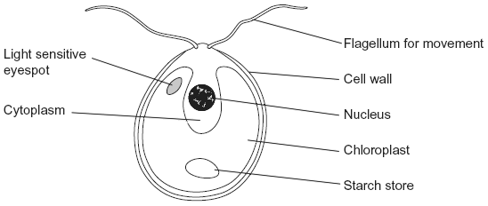

(a)     Name **two** structures shown in the diagram that are present in plant cells but are **not** present in animal cells.

1 ...................................................................................................................

......................................................................................................................

2 ...................................................................................................................

......................................................................................................................

**(2)**

(b)*Chlamydomonas* lives in fresh water ponds. Use your knowledge of osmosis to suggest an advantage of using starch as a carbohydrate store.

......................................................................................................................

......................................................................................................................

......................................................................................................................

......................................................................................................................

......................................................................................................................

**(2)**

(c)*Chlamydomonas* has adaptations that help it to maintain a high rate of photosynthesis.

Use information in the diagram to explain what these adaptations are.

......................................................................................................................

......................................................................................................................

......................................................................................................................

......................................................................................................................

......................................................................................................................

*(Extra space) ..*.............................................................................................

......................................................................................................................

......................................................................................................................

**(3)**

**(Total 7 marks)**

 Q**2.**          The diagram shows a bacterium.

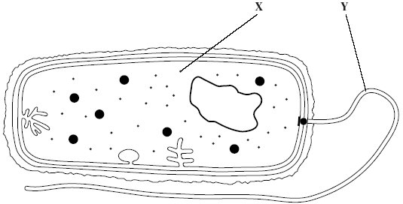

(a)     Give the function of

(i)      organelle **X**;

.............................................................................................................

(ii)     organelle **Y**.

.............................................................................................................

**(2)**

       (b)     (i)      Give **two** ways in which the structure of this bacterium is similar to the   
         structure of a cell lining the human small intestine.

1 ..........................................................................................................

.............................................................................................................

2 ..........................................................................................................

.............................................................................................................

**(2)**

(ii)     Give **two** ways in which the structure of this bacterium differs from the structure of a cell lining the human small intestine.

1 ..........................................................................................................

.............................................................................................................

2 ..........................................................................................................

.............................................................................................................

**(2)**

**(Total 6 marks)**

**Q3.**          The diagram shows a bacterium.

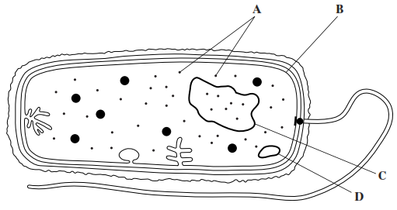

(a)     Name

(i)      organelle **A** .............................................................................................

**(1)**

(ii)     structure **B** ..............................................................................................

**(1)**

(b)     Give **two** ways in which the structure of this bacterium is different from the structure of cells lining the alveoli of a human lung.

1 ................................................................................................................

...................................................................................................................

2 ................................................................................................................

...................................................................................................................

**(2)**

(c)     Structures **C** and **D** are made of the same type of biological molecule. They have a similar function.

What is the function of **C** and **D**?

.......................................................................................................................

.......................................................................................................................

**(1)**

**(Total 5 marks)**

**Q4.**          The diagram shows the structure of a plasma membrane.

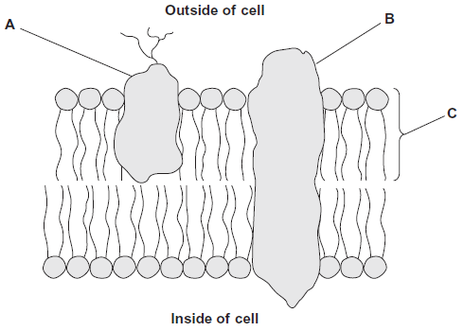

(a)     Name

protein **A** ......................................................................................................

protein **B** ......................................................................................................

molecule **C** ...................................................................................................

**(3)**

(b)     Name **two** structures found in a prokaryotic cell that are **not** found in a human cell.

1 ...................................................................................................................

2 ...................................................................................................................

**(2)**

**(Total 5 marks)**

**Q5.**          The drawing shows part of a human cell.

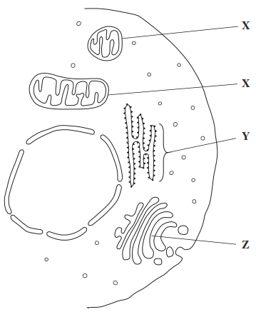

(a)     Name organelles

**X** ..................................................................................................................

**Y** ..................................................................................................................

**(2)**

(b)     (i)      The organelles labelled **X** all have very similar shapes in this cell.  
Explain why they appear to have different shapes in this drawing.

.............................................................................................................

.............................................................................................................

*(Extra space)*  .....................................................................................

.............................................................................................................

**(1)**

(ii)     Large numbers of organelles **X** and **Z** are found in mucus-secreting cells.  
Explain why.

.............................................................................................................

.............................................................................................................

.............................................................................................................

.............................................................................................................

*(Extra space)*  .....................................................................................

.............................................................................................................

**(2)**

**(Total 5 marks)**

**Q6.**          The drawing shows an electron micrograph of parts of epithelial cells from the small intestine.

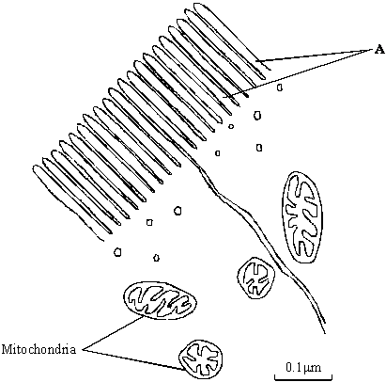

(a)     (i)      Name the structures labelled **A**.

.............................................................................................................

**(1)**

(ii)     Explain how these structures help in the absorption of substances from the small intestine.

.............................................................................................................

.............................................................................................................

**(1)**

(b)     (i)      The scale bar on this drawing represents a length of 0.1μm. Calculate the magnification of the drawing. Show your working.

Magnification .............................................

**(2)**

(ii)     Explain why an electron microscope shows more detail of cell structure than a light microscope.

.............................................................................................................

.............................................................................................................

.............................................................................................................

**(2)**

(c)     The length of mitochondria can vary from 1.5 μm to 10 μm but their width never exceeds 1μm. Explain the advantage of the width of mitochondria being no more than 1μm.

......................................................................................................................

......................................................................................................................

**(1)**

**(Total 7 marks)**

**Q7.**          **S**       Gorter and Grendel investigated the structure of the surface membrane of cells. They extracted the phospholipids from the surface membranes of red blood cells in 1 cm3 of blood and placed them in the apparatus shown in **Figure 1**.

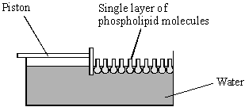

**Figure 1**

The piston was pushed across the surface of the water until the phospholipid molecules were tightly packed into a single layer. The area covered by the phospholipid molecules was measured. This area was compared with the estimated surface area of the red blood cells from which phospholipids were extracted.

Gorter and Grendel obtained the data shown in the table.

|  |  |
| --- | --- |
| Number of red blood cells per cm3 of blood | 4.74 × 109 |
| Estimated mean surface area of one red blood cell | 99.4 μm2 |
| Surface area of membrane phospholipids extracted from 1cm3 of blood | 0.92 m2 |

(a)     Explain what these data suggest about the arrangement of phospholipids in the surface membranes of red blood cells. Support your explanation with suitable calculations.

Show your working.

......................................................................................................................

......................................................................................................................

......................................................................................................................

......................................................................................................................

......................................................................................................................

......................................................................................................................

**(3)**

(b)     **Figure 2** shows a red blood cell and a white blood cell.

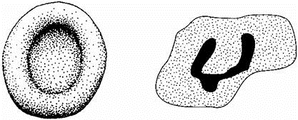

Red blood cell                                  White blood cell

**Figure 2**

Explain why red blood cells were used in this investigation rather than white blood cells.

......................................................................................................................

......................................................................................................................

......................................................................................................................

......................................................................................................................

**(2)**

**(Total 5 marks)**

**Q8.**          (a)     Changes to the protein coat of the influenza virus cause antigenic variability. Explain how antigenic variability has caused some people to become infected more than once with influenza viruses.

......................................................................................................................

......................................................................................................................

......................................................................................................................

......................................................................................................................

**(2)**

(b)     The drawings show the changes in a B lymphocyte after stimulation by specific antigens.

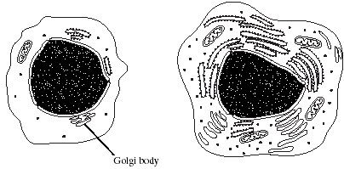

B lymphocyte before stimulation        B lymphocyte after stimulation

(i)      Describe the role of macrophages in stimulating B lymphocytes.

.............................................................................................................

.............................................................................................................

**(1)**

**S**       (ii)     Explain how the changes shown in the drawings are related to the function of B lymphocytes.

.............................................................................................................

.............................................................................................................

.............................................................................................................

.............................................................................................................

.............................................................................................................

.............................................................................................................

.............................................................................................................

.............................................................................................................

**(4)**

**(Total 7 marks)**

**Q9.**          The electron micrograph shows part of a chloroplast.

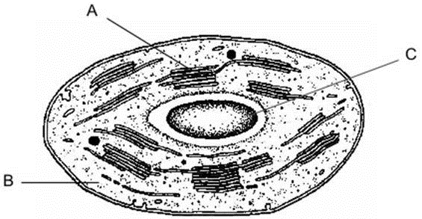

(a)     Name the parts labelled **A** and **B** and, for each, describe **one** role in the process of photosynthesis.

**A** Name ........................................................................................................

   Role ...........................................................................................................

**(2)**

**B** Name ........................................................................................................

   Role ...........................................................................................................

**(2)**

(b)     (i)      Name the main substance present in the part labelled **C**.

.............................................................................................................

**(1)**

(ii)     How is this substance formed?

.............................................................................................................

.............................................................................................................

**(1)**

**(Total 6 marks)**

**Q10.**            The drawing shows part of a plant cell as seen with an electron microscope.

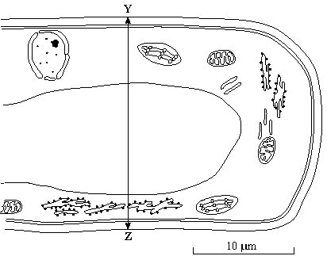

(i)      Give **two** features shown in the drawing which are evidence that this cell is eukaryotic.

1 ...................................................................................................................

......................................................................................................................

2 ...................................................................................................................

......................................................................................................................

**(2)**

(ii)     Calculate the actual width of the cell from **Y** to **Z**. Give your answer in micrometres (µm) and show your working.

Answer ..................................... µm

**(2)**

(iii)     Give **one** way in which a typical animal cell differs from the cell shown in the drawing.

......................................................................................................................

......................................................................................................................

**(1)**

**(Total 5 marks)**

**Q11.**          The diagram shows part of an animal cell as seen through an electron microscope.

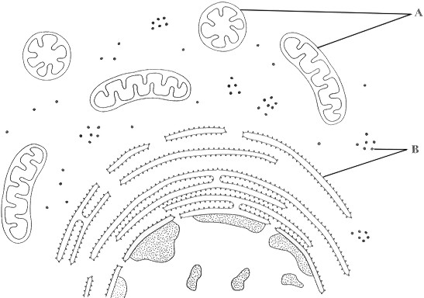

(a)     Name the organelles labelled **A** and **B**.

**A** …..............................................................................................................

**B** ..................................................................................................................

**(2)**

(b)     Explain why the shapes of the two organelles labelled **A** appear different.

......................................................................................................................

......................................................................................................................

......................................................................................................................

......................................................................................................................

**(2)**

(c)     Give the function of organelle **B**.

......................................................................................................................

......................................................................................................................

**(1)**

(d)     The epithelial cells of the small intestine have large numbers of organelle **A**.  
Explain how this is an adaptation for the function of these cells.

......................................................................................................................

......................................................................................................................

......................................................................................................................

......................................................................................................................

......................................................................................................................

......................................................................................................................

**(3)**

**(Total 8 marks)**

**Q12.**          **S**       The diagram shows a single-celled organism called *Chlamydomonas*.

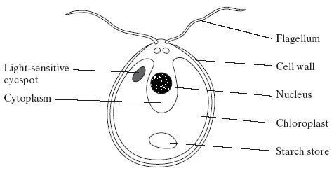

(a)     *Chlamydomonas* lives in fresh-water ponds. It uses its flagella to swim towards light of moderate intensity but away from very bright light. Using information in the diagram, explain the advantage of this behaviour.

......................................................................................................................

......................................................................................................................

......................................................................................................................

......................................................................................................................

**(2)**

(b)     A *Chlamydomonas* cell has two flagella. These flagella contain a single sort of protein. A flagellum consists of a bundle of 242 filaments. Each filament consists of 7500 protein molecules. Each protein molecule contains 900 amino acid units.

(i)      What would be the minimum number of nucleotides in the coding region of the mRNA used to synthesise this protein?

.............................................................................................................**(1)**

(ii)     In an investigation, a culture of *Chlamydomonas* was treated in a way that caused them to lose their flagella without any other damage to the cells. The flagella grew back to their original length in 60 minutes.

How many amino acid molecules would be incorporated into each growing flagellum per minute? Show your working.

Answer .........................................

**(2)**

(c)     The researchers investigated the rate at which the flagella grew in three different media.

1.      A medium containing actinomycin D, which prevents transcription by binding to the guanine in DNA

2.      A medium containing puromycin, which prevents translation by attaching to ribosomes

3.      A control medium

The results are shown in the graph.

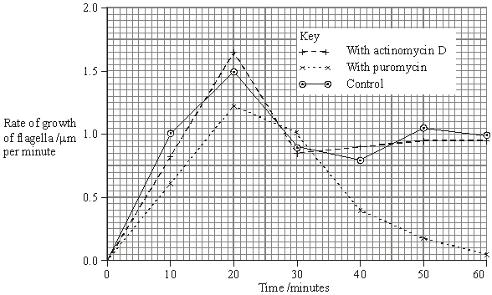

(i)      Describe how the rate of growth was affected by puromycin.

.............................................................................................................

.............................................................................................................

.............................................................................................................

.............................................................................................................

**(2)**

(ii)     The researchers concluded

1.       that the cells used mRNA that is already present in the cytoplasm for the regrowth of the flagella;

2.       that some of the regrowth uses protein molecules already present in the cell.

Explain the evidence for each of these conclusions.

1 ..........................................................................................................

.............................................................................................................

.............................................................................................................

.............................................................................................................

2 ..........................................................................................................

.............................................................................................................

.............................................................................................................

.............................................................................................................

**(4)**

**(Total 11 marks)**

**Q13.**          The figure shows a section through a palisade cell in a leaf as seen with a light microscope. The palisade has been magnified × 2000.

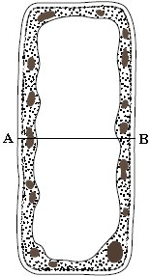

x 2000

(a)     Calculate the actual width of the cell, measured from **A** to **B**, in μm. Show your working

Answer ........................................... μm

**(2)**

(b)     Palisade cells are the main site of photosynthesis. Explain **one** way in which a palisade cell is adapted for photosynthesis.

......................................................................................................................

......................................................................................................................

......................................................................................................................

......................................................................................................................

**(2)**

**(Total 4 marks)**

**Q14.**          The thyroid gland is an organ in the neck. The diagram shows the process in which epithelial cells from the thyroid gland make and secrete a protein called thyroglobulin.

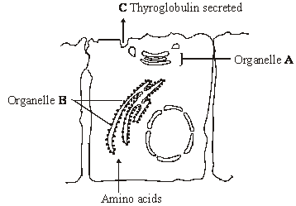

(a)     Name

(i)      organelle **A**;

.............................................................................................................

**(1)**

(ii)     the process by which thyroglobulin is secreted from the cell at **C**.

.............................................................................................................

**(1)**

(b)     (i)      Describe the part played by the organelles labelled **B**.

.............................................................................................................

.............................................................................................................

**(1)**

(ii)     Organelle **B** is very small. It cannot be seen when thyroid cells are examined with an optical microscope but it can be seen with an electron microscope. Explain why this organelle can be seen with an electron microscope.

.............................................................................................................

.............................................................................................................

.............................................................................................................

.............................................................................................................

**(2)**

**(Total 5 marks)**

**Q15.**          (a)     Small samples of plant tissue were placed in a cold, isotonic solution and then treated to break open the cells to release the organelles. The different organelles were then separated. Describe a technique that could be used to

(i)      break open the cells;

.............................................................................................................

.............................................................................................................

(ii)     separate the organelles.

.............................................................................................................

.............................................................................................................

**(2)**

(b)     One group of organelles was placed in a hypotonic solution. The diagram shows one of these organelles seen under an electron microscope before and after it was placed in the hypotonic solution.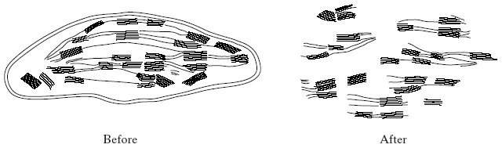

Name the organelle.

......................................................................................................................

**(1)**

**Total 3 marks)**

**Q16.**          The diagram shows the structure of a mitochondrion.

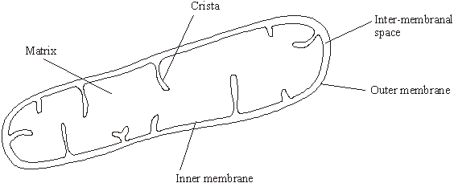

(a)     In which part of the mitochondrion does the Krebs cycle take place?

......................................................................................................................

**(1)**

(b)     Name **two** substances for which there would be net movement into the mitochondrion.

1 ...................................................................................................................

2 ...................................................................................................................

**(2)**

(c)     The mitochondria in muscles contain many cristae. Explain the advantage of this.

......................................................................................................................

......................................................................................................................

......................................................................................................................

......................................................................................................................

**(2)**

**(Total 5 marks)**

**Q17.**          (a)     The diagram shows a bacterial cell.

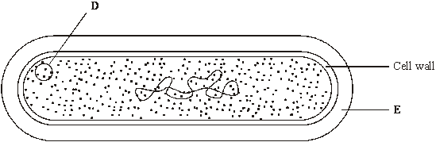

(i)      Name the parts labelled **D** and **E.**

**D** .........................................................................................................

**E** .........................................................................................................

**(2)**

(ii)     Give **one** function of the cell wall.

.............................................................................................................

.............................................................................................................

**(1)**

(b)     Name **two** structures present in eukaryotic cells that are not present in the cells of prokaryotes.

1 ...................................................................................................................

2 ...................................................................................................................

**(2)**

(c)     Several small pieces of a saprophytic fungus were placed on a starch agar plate. After 48 hours the iodine solution was poured over the starch agar. The result is shown in the diagram below.

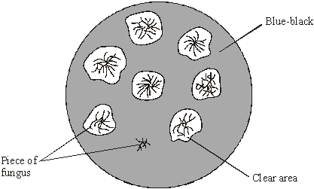

(i)      Explain why there is a clear area around most of the pieces of fungus.

.............................................................................................................

.............................................................................................................

.............................................................................................................

.............................................................................................................

**(2)**

(ii)     Suggest why one piece of fungus has no clear area round it.

.............................................................................................................

.............................................................................................................

**(1)**

**(Total 8 marks)**

**Q18.** The diagram shows the structure of a chloroplast.

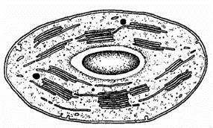

(a)     Label the diagram with an **X** to show where the light-dependent reactions take place and with a **Y** to show where the light-independent reactions take place.

**(1)**

(b)     The photolysis of water is an important part of the process of photosynthesis. Describe what happens in the photolysis of water.

......................................................................................................................

......................................................................................................................

......................................................................................................................

......................................................................................................................

**(2)**

(c)     ATP and reduced NADP are two products of the light-dependent reactions. Describe **one** function of **each** of these substances in the light-independent reactions.

ATP ..............................................................................................................

......................................................................................................................

Reduced NADP ............................................................................................

......................................................................................................................

**(2)**

**(Total 5 marks)**

**Q19.**          (a)     The diagram shows two organelles found in a eukaryotic cell.

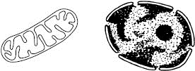

**A**                                           **B**

(i)      Name the organelles.

**A** ..........................................................................................................

**B** ..........................................................................................................

**(1)**

(ii)     Explain how the inner membrane is adapted to its function in organelle **A**.

.............................................................................................................

.............................................................................................................

.............................................................................................................

.............................................................................................................

**(2)**

(b)     Give **one** feature of a prokaryotic cell that is not found in a eukaryotic cell.

......................................................................................................................

**(1)**

(c)     Describe how a sample consisting only of chloroplasts could be obtained from homogenised plant tissue.

......................................................................................................................

......................................................................................................................

......................................................................................................................

......................................................................................................................

......................................................................................................................

......................................................................................................................

**(3)**

**(Total 7 marks)**

**Q20.** Read the following passage.

Human milk contains all the nutrients a young baby needs in exactly the right  
proportions. It is formed in the mammary glands by small groups of milk-producing cells.  
These cells absorb substances from the blood and use them to synthesise the lipids,  
carbohydrates and proteins found in milk. Milk-producing cells are roughly cube-shaped

5     and have a height to breadth ratio of approximately 1.2 : 1.

The main carbohydrate in milk is lactose. Lactose is a disaccharide formed by the  
condensation of two monosaccharides, glucose and galactose. (A molecule of galactose  
has the same formula as a molecule of glucose – the atoms are just arranged in a different  
way.)

10   Lactose is synthesised in the Golgi apparatus and transported in vesicles through the

cytoplasm. Because lactose is unable to escape from these vesicles, they increase in  
diameter as they move towards the plasma membrane. The vesicle membranes fuse with  
the plasma membrane and the vesicles empty their contents out of the cell.

Use the information from the passage and your own knowledge to answer the following questions.

(a)     (i)      The breadth of a milk-producing cell is 26 µm. Calculate the height of this cell.

Height = .......................... µm

**(1)**

(ii)     Describe and explain how you would expect the height to breadth ratio of an epithelial cell from a lung alveolus to differ from the height to breadth ratio of a milk-producing cell.

.............................................................................................................

.............................................................................................................

.............................................................................................................

.............................................................................................................

**(2)**

(b)     How many oxygen atoms are there in a molecule of

(i)      galactose;

.............................................................................................................

**(1)**

(ii)     lactose?

.............................................................................................................

**(1)**

(c)     The lactose-containing vesicles increase in diameter as they move towards the plasma membrane of the milk-producing cell (lines 11-12). Use your knowledge of water potential to explain why.

......................................................................................................................

......................................................................................................................

......................................................................................................................

......................................................................................................................

**(2)**

(d)     Suggest **one** advantage of milk-producing cells containing large numbers of mitochondria.

......................................................................................................................

......................................................................................................................

......................................................................................................................

......................................................................................................................

**(2)**

(e)     Some substances pass through the plasma membrane of a milk-producing cell by diffusion. Describe the structure of a plasma membrane and explain how different substances are able to pass through the membrane by diffusion.

......................................................................................................................

......................................................................................................................

......................................................................................................................

......................................................................................................................

......................................................................................................................

......................................................................................................................

......................................................................................................................

......................................................................................................................

......................................................................................................................

......................................................................................................................

......................................................................................................................

**(6)**

**(Total 15 marks)**

**Q21.** The drawing shows an electron micrograph of a section through part of an alveolus from a lung.

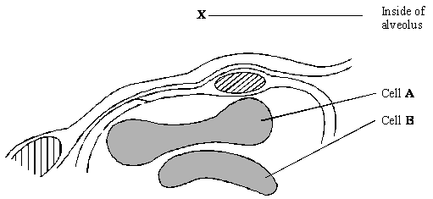

(a)     Describe the path of a molecule of oxygen from the air in the alveolus at **X** to the plasma membrane of cell **A**.

......................................................................................................................

......................................................................................................................

**(1)**

(b)     Cell **A** is a eukaryotic cell. Give **two** features that may be found in a prokaryotic cell which are not found in cell **A**.

1 ...................................................................................................................

......................................................................................................................

2 ...................................................................................................................

......................................................................................................................

**(2)**

(c)     Cells **A** and **B** are biconcave discs. Explain **one** advantage of a biconcave disc over a spherical cell of the same volume in transporting oxygen.

......................................................................................................................

......................................................................................................................

......................................................................................................................

......................................................................................................................

**(2)**

(d)     The diameter of a human red blood cell is 7 µm.

(i)      Calculate the magnification of the drawing. Show your working.

Magnification = ...............................

**(2)**

(ii)     In calculating the magnification, what assumption did you have to make about how the section was cut?

.............................................................................................................

.............................................................................................................

**(1)**

**(Total 8 marks)**

**Q22.**          Read the following passage.

In a human, there are over 200 different types of cell clearly distinguishable from each other.  
What is more, many of these types include a number of different varieties. White blood cells,  
for example, include lymphocytes and granulocytes.

Although different animal cells have many features in common, each type has adaptations.

5       associated with its function in the organism. As an example, most cells contain the same  
organelles, but the number may differ from one type of cell to another. Muscle cells contain  
many mitochondria, while enzyme-secreting cells from salivary glands have particularly large  
amounts of rough endoplasmic reticulum.

The number of a particular kind of organelle may change during the life of the cell. An

10      example of this change is provided by cells in the tail of a tadpole. As a tadpole matures into  
a frog, its tail is gradually absorbed until it disappears completely. Absorption is associated  
with an increase in the number of lysosomes in the cells of the tail.

Use information from the passage and your own knowledge to answer the following questions.

(a)     Explain the link between.

(i)      mitochondria and muscle cells (lines 6 - 7);

.............................................................................................................

.............................................................................................................

.............................................................................................................

.............................................................................................................

.............................................................................................................

**(3)**

(ii)     rough endoplasmic reticulum and enzyme-secreting cells from salivary glands   
(lines 7 - 8).

.............................................................................................................

.............................................................................................................

.............................................................................................................

.............................................................................................................

**(2)**

(b)     Use information in the passage to explain how a tadpole’s tail is absorbed as a tadpole changes into a frog.

......................................................................................................................

......................................................................................................................

......................................................................................................................

......................................................................................................................

**(2)**

(c)     Starting with some lettuce leaves, describe how you would obtain a sample of undamaged chloroplasts. Use your knowledge of cell fractionation and ultracentrifugation to answer this question.

......................................................................................................................

......................................................................................................................

......................................................................................................................

......................................................................................................................

......................................................................................................................

......................................................................................................................

......................................................................................................................

......................................................................................................................

......................................................................................................................

......................................................................................................................

**(6)**

**(Total 13 marks)**

**Q23.**          Moulds belong to a group of organisms called fungi. When mould is examined with a microscope it is seen to consist of long, colourless threads called hyphae.

A student investigated the growth of fungal hyphae. The diagram shows part of a hypha seen under a microscope at the beginning of a lesson and again at the end of the lesson.

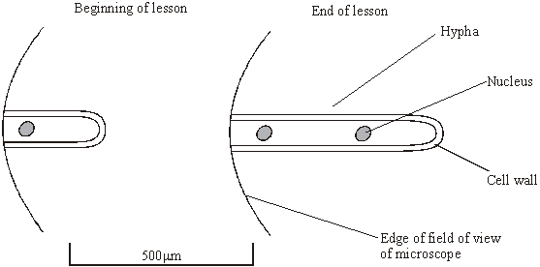

(a)     Give **one** piece of evidence from the diagram that fungi are eukaryotic.

......................................................................................................................

......................................................................................................................

**(1)**

(b)     (i)      By how much had the hypha grown during the lesson? Show your working.

Answer: ........................... µm

**(2)**

(ii)     Explain how you could use your answer to calculate the rate of growth of this hypha.

.............................................................................................................

.............................................................................................................

**(1)**

(c)     Under the microscope, small granules were seen in the hypha. Describe how you could show that these granules consisted of starch.

......................................................................................................................

......................................................................................................................

......................................................................................................................

......................................................................................................................

**(2)**

**(Total 6 marks)**

**Q24.**          Liver was ground to produce a homogenate. The diagram shows how fractions containing different cell organelles were produced from the filtered homogenate.

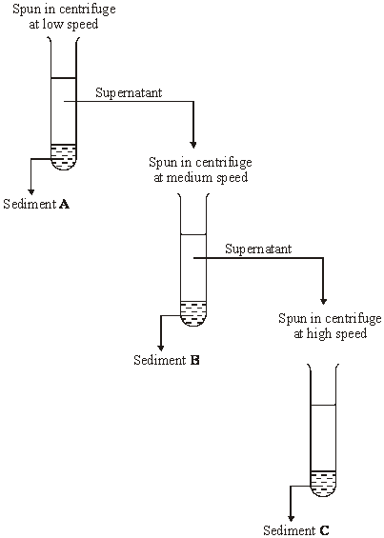

(a)     Explain why the homogenate was filtered before spinning at low speed in the centrifuge.

......................................................................................................................

......................................................................................................................

......................................................................................................................

......................................................................................................................

**(2)**

(b)     The main organelles present in sediment **B** were mitochondria. Suggest the main organelles present in

(i)      sediment **A**;

.............................................................................................................

**(1)**

(ii)     sediment **C**.

.............................................................................................................

**(1)**

(c)     What property of cell organelles allows them to be separated in this way?

......................................................................................................................

......................................................................................................................

**(1)**

(d)     Explain why the organelles in sediment **C** could be seen with a transmission electron microscope but not with an optical microscope.

......................................................................................................................

......................................................................................................................

......................................................................................................................

......................................................................................................................

**(2)**

**(Total 7 marks)**

 Q**25.**          The diagram shows a cell from a potato.

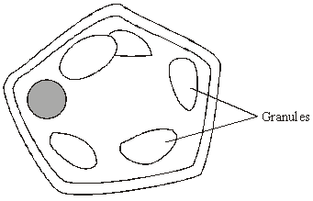

(a)     Give **two** features which may be found in a prokaryotic cell which would not be found in this cell.

1 ...................................................................................................................

2 ...................................................................................................................

**(2)**

(b)     (i)      Describe how you could confirm that the granules contained starch.

.............................................................................................................

.............................................................................................................

**(1)**

.............................................................................................................

(ii)     Name **one** polysaccharide other than starch that would be found in this cell.

.............................................................................................................

**(1)**

(c)     Explain **one** advantage of storing starch rather than glucose in potato cells.

......................................................................................................................

......................................................................................................................

......................................................................................................................

......................................................................................................................

**(2)**

**(Total 6 marks)**

**Q26.**          (a)     A plant cell was observed with an optical microscope. Describe how the length of the cell could be estimated.

......................................................................................................................

......................................................................................................................

......................................................................................................................

......................................................................................................................

**(2)**

(b)     The water potential of a plant cell is –400 kPa. The cell is put in a solution with a water potential of –650 kPa. Describe and explain what will happen to the cell.

......................................................................................................................

......................................................................................................................

......................................................................................................................

......................................................................................................................

......................................................................................................................

......................................................................................................................

**(3)**

(c)     A group of students investigated the effect of sucrose concentration on the change in length of cylinders of tissue cut from a young carrot. They measured the initial lengths of the carrot cylinders, then placed one in each of a number of sucrose solutions. After 18 hours, they removed the carrot cylinders and measured their final lengths. Some of the results are shown in the table.

|  |  |  |
| --- | --- | --- |
|  | **Concentration of sucrose / mol dm–3** | **Percentage decrease in length of carrot cylinder** |
|  | 0.4 | 4.2 |
|  | 0.5 | 8.7 |
|  | 0.6 | 13.0 |
|  | 0.7 | 16.8 |
|  | 0.8 | 18.1 |
|  | 0.9 | 18.1 |
|  | 1.0 | 18.1 |

(i)      The carrot cylinders were left for 18 hours in the sucrose solutions. Explain why they were left for a long time.

.............................................................................................................

.............................................................................................................

**(1)**

(ii)     Explain how you would use a graph to predict the concentration of sucrose that would result in no change in length of the carrot cylinders.

.............................................................................................................

.............................................................................................................

.............................................................................................................

.............................................................................................................

**(2)**

(iii)     Young carrots store sugars in their tissues but, in older carrots, some of this is converted to starch. How would using cylinders of tissue from older carrots affect the results obtained for a sucrose solution of 0.6 mol dm–3? Give a reason for your answer.

.............................................................................................................

.............................................................................................................

.............................................................................................................

.............................................................................................................

**(2)**

**(Total 10 marks)**

**Q27.**          The diagram shows a cholera bacterium. It has been magnified 50 000 times.

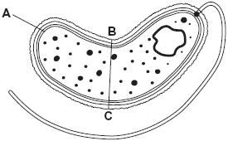

(a)     Name **A**.

......................................................................................................................

**(1)**

(b)     Name **two** structures present in an epithelial cell from the small intestine that are **not** present in a cholera bacterium.

1 ...................................................................................................................

2 ...................................................................................................................

**(2)**

(c)     Cholera bacteria can be viewed using a transmission electron microscope (TEM) or a scanning electron microscope (SEM).

(i)      Give **one** advantage of using a TEM rather than a SEM.

.............................................................................................................

.............................................................................................................

**(1)**

(ii)     Give **one** advantage of using a SEM rather than a TEM.

.............................................................................................................

.............................................................................................................

.............................................................................................................

**(1)**

(d)     Calculate the actual width of the cholera bacterium between points **B** and **C**.  
Give your answer in micrometres and show your working.

.................................. µm

**(2)**

(e)     An outbreak of cholera occurred in London in 1849. The graph shows the relationship between the number of deaths from cholera and the height at which people lived above sea level.

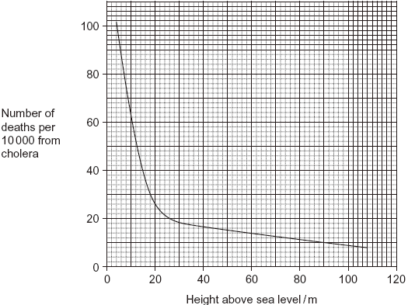

Describe the relationship between the number of deaths from cholera and the height at which people lived above sea level.

......................................................................................................................

......................................................................................................................

......................................................................................................................

......................................................................................................................

......................................................................................................................

**(2)**

**(Total 9 marks)**

**Q28.**          The diagram shows how some organelles may be distinguished from each other.



Organelle found in prokaryotic           Organelle found only in

and eukaryotic cells                         eukaryotic cells

Organelle **A**



Organelle found in                    Organelle found in

animal cells and in                 plant cells. Contains

 plant cells. Does not                  inner membranes

  contain membranes                 arranged in stacks.

 arranged in stacks.                      Organelle **B**



Larger organelle surrounded             Smaller organelle surrounded

 by an envelope through which        by an outer membrane. Has an inner

 there are pores. usually one           membrane, folded to form cristae.

per cell.                                          Many in the cell.

Organelle **C** Organelle **D**

(a)     (i)      Name organelle **B**.

.............................................................................................................

**(1)**

(ii)     Describe the function of organelle **B**.

.............................................................................................................

.............................................................................................................

.............................................................................................................

.............................................................................................................

**(2)**

(b)     Which of organelles **A**, **B**, **C** or **D**

(i)      is a ribosome;

.............................................................................................................

**(1)**

(ii)     contains most of the DNA found in a plant cell?

.............................................................................................................

**(1)**

(c)     Some liver tissue was ground, filtered and centrifuged to make a suspension of organelle **D**.

(i)      Explain why the solution in which the liver tissue was ground should be ice-cold.

.............................................................................................................

.............................................................................................................

**(1)**

(ii)     The ground liver was centrifuged at low speed. The pellet that formed at the bottom of the centrifuge tube was thrown away and the supernatant centrifuged again at higher speed. Explain why it was necessary to first centrifuge the ground liver at low speed in order to obtain a suspension of organelle **D**.

.............................................................................................................

.............................................................................................................

.............................................................................................................

.............................................................................................................

**(2)**

**(Total 8 marks)**

**Q29.**          Scientists use optical microscopes and transmission electron microscopes (TEMs) to investigate cell structure. Explain the advantages and the limitations of using a TEM to investigate cell structure.

...............................................................................................................................

...............................................................................................................................

...............................................................................................................................

...............................................................................................................................

...............................................................................................................................

...............................................................................................................................

...............................................................................................................................

...............................................................................................................................

...............................................................................................................................

...............................................................................................................................

**(Total 5 marks)**

**Q30.**          Giardiasis is an intestinal disease. It is caused by the microorganism *Giardia lamblia*. The drawing shows some of the structures present in *G. lamblia*.

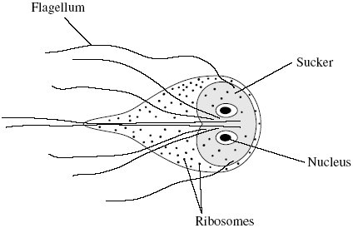

(a)     Name **one** structure shown in the drawing which confirms that *G. lamblia* is a eukaryotic organism.

......................................................................................................................

**(1)**

(b)     *G. lamblia* can attach itself with its sucker. Explain how this is an adaptation to living in the intestines.

......................................................................................................................

......................................................................................................................

**(1)**

(c)     Giardiasis is one of the main causes of diarrhoea in the USA. It is usually transmitted by drinking contaminated water. The bar chart shows the number of cases of giardiasis in one state of the USA during one year.

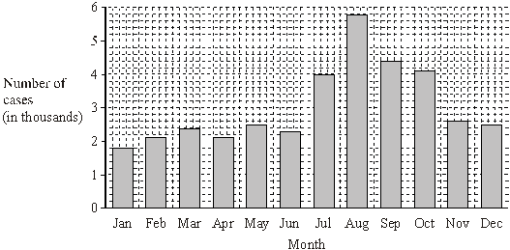

(i)      Calculate the percentage increase in the number of cases of giardiasis from January to August. Show your working.

Answer ......................................

**(2)**

(ii)     Suggest **one** reason for the number of cases being highest in the late summer months.

.............................................................................................................

.............................................................................................................

**(1)**

(d)     A test has been developed to find out whether a person is infected with *G. lamblia.* The test is shown in the flow chart.

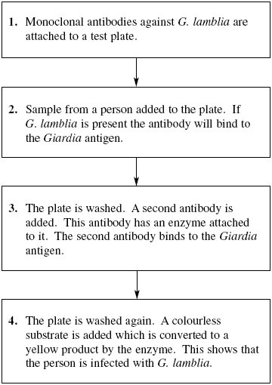

(i)      Explain why the antibodies used in this test must be monoclonal antibodies.

.............................................................................................................

.............................................................................................................

**(1)**

(ii)     Explain why the *Giardia* antigen binds to the antibody in step **2**.

.............................................................................................................

.............................................................................................................

**(1)**

(iii)     The plate must be washed at the start of step **4**, otherwise a positive result could be obtained when the *Giardia* antigen is not present. Explain why a positive result could be obtained if the plate is not washed at the start of step **4**.

.............................................................................................................

.............................................................................................................

.............................................................................................................

.............................................................................................................

**(2)**

**(Total 9 marks)**

**Q31.**          The diagram shows the outer layers of three different cells, **A**, **B** and **C**.

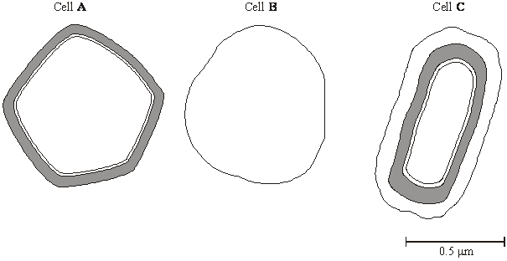

(a)     What is the evidence from the diagram that

(i)      cell **B** is an animal cell,

.............................................................................................................

.............................................................................................................

**(1)**

(ii)     cell **C** is a prokaryotic cell?

.............................................................................................................

.............................................................................................................

**(1)**

(b)     Explain how you would calculate the magnification of cell **C**.

......................................................................................................................

......................................................................................................................

**(1)**

(c)     Cell **A** is a plant cell. Name a polysaccharide which may be found in cell **A** but would not be found in the animal cell.

......................................................................................................................

**(1)**

(d)     Penicillin is an antibiotic. It prevents the formation of bacterial cell walls. As a result, bacterial cells that have been treated with penicillin swell and burst as water enters.

(i)      Explain how water enters a bacterial cell.

.............................................................................................................

.............................................................................................................

.............................................................................................................

.............................................................................................................

**(2)**

(ii)     Suggest why penicillin has no effect on plant cells.

.............................................................................................................

.............................................................................................................

**(1)**

**(Total 7 marks)**

**Q32.**          (a)     What is a tissue?

......................................................................................................................

......................................................................................................................

**(1)**

(b)     A student cut a thin section of tissue from a potato and examined it with an optical microscope.

(i)      Starch was present in the cells of this tissue. Describe how the student could find out where in the cells the starch was present.

.............................................................................................................

.............................................................................................................

.............................................................................................................

.............................................................................................................

.............................................................................................................

**(2)**

(ii)     The student cut a thin section of the tissue. Explain why it was important that the section was thin.

.............................................................................................................

.............................................................................................................

.............................................................................................................

.............................................................................................................

.............................................................................................................

**(2)**

(c)     The cell walls of potato cells contain cellulose. Cellulose and starch are both carbohydrates. Describe **two** ways in which molecules of cellulose are similar to molecules of starch.

......................................................................................................................

......................................................................................................................

......................................................................................................................

......................................................................................................................

**(2)**

**(Total 7 marks)**

**Q33.**The diagram shows a mitochondrion.

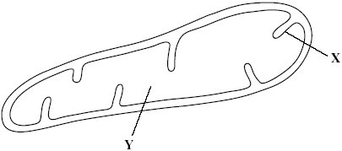

(a)     Name the parts labelled **X** and **Y**.

(i)      **X** .............................................................

(ii)     **Y** ..............................................................

**(2)**

Scientists isolated mitochondria from liver cells. They broke the cells open in an ice-cold, isotonic solution. They then used a centrifuge to separate the cell organelles. The diagram shows some of the steps in the process of centrifugation.

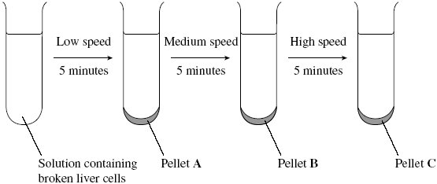

(b)     Suggest which pellet, **A**, **B** or **C** contained the mitochondria.



**(1)**

c)     Explain why the solution used was

(i)      ice-cold

.............................................................................................................

.............................................................................................................

**(1)**

(ii)     isotonic.

.............................................................................................................

.............................................................................................................

.............................................................................................................

.............................................................................................................

**(2)**

(d)     People with mitochondrial disease have mitochondria that do not function properly.

Some people with mitochondrial disease can only exercise for a short time. Explain why a person with mitochondrial disease can only exercise for a short time.

......................................................................................................................

......................................................................................................................

......................................................................................................................

......................................................................................................................

**(2)**

**(Total 8 marks)**

**Q34.**Triglycerides are taken into the body as part of a balanced diet. These triglycerides contain fatty acids including omega-3 fatty acids. It has been discovered that omega-3 fatty acids are associated with health benefits. The benefits include faster development of nerve cells and clearer vision. Omega-3 fatty acids are also associated with protection from heart disease, arthritis and cancer.

The following figure shows how omega-3 and other fatty acids are taken in and used by the bodies of animals including humans.

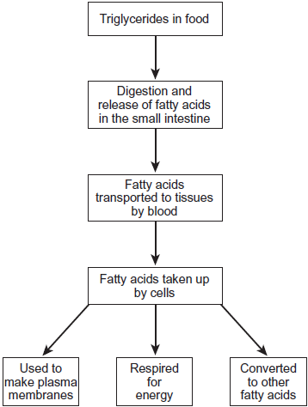

Use the information in the figure to explain **two** ways in which fatty acids are important in the formation of new cells.

1. .............................................................................................................................

.................................................................................................................................

.................................................................................................................................

.................................................................................................................................

2. .............................................................................................................................

.................................................................................................................................

.................................................................................................................................

.................................................................................................................................

**(Total 4 marks)**

**Q35.**          (a)     Name the process in which cells become adapted for different functions.

......................................................................................................................

**(1)**

(b)     Palisade cells are found in leaves. The diagram shows a palisade cell.

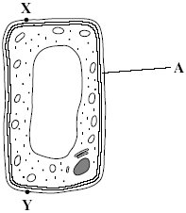

(i)      Name structure **A**.

.............................................................................................................

**(1)**

(ii)     The real length of this cell between **X** and **Y** is 20 micrometres (µm). By how many times has it been magnified? Show your working.

Answer ............................................

**(2)**

(iii)     Explain **one** way in which this cell is adapted for photosynthesis.

.............................................................................................................

.............................................................................................................

**(1)**

**(Total 5 marks)**

**Q36.**          The diagram shows an epithelial cell from the small intestine.

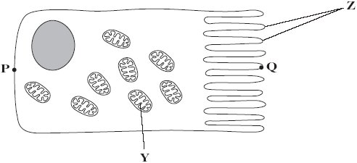

(a)     (i)      Name organelle **Y**.

.............................................................................................................

**(1)**

(ii)     There are large numbers of organelle **Y** in this cell. Explain how these organelles help the cell to absorb the products of digestion.

.............................................................................................................

.............................................................................................................

.............................................................................................................

.............................................................................................................

.............................................................................................................

**(2)**

(b)     This diagram shows the cell magnified 1000 times. Calculate the actual length of the cell between points **P** and **Q**. Give your answer in µm. Show your working.

Answer ...................................... µm

**(2)**

(c)     Coeliac disease is a disease of the human digestive system. In coeliac disease, the structures labelled **Z** are damaged.

Although people with coeliac disease can digest proteins they have low concentrations of amino acids in their blood.

Explain why they have low concentrations of amino acids in their blood.

......................................................................................................................

......................................................................................................................

......................................................................................................................

......................................................................................................................

......................................................................................................................

**(2)**

**(Total 7 marks)**

**Q37.**          (a)     Name the type of bond that joins amino acids together in a polypeptide.

......................................................................................................................

**(1)**

          The diagram shows a cell from the pancreas.

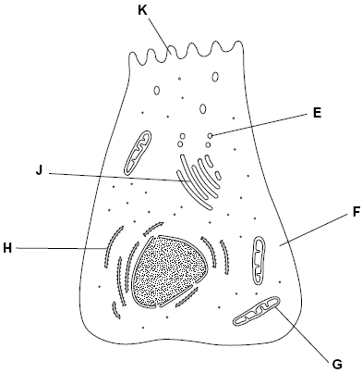

(b)     The cytoplasm at **F** contains amino acids. These amino acids are used to make proteins which are secreted from the cell.

Place the appropriate letters in the correct order to show the passage of an amino acid from the cytoplasm at **F** until it is secreted from the cell as a protein at **K**.

|  |  |  |  |  |
| --- | --- | --- | --- | --- |
| **F** |  |  |  | **K** |

**(2)**

(c)     There are lots of organelle **G** in this cell. Explain why.

......................................................................................................................

......................................................................................................................

......................................................................................................................

......................................................................................................................

**(2)**

(d)     A group of scientists homogenised pancreatic tissue before carrying out cell fractionation to isolate organelle **G**.

Explain why the scientists

(i)      homogenised the tissue

.............................................................................................................

.............................................................................................................

**(1)**

(ii)     filtered the resulting suspension

.............................................................................................................

.............................................................................................................

**(1)**

(iii)     kept the suspension ice cold during the process

.............................................................................................................

.............................................................................................................

**(1)**

(iv)    used isotonic solution during the process.

.............................................................................................................

.............................................................................................................

.............................................................................................................

.............................................................................................................

**(2)**

**(Total 10 marks)**

**Q38.**The diagram shows a eukaryotic cell.

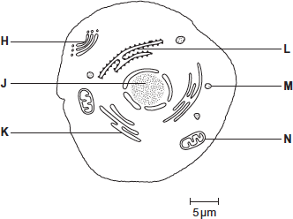

(a)     Complete the table by giving the letter labelling the organelle that matches the function.

|  |  |  |
| --- | --- | --- |
|  | **Function of organelle** | **Letter** |
|  | Protein synthesis |  |
|  | Modifies protein (for example, adds carbohydrate to protein) |  |
|  | Aerobic respiration |  |

**(3)**

(b)     Use the scale bar in the diagram above to calculate the magnification of the drawing.  
Show your working.

Answer = ................................

**(2)**

**(Total 5 marks)**

**Q39.**(a)    The table shows some statements about three carbohydrates. Complete the table with a tick in each box if the statement is true.

|  |  |  |  |  |
| --- | --- | --- | --- | --- |
|  | **Statement** | **Starch** | **Cellulose** | **Glycogen** |
|  | Found in plant cells |  |  |  |
|  | Contains glycosidic bonds |  |  |  |
|  | Contains β-glucose |  |  |  |

**(3)**

(b)     Name the type of reaction that would break down these carbohydrates into their monomers.

........................................................................................................................

**(1)**

(c)     Give **one** feature of starch and explain how this feature enables it to act as a storage substance.

Feature...........................................................................................................

Explanation.....................................................................................................

........................................................................................................................

........................................................................................................................

**(2)**

(d)     The picture shows starch grains as seen with an optical microscope. The actual length of starch grain **A** is 48 μm. Use this information and the arrow line to calculate the magnification of the picture. Show your working.

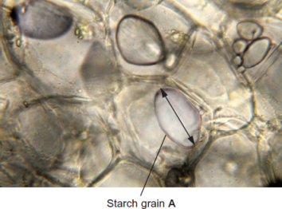  
                                                                               © iStock/Thinkstock

Magnification ...................................... times

**(2)**

**(Total 8 marks)**

**Q40.**The diagram shows the structure of a bacterium and the sites of action of two antibiotics.

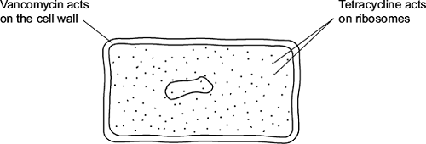

(a)     (i)      Use information in the diagram to explain why vancomycin does **not** affect human cells.

...............................................................................................................

...............................................................................................................

**(1)**

(ii)     Use information in the diagram to explain how tetracycline prevents bacterial growth.

...............................................................................................................

...............................................................................................................

**(1)**

(b)     Frequent treatment with vancomycin can result in resistant strains of bacteria. Explain how.

........................................................................................................................

........................................................................................................................

........................................................................................................................

........................................................................................................................

........................................................................................................................

........................................................................................................................

*(Extra space)* .................................................................................................

........................................................................................................................

........................................................................................................................

**(2)**

**(Total 4 marks)**

**Q41.**The photograph shows part of the cytoplasm of a cell.

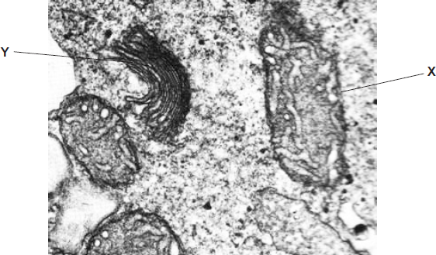

(a)     (i)      Organelle **X** is a mitochondrion.

What is the function of this organelle?

...............................................................................................................

...............................................................................................................

**(1)**

(ii)     Name organelle **Y.**

...............................................................................................................

**(1)**

(b)     This photograph was taken using a transmission electron microscope. The structure of the organelles visible in the photograph could not have been seen using an optical(light) microscope. Explain why.

........................................................................................................................

........................................................................................................................

........................................................................................................................

........................................................................................................................

........................................................................................................................

**(2)**

**(Total 4 marks)**

**Q42.**The diagram shows a chloroplast as seen with an electron microscope.

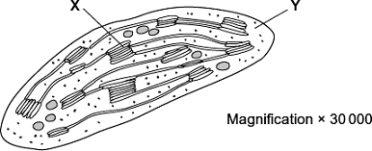

(a)     Name **X** and **Y**.

**X** ....................................................................................................................

**Y** ....................................................................................................................

**(2)**

(b)     Describe the function of a chloroplast.

........................................................................................................................

........................................................................................................................

........................................................................................................................

........................................................................................................................

........................................................................................................................

**(2)**

(c)     Calculate the maximum length of this chloroplast in micrometres (μm). Show your working.

                                            Answer ............................................... μm

**(2)**

**(Total 6 marks)**

**Q43.**The diagram shows part of an epithelial cell from an insect’s gut.

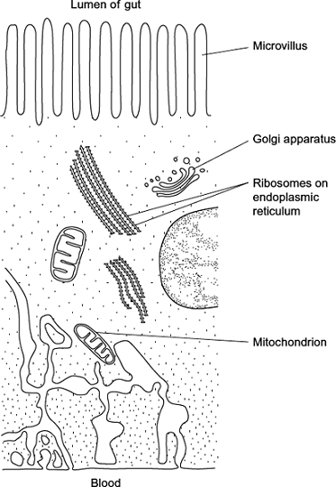

This cell is adapted for the three functions listed below. Use the diagram to explain how this cell is adapted for each of these functions.

Use a **different** feature in the diagram for each of your answers.

(a)      the active transport of substances from the cell into the blood

........................................................................................................................

........................................................................................................................

........................................................................................................................

........................................................................................................................

........................................................................................................................

........................................................................................................................

**(2)**

(b)     the synthesis of enzymes

........................................................................................................................

........................................................................................................................

........................................................................................................................

........................................................................................................................

........................................................................................................................

**(2)**

(c)    rapid diffusion of substances from the lumen of the gut into the cytoplasm

........................................................................................................................

........................................................................................................................

........................................................................................................................

**(1)**

**(Total 5 marks)**

**Q44.**          An amoeba is a single-celled, eukaryotic organism. Scientists used a transmission electron microscope to study an amoeba. The diagram shows its structure.

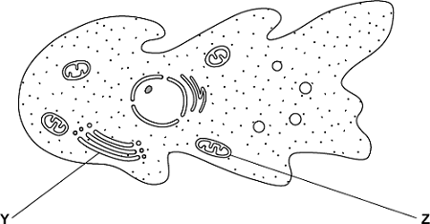

(a)     (i)      Name organelle **Y**.

...............................................................................................................

**(1)**

(ii)     Name **two** other structures in the diagram which show that the amoeba is a eukaryotic cell.

1 ............................................................................................................

2 ............................................................................................................

**(2)**

(b)     What is the function of organelle **Z**?

........................................................................................................................

........................................................................................................................

........................................................................................................................

**(1)**

(c)     The scientists used a transmission electron microscope to study the structure of the amoeba. Explain why.

**(2)**

**(Total 6 marks)**

**Q45.**A stomach ulcer is caused by damage to the cells of the stomach lining. People with stomach ulcers often have the bacterium *Helicobacter pylori* in their stomachs.

A group of scientists was interested in trying to determine how infection by *H. pylori* results in the formation of stomach ulcers.

The scientists grew different strains of *H. pylori* in liquid culture.

The table below shows the substances released by each of these strains.

|  |  |  |  |
| --- | --- | --- | --- |
|  | ***H. pylori* strain** | **Substances released by the *H. pylori* cells** | |
|  | **Toxin** | **Enzyme that neutralises acid** |
|  | **A** |  |  |
|  | **B** |  |  |
|  | **C** |  |  |

The scientists centrifuged the cultures of each strain to obtain cell-free liquids. They added each liquid to a culture of human cells. They then recorded the amount of damage to the human cells.

Their results are shown below. The error bars show ± 1 standard deviation.

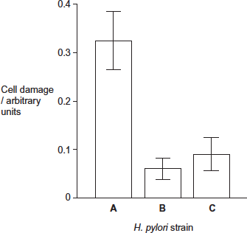

(a)     Describe and explain how centrifuging the culture allowed the scientists to obtain a cell-free liquid.

........................................................................................................................

........................................................................................................................

........................................................................................................................

........................................................................................................................

........................................................................................................................

........................................................................................................................

**[Extra space]** ................................................................................................

........................................................................................................................

........................................................................................................................

**(3)**

(b)     The scientists measured cell damage by measuring the activity of lysosomes.  
Give **one** function of lysosomes.

........................................................................................................................

........................................................................................................................

........................................................................................................................

**(1)**

(c)     *H. pylori* cells produce an enzyme that neutralises acid.  
Suggest **one** advantage to the *H. pylori* of producing this enzyme.

........................................................................................................................

........................................................................................................................

........................................................................................................................

........................................................................................................................

........................................................................................................................

**(2)**

(d)     What do these data suggest about the damage caused to human cells by the toxin and by the enzyme that neutralises acid?  
Explain your answer.

........................................................................................................................

........................................................................................................................

........................................................................................................................

........................................................................................................................

........................................................................................................................

........................................................................................................................

**[Extra space]** ................................................................................................

........................................................................................................................

........................................................................................................................

**(3)**

(e)     The scientists carried out a further investigation. They treated the liquid from **strain A** with a protein-digesting enzyme before adding it to a culture of human cells. No cell damage was recorded.  
Suggest why there was no damage to the cells.

........................................................................................................................

........................................................................................................................

........................................................................................................................

........................................................................................................................

........................................................................................................................

........................................................................................................................

**[Extra space]** ................................................................................................

........................................................................................................................

........................................................................................................................

**(3)**

**(Total 12 marks)**

**Q46.**(a)     Describe how you could use cell fractionation to isolate chloroplasts from leaf tissue.

........................................................................................................................

........................................................................................................................

........................................................................................................................

........................................................................................................................

........................................................................................................................

........................................................................................................................

**(Extra space)** .................................................................................................

........................................................................................................................

**(3)**

The figure below shows a photograph of a chloroplast taken with an electron microscope.

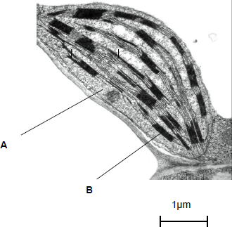

© Science Photo Library

(b)     Name the parts of the chloroplast labelled **A** and **B**.

Name of **A** .....................................................................................................

Name of **B** .....................................................................................................

**(2)**

(c)     Calculate the length of the chloroplast shown in the figure above.

Answer ................................................

**(1)**

(d)     Name **two** structures in a eukaryotic cell that **cannot** be identified using an optical microscope.

1 .....................................................................................................................

2 .....................................................................................................................

**(1)**

**(Total 7 marks)**

**Q47.**Read the following passage.

Microfold cells are found in the epithelium of the small intestine. Unlike other epithelial cells in the small intestine, microfold cells do not have adaptations for the absorption of food.

Microfold cells help to protect against pathogens that enter the intestine. They have receptor proteins on their cell-surface membranes that bind to antigens on the surface of pathogens.    5  
The microfold cells take up the antigens and transport them to cells of the immune system. Antibodies are then produced which give protection against the pathogen.

Scientists believe that it may be possible to develop vaccines that make use of microfold cells. These vaccines could be swallowed in tablet form.                                                                      10

Use information from the passage and your own knowledge to answer the following questions.

(a)    (i)      Microfold cells have receptor proteins on their cell-surface membranes that bind to antigens (line 5). What is an antigen?

...............................................................................................................

...............................................................................................................

...............................................................................................................

**(1)**

(ii)     Microfold cells take up the antigens and transport them to cells of the immune system (lines 6-7). Antigens are not able to pass through the cell-surface membranes of other epithelial cells. Suggest **two** reasons why.

...............................................................................................................

...............................................................................................................

...............................................................................................................

...............................................................................................................

...............................................................................................................

**(2)**

(b)     Scientists believe that it may be possible to develop vaccines that make use of microfold cells (lines 9-10). Explain how this sort of vaccine would lead to a person developing immunity to a pathogen.

**(5)**

**(Total 8 marks)**

**Q48.**The diagram shows the structure of the cell-surface membrane of a cell.

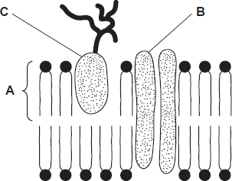

(a)     Name **A** and **B.**

**A**.....................................................................................................................

**B**.....................................................................................................................

**(2)**

(b)     (i)      **C** is a protein with a carbohydrate attached to it. This carbohydrate is formed by joining monosaccharides together. Name the type of reaction that joins monosaccharides together.

Name the type of reaction that joins monosaccharides together.

...............................................................................................................

**(1)**

(ii)     Some cells lining the bronchi of the lungs secrete large amounts of mucus. Mucus contains protein.

Name **one** organelle that you would expect to find in large numbers in a mucus-secreting cell and describe its role in the production of mucus.

Organelle...............................................................................................

Description of role..................................................................................

...............................................................................................................

...............................................................................................................

...............................................................................................................

**(2)**

**(Total 5 marks)**

**Q49.**Read the following passage.

|  |  |  |
| --- | --- | --- |
|  | Whooping cough is caused by the bacterium *Bordetella pertussis*. The first vaccines for whooping cough contained whole bacterial cells that had been heated for several minutes. Today, most vaccines only contain between one and three parts of the bacterial cells. People given whole-cell vaccines were more likely to develop harmful side effects than the people given the vaccines containing parts of the bacterial cells. Those given whole-cell vaccines produced a greater range of antibodies against the bacterium.  There have been suggestions that whooping cough vaccines may not work very well. These suggestions are due to recent reports of large 10 rises in the number of cases of whooping cough. Doctors who examined a group of patients with coughs diagnosed about 17% of them as having whooping cough. Scientists tested the blood of the same group of patients for antibodies against a toxin produced by *Bordetella pertussis*. They concluded that 4% of this group actually had whooping cough. | 5  10     15 |

Use the information in the passage and your own knowledge to answer the following questions.

(a)     (i)      People given whole-cell vaccines were more likely to develop harmful side effects than the people given the vaccines containing parts of the bacterial cells (lines 4–6).

Suggest reasons why.

...............................................................................................................

...............................................................................................................

...............................................................................................................

...............................................................................................................

...............................................................................................................

...............................................................................................................

*(Extra space)* ........................................................................................

...............................................................................................................

...............................................................................................................

**(3)**

(ii)     People given whole-cell vaccines produced a greater range of antibodies against the bacterium than the people given the vaccines containing parts of the bacterial cells (lines 7–8).

Explain why.

...............................................................................................................

...............................................................................................................

...............................................................................................................

...............................................................................................................

**(2)**

(b)     The scientists concluded from their test that 4% of patients with long-term coughs actually had whooping cough (line 15).

Explain how they used the results of their test to reach this conclusion.

........................................................................................................................

........................................................................................................................

........................................................................................................................

........................................................................................................................

........................................................................................................................

........................................................................................................................

*(Extra space)* .................................................................................................

........................................................................................................................

........................................................................................................................

**(3)**

(c)     What does the scientists’ work suggest about reports of large rises in the number of cases of whooping cough (lines 10–11)?

Explain your answer.

........................................................................................................................

........................................................................................................................

........................................................................................................................

........................................................................................................................

**(2)**

**(Total 10 marks)**

**Q50.**(a)     Describe how bacteria are destroyed by phagocytes.

........................................................................................................................

........................................................................................................................

........................................................................................................................

........................................................................................................................

........................................................................................................................

........................................................................................................................

*(Extra space)* ................................................................................................

........................................................................................................................

........................................................................................................................

**(3)**

(b)     Give **two** structures a bacterial cell may have that a white blood cell does not have.

1 .....................................................................................................................

........................................................................................................................

2 .....................................................................................................................

........................................................................................................................

**(2)**

**(Total 5 marks)**

**Q51.**(a)     Describe how phospholipids are arranged in a plasma membrane.

........................................................................................................................

........................................................................................................................

........................................................................................................................

........................................................................................................................

**(2)**

(b)     Cells that secrete enzymes contain a lot of rough endoplasmic reticulum (RER) and a large Golgi apparatus.

(i)      Describe how the RER is involved in the production of enzymes.

...............................................................................................................

...............................................................................................................

...............................................................................................................

...............................................................................................................

**(2)**

(ii)     Describe how the Golgi apparatus is involved in the secretion of enzymes.

...............................................................................................................

...............................................................................................................

...............................................................................................................

**(1)**

**(Total 5 marks)**

**Q52.**(a)     Describe how you could make a temporary mount of a piece of plant tissue to observe the position of starch grains in the cells when using an optical (light) microscope.

........................................................................................................................

........................................................................................................................

........................................................................................................................

........................................................................................................................

........................................................................................................................

........................................................................................................................

........................................................................................................................

........................................................................................................................

**(Extra space)** ................................................................................................

........................................................................................................................

........................................................................................................................

**(4)**

The figure below shows a microscopic image of a plant cell.

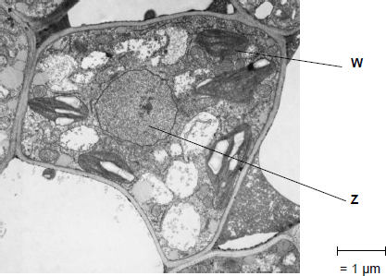

© Science Photo Library

(b)     Give the name and function of the structures labelled **W** and **Z**.

Name of **W** .......................................................................................................

Function of **W** ...................................................................................................

Name of **Z** ........................................................................................................

Function of **Z** ....................................................................................................

**(2)**

(c)     A transmission electron microscope was used to produce the image in the figure above.   
Explain why.

........................................................................................................................

........................................................................................................................

........................................................................................................................

........................................................................................................................

........................................................................................................................

**(2)**

(d)     Calculate the magnification of the image shown in the figure in part (a).

Answer = ...................................

**(1)**

**(Total 9 marks)**

**Q53.**Silkworms secrete silk fibres, which are harvested and used to manufacture silk fabric.

Scientists have produced genetically modified (GM) silkworms that contain a gene from a spider.

The GM silkworms secrete fibres made of spider web protein (spider silk), which is stronger than normal silk fibre protein.

The method the scientists used is shown in the figure below.

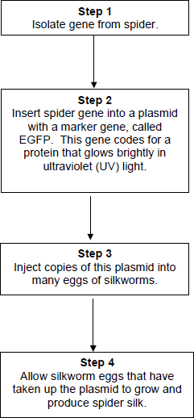

(a)     Suggest why the plasmids were injected into the eggs of silkworms, rather than into the silkworms.

........................................................................................................................

........................................................................................................................

........................................................................................................................

........................................................................................................................

**(2)**

(b)     Suggest why the scientists used a marker gene and why they used the EGFP gene.

........................................................................................................................

........................................................................................................................

........................................................................................................................

........................................................................................................................

**(2)**

The scientists ensured the spider gene was expressed only in cells within the silk glands.

(c)     What would the scientists have inserted into the plasmid along with the spider gene to ensure that the spider gene was only expressed in the silk glands of the silkworms?

........................................................................................................................

**(1)**

(d)     Suggest **two** reasons why it was important that the spider gene was expressed only in the silk glands of the silkworms.

1 .....................................................................................................................

........................................................................................................................

2 .....................................................................................................................

........................................................................................................................

**(2)**

**(Total 7 marks)**

**Q54.**Starch and cellulose are two important plant polysaccharides.

The following diagram shows part of a starch molecule and part of a cellulose molecule.

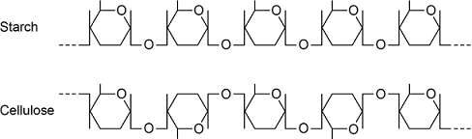

(a)     Explain the difference in the structure of the starch molecule and the cellulose molecule shown in the diagram above.

........................................................................................................................

........................................................................................................................

........................................................................................................................

........................................................................................................................

**(2)**

(b)     Starch molecules and cellulose molecules have different functions in plant cells. Each molecule is adapted for its function.

Explain **one** way in which starch molecules are adapted for their function in plant cells.

........................................................................................................................

........................................................................................................................

........................................................................................................................

........................................................................................................................

**(2)**

(c)     Explain how cellulose molecules are adapted for their function in plant cells.

........................................................................................................................

........................................................................................................................

........................................................................................................................

........................................................................................................................

........................................................................................................................

........................................................................................................................

**(Extra space)** ................................................................................................

........................................................................................................................

........................................................................................................................

**(3)**

**(Total 7 marks)**

**M1.**          (a)     Cell wall;

Starch (store);

Chloroplast;

*Accept: phonetic spelling*

**2 max**

(b)     Insoluble;

Reduces / ’stops’ water entry / osmosis / does not affect water  
potential / is osmotically inactive;

*Accept: description for first point e.g. ‘does not dissolve’.*

**2**

(c)     Light sensitive eyespot / eyespot detects light;

Flagellum enables movement towards light;

Chloroplast / chlorophyll absorbs light / for photosynthesis;

*Do not penalise references to ‘many chloroplasts’.*

**3**

**[7]**

**M2.**          (a)     X protein synthesis / translation;  
Y movement;

**2**

(b)     (i)cytoplasm;  
ribosomes;  
phospholipid membranes / cell membrane / semipermeable  
membrane;

*(accept folded membrane for two marks)*

**2 max**

(ii)     *(it = bacterium)*cell wall;  
capsule;  
flagellum;  
mesosome;  
no nucleus / nuclear membrane / DNA free;  
no mitochondria;

*(accept ‘no membrane-bound organelles’ if neither nucleus nor mitochondria mark scored)*

no microvilli;  
no Golgi;  
no ER;  
70S / smaller ribosomes;

**2 max**

**[6]**

**M3.**          (a)     (i)      Ribosome(s);

**1**

(ii)     Plasma/cell (surface) membrane;

*Accept membrane unless disqualify with, e.g. nuclear membrane*

**1**

(b)     **Two** suitable comparisons, accepting bacterial cell has;

Examples,Bacterial cell has capsule/slime layer;Cell wall;(Bacterial) flagellum;Mesosome;Different size ribosomes;Circular DNA;Human cell has nucleus;Membrane-bound organelles;Two named examples of membrane-bound organelles;

*Reject ref to thin and flat*

**2 max**

(c)     Carry genetic information/genes;

*Reject/ignore to carry DNA to carry genetic code*

*Accept genetic material with coded information –  
information for protein synthesis*

*Ignore genetic material on its own*

**1**

**[5]**

**M4.**          (a)     **A** ‒ receptor /extrinsic (protein);

*Accept glycoprotein/antigen*

**B** ‒ transmembrane/intrinsic/channel/carrier (protein);

*Accept hydrophobic tail*

**C** ‒ phospholipid;

*Ignore ref. to bilayer*

**3**

(b)     Cell wall;

*Accept smaller/70S ribosome(s)*

Capsule/slime layer;

*Accept DNA without histone*

(Bacterial) flagellum;

*Reject capsid*

Circular DNA/chromosome;

Plasmid;

Mesosome;

**2 max**

**[5]**

**M5.**         (a)     X = mitochondria;Y = (rough) endoplasmic reticulum;

*Accept ribosomes/ER/RER for Y*

*Reject smooth endoplasmic reticulum for Y*

**2**

(b)     (i)      (Sections cut at) different angles/in different planes;

*Ignore name given to organelle*

**1**

(ii)     Z modifies/packages/transports/secretes mucus/ Z adds sugars to proteins;X provides ATP/energy (for this);

*Accept makes in relation to Z but not X*

*Ignore names of organelles if function correct*

**2**

**[5]**

**M6.**          (a)     (i)      microvilli; (*reject brush border*)

**1**

(ii)     increased surface area (for diffusion);

**1**

(b)     (i)       principle of ;

*(15 –17 tolerance)*

160000;

*(correct answer award 2 marks)*

**2**

(ii)     electron microscope has a greater resolving  
power / objects closer   
together can be distinguished;   
electron (beams) have a shorter wavelength;

**2**

(c)     short diffusion pathway / short pathway to the centre / large SA:V ratio  
for faster, more diffusion;

**1**

**[7]**

**M7.**          (a)     phospholipids in a double layer / area covered is twice total surface area of red blood cells;   
evidence of calculation of number × surface area (4.74 × 109 × 99.4 μm2 ) /

calculation of area of 1 cell 

0.471 m2 ≈ 0.5 × 0.92 m2 / 194 μm ≈ 2 × 99.4;

**3**

(b)     EITHER feature + explanation  
red blood cells do not contain organelles / nucleus;   
so only surface membrane / no internal membranes in macerate;  
OR  
red blood cells have simple / regular / spherical shape;  
so easy to calculate surface area;  
OR  
*any two features, e.g.*simple / regular shape;  
all same size;

**2**

**[5]**

**M8.**          (a)     memory B / T cells do not recognise (new antigens);  
antibodies previously produced are not effective  
as shape not complementary to new antigen;

**2**

(b)     (i)      antigen in membrane presented to lymphocytes /   
produce cytokinins;

**1**

(ii)     mitochondria provide (more) ATP / energy;  
(more) RER / ribosomes synthesise proteins;  
(more) Golgi body secretes / modifies or packages proteins /   
produces glycoproteins;  
(B lymphocytes) produces antibodies;

**4**

**[7]**

**M9.**          (a)     A – granum / thylakoid;  
chlorophyll molecules to trap light / light absorbing pigments /   
light dependent reaction / part of light dependent reaction;

**2**

B – stroma;  
(contains enzymes for) carbon dioxide fixation / light-independent reaction /   
part of light-independent reaction;  
*(allow ribosome role of protein in photosynthesis)*

**2**

(b)     (i)      C – starch;

**1**

(ii)     from glucose in a condensation / polymerisation reaction / many  
glucose molecules joined together;

**1**

**[6]**

**M10.**          (i)      named organelle e.g. nucleus / nuclear envelope; vacuole;  
chloroplast; RER; mitochondrion; no membrane bound organelles;

*(only award if no organelles named)  
(reject ribosomes, cell membrane, cell wall)*

ref to large(r) size

**2 max**

(ii)     

20.4 – 21.8

*(correct answer 2 marks)*

**2**

(iii)     no cell wall (permanent) / (large) vacuole / chloroplasts / smaller;

*(accept microvilli)*

**1 max**

**[5]**

**M11.**          (a)     A mitochondria;  
B ribosomes (*accept ribosomes and rER*)

**2**

(b)     idea of sections or cuts;  
idea of mitochondria orientated differently or in different positions / description of 3D structure of mitochondria, e.g. sausage-shaped;

**2**

(c)     translation / protein / polypeptide synthesis;

**1**

(d)     provide / produce energy or ATP (*reject* *create energy*);  
(*disqualify first mark if* ‘*for* *respiration*’)  
high respiration (rate) (*accept lots*) for active uptake / transport  
(*accept description*);  
absorption of digested food / substances / products / correctly named product

*(only accept monosaccharides, amino acids, dipeptides);*

**3**

**[8]**

**M12.**         (a)     chloroplast, so cell photosynthesises and moves to optimum / best light intensity for photosynthesis;  
avoids damage due to bright light;

**2**

(b)     (i)      2700

**1**

(ii)      = 27 225 000 / 27 × 106 = *2 marks*

*(allow 1 mark for principle: )*

**2**

(c)     (i)      rate slightly slower / not affected in first 20 / 30 minutes / lower  
peak than control;  
then decreases / much lower (than control);

*(allow 1 mark for increase in first 20 / 30 minutes, then decreased, if not compared with control / normal)*

*(disqualify flagellum grows longer)*

**2**

(ii)     1.       actinomycin has no effect (on growth of flagella);  
          even though mRNA production / transcription prevented;

*(accept references to ‘expt 1’)*

2.       (re)growth little affected by puromycin at first;  
protein synthesis inhibited, so likely to be using proteins  
present;

**4**

**[11]**

**M13.**          (a)     16 gains 2 marks;

*(accept 15.5 . 16.5)*

*(principal of calculation i.e.   
measured distance (31-33mm / 3.1-3.3cm)   gains 1 mark)   
                             Mag*

**2**

(b)     relevant adaptation;

and explanation for second mark; e.g.

*idea of* many chloroplasts / lots of chlorophyll;

to trap or absorb light (energy);

elongated cells;

*idea of* maximum light absorption / light penetration;

chloroplasts move;

to trap or absorb light (energy);

range of pigments;

can absorb a range of wavelengths / colours / for max light absorption;

large S.A. or cell wall feature e.g. thin / permeable;

for (rapid) CO2 absorption;

**2**

**[4]**

**M14.**          (a)     (i)      Golgi;

**1**

(ii)     Exocytosis;

**1**

(b)     (i)      Joining together of amino acids / synthesis / production of  
thyroglobulin / makes protein;

*Do not credit synthesis of amino acids*

**1**

(ii)     Electron microscope has high / greater resolution;  
Because it uses electrons which have smaller wave(length);

**2**

**[5]**

**M15.**          (a)     (i)      homogeniser / blender / pestle and mortar / description  
e.g. grind with sand;

**1**

(ii)     centrifuge / description e.g. spin at high speeds;

**1**

(b)     (i)      chloroplast;

**1**

**[3]**

**M16.**          (a)     matrix;

**1**

(b)     pyruvate;

ADP;

P / inorganic phosphate;

reduced NAD;

oxygen;

**2 max**

(c)     larger surface area for electron carrier system / oxidative  
phosphorylation; provide ATP / energy for contraction;

**2**

**[5]**

**M17.**          (a)     (i)      **D** plasmid / ribosome(s) / cytoplasm / storage granules;

*(accept any sensible structure)*

**E** (slime / mucous) capsule

*OR*

slime / mucous layer;

**2**

(ii)     protection / maintain shape / prevent lysis / strength / support;

**1**

(b)     two of the following:

nucleus;

OR

nuclear envelope / mitochondria / chloroplasts / sER / rER /

golgi apparatus / 80s ribosomes

linear DNA / chromosomes / lysosomes / vacuole / vescicles /   
cellulose cell wall;

**2 max**

(c)     (i)      starch digested / broken down;

by amylase / carbohydrase;

**2**

(ii)     any sensible suggestion e.g. no secretion of amylase /   
functional amylase /

piece of fungus might have died;

*(accept carbohydrase / enzyme for amylase)*

*(reject “no digestion” without qualification)*

**1**

**[8]**

**M18.**          (a)     On diagram, correctly labelled:

Light-dependent: granum / thylakoid membranes – labelled ‘X’  
AND  
Light-independent: stroma – labelled ‘Y’;

**1**

(b)     Any two from:

(Water) forms H+ / hydrogen ions and electrons / e– ;

O2 / oxygen formed; [*NOT* ‘O’, *NOT* ‘O–’]

(Light) excites electrons / raises energy level of electrons / electrons to  
chlorophyll / to photosystem;

**max 2**

(c)     (ATP) Provides energy for GP → TP / provides P for RuP / TP → RuBP;

(Reduced NADP) Provides H / electrons for GP → TP / reduces GP to TP;

**2**

**[5]**

**M19.**          (a)     (i)      A mitochondrion and B nucleus;  
*(need both for one mark)*

**1**

(ii)     increased surface area;  
for respiration / enzymes;

**2**

(b)     *any suitable feature*e.g. plasmid / capsule / 70S ribosomes / smaller  
ribosomes / complex cell wall / mesosome / no nucleus;

**1**

(c)     use of differential centrifugation / or description;  
first / low-spin pellet discarded / spin at low speed to remove cell   
wall material / cell debris;  
supernatant re-spun at higher speed / until pellet with chloroplasts is found;  
method of identifying chloroplasts e.g. microscopy;

**3 max**

**[7]**

**M20.**          (a)     (i)      31 / 31.2;

**1**

(ii)     Ratio would be less / smaller;  
Cell is thin / has large surface area / (adapted) for diffusion;

*Accept converse. Must relate to concept of ratio.*

**2**

(b)     (i)      6;

**1**

(ii)     11;

**1**

(c)     Water potential inside vesicle more negative / lower;   
Water moves into vesicle by osmosis / diffusion;

**2**

(d)     Mitochondria supply energy / ATP;  
For active transport / absorption against concentration  
gradient / synthesis / anabolism / exocytosis / pinocytosis;

*Do not credit references to making,  
creating or producing energy.*

**2**

(e)     1   Phospholipids forming bilayer / two layers;  
2   Details of arrangement with “heads” on the outside;  
3   Two types of protein specified;  
     e.g.   passing right through or confined to one layer /   
              extrinsic or intrinsic /   
              channel proteins and carrier proteins /   
              two functional types  
4   Reference to other molecule e.g. cholesterol or glycoprotein;  
5   Substances move down concentration gradient / from high to low  
     concentration;

*Reject references to across or along a gradient*

6   Water / ions through channel proteins / pores;

7   Small / lipid soluble molecules / examples pass between phospholipids /   
through phospholipid layer;

8   Carrier proteins involved with facilitated diffusion;

*Ignore references to active transport.*

*Credit information in diagrams.*

**max 6**

**[15]**

**M21.**          (a)     Epithelium of alveolus, capillary wall / epithelium / endothelium, plasma;

**1**

(b)     Cell wall;  
Capsule;  
Flagellum;  
Mesosomes;  
Plasmid;  
Genetic material / DNA / nucleoid;  
Ribosomes;

*Accept references to size only if some idea of range is given*

**max 2**

(c)     Large (surface) area;  
For diffusion;  
     or  
Short distance to centre of cell / to all haemoglobin;  
For diffusion;

**2**

(d)     (i)      Correct answer of approximately 7800 / 8000 = 2 marks  
Incorrect answer but clearly derived by  
dividing diameter of cell A by 7                        = 1 mark

**2**

(ii)     Idea of cut through maximum diameter / middle;

**1**

**[8]**

**M22.**          (a)     (i)      Mitochondria site of respiration;  
Production of ATP / release of energy;  
For contraction;

*Do not award credit for making or producing energy.*

**3**

(ii)     Enzymes are proteins;  
Proteins synthesised / made on ribosomes;

**2**

(b)     Lysosomes produce / contain enzymes;  
Which break down / hydrolyse proteins / substances / cells of tail;

**2**

(c)     1. Chop up (accept any reference to crude breaking up);  
2. Cold;  
3. Buffer solution;  
4. Isotonic / same water potential;  
5. Filter and centrifuge filtrate;  
6. Centrifuge supernatant;  
7. At higher speed;  
8. Chloroplasts in (second) pellet;

**max 6**

**[13]**

**M23.**          (a)     presence of nuclei;

**1**

(b)     (i)      1 mark        growth clearly calculated from difference  
                   between lengths at beginning and end of lesson

2 marks      correct answer of 300 µm

**2**

*(Allow for slight measurement errors)*

(ii)     divide by time (between measurements);

**1**

(c)     blue-black / dark blue / purple / black;  
iodine added to slide / specimen / granules;

**2**

**[6]**

**M24.**          (a)     removes debris / intact cells / sand;  
which would contaminate sediment A / interfere with the results;

**2**

(b)     (i)      nuclei;

**1**

(ii)     ribosomes / endoplasmic reticulum / membrane / Golgi;

**1**

(c)     density / size / mass / weight;

**1**

(d)     an electron microscope has a higher resolution;  
electrons with shorter wavelength;

**2**

**[7]**

**M25.**          (a)     Any two from:  
Loop of DNA;                     Non-cellulose cell wall;  
Plasmid;                            Capsule;  
Flagellum;                          Mesosome;

*Accept small ribosomes*

**2**

(b)     (i)      (Granules) turn blue-black / dark blue / black / purple with iodine;

**1**

(ii)     Cellulose / pectin;

**1**

(c)     Use principle:  
Feature of starch;  
Consequence in terms of storage;  
e.g.  
Insoluble;  
Therefore will not “wash” out of cell / affect water  
potential / affect osmosis;  
OR  
Molecule coiled / branched;  
Therefore large amount stored in small space / compact  
OR  
Does not affect water potential;  
So no effect on entry of water (into cell);

**2**

**[6]**

**M26.**          (a)     Measure diameter of field with ruler; And proportion taken up by the cell; or Measure length with (eyepiece) graticule / eyepiece scale;  
Calibrated against stage micrometer / something of known length;

*Reject divide apparent length by magnification*

**2**

(b)     Membrane / cytoplasm shrinks / pulls away from cell wall / cell plasmolysed / goes flaccid; Water moves down water potential gradient / to lower / more negative water potential; By osmosis;

**3**

(c)     (i)      Reaches equilibrium / no further / maximum change in length;

*Reject osmosis takes time*

**1**

(ii)     Line / curve of best fit; Extrapolate (and read off) / find where it crosses x-axis;

**2**

(iii)     Greater decrease / length smaller; More water removed;  
Greater difference in water potential / cell with higher / less negative water potential; Starch is insoluble / has no effect on osmosis

**max 2**

**[10]**

**M27.**          (a)     (Plasma / cell) membrane;

*Reject: nuclear membrane*

**1**

(b)     Nucleus / nuclear envelope / nuclear membrane / nucleolus;

*Accept: membrane-bound organelles only if an example has not been given*

Mitochondrion;

(Smooth / rough) ER;

Lysosome;

Microvillus / brush border;

*Neutral: villi*

Golgi;

Linear / non-circular DNA / chromosome;

*Neutral: DNA strands*

80S / denser / heavier / larger ribosomes;

*Neutral: ribosomes*

**2 max**

(c)     (i)      Higher resolution / higher (maximum) magnification / higher detail (of image);

***OR***

Allows internal details / structures within (cells) to be seen / cross section to be taken;

*Accept: ‘better’ instead of ‘higher’*

*Neutral: shorter wavelength*

*Reject: longer wavelength*

*Reject: can be used on living specimens*

***Q*** *Do not accept ‘clearer’ image*

**1**

(ii)     Thin sections do not need to be prepared / shows surface of specimen / can have 3-D images;

*Accept: can be used on thick(er) specimens*

*Reject: can be used on living specimens*

*Neutral: refs. to staining / preparation / artefacts / colour*

**1**

(d)     Two marks for correct answer of 0.42 – 0.46;;

One mark for incorrect answers in which candidate clearly divides measured width by magnification;

*Correct answer = 2 marks outright*

*Accept: 0.4 or 0.5 only if working is correct for 2 marks*

*Do not award a mark for 0.4 or 0.5 if there is no working out*

*Ignore rounding up*

**2**

(e)     As height increases, the number of deaths decrease / inversely proportional / negative correlation;

Correct reference to increase / decrease at 14-30m;

*Accept: converse statement*

*Must give a trend and not simply give individual points*

*Do not penalise for ‘more likely to get cholera’*

**2**

**[9]**

**M28.**          (a)     (i)      Chloroplast;

**1**

(ii)     Photosynthesis;

Uses light (energy);

To produce carbohydrates / starch / glucose / sugars / ATP /   
reduced NADP;

*Note that candidates cannot be expected to have a detailed knowledge of photosynthesis.*

**max 2**

(b)     (i)      **A**;

**1**

(ii)     **C**;

**1**

(c)     (i)      Slows enzymes / prevents enzymes being denatured /

prevents / stops self-digestion;

*Ignore references to bacteria. Reject enzymes not working*

**1**

(ii)     To remove organelle C / nuclei;

Which are larger / more dense;

**2**

**[8]**

**M29.**          Advantages:

1       Small objects can be seen;

2       TEM has high resolution as wavelength of electrons shorter;

*Accept better*

Limitations:

3       Cannot look at living cells as cells must be in a vacuum / must cut section / thin specimen;

4       Preparation may create artefact

5       Does not produce colour image;

**[5]**

**M30.**          (a)     Nucleus;

**1**

(b)     Enables organism to remain in area (of food source) / prevent its removal;

***Q*** *‘To attach’ is not sufficient unless qualified*

**1**

(c)     (i)      Correct answer of 222(%);;

Incorrect answer that clearly identifies difference in number of cases as 5800 –1800 or 5.8 – 1.8;

*Correct answer gains two marks*

**2**

(ii)     More water-related activities / more ‘organisms’ with increased temperature;

***Q*** *Allow any reference to growth or replication of ‘organisms’. Do not penalise reference to bacteria.*

***Q*** *Do not allow increase in water consumption.*

**1**

(d)     (i)      All have same shape / only binds to *Giardia* / one type of / specific antigen;

**1**

(ii)     Has complementary (shape) / due to (specific) tertiary structure / variable region (of antibody);

***Q*** *Binds / fits not sufficient unless qualified;*

**1**

(iii)    Enzyme / second antibody would remain / is removed by washing;

Enzyme can react with substrate (when no antigen is present);

**2**

**[9]**

**M31.**          (a)     (i)      no cell wall / only has (plasma) membrane;

**1**

(ii)     has capsule / slime layer;

**1**

(b)     correct approach which makes use of scalebar; *ignore* reference to units.

**1**

(c)     cellulose / starch / amylose / amylopectin;

**1**

(d)     (i)      water potential lower / more negative in cell;  
(water enters by) osmosis;

**2**

(ii)     plant cell wall made of a different substance / cellulose / penicillin  
does not affect cellulose;

**1**

**[7]**

**M32.**          (a)     (Group of) similar / identical cells / cells with a common origin;

***Q*** *Ignore references to function*

**1**

(b)     (i)      Add iodine / stain specific for starch to the slide / cells / tissue / add iodine / stain specific for starch and examine under microscope;

Blue-black / blue / black / purple;

*Reject sample*

**2**

(ii)     Need a single layer of cells / only a few cells thick / not too many layers / detail obscured by cells underneath;

Light must be able to pass through;

**2**

(c)     Both are polymers / made of monomers;

Joined by condensation / molecules can be broken down by hydrolysis;

Both have 1-4 links;

Contain C(arbon), H(ydrogen) and O(xygen) / both made up of glucose;

Both insoluble;

Both contain glycosidic bonds;

*Accept other valid answers.  
Ignore ref to unbranched.*

**2 max**

**[7]**

**M33.**(a)     (i)      Crista / inner membrane;

**1**

(ii)     Matrix;

**1**

(b)     B;

**1**

(c)     (i)      Reduce / prevent enzyme activity;

**1**

(ii)     Prevents osmosis / no (net) movement of water;

So organelle / named organelle does not burst / shrivel;

***Q*** *Allow reference to cell rather than organelle for first mark point only.*

*Regard damage as neutral*

**2**

(d)     (Mitochondria) use aerobic respiration;

Mitochondria produce ATP / release energy required for muscles (to contract);

***Q*** *Do not accept reference to making / producing energy.*

**2**

**[8]**

**M34.**Fatty acids used to make phospholipids;  
Phospholipids in membranes;  
More phospholipids more membranes made;

**2 max**

Fatty acids respired to release energy;  
More triglycerides more energy released;  
Energy used for cell production / production of named cell component;

*Do not allow credit for ‘making’ energy*

**2 max**

**[4]**

**M35.**          (a)     Differentiation / specialisation

**1**

(b)     (i)      (cellulose) Cell wall;

**1**

(ii)     Two marks for correct answer 2350–2500;;

*Accept measured and real lengths in different units for one mark.*

         One mark for a measured length divided by real length;

**2**

(iii)    Chloroplasts absorb light;

***Q*** *Do not accept chlorophyll as alternative to chloroplasts*

Or

         Large vacuole pushes chloroplasts to edge (of cell);

Or

         Thin / permeable (cell) wall to absorb carbon dioxide;

**1 max**

**[5]**

**M36.**          (a)     (i)      Mitochondrion;

*Neutral: cristae*

**1**

(ii)     (Site of aerobic) respiration / ATP production / energy release;

***Q*** *Reject: anaerobic respiration*

***Q*** *Reject: energy produced*

         Active transport / transport against the concentration gradient;

*Accept: energy produced in the form of ATP*

**2**

(b)     89 – 91 gains 2 marks;

*Correct answer gains 2 marks outright*

Principle of:

 gains 1 mark;

*89-91 (mm) / 1000 or 8.9-9.1 (cm) / 1000 gains 1 mark*

**2**

(c)     Suitable explanation given e.g.

*Accept: converse arguments*

          Reduced surface area; (So) less absorption;

*Neutral: structure* ***Z*** *incorrectly named*

(Membrane-bound) enzymes less effective;  
(So) proteins / polypeptides not digested;

*Reduced surface area for absorption gains 2 marks*

Cell membranes damaged;  
(So) Fewer / less effective carrier / channel proteins;

*Accept: references to diffusion and active transport for ‘absorption’*

Carrier / channel proteins damaged;  
(So) less absorption;

*Reject: active transport if linked to channel proteins*

**2**

**[7]**

**M37.**          (a)     Peptide;

***Q*** *Do not accept polypeptide  
Neutral: covalent*

**1**

(b)          (F) H J E (K);

*All three boxes correct = 2 marks  
Two boxes correct = 1 mark*

**2**

(c)     (Site of aerobic) respiration;

Release ATP / energy for active transport / transport against the concentration gradient / protein synthesis / exocytosis;

***Q*** *Reject: anaerobic respiration*

***Q*** *Reject: produces / makes energy*

*Accept: produces ATP for energy*

*Reject: produces ATP for respiration*

*Neutral: protein secretion*

**2**

(d)     (i)      Breaks open cells / disrupts cell membrane / releases cell contents / releases organelles / break up cells;

*Reject: breaks down cell wall*

*Neutral: separates the cells*

*Reject: breaks up cells so they can be separated*

*Reject: breaks up / separates organelles*

**1**

(ii)     Removes (cell) debris / complete cells / tissue;

*Neutral: to isolate organelle* ***G*** */ mitochondria*

*Neutral: removes unwanted substances / impurities*

*Reject: removes organelles / cell walls*

**1**

(iii)    Reduces / prevents enzyme activity;

*Reject: ref. to denaturation*

**1**

(iv)    Prevents osmosis / no (net) movement of water / water does not enter organelle / water does not leave organelle;

So organelle / named organelle is not damaged / does not burst / does not shrivel;

*Neutral: ref. to water potential*

***Q*** *Ref. to cells rather than organelles negates the second mark only*

*Reject: ref. to turgid / flaccid for second mark*

*Reject: organelle ‘explodes’ for second mark*

**2**

**[10]**

**M38.**

(a)

|  |  |  |  |
| --- | --- | --- | --- |
|  |  | Protein synthesis | **L;** |
|  | Modifies protein | **H;** |
|  | Aerobic respiration | **N;** |

**3**

(b)     1800−2200;

*1.8, 2.0 or 2.2 in working or answer = 1 mark.*

*Ignore units in answer.*

1 mark for an incorrect answer in which student clearly divides measured length by actual length (of scale).

*Accept I / A or I / O for 1 mark but ignore triangle.*

*Accept approx 60mm divided by 30μm for 1 mark*

**2**

**[5]**

**M39.**(a)

|  |  |  |  |  |
| --- | --- | --- | --- | --- |
|  | Statement | Starch | Cellulose | Glycogen |
|  | Found in  plant cells |  |  |  |
|  | Contains glycosidic bonds |  |  |  |
|  | Contains β-glucose |  |  |  |

*One mark for each correct row*

**3**

(b)     Hydrolysis;

*Accept: if phonetically correct*

*Do not accept: ‘hydration’*

**1**

(c)     1.      Coiled / helical / spiral;

*Feature = one mark*

*Explanation = one mark*

*Note: these are independent marking points*

*These must be related for both marks but can be in reverse order*

2.      (So) compact / tightly packed / can fit (lots) into a small space;

3.      Insoluble;

4.      (So) no osmotic effect / does not leave cell / does not affect water potential;

*Accept: prevents osmosis*

5.      Large molecule / long chain;

6.      (So) does not leave cell / contains large number of glucose units;

*4. and 6. Accept: can’ t cross membranes*

7.     Branched chains;

8.     (So) easy to remove glucose;

**2 max**

(d)     Two marks for correct answer of 479 - 521;

*Accept: measured and actual lengths in different but correct units for 1 mark*

One mark for incorrect answers in which candidate clearly divides measured length by actual length;

*The actual range is 23 - 25mm, If they just divide this by 48 they gain 1 mark*

*Just writing the formula is insufficient, numbers must be used*

**2**

**[8]**

**M40.**(a)     (i)      (Human cells) don't have a cell wall;

*Accept "they" refers to human cells.*

**1**

(ii)     (Affects) protein synthesis;

*Allow description e.g. 'amino acids not joined together / translation.*

*Reject: affects transcription.*

**1**

(b)     1.      Mutation present / occurs;

*Ignore antibiotic causes mutation.*

2.      Resistance gene / allele;

*1. or 2.*

*Reference to immunity disqualifies first credited marking point.*

3.      Resistant bacteria (survive and) reproduce;

*Reference to mitosis negates marking point 3.*

**2**

**[4]**

**M41.**(a)     (i)      (Aerobic) respiration;

*Accept ATP production / energy release*

*Reject anaerobic respiration*

*Reject energy production*

**1**

(ii)     Golgi (apparatus / body);

*Ignore smooth ER*

**1**

(b)     (‘It’ = Optical microscope)

*Ignore reference to magnification*

1.      Has low resolution / not high enough resolution;

*Accept converse relating to EM*

2.      (Because) wavelength of light not short enough / too long;

*Accept larger wavelength*

*Accept statements that microscopes have a wavelength*

**2**

**[4]**

**M42.**(a)     1.      Granum / grana / thylakoid;

*Ignore references to membranes, stacks or discs.*

2.      Stroma;

*Allow phonetic spellings.*

**2**

(b)     1.      Absorbs / traps / uses light;

*Light dependent reaction = marking point 1.*

2.      For photosynthesis;

3.      Produces carbohydrates / sugars / lipids / protein;

*Accept any named product of photosynthesis for marking point 3.*

*Reference to light dependent and light independent reactions  
= two marks*

**2 max**

(c)     Correct answer in range of 2.53 - 2.66;

Any length divided by 30000 = 1 mark;

**2**

**[6]**

**M43.**(a)     1.      Mitochondria respire to release energy / produce ATP;

*1. Do not credit make energy*

2.      Transport against gradient;

*2. Do not credit active transport as this is given in question.*

*2. Do not accept diffusion against.*

***OR***

3.      Infolding of membrane increases area;

*3. Reject microvilli but if mentioned can still accept point 4.*

4.      More proteins for active transport;

**2 max**

(b)     1.      Ribosomes make proteins / enzymes;

*Ignore references to Golgi or rough ER.*

2.      Enzymes are proteins;

***OR***

3.      Mitochrondria respire;

4.      Release energy / produce ATP;

5.      (Energy / ATP) for protein / enzyme synthesis;

**2**

(c)     Microvilli increase area / have large area;

*Ignore references to other properties of microvilli.*

**1**

**[5]**

**M44.**         (a)     (i)     Golgi (apparatus / body);

**1**

(ii)     1.      Nucleus;

*Accept: nucleolus / nuclear envelope / nuclear membranes*

2.      Mitochondrion;

*Accept cristae / mitochondrial membranes*

3.      Endoplasmic reticulum / ER;

*Ignore reference to rough / smooth*

4.      Lysosome;

*Reject lysozyme*

**2 max**

(b)     (Aerobic) respiration / ATP production / provide energy;

*Accept Krebs cycle / electron transport.*

*Ignore 'produces energy'*

*Reject anaerobic respiration*

*Ignore what energy is used for*

**1**

(c)     1.      High / better resolution;

2.      Shorter wavelength;

3.      To see internal structures / organelles / named organelles;

*Accept ultrastructure*

**2 max**

**[6]**

**M45.**(a)     1.      Large / dense / heavy cells;

2.      Form pellet / move to bottom of tube (when centrifuged);

3.      Liquid / supernatant can be removed.

*Must refer to whole cells.*

**3**

(b)     Break down cells / cell parts / toxins.

*Idea of ‘break down / digestion’ needed, not just damage*

**1**

(c)     1.      To stop / reduce them being damaged / destroyed / killed;

*Reject (to stop) bacteria being denatured.*

2.      By stomach acid.

*Must be in context of stomach.*

**2**

(d)     1.      More cell damage when both present / A;

2.      Some cell damage when either there on their own / some cell damage in B and C;

*MP1 and MP2 − figures given from the graph are insufficient.*

3.      Standard deviation does not overlap for A with B and C so  
         difference is real;

*MP3 and MP4* ***both*** *aspects needed to gain mark.*

4.     Standard deviations do overlap between B and C so no real  
        difference.

*MP3 and MP4 accept reference to significance / chance for ‘real difference’*

**3 max**

(e)     1.      Enzyme (a protein) is broken down (so no enzyme activity);

*Accept hydrolyse / digested for ‘broken down’.*

2.      No toxin (as a result of protein-digesting enzyme activity);

*Must be in the correct context.*

3.      (So) toxin is protein.

*This must be stated, not inferred from use of ‘protein−digesting enzyme’.*

**3**

**[12]**

**M46.**(a)     1.      How to break open cells and remove debris;

2.      Solution is cold / isotonic / buffered;

3.      Second pellet is chloroplast.

**3**

(b)     1.      **A** stroma;

2.      **B** granum.

*Accept thylakoid*

**2**

(c)      μm

**1**

(d)     **Two** of the following for **one** mark:

Mitochondrion / ribosome / endoplasmic reticulum / lysosome / cell-surface membrane.

**1 max**

**[7]**

**M47.**(a)     (i)      Substance that causes an immune response / production of antibodies;

*Ignore foreign / non-self*

**1**

(ii)     1.      Not lipid soluble;

2.      Too large (to diffuse through the membrane);

3.      Antigens do not have the complementary shape / cannot bind to receptor / channel / carrier proteins (in membranes of other epithelial cells);

**2 max**

(b)     1.      (Vaccine contains) antigen / attenuated / dead pathogen;

*1. Reject if in context of injection of vaccine*

2.       T-cells activate B-cells;

3.       B-cells divide / form clone / undergo mitosis;

4.      Plasma cells produce antibodies;

5.      Memory cells produced meaning more antibodies / antibodies produced faster in secondary response / on reinfection;

**5**

**[8]**

**M48.**(a)     1.       **A**: phospholipid (layer);

*1. Reject hydrophobic / hydrophilic phospholipid*

2.      **B**: pore / channel / pump / carrier / transmembrane / intrinsic / transport protein;

*2. Ignore unqualified reference to protein*

**2**

(b)     (i)      Condensation (reaction);

**1**

(ii)     Organelle named; Function in protein production / secretion;

*Function must be for organelle named*

*Incorrect organelle = 0*

eg

1.      Golgi (apparatus);

*1. Accept smooth endoplasmic reticulum*

2.      Package / process proteins;

***OR***

3.      Rough endoplasmic reticulum / ribosomes;

*3. Accept alternative correct functions of rough endoplasmic reticulum. ER / RER is insufficient*

*3. Accept folding polypeptide / protein*

4.      Make polypeptide / protein / forming peptide bonds;

***OR***

5.      Mitochondria;

6.      Release of energy / make ATP;

*6. Reject produce / make energy*

*6. Accept produce energy in the form of ATP*

***OR***

7.      Vesicles;

8.      Secretion / transport of protein;

**2**

**[5]**

**M49.**(a)     (i)      **(Whole-cell vaccine),**

*Accept converse statements for other vaccine*

*Reject references to the vaccine being alive or the disease reproducing etc*

1.      Heat(ing) supposed to kill bacteria;

2.      Some might be alive / active / viable;

*Accept active pathogens present*

3.      (If so) bacteria could reproduce;

4.      Bacterium makes or contains toxin;

5.      Toxin might not be affected / all destroyed by heat;

6.      Bacteria or toxins attacking / killing person’s cells;

**3 max**

(ii)     **(Whole-cell vaccine),**

*Ignore references to more / greater antigens unqualified. It is the variety of antigens that matters*

1.      (Contains) many different / greater range of antigens;

2.      Each antigen causes its own immune response / production of / has a specific (type of) antibody;

**2**

(b)     1.      Only patients who had whooping cough have toxin / antibody /   
immune response;

*Accept converse e.g. those without antibody had another disease*

2.      Toxin is an antigen and is (only) produced by this bacterium;

3.      Leading to presence of specific antibody / only 4% had this antibody / 13% did not have antibody;

**3**

(c)     1.      There may not be large rises;

2.      Might be the result of wrong diagnosis / reference to difference in figures / 13% diagnosed with whooping cough didn’t have it;

*Ignore reference to new strains or antigenic variability*

**2**

**[10]**

**M50.**(a)                         *QWC*

1.      (Phagocyte engulfs) to form vacuole / vesicle / phagosome;

*Accept surrounds bacteria with membrane*

2.      Lysosome empties contents into vacuole / vesicle / phagosome;

*Accept joins / fuses*

3.      (Releasing) enzymes that digest / hydrolyse bacteria;

*Ignore breakdown / destroy / lytic enzymes*

**3**

(b)     Two suitable structures;;

Examples,

1.      Cell wall;

2.      Capsule / slime layer;

3.      Circular DNA;

*Reject “circular chromosome”*

4.      Naked DNA / DNA without histones;

5.      Flagellum;

6.      Plasmid;

7.      Pilus;

8.      70s / smaller ribosomes;

9.      Mesosome;

**2 max**

**[5]**

**M51.**(a)     1.      Bilayer;

*Accept double layer*

*Accept drawing which shows bilayer*

2.      Hydrophobic / fatty acid / lipid (tails) to inside;

3.      Polar / phosphate group / hydrophilic (head) to outside;

*2. &  3.  need labels*

*2. &  3.  accept water loving or hating*

**2 max**

(b)     (i)      1.      (Rough endoplasmic reticulum has) ribosomes;

*accept “contains / stores”*

2.      To make protein (which an enzyme is);

*Accept amino acids joined together / (poly)peptide*

*Reject makes amino acids*

*Ignore glycoprotein*

**2**

(ii)     (Golgi apparatus) modifies (protein)

**OR**

packages / put into (Golgi) vesicles

**OR**

transport to cell surface / vacuole;

*Accept protein has sugar added*

*Reject protein synthesis*

*Accept lysosome formation*

**1**

**[5]**

**M52.**(a)     1.      Add drop of water to (glass) slide;

2.      Obtain thin section (of plant tissue) and place on slide / float on drop of water;

3.      Stain with / add iodine in potassium iodide.

*3.    Allow any appropriate method that avoids trapping air bubbles*

4.      Lower cover slip using mounted needle.

**4**

(b)     1.      **W** – chloroplast, photosynthesis;

2.      **Z** – nucleus, contains DNA / chromosomes / holds genetic information of cell.

**2**

(c)     1.      High resolution;

2.      Can see internal structure of organelles.

**2**

(d)     Length of bar in mm × 1000.

**1**

**[9]**

**M53.**(a)     1.      (If injected into egg), gene gets into all / most of cells of silkworm;

2.      So gets into cells that make silk.

**2**

(b)     1.      Not all eggs will successfully take up the plasmid;

2.      Silkworms that have taken up gene will glow.

**2**

(c)     Promoter (region / gene).

**1**

(d)     1.      So that protein can be harvested;

2.      Fibres in other cells might cause harm.

**2**

**[7]**

**M54.**(a)     1.      Starch formed from α-glucose but cellulose formed from β-glucose;

2.      Position of hydrogen and hydroxyl groups on carbon atom 1 inverted.

**2**

(b)     1.      Insoluble;

2.      Don’t affect water potential;

***OR***

3.      Helical;

*Accept form spirals*

4.      Compact;

***OR***

5.      Large molecule;

6.      Cannot leave cell.

**2**

(c)     1.      Long and straight chains;

2.      Become linked together by many hydrogen bonds to form fibrils;

3.      Provide strength (to cell wall).

**3**

**[7]**

**E1.**          (a)     The vast majority of candidates obtained both marks, usually by naming the cell wall and chloroplast as structures that are present in plant cells but not in animal cells. Very few candidates scored zero.

(b)     Most candidates gained one mark for stating that starch is insoluble. However, less than half the candidates were then able to suggest an advantage of this in terms of osmosis or water potential. A common error was to suggest that starch would not move into or out of the cell by osmosis.

(c)     Most candidates scored two on this question and over a third of candidates gained all three marks. Generally there was a clear understanding of the roles of the chloroplast and eyespot. A smaller percentage of candidates was able to explain the role of the flagellum. A significant number incorrectly involved the starch store in their answer.

**E2.**          (a)     This question was answered very well indeed, with even weaker candidates gaining high marks.

Some identified the structures when the question required a function.

(b)     (i)      Most candidates gained several marks for this synoptic question. There was more confusion with the similarities than the differences. Some weaker candidates referred to both cells having DNA, which was too general for credit.

(ii)     Most candidates gained full marks for this question. A minority of candidates mentioned plasmids as a difference. The question stem required differences for the bacterium shown in the diagram, which had no visible plasmids.

**E3.**          Part (a) was correctly answered by most candidates. The commonest error was to identify B as the cell wall. Similarly, part (b) allowed almost all candidates to obtain at least one mark and half got two marks. In part (b), many candidates ignored the instruction to give the *function* of C and D and just said they were DNA.

**E4.**          This question was intended to be an accessible start to the paper but proved challenging to many. In (a), over a third of the candidates obtained all three marks. However, about the same number of candidates obtained nought or one. The examiners felt that the structure of a membrane was something candidates would be familiar with.

In (b), only just over half of candidates could give two structures of prokaryotic cells. About a fifth of candidates obtained nought or failed to attempt the question.

**E5.**          (a)     There were many good responses here. Most candidates could identify these organelles, although a surprising number of candidates left the answer blank.

(b)     In (i), many candidates explained the differences in shape by suggesting that the drawing had been done badly, or that the person doing the drawing had not observed the cell section clearly enough. However, a significant minority correctly understood that the section could have cut the organelles in different planes. In (ii), most candidates who recognised the organelles could give an acceptable answer. A few failed to obtain marks due to careless expression; such as suggesting that **X** ‘produces energy’, or by a simplistic answer such as ‘they produce mucus’. A few thought that **Z** (the Golgi body) was involved in protein synthesis.

**E6.**          (a)     Only the weakest candidates failed to score here. Some candidates gave villi or failed to gain the mark by giving the examiner the choice of microvilli /villi.

(b)     Many candidates failed to measure the scale bar and most did not know that there are 1000µm in a mm. Answers were often out by a factor of 10. Most candidates gained the resolution mark but then failed to relate this to the shorter wavelength of the electrons’ beam. Some answers linked detail only to increased magnification.

(c)     This part was not well answered, only the better candidates recognising the link between width and short diffusion pathway. Many referred to SA:V ratio but then failed to relate this to diffusion. A common error was to assume the mitochondria would be able to move around the cell more easily, and weaker candidates often opted for the simple idea that more would fit into a cell.

**E7.**          (a)     A majority of candidates did not attempt to calculate the total surface area of the red blood cells. Most of those who made the attempt had difficulty with units or with standard form, consequently only a handful successfully completed the calculation and were able to make the correct deduction from the data.

(b)     Most candidates obtained at least one of the two marks, but relatively few could relate the feature they described to measurement of membrane surface area.

**E8.**          This question produced a wide range of marks and proved to be an effective discriminator.

(a)     Answers to this question were rather disappointing, often lacking the precise details expected at Advanced level. Although some candidates referred to ‘memory cells’, many did not specify that these are T or B cells (lymphocytes). Better candidates did mention antibodies but they often failed to explain that antibodies previously produced were ineffective or that it takes time to produce new effective antibodies following infection by a new strain of the influenza virus.

(b)     In part (c)(i), although many candidates appreciated that macrophages engulf pathogens, few candidates precisely described that the antigen is then displayed on the macrophage cell membrane. An alternative mark point credited was the role of macrophages in producing cytokinins which stimulate B lymphocytes. Part (c)(ii) was generally well answered with most candidates obtaining at least two marks. Many candidates explained that the mitochondria provide ATP and that the RER or ribosomes are involved in protein synthesis. Although some candidates then linked protein synthesis to antibody production, only the best candidates provided a correct function of the Golgi body in terms of packaging and/or secreting proteins or glycoproteins.

**E9.**          (a)     This was answered well by the majority of candidates, with many scoring full marks. Part (i) was answered better than (ii), as a significant number identified **B** as the cytoplasm, even though they correctly gave its role in photosynthesis.

(b)     Many candidates identified the main substance in **C** as starch. Although some candidates mentioned glucose as the substrate, only a minority explained how starch was formed from the glucose. There was a wide range of incorrect answers including chlorophyll, water and protein.

**E10.**          Cell structure was generally well understood, although some candidates assumed that cell walls are a feature of eukaryotic cells and are absent from prokaryotes. The calculation was attempted by the majority of candidates, most of whom measured the scale bar and gained at least one mark.

**E11.**          (a)     Very few candidates failed to gain at least one mark. **A** was almost invariably correctly identified as mitochondria but **B** was more frequently incorrectly labelled. The most common mistake was to label it endoplasmic reticulum, without reference to ribosomes. Some candidates apparently failed to appreciate that the guideline did not point to a ribosome.

(b)     This question was generally not well answered with a significant number of candidates gaining no marks. Only the better candidates suggested that the different shapes were a result of sections taken of mitochondria in different positions. There were poorly expressed references to organelles being seen from different angles. Weaker candidates often gave explanations in terms of the mitochondria being specialised for different functions.

(c)     Most candidates gained a mark. The most common mistake was to suggest the function was transport, even after correctly naming the organelle.

(d)     Only the better candidates achieved full marks, with the majority gaining two. Very few linked the high numbers of mitochondria with a high rate of respiration. The most common omission was a failure to link an adaptation with the function of these cells in absorption.

**E12.**          (a)     Although more demanding than the others, it was pleasing to find that many candidates performed well on this question, and that a considerable number gained at least 6 or 7 marks. In particular, an encouraging number managed to get to grips with part (c).

Surprisingly, this was rather poorly answered by many candidates. Often this was because they failed to use the diagram, and, for example, quite often the presence of the chloroplast was not related to photosynthesis. Very few suggested that the movements might position the cells in the optimum light intensity for photosynthesis. The commonest suggestion was that moving away from very bright light would avoid damage, more often to the eyespot than the chlorophyll. Some equated bright light with heat and suggested it would denature enzymes. Others were sidetracked into accounts of avoiding predators or referred to physiological processes that could not be seen in the diagram. Quite a few suggested that bright light was avoided so that the cells would not make too much starch or sugar and burst.

(b)     (i)      This proved more discriminating than expected, and only the better candidates simply multiplied the 900 amino acids by three.

(ii)     There was a good proportion of correct answers, and many more made a sufficiently sensible attempt to gain a mark for the principle. Some gave a figure for two flagella, rather than for each flagellum, and others made errors with the number of zeros or the indices.

(c)     (i)      A good proportion of candidates gained both marks for this part, but quite a large number failed to compare the results for puromycin with those for the control. The latter group simply described the curve for puromycin. Some weaker candidates misinterpreted the graph and stated that the flagella stopped growing longer after 20 minutes.

(ii)     This question was targeted at the more able candidates and the examiners were looking for a precise explanation of the evidence. It was, however, pleasing to note that large numbers of candidates were able to make the links between transcription and mRNA production and between translation and protein synthesis. Better candidates did point out that actinomycin D had no significant effect on regrowth of the flagella and that therefore the cells must be using existing mRNA. Fewer specified that the rate of regrowth declined after about 20 minutes in the presence of puromycin, so only some of the regrowth could be attributed to proteins already present in the cells.

**E13.**          (a)     In part (a), most candidates scored one mark for the principle of the calculation, but many then failed to convert their answer correctly to micrometers.

(b)     Most candidates managed to score one mark, mostly by mentioning many chloroplasts, but fewer candidates gained the second mark, with many giving vague answers, such as ‘where photosynthesis occurs’. A significant number of candidates thought wrongly that mitochondria were the site of photosynthesis.

**E14.**          (a)     A well answered question with the majority of candidates gaining full credit. Diffusion and endocytosis occasionally appeared in the answers to part (ii).

(b)     In part (i), candidates who adopted the approach of identifying the organelle and then relating this to the context of the question generally described the role of the ribosomes in the synthesis of thyroglobulin. Others started from the end point of thyroglobulin secretion and met with rather less success by emphasising vesicle formation, and protein packaging and modification. Some candidates were clearly uncertain as to the meaning of the word synthesise and there were frequent references to amino acids being “synthesised” and RNA being “synthesised into” proteins. The answers to part (ii) revealed that many candidates understand the concept of resolution and could account for the higher resolving power of an electron microscope.

**E15.**          (a)     This was generally well answered. Most candidates understood the techniques and many gained both marks, although the spelling of ‘centrifugation’ was frequently poor. Incorrect answers included references to use of different solvents or enzymes to break open the cells.

(b)     Most candidates correctly identified the organelle as a chloroplast. Mitochondrion was the most frequent incorrect answer, with Golgi apparatus, endoplasmic reticulum or nucleus occasionally being given.

**E16.**          This question was generally well answered, the majority of candidates gaining at least two marks.

(a)     The majority of candidates correctly gave the matrix as the site of the Krebs cycle.

(b)     Most candidates gained one mark for naming pyruvate, oxygen or reduced NAD. ATP and glucose were the most frequent incorrect responses. Better candidates had little difficulty in obtaining both marks.

(c)     Many candidates gained a mark for linking ATP production to the electron carrier system but few provided further details such as the large surface area provided by the many cristae.

**E17.**          (a)     There was evidence of some confusion concerning the drawing of the plasmid in this question. In order not to disadvantage the candidates, any reasonable structure was accepted. The most common answers were ribosomes and plasmid for **D**. Not many candidates knew capsule for **E**. Common incorrect answers were ‘cell wall’ and ‘membrane’.

(b)     Most candidates could give a function for the cell wall, but some gave vague statements such as ‘keeping the structure’.

(c)     Many candidates realised that starch had been digested, but few could name amylase as the specific enzyme. Many gave a credible explanation for the piece of fungus not having a clear area; the most common answer was that the fungus had died or was unable to secrete an enzyme to digest the starch. Answers stating the starch had not been digested were not accepted.

**E18.**          (a)     Most correctly identified the site of the light-dependent reaction as being in the granum and the light-independent reaction in the stroma of the chloroplast. A substantial minority did, however, reverse these, with some labelling the starch grain, an oil droplet or even the chloroplast envelope as one of the sites.

(b)     Most knew what was meant by the photolysis of water, but many failed to gain marks through imprecision – ‘hydrogen’, ‘H’, ‘H2’ could not be regarded as synonymous with *hydrogen ions*; other imprecise symbols included ‘e’ for electrons and ‘O’ or ‘O–’ for molecular oxygen. While candidates are generally at liberty to use chemical symbols in their answers, it is their responsibility to ensure that these are correct. Thus, ‘H2O → H+ + e– + O2’ was quite acceptable for 2 marks, even without being correctly balanced. Some candidates also knew that light excited electrons or that they were transferred to a photosystem.

(c)     Precise answers were required in this section giving the specific roles of ATP and reduced NADP in particular reactions. Answers such as ‘ATP is used to change GP to TP’ were regarded as imprecise, whereas ATP providing energy to drive this conversion, and reduced NADP supplying hydrogens for it, were acceptable.

**E19.**          The question was accessible to the majority of candidates and many obtained full marks.

          (a)     (i)      This was generally answered well, although some candidates thought that **B** was a nucleolus.

(ii)     Most candidates gained a mark for saying ‘increased surface area’ and many also knew the link to respiration.

(b)     This was answered well by the majority of candidates, although some misinterpretted the question and gave a feature of a eukaryotic cell instead. Some candidates gave flagellum, but did not qualify this with ‘bacterial’.

(c)     Generally, candidates achieved 3 marks in most cases. However, a significant number wasted time by describing how a homogenate is produced. Weak terminology let down other candidates.

**E20.**          (a)     Although, in part (i), most candidates showed sufficient familiarity with the concept of a ratio to be able to calculate the answer correctly, part (ii) presented more difficulties. The few candidates who analysed the question with sufficient care and began their answers with wording along the lines of “The height to breadth ratio of an epithelial cell . . “ were usually able to obtain credit. The main problems which arose elsewhere were either a failure to make any reference to a ratio, or to answer in terms of the milk-producing cell. These approaches, coupled with confused explanation, severely limited the marks that could be awarded in many cases.

(b)     Most candidates recognised that a molecule of galactose would contain six oxygen atoms. Predictably, the most frequent incorrect answer in part (ii) was 12 and this appeared with considerable frequency.

(c)     This question required candidates to apply their knowledge of water potential to unfamiliar material. Most demonstrated that they understood the principles involved but gave the impression, yet again, of relying on their knowledge of seemingly similar, but very different, questions which had been set in the past. Those who related their answers to the vesicles usually gained full credit. Unfortunately many lost their way by attempting to describe water movement into the cell or, in some cases, the membrane.

(d)     Those candidates who avoided the obvious pitfall of describing mitochondria as “making” energy and referred to releasing energy or producing ATP were able to gain at least one mark. They were not always successful in gaining the second, however. Some of these less convincing answers were based on bland statements about the ATP or energy being “needed” by the cells. Others treated energy as a specific substance required by the baby.

(e)     There were some outstanding answers to this question and candidates from some centres demonstrated not only a good understanding of membrane structure but were able to relate this clearly to diffusion. Less able candidates showed that they understood the structure of a plasma membrane in terms of the phospholipid bilayer but were less certain of the role of proteins in diffusion, often failing to link them with facilitated diffusion.

**E21.**          (a)     Only the best candidates interpreted the diagram correctly and, having done this, were able to describe the pathway in appropriate biological language. There were rather too many references to walls and membranes to be sure of understanding. In addition, there was some interpretation of the question as requiring a reference to the mechanism involved. This resulted in some lengthy explanations of the process of diffusion.

(b)     Common correct answers were the possession of a capsule and a cell wall, but there was a disappointing number of incorrect responses. These tended to arise either because the candidate sought to compare a prokaryotic cell with an unspecified eukaryotic cell, or because references were made to features such as nuclei and mitochondria which were absent from prokaryotic cells. Many of the responses made in this question clearly highlighted the perils of failing to read the question carefully.

(c)     Candidates who explained the advantage of a disc shape in terms of increased surface area encountered few problems in equating this property to diffusion. Others were less successful, either because they were unable to explain the flattened shape of the cell in terms of a short diffusion pathway, or because they constructed inappropriate arguments based on the amount of haemoglobin present or the flexibility of the cells.

(d)     Despite the frequency of such calculations in Unit tests, candidates met with only limited success in part (i). This part of the question gave rise to two problems which created particular difficulties. Candidates had to select the right measurement to represent the diameter and they had to convert this measurement to micrometres. Both tasks presented major hurdles to those of more limited ability. Further difficulties arose from a failure to calculate magnification from the data provided. Part (ii), however, was generally answered well, although there were those who sought to offer explanations based on resolution or the orientation of the specimen, perhaps relying on uncertain memories of previous mark schemes.

**E22.**          (a)     Superficial answers along the lines that ‘muscles have many mitochondria because we use our muscles in everyday life’ failed to gain credit but, even where candidates had some understanding of the function of these organelles, errors crept into the accounts they gave. There were still many thermodynamically incorrect statements about ‘making’ energy and a significant number were reluctant to associate mitochondria with respiration, or having done so, expressed their ideas incorrectly in terms of the ATP produced by mitochondria being used for respiration or to ‘allow the muscle to respire’. Many candidates were clearly of the opinion that rough endoplasmic reticulum synthesises protein so did not refer to ribosomes in their answers to part (ii).  Others were somewhat equivocal about the status of enzymes and proteins.

(b)     There was considerable confusion between lymphocytes and phagocytes with many candidates describing reabsorption of the tail in terms of it being engulfed by lysosomes. Most, however, realised that lysosomes contained enzymes, although there were some who were of the opinion that they were enzymes. There was less clarity about the function of these enzymes. Their digestive role was seldom recognised and most responses concluded with a vague statement about ‘destroying’ the tail.

(c)     Responses to this part of the question were frequently marred by misuse of terminology. Homogenate and supernatant, fractionation and centrifugation were often confused. Where possible, examiners ignored such incorrect usage, but where this obscured the underlying meaning, marks were withheld. Most candidates clearly appreciated the significance of adding a cold, isotonic buffer although this was generally added at a rather late stage in the procedure. From this point on, many accounts became less convincing. Homogenisation as a process which breaks open cells was perhaps not understood, with many answers giving the impression that whole leaves, or small pieces of leaf were centrifuged; few referred to filtering before centrifugation, while others appeared to lose track of precisely what they were centrifuging, supernatant or pellet.

**E23.**          This question targeted grade E and most candidates revealed a sound knowledge of the principles and skills tested here.

(a)     The presence of a nucleus was usually correctly identified as being a eukaryotic feature, although there were occasional inappropriate references to cell walls.

(b)     (i)      The majority of candidates measured hypha length to an acceptable level of accuracy although errors of a centimetre or more were surprisingly frequent. Most completed the necessary subtraction to arrive at a value for growth but problems were frequently encountered with the use of the scale bar and conversion to micrometres.

(ii)     Candidates were expected to provide a method of calculation but a significant number, although identifying the key variables of growth and time, could not supply the necessary idea of growth divided by time.

(c)     It was expected that candidates would draw on their knowledge of the biochemical test for starch in their responses. While most were successful, many answers made no attempt to link this to the context of the question and wrote generally about “doing the iodine test” on “the food” or on “the solution”. There was occasional confusion with Benedict’s test and the biuret reaction. Some referred incorrectly to the reagent as potassium iodide and a few were rather more concerned about representing their findings than testing for starch.

**E24.**          (a)     Maximum credit was rarely awarded to answers. Although candidates appeared familiar with the need for initial filtration, few had a clear idea as to what was being removed, with many being of the opinion that it was either “broken organelles”, plasma membranes or individual molecules.

(b)     Most candidates answered correctly but some negated their answers by subsequently referring to chloroplasts and cell walls.

(c)     Apart from the few candidates who were of the opinion that centrifugation can only be used to separate membrane-bound organelles, answers were good.

(d)     Most candidates correctly involved the concept of resolution in their responses, but frequently linked this to the wavelength of the electron microscope rather than of the beam of electrons used.

**E25.**          (a)     The wording of the question made it clear that candidates were required to give features found in prokaryotic cells. Many of those who failed to gain credit for this very straightforward question ignored this instruction, and listed features of a eukaryotic cell which would not be found. Such answers failed to gain credit.

(b)     Among those candidates who clearly knew which test should be used, some identified the reagent as ‘potassium iodide’ while others limited their responses to ‘iodine test’. Credit was withheld in both these cases, in the first instance for the use of an incorrect reagent and in the second, for an inadequate answer. The instruction ‘Describe’ should have indicated that rather more was required. The most frequent error in part (ii) was to identify the polysaccharide concerned as protein, although there were also numerous references to glycogen.

(c)     Most candidates were able to give both a relevant aspect of starch molecules and a consequence of the feature described, and thus gained maximum credit. Those who failed to do so, either did not add significantly to information provided in the question with answers such as ‘It is insoluble, so can be stored’ or concentrated on aspects of glucose which were linked to its function as a respiratory substrate, clearly an inappropriate approach to this question.

**E26.**          (a)     It was apparent from the answers that few candidates were conversant with section 10.1 of the specification which refers to the requirement for practical microscopy including the estimation of size. Most simply measured the image without explaining how, and then used a formula to relate magnification and observed length to real length.

(b)     The answers were generally sound and many of the better candidates correctly related the water potential gradient to osmotic movement from the cell and plasmolysis. There was, however, evidence of less certainty about this topic than has been shown in the past, in particular with the direction of water movement. Candidates are free to discuss values of water potential either in terms of higher and lower values or as being less negative or more negative, respectively. They would be well advised, however, to stay with the same approach throughout. Combining both tends to lead to contradiction and an inevitable failure to gain credit.

(c)     There were few references in part (i) either to achieving equilibrium or to allowing a maximum change in length. Most candidates referred somewhat imprecisely to osmosis taking a long time or being slow. Candidates should be familiar from their practical work with the use of graphs as analytical tools. There was, however, a frequent misconception in part (ii) that the sucrose concentration equating with no change in length was where the curve levelled out, suggesting that many candidates failed to examine the data with sufficient care before attempting the question. What was required here was the drawing of a curve of best fit and extrapolating this to obtain the required value. Candidates found part (iii) difficult especially when they abandoned osmosis in favour of diffusion or hydolysis of starch. However, most candidates were able to gain some credit for recognising that starch was insoluble even if they subsequently failed to link sufficient steps in the reasoning to produce a coherent explanation.

**E27.**          (a)     Just over 75% of candidates correctly named A as the membrane. The most common responses seen that did not gain credit were ‘cell wall’ and ‘capsule’.

(b)     Many candidates gained two marks for ‘nucleus’, ‘mitochondrion’, ‘Golgi’, ‘smooth/rough ER’ or ‘heavier ribosomes’. Unfortunately, some candidates failed to gain a mark due to a lack of detail. This was usually for failing to qualify ‘ribosomes’ or stating ‘villi’ instead of microvilli. A minority of weaker candidates failed to score through failing to read the question stem with sufficient care. They named structures that were present in a cholera bacterium but absent from an epithelial cell.

(c)     A common misconception seen by weaker candidates in both question parts was that a TEM or SEM can be used to view living specimens. Vague references to cost and preparation were not uncommon. A few candidates confused the two types of electron microscope.

(i)      Two thirds of candidates were aware that a TEM provides a higher resolution or that it can be used to view the internal structures within cells.

(ii)     Just over half of candidates were aware that an SEM allows a 3-D image, thicker sections to be prepared or the surface of a specimen to be viewed. Some candidates stated that an SEM provides colour images. This was not credited. Both types of electron microscope produce black and white images, which can then be enhanced with colour, using computer software.

(d)     Just over 40% of candidates scored full marks. Many candidates were aware of the equation used to calculate the actual width of the cholera bacterium. However, the ability to convert millimeters to micrometres proved to be a good discriminator. Where candidates had expressed their answer in standard form, this was usually done poorly. A common error seen by weaker candidates was to multiply the measured length and magnification.

(e)     Almost all candidates gained one mark for correctly describing the relationship between height above sea level and the number of deaths from cholera. However, a few then went on to disqualify this mark by referring to this as a ‘positive correlation’.

Some weaker candidates referred to the ‘sea level increasing’ rather than the height above sea level increasing.

**E28.**          (a)     Although most candidates were able to identify organelle **B** as a chloroplast, some were undoubtedly influenced by the reference to the inner membranes being arranged in stacks and identified it as Golgi. There were also occasional references to cell walls. Those who named the organelle correctly usually offered appropriate descriptions of photosynthesis, although there was evidence of some confusion with respiration.

(b)     It was likely that the considerable number of candidates who selected **D** for part (b)(i) were again unduly influenced by a single phrase in the description and selected this organelle because it was described as being smaller. However, part (b)(ii) was correctly answered by almost all.

(c)     It was apparent from part (c)(i) that although many candidates were familiar with the requirement for a cold, buffered, isotonic solution in preparing tissue for centrifugation, rather fewer understood the reasons for the procedure. Although there were many who wrote convincingly of minimising enzyme activity or preventing autolysis, there were numerous references to ice regulating pH or preventing osmosis. Even among those who realised that enzymes were involved, many failed to gain marks by ignoring the context of the question and describing the role of enzymes in “protecting’ cells from damage. Part (c)(ii) was generally answered well but many answers underlined the importance of reading the question carefully. This question related to liver. The initial centrifugation in this case removed the nuclei; it could not remove chloroplasts and cell walls.

**E29.**          The examiners were at something of a loss to explain why so many candidates chose to write about the advantages and limitations of using a transmission electron microscope rather than a scanning electron microscope. Those who selected the right instruments usually commented about the greater resolution of an electron microscope but occasionally attributed this to the **lower** wavelength of the instrument itself. Limitations, however, were somewhat less convincingly discussed and there were many vague references to size, cost and portability and an obsession among the least able with the fact that electron microscopes were unsuitable for school use.

**E30.**          (a)     Over two thirds of the candidates correctly named the nucleus as the structure which confirms that *G. lamblia* is a eukaryotic organism. Ribosome and flagellum were frequent incorrect responses.

(b)     Most candidates gained this mark for stating that the sucker enabled *G. lamblia* to remain in the intestines rather than being moved out as substances passed through. However, some candidates suggested the sucker enabled nutrients to be absorbed or somehow prevented digestion of the organism.

(c)     (i)      Approximately one in five candidates obtained both marks for this calculation. A similar number of candidates did gain one mark for showing some valid working in attempting the calculation.

(ii)     The vast majority of candidates did not obtain this mark as they suggested that the number of cases would increase in the summer due to an increase in water consumption. Very few candidates suggested that an increase in temperature could lead to an increase in the number of *G. lamblia* in contaminated water.

(d)     (i)      Most candidates stated that monoclonal antibodies are the identical with no reference to their shape or the idea that they are specific to a particular antigen.

(ii)     Many candidates obtained this mark often by referring to the complementary shapes of the antibody and *Giardia* antigen. Fewer candidates mentioned the tertiary structure or the variable region of antibodies. Most incorrect responses suggested the antibody has an ‘active site’ or the ‘same’ shape as the *Giardia* antigen.

(iii)     As expected this proved to be a difficult question. Most candidates had difficulty understanding the flow chart and gave a variety of incorrect responses. Despite the information provided in the stem of the question many candidates suggested that the *Giardia* antigen would remain on the plate and cause a positive result.  
Other misconceptions related to the enzyme reacting with the antigen or with the antibodies. Approximately forty percent of candidates obtained one mark for realising that the second antibody with the attached enzyme would remain on the plate. Far fewer of these candidates went on to explain that the enzyme would react with the substrate to provide a yellow colour.

**E31.**          (a)     Knowledge of cell structure was sound and most candidates provided evidence supporting the identity of cell B. Those who failed to gain credit often incorrectly identified the surrounding layer as a wall. Although most were also able to recognise the significance of the third cell layer possessed by cell C, terminology raised problems for some of the less able candidates. Although some of these offered acceptable alternatives to capsule, others suggested that there was an extra cell wall or even an extra membrane. Examiners were of the impression that some candidates attempted to recall similar questions from past papers and there were numerous references to nuclei and membrane-bound organelles, features that were not visible in the diagrams.

(b)     Few candidates attempted to make use of a scale bar in calculating magnification, many falling back on uncertain memory of the relationship between the size of the object, the size of the image and magnification. The simplest correct approach was to divide the actual length of the scale bar, in micrometres, by 0.5. Candidates who adopted this method experienced few difficulties in gaining the mark. Others recognised that they should involve the scale bar in some way but were uncertain of to how to progress. The most frequent approach was to divide the size of the cell by the length of the scale bar without appreciating that this technique would give rise to different “magnifications” depending on whether the length or breadth of the cell were measured.

(c)     While most candidates named an appropriate polysaccharide, there were many references to “chlorophyll” and “chloroplast”.

(d)     Despite the emphasis in the specification on the link between osmosis and water potential, many candidates fail to use the term in explaining osmotic phenomena. Such was the case here. Those who adopted the required approach frequently gained maximum credit for part (i) although there were possibly more instances than in the past of negative values presenting difficulties. There were many excellent answers to part (ii), but some less able candidates were clearly unable to link the lack of action of penicillin on plant cell walls to some aspect of their structure. Many such candidates appeared distracted by the content of later modules and sought responses based on aspects of immunology.

**E32.**          (a)     In defining a tissue, care needs to be taken to produce a definition that excludes organs and other levels of organisation. Thus, it is essential to refer to the cells involved being similar or with a common origin. To say that a tissue consists of cells that carry out a particular function lacks the necessary precision.

(b)     In part (a)(i), most candidates appeared to appreciate that iodine solution could be used to locate starch but often failed to note the specific requirement of the question. There was a tendency to describe the test concerned without heeding the need to find out where in the cells the starch was present. On occasions, candidates failed to note that this question was directed towards what a student should do, and there were a number of inappropriate answers involving electron microscopes and ultracentrifugation. Most of the answers to part (b) (ii) identified the need to produce a section through which light could pass but seldom developed the arguments further to embrace the points made in the mark scheme. Some of the less able candidates confused optical and electron microscopes.

(c)     Although most candidates produced sound answers to part (c), some occasionally went far beyond the two differences required in the question. They should be aware that this approach is not without its drawbacks. Examiners cannot be expected to select correct answers from a mixture of correct and incorrect responses. In order to be fair to all, once the required number of responses has been exceeded, correct answers are disqualified by those that are clearly wrong. ***Guidance for Teachers Marking ISAs*** on the AQA Website has useful information about the application and interpretation of mark schemes.

**E33.**(a)     (i) Rather disappointingly only approximately half the candidates correctly named part **X** as a crista or as an inner membrane. Common incorrect responses included ‘fold’ ‘villi’ and ‘microvilli’.

(ii)     Even fewer candidates correctly named part **Y** as the matrix. A common incorrect response was ‘cytoplasm’.

(b)     The majority of candidates correctly suggested that pellet **B** would contain mitochondria.

(c)     (i)      Most candidates realised that using an ice-cold solution would reduce or prevent enzyme activity. However, a significant minority of candidates suggested that this denatured enzymes.

(ii)     Many candidates started by providing a definition of the term isotonic and then explained that using an isotonic solution prevents net movement of water.  
However, most of these candidates referred to water movement into or out of ‘cells’ and did not obtain the second mark for explaining that organelles would not burst or shrivel.

(d)     Very few candidates obtained both marks for this question. Although many candidates gained a mark for stating that mitochondria produce ATP or release energy, a significant number referred to ‘energy being produced’. Few candidates referred to aerobic respiration or linked exercise to muscles. There were a number misconceptions concerning respiration particularly in relation to ‘energy being used’ in respiration and to mitochondria providing oxygen during respiration.

**E34.**Some excellent responses were seen. Candidates were able to establish a link between fatty acids and the phospholipid content of the membranes. Many candidates were aware that fatty acids could be respired and the energy released could be used appropriately. Some centres awarded credit when responses indicated that energy was for respiration or when energy was made during respiration. It was rare to see any evidence of the third marking point.

**E35.**          (a)     The vast majority of candidates correctly named the process as differentiation or specialisation. The most common incorrect response was ‘mutation’.

(b)     (i)      Even more candidates correctly named structure **A** as the (cellulose) cell wall. A common incorrect response was ‘cell membrane’.

(ii)     It was disappointing that over a third of candidates scored zero on this question. Most candidates did gain one mark for the principle of dividing the measured length by the magnification. However, only one in every four candidates was able to complete the calculation to provide the correct answer in micrometres.

(iii)     Almost two thirds of candidates failed to obtain the mark for this question. Most candidates mentioned chloroplasts, but only better candidates outlined their role in absorbing light. A significant number of candidates confused chloroplasts with chlorophyll. Very few candidates provided answers relating to the thin cell wall or to chloroplasts being at the periphery of the cell.

**E36.**          (a)     (i)      Over 90% of candidates correctly identified organelle **Y** as a mitochondrion.

(ii)     This question proved to be a good discriminator. Most candidates gained at least one mark for the function of mitochondria in terms of respiration, energy release or ATP production. Better candidates usually went on to link this to active transport. Unfortunately, some candidates disqualified the first mark through poor expression e.g. ‘energy produced’ and ‘produces ATP for respiration’. Similarly, some answers referred to facilitated diffusion and linked this to a requirement for ATP. A minority of candidates incorrectly referred to structure **Y** as either ‘microvilli’ or ‘ribosome’. This resulted in incorrect answers relating to surface area and protein synthesis respectively.

(b)     Most candidates gained one mark for the principle of dividing the measured length by the magnification. However, only the best candidates were able to convert the measured length to micrometres. Candidates who failed to score often divided the magnification by the measured length.

(c)     Most candidates scored one mark for mentioning a reduced surface area. The more able usually went on to link this to reduced absorption for full marks. However, some candidates disqualified this mark by referring to less protein being absorbed. Relatively few candidates referred to the cell membrane or membrane proteins.

**E37.**          (a)     Approximately 70% of candidates gained the mark for ‘peptide bond’. The most common incorrect responses seen were ‘hydrogen bond’ and ‘glycosidic bond’.

(b)     Fewer than half of the candidates gave the correct sequence HJE.

(c)     Most candidates gained one mark for describing the role of organelle G in respiration or in producing ATP. Unfortunately, some disqualified this mark through poor expression such as by stating that respiration ‘produces energy’ or ‘produces ATP for respiration’. However, it was encouraging to see that this seemed to be less frequent than in the January paper. Better candidates usually went on to link this role to active transport or protein synthesis. However, some candidates incorrectly referred to organelle G as a ribosome.

(d)     (i)      Fewer than half of the candidates were aware that the tissue was homogenised to break open cells or to release their contents. A common misconception was that this process alone separates the organelles. Weaker candidates usually gave vague answers or answers that were out of context such as ‘to break up the tissue’ or ‘to separate the cells’. Similarly, a minority seemed to focus on the homo- aspect of homogenised and suggested that this process was used ‘to keep the pH the same’.

(ii)     Only 35% of candidates were aware that the suspension was filtered to allow cell debris or complete cells to be removed. The most common misconception seen was that filtration separates the organelles. A number of weaker candidates failed to score though repeating information from the question stem in that ‘it allows organelle G to be isolated’.

(iii)     Just over 60% of candidates were aware that the suspension was kept ice cold to reduce enzyme activity. Candidates who failed to score often had the idea of ‘reduced activity’ or ‘less kinetic energy’ but they did not mention enzymes. A minority of weaker candidates incorrectly related the low temperature to preventing denaturation.

(iv)    Many candidates gained one mark for the idea that an isotonic solution prevents osmosis. However, it was usually only the better candidates who explained the advantage of this in terms of organelles not bursting or shrinking. Unfortunately, many candidates did have the general idea but referred to cells instead of organelles. Consequently, there were many references to ‘preventing cells from bursting’ and to ‘preventing cells from becoming turgid’.

**E38.**(a)     It was pleasing to see that most students had a good understanding of the function of organelles with the majority scoring at least two marks. The most common error was in identifying the Golgi apparatus, organelle H.

(b)     Although most students knew the simple triangle for relating magnification to image and actual size, only about 40% knew how to apply it correctly to the scale line calculation. Many students found it difficult to work with the scale line, and one of the commonest mistakes was to use the figures to work out the actual size of the cell, rather than the magnification. Sometimes students confused two methods, using the cell proportions along with the scale line proportions. Other common errors occurred when converting units, with many answers being an order of magnitude or so out, in either direction.

**E39.**Given that this question was targeted at grade **E**, it is surprising that all parts proved to be good discriminators.

(a)     Nearly half of students gained full marks. Students who did not showed a vast range of incorrect answers.

(b)     Most students correctly named the type of reaction as ‘hydrolysis’. The most common incorrect response was ‘condensation’.

(c)     Just over 60% of students gained full marks. This was usually for relating the insolubility of starch to no osmotic effect, or the coiled shape of starch to being compact. However, some students were prevented from scoring full marks due to giving a definition of ‘compact’. The response ‘compact so can fit a lot into a small space’ was frequently seen.

(d)     Nearly half of students scored full marks. A common error seen in weaker responses was to divide the actual length by the measured length. Similarly, the ability to convert between millimetres and micrometres proved to be a good discriminator.

**E40.**(a)     (i)      Over 90% of students correctly explained that vancomycin does not affect human cells as these cells do not contain a cell wall.

(ii)     Approximately two thirds of students gained this mark by outlining the role of ribosomes in protein synthesis.

(b)     This proved to be an effective discriminator. Most students obtained at least one mark often by referring to vertical gene transmission. Many students then referred to the reproduction of resistant bacteria to gain a second mark. Over a third of students gained maximum marks by explaining that a mutation leads to resistant strains or by stating that a resistant gene or allele is produced. Unfortunately, some weaker students incorrectly referred to bacteria becoming 'immune' or to bacteria reproduction by 'mitosis'.

**E41.**(a)     (i)      This question proved easy for almost all students.

(ii)     This question proved easy for almost all students. It was pleasing that they were able to identify the Golgi apparatus from a photomicrograph, rather than an artist’s impression.

(b)     A large majority of students understood that the light microscope does not have sufficient resolution and scored one mark. About forty percent gained the second mark for some reasonable statement about wavelengths of light or electrons. Some students persisted in thinking, wrongly, that magnification is the issue.

**E42.**(a)     The vast majority of students correctly named structure **X** as the granum or thylakoid. Structure **Y** was often incorrectly labelled as cytoplasm or matrix.

(b)     Over 80% of students gained both marks by referring to a chloroplast absorbing light in photosynthesis. A small minority of students incorrectly suggested that the function of a chloroplast is in 'energy production'.

(c)     Most students gained one mark for the principle of dividing the measured length by the magnification. However, only two in every five students were able to complete the calculation to provide the correct answer in micrometres.

**E43.**In part (a), most students correctly linked the presence of mitochondria with active transport. Credit was usually awarded for the role of these organelles in releasing energy through the process of respiration. Weak expression occasionally limited the marks awarded. Credit was not awarded, for example, where the student wrote of "making energy" or using energy "for respiration". The frequency with which Golgi appeared both in this part and in part (b) suggested considerable uncertainty as to its role. Students who recognised that enzymes were proteins and that proteins were synthesised on ribosomes gained both marks for part (b). However, many failed to distinguish synthesis and subsequent modification and wrote inappropriately about Golgi. Additionally such comments as "the proteins are now made into enzymes" suggested uncertainty over the relationship between proteins and enzymes. There were many correct answers to part (c) although the role of microvilli was not always appropriately associated with an increase in surface area.

**E44.**         (a)      (i)     The vast majority of students correctly named organelle Y.

(ii)     Most students were able to identify two structures showing the cell was eukaryotic. Those who did not often failed to use the diagram as instructed or confused prokaryotic and eukaryotic cells.

(b)     Whilst most students correctly linked the mitochondrion with respiration or ATP production, there was still a sizeable minority with incorrect ideas about energy creation in the mitochondria.

(c)     Students generally had a good understanding of why a transmission electron microscope would be needed to see the organelles of the cell. Inevitably there were those who confused transmission with scanning electron microscopy or light microscopy with electron microscopy.

**E45.**(a)     Most students tried to answer this question by writing all they knew about the use of the centrifuge in cell fractionation, rather than applying their knowledge of the use of the centrifuge to this example of obtaining a cell free liquid. Mark points 2 and 3 were still available if the cells were homogenised first. Mark point 3 was rarely awarded, as many students simply referred to removing the pellet (rather than the supernatant), or they suggested filtering which would break up the pellet and mix the contents once again.

(b)     The vast majority of students could recall the function of lysosomes. Some only stated that lysosomes stored enzymes rather than identifying their active role.

(c)     This question was generally well answered, with just a few students showing confusion by suggesting that ‘bacteria would be denatured’ or that ‘neutralising acid would lower the pH’.

(d)     Mark points 1 and 2 were commonly awarded but few students could correctly describe the relevance of the standard deviation and the overlap with other strains. Some students tried to explain why the damage was caused to human cells, rather than explain how the data support the conclusion drawn.

(e)     Students who fully understood Resource B and the principle of the cell-free liquid answered this question very well. Many students gave answers suggesting the *H. pylori* cells were still present. They were often unable to score mark point 2, as they were suggesting there was no toxin as a result of the cells being unable to produce it; the incorrect context for awarding this mark.

**E47.**(a)    (i)      This was done well by many students. Where the mark was not given it was usually because a student stated that the antigen was foreign but did not go on to add that it would cause an immune response.

(ii)     Difficulties with this question were linked to poor understanding of the ways in which substances pass through membranes. Weaker answers referred to the antigens not being ‘allowed’ through, rather than incompatibility between the shape of the antigen and the shape of trans-membrane protein channels.

(b)     Many students scored full marks. Rather than microfold cells being the route by which vaccines could enter the body, weaker responses included ideas such as the vaccine being given as treatment for a disease, or people being injected with microfold cells.

**E48.**(a)     The majority of students gained both of the marks on this question, although some failed to score because they made unqualified references to protein or lipid. Although some students had learnt the term ‘integral protein’, few qualified this to show they recognised this integral protein spanned the membrane. A few answers referred to guard cells, microvilli and mitochondria, suggesting that the students had not understood the difference between the molecular structure of a membrane and the gross structure of cells or organelles.

(b)     (i)       Most students knew this term although some were clearly guessing between condensation and hydrolysis, having written both down and then crossed out one or other of the terms.

(ii)     The great majority of students gave mark points 3 and 4, with a few failing to score because they used abbreviations such as ER or RER. These abbreviations were not accepted, since students were asked to name the organelle. The full name endoplasmic reticulum is given in the specification, with no abbreviation offered as an alternative. Where Golgi was given as the organelle, the associated function was not often correctly linked to protein formation. For mark point 6 (release of energy / make ATP), references to producing or making energy were not given credit. Incorrect references to cilia, microvilli, stomach acids and lysosomes suggested that some students did not understand what was meant by the term organelle.

**E49.**A number of misconceptions about the immune system, immune response and vaccination were commonly expressed by students in different parts of this question. The same, or similar, misconceptions have been seen in previous papers and have been commented upon in the reports.

(a)    (i)      Many students did not focus on a comparison of a vaccine consisting of whole cells that had been heat treated with one containing only parts of the bacterial cell. The former might not have been killed, or might contain toxins, whereas the latter could not be alive and would not contain toxin. Many students felt that the introduction of whole cells with their many antigens might overwhelm the immune system. These students did not seem to appreciate that our immune systems are exposed to multiple antigens on a daily basis and are not overwhelmed.

(ii)     The examiners were looking for the idea that a whole-cell vaccine would contain many different antigens and each would lead to the production of an antibody specific to it. Only about a fifth of students obtained both marks here. Most students simply wrote that there would be more antigens and thus more antibodies. This made it impossible for examiners to know whether or not they understood the ideas of different antigens and different, specific antibodies.

(b)     This part produced roughly equal percentages of students obtaining 3, 2, 1 or 0 marks. Many started with the assumption that people with whooping cough would have no antibody against the toxin; because if they had the antibody, they wouldn’t get ill. Indeed, many stated that only people who had been vaccinated against whooping cough could have antibody against the toxin. In essence, they did not seem to understand that an immune response occurs naturally when someone becomes infected with a pathogen.

(c)     Many appeared to find it difficult to accept that a doctor’s diagnosis might be wrong and wrote about vaccines not working and the bacterium mutating. About a quarter of students did spot that the scientists’ work suggests there might not be a real rise in whooping cough cases and that this might be linked to mis-diagnosis. Another quarter identified one of these points.

**E50.**(a)    It was pleasing to see many good answers to this part that focused on how bacteria are destroyed by phagocytes. Some students drifted into general accounts of the immune response and others began by writing at length about how phagocytes find bacteria. About 30% obtained all three marks. It was common for students to be vague or wrong about the role of lysosomes. It was not uncommon to see references to lysosomes fusing with bacteria, rather than with the vacuole containing the bacteria. The examiners were looking for references to hydrolytic or digestive enzymes destroying the bacteria, rather than just enzymes breaking down bacteria.

(b)     80% obtained both marks. Those who failed to score usually included features of eukaryotic cells in their answers.

**E51.**This question was intended to provide an accessible start to the paper. In practice, it discriminated quite highly, with students who scored highly on the paper as a whole tending to get the highest marks.

(a)     About two thirds obtained both marks. Quite a few students used the terms hydrophilic and hydrophobic the wrong way round. Others appeared confused about the position of the ‘heads’ and ‘tails’ of phospholipids. Some had them the wrong way round in the membrane and others had heads facing out of the cell and tails facing into the cell.

(b)    (i)      There were many good answers and just over 60% obtained both marks. Some students confused the roles of the rough endoplasmic reticulum and the Golgi apparatus.

(ii)     A range of related functions was allowed in part (ii) and just over 70% obtained this mark.