**Q1.**          A student found the number of stomata per cm2 on the lower surface of a daffodil leaf.  
He removed a small, thin piece of lower epidermis and mounted it on a microscope slide.

He examined the slide using an optical microscope.

(a)     Explain why it was important that the piece of the epidermis that the student removed was thin.

......................................................................................................................

......................................................................................................................

......................................................................................................................

......................................................................................................................

**(2)**

(b)     Suggest how the student could have used his slide to find the number of stomata per cm2.

......................................................................................................................

......................................................................................................................

......................................................................................................................

......................................................................................................................

......................................................................................................................

......................................................................................................................

**(3)**

(c)     The stomata on the leaves of pine trees are found in pits below the leaf surface. Explain how this helps to reduce water loss.

......................................................................................................................

......................................................................................................................

......................................................................................................................

......................................................................................................................

**(2)**

**(Total 7 marks)**

**Q2.**          The drawing shows four common plants found in the Mojave Desert.

**W**                       **X**                   **Y**                                 **Z**

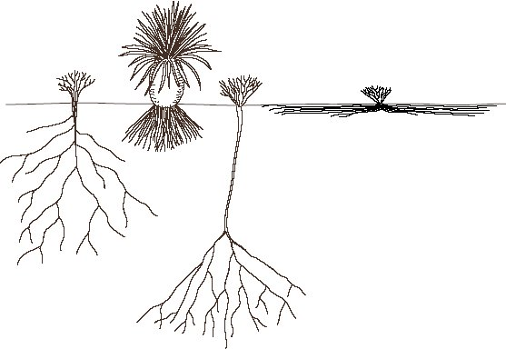

(a)     Explain how **three** features of the plants shown in the drawing are adaptations to desert conditions.

1 ...................................................................................................................

......................................................................................................................

2 ...................................................................................................................

......................................................................................................................

3 ...................................................................................................................

......................................................................................................................

**(3)**

(b)     Resurrection plants can lose up to 95% of their water content without dying. They can survive for many years in this desiccated state and will revive within hours of rainfall. Suggest which of the plants **W** to **Z** is most likely to be a resurrection plant. Give a reason for your choice.

......................................................................................................................

......................................................................................................................

......................................................................................................................

......................................................................................................................

**(2)**

**(Total 5 marks)**

**Q3.**          (a)     The table shows the transpiration rate of a group of plants exposed to different humidities at a temperature of 25°C.

|  |  |
| --- | --- |
| **Humidity / %** | **Transpiration rate / arbitrary units** |
| 20 | 26.0 |
| 40 | 21.0 |
| 50 | 16.5 |
| 60 | 11.0 |
| 70 | 9.5 |

Describe and explain the relationship between humidity and transpiration rate.

......................................................................................................................

......................................................................................................................

......................................................................................................................

......................................................................................................................

......................................................................................................................

......................................................................................................................

**(3)**

(b)     The diagrams show a section through a typical leaf and a section through a leaf from a xerophytic plant. The xerophytic leaf has a lower transpiration rate than the typical leaf.

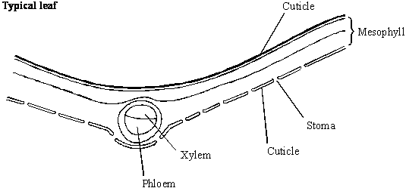

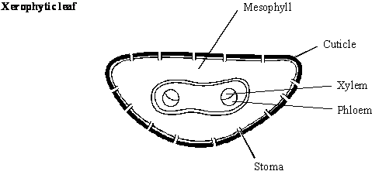

Describe **two** features shown in the diagram of the xerophytic leaf which reduce transpiration rate. Explain how each of these features contributes to a lower transpiration rate.

Feature 1 ......................................................................................................

Explanation ...................................................................................................

......................................................................................................................

Feature 2 ......................................................................................................

Explanation ...................................................................................................

......................................................................................................................

**(4)**

**(Total 7 marks)**

**Q4.**          (a)     The diameter of a branch of a tree and the rate of flow of water through the branch were measured over a 24-hour period. The results are shown in the graph.

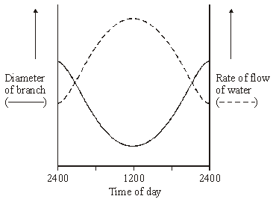

Using your knowledge of cohesion-tension theory

(i)      describe and explain the changes in rate of flow of water in the branch over the 24 hour period;

.............................................................................................................

.............................................................................................................

.............................................................................................................

.............................................................................................................

.............................................................................................................

.............................................................................................................

**(3)**

(ii)     explain why the diameter of the branch decreased during the first 12 hours.

.............................................................................................................

.............................................................................................................

**(1)**

(b)     A stem was cut from a transpiring plant. The cut end of the stem was put into a solution of picric acid, which kills plant cells. The transpiration stream continued. Suggest an explanation for this observation.

......................................................................................................................

......................................................................................................................

......................................................................................................................

......................................................................................................................

**(2)**

**(Total 6 marks)**

**Q5.**          (a)     Describe how water is moved through a plant according to the *cohesion-tension* hypothesis.

......................................................................................................................

......................................................................................................................

......................................................................................................................

......................................................................................................................

......................................................................................................................

......................................................................................................................

......................................................................................................................

......................................................................................................................

**(4)**

(b)     The mass of water lost from a plant was investigated. The same plant was used in every treatment and the plant was subjected to identical environmental conditions. In some treatments, the leaves were coated with a type of grease. This grease provides a waterproof barrier. The results of the investigation are given in the table.

|  |  |
| --- | --- |
| **Treatment** | **Mass lost in 5 days / g** |
| No grease applied | 10.0 |
| Grease applied only to the upper surface of every leaf | 8.7 |
| Grease applied to both surfaces of every leaf | 0.1 |

(i)      What is the advantage of using the same plant in every treatment?

.............................................................................................................

.............................................................................................................

**(1)**

(ii)     Why was it important to keep the environmental conditions constant?

.............................................................................................................

.............................................................................................................

**(1)**

(iii)     What is the evidence that the grease provides a waterproof barrier?

.............................................................................................................

.............................................................................................................

**(1)**

(c)     (i)      Calculate the mass of water lost in 5 days through the upper surface of the leaves.

Answer ................................................................

**(1)**

(ii)     Use your knowledge of leaf structure to explain why less water is lost through the upper surface of leaves than is lost through the lower surface.

.............................................................................................................

.............................................................................................................

.............................................................................................................

.............................................................................................................

**(2)**

**(Total 10 marks)**

**Q6.**          (a)     Explain how each of the following is related to the function of xylem tissue.

(i)      Xylem tissue contains hollow tubes.

.............................................................................................................

.............................................................................................................

(ii)     Lignin is present in xylem cell walls.

.............................................................................................................

.............................................................................................................

**(2)**

(b)     In an investigation the total area of the stomatal openings and the rate of flow of water through xylem were measured in a plant over a period of 24 hours. The results are shown in the graph.

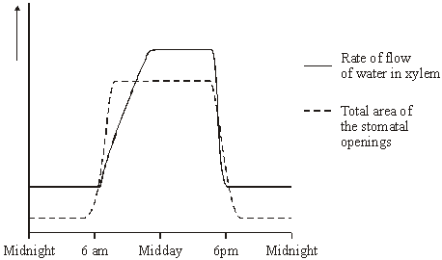

(i)      Describe the relationship between the rate of flow of water and the total area of the stomatal openings for the period of time between midday and midnight.

.............................................................................................................

.............................................................................................................

**(1)**

(ii)     Between 8 am and midday the rate of flow of water continues to rise although the total area of the stomatal openings remains constant. Explain why the rate of flow of water rises.

.............................................................................................................

**(1)**

(iii)     How would the curve showing the total area of the stomatal openings differ if the investigation was repeated on a dull day?

.............................................................................................................

.............................................................................................................

**(1)**

(c)     Some xerophytic plants have sunken stomata. Explain the advantage of this adaptation.

......................................................................................................................

......................................................................................................................

......................................................................................................................

......................................................................................................................

**(2)**

**(Total 7 marks)**

**Q7.**          (a)     Explain how xylem tissue is adapted for its function.

......................................................................................................................

......................................................................................................................

......................................................................................................................

......................................................................................................................

......................................................................................................................

......................................................................................................................

......................................................................................................................

......................................................................................................................

**(4)**

(b)     The graph shows the flow rate in the xylem in the trunk of a tree.

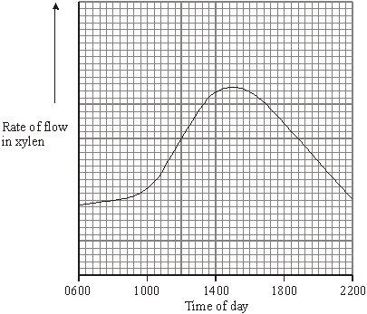

(i)      Explain the increase in the flow rate between 1000 and 1400 hours.

.............................................................................................................

.............................................................................................................

.............................................................................................................

.............................................................................................................

**(2)**

(ii)     The diameter of the trunk decreased during the same period, reaching its minimum when the flow rate was highest. Use your knowledge of the cohesion-tension theory to suggest an explanation for this decrease.

.............................................................................................................

.............................................................................................................

.............................................................................................................

.............................................................................................................

**(2)**

**(Total 8 marks)**

**Q8.**          **Figure 2** shows a single stoma and surrounding cells from the leaf of a xerophytic plant.

**Figure 2**

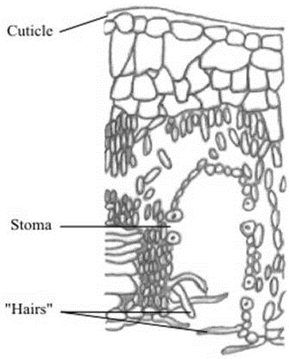

(i)      Explain how the cuticle reduces water loss.

......................................................................................................................

......................................................................................................................

**(1)**

(ii)     Explain how **one** of the other labelled parts reduces water loss.

......................................................................................................................

......................................................................................................................

......................................................................................................................

......................................................................................................................

**(2)**

**(Total 3 marks)**

**Q9.**          (a)     The graphs show the daily changes in environmental temperature and light intensity, and changes in the diameter of the trunk of a pine tree.

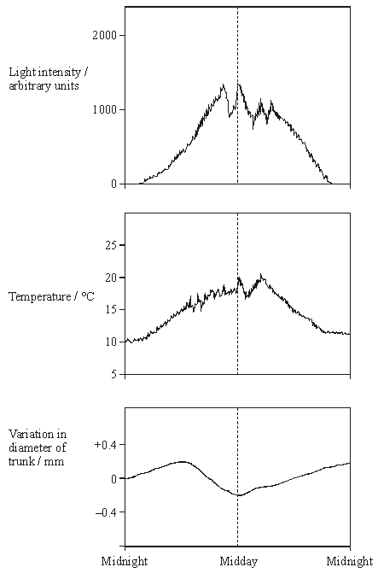

Use information from the graphs, and your knowledge of the cohesion-tension theory of water movement through a plant, to explain why the diameter of the trunk is smallest at midday.

......................................................................................................................

......................................................................................................................

......................................................................................................................

......................................................................................................................

......................................................................................................................

......................................................................................................................

......................................................................................................................

......................................................................................................................

......................................................................................................................

......................................................................................................................

......................................................................................................................

......................................................................................................................

......................................................................................................................

......................................................................................................................

**(6)**

(b)     Describe and explain **three** ways in which the leaves of xerophytic plants may be adapted to reduce water loss.

......................................................................................................................

......................................................................................................................

......................................................................................................................

......................................................................................................................

......................................................................................................................

......................................................................................................................

**(3)**

**(Total 9 marks)**

**Q10.**          The chart shows the results obtained from an investigation to determine the effect of light intensity on the tension in xylem vessels in the leaves of a plant.

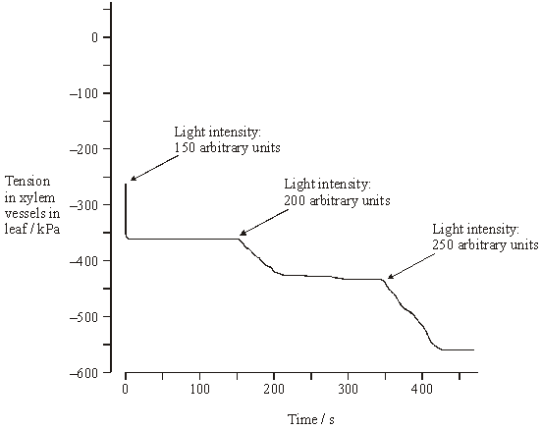

(a)     Describe and explain the effects of increasing light intensity on the tension in the xylem vessels in the leaves.

......................................................................................................................

......................................................................................................................

......................................................................................................................

......................................................................................................................

......................................................................................................................

......................................................................................................................

......................................................................................................................

......................................................................................................................

......................................................................................................................

......................................................................................................................

**(5)**

(b)     Explain why it was important to keep the humidity constant during the investigation.

......................................................................................................................

......................................................................................................................

......................................................................................................................

......................................................................................................................

**(2)**

**(Total 7 marks)**

**Q11.**          The drawing shows part of the lower leaf epidermis of sorghum.

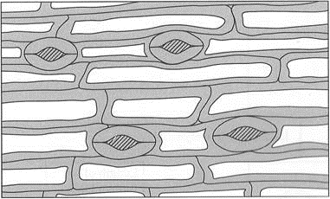



(a)     Calculate the number of stomata per mm2 of the leaf surface. Show your working.

Answer ....................................... stomata per mm2

**(2)**

(b)     Sorghum has few stomata per mm2 of leaf surface area. Explain how this is an adaptation to the conditions in which sorghum grows.

......................................................................................................................

......................................................................................................................

......................................................................................................................

......................................................................................................................

......................................................................................................................

......................................................................................................................

**(3)**

**(Total 5 marks)**

**Q12.**(a)     (i)      Give **two** ways in which the structure of starch is **similar** to cellulose.

1 ................................................................................................................

2 ................................................................................................................

**(2)**

(ii)     Give **two** ways in which the structure of starch is **different** from cellulose.

1 ................................................................................................................

2 ................................................................................................................

**(2)**

(b)     In plants, mass transport of sugars takes place through columns of sieve cells in the phloem. Other cells, called companion cells, transport sugars into, and out of, the sieve cells.

The diagram shows the structure of phloem.

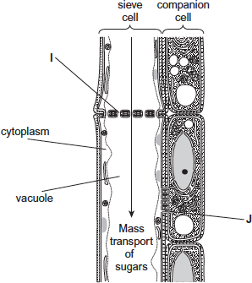

Structures **I** and **J** allow the transport of sugars between cells.

(i)      Using the diagram, suggest and explain **one** other way in which sieve cells are adapted for mass transport.

...................................................................................................................

...................................................................................................................

...................................................................................................................

...................................................................................................................

...................................................................................................................

**(2)**

(ii)     Using the diagram, suggest and explain **one** other way in which companion cells are adapted for the transport of sugars between cells.

...................................................................................................................

...................................................................................................................

...................................................................................................................

...................................................................................................................

...................................................................................................................

**(2)**

**(Total 8 marks)**

**Q13.**          (a)     Students measured the rate of transpiration of a plant growing in a pot under different environmental conditions. Their results are shown in the table.

|  |  |  |
| --- | --- | --- |
|  | **Conditions** | **Transpiration rate / g h–1** |
|  | **A**    Still air 15° | 1.2 |
|  | **B**    Moving air 15° | 1.7 |
|  | **C**    Still air 25° | 2.3 |

During transpiration, water diffuses from cells to the air surrounding a leaf.

(i)      Suggest an explanation for the difference in transpiration rate between conditions **A** and **B**.

.............................................................................................................

.............................................................................................................

.............................................................................................................

.............................................................................................................

.............................................................................................................

**(2)**

(ii)     Suggest an explanation for the difference in transpiration rate between conditions **A** and **C**.

.............................................................................................................

.............................................................................................................

.............................................................................................................

.............................................................................................................

.............................................................................................................

**(2)**

(b)     Scientists investigated the rate of water movement through the xylem of a twig from a tree over 24 hours. The graph shows their results. It also shows the light intensity for the same period of time.

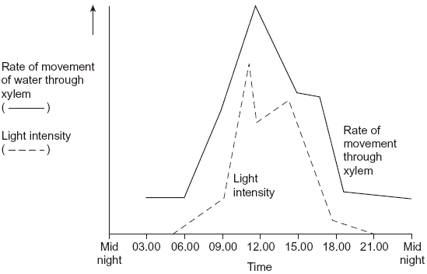

(i)      Describe the relationship between the rate of water movement through the xylem and the light intensity.

.............................................................................................................

.............................................................................................................

.............................................................................................................

**(1)**

(ii)     Explain the change in the rate of water movement through the xylem between 06.00 and 12.00 hours.

.............................................................................................................

.............................................................................................................

.............................................................................................................

.............................................................................................................

.............................................................................................................

**(2)**

(iii)     The scientists also measured the diameter of the trunk of the tree on which the twig had been growing. The diameter was less at 12.00 than it was at 03.00 hours.

Explain why the diameter was less at 12.00 hours.

.............................................................................................................

.............................................................................................................

.............................................................................................................

.............................................................................................................

.............................................................................................................

**(2)**

(c)     Arteries and arterioles take blood away from the heart.

Explain how the structures of the walls of arteries and arterioles are related to their functions.

......................................................................................................................

......................................................................................................................

......................................................................................................................

......................................................................................................................

......................................................................................................................

......................................................................................................................

......................................................................................................................

......................................................................................................................

......................................................................................................................

......................................................................................................................

......................................................................................................................

......................................................................................................................

**(6)**

**(Total 15 marks)**

**Q14.**A student investigated the rate of transpiration from a leafy shoot. She used a potometer to measure the rate of water uptake by the shoot. The diagram shows the potometer used by the student.

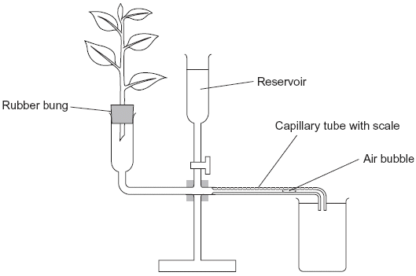

(a)     Give **one** environmental factor that the student should have kept constant during this investigation.

......................................................................................................................

**(1)**

(b)     The student cut the shoot and put it into the potometer under water. Explain why.

......................................................................................................................

......................................................................................................................

**(1)**

(c)     The student wanted to calculate the rate of water uptake by the shoot in cm3 per minute. What measurements did she need to make?

......................................................................................................................

......................................................................................................................

......................................................................................................................

......................................................................................................................

**(2)**

(d)     The student assumed that water uptake was equivalent to the rate of transpiration.

Give **two** reasons why this might **not** be a valid assumption.

1 ...................................................................................................................

......................................................................................................................

2 ...................................................................................................................

......................................................................................................................

**(2)**

(e)     The student measured the rate of water uptake three times.

(i)      Suggest how the reservoir allows repeat measurements to be made.

.............................................................................................................

.............................................................................................................

**(1)**

(ii)     Suggest why she made repeat measurements.

.............................................................................................................

.............................................................................................................

**(1)**

**(Total 8 marks)**

**Q15.**Scientists used fossil leaves from one species of pine tree to investigate whether changes in the concentration of carbon dioxide in the air over long periods of time had led to changes in the number of stomata in the leaves.

Their method is outlined below.

•        They selected sites of different ages.

•        They collected between 11 and 24 fossil leaves from each site.

•        They found the mean number of stomata per mm2 on the leaves from each site.

•        They estimated the age of each sample by dating organic remains around the leaves at each site.

They compared results from the fossil leaves with leaves from the same species of pine tree growing today.

They knew the concentration of carbon dioxide in the air at different times in the past.

Their results are shown in the table.

|  |  |  |  |
| --- | --- | --- | --- |
|  | **Age of sample  / years** | **Concentration of  carbon dioxide in the  air / %** | **Mean number of stomata  per mm2  (± standard deviation)** |
|  | present day | 0.0350 | 92 (±2) |
|  | 5000 | 0.0270 | 87 (±4) |
|  | 10 000 | 0.0250 | 95 (±2) |
|  | 15 000 | 0.0205 | 108 (±6) |
|  | 20 000 | 0.0195 | 115 (±4) |
|  | 25 000 | 0.0188 | 118 (±6) |
|  | 30 000 | 0.0190 | 130 (±6) |

(a)     The concentration of carbon dioxide in the air has changed with time. Use the data to describe how.

........................................................................................................................

........................................................................................................................

........................................................................................................................

........................................................................................................................

........................................................................................................................

**(2)**

(b)     The scientists calculated the mean number of stomata per mm2 and the standard deviation.

What does the standard deviation show?

........................................................................................................................

........................................................................................................................

........................................................................................................................

........................................................................................................................

........................................................................................................................

**(2)**

(c)     The scientists found the age of the fossil leaves by dating the organic remains around them.  
Would this have affected the accuracy of their data? Explain your answer.

........................................................................................................................

........................................................................................................................

........................................................................................................................

**(1)**

(d)     30 000 years ago the mean number of stomata per mm2 on the lower epidermis of pine tree leaves was much higher than it is today. This would have enabled the plant to grow faster when the carbon dioxide concentration of the air was low.

Explain why.

........................................................................................................................

........................................................................................................................

........................................................................................................................

**(1)**

(e)     A student who saw these results concluded that as the carbon dioxide concentration of the air had increased the number of stomata per mm2 in leaves had decreased.  
Do the results support this conclusion?

........................................................................................................................

........................................................................................................................

........................................................................................................................

........................................................................................................................

........................................................................................................................

........................................................................................................................

(Extra space) .................................................................................................

........................................................................................................................

........................................................................................................................

**(3)**

(f)      The leaves of plants that grow in dry areas usually have a low number of stomata per mm2. Use your knowledge of leaf structure to suggest **three** other adaptations that the leaves might have that enable the plants to grow well in dry conditions.

1 .....................................................................................................................

2 .....................................................................................................................

3 .....................................................................................................................

**(3)**

**(Total 12 marks)**

**Q16.**Organic compounds synthesised in the leaves of a plant can be transported to the plant’s roots.  
This transport is called translocation and occurs in the phloem tissue of the plant.

(a)     One theory of translocation states that organic substances are pushed from a high pressure in the leaves to a lower pressure in the roots.

Describe how a high pressure is produced in the leaves.

........................................................................................................................

........................................................................................................................

........................................................................................................................

........................................................................................................................

........................................................................................................................

........................................................................................................................

**(Extra space)** ................................................................................................

........................................................................................................................

........................................................................................................................

**(3)**

PCMBS is a substance that inhibits the uptake of sucrose by plant cells.

Scientists investigated the effect of PCMBS on the rate of translocation in sugar beet.  
The figure below shows their results.

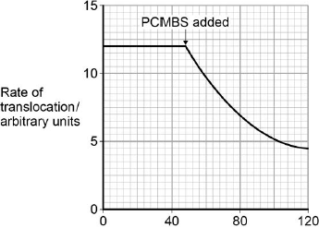                          
Time / minutes

(b)     During their experiment, the scientists ensured that the rate of photosynthesis of their plants remained constant.  
Explain why this was important.

........................................................................................................................

........................................................................................................................

........................................................................................................................

........................................................................................................................

**(2)**

(c)     The scientists concluded that some translocation must occur in the spaces in the cell walls.  
Explain how the information in the figure above supports this conclusion.

........................................................................................................................

........................................................................................................................

........................................................................................................................

........................................................................................................................

........................................................................................................................

**(2)**

**(Total 7 marks)**

**Q17.**          A student investigated the rate of transpiration from privet leaves.

•        She obtained two sets of ten privet leaves.

•        She left the ten leaves in set **A** untreated. She covered the upper surfaces of the ten leaves in set **B** with grease.

•        She weighed each set of leaves and then tied all the leaves in each set to a separate length of thread. This is shown in the diagram.

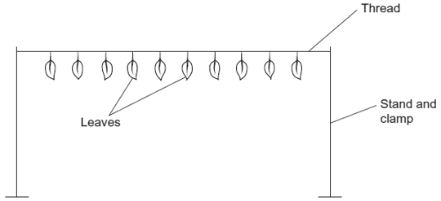

•        She then weighed each set of leaves every 20 minutes over a period of 2 hours and plotted a graph of her results.

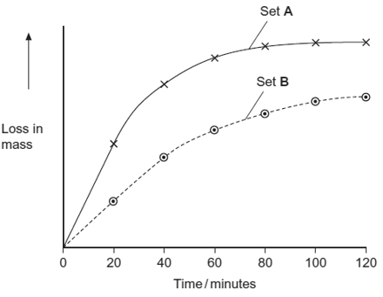

(a)Give **two** environmental conditions that the student should have kept constant during this investigation.

1 ...................................................................................................................

2 ...................................................................................................................

**(2)**

(b)The student measured the water loss in milligrams. Explain the advantage of using ten leaves when taking measurements in milligrams.

......................................................................................................................

......................................................................................................................

**(1)**

(c)Explain the change in mass of untreated leaves in set **A** shown in the graph.

......................................................................................................................

......................................................................................................................

......................................................................................................................

......................................................................................................................

......................................................................................................................

......................................................................................................................

*(Extra space) .*...............................................................................................

......................................................................................................................

......................................................................................................................

**(3)**

(d)The results that the student obtained for the leaves in set **B** were different from those for set **A**. Suggest an explanation for this difference.

......................................................................................................................

......................................................................................................................

......................................................................................................................

......................................................................................................................

......................................................................................................................

**(2)**

**(Total 8 marks)**

**Q18.**A biologist investigated the rate of water movement during the day in different parts of a tree. The results are shown in the graph.

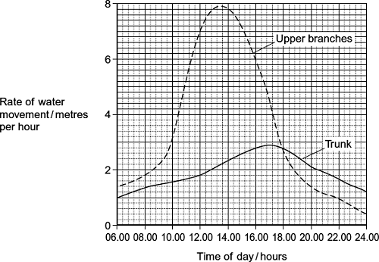

(i)      Describe how the rate of water movement in the upper branches changed over the period shown in the graph.

........................................................................................................................

........................................................................................................................

........................................................................................................................

........................................................................................................................

........................................................................................................................

**(2)**

(ii)     The rate of water movement in the upper branches was different from the rate of water movement in the trunk. Describe how.

........................................................................................................................

........................................................................................................................

........................................................................................................................

........................................................................................................................

........................................................................................................................

**(2)**

(iii)    The results of this investigation support the cohesion tension theory. Explain how.

........................................................................................................................

........................................................................................................................

........................................................................................................................

........................................................................................................................

........................................................................................................................

**(2)**

**(Total 6 marks)**

**Q19.**Students investigated the effect of removing leaves from a plant shoot on the rate of water uptake. Each student set up a potometer with a shoot that had eight leaves. All the shoots came from the same plant. The potometer they used is shown in the diagram.

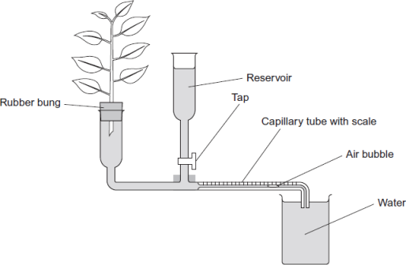

(a)     Describe how the students would have returned the air bubble to the start of the capillary tube in this investigation.

........................................................................................................................

........................................................................................................................

........................................................................................................................

**(1)**

(b)     Give **two** precautions the students should have taken when setting up the potometer to obtain reliable measurements of water uptake by the plant shoot.

1......................................................................................................................

2......................................................................................................................

**(2)**

(c)     A potometer measures the rate of water uptake rather than the rate of transpiration. Give **two** reasons why the potometer does **not** truly measure the rate of transpiration.

1......................................................................................................................

2......................................................................................................................

**(2)**

(d)     The students’ results are shown in the table.

|  |  |  |
| --- | --- | --- |
|  | **Number of leaves removed from the plant shoot** | **Mean rate of water uptake /  cm3 per minute** |
|  | 0 | 0.10 |
|  | 2 | 0.08 |
|  | 4 | 0.04 |
|  | 6 | 0.02 |
|  | 8 | 0.01 |

Explain the relationship between the number of leaves removed from the plant shoot and the mean rate of water uptake.

........................................................................................................................

........................................................................................................................

........................................................................................................................

........................................................................................................................

........................................................................................................................

........................................................................................................................

*(Extra space)*..................................................................................................

........................................................................................................................

........................................................................................................................

**(3)**

**(Total 8 marks)**

**Q20.**          (a)     Scientists measured the rate of water flow and the pressure in the xylem in a small branch. Their results are shown in the graph.

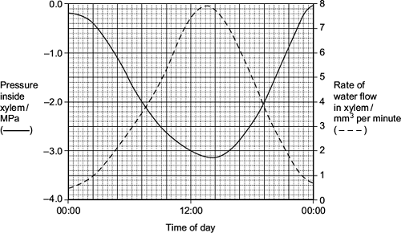

(i)      Use your knowledge of transpiration to explain the changes in the rate of flow in the xylem shown in the graph.

...............................................................................................................

...............................................................................................................

...............................................................................................................

...............................................................................................................

...............................................................................................................

...............................................................................................................

*(Extra space)* ........................................................................................

...............................................................................................................

...............................................................................................................

**(3)**

(ii)     Explain why the values for the pressure in the xylem are negative.

...............................................................................................................

...............................................................................................................

...............................................................................................................

**(1)**

(b)     Doctors measured the thickness of the walls of three blood vessels in a large group of people. Their results are given in the table.

|  |  |  |
| --- | --- | --- |
|  | **Name of vessel** | **Mean wall thickness /mm (± standard deviation)** |
|  | Aorta | 5.7 ± 1.2 |
|  | Pulmonary artery | 1.0 ± 0.2 |
|  | Pulmonary vein | 0.5 ± 0.2 |

(i)      Explain the difference in thickness between the pulmonary artery and the pulmonary vein.

...............................................................................................................

...............................................................................................................

...............................................................................................................

**(1)**

(ii)     The thickness of the aorta wall changes all the time during each cardiac cycle.  
Explain why

...............................................................................................................

...............................................................................................................

...............................................................................................................

...............................................................................................................

...............................................................................................................

...............................................................................................................

*(Extra space)* ........................................................................................

...............................................................................................................

...............................................................................................................

**(3)**

(iii)    Which of the three blood vessels shows the greatest variation in wall thickness?  
Explain your answer.

...............................................................................................................

...............................................................................................................

...............................................................................................................

**(1)**

(c)     Describe how tissue fluid is formed **and** how it is returned to the circulatory system.

........................................................................................................................

........................................................................................................................

........................................................................................................................

........................................................................................................................

........................................................................................................................

........................................................................................................................

........................................................................................................................

........................................................................................................................

........................................................................................................................

........................................................................................................................

........................................................................................................................

........................................................................................................................

*(Extra space)* .................................................................................................

........................................................................................................................

........................................................................................................................

........................................................................................................................

........................................................................................................................

........................................................................................................................

........................................................................................................................

........................................................................................................................

........................................................................................................................

........................................................................................................................

........................................................................................................................

**(6)**

**(Total 15 marks)**

**Q21.**(a)     Contrast the processes of facilitated diffusion and active transport.

........................................................................................................................

........................................................................................................................

........................................................................................................................

........................................................................................................................

........................................................................................................................

........................................................................................................................

**(Extra space)** ................................................................................................

........................................................................................................................

........................................................................................................................

**(3)**

Students investigated the uptake of chloride ions in barley plants. They divided the plants into two groups and placed their roots in solutions containing radioactive chloride ions.

•        Group **A** plants had a substance that inhibited respiration added to the solution.

•        Group **B** plants did not have the substance added to the solution.

The students calculated the total amount of chloride ions absorbed by the plants every 15 minutes. Their results are shown in the figure below.

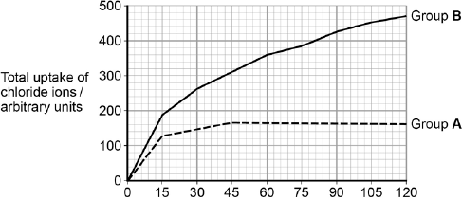  
                  Time / minutes

(b)     Calculate the ratio of the mean **rate** of uptake of chloride ions in the first hour to the **rate** of uptake of chloride ions in the second hour for group **B** plants.

Ratio = ................................... :1

**(2)**

(c)     Explain the results shown in the figure above.

........................................................................................................................

........................................................................................................................

........................................................................................................................

........................................................................................................................

........................................................................................................................

........................................................................................................................

........................................................................................................................

........................................................................................................................

........................................................................................................................

**(Extra space)** ................................................................................................

........................................................................................................................

........................................................................................................................

........................................................................................................................

**(4)**

**(Total 9 marks)**

**Q22.**Environmental factors can affect the density of stomata in the lower epidermis of leaves of plants of the same species.

Scientists investigated how growing plants at different temperatures affected the density of stomata in the lower epidermis of leaves. They grew plants of the same species from seeds.

Their method is outlined below.

•        They took 8 trays containing soil and planted 50 seeds in each tray.

•        They put each tray in a controlled environment at a different temperature.

•        When the plants had grown from the seeds, they selected 20 fully grown leaves from the plants in each tray.

•        They determined the mean number of stomata per mm2 in the lower epidermis for each group of leaves.

Their results are shown in the graph.

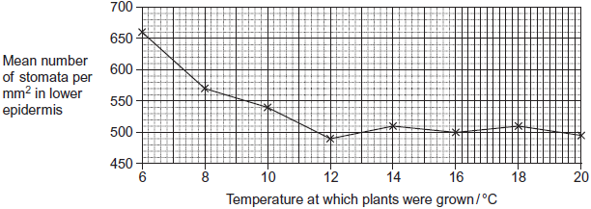

(a)     Give **three** environmental variables, other than temperature, that the scientists would have controlled when growing the plants.

1 .....................................................................................................................

2 .....................................................................................................................

3 .....................................................................................................................

**(3)**

(b)     The scientists used a range of temperatures from 6 to 20 °C.  
Using their data, explain why they did not use temperatures above 20 °C.

........................................................................................................................

........................................................................................................................

........................................................................................................................

**(1)**

(c)     The scientists only selected fully grown leaves from the plants.

Suggest why.

........................................................................................................................

........................................................................................................................

........................................................................................................................

**(1)**

(d)     The plants grown at higher temperatures had a lower number of stomata per mm2.  
This would be an advantage to the plant because the transpiration rate increases as the temperature increases.

Explain why the transpiration rate increases when the temperature increases.

........................................................................................................................

........................................................................................................................

........................................................................................................................

........................................................................................................................

........................................................................................................................

**(2)**

**(Total 7 marks)**

**Q23.**Scientists investigated the effect of the water potential of soil water on plant growth. They investigated the effect of this water potential on several plant processes.

The figure below shows their results in the form they were presented. The bars show whether or not each process was occurring.

The plants stopped growing when the water potential of the soil water was below –0.7 mPa. All of the changes in the plants were related to the ability of the roots to take up water from the soil.

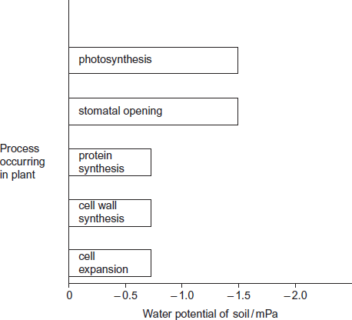

(a)     Describe the results in the figure.

........................................................................................................................

........................................................................................................................

........................................................................................................................

........................................................................................................................

........................................................................................................................

**(2)**

(b)     Explain the relationship between stomatal opening and photosynthesis.

........................................................................................................................

........................................................................................................................

........................................................................................................................

........................................................................................................................

........................................................................................................................

**(2)**

(c)     Although photosynthesis is still occurring, plants stop growing when the soil water potential falls below –0.7 mPa.

Use information from the figure above to suggest two reasons why.

........................................................................................................................

........................................................................................................................

........................................................................................................................

........................................................................................................................

........................................................................................................................

........................................................................................................................

**(3)**

**(Total 7 marks)**

**Q24.**(a)     Describe the mass flow hypothesis for the mechanism of translocation in plants.

........................................................................................................................

........................................................................................................................

........................................................................................................................

........................................................................................................................

........................................................................................................................

........................................................................................................................

........................................................................................................................

........................................................................................................................

**(Extra space)** ................................................................................................

........................................................................................................................

**(4)**

Scientists measured translocation in the phloem of trees. They used carbon dioxide labelled with radioactive 14C.

They put a large, clear plastic bag over the leaves and branches of each tree and added 14CO2. The main trunk of the tree was not in the plastic bag.

At regular intervals after adding the 14CO2 to the bag, the scientists measured the amount of 14CO2 released from the top and bottom of the main trunk of the tree. On the surface of the trunk of these trees, there are pores for gas exchange.

The following figure shows the scientists’ results.

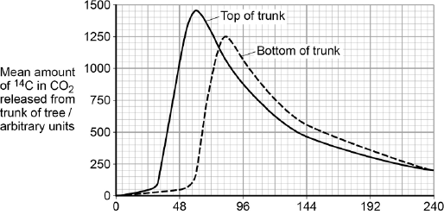  
                               Time after 14C labelled CO2 given / hours

(b)     Name the process that produced the 14CO2 released from the trunk.

........................................................................................................................

**(1)**

(c)     How long did it take the 14C label to get from the top of the trunk to the bottom of the trunk? Explain how you reached your answer.

........................................................................................................................

........................................................................................................................

........................................................................................................................

........................................................................................................................

**(2)**

(d)     What other information is required in order to calculate the mean rate of movement of the 14C down the trunk?

........................................................................................................................

........................................................................................................................

**(1)**

**(Total 8 marks)**

**M1.**          (a)     Single layer of cells / few layers of cells;

So that light that can pass through / cells absorb light;

**2**

(b)     Method of determining area of field of view / area seen using microscope;

Count number of stomata in field of view;

Repeats and calculation of mean;

**3**

(c)     Water vapour accumulates / increased humidity / reduced air movement (around stomata);

Water potential / diffusion gradient reduced;

**2**

**[7]**

**M2.**          (a)     shallow roots enable rapid uptake of rainfall (in **X** and / or **Z**);  
widespread / shallow roots allow collection of larger volume  
water / over a larger area / rapid uptake of water (in **Z**);  
swollen stem for water storage (in **X**);  
deep roots for accessing deep groundwater (in **Y**);  
small / no leaves so little transpiration;

**3**

(b)     **Z**;  
wide spread of roots for rapid water absorption;  
(accept **X**; if linked to leaves channelling water to roots)  
(ignore references to water storage abilities)  
(accept other responses if justified)

**2**

**[5]**

**M3.**          (a)     increased humidity leads to decreased transpiration;  
high humidity means more water in the air / increased saturation /   
increased water potential;  
reduced diffusion gradient / water potential gradient;  
slower rate of water loss / less evaporation;

**3 max**

(b)     thick cuticle;   
impermeable to water / waterproof;

sunken stomata;   
reduces water diffusion gradient;

shape of leaf / rounded / small surface area;  
small surface area : volume ratio;

*(explanation must be linked to feature)*

**4 max**

**[7]**

**M4.**          (a)     (i)      rate of flow increases to max at 1200 and then decreases;  
increasing transpiration / evaporation from leaves;  
transpiration creates tension / increases transpirational pull;  
water molecules are cohesive / stick together;  
produces a water column;

**3 max**

(ii)     (increase transpiration) produce a higher tension / reduces the  
pressure in the xylem reducing the diameter / adhesive forces   
between xylem and water;

**1**

(b)     water moves in dead cells / xylem is non-living tissue;  
the process is passive / no energy is needed;

**2**

**[6]**

**M5.**          (a)     1. water evaporates / transpires from leaves;  
2. reduces water potential in cell / water potential / osmotic gradient across  
    cells *(ignore reference to air space)*;  
3. water is drawn out of xylem;  
4. creates tension *(accept negative pressure, not reduced pressure)*;  
5. cohesive forces between water molecules;  
6. water pulled up as a column;

**4 max**

(b)     (i)      same surface area of leaf / number of leaves / age / thickness of  
cuticle;

**1**

(ii)     (environmental conditions) affect rate of transpiration / evaporation;

**1**

(iii)     presence of grease reduces water loss;

**1**

(c)     (i)      1.2 / 1.3g;

**1**

(ii)     more stomata on the lower surface;  
(thicker) waxy cuticle on the upper surface;

**2**

**[10]**

**M6.**          (a)     (i)      unrestricted / free / quick / easy water flow / continuous column / maintains transpiration stream;

**1**

(ii)     resists tension in water (column) / provides support / strength /   
maintains column of water / adhesion / prevents water loss

*(allow waterproofing in correct context i.e. not absorbing);*

**1**

(b)     (i)      as total area of stomata decreases the rate of water flow decreases /   
decrease is proportional;

*(reject proportional, ‘as one goes up the other goes up’ and ‘same shape’)*

**1**

(ii)     increasing / higher temperature causes increasing / higher rate of evaporation / transpiration;  
(*not water loss*)

**1**

(iii)lower plateau (start and finish at same point);  
(allow *if curve sketched on original graph, reject ‘curve is lower’*)

**1**

(c)     conserves water / reduces water loss / reduces transpiration / reduces evaporation;  
high humidity (in pit) / reduced water potential gradient / less water blown away  /  increased diffusion pathway;

**2**

**[7]**

**M7.**          (a)     long cells / tubes with no end walls;

continuous water columns;

no cytoplasm / no organelles / named organelle;

to impede / obstruct flow / allows easier water flow;

thickening / lignin;

support / withstand tension / waterproof / keeps water in cells;

pits in walls;

allow lateral movement / get round blocked vessels;

**4 max**

(b)     (i)      increase in transpiration rate / evaporation due to  
increase in temperature ;

increased (kinetic) energy of water molecules;

*OR*

increase in light (intensity) increases transpiration rate / evaporation;

greater stomatal aperture / more stomata open so increase in flow  
rate due to cohesion / attraction of water molecules;

**2 max**

(ii)     adhesion / attraction of water molecules to walls of xylem;

results in tension as water pulled up stem;

pulling in walls;

**2**

**[8]**

**M8.**          (i)      (waxy so) impermeable to water / waterproof / stops water  
passing through;

**1**

(ii)     reference to hairs / position of stomata (sunken stomata /   
stomata in pits )  
LINKED to reduced air movement / trap layer of air /   
trap water vapour (*reject water) /* maintains humidity;

reduces diffusion gradient / concentration gradient of water /   
water potential gradient;

*OR*

stoma can close;  
reduces area for evaporation or transpiration;

**2**

**[3]**

**M9.**          (a)    1.      Diameter of trunk minimal at warmest / brightest time of day / midday = warmest /   
          brightest;

2.      Stomata open in light → more water loss;

3.      Water evaporates more when warm / more heat energy for water evaporation;

4.      Hydrogen-bonding between water molecules / cohesion ( / described) between water molecules;

5.      Adhesion (described) between water molecules and walls of xylem vessels;

6.      (Xylem) pulled inwards by faster flow of water / pulled in by tension;

**6**

(b)

|  |  |
| --- | --- |
| Feature | Explanation |
| Think cuticle / wax layer | waterproof / impermeable; |
| Sunken stomata | saturated layer of still air outside; |
| Hairy | saturated layer of still air outside; |
| Leaves small / reduced to spines / needles | reduced S.A. for water loss; |
| Leaves roll up in dry weather | less S.A. for water loss / stomata covered / saturated region of still air; |
| Reduced number of stomata | reduced S.A. for water loss; |
| CAM ( / Crassulacean Acid Metabolism) | stomata closed in light / in warm / only open in dark / when cool; |

*3 features but no explanations – max 1 mark*

**max 3**

**[9]**

**M10.**         (a)     1.       (when light intensity is increased) tension in the xylem becomes greater / more negative / stronger;

2.       (this increase) takes place over ≈100 second;  
3.       then levels out;  
4.       stomata open (more);  
5.       increased evaporation / transpiration;  
6.       therefore the water potential of leaf cells becomes more negative /   
          lower;  
7.       therefore more water moves from xylem to surrounding cells;  
8.       down a water potential gradient;  
9.       correct ref. to hydrogen bonds / cohesion;

**5 max**

(b)     humidity will affect (the rate of) evaporation / transpiration;  
increased humidity / humid conditions decreases rate of water loss;

**2**

**[7]**

**M11.**          (a)     235–240;;  
*(one mark for an answer between 200-300  
based on 2 - 3 stomata in 0.01mm2Alternatively, one mark for calculating the area of the  
rectangle correctly as 0.016 – 0.017mm2)*

**2**

(b)     grows in arid / dry conditions;  
less surface area;  
(rate of) transpiration / water loss would be reduced;

**3**

**[5]**

**M12.**(a)     (i)      ***(Both)***

1.      Are polymers / polysaccharides / are made of monomers / of monosaccharides;

2.      Contain glucose / carbon, hydrogen and oxygen;

3.      Contain glycosidic bonds;

4.      Have 1−4 links;

*Neutral: references to ‘unbranched’, insoluble, formed by condensation, flexible and rigid*

*Are made of the monomer glucose = MP 1 and 2 = 2 marks*

5.      Hydrogen bonding (within structure).

*Ignore reference to H bonds between cellulose molecules*

**2 max**

(ii)     (Starch)

1.      Contains α / alpha glucose;

*Assume ‘it’ refers to starch*

*Accept: converse arguments only if linked directly to cellulose*

*Accept: forms α glycosidic bonds*

2.      Helical / coiled / compact / branched / not straight;

3.      1,6 bonds / 1,6 branching;

4.      Glucoses / monomers same way up;

5.      No H-bonds between molecules;

6.      No (micro / macro) fibres / fibrils.

**2 max**

(b)     (i)      1.      No / few organelles / very little cytoplasm / cytoplasm at  
         edge / more room / hollow / large vacuole / large space /  
         thick walls;

*Accept strong walls for thick walls*

2.      (So) easier / more flow / (thick / strong walls) resist pressure.

*Easier flow may be expressed in other ways e.g. lower resistance to flow*

**2**

(ii)     1.      Mitochondria release energy / ATP / site of respiration;

***Q*** *Reject: ‘produce energy’*

*but accept produce energy in form of ATP*

2.      For active transport / uptake against concentration gradient.

*Note: no mark is awarded for simply naming an organelle*

***OR***:

3.      Ribosomes / rough endoplasmic reticulum produce(s)  
         proteins;

*Concept of making proteins needed*

4.      (Proteins) linked to transport e.g. carrier proteins / enzymes.

**2**

**[8]**

**M13.**         (a)     (i)      1.      Removes water vapour / moisture / saturated air;

2.      Increases water potential gradient / more diffusion / more evaporation;

**2**

(ii)     1.      Increases kinetic energy so water molecules move faster;

2.      Increases diffusion / evaporation;

**2**

(b)     (i)      Positive correlation / as light intensity increases so does rate of water movement / follows same pattern / directly proportional;

**1**

(ii)     1.      Stomata open and photosynthesis increases / transpiration increases;

2.      More water pulled up due to cohesion between water molecules / by cohesion tension;

**2**

(iii)    1.      Water pulled up trunk / moves up at fast rate under tension;

2.      Sticking / adhesion (between water and) cells / walls / pulls xylem in;

*Adhesion is not a specification requirement.*

*Accept cohesion in this context*

**2**

(c)     **Elastic tissue**

1.      Elastic tissue stretches under pressure / when heart beats then recoils / springs back;

2.      Evens out pressure / flow;

*Do not allow credit for expands / contracts / relaxes in this context.*

*From a marking viewpoint ignore all specific references to arteries and arterioles. Consider all points as applying to both.*

*2   Do accept controls*

**Muscle**

3.      Muscle contracts to reduce diameter of lumen / vasoconstriction / constricts vessel;

4.      Changes flow / pressure;

**Epithelium**

5.      Epithelium smooth;

6.      Reduces friction / blood clots / less resistance;

**6**

**[15]**

**M14.**(a)     Light (intensity) / temperature / air movement / humidity;

**1**

(b)     Prevent air entering / continuous water column;

*Allow answer in context of shoot, xylem or potometer.*

**1**

(c)     Distance and time;

*Reject ‘amount bubble moves’*

**1**

Radius / diameter / area (of capillary tube);

**1**

(d)     (used to provide) turgidity / support / description of;

(used in) photosynthesis / (produced in) respiration;

Apparatus not sealed / ’leaks’;

**2 max**

(e)     (i)      Returns bubble (to start);

**1**

(ii)     Increases reliability (of results) / anomalous result can be identified;

***Q*** *Ignore references to validity / precision / accuracy etc.*

**1**

**[8]**

**M15.**(a)     1.      The more recent the sample the greater the concentration;

*Accept converse*

*This could be expressed by reference to time e.g. ‘concentration has increased since 25 000 years ago*

2.      Increases most in last 5000 years / more or less constant / slight increase between 30 000 and 15 000 years ago;

**2**

(b)     1.      Variation in data / spread of data;

*Reject references to range e.g. ‘range of data’*

2.      Around the mean;

*Both marks are possible in the context of using the data*

**2**

(c)     1.      Yes as pine leaves not in organic matter of the same age;

2.      No as organic matter would be the same age as the pine leaves;

*Accept either approach*

**1 max**

(d)     Can get more CO2 for photosynthesis;

*More CO2 enters leaf is insufficient.   
Accept light-independent (reaction) as equivalent*

**1**

(e)     Any **three** from:

1.      (Overall data show) negative correlation;

*Do not allow description of correlation because in question stem*

2.      Little change in number of stomata in last 10 000 years;

3.      Small sample size;

4.      Only one species studied;

5.      Other factors / named factor may have affected number of stomata;

6.      Evidence does not support the conclusion between 30 000 and 25 000 years ago / between 5000 years ago and present day;

*Accept reference to either one of these age ranges*

7.      Appropriate reference to standard deviations (in comparing means);

*E.g. no overlap between 15 000 and 10 000 years ago*

**3 max**

(f)     Any **three** from :

1.      Thick cuticle;

2.      Small leaves / low surface area;

*Accept other ways of describing ‘small’, e.g. ‘needle-like’*

3.      Hairy leaves;

4.      Sunken stomata;

5.      Rolled leaves;

**3 max**

**[12]**

**M16.**(a)     1.      Water potential becomes lower / becomes more negative (as sugar enters phloem);

2.      Water enters phloem by osmosis;

3.      Increased volume (of water) causes increased pressure.

**3**

(b)     1.      Rate of photosynthesis related to rate of sucrose production;

2.      Rate of translocation higher when sucrose concentration is higher.

**2**

(c)     1.      Rate of translocation does not fall to zero / translocation still occurs after 120 minutes;

2.      But sucrose no longer able to enter cytoplasm of phloem cells.

**2**

**[7]**

**M17.**          (a)     Light;

Humidity / moisture in air;

Air movement / wind;

Temperature;

**2 max**

(b)     Decreases chance of error / larger difference in mass / improves  
accuracy / precision;

*Neutral: Reliability, references to anomalies.*

**1**

(c)     1.      Stomata open, (water) transpired / evaporates / diffuses out (via) water potential gradient / leaf has higher water potential;

2.      Water potential / diffusion gradient reduces (during investigation) as water not being replaced / no water supply;

3.      Stomata close / closing;

*Must clearly indicate that stomata are open for third marking point. However, allow correct descriptions of guard cells being turgid or flaccid as being equivalent to stomata being open or closed. ‘Loss through stomata’ on its own is not sufficient.*

*Neutral: Any reference to ‘loss by osmosis’.*

**3**

(d)     Stomata (on upper surface) covered / stomata close due to lack of  
light / (grease provides) longer diffusion pathway;

Less evaporation / transpiration / diffusion out;

*Accept: Evaporation / transpiration / diffusion ‘stops’ for second point as this could be referring to upper surface.*

**2**

**[8]**

**M18.**(i)      1.      Increases then decreases;

*Allow peak / maximum at any time between 13.00 - 14.00 or 7.8 - 8.0;*

2.      Peak / maximum at 13.00 / 14.00 (hours) / 7.8 - 8.0;

**2**

(ii)     1.      Maximum / overall rate is higher (in branches);

*Allow converse for all marking points.*

2.      Reaches maximum / peak earlier (in the day) (in branches);

3.      Starts higher / ends lower (in branches)

**2**

(iii)    1.      Movement starts / peaks earlier in branches / higher up;

2.      Creates tension / 'negative pressure' / 'pull'

**2**

**[6]**

**M19.**(a)     Open / use tap / add water from reservoir;

**1**

(b)     1.      Seal joints / ensure airtight / ensure watertight;

*Answer must refer to precautions when setting up the apparatus*

*Ignore: references to keeping other factors constant*

2.      Cut shoot under water;

3.      Cut shoot at a slant;

4.      Dry off leaves;

5.      Insert into apparatus under water;

6.      Ensure no air bubbles are present;

7.      Shut tap;

8.      Note where bubble is at start / move bubble to the start position;

**2 max**

(c)     1.      Water used for support / turgidity;

*Accept: water used in (the cell’s) hydrolysis or condensation (reactions) for one mark. Allow a named example of these reactions*

2.      Water used in photosynthesis;

3.      Water produced in respiration;

4.      Apparatus not sealed / ‘leaks’;

**2 max**

(d)     As number of leaves are reduced (no mark),

*Accept: converse arguments*

1.      Less surface area / fewer stomata;

3.      Less evaporation / transpiration;

4.      Less cohesion / tension / pulling (force);

**3**

**[8]**

**M20.**         (a)     (i)      1.      Stomata open;

*Allow converse*

2.      Transpiration highest around mid-day as middle of day warmer / lighter;

*2. Allow ‘Sun is at its hottest’*

3.      (Increased) tension / water potential gradient;

*Ignore ‘pull, suck’*

**3**

(ii)     (Inside xylem) lower than atmospheric pressure / (water is under) tension;

*Accept cohesion tension. Ignore vacuum*

**1**

(b)     (i)     High pressure / smoothes out blood flow / artery wall contains more collagen / muscle / elastic (fibres) / connective tissue;

*Accept converse for pulmonary vein*

*Incorrect function of artery disqualifies mark*

**1**

(ii)     1.      (Aorta wall) stretches because ventricle / heart contracts / systole / pressure increases;

*1. Allow expand*

2.      (Aorta wall) recoils because ventricle relaxes / heart relaxes / diastole / pressure falls;

*2. Allow spring back*

*Reject any reference to contract / relax in MP1 and 2*

3.      Maintain smooth flow / pressure;

**3**

(iii)    Aorta 1.2 / largest SD;

*Allow pulmonary vein provided candidate relates standard deviation to mean*

**1**

(c)     Formation

1.      High blood / hydrostatic pressure / pressure filtration;

2.      Forces water / fluid out;

*2. Reject plasma, ignore tissue*

3.      Large proteins remain in capillary;

Return

4.      Low water potential in capillary / blood;

5.      Due to (plasma) proteins;

6.      Water enters capillary / blood;

7.      (By) osmosis;

*7. Osmosis must be in correct context*

8.      Correct reference to lymph;

**6 max**

**[15]**

**M21.**(a)     1.      Facilitated diffusion involves channel or carrier proteins whereas active transport only involves carrier proteins;

2.      Facilitated diffusion does not use ATP / is passive whereas active transport uses ATP;

3.      Facilitated diffusion takes place down a concentration gradient whereas active transport can occur against a concentration gradient.

*Since ‘contrast’, both sides of the differences needed*

**3**

(b)     3.3:1.

*Correct answer = 2 marks*

*If incorrect, allow 1 mark for 470–360 / 60 for rate in second hour*

**2**

(c)     1.      Group **A** – initial uptake slower because by diffusion (only);

2.      Group **A** – levels off because same concentrations inside cells and outside cells / reached equilibrium;

3.      Group **B** – uptake faster because by diffusion plus active transport;

4.      Group **B** fails to level off because uptake against gradient / no equilibrium to be reached;

5.      Group **B** – rate slows because few / fewer chloride ions in external solution / respiratory substrate used up.

**4 max**

**[9]**

**M22.**(a)     Any **three** from:

1.      Light;

2.      Carbon dioxide;

3.      Type of soil;

4.      Minerals / nutrients;

*Accept named example*

5.      Water (in soil);

6.      Humidity (of air);

7.      pH (of soil)

8.      Planting density;

*Idea of equally spaced*

**3 max**

(b)     Already levelled out (before 20 °C);

**1**

(c)     Young leaves (may) have different number of stomata (per mm2) / number of stomata (per mm2) changes during development (of leaf);

*Accept reference to density of stomata*

**1**

(d)     Any **two** from:

*Points 1 and 2 need context of ‘more’*

1.      Molecules have more kinetic energy;

*Accept KE*

2.      Faster diffusion of water / more evaporation of water (as temperature increases in leaf);

*For this point, diffusion must relate to movement of water*

3.      For this point, diffusion must relate to movement of water

**2 max**

**[7]**

**M23.**(a)     1.      Protein synthesis **and** cell wall synthesis **and** cell expansion   
         stop at −0.7 / at a *higher* water potential than other two;

*If all 3 are correctly identified in marking point 1, accept ‘the others / the other two’ in marking point 2, and vice versa*

2.      Photosynthesis **and** stomatal opening stop at -1.5 / at a *lower* water potential than other three;

*Correct processes must be named in at least one of marking point 1 or marking point 2*

*Where reference to water potential differences are made, they must be comparative, eg ‘higher’*

**2**

(b)     1.      Stomata allow uptake of carbon dioxide;

2.      Carbon dioxide used in / required for photosynthesis;

**2**

(c)     1.      Growth involves cell division / cell expansion / increase in mass;

*Marking point 1 is for the principle*

2.      Protein synthesis stops **so** no enzymes / no membrane proteins / no named protein (for growth / division);

*Marking points 2, 3 and 4 require appreciation of ‘why’ before credit can be awarded*

*‘named’ protein must relate to proteins involved in growth or cell division*

3.      Cell wall synthesis stops **so** no new cells can be made;

*Full credit is possible without a statement of the principle   
(marking point 1)*

4.      No cell expansion / increase in mass **because** (cells) stop taking up water;

**3 max**

**[7]**

**M24.**(a)     1.      In source / leaf sugars actively transported into phloem;

2.      By companion cells;

3.      Lowers water potential of sieve cell / tube and water enters by osmosis;

4.      Increase in pressure causes mass movement (towards sink / root);

5.      Sugars used / converted in root for respiration for storage.

*Accept starch*

**4 max**

(b)     Respiration.

**1**

(c)     1.      (About) 30 hours;

2.      Time between peak 14C at top of trunk and bottom.

**2**

(d)     Length of trunk (between top and bottom).

**1**

**[8]**

**E1.**          (a)     Most candidates appreciated that having a thin piece of epidermis would allow light to pass through the specimen. However, far fewer candidates could explain this in terms of a single or few layers of cells being present. A common misconception was that being thin enabled organelles to be identified.

(b)     This proved to be the most demanding question on the paper with over 75% of candidates scoring zero. It was very evident that most candidates had little experience or recall of this type of practical work. Most candidates simply stated that the number of stomata on a leaf would be counted and divided by the area without any reference to using the slide. Almost invariably when candidates did gain a mark, this was for carrying out repeats and calculating a mean.

(c)     Although many candidates gained one mark, a significant minority did not mainly due to poor or imprecise terminology. References to ‘trapped water droplets’ rather than water vapour or to ‘concentration gradient’ rather than water potential gradient were frequently penalised. Consequently, few candidates obtained both marks.

**E2.**          (a)     Most candidates could identify three features which were adaptations to desert conditions. Some candidates were rather vague with responses like ‘lots of roots’, and many failed to identify which plant(s) they were referring to.

(b)     Most candidates correctly identified **Z** as the resurrection plant and gained two marks. The most common error was suggesting plant **X** because of its ability to store water. This was not given credit.

**E3.**          Again most candidates scored highly on this question, with many achieving maximum marks.

(a)     Most candidates were able to describe the relationship between humidity and transpiration rate, and then to explain this relationship in terms of how high humidity increases the amount of water in the air, and therefore decreases the diffusion gradient, resulting in a slower rate of water loss. Marks were often not awarded for incorrect or vague explanations, such as ‘water is lost to the air by osmosis’ or ‘humidity affects the aperture of the stomata’.

(b)     There were many excellent answers relating features evident in the diagrams with clear explanations of how each feature contributes to a lower rate of transpiration. For example, many candidates correctly recognised the thicker cuticle of the xerophytic leaf and explained how the waterproof property of the cuticle reduces water loss. A lack of precision often resulted in few marks, such as the vague statement that the cuticle reduces water loss with no explanation of how this is achieved. Sunken stomata reducing the diffusion gradient of water and the shape of the leaf resulting in a smaller surface area:volume ratio, were correctly identified as other explanations, but they were less common.

**E4.**          (a)     (i)      This question was answered well by only the better candidates. The description of water flow was not well done; often the information in the graph was not used to give an A level standard description. For example, although many candidates noted that it increased and decreased few wrote that water flow peaked at midday. To explain this pattern many answers used the phrase ‘cohesion tension’ very loosely. However, good answers explained clearly the relationship between the rate of transpiration, the movement of water and the cohesive properties of water molecules. There were many confused accounts which involved general descriptions of water flow and diameter changes which were not creditworthy. The fact that transpiration increased during the day was often missed, and the link between that and an increased tension was tenuous at best.

(ii)     Very few candidates gained credit for explaining why the diameter of the branch decreased. A common misconception was that the change was due to lack of turgor. The effect of cohesion and adhesion confused many candidates with few making references to a reduction in pressure; far more candidates thought that there was an increase in pressure.

(b)     Many answers correctly stated that picric acid would have no effect on xylem as this is non-living or dead tissue. Better answers went on to relate this observation to the passive nature of the transpiration stream.

**E5.**          (a)     There were some very good answers achieving maximum marks. However, many answers used very vague language, such as ‘water is pulled up by cohesion-tension’, with no description of what cohesion involves, or what creates the tension. Water was said by many to be ‘sticky’. This was the lowest level of answer accepted for a mark about cohesion. Root pressure was often included in the description of cohesion-tension, which cost candidates time but gained no credit.

(b)     (i)      Many candidates appear to confuse the concept of fair testing with reliability; both terms being used interchangeably.

(ii)     More able candidates answered in terms of how an environmental variable could affect the rate of transpiration, or the rate of evaporation, rather than just stating ‘to keep water loss the same’.

(iii)     Most candidates gave the correct answer.

(c)     (i)      Most candidates calculated the mass of water lost accurately.

(ii)     Many candidates missed marks by failing to give a comparison between the upper and lower surfaces of leaves. There were many references to ‘pores’ rather than ‘stomata’, or a ‘waxy layer’ rather than a ‘cuticle’, indicating a poor knowledge of leaf structure.

**E6.**          (a)     Both parts of this question were answered correctly by the vast majority of candidates.

(b)     (i)      Many candidates achieved the mark for this question by correctly identifying the relationship in the given time period, but some failed to achieve it because they gave a general relationship which is not valid between midday and midnight: for example, ‘the relationship is proportional’ does not sufficiently explain the decreasing aspect of the relationship in the time given. Some candidates lost this mark by making an inappropriate link between the cause and effect: for example, ‘the total area of stomatal openings decreases when the rate of flow of water decreases’.

(ii)     Relatively few candidates gave enough detail in their answer to achieve this mark. Often they failed to appreciate the temperature is likely to continue increasing between 8 am and midday. If they had this idea they often failed to link it to a process in which water is lost from a plant (by evaporation or transpiration). A lot of candidates recognised that there would be an increased rate of transpiration, but they gave the wrong reason for it: for example, because light intensity has increased or there is more photosynthesis taking place.

(iii)     This proved to be a difficult question for many candidates who clearly understood what was required, but who expressed themselves without sufficient clarity to gain the mark: for example, ‘the curve is lower’, ‘the area of stomata is smaller’ were often quoted and gained no mark.

(c)     Xerophytic adaptations are known well by the majority of candidates. Many achieved both marks.

**E7.**          (a)     This question produced a full range of marks with some candidates gaining full marks but a substantial number gaining no marks. This appeared to be a topic that was often overlooked by centres.

(b)     Only the better candidates scored both marks in part (i). Many correctly linked an increase in temperature or light intensity with an increase in the rate of transpiration. Only the more able went on to explain this increase in terms of kinetic energy or stomatal aperture. Few related this to the flow rate. Part (ii) was answered well with many candidates able to relate the adhesion properties of water to the pulling in of xylem vessels. As in previous years, many candidates used the terms ‘cohesion’ and ‘tension’ very loosely with little understanding of their meaning.

**E8.**          The role of the cuticle was well known. Some candidates failed to gain marks through incomplete answers such as ‘the cuticle reduces transpiration’ rather than relating water loss to the impermeable nature of the cuticle. In part (ii), most candidates were able to describe a feature that reduces water loss, but only the more able candidates explained how the feature reduces transpiration by affecting the water diffusion gradient.

**E9.**          (a)    Most candidates used the graphs to link midday with high light intensity and high temperature. Better candidates related higher temperature to a high rate of water evaporation, but only a few commented on the relationship between high light intensity and stomatal opening. Most understood the principles of cohesion and adhesion with a fair proportion mentioning hydrogen bonding as the cause of these phenomena. While most realised that water was pulled up the plant, driven by transpiration from the leaves, explanations of how this would generate an inward pulling force on the xylem vessels were frequently not very clear. In some cases due to the use of the term ‘pressure’, it was difficult to decide what the candidate intended.

(b)     While most candidates were able to give three adaptations of the leaves of xerophytic plants for reduction of water loss, explanations were often not very thorough. Others were excellent, stating that trapped layers of water vapour would reduce the water potential gradient and hence slow down diffusion of water molecules. Some, unfortunately, did not confine themselves to the constraints of the question and included inappropriate references to the root system or to water storage tissue in the stem.

**E10.**          (a)     An increase in negativity, representing an increase in tension, was a stumbling block for many candidates. Having set off on the wrong foot they then found it more difficult to answer the question effectively, even though they often understood the mechanics of water transport quite well. Few candidates scored more than one mark for their description of the effects of increasing light intensity. A reasonable number of candidates lost their way in detailed descriptions of the mechanism of stomatal opening. As a result, few candidates scored all five marks although many gained some credit. The contribution of increased photosynthesis to tension is so small that credit could not be given for the suggestion.

(b)     This question produced many simplistic responses which centred around the idea of ‘a fair test’.

It appeared that many of the candidates knew the answer failed to gain marks for not being sufficiently explicit. Many answers made the connection between humidity and transpiration but went no further.

**E11.**          (a)     Very few candidates correctly worked out the area as 0.0167mm2 and many seemed to have a basic problem with calculating areas. It was common to see 0.1 x 0.1 = 0. l mm2. Many candidates failed to gain credit by carrying out calculations that were not clearly identified. A common approach was to estimate the number of stomata in an area 0. 1mm x 0. 1mm, which gained credit if done correctly. Many gave answers that were clearly incorrect, such as 20-25 or even 0.25!

(b)     Most candidates picked up the 2 marking points but some failed to gain the second point by incorrectly stating that ‘fewer stomata prevent water loss’. Few answers referred to the idea of there being a reduced surface area.

**E12.**(a)     This part discriminated more than was, perhaps, intended. In both (i) and (ii), many students did not read the question carefully enough and included comparisons of properties or function, rather than structure. For example, many wrote about starch and cellulose being insoluble but this is not a similarity of structure. About 40% obtained both marks in (i) and 60% in (ii).

(b)     This required students to use the figure and apply some basic concepts. As in (a), some students did not read the stem of the question carefully enough and couched their answers in terms of structures I and J.

(i)      Many students described (in various ways) the large open space in the sieve cell and some went on to suggest that this would lead to a (relatively) unrestricted flow; about 30% obtained 2 marks and 40% 1 mark.

(ii)     This was where more students failed to score because of answers based around plasmodesmata (J), which are precluded by the stem of the question. Over 40% obtained 2 marks by linking energy from mitochondria to active transport. Some students missed one mark because the examiners rejected references to mitochondria creating or making energy.

**E13.**          (a)     Many candidates appeared to understand the principles that were being tested in the two parts of this question but explanations often fell short of the required standard. In part (i) a reference was required to the dispersal of water vapour and the consequences of this on the diffusion or water potential gradient. Many less able candidates offered explanations in terms of moving air forcing water out of the leaf or involving water moving out of the leaf by osmosis. Those who appreciated, in part (ii), that an increase in temperature increased kinetic energy usually progressed to refer to an increase in the rate of movement of water molecules. Others, perhaps inevitably, attempted to link temperature with enzyme activity

(b)     Most candidates followed the instruction in part (i) and described the relationship with sufficient precision to gain the mark. They were also able to link movement through the xylem to increased light intensity and stomatal opening with some success. However, by far the most popular response to part (ii) was to suggest that there would be an increase in the rate of photosynthesis and therefore more water would be needed by the plant. The terms cohesion and tension were frequently used in such a way as to suggest little real understanding. It was not uncommon to read about water molecules being pulled through the xylem because “they stick to each other by cohesion-tension”. The idea conveyed in part (iii) appeared to be unfamiliar to all but the best candidates. The structure of the question should have lead candidates to realise that it was testing the same basic principle. The question was worded in such a way as to encourage candidates to explain the lower diameter at 12.00. Many opted however to explain the converse of this and based their answers on suggestions involving storage of water in the xylem.

(c)     Responses to this question were very disappointing as evidenced by the large number of candidates who were unable to gain credit. Many answers were very general and did little more than suggest, often at great length, that “strong” walls meant that blood vessels did not burst under pressure. Such answers often established this point for arteries, then repeated it for arterioles. Only the very best candidates appeared aware of the presence of muscle and elastic tissue within the walls and could describe the roles of these particular tissues. There was also much emphasis on valves. They were correctly described as not being present in arteries and arterioles but then discussed in terms of what they would have done if they had been present. Those candidates who referred to the endothelium were generally able to point out its functions in reducing friction. There were others, however, who considered the lumen to be a fundamental component of the wall.

**E14.**(a)     The vast majority of candidates was able to give one correct environmental factor that the student should have kept constant during the investigation.

(b)     Answers to this question were generally disappointing with only a third of candidates appreciating that it was important to prevent air entering the shoot, xylem or potometer.

(c)     Approximately half the candidates obtained a mark for indicating that distance and time have to be measured. Very few candidates obtained a second mark by indicating that the radius, diameter or area of the capillary tube had to be measured.

(d)     Surprisingly, this proved the most difficult question on the paper. Seventy five percent of candidates scored zero with many candidates simply stating that not all the water is used in transpiration. Candidates obtaining one mark often referred to water being used in photosynthesis. Very few candidates obtained a second mark by indicating that water is used to provide support or that it may evaporate or ‘leak’ from the apparatus.

(e)     (i)      Most candidates simply suggested that the reservoir would allow water to be added. Fewer candidates gained the mark by linking this to moving the position of the bubble.

(ii)     Most candidates gained this mark by indicating that repeat measurements would enable the reliability of the results to be assessed.

**E15.**(a)     In general, students made good use of the data, as required, answering this question. Weaker answers only identified the overall trend.

(b)     There was some misinterpretation of this question by students. All that was required was a description of what standard deviation shows, namely, the variation in, or spread of data about, the mean value. Some attempted to discuss standard deviation values related to the data obtained but there was no specific direction to do so in this case.

(c)     Given that two possible approaches to this question were possible, the majority of students were able to make one acceptable line of reasoning.

(d)     The link between carbon dioxide and photosynthesis was not apparent to a large number of students. Thus, they failed to gain the mark for this question.

(e)     Although all responses were seen within the work that was moderated, most students could not make three relevant points – the mark allocation was the key for this – to justify whether the results supported the conclusion. It was rare to see recognition of a negative correlation, although some described such but were only repeating the question stem and, for doing so, there is no credit. This type of question reflects a weakness with the assimilation of resource material. The likelihood of another factor being responsible was the most common point made, but this supports the idea that many students produce rehearsed answers without showing a comprehension of what is in the resources.

(f)     Many students finished strongly with a question relying on recall. The Marking Guidelines specifically referred to “thick” cuticle but some assessors credited reference to ‘waxy’ as an alternative.

**E17.**          (a)     This was a straightforward question with over ninety percent of candidates gaining both marks and very few scoring zero.

(b)     A third of the candidates gained this mark for clearly indicating that measuring water loss in milligrams would improve precision or accuracy. Incorrect responses often mentioned reliability, anomalous results, or calculating a mean.

(c)     Some answers were limited to descriptions of the graph and scored zero, or referred in general terms to transpiration for one mark. Candidates scoring three marks often provided a clear, detailed explanation of the results including reference to changing water potential gradients and the opening and closing of stomata. A significant number of candidates also realised that water was not replaced in the leaves as they were detached.

(d)     Most candidates gained one mark for indicating that there would be less transpiration or evaporation. Far fewer candidates, however, suggested that the grease had covered the stomata or had increased the diffusion pathway. Many candidates failed to get this mark as they simply stated that the grease provided a waterproof layer.

**E18.**(i)      It was pleasing to note that the vast majority of students were able to describe the rate of water movement in the upper branches and gain both marks. Only 5% obtained zero on this question.

(ii)     Many students gained one mark for the idea that the peak is higher in the upper branches. However, relatively few students described a second difference between the results in the trunk and upper branches. A significant number of students simply described one of the results and gained no marks.

(iii)    Approximately half the students gained one mark by describing how tension is produced or by referring to water being pulled up the tree. Very few students referred to water movement starting in the upper branches for a second mark.

**E19.**It appeared that some students had not used a potometer. The investigative and practical skills section of the specification for this unit clearly states that students require specific knowledge of the use of a potometer to measure the rate of water uptake. It also makes clear that students can be tested on this in the examination.

(a)     Many students were aware that opening the tap would return the air bubble to the start. Students who appeared unfamiliar with a potometer usually made incorrect guesses from the diagram, e.g. ‘add water to the reservoir’, ‘remove the plant’ or ‘remove the bung’.

(b)     60% of students gained at least one mark. Better responses usually went beyond ensuring that the apparatus was airtight. The question asked for specific precautions that should have been taken when *setting* up the potometer. Despite this, weaker responses typically named factors that should be kept constant.

(c)     Given that this question has been asked in a previous series, it is disappointing that over 60% of students scored zero. Better responses showed appreciation that water is used for support and photosynthesis and produced during respiration. However, weaker responses seemed to focus on the word ‘transpiration’ in the question stem. Consequently, references to the opening and closing of stomata, effects of environmental factors and not all water being used in transpiration were widespread. Similarly, some students thought that water is used in respiration, or produced during photosynthesis.

(d)     This proved to be an excellent discriminator. Just under half of students scored at least two marks. This was usually for appreciating that removing more leaves meant fewer stomata, less transpiration and less tension. Unfortunately, weaker responses often did no more than describe the relationship between the number of leaves removed and the rate of transpiration. Some students had difficulty in applying their knowledge to an unfamiliar context. They wrote all they knew about cohesion-tension, without linking this directly to the data in the table.

**E20.**         (a)      (i)       There were many approaches used in trying to explain this. Better students were precise in answering, relating data given to stomatal action and transpiration. Some did not read the stem carefully and wrote about changes in pressure. Many others failed to make the link between flow in the xylem and transpiration. The idea of increased tension occured only rarely but most students showed an understanding of cohesion.

(ii)     Most students made an attempt at this question but often made incorrect reference to root pressure and osmosis. There were some imprecise general discussions of water flow and transpiration, but there were also good answers showing clear understanding of principles. Again the best answers addressed the context of the question rather than producing generalisations. Many incorrect answers linked the negative values of water potential to negative pressure in the xylem.

(b)     (i)       Generally answered well, but answers often only described rather than explained the difference in wall thickness. A significant number of students wrongly referred to the artery wall as ‘needing thick layer of muscle to pump the blood’.

(ii)     There were frequent incorrect references to the aorta wall contracting or relaxing and to thickness increasing due to contraction. There were also many very general references to vasodilation or constriction. A frequently expressed incorrect idea was that the wall would become thicker with increasing pressure.

(iii)    This question was answered well by the majority of students. Frequent inappropriate responses involved relating the function of the vessel to wall thickness rather than to the variations in wall thickness.

(c)     The majority of students were able to score high marks on this question. Many gave well reasoned answers, although some failed to include precise detail. There were often good discussions relating to hydrostatic, water and osmotic pressures. Many students made good references to the role of the lymphatic system, although a common error was to state that the lymph nodes returned the surplus fluid to the circulatory system.

**E22.**(a)     Invariably, students could offer three appropriate environmental variables that scientists would have controlled. Some assessors credited what they considered valid, as a general reaction to control of variables, without considering the conditions that would apply as outlined in the resource materials with seeds sown in trays and kept in controlled conditions. Students who failed to achieve full credit were usually guilty of producing a stereotyped response.

(b)     This question troubled many, but the higher scoring students recognised that the curve had already levelled out and, in effect, it would serve no purpose to continue at higher temperatures.

(c)     Many students chose the wrong reasoning considering the growing conditions to be the relevant factor as opposed to potential differences in the number of stomata at different stages of leaf development.

(d)     In marking point 1, ‘kinetic’ was underlined. This means that use of the term is essential before the marking point can be awarded. Students often identified the effect of a temperature increase on evaporation rate but few expressed this in terms of diffusion rate. As a consequence, most students failed to gain marking point 3.

**E23.**(a)     Some of the lower-scoring students failed to access this question. Credit was available for stating that the relative processes stopped at particular values. Reference to processes happening at those values was insufficient, unless qualified by giving the range of values over which the processes happened. Some assessors incorrectly gave credit where positive, rather than negative, values were shown.

(b)     This question proved accessible to most but some explanations were unnecessarily complicated by reference to transpiration.

(c)     Many students found this question challenging. They were expected to suggest how growth was prevented when the processes stopped. Merely stating that they stopped was unworthy of a mark. Credit was inappropriately given by some assessors when the potential role of proteins as enzymes or membrane proteins, or the *naming* of a specific protein, had not been given. Some students failed to explain that a lack of cell wall synthesis would affect new cell production and consequently prevent growth. Higher-scoring students frequently achieved full credit.