**Q1.**(a)     A mutation can lead to the production of a non-functional enzyme. Explain how.

**(6)**

Scientists investigated the effect of a specific antibiotic on two strains of the same species of bacterium.

•        One strain, SR, shows a **stringent response** in the presence of this antibiotic. Part of this response involves stopping cell division. This gives this strain a greater resistance to the effects of this antibiotic.

•        The other strain, non-SR, cannot carry out a stringent response.

The scientists grew cultures of the SR strain and the non-SR strain containing the same number of bacterial cells. They then stopped each strain from dividing and exposed them to different concentrations of the antibiotic. After a fixed time, the scientists estimated the number of living bacteria remaining in the cultures.

**Figure 1** shows their results.

**Figure 1**

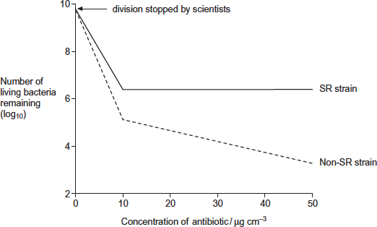

(b)     Describe differences in the effect of increasing the concentration of antibiotic on the SR strain and the non-SR strain.

........................................................................................................................

........................................................................................................................

........................................................................................................................

........................................................................................................................

........................................................................................................................

**[Extra space]** ................................................................................................

........................................................................................................................

**(2)**

(c)     One way in which the stringent response gives resistance to this antibiotic is by stopping cell division.

The scientists concluded that stopping cell division is not the **only** way in which the stringent response gives resistance to this antibiotic.

Explain how **Figure 1** supports this conclusion.

........................................................................................................................

........................................................................................................................

........................................................................................................................

........................................................................................................................

........................................................................................................................

**[Extra space]** ................................................................................................

........................................................................................................................

**(2)**

(d)     The stringent response involves a number of enzyme-catalysed reactions.

Explain how scientists could use this knowledge to design drugs that make the treatment of infections caused by the SR strain more successful.

........................................................................................................................

........................................................................................................................

........................................................................................................................

........................................................................................................................

........................................................................................................................

**(2)**

The antibiotic damages the bacterium by causing the production of substances called free radicals.

The scientists exposed the SR strain and the non-SR strain to the antibiotic. They then measured the amounts of free radicals and an enzyme called catalase in both strains.

**Figure 2** shows their results.

**Figure 2**

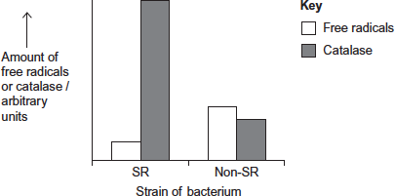

(e)     Use the information provided and **Figure 2** to suggest an explanation for the greater resistance of the SR strain to this antibiotic.

........................................................................................................................

........................................................................................................................

........................................................................................................................

........................................................................................................................

........................................................................................................................

........................................................................................................................

........................................................................................................................

**[Extra space]** ................................................................................................

........................................................................................................................

........................................................................................................................

**(3)**

**(Total 15 marks)**

**Q2.**         Two pairs of alleles **A** and **a**, and **B** and bare found on one pair of homologous chromosomes. A person has the genotype **AaBb**. **Figure 1** shows the chromosomes at an early stage of meiosis. The position of two of the alleles is shown.

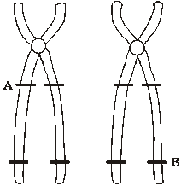

**Figure 1**

(a)     Complete **Figure 1** to show the alleles present at the other marked positions.

**(1)**

Crossing over occurs as shown in **Figure 2**.

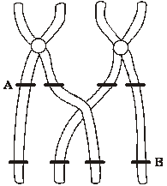

**Figure 2**

(b)     What term is used to describe the pair of homologous chromosomes shown in **Figure 2**?

......................................................................................................................

**(1)**

(c)     From **Figure 2**, give the genotypes of the gametes produced containing the chromatids

(i)      that have **not** crossed over;

.............................................................................................................

(ii)     that have crossed over.

.............................................................................................................

**(2)**

(d)     Give **two** processes, other than crossing over, which result in genetic variation. Explain how each process contributes to genetic variation.

Process ........................................................................................................

Explanation ..................................................................................................

......................................................................................................................

**(2)**

Process ........................................................................................................

Explanation ..................................................................................................

......................................................................................................................

**(2)**

**(Total 8 marks)**

**Q3.          Figure 1** and **Figure 2** show the chromosomes from a single cell at different stages of meiosis.

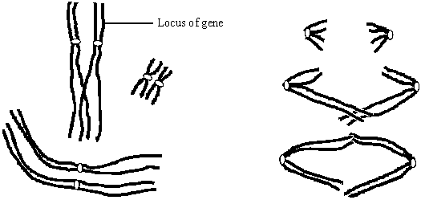

**Figure 1                                                                    Figure 2**

(a)     What is the diploid number of chromosomes in the organism from which this cell was taken?

......................................................................................................................

**(1)**

(b)     Describe what is happening to the chromosomes at the stage shown in

(i)      **Figure 1**;

.............................................................................................................

.............................................................................................................

.............................................................................................................

.............................................................................................................

**(2)**

(ii)     **Figure 2**.

.............................................................................................................

.............................................................................................................

.............................................................................................................

.............................................................................................................

**(2)**

(c)     (i)      The genotype of this organism is **Bb**. The locus of this pair of alleles is shown in **Figure 1**.

Label **two** chromosomes on **Figure 2** to show the location of the **B** allele and the location of the **b** allele.

**(1)**

(ii)     How many genetically different gametes can be produced by meiosis from a cell with the genotype, **Bb Cc Dd**? Assume these genes are located on different pairs of homologous chromosomes. Show your working.

.............................................................................................................

**(2)**

**(Total 8 marks)**

**Q4.**          The diagram shows part of the metabolic pathway involved in the clotting of blood in response to an injury.

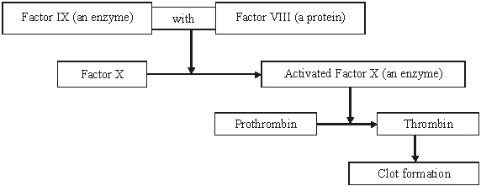

Haemophilia is a condition in which blood fails to clot. This is usually because of a mutant allele of the gene for Factor VIII.

(a)     Explain how mutation could lead to faulty Factor VIII.

......................................................................................................................

......................................................................................................................

......................................................................................................................

......................................................................................................................

**(2)**

(b)     Use information in the diagram to explain how faulty Factor VIII causes haemophilia.

......................................................................................................................

......................................................................................................................

......................................................................................................................

......................................................................................................................

**(2)**

(c)     A boy had haemophilia caused by faulty Factor IX. When his blood was mixed with blood from a haemophiliac with faulty Factor VIII, the mixture clotted. Suggest an explanation for clotting of the mixture.

......................................................................................................................

......................................................................................................................

......................................................................................................................

......................................................................................................................

**(2)**

**(Total 6 marks)**

**Q5.**          (a)     Explain the importance of meiosis in the life cycles of organisms which reproduce sexually.

......................................................................................................................

......................................................................................................................

......................................................................................................................

......................................................................................................................

......................................................................................................................

......................................................................................................................

**(3)**

(b)     The diagram shows the life cycle of a moss plant.

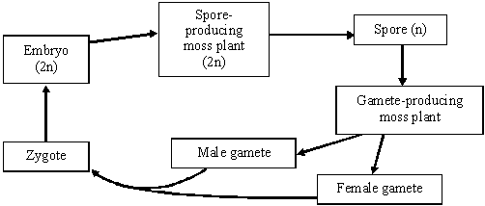

On the diagram mark with an **M** where meiosis takes place.

**(1)**

**(Total 4 marks)**

**Q6.**          The National Vegetable Research Station stores a collection of seeds from many species and varieties of vegetables. These include old and rare varieties.

**S**       (a)     Why is it important to keep seeds from old and rare varieties of vegetables?

......................................................................................................................

......................................................................................................................

......................................................................................................................

......................................................................................................................

**(2)**

**S**       (b)     Every few years, seeds of each variety in the collection are germinated and grown into mature plants. New seeds obtained from these plants are added to the collection.

(i)      Suggest why it is necessary to obtain new seeds every few years.

.............................................................................................................

.............................................................................................................

**(1)**

(ii)     Within each variety, the scientists cross plants with different genotypes. Explain the advantage of this.

.............................................................................................................

.............................................................................................................

.............................................................................................................

.............................................................................................................

**(2)**

**(Total 5 marks)**

**Q7.**          (a)     Explain how crossing over can contribute to genetic variation.

......................................................................................................................

......................................................................................................................

......................................................................................................................

......................................................................................................................

......................................................................................................................

......................................................................................................................

**(3)**

(b)     Maize seeds were an important food crop for the people who lived in Peru. The seeds could be kept for long periods. Each year, some were sown to grow the next crop. Archaeologists have found well-preserved stores. The graph shows the lengths of seeds collected from three stores of different ages.

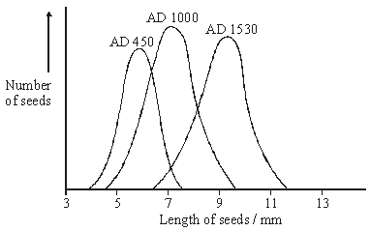

(i)      Within each store the maize seeds showed a range of different lengths.  
Explain **one** cause of this variation.

.............................................................................................................

.............................................................................................................

.............................................................................................................

.............................................................................................................

**(2)**

(ii)     Use your knowledge of genetics and selection to explain the changes in the mean length of the seeds between AD 450 and AD 1530.

.............................................................................................................

.............................................................................................................

.............................................................................................................

.............................................................................................................

.............................................................................................................

.............................................................................................................

.............................................................................................................

**(4)**

**(Total 9 marks)**

**Q8.**          (a)     During meiosis, one chromosome from each homologous pair goes to each of the cells produced. Explain why this is important.

......................................................................................................................

......................................................................................................................

......................................................................................................................

......................................................................................................................

**(2)**

(b)     The diagram shows the life cycle of a fern plant. Drawings of the chromosomes during cell division are shown for the stages that give the spore-producing plant and the gamete-producing plant.

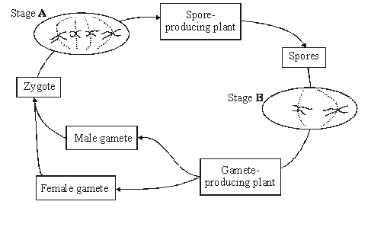

(i)      What is the diploid number of chromosomes in this fern plant?

...................................................

**(1)**

(ii)     Explain the difference in the number of chromosomes at stages **A** and **B**.

.............................................................................................................

.............................................................................................................

**(1)**

(iii)     Are the male and female gametes produced by mitosis or meiosis?

Explain your answer.

.............................................................................................................

.............................................................................................................

.............................................................................................................

.............................................................................................................

**(2)**

**(Total 6 marks)**

**Q9.**          (a)     The number of patients infected with the bacterium MRSA has increased in some hospitals. Scientists have suggested ways to reduce the transmission of MRSA in hospitals. Suggest **two** ways to reduce the transmission of MRSA in hospitals.

1 ...................................................................................................................

......................................................................................................................

2 ...................................................................................................................

......................................................................................................................

**(2)**

(b)     The minimum inhibitory concentration (MIC) is the lowest concentration of a substance that prevents the growth of a microorganism.

When antibiotics are prescribed for treating patients, higher doses than the MIC are recommended. Suggest **two** reasons why.

1 ...................................................................................................................

......................................................................................................................

2 ...................................................................................................................

......................................................................................................................

**(2)**

Scientists tested a new group of drugs for their effectiveness against four species of bacteria. The scientists used MICs to compare the effectiveness of four drugs. The results are shown in the table.

|  |  |  |  |  |  |
| --- | --- | --- | --- | --- | --- |
|  |  | **Minimum inhibitory concentration / μg cm–3** | | | |
|  | **Drug** | *Escherichia coli* | *Staphylococcus aureus* | *Enterococcus faecalis* | *Pseudomonas aeruginosa* |
|  | **P** | 0.39 | 0.049 | 0.049 | 3.13 |
|  | **Q** | 1.54 | 0.049 | 0.195 | 3.13 |
|  | **R** | 0.39 | 0.049 | 0.195 | 1.56 |
|  | **S** | 1.56 | 0.098 | 0.390 | 12.50 |

(c)     Which of the four drugs is

(i)      most effective against *Enterococcus faecalis*?



**(1)**

(ii)     least effective against all the species of bacteria used?



**(1)**

(d)     The effectiveness of these drugs was tested in double-blind trials using human volunteers. In a double-blind trial neither the volunteers nor the scientists know which treatment a particular volunteer is receiving.

(i)      Suggest **two** ways in which a double-blind trial improves reliability.

1 ..........................................................................................................

.............................................................................................................

2 ..........................................................................................................

.............................................................................................................

**(2)**

(ii)     Suggest **two** factors the scientists should have considered when selecting adult volunteers for this trial.

1 ..........................................................................................................

2 ..........................................................................................................

**(2)**

(e)     Scientists investigated resistance of the bacterium, *S. aureus* to the antibiotic Norfloxacin. They grew the bacteria in a medium containing a low concentration of Norfloxacin. The concentration of Norfloxacin that they added killed some of the bacteria. It did not kill all of them. Every 24 hours, they removed a sample of the bacteria from the culture. They tested the sample to find the concentration of Norfloxacin that prevented the growth of 50 % of the bacteria in the sample.  
The scientists then used the same method to investigate the resistance of *S. aureus* to a new drug, drug **X**. The results of both investigations are shown in the graph.

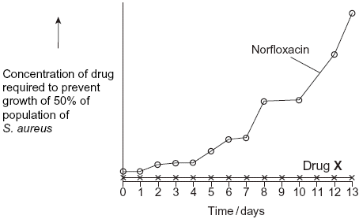

Describe the results obtained with Norfloxacin.

......................................................................................................................

......................................................................................................................

**(1)**

**(Total 11 marks)**

**Q10.**          The diagram represents a cell from a fruit fly in which the diploid number is eight.

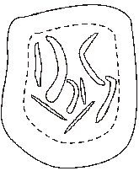

(a)     Draw a diagram to show

(i)      this cell during anaphase of mitosis;

**(2)**

(ii)     the chromosomes in a gamete produced from this cell by meiosis.

**(2)**

(b)     Explain why meiosis is important in sexual reproduction, apart from producing gametes that are genetically different.

......................................................................................................................

......................................................................................................................

......................................................................................................................

......................................................................................................................

**(2)**

**(Total 6 marks)**

**Q11.**          New alleles arise as a result of mutations in existing genes. These mutations may occur during DNA replication.

(a)     Explain what is meant by an allele.

......................................................................................................................

......................................................................................................................

**(1)**

(b)     Explain how DNA replicates.

......................................................................................................................

......................................................................................................................

......................................................................................................................

......................................................................................................................

......................................................................................................................

......................................................................................................................

......................................................................................................................

......................................................................................................................

**(4)**

(c)     Explain why a mutation involving the deletion of a base may have a greater effect than one involving substitution of one base for another.

......................................................................................................................

......................................................................................................................

......................................................................................................................

......................................................................................................................

......................................................................................................................

......................................................................................................................

**(3)**

**(Total 8 marks)**

**Q12.**          (a)     Name **one** mutagenic agent.

......................................................................................................................

**(1)**

(b)     In flax plants the flowers are white, lilac or blue. The diagram shows the pathway by which the flower cells produce coloured pigments.

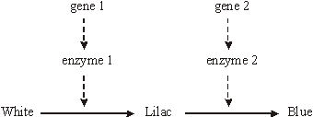

(i)      A deletion mutation occurs in gene 1. Describe how a deletion mutation alters the structure of a gene.

.............................................................................................................

.............................................................................................................

.............................................................................................................

.............................................................................................................

**(2)**

(ii)     Describe and explain how the altered gene could result in flax plants with white-coloured flowers.

.............................................................................................................

.............................................................................................................

.............................................................................................................

.............................................................................................................

.............................................................................................................

.............................................................................................................

.............................................................................................................

.............................................................................................................

**(4)**

(iii)     Electrophoresis was used to separate the enzymes involved in this pathway. When extracts of the differently coloured flax petals were analysed, four different patterns of bands were produced. In the table, only bands that contain functional enzymes are shown.

|  |  |
| --- | --- |
| **Result of electrophoresis** | **Colour of petal** |
|  | White |
|  |  |
|  |  |
|  |  |

Complete the table to give the colour of the petal from which each extract was taken.

**(2)**

**(Total 9 marks)**

**Q13.**          (a)     **Figure 1** shows two pairs of chromosomes from a plant cell. The letters represent alleles.

**Figure 1**

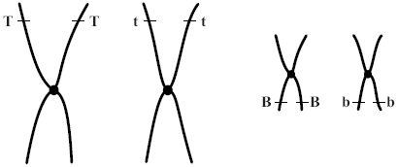

(i)      Give all the different genotypes of the gametes which could be produced by this plant.

.............................................................................................................

**(1)**

(ii)     **Figure 2** shows the same chromosomes on the spindle during meiosis. Complete the labelling of all the chromosomes to show the arrangement of the alleles that would result in the production of a gamete with the genotype **TB**.

**Figure 2**

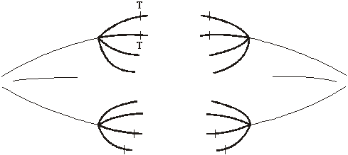

**(1)**

(iii)     One chromosome has two copies of allele **T**. What occurs during meiosis which results in only one copy of the allele **T** being present in a gamete?

.............................................................................................................

.............................................................................................................

**(1)**

(b)     **Figure 3** shows another pair of chromosomes from the same plant cell. The table shows the numbers of gametes with each genotype produced by this plant.

**Figure 3**

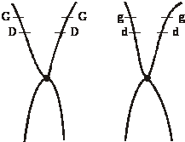

|  |  |  |  |  |
| --- | --- | --- | --- | --- |
| Genotype of gametes | **GD** | **gd** | **Gd** | **gD** |
| Number of gametes | 1096 | 1124 | 210 | 230 |

(i)      Describe what happens during meiosis, which results in the new combinations of alleles, **Gd** and **gD**.

.............................................................................................................

.............................................................................................................

.............................................................................................................

.............................................................................................................

.............................................................................................................

.............................................................................................................

**(3)**

(ii)     Suggest why there are fewer gametes with genotypes **Gd** and **gD** than **GD** and **gd**.

.............................................................................................................

.............................................................................................................

**(1)**

**(Total 7 marks)**

**Q14.**          (a)     Apart from increasing genetic variation, explain why meiosis is important in organisms which reproduce sexually.

......................................................................................................................

......................................................................................................................

......................................................................................................................

......................................................................................................................

**(2)**

(b)     **Figure 1** shows the chromosomes in a diploid cell.

**Figure 1**

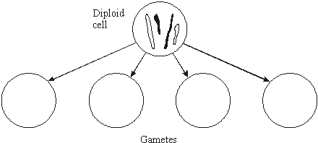

Complete **Figure 1** to show the four different combinations of these chromosomes in the gametes produced by meiosis.

**(2)**

(c)     **Figure 2** shows the main stages in the production of pollen grains in a flowering plant.

**Figure 2**

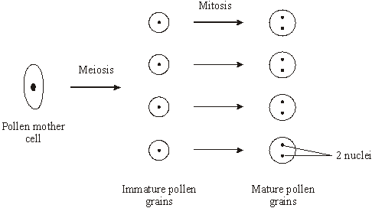

The diploid number of chromosomes in this plant is sixteen. How many chromosomes would there be in

(i)      the nucleus of an immature pollen grain;

.............................................................................................................

(ii)     one of the nuclei of a mature pollen grain?

.............................................................................................................

**(2)**

(d)     In tissues that produce gametes, there is a greater proportion of cells undergoing meiosis in male tissue than in female tissue. Suggest **one** advantage of this.

......................................................................................................................

......................................................................................................................

**(1)**

**(Total 7 marks)**

**Q15.**          (a)     (i)      What is the role of RNA polymerase in transcription?

.............................................................................................................

.............................................................................................................

**(1)**

(ii)     Name the organelle involved in translation.

.............................................................................................................

**(1)**

(b)     **Figure 1** shows some molecules involved in protein synthesis.

**Figure 1**

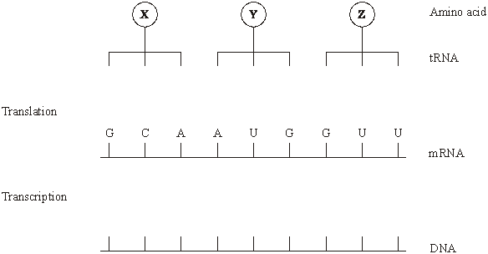

Complete **Figure 1** to show

(i)      the bases on the DNA strand from which the mRNA was transcribed;

(ii)     the bases forming the anticodons of the tRNA molecules.

**(2)**

**Figure 2** shows the effects of two different mutations of the DNA on the base sequence of the mRNA. The table shows the mRNA codons for three amino acids.

**Figure 2**

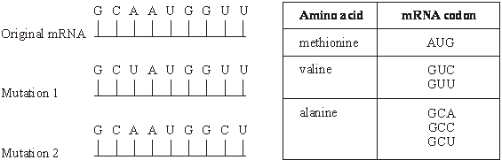

(c)     Name the type of mutation represented by mutation 1.

......................................................................................................................

**(1)**

(d)     Use the information in the table to

(i)      identify amino acid **X** in **Figure 1**;

.............................................................................................................

**(1)**

(ii)     explain how each mutation may affect the polypeptide for which this section of DNA is part of the code.

Mutation 1 ...........................................................................................

.............................................................................................................

.............................................................................................................

.............................................................................................................

**(2)**

Mutation 2 ...........................................................................................

.............................................................................................................

.............................................................................................................

.............................................................................................................

**(2)**

**(Total 10 marks)**

**Q16.**          The graph shows the variation in length of 86 Atlantic salmon.

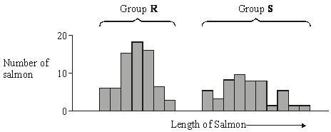

(a)     Give **two** possible causes of this variation that result from meiosis during gamete formation.

1 ...................................................................................................................

......................................................................................................................

2 ...................................................................................................................

......................................................................................................................

**(2)**

(b)     When comparing variation in size between two groups of organisms, it is often considered more useful to compare standard deviations rather than ranges. Explain why.

......................................................................................................................

......................................................................................................................

......................................................................................................................

......................................................................................................................

**(2)**

**(Total 4 marks)**

**Q17.**(a)     Explain **one** way in which the behaviour of chromosomes during meiosis produces genetic variation in gametes.

........................................................................................................................

........................................................................................................................

........................................................................................................................

........................................................................................................................

**(2)**

(b)     In mosquitoes, the sex of an individual is determined by one gene. Males have the genotype **Mm** and females **mm**.

Another gene is carried on the same chromosome. Normal males and females are homozygous **dd** for this gene. Abnormal males have a dominant **D** allele.  
The possible genotypes are shown below. The vertical lines represent homologous chromosomes.



During meiosis, allele **D** causes the homologous chromosome carrying the **m** allele to disintegrate. Cells lacking this chromosome do not develop further.

Complete the genetic diagram to show how allele **D** is transmitted from an abnormal male to his offspring.

|  |  |  |  |
| --- | --- | --- | --- |
|  | *Parental phenotypes* | Abnormal male | Normal female |
|  | *Parental genotypes* |  |  |
|  |  |  |  |
|  | *Gametes* | ....................... | ....................... |
|  | *Offspring genotype(s)* | ............................................................ | |
|  | *Offspring phenotype(s)* | ............................................................ | |

**(3)**

**(Total 5 marks)**

**Q18.**          (a)     Give **one** process which occurs in the nucleus of a cell during interphase which is necessary before cell division can take place.

......................................................................................................................

**(1)**

(b)     The diagram shows the chromosomes from a cell with a diploid chromosome number of six.

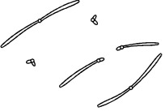

Draw a diagram to show the chromosomes from one of the resulting cells if

(i)      the cell divides by **mitosis**;

**(2)**

(ii)     the cell divides by **meiosis**.

**(2)**

(c)     Explain **one** advantage of cells lining the human gut dividing very frequently.

......................................................................................................................

......................................................................................................................

**(1)**

**(Total 6 marks)**

**Q19.**          (a)     Describe what happens to chromosomes in meiosis.

......................................................................................................................

......................................................................................................................

......................................................................................................................

......................................................................................................................

......................................................................................................................

......................................................................................................................

......................................................................................................................

......................................................................................................................

......................................................................................................................

......................................................................................................................

......................................................................................................................

......................................................................................................................

**(6)**

(b)     Meiosis results in genetic variation in the gametes which leads to variation in the offspring formed by sexual reproduction. Describe how meiosis causes this variation and explain the advantage of variation to the species.

......................................................................................................................

......................................................................................................................

......................................................................................................................

......................................................................................................................

......................................................................................................................

......................................................................................................................

......................................................................................................................

......................................................................................................................

......................................................................................................................

......................................................................................................................

**(5)**

(c)     An old form of wheat, emmer wheat (*Triticum turgidum*), has a diploid chromosome number of 28 (2n = 28). A wild wheat, einkorn wheat (*Triticum tauschii*), has a diploid chromosome number of 14 (2n = 14). These two species occasionally crossed and produced sterile hybrid plants. Due to an error during cell division, one of these hybrid plants formed male and female gametes with 21 chromosomes. Fusion of these gametes resulted in viable offspring. These plants were a new species, *Triticum aestivum* (2n = 42), our modern bread wheat.

(i)      How many chromosomes would there have been in each of the cells of the hybrid plant produced by crossing *Triticum turgidum* with *Triticum tauschii*?

.............................................................................................................

**(1)**

(ii)     Explain why *Triticum aestivum* is fertile while the majority of hybrid plants were not.

.............................................................................................................

.............................................................................................................

.............................................................................................................

.............................................................................................................

.............................................................................................................

.............................................................................................................

.............................................................................................................

**(3)**

**(Total 15 marks)**

**Q20.**          Division of the nucleus by meiosis produces haploid cells from a diploid cell. Nuclei produced by mitosis have the same number of chromosomes as the parent nucleus.

(a)     What is the biological importance of reducing the chromosome number when the cell divides by meiosis?

......................................................................................................................

......................................................................................................................

......................................................................................................................

......................................................................................................................

**(2)**

(b)     The table gives one difference between meiosis and mitosis. Complete the table by giving **three** further differences.

|  |  |  |  |
| --- | --- | --- | --- |
|  |  | **Meiosis** | **Mitosis** |
|  | 1 | Reduces the chromosome number | Maintains the same chromosome number as in the parent nucleus |
|  | 2 |  |  |
|  | 3 |  |  |
|  | 4 |  |  |

**(3)**

**(Total 5 marks)**

**Q21.**          (a)     Complete the table to describe some of the events during the cell cycle.

|  |  |  |
| --- | --- | --- |
|  | **Stage of cell cycle** | **Main event which takes place** |
|  | Metaphase |  |
|  |  | Chromosomes coil and shorten |
|  |  | Daughter chromosomes move to poles of the cell |
|  | S-phase |  |
|  |  | Nuclear envelope re-forms |

**(5)**

(b)     The diagram shows the life cycle of an organism. The numbers show how many chromosomes are present in one cell at each stage of the life cycle.

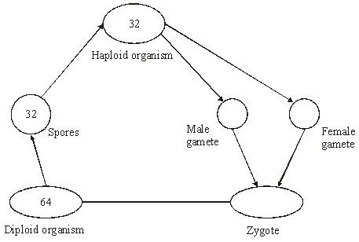

(i)      Name the type of cell division that must be involved in producing the spores.

.............................................................................................................

**(1)**

(ii)     How many chromosomes are there in a male gamete from this organism?

.............................................................................................................

**(1)**

**(Total 7 marks)**

**Q22.**          Finches are small birds. Fourteen species of finch are found on the Galapagos Islands.

(a)     What is a species?

......................................................................................................................

......................................................................................................................

......................................................................................................................

......................................................................................................................

**(2)**

(b)     Measurements were made of the beak depth of two species of finch (species **A** and species **B**) on different islands. Species **A** is found on island 1, species **B** is found on island 2. Both species are found on island 3. They are thought to have colonised island 3 from islands 1 and 2 respectively. The graphs show the ranges of beak depths of the two species on the different islands.

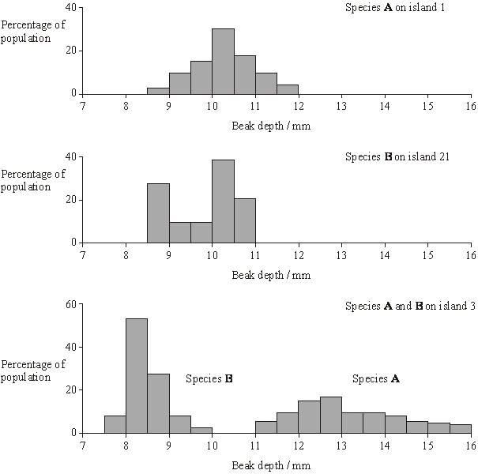

What type of natural selection took place in the populations of both species after they had colonised island 3? Explain your answer.

......................................................................................................................

......................................................................................................................

......................................................................................................................

......................................................................................................................

......................................................................................................................

**(3)**

**(Total 5 marks)**

**Q23.**          (a)     In which phase of the cell cycle does DNA replication take place?

......................................................................................................................

**(1)**

(b)     The diagrams show five stages of mitosis.

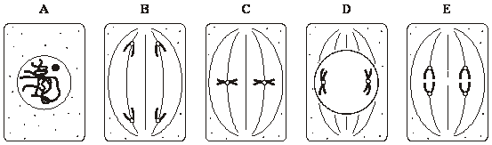

List the stages **A** to **E** in the correct sequence, beginning with the earliest stage.

.....................        .....................        .....................       .....................       .....................

**(1)**

(c)     Describe the role of the spindle during mitosis.

......................................................................................................................

......................................................................................................................

......................................................................................................................

......................................................................................................................

**(2)**

(d)     Meiosis also occurs during the life cycle of organisms. What is the importance of meiosis?

......................................................................................................................

......................................................................................................................

......................................................................................................................

......................................................................................................................

**(2)**

**(Total 6 marks)**

**Q24.**          (a)     The diagram shows a cell undergoing cell division.

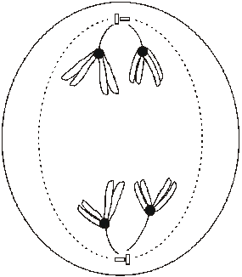

Identify the type and stage of cell division shown. Give evidence from the diagram to support your answer.

......................................................................................................................

......................................................................................................................

......................................................................................................................

......................................................................................................................

......................................................................................................................

......................................................................................................................

**(3)**

(b)     Describe how crossing over occurs during meiosis I.

......................................................................................................................

......................................................................................................................

......................................................................................................................

......................................................................................................................

**(2)**

**(Total 5 marks)**

**Q25.**          There is evidence that the first photosynthetic organisms were primitive water-dwelling bacteria. The very first of these lived near the surface of the water in lakes and contained a purple pigment that absorbed light most strongly in the green region of the spectrum. Later, other bacteria evolved that lived on the top of sediment at the bottom of the lakes (**Figure 1**). Gene mutations had enabled these bacteria to synthesise chlorophyll instead of the purple pigment present in the bacteria living near to the surface. Chlorophyll absorbs light most strongly in the blue and red regions of the spectrum (**Figure 2**).

**Figure 1**

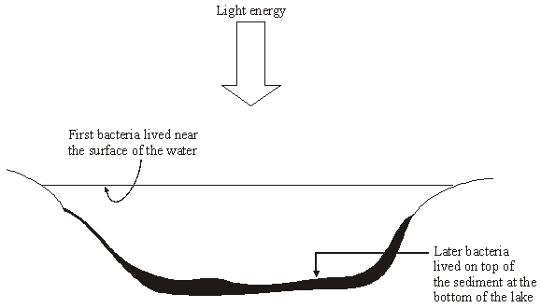

**Figure 2**

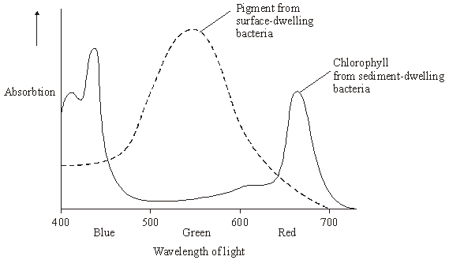

(a)     Describe how light energy absorbed by chlorophyll molecules is used to synthesise ATP.

......................................................................................................................

......................................................................................................................

......................................................................................................................

......................................................................................................................

......................................................................................................................

......................................................................................................................

......................................................................................................................

......................................................................................................................

......................................................................................................................

......................................................................................................................

**(5)**

(b)     Use **Figure 2** to explain how natural selection would favour the evolution of sediment-dwelling bacteria containing a different photosynthetic pigment from those living near the surface of the water.

......................................................................................................................

......................................................................................................................

......................................................................................................................

......................................................................................................................

......................................................................................................................

......................................................................................................................

......................................................................................................................

......................................................................................................................

......................................................................................................................

......................................................................................................................

......................................................................................................................

**(6)**

**(Total 11 marks)**

**Q26.**          Ions of metals such as zinc often pollute rivers. The effect of zinc ions on gas exchange and respiration in fish was investigated. Fish were kept in tanks of water in a laboratory.

The fish in one group (**X**) had a solution of a zinc compound injected directly into their blood and were then put in a tank of zinc-free water. A second group (**Y**) was not injected but had the solution of the zinc compound added to the water in the tank.

The partial pressure of oxygen in the blood of both groups of fish was then monitored. The results are shown in the graph.

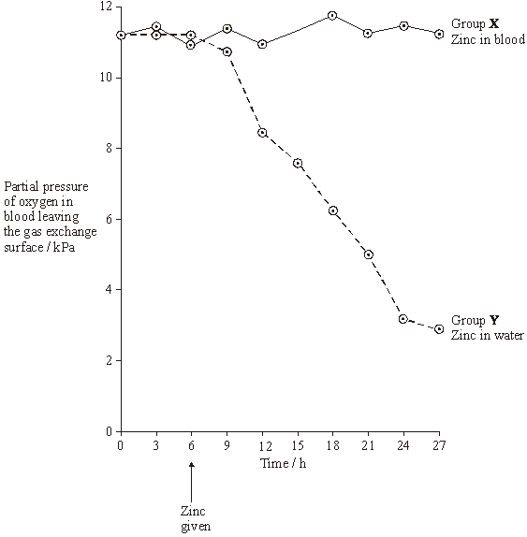

(a)     During this investigation, the water temperature in the tanks was kept constant. Explain why changes in the water temperature might lead to the results of the investigation being unreliable.

......................................................................................................................

......................................................................................................................

**(1)**

(b)     The results from the two groups were compared using a statistical test.

(i)      Suggest a null hypothesis that could be tested.

.............................................................................................................

**(1)**

(ii)     Explain why it is important to use a statistical test in analysing the results of this investigation.

.............................................................................................................

.............................................................................................................

.............................................................................................................

.............................................................................................................

**(2)**

(c)     Two suggestions were made to explain the results shown in the graph.

**A**       Zinc ions reduce the rate at which oxygen is taken up from the water and passes into the blood.

**B**       Zinc ions reduce the ability of haemoglobin to transport oxygen.

Which of these suggestions is the more likely? Explain the evidence from the graph that supports your answer.

......................................................................................................................

......................................................................................................................

......................................................................................................................

......................................................................................................................

**(2)**

(d)     During the investigation, the pH of the blood was also monitored. It decreased in group **Y**. Suggest an explanation for this decrease in pH.

......................................................................................................................

......................................................................................................................

......................................................................................................................

......................................................................................................................

......................................................................................................................

......................................................................................................................

**(3)**

(e)     Leaves were collected from sycamore trees growing in a polluted wood and the concentration of some metal ions in samples of these leaves was measured. Woodlice were then fed with the leaves. After 20 weeks, the concentration of the ions in the bodies of the woodlice was measured. Some of the results are shown in the table.

|  |  |  |  |  |
| --- | --- | --- | --- | --- |
|  | **Concentration of ions / µg g–1** | | | |
|  | Copper | Cadmium | Zinc | Lead |
| Leaves | 52 | 26 | 1430 | 908 |
| Woodlice | 1130 | 525 | 1370 | 132 |

(i)      Which of the elements shown in the table is concentrated most by the woodlice? Use suitable calculations to support your answer.

**(2)**

(ii)     Suggest what happens to most of the lead ions in the leaves eaten by the woodlice.

.............................................................................................................

.............................................................................................................

**(1)**

(iii)     Explain the difference in the copper ion concentration between the leaves and the woodlice.

.............................................................................................................

.............................................................................................................

.............................................................................................................

.............................................................................................................

**(2)**

(f)      Yorkshire fog is a species of grass. Two varieties of Yorkshire fog were studied. One variety was tolerant to arsenic, while the other variety was not. In a series of investigations, it was found that

•        Arsenic-tolerant plants grow in soil which contains a high concentration of arsenic.

•        Arsenic-tolerant plants growing in soil containing high concentrations of arsenic and phosphorus-containing compounds have very low concentrations of arsenic in their cells. They also have low concentrations of phosphates in their cells. Arsenic and phosphorus are chemically similar.

•        Plants that are not tolerant to arsenic grow poorly on soil which has a high concentration of both arsenic and phosphorus-containing compounds.

•        Tolerance to arsenic in Yorkshire fog is caused by a single gene with the allele, **a**, for tolerance recessive to the allele, **A**, for non-tolerance.

(i)      What caused the allele for tolerance to first arise?

.............................................................................................................

.............................................................................................................

**(1)**

(ii)     Give **two** functions of phosphates in plant cells.

1 ..........................................................................................................

.............................................................................................................

2 ..........................................................................................................

.............................................................................................................

**(2)**

(iii)     Arsenic-tolerant Yorkshire fog plants are very rare in areas with low concentrations of arsenic in the soil, even where the soil has a high concentration of phosphate. Explain why they are unable to compete in these conditions with plants that are not tolerant to arsenic.

.............................................................................................................

.............................................................................................................

.............................................................................................................

.............................................................................................................

.............................................................................................................

.............................................................................................................

**(3)**

**(Total 20 marks)**

**Q27.**          (a)     Nucleus **A** and nucleus **B** come from the same organism. The diagram shows these nuclei immediately before division and the nuclei formed immediately after their division. The table gives information about some of the nuclei shown in the diagram.

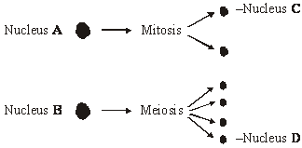

|  |  |  |
| --- | --- | --- |
| **Nucleus** | **Number of chromosomes** | **Mass of DNA / arbitrary units** |
| **A** | 8 | 600 |
| **B** | 8 | 600 |
| **C** |  |  |
| **D** |  |  |

          Complete the table for nuclei **C** and **D**.

**(2)**

(b)     A student investigated the process of meiosis by observing cells on a microscope slide. The cells on the slide had been stained.

(i)      Name an organ from which the cells may have been obtained.

.............................................................................................................

**(1)**

(ii)     Explain why a stain was used.

.............................................................................................................

.............................................................................................................

**(1)**

**(Total 4 marks)**

**Q28.**(a)     Meiosis results in cells that have the haploid number of chromosomes and show genetic variation. Explain how.

........................................................................................................................

........................................................................................................................

........................................................................................................................

........................................................................................................................

........................................................................................................................

........................................................................................................................

........................................................................................................................

........................................................................................................................

........................................................................................................................

........................................................................................................................

**(6)**

(b)     In mice, two genes affecting coat colour are on different chromosomes.  
One gene controls whether there is any black pigment in the hairs. The dominant allele of this gene, **B**, results in black fur. The recessive allele, **b**, results in white fur. The second gene controls banding of the fur. The dominant allele, **A**, causes a yellow band to develop on each hair. The resulting coat colour is called agouti. The recessive allele, **a**, results in hairs with no bands on them. This gene has no effect on mice with white fur; white mice do not develop bands, even if they have the **A** allele.

Breeders performed many crosses in which agouti mice were crossed with white mice, homozygous for both genes. They expected agouti, black and white mice in the offspring in a 1 : 1 : 2 ratio.

(i)      Complete the genetic diagram to show how this ratio of phenotypes would be produced.

|  |  |  |  |
| --- | --- | --- | --- |
|  | Parental phenotypes | Agouti | White |

Parental genotypes

Gamete genotypes

Offspring genotypes

Offspring phenotypes

**(4)**

(ii)     The actual numbers of offspring with each phenotype were

|  |  |  |
| --- | --- | --- |
|  | Agouti | 34 |
|  | Black | 35 |
|  | White | 51 |

The *x*2 test can be used to test the hypothesis that there is no significant difference between these results and the expected 1 : 1 : 2 ratio. Complete the table to calculate the value of *x*2 for these results.

|  |  |  |  |  |  |  |
| --- | --- | --- | --- | --- | --- | --- |
|  | **Colour of offspring** | **Observed (O)** | **Expected (E)** | **(O - E)** | **(O - E)2** |  |
|  | Agouti | 34 |  |  |  |  |
|  | Black | 35 |  |  |  |  |
|  | White | 51 |  |  |  |  |
|  |  | | | Σ= | | |

**(2)**

(iii)    The table shows values for *x*2 at different levels of probability and for different degrees of freedom.

|  |  |  |  |  |  |  |
| --- | --- | --- | --- | --- | --- | --- |
|  | **Degrees of freedom** | **Probability, p** | | | | |
|  | **0.2** | **0.1** | **0.05** | **0.02** | **0.01** |
|  | 1 | 1.64 | 2.71 | 3.84 | 5.41 | 6.64 |
|  | 2 | 3.22 | 4.61 | 5.99 | 7.82 | 9.21 |
|  | 3 | 4.64 | 6.25 | 7.82 | 9.84 | 11.35 |
|  | 4 | 5.99 | 7.78 | 9.49 | 11.67 | 13.28 |
|  | 5 | 7.29 | 9.24 | 11.07 | 13.39 | 15.09 |

What should the breeders conclude about the significance of their results?  
Explain your answer.

...............................................................................................................

...............................................................................................................

...............................................................................................................

...............................................................................................................

...............................................................................................................

...............................................................................................................

**(3)**

**(Total 15 marks)**

**Q29.**          (a)     Haemoglobin contains iron. One type of anaemia is caused by a lack of iron. This type of anaemia can be treated by taking tablets containing iron. A number of patients were given a daily dose of 120 mg of iron. **Figure 1** shows the effect of this treatment on the increase in the concentration of haemoglobin in their red blood cells.

**Figure 1**

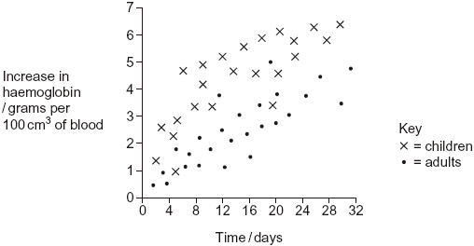

(i)      Give **one** difference in the response of adults and children to this treatment.

.............................................................................................................

.............................................................................................................

**(1)**

(ii)     You could use the graph to predict the effect of this treatment on the increase in haemoglobin content of an adult after 40 days. Explain how.

.............................................................................................................

.............................................................................................................

.............................................................................................................

.............................................................................................................

**(2)**

(iii)     Haemoglobin has a quaternary structure. Explain what is meant by a quaternary structure.

.............................................................................................................

.............................................................................................................

**(1)**

(b)     (i)      Pernicious anaemia is another type of anaemia. One method of identifying pernicious anaemia is to measure the diameter of the red blood cells in a sample of blood that has been diluted with an isotonic salt solution. Explain why an isotonic salt solution is used to dilute the blood sample.

.............................................................................................................

.............................................................................................................

.............................................................................................................

.............................................................................................................

.............................................................................................................

.............................................................................................................

**(3)**

(ii)     A technician compared the red blood cells in two blood samples of equal volume. One sample was from a patient with pernicious anaemia, the other was from a patient who did not have pernicious anaemia. **Figure 2** shows some of the results she obtained.

**Figure 2**

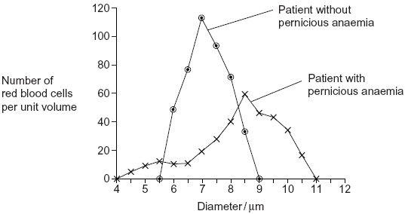

Describe **two** differences between the blood samples.

1 ..........................................................................................................

.............................................................................................................

2 ..........................................................................................................

.............................................................................................................

**(2)**

**(Total 9 marks)**

**Q30.**Cyanide is a poisonous substance. Cyanogenic clover plants produce cyanide when their tissues are damaged. The ability to produce cyanide is controlled by genes at loci on two different chromosomes. The dominant allele, **A**, of one gene controls the production of an enzyme which converts a precursor to linamarin. The dominant allele, **L**, of the second gene controls the production of an enzyme which converts linamarin to cyanide. This is summarised in the diagram.

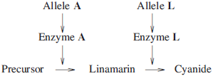

(a)     Acyanogenic clover plants cannot produce cyanide. Explain why a plant with the genotype **aaLl** cannot produce cyanide.

........................................................................................................................

........................................................................................................................

**(1)**

(b)     A clover plant has the genotype **AaLl**.

(i)      Give the genotypes of the male gametes which this plant can produce.

...............................................................................................................

**(1)**

(ii)     Explain how meiosis results in this plant producing gametes with these genotypes.

...............................................................................................................

...............................................................................................................

...............................................................................................................

...............................................................................................................

**(2)**

(c)     Two plants, heterozygous for both of these pairs of alleles, were crossed. What proportion of the plants produced from this cross would you expect to be acyanogenic but able to produce linamarin? Use a genetic diagram to explain your answer.

**(3)**

In an investigation, cyanogenic and acyanogenic plants were grown together in pots. Slugs were placed in each pot and records were kept of the number of leaves damaged by the feeding of the slugs over a period of 7 days. The results are shown in **Table 1**.

**Table 1**

|  |  |  |  |
| --- | --- | --- | --- |
|  |  | **Undamaged** | **Damaged** |
|  | Cyanogenic plants | 160 | 120 |
|  | Acyanogenic plants | 88 | 192 |

(d)     A *x*2 test was carried out on the results.

(i)      Suggest the null hypothesis that was tested.

...............................................................................................................

...............................................................................................................

**(1)**

(ii)     *x*2 was calculated. When this value was looked up in a table, it was found to correspond to a probability of less than 0.05. What conclusion can you draw from this?

...............................................................................................................

...............................................................................................................

...............................................................................................................

...............................................................................................................

...............................................................................................................

...............................................................................................................

**(3)**

A second investigation was carried out in a field of grass which had been undisturbed for many years. **Table 2** shows the population density of slugs and the numbers of cyanogenic and acyanogenic clover plants at various places in the field.

**Table 2**

|  |  |  |  |
| --- | --- | --- | --- |
|  | **Population density of slugs** | **Number of acyanogenic clover plants per m2** | **Number of cyanogenic clover plants per m2** |
|  | Very low | 26 | 10 |
|  | Low | 17 | 26 |
|  | High | 0 | 10 |
|  | Very high | 0 | 5 |

(e)     Explain the proportions of the two types of clover plant in different parts of the field.

........................................................................................................................

........................................................................................................................

........................................................................................................................

........................................................................................................................

........................................................................................................................

........................................................................................................................

........................................................................................................................

........................................................................................................................

**(Extra space)**..................................................................................................

........................................................................................................................

**(4)**

**(Total 15 marks)**

**Q31.Figure 1** shows a pair of chromosomes at the start of meiosis. The letters represent alleles.

**Figure 1**

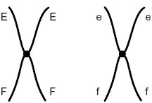

(a)     What is an allele?

......................................................................................................................

......................................................................................................................

**(1)**

(b)     Explain the appearance of one of the chromosomes in **Figure 1**.

......................................................................................................................

......................................................................................................................

......................................................................................................................

......................................................................................................................

**(2)**

(c)     The cell containing this pair of chromosomes divided by meiosis. **Figure 2** shows the distribution of chromosomes from this pair in four of the gametes produced.

**Figure 2**

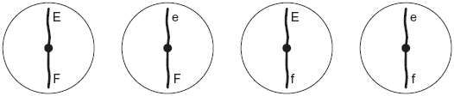

(i)      Some of the gametes formed during meiosis have new combinations of alleles.

Explain how the gametes with the combinations of alleles Ef and eF have been produced.

..............................................................................................................

.............................................................................................................

.............................................................................................................

.............................................................................................................

**(2)**

(ii)     Only a few gametes have the new combination of alleles Ef and eF. Most gametes have the combination of alleles EF and ef. Suggest why only a few gametes have the new combination of alleles, Ef and eF.

.............................................................................................................

.............................................................................................................

**(1)**

(d)     **Figure 3** shows a cell with six chromosomes.

**Figure 3**

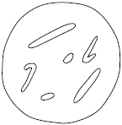

(i)      This cell produces gametes by meiosis. Draw a diagram to show the chromosomes in one of the gametes.

**(2)**

(ii)     How many different types of gametes could be produced from this cell as a result of different combinations of maternal and paternal chromosomes?



**(1)**

**(Total 9 marks)**

**Q32.**          **Figure 1** shows a fresh-water shrimp.

**Figure 1**

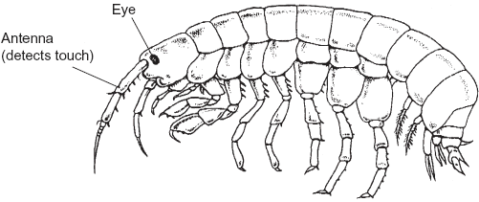

Biologists collected shrimps from a stream inside a cave and from the same stream when it was in the open.

They measured the maximum diameter of each shrimp’s eye. They also measured the length of its antenna. From these measurements they calculated the mean values for each site. **Figure 2** shows their results.

**Figure 2**

|  |  |  |  |
| --- | --- | --- | --- |
|  |  | Shrimps from the stream | |
|  |  | Inside the cave | In the open |
|  | Mean diameter of eye /mm | 0.09 | 0.24 |
|  | Mean length of antenna /mm | 8.46 | 5.81 |

(a)     The biologists measured the maximum diameter of each shrimp’s eye.

Explain why they measured the **maximum** diameter.

......................................................................................................................

......................................................................................................................

......................................................................................................................

**(1)**

(b)     A scientist working many years earlier suggested that animals which live in caves had similar adaptations. These adaptations included

•        smaller eyes

•        greater use of sense organs such as those involved in detecting touch.

(i)      Do the data in **Figure 2** support this scientist’s suggestion? Explain your answer.

.............................................................................................................

.............................................................................................................

.............................................................................................................

.............................................................................................................

.............................................................................................................

**(2)**

(ii)     The data in **Figure 2** are mean values. Explain how standard deviations of these cmean values would help you to interpret the data in **Figure 2**.

.............................................................................................................

.............................................................................................................

.............................................................................................................

.............................................................................................................

.............................................................................................................

**(2)**

(c)     The biologists investigated shrimps living in other streams. They measured the length of the antennae of these shrimps. They also measured their body length. **Figure 3** shows the mean antenna length plotted against mean body length for each site.

**Figure 3**

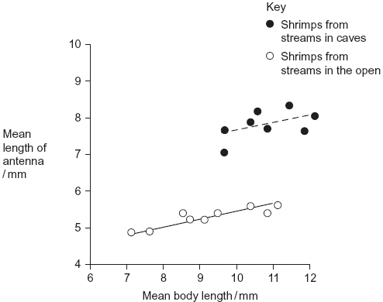

(i)      What does the information in the graph suggest about the body lengths of shrimps living in caves and living in the open?

.............................................................................................................

.............................................................................................................

.............................................................................................................

.............................................................................................................

.............................................................................................................

**(2)**

(ii)     Do the data in the graph support the conclusion that shrimps with longer bodies have longer antennae? Give the reason for your answer.

.............................................................................................................

.............................................................................................................

.............................................................................................................

**(1)**

Other biologists investigated the genetic diversity of these shrimps. **Figure 4** shows some of the data they collected.

**Figure 4**

|  |  |  |  |  |
| --- | --- | --- | --- | --- |
|  | **Gene** | **Allele** | **Percentage of shrimps with this allele in steam** | |
|  | **Inside a cave** | **In the open** |
|  | PGI | **A** | 0.9 | 2.5 |
|  | **B** | 0.0 | 3.3 |
|  | **C** | 98.2 | 66.4 |
|  | **D** | 0.9 | 6.6 |
|  | **E** | 0.0 | 21.3 |
|  |  | | | |
|  | ACO2 | **J** | 0.0 | 5.6 |
|  | **K** | 0.0 | 76.7 |
|  | **L** | 100.0 | 17.8 |

(d)     The biologists concluded that the shrimps in the open had a higher genetic diversity than those in the cave. Explain how the data in **Figure 4** support this conclusion.

......................................................................................................................

......................................................................................................................

......................................................................................................................

**(1)**

(e)     The percentage of shrimps with allele **L** in the cave is different from the percentage of shrimps with allele **L** in the open. Use your knowledge of the founder effect to suggest a reason for this difference.

......................................................................................................................

......................................................................................................................

......................................................................................................................

......................................................................................................................

......................................................................................................................

......................................................................................................................

**(3)**

(f)      The biologists who studied these shrimps wanted to know if the shrimps living in the cave were the same species as those living in the open. They used breeding experiments to investigate this.

(i)      Describe how the biologists should carry out these breeding experiments.

.............................................................................................................

.............................................................................................................

.............................................................................................................

.............................................................................................................

(ii)     The results of breeding experiments would help the biologists to decide whether the shrimps were the same species. Explain how.

.............................................................................................................

.............................................................................................................

**(3)**

**(Total 15 marks)**

**Q33.**          (a)     What name is used for the non-coding sections of a gene?

......................................................................................................................

**(1)**

**Figure 1** shows a DNA base sequence. It also shows the effect of two mutations on this base sequence. **Figure 2** shows DNA triplets that code for different amino acids.

**Figure 1**

|  |  |  |  |  |  |  |  |  |  |  |  |  |
| --- | --- | --- | --- | --- | --- | --- | --- | --- | --- | --- | --- | --- |
| Original DNA base sequence | A | T | T | G | G | C | G | T | G | T | C | T |
| Amino acid sequence |  | | |  | | |  | | |  | | |
| Mutation **1** DNA base sequence | A | T | T | G | G | A | G | T | G | T | C | T |
| Mutation **2** DNA base sequence | A | T | T | G | G | C | C | T | G | T | C | T |

**Figure 2**

|  |  |
| --- | --- |
| **DNA triplets** | **Amino acid** |
| GGT, GGC, GGA, GGG | Gly |
| GTT, GTA, GTG, GTC | Val |
| ATC, ATT, ATA | Ile |
| TCC, TCT, TCA, TCG | Ser |
| CTC, CTT, CTA, CTG | Leu |

(b)     Complete **Figure 1** to show the sequence of amino acids coded for by the original DNA base sequence.

**(1)**

(c)     Some gene mutations affect the amino acid sequence. Some mutations do not.  
Use the information from **Figure 1** and **Figure 2** to explain

(i)      whether mutation **1** affects the amino acid sequence

.............................................................................................................

.............................................................................................................

.............................................................................................................

.............................................................................................................

**(2)**

(ii)     how mutation **2** could lead to the formation of a non-functional enzyme.

.............................................................................................................

.............................................................................................................

.............................................................................................................

.............................................................................................................

.............................................................................................................

.............................................................................................................

**(3)**

(d)     Gene mutations occur spontaneously.

(i)      During which part of the cell cycle are gene mutations most likely to occur?

.............................................................................................................

**(1)**

(ii)     Suggest an explanation for your answer.

.............................................................................................................

.............................................................................................................

**(1)**

**(Total 9 marks)**

**Q34.**          Penicillins are antibiotics. Some bacteria produce an enzyme that breaks down one sort of penicillin.

(a)     There are different sorts of penicillin. All of these have the same basic chemical structure shown in the diagram but group **X** is different.

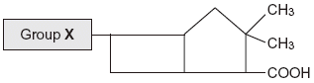

A bacterial infection that cannot be treated with one sort of penicillin can be treated with a different sort. Use your knowledge of enzyme action to explain why the different sort of penicillin is effective in treating the infection.

......................................................................................................................

......................................................................................................................

......................................................................................................................

......................................................................................................................

......................................................................................................................

......................................................................................................................

**(3)**

(b)     Farmers often keep large numbers of cattle together. Farmers used to give cattle food which had antibiotics added to it.

(i)      Suggest how adding antibiotics to the food of the cattle increased profit for the farmers.

.............................................................................................................

.............................................................................................................

.............................................................................................................

.............................................................................................................

**(2)**

(ii)     Adding antibiotics to the food of cattle is now banned in many countries. Use your knowledge of selection to explain why adding antibiotics was banned.

.............................................................................................................

.............................................................................................................

.............................................................................................................

.............................................................................................................

**(2)**

**(Total 7 marks)**

**Q35.**          The table shows some differences between three varieties of banana plant.

|  |  |  |  |  |
| --- | --- | --- | --- | --- |
|  |  | Variety **A** | Variety **B** | Variety **C** |
|  | Number of chromosomes in a leaf cell | 22 | 33 | 44 |
|  | Growth rate of fruit / cm3 week–1 | 2.9 | 6.9 | 7.2 |
|  | Breaking strength of leaf / arbitrary units | 10.8 | 9.4 | 7.8 |

(a)     (i)      How many chromosomes are there in a male gamete from variety **C**?



**(1)**

(ii)     Variety **B** cannot produce fertile gametes. Use information in the table to explain why.

.............................................................................................................

.............................................................................................................

.............................................................................................................

.............................................................................................................

.............................................................................................................

**(2)**

          In some countries very strong winds may occur. Banana growers in these countries choose to grow variety **B**.

(b)     (i)      Use the data in the table to explain why banana growers in these countries choose to grow variety **B** rather than variety **A**.

.............................................................................................................

.............................................................................................................

.............................................................................................................

**(1)**

(ii)     Use the data in the table to explain why banana growers in these countries choose to grow variety **B** rather than variety **C**.

.............................................................................................................

.............................................................................................................

.............................................................................................................

**(1)**

(c)     Banana growers can only grow new variety **B** plants from suckers. Suckers grow from cells at the base of the stem of the parent plant.

Use your knowledge of cell division to explain how growing variety **B** on a large scale will affect the genetic diversity of bananas.

......................................................................................................................

......................................................................................................................

......................................................................................................................

......................................................................................................................

......................................................................................................................

**(2)**

**(Total 7 marks)**

**Q36.**          (a)     *Clostridium difficile* is a bacterium that is present in the gut of up to 3% of healthy adults and 66% of healthy infants.

(i)*C. difficile* rarely causes problems, either in healthy adults or in infants. This is because its numbers are kept low by competition with harmless bacteria that normally live in the intestine.

Use this information to explain why some patients treated with antibiotics can be affected by *C. difficile*.

.............................................................................................................

.............................................................................................................

.............................................................................................................

.............................................................................................................

.............................................................................................................

**(2)**

(ii)     Suggest why older people are more likely to be affected by *C. difficile*.

.............................................................................................................

.............................................................................................................

.............................................................................................................

**(1)**

(b)The antibiotic methicillin inhibits the enzyme transpeptidase. This enzyme is used by some bacteria to join monomers together during cell wall formation. Methicillin has a similar structure to these monomers. Use this information to explain how methicillin inhibits the enzyme transpeptidase.

......................................................................................................................

......................................................................................................................

......................................................................................................................

......................................................................................................................

......................................................................................................................

**(2)**

(c)     MRSA is a variety of *Staphylococcus aureus*. It is difficult to treat infections caused by this bacterium because it is resistant to methicillin and to some other antibiotics. As a result, some patients who are already very ill may die if they become infected with MRSA. The graph shows the number of deaths in England and Wales between 1994 and 2008 caused by MRSA.

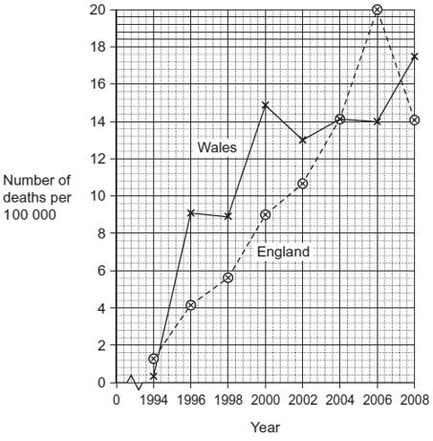

(i)It may be difficult to identify MRSA as the actual cause of death. Explain why.

.............................................................................................................

.............................................................................................................

.............................................................................................................

**(1)**

(ii)     Describe the change in the number of deaths caused by MRSA in England in the period shown in the graph.

.............................................................................................................

.............................................................................................................

.............................................................................................................

**(1)**

(iii)Calculate the percentage increase in the number of deaths caused by MRSA in Wales from 1996 to 2006. Show your working.

Answer ......................................

**(2)**

**(Total 9 marks)**

**Q37.**The figure below summarises the process of meiosis. The circles represent cells and the structures within each cell represent chromosomes.

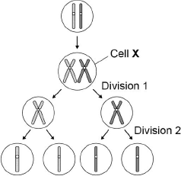

(a)     Describe and explain the appearance of **one** of the chromosomes in cell **X**.

........................................................................................................................

........................................................................................................................

........................................................................................................................

........................................................................................................................

........................................................................................................................

........................................................................................................................

........................................................................................................................

**(Extra space)** .................................................................................................

........................................................................................................................

........................................................................................................................

**(3)**

(b)     Describe what has happened during division 1 in the figure above.

........................................................................................................................

........................................................................................................................

........................................................................................................................

........................................................................................................................

........................................................................................................................

........................................................................................................................

**(2)**

(c)     Identify **one** event that occurred during division 2 but **not** during division 1.

........................................................................................................................

**(1)**

(d)     Name **two** ways in which meiosis produces genetic variation.

1 .....................................................................................................................

2 .....................................................................................................................

**(2)**

**(Total 8 marks)**

**Q38.**          (a)     Explain what is meant by genetic diversity.

......................................................................................................................

......................................................................................................................

**(1)**

(b)Apart from genetic factors what other type of factor causes variation within a species?

......................................................................................................................

**(1)**

(c)The spotted owl is a bird. Numbers of spotted owls have decreased over the past 50 years. Explain how this decrease may affect genetic diversity.

......................................................................................................................

......................................................................................................................

......................................................................................................................

......................................................................................................................

......................................................................................................................

**(2)**

**(Total 4 marks)**

**Q39.**The diagram shows the structure of a bacterium and the sites of action of two antibiotics.

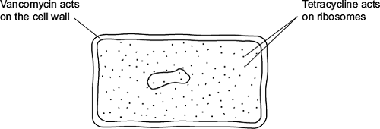

(a)     (i)      Use information in the diagram to explain why vancomycin does **not** affect human cells.

...............................................................................................................

...............................................................................................................

**(1)**

(ii)     Use information in the diagram to explain how tetracycline prevents bacterial growth.

...............................................................................................................

...............................................................................................................

**(1)**

(b)     Frequent treatment with vancomycin can result in resistant strains of bacteria. Explain how.

........................................................................................................................

........................................................................................................................

........................................................................................................................

........................................................................................................................

........................................................................................................................

........................................................................................................................

*(Extra space)* .................................................................................................

........................................................................................................................

........................................................................................................................

**(2)**

**(Total 4 marks)**

**Q40.**Phenylketonuria is a disease caused by mutations of the gene coding for the enzyme PAH. The table shows part of the DNA base sequence coding for PAH. It also shows a mutation of this sequence which leads to the production of non-functioning PAH.

|  |  |  |  |  |  |  |  |  |  |  |  |  |  |
| --- | --- | --- | --- | --- | --- | --- | --- | --- | --- | --- | --- | --- | --- |
|  | DNA base sequence coding for PAH | C | A | G | T | T | C | G | C | T | A | C | G |
|  | DNA base sequence coding for non-functioning PAH | C | A | G | T | T | C | C | C | T | A | C | G |

(a)     (i)      What is the maximum number of amino acids for which this base sequence could code?



**(1)**

(ii)     Explain how this mutation leads to the formation of non-functioning PAH.

...............................................................................................................

...............................................................................................................

...............................................................................................................

...............................................................................................................

...............................................................................................................

...............................................................................................................

(*Extra space*) ........................................................................................

...............................................................................................................

...............................................................................................................

**(3)**

PAH catalyses a reaction at the start of two enzyme-controlled pathways.  
The diagram shows these pathways.

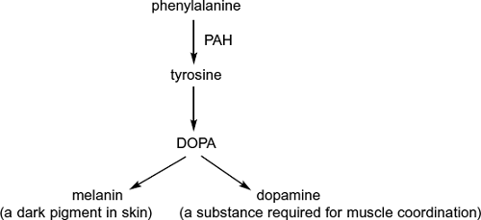

(b)     Use the information in the diagram to give **two** symptoms you might expect to be visible in a person who produces non-functioning PAH.

1 .....................................................................................................................

2 .....................................................................................................................

**(2)**

(c)     One mutation causing phenylketonuria was originally only found in one population in central Asia. It is now found in many different populations across Asia. Suggest how the spread of this mutation may have occurred.

........................................................................................................................

........................................................................................................................

........................................................................................................................

**(1)**

**Q41.**(a)    **Figure 1** shows one pair of homologous chromosomes.

**Figure 1**

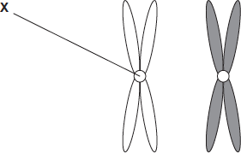

(i)      Name **X.**

...............................................................................................................

**(1)**

(ii)     Describe the role of **X** in mitosis.

...............................................................................................................

...............................................................................................................

...............................................................................................................

...............................................................................................................

...............................................................................................................

**(2)**

(iii)    Homologous chromosomes carry the same genes but they are **not** genetically identical.Explain why.

...............................................................................................................

...............................................................................................................

...............................................................................................................

**(1)**

(b)     **Figure 2** shows three pairs of homologous chromosomes in a cell at the end of cell division.

**Figure 2**



(i)      The appearance of each chromosome in **Figure 2** is different from those shown in **Figure 1.** Explain why.

...............................................................................................................

...............................................................................................................

...............................................................................................................

**(1)**

(ii)     Complete the diagram to show the chromosomes in one cell that could be produced from the cell in **Figure 2**  as a result of meiosis.



**(2)**

(iii)    Other than independent segregation, give **one** way in which meiosis allows the production of genetically different cells.

...............................................................................................................

...............................................................................................................

...............................................................................................................

**(1)**

**(Total 8 marks)**

**Q42.**(a)     (i)      Why is the genetic code described as being universal?

...............................................................................................................

...............................................................................................................

**(1)**

(ii)     The genetic code uses four different DNA bases. What is the maximum number of different DNA triplets that can be made using these four bases?



**(1)**

Transcription of a gene produces pre-mRNA.

(b)     Name the process that removes base sequences from pre-mRNA to form mRNA.

........................................................................................................................

**(1)**

(c)     The figure below shows part of a pre-mRNA molecule. Geneticists identified two mutations that can affect this pre-mRNA, as shown in the figure.

|  |  |  |  |
| --- | --- | --- | --- |
|  | Base sequence coding for amino acids | Base sequence removed from pre-mRNA | Base sequence coding for amino acids |

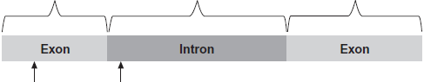

|  |  |  |
| --- | --- | --- |
|  | **Mutation 1, single base deletion** | **Mutation 2, single base substitution** |

(i)      **Mutation 1** leads to the production of a non-functional protein.

Explain why.

...............................................................................................................

...............................................................................................................

...............................................................................................................

...............................................................................................................

...............................................................................................................

...............................................................................................................

*(Extra space)* ........................................................................................

...............................................................................................................

...............................................................................................................

**(3)**

(ii)     What effect might **mutation 2** have on the protein produced?

Explain your answer.

...............................................................................................................

...............................................................................................................

...............................................................................................................

...............................................................................................................

**(2)**

**(Total 8 marks)**

**Q43.**Read the following passage carefully.

|  |  |  |
| --- | --- | --- |
|  | A large and growing number of disorders are now known to be due to types of mitochondrial disease (MD). MD often affects skeletal muscles, causing muscle weakness. |  |
|  | We get our mitochondria from our mothers, via the fertilised egg cell. Fathers do not pass on mitochondria via their sperm. Some mitochondrial diseases are caused by mutations of mitochondrial genes inside the mitochondria. Most mitochondrial diseases are caused by mutations of genes in the cell nucleus that are involved in the functioning of mitochondria. These mutations of nuclear DNA produce recessive alleles. | 5 |
|  | One form of mitochondrial disease is caused by a mutation of a mitochondrial gene that codes for a tRNA. The mutation involves substitution of guanine for adenine in the DNA base sequence. This changes the anticodon on the tRNA. This results in the formation of a non-functional protein in the mitochondrion. | 10 |
|  | There are a number of ways to try to diagnose whether someone has a mitochondrial disease. One test involves measuring the concentration of lactate in a person’s blood after exercise. In someone with MD, the concentration is usually much higher than normal. If the lactate test suggests MD, a small amount of DNA can be extracted from mitochondria and DNA sequencing used to try to find a mutation. | 15 |

Use information in the passage and your own knowledge to answer the following questions.

(a)     Mitochondrial disease (MD) often causes muscle weakness (lines 1–3). Use your knowledge of respiration and muscle contraction to suggest explanations for this effect of MD.

........................................................................................................................

........................................................................................................................

........................................................................................................................

........................................................................................................................

........................................................................................................................

........................................................................................................................

**(Extra space)** ................................................................................................

........................................................................................................................

........................................................................................................................

**(3)**

Two couples, couple **A** and couple **B**, had one or more children affected by a mitochondrial disease. The type of mitochondrial disease was different for each couple.

None of the parents showed signs or symptoms of MD.

•        Couple **A** had four children who were all affected by an MD.

•        Couple **B** had four children and only one was affected by an MD.

(b)     Use the information in lines 5–9 and your knowledge of inheritance to suggest why:

•        all of couple **A**’s children had an MD

•        only one of couple **B**’s children had an MD.

Couple **A** ........................................................................................................

........................................................................................................................

........................................................................................................................

........................................................................................................................

Couple **B** ........................................................................................................

........................................................................................................................

........................................................................................................................

........................................................................................................................

**(Extra space)** ................................................................................................

........................................................................................................................

........................................................................................................................

........................................................................................................................

**(4)**

(c)     Suggest how the change in the anticodon of a tRNA leads to MD (lines 10–13).

........................................................................................................................

........................................................................................................................

........................................................................................................................

........................................................................................................................

........................................................................................................................

........................................................................................................................

**(Extra space)** ................................................................................................

........................................................................................................................

........................................................................................................................

**(3)**

(d)     If someone has MD, the concentration of lactate in their blood after exercise is usually much higher than normal (lines 15–17). Suggest why.

........................................................................................................................

........................................................................................................................

........................................................................................................................

........................................................................................................................

........................................................................................................................

........................................................................................................................

**(Extra space)** ................................................................................................

........................................................................................................................

........................................................................................................................

**(3)**

(e)     A small amount of DNA can be extracted from mitochondria and DNA sequencing used to try to find a mutation (lines 18–19).

From this sample:

•        how would enough DNA be obtained for sequencing?

•        how would sequencing allow the identification of a mutation?

........................................................................................................................

........................................................................................................................

........................................................................................................................

........................................................................................................................

**(2)**

**(Total 15 marks)**

**Q44.**(a)     Explain how the structure of DNA is related to its functions.

........................................................................................................................

........................................................................................................................

........................................................................................................................

........................................................................................................................

........................................................................................................................

........................................................................................................................

........................................................................................................................

........................................................................................................................

........................................................................................................................

........................................................................................................................

........................................................................................................................

........................................................................................................................

*(Extra space)* ..................................................................................................

........................................................................................................................

........................................................................................................................

........................................................................................................................

........................................................................................................................

........................................................................................................................

........................................................................................................................

........................................................................................................................

........................................................................................................................

........................................................................................................................

........................................................................................................................

**(6)**

Scientists investigated three genes, **C**, **D** and **E**, involved in controlling cell division.  
They studied the effect of mutations in these genes on the risk of developing lung cancer.

The scientists analysed genes **C**, **D** and **E** from healthy people and people with lung cancer.

•        If a person had a normal allele for a gene, they used the symbol N.

•        If a person had two mutant alleles for a gene, they used the symbol M.

They used their data to calculate the risk of developing lung cancer for people with different combinations of N and M alleles of the genes. A risk value of 1.00 indicates no increased risk. The following table shows the scientists’ results.

|  |  |  |  |  |
| --- | --- | --- | --- | --- |
|  | **Gene C** | **Gene D** | **Gene E** | **Risk of developing lung cancer** |
|  | N | N | N | 1.00 |
|  | M | N | N | 1.30 |
|  | N | N | M | 1.78 |
|  | N | M | N | 1.45 |
|  | N = at least one copy of the normal allele is present M = two copies of the mutant allele are present | | | |

(b)     What do these data suggest about the relative importance of the mutant alleles of genes **C**, **D** and **E** on **increasing** the risk of developing lung cancer? Explain your answer.

........................................................................................................................

........................................................................................................................

........................................................................................................................

........................................................................................................................

........................................................................................................................

........................................................................................................................

........................................................................................................................

**(3)**

Chemotherapy is the use of a drug to treat cancer. The drug kills dividing cells.  
The figure below shows the number of healthy cells and cancer cells in the blood of a patient receiving chemotherapy. The arrows labelled **F** to **I** show when the drug was given to the patient.

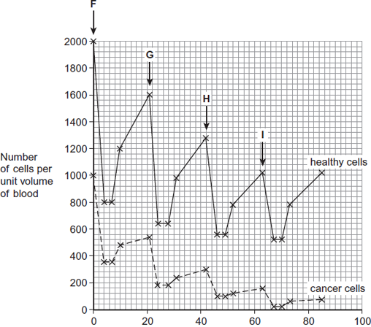  
                                    Time / days

(c)     Calculate the rate at which healthy cells were killed between days 42 and 46.

.............. cells killed per unit volume of blood per day

**(1)**

(d)     Describe similarities and differences in the response of healthy cells and cancer cells to the drug between times **F** and **G**.

........................................................................................................................

........................................................................................................................

........................................................................................................................

........................................................................................................................

........................................................................................................................

........................................................................................................................

*(Extra space)* .................................................................................................

........................................................................................................................

........................................................................................................................

**(3)**

(e)     More cancer cells could be destroyed if the drug was given more frequently.

Suggest why the drug was **not** given more frequently.

........................................................................................................................

........................................................................................................................

........................................................................................................................

........................................................................................................................

**(2)**

**(Total 15 marks)**

**Q45.**The following figure shows how some animals with hooves are classified.

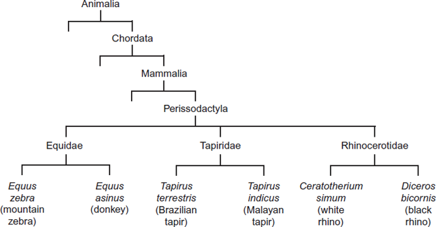

(a)     This type of classification can be described as a phylogenetic hierarchy.

(i)      What is meant by a **hierarchy**?

...............................................................................................................

...............................................................................................................

...............................................................................................................

...............................................................................................................

*(Extra space)* ........................................................................................

...............................................................................................................

**(2)**

(ii)     How many different families are shown in the figure?



**(1)**

(iii)    To which phylum does the white rhino belong?

...............................................................................................................

**(1)**

(b)     (i)      Explain the role of independent segregation in meiosis.

...............................................................................................................

...............................................................................................................

...............................................................................................................

...............................................................................................................

**(2)**

(ii)     A zedonk is the offspring produced from breeding a mountain zebra with a donkey.

•        The body cells of a mountain zebra contain 32 chromosomes.

•        The body cells of a donkey contain 62 chromosomes.

Use this information to suggest why zedonks are usually infertile.

...............................................................................................................

...............................................................................................................

...............................................................................................................

...............................................................................................................

**(2)**

**(Total 8 marks)**

**Q46.**Malaria is a disease that is spread by insects called mosquitoes. In Africa, DDT is a pesticide used to kill mosquitoes, to try to control the spread of malaria.

Mosquitoes have a gene called *KDR*. Today, some mosquitoes have an allele of this gene, *KDR minus*, that gives them resistance to DDT. The other allele, *KDR plus*, does not give resistance.

Scientists investigated the frequency of the *KDR minus* allele in a population of mosquitoes in an African country over a period of 10 years.

The figure below shows the scientists’ results.

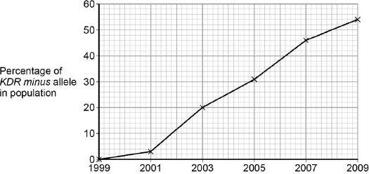

          Year

(a)     Use the Hardy–Weinberg equation to calculate the frequency of mosquitoes heterozygous for the *KDR* gene in this population in 2003.

Show your working.

Frequency of heterozygotes in population in 2003 ...................................

**(2)**

(b)     Suggest an explanation for the results in the figure above.

........................................................................................................................

........................................................................................................................

........................................................................................................................

........................................................................................................................

........................................................................................................................

........................................................................................................................

........................................................................................................................

........................................................................................................................

**(Extra space)** ................................................................................................

........................................................................................................................

........................................................................................................................

........................................................................................................................

........................................................................................................................

**(4)**

The *KDR plus* allele codes for the sodium ion channels found in neurones.

(c)     When DDT binds to a sodium ion channel, the channel remains open all the time.  
Use this information to suggest how DDT kills insects.

........................................................................................................................

........................................................................................................................

........................................................................................................................

........................................................................................................................

**(2)**

(d)     Suggest how the *KDR minus* allele gives resistance to DDT.

........................................................................................................................

........................................................................................................................

........................................................................................................................

........................................................................................................................

**(2)**

**(Total 10 marks)**

**Q47.**The figure below shows some cells from an onion root tip at different stages of the cell cycle.

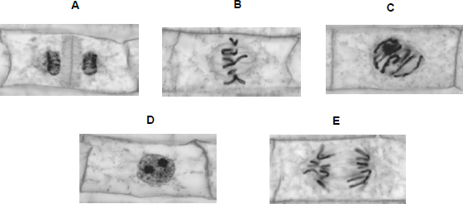

© Ed Reschke/Oxford Scientific/Getty Images

(a)     Place stages **A** to **E** in the correct order. Start with stage **D**.

**D**.............................................................................................................

**(1)**

To obtain these images, the onion root tip was cut off, stained and put on a microscope slide. A cover slip was placed on top. The root tip was then firmly squashed and viewed under an optical microscope.

(b)     Complete the table below to give **one** reason why each of these steps was necessary.

|  |  |  |
| --- | --- | --- |
|  | **Step** | **Reason** |
|  | Taking cells from the root tip |  |
|  | Firmly squashing the root tip |  |

**(2)**

The figure below shows how the amount of DNA per cell changed during interphase and meiosis in an animal.

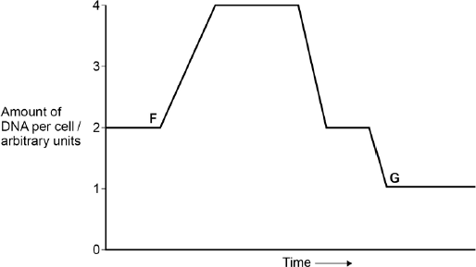

(c)     Explain how the behaviour of chromosomes causes these changes in the amount of DNA per cell between **F** and **G**.

........................................................................................................................

........................................................................................................................

........................................................................................................................

........................................................................................................................

........................................................................................................................

........................................................................................................................

**(Extra space)** ................................................................................................

........................................................................................................................

........................................................................................................................

**(3)**

(d)     What would happen to the amount of DNA per cell at fertilisation of cell **G?**

........................................................................................................................

........................................................................................................................

**(1)**

**(Total 7 marks)**

**Q48.**The table shows the taxons and the names of the taxons used to classify one species of otter. They are **not** in the correct order.

|  |  |  |  |
| --- | --- | --- | --- |
|  |  | **Taxon** | **Name of taxon** |
|  | **J** | Family | Mustelidae |
|  | **K** | Kingdom | Animalia |
|  | **L** | Genus | Lutra |
|  | **M** | Class | Mammalia |
|  | **N** | Order | Carnivora |
|  | **O** | Phylum | Chordata |
|  | **P** | Domain | Eukarya |
|  | **Q** | Species | lutra |

(a)     Put letters from the table above into the boxes in the correct order. Some boxes have been completed for you.

|  |  |  |  |  |  |  |  |  |  |  |  |  |  |  |  |
| --- | --- | --- | --- | --- | --- | --- | --- | --- | --- | --- | --- | --- | --- | --- | --- |
|  |  |  |  |  | **O** |  | **M** |  |  |  |  |  | **L** |  | **Q** |

**(1)**

(b)     Give the scientific name of this otter.

........................................................................................................................

**(1)**

Scientists investigated the effect of hunting on the genetic diversity of otters. Otters are animals that were killed in very large numbers for their fur in the past.

The scientists obtained DNA from otters alive today and otters that were alive before hunting started.

For each sample of DNA, they recorded the number of base pairs in alleles of the same gene. Mutations change the numbers of base pairs over time.

The figure below shows the scientists’ results.

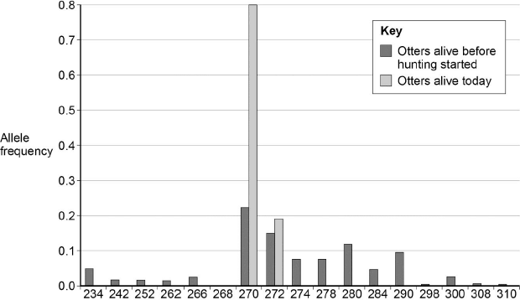  
                        Allele size / number of base pairs

(c)     The scientists obtained DNA from otters that were alive before hunting started.

Suggest **one** source of this DNA.

........................................................................................................................

........................................................................................................................

**(1)**

(d)     What can you conclude about the effect of hunting on genetic diversity in otters? Use data from the figure above to support your answer.

........................................................................................................................

........................................................................................................................

........................................................................................................................

........................................................................................................................

**(2)**

(e)     Some populations of animals that have never been hunted show very low levels of genetic diversity.

Other than hunting, suggest **two** reasons why populations might show very low levels of genetic diversity.

1 .....................................................................................................................

........................................................................................................................

2 .....................................................................................................................

........................................................................................................................

**(2)**

**(Total 7 marks)**

**Q49.Table 1** shows how a bird called the bluethroat (*Luscinia svecica*) is classified by biologists.

**Table 1**

|  |  |  |
| --- | --- | --- |
|  | **Taxon** | **Name of taxon** |
|  | Domain | Eukaryota |
|  |  | Animalia |
|  |  | Chordata |
|  |  | Aves |
|  |  | Passeriformes |
|  |  | Muscicapidae |
|  | Genus |  |
|  | Species |  |

(a)     Complete **Table 1** by filling the seven blank spaces with the correct terms.

**(2)**

A group of scientists investigated genetic diversity in different species of bird. For each species, the scientists:

•        collected feathers from a large number of birds

•        extracted DNA from cells attached to each feather

•        analysed the samples of DNA to find genetic diversity.

**Table 2** summarises their results.

**Table 2**

|  |  |  |  |
| --- | --- | --- | --- |
|  | **Species of bird** | **Number of genes  examined** | **Number of genes  examined that showed genetic diversity** |
|  | Willow flycatcher | 708 | 197 |
|  | House finch | 269 | 80 |
|  | Bluethroat | 232 | 81 |

(b)     In this investigation, what is meant by **genetic diversity?**

........................................................................................................................

........................................................................................................................

**(1)**

(c)     The scientists concluded that the bluethroat showed greater genetic diversity than the willow flycatcher. Explain why they reached this conclusion. Use calculations to support your answer.

........................................................................................................................

........................................................................................................................

........................................................................................................................

........................................................................................................................

**(2)**

**(Total 5 marks)**

**Q50.**To reduce the damage caused by insect pests, some farmers spray their fields of crop plants with pesticide. Many of these pesticides have been shown to cause environmental damage.

Bt plants have been genetically modified to produce a toxin that kills insect pests. The use of Bt crop plants has led to a reduction in the use of pesticides.

Scientists have found that some species of insect pest have become resistant to the toxin produced by the Bt crop plants.

The figure below shows information about the use of Bt crops and the number of species of insect pest resistant to the Bt toxin in one country.

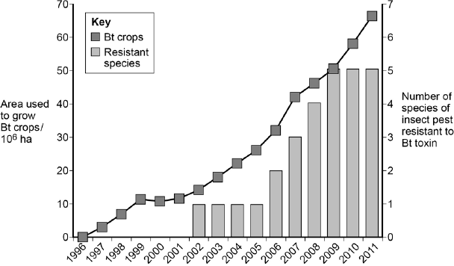  
      Year

(a)     Can you conclude that the insect pest resistant to Bt toxin found in the years 2002 to 2005 was the same insect species? Explain your answer.

........................................................................................................................

........................................................................................................................

**(1)**

(b)     One farmer stated that the increase in the use of Bt crop plants had caused a mutation in one of the insect species and that this mutation had spread to other species of insect. Was he correct? Explain your answer.

........................................................................................................................

........................................................................................................................

........................................................................................................................

........................................................................................................................

........................................................................................................................

........................................................................................................................

........................................................................................................................

........................................................................................................................

**(Extra space)** ................................................................................................

........................................................................................................................

........................................................................................................................

........................................................................................................................

**(4)**

(c)     There was a time lag between the introduction of Bt crops and the appearance of the first insect species that was resistant to the Bt toxin.  
Explain why there was a time lag.

........................................................................................................................

........................................................................................................................

........................................................................................................................

........................................................................................................................

........................................................................................................................

........................................................................................................................

**(3)**

**(Total 8 marks)**

**Q51.**The diagram below represents one process that occurs during protein synthesis.

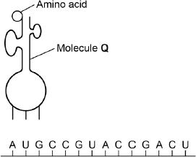

(a)     Name the process shown.

........................................................................................................................

**(1)**

(b)     Identify the molecule labelled **Q**.

........................................................................................................................

**(1)**

(c)     In the diagram above, the first codon is AUG. Give the base sequence of:

the complementary DNA base sequence .....................................................

the missing anticodon ...................................................................................

**(2)**

The table below shows the base triplets that code for two amino acids.

|  |  |  |
| --- | --- | --- |
|  | **Amino acid** | **Encoding base triplet** |
|  | Aspartic acid | GAC, GAU |
|  | Proline | CCA, CCG, CCC, CCU |

(d)     Aspartic acid and proline are both amino acids. Describe how two amino acids differ from one another. You may use a diagram to help your description.

........................................................................................................................

........................................................................................................................

........................................................................................................................

**(1)**

(e)     Deletion of the sixth base (G) in the sequence shown in the diagram above would change the nature of the protein produced but substitution of the same base would not. Use the information in the table and your own knowledge to explain why.

........................................................................................................................

........................................................................................................................

........................................................................................................................

........................................................................................................................

........................................................................................................................

........................................................................................................................

**(Extra space)** ................................................................................................

........................................................................................................................

........................................................................................................................

**(3)**

**(Total 8 marks)**

**M1.**(a)      1.      Change / mutation in base / nucleotide sequence (of DNA / gene);

*Q.*

*Ignore: references to changing base-pairing*

*Accept: affect for change, if in correct context*

*Accept: changes triplets / codons*

2.      Change in amino acid sequence / primary structure (of enzyme);

*Accept: different amino acid(s) coded for*

***Q*** *Reject: different amino acids produced / formed / made*

3.      Change in hydrogen / ionic / disulfide bonds;

*Accept: references to sulfur bonds*

4.      Change in the tertiary structure / shape;

*Neutral: alters 3D structure / 3D shape*

5.      Change in active site;

6.      Substrate not complementary / cannot bind (to enzyme / active site) / no enzyme-substrate complexes form.

*Accept: no E S complexes form*

**6**

(b)     1.      Non-SR strain falls more / SR strain falls less / up to 10(μg / cm−3);

*Must include 10 but only required once in either MP1 or MP2*

*Ignore: units or absence of*

*This must be a comparative statement*

2.      Above 10(μg / cm−3), SR strain levels out / off and non-SR strain continues to decrease;

3.      Greater difference between strains with increasing concentration of antibiotic.

*This must be a comparative statement*

**2 max**

(c)     1.      Division stopped (of both strains by scientist);

*Reject: references to mitosis stopping*

2.      SR strain still more resistant / fewer die / none die (at higher concentrations of antibiotic).

*Accept: SR strain and non-SR strain would be similar if resistance is due to only stopping division*

*Need some comparison with non-SR*

**2**

(d)     1.      Make a competitive / non-competitive inhibitor;

*Mark in pairs*

*either MP1 and MP2 OR MP3 and MP4*

2.      Competitive competes with / blocks active site / non-competitive inhibitor affects / changes active site;

*Do not mix and match*

OR

3.      (Make a drug) that inhibits / denatures / destroys enzyme / stringent response;

*Accept: drug that ‘knocks out’ / destroys enzyme*

4.      Give at the same time as / before an antibiotic.

**2 max**

(e)     (SR strain)

1.      Fewer free radicals (than non-SR);

*Note: has to be comparative statement*

2.      Produces more catalase (than non-SR);

*Accept converse statements for non-SR.*

3.      Catalase (might be) linked to production of fewer free radicals / breaking down / removing free radicals.

*Accept: hydrolysis of radicals by catalase.*

**3**

**[15]**

**M2.**          (a)

|  |  |  |  |  |  |
| --- | --- | --- | --- | --- | --- |
| A    b |  | A    b | a    B |  | a    B |

**1**

(b)     bivalent;

**1**

(c)     (i)      Ab, aB;

(ii)     AB, ab;

**2**

(d)     mutation;  
different / new allele formed / genes deleted or duplicated / sequence  
of genes changed *(reject genetic information)*;  
random fusion of gametes / fertilisation;  
new combination of alleles;  
independent assortment (of chromosomes) *(accept random)*;  
shuffling of maternal and paternal chromosomes / new combination  
of alleles;  
*(ignore references to stages of meiosis)*any 2 × 2

**4 max**

**[8]**

**M3.**          (a)     6;

**1**

(i)      chromosomes are arranged in (homologous) pairs / bivalents;  
crossing over / chiasma present / exchange of genetic information;   
bivalents arranged independently;

**2 max**

(ii)     separation / spliting / pulling apart of homologous chromosomes /   
pairs of chromosomes;

*(must give indication that one chromosome moves to each side)  
(must be in the context of meiosis – not chromatid movements and not chromosomes separate)*

pulled at centromere / by spindle / fibres;

**2**

(c)     (i)      the short arm of both chromosomes labelled on the middle   
homologous pair;

*(****B*** *and* ***b*** *must be labelled on separate chromosomes)*

**1**

(ii)     8 = 2 marks;  
working showing genotypes with 1 allele from each pair   
(for example, **B C D**) = 1 mark

**2**

**[8]**

**M4.**          (a)     mutation changes the amino acid sequence / primary structure of Factor VIII protein;  
changes the tertiary structure / 3D shape;

**2**

(b)     (mutant) Factor VIII protein is non-functional / does not work with Factor IX;  
so no conversion of Factor X to active form and pathway blocked;

**2**

(c)     boy’s blood contains (active) Factor VIII;  
Factor VIII haemophiliac’s blood contains (active) Factor IX;  
the mixture has both Factors and so the pathway can  
complete / blood clots;

**2 max**

**[6]**

**M5.**          (a)     meiosis halves the chromosome number / from diploid to haploid / produces haploid / n cells;  
when gametes fuse / at fertilisation, the diploid number is restored / this keeps the chromosome number constant / correct from one  
generation to the next / after sexual reproduction;  
introduces genetic variation / independent assortment / crossing over;

**3**

(b)     **M** between moss plant and spore;

**1**

**[4]**

**M6.**          (a)     limited genetic diversity in modern varieties / greater genetic  
diversity in old varieties / older varieties contain other (useful)  
alleles / genes;  
old varieties useful for future breeding programmes;

**2**

(b)     (i)      seeds lose viability / will not germinate / develop  
after long storage;

**1**

(ii)     preserve variety of alleles / different genotypes / maintain genetic variation;  
prevent inbreeding / reduces the chance of homozygosity;

**2**

**[5]**

**M7.**          (a)     sections of chromatids exchanged;  
sections have different alleles;  
new combinations of (linked) alleles;

*(allow 1 mark for idea that ‘genes’ are exchanged,  
if no other marks gained)*

**3**

(b)     (i)      length controlled by many genes / polygenes;  
each gene may have different alleles / idea of additive effects;  
OR  
environmental factors / or named factor;  
how named factor may affect growth of seeds;

**2 max**

(ii)     1.      selection of large seeds for sowing;

2.      higher proportion of alleles for long length / loss of alleles for short seeds from population;

3.      (possible appearance of) new alleles through mutation;

4.      process repeated over many generations;

*(G - allow 1 mark idea for that ‘largeness’ selected, survives and inherited)*

**4**

**[9]**

**QWC 1**

**M8.**          (a)to get haploid / n / half number of chromosomes (in cells);  
so that each cell gets one copy of each chromosome / gene / full  
set of genes / so that fertilisation produces diploid / constant  
chromosome number; results in independent assortment;

**2**

(b)     (i)      4;

**1**

(ii)     meiosis (has halved the chromosome number);

**1**

(ii)     (mitosis because) zygote gets two chromosomes from each gamete / has four chromosomes;

*accept haploid for two and diploid for four*

gamete-producing plant has two chromosomes,  
so mitosis to produce gametes with two;

**2**

**[6]**

**M9.**          (a)     Isolation / quarantine / ‘kept separate’;

Screening / testing (of patients / doctors etc);

Sterilisation of wards / equipment / method to improve hygiene;

*Do not allow improve ‘hygiene’ or ‘cleanliness’ without named example such as ‘washing hands’ use of gloves etc.*

**2 max**

(b)     May not all be absorbed;

May be broken down / metabolised / excreted quickly;

To kill the microorganisms / bacteria;

Reference to antibiotic resistance;

*Reference to becoming ‘immune’ negates last marking point.*

**2 max**

(c)     (i)      P;

**1**

(ii)     S;

**1**

(d)     (i)      Prevents bias;

Vested interest (of scientists);

Prevents ‘placebo’ / positive / negative / psychological effects / ‘demand characteristics’ (in volunteers);

**2 max**

(ii)     Age;

Ethnicity;

Lifestyle;

Body mass;

Health;

Sex of person;

*Ignore references to same or different*

**2 max**

(e)     Gradual / slight increase followed by rapid / greater increase;

*Allow more detailed descriptions which describe similar trend of gradual increase followed by rapid increase.*

**1**

**[11]**

**M10.**          (a)     (i)      8 ‘chromatids’ each side;  
spindle drawn;

**2**

(ii)     4 chromosomes;  
1 from each homologous pair;

**2**

(b)     produces haploid cells / chromosome number halved;  
fertilisation maintains the diploid / chromosome number (in next generation);

**2**

**[6]**

**M11.**          (a)     different form of a gene;

**1**

(b)     hydrogen bonds broken;  
semi-conservative replication / both strands used (as templates);  
nucleotides line up complementary / specific base pairing / A and T / C and G;  
DNA polymerase;

**4**

(c)     deletion causes frame shift / alters base sequence (from point of mutation);  
changes many amino acids / sequence of amino acids (from this point);  
substitution alters one codon / triplet / one amino acid altered / code  
degenerate / same amino acid coded for;

**3**

**[8]**

**M12.**          (a)     high energy radiation / ionising particles;

named particles / α, β, γ;

colchicine;

x rays / cosmic rays;

uv (light);

carcinogen / named carcinogen;

mustard gas / phenols / tar (qualified);

**1 max**

(b)     (i)      removal of one or more bases / nucleotide;

frameshift / (from point of mutation) base sequence change;

**2**

(ii)     sequence of bases in mRNA would change;

(sequence of) amino acids different / different primary structure;

(active site / enzyme 1) changed tertiary shape / changed active  
sites;

white pigment does not bind;

lilac pigment not produced / white pigment remains unchanged /

enzyme 1 does not function;

**4 max**

(iii)     blue and lilac; white;

|  |
| --- |
| *colour of petal* |
| *(white)* |
| blue |
| lilac; |
| white; |

**2**

**[9]**

**M13.**          (a)     (i)      TB Tb tB tb;

**1**

(ii)     homologous chromosomes appropriately labelled;

**1**

(iii)     separation of chomatids;

**1**

(b)     (i)      crossing over occurs;  
between **D** and **G**;  
sections of chromatids / chromosomes / DNA / genes exchanged;

**3**

(ii)     crossing over is infrequent(between close genes);

**1**

**[7]**

**M14.**          (a)     haploid cells produced / halves chromosome number;  
fertilisation / fusion of gametes, diploid number restored;  
chromosome number constant at each generation;

**2 max**

(b)     principle of 2 chromosomes per cell;  
4 correct combinations, long with short;

**2**

(c)     (i)      8;

(ii)     8;

**2**

(d)     (in males) more gametes produced / rapid gamete production / more lost;

**1**

**[7]**

**M15.**          (a)     (i)      join / attach nucleotides, to form a strand / along backbone / phosphodiester bonds;

*(reject reference to H bonds, complementary base pairing)*

**1**

(ii)     ribosome / RER;

**1**

(b)     (i)      CGTTACCAA;

**1**

(ii)     CGU UAC CAA;

**1**

(c)     substitution;

**1**

(d)     (i)      alanine;

**1**

(ii)     (mutation 1)  
no change(to sequence of amino acids);  
codon for alanine / degenerate codon / same amino acid coded for;

**2**

(mutation 2)  
(change in sequence) valine replaced by alanine / codon for alanine;  
folding / shape / tertiary structure / position of bonds may change;

*(reject peptide bonds)*

**2**

**[10]**

**M16.**          (a)     (i)     Continuous variation – range of values / not discrete categories / many  
categories / no gaps;

**1**

(ii)     Crossing over / chiasmata;  
Random segregation / independent assortment;  
In meiosis I and meiosis II;

**max 2**

(b)     Range influenced by single ‘outlier’ (*accept anomaly*) /   
converse for S.D.;  
S.D. shows dispersion / spread about mean / range only shows highest  
and lowest values / extremes;  
Or  
S.D. allows statistical use;  
Tests whether or not differences are significant;

**max 2**

**[4]**

**M17.**(a)     *Two linked points:*

Crossing over / exchange of material (between chromatids);  
Different combinations of alleles / linkage groups changed / broken;

*OR*

Independent assortment / alignment of (homologous) chromosomes;  
Different combinations of (maternal and paternal) chromosomes / alleles;

**2 max**

|  |  |  |  |  |
| --- | --- | --- | --- | --- |
|  | (b) | Gamete genotype |  |  |
|  | Offspring genotype |  |  |
|  | Offspring phenotypes | Abnormal males / (all)     (no females); | |

**3**

**[5]**

**M18.**          (a)     replication / duplication / doubling of chromosomes /   
replication of DNA / transcription of DNA;

**1**

(b)     (i)      cell to show correct number of chromosomes;   
correct shape and position of centromere;

**2**

(ii)     as (i) except everything halved – *Ignore crossing over*;  
(if mitosis and meiosis reversed, allow 1 if otherwise correct)

**2**

(c)     to replace cells;

**1**

**[6]**

**M19.**          (a)     1.  Chromosomes shorten / thicken / condense;  
2.  Chromosomes associate in homologous / (described) pairs /   
    formation of bivalents / tetrads;  
3.  Crossing-over / chiasma formation;  
4.  Join to spindle (fibres) / moved by spindle;(*)  
5.  (At) equator / middle of cell;(*)  
6.  (join via) centromere / kinetochore;(*)  
7.  (Homologous) chromosomes move to opposite poles /   
     chromosomes separate / move apart; (*ALLOW* ‘are pulled apart’)  
8.  (Pairs of) chromatids separated in 2nd division;

(*) OR “ independent assortment”  
     unqualified = 1 mark

**max 6**

(b)     1.  Crossing-over; [*IGNORE* any wrong ref. to timing]  
2.  Independent / random assortment / orientation / segregation of  
     (homologous) chromosomes in meiosis I;  
3.  Independent / random assortment / orientation / segregation of  
     chromatids in meiosis II;

+   Any **three** from:  
4.  Different adaptations / some better adapted;  
5.  Some survive / example described;  
6.  To reproduce;  
7.  Pass on gene / allele;  
8.  Allows for changing environment / different environment / example  
described;

**max 5**

(c)     (i)      21;

**1**

(ii)     1. *T. aestivum* has 2 copies of each type of chromosome / is diploid;  
2. *T. aestivum’s* chromosomes can form bivalents / can assort in meiosis */* can produce haploid gametes;  
3. *T. aestivum’s* gametes receive a copy of every chromosome / receive all the genetic information;

*ACCEPT converse argument for hybrid plants*

**3**

**[15]**

**M20.**          (a)     Later fertilisation / cell fusion; (NOT just ‘sexual reproduction’)  
Restoring diploid / original number / not doubling chromosome number;

*ALLOW ref ‘½ + ½’*

**2**

(b)     Any three pairs from:

*need comparison of meiosis and mitosis each time*

|  |  |
| --- | --- |
| Meiosis | Mitosis |
| (Homologous) chromosomes associate in pairs | (Homologues) independent / do not pair (IGNORE ref. separation |
| Crossing-over / chiasmata formation | No crossing-over; |
| Two / (nuclear stages) divisions / → 4 offspring cells | One / (nuclear stage) division / → 2 offspring cells; |
| Genetically different (product) | Genetically identical (product); |

*IGNORE refs. To location*

**max 3**

**[5]**

**M21.**          (a)     Chromosomes attach to equator / middle of cell / spindle;  
Prophase;  
Anaphase;  
DNA replication / synthesis / chromosome copying / duplication;  
Telophase;

**5**

(b)     (i)      Meiosis;

**1**

(ii)     32;

**1**

**[7]**

**M22.**          (a)     group of organisms with similar features;  
can (interbreed to) produce fertile offspring;

**2**

(b)     directional selection;   
*any TWO from*selection against one extreme / for one extreme;  
against broadest beaks in B and narrowest beaks  
in **A** / for narrowest in **B** and broadest in **A**;  
whole distribution / range / mean / mode / median is  
shifted towards favoured extreme;

**3 max**

**[5]**

**M23.**          (a)     Interphase / S-phase;

**1**

(b)     **A D C E B;**

**1**

(c)     Attachment of centromeres / chromosomes / chromatids; Separation of centromeres / chromatids / chromosomes;

**2**

(d)     Halves chromosome number / haploid;

Diploid / full number restored at fertilisation;

*Allow correct reference to variation*

**max 2**

**[6]**

**M24.**          (a)     (meiosis) anaphase I;  
chromosomes are moving apart;  
chromosomes still double structures;

**3**

(b)     chromosomes in each (homologous) pair twist around each other;  
chromatids break and rejoin to chromatid on sister chromosome;

*(accept points from a suitable diagram)*

**2**

**[5]**

**M25.**          (a)     Excitation of chlorophyll molecule / electrons / energy of (pairs of)  
electrons raised to higher energy level;

Electron(s) emitted from chlorophyll molecule;

Electron(s) to electron transport chain;

Loss of energy by electron(s) along electron transport chain;

Energy lost by electron(s) is used to synthesise ATP;

From ADP + Pi;

*“By electrons” need not be stated in each marking point if it can be reasonably inferred that the candidate is referring to electrons*

**max 5**

(b)     Little green light reaches bottom as absorbed by surface dwellers / water;  
Red and blue not absorbed and so penetrate;  
Variation in pigments of sediment dwellers;  
Bacteria with chlorophyll at an advantage as chlorophyll absorbs red and blue;  
(Survive to) reproduce in greater numbers and pass on advantageous   
alleles / genes in greater numbers / increase in frequency of advantageous  
alleles in subsequent generations;  
Increase in frequency / numbers of bacteria with chlorophyll;

**6**

**[11]**

**M26.**          (a)     (variation in) temperature will affect the solubility of oxygen / rate of respiration / use of oxygen by cells / diffusion / gas exchange;  
*to gain credit point made must concern oxygen*

**1**

(b)     (i)      there is no difference between the partial pressure of oxygen in the two groups / the partial pressure of oxygen is the same in each group;

**1**

(ii)     results may have been due to chance and statistical test allows us to determine the probability of this / of the difference between results   
being significant;  
enables acceptance or rejection of null hypothesis;  
*The key points here are chance and probability used in the correct context.*

**2**

(c)     **A**;  
because partial pressure of oxygen only reduced when zinc in water / in **Y** / because when injected zinc / in **X** has no effect on partial pressure of oxygen in blood;

**2**

(d)     less oxygen transport to cells / in fish / in blood;   
anaerobic respiration;  
lactic acid produced / less carbon dioxide removed (from gills);  
more H+;

**3 max**

(e)     (i)      copper;  
calculation based on comparing concentration in woodlice with that in leaves;  
*accept any suitable method here, giving marks for the method and explanation. For example, calculating ratio of concentration in woodlice to concentration in leaves.*

**2**

(ii)     not absorbed from gut / passes out in faeces / egested / urine / excreted;

**1**

(iii)     woodlice eat large amount of leaves;  
copper stored / accumulates in body;

**2**

(f)      (i)      mutation;

**1**

(ii)     (as a component of) nucleic acids / DNA / RNA / nucleotides;  
phospholipids;   
ATP / ADP;

**2 max**

(iii)     arsenic-tolerant plants would not be able to take up phosphates / take up a little phosphate;  
since likely to involve same mechanism / same carrier / protein;   
(process of ) growth would be poorer than non-tolerant plants;

**3**

**[20]**

**M27.**         (a)     Chromosomes:            **C** = 8 *and* **D** = 4;  
DNA:                             **C** = 300 *and* **D** = 150;

**2**

(b)     (i)      testis / ovary;  
*accept anther / carpel / stamen / testicle*

**1**

(ii)     to make chromosomes / chromatids / DNA / genetic material visible;

**1**

**[4]**

**M28.**(a)     1.      Homologous chromosomes pair up / bivalents form;

2.      Crossing over / chiasmata form;

3.      Produces new combination of **alleles;**

4.      Chromosomes separate;

5.      At random;

6.      Produces varying combinations of chromosomes / genes / alleles (*not twice*) ;

7.      Chromatids separated at meiosis II / later;

*Independent assortment / random segregation = marking points 4 and 5*

**6 max**

(b)     (i)

|  |  |  |  |  |
| --- | --- | --- | --- | --- |
|  | Parental phenotypes | Agouti | White |  |
|  | Parental genotypes | BbAa | bbaa | ; |
|  | Gamete genotypes | BA     Ba     bA     ba | ba | ; |
|  | Offspring genotypes | BbAa     Bbaa | bbAa     bbaa | ; |
|  | Offspring phenotype | Agouti     Black | White     White | ; |

*Phenotypes must match genotypes*

*Allow marking points 2 and 3 if correctly derived from wrong parental genotypes*

**4**

(ii)

|  |  |  |  |  |  |  |
| --- | --- | --- | --- | --- | --- | --- |
|  | ***Colour of offspring*** | ***Observed (O)*** | ***Expected (E)*** | ***(O-E)*** | ***(O-E)2*** |  |
|  | Agouti | 34 | 30 | 4 | 16 | 0.53 |
|  | Black | 35 | 30 | 5 | 25 | 0.83 |
|  | White | 51 | 60 | 9 | 81 | 1.35 |
|  |  | | | | ***Σ*= 2.71 or 2.72** | |
|  |  | | | | ;;       2 | |

*(χ2 correct = 2 marks)*

*((O-E)2 all correct = 1 mark)*

p = 0.05;

2 degrees of freedom;

Differences due to chance / no significant difference as χ2 less than / to left of critical value OR Not due to chance / difference is significant as χ2 greater than to right of critical value;

*(as appropriate for candidates χ2)*

**3**

**[15]**

**M29.**          (a)     (i)      Faster / greater / more effective response in children;

*Do not accept children have more haemoglobin*

**1**

(ii)     Use line of best fit;

**1**

Extrapolate / extend line (and read from graph);

*Allow calculation using rate of increase per day = one mark.  
However for both marks this must be linked to line of best fit.*

**1**

(iii)    More than one polypeptide chain;

*Allow many polypeptide chains.*

*‘Haemoglobin has four polypeptide chains’ must be in correct context to gain mark.*

**1**

(b)     (i)      Has same water potential;

*Allow converse for effect of using distilled water or a concentrated solution.*

**1**

No (net) water movement / osmosis;

**1**

Cells will not swell / burst / change size;

*No osmotic lysis = two marks*

**1**

(ii)     Pernicious anaemia (cells) greater range / spread / variation of diameters / widths;

Some pernicious anaemia (cells) wider than 9 (µm) / some  
less than 5.5 (µm) / without pernicious anaemia none more than 9 (µm) / none less than 5.5 (µm);

Pernicious anaemia (cells) peak / most frequent at 8.5 (µm) / peak / most frequent at higher diameter / / without pernicious anaemia peak / most frequent at 7 (µm) / peaks at lower diameter;

*There are several alternatives for marking points 2 and 3*

**2 max**

**[9]**

**M30.**(a)     Cannot make (active) enzyme A (which converts precursor to linamarin) / cannot make linamarin;

**1**

(b)     (i)      **AL**     +     **Al**     +     **aL**     +     **al** ;

**1**

(ii)     Meiosis separates alleles / homologous chromosomes / pairs of chromosomes;

Independent assortment / means either of **A** / **a** can go with either of **L** / **l**;

*Accept “random segregation” but cancel if reference to crossing-over*

**2**

(c)     From parental genotypes: **AaLl**     ×     **AaLl** (no mark)

Note: If wrong parental genotypes / wrong gametes: ALLOW correct derivation of offspring genotypes = 1 max

Correct derivation of offspring genotypes; max 2 marks if error in Punnett square

|  |  |  |  |  |  |
| --- | --- | --- | --- | --- | --- |
|  |  | **AL** | **Al** | **aL** | **al** |
|  | **AL** | AALL | AALl | AaLL | AaLl |
|  | **Al** | AALl | AAll | AaLl | Aall |
|  | **aL** | AaLL | AaLl | aaLL | aaLl |
|  | **al** | AaLl | Aall | aaLl | aall |

Correct identification of offspring genotypes with at least one **A** and two **l** alleles (= grey cells in above table);

Correct proportion: 3 / 16 / 3:13 / 18.75% ;

**3**

(d)     (i)      There was no (significant) difference in damage between cyanogenic and acyanogenic / being cyanogenic has no effect;

**1**

(ii)     The difference (from expected / from chance variation) is significant / difference / results not just due to chance;

Reject null hypothesis;

Being cyanogenic does help protect from slug damage;

**3**

(e)     High slug population:

1.      Find only cyanogenic plants / only cyanogenic plants survive;

2.      (Cyanide release) limits / stops feeding by slugs / slugs killed;

*Accept: converse argument re. acyanogenic plants*

Low slug population:

3.      Find both types of plant;

4.      Less selection pressure on plants from slugs / no selective advantage / no selection / described;

**4**

**[15]**

**M31.**(a)     (Different) form / type / version of a gene / different base sequence of a gene;

**1**

(b)     Two / sister chromatids joined by a centromere;

Due to DNA replication;

**2**

(c)     (i)      Crossing over;

**1**

Exchange (of alleles) between chromatids / chromosomes;

*Negate first marking point for answers which refer to independent segregation.*

*Chiasma / chiasmata = first marking point*

**1**

(ii)     Is infrequent / rare;

*References to it being ‘random’, ‘occurs by chance’ or ‘doesn’t always occur’ should not be credited without a clear idea that it is rare or infrequent.*

**1**

(d)     (i)      Three chromosomes shown;

**1**

One from each homologous pair;

*For first mark point allow drawings showing three chromosomes as single or double structures.*

**1**

(ii)     8;

**1**

**[9]**

**M32.**          (a)     (So results) can be compared / so measurement is the same each time / because eye is not perfectly round / uniform;

*Accept eye opens to different amounts*

**1**

(b)     (i)      1.      Eye (diameter) is smaller and antennae longer;

2.      Antennae detecting touch;

3.      Data only refers to shrimps / data may not apply to all animals / only in one area;

*The principle here is that candidate has recognised that both features confirm suggestion. Exact wording does not matter.*

**2 max**

(ii)     1.      Standard deviation gives a measure of spread / variation;

2.      More standard deviations overlap, the less likely it is that differences are real / significant / the more likely they are caused by chance;

*Do not accept range*

*Accept converse.*

*Although we are looking for the idea of significance, we cannot require this term.*

**2**

(c)     (i)      Qualitative statement about

          difference in size /

          difference in variation /

          overlap in size;

Quantitative statement about

          difference in size /

          difference in variation /

          overlap in size;

Supported by relevant two sets of figures from graph;;

*Note simplistic answer involving a quantitative statement gains 1 mark.*

*More specific answer involving quantitative information gains 2 marks.*

**2**

(ii)     (No) for same body length, antenna are longer / antenna are shorter / some with longer body have short antennae / some with shorter body length have longer antennae;

***OR***

(Yes) positive correlation in open / in cave;

*Habitat not critical as a term.*

*Must refer to idea of same habitat*

*Accept description*

**1**

(d)     More alleles of each gene / shrimps in open have all the alleles;

*Candidates are required to use the information from the table. Must therefore refer to alleles.*

**1**

(e)     1.      A small number of shrimps were / went into the cave;

2.      All / high proportion of shrimps had allele L;

3.      Cave population descended from these / these reproduce;

**3**

(f)      (i)      1.      Cross shrimps from two sites / watch courtship;

2.      Breed young together / observe mating;

3.      Allow 1 mark for any method of improving quality of results e.g. carry out reciprocal crosses / large number of crosses / isolate beforehand;

*Other valid equivalent suggestions should be accepted.*

(ii)     If same species the shrimps would breed, producing fertile young / courtship species specific;

*Accept any form of evidence – mating / laying eggs / giving birth to young.*

**3**

**[15]**

**M33.**          (a)     Introns;

**1**

(b)     Ile Gly Val Ser;

**1**

(c)     (i)      Has no effect / same amino acid (sequence) / same  
primary structure;

***Q*** *Reject same amino acid formed or produced.*

**1**

Glycine named as same amino acid;

**1**

*It still codes for glycine = two marks.*

(ii)     Leu replaces Val / change in amino acid (sequence) / primary structure;

Change in hydrogen / ionic bonds which alters tertiary structure / active site;

***Q*** *Different amino acid formed or produced negates first marking point.*

Substrate cannot bind / no longer complementary /   
no enzyme-substrate complexes form;

*Active site changed must be clear for third marking point but does not need reference to shape.*

**3**

(d)     (i)      Interphase / S / synthesis (phase);

**1**

(ii)     DNA / gene replication / synthesis occurs / longest stage;

*Allow ‘genetic information’ = DNA.*

*Allow ‘copied’ or ‘formed’ = replication / synthesis*

**1**

**[9]**

**M34.**          (a)     **Shape**

1.      Different penicillin has different shape / structure / enzyme / active site has specific shape / structure;

*Not different*

**Binding**

2.      No longer fits / binds to active site / not complementary to active site / does not form E-S complex;

**Consequence**

3.      (Different) penicillin not broken down;

**3**

(b)     (i)      1.      Kills pathogenic / harmful bacteria / pathogens;

2.      Disease less likely / improves health / animals healthier / reduces spread of infection;

3.      Faster growth / more productive animals / more food converted to meat / greater survival / lower vet’s bills / increased yield / less energy (for “fighting infection”);

*Principles:*

*Action of antibiotic. Do not accept stops all disease*

*Action on health*

*Effect on production*

**2 max**

(ii)     1.      (Adding antibiotics) selects in favour of antibiotic resistance / resistant bacteria more likely to survive;

2.      Increase in numbers / higher proportion of resistant bacteria;

*Penalise immune only on the first occasion it occurs in this part of the question.*

**2**

**[7]**

**M35.**          (a)     (i)      22;

**1**

(ii)     1.      Odd number of chromosomes / 33 chromosomes (in leaf cell);

2.      Chromosomes cannot pair / cannot undergo meiosis / would result in half chromosomes / cannot form haploid cells;

**2**

(b)     (i)      Fast growth / produces crop fast / produces large crop;

*Do not insist on relative statement.*

*Accept similar terms for fast. E.g. “better” growth*

*Do not accept unqualified references to profit.*

**1**

(ii)     Leaves less likely to break / higher breaking strength;

**1**

(c)     Low genetic diversity because they are produced by mitosis;

Will all have the same DNA / genes / alleles / will be genetically identical / will be clones;

***OR***

Low genetic diversity because they are not produced by meiosis;

No crossing over / independent segregation / will not be genetically different;

*Independent segregation is the specification term. Accept other such as random assortment.*

**2**

**[7]**

**M36.**          (a)     (i)      Antibiotics kill other bacteria / *Clostridium* is resistant;

Less / no competition so (*Clostridium*)  
reproduces / replicates / multiplies / increases in number;

*Reference to bacteria being ‘immune’ negates first marking point.*

*Reference to mitosis negates second marking point.*

**2**

(ii)     Immune system less effective / more likely to have other  
infections / been in hospital;

*Accept: ‘Weak / lower’ immune system’.*

**1**

(b)     Attaches to active site (of enzyme);  
(Methicillin) is a competitive inhibitor / prevents monomers / substrate  
attaching (to enzyme);

*‘Competes for active site’ = 2 marks.*

*Neutral: ‘Prevents monomers joining / attaching to each other’.*

*Allow one mark max for answers relating to non-competitive inhibitor changing active site / preventing substrate attaching.*

*Do not penalise Methicillin forms an enzyme / substrate complex.*

**2**

(c)     (i)      Have other illness / medical condition / ’weak’ immune system / disease / infection;

*Reject: Due to ‘other factors’, ‘are smokers’, ‘are obese’ unless related to disease or illness.*

**1**

(ii)     Increase up to 2006 / 20 (per 100 000) then decreases;

**1**

(iii)     Correct answer in range of 52 – 59.1% = two marks;

Incorrect answer but shows change as between 4.8 – 5.2 / shows  
correct subtraction giving this change e.g. 14 – 9 = one mark.

**2**

**[9]**

**M37.**(a)     1.      Chromosome is formed of two chromatids;

2.      (Because) DNA replication (has occurred);

3.      (Sister) chromatids held together by centromere.

**3**

(b)     1.      Chromosomes in homologous pair;

2.      One of each into daughter cells / haploid number.

**2**

(c)     Separation of (sister) chromatids / division of centromere.

**1**

(d)     1.      Independent segregation (of homologous chromosomes);

*Accept random assortment*

2.      Crossing over / formation of chiasmata.

**2**

**[8]**

**M38.**          (a)     Difference in DNA / base sequence / difference in alleles / genes / gene pool;

*Neutral: ‘fewer alleles’ unless qualified e.g. fewer different alleles.*

**1**

(b)     Environmental;

*Accept: Environment*

**1**

(c)     Reduced (genetic diversity);

As fewer different / varied alleles / genes / reduced gene pool;

**2**

**[4]**

**M39.**(a)     (i)      (Human cells) don't have a cell wall;

*Accept "they" refers to human cells.*

**1**

(ii)     (Affects) protein synthesis;

*Allow description e.g. 'amino acids not joined together / translation.*

*Reject: affects transcription.*

**1**

(b)     1.      Mutation present / occurs;

*Ignore antibiotic causes mutation.*

2.      Resistance gene / allele;

*1. or 2.*

*Reference to immunity disqualifies first credited marking point.*

3.      Resistant bacteria (survive and) reproduce;

*Reference to mitosis negates marking point 3.*

**2**

**[4]**

**M40.**(a)     (i)      4;

**1**

(ii)     1.      Change in amino acid / (sequence of) amino acids / primary structure;

*1. Reject = different amino acids are 'formed'*

2.      Change in hydrogen / ionic / disulphide bonds alters tertiary structure / active site (of enzyme);

*2. Alters 3D structure on its own is not enough for this marking point.*

3.      Substrate not complementary / cannot bind (to enzyme / active site) / no enzyme- substrate complexes form;

**3**

(b)     1.      Lack of skin pigment / pale / light skin / albino;

2.      Lack of coordination / muscles action affected;

**2 max**

(c)     Founder effect / colonies split off / migration / interbreeding;

*Allow description of interbreeding e.g. reproduction between individuals from different populations*

**1**

**[7]**

**M41.**(a)     (i)      Centromere;

*Accept: if phonetically correct*

*Reject: centriole*

**1**

(ii)     1.      Holds chromatids together;

2.      Attaches (chromatids) to spindle;

3.      (Allows) chromatids to be separated / move to (opposite) poles / (centromere) divides / splits at metaphase / anaphase;

*3.* ***Q*** *Neutral: chromosomes or chromatids split / halved / divided*

*3. Reject: reference to homologous chromosomes being separated*

*Accept ‘chromosomes’ instead of ‘chromatids’*

*Ignore incorrect names for* ***X***

**2 max**

(iii)    (Homologous chromosomes) carry different alleles;

*Accept alternative descriptions for ‘alleles’ eg different forms of a gene / different base sequences*

*Neutral: reference to maternal and paternal chromosomes*

**1**

(b)     (i)      (In **Figure 2**)

1.      Chromatids have separated (during anaphase);

*1.* ***Q*** *Neutral: split / halved / divided*

*1. Reject: reference to homologous chromosomes  
being separated*

*or*

2.      Chromatids have not replicated;

*1. & 2. Accept ‘chromosomes’ instead of ‘chromatids’*

*or*

3.      Chromosomes formed from only one chromatid;

*Accept converse arguments for* ***Figure 1***

*Ignore references to the cell not dividing as in the question stem*

*Ignore: named phases*

**1 max**

(ii)     1.      Three chromosomes;

*Ignore shading*

2.      One from each homologous pair;

*Only one mark for three chromosomes shown as pairs of chromatids*

**2**

(iii)    Crossing over / alleles exchanged between chromosomes or chromatids / chiasmata formation / genetic recombination;

*Accept: description of crossing over eg sections of chromatids break and rejoin*

*Neutral: random fertilisation*

*Reject: reference to sister chromatids*

***Q*** *Neutral: genes exchanged*

*Neutral: mutation*

**1**

**[8]**

**M42.**(a)     (i)      (In all organisms / DNA,) the same triplet codes for the same amino acid;

*Accept codon / same three bases / nucleotides*

*Accept plurals if both triplets and amino acids*

*Reject triplets code for an amino acid*

*Reject reference to producing amino acid*

**1**

(ii)     64;

**1**

(b)     Splicing;

*Ignore deletion references*

*Accept RNA splicing*

**1**

(c)     (i)      1.      (Mutation) changes triplets / codons after that point / causes frame shift;

*Accept changes splicing site*

*Ignore changes in sequence of nucleotides / bases*

2.      Changes amino acid sequence (after this) / codes for different amino acids (after this);

*Accept changes primary structure*

*Reject changes amino acid formed / one amino acid changed*

3.      Affects hydrogen / ionic / sulfur bond (not peptide bond);

4.      Changes tertiary structure of protein (so non-functional);

*Neutral 3-D structure*

**3 max**

(ii)     1.      Intron non-coding (DNA) / only exons coding;

*Context is the* ***intron***

*Do not mix and match from alternatives*

*Neutral references to introns removed during splicing*

*1.and 2. Ignore ref. to code degenerate and get same / different amino acid in sequence*

2.      (So) not translated / no change in mRNA produced / no effect (on protein) / no effect on amino acid sequence;

*Accept does not code for amino acids*

***OR***

3.      Prevents / changes splicing;

4.      (So) faulty mRNA formed;

*Accept exons not joined together / introns not removed*

5.      Get different amino acid sequence;

**2 max**

**[8]**

**M43.**(a)      1.      Reduction in ATP production by aerobic respiration;

2.      Less force generated because fewer actin and myosin interactions in muscle;

3.      Fatigue caused by lactate from anaerobic respiration.

**3**

(b)     Couple **A**,

1.      Mutation in mitochondrial DNA / DNA of mitochondrion affected;

2.      All children got affected mitochondria from mother;

3.      (Probably mutation) during formation of mother’s ovary / eggs;

Couple **B**,

4.      Mutation in nuclear gene / DNA in nucleus affected;

5.      Parents heterozygous;

6.      Expect 1 in 4 homozygous affected.

**4 max**

(c)     1.      Change to tRNA leads to wrong amino acid being incorporated into protein;

2.      Tertiary structure (of protein) changed;

3.      Protein required for oxidative phosphorylation / the Krebs cycle, so less / no ATP made.

**3**

(d)     1.      Mitochondria / aerobic respiration not producing much / any ATP;

2.      (With MD) increased use of ATP supplied by increase in anaerobic respiration;

3.      More lactate produced and leaves muscle by (facilitated) diffusion.

**3**

(e)     1.      Enough DNA using PCR;

2.      Compare DNA sequence with ‘normal’ DNA.

**2**

**[15]**

**M44.**(a)     1.      Sugar-phosphate (backbone) / double stranded / helix **so** provides strength / stability / protects bases / protects hydrogen bonds;

*Must be a direct link / obvious to get the mark*

*Neutral: reference to histones*

2.      Long / large molecule **so** can store lots of information;

3.      Helix / coiled **so** compact;

*Accept: can store in a small amount of space for ‘compact’*

4.      Base sequence allows information to be stored / base sequence codes for amino acids / protein;

*Accept: base sequence allows transcription*

5.      Double stranded **so** replication can occur semi-conservatively / strands can act as templates / complementary base pairing / A-T and G-C so accurate replication / identical copies can be made;

6.      (Weak) hydrogen bonds **for** replication / unzipping / strand separation / many hydrogen bonds **so** stable / strong;

*Accept: 'H-bonds' for ‘hydrogen bonds’*

**6**

(b)     1.      (Mutation) in **E** produces highest risk / 1.78;

2.      (Mutation) in **D** produces next highest risk / 1.45;

3.      (Mutation) in **C** produces least risk / 1.30;

*Must be stated directly and not implied*

***E*** *>* ***D*** *>* ***C*** *= 3 marks*

*Accept: values of 0.78, 0.45 and 0.30 for MP1, MP2 and MP3 respectively*

*If no mark is awarded, a principle mark can be given for the idea that all mutant alleles increase the risk*

**3**

(c)     **180**;

**1**

(d)     **(Similarities):**

1.      Same / similar pattern / both decrease, stay the same then increase;

2.      Number of cells stays the same for same length of time;

*Ignore: wrong days stated*

**(Differences):**

(Per unit volume of blood)

3.      Greater / faster decrease in number of healthy cells / more healthy cells killed / healthy cells killed faster;

*Accept: converse for cancer cells*

*Accept: greater percentage decrease in number of cancer cells / greater proportion of cancer cells killed*

4.      Greater / faster increase in number of healthy cells / more healthy cells replaced / divide / healthy cells replaced / divide faster;

*Accept: converse for cancer cells*

*For* ***differences****, statements made must be comparative*

**3 max**

(e)     1.      More / too many healthy cells killed;

2.      (So) will take time to replace / increase in number;

*Neutral: will take time to ‘repair’*

3.      Person may die / have side effects;

**2 max**

**[15]**

**M45.**(a)     (i)      1.      Groups within groups;

*Accept: idea of larger groups at the top* ***or*** *smaller groups at the bottom*

2.      No overlap (between groups);

**2**

(ii)     **3**;

**1**

(iii)    Chordata;

*Accept: if phonetically correct eg ‘Cordata’*

**1**

(b)     (i)      1.      (To provide) genetic variation;

*Genetic variation must be directly stated and not implied*

2.      (Allows) different combinations of maternal and paternal chromosomes / alleles;

*Accept: any allele of one gene can combine with any allele of another gene*

**2**

(ii)     1.      (Zedonk has) 47 / odd / uneven number of chromosomes;

*Accept: diploid number would be odd*

*Reject: if wrong number of chromosomes is given*

2.      Chromosomes cannot pair / are not homologous / chromosome number cannot be halved / meiosis cannot occur / sex cells / haploid cells are not produced;

*Accept: cannot have half a chromosome*

***Q*** *Reject: meiosis cannot occur* ***in*** *sex cells*

**2**

**[8]**

**M46.**(a)      0.32.

*Correct answer = 2 marks*

*Accept 32% for 1 mark max*

*Incorrect answer but identifying 2pq as heterozygous = 1 mark*

**2**

(b)     1.      Mutation produced *KDR minus* / resistance allele;

2.      DDT use provides selection pressure;

3.      Mosquitoes with *KDR minus* allele more likely (to survive) to reproduce;

4.      Leading to increase in *KDR minus* allele in population.

**4**

(c)     1.      Neurones remain depolarised;

2.      So no action potentials / no impulse transmission.

**2**

(d)     1.      (Mutation) changes shape of sodium ion channel (protein) / of receptor (protein);

2.      DDT no longer complementary / no longer able to bind.

**2**

**[10]**

**M47.**(a)      (D)CBEA.

**1**

(b)

|  |  |  |
| --- | --- | --- |
|  | **Step** | **Reason** |
|  | (Taking cells from the root tip) | Region where mitosis / cell division occurs; |
|  | (Firmly squashing the root tip) | To allow light through /  make tissue layer thin; |

**2**

(c)     (Increase)

1.      Chromosomes / DNA replicates;  
(First decrease)

2.      Homologous chromosomes separate;  
(Second decrease)

3.      Sister chromatids separate.

**3**

(d)     1.      (DNA would) double / go to 2 (arbitrary units).

**1**

**[7]**

**M48.**(a)      PKNJ.

**1**

(b)     *Lutra lutra.*

**1**

(c)     Bone / skin / preserved remains / museums.

**1**

(d)     1.      (Hunting) reduced population size(s), so (much) only few alleles left;

*Accept bottleneck*

2.      Otters today from one / few surviving population(s);

*Accept founder effect*

3.      Inbreeding.

*Allow any* ***two***

**2 max**

(e)     1.      Population might have been very small / genetic bottleneck;

2.      Population might have started with small number of individuals / by one pregnant female / founder effect;

3.      Inbreeding.

*Allow any* ***two***

**2 max**

**[7]**

**M49.**(a)      1.      Kingdom, Phylum, Class, Order, Family;

2.      *Luscinia svecica.*

*1 mark for each correct column*

*Allow Genus and Species if both placed in box for species but not if both placed in genus box*

**2**

(b)     Number of different alleles of each gene.

*Accept number of different base sequences (found) in each gene*

**1**

(c)     1.      Has greater proportion of genes / percentage of genes showing diversity;

2.      Percentage is 35% compared with 28% / proportion is 0.35 compared with 0.28.

*Allow correct figures that are not rounded up, i.e., 34.9% / 0.349 and 27.8% / 0.278*

**2**

**[5]**

**M50.**(a)     (No – no mark)

Graph / bar chart only shows number of species, not the name of the species.

**1**

(b)     (No – no mark)

1.      Mutations are spontaneous / random;

2.      Only the rate of mutation is affected by environment;

3.      Different species do not interbreed / do not produce fertile offspring;

4.      So mutation / gene / allele cannot be passed from one species to another.

*Ignore references to correlation does not prove causation*

**4**

(c)     1.      Initially one / few insects with favourable mutation / allele;

2.      Individuals with (favourable) mutation / allele will have more offspring;

3.      Takes many generations for (favourable) mutation / allele to become the most common allele (of this gene).

**3**

**[8]**

**M51.**(a)     Translation.

**1**

(b)     Transfer RNA / tRNA.

**1**

(c)     TAC;

UAC.

**2**

(d)     Have different R group.

*Accept in diagram*

**1**

(e)     1.      Substitution would result in CCA / CCC / CCU;

2.      (All) code for same amino acid / proline;

3.      Deletion would cause frame shift / change in all following codons / change next codon from UAC to ACC.

**3**

**[8]**

**E1.**(a)     There were many good answers to this part, with 25% of students obtaining all 6 marks. For the rest, it was a matter of how much of the story they gave. Some students failed to gain one of the marks because the examiners rejected references to changes in base sequences leading to different amino acids being produced or made. The most commonly missed point related to changes in bonding within the structure, due to a different primary structure. The examiners were also looking for changes in tertiary structure of the protein, rather than just changes in shape.

(b)     In this part, many obtained one mark for noting the difference in response of SR and non-SR above 10 μg cm-3. Fewer, about a third, noted the greater effect on the non-SR up to 10 μg cm-3 and obtained a second mark.

(c)     The logic in this part defeated many students and nearly half failed to score. In the main stem, it says that the scientists stopped cell division before exposing the bacteria to the antibiotic. Despite stopping cell division in both SR and non-SR, the SR bacteria remained more resistant. This suggests something other than stopping cell division is involved. There were some very good answers (13%) that did follow the logic and obtained 2 marks. Some obtained 1 mark, usually for noting that cell division had been stopped.

(d)     Many students obtained 1 mark for suggesting the development / use of either a competitive or non-competitive inhibitor of an enzyme involved in the stringent response. Surprisingly few were able to explain successfully how either of these would stop an enzyme working and thus obtain a second mark. A minority of students obtained a mark for just suggesting the use of an inhibitor (type unspecified) to block the enzyme pathway.

In this part, students illustrated something that is frequently seen in answers to exam questions. Information is provided in the question, students are instructed to use this information, but then go off on a different tangent. Students who did use the information often produced very good and very clear answers along the following lines. The SR bacteria contain fewer harmful free radicals. They also contain more of the enzyme catalase. (Perhaps) the catalase breaks down the free radicals (before they cause harm). Other students did not make comparisons between SR and non-SR but often tried explanations based around comparisons between free radicals and catalase within strains but with no sensible explanation of how this would help the bacteria. Some invented hypothetical effects of free radicals, or catalase, or both on antibiotics, or on bacterial cells.

**E2.**          Only the better candidates scored well on this question, with just a few scoring full marks.

(a)     Only a minority of candidates were able to complete the diagram correctly. There was a large variety of incorrect answers, with many candidates having two alleles of the same gene on one chromosome or submitting incomplete answers.

(b)     Many candidates correctly described the pair of chromosomes as a bivalent, others did not answer the question set and therefore gave chiasma, or crossing over as the answer.

(c)     Surprisingly, this was answered quite well after the failure to complete the diagram correctly in (a), with many candidates scoring at least one mark. The most common incorrect answer given was that all four possible combinations could be formed. There were also many candidates who gave genotypes of gametes, which contained two alleles of the same gene.

(d)     Most candidates correctly named two processes which would result in genetic variation. Few, however, went on to explain how they contributed to genetic variation. Most just described what the process involved, making no link to new alleles, new allele combinations or shuffling of maternal and paternal chromosomes. Alternative terms, such as ‘random segregation’, were often used to describe independent assortment of chromosomes. These terms often failed to explain clearly the process involved. These terms could not be given credit unless further explanations were present which described the process accurately.

**E3.**          (a)     This proved to be a discriminating question with few candidates giving the correct diploid number of chromosomes. Common incorrect answers included 46, 23, 12 and 3.

(b)     (i)      Most candidates correctly referred to crossing over or a chiasma (although many used the plural, when the diagram showed that a single event was present). A common misconception was observed when candidates described chromosome replication happening in meiosis and also that chromatids pair together.

(ii)     A significantly high proportion of candidates failed to describe the movement of chromosomes in a way that distinguished meiosis from mitosis. Often, it was difficult to determine whether candidates meant chromosomes were separating from single pairs. Poor expression cost marks for some candidates, such as describing the separation of whole bivalents or the movement of pairs of chromatids.

(c)     (i)      Most candidates found this difficult. A common error was to label sister chromatids with different alleles.

(ii)     Very few candidates achieved both marks for this question. Interestingly, a significant number of candidates who were able to give correctly the gametes from a dihybrid cross in the answer to question 5(c) could not extend the principle to three alleles in this question. Often, candidates correctly understood that these gametes contained three different alleles, but could not give the correct total for the number of different types of these gametes.

**E4.**          Quite a large number of candidates failed to perform well on this question because of poor use of language and terminology in parts (a) and (b).

(a)     Most candidates obtained the mark for the idea that the mutation alters the amino acid sequence in Factor VIII protein. Good candidates then related this to a change in the tertiary structure (or three-dimensional shape) of the protein. Poorer candidates made vague references to changes in the protein, or it not being able to work.

(b)     Most candidates scored one mark for the idea that the faulty Factor VIII leads to a failure of the activation of Factor X and blocking of the clotting pathway. Fewer candidates were able to give a reasonable description of Factor X not being activated, because non-functional Factor VIII cannot work with Factor IX. Weaker candidates misunderstood the diagram and thought that Factor IX and Factor VIII were used to make Factor X.

(c)     Only the best candidates understood that the blood from each haemophiliac contained the functional factor that the other lacked. Some who understood this only gained one mark because they simply stated that the mixture contained both factors. The examiners wanted a clear statement for the second mark that blood from the boy with faulty Factor IX contained working Factor VIII and the blood from the haemophiliac with faulty Factor VIII contained working Factor IX. A common misconception was that the mutations to the genes for Factor VIII and Factor IX would produce proteins that were able to interact, because they were both the products of mutation.

**E5.**          Many candidates had obviously learnt the importance of meiosis in organisms that reproduce sexually but most were unable to relate this to a diagram of a life cycle.

(a)     Many candidates scored two marks, usually because they understood that meiosis halves the chromosome number and fertilisation restores the diploid number. Fewer obtained a third mark for clearly stating that meiosis results in the chromosome number remaining constant from one generation to the next. Some candidates obtained only one mark, because they wrote at length about the production of genetic variation by crossing over and independent assortment. It was not uncommon for candidates’ answers to be marred by vague statements such as ‘keeping the right chromosomes’.

(b)     Very few candidates put the ‘M’ in the correct place between the spore-producing plant (marked 2n) and the spore (marked n). Most put it either between the spore and the gamete-producing plant, or between the gamete-producing plant and the gametes. This was even true of some candidates who had given very good answers to part (a).

**E6.**          Very few candidates achieved all five marks for this question, but the more able candidates were able to demonstrate a sound understanding of genetics in relation to the conservation of breeding in plants. Many candidates confused the concept of species conservation with breeding programmes, giving answers about the process of evolution rather than concentrating on aspects of selective breeding.

(a)     Many candidates gained a mark for explaining that old varieties of a plant could be used for producing new varieties, but few made any reference to the useful alleles they may contain. Often answers suggested the old and rare varieties could be used if the species became extinct, which suggested a poor understanding about the concept of extinction.

(b)     (i)     This was often the only mark achieved on this question by candidates.

(ii)     Very few candidates seemed to appreciate that the question was asking about the advantage of crossing plants to obtain seeds for the seed collection and many took it as a reference to maintaining the viability of populations in the wild. As a result, many candidates discussed the advantage of crossing plants to improve evolutionary successes rather than to consider selective breeding. A few candidates did provide good descriptions about using crosses to avoid inbreeding, the deleterious effects of homozygous loci and to maintain genetic variation. A common misconception was observed in answers which referred to using selective breeding to increase the size of a gene pool or produce new alleles. This represented a poor understanding about the concept of mutation and the inappropriate use of some terminology used commonly in explaining the process of evolution.

**E7.**          (a)     This question revealed an unexpected lack of understanding of how crossing over actually results in variation, despite the fact that is regularly cited as a cause. Very few referred to the exchange of parts of chromatids, and even fewer pointed out that variation resulted when sections with different alleles were recombined. Crude diagrams often indicated that it was thought that alleles of the same gene were at different loci. The only mark obtained by the majority was for the general principle that ‘genes’ are exchanged, which was credited despite the lack of precision. Many candidates revealed major misconceptions, such as that genes are exchanged at the point where ‘chromosomes’ cross over, and that as a result of crossing over cells ‘contain genes from different gametes’.

(b)     (i)      Most candidates did not appreciate that the question was asking about variation within each store, rather than the change over time. Many, therefore, gave mutation as an answer. Those who did try to explain continuous variation within a store of seeds explained it more often in terms of an environmental factor, which was credited, than there being several genes controlling length. Those who mentioned an environmental factor rarely went on to explain how it would result in variation.

(ii)     Because only a few candidates understood that the variation involved many genes, each possibly with two or more alleles, there were few explanations which referred to the longer seeds having a higher proportion of alleles favouring length, with this proportion increasing as a result of regular selection. Most gave a vague general account of selection, often couched in terms which indicated scant regard for the role of seeds in the life of plants. It was frequently suggested that the seeds adapted to conditions, reproduced and then passed on their genes. A significant number of candidates misinterpreted the graph, and thought that the mean length of the seeds increased up to AD 1000 and then decreased again.

**E8.**          (a)     The examiners were looking for answers that demonstrated candidates’ understanding of the importance of meiosis in eukaryotic organisms that have sexual reproduction in their life cycle. Meiosis produces haploid cells that contain one full set of chromosomes or genes. This results in the maintaining of the diploid (or a constant) number of chromosomes after fertilisation. Many candidates obtained one mark for statements about the production of haploid cells. A minority obtained a second mark, usually for references to fertilisation producing diploid cells. Many candidates appeared to think that the main (or only) purpose of meiosis is to produce genetic variation through crossing over and independent assortment. One mark was awarded for clear references to independent assortment, since this does rely on one chromosome from each homologous pair going to each cell formed.

(b)     This part of the question was poorly answered by many candidates and brought to light many common misconceptions and confusions.

(i)      A majority of candidates correctly identified the diploid number as 4. The commonest wrong answer was 8, implying that pairs of chromosomes were shown at Stage **A**, rather than sister chromatids attached at centromeres.

(ii)     To halve the chromosome number, meiosis must have taken place between Stage **A** and Stage **B**. There were quite a lot of correct answers but some were spoilt by implications, or statements, that meiosis was taking place at Stage **B**.

(iii)     The best answers came from candidates who used the information and terminology from the diagram of the life cycle. They noted that the zygote must receive two chromosomes from each gamete. They then pointed out that the gamete-producing plant had two chromosomes and thus the gametes must be produced by mitosis. Very many candidates insisted that the gametes must be produced by meiosis, even those who correctly explained in (ii) that meiosis happened between Stage **A** and Stage **B**.

**E9.**          (a)     The vast majority of candidates gained at least one mark often by describing a method to improve hygiene. The failure of many candidates to gain both marks was often due to providing two methods of improving hygiene rather than two distinct ways of reducing transmission of MRSA. Approximately a third of candidates did obtain a second mark, usually by referring to isolation of infected patients.

(b)     Approximately two thirds of candidates obtained at least one mark by suggesting that higher doses than the minimum inhibitory concentration of antibiotic would kill microorganisms. Better candidates referred to the need to prevent antibiotic resistant bacteria surviving. Weaker candidates often incorrectly referred to bacteria ‘becoming immune’. There were few correct answers relating to some of the antibiotic not being absorbed or being broken down in the body.

(c)     (i)      The vast majority of candidates, almost 90 %, correctly named drug P as being most effective against Enteroccus faecalis.

(ii)     A similar percentage of candidates correctly named drug S as being most effective against all the species of bacteria used.

(d)     (i)      The vast majority of candidates obtained at least one mark often by referring to the prevention of bias. Over a third of candidates gained a second mark usually by commenting on the ‘placebo effect’.

(ii)     This was well answered with almost 95 % of candidates gaining at least one mark and two thirds of candidates gaining both points. Age, sex and health were the most common responses. Failure to obtain both marks was often due to two health-related factors being provided.

(e)     Conversely, this was not well answered with almost nine out of ten candidates failing to describe the results shown on the graph. Most candidates simply stated that there was an increase without referring to a gradual, followed by a rapid, increase.

**E10.**          This question was generally well answered by the majority of candidates, although few candidates gained maximum marks.

(a)     In part (i), many candidates incorrectly drew a total of eight rather than sixteen chromatids. However, the vast majority did gain one mark for drawing a spindle. In part (ii), most candidates gained one mark by drawing four separate chromosomes. Only better candidates obtained the second mark by clearly showing that the four chromosomes represented one from each homologues pair.

(b)     This caused few problems for the majority of candidates, many obtaining both marks. Candidates who obtained a single mark usually referred to the importance of meiosis in maintaining the chromosome number from generation to generation, but failed to mention that meiosis results in the production of haploid cells.

**E11.**          There were some excellent answers to this question with the most able candidates gaining maximum marks. Weaker candidates were often able to obtain some marks in parts (b) and part (c).

Surprisingly, explaining what is meant by an allele proved to be quite difficult for many candidates. There were many vague references to an allele ‘being part of a gene’ or ‘being a gene for eye colour’. The context provided by candidates often suggested that alleles were different genes.

As in previous years a significant number of candidates confused DNA replication with transcription. It was often difficult to give credit in these answers, except for the first mark point referring to hydrogen bonds being broken. As in previous years, there was considerable confusion concerning the role of DNA polymerase. However, naming the enzyme itself was credited in this answer to avoid a double penalty for incorrectly describing its role in question 6(b). There was also some confusion between bases and nucleotides. Nevertheless, better candidates had little difficulty obtaining maximum marks, some answers displaying knowledge well beyond the requirements of this specification. Weaker candidates often gained marks for referring to semi-conservative replication and complementary base pairing.

In part (c) the effects of a mutation involving a deletion or a substitution were generally well known. Most candidates referred to ‘frame shifts’ and appreciated the degenerate nature of the genetic code. However, some weaker candidates referred to ‘amino acids in the DNA’ being deleted or substituted. Better candidates had little difficulty gaining maximum marks.

**E12.**          This question produced a very wide spread of marks. Candidates frequently failed to gain marks through their inability to select appropriate information to answer the specific question asked. This particularly applied to part (b) (ii). Again, inaccurate use of terminology compromised the marks gained by many candidates.

(a)     The majority of candidates gained the mark, UV light being the most popular response. Vague reference to cigarettes or tar, without further qualification, did not gain credit.

(b)     In part (i), most candidates recognised the loss of a base and the frame shift occurring in consequence and gained both marks. Weaker candidates confused the change in base sequence with amino acid sequence, seemingly unaware of the distinction between the two. Very few candidates scored full marks in part (ii) and a substantial minority gained only one. The most common point to gain credit was reference to the enzyme.s inability to function. Weaker candidates wrote in general terms about enzyme function and did not specifically refer to enzyme 1 in the question. Again, as in section (i), some candidates confused the structure of a gene with the structure of a protein and gained no marks. The change to the mRNA was rarely mentioned and descriptions of alteration to tertiary shape were too often vague and imprecise to gain credit. In part (iii), any candidates interchanged the lilac and blue colour when completing the table. Errors also included ‘no pigment’ and ‘albino’ for the unlabelled white petal.

**E13.**          Most candidates were able to score at least two marks on this question. However, very few candidates obtained maximum marks.

          (a)     (i)      Although most candidates gained this mark, weaker candidates often had alleles of the same gene in one gamete.

(ii)     Most candidates gained this mark, displaying a good understanding of the segregation of homologous chromosomes.

(iii)     This proved to be an effective discriminator with only the best candidates clearly relating the presence of one copy of the T allele to the separation of chromatids. Although some candidates did refer to ‘chromosomes splitting’ demonstrating some knowledge of the process, many erroneously referred to crossing over.

(b)     (i)      Most candidates obtained two marks by referring to crossing over and the exchange of alleles. Few candidates obtained the third mark for identifying where crossing over would occur to produce the new combination of alleles shown.

(ii)     Many candidates simply stated ‘crossing over did not occur all the time’ rather than clearly stating it was infrequent.

**E14.**          There were very few maximum marks for this question with most candidates scoring two or three.

(a)     The majority of candidates recognised the importance of meiosis in halving chromosome content and scored one mark. Many then could not complete the story with sufficient precise detail to gain any further credit.

(b)     Most candidates realised each gamete would contain two chromosomes. Many seemed unaware of the significance of homologous pairs and were content to draw any combination of two chromosomes and failed to gain the second mark.

(c)     There was a disappointing number of correct responses. The most common error was to double the number of chromosomes during mitosis. Many candidates seemed unaware that mitosis maintains chromosome number even when the cell involved is haploid.

(d)     The vast majority of candidates gained this mark.

**E15.**          Most candidates were able to apply their knowledge and gained credit but poor expression marred the answers of the weaker candidates.

(a)     The role of RNA polymerase was not well known. There were very few answers worthy of credit. The majority of candidates described the role of RNA polymerase as catalysing complementary base pairing. Responses were often ambiguous and it was not clear if the enzyme was joining nucleotide to nucleotide along the backbone. In contrast, the vast majority could name the ribosome.

(b)     The majority of candidates gained both marks.

(c)     Well answered.

(d)     Most candidates recognised the amino acid alanine. Very few candidates scored full marks in part (ii) and a substantial minority gained only one. The most common point to gain credit was reference to mutation 1 having no effect. Weaker candidates described the change in the DNA triplet as causing a different amino acid to be made as the result of mutation 2 and then failed to relate description of the change to the polypeptide in terms of shape or tertiary structure.

**E16.**          (a)     Most candidates suggested crossing over in prophase I and independent assortment of chromosomes in anaphase I of meiosis. Some correctly suggested independent assortment of chromatids in anaphase II of meiosis.

(b)     Explanations of standard deviation and range sometimes suffered as a result of vague and imprecise language. It is not helpful to use the term ‘range’ when trying to explain what range means. It is incorrect to say that standard deviation relates *each value* to the mean, as a good number of candidates suggested, and it is not enough to say that standard deviation describes the spread of data; it describes the dispersion or spread *about the mean*. Candidates need to be more precise in their answers.

**E17.**Most candidates could not apply the information given in the stem of the question in (b) and therefore limited the marks gained to two.

(a)     The majority of candidates gained one mark for naming a process but poor expression marred the answers of weaker candidates, in particular the distinction between allele and gene and the concept of different combinations of alleles.

(b)     Candidates did not have the confidence to answer the question set and gave all possible genotypes and phenotypes. The common error was to produce two different gametes from the male, as the vast majority of candidates failed to use the information given under the diagram in the stem of the question.

**E18.**          **BYA2**

(a)     Whilst replication of the genetic material was given in some form by many candidates, several failed to relate their answers to the nucleus or were unaware that most organelles are reproduced in the cytoplasm.

(b)     A few candidates confused mitosis and meiosis but the majority failed to gain marks through careless drawing even when they had identified the correct number of chromosomes. A surprising number drew chromosomes in part (ii) which had been bisected so they had the centromere with one ‘arm’ attached.

(c)     Many correctly discussed replacing cells although some thought they could be repaired by this process.

**BYA3**

(a)     This was known by most candidates, though a small number referred to chromosomes appearing or to events, such as protein synthesis or production of organelles, happening outside the nucleus.

(b)     Many students gained the mark for the correct number of chromosomes in (i) and (ii), showing that the basic ideas behind mitosis and meiosis are well understood. However, fewer gained the mark for drawing the chromosomes correctly: many drew all chromosomes as identical.

(c)     Many candidates realised that mitosis would allow damaged cells to be replaced, although the less able referred to repair of cells damaged by acid or enzymes.

**E19.**          (a)     Many candidates had a clear picture of chromosome behaviour in the process of meiosis and were able to give an unambiguous, detailed account of this. Others omitted certain details and some were very confused, for example believing that crossing-over occurred in meiosis II, even after the homologous chromosomes had been separated. The best accounts were from those who had a clear grasp of the correct terminology (for example, the terms *homologous*, *bivalent*, *chiasmata*, *centromere*, *spindle fibre*, *chromosome* and *chromatid*) and who were able to deploy this appropriately.

(b)     Unfortunately, many candidates concentrated on only part of the question, giving great detail about the generation of variation by crossing-over and by random assortment of chromosomes and/or chromatids. More marks were, in fact, available for the second aspect of the question, explaining the advantage of such variation. This involved the concepts of there being different phenotypes among the offspring and hence differential survival and reproduction and, consequentially, the passing on of only certain alleles to the offspring which might give a selective advantage should environmental conditions change. A common failing was to describe the ‘species’ as surviving due to variation rather than survival of certain well adapted individuals of that species.

(c)     In (i), many candidates deduced that there would have been 21 chromosomes in the hybrid. Answers such as ‘10.5 chromosomes’ beggared belief.

In (ii), those who thought they could remember an answer, rather than making use of the given information, centred their arguments around the concept that members of the same species would be able to produce fertile offspring. Although true, such answers did not actually explain *why* this was so. Many who did attempt to discuss chromosome numbers were often insufficiently precise. Better candidates referred to diploid (or even polyploid) parent plants whose chromosomes could form bivalents in meiosis and hence produce haploid gametes. Even here, some seemed to think that merely having an even number of chromosomes was sufficient, failing to realise that, unless the chromosomes could all pair up in meiosis, this would avail nothing. Very few candidates appreciated that a copy of *all* the genetic information would need to be present in *each* gamete if viable offspring were to result from their fusion.

**E20.**          (a)     Many candidates presumably misinterpreted the question because, instead of explaining the biological importance of *reducing the chromosome number* in meiosis, they discussed the importance of the variation which meiosis produced. However, most answered appropriately with reference to fertilisation and the need to prevent doubling of the chromosome number from generation to generation.

(b)     Relatively few candidates were able to make three correct comparisons between meiosis and mitosis. One problem was the belief that the two rounds of division in meiosis and the production of four cells from the original constituted *two* different features. Some candidates also repeated the example given in the table. The points most commonly missed were the association of homologous chromosomes (or formation of bivalents) in meiosis and the production of *genetically* different cells by meiosis. Candidates were required to make a comment on both the meiosis and on the mitosis side of the table in order to score each mark.

**E21.**          **BYA2**

The stages of mitosis were well known in part (a). Some candidates lost marks by referring to ‘replication’ in the S-phase, without stating what was being replicated. In part (b) (i), most candidates recognised that meiosis was involved in producing the spores, though the spellings were extremely varied. Examiners allowed phonetic misspellings, but had to reject “hybrid” spellings such as ‘meitosis’. In part (ii), about half the candidates gave the correct answer of 32. The commonest error was 16, though many gave 23.

**BYA3**

(a)     A range of responses was seen here, with many completely correct.

(b)     The examiners agreed to accept alternative spellings of ‘meiosis’ provided they were phonetically unambiguous. Had they demanded an exact spelling, the number gaining the mark would have plummeted. Various numbers of chromosomes were offered, 16, 32 and 64 being common, but many gave 23.

**E22.**          (a)     Nearly all candidates knew that members of the same species can reproduce to produce fertile offspring. Fewer, made the additional point that they shared similar features.

(b)     Responses to this question were disappointing and were most likely due to candidates not really looking carefully at the evidence and realising that the means and ranges of beak depth of the two species on island 3 had shifted in opposite directions. A majority of candidates thought that the changes in distribution of beak depths of the two species on island 3 were an example of disruptive selection. It is likely that these candidates focused on the third graph, saw two distributions and assumed that there had been selection in favour of the two extremes of one distribution. Some even went as far as to say that sympatric speciation had occurred.

**E23.**          **Unit 2**

          (a)     Most candidates knew that DNA replication occurs during interphase, or the S-phase, and could put the stages of mitosis in the right order.

(b)     The commonest error here was to give ACDEB, i.e. failing to recognise that stage D came before stage C. Nevertheless, a few who did not read the question properly simple wrote ”Interphase, prophase, metaphase’ etc on the lines.

(c)     The role of the spindle was well known although expression was clumsy.

(d)     Many demonstrated full understanding. The terms haploid and diploid were confused by some and so fusion was described as producing the full set of haploid chromosomes. Variation was mentioned by some, but often vaguely suggesting that it occurred at fertilisation rather than during gamete formation. Confusion exists between meiosis and mitosis and a significant number of candidates explained that gametes were identical as a result of being formed by mitosis.

**Unit 3**

(a)     This question was well answered with very few incorrect responses.

(b)     Most candidates correctly identified the sequence of events. The most common error was to place **B** as the second event. Unfortunately some candidates did not follow the rubric and gave the stage names in sequence rather than the sequence of diagrams.

(c)     Weaker candidates tended to confuse centrioles and centromeres and this led to some unacceptable responses. The idea that the spindle makes chromosomes move was well understood though some candidates did not appear to appreciate that the chromosomes are separated or moved to opposite poles.

(d)     As is usual in January, there were many resit candidates who used information from module BYA5 in their answers to this question. Where correct, this was credited by the examiners.

**E24.**          (a)     A good number of candidates knew that the diagram represented anaphase I of meiosis. Most of these were able to explain that it was anaphase because chromosomes were being pulled to the poles by the spindle fibres. Some went on to explain that it must be anaphase I because sister chromatids had not yet separated. However, there was a good deal of unclear use of terminology by some candidates, with the terms bivalents, chromosomes and chromatids being interchanged at will.

(b)     Very few candidates were able to describe crossing over adequately and most responses could not begin an explanation without using the term ‘crossing over’. They were unsure as to when crossing over takes place, the mechanism by which it takes place and just what genetic material is exchanged. Some better candidates could describe the exchange of portions of non-sister chromatids between homologous chromosomes in a bivalent, but, again, most were unsure of the terminology. Most responses awarded full marks were given to candidates who had thought to include a series of labelled diagrams to explain the process.

**E25.**          (a)     Nearly all candidates were able to described photophosphorylation accurately and many scored full marks.

(b)     A good number of candidates recognised the benefit of sediment-dwelling bacteria being able to absorb wavelengths of light that were not absorbed by the surface-dwelling bacteria. However they often then went on to suggest that the bacteria with this ability would out-compete the surface dwellers, rather than sediment dwellers without the ability to synthesise chlorophyll. As a result, some of the points they made about the process of natural selection were in the wrong context.

**E26.**          **Unit 8**

(a)     Most candidates were able to explain that an increase in water temperature would influence a relevant feature such as oxygen solubility or respiration. Answers based on the effect of temperature on the rate of enzyme activity or on metabolism were, however, a little too general, failing to relate to the specific investigation described in the question. There were a few references to ensuring “a fair test”, an entirely inappropriate response at this level.

(b)     The responses to this section formed a sharp contrast to the high marks frequently awarded for statistical analysis in coursework. Answers to part (i) were often centre-dependent, some candidates being able to produce a sound null hypothesis; others clearly had little idea. These candidates frequently lacked understanding of the purpose of the investigation or of the concept of a null hypothesis. The weakest responses usually involved equating the expression with an inappropriate statistical formula. In part (ii), many candidates were aware that statistical tests are related to chance, but fewer were able to explain that such tests give a measure of the probability that chance might account for the results obtained.

(c)     Most candidates correctly identified A as the more likely explanation and were able to justify their choice.

(d)     Better candidates were able to produce in a logical account in which they successfully linked a lower oxygen concentration to anaerobic respiration and the production of lactic acid. Others revealed a disturbing lack of understanding of respiratory biochemistry, suggesting that the evolution of carbon dioxide was entirely independent of the consumption of oxygen. They inevitably based their answers on an argument that, despite reduced oxygen, fish must continue to respire aerobically, so there would be an increase in carbon dioxide. There were occasional references to supposed chemical effects of zinc.

(e)     The best candidates used common sense in part (i) and, realising that the only elements that were concentrated were copper and cadmium, calculated appropriate ratios for these ions. Credit was also given to those who supported their conclusions by calculating the inverse. A significant number, however, merely subtracted the relevant values from each other, an approach which inevitably led to an incorrect answer. The examiners were instructed to be generous in marking the calculations and undertook much work in interpreting confusing presentation. Centres would do well to advise candidates that it is their responsibility to present material sufficiently clearly that the logic of the response can be followed. In part (ii), most recognised that lead ions would be egested or excreted, although there was some incorrect usage of these terms. Most candidates were aware, in part (iii), that woodlice would concentrate copper. The principle of bioaccumulation was often correctly described but not always related to eating a large number of leaves. Weaker candidates frequently referred to additional sources of copper ions or to the intriguing possibility of copper ions multiplying within the body of the woodlouse.

(f)      Mutation figured widely in the responses to part (i), although there were occasional incorrect references to natural selection or to the presence of arsenic causing the allele to first arise. Although there were a number of rather vague references to growth and formation of new cells, the majority of candidates were able to identify two specific effects of phosphates in part (ii). Answers to part (iii) were frequently marred by a failure to answer the question and explain why arsenic-tolerant plants were unable to compete in the conditions described. Candidates referred to both arsenic-tolerant and non-tolerant plants as “they” and it was often far from clear as to which they were referring. However, it was encouraging to note that, although this question was targeted specifically at Grade A candidates, many others were able to suggest that arsenic-tolerant plants would not grow as well because they were unable to take up sufficient phosphates.

**Unit 9**

(a)     Candidates offered a range of explanations, suggesting that the air mixed the water, that it affected the zinc, and that it was needed to make the test fair. Few candidates earned a mark; those that did suggested that oxygen would no longer be a limiting factor. Links were rarely made with the effect it would have on the saturation of the haemoglobin.

(b)     (i)      A large number of individuals know from their coursework that the term ‘null hypothesis’ implies ‘no difference’, but they did not always recognise where this lack of difference might lie. Weaker candidates made comments about chance. The commonest error was to devise a hypothesis relating to gas exchange and respiration.

(ii)     Many commented on the need to look for effects that are due to chance. Some quoted significance levels, but failed to mention probability. Many referred to establishing levels of accuracy, and a few made statements about the null hypothesis. It was disappointing to note that large numbers of candidates are able to suggest null hypotheses in their coursework but are unable to apply these statistical skills to material presented in an unfamiliar context.

(c)     Most candidates recognised the answer as A, and were able to use the graph to explain their choice. Those that could not were vague in their answers.

(d)     Unless candidates recognised that there was less oxygen available to the cells they were inclined to answer irrelevantly. The best recognised the anaerobic respiration that would ensue, and therefore lactic acid would be produced. Some wrote of haemoglobin as a buffer, but failed to recognise that it would be the extra hydrogen ions which affected the pH not those absorbed through the buffer. Weaker candidates were confused over the numbering of the pH scale. They thought that zinc affected the pH of the water, or that zinc caused haemoglobin to pick up fewer hydrogen ions from the water.

(e)     (i)      The calculations were absent in some cases, and very varied where present. Simple ratios were the best idea, but some even calculated standard deviations. Subtractions were also fine. Many candidates had no idea what to calculate. The commonest response was to find the mean concentration of cadmium and copper in shrews, without any reference to the levels in the source of food. Many gave calculations without saying what they were, leaving the examiner to guess. The weakest candidates mis-read the data as numbers of shrews or numbers of ions. Despite poor performances on the supporting mathematics, many candidates could comment on the relative concentrations.

(ii)     The fate of the ions was mixed. There appears to be widespread confusion over egestion and excretion and the fact that ions have to be absorbed before they can be used appears to have escaped some. Weaker candidates were of the opinion that the copper ions could be broken down.

(iii)     Candidates had little understanding of the ways in which ions accumulate through diet.

(f)      (i)      Most candidates correctly identified mutations as the cause of the allele arising, but some offered a choice to the examiner regarding natural selection.

(ii)     Likewise, most candidates were able to name two functions of phosphates. A few were confused with protein synthesis. Some answered too vaguely with ‘membranes’, iii). This part of the question presented difficulties to many and only the better candidates directed their responses appropriately. There were many vague references to “fogs” and inappropriate set-piece answers on inheritance.

**E27.**          **Unit 2**

          (a)     Very few scored two marks for this question. Most missed the fact that the mass of DNA given was for a cell just before cell division and it had therefore already replicated its DNA. C = 600 and D = 300 was a common incorrect response.

(b)     In (i), some good answers were found when candidates realised that the process was meiosis. Many just gave any organ where cell division takes place, misinterpreting the process as mitosis. So liver, skin or even roots were given by many. Part (ii) was again well answered when candidates realised that the purpose was to see the chromosomes. Poorer answers gave general purposes for staining, such as ‘to show the process’ or ‘to show up the cell/organe lles’.

**Unit 3**

(a)     The accurate completion of the table proved challenging for all but a few candidates. ‘Immediately before division’ should have allowed the interpretation that chromosomes had replicated and would exist as a pair of chromatids. The chromosome number of an organism is not altered but the mass of DNA within the cell is temporarily doubled, and shown in the table. Few appreciated this and almost the whole cohort failed to link correctly change in chromosome number with mass of DNA.

(b)     Weaker candidates failed to name an appropriate organ, or thought that meiosis might occur within the liver or skin, and many misinterpreted the question by identifying cells. Where, perhaps, candidates had investigated stages of cell division first-hand, the use of a stain to make chromosomes visible was appreciated more readily.

**E28.**(a)     Many candidates produced stock answers to the question ‘describe how meiosis takes place’. By not concentrating on the key features, candidates are likely to produce responses that address those features in insufficient detail. Good candidates, however, were more selective and produced focused responses which described how crossing over between the non-sister chromatids of bivalents produced new combinations of alleles and how random segregation of homologous chromosomes reduced the chromosome number and produced different combinations of chromosomes. They usually also went on to describe the role of meiosis II in splitting the chromatids. A common omission from otherwise good answers was to fail to explain how the processes of crossing over and random segregation introduce variation.

(b)     (i)      Good candidates made use of all the information supplied and were able to deduce that to produce black offspring the white parents must be aabb not AAbb and the agouti mice must be Aa not AA; to produce white offspring the agouti parents must be Bb, not BB. The good candidates then laid out the cross correctly and were able to show the correct ratio of genotypes. Some failed to gain a mark by not clearly showing which genotype produced which phenotype. Candidates who did not make use of all of the information, frequently began from wrong parental genotypes, and often ended with the wrong ratio. Oddly, they did not then attempt to correct this.

(ii)     Most candidates were able to calculate χ2 correctly, although many made a basic arithmetic error in calculating (O − E) for the white mice. These candidates correctly calculated E as 60, but then in subtracting 51 from 60 produced the answer 11.

(iii)    Most candidates correctly stated that there would be two degrees of freedom. They were then able to correctly relate **their** calculated value of χ2 to the critical value at a probability level of p = 0.05 and, from this, to correctly infer whether or not the results were, or were not, significantly different from the expected ratio.

**E29.**          (a)     (i)      Most candidates gained this mark by indicating that the response was more effective in children. However, a significant minority of candidates interpreted the graph as showing that adults had a more effective response to the treatment.

(ii)     Considering a similar question was asked on the January 2010 paper it was disappointing to note that less than half the candidates gained both marks. Most candidates did refer to a line of best fit but many then failed to explain that the line should be extended to predict the haemoglobin content after 40 days. Credit was also given for detailed answers using the rate of increase per day to predict haemoglobin content.

(iii)     Only a third of candidates clearly explained what is meant by a quaternary structure. Most candidates suggested that it meant four polypeptide chains or many proteins were present.

(b)     (i)      Almost a third of candidates obtained zero on this question, suggesting these candidates had not revised relevant principles from unit 1. A significant number of candidates interpreted isotonic as meaning a constant pH. Candidates who did know what isotonic meant were often able to provide a suitable explanation to gain at least two out of the three marks. However, there was still some confusion over the term osmosis with weaker candidates referring to salt moving by this process.

(ii)     Most candidates were able to describe one difference between the two blood samples, often in relation to the variation in diameters. Many incorrectly referred to a difference in number of red blood cells, or their descriptions were too vague to gain a second mark point.

**E31.**(a)     Approximately half the candidates obtained this mark. A common error was to suggest that an allele was part of a gene.

(b)     Most candidates gained at least one mark, usually for referring to sister chromatids. Many of these candidates referred to the centromere for a second mark. Very few candidates explained the presence of two chromatids in terms of DNA replication. Weaker candidates confused centromeres with centrioles, the latter not being a term required on the specification.

(c)     (i)      Almost half the candidates gained both marks for this question. Candidates gaining a single mark often referred to crossing over but provided a poor explanation of the process. Weaker candidates often attempted to explain the new combinations of alleles in terms of random fusion of gametes or independent segregation.

(ii)     Most candidates did not obtain this mark as they simply referred to crossing over being ‘random’ or occurring by ‘chance’. Better candidates clearly indicated that crossing over was rare or infrequent.

(d)     (i)      The vast majority of candidates gained one mark by showing three chromosomes. Approximately half the candidates obtained a second mark by clearly showing one member from each homologous pair of chromosomes.

(ii)     Less than 10% of candidates obtained this mark. It was obvious from the vast range of answers that most candidates had no idea how to determine the answer.

**E32.**          (a)     Although a considerable number of candidates gained credit for their answers to this part of the question, others offered inappropriate suggestions. Many of these were yet again centred on the converse and attempted to explain why they did not measure the minimum diameter.

(b)     There was evidence from the answers to part (i) that many candidates still fail to absorb material presented in the stem of a question or look critically at data in tables and graphs. Thus, although most appreciated that shrimps that lived in caves had smaller eyes and longer antennae than those that lived in the open, they were unable to point out either that the antennae were responsible for detecting touch or that these data only referred to shrimps. More limited candidates often suggested that shrimps either had eyes or sense organs. Those candidates who avoided explaining standard deviation in terms of range, generally gained at least one mark for part (ii). Better candidates were also aware that overlap in the values of standard deviation was important in indicating whether differences were attributable to chance or were significant.

(c)     In part (i), most candidates made an appropriate qualitative statement about the body lengths of the shrimps concerned but few supported this with data from the graph. Some appeared distracted by antennal length and failed to identify the thrust of the question. Part (ii) was generally well answered.

(d)     Most candidates appeared to have understood the information in the graph but could not always explain this with sufficient clarity to gain credit. Thus, although an answer relating to cave shrimps and ocean shrimps (interpreted as shrimps living in open streams) could be awarded credit, one that merely referred to shrimps in streams could not. There were also many sweeping statements such as that “the percentage of shrimps was higher in the open for all alleles”. This was clearly not correct. More credit might have been awarded had candidates based their wording more carefully on that supplied in the column headings in the table.

(e)     One of the key phrases in this question was “Use your knowledge of the founder effect”. This should have indicated that candidates were required to apply this concept to the example provided in the question. A significant number failed to do this and opted instead to discuss the difference in percentages in terms of either natural selection or genetic bottlenecks. Such approaches rarely gained credit. Others offered extremely general explanations that made no reference either to shrimps or to allele L. These accounts often incorporated volcanic eruptions and hunting to extinction. Answers were further marred by imprecise language with the term “species” used in a variety of ways that had an adverse effect on the sense of the argument presented. Some candidates again turned the question round and attempted unsuccessfully to use their knowledge of the founder effect to explain the percentage of shrimps with the allele L in the open.

(f)      Candidates who answered this question successfully either suggested breeding cave shrimps with those living in the open to see if fertile offspring were produced, or looking at whether courtship behaviour led to successful mating. Although both of these approaches were acceptable, those based on DNA hybridisation and protein analysis were not. Those candidates who chose to discuss crossing shrimps often suggested procedures that would not have guaranteed the relevant parentage. Attempts were made to add detail and there were some valid comments about repeats and carrying out reciprocal crosses. However, there was much discussion about the ethics of experimental work and the perceived cruelty of such experiments that could not be given credit.

**E33.**          (a)     Less than half the candidates correctly named introns as the non-coding sections of a gene.

(b)     The vast majority of candidates correctly identified the amino acid sequence.

(c)     (i)      Most candidates obtained at least one mark for stating that the amino acid sequence would not change. However, less than half the candidates gained the second mark by explaining that the new base triplet would still code for glycine.

(ii)     Most candidates gained at least one mark, often by mentioning a change in the sequence of amino acids. However, a significant number of candidates incorrectly referred to ‘different amino acids being formed’. Many candidates gained a second mark for explaining that the active site/ tertiary structure would be altered. The best candidates gained maximum marks either by linking this to enzyme-substrate complexes not being formed or to changes in hydrogen or ionic bonds.

(d)     (i)      Almost two thirds of candidates correctly identified the part of the cell cycle as being interphase or the synthesis stage. Anaphase was a common incorrect response.

(ii)     Most candidates obtained this mark, often by indicating that DNA replication occurs during interphase.

**E34.**          (a)     Better candidates accessed the full mark range and there were some excellent logical accounts based on the information provided. Less able candidates were generally able to recognise that they were expected to draw on their knowledge of enzymes. They experienced considerable difficulties, however, in identifying the enzyme and its substrate in the context of this question. Thus the enzyme was often incorrectly given as the penicillin molecule or equated with the gene encoding it. The substrate on the other hand was identified as either an antigen or an antibody or, more commonly, as a bacterium. Elsewhere, there were a number of answers which offered convincing detail of enzyme action but were totally unrelated to the situation presented in the question.

(b)     Although part (i) revealed a general understanding that the addition of antibiotics would result in fewer cows becoming ill, candidates did not always link this to bacterial infection or could indicate with sufficient clarity how famers would benefit financially. In part (ii), the concept of selection proved to be very poorly understood by all but the best candidates. Where the concept was invoked, there was a widespread failure to appreciate that, in the context of this question, selection referred to antibiotic resistance in bacteria, not in cattle. Other candidates resorted to ethical considerations, many of which implied a total lack of consideration of animal welfare by farmers.

**E35.**          (a)     Most candidates correctly identified the number of chromosomes in a male gamete in part (i) and appreciated in part (ii) that a chromosome number of 33 could not lead to viable gametes. Not all were certain as to the reason for this, however. One frequent misconception was that it is not possible to have a gamete with an odd number of chromosomes. Weaker candidates often attempted to explain why the gametes that would be produced were unable to form a zygote. Their answers were often further marred by poor use of technical language. There was much confusion between the terms chromosome, gamete and zygote.

(b)     There were some excellent answers to both parts of this question. Both parts again required candidates to use the data in the table and it was clear that some failed to take sufficient care with this. The breaking strength of the leaf, for example, was not uncommonly expressed as the strength of the plant or even the breaking strength of the banana fruit. Candidates should be advised to use the wording provided in table headings and graph labels wherever possible.

(c)     It was clear that some candidate’s knowledge of cell division failed to extend to the use of such terms as mitosis and meiosis. The quality of many answers was also influenced by poor understanding of technical terms. Thus different varieties of bananas were not infrequently referred to as species and genetic diversity was equated with species diversity. Consequently what should have been a simple answer linking mitosis to genetically identical offspring not often involved irrelevant accounts of competition and speciation.

**E36.**          (a)     (i)      This caused little difficulty for most candidates with the vast majority gaining at least one mark for suggesting that *C. difficile* is resistant to antibiotics. Although many candidates realised that the other bacterial species would be killed, they failed to gain a second mark by not stating that there would be an increase in the number of *C. difficile*.

(ii)     Most candidates gained this mark by suggesting that the immune system would be less effective. There were several answers linked to older people taking lots of antibiotics. These responses were not credited.

(b)     Although the majority of candidates obtained at least one of the two marks available, there was still some confusion, particularly with weaker candidates, about the precise role of methicillin. Most candidates realised it was a competitive inhibitor but a significant number referred to it possessing an active site. Approximately forty percent of candidates provided a clear accurate explanation of competitive inhibition by methicillin.

(c)     (i)      The majority of candidates had little difficulty explaining that some of these patients were already ill and this illness could be the cause of death.

(ii)     The vast majority of candidates gained this mark by describing the increase in the number of deaths up to 2006 followed by a decrease.

(iii)     Less than a third of candidates could correctly calculate the percentage increase in the number of deaths caused by MRSA in Wales from 1996 to 2006. A small percentage of candidates obtained a single mark for reading figures from the graph but almost sixty percent scored zero.

**E38.**          (a)     Over seventy percent of candidates were able to explain what is meant by genetic diversity. Weaker candidates confused genetic diversity with species diversity. A significant number referred to fewer alleles rather than fewer different alleles.

(b)     Very few candidates did not refer to the environment as the other type of factor causing variation in a species.

(c)     Very few candidates scored zero and fifty percent gained both marks in this question. Most candidates realised that genetic diversity would be reduced and many could explain this in terms of a genetic bottleneck or reduction in the variety of alleles in the population.

**E39.**(a)     (i)      Over 90% of students correctly explained that vancomycin does not affect human cells as these cells do not contain a cell wall.

(ii)     Approximately two thirds of students gained this mark by outlining the role of ribosomes in protein synthesis.

(b)     This proved to be an effective discriminator. Most students obtained at least one mark often by referring to vertical gene transmission. Many students then referred to the reproduction of resistant bacteria to gain a second mark. Over a third of students gained maximum marks by explaining that a mutation leads to resistant strains or by stating that a resistant gene or allele is produced. Unfortunately, some weaker students incorrectly referred to bacteria becoming 'immune' or to bacteria reproduction by 'mitosis'.

**E40.**(a)     (i)      Over 90% of students correctly determined that base sequence could code for a maximum number of four amino acids.

(ii)     The vast majority of students gained at least one mark, often by mentioning a change in the sequence in amino acids. However, a significant number of students incorrectly referred to 'different amino acids being formed'. Most students gained a second mark for explaining that the active site/ tertiary structure would be altered. Over 50% of students gained maximum marks either by linking this to enzyme-substrate complexes not being formed or to changes in hydrogen bonds.

(b)     Most students had little difficulty in using the information to give two symptoms of phenylketonuria and gained both marks.

(c)     The majority of students obtained this mark, often by referring to migration or by describing interbreeding. However, over a third of students failed to gain credit and often accounted for the spread of phenylketonuria by horizontal or vertical gene transfer.

**E41.**Given that this question was targeted at grade E, it is surprising that all parts proved to be good discriminators.

(a)     (i)      Over three-quarters of students gained full marks. The most common incorrect response was ‘centriole’.

(ii)     Most students gained at least one mark for stating that the centromere attaches chromosomes to the spindle. However, the ability to tell the rest of the story, in terms of allowing the chromatids to be separated, discriminated well. Unfortunately, some students failed to read the question stem carefully enough. They instead described the role of the centromere in allowing homologous chromosomes to be separated during meiosis.

(iii)    Many students were aware that homologous chromosomes carry different alleles. However, some failed to score through a lack of detail or poor expression. They typically mentioned maternal and paternal chromosomes, crossing over of alleles or thought that the sequence of genes on each homologous chromosome is different.

(b)     (i)       It was disappointing that sixty percent of students failed to score. This was usually for simply repeating information from the question stem, in terms of the cell having finished cell division. However, some students did not appreciate that an explanation was required. They simply stated that the chromosomes in **Figure 2** lack a centromere. Only the best responses mentioned that the chromosomes had not replicated, or had separated.

(ii)     Just over half of students gained full marks. However, it was disappointing that nearly one-third failed to score. A vast range of incorrect responses was seen, in relation to the number of chromosomes drawn in the cell. It was evident that some students did not realise that meiosis produces haploid cells. Similarly, some students drew chromosomes consisting of two chromatids joined by a centromere.

(iii)    Most students gained this mark for ‘crossing over’ or ‘genetic recombination’. The most common response that failed to score was ‘random fertilisation’.

**E42.**(a)     (i)      This part asked students why the genetic code is described as universal. Universal in this context means found in all organisms. A large percentage of students wrote that it is universal because it is found everywhere. Only a quarter of students made correct references to the triplet code used in DNA. Some had the correct idea but wrote things such as, ‘The same triplet codes for all amino acids’ and failed to score.

(ii)     50% of students gave the correct answer.

(b)     This part discriminated well, but with over 40% getting all three marks. Most stated or described the idea of a frame shift. However, some wrote that this changed the sequence of bases afterwards, rather than the sequence of codons. Another fairly common misconception was that mRNA leads to the synthesis, or formation, of amino acids.

(c)     This part proved more challenging and only about a third obtained both marks. Most correct answers revolved around the idea of introns being non-coding and thus not affecting an amino acid sequence. Students who failed to score often ignored the fact that the mutation was in an intron and wrote about possible effects of a substitution on amino acid sequences. In the figure, it clearly states that the intron is removed from pre-mRNA.

**E44.**Parts (a), (b) and (d) proved to be good discriminators.

(a)     It was disappointing that only just below 40% of students scored at least half marks. This was mainly due to simply describing the structure of DNA, without explaining how these features relate to its functions. Some students wrote about DNA structure and function in different paragraphs. This made it unclear which feature went with which function, as no direct links had been made. In contrast, there were some truly excellent responses, which had clearly been well planned before putting pen to paper. The most common mark points awarded were for the sugar-phosphate backbone providing strength or protecting bases, the helix allowing the molecule to be compact, weak hydrogen bonds allowing strand separation or replication and the two strands acting as templates or allowing semi-conservative replication. Relatively few students linked complementary base pairing with accurate replication or the production of identical copies of DNA. Similarly, few students referred to DNA as a large molecule that can store lots of information, or the base sequence coding for amino acids. Weaker responses often mentioned this in the context of the genetic code being degenerate. Indeed, some students thought that the base sequence causes amino acids to be *produced*. The ability to convey that *many* hydrogen bonds provide stability was rarely seen. It was also unfortunate that a number of students wasted their time by writing about irrelevant topics such as the differences between prokaryotic and eukaryotic DNA and the role of histones. There were also some lengthy accounts of DNA replication, enzyme structure and the different levels of protein structure.

(b)     Many students scored at least two marks for stating that a mutation in gene **E** produces the highest risk and a mutation in gene **C** produces the lowest risk. However, only the best responses also referred to gene **D**. Students who did not mention any of the genes usually picked up one mark for noting that all of the mutant alleles increase the risk of lung cancer. Surprisingly, some thought that a mutation in gene **D** produces the highest risk.

(c)     Just fewer than 40% of students gave the correct answer of **180**.

(d)     Two-thirds of students scored at least two marks. Many were able to identify the decrease, plateau and increase for healthy cells and cancer cells. However, relatively few made reference to the plateau occurring for the same length of time. Students who failed to gain a mark for a similarity usually ignored the plateau. Most students spotted that a greater number of healthy cells were killed or that they experienced a faster decrease in number. Similarly, it was impressive to see that some used data from the graph to calculate that a greater *proportion* of cancer cells were killed. Many students also noted the faster increase in the number of healthy cells.

(e)     Half of students scored full marks. This was usually for mentioning that too many healthy cells would be killed, which could kill the patient or cause side effects. However, relatively few appreciated that it would take time to replace the healthy cells that had been killed.

**E45.**Given that this question was targeted at grade E, it was surprising that parts (a)(i), (b)(i) and (b)(ii) proved to be good discriminators.

(a)    (i)      Half of students were aware that a hierarchy contains groups within groups, with no overlap. However, the ‘no overlap’ concept was often missed. Similarly, it was disappointing that nearly 30% of students failed to score, considering that a simple definition from the specification was required. Weaker responses often referred to the idea of ranking, dominance or importance.

(ii)     Most students gave the correct answer of **3**.

(iii)    Most students gave the correct answer of **Chordata**.

(b)    (i)      Just over half of students scored at least one mark. This was usually for relating independent segregation to genetic variation. Better responses showed an appreciation of how this is achieved. Typically, these referred to different combinations of maternal and paternal chromosomes, or the random arrangement of homologous chromosomes. Commonly seen responses that lacked the required precision included ‘provides variation’ and ‘allows different combinations of chromosomes’. A minority of students failed to score due to writing about crossing over. The role of independent segregation in producing haploid cells was rarely seen.

(ii)     One-third of students scored full marks. However, a number lost marks through a lack of precision; for example, ‘there would be the wrong number of chromosomes’ or ‘they are different species so the offspring would be infertile’. The most common misconceptions seen were that ‘the offspring would have 94 chromosomes’ and ‘meiosis would not be able to occur *in* the sex cells’.