**Q1.**Scientists investigated the effect of a mycorrhizal fungus on the growth of pea plants with a nitrate fertiliser or an ammonium fertiliser. The fertilisers were identical, except for nitrate or ammonium.

The scientists took pea seeds and sterilised their surfaces. They planted the seeds in soil that had been heated to 85 °C for 2 days before use. The soil was sand that contained no mineral ions useful to the plants.

(a)     Explain why the scientists sterilised the surfaces of the seeds and grew them in soil that had been heated to 85 °C for 2 days.

........................................................................................................................

........................................................................................................................

........................................................................................................................

........................................................................................................................

**(2)**

(b)     Explain why it was important that the soil contained no mineral ions useful to the plants.

........................................................................................................................

........................................................................................................................

**(1)**

The pea plants were divided into four groups, **A**, **B**, **C** and **D**.

•        **Group A** – heat-treated mycorrhizal fungus added, nitrate fertiliser

•        **Group B** – mycorrhizal fungus added, nitrate fertiliser

•        **Group C** – heat-treated mycorrhizal fungus added, ammonium fertiliser

•        **Group D** – mycorrhizal fungus added, ammonium fertiliser

The heat-treated fungus had been heated to 120 °C for 1 hour.

(c)     Explain how groups **A** and **C** act as controls.

........................................................................................................................

........................................................................................................................

........................................................................................................................

........................................................................................................................

**(2)**

After 6 weeks, the scientists removed the plants from the soil and cut the roots from the shoots. They dried the plant material in an oven at 90 °C for 3 days. They then determined the mean dry masses of the roots and shoots of each group of pea plants.

(d)     Suggest what the scientists should have done during the drying process to be sure that all of the water had been removed from the plant samples.

........................................................................................................................

........................................................................................................................

........................................................................................................................

........................................................................................................................

**(2)**

The scientists’ results are shown in the table below.

|  |  |  |  |
| --- | --- | --- | --- |
|  | **Treatment** | **Mean dry mass / g per plant ( standard deviation)** | |
|  | **Root** | **Shoot** |
|  | **A** – heat-treated fungus  and nitrate fertiliser | 0.40 (±0.05) | 1.01 (±0.12) |
|  | **B** – fungus and nitrate  fertiliser | 1.61 (±0.28) | 9.81 (±0.33) |
|  | **C** – heat-treated fungus  and ammonium fertiliser | 0.34 (±0.03) | 0.96 (±0.26) |
|  | **D** – fungus and  ammonium fertiliser | 0.96 (±0.18) | 4.01 (±0.47) |

(e)     What conclusions can be drawn from the data in the table about the following?

The effects of the fungus on growth of the pea plants.

........................................................................................................................

........................................................................................................................

........................................................................................................................

........................................................................................................................

The effects of nitrate fertiliser and ammonium fertiliser on growth of the pea plants.

........................................................................................................................

........................................................................................................................

........................................................................................................................

........................................................................................................................

**(4)**

The scientists determined the dry mass of the roots and shoots separately. The reason for this was they were interested in the ratio of shoot to root growth of pea plants. It is the shoot of the pea plant that is harvested for commercial purposes.

(f)     Explain why determination of dry mass was an appropriate method to use in this investigation.

........................................................................................................................

........................................................................................................................

........................................................................................................................

........................................................................................................................

**(2)**

(g)     Which treatment gave the best result in commercial terms? Justify your answer.

........................................................................................................................

........................................................................................................................

........................................................................................................................

........................................................................................................................

**(2)**

**(Total 15 marks)**

**Q2.**          Since 1965 there has been a steady rise in the phosphate concentration in the water of Lake Windermere. Scientists have monitored the phosphate concentration and plant biomass over a period of time. The results are shown in the graphs.

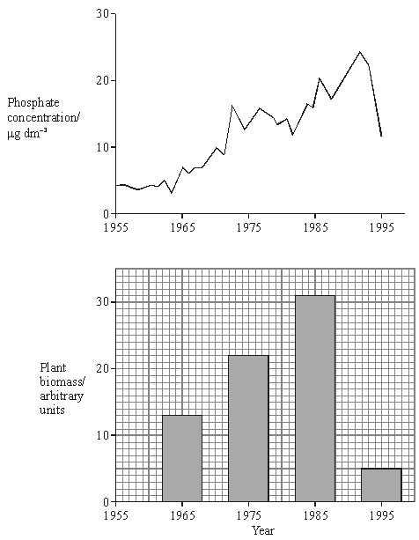

(a)     Suggest **one** source of the phosphate in the lake.

......................................................................................................................

......................................................................................................................

**(1)**

(b)     Calculate the percentage decrease in plant biomass between 1985 and 1995. Show your working.

Answer ............................................

**(2)**

(c)     From these graphs, a student concluded that changes in phosphate concentration caused changes in plant biomass. Explain why this conclusion may not be valid.

......................................................................................................................

......................................................................................................................

......................................................................................................................

......................................................................................................................

**(2)**

(d)     Between 1982 and 1992 the number of fish in the lake decreased. Explain how the change in phosphate concentration may have resulted in this decrease in the fish population.

......................................................................................................................

......................................................................................................................

......................................................................................................................

......................................................................................................................

......................................................................................................................

......................................................................................................................

......................................................................................................................

......................................................................................................................

......................................................................................................................

......................................................................................................................

......................................................................................................................

......................................................................................................................

**(6)**

**(Total 11 marks)**

**Q3.**          The diagram shows a river system in an area of farmland. The numbers show the nitrate concentration in parts per million (ppm) in water samples taken at various locations along the river. Concentrations above 250 ppm encourage eutrophication in the river.

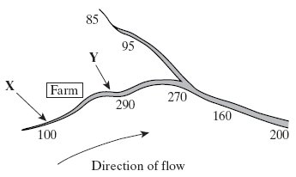

(i)      Explain how farming practices might be responsible for the change in nitrate concentration in the water between point **X** and point **Y**.

......................................................................................................................

......................................................................................................................

......................................................................................................................

......................................................................................................................

**(2)**

(ii)      Describe the effect the nitrate concentration may have in the river at point **Y**.

......................................................................................................................

......................................................................................................................

......................................................................................................................

......................................................................................................................

......................................................................................................................

......................................................................................................................

......................................................................................................................

......................................................................................................................

......................................................................................................................

......................................................................................................................

**(5)**

**(Total 7 marks)**

**Q4.**         Answers should be written in continuous prose, where appropriate.

A large lake is surrounded by fields. These fields are separated from each other by hedges. One hundred years ago the lake was a habitat for many plants, invertebrates and fish. Today the lake has no fish and few plants or invertebrates.

Explain how increased use of inorganic fertilisers on the fields may have led to these changes.

................................................................................................................................

................................................................................................................................

................................................................................................................................

................................................................................................................................

................................................................................................................................

................................................................................................................................

................................................................................................................................

................................................................................................................................

................................................................................................................................

**(Total 5 marks)**

**Q5.**          (a)     Farmers who grow wheat sometimes leave a field fallow for a year by not growing a crop in it. The concentration of nitrate ions in the soil decreases when a field is left fallow.

(i)      When grass is grown in the field, fewer nitrate ions are lost than when the field is left with bare soil. Explain why.

.............................................................................................................

.............................................................................................................

**(1)**

(ii)     A crop of leguminous plants such as clover may be grown in the field and then ploughed in. Explain why less fertiliser would be needed for the wheat crop in the following year.

.............................................................................................................

.............................................................................................................

.............................................................................................................

.............................................................................................................

**(2)**

(b)     The table gives information about the yield and profitability of a wheat crop grown using different amounts of fertiliser.

|  |  |  |  |  |  |
| --- | --- | --- | --- | --- | --- |
| **Nitrogen fertiliser applied / kg ha–1** | **Grain yield / tonnes ha–1** | **Grain protein / %** | **Value added by using fertiliser / £ha–1** | **Cost of using fertiliser / £ha–1** | **Benefit : cost ratio** |
| 0 | 2.4 | 11.7 | – | – | – |
| 25 | 2.5 | 12.5 | 19 | 11 | 1.7 : 1.0 |
| 50 | 2.5 | 12.9 | 25 | 22 | 1.1 : 1.0 |
| 75 | 2.5 | 13.3 | 31 | 33 | 0.9 : 1.0 |
| 100 | 2.5 | 13.5 | 37 |  |  |

(i)      Describe the effects of increasing fertiliser application on the yield and protein content of the grain produced.

.............................................................................................................

.............................................................................................................

.............................................................................................................

.............................................................................................................

**(2)**

(ii)     Use the data in the table to estimate the benefit: cost ratio for a fertiliser application of 100 kg ha–1. Write your answer in the table.

**(1)**

**(Total 6 marks)**

**Q6.**          In autumn when there is no crop, farm land may be used to grow mustard. The mustard absorbs nitrates which otherwise can leach out of the soil at this time of the year. The mustard is ploughed back into the soil just before sowing of the main crop in the spring.

(a)     Nitrogen compounds in the mustard plants are made available for the main crop after ploughing in spring. Describe the role of microorganisms in this process.

......................................................................................................................

......................................................................................................................

......................................................................................................................

......................................................................................................................

......................................................................................................................

......................................................................................................................

......................................................................................................................

......................................................................................................................

......................................................................................................................

**(5)**

(b)     Explain why it is important for the farmer to reduce the leaching of nitrates.

......................................................................................................................

......................................................................................................................

......................................................................................................................

......................................................................................................................

**(2)**

**S** (c)     Plants absorb a number of other nutrients from the soil including phosphates. Describe why phosphates are needed by a growing plant.

......................................................................................................................

......................................................................................................................

......................................................................................................................

......................................................................................................................

......................................................................................................................

......................................................................................................................

......................................................................................................................

**(4)**

**(Total 11 marks)**

**Q7.**          The mesquite tree grows in dry areas which have soils with low concentrations of ions.  
Its roots grow down to 25 metres and contain nitrogen-fixing bacteria. It is considered a pest in areas where farm animals graze because it out-competes grass. In some areas, young mesquite trees are cut down and then ploughed into the ground. This is expensive but makes the soil slightly more fertile for a few years.

(a)     Using the information given, explain **one** way in which mesquite trees are adapted for survival.

.............................................................................................................

.............................................................................................................

**(1)**

**S**       (b)     Name the type of competition occurring between mesquite and grass.

.............................................................................................................

**(1)**

**S**       (c)     Explain how ploughing the mesquite into the soil makes it more fertile.

.............................................................................................................

.............................................................................................................

.............................................................................................................

.............................................................................................................

.............................................................................................................

.............................................................................................................

**(3)**

**(Total 5 marks)**

**Q8.**          Pea plants are leguminous and have nodules on their roots which contain bacteria that are able to fix nitrogen. The diagram shows some of the processes involved in nitrogen fixation by these bacteria.

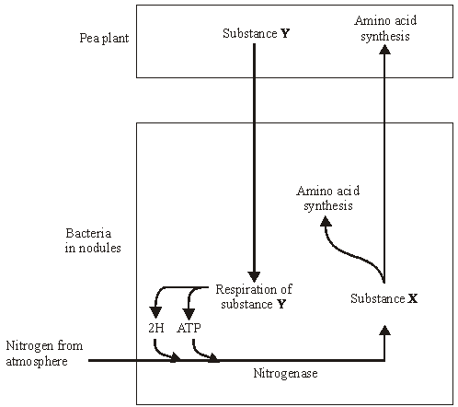

(a)     Name

(i)      substance **X**;

.............................................................................................................

**(1)**

(ii)     substance **Y**.

.............................................................................................................

**(1)**

**S**       (b)     Pea plants respire aerobically, producing ATP which can be used for amino acid synthesis. Describe the role of oxygen in aerobic respiration.

......................................................................................................................

......................................................................................................................

......................................................................................................................

......................................................................................................................

**(2)**

**S**       (c)     The bacteria respire anaerobically. This produces hydrogen and ATP used in nitrogen fixation. The hydrogen comes from reduced NAD. Explain how the regeneration of NAD in this way allows ATP production to continue.

......................................................................................................................

......................................................................................................................

......................................................................................................................

......................................................................................................................

**(2)**

**S**       (d)     The enzyme nitrogenase is specific to the reaction shown. Explain how **one** feature of the enzyme would contribute to this specificity.

          Feature

......................................................................................................................

          Explanation

......................................................................................................................

......................................................................................................................

......................................................................................................................

**(2)**

**S**       (e)     Sodium ions act as a non-competitive inhibitor of the enzyme nitrogenase. Explain how the presence of a non-competitive inhibitor can alter the rate of the reaction catalysed by nitrogenase.

......................................................................................................................

......................................................................................................................

......................................................................................................................

......................................................................................................................

......................................................................................................................

......................................................................................................................

**(3)**

**(Total 11 marks)**

**Q9.** The soybean is a leguminous plant. The effect of nitrate fertiliser and of the nitrogen-fixing bacterium, *Rhizobium*, on the growth of soybeans and on the growth of one species of grass was investigated. The soybeans and grass seeds were sown together in pots of soil in five different proportions. They were then treated with different combinations of nitrate fertiliser and *Rhizobium* bacteria, as follows:

Batch **A**: no *Rhizobium*, no nitrate fertiliser  
Batch **B**: *Rhizobium* added, no nitrate fertiliser  
Batch **C**: no *Rhizobium*, nitrate fertiliser added  
Batch **D**: *Rhizobium* added, nitrate fertiliser added

          The dry masses of the soybean plants and of the grass were determined after 6 months of growth. The results are shown in the graphs.

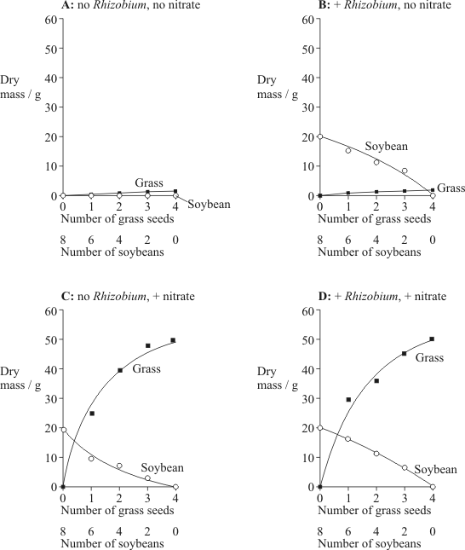

(a)     Did *Rhizobium* bacteria have any effect on the growth of the grass? Give evidence from graphs **C** and **D** for your answer.

......................................................................................................................

......................................................................................................................

**(1)**

(b)     Can the soybean make use of nitrogen supplied in the form of nitrate fertiliser?  
Give evidence from the graphs for your answer.

......................................................................................................................

......................................................................................................................

......................................................................................................................

......................................................................................................................

**(2)**

(c)     Describe and explain the effect of *Rhizobium* bacteria on the growth of soybeans.

......................................................................................................................

......................................................................................................................

......................................................................................................................

......................................................................................................................

......................................................................................................................

......................................................................................................................

......................................................................................................................

......................................................................................................................

**(3)**

**(Total 6 marks)**

**Q10.**          The flow chart shows how high nitrate concentration can affect a river.

High nitrate concentration

**↓**

Increased growth of algae

**↓**

Death and decay of submerged plants rooted in the mud

**↓**

Reduced oxygen concentration and increased nitrate production

**S**       (a)     Explain how a high nitrate concentration increases the growth of algae.

......................................................................................................................

......................................................................................................................

......................................................................................................................

**(2)**

(b)     Suggest how increased growth of algae could lead to the death of the submerged plants.

......................................................................................................................

......................................................................................................................

......................................................................................................................

......................................................................................................................

**(2)**

(c)     Explain how the decay of dead plants results in reduced oxygen concentration and increased nitrate production.

......................................................................................................................

......................................................................................................................

......................................................................................................................

......................................................................................................................

......................................................................................................................

......................................................................................................................

......................................................................................................................

......................................................................................................................

**(6)**

(d)     Describe how the reduced oxygen concentration of the water will change the composition of the communities in the river.

......................................................................................................................

......................................................................................................................

......................................................................................................................

......................................................................................................................

**(2)**

**(Total 12 marks)**

**Q11.**          The diagram shows a hedgerow and part of a field with a crop. The land is farmed in a way that conserves wildlife. The strip of bare ground next to the hedgerow is ploughed frequently to prevent any plants from growing. The first 6 m of the field, called the conservation headland, is sprayed with a selective herbicide to control some kinds of weeds. The rest of the field is sprayed with herbicide to kill all weeds.

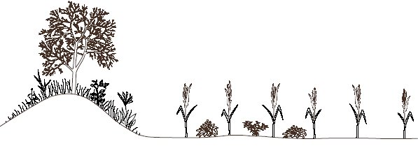

|  |  |  |  |  |
| --- | --- | --- | --- | --- |
|  |  |  |  |  |
|  |  |  |  |  |

Hedgerow                   Bare                  Conservation                            Crop

 ground                   headland

(2 m wide)              (6 m wide)

**S**       (a)     Suggest **one** advantage of leaving a strip of bare ground between the hedgerow and the field.

......................................................................................................................

......................................................................................................................

**(1)**

(b)     Suggest the benefit of allowing some weeds to grow in the conservation headland.

......................................................................................................................

......................................................................................................................

......................................................................................................................

......................................................................................................................

**(2)**

**S**       (c)     After harvesting the crop, the farmer digs the unwanted stems and roots into the soil. Explain how the nutrients contained in these plant parts become available for use by other organisms.

......................................................................................................................

......................................................................................................................

......................................................................................................................

......................................................................................................................

......................................................................................................................

......................................................................................................................

......................................................................................................................

......................................................................................................................

**(4)**

**(Total 7 marks)**

**Q12.**          The wildebeest is a large mammal that lives on grasslands in Africa and feeds on a number of species of plant. A lot of rain falls from April to May and also in November. In the dry season between July and October very little rain falls.

The graph shows changes in the mean protein content of all the plants that could be eaten at different times of year. It also shows the mean protein content of the food the wildebeest actually eat.

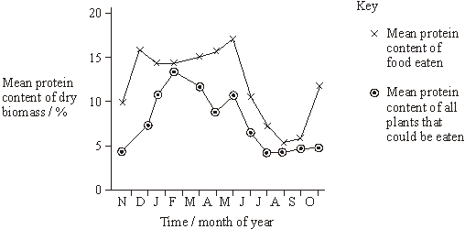

**S**       (a)     During the dry season the protein content of the plants decreases. Suggest **one** way in which a lack of rain could account for this change.

......................................................................................................................

......................................................................................................................

......................................................................................................................

......................................................................................................................

**(2)**

**S**       (b)     Throughout the year the mean protein content of all the plants which could be eaten and the mean protein content of the food actually eaten differs. Suggest **one** explanation for this difference.

......................................................................................................................

......................................................................................................................

......................................................................................................................

......................................................................................................................

**(2)**

**S**       (c)     When wildebeest eat food containing less than 6% protein, they start to lose protein from their body tissues. Suggest and explain how a deficiency of **one** named protein makes the wildebeest more susceptible to being caught by predators.

......................................................................................................................

......................................................................................................................

......................................................................................................................

......................................................................................................................

**(2)**

**(Total 6 marks)**

**Q13.**          (a)     Explain how including leguminous plants in a crop rotation reduces the need to use artificial fertilisers.

......................................................................................................................

......................................................................................................................

......................................................................................................................

......................................................................................................................

**(2)**

**S**       (b)     Application of very high concentrations of fertiliser to the soil causes plants to wilt. Explain why.

......................................................................................................................

......................................................................................................................

......................................................................................................................

......................................................................................................................

**(2)**

**(Total 4 marks)**

**Q14.**          Purification ponds can be used in warm climates to break down sewage. The ponds are about 1m deep and contain bacteria and green algae. The diagram summarises the processes involved in the breakdown of sewage in a purification pond.

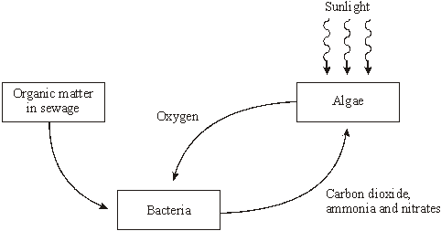

(a)     Explain the advantage of having both algae and bacteria in a purification pond.

......................................................................................................................

......................................................................................................................

......................................................................................................................

......................................................................................................................

......................................................................................................................

......................................................................................................................

......................................................................................................................

......................................................................................................................

**(4)**

**S**       (b)     Purification ponds only work efficiently when they are shallow and warm. Explain why.

......................................................................................................................

......................................................................................................................

......................................................................................................................

......................................................................................................................

......................................................................................................................

......................................................................................................................

......................................................................................................................

......................................................................................................................

**(4)**

**(Total 8 marks)**

**Q15.**          (a)     Name the type of bacteria which convert

(i)      nitrogen in the air into ammonium compounds;

.............................................................................................................

(ii)     nitrites into nitrates.

.............................................................................................................

**(2)**

(b)     (i)      Other than spreading fertilisers, describe and explain how **one** farming practice results in addition of nitrogen-containing compounds to a field.

.............................................................................................................

.............................................................................................................

.............................................................................................................

.............................................................................................................

**(2)**

(ii)     Describe and explain how **one** farming practice results in the removal of nitrogen-containing compounds from a field.

.............................................................................................................

.............................................................................................................

.............................................................................................................

.............................................................................................................

**(2)**

**(Total 6 marks)**

**Q16.** Two fields, **A** and **B**, were used to grow the same crop. The fields were divided into plots. Different masses of fertiliser containing sodium nitrate were applied to these plots. After six weeks, samples of crop plants from each plot were collected and their mass determined. The results are shown in the table.

|  |  |  |  |
| --- | --- | --- | --- |
|  | **Mass of fertiliser added/kg ha–1** | **Mass of crop/kg m–2** | |
|  | Field **A** - used for grazing cattle in previous year | Field **B** - used for same crop in previous year |
|  | 0 | 14.5 | 6.4 |
|  | 10 | 16.7 | 9.8 |
|  | 20 | 17.4 | 12.9 |
|  | 30 | 17.5 | 16.2 |
|  | 40 | 17.5 | 17.1 |
|  | 50 | 17.5 | 17.1 |
|  | 60 | 17.5 | 17.1 |

(a)     (i)      Describe the pattern shown by the data for field **B**.

.............................................................................................................

.............................................................................................................

**(1)**

(ii)     Explain the change in the mass of crop produced from field **B** when the mass of fertiliser added increases from 0 to 20 kg ha–1.

.............................................................................................................

.............................................................................................................

.............................................................................................................

.............................................................................................................

**(2)**

(iii)     Explain why the mass of crop produced stays the same in both fields when more than 40 kg of fertiliser is added.

.............................................................................................................

.............................................................................................................

.............................................................................................................

.............................................................................................................

**(2)**

(b)     In the previous year, field **A** had been used for grazing cattle. Field **B** had been used to grow the same crop as this year. When no fertiliser was added, the mass of crop from field **A** was higher than from field **B**. Explain this difference.

......................................................................................................................

......................................................................................................................

......................................................................................................................

......................................................................................................................

**(2)**

**(Total 7 marks)**

**Q17.**          The diagram shows part of the nitrogen cycle.

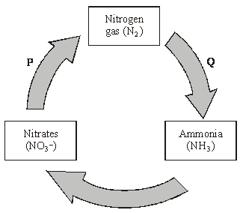

(a)     Name processes **P** and **Q**.

**P** .......................................................................................

**Q** .......................................................................................

**(2)**

(b)     It is estimated that, each year, a total of 3 × 109 tonnes of ammonia are converted to nitrate. Only 2 × 108 tonnes of ammonia are produced from nitrogen gas. Explain the difference in these figures.

......................................................................................................................

......................................................................................................................

......................................................................................................................

......................................................................................................................

**(2)**

(c)     The conversion of ammonia to nitrate involves oxidation. What evidence in the diagram supports this?

......................................................................................................................

......................................................................................................................

**(1)**

**(Total 5 marks)**

**Q18.**          Intensive rearing of livestock produces large quantities of waste. Some farmers use an anaerobic digester to get rid of the waste.

In an anaerobic digester, microorganisms break down the large, organic molecules in the waste. This produces methane, which is a useful fuel. It also produces organic substances that can be used as a natural fertiliser.

The diagram shows an anaerobic digester.

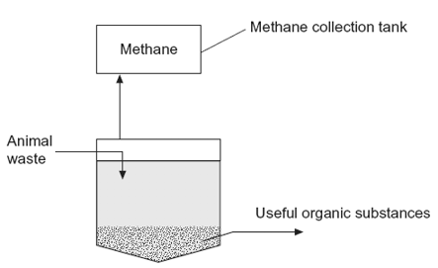

(a)     (i)      Suggest **two** advantages of processing waste in anaerobic digesters rather than in open ponds.

1 ..........................................................................................................

.............................................................................................................

2 ..........................................................................................................

.............................................................................................................

**(2)**

(ii)     The anaerobic digester has a cooling system, which is not shown in the diagram.

Without this cooling system the digester would soon stop working. Explain why.

.............................................................................................................

.............................................................................................................

.............................................................................................................

.............................................................................................................

.............................................................................................................

**(2)**

(b)     (i)      The over-application of fertiliser increases the rate of leaching. Explain the consequences of leaching of fertiliser into ponds and lakes.

.............................................................................................................

.............................................................................................................

.............................................................................................................

.............................................................................................................

.............................................................................................................

.............................................................................................................

(*Extra Space)* ......................................................................................

.............................................................................................................

.............................................................................................................

**(3)**

(ii)     Give **one** advantage of using natural fertiliser produced in the digester rather than an artificial fertiliser.

.............................................................................................................

.............................................................................................................

.............................................................................................................

**(1)**

**(Total 8 marks)**

**Q19.**          (a)     The flow chart shows the main stages in aerobic respiration.

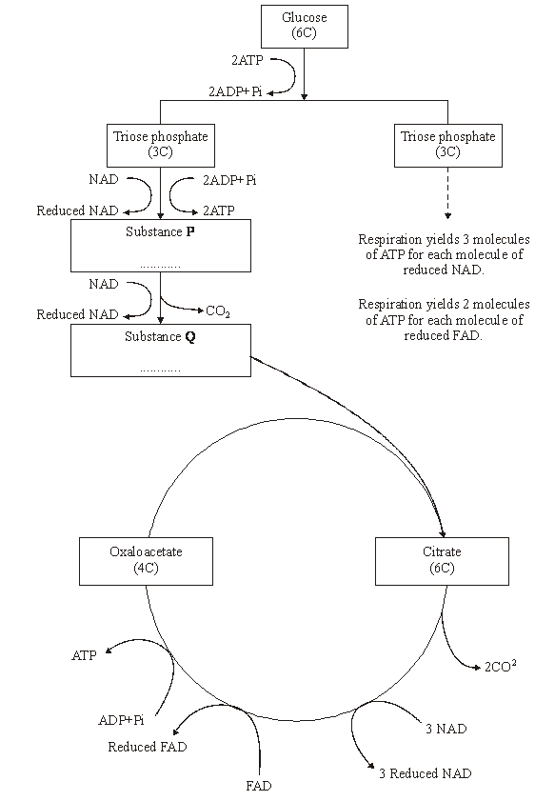

(i)      Complete the flow chart by writing, in the appropriate boxes, the number of carbon atoms in substance **P** and the name of substance **Q**.

**(2)**

(ii)     Some ATP is formed in the cytoplasm and some in the mitochondria. Use the information given to calculate the number of molecules of ATP formed in a mitochondrion from one molecule of glucose in aerobic respiration. Show how you arrived at your answer.

Answer.....................................

**(2)**

(iii)     In the presence of oxygen, respiration yields more ATP per molecule of glucose than it does in the absence of oxygen. Explain why.

.............................................................................................................

.............................................................................................................

.............................................................................................................

.............................................................................................................

.............................................................................................................

.............................................................................................................

**(3)**

(b)     Anabaena is a prokaryote found inside the leaves of a small fern. Anabaena can produce ammonia from nitrogen (nitrogen fixation). This reaction only takes place in the anaerobic conditions found in cells called heterocysts. Heterocysts are thick-walled cells that do not contain chlorophyll. The drawing shows the relationship between *Anabaena* and the fern.

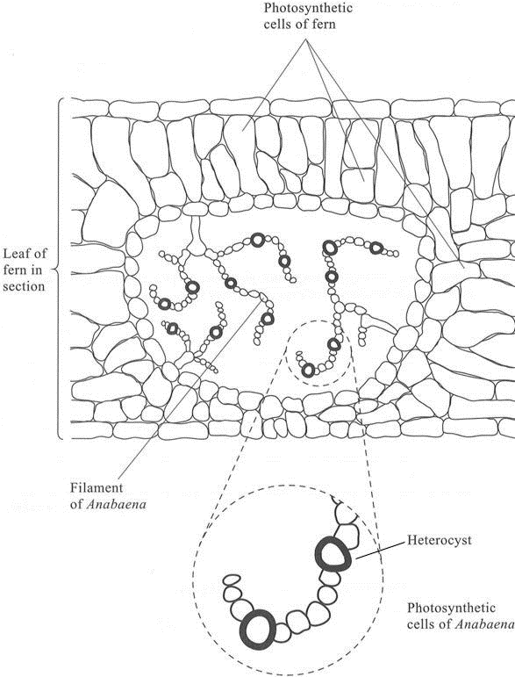

(i)      Suggest how the features of the heterocysts improve the efficiency of the process of nitrogen fixation.

.............................................................................................................

.............................................................................................................

.............................................................................................................

.............................................................................................................

.............................................................................................................

.............................................................................................................

**(3)**

(ii)     In China, the fern is cultivated and ploughed into fields to act as an organic fertiliser. Explain how ploughing the fern plants into the soil results in an improvement in the growth of the rice crop grown in these fields.

.............................................................................................................

.............................................................................................................

.............................................................................................................

.............................................................................................................

.............................................................................................................

.............................................................................................................

.............................................................................................................

.............................................................................................................

.............................................................................................................

.............................................................................................................

**(5)**

**(Total 15 marks)**

**Q20.**          In the activated sludge method of sewage treatment, organic matter in untreated sewage supplies nutrients to bacteria in the treatment tank. These bacteria include decomposers and nitrifying bacteria. The bacteria are eaten by ciliated protoctistans, which are, in turn, eaten by carnivorous protoctistans.

(a)     (i)      Explain the roles of the decomposers and the nitrifying bacteria in converting nitrogen in organic compounds in the sewage into a soluble, inorganic form.

.............................................................................................................

.............................................................................................................

.............................................................................................................

.............................................................................................................

.............................................................................................................

.............................................................................................................

**(3)**

(ii)     Nitrifying bacteria are one kind of bacteria that are important in the nitrogen cycle; nitrogen-fixing bacteria are another kind. Describe the part played by nitrogen-fixing bacteria in the nitrogen cycle.

.............................................................................................................

.............................................................................................................

.............................................................................................................

.............................................................................................................

**(2)**

(b)     The organic matter in untreated sewage consists of small particles, which are suspended in water. Activated sludge consists of solid lumps (flocs) of organic matter and bacteria. When the two are mixed in the treatment tank, bacteria from the flocs become dispersed in the water and feed on the suspended organic matter, converting it to flocs. Different types of ciliated protoctistans feed on the bacteria.

•        Free-swimming protoctistans are able to move throughout the tank.

•        Crawling protoctistans can only move over the surface of the flocs.

The diagram shows the change in the nature of the organic matter in the treatment tank and the changes in the numbers of the different types of organisms present.

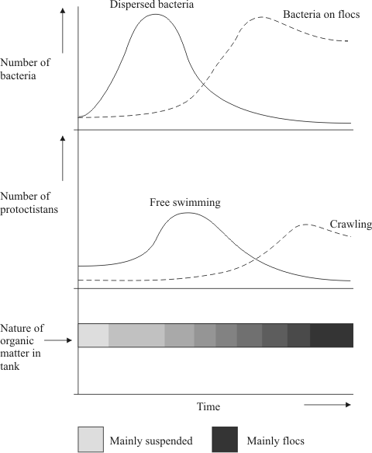

(i)      Explain the changes in the numbers of dispersed bacteria and the numbers of free-swimming protoctistans.

.............................................................................................................

.............................................................................................................

.............................................................................................................

.............................................................................................................

.............................................................................................................

.............................................................................................................

**(3)**

(ii)     Explain how the changes that occur in the treatment tank illustrate the process of succession.

.............................................................................................................

.............................................................................................................

.............................................................................................................

.............................................................................................................

.............................................................................................................

.............................................................................................................

.............................................................................................................

.............................................................................................................

**(4)**

**(Total 12 marks)**

**Q21.**         When fertilisers are applied to fields next to a lake, nitrogen-containing substances from the fertilisers get into the lake.

(a)     (i)      Describe how the nitrogen-containing substances get into the lake.

.............................................................................................................

.............................................................................................................

.............................................................................................................

**(1)**

(ii)     It takes longer for the nitrogen-containing substances to get into the lake when an organic fertiliser is used than when an inorganic fertiliser is used. Explain why it takes longer when an organic fertiliser is used.

.............................................................................................................

.............................................................................................................

**(2)**

(b)     Describe how the presence of nitrates in a lake may eventually lead to the death of fish.

......................................................................................................................

......................................................................................................................

......................................................................................................................

......................................................................................................................

......................................................................................................................

......................................................................................................................

......................................................................................................................

......................................................................................................................

**(4)**

**(Total 7 marks)**

**Q22.**          Nitrogenase catalyses the reduction of nitrogen during nitrogen fixation. The reaction requires 16 molecules of ATP for each molecule of nitrogen that is reduced.

(a)     Nitrogen gas is the usual substrate for this enzyme. Name the product.

......................................................................................................................

**(1)**

(b)     Nitrogenase also catalyses reactions involving other substances. Explain what this suggests about the shapes of the molecules of these other substances.

......................................................................................................................

......................................................................................................................

......................................................................................................................

......................................................................................................................

......................................................................................................................

**(2)**

(c)     (i)      *Azotobacter* is a nitrogen-fixing bacterium. It produces the enzyme nitrogenase. The enzyme only works in the absence of oxygen.

*Azotobacter* has a very high rate of aerobic respiration compared with bacteria that do not fix nitrogen. Suggest **two** advantages of the very high rate of aerobic respiration.

.............................................................................................................

.............................................................................................................

.............................................................................................................

.............................................................................................................

.............................................................................................................

**(2)**

(ii)     If scientists could transfer the gene that codes for nitrogenase to cereal plants, these cereal plants would be able to fix nitrogen. However, the scientists would expect these genetically engineered cereal plants to grow more slowly than cereal plants that get their nitrogen from fertiliser. Explain why they would grow more slowly.

.............................................................................................................

.............................................................................................................

.............................................................................................................

.............................................................................................................

.............................................................................................................

**(2)**

**(Total 7 marks)**

**Q23.**          Urea from animal waste can be used as a fertiliser. Some bacteria in the soil secrete the enzyme urease which hydrolyses urea into ammonia. Some of this ammonia is released into the atmosphere. NBPT is an inhibitor of urease and can be added to urea fertiliser to reduce the loss of ammonia to the atmosphere.

(a)     A molecule of NBPT has a similar structure to a molecule of urea. Use this information to suggest how NBPT inhibits the enzyme urease.

......................................................................................................................

......................................................................................................................

......................................................................................................................

......................................................................................................................

......................................................................................................................

**(2)**

Scientists investigated the effect of NBPT on the release of ammonia from urea fertiliser added to the soil. A control experiment was carried out. This involved adding urea fertiliser only. The graph shows their results.

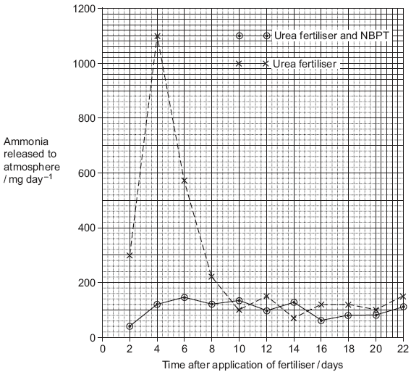

(b)     (i)      Describe how NBPT affected the loss of ammonia from urea fertiliser.

.............................................................................................................

.............................................................................................................

.............................................................................................................

**(1)**

(ii)     Suggest an explanation for the increase in mass of ammonia released over the first four days in the control experiment.

.............................................................................................................

.............................................................................................................

.............................................................................................................

.............................................................................................................

.............................................................................................................

**(2)**

(c)     Suggest how the addition of NBPT to urea fertiliser could result in increased growth of crop plants.

......................................................................................................................

......................................................................................................................

......................................................................................................................

......................................................................................................................

......................................................................................................................

......................................................................................................................

**(3)**

**(Total 8 marks)**

**Q24.**          (a)     The concentrations of carbon dioxide in the air at different heights above ground in a forest changes over a period of 24 hours. Use your knowledge of photosynthesis to describe these changes and explain why they occur.

......................................................................................................................

......................................................................................................................

......................................................................................................................

......................................................................................................................

......................................................................................................................

......................................................................................................................

......................................................................................................................

......................................................................................................................

......................................................................................................................

......................................................................................................................

**(5)**

(b)     In the light-independent reaction of photosynthesis, the carbon in carbon dioxide becomes carbon in triose phosphate. Describe how.

......................................................................................................................

......................................................................................................................

......................................................................................................................

......................................................................................................................

......................................................................................................................

......................................................................................................................

......................................................................................................................

......................................................................................................................

......................................................................................................................

......................................................................................................................

......................................................................................................................

......................................................................................................................

**(5)**

**(Total 10 marks)**

**Q25.**          Much of Indonesia is covered with forest. Large areas of forest have been cleared and planted with oil-palm trees to be used in the production of fuel.

(a)     In these forests, nitrogen in dead leaves is made available to growing plants by the action of bacteria. Describe the role of bacteria in making the nitrogen in dead leaves available to growing plants.

......................................................................................................................

......................................................................................................................

......................................................................................................................

......................................................................................................................

......................................................................................................................

......................................................................................................................

......................................................................................................................

......................................................................................................................

......................................................................................................................

......................................................................................................................

*(Extra space)* ...............................................................................................

......................................................................................................................

......................................................................................................................

......................................................................................................................

......................................................................................................................

......................................................................................................................

......................................................................................................................

**(5)**

(b)     During photosynthesis, oil-palm trees convert carbon dioxide into organic substances. Describe how.

......................................................................................................................

......................................................................................................................

......................................................................................................................

......................................................................................................................

......................................................................................................................

......................................................................................................................

......................................................................................................................

......................................................................................................................

......................................................................................................................

......................................................................................................................

......................................................................................................................

......................................................................................................................

*(Extra space)* ...............................................................................................

......................................................................................................................

......................................................................................................................

......................................................................................................................

......................................................................................................................

......................................................................................................................

**(6)**

**(Total 11 marks)**

**Q26.**Write an essay on the following topic.

There are many different types of relationships and interactions between organisms.

**(25)**

**Q27.**          (a)     Explain how farming practices increase the productivity of agricultural crops.

........................................................................................................................

........................................................................................................................

........................................................................................................................

........................................................................................................................

........................................................................................................................

........................................................................................................................

........................................................................................................................

........................................................................................................................

........................................................................................................................

........................................................................................................................

*(Extra space)* .................................................................................................

........................................................................................................................

........................................................................................................................

........................................................................................................................

........................................................................................................................

........................................................................................................................

........................................................................................................................

........................................................................................................................

........................................................................................................................

........................................................................................................................

........................................................................................................................

........................................................................................................................

........................................................................................................................

**(5)**

(b)     Describe how the action of microorganisms in the soil produces a source of nitrates for crop plants.

........................................................................................................................

........................................................................................................................

........................................................................................................................

........................................................................................................................

........................................................................................................................

........................................................................................................................

........................................................................................................................

........................................................................................................................

........................................................................................................................

........................................................................................................................

*(Extra space)* .................................................................................................

........................................................................................................................

........................................................................................................................

........................................................................................................................

........................................................................................................................

........................................................................................................................

........................................................................................................................

........................................................................................................................

........................................................................................................................

........................................................................................................................

........................................................................................................................

........................................................................................................................

........................................................................................................................

**(5)**

**(Total 10 marks)**

**Q28.**Nitrate from fertiliser applied to crops may enter ponds and lakes. Explain how nitrate may cause the death of fish in fresh water.

**(Total 5 marks)**

**Q29.**(a)     Name the process by which some bacteria oxidise ammonia to nitrate.

........................................................................................................................

**(1)**

Reeds are plants that grow with their roots under water. A reed bed contains a large number of growing reeds. Reed beds may be used to absorb nitrates produced when bacteria break down human sewage. The diagram shows a reed bed.

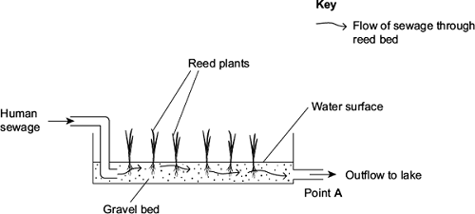

(b)     Reeds have hollow, air-filled tissue in their stems which supplies oxygen to their roots.  
Explain how this enables the roots to take up nitrogen-containing substances.

........................................................................................................................

........................................................................................................................

........................................................................................................................

........................................................................................................................

........................................................................................................................

**(2)**

(c)     (i)      There is an optimum rate at which human sewage should flow through the reed  
bed. If the flow of human sewage is too fast, the nitrate concentration at point **A** falls.  
Explain why.

...............................................................................................................

...............................................................................................................

...............................................................................................................

...............................................................................................................

...............................................................................................................

**(2)**

(ii)     An increase in nitrate concentration in the water entering the lake could affect algae and fish in the lake. Explain how.

...............................................................................................................

...............................................................................................................

...............................................................................................................

...............................................................................................................

...............................................................................................................

...............................................................................................................

*(Extra space)* ........................................................................................

...............................................................................................................

...............................................................................................................

**(3)**

**(Total 8 marks)**

**Q30.**The diagram shows the nitrogen cycle.

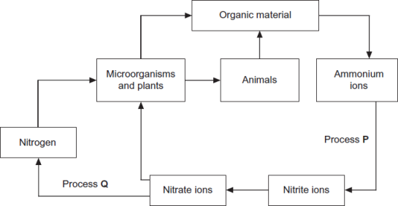

(a)     (i)      Name process **P**.

...............................................................................................................

**(1)**

(ii)     Name process **Q**.

...............................................................................................................

**(1)**

(b)     Leguminous crop plants have nitrogen-fixing bacteria in nodules on their roots.  
On soils with a low concentration of nitrate ions, leguminous crops often grow better than other types of crop. Explain why.

........................................................................................................................

........................................................................................................................

........................................................................................................................

........................................................................................................................

........................................................................................................................

**(2)**

(c)     Applying very high concentrations of fertiliser to the soil can reduce plant growth. Use your knowledge of water potential to explain why.

........................................................................................................................

........................................................................................................................

........................................................................................................................

........................................................................................................................

........................................................................................................................

**(2)**

**(Total 6 marks)**

**Q31.**Scientists measured the rate of respiration in **three** parts of an ecosystem.

They did this by measuring carbon dioxide released into the air by:

•        leaves of plants

•        stems and roots of plants

•        non-photosynthetic soil organisms.

The table below shows the scientists’ results for these three parts of the ecosystem.

|  |  |  |  |
| --- | --- | --- | --- |
|  | **Part of ecosystem** | **Mean rate of carbon dioxide production / cm3 m−2 s−1** | **Percentage of total carbon dioxide production measured by the scientists** |
|  | Leaves of plants | 0.032 | 25.0 |
|  | Stems and roots of plants | 0.051 |  |
|  | Non- photosynthetic soil organisms | 0.045 |  |

(a)     Complete the table to show the percentage of total carbon dioxide production by each part of the ecosystem.

Show your working.

**(2)**

(b)     A student who looked at the data in the table concluded that plants carry out more respiration than non-photosynthetic organisms in the ecosystem.

Use the information provided to suggest why these data may **not** support the student’s conclusion.

........................................................................................................................

........................................................................................................................

........................................................................................................................

........................................................................................................................

**(2)**

(c)     What measurements would the scientists have made in order to calculate the rate of carbon dioxide production?

........................................................................................................................

........................................................................................................................

........................................................................................................................

........................................................................................................................

**(2)**

(d)     The scientists calculated the mean rate of carbon dioxide production of the leaves using measurements of carbon dioxide release in the dark.

Explain why they did **not** use measurements taken in the light.

........................................................................................................................

........................................................................................................................

........................................................................................................................

........................................................................................................................

**(2)**

Another group of scientists measured the mean rate of respiration in soil under trees and soil not under trees in the same wood. They also measured the mean rate of photosynthesis in the trees.

They took measurements at different times of day during the summer.

The figure below shows the scientists’ results.

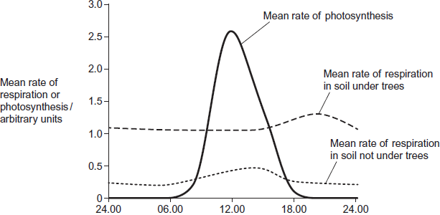  
          Time of day

(e)     (i)      Describe **two** ways in which the mean rate of respiration in soil under trees is different from soil not under trees.

1 ............................................................................................................

...............................................................................................................

2 ............................................................................................................

...............................................................................................................

**(2)**

(ii)     Suggest **one** explanation for the differences in the mean rate of respiration in soil under trees and soil not under trees between 06.00 and 12.00.

...............................................................................................................

...............................................................................................................

...............................................................................................................

...............................................................................................................

**(2)**

(f)     The scientists suggested that the rise in the mean rate of photosynthesis was the cause of the rise in the mean rate of respiration in soil under trees.

(i)      Suggest how the rise in the mean rate of photosynthesis could lead to the rise in the mean rate of respiration in soil under trees.

...............................................................................................................

...............................................................................................................

...............................................................................................................

...............................................................................................................

**(2)**

(ii)     Suggest why there is a delay between the rise in the mean rate of photosynthesis and the rise in the mean rate of respiration.

...............................................................................................................

...............................................................................................................

**(1)**

**(Total 15 marks)**

**Q32.**Upwelling is a process where water moves from deeper parts of the sea to the surface. This water contains a lot of nutrients from the remains of dead organisms.

(a)     (i)      Nitrates and phosphates are two of these nutrients. They provide a source of nitrogen and phosphorus for cells.

Give a biological molecule that contains:

1. nitrogen .............................................................................................

2. phosphorus.........................................................................................

**(2)**

(ii)     Describe the role of microorganisms in producing nitrates from the remains of dead organisms.

...............................................................................................................

...............................................................................................................

...............................................................................................................

...............................................................................................................

...............................................................................................................

...............................................................................................................

*(Extra space)* ........................................................................................

...............................................................................................................

...............................................................................................................

**(3)**

(b)     Upwelling often results in high primary productivity in coastal waters.  
Explain why some of the most productive fishing areas are found in coastal waters.

........................................................................................................................

........................................................................................................................

........................................................................................................................

........................................................................................................................

**(2)**

**(Total 7 marks)**

**Q33.**Stemborers are insect pests that feed on maize plants. Scientists investigated the effect of **push-pull** stimuli on the control of these pests.

For this investigation, the scientists divided a large field into plots measuring 50 m × 50 m. They then designated each plot as a control plot or a test plot. The following figure shows what they planted in each type of plot.

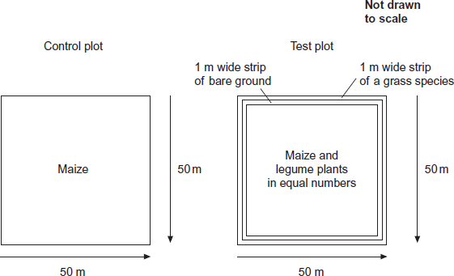

The legumes planted with the maize drive stemborers away.

The grass species attracts stemborers.

The table below shows the scientists’ results.

|  |  |  |  |  |  |
| --- | --- | --- | --- | --- | --- |
|  | **Plots** | **Mean percentage damage to maize plants** | **Mean maize grain yield / tonnes per hectare (± standard deviation)** | **Mean production costs per farmer / $ per hectare (± standard deviation)** | **Mean total income for farmer / $ per hectare (± standard deviation)** |
|  | Control | 29.6 | 1.5 (±0.2) | 250 (±0.7) | 329 (±5.9) |
|  | Test | 6.7 | 3.7 (±0.3) | 278 (±1.1) | 679 (±10.2) |

(a)     In the test plot of land, identify the push stimulus and the pull stimulus.

Push stimulus ..............................................................................................

Pull stimulus .................................................................................................

**(1)**

(b)     When measuring the mean percentage damage to maize plants, 60 plants from each test plot were selected at random and examined.  
Describe how the maize plants could be selected at random.

........................................................................................................................

........................................................................................................................

........................................................................................................................

........................................................................................................................

........................................................................................................................

........................................................................................................................

(Extra space) .................................................................................................

........................................................................................................................

........................................................................................................................

**(3)**

(c)     In the test plot, bare ground was left between the maize and the grass species.  
Suggest an explanation why.

........................................................................................................................

........................................................................................................................

........................................................................................................................

........................................................................................................................

........................................................................................................................

**(2)**

(d)     The legume plants have nodules containing nitrogen-fixing bacteria on their roots.  
Explain how nitrogen-fixing bacteria could increase the growth of the maize.

........................................................................................................................

........................................................................................................................

........................................................................................................................

........................................................................................................................

........................................................................................................................

**(2)**

(e)     A year after this investigation, the government of one country decided that their farmers should use these **push-pull** stimuli.  
How do these data support this decision?

........................................................................................................................

........................................................................................................................

........................................................................................................................

........................................................................................................................

........................................................................................................................

........................................................................................................................

(Extra space) .................................................................................................

........................................................................................................................

........................................................................................................................

**(3)**

**(Total 11 marks)**

**Q34.**During the light-independent reaction of photosynthesis, carbon dioxide is converted into organic substances. Describe how.

................................................................................................................................

................................................................................................................................

................................................................................................................................

................................................................................................................................

................................................................................................................................

................................................................................................................................

................................................................................................................................

................................................................................................................................

................................................................................................................................

................................................................................................................................

................................................................................................................................

................................................................................................................................

*(Extra space)* .........................................................................................................

................................................................................................................................

................................................................................................................................

................................................................................................................................

................................................................................................................................

................................................................................................................................

................................................................................................................................

................................................................................................................................

................................................................................................................................

................................................................................................................................

**(Total 6 marks)**

**Q35.**The diagram shows part of the nitrogen cycle.

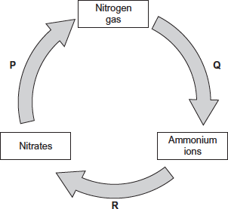

(a)     Which **one** of the processes **P**, **Q** or **R** involves nitrification?



**(1)**

(b)     The diagram above includes one process in which microorganisms add ammonium ions to soil.

Describe another process carried out by microorganisms which adds ammonium ions to soil.

........................................................................................................................

........................................................................................................................

........................................................................................................................

........................................................................................................................

........................................................................................................................

**(2)**

(c)     Denitrification requires anaerobic conditions. Ploughing aerates the soil.  
Explain how ploughing would affect the fertility of the soil.

........................................................................................................................

........................................................................................................................

........................................................................................................................

........................................................................................................................

........................................................................................................................

**(2)**

(d)     One farming practice used to maintain high crop yields is crop rotation. This involves growing a different crop each year in the same field.

Suggest **two** ways in which crop rotation may lead to high crop yields.

1 .....................................................................................................................

........................................................................................................................

........................................................................................................................

2 .....................................................................................................................

........................................................................................................................

........................................................................................................................

**(2)**

**(Total 7 marks)**

**M1.**(a)      1.      To kill any fungus / bacteria on surface of seeds or in soil;

2.      So only the added fungus has any effect.

**2**

(b)     So that only nitrate or ammonia / type of fertiliser affects growth.

**1**

(c)     1.      So that effects of nitrate or ammonium alone could be seen;

2.      So that effects of fungus can be seen.

**2**

(d)     1.      Weigh samples at intervals during drying;

2.      To see if weighings became constant (by 3 days).

**2**

(e)     With live fungus – showing effects of the fungus:

1.      Fungus increases growth of roots and shoots in both;

2.      Produces greater growth with nitrate.

With heat-treated fungus – showing effects of fertiliser:

3.      Similar dry masses for roots and shoots;

4.      (Probably) no significant difference because SDs overlap.

**4**

(f)     1.      Dry mass measures / determines increase in biological / organic material;

2.      Water content varies.

**2**

(g)     1.      Fungus with nitrate-containing fertiliser gave largest shoot: root ratio;

2.      And largest dry mass of shoot;

3.      6.09:1 compared with ammonium-containing fertiliser 4.18:1

**2 max**

**[15]**

**M2.**          (a)     Fertilisers / detergents / slurry / manure / sewage / faeces;

**1**

(b)     (31 – 5) / 31 x 100% / single error in otherwise correct method;  
83.87 / 83.9 / 84%;

**2**

(c)     Have continuous data for phosphate but not for biomass;  
Effect of named factor explained;

**2**

(d)     1.      Increased phosphate causes increase in plant growth / algal bloom;

2.      Plants (cover surface and) block out light so plants (under surface) die;

3.      Increase in (aerobic) bacteria / decomposers (which break down plants);

4.      Bacteria / decomposers use up oxygen / reduce oxygen conc. in water;

5.      In respiration;

6.      Plants unable to photosynthesise so less oxygen produced;

**max 6**

**[11]**

**M3.**          (i)      excessive use of fertilisers;  
run-off / leaching;

**2 max**

(ii)      1. growth of algae / plants stimulated / increased;  
2. death of algae / plants;  
3. more bacteria / decomposers / decomposition;  
4. respiration;  
5. decomposers / bacteria remove oxygen;  
6. animals die (because of lack of oxygen);

**5 max**

**[7]**

**M4.**         run off / leaching of nutrients / nitrates;  
leads to increased growth of algae / plants;  
competition for light / effect of competition;   
death of algae / plants;  
increases food supply / increases microorganisms / decomposers;  
respiration (of microorganisms) uses up oxygen / increases BOD;  
fish / animals die due to lack of oxygen;

**[5]**

**M5.**          (a)     (i)      presence of grass causes less nutrients / minerals / nitrates /   
ammonium ions to be leached;

*(do not allow references to less nitrogen)*

**1**

(ii)     clover contains nitrogen-fixing bacteria;

*(do not allow references to nitrifying bacteria)*

decomposition (of ploughed clover) introduces nitrates /   
ammonium ions into soil;

**2**

(b)     (i)      minimal effect / no significant effect on yield / small  
increase up to 25 kg ha–1;  
increase in protein content of grain with all fertiliser applications;

**2**

(ii)     (37 ÷ 44 =) 0.84 : 1.0

*(allow 0.8 : 1);*

**1**

**[6]**

**M6.**          (a)     proteins / amino acids broken down;  
deamination / ammonification / release of ammonium compounds;  
conversion to nitrates;  
by nitrifying bacteria / named bacterium;  
nitrates absorbed into roots;

**5**

(b)     fewer nitrates in the soil for the next crop / plants grow less well  
because of lack of nitrates;  
requiring application of more fertiliser / economic reason for using less fertiliser / valid environmental reason explained e.g. nitrates leaching into water / eutrophication / explanation / health related e.g drinking water;

**2**

(c)     production of phospholipids;  
in cell membranes;  
synthesis of ATP;  
production of DNA;  
production of RNA;  
production of NADP;

**4 max**

**[11]**

**M7.**          (a)    very long / deep roots, to reach water deep in the soil / nitrogen-fixing bacteria, to provide a source of nitrogen for growth in poor soil;

**1**

interspecific;

**1**

(b)     (mesquite) proteins / amino acids (ploughed) into soil / nodules ploughed in and (decomposers) bacteria / fungi feed on these;  
excrete ammonia;  
nitrifying bacteria convert these to nitrites / nitrates;  
absorbed by roots of grasses and increase their growth;  
*accept increases recycling of other ions / phosphate / potassium;*

**3**

(c)     control organism a parasite / predator;  
specific to pest;  
population varies with population of pest;  
controls size of pest population but does not kill all;  
keeps pest population low enough to prevent significant (economic) damage;

**3 max**

**[8]**

**M8.**          (a)     (i)      ammonia / ammonium ions / compound;

**1**

(ii)     glucose;

**1**

(b)     final acceptor for hydrogen:  
to form water;

**2**

(c)     glycolysis can continue;  
NAD can accept more hydrogen;

**2**

(d)     secondary / tertiary structure;  
produces particular shape of active site;  
*or*(shape of) active site;  
complementary to shape of substrate;

**2**

(e)     sodium ions / non-competitive inhibitor binds to enzyme  
at a site other than active site;  
resulting in change of shape of active site / no longer complementary;  
substrate can no longer bind with the enzyme / enzyme-substrate  
complexes no longer formed;

**3**

**[11]**

**M9.**          (a)     No - very little increase / no increase in yield of grass when *Rhizobium*added / no difference between C and D;

**1**

(b)     Yes: increased yield with nitrates;

Correct reference to result in graph **C** c.f. graph **A /** use of correct   
numbers (from C + A)  
e.g. greater yield of soyabean in C than in A /   
       greater yield of soyabean with nitrate than without if no *Rhizobium;*

**2**

(c)     Forms mutualistic / symbiotic union with soyabean / forms root nodules /   
mutual benefits ( / described);  
makes ammonia / ammonium;  (Nitrates – CANCEL)  
Helps produce organic-N / amino acids / protein;

**max 3**

**[6]**

**M10.**          (a)     more proteins / amino acids / more DNA / nucleotides / nucleotide derivative;

increased cell division / number of cells formed;

**2**

(b)     reduced light / shading;

less photosynthesis;

**2**

(c)     1       bacteria / fungi feed on dead matter saprobiotically;

2       respiration uses up oxygen;

3       converts proteins to amino acids;

4       then to ammonium compounds;

5       nitrifying bacteria convert ammonium compounds;

6       via nitrates;

**6**

(d)     lower species diversity / number of species;

species tolerant to low oxygen thrive / species requiring high oxygen  
die out;

**2**

**[12]**

**M11.**          (a)     prevents disease / pest organisms from reaching crop plants / prevents herbicides from reaching hedgerow / enables machinery to manoeuvre without damaging crop / hedgerow;

**1**

(b)     some weeds provide habitats / niche for (beneficial) insects / animals:  
allow (insect) pest predators to survive;  
conserve (common) weed plants;  
weeds are producers in food chains / food source;

**2 max**

(c)     decomposers / saprophyte / bacteria / fungi / micro organisms (organisms) excrete / produce nitrogenous waste / e.g.; bacteria convert to nitrate / nitrifying bacteria;  
(increased) nitrates(in soil) taken up / used by plants;  
release of phosphate / potassium;  
organisms respire and produce carbon dioxide which is used by plants in photosynthesis;

**4**

**[7]**

**M12.**          (a)     less nitrate taken up;  
less amino acid / protein synthesis;

*OR*

parts of plant higher in protein die;  
higher proportion of cellulose / non-protein components in diet;

**2**

(b)     (wildebeest) selective feeders / only some species / parts of plant eaten;  
choose to eat species / part of plant with high protein content;

**2**

(c)     named protein;  
consequences of lack of protein related to failure to escape from predators;

examples:

myosin / actin;  
(skeletal) muscles weak / less muscular tissue so slower movement;

*OR*

relevant named enzyme;  
why deficiency of enzyme increases chance of being caught;

*OR*

haemoglobin;  
insufficient oxygen for muscle contraction;

**2**

**[6]**

**M13.**          (a)     contain nitrogen-fixing bacteria in roots / nodules (so don’t need fertiliser);  
nitrogen containing compounds added to the soil  
when plant dies / after harvest of crop;

**2**

(b)     low(er) / more negative water potential in soil (than in the plant);  
prevents roots from taking up water (from the soil) / plants still lose water   
by transpiration; plants lose water to soil by osmosis;

**2**

**M14.**          (a)     breakdown of organic matter / sewage by enzymes from bacteria;  
nitrates / ammonia used by algae to make amino acids / proteins;  
algae photosynthesise;  
bacterial respiration uses O2 / produces CO2 for algae;  
(respiration) allows for reproduction / growth of bacteria;

**4**

(b)     sufficient light penetration for photosynthesis (of algae);  
warm leads to faster enzyme activity;  
faster bacterial respiration / decomposition;  
faster photosynthesis;  
increased growth / reproduction of bacteria / algae;

**4**

**[8]**

**M15.**          (a)     (i)      nitrogen-fixing;

(ii)     nitrifying;

*(names neutral, name only no mark)*

**2**

(b)     (i)      growing legumes / named legume;  
ploughed in / allowed to decompose / nitrogen-fixing  
(bacteria in nodules);

*OR*

allow cattle / named species / (farm) animals (to graze);  
add dung / urine;

*OR*

spread / add manure / slurry;  
decomposed to release nitrates / ammonia / nitrites;

**2**

(ii)     bare soil / fallow in winter / hedge removal; leaching  
(of nitrates) / soil erosion;

*OR*

uptake of nitrates / ammonium compounds by crop;  
harvesting crop / named crop which would be harvested;

*OR*

(farm) animals eat plants  
(in field); (then) animals removed;

**2**

**[6]**

**M16.**          (a)     (i)      mass produced increases then levels off at 17.1 kg m–2 /   
concentrations above 40 kg ha–1;

**1**

(ii)     replaces nutrients removed;  
fertiliser provides nitrate needed for protein / amino acid  
production; as more fertiliser added, there is more growth /   
protein / amino acid / yield;

**2**

(iii)     plants already have enough nitrate / nitrate no longer limiting;  
another named factor / element is limiting growth;

**2**

(b)     because cattle excreted / produced faeces / droppings / cowpats /   
manure; in field B crop used elements / minerals / nitrates /   
nutrients last year;

**2**

**[7]**

**M17.**          (a)     **P** – denitrification;  
**Q** – Nitrogen fixation;

**2**

(b)     Ammonia formed by decay / decomposition / putrefying / ammonifying /   
by action of decomposers / saprobionts;  
On nitrogenous waste / urea *or* nitrogenous compounds (e.g. proteins,  
amino acids, DNA, ATP);

**2**

(c)     Oxygen added / hydrogen removed;  
*Ignore references to electron loss*

**1**

**[5]**

**M18.**          (a)     (i)      1.      Gases / correct named gas not released;

2.      Conditions (in digester) can be controlled;

3.      Products / named product can be collected;

4.      Open ponds associated with health risk / environmental damage / eutrophication;

*Correct named gases include: methane, carbon dioxide, hydrogen sulphide, nitrogen oxides*

*1. Allow substance = product*

*4. Accept ‘pond’ in any context*

**2 max**

(ii)      1.      Respiration causes temperature increase / release of heat;

2.      Enzymes would be denatured / microorganisms killed;

**2**

(b)     (i)      1.      Increase algae / algal bloom causes light to be blocked out;

2.      Plants can’t photosynthesise / plants and / or algae die;

3.      Bacteria / saprobionts / EW feed off / breakdown dead organisms using up oxygen / bacteria respire / BOD rises;

**3**

(ii)     1.      Acts as soil conditioner / improves drainage / aerates soil / increases organic content of soil;

2.      Contains other elements / named element / wider range of elements;

3.      Production of artificial fertiliser energy-consuming;

4.      Less leaching / slow release (of nutrient);

*Unspecified answers relate to natural fertiliser. Ignore references to cost / eutrophication*

*2. i.e. elements other than nitrogen, phosphorus and potassium*

**1 max**

**[8]**

**M19.**          (a)     (i)      **P** = 3;

**Q** = acetylcoenzyme A;

**2**

(ii)     36 ATP, however derived = 2 marks

30 ATP, however derived = 1 mark

**2**

(iii)     *Correct statement in the context of aerobic respiration or  
anaerobic respiration concerning*:

Oxygen as terminal hydrogen / electron acceptor allowing operation of electron transport chain / oxidative phosphorylation;

Fate of pyruvate;

Significance of ATP formed in glycolysis;

**3**

(b)     (i)      Thick walls exclude oxygen;

Produced by photosynthetic cells (of fern and *Anabaena*);

Contain no chlorophyll so do not photosynthesise;

Do not produce oxygen;

Oxygen would inhibit nitrogen fixation process;

**max. 3**

(ii)     Decomposers / bacteria / fungi / saprobionts (in fields);

Convert protein / organic nitrogen (in cells of fern) into  
ammonium ions (*allow ammonia*);

Ammonium ions (ammonia) converted to nitrite, then converted to nitrate;

*Allow 1 mark for NH3 / NH NO3*

By nitrifying bacteria / correctly named;

Nitrate used to form protein / amino acids in rice;

**5**

**[15]**

**M20.**          (a)     (i)      decomposers convert (nitrogen in organic compounds) into ammonia / ammonium; suitable example of “organic nitrogen” - protein / urea / amino acid etc. (e.g. linked to process); nitrifying bacteria / correctly named convert ammonium to nitrate; via nitrite;

**3**

(ii)     convert nitrogen (gas) into ammonium / ammonia / amino acids;  
add usable / available nitrogen to an ecosystem / eq.;

**2**

(b)     (i)      1.      numbers of dispersed bacteria increase as they feed on organic matter;

2.      numbers of free-swimming protoctistans increase because number of bacteria increase;

3.      dispersed bacteria decrease as amount of dispersed organic matter decreases / due to lack of food / as organic matter is converted to flocs / are preyed on by free-swimming protoctistans;

**3**

(ii)     1.      (in a succession) organisms (enter an area and) change the environment / conditions creating new niches / habitats;

2.      allows different species / different types of organisms to enter / be successful;

3.      dispersed bacteria change dispersed organic matter to flocs;

4.      presence of flocs allows crawling protoctistans to enter / to increase / to be successful;

**4**

**[12]**

**M21.**          (a)     (i)      dissolve (in soil water) / run-off / leaching; *reject nitrogen dissolving.*

**1**

(ii)     insoluble / less soluble;  
(molecules) require breaking down / slow release;

**2**

(b)     increased growth / algal bloom;   
blocks light; less photosynthesis;   
plants die;  
increase in decomposers / bacteria; *ignore growth of bacteria*bacteria respire;   
less oxygen;

**4 max**

**[7]**

**M22.**          (a)     Ammonia / ammonium / NH3 / NH4+;

**1**

(b)     Will have similar shape / tertiary structure (as substrate) / complementary shape (to active site);

*Neutral: same shape as substrate*

Fit / bind with active site / forms enzyme-substrate complex;

*Reject: same shape as active site*

**2**

(c)     (i)      Provides ATP for the reaction / nitrogen fixation / reduction of nitrogen / formation of ammonia;

*Accept: ATP or energy*

Enzyme / nitrogenase produced quicker / more enzyme produced;

*Ignore references to temperature*

Uses / removes oxygen (so nitrogenase works);

*Use of oxygen must be in the correct context*

**2 max**

(ii)     ATP used for / needed for nitrogen fixation / reduction of nitrogen / formation of ammonia / production of enzyme / nitrogenase;

*Accept: ATP or energy*

(So less ATP) available for growth / protein synthesis / production of new cells / production of biomass;

*Accept: converse for those without fertiliser*

**2**

**[7]**

**M23.**          (a)     Complementary to / fits / binds to active site;

Competitive / competes / ‘prevents’ enzyme-substrate complexes / ‘prevents’ urea attaching;

*Max one mark if candidate suggests that active site / enzyme is damaged destroyed or useless.*

*Allow inhibitor ‘prevents’ or ‘stops’ urea / substrate attaching unless candidate clearly indicates this is permanent.*

*Ignore reference to inhibitor forming an enzyme / substrate complex.*

**2**

(b)     (i)      Reduces loss of ammonia up to day8 / 9;

**1**

(ii)     Increase in urease / temperature;

More enzyme-substrate complexes;

More bacteria;

**2 max**

(c)     Less urea / ammonia lost (from soil) / less urea broken down;

Urea / ammonia converted to nitrite / nitrate;

Used to produce protein / amino acids / DNA / bases / nucleotides;

*Reference to incorrect bacteria (e.g. denitrifying) producing nitrite / nitrate negates second marking point.*

**3**

**[8]**

**M24.**          (a)     1.      High concentration of carbon dioxide linked with night / darkness;

*Accept: converse of low in day*

2.      No photosynthesis in dark / night / light required for photosynthesis / light-dependent reaction;

*Ignore references to rate of photosynthesis in day / night  
Accept day = light*

3.      (In dark) plants (and other organisms) respire;

*Must be a reference to plants or all organisms*

4.      In light net uptake of carbon dioxide by plants / plants use more carbon dioxide than they produce / rate of photosynthesis greater  
than rate of respiration;

*Do not allow converse for this point  
Accept description of compensation point*

5.      Decrease in carbon dioxide concentration with height;

*Accept: converse of increase closer to ground*

6.      At ground level fewer leaves / less photosynthesising  
tissue / more animals / less light;

**5 max**

(b)     1.      Carbon dioxide combines with ribulose bisphosphate / RuBP;

2.      To produce two molecules of glycerate 3-phosphate / GP;

3.      Reduced to triose phosphate / TP;

4.      Requires reduced NADP;

5.      Energy from ATP;

*This mark scheme is based on specification content. Accept alternate names such as NADPH*

*Credit relevant diagrams*

*Accept: description of ‘reduced’*

**5**

**[10]**

**M25.**          (a)     1.      Saprobionts / saprophytes;

2.      Digest / break down proteins / DNA / nitrogen-containing substances;

3.      Extracellular digestion / release of enzymes;

4.      Ammonia / ammonium produced;

5.      Ammonia converted to nitrite to nitrate / ammonia to nitrate;

6.      Nitrifying (bacteria) / nitrification;

7.      Oxidation;

*Ignore all references to other parts of the nitrogen cycle*

*1. Accept saprotrophs. Allow this mark if saprobionts linked to fungi.*

*2. Ignore"nitrogen in plants"*

*Ignore enzymes excreted*

*6. Accept Nitrosomonas / Nitrobacter*

**5 max**

(b)     1.      Carbon dioxide combines with ribulose bisphosphate / RuBP;

2.      Produces two molecules of glycerate (3-)phosphate / GP;

3.      Reduced to triose phosphate / TP;

4.      Using reduced NADP;

5.      Using energy from ATP;

6.      Triose phosphate converted to other organic substances / named organic substances / ribulose bisphosphate;

7.      In light independent reaction / Calvin cycle;

*3. Accept add hydrogen for reduced*

*4. Accept alternatives such as NADPH for reduced NADP / GALP for TP / ribulose biphosphate*

**6 max**

**[11]**

**M26.**

**1.P**    Pathogens and effects on host

**2.T**    Taxonomy

**2.C**    Classification and evolution.

**2.I**      Inheritance and evolution

**2.Gc**  Genetic code, universal

**2.B**     Behaviour

**2.Ev**   Populations and evolution, variation between individuals within a species

**3.BP**  Relationships within ecosystems − eg predator / prey

**3.E**     Energy transfer in ecosystems

**3.N**    Nutrient cycles, the organisms involved

**3.S**    Succession, biodiversity, species and individuals in a community

**4.H**    Human impacts on the environment and its effect on relationships between organisms − including farming

**4.Gt**   Gene technology and GMO and selective breeding

**4.Ar**    Antibiotic resistance

*Examiners are free to select other letters if they wish*

*The emphasis in answers should be on the relationships and interactions between organisms not just the topics themselves*

*Breadth, one mark for use of an example from each of the following approaches − 3 max:*

*1. Pathogen and host*

*2. Evolution (related topics)*

*3. Ecological*

*4. Human intervention in relationships*

**[25]**

**M27.**          (a)     1.      Fertilisers / minerals / named ion (added to soil);

*Accept any named examples of natural fertilisers for mark point 1 e.g. manure, bone meal etc. Ignore named elements*

2.      Role of named nutrient or element e.g. nitrate / nitrogen for proteins / phosphate / phosphorus for ATP / DNA;

*Accept fertilisers / minerals / named nutrient / element removes limiting factor for mark point 2*

3.      Selective breeding / genetic modification (of crops);

*Accept idea of choosing particular variety of crop for mark point 5*

4.      Ploughing / aeration allows nitrification / decreases denitrification;

5.      Benefit of crop rotation in terms of soil nutrients / fertility / pest reduction;

**5**

(b)     1.      Protein / amino acids / DNA into ammonium compounds / ammonia;

*Accept any named nitrogen containing compound e.g. urea for mark point 1*

2.      By saprobionts;

*Accept saprophytes for mark point 2*

3.      Ammonium / ammonia into nitrite;

*Accept marks for conversion i.e. mark points 1, 3, 4 and 6 even if incorrect type of bacteria named as being involved*

4.      Nitrite into nitrate;

*However, reject marks for type of bacteria i.e. mark points 2, 5 and 7 if linked to incorrect process e.g. nitrite converted to nitrate by saprobionts*

5.      By nitrifying bacteria / microorganisms;

6.      Nitrogen to ammonia / ammonium;

*Award one mark for ammonia / ammonium into nitrate if neither mark point 3 or 4 awarded*

7.      By nitrogen-fixing bacteria / microorganisms in soil;

*Ignore reference to nitrogen-fixing bacteria in root nodules. If not specified, assume nitrogen-fixing bacteria are in the soil*

**5 max**

**[10]**

**M28.**1.      Growth of algae / surface plants / algal bloom blocks light;

2.      Reduced / no photosynthesis so (submerged) plants die;

3.      Saprobiotic (microorganisms / bacteria);

*3. Accept: Saprobiont / saprophyte / saprotroph*

*3. Neutral: decomposer*

4.      Aerobically respire / use oxygen in respiration;

5.      Less oxygen for fish to respire / aerobic organisms die;

**[5]**

**M29.**          (a)     Nitrification;

*Accept nitrifying.*

*Do not accept nitrogen fixing.*

**1**

(b)     1.      Uptake (by roots) involves active transport;

*Reject all references to bacteria*

2.      Requires ATP / aerobic respiration;

**2**

(c)     (i)      1.      Not enough time / fast flow washes bacteria away;

*“Not enough time for bacteria to convert all the ammonia to nitrate” gains 2 marks*

2.      (Not all / less) ammonia converted to nitrate / less nitrification;

**2**

(ii)     1.      Algal bloom / increase in algae blocks light / plants / algae die;

2.      Decomposers / saprobionts / bacteria break down dead plant materials;

3.      Bacteria / decomposers / saprobionts use up oxygen in respiration / increase BOD causing fish to die;

*3. Accept alternatives such as microbes / saprophytes.*

**3**

**[8]**

**M30.**(a)     (i)      Nitrification / oxidation;

*Accept ‘nitrifying’*

**1**

(ii)     Denitrification;

*Accept ‘denitrifying’*

**1**

(b)     1.      (Nitrogen) to ammonia / NH3 / ammonium;

*1. Do not disqualify mark for any references to ammonia being converted to nitrite, nitrate etc*

2.      Produce protein / amino acids / named protein / DNA / RNA;

*2. Do not disqualify mark for any references to protein being formed from nitrogen, nitrite or nitrate*

**2**

(c)     1.      Soil has low(er) water potential / plant / roots have higher water potential;

*1. Reference to water potential gradient is sufficient if correct direction of gradient or water movement is outlined*

*1. Accept WP or Ψ for water potential*

2.      Osmosis from plant / diffusion of water from plant;

*2. Accept plant takes up less / not enough water by osmosis*

*2. Reference to movement of minerals by osmosis negates mark*

**2**

**[6]**

**M31.**(a)

|  |  |  |  |
| --- | --- | --- | --- |
|  | **Part of ecosystem** | **Mean rate of carbon dioxide production /  cm3 m−2 s−1** | **Percentage of total carbon dioxide production measured by the scientists** |
|  | Leaves of plants | 0.032 | 25.0 |
|  | Stems and roots of plants | 0.051 | **39.8** |
|  | Non- photosynthetic soil organisms | 0.045 | **35.2** |

2 correct = 2 marks;;

Adding rates to get 0.128 = 1;

*If rounded to 40 and 35 in table;*

*•    but working shows decimal points, then award 2 marks   
•    but no working shown, then 1 max*

**2 max**

(b)     1.      Data only include (heterotrophic) soil organisms;

2.      Doesn’t include animals (above ground) / other (non-soil) organisms;

3.      Doesn’t take into account anaerobic respiration;

*Award points in any combination*

*Accept for 1 mark idea that CO2 for leaves doesn’t take into account photosynthesis – not told in dark until part (d)*

**2 max**

(c)     **All three** of following = 2 marks;;

**Two** of them = 1 mark;

Volume of carbon dioxide given off

(From known) area / per m2 / m-2

In a known / set time

*Ignore ‘amount’ / concentration of CO2*

*Accept per second / per unit time*

**2**

(d)     1.      (In the light) photosynthesis / in the dark no photosynthesis;

2.      (In light,) carbon dioxide (from respiration) being used / taken up (by photosynthesis);

**2**

(e)     (i)      (Rate of respiration)

*Assume “it” means soil under trees*

1.      In soil under trees (always) higher;

*Accept converse for soil not under trees*

*Accept ‘in the shade’ means under the trees*

2.      In soil under trees does not rise between 06.00 and 12.00 / in the middle of the day / peaks at 20:00-21.00 / in the evening;

3.      In soil **not** under trees, peaks at about 14:00-15:00 / in middle of day;

*2. and 3. No mm grid, so accept ‘between 18.00 and 24.00’ or ‘between 12.00 and 18.00’*

**2 max**

(ii)     (Between 06.00 and 12.00, (No Mark))

Respiration higher in soil under tree, (No mark)

*Do not mix and match mark points*

*No list rule*

1.      Tree roots carry out (a lot of) respiration;

2.      More / there are roots under tree;

*Accept converse for soil not under trees*

***OR***

3.      More food under trees;

4.      So more active / greater mass of / more organisms (carrying out respiration);

*Accept converse for soil not under trees*

***OR***

Soil not under trees respiration increases (No mark)

5.      Soil in sunlight gets warmer;

6.      Enzymes (of respiration) work faster;

*Accept converse for soil under trees*

**2 max**

(f)      (i)      1.      Photosynthesis produces sugars;

2.      Sugars moved to roots;

*Do not penalise named sugars other than sucrose*

3.      (Sugars) are used / required for respiration;

**2 max**

(ii)     Takes time to move sugars to roots;

*Look for movement idea in (i) – can carry forward to (ii)*

**1**

**[15]**

**M32.**(a)     (i)      1.      Amino acid / protein / enzyme / urea / nucleic acid /   
         chlorophyll / DNA / RNA / / ATP / ADP / AMP / NAD / NADP;

2.      DNA / RNA / nucleic acid / ATP / ADP / AMP / NADP / TP / GP / RuBP / phospholipids;

*1. and 2. Accept any named equivalent examples e.g. nucleotides.*

*Neutral: ammonia / nitrite / nitrate / phosphate.*

**2**

(ii)     1.      Saprobiotic (microorganisms / bacteria) break down remains / dead material / protein / DNA into ammonia / ammonium;

*Accept: saprobionts / saprophytes / saprotrophs*

*Neutral: decomposer*

2.      Ammonia / ammonium ions into nitrite and then into nitrate;

*Allow correct chemical symbols.*

*Accept: correct answers which use incorrect bacteria e.g. nitrogen-fixing but then reject m.p. 3.*

3.      (By) Nitrifying bacteria / nitrification;

**3**

(b)     1.      Nitrate / phosphate / named ion / nutrients for growth of / absorbed / used by plants / algae / producers;

2.      More producers / consumers / food **so** more fish / fish reproduce more / fish grow more / fish move to area;

*Must have idea of more plants related to some increase in fish.*

**2**

**[7]**

**M33.**(a)     Push – legume

Pull – grass;

*Both needed for mark*

**1**

(b)     1.      Set up tape measures on two sides of the plot / make grid of plot;

*Allow ‘Number each plant’. With this approach mp3 cannot be awarded.*

2.      Use random number table / calculator / generator;

*Allow ‘Select from a hat’ idea.*

3.      To generate coordinates;

**3**

(c)     1.      To prevent competition between the maize and the grass;

2.      For light / nutrients / water;

***OR***

3.      Idea of limits movement of pest (between grass and maize);

4.      Only eating / damaging grass;

**2 max**

(d)     1.      Nitrogen-fixing bacteria convert nitrogen (in the air) into ammonium compounds (in the soil) which are converted into nitrates / nitrification occurs;

*Accept 'ammonia' for 'ammonium compounds'.*

2.      Maize uses nitrates (in soil) for amino acid / protein / ATP / nucleotide production;

*2. Must be in the context of maize.  
Ignore ionic formulae unless only these are given.*

**2**

(e)     1.      Reduced % damage to maize plants / increased maize grain yield;

2.      Calculation to justify mp 1;

3.      Standard deviation shows no overlap but need stats to show significance of this difference;

4.      More profit / net income / greater income than additional cost (with push-pull);

5.      $322 extra / 408% more / $401 v $79 profit;

*Accept ‘$350 extra income compared to $28 extra spend’.*

*Mp5 gains credit for both mp4 and 5*

**3 max**

**[11]**

**M34.**1.      Carbon dioxide combines with ribulose bisphosphate / RuBP;

2.      Produces two glycerate (3-)phosphate / GP;

*Accept: any answer which indicates that 2 x as much GP produced from one RuBP.*

3.      GP reduced to triose phosphate / TP;

*Must have idea of reduction. This may be conveyed by stating m.p. 4.*

4.      Using reduced NADP;

***Reject****: Any reference to reduced NAD for m.p.4 but allow reference to reduction for m.p. 3.*

5.      Using energy from ATP;

*Must be in context of GP to TP.*

6.      Triose phosphate converted to glucose / hexose / RuBP / ribulose bisphosphate / named organic substance;

**[6]**

**M35.**(a)     R.

**1**

(b)     1.      Protein / amino acids broken down (to ammonium ions / ammonia);

*Accept: nucleic acids / RNA / DNA / urea / any named nitrogen containing compound as an alternative to protein / amino acids*

*Accept: saprophytes / saprotrophs*

2.      By saprobionts / saprobiotic (microorganisms).

*Neutral: decomposers*

*Reject: answers where incorrect type of bacteria given as saprobionts e.g. Nitrogen fixing bacteria*

**2**

(c)     1.      (Fertility increased as) more nitrate formed / less nitrate removed / broken down;

*Accept: Nitrate remains*

2.      Less / no denitrification / process P is decreased / fewer denitrifying bacteria.

*Accept: more nitrification / more nitrifying bacteria / process R is increased*

**2**

(d)     1.      Grow crops / plants with nitrogen-fixing (bacteria);

*Accept: grow legumes / named example e.g. peas, beans, clover*

*Accept: fallow year*

*Accept: use different amounts of ions / nutrients*

2.      (Different crops use) different minerals / salts / nutrients / ions (from the soil);

3.      (Different crops have) different pests / pathogens / diseases.

**2 max**

**[7]**

**E2.**          (a)     Fertiliser was the most frequently seen answer but many attributed dying plants with the ability to release significant volumes of phosphate.

(b)     The calculation was well done by many and some credit was given even to those who chose the wrong denominator or misread the graph. Some used the wrong graph or calculated the 1995 level as the difference.

(c)     It was good to see most candidates attempting this question, many appreciating that other factors might be involved. The second mark was only rarely given, usually for a comment on the validity of the information or for an explanation of the effect of the factor.

(d)     Whilst many candidates were easily able to gain maximum credit here, a number performed badly and failed to recognise the idea of the question. References to phosphate killing fish directly or to plants giving out lethal levels of carbon dioxide were often seen. The main points missed were reference to *increased* phosphate and development of the lack of light aspect in reducing photosynthesis and thus oxygen output.

**E3.**          (i)      Most candidates gained credit for the fact that the fertiliser had leached into the river, but only the more able explained that it is excess fertiliser that leaches in this way.

(ii)      The vast majority of candidates scored highly by correctly recounting the standard sequence of events in eutrophication.

**E4.**        This question demonstrated most students clearly understand the principles of eutrophication with high marks being gained for the first section. The remaining sections were less well answered.

Most students gained maximum marks with well-rehearsed answers. Some students gave slightly confused answers with inappropriate ordering of the stages but even these often achieved sufficient marks to score the maximum. A very few suggested bioaccumulation of fertiliser as a cause of the changes.

**E5.**          (a)     (i)      Most candidates achieved this mark.

(ii)     The presence of nitrogen-fixing bacteria in leguminous plants is well known, but the process by which the fixed nitrogen is made available to a future crop is not. Very few candidates referred to the role of decomposition in recycling nitrogen and many implied that the fixed nitrogen was automatically made available. Nitrifying bacteria were incorrectly given as having the ability to fix nitrogen and a surprising number of candidates believe clover is able to fix it.

(b)     (i)      The effect of increasing fertiliser application on the protein content of grain was usually described adequately, but only the most able candidates identified the small effect that fertiliser applications had on grain yield. Many candidates ignored the small increase in yield at low doses of fertiliser by stating that fertiliser had no effect on yield, without any indication that the yield increase might not be statistically significant.

(ii)     This was well answered by the majority of candidates.

**E6.**          (a)     This question produced a range of answers, with some clear and organised responses. A significant number, however, resorted to a strategy of writing everything they knew of the nitrogen cycle including a lengthy and irrelevant discussion of nitrogen fixation and the role of denitrifying bacteria, failing to take into account the information given. Some assumed the mustard contained root nodules and increased the nitrogen content of soil. A common omission was the lack of reference to the breakdown of proteins that leads to ammonium ions in the soil. Marks were also lost by candidates discussing ammonia or failing to explain the absorption of nitrate. Weaker answers confused the sequence of events completely.

(b)     Most candidates gained one mark, usually either for recognising the eutrophication link, probably due to the association with leaching of nitrates, or for the effect on crop growth of a lack of nitrates. Few candidates gained two marks by providing a description of both or for suggesting the benefits to the farmer. There was a tendency to discuss in detail the effects of eutrophication.

(c)     This question produced varied answers with candidates having problems with the synoptic element. Few were able to give a range of uses of phosphate necessary to gain full marks. Most gained one mark by providing ATP as one example but then described in detail its role. DNA and nucleic acids were also a relatively common answer but surprisingly few suggested phospholipids and cell membranes.

**E7.**          (a)     Almost all of the candidates cited the long roots of the plant.

(b)     Almost every candidate correctly identified inter-specific competition.

(c)     Most candidates thought that the nitrogen-fixing bacteria in the root nodules of the mesquite would remain active somehow after the plant was dead. There were few attempts to relate the increase in fertility to the decomposition of the plants.

**E8.**          (a)     (i)      Few candidates identified substance X as ammonium ions or ammonia. Nitrate was the most common incorrect answer.

(ii)     Most candidates correctly identified substance Y as gluscose.

(b)     Only the more able candidates successfully described the role of oxygen as the final hydrogen acceptor, producing water; many weaker candidates merely cited the equation for aerobic respiration. A surprising number of candidates responded incorrectly by discussing the role of oxygen in Krebs cycle or its use in lactic acid removal in muscles.

(c)     This question was not well answered. Candidates failed to read the question and few realised that only glycolysis is operating during anaerobic respiration. The importance of NAD in allowing glycolysis to continue was missed and candidates concentrated instead on the production of ATP in the electron transfer chain.

(d)     Most candidates recognised the active site as a feature of an enzyme that would contribute to its specificity; fewer scored the second mark explaining the significance of the active site by referring to its complementary shape.

(e)     This was generally well answered, with most candidates aware of the action of non-competitive inhibitors.

**E9.**          Many candidates found this to be quite a difficult question. Answers were frequently expressed with insufficient clarity and data were often used non-selectively.

          (a)     Most candidates realised that the data for the grass in graphs **C** and **D** showed no significant difference. Weaker candidates imagined that some of the slight differences were of significance.

(b)     For those who selected the appropriate graphs for comparison (i.e. **A** and **C**, with neither having *Rhizobium* added and only **C** having the nitrate), there was little difficulty in finding evidence for the effect of nitrate fertiliser on the soybeans. Less selective candidates produced very confused arguments.

(c)     This section required candidates to both describe and explain the effect of *Rhizobium* on the growth of the soybeans. Many candidates did either one or the other. Explanations were frequently confused regarding the details of nitrogen fixation and answers often included nitrate production in addition to, or instead of, that of ammonium ions. A sizeable minority realised that a mutualistic relationship existed between the *Rhizobium* and the legume (or that, at least, the bacterium formed nodules on the plant’s roots), and some went on to explain that the plant would gain organic nitrogen compounds such as amino acids or proteins as a result of the relationship.

In sections (b) and (c), a sizeable proportion of candidates appeared confused regarding what had been used in the experiment as a measure of plant growth – there were many references to the ‘number of seeds’ produced but, since this was plotted on the x-axis, it should have been realised that the number of seeds was a manipulated variable and not a result.

**E10.**          (a)     Most candidates scored at least one mark by referring to protein synthesis. Fewer candidates were able to give a second use of nitrate.

(b)     The majority of candidates scored two marks for describing the shading of the submerged plants and the consequences of this on their photosynthesis.

(c)     Many candidates scored high marks for explaining both the reduction in oxygen and the production of nitrates. Few, however, linked the saprobiotic digestion of the proteins in the dead organic matter to the production of ammonium compounds, and a significant number were confused as to which bacteria were involved in the process of nitrate production.

(d)     Many candidates correctly described the lower species diversity, but only a minority appreciated the concept of tolerance, instead answering in terms of .aerobic species die. As in previous questions, poor expression was a problem, with many candidates referring to different animals’ rather than species.

**E11.**          (a)     This was well answered and most candidates were able to suggest a reason for leaving a strip of bare ground between the hedgerow and the conservation headland.

(b)     This question was generally poorly answered with vague responses and poor terminology. Only the best candidates discussed ideas like habitats for pest predators. Weaker candidates refered to ‘homes for insects’, or stated increased diversity with no explanation.

(c)     This was well answered by many, with candidates gaining three marks for a discussion of the nitrogen cycle. Few candidates discussed the carbon cycle, and those that did were rather vague.

**E12.**          (a)     This was poorly answered as few candidates referred to the loss of high protein parts of the plants in dry conditions or the reduced uptake of nitrates. Most stated that, as the process of photosynthesis required water, there would be less energy or less carbohydrate for protein synthesis.

(b)     Only a minority of candidates correctly explained the higher protein content in the food by selective eating of the high protein species/parts. Many stated that wildebeest had another source of protein, such as animals.

(c)     There was a very wide variety of acceptable answers, although most candidates described the effect of a lack of actin or myosin. A significant number of candidates gave non-protein examples such as glucose, starch and acetylcoenzyme A or did not name a protein.

**E13.**          (a)     This was not well answered by many candidates. Most knew that legumes fixed nitrogen but references to roots, nodules or bacteria were often missing or incorrect. Very few discussed the advantage in a crop rotation, and just discussed the need for less fertiliser.

(b)     This was either well answered or very poorly answered. If candidates made the link between fertiliser and water potential, they usually scored both marks but many candidates were unable to make this link.

**E14.**          The question was generally well answered with the majority of candidates scoring more than half marks. However, only a minority of candidates scored full marks.

(a)     The majority of candidates scored two marks for describing the importance of photosynthesis and respiration. Only a few candidates developed their answer fully to explain the role of enzymes in the breakdown of organic matter by bacteria, or explained how algae use nitrates and ammonia to form organic nitrogen compounds. Most just stated that they are needed for ‘growth’. The weaker candidates tended to describe the information given in the diagram rather than explain it.

(b)     The majority of candidates linked the increased temperature to higher enzyme activity, but many of these failed to develop their answer further to discuss the effect of this on named metabolic processes. Many candidates just referred to enzymes working more efficiently or stated that the enzymes would be at their optimum. Many also stated that the shallow pond was to keep the bacteria and algae close together.

**E15.**          This question produced the full range of marks, with some excellent answers and some with little knowledge of the nitrogen cycle and its importance to farming.

(a)     Many candidates scored full marks, but there were also many who seemed to be naming any bacterium which was part of the nitrogen cycle.

(b)     Only a minority of candidates scored full marks. There were many incomplete answers from candidates who just named a farming practice, and then gave no detail of the nitrogen compounds involved or how the farming practice would add or remove the nitrogen compounds. Many candidates did not seem aware of what constituted a farming practice, with many references to adding various types of bacteria or water-logging fields, or describing totally unrelated practices such as spraying pesticides. ‘Growing legumes’ and ‘hedge removal’ with associated explanations were the most common correct answers to (i) and (ii) respectively. Many candidates thought that the growing of any crop, and then ploughing it, would increase the nitrogen content.

**E16.**          (a)     Many descriptions lacked precision through not supplying figures or giving only part of the pattern. Weak explanations failed to refer to the nitrate and its use in the plant. In the third part only a few realized that the nitrate would no longer be limiting and many offered no alternative limiting factors which might be operating. In this part, and elsewhere in the question, answers would have attained higher marks if the word ‘nutrient’ had been replaced by a more exact term.

(b)     This section scored highly although a surprising number overlooked the output of the cattle and concentrated on the paucity of their input. The idea of a crop clearing a field of a particular mineral was seen in many scripts and removal on harvesting was well known.

**E17.**          Once again, the nitrogen cycle proved a weak link in the understanding of a large number of candidates.

(a)     More candidates were able to identify process **P** as denitrification than were able to identify process **Q** as nitrogen fixation. Nitrification was a common wrong answer, as was ammonification, since this refers to the conversion of nitrogen in organic compounds to ammonia.

(b)     Many candidates misread the questions and did not realise that they had to account for the apparent discrepancy between the amount of ammonia converted to nitrates and the amount formed by nitrogen fixation. Good candidates knew that ammonia is also formed by the decomposition of proteins, amino acids, urea and other organic compounds in the detritus that contain nitrogen.

(c)     Most candidates realised that hydrogen is lost and oxygen is gained in the conversion of ammonia to nitrate.

**E18.**          (a)     Apart from the few candidates in part (i) who discussed the recycling of „animal‟, this question seemed to pose few problems. Where candidates interpreted 'open pond' as a natural pond containing wildlife and associated processing of waste with environmental damage, they were given credit. In part (ii), better candidates explained the effect of heat on enzymes and, thus, on microorganisms if it were not dissipated. Weaker candidates tended to do no more than repeat the stem of the question.

(b)     In part (i), the effects of leaching of nitrates into watercourses were well known and many candidates gained full marks on this section. Part (ii) was answered less convincingly, with many candidates referring to the low cost or easy availability of animal waste, rather than identifying the high energy demands and carbon dioxide emissions associated with the production of artificial fertiliser.

**E19.**          (a)     Too many candidates saw two empty boxes in the flowchart in (i) and either wrote the names of both substances in the boxes or the number of carbon atoms in each substance. This clearly is the result of not reading the question carefully. Those who did answer the question set, usually scored both marks. In part (ii) good candidates realised that all ATP is produced in mitochondria, except that produced in glycolysis. They therefore arrived at the correct answer of 36 ATP by deducting 2 from the net total yield of 38 ATP per molecule of glucose, or by deducting 4 from the total production of 40 ATP. Others did arrive at the correct answer by working out where each molecule of ATP was produced, but many attempting this method did so in a disorganised way and so made errors in calculation. In (iii) most candidates knew that, in the absence of oxygen, some of the reactions of respiration could not take place, but many were unable to describe the extent of anaerobic respiration. Well prepared candidates were able to state clearly that only glycolysis would take place and, therefore, the ATP production of the Krebs cycle and electron transport chain would be lost. They also often

(b)     Despite being given specific information in part (i) concerning the features of the heterocysts (thick walls and the absence of chlorophyll), and the requirements of nitrogen fixation (anaerobic conditions) candidates too often invented other features and reasons other than maintaining anaerobic conditions for those features. Disappointingly few candidates confined themselves to answers based on excluding oxygen and not producing oxygen, which would inhibit the process of nitrogen fixation. There were some excellent answers to part (ii) from candidates who appreciated that nitrogen-containing compounds in the rice plants would be the starting point for the reactions of the nitrogen cycle, and duly described the roles of decomposition and nitrification accurately and logically. Some realised that the decomposers would produce carbon dioxide as a result of their respiration and that this could be used in photosynthesis by the leaves of the rice plants. However, too many just assumed that the ammonia produced by the heterocysts would be released into the soil, apparently unused by the fern and, in their answers, took this as the starting point for the nitrogen cycle. This clearly shows less appreciation of the situation as described.

**E20.**          (a)     In this question, it was a relatively common failing for candidates to be unable to write about the relevant part of the nitrogen cycle without also trying to include other aspects. In (i), some candidates failed to distinguish between the roles of decomposers and nitrifying bacteria in their answers, phrasing their responses along the lines of “the decomposers and nitrifying bacteria convert the organic substances into ammonia and then to nitrates”. It was also disappointing to read the number of answers that included references to lightning and the Haber process. However, candidates who understood the nitrogen cycle well usually had little problem with this question. There was a general understanding in (ii) that nitrogen-fixing bacteria convert nitrogen gas into a form that is more readily available; however, there was also a widespread misconception that they convert the gas directly into nitrate ions.

(b)     In (i), a disappointing number of candidates did not read the question carefully and described changes in the populations of both types of bacteria and both types of protoctistans, usually without really explaining the reasons for any of the changes. Good candidates recognised the predator-prey relationship between the dispersed bacteria and the free-swimming protoctistans in the way the numbers increased and then declined slightly out of phase with each other. In (ii), candidates who understood the process of succession were generally able to recognise the changes in the environment in the treatment tank that resulted in changes in the community inhabiting that environment. A common failing was not to make clear that it is the activities of the organisms that inhabit an area that change the environment and so make it suitable for colonisation by other species.

**E21.**          (a)     In (i), most candidates understood the principles of run-off or leaching, although weaker candidates insisted on referring to ‘the nitrogen’ being leached.

In (ii), most candidates understood that organic fertilisers contain fewer soluble components. Fewer candidates realised that organic fertiliser takes time to break down.

(b)     There were some very good accounts of eutrophication, with many candidates scoring maximum marks. Weaker candidates thought that nitrates poisoned the fish, or that nitrates stimulated respiration by plants, using up all the oxygen.

**E22.**          (a)     Most candidates correctly identified ammonia as the product of nitrogen fixation.

(b)     Candidates appreciated the idea of substances with a similar shape fitting the active site of an enzyme. Some, however, incorrectly identified the active site as part of a substrate structure.

(c)     (i)      Better candidates identified ATP as the product of aerobic respiration and went on to suggest, appropriately, that as Azotobacter removes oxygen during aerobic respiration, nitrogenase would have the required anaerobic conditions and catalyse the fixation of nitrogen. Less able candidates did not make full use of information provided in the question introduction and had limited success.

(ii)     Processes involved in growth, such as protein synthesis or the production of new cells, require energy. If this energy is used in nitrogen fixation, less will be available for growth. Consequently, growth will be slower. Better candidates expressed this idea clearly.

**E23.**          (a)     Most candidates obtained at least one mark often for referring to NBPT attaching to the active site. Better candidates referred to competitive inhibition or provided a suitable description to gain the second mark. Weaker candidates often referred to an active site on NBPT or described non-competitive inhibition.

(b)     (i)      Very few candidates stated that the inhibitor reduced the loss of ammonia up to day 8 or day 9. Most candidates gave very general descriptions of the effect of NBPT on the loss of ammonia from urea fertiliser or suggested it was lower for only 4-6 days.

(ii)     This also proved problematic for candidates. Most candidates suggested that the increase in urea in the soil would lead to an increase in the loss of ammonia. However, this would not fully explain the increase from day 2 to day 4. Very few candidates gained both marks by suggesting that an increase in bacteria would lead to more urease being present. However, a number of candidates did gain one mark for referring to more enzyme-substrate complexes being formed.

(c)     Most candidates gained at least one mark for indicating that less ammonia would be lost from the soil. Approximately two thirds of candidates gained a second mark by explaining this would be converted to nitrite/nitrate in the soil. Better candidates then described how this nitrogen source could be used to form proteins or nucleic acids.

**E24.**          This question allowed candidates to demonstrate their knowledge but this did not mean that all were successful. All parts discriminated across the ability range.

(a)     A significant proportion of candidates still gave the impression that they believed that respiration in plants only occurs at night. Others suggested that photosynthesis continues at night, but at a reduced rate. There were contradictions relating to the concentration of carbon dioxide in the canopy and at ground level. Few candidates considered the idea of the relative rates of photosynthesis and respiration in the light and the effect on the net uptake of carbon dioxide. There were, however, many complete and high scoring responses.

(b)     Weaker candidates confused substances featuring in the light-independent reaction with those featuring in the Krebs cycle, and confused reduced NADP and reduced NAD. There were many good answers which identified that two molecules of glycerate-3-phosphate are formed and that this is reduced to triose phosphate using reduced NADP and energy from ATP.

**E25.**          (a)     The majority of answers were correct and concise but some candidates included extensive detail about nitrogen fixation, and denitrification that were not required by the question.

(b)     A very large number of candidates appeared to have written all they knew about photosynthesis, rather than focus on the light independent reaction as required by the question. Generalising the reactions and writing too superficially, e.g., 'GP is converted to TP using ATP', was common but gained no marks, whereas 'GP is reduced to TP' would have gained one mark and 'GP is reduced to TP using energy from ATP and the reducing power from reduced NADP' would have gained three. Many diagrams and schemes for the light-independent reaction were included and, where these contained additional information, this was credited. However, many were inaccurate or only repeated what had already been written There were also a worrying number of these diagrams labelled as the Krebs cycle.

**E26.**Large numbers of good and excellent essays were seen.

The vast majority of students appeared to understand that this is a synoptic exercise, where they have to draw on a wide range of examples to obtain a high mark. Some students only dealt with one or two topics but in great detail and depth. Unfortunately, this severely limited the mark they could obtain.

Essays with a narrow scope were more common with this question about relationships and interactions. Many of these just went on endlessly about food chains and webs. Attempts at extension material were common. However, the use of examples that any member of the public might use did not gain any extra credit; for example, vague accounts of the plight of polar bears as ice caps melt. Extension material has to be at least of A-level standard and accurately described using appropriate scientific terminology.

There are many different types of relationships and interactions between organisms.

There were some good accounts of the interactions between pathogen and host. These usually focused on the reaction of the immune system to a pathogen. Some looked more at how a pathogen may harm the host. This was a topic area where extension material was quite often included, usually relating to detailed accounts of the effects of a pathogen not named in the specification. Cholera was used as a specific example by many, together with varying amounts of detail on how it interacts with the host. Tuberculosis was quite often cited but relevant detail appeared to be rare.

Only the best essays tended to contain detailed and relevant accounts of taxonomy, classification and evolution. These included accounts of principles of phylogenetic classification, DNA hybridisation and immunological comparisons of proteins. These essays often contained good accounts of evolution of populations and speciation. Weaker essays often contained rambling accounts of competition and evolution of new species but used little or no correct terminology and often confused populations and species.

Behaviour was a very popular topic. There were good accounts of its importance during reproduction to identify individuals of the same species, in order to produce fertile offspring. Some accounts went on to explain its role in identifying individuals in breeding state, or even its role in promoting gamete production or release. There were a lot of vague descriptions of behaviour showing who was ready to mate, with no A-level content.

Many essays had very long and rambling accounts of relationships within ecosystems. Some consisted of little else. There were some very good accounts of the concepts of food chains and food webs and the inter-dependence of populations of different species within a community. These often went on to consider energy transfers within ecosystems, between different trophic levels. Weak accounts were at GCSE level or below, with references to plants making their own food, or energy, and this being passed on to all the animals. The predator-prey relationship was often described but infrequently with references to populations, inter and intra-specific competition or time lags.

Succession was another frequently seen topic. The best accounts wrote about pioneer species and communities, resultant changes in abiotic and biotic factors and the ensuing competition from other species that (may) out-compete the pioneers. They also wrote about communities and biodiversity changing over time until a climax community was established. Many accounts contained little or no scientific terminology or concepts.

Human impacts on the environment were as commonly written about as relationships within ecosystems. Unfortunately, many accounts were at or below GCSE standard and were often at the level of humans causing global warming which was bad for polar bears. There were good accounts that used, for example, deforestation as an example and contained references to habitat destruction, loss of niches, loss of diversity and the reasons for this. Others wrote about farming and the simplification of food webs, loss of diversity, use of pesticides and selective breeding. Nutrient cycles were written about by most students. The specification rather limits what they can be expected to know about the carbon cycle but some failed to include any relevant detail. The nitrogen cycle was well done by some but there were common misconceptions about what happens in the root nodules of leguminous plants. Many thought that *Rhizobium* converts nitrogen to nitrates for the plants. There was also considerable confusion between nitrifying and denitrifying bacteria. Many students went on to write about eutrophication and it was pleasing to see many correct accounts of the process.

Gene technology in various forms was a popular topic. Most wrote about genetically engineering microorganisms to produce useful substances such as insulin. Others wrote about genetically engineered crop plants with herbicide resistance, or that produced an insecticidal protein. The quality of the accounts varied a great deal. Many who wrote about this also wrote about evolution of antibiotic resistance in bacteria. Good accounts included horizontal transmission of genes for resistance between species of bacteria, involving plasmids. Relatively few students made any mention of antibiotics as a selection pressure, or random mutations as the source of resistance.

**E27.**          (a)     This question, as with part (b), proved to be a very effective discriminator. The vast range of farming practices which increase productivity of agricultural crops resulted in an extended mark scheme. The most commonly awarded marks were for fertilisers and the roles of named nutrients (usually nitrates for proteins), and for pesticides reducing crop damage. Many students also appreciated the role of herbicides in destroying weeds and removing competition. A significant number of students wrote at length about optimising light, temperature and carbon dioxide to maximise photosynthesis. Only one mark was available for this idea and it had to be in the context of using glasshouses. Selective breeding and the benefits of ploughing were also mentioned by a good proportion of students. Marks were awarded for correct references to crop rotation, irrigation and other similar farming practices not specifically outlined on the specification. However, many students failed to gain marks by correctly identifying a farming practice but then failing to explain clearly how it increased productivity.

(b)     It was pleasing to note that, compared with previous years, a higher percentage of students obtained good marks on this topic. The most frequently awarded marks related to the action of nitrifying bacteria in the process of converting ammonium ions into nitrite and then into nitrate. However a significant number of students missed a mark by not clearly describing that the conversion of nitrite to nitrate is a separate process. There was some confusion relating to saprobiotic nutrition with relatively few students providing a named compound from which ammonia is formed. The action of nitrogen-fixing bacteria was outlined by better students although most simply referred to their presence in root nodules. There were inevitably some irrelevant descriptions of the role of denitrifying bacteria.

**E28.**Not surprisingly this question produced a lot of good answers but still discriminated well despite forty percent of students scoring four or more marks out of the five available. Weaker responses lacked the appropriate level of scientific terminology, omitted essential details or confused ideas. Most students referred to an algal bloom and its effect on penetration of light. However, some students omitted any reference to photosynthesis, or related a reduced oxygen concentration solely to the activity of plants. Some students referred to fish dying due to lack of food with no reference to oxygen or respiration. The best responses were often clear and concise and read as the mark scheme. These answers referred to saprobiotic microorganisms rather than simply ‘decomposers’ and clearly related the death of fish to a decrease in oxygen for respiration.

**E29.**          (a)     Nitrogen-fixing was the commonest wrong answer in this question. The majority of responses were correct.

(b)     This question was answered poorly because students did not think through the processes that were taking place in the reed bed. There were many incorrect responses referring to processes in the reeds that result in the formation of nitrates from ammonia / nitrite. Some then went on to gain one mark for active transport of these nitrates into the plant roots. Better students correctly linked the use of ATP from aerobic respiration in the active transport of nitrates, and wrote clearly and concisely. There was a surprising amount of confusion between diffusion and active transport, with active transport being said to be needed to diffuse nitrogen-containing substances from areas of high to low concentration. The oxygen was also thought to create a concentration gradient to allow the roots to take up the nitrogen-containing substances by diffusion.

(c)     There were some very clear answers to part (i) from students who understood that too fast a flow would not allow time for the nitrification to occur, hence the decrease in concentration of nitrates. There was also not enough time for the saprophytes to decompose the sewage to release ammonium compounds. Some failed to mention the ammonia being converted. Other answers suggested that the soil would become waterlogged, preventing the action of the nitrifying bacteria, or that the reeds would take up more of the nitrates or that numbers of denitrifying bacteria would increase, converting the nitrate to nitrogen gas. A number thought that if the flow was too fast, the reeds would be unable to take up the nitrates, so they would end up in the lake. The fast flow was also thought to reduce the oxygen concentration in the water, thus preventing the action of the nitrifying bacteria. There was also confusion with leaching and eutrophication. There were only very occasional references to the bacteria being washed away by the fast flow. The fast flow was also said to maintain a steep diffusion gradient and increase uptake by the plant roots.

In part (ii), it was clear that many students had learnt this topic thoroughly and included all marking points. Weaker students could not explain the increase in decomposers breaking down the dead plants and using up the oxygen in the water in their respiration. The algae were often described as ‘feeding’ on the nitrates. A common incorrect reason for the death of the fish was a lack of food once the plants in the lake died. A minority of students had no understanding of the process of eutrophication and thought that dehydration and osmosis caused the fish to die or that high nitrate concentrations were toxic to both fish and algae. Increasing concentrations of carbon dioxide were also thought to be responsible for the death of the fish.

**E30.**(a)     (i)      Almost ninety percent of students correctly identified process **P** as being nitrification.

(ii)     Slightly fewer students correctly identified process **Q** as being denitrification.

(b)     Very few students gained both marks in this question. The most common error was to suggest that nitrogen-fixing bacteria fix nitrogen to form nitrate rather than ammonia. Approximately half the students obtained one mark for indicating that the crop would be able to produce amino acids or proteins. Weaker answers simply stated that nitrogen was needed for better growth.

(c)     Most students gained at least one mark by referring to a decrease in the water potential of the soil. Many students mentioned water loss from the plant but did not always refer to osmosis or diffusion to gain a second mark. Some students suggested that fertilisers would move into the plant by osmosis, or would alter the pH of the soil. Other students misinterpreted the context of the question and described the effects of eutrophication.

**E31.**(a)    About three quarters of students obtained both marks for the calculation in this part. Some students only scored one mark because of incorrect rounding of numbers in their calculations or answers.

(b)     This part proved far more challenging than intended. It was hoped that students would note that only (plants and) non-photosynthetic soil organisms are mentioned in the study and point out that there are lots of other organisms / animals that are not mentioned. The examiners accepted statements that carbon dioxide from leaves did not take into account effects of photosynthesis, because students were not told until (d) that measurements were taken in the dark. Quite a few students treated the leaves of plants and the stems and roots of plants as separate organisms, rather than different parts of the same organisms. Nearly three quarters of students failed to score any marks.

(c)     To obtain two marks in this part, students had to identify three measurements: volume of carbon dioxide, from a given / known area, in a set time. If they identified two of these, they obtained one mark. A quarter of students obtained two marks and about half failed to score. There were many vague references to *amount* of carbon dioxide and *time* unqualified and many students missed out area altogether.

(d)     This part was done well by many students and three quarters obtained both marks. They were able to state that there is no photosynthesis in the dark and photosynthesis would take up carbon dioxide. Some students were confused about whether it was photosynthesis or respiration that produces carbon dioxide, or uses it.

(e)    (i)       Most students noted that respiration in soil under trees is always higher in this part. Over a third went on to describe a difference in the peak times of respiration in soil under trees and soil not under trees. Although a 2 mm grid was not given on the graph, the examiners expected some attempt to describe time frames, rather than just *earlier* or *later*.

(ii)     Correct answers to this part usually revolved around respiration in soil not under trees increasing because the soil gets warmer in sunshine and this leads to faster enzyme activity. Very few looked back to the table and noted the high rate of respiration in roots of plants, of which there would be a lot under trees. Many students thought that photosynthesis by the trees would make more oxygen available in the soil under the trees. Others thought that photosynthesis by the soil not under the trees would increase during the day.

(f)      As the final interpretive question on the final paper, this part was intended to be challenging and so it proved. Very few students appear to appreciate the relationship between photosynthesis and respiration in plants in terms of respiratory substrate. This was tested last year and proved challenging then. Students should appreciate that plants make their own respiratory substrates via photosynthesis. Those students who did score in this part did understand this. Given that many students treated leaves and roots of plants as separate organisms in (b), it was perhaps not surprising that very few students suggested it takes time for sugars to travel from leaves to roots. Some got ‘close’ by suggesting it took time for oxygen from photosynthesis to travel to the roots.

**E32.**(a)     (i)      Over two thirds of students correctly identified two molecules containing nitrogen or phosphorus, most often DNA and ATP. The commonest answers were DNA, proteins and amino acids for a nitrogen-containing molecule and ATP and DNA for a phosphorus-containing molecule. Ammonia and nitrate were not accepted as biological molecules as they do not contain carbon. Fewer students could name a phosphorus-containing molecule, with lipids being a common incorrect response.

(ii)     Although slightly more than 50% of students obtained all three marks, this question proved to be a fairly good discriminator. It was pleasing to note that fewer students than on previous papers were confusing nitrifying and nitrogen-fixing bacteria. Most students did appreciate that nitrification involved the conversion of ammonia to nitrate via nitrite. However, a significant number of students simply referred to ‘decomposers’ rather than providing any reference to saprobionts or saprobiotic nutrition.

(b)     Almost half the students failed to gain a mark in this question. Many of these students stated that the nutrients were used as a food source by fish. Students who did gain credit often did so by linking the increase in nitrates / nutrients to an increase in producers. Approximately half of these students then linked the increase in producers to some increase in the productivity of fish, usually increased growth or number.

**E33.**(a)     This question was intended as a gentle introduction to ensure the students had read and thought through the resource material and 95% of students gained this mark.

(b)     This was a high-scoring question, with 65% of students gaining all three marks and 95% gaining two or more. Students who failed to obtain a third mark usually numbered each individual plant, rather than using a coordinate system, or missed out the first step of generating a grid.

(c)     Students struggled to suggest why bare ground was left. If they thought about competition, they generally answered successfully and scored marking points 1 and 2. The idea of there being less movement of the pest between the maize and grass was rarely expressed clearly.

(d)     Very poor understanding of the nitrogen cycle was frequently seen. Many students had the N-fixing bacteria providing ‘the plant’ with proteins, demonstrated poor understanding of nitrogen fixation and the use of nitrates by plants or failed to distinguish between the legume and the maize.

(e)     Most students achieved marking point 1, for identifying a trend in the data. Fewer went on to use the data in a calculation to justify the trend they had reported. Many had the idea of an improved profit, although some expressed this very poorly, but few used the data to calculate the actual increase in profit in order to gain marking point 5. Virtually no students made reference to the standard deviations shown in the data.

**E34.**This question was well answered by most students, with over 75% of students obtaining four or more marks. The most commonly awarded marks were; carbon dioxide combining with RuBP, the formation of 2GP from this reaction, the reduction of GP to TP and the formation of a named compound, usually glucose or RuBP from TP. Approximately one in every four students specifically mentioned that ATP provides the energy for the reduction of GP to TP. A much higher percentage of students stated that reduced NADP is essential for the reduction of GP to TP. However, there was a significant minority of students who referred to reduced NAD rather than reduced NADP.

**E35.**(a)     The vast majority of students correctly identified that process **R** involves nitrification.

(b)     Most students gained one mark for mentioning saprobionts, although a minority simply referred to decomposers. Far fewer students gained the mark for referring to the breakdown of a named nitrogen-containing compound such as protein. Most students simply referred to dead organic matter or faeces. Other students limited their descriptions to extracellular digestion, nitrogen fixation or denitrification.

(c)     The addition of oxygen to the soil as a result of ploughing and its effect in decreasing denitrification and / or increasing nitrification was well known, with many students also gaining the mark for increase in fertility related to the formation of more nitrate. However, there was also some confusion amongst weaker students concerning fertility, with some stating that more nitrates would decrease soil fertility or that the presence of nitrogen on its own in soil increases fertility. Occasionally, ploughing increasing oxygen availability was believed to increase denitrification and so reduce soil fertility or increase fertility by stimulating nitrogen-fixing bacteria.

(d)     Only one in five students gained both marks; almost two thirds of students, however, gained one mark. These students often appreciated the idea that some pests will not be able to survive on different crops or outlined the advantages of growing legumes / plants with nitrogen-fixing bacteria. A significant minority of students stated that legumes contain nitrifying bacteria in their root nodules. The concept of different crops having different nutrient requirements was awarded less often. Many students mentioned crops dying and adding nutrients to the soil, not realising that these nutrients had been removed by the plants and were simply being replaced. Similarly students did not consider that crops are usually harvested thus taking nutrients from the soil.