**Q1.**Scientists studied the rate of carbon dioxide uptake by grape plant leaves. Grape leaves have stomata on the lower surface but no stomata on the upper surface.

The scientists recorded the carbon dioxide uptake by grape leaves with three different treatments:

**Treatment 1** − No air-sealing grease was applied to either surface of the leaf.

**Treatment 2** − The lower surface of the leaf was covered in air-sealing grease that prevents gas exchange.

**Treatment 3** − Both the lower surface and the upper surface of the leaf were covered in air–sealing grease that prevents gas exchange.

The scientists measured the rate of carbon dioxide uptake by each leaf for 60 minutes in light and then for 20 minutes in the dark.

The scientists’ results are shown in the diagram below.

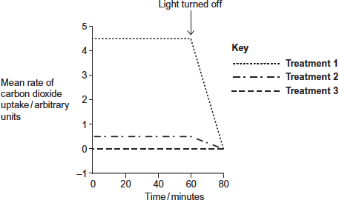

(a)     Suggest the purpose of each of the three leaf treatments.

**Treatment 1** ..................................................................................................

........................................................................................................................

........................................................................................................................

**Treatment 2** ..................................................................................................

........................................................................................................................

........................................................................................................................

**Treatment 3** ..................................................................................................

........................................................................................................................

........................................................................................................................

**(3)**

(b)     (i)      Describe the results shown for **Treatment 1**.

...............................................................................................................

...............................................................................................................

...............................................................................................................

...............................................................................................................

...............................................................................................................

**(2)**

(ii)     The stomata close when the light is turned off.

Explain the advantage of this to the plant.

...............................................................................................................

...............................................................................................................

...............................................................................................................

...............................................................................................................

...............................................................................................................

**(2)**

(c)     (i)      **Treatment 2** shows that even when the lower surface of the leaf is sealed there is still some uptake of carbon dioxide.

Suggest how this uptake of carbon dioxide continues.

...............................................................................................................

...............................................................................................................

...............................................................................................................

**(1)**

(ii)     In both **Treatment 1** and **Treatment 2**, the uptake of carbon dioxide falls to zero when the light is turned off.

Explain why.

...............................................................................................................

...............................................................................................................

...............................................................................................................

...............................................................................................................

...............................................................................................................

**(2)**

**(Total 10 marks)**

**Q2.**Beech trees have two types of leaves called sun leaves and shade leaves. Sun leaves grow on branches exposed to direct sunlight, shade leaves grow on branches exposed to light that has passed through leaves. An ecologist collected sun leaves and shade leaves from beech trees and determined the mean mass of each photosynthetic pigment in both types of leaf. His results are shown the table below.

|  |  |  |  |
| --- | --- | --- | --- |
|  | **Photosynthetic pigment** | **Mean mass of each pigment per m2 of leaf area / μg (± standard deviation)** | |
|  | **Sun leaves** | **Shade leaves** |
|  | Chlorophyll a | 299.3 (± 2.1) | 288.9 (± 0.1) |
|  | Chlorophyll b | 290.7 (± 2.1) | 111.1 (± 0.1) |
|  | Chlorophyll c | 0.10 (± 0.01) | 0.07 (± 0.01) |

(a)     Describe how you would present the data in the table as a graph.

.........................................................................................................................

.........................................................................................................................

.........................................................................................................................

.........................................................................................................................

.........................................................................................................................

**(2)**

(b)     The ecologist collected shade leaves at random from a branch.  
Suggest a method he could have used to collect shade leaves at random from a branch.

.........................................................................................................................

.........................................................................................................................

.........................................................................................................................

.........................................................................................................................

.........................................................................................................................

**(2)**

(c)     The ecologist concluded that there is a significant difference between the amounts of chlorophyll b in sun leaves and shade leaves of beech trees.

Do you agree with this conclusion?

.........................................................................................................................

.........................................................................................................................

.........................................................................................................................

.........................................................................................................................

.........................................................................................................................

**(2)**

(d)     Each type of chlorophyll is produced by a specific enzyme-controlled pathway.  
Use this information to suggest how the same beech tree can produce more chlorophyll b in some leaf cells than others.

.........................................................................................................................

.........................................................................................................................

.........................................................................................................................

.........................................................................................................................

.........................................................................................................................

**(2)**

**(Total 8 marks)**

**Q3.**Tomato plants were grown in two glasshouses, each with an area of 2000 m2. The table shows the mean number of hours of sunshine per month during fruit production.

|  |  |  |  |
| --- | --- | --- | --- |
|  |  | **1995 – 1997  (no extra carbon dioxide** | **1998 – 2000  (extra carbon dioxide)** |
|  | Mean number of hours of  sunshine per month | 148.91 | 147.00 |

•        The scientists used heating to maintain the tempera ture inside the glasshouses above 18 °C. They opened the windows to keep the tempera ture below 30 °C.

•        From 1998 to 2000 they maintained the carbon dioxide concentration between 0.06 % and 0.08 % when the windows were closed and between 0.04 % and 0.05 % when the windows were open.

•        The carbon dioxide concentra tion in the air outside the glasshouse was 0.04 %.

(a)     The scientists monitored the number of hours of sunshine per month. Explain why they monitored the number of hours of sunshine.

........................................................................................................................

........................................................................................................................

........................................................................................................................

........................................................................................................................

........................................................................................................................

........................................................................................................................

**(2)**

(b)     The temperature, the use of fertiliser and the number of insect pests were controlled during this investigation. Name one other factor which should have been controlled during the investigation. Explain why variation in this factor would affect yield.

Factor .............................................................................................................

Explanation .....................................................................................................

........................................................................................................................

**(2)**

**(Total 4 marks)**

**Q4.**(a)     Energy enters most ecosystems through the light-dependent reaction of photosynthesis. Describe what happens during the light-dependent reaction.

**(5)**

(b)     Changes in ecosystems can lead to speciation. A high concentration of copper in soil is toxic to most plants. In some areas where the soil is polluted with copper, populations of grasses are found to be growing. These populations of grass belong to a species also found growing on unpolluted soils.

It has been suggested that a new species of grass may evolve on soil that has been polluted with copper. Explain how this new species might evolve.

**(5)**

**(Total 10 marks)**

**Q5.**          Scientists investigated the effects of temperature and light intensity on the rate of photosynthesis in creeping azalea. They investigated the effect of temperature on the net rate of photosynthesis at three different light intensities. They also investigated the effect of temperature on the rate of respiration. The graph shows the results.

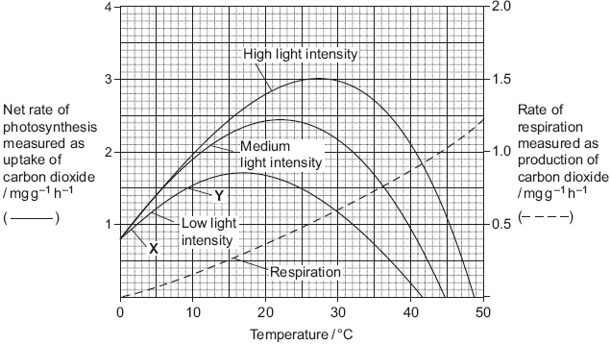

(a)     (i)      Name the factors that limited the rate of photosynthesis between **X** and **Y**.

.............................................................................................................

**(1)**

(ii)     Use information from the graph to explain your answer.

.............................................................................................................

.............................................................................................................

.............................................................................................................

.............................................................................................................

.............................................................................................................

**(2)**

(b)     Use information from the graph to find the gross rate of photosynthesis at 20°C and medium light intensity.

Answer .....................................................

**(1)**

(c)     Creeping azalea is a plant which grows on mountains. Scientists predict that in the area where this plant grows the mean summer temperature is likely to rise from 20 °C to 23 °C. It is also likely to become much cloudier. Describe and explain how these changes are likely to affect the growth of creeping azalea.

......................................................................................................................

......................................................................................................................

......................................................................................................................

......................................................................................................................

......................................................................................................................

......................................................................................................................

**(3)**

**(Total 7 marks)**

**Q6.**          (a)     The concentrations of carbon dioxide in the air at different heights above ground in a forest changes over a period of 24 hours. Use your knowledge of photosynthesis to describe these changes and explain why they occur.

......................................................................................................................

......................................................................................................................

......................................................................................................................

......................................................................................................................

......................................................................................................................

......................................................................................................................

......................................................................................................................

......................................................................................................................

......................................................................................................................

......................................................................................................................

**(5)**

(b)     In the light-independent reaction of photosynthesis, the carbon in carbon dioxide becomes carbon in triose phosphate. Describe how.

......................................................................................................................

......................................................................................................................

......................................................................................................................

......................................................................................................................

......................................................................................................................

......................................................................................................................

......................................................................................................................

......................................................................................................................

......................................................................................................................

......................................................................................................................

......................................................................................................................

......................................................................................................................

**(5)**

**(Total 10 marks)**

**Q7.**(a)     ATP is useful in many biological processes. Explain why.

........................................................................................................................

........................................................................................................................

........................................................................................................................

........................................................................................................................

........................................................................................................................

........................................................................................................................

........................................................................................................................

........................................................................................................................

*(Extra space)* .................................................................................................

........................................................................................................................

........................................................................................................................

........................................................................................................................

**(4)**

(b)     Describe how ATP is made in mitochondria.

........................................................................................................................

........................................................................................................................

........................................................................................................................

........................................................................................................................

........................................................................................................................

........................................................................................................................

........................................................................................................................

........................................................................................................................

........................................................................................................................

........................................................................................................................

........................................................................................................................

........................................................................................................................

*(Extra space)* .................................................................................................

........................................................................................................................

........................................................................................................................

........................................................................................................................

........................................................................................................................

........................................................................................................................

**(6)**

(c)     Plants produce ATP in their chloroplasts during photosynthesis. They also produce ATP during respiration. Explain why it is important for plants to produce ATP during respiration in addition to during photosynthesis.

........................................................................................................................

........................................................................................................................

........................................................................................................................

........................................................................................................................

........................................................................................................................

........................................................................................................................

........................................................................................................................

........................................................................................................................

........................................................................................................................

........................................................................................................................

*(Extra space)* .................................................................................................

........................................................................................................................

........................................................................................................................

........................................................................................................................

........................................................................................................................

**(5)**

**(Total 15 marks)**

**Q8.**          Much of Indonesia is covered with forest. Large areas of forest have been cleared and planted with oil-palm trees to be used in the production of fuel.

(a)     In these forests, nitrogen in dead leaves is made available to growing plants by the action of bacteria. Describe the role of bacteria in making the nitrogen in dead leaves available to growing plants.

......................................................................................................................

......................................................................................................................

......................................................................................................................

......................................................................................................................

......................................................................................................................

......................................................................................................................

......................................................................................................................

......................................................................................................................

......................................................................................................................

......................................................................................................................

*(Extra space)* ...............................................................................................

......................................................................................................................

......................................................................................................................

......................................................................................................................

......................................................................................................................

......................................................................................................................

......................................................................................................................

**(5)**

(b)     During photosynthesis, oil-palm trees convert carbon dioxide into organic substances. Describe how.

......................................................................................................................

......................................................................................................................

......................................................................................................................

......................................................................................................................

......................................................................................................................

......................................................................................................................

......................................................................................................................

......................................................................................................................

......................................................................................................................

......................................................................................................................

......................................................................................................................

......................................................................................................................

*(Extra space)* ...............................................................................................

......................................................................................................................

......................................................................................................................

......................................................................................................................

......................................................................................................................

......................................................................................................................

**(6)**

**(Total 11 marks)**

**Q9.**(a)     The table contains statements about three biological processes.

Complete the table with a tick if the statement in the first column is true, for each process.

|  |  |  |  |  |
| --- | --- | --- | --- | --- |
|  |  | **Photosynthesis** | **Anaerobic respiration** | **Aerobic respiration** |
|  | ATP produced |  |  |  |
|  | Occurs in organelles |  |  |  |
|  | Electron transport chain involved |  |  |  |

**(3)**

(b)     Write a simple equation to show how ATP is synthesised from ADP.

......................................................................................................................

**(1)**

(c)     Give **two** ways in which the properties of ATP make it a suitable source of energy in biological processes.

1 ...................................................................................................................

......................................................................................................................

2 ...................................................................................................................

......................................................................................................................

**(2)**

(d)     Humans synthesise more than their body mass of ATP each day. Explain why it is necessary for them to synthesise such a large amount of ATP.

......................................................................................................................

......................................................................................................................

......................................................................................................................

......................................................................................................................

......................................................................................................................

**(2)**

**(Total 8 marks)**

**Q10.**Mountains are harsh environments. The higher up the mountain, the lower the temperature becomes. The diagram shows a forest growing on the side of a mountain.  
The upper boundary of the forest is called the tree line. Trees do not grow above the tree line.

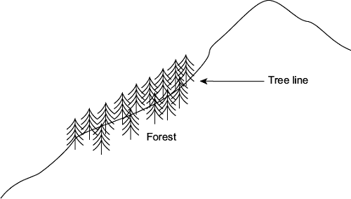

(a)     (i)      The position of the tree line is determined by abiotic factors.  
What is meant by an abiotic factor?

...............................................................................................................

...............................................................................................................

**(1)**

(ii)     Other than temperature, suggest **one** abiotic factor that is likely to affect the position of the tree line on the mountain.

...............................................................................................................

**(1)**

(b)     Scientists measured the concentration of carbon dioxide in the air in one part of the forest. They took measurements at different times of day and at two different heights above the ground. Their results are shown in the bar chart.

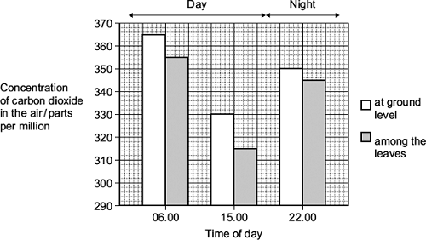

Use your knowledge of photosynthesis and respiration to explain the data in the bar chart.

........................................................................................................................

........................................................................................................................

........................................................................................................................

........................................................................................................................

........................................................................................................................

........................................................................................................................

........................................................................................................................

........................................................................................................................

*(Extra space)* .................................................................................................

........................................................................................................................

........................................................................................................................

........................................................................................................................

**(4)**

(c)     The population of trees in the forest evolved adaptations to the mountain environment.  
Use your knowledge of selection to explain how.

........................................................................................................................

........................................................................................................................

........................................................................................................................

........................................................................................................................

........................................................................................................................

........................................................................................................................

*(Extra space)* .................................................................................................

........................................................................................................................

........................................................................................................................

**(3)**

**(Total 9 marks)**

**Q11.Figure 1** shows the effect of wavelength on the percentage of light absorbed by the chlorophyll from these seaweeds.

**Figure 1**

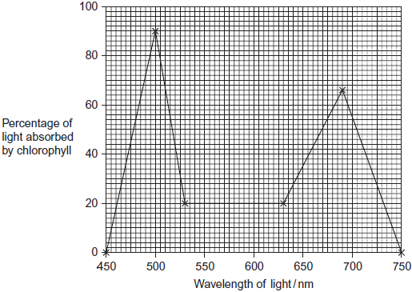

Some scientists investigated the growth of these seaweeds in artificial conditions.

They investigated the effect of different lamps on the rate of photosynthesis of the seaweeds.

•        Lamp **P** produced light containing all wavelengths of visible light. (450 to 750 nm)

•        Lamp **Q** only produced light of wavelength 460 nm.

The scientists measured photosynthesis by recording the rate of oxygen production. Their results are shown in **Figure 2**.

**Figure 2**

|  |  |  |  |
| --- | --- | --- | --- |
|  |  | **Mean rate of photosynthesis / arbitrary units ( ± standard deviation)** | |
|  | **Species** | Lamp **P**  Light of all wavelengths of  visible light | Lamp **Q**  Light of wavelength 460nm |
|  | *Ulva pertusa* | 1300.9 ( ± 125.4) | 776.6 ( ± 105.6) |
|  | *Mastocarpus yendoi* | 318.9 ( ± 69.5) | 299.6 ( ± 83.2) |

(a)     Between 500 and 700 nm, what range of wavelengths of light is absorbed least by chlorophyll?

........................................................................................................................

**(1)**

(b)     The scientists measured the oxygen produced by the light-dependent reaction of photosynthesis. Name **two** other substances produced by the light-dependent reaction.

1 .....................................................................................................................

2 .....................................................................................................................

**(2)**

(c)     (i)      The scientists measured the rate of photosynthesis of the seaweeds in this investigation in terms of oxygen produced.  
Suggest the units they should use.

...............................................................................................................

**(2)**

(ii)     This investigation was carried out in bright light. Explain why reducing the light intensity would affect the amount of oxygen released by the seaweeds.

...............................................................................................................

...............................................................................................................

...............................................................................................................

...............................................................................................................

...............................................................................................................

...............................................................................................................

(Extra space) ........................................................................................

...............................................................................................................

...............................................................................................................

**(3)**

(d)     In this investigation, the scientists kept the temperature at 15 °C. A student suggested that repeating the investigation at 20 °C would not affect the amount of oxygen released by the seaweed. Evaluate this suggestion.

........................................................................................................................

........................................................................................................................

........................................................................................................................

........................................................................................................................

........................................................................................................................

........................................................................................................................

(Extra space) .................................................................................................

........................................................................................................................

........................................................................................................................

**(3)**

(e)     (i)      Did the type of lamp used affect the rate of photosynthesis in *M. yendoi*? Explain the evidence for your answer.

...............................................................................................................

...............................................................................................................

...............................................................................................................

...............................................................................................................

...............................................................................................................

**(2)**

(ii)     The different lamps resulted in different rates of photosynthesis by *U. pertusa*. Explain why there was a higher rate of photosynthesis when the seaweed was illuminated with lamp **P**.

...............................................................................................................

...............................................................................................................

...............................................................................................................

...............................................................................................................

...............................................................................................................

...............................................................................................................

(Extra space) ........................................................................................

...............................................................................................................

...............................................................................................................

**(3)**

**(Total 16 marks)**

**Q12.**          A scientist investigated the uptake of radioactively labelled carbon dioxide in chloroplasts. She used three tubes, each containing different components of chloroplasts. She measured the uptake of carbon dioxide in each of these tubes.  
Her results are shown in the table.

|  |  |  |
| --- | --- | --- |
| **Tube** | **Contents of tube** | **Uptake of radioactively labelled CO2 / counts per minute** |
| **A** | Stroma and grana | 96 000 |
| **B** | Stroma, ATP and reduced NADP | 97 000 |
| **C** | Stroma | 4 000 |

(a)     Name the substance which combines with carbon dioxide in a chloroplast.

........................................................................................................................

**(1)**

(b)     Explain why the results in tube **B** are similar to those in tube **A**.

........................................................................................................................

........................................................................................................................

........................................................................................................................

**(1)**

(c)     Use the information in the table to predict the uptake of radioactively labelled carbon dioxide if tube **A** was placed in the dark. Explain your answer.

........................................................................................................................

........................................................................................................................

........................................................................................................................

........................................................................................................................

........................................................................................................................

**(2)**

(d)     Use your knowledge of the light-independent reaction to explain why the uptake of carbon dioxide in tube **C** was less than the uptake in tube **B**.

........................................................................................................................

........................................................................................................................

........................................................................................................................

........................................................................................................................

........................................................................................................................

**(2)**

(e)     DCMU is used as a weed killer. It inhibits electron transfer during photosynthesis. The addition of DCMU to tube **A** decreased the uptake of carbon dioxide. Explain why.

........................................................................................................................

........................................................................................................................

........................................................................................................................

........................................................................................................................

........................................................................................................................

**(2)**

**(Total 8 marks)**

**Q13.**          (a)     The flow chart shows the main stages in aerobic respiration.

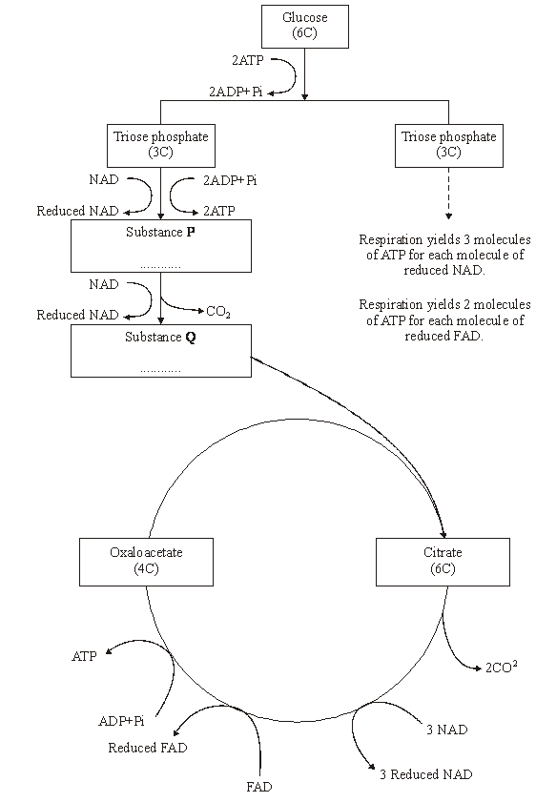

(i)      Complete the flow chart by writing, in the appropriate boxes, the number of carbon atoms in substance **P** and the name of substance **Q**.

**(2)**

(ii)     Some ATP is formed in the cytoplasm and some in the mitochondria. Use the information given to calculate the number of molecules of ATP formed in a mitochondrion from one molecule of glucose in aerobic respiration. Show how you arrived at your answer.

Answer.....................................

**(2)**

(iii)     In the presence of oxygen, respiration yields more ATP per molecule of glucose than it does in the absence of oxygen. Explain why.

.............................................................................................................

.............................................................................................................

.............................................................................................................

.............................................................................................................

.............................................................................................................

.............................................................................................................

**(3)**

(b)     Anabaena is a prokaryote found inside the leaves of a small fern. Anabaena can produce ammonia from nitrogen (nitrogen fixation). This reaction only takes place in the anaerobic conditions found in cells called heterocysts. Heterocysts are thick-walled cells that do not contain chlorophyll. The drawing shows the relationship between *Anabaena* and the fern.

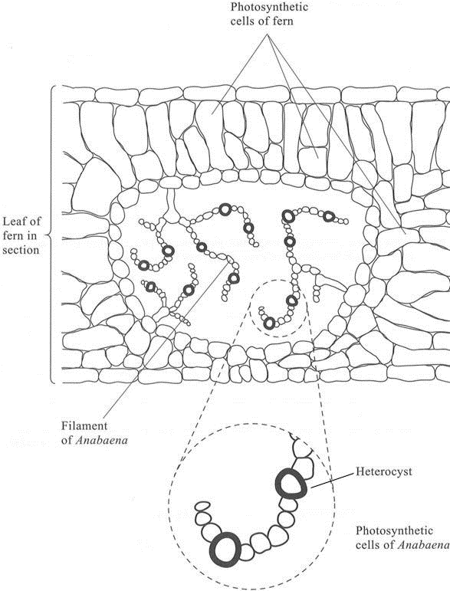

(i)      Suggest how the features of the heterocysts improve the efficiency of the process of nitrogen fixation.

.............................................................................................................

.............................................................................................................

.............................................................................................................

.............................................................................................................

.............................................................................................................

.............................................................................................................

**(3)**

(ii)     In China, the fern is cultivated and ploughed into fields to act as an organic fertiliser. Explain how ploughing the fern plants into the soil results in an improvement in the growth of the rice crop grown in these fields.

.............................................................................................................

.............................................................................................................

.............................................................................................................

.............................................................................................................

.............................................................................................................

.............................................................................................................

.............................................................................................................

.............................................................................................................

.............................................................................................................

.............................................................................................................

**(5)**

**(Total 15 marks)**

**Q14.**         Transpiration in sorghum plants was measured under different conditions. The table shows the results

|  |  |  |
| --- | --- | --- |
| **Growing conditions** | **Transpiration rate / mmol m-2 s-1** | |
| **Low carbon dioxide concentration** | **High carbon dioxide concentration** |
| Dry soil | 12.68 ± 1.64 | 11.07 ± 1.52 |
| Watered soil | 18.29 ± 1.51 | 15.08 ± 1.38 |

(a)     Changing the carbon dioxide concentration had a greater effect on the rate of transpiration when the plants were watered than when they were kept in dry conditions. Explain why.

......................................................................................................................

......................................................................................................................

......................................................................................................................

......................................................................................................................

**(2)**

**S**       (b)     (i)      Giving a reason for your choice, suggest **one** factor which should be kept constant during this investigation.

Factor .................................................................................................

Reason ...............................................................................................

.............................................................................................................

**(1)**

(ii)     The figures in the table are the mean values ± standard deviation. Suggest what the values of standard deviation given in the table indicate about the effects of carbon dioxide concentration and of watering on the variability of the results.

.............................................................................................................

.............................................................................................................

**(1)**

**(Total 4 marks)**

**Q15.**          An investigation was carried out into the effect of carbon dioxide concentration and light intensity on the rate of photosynthesis in a species of plant.

(a)     The temperature was kept constant during this investigation. Explain why.

......................................................................................................................

......................................................................................................................

**(2)**

(b)     The table shows the effect of increasing carbon dioxide concentration on the rate of photosynthesis in maize.

|  |  |
| --- | --- |
| **Carbon dioxide concentration / arbitrary units** | **Rate of photosynthesis / arbitrary units** |
| 30 | 10 |
| 60 | 20 |
| 100 | 30 |
| 150 | 40 |
| 230 | 50 |
| 300 | 60 |
| 400 | 60 |

Describe and explain the effect of increasing carbon dioxide concentration on the rate of photosynthesis.

......................................................................................................................

......................................................................................................................

......................................................................................................................

......................................................................................................................

......................................................................................................................

......................................................................................................................

**(3)**

**(Total 5 marks)**

**Q16.**          There is evidence that the first photosynthetic organisms were primitive water-dwelling bacteria. The very first of these lived near the surface of the water in lakes and contained a purple pigment that absorbed light most strongly in the green region of the spectrum. Later, other bacteria evolved that lived on the top of sediment at the bottom of the lakes (**Figure 1**). Gene mutations had enabled these bacteria to synthesise chlorophyll instead of the purple pigment present in the bacteria living near to the surface. Chlorophyll absorbs light most strongly in the blue and red regions of the spectrum (**Figure 2**).

**Figure 1**

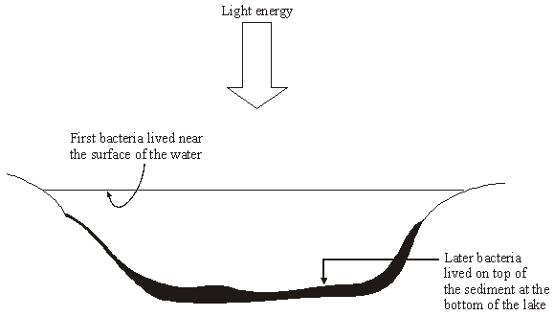

**Figure 2**

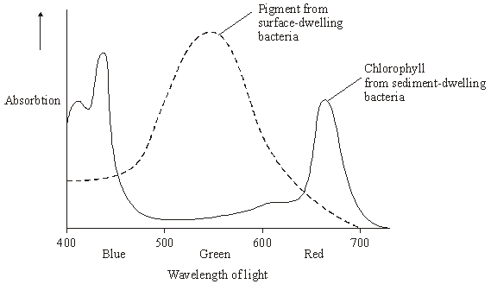

(a)     Describe how light energy absorbed by chlorophyll molecules is used to synthesise ATP.

......................................................................................................................

......................................................................................................................

......................................................................................................................

......................................................................................................................

......................................................................................................................

......................................................................................................................

......................................................................................................................

......................................................................................................................

......................................................................................................................

......................................................................................................................

**(5)**

(b)     Use **Figure 2** to explain how natural selection would favour the evolution of sediment-dwelling bacteria containing a different photosynthetic pigment from those living near the surface of the water.

......................................................................................................................

......................................................................................................................

......................................................................................................................

......................................................................................................................

......................................................................................................................

......................................................................................................................

......................................................................................................................

......................................................................................................................

......................................................................................................................

......................................................................................................................

......................................................................................................................

**(6)**

**(Total 11 marks)**

**Q17.**         In the light-dependent reaction of photosynthesis, light energy generates ATP.

Describe how.

...............................................................................................................................

...............................................................................................................................

...............................................................................................................................

...............................................................................................................................

...............................................................................................................................

...............................................................................................................................

...............................................................................................................................

...............................................................................................................................

...............................................................................................................................

**(Total 5 marks)**

**Q18.**A student investigated the effect of different wavelengths of light on the rate of photosynthesis. She used the apparatus shown in **Figure 1**.

**Figure 1**

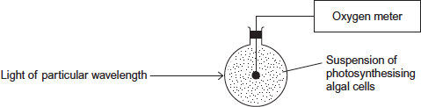

(a)     What measurements should the student have taken to determine the rate of photosynthesis?

........................................................................................................................

........................................................................................................................

**(1)**

(b)     Other than temperature and pH, give **two** factors which should be kept constant during this investigation.

1 .....................................................................................................................

2 .....................................................................................................................

**(2)**

(c)     The student did **not** use a buffer to maintain the pH of the solution.   
Explain what would happen to the pH of the solution during this investigation.

........................................................................................................................

........................................................................................................................

........................................................................................................................

........................................................................................................................

........................................................................................................................

**(2)**

(d)     **Figure 2** shows the student’s results.

**Figure 2**

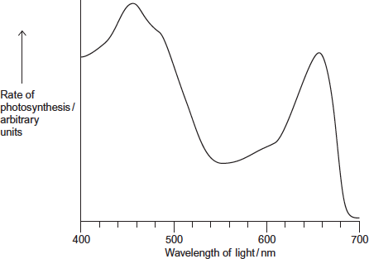

Suggest and explain why the rate of photosynthesis was low between 525 nm and 575 nm wavelengths of light.

........................................................................................................................

........................................................................................................................

........................................................................................................................

........................................................................................................................

........................................................................................................................

**[Extra space]** ................................................................................................

........................................................................................................................

**(2)**

**(Total 7 marks)**

**Q19.**Plants have pigments that absorb light energy for photosynthesis. These pigments include two types of chlorophyll and a group of pigments known as carotenoids. Different species of plant contain different amounts of these pigments. The pigments that each plant species has are adaptations to where and how they live; their ecological niche.

**Figure 1** shows the absorption of light of different wavelengths by chlorophyll a, chlorophyll b and carotenoids.

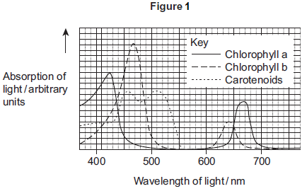

A scientist investigated the energy in light of different wavelengths reaching the ground in a forest. She measured the energy in

•        direct sunlight

•        sunlight that had passed through the leaves of trees.

**Figure 2** shows her results.

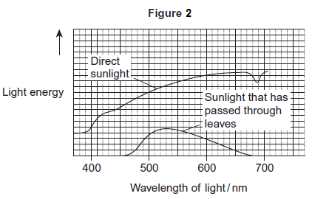

(a)     Use **Figure 1** to describe the absorption of light of different wavelengths by chlorophyll a.

.........................................................................................................................

.........................................................................................................................

.........................................................................................................................

.........................................................................................................................

.........................................................................................................................

**(2)**

(b)     Few species of plant can live below large trees in a forest.  
Use the information in **Figure 1** and **Figure 2** to suggest why.

.........................................................................................................................

.........................................................................................................................

.........................................................................................................................

.........................................................................................................................

.........................................................................................................................

.........................................................................................................................

*(Extra space)* ..................................................................................................

.........................................................................................................................

.........................................................................................................................

**(3)**

(c)     In leaves at the top of trees in a forest, carbon dioxide is often the limiting factor for photosynthesis.  
Use your knowledge of photosynthesis to suggest and explain **one** reason why.

.........................................................................................................................

.........................................................................................................................

.........................................................................................................................

.........................................................................................................................

.........................................................................................................................

**(2)**

**(Total 7 marks)**

**Q20.**          The diagram represents some of the light-independent reactions of photosynthesis.

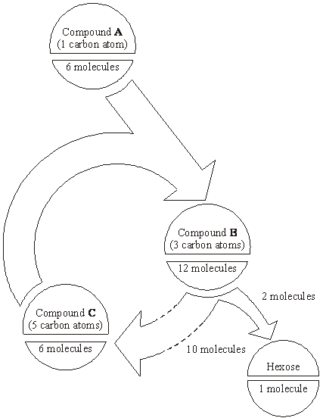

(a)     Describe the light-independent reactions of photosynthesis and explain how they allow the continued synthesis of hexose sugars.

......................................................................................................................

......................................................................................................................

......................................................................................................................

......................................................................................................................

......................................................................................................................

......................................................................................................................

......................................................................................................................

......................................................................................................................

......................................................................................................................

......................................................................................................................

......................................................................................................................

......................................................................................................................

......................................................................................................................

**(6)**

(b)     Describe the role of electron transport chains in the light-dependent reactions of photosynthesis.

......................................................................................................................

......................................................................................................................

......................................................................................................................

......................................................................................................................

......................................................................................................................

......................................................................................................................

......................................................................................................................

......................................................................................................................

......................................................................................................................

......................................................................................................................

......................................................................................................................

......................................................................................................................

......................................................................................................................

**(6)**

(c)     Explain why the increase in the dry mass of a plant over twelve months is less than the mass of hexose produced over the same period.

......................................................................................................................

......................................................................................................................

......................................................................................................................

......................................................................................................................

......................................................................................................................

......................................................................................................................

......................................................................................................................

**(3)**

**(Total 15 marks)**

**Q21.Introduction**

**Resource A – D** relate to a single investigation.

Scientists investigated the effect of supplying extra carbon dioxide on the yield of tomatoes growing in a glasshouse. They compared the mean yield of tomatoes from 1995 to 1997 when no extra carbon dioxide was supplied with the mean yield of tomatoes from 1998 to 2000 when extra carbon dioxide was supplied.

**Resource A**

Tomato plants were grown in two glasshouses, each with an area of 2000 m2. Figure 1 shows the mean number of hours of sunshine per month during fruit production.

**Figure 1**

|  |  |  |  |
| --- | --- | --- | --- |
|  |  | **1995 - 1997  (no extra carbon dioxide)** | **1998 - 2000  (extra carbon dioxide)** |
|  | Mean number of hours of sunshine per month | 148.91 | 147.00 |

•        The scientists used heating to maintain the tempera ture inside the glasshouses above 18 °C. They opened the windows to keep the tempera ture below 30 °C.

•        From 1998 to 2000 they maintained the carbon dioxide concentration between 0.06 % and 0.08 % when the windows were closed and between 0.04 % and 0.05 % when the windows were open.

•        The carbon dioxide concentra tion in the air outside the glasshouse was 0.04 %.

**Resource B**

**Figure 2** shows the mean difference between the yield of tomatoes with extra carbon dioxide and the yield with no extra carbon dioxide for each week during the harvesting period.

If the yield is greater when extra carbon dioxide is supplied, the difference in yield is shown as an increase. If the yield is lower when extra carbon dioxide is supplied, the difference is shown as a decrease.

**Figure 2**

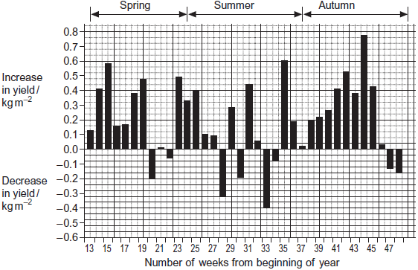

**Resource C**

**Figure 3** shows the relationship between the time when the tomatoes were harvested and the yield.

**Figure 3**

|  |  |  |  |
| --- | --- | --- | --- |
|  | **Number of weeks from  beginning of year** | **Mean yield per week with  extra carbon dioxide / kg m–2** | **Mean yield per week without  extra carbon dioxide / kg m–2** |
|  | 13 – 19 | 1.25 | 0.83 |
|  | 20 – 25 | 1.62 | 1.47 |
|  | 26 – 48 | 1.23 | 1.06 |

The commercial price for tomatoes varies with the time of year. The highest price is paid for tomatoes between weeks 13 and 19. The lowest price is paid between weeks 26 and 48.

**Resource D**

Whiteflies are an important insect pest of tomatoes. The adults can fly from plant to plant. Their young do not have wings. The adults and young feed on the plant sap and introduce viruses into the tomato plants. Feeding and the introduction of viruses both reduce the yield of tomatoes. The scientists controlled the number of whitefly in the glasshouses by releasing parasitic wasps. The wasps lay their eggs in the young of the whitefly. The wasp eggs hatch and feed on the young whitefly, killing them.

(a)     (i)      An increase in carbon dioxide concentration affected the yield of tomatoes in week 35. Use **Figure 2** to describe how.

...............................................................................................................

...............................................................................................................

**(1)**

(ii)     There was a decrease in yield when extra carbon dioxide was supplied during some weeks of the year. Use information from **Resource A** to suggest why.

...............................................................................................................

...............................................................................................................

**(1)**

(b)     Using **Figure 3**, calculate the percentage increase in yield when extra carbon dioxide was added for weeks 13 to 19. Show your working.

Percentage increase ......................................

**(2)**

(c)     Additional information is required for tomato growers to decide whether it is economically profitable to add extra carbon dioxide to produce very early tomatoes.

Give **two** pieces of information that the growers would require.

1 .....................................................................................................................

........................................................................................................................

2 .....................................................................................................................

........................................................................................................................

**(2)**

(d)     Adding extra carbon dioxide during the summer (weeks 24 – 36) is unlikely to be profitable. Use data from the resource sheet explain why.

........................................................................................................................

........................................................................................................................

........................................................................................................................

........................................................................................................................

**(2)**

(e)     The control experiment in this investigation was when data were collected with no extra carbon dioxide added. Some scientists said this control experiment was not satisfactory. Explain how you could improve the control experiment.

........................................................................................................................

........................................................................................................................

........................................................................................................................

........................................................................................................................

**(2)**

**(Total 10 marks)**

**Q22.**During photosynthesis, carbon dioxide reacts with ribulose bisphosphate (RuBP) to form two molecules of glycerate 3-phosphate (GP). This reaction is catalysed by the enzyme Rubisco. Rubisco can also catalyse a reaction between RuBP and oxygen to form one molecule of GP and one molecule of phosphoglycolate. Both the reactions catalysed by Rubisco are shown in **Figure 1**.

**Figure 1**

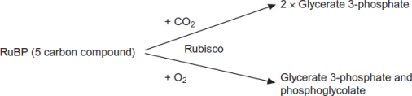

(a)     (i)      Where exactly in a cell is the enzyme Rubisco found?

...............................................................................................................

**(1)**

(ii)     Use the information provided to give the number of carbon atoms in **one** molecule of phosphoglycolate.



**(1)**

(b)     Scientists investigated the effect of different concentrations of oxygen on the rate of absorption of carbon dioxide by leaves of soya bean plants. Their results are shown in **Figure 2**.

**Figure 2**

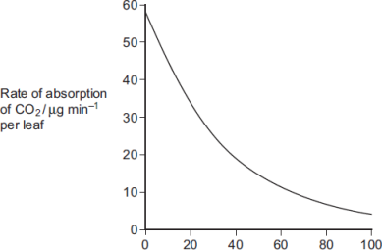

                                Concentration of oxygen / %

Use **Figure 1** to explain the results obtained in **Figure 2**.

........................................................................................................................

........................................................................................................................

........................................................................................................................

........................................................................................................................

........................................................................................................................

**(2)**

(c)     Use the information provided and your knowledge of the light-independent reaction to explain why the yield from soya bean plants is decreased at higher concentrations of oxygen. Phosphoglycolate is not used in the light-independent reaction.

........................................................................................................................

........................................................................................................................

........................................................................................................................

........................................................................................................................

........................................................................................................................

*(Extra space)*..................................................................................................

........................................................................................................................

........................................................................................................................

**(3)**

**(Total 7 marks)**

**Q23.**Plants have pigments that absorb light energy for photosynthesis. These pigments include two types of chlorophyll and a group of pigments known as carotenoids. Different species of plant contain different amounts of these pigments. The pigments that each plant species has are adaptations to where and how they live; their ecological niche.

**Figure 1** shows the absorption of light of different wavelengths by chlorophyll a, chlorophyll b and carotenoids.

**Figure 1**

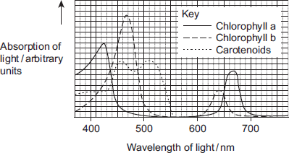

A scientist investigated the energy in light of different wavelengths reaching the ground in a forest. She measured the energy in

•        direct sunlight

•        sunlight that had passed through the leaves of trees.

**Figure 2** shows her results.

**Figure 2**

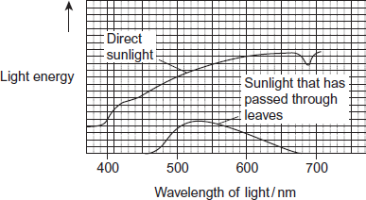

Beech trees have two types of leaves called sun leaves and shade leaves. Sun leaves grow on branches exposed to direct sunlight, shade leaves grow on branches exposed to light that has passed through leaves. An ecologist collected sun leaves and shade leaves from beech trees and determined the mean mass of each photosynthetic pigment in both types of leaf. His results are shown in **Figure 3**.

**Figure 3**

|  |  |  |  |
| --- | --- | --- | --- |
|  | **Photosynthetic pigment** | **Mean mass of each pigment per m2 of leaf  area / μg (± standard deviation)** | |
|  | **Sun leaves** | **Shade leaves** |
|  | Chlorophyll a | 299.3 (± 2.1) | 288.9 (± 0.1) |
|  | Chlorophyll b | 90.7 (± 2.1) | 111.1 (± 0.1) |
|  | Carotenoids | 0.10 (± 0.01) | 0.07 (± 0.01) |

(a)     It is an advantage to beech trees to produce more chlorophyll b in the shade leaves.

Suggest and explain why.

........................................................................................................................

........................................................................................................................

........................................................................................................................

........................................................................................................................

........................................................................................................................

........................................................................................................................

**(2)**

(b)     There are two hypotheses about the advantage to plants of producing carotenoids.

**Hypothesis 1**

Carotenoids help shade leaves to absorb more light of wavelengths 480 nm to 520nm for photosynthesis.

**Hypothesis 2**

Carotenoids prevent damage to chlorophyll from very bright light.

(i)      Which hypothesis do the data provided on the resource sheet support?

Explain your answer.

Hypothesis ....................................

Explanation ............................................................................................

...............................................................................................................

...............................................................................................................

...............................................................................................................

**(2)**

(ii)     Suggest **one** other piece of experimental evidence you would need in order to be more confident about drawing your conclusion in (b)(i).

...............................................................................................................

...............................................................................................................

...............................................................................................................

**(1)**

**(Total 5 marks)**

**Q24.**(a)     On islands in the Caribbean, there are almost 150 species of lizards belonging to the genus *Anolis*. Scientists believe that these species evolved from two species found on mainland USA. Explain how the Caribbean species could have evolved.

**(6)**

(b)     *Anolis sagrei* is a species of lizard that is found on some of the smallest Caribbean islands. Describe how you could use the mark-release-recapture method to estimate the number of *Anolis sagrei* on one of these islands.

**(4)**

(c)     Large areas of tropical forest are still found on some Caribbean islands. The concentration of carbon dioxide in the air of these forests changes over a period of 24 hours and at different heights above ground.

Use your knowledge of photosynthesis and respiration to describe and explain how the concentration of carbon dioxide in the air changes:

•        over a period of 24 hours

•        at different heights above ground.

**(5)**

**(Total 15 marks)**

**Q25.**Some species of crop plant produce a substance called glycinebetaine (GB).

Scientists transferred the gene for GB into a species of crop plant that does not normally produce GB. These genetically modified plants then produced GB.

The scientists grew large numbers of the same crop plant with and without the gene at different temperatures. After 3 days, they found the increase in dry mass of the plants.

**Figure 1** shows their results.

**Figure 1**

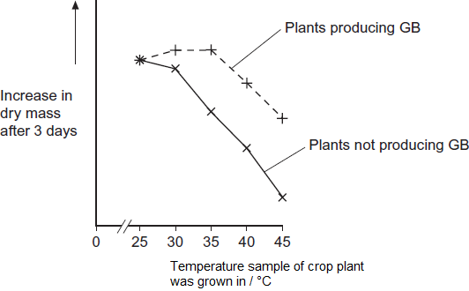

(a)     Describe the effect on growth of transferring the gene for GB into this plant.

........................................................................................................................

........................................................................................................................

........................................................................................................................

........................................................................................................................

........................................................................................................................

**(2)**

(b)     The scientists measured the rate of photosynthesis in plants that produce GB and plants that do not produce GB at 25°C, 35°C and 45°C.

**Figure 2** shows their results.

**Figure 2**

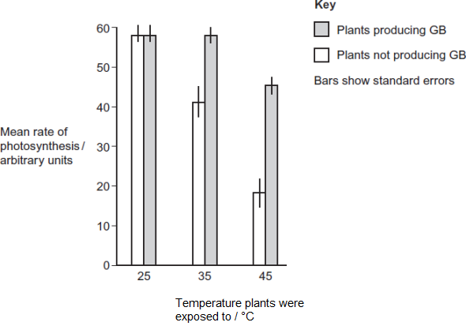

(i)      The scientists concluded that the production of GB protects photosynthesis from damage by high temperatures.

Use these data to support this conclusion.

...............................................................................................................

...............................................................................................................

...............................................................................................................

**(1)**

(ii)     Use the data from **Figure 2**  for plants that do not produce GB to explain the effect of temperature on changes in dry mass of the plants shown in **Figure 1.**

...............................................................................................................

...............................................................................................................

...............................................................................................................

...............................................................................................................

...............................................................................................................

...............................................................................................................

...............................................................................................................

...............................................................................................................

*(Extra space)*........................................................................................

...............................................................................................................

...............................................................................................................

...............................................................................................................

**(4)**

Rubisco activase is an enzyme found in chloroplasts. It activates the light-independent reaction of photosynthesis.

The scientists discovered that, as temperature increased from 25°C to 45°C, rubisco activase began attaching to thylakoid membranes in chloroplasts and this stopped it working.

(c)     Rubisco activase stops working when it attaches to a thylakoid.

Use your knowledge of protein structure to explain why.

........................................................................................................................

........................................................................................................................

........................................................................................................................

........................................................................................................................

........................................................................................................................

**(2)**

(d)     The scientists investigated the effect of GB on attachment of rubisco activase to thylakoid membranes at different temperatures.

**Figure 3** shows their results.

**Figure 3**

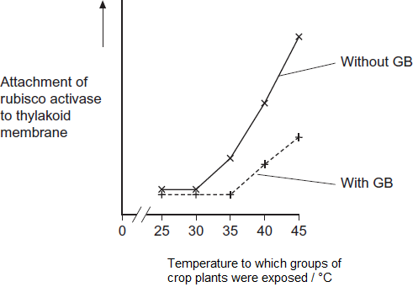

Use information from **Figure 2** and **Figure 3** to suggest how GB protects the crop plant from high temperatures.

........................................................................................................................

........................................................................................................................

........................................................................................................................

........................................................................................................................

........................................................................................................................

........................................................................................................................

........................................................................................................................

........................................................................................................................

*(Extra space)*..................................................................................................

........................................................................................................................

........................................................................................................................

........................................................................................................................

**(4)**

(e)     The scientists’ hypothesis at the start of the investigation was that crop plants genetically engineered to produce GB would become more resistant to high environmental temperatures.  
The scientists developed this hypothesis on the basis of previous research on crops that are grown in hot climates.

Suggest how the scientists arrived at their hypothesis.

........................................................................................................................

........................................................................................................................

........................................................................................................................

........................................................................................................................

........................................................................................................................

**(2)**

**(Total 15 marks)**

**Q26.**Scientists investigated the effect of iron deficiency on the production of triose phosphate in sugar beet plants. They grew the plants under the same conditions with their roots in a liquid growth medium containing all the necessary nutrients. Ten days before the experiments, they transferred half the plants to a liquid growth medium containing no iron. The scientists measured the concentration of triose phosphate produced in these plants and in the control plants:

•        at the end of 6 hours in the dark

•        then for 16 hours in the light.

Their results are shown in the graph.

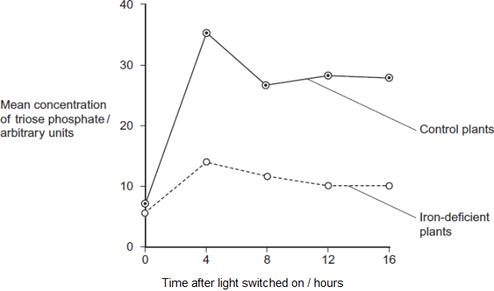

(a)     (i)      The experiments were carried out at a high carbon dioxide concentration. Explain why.

...............................................................................................................

...............................................................................................................

...............................................................................................................

**(1)**

(ii)     Explain why it was important to grow the plants under the same conditions up to ten days before the experiment.

...............................................................................................................

...............................................................................................................

...............................................................................................................

**(1)**

(iii)    The plants were left in the dark for 6 hours before the experiment. Explain why.

...............................................................................................................

...............................................................................................................

...............................................................................................................

**(1)**

(b)     Iron deficiency reduces electron transport. Use this information and your knowledge of photosynthesis to explain the decrease in production of triose phosphate in the iron-deficient plants.

........................................................................................................................

........................................................................................................................

........................................................................................................................

........................................................................................................................

........................................................................................................................

........................................................................................................................

........................................................................................................................

........................................................................................................................

*(Extra space)*.................................................................................................

........................................................................................................................

........................................................................................................................

........................................................................................................................

**(4)**

(c)     Iron deficiency results in a decrease in the uptake of carbon dioxide. Explain why.

........................................................................................................................

........................................................................................................................

........................................................................................................................

........................................................................................................................

**(2)**

**(Total 9 marks)**

**Q27.**Scientists investigated the effect of the water potential of soil water on plant growth. They investigated the effect of this water potential on several plant processes.

The figure below shows their results in the form they were presented. The bars show whether or not each process was occurring.

The plants stopped growing when the water potential of the soil water was below –0.7 mPa. All of the changes in the plants were related to the ability of the roots to take up water from the soil.

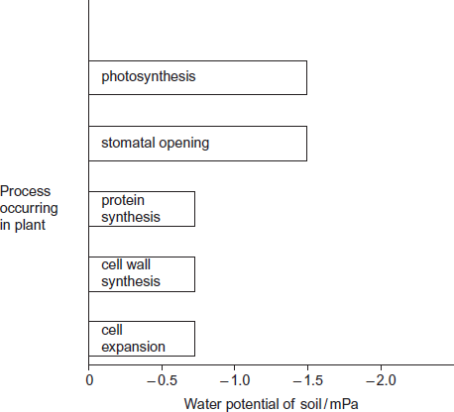

(a)     Describe the results in the figure.

........................................................................................................................

........................................................................................................................

........................................................................................................................

........................................................................................................................

........................................................................................................................

**(2)**

(b)     Explain the relationship between stomatal opening and photosynthesis.

........................................................................................................................

........................................................................................................................

........................................................................................................................

........................................................................................................................

........................................................................................................................

**(2)**

(c)     Although photosynthesis is still occurring, plants stop growing when the soil water potential falls below –0.7 mPa.

Use information from the figure above to suggest two reasons why.

........................................................................................................................

........................................................................................................................

........................................................................................................................

........................................................................................................................

........................................................................................................................

........................................................................................................................

**(3)**

**(Total 7 marks)**

**Q28.**Scientists measured the rate of respiration in **three** parts of an ecosystem.

They did this by measuring carbon dioxide released into the air by:

•        leaves of plants

•        stems and roots of plants

•        non-photosynthetic soil organisms.

The table below shows the scientists’ results for these three parts of the ecosystem.

|  |  |  |  |
| --- | --- | --- | --- |
|  | **Part of ecosystem** | **Mean rate of carbon dioxide production / cm3 m−2 s−1** | **Percentage of total carbon dioxide production measured by the scientists** |
|  | Leaves of plants | 0.032 | 25.0 |
|  | Stems and roots of plants | 0.051 |  |
|  | Non- photosynthetic soil organisms | 0.045 |  |

(a)     Complete the table to show the percentage of total carbon dioxide production by each part of the ecosystem.

Show your working.

**(2)**

(b)     A student who looked at the data in the table concluded that plants carry out more respiration than non-photosynthetic organisms in the ecosystem.

Use the information provided to suggest why these data may **not** support the student’s conclusion.

........................................................................................................................

........................................................................................................................

........................................................................................................................

........................................................................................................................

**(2)**

(c)     What measurements would the scientists have made in order to calculate the rate of carbon dioxide production?

........................................................................................................................

........................................................................................................................

........................................................................................................................

........................................................................................................................

**(2)**

(d)     The scientists calculated the mean rate of carbon dioxide production of the leaves using measurements of carbon dioxide release in the dark.

Explain why they did **not** use measurements taken in the light.

........................................................................................................................

........................................................................................................................

........................................................................................................................

........................................................................................................................

**(2)**

Another group of scientists measured the mean rate of respiration in soil under trees and soil not under trees in the same wood. They also measured the mean rate of photosynthesis in the trees.

They took measurements at different times of day during the summer.

The figure below shows the scientists’ results.

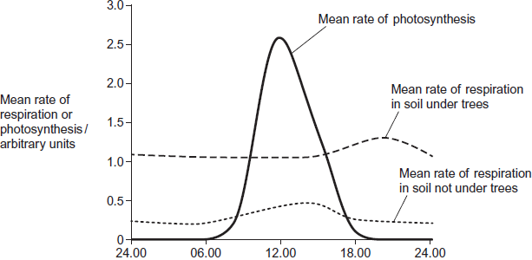  
          Time of day

(e)     (i)      Describe **two** ways in which the mean rate of respiration in soil under trees is different from soil not under trees.

1 ............................................................................................................

...............................................................................................................

2 ............................................................................................................

...............................................................................................................

**(2)**

(ii)     Suggest **one** explanation for the differences in the mean rate of respiration in soil under trees and soil not under trees between 06.00 and 12.00.

...............................................................................................................

...............................................................................................................

...............................................................................................................

...............................................................................................................

**(2)**

(f)     The scientists suggested that the rise in the mean rate of photosynthesis was the cause of the rise in the mean rate of respiration in soil under trees.

(i)      Suggest how the rise in the mean rate of photosynthesis could lead to the rise in the mean rate of respiration in soil under trees.

...............................................................................................................

...............................................................................................................

...............................................................................................................

...............................................................................................................

**(2)**

(ii)     Suggest why there is a delay between the rise in the mean rate of photosynthesis and the rise in the mean rate of respiration.

...............................................................................................................

...............................................................................................................

**(1)**

**(Total 15 marks)**

**Q29.**          (a)     (i)      Give **two** products of the light-dependent stage of photosynthesis.

1 ..........................................................................................................

2 ..........................................................................................................

**(2)**

(ii)     The products of the light-dependent stage are used in the light-independent stage of photosynthesis. What are these products used for?

.............................................................................................................

.............................................................................................................

**(1)**

(b)     The graph shows the rate of uptake or release of carbon dioxide by a plant at different light intensities.

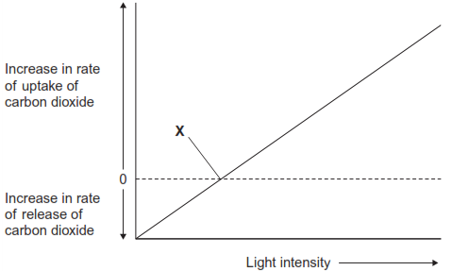

Explain the rate of carbon dioxide exchange at point **X**.

......................................................................................................................

......................................................................................................................

......................................................................................................................

......................................................................................................................

**(2)**

**(Total 5 marks)**

**Q30.**          The percentage of light absorbed by an aquatic plant was measured when it was exposed to different wavelengths. The rate of photosynthesis was also measured at each wavelength of light. The results are shown in the graph.

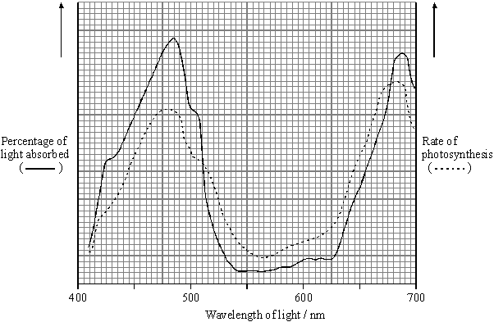

(a)     Describe and explain the relationship between light absorption and the rate of photosynthesis for the wavelengths of light between 410 nm and 500 nm.

......................................................................................................................

......................................................................................................................

......................................................................................................................

......................................................................................................................

**(2)**

(b)     Give **one** dependent variable you could measure in order to determine the rate of photosynthesis in an aquatic plant.

......................................................................................................................

**(1)**

(c)     Use the graph to identify the range of wavelengths of light that would be green in colour.

Give a reason for your answer.

Wavelengths ................... to ................... nm

Reason ........................................................................................................

......................................................................................................................

**(2)**

(d)     A suspension of chloroplasts was isolated from an aquatic plant and a reagent was added. The reagent is blue when oxidised and is colourless when reduced.

(i)      The suspension of chloroplasts in blue reagent was exposed to sunlight. The blue colour disappeared. Use your knowledge of the light-dependent reactions of photosynthesis to explain why.

.............................................................................................................

.............................................................................................................

.............................................................................................................

.............................................................................................................

**(2)**

(ii)     Another suspension of chloroplasts was set up as before. Small quantities of ADP and phosphate ions were added and then the tube was exposed to light. The blue colour disappeared more quickly. Explain why.

.............................................................................................................

.............................................................................................................

.............................................................................................................

.............................................................................................................

**(2)**

**(Total 9 marks)**

**Q31.**          Tomato growers have increased the yield of fruit from 100 to 400 tonnes per hectare by growing the tomato plants in automatically heated glasshouses and enhancing the carbon dioxide concentration. To control the nutrient supply to the roots, the plants are grown without soil in plastic troughs, as shown in the diagram.

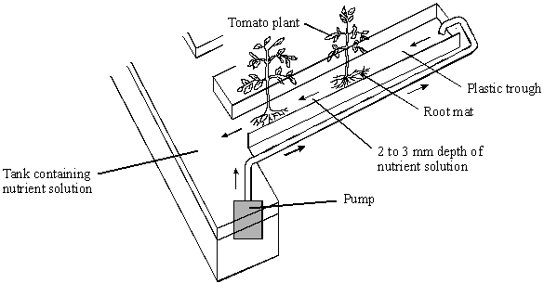

(a)     Explain how enhancing the carbon dioxide concentration helps to increase the yield.

......................................................................................................................

......................................................................................................................

......................................................................................................................

......................................................................................................................

**(2)**

(b)     Maintaining a high temperature in a glasshouse in winter, when the light intensity is low, may reduce the yield. Explain how.

......................................................................................................................

......................................................................................................................

......................................................................................................................

......................................................................................................................

**(2)**

**S** (c)     Tomato fruits have a high percentage of water. When making tomato ketchup, it is more economical to use fruits which have a low percentage of water. Growers can reduce the water content of the fruit by adding sodium chloride to the nutrient solution in the plastic trough.

Explain how adding sodium chloride can reduce the water content of the fruit.

......................................................................................................................

......................................................................................................................

......................................................................................................................

......................................................................................................................

**(2)**

**(Total 6 marks)**

**Q32.**          (a)     Describe how NADP is reduced in the light-dependent reaction of photosynthesis.

......................................................................................................................

......................................................................................................................

......................................................................................................................

......................................................................................................................

**(2)**

(b)     In an investigation of the light-independent reaction, the amounts of glycerate  
3-phosphate (GP) and ribulose bisphosphate (RuBP) in photosynthesising cells were measured under different environmental conditions.

**Figure 1** shows the effect of reducing the carbon dioxide concentration on the amounts of glycerate 3-phosphate and ribulose bisphosphate in photosynthesising cells.

**Figure 1**

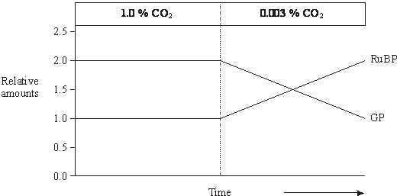

(i)      Explain why there is twice the amount of glycerate 3-phosphate as ribulose bisphosphate when the carbon dioxide concentration is high.

.............................................................................................................

.............................................................................................................

**(1)**

(ii)     Explain the rise in the amount of ribulose bisphosphate after the carbon dioxide concentration is reduced.

.............................................................................................................

.............................................................................................................

**(1)**

(c)     **Figure 2** shows the results of an experiment in which photosynthesising cells were kept in the light and then in darkness.

**Figure 2**

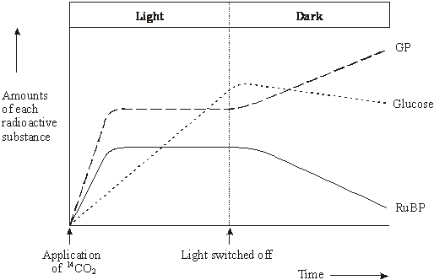

(i)      In the experiment the cells were supplied with radioactively labelled 14CO2. Explain why the carbon dioxide used was radioactively labelled.

.............................................................................................................

.............................................................................................................

**(1)**

(ii)     Explain how lack of light caused the amount of radioactively labelled glycerate 3-phosphate to rise.

.............................................................................................................

.............................................................................................................

.............................................................................................................

.............................................................................................................

**(2)**

(iii)     Explain what caused the amount of radioactively labelled glucose to decrease after the light was switched off.

.............................................................................................................

.............................................................................................................

**(1)**

**(Total 8 marks)**

**Q33.**          Gas exchange in an aquatic plant was investigated by placing shoots in tubes containing bromothymol blue indicator solution. Bromothymol blue indicator is yellow below pH 6, green between pH 6.1 and 7.5, and blue at pH 7.6 and above. Into each of four tubes, **A**, **B**, **C** and **D**, 10 cm3 of bromothymol blue solution were placed. Each tube was closed with a bung and left for 10 minutes. Similar-sized shoots of an aquatic plant were then placed into each of tubes **A**, **B** and **C**. The tubes were treated as shown in the diagram.

They were then placed at equal distances from a 60 watt lamp and left for one hour.

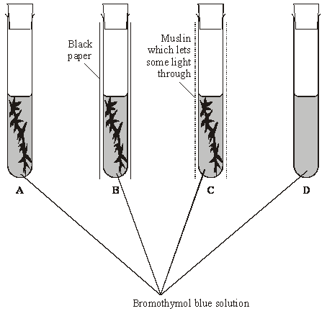

The table shows the initial and final colours of the indicator in the four tubes.

|  |  |  |  |
| --- | --- | --- | --- |
| **Tube** | **Treatment** | **Initial colour of indicator** | **Colour of indicator after one hour** |
| **A** | Uncovered | Green | Blue |
| **B** | Covered with black paper | Green | Yellow |
| **C** | Covered with muslin | Green | Green |
| **D** | Uncovered | Green | Green |

(a)     Explain the results for

tube **A**;

......................................................................................................................

......................................................................................................................

......................................................................................................................

......................................................................................................................

tube **B**;

......................................................................................................................

......................................................................................................................

......................................................................................................................

......................................................................................................................

tube **C**.

......................................................................................................................

......................................................................................................................

......................................................................................................................

......................................................................................................................

**(4)**

(b)     (i)      Explain how the results from tube **D** help to confirm that the explanations for the other tubes are valid.

.............................................................................................................

.............................................................................................................

**(1)**

(ii)     Explain why all the tubes were placed the same distance from the lamp.

.............................................................................................................

.............................................................................................................

**(1)**

**(Total 6 marks)**

**Q34.**          The diagram shows a summary of the light-independent reaction of photosynthesis.

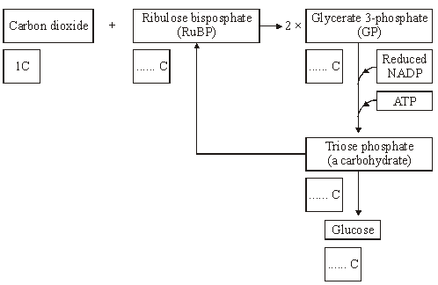

(a)     (i)      Complete the boxes to show the number of carbon atoms in the molecules.

**(2)**

(ii)     In which part of a chloroplast does the light-independent reaction occur?

.............................................................................................................

**(1)**

(iii)     Which process is the source of the ATP used in the conversion of glycerate  
3-phosphate (GP) to triose phosphate?

.............................................................................................................

**(1)**

(iv)    What proportion of triose phosphate molecules is converted to ribulose bisphosphate (RuBP)?

.............................................................................................................

**(1)**

(b)     Lowering the temperature has very little effect on the light-dependent reaction, but it slows down the light-independent reaction. Explain why the light-independent reaction slows down at low temperatures.

......................................................................................................................

......................................................................................................................

......................................................................................................................

......................................................................................................................

**(2)**

**(Total 7 marks)**

**Q35.**          The graph shows the absorption of different wavelengths of light by three photosynthetic pigments in a red seaweed.

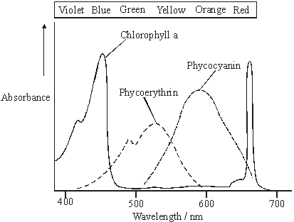

(a)     (i)      Describe what the graph shows about the properties of chlorophyll a.

.............................................................................................................

.............................................................................................................

**(1)**

(ii)     Describe the part played by chlorophyll in photosynthesis.

.............................................................................................................

.............................................................................................................

.............................................................................................................

.............................................................................................................

.............................................................................................................

.............................................................................................................

**(3)**

(b)     The red seaweed lives under water at a depth of 2 metres. Suggest an advantage to the red seaweed of having other pigments in addition to chlorophyll a.

......................................................................................................................

......................................................................................................................

......................................................................................................................

......................................................................................................................

**(2)**

**(Total 6 marks)**

**Q36.**         The diagram shows the energy flow through a freshwater ecosystem.All units are kJ m–2year–1.

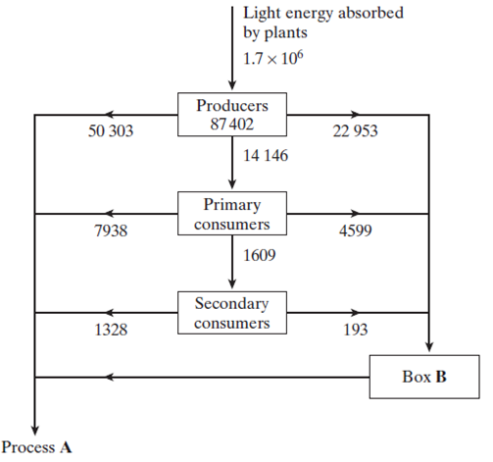

(a)     Name

(i)      process **A**;

.............................................................................................................

**(1)**

(ii)     the group of organisms represented by box **B**.

.............................................................................................................

**(1)**

(b)     Calculate the percentage efficiency with which light energy is transferred to energy in producers. Show your working.

Answer ........................................

**(2)**

**S**       (c)     Describe the effect of light energy in the light-dependent reaction of photosynthesis.

......................................................................................................................

......................................................................................................................

......................................................................................................................

......................................................................................................................

**(2)**

**S**       (d)     If a plant is kept in the dark it is still able to produce carbohydrates, as long as it is provided with two products of the light-dependent reaction of photosynthesis. Give the name of these products and explain their function in the light-independent reaction of photosynthesis.

Name ............................................................................................................

Function ........................................................................................................

......................................................................................................................

Name ............................................................................................................

Function ........................................................................................................

......................................................................................................................

**(4)**

**(Total 10 marks)**

**Q37.**          (a)     The table contains some statements relating to biochemical processes in a plant cell. Complete the table with a tick if the statement is true or a cross if it is not true for each biochemical process.

|  |  |  |  |
| --- | --- | --- | --- |
| **Statement** | **Glycolysis** | **Krebs cycle** | **Light-dependent reaction of photosynthesis** |
| NAD is reduced |  |  |  |
| NADP is reduced |  |  |  |
| ATP is produced |  |  |  |
| ATP is required |  |  |  |

**(4)**

(b)     An investigation was carried out into the production of ATP by mitochondria. ADP, phosphate, excess substrate and oxygen were added to a suspension of isolated mitochondria.

(i)      Suggest the substrate used for this investigation.

.............................................................................................................

**(1)**

(ii)     Explain why the concentration of oxygen and amount of ADP fell during the investigation.

.............................................................................................................

.............................................................................................................

.............................................................................................................

.............................................................................................................

**(2)**

(iii)     A further investigation was carried out into the effect of three inhibitors, **A**, **B** and **C**, on the electron transport chain in these mitochondria. In each of three experiments, a different inhibitor was added. The table shows the state of the electron carriers, **W–Z**, after the addition of inhibitor.

|  |  |  |  |  |
| --- | --- | --- | --- | --- |
| **Inhibitor added** | **Electron carrier** | | | |
| **W** | **X** | **Y** | **Z** |
| **A** | oxidised | reduced | reduced | oxidised |
| **B** | oxidised | oxidised | reduced | oxidised |
| **C** | reduced | reduced | reduced | oxidised |

Give the order of the electron carriers in this electron transport chain. Explain your answer.

Order      ..............      ..............      ..............      ..............

Explanation .........................................................................................

.............................................................................................................

.............................................................................................................

**(2)**

**(Total 9 marks)**

**Q38.** The diagram shows the structure of a chloroplast.

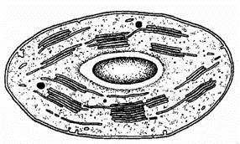

(a)     Label the diagram with an **X** to show where the light-dependent reactions take place and with a **Y** to show where the light-independent reactions take place.

**(1)**

(b)     The photolysis of water is an important part of the process of photosynthesis. Describe what happens in the photolysis of water.

......................................................................................................................

......................................................................................................................

......................................................................................................................

......................................................................................................................

**(2)**

(c)     ATP and reduced NADP are two products of the light-dependent reactions. Describe **one** function of **each** of these substances in the light-independent reactions.

ATP ..............................................................................................................

......................................................................................................................

Reduced NADP ............................................................................................

......................................................................................................................

**(2)**

**(Total 5 marks)**

**Q39.**          An investigation was carried out to find the effect of increasing carbon dioxide concentration on the rate of photosynthesis in a particular type of plant. The graph shows the results.

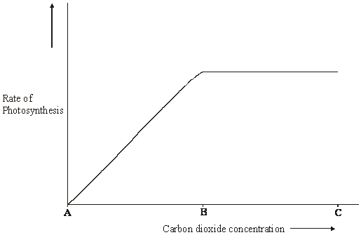

(a)     (i)      In this investigation, temperature was kept constant. Explain why.

.............................................................................................................

.............................................................................................................

**(1)**

(ii)     Suggest suitable units for measuring the rate of photosynthesis in this investigation.

.............................................................................................................

**(2)**

(b)     (i)      Give the evidence from the graph that carbon dioxide is limiting the rate of photosynthesis between **A** and **B**.

.............................................................................................................

.............................................................................................................

**(1)**

(ii)     Explain the shape of the curve between **B** and **C**.

.............................................................................................................

.............................................................................................................

.............................................................................................................

.............................................................................................................

**(2)**

**(Total 6 marks)**

**Q40.**          The diagram shows the light-dependent reactions of photosynthesis.

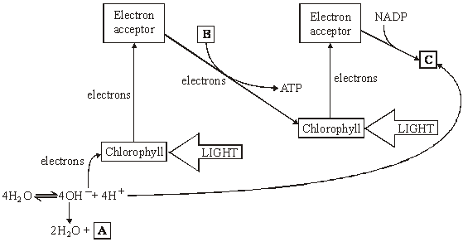

(a)     In which part of a chloroplast do the light-dependent reactions occur?

......................................................................................................................

**(1)**

(b)     Name the substances in boxes **A**, **B** and **C**.

**A** ................................................................

**B** ..................…........ + ....................…......

**C** .................................................................

**(3)**

(c)     Use information in the diagram to explain

(i)      the role of chlorophyll in photolysis;

.............................................................................................................

.............................................................................................................

.............................................................................................................

.............................................................................................................

.............................................................................................................

.............................................................................................................

**(3)**

(ii)     how the energy of light is converted into chemical energy in the light-dependent reactions.

.............................................................................................................

.............................................................................................................

.............................................................................................................

.............................................................................................................

.............................................................................................................

.............................................................................................................

**(3)**

(d)     In an investigation, single-celled algae were kept in bright light and were supplied with carbon dioxide containing radioactive carbon atoms. After 300 seconds, the carbon dioxide supply was turned off. The graph shows how the concentrations of carbon dioxide, glycerate 3-phosphate (GP) and ribulose bisphosphate (RuBP) changed.

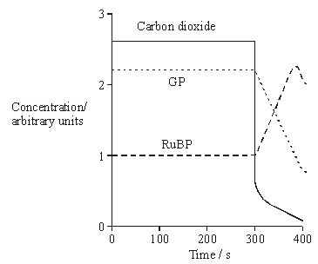

(i)      Explain why, between 0 seconds and 300 seconds, the concentration of radioactive GP remained constant.

.............................................................................................................

.............................................................................................................

.............................................................................................................

.............................................................................................................

.............................................................................................................

.............................................................................................................

**(3)**

(ii)     Explain why, between 300 seconds and 380 seconds, the concentration of radioactive RuBP increased.

.............................................................................................................

.............................................................................................................

.............................................................................................................

.............................................................................................................

**(2)**

**(Total 15 marks)**

**Q41.**During the light-independent reaction of photosynthesis, carbon dioxide is converted into organic substances. Describe how.

................................................................................................................................

................................................................................................................................

................................................................................................................................

................................................................................................................................

................................................................................................................................

................................................................................................................................

................................................................................................................................

................................................................................................................................

................................................................................................................................

................................................................................................................................

................................................................................................................................

................................................................................................................................

*(Extra space)* .........................................................................................................

................................................................................................................................

................................................................................................................................

................................................................................................................................

................................................................................................................................

................................................................................................................................

................................................................................................................................

................................................................................................................................

................................................................................................................................

................................................................................................................................

**(Total 6 marks)**

**Q42.**Farmland previously used for growing crops was left for 30 years and developed into woodland. During this period, ecologists recorded an increase in the diversity of birds in the area.

(a)     Name the process that resulted in the development of woodland from farmland.

........................................................................................................................

**(1)**

(b)     Explain the increase in the diversity of birds as the woodland developed.

........................................................................................................................

........................................................................................................................

........................................................................................................................

........................................................................................................................

........................................................................................................................

........................................................................................................................

*(Extra space)* .................................................................................................

........................................................................................................................

........................................................................................................................

**(3)**

(c)     The ecologists also investigated photosynthesis in two species of plant found in the woodland. One of the species was adapted to growing in bright sunlight (sun plant) and the other was adapted to growing in the shade (shade plant). The ecologists’ results are shown in the figure below.

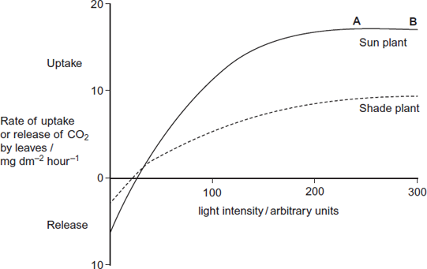

(i)      Give **two** factors which could be limiting the rate of photosynthesis in the sun plant between points **A** and **B** on the figure.

1..............................................................................................................

2.............................................................................................................

**(1)**

(ii)     Explain why CO2 uptake is a measure of net productivity.

...............................................................................................................

...............................................................................................................

*(Extra space)* ........................................................................................

...............................................................................................................

**(1)**

(iii)    Use the information in the figure to explain how the shade plant is better adapted than the sun plant to growing at low light intensities.

...............................................................................................................

...............................................................................................................

...............................................................................................................

...............................................................................................................

*(Extra space)* ........................................................................................

...............................................................................................................

**(2)**

**(Total 8 marks)**

**Q43.**Chloroplasts contain chlorophyll a and chlorophyll b. Scientists found tobacco plants with a mutation that caused them to make more chlorophyll b than normal tobacco plants. They investigated the effect of this mutation on the rate of photosynthesis.

The scientists carried out the following investigation.

•        They grew normal and mutant tobacco plants. They grew some of each in low light intensity and grew others in high light intensity.

•        They isolated samples of chloroplasts from mature plants of both types.

•        Finally, they measured oxygen production by the chloroplasts they had isolated from the plants.

The figure below shows the scientists’ results.

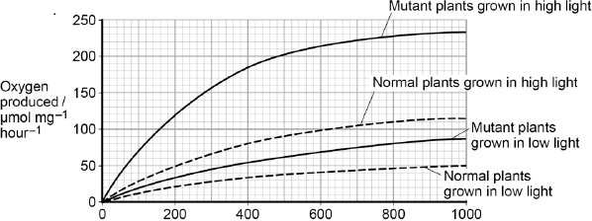  
Light intensity / μmol photons m-2s-1

(a)     Explain why the scientists measured the rate of production of oxygen in this investigation.

........................................................................................................................

........................................................................................................................

........................................................................................................................

........................................................................................................................

**(2)**

In each trial, the scientists collected oxygen for 15 minutes.

(b)     Calculate the difference in the oxygen produced by the chloroplasts from mutant plants grown in low and high light intensities at a light intensity of 500 μmol photons m–2 s–1.

Show your working.

Difference .................................................................... μmol O2 mg–1 hour–1

**(2)**

(c)     The scientists suggested that mutant plants producing more chlorophyll b would grow faster than normal plants in all light intensities.

Explain how these data support this suggestion.

........................................................................................................................

........................................................................................................................

........................................................................................................................

........................................................................................................................

........................................................................................................................

........................................................................................................................

........................................................................................................................

........................................................................................................................

**(Extra space)** ................................................................................................

........................................................................................................................

........................................................................................................................

........................................................................................................................

**(4)**

**(Total 8 marks)**

**M1.**(a)     1.      (No grease)

            means stomata are open

            OR

            allows normal CO2 uptake;

*Allow ‘gas exchange’ for CO2 uptake.*

*‘As a control’ is insufficient on its own.*

2.      (Grease on lower surface)

seals stomata

OR

stops CO2 uptake through

stomata

OR

to find CO2 uptake through

stomata

OR

shows CO2 uptake through cuticle / upper surface;

3.      (Grease on both surfaces) shows sealing is effective

OR

stops all CO2 uptake.

**3**

(b)     (i)      1.      (Mean rate of) carbon dioxide uptake was constant *and* fell after the light turned off;

*Ignore absence of arbitrary units in both marking points.*

*Both ideas needed for mark.*

*Accept ‘stayed at 4.5’ as equivalent to ‘was constant’.*

2.      Uptake fell from 4.5 to 0 / uptake started to fall at 60 minutes and reached lowest at 80 minutes / uptake fell over period of 20 minutes;

*One correct use of figures required.*

*Accept fell to nothing / no uptake for 0.*

**2**

(ii)     1.      (Because) water is lost through stomata;

2.      (Closure) prevents / reduces water loss;

3.      Maintain water content of cells.

*This marking point rewards an understanding of reducing water loss e.g. reduce wilting, maintain turgor, and is not related to photosynthesis.*

**2 max**

(c)     (i)      (Carbon dioxide uptake) through the upper surface of the leaf / through cuticle.

**1**

(ii)     1.      No use of carbon dioxide in photosynthesis (in the dark);

2.      No diffusion gradient (maintained) for carbon dioxide into leaf / there is now a diffusion gradient for carbon dioxide out of leaf (due to respiration).

**2**

**[10]**

**M2.**(a)     1.      Bar chart;

2.      Error bars to represent standard deviation (of mean);

3.      Photosynthetic pigment on *x* axis and mass of pigment on *y* axis;

*Accept suitable sketch*

**2 max**

(b)     1.      Number leaves on the branch;

2.      Use random number table / calculator / pick numbers from bag to determine which leaf to pick;

*Accept use of random number generator*

***OR***

3.      Collect large number of leaves;

4.      Pick out of bag with some idea of randomness;

**2**

(c)     No (no mark)

1.      No stats test carried out;

2.      Standard error / 95% confidence interval calculation identified;

*If awarded, student scores 2 marks – for points 1 and 2*

Yes (no mark)

3.      No overlap shown by the standard deviations;

4.      Ranges around mean stated;

*88.6-92.8 and 111.0-111.2 (1 × SD) or 86.5-94.9 and 110.9-111.3   
(2 × SD)*

**2 max**

(d)     In shade leaves:

1.      Greater amount of enzyme / enzyme activity (for production of chlorophyll b);

2.      Greater gene expression / transcription of the gene / more mRNA produced / gene switched on;

3.      Greater translation;

4.      Enzyme / substrate is light sensitive – faster rate of reaction with lower light;

**2 max**

**[8]**

**M3.**(a)     To see if a difference in hours of sunshine was present / because it is necessary to monitor factors which cannot be controlled;  
So that they could eliminate this factor from affecting the yield (with /without extra carbon dioxide);  
OR  
Duration of light influences length of time for photosynthesis / temperaturein glasshouse;  
Higher photosynthesis results in higher yield / more carbohydrates /sugars / proteins produced;

**2 max**

(b)     Named factor;  
Explanation of why the factor is important;  
E.g.  
Density of planting;  
Competition for named resource;  
or  
Same variety of tomato;   
Yield will vary with different varieties / with different genotypes;  
or  
Water (application);  
Water needed for expansion of fruit / maintain leaf turgidity / maintain stomatal opening / replace water lost in transpiration / water used in photosynthesis;

*For named resourceaccept ‘nutrient’ but not ‘food’*

**2**

**[4]**

**M4.**(a)     1.      Chlorophyll absorbs light energy;

*Accept light energy ‘hits’ chlorophyll*

*Accept photon for light energy*

2.      Excites electrons / electrons removed (from chlorophyll);

*Accept higher energy level as ‘excites’*

3.      Electrons move along carriers / electron transport chain releasing energy;

*Accept movement of H+ / protons across membrane releases energy*

4.      Energy used to join ADP and Pi to form ATP;

*Negate ‘produces energy’ for either mark but not for both*

*Accept energy used for phosphorylation of ADP to ATP*

*Do not accept P as Pi*

5.      Photolysis of water produces protons, electrons and oxygen;

*3. and 4.*

6.      NADP reduced by electrons / electrons and protons / hydrogen;

*Accept NADP to NADPH (or equivalent) by addition of electrons / hydrogen*

*Do not accept NADP reduced by protons on their own*

**5 max**

(b)     1.      Variation / variety;

2.      Mutation;

*Do not accept answers which suggest the mutation is caused by copper*

3.      Some plants have allele to survive / grow / live in high concentration of copper / polluted soils;

*Reference to immunity disqualifies this mark*

*Do not disqualify mark for references to allele providing resistance to copper*

4.      (Differential) reproductive success / adapted organisms reproduce;

5.      Increase in frequency of allele;

6.      No interbreeding (with other populations) / separate gene pool / gene pool differs (from other populations);

*Accept reproductive isolation*

**5 max**

**[10]**

**M5.**          (a)     (i)      Temperature and light;

**1**

(ii)     Increase in temperature causes increase in rate of photosynthesis / uptake of carbon dioxide;

Increase in light / more / medium / high light (intensity) causes increase in rate of photosynthesis / uptake of carbon dioxide;

**2**

(b)     2.75 – 2.81 (mg g–1 hr–1)

*Accept answers in range 2.75 – 2.81*

**1**

(c)     1.      Growth will decrease (at higher temperature);

2.      Rate of respiration will increase at higher temperature;

3.      Photosynthesis decreases as limited by light / as there is less light;

*Ignore references to effect of temperature on rate of photosynthesis*

**3**

**[7]**

**M6.**          (a)     1.      High concentration of carbon dioxide linked with night / darkness;

*Accept: converse of low in day*

2.      No photosynthesis in dark / night / light required for photosynthesis / light-dependent reaction;

*Ignore references to rate of photosynthesis in day / night  
Accept day = light*

3.      (In dark) plants (and other organisms) respire;

*Must be a reference to plants or all organisms*

4.      In light net uptake of carbon dioxide by plants / plants use more carbon dioxide than they produce / rate of photosynthesis greater  
than rate of respiration;

*Do not allow converse for this point  
Accept description of compensation point*

5.      Decrease in carbon dioxide concentration with height;

*Accept: converse of increase closer to ground*

6.      At ground level fewer leaves / less photosynthesising  
tissue / more animals / less light;

**5 max**

(b)     1.      Carbon dioxide combines with ribulose bisphosphate / RuBP;

2.      To produce two molecules of glycerate 3-phosphate / GP;

3.      Reduced to triose phosphate / TP;

4.      Requires reduced NADP;

5.      Energy from ATP;

*This mark scheme is based on specification content. Accept alternate names such as NADPH*

*Credit relevant diagrams*

*Accept: description of ‘reduced’*

**5**

**[10]**

**M7.**          (a)     1.      Releases energy in small / manageable amounts;

*1. Accept less than glucose*

2.      (Broken down) in a one step / single bond broken immediate energy compound / makes energy available rapidly;

*2. Accept easily broken down*

3.      Phosphorylates / adds phosphate makes (phosphorylated substances) more reactive / lowers activation energy;

*3. Do not accept phosphorus or P on its own*

4.      Reformed / made again;

*4. Must relate to regeneration*

**4**

(b)     1.      Substrate level phosphorylation / ATP produced in Krebs cycle;

*Accept alternatives for reduced NAD*

2.      Krebs cycle / link reaction produces reduced coenzyme / reduced NAD / reduced FAD;

*2. Accept description of either Krebs cycle or link reaction*

3.      Electrons released from reduced / coenzymes / NAD / FAD;

4.      (Electrons) pass along carriers / through electron transport chain / through series of redox reactions;

5.      Energy released;

*5. Allow this mark in context of electron transport or chemiosmosis*

6.      ADP / ADP + Pi;

*6. Accept H+ or hydrogen ions and cristae*

7.      Protons move into intermembrane space;

*7. Allow description of movement through membrane*

8.      ATP synthase;

*8. Accept ATPase. Reject stalked particles*

**6 max**

(c)     1.      In the dark no ATP production in photosynthesis;

*1. In context of in photosynthetic tissue / leaves*

2.      Some tissues unable to photosynthesise / produce ATP;

3.      ATP cannot be moved from cell to cell / stored;

4.      Plant uses more ATP than produced in photosynthesis;

5.      ATP for active transport / synthesis (of named substance);

**5**

**[15]**

**M8.**          (a)     1.      Saprobionts / saprophytes;

2.      Digest / break down proteins / DNA / nitrogen-containing substances;

3.      Extracellular digestion / release of enzymes;

4.      Ammonia / ammonium produced;

5.      Ammonia converted to nitrite to nitrate / ammonia to nitrate;

6.      Nitrifying (bacteria) / nitrification;

7.      Oxidation;

*Ignore all references to other parts of the nitrogen cycle*

*1. Accept saprotrophs. Allow this mark if saprobionts linked to fungi.*

*2. Ignore"nitrogen in plants"*

*Ignore enzymes excreted*

*6. Accept Nitrosomonas / Nitrobacter*

**5 max**

(b)     1.      Carbon dioxide combines with ribulose bisphosphate / RuBP;

2.      Produces two molecules of glycerate (3-)phosphate / GP;

3.      Reduced to triose phosphate / TP;

4.      Using reduced NADP;

5.      Using energy from ATP;

6.      Triose phosphate converted to other organic substances / named organic substances / ribulose bisphosphate;

7.      In light independent reaction / Calvin cycle;

*3. Accept add hydrogen for reduced*

*4. Accept alternatives such as NADPH for reduced NADP / GALP for TP / ribulose biphosphate*

**6 max**

**[11]**

**M9.**(a)

|  |  |  |  |  |
| --- | --- | --- | --- | --- |
|  |  | Photosynthesis | Anaerobic respiration | Aerobic respiration |
|  | ATP produced |  |  |  |
|  | Occurs in organelles |  |  |  |
|  | Electron transport chain involved |  |  |  |

*1 mark per column*

*Mark ticks only. Ignore anything else if different symbols such as crosses are used as well.*

*If crosses are used instead of ticks allow cross as equivalent to a tick.*

*Reject tick with a line through*

**3**

(b)     ADP + Pi → ATP;

*Both sides correct, but allow other recognised symbols or words for phosphate ion. Reject P unless in a circle.*

*Accept = as equivalent to arrow*

*Accept reversible arrow*

*Ignore any reference to kJ / water*

**1**

(c)     1.      Energy released in small / suitable amounts;

2.      Soluble;

3.      Involves a single / simple reaction;

*1. In context of release, not storage. Ignore producing energy / manageable amounts.*

*2. Reject "broken down easily / readily". Reject "quickly / easily resynthesised".*

**2 max**

(d)     1.      ATP cannot be stored / is an immediate source of energy;

2.      ATP only releases a small amount of energy at a time;

**2**

**[8]**

**M10.**         (a)     (i)     Non-living / physical / chemical factor / non biological;

*Do not accept named factor unless general answer given.*

**1**

(ii)     Accept an abiotic factor that may limit photosynthesis / growth;

*Reject altitude / height*

Water

Named soil factor

*Not “soil” / “weather”*

Light

Carbon dioxide

*Accept Oxygen*

Incline / aspect

Wind / wind speed

**1**

(b)     1.      Correct explanation for differences between day and night e.g.  
photosynthesises only during the daytime / no photosynthesis / only respiration at night;

2.      Net carbon dioxide uptake during the day / in light

***OR***

         No carbon dioxide taken up at night / in dark / carbon dioxide released at night / in dark;

3.      At ground level more respiration / in leaves more photosynthesis;

4.      Carbon dioxide produced at ground level / carbon dioxide taken up in leaves;

*Principles*

***Comparing day and night / light and dark***

*1. Explanation in terms of photosynthesis / respiration*

*2. Effect on carbon dioxide production / uptake*

***Comparing leaves with ground level***

*3. Explanation in terms of photosynthesis / respiration*

*4. Effect on carbon dioxide production / uptake*

*2 and 4 must relate to why the change occurs*

**4**

(c)     1.      Variation in original colonisers / mutations took place;

2.      Some better (adapted for) survival (in mountains);

*2. Allow “advantage so able to survive”*

3.      Greater reproductive success;

4.      Allele frequencies change;

*4. Reject gene / genotype*

**3 max**

**[9]**

**M11.**(a)     530 to 630;

**1**

(b)     1.      Reduced NADP;

*Accept NADPH or rNADP*

2.      ATP;

*Reduced NAD is incorrect*

**2**

(c)     (i)      1.      Unit of volume and unit of time;

*Accept any reasonable unit of volume*

*E.g. cm3 or ml*

*Accept any reasonable unit of time*

*E.g. s, min or h*

2.      Unit of area / mass;

*Accept any reasonable unit of area or mass*

*E.g. cm2 or g*

*Symbols should be correct. Do not accept m for minutes.*

**2**

(ii)     1.      (Light intensity) limiting factor;

2.      Fewer electrons (released) from chlorophyll;

3.      Less photolysis therefore (less) oxygen from water;

**3**

(d)     Will not affect (no mark):

1.      Photolysis / splitting of water does not use enzymes;

Will affect (no mark):

2.      May increase respiration;

3.      Respiration uses oxygen;

**3**

(e)     (i)      1.      Overlap in standard deviations;

2.      Unlikely that any difference is significant;

**2**

(ii)     1.      **P** / visible light has more wavelengths;

2.      **Q** has only light of wavelength 460 nm;

3.      Wavelengths over 460 nm can also be used for photosynthesis / wavelengths over 460 nm can also be absorbed;

**3**

**[16]**

**M12.**          (a)     Ribulose bisphosphate / RuBP;

*Accept Ribulose biphosphate or Ribulose diphosphate*

*Accept phonetic spellings*

*Accept any variation in upper or lower case for RuBP*

**1**

(b)     ATP and reduced NADP are produced in grana / thylakoids / present in A / both tubes;

*Must be reduced NADP but accept any alternative which show hydrogen attached to NADP*

*Must be reduced NADP not reduced NAD*

**1**

(c)     1.      4 000;

*Accept ‘same as in (tube) C’, but not ‘same’ on its own*

2.      Light-dependent reaction does not occur / ATP and reduced NADP are not produced;

*Accept converse for mark point 2*

**2**

(d)     1.      (Less) GP converted to TP;

*GP = glycerate 3-phosphate*

*TP = triose phosphate but abbreviations are sufficient*

2.      (Less) TP converted to RuBP;

*Accept GALP as TP*

**2**

(e)     1.      No / less ATP / ATP produced (during electron transport);

*Must be reduced NADP but accept any alternative which shows hydrogen attached to NADP*

2.      No / less reduced NADP / reduced NADP produced (during electron transport)

**2**

**[8]**

**M13.**          (a)     (i)      **P** = 3;

**Q** = acetylcoenzyme A;

**2**

(ii)     36 ATP, however derived = 2 marks

30 ATP, however derived = 1 mark

**2**

(iii)     *Correct statement in the context of aerobic respiration or  
anaerobic respiration concerning*:

Oxygen as terminal hydrogen / electron acceptor allowing operation of electron transport chain / oxidative phosphorylation;

Fate of pyruvate;

Significance of ATP formed in glycolysis;

**3**

(b)     (i)      Thick walls exclude oxygen;

Produced by photosynthetic cells (of fern and *Anabaena*);

Contain no chlorophyll so do not photosynthesise;

Do not produce oxygen;

Oxygen would inhibit nitrogen fixation process;

**max. 3**

(ii)     Decomposers / bacteria / fungi / saprobionts (in fields);

Convert protein / organic nitrogen (in cells of fern) into  
ammonium ions (*allow ammonia*);

Ammonium ions (ammonia) converted to nitrite, then converted to nitrate;

*Allow 1 mark for NH3 / NH NO3*

By nitrifying bacteria / correctly named;

Nitrate used to form protein / amino acids in rice;

**5**

**[15]**

**M14.**          (a)     dry conditions - stomata partially closed;  
due to less turgor in guard cells;  
OR  
watered conditions - stomata more open;   
due to greater turgor in guard cells;

**2**

(b)     (i)      *EITHER*temperature *[Allow heat] -* higher causes more water evaporation /   
diffusion *[not just transpiration]   
OR*light - causes stomatal opening   
*OR*soil texture - determines availability of water   
*OR*humidity - reduces evaporation / reduces gradient / wind  
causes more (water) evaporation;

**1**

(ii)     high CO2 gives less variation AND watering gives less variation;   
OR  
insignificant difference in variability as small differences in SD;  
*reject ‘no difference’*

**1**

**[4]**

**M15.**          (a)     Temperature affects photosynthesis; Affects enzyme activity;  
So that any change in photosynthesis rate is result of carbon dioxide / light intensity;

**max 2**

(b)     Carbon dioxide increases rate of photosynthesis;  
Up to max;  
Something else / correct suggestion is a limiting factor;

**3**

**[5]**

**M16.**          (a)     Excitation of chlorophyll molecule / electrons / energy of (pairs of)  
electrons raised to higher energy level;

Electron(s) emitted from chlorophyll molecule;

Electron(s) to electron transport chain;

Loss of energy by electron(s) along electron transport chain;

Energy lost by electron(s) is used to synthesise ATP;

From ADP + Pi;

*“By electrons” need not be stated in each marking point if it can be reasonably inferred that the candidate is referring to electrons*

**max 5**

(b)     Little green light reaches bottom as absorbed by surface dwellers / water;  
Red and blue not absorbed and so penetrate;  
Variation in pigments of sediment dwellers;  
Bacteria with chlorophyll at an advantage as chlorophyll absorbs red and blue;  
(Survive to) reproduce in greater numbers and pass on advantageous   
alleles / genes in greater numbers / increase in frequency of advantageous  
alleles in subsequent generations;  
Increase in frequency / numbers of bacteria with chlorophyll;

**6**

**[11]**

**M17.**          1.      Light (energy) excites / raises energy level of electrons in chlorophyll;

2.      Electrons pass down electron transfer chain;

***Q*** *Accept any reasonable alternative for electron transfer chain.*

3.      (Electrons) reduce carriers / passage involves redox reactions;

4.      Electron transfer chain / role of chain associated with chloroplast  
membranes / in thylakoids / grana;

*Example such as chemiosmosis;*

5.      Energy released / carriers at decreasing energy levels;

6.      ATP generated from ADP and phosphate / Pi  / phosphorylation of ATP;

**[5]**

**M18.**(a)     Oxygen production / concentration and time.

*Accept: oxygen volume / concentration*

*Reject: oxygen uptake*

*Neutral: reference to carbon dioxide uptake*

**1**

(b)     1.      Intensity of light;

*Accept: distance from light*

2.      Amount / number / mass / species of algae / photosynthesising cells;

3.      Carbon dioxide (concentration / partial pressure);

4.      Time.

**2 max**

(c)     1.      (pH) increases;

*Neutral: becomes more alkaline / less acidic*

2.      As (more) carbon dioxide removed (for photosynthesis).

**2**

(d)     1.      Less absorption / (more) reflection (of these wavelengths of light);

*Reject: no absorption or cannot absorb unless in context of green light.*

*Note: no green light absorbed or green light reflected = 2 marks.*

2.      (Light required) for light dependent (reaction) / photolysis

*Accept: for excitation / removal of electrons (from chlorophyll)*

3.      (Represents) green light / colour of chlorophyll.

**2 max**

**[7]**

**M19.**(a)     1.     Peaks at 420-430 and 660-670;

2.      No absorption of light between approximately 500 and 600;

3.      Highest peak at 420-430;

**2 max**

(b)     1.     Less (light) energy passes through leaves / reaches ground;

2.      Smaller range of wavelengths passes through leaves;

*Accept reference to only green (and yellow) light pass through*

3.      Little light for chlorophyll to absorb;

*Accept carotenoids can absorb this light*

4.      So insufficient photosynthesis (for growth);

*Sufficient photosynthesis for plants with carotenoids*

5.      Photosynthesis unlikely to exceed respiration;

**3 max**

(c)     1.     Light not limiting / lots of light (as no shading);

2.     Light-dependent reaction not limiting / fast;

***OR***

3.     Temperature not limiting / Warm (as no shading);

4.     Fast reactions of enzymes in light-independent reaction;

***OR***

5.     High use of CO2;

6.     Light-independent reaction is limiting;

*Mark as a pair*

**2**

**[7]**

**M20.**          (a)     1       5C / RuBP combines with CO2;

2       to form 3C compound / TP / GP;

3       using ATP;

4       and reduced NADP / eq;

5       2 molecules of 3C compound / TP / GP form hexose;

6       all RuBP is regenerated;

7       10 molecules of 3C / TP / GP form 6 molecules of 5C / RuBP;

**6 max**

(b)     1       electron transport chain accepts excited electrons;

2       from chlorophyll / photosystem;

3       electrons lose energy along chain;

4       ATP produced;

5       from ADP and Pi;

6       reduced NADP formed;

7       when electrons (from transport chain) and H+ combine with NADP;

8       H+ from photolysis;

**6 max**

(c)     1       some hexose / biomass / eq. used in respiration;

*growth cancels this point*

2       CO2 produced (is lost to air);

3       some parts of the plant are eaten / some parts lost to decomposers  
/ in leaf fall;

**3**

**[15]**

**M21.**(a)     (i)      Yield increases by 0.6 kg m–2 (when extra carbon dioxide present);

**1**

(ii)     Temperature / light intensity so could be lower in these weeks (as temperature / light insensity not fully controlled / monitored) (over period 1998 – 2000);

**1**

(b)     Two marks for correct answer of 50.6%;;  
One mark for incorrect answer in which candidate has shown clearly that calculation based on an increase / 0.42 and original mass / 0.83

**2**

(c)     Cost of supplying carbon dioxide;  
Price of (very early) tomatoes;

**2**

(d)     Lowest price paid for tomatoes;  
Some carbon dioxide lost as windows open in summer;  
Little / no mean increase in yield in summer;

**2 max**

(e)     Grow with extra carbon dioxide in one glasshouse and without carbon dioxidein other glasshouse at same time;  
So all environmental conditions / light and temperature same for experiment and control;

**2**

**[10]**

**M22.**(a)     (i)      Stroma (of chloroplasts);

*Reject: stoma*

**1**

(ii)     2;

**1**

(b)     1.      As oxygen (concentration) increases less Rubisco / RuBP reacts / binds with carbon dioxide;

*1. Accept - as oxygen (concentration) increases more Rubisco / RuBP reacts / binds with oxygen*

*1. Accept – less GP / more phosphoglycolate formed as oxygen (concentration) increases*

2.      Competitive inhibition / competition between oxygen and carbon dioxide for rubisco / enzyme / active site (therefore) less RuBP formed / regenerated (to join with carbon dioxide);

*2. Accept oxygen and carbon dioxide are complementary to active site*

**2**

(c)     1.      Less glycerate 3-phosphate / GP produced;

*1. Accept one GP formed rather than two GP*

2.      (Less) triose phosphate to form sugars / protein / organic (product) / any named photosynthetic product;

3.      Less RuBP formed / regenerated;

*3. Accept RuBP takes longer to form*

**3**

**[7]**

**M23.**(a)     1.      (Some of the) light that passes through is absorbed  
         by chlorophyll b;

2.      This is light of around 500 and / or around 640;

*Accept any value or range between 460 and 540 and /   
or 600 and 670*

**2**

(b)     (i)      Supports hypothesis 2 (no mark)

1.      Greater carotenoid found in sun leaves than shade leaves of beech tree;

2.      Sun leaves exposed to much brighter light than shade leaves;

**OR**

It supports hypothesis 2 because it does not support hypothesis 1 (no mark)

3.      Although carotenoids absorb wavelengths of light that pass through leaves;

4.      There are not more carotenoids in shade leaves;

**2**

(ii)     1.      Mass of pigments / carotenoids in sun and shade leaves of other trees;

2.      Position of carotenoids in leaf cells;

3.      Effect of bright light on (isolated) chlorophyll;

4.      Whether without carotenoids chlorophyll is damaged (supporting hypothesis 2) / photosynthesis is reduced (supporting hypothesis 1);

**1 max**

**[5]**

**M24.**(a)     1.      Geographic(al) isolation;

2.      Separate gene pools / no interbreeding / gene flow (between populations);

*Accept: reproductive isolation*

*This mark should only be awarded in context of during the process of speciation. Do not credit if context is after speciation has occurred.*

3.      Variation due to mutation;

4.      Different selection pressures / different abiotic / biotic conditions / environments / habitats;

*Neutral: different conditions / climates if not qualified*

*Accept: named abiotic / biotic conditions*

5.      Different(ial) reproductive success / selected organisms (survive and) reproduce;

*Accept: pass on alleles / genes to next generation as equivalent to reproduce*

6.      Leads to change / increase in allele frequency.

*Accept: increase in proportion / percentage as equivalent to frequency*

**6**

(b)     1.      Capture / collect sample, mark and release;

2.      Method of marking does not harm lizard / make it more visible to predators;

3.      Leave sufficient time for lizards to (randomly) distribute (on island) before collecting a second sample;

4.      (Population =) number in first sample × number in second sample divided by number of marked lizards in second sample / number recaptured.

**4**

(c)     1.      High concentration of / increase in carbon dioxide linked with respiration at          night / in darkness;

2.      No photosynthesis in dark / night / photosynthesis only in light / day;

*Neutral: less photosynthesis*

3.      In light net uptake of carbon dioxide / use more carbon dioxide than produced / (rate of) photosynthesis greater than rate of respiration;

4.      Decrease in carbon dioxide concentration with height;

*More carbon dioxide absorbed higher up*

*Accept: less carbon dioxide higher up / more carbon dioxide lower down*

5.      (At ground level)

         less photosynthesis / less photosynthesising tissue / more respiration / more micro-organisms / micro-organisms produce carbon dioxide.

*Neutral: less leaves unqualified or reference to animals*

**5**

**[15]**

**M25.**(a)     1.      No effect at 25°C

*The question only refers to plants with GB*

*1. Reject same mass*

2.      Keeps growing at 30°C and 35°C / up to 35°C (more than without GB);

3.      Above 35°C, falls but grows more than plant without GB;

*3. Accept at all temperatures above 25°C more growth than without GB*

**2 max**

(b)     (i)      Significantly different / SEs do not overlap ;

*Accept converse without GB*

**1**

(ii)     (As temperature increases,)

1.      Enzyme activity reduced / (some) enzymes denatured;

2.      Less photosynthesis, so fewer sugars formed;

3.      Less respiration / less energy / ATP for growth;

4.      Less energy for named function associated with growth

*4. Eg mitosis, uptake of mineral ions*

**4**

(c)     1.      (Rubisco activase attaches to thylakoid and) this changes shape / tertiary structure (of enzyme) / blocks active site / changes active site;

*Note - question states enzyme stops working when it attaches to thylakoid, not before*

*1. Accept rubisco in this context*

2.      (This) prevents substrate / RuBP entering active site / binding;

*2. Accept prevents ES complex forming*

*2. Accept no longer complementary to substrate / RuBP*

**2**

(d)     1.      GB prevents / reduces binding of rubiscoactivase to (thylakoid membrane);

*1. Accept enzyme instead of rubiscoactivase. Accept rubisco*

2.      (Prevents it) up to 35°C;

3.      (So) rubiscoactivase / enzyme remains active;

4.      (So) photosynthesis / light-independent stage still happens;

*4. Accept descriptions of light-independent stage*

5.      Above 35°C, some binding still occurs but less than without GB, so less reduction in growth;

**4 max**

(e)     1.      Looked for information / journals, on crop plants that grow at high temperatures;

*1. “other research” is minimum accepted*

*1. Accept previous experiments research with temperature resistant crops*

*Ignore simple references to looking at previous studies / other plants - need to relate to this context*

2.      (Crop plants cited in this research) contain / make GB;

3.      So assumed making plants produce GB makes them resistant to high temperatures;

**2 max**

**[15]**

**M26.**(a)     (i)    So it / CO2 is not a limiting factor (on growth / photosynthesis);

*Accept: CO2 is a limiting factor*

**1**

(ii)     So any difference is due to iron (deficiency);

*Accept: iron is the variable*

**1**

(iii)    Amount of triose phosphate / TP will be similar / same / low (at start);

*Accept: to allow triose phosphate to stabilise / become constant*

*Reject: so all triose phosphate is used up*

*Reject: so no triose phosphate*

**1**

(b)     1.      (Less) ATP produced;

*Accept: alternatives for reduced NADP ie NADP with hydrogen / s attached*

2.      (Less) reduced NADP produced;

3.      ATP / reduced NADP produced during light-dependent reaction;

4.      (Less) GP to triose phosphate / TP;

**4**

(c)     1.      Less triose phosphate converted to RuBP;

*Accept: less triose phosphate so less RuBP*

2.      CO2 combines with RuBP;

**2**

**[9]**

**M27.**(a)     1.      Protein synthesis **and** cell wall synthesis **and** cell expansion   
         stop at −0.7 / at a *higher* water potential than other two;

*If all 3 are correctly identified in marking point 1, accept ‘the others / the other two’ in marking point 2, and vice versa*

2.      Photosynthesis **and** stomatal opening stop at -1.5 / at a *lower* water potential than other three;

*Correct processes must be named in at least one of marking point 1 or marking point 2*

*Where reference to water potential differences are made, they must be comparative, eg ‘higher’*

**2**

(b)     1.      Stomata allow uptake of carbon dioxide;

2.      Carbon dioxide used in / required for photosynthesis;

**2**

(c)     1.      Growth involves cell division / cell expansion / increase in mass;

*Marking point 1 is for the principle*

2.      Protein synthesis stops **so** no enzymes / no membrane proteins / no named protein (for growth / division);

*Marking points 2, 3 and 4 require appreciation of ‘why’ before credit can be awarded*

*‘named’ protein must relate to proteins involved in growth or cell division*

3.      Cell wall synthesis stops **so** no new cells can be made;

*Full credit is possible without a statement of the principle   
(marking point 1)*

4.      No cell expansion / increase in mass **because** (cells) stop taking up water;

**3 max**

**[7]**

**M28.**(a)

|  |  |  |  |
| --- | --- | --- | --- |
|  | **Part of ecosystem** | **Mean rate of carbon dioxide production /  cm3 m−2 s−1** | **Percentage of total carbon dioxide production measured by the scientists** |
|  | Leaves of plants | 0.032 | 25.0 |
|  | Stems and roots of plants | 0.051 | **39.8** |
|  | Non- photosynthetic soil organisms | 0.045 | **35.2** |

2 correct = 2 marks;;

Adding rates to get 0.128 = 1;

*If rounded to 40 and 35 in table;*

*•    but working shows decimal points, then award 2 marks   
•    but no working shown, then 1 max*

**2 max**

(b)     1.      Data only include (heterotrophic) soil organisms;

2.      Doesn’t include animals (above ground) / other (non-soil) organisms;

3.      Doesn’t take into account anaerobic respiration;

*Award points in any combination*

*Accept for 1 mark idea that CO2 for leaves doesn’t take into account photosynthesis – not told in dark until part (d)*

**2 max**

(c)     **All three** of following = 2 marks;;

**Two** of them = 1 mark;

Volume of carbon dioxide given off

(From known) area / per m2 / m-2

In a known / set time

*Ignore ‘amount’ / concentration of CO2*

*Accept per second / per unit time*

**2**

(d)     1.      (In the light) photosynthesis / in the dark no photosynthesis;

2.      (In light,) carbon dioxide (from respiration) being used / taken up (by photosynthesis);

**2**

(e)     (i)      (Rate of respiration)

*Assume “it” means soil under trees*

1.      In soil under trees (always) higher;

*Accept converse for soil not under trees*

*Accept ‘in the shade’ means under the trees*

2.      In soil under trees does not rise between 06.00 and 12.00 / in the middle of the day / peaks at 20:00-21.00 / in the evening;

3.      In soil **not** under trees, peaks at about 14:00-15:00 / in middle of day;

*2. and 3. No mm grid, so accept ‘between 18.00 and 24.00’ or ‘between 12.00 and 18.00’*

**2 max**

(ii)     (Between 06.00 and 12.00, (No Mark))

Respiration higher in soil under tree, (No mark)

*Do not mix and match mark points*

*No list rule*

1.      Tree roots carry out (a lot of) respiration;

2.      More / there are roots under tree;

*Accept converse for soil not under trees*

***OR***

3.      More food under trees;

4.      So more active / greater mass of / more organisms (carrying out respiration);

*Accept converse for soil not under trees*

***OR***

Soil not under trees respiration increases (No mark)

5.      Soil in sunlight gets warmer;

6.      Enzymes (of respiration) work faster;

*Accept converse for soil under trees*

**2 max**

(f)      (i)      1.      Photosynthesis produces sugars;

2.      Sugars moved to roots;

*Do not penalise named sugars other than sucrose*

3.      (Sugars) are used / required for respiration;

**2 max**

(ii)     Takes time to move sugars to roots;

*Look for movement idea in (i) – can carry forward to (ii)*

**1**

**[15]**

**M29.**          (a)     (i)      Reduced NADP;

*Accept NADPH/ NADPH+/NADPH2*

**1**

ATP;

*Accept oxygen/O2*

**1**

(ii)     (To incorporate carbon dioxide) to make sugars/glucose/fructose;

*Accept ‘to fix carbon dioxide’*

*Accept correct biochemical answers*

*Accept provide energy to make sugars*

**1**

(b)     Change (in CO2 exchange) due to photosynthesis;

**1**

Plants carry out photosynthesis and respiration;

**1**

At **X** (rates of) respiration and photosynthesis same;

**1**

**2 max**

**[5]**

**M30.**          (a)     the more light absorbed, the greater the rate of photosynthesis;  
light provides the energy for light dependent reactions / photolysis /   
light independent reactions / production of reduced NADP /   
exciting electrons in chlorophyll;

*(do not give credit if energy is used in photosynthesis)*

**2**

(b)     count the number of bubbles / measure the volume of gas / measure the   
change in pH / carbon dioxide / hydrogen carbonate ions;

*(credit oxygen produced)*

**1**

(c)     530 – 630 nm;

*(any values within this range)*

limited absorption of light / (green) plants reflect green light /   
limited photosynthesis at these wavelengths of light;

*(allow references to no light absorbed or no photosynthesis)*

**2**

(d)     (i)      chlorophyll excited / reduced NADP formed;  
electrons from chlorophyll / reduced NADP changes the dye colour;

**2**

(ii)     ADP and phosphate needed to produce ATP / ATP is a product of   
the light dependent reactions;  
ADP levels are a limiting factor;

*(must explain the idea of limiting factors – do not credit answers like more ADP causes more photosynthesis)*

**2**

**[9]**

**M31.**          (a)     rate of photosynthesis increased;  
normal atmospheric concentration a limiting factor / more / faster   
production of biomass or sugars / more products of photosynthesis  
transported to fruits;

**2**

(b)     (increased temperature) increases rate of respiration;  
rate of photosynthesis too low to replace respiratory loss

**2**

(c)     lower water potential of nutrient solution;  
less water absorbed into roots (by osmosis);

*(not: water lost from roots)*

**2**

**[6]**

**M32.**          (a)     electrons;

from chlorophyll / photolysis;

**2**

(b)     (i)      RuBP combines with carbon dioxide to produce 2 x GP;

**1**

(ii)     less used to combine with carbon dioxide /

less used to form glycerate 3-phosphate;

**1**

(c)     (i)      used in photosynthesis allows detection of products;

**1**

(ii)     ATP and reduced NADP not formed;

GP is not being used to form RuBP / is being formed from RuBP;

**2**

(iii)     used in respiration / formation of starch / cellulose;

**1**

**[8]**

**M33.**          (a)     adding CO2 decreases pH / makes more acid   
OR removing CO2 increases pH / makes more alkaline;

*(credit anywhere but do not credit this mark if  
stated that oxygen is an alkaline gas)*

rate of photosynthesis > rate of respiration in **A**;  
respiration only in **B**;  
rate of photosynthesis = rate of respiration in **C**;

**4**

(b)     (i)      shows that indicator alone does not change colour in light;

**1**

(ii)     so that all tubes receive same amount of heat

**1**

**[6]**

**M34.**          (a)     (i)      RuBP – 5; GP – 3; TP – 3; Glucose – 6;

*(all correct = 2 marks; 3 or 2 correct = 1 mark)*

**2**

(ii)     stroma;

**1**

(iii)     light-dependent reaction / (photo)phosphorylation;

*(accept photolysis)*

**1**

(iv)    5 out of 6 / 83% / equivalent;

**1**

(b)     enzymes involved / not a photochemical reaction;  
slow rate of enzyme / chemical reaction at low temperature /   
less kinetic energy / fewer collisions;

**2**

**[7]**

**M35.**          (a)     (i)      pigment reflects / does not absorb green or yellow or orange;  
pigment absorbs blue or violet;  
pigment absorbs red;

*(accept correct wavelengths instead of colours)  
(any 2 for 1 mark)*

**1**

(ii)     light (energy) absorbed by chlorophyll;  
raises energy level of electrons / electrons are excited / emitted;  
ATP formed;

**3**

(b)     more wavelengths / colours absorbed;  
more (efficient) photosynthesis can occur at these depths / low light intensities  
*or*more (efficient) photosynthesis can occur when some wavelengths are not  
present;

**2**

**[6]**

**M36.**          (a)     (i)      respiration;

**1**

(ii)     decomposers;  
(*accept bacteria / fungi*)

**1**

(b)      × 100 = 5.14 / 5.1%;

*(correct answer = 2 marks)  
(principle: energy in producers ÷ energy of light absorbed = 1 mark)*

**2**

(c)     excites chlorophyll / electrons;  
release electron(s);

**2 max**

(d)     reduced NADP;  
reduces GP / to change GP to TP;  
ATP;  
provides the energy to reduce GP / convert GP to TP / TP to RuBP /   
provides phosphate to convert TP to RuBP;

**4**

**[10]**

**M37.**          (a)     ** x;  
x        x        ;  
              
      x        x

**4**

(b)     (i)      pyruvate / succinate / any suitable Krebs cycle substrate;

**1**

(ii)     ADP and phosphate forms ATP;  
oxygen used to form water / as the terminal acceptor;

**2**

(iii)     Y X W Z;  
order of carriers linked to sequence of reduction / reduced  
carriers cannot pass on electrons when inhibited;

**2**

**[9]**

**M38.**          (a)     On diagram, correctly labelled:

Light-dependent: granum / thylakoid membranes – labelled ‘X’  
AND  
Light-independent: stroma – labelled ‘Y’;

**1**

(b)     Any two from:

(Water) forms H+ / hydrogen ions and electrons / e– ;

O2 / oxygen formed; [*NOT* ‘O’, *NOT* ‘O–’]

(Light) excites electrons / raises energy level of electrons / electrons to  
chlorophyll / to photosystem;

**max 2**

(c)     (ATP) Provides energy for GP → TP / provides P for RuP / TP → RuBP;

(Reduced NADP) Provides H / electrons for GP → TP / reduces GP to TP;

**2**

**[5]**

**M39.**          (a)     (i)      temperature also affects photosynthesis / rate of reaction; need to ensure the effect of only one variable is being observed;

**1**

(ii)     CO2 used / O2 produced / sugar produced / increase in mass;  
per unit of time;

*accept any volume or mass unit; per time unit;)*

*(allow one mark for indicator of photosynthesis – second mark is for time element)*

**2**

(b)     (i)      as carbon dioxide increases, rate of photosynthesis increases;

**1**

(ii)     carbon dioxide not limiting photosynthesis / another factor / named   
factor limiting;  
explanation for named factor;

**2**

**[6]**

**M40.**          (a)     Grana / thylakoids / lamellae;

**1**

(b)     **A** = oxygen / O2**B** = ADP and phosphate / Pi  / phosphoric acid / correct formula;  
**C** = reduced NADP; ALLOW NADPH / NADPH2 / NADPH + H+

**3**

(c)     (i)      Absorbs light / energy;  
Loses electrons / becomes positively charged / is oxidised;  
Accepts electrons from water / from OH– which causes more water   
to dissociate / pulls equilibrium to the right;

**3**

(ii)     Electrons raised to higher energy level / electrons excited;  
Use of electron carriers / cytochromes / acceptors;  
For production of ACT

*[REJECT ‘energy production’]*

**3**

(d)     (i)      GP formed from RuBP + CO2;  
GP → TP / sugar-phosphate / sugar / to RuBP;  
GP formed at same rate as it is used;

**3**

(ii)     No CO2 to combine with / not enough CO2 to combine with RuBP  
RuBP not changed into GP / TP RuBP reformed from GP / TP;

**2**

**[15]**

**M41.**1.      Carbon dioxide combines with ribulose bisphosphate / RuBP;

2.      Produces two glycerate (3-)phosphate / GP;

*Accept: any answer which indicates that 2 x as much GP produced from one RuBP.*

3.      GP reduced to triose phosphate / TP;

*Must have idea of reduction. This may be conveyed by stating m.p. 4.*

4.      Using reduced NADP;

***Reject****: Any reference to reduced NAD for m.p.4 but allow reference to reduction for m.p. 3.*

5.      Using energy from ATP;

*Must be in context of GP to TP.*

6.      Triose phosphate converted to glucose / hexose / RuBP / ribulose bisphosphate / named organic substance;

**[6]**

**M42.**(a)     Succession;

*Ignore any word in front of succession e.g. secondary / ecological succession.*

*Neutral ‘forestation’.*

**1**

(b)     1.      Greater variety / diversity of plants / insects / more plant / insect species;

*Neutral: more plants.*

2.      More food sources / more varieties of food;

*Neutral: more food / more / greater food source (singular).*

3.      Greater variety / more habitats / niches;

*Accept: more nesting sites.*

***Q*** *Neutral: more homes / shelters.*

**3**

(c)     (i)      Temperature and carbon dioxide;

*Neutral: water, chlorophyll.*

**1**

(ii)     Shows (gross) photosynthesis / productivity minus respiration / more carbon dioxide used in photosynthesis than produced in respiration;

*Correct answers are often shown as: net productivity = (gross) photosynthesis – (minus) respiration.*

**1**

(iii)    1.      (Shade plant) has lower (rate of) respiration / respiratory losses / less CO2 released at 0 light intensity / in dark;

*Accept use of figures.*

*Accept: lower compensation point.*

2.      Greater (net) productivity / less sugars / glucose used / more sugars / glucose available;

*Neutral: any references to rate of photosynthesis.*

**2**

**[8]**

**M43.**(a)      1.      Oxygen produced in light-dependent reaction;

2.      The faster (oxygen) is produced, the faster the light-dependent reaction.

**2**

(b)     35–36 μmol Oxygen per mg chlorophyll.

*Correct difference at 500 μmol photons m–2 s–1 or incorrect difference but division by 4 shown = 1 mark.*

**2**

(c)     At all light intensities, chloroplasts from mutant plants:

1.      Have faster production of ATP and reduced NADP;

2.      (So) have faster / more light-independent reaction;

3.      (So) produce more sugars that can be used in respiration;

4.      (So) have more energy for growth;

5.      Have faster / more synthesis of new organic materials.

*Accept converse points if clear answer relates to non-mutant plants*

**4 max**

**[8]**

**E1.**(a)     Most students gave reasonable suggestions for the purpose of treatments 1 and 2 but found the purpose of treatment 3 more difficult to explain. In this question and in question (c)(i), it was important that students had read the information in Resource B stating that these leaves have stomata only on their lower surface.

(b)     (i)      Students still find it difficult to describe a trend on a graph such as this accurately. Many students failed to state clearly that the rate stayed constant for the first 60 minutes and then fell (as required for mark point 1).

(ii)     Some students were not explicit enough in their answer that the water is lost through the stomata in order to achieve mark point 1.

(c)     (i)      Students who stated that there were stomata on the upper surface of the leaf could not be awarded this mark, as Resource B stated that these leaves have stomata only on their lower surface.

(ii)     Most students achieved mark point 1 but only better answers went on to explain why this meant there was no uptake of carbon dioxide.

**E2.**(a)     This was generally answered well. Some references to error bars without mention of representing standard deviation were seen, and these answers were not given credit for mark point 2.

(b)     This was generally answered well. There were some inappropriate uses of grids and coordinates and some trees shaken or beaten to remove leaves; neither method was credited.

(c)     The vast majority of students pointed out that there was no overlap of standard deviations (or 2 × the standard deviation) for mark point 3 but did not go any further to gain the second mark. Although the range was calculated correctly by many for mark point 4, very few correctly identified that it was not possible to draw a conclusion without a statistical test result. Many students referred to standard error without appreciating that this had not been given and could not be worked out without knowing the sample size.

(d)     This question provided an opportunity for students to shine and express their understanding correctly in the context of the information provided. Many answers were seen, however, relating to sun leaves being warmer and therefore having more enzyme activity to produce chlorophyll. These were in the wrong context and did not gain the marks.

**E3.**(a)     Considerable confusion was evident between light duration and light intensity in candidate responses. There seemed to be little appreciation that light intensity would affect the rate of photosynthesis and light duration would only affect the time available for photosynthesis. It was not possible to credit references to light intensity although many centres did so.

Many candidates correctly recognised that it was essential to monitor the number of hours of sunshine to check that both crops were experiencing similar levels.

(b)     All factors were seen in responses. The explanations were often weak and were not sufficiently precise to award the mark correctly. Light intensity, light and carbon dioxide were regularly seen but were ~~these~~ often incorrectly awarded marks by the centre.

**E4.**(a)     This question was well answered by students with over eighty percent of students obtaining three or more marks. The most commonly awarded marks were; electrons becoming ‘excited’, energy being released from the ETC, energy being used to form ATP from ADP and Pi and details of the photolysis of water. Marks were often not awarded because of references to chlorophyll absorbing light rather than light energy (or photons), or for referring to NAD being reduced rather than NADP. However, it was clearly evident that this topic is well understood by most students, with many answers including factual details well beyond the requirements of the specification.

(b)     This question proved to be a relatively good discriminator and provided a good spread of marks. There were some excellent answers where students provided a detailed account of speciation, clearly linking this process to the context of the question. At the other end of the range, there were references to plants becoming ‘immune to copper’ and considerable confusion between genes and alleles. Most students referred to a mutation, to an allele providing ‘resistance to copper’ and to differential reproductive success. Better answers mentioned the ‘allele for copper resistance’ and often appreciated that the frequency of the allele would increase in future generations. Far fewer students mentioned ‘variation’. A significant minority of students provided a description of succession, often in addition to explaining speciation.

**E5.**          (a)     (i)      Approximately half the candidates correctly identified light and temperature as the limiting factors between X and Y on the graph. Most incorrect responses referred to only one of these factors or included carbon dioxide.

(ii)     Many candidates gained at least one mark by using information from the graph to explain how one of the factors limits the rate of photosynthesis. Better candidates provided evidence to explain how both light and temperature limited the rate of photosynthesis. However, a number of candidates did not refer to evidence from the graph or used evidence which did not relate to rate of photosynthesis between X and Y.

(b)     There were very few correct responses. Many candidates failed to notice the different axes for photosynthesis and respiration. It was also evident that many candidates do not fully understand gross/net photosynthesis when presented in an unfamiliar context.

(c)     Most candidates gained at least one mark for indicating that a reduction in light intensity would decrease photosynthesis. Although many candidates did appreciate that overall growth would be reduced, they did not all obtain a second mark as their explanations often contained contradictory statements. The effect of temperature on respiration was overlooked by many candidates. A significant number of candidates who did mention respiration stated that increased respiration leads to increased growth. Consequently, very few candidates gained maximum marks.

**E6.**          This question allowed candidates to demonstrate their knowledge but this did not mean that all were successful. All parts discriminated across the ability range.

(a)     A significant proportion of candidates still gave the impression that they believed that respiration in plants only occurs at night. Others suggested that photosynthesis continues at night, but at a reduced rate. There were contradictions relating to the concentration of carbon dioxide in the canopy and at ground level. Few candidates considered the idea of the relative rates of photosynthesis and respiration in the light and the effect on the net uptake of carbon dioxide. There were, however, many complete and high scoring responses.

(b)     Weaker candidates confused substances featuring in the light-independent reaction with those featuring in the Krebs cycle, and confused reduced NADP and reduced NAD. There were many good answers which identified that two molecules of glycerate-3-phosphate are formed and that this is reduced to triose phosphate using reduced NADP and energy from ATP.

**E7.**          (a)     Some good answers were given to this question, with candiates being confident in their understanding of the way in which ATP rapidly releases small, manageable amounts of energy in a single hydrolytic reaction. Marking points 5 and 6 were the least often seen, and the use of ATP to lower activation energy was very rarely seen, although answers frequently referred to activation of glucose in glycolysis.

(b)     Many excellent answers were given in this section that included six or more of the marking points and showed excellent understanding of the processes involved in ATP formation, including chemiosmosis. A significant number gave an account of the whole process of respiration, including glycolysis, using up the space provided and indicating that the answer continued on a separate sheet. One or two included the digestion and absorption of carbohydrates. Weaker students often gained marking points 1, 2 and 6. There was confusion over protons and electrons and hydrogen ions/atoms and molecules. Some students confused the processes of respiration and the light-independent reaction of photosynthesis. Glycerate 3-phosphate (GP) and triose phosphate (TP) were sometimes said to be involved in the Krebs cycle, as was NADP. The movement of protons through the inner mitochondrial membrane into the intermembrane space was often only loosely described, with protons passing into the membrane, along the membrane, or out of the mitochondrion.

(c)     Many students did not appear to have any real understanding of the relationship between photosynthesis and respiration. Statements such as ‘plants have to respire so they can make the carbon dioxide so they can photosynthesise’ were not atypical. The weakest students completely reversed the roles of the two processes. Most commonly, students gained two marks, for referring to the uses of ATP in active transport and synthesis. Marking points 1 and 4 were seen rather less often and marking points 2 and 3 were fairly rarely made. Some students demonstrated good knowledge but not the ability to be selective, giving accounts in some detail of both photosynthesis and respiration which failed to address the question fully.

**E8.**          (a)     The majority of answers were correct and concise but some candidates included extensive detail about nitrogen fixation, and denitrification that were not required by the question.

(b)     A very large number of candidates appeared to have written all they knew about photosynthesis, rather than focus on the light independent reaction as required by the question. Generalising the reactions and writing too superficially, e.g., 'GP is converted to TP using ATP', was common but gained no marks, whereas 'GP is reduced to TP' would have gained one mark and 'GP is reduced to TP using energy from ATP and the reducing power from reduced NADP' would have gained three. Many diagrams and schemes for the light-independent reaction were included and, where these contained additional information, this was credited. However, many were inaccurate or only repeated what had already been written There were also a worrying number of these diagrams labelled as the Krebs cycle.

**E9.**(a)     The column for aerobic respiration was usually correct, but the other two contained a variety of errors that suggested that these processes were less well understood.

(b)     Most candidates gained this mark, but a number did not through the use of P, the symbol for the element phosphorus, rather than one of the many accepted abbreviations for phosphate.

(c)     There were some good answers here where candidates showed a sound understanding of ATP releasing energy in small amounts in a single reaction. However, a large number of responses were very vague, simply stating that the production of ATP was quick or easy.

(d)     Few candidates understood the significance of ATP being too unstable to be stored within cells. A larger number understood that a high turnover of ATP balances its continuous use within cells. Weaker candidates gained one of the marks by showing that they knew of specific processes that required ATP, such as active transport or muscle contraction. Marks were not given for imprecise terms such as growth.

**E10.**          (a)      Part (i) was correctly answered by many as a non-living factor, and most students gave a suitable example for part (ii).

(b)     Answers to this question were frequently very disorganised, with students wasting many lines describing the data before attempting an explanation. The first marking point was often gained, usually for no photosynthesis at night, but students did not then develop the idea and explain that this resulted in no carbon dioxide being taken up at night. The production of carbon dioxide in respiration, and therefore that the uptake in the light was a net movement, was also very rarely mentioned. A few students tried to include the detail of the Calvin cycle to explain the reduction in carbon dioxide levels. Marking point 4 was often awarded for carbon dioxide taken in by leaves. The higher concentration of carbon dioxide at ground level was sometimes explained as being because it is denser than oxygen.

(c)     There were many excellent answers where all four marking points were clearly understood and explained using the correct terminology. Many students could clearly explain that advantageous characteristics allowed trees to survive and reproduce successfully. They gained two marks. The change in allele frequency was also often correctly explained with fewer incorrect references to genes. There was some apparent misunderstanding of germination which seemed to be taken by some students to mean reproduction. There was the occasional account of succession or descriptions of features advantageous to survival in the mountains. Weaker students could say little more than that the trees with an advantage were more likely to survive. There were frequent references to directional and stabilising selection.

**E11.**(a)     Most students correctly identified the relevant wavelength of light.

(b)     It was relatively uncommon to encounter errors in the answers to this question, but there were occasional references to inappropriate substances.

(c)     (i)      Very few students appeared to appreciate that rate required a unit of volume and a unit of time, while the comparison meant that, additionally, there should have been a unit of area or mass. In addition, students are expected either to write units out in full or to use the correct symbols for the units concerned. Given the specification requirement that “students should be encouraged to carry out practical and investigative work throughout the course” the poor standard of the answers to this question was most disappointing.

(ii)     Responses to this question frequently lacked appropriate detail, offering little more than a passing reference to the need for light for photosynthesis. A mark allocation of three should have indicated that rather more was required.

(c)     This question required students to evaluate the suggestion and, as such, should have evoked responses that both supported and negated the idea. The more able students appreciated that photolysis, or the light-dependent reaction, was not directly controlled by enzymes but frequently failed to consider the role of temperature on respiration and its effect on oxygen release.

(d)     (i)      Less able students identified this question as inviting a repetition of the conclusions they reached as a result of the statistical test that they had carried out earlier, and failed to make use of data relating to standard deviation in Figure 2.

(ii)     Most students commented appropriately about the difference in light emitted by the two lamps but were less successful in explaining how this influenced the rate of photosynthesis in *Ulva pertusa*.

**E12.**          (a)     Four out of five students were able to name ribulose bisphosphate as the substance which combines with carbon dioxide in a chloroplast.

(b)     The formation of ATP and reduced NADP in the grana was well known by many students. A significant number did not state that the NADP was reduced and some referred to reduced NAD. Others knew that the light-dependent reaction occurred in the grana but did not identify the products needed in the light-independent reaction or only identified one of the two. Others only stated that the stroma is where the light-independent reaction takes place which fixes carbon dioxide. Some thought that the grana have no effect on the uptake of carbon dioxide or that the light-dependent reaction occurs in the stroma.

(c)     This proved more demanding with only one in four students gaining both marks. Most students did appreciate that the lack of light would prevent the light-dependent reaction from taking place or named the products which could no longer be produced from this process. However, they often did not use this information to predict the uptake of radioactively labelled carbon dioxide if tube **A** were placed in the dark. A few students thought there would be ‘no difference’ to the uptake of carbon dioxide in the dark as the light-independent reaction does not use light. A small number of students thought that there would be more respiration in the dark leading to an increase in carbon dioxide in tube **A**.

(d)     Despite the question asking students to use their knowledge of the light-independent reaction, a significant number of students only referred to the lack of the products of the light-dependent reaction resulting in a lack of RuBP without any details of the pathway of its production. Many students did appreciate that ATP and reduced NADP were involved in reducing glycerate 3-phosphate but not all of them named triose phosphate as the product to gain a mark. Relatively few students obtained the second marking point by outlining that RuBP is formed from triose phosphate.

(e)     Less than a third of students obtained both marks in this question. However most gained at least one mark often by linking electron transfer to the production of ATP. The fact that electron transfer is required for the reduction of NADP was less well known. The reference to electron transfer in the question resulted in some weaker students providing details about chemiosmosis in respiration or relating to reduced NAD.

**E13.**          (a)     Too many candidates saw two empty boxes in the flowchart in (i) and either wrote the names of both substances in the boxes or the number of carbon atoms in each substance. This clearly is the result of not reading the question carefully. Those who did answer the question set, usually scored both marks. In part (ii) good candidates realised that all ATP is produced in mitochondria, except that produced in glycolysis. They therefore arrived at the correct answer of 36 ATP by deducting 2 from the net total yield of 38 ATP per molecule of glucose, or by deducting 4 from the total production of 40 ATP. Others did arrive at the correct answer by working out where each molecule of ATP was produced, but many attempting this method did so in a disorganised way and so made errors in calculation. In (iii) most candidates knew that, in the absence of oxygen, some of the reactions of respiration could not take place, but many were unable to describe the extent of anaerobic respiration. Well prepared candidates were able to state clearly that only glycolysis would take place and, therefore, the ATP production of the Krebs cycle and electron transport chain would be lost. They also often

(b)     Despite being given specific information in part (i) concerning the features of the heterocysts (thick walls and the absence of chlorophyll), and the requirements of nitrogen fixation (anaerobic conditions) candidates too often invented other features and reasons other than maintaining anaerobic conditions for those features. Disappointingly few candidates confined themselves to answers based on excluding oxygen and not producing oxygen, which would inhibit the process of nitrogen fixation. There were some excellent answers to part (ii) from candidates who appreciated that nitrogen-containing compounds in the rice plants would be the starting point for the reactions of the nitrogen cycle, and duly described the roles of decomposition and nitrification accurately and logically. Some realised that the decomposers would produce carbon dioxide as a result of their respiration and that this could be used in photosynthesis by the leaves of the rice plants. However, too many just assumed that the ammonia produced by the heterocysts would be released into the soil, apparently unused by the fern and, in their answers, took this as the starting point for the nitrogen cycle. This clearly shows less appreciation of the situation as described.

**E14.**          (a)     In an attempt to relate the given transpiration data to carbon dioxide and water supply, many candidates offered explanations which contradicted the experimental evidence. Thus, ‘high carbon dioxide concentration causes stomata to open’ was a contradiction of the reduced rates of transpiration given in the table for these conditions. The essential point of the question related to turgor of the guard cells and thus the opening and closure of the stomata dependent upon the availability of water. A few candidates related the data to the degree of opening of the stomata under the differing watering regimes, but even fewer related this to turgor in the guard cells.

(b)     In (i), many candidates selected an appropriate factor to be kept constant in the investigation, such as temperature, light intensity, humidity or wind speed, but explanations were almost universally too weak. Thus light, for example, does not just ‘affect transpiration’; bright light stimulates the opening of stomata and thus facilitates water evaporation. In (ii), better candidates were able to interpret the patterns in the given values of standard deviation in the data, correctly deducing that both watering and high carbon dioxide concentration reduced the variability in the results. Since the given changes were small, the conclusion that the differences in variability were insignificant was also allowed. Many candidates clearly did not understand the concept of standard deviation and many others wrote about either the carbon dioxide effect or the watering but not about both.

**E15.**         (a)     Candidates were aware that temperature would affect the rate of photosynthesis. Almost all believed that it would increase the rate of photosynthesis. Only a very small minority expressed this in terms of enzyme activity. Many arguments were simplistically presented as making it a ”fair test’. It was a rare event for candidates to express their answers in terms of allowing the experimenter to identify that change was the result of carbon dioxide concentrations or light intensity. Many arguments related to only having one independent variable.

(b)     Candidates regularly scored three or two marks. The only part of the argument sometimes missing was not suggesting that there was a different limiting factor after 300 units.

**E16.**          (a)     Nearly all candidates were able to described photophosphorylation accurately and many scored full marks.

(b)     A good number of candidates recognised the benefit of sediment-dwelling bacteria being able to absorb wavelengths of light that were not absorbed by the surface-dwelling bacteria. However they often then went on to suggest that the bacteria with this ability would out-compete the surface dwellers, rather than sediment dwellers without the ability to synthesise chlorophyll. As a result, some of the points they made about the process of natural selection were in the wrong context.

**E17.**          This question allowed for continuous prose and accounted for a considerable number of the marks available for knowledge and understanding.

This part of the question was generally answered well with most candidates able to comment sensibly on the raised energy level of electrons and their subsequent passage down an electron transfer chain. There were also frequent references to the release of energy allowing the generation of ATP from ADP and phosphate. Better candidates often made an appropriate reference to oxidation and reduction or to the association of the electron transfer chain with the chloroplast membranes. There was, perhaps, the inevitable confusion between photosynthesis and respiration but most problems arose where candidates had gone far beyond the requirements of the specification. In such cases detail was often confused and led to a range of contradictory and inaccurate statements.

**E18.**(a)     Fewer than fifty percent of students correctly referred to oxygen production and time. Many simply referred to oxygen production or uptake of carbon dioxide. A number of students mentioned the mass / volume of the algal cells and suggested measuring the rate of oxygen production per unit mass of cells per unit time.

(b)     Two thirds of students were able to suggest two correct factors and almost every student obtained at least one mark usually for light intensity or carbon dioxide concentration. Despite the rubric stating ‘other than temperature’, a significant minority gave temperature as one of the factors. Common incorrect responses included water concentration, humidity and wavelength of light.

(c)     Approximately half the students obtained both marks explaining that the increase in pH was due to carbon dioxide being absorbed and used in photosynthesis. However, other students did not state whether the pH increased or decreased when carbon dioxide was removed from the solution, even though they correctly described the solution becoming more alkaline or less acidic. A decrease in pH sometimes became an increase by the end of an answer. Weaker responses often confused carbon dioxide with oxygen and respiration with photosynthesis. These students often suggested that carbon dioxide or oxygen was alkaline.

(d)     Most students obtained at least one mark usually for outlining the role of light energy in the light-dependent reaction. Fewer students obtained the first mark point as they suggested no light was absorbed rather than less absorption of light. Nevertheless, almost forty percent of students gained both marks by linking less absorption to a decrease in the light-dependent reaction or by suggesting that the wavelengths reflected represented green light. Incorrect responses often referred to limiting factors such as temperature or carbon dioxide.

**E19.**(a)     This was answered well by many students, although some failed to identify the peaks accurately.

(b)     This was answered well, with many scoring three marks. Only better answers noted that at all wavelengths less light energy was passing through, for mark point 1. Very few went on to point out that photosynthesis would not exceed respiration (mark point 5). Some students stated that none of the pigments could absorb the wavelengths that pass through, rather than specifying chlorophyll.

(c)     Many students gained one mark here but few achieved both. Many identified that light or temperature would not be limiting but did not go on to describe how this would affect the biochemistry of photosynthesis. Some mentioned the use of carbon dioxide in the light-independent reaction but did not link this to the high use of carbon dioxide, to gain both mark points 5 and 6. Several answers were seen with a clear misunderstanding that a higher concentration of oxygen causes a lower concentration of carbon dioxide.

**E20.**          (a)     Most candidates were able to score quite well here, but too many just produced a standard response to the question “describe the light-independent reactions of photosynthesis”. However, the question required candidates to explain how these reactions allow the continued synthesis of hexose, which demanded that they make use of the information in the diagram.

(b)     There were many excellent descriptions of the role of the electron transport chains in the light-dependent reactions in producing both ATP and reduced NADP. However, some candidates did not give any account of the production of reduced NADP, and some confused it with NAD. Others unfortunately described the synthesis of ATP in the electron transport chains involved in oxidative phosphorylation and, consequently, were able to score very few marks.

(c)     Although a good number of candidates realised that some of the hexose produced in photosynthesis is used in respiration, only a few could explain that this resulted in mass loss due to the loss of carbon dioxide. Many could not separate mass and energy and suggested that because energy is released in respiration, this accounted for the mass loss. A few candidates realised that, over a twelve-month period, parts of the plant may be lost to decomposers and parts may be eaten by animals, both of which would reduce the increase in dry mass over that period.

**E21.**(a)     (i)      This was correctly answered by the vast majority, although some candidates simply stated that the yield increased. This was incorrectly given credit by some centres.

(ii)     This was well understood by the vast majority and marked at the correct level. Some candidates did not answer the question and wrote about differences in mean monthly values rather than in some weeks of the year.

(b)     This was well answered and marked at the correct level, two marks being scored frequently. Centres tended to be over-generous in awarding one mark, accepting either of the figures in the marking guidelines instead of requiring both to be present. Incorrect responses usually involved candidates expressing a response based on 0.42 / 1.25, giving an answer of 33.6%.

(c)     Most candidates indicated that the addition of extra carbon dioxide would incur costs and realised that the price of tomatoes would also have to be taken into account. A smaller but significant number of candidates realised that customer demand would also be important. This question was generally marked at the correct level.

(d)     Many candidates realised that the lowest price was paid for tomatoes during this period. They also observed that there were weeks when there were decreased yields. The more discerning candidates recognised that the yield showed little or no increase in the summer. These candidates also successfully linked the opening of windows to reduce temperature and improved ventilation with the reduced carbon dioxide levels.

(e)     Most candidates failed to appreciate that the control would be improved if the experiment took place at the same time. When candidates did appreciate that it would be sensible to ensure that the plants experienced the same growing or environmental conditions, they unfortunately did not express this clearly enough, or failed to mention specific conditions of light and temperature. This question was often too generously marked, with credit being awarded for answers which were below the standard expected by the marking guidelines.

**E22.**(a)     (i)      Slightly more than two-thirds of students correctly identified the stroma as the precise location of the enzyme Rubisco. Common incorrect responses included the ‘matrix’, ‘grana’ and ‘cytoplasm’.

(ii)     Most students correctly gave the answer of two as the number of carbon atoms in one molecule of phosphoglycolate. The most common incorrect responses were three and five.

(b)     The majority of students clearly understood that, as the oxygen concentration increased, more Rubisco / RuBP reacts with the oxygen rather than with carbon dioxide. However, very few students realised that this was an example of competitive inhibition or mentioned that less RuBP would be regenerated. Consequently, most students obtained only one of the two marks available.

(c)     This proved to be a good discriminator. Most students gained one mark for realising that less glycerate 3-phosphate would be produced. A significant percentage of these students then gained a second mark for describing the formation of a named photosynthetic product from triose phosphate. However, less than ten percent of students referred to less RuBP being regenerated. Weaker answers often included references to the Krebs cycle rather than the Calvin cycle and linked the uptake of oxygen to respiration.

**E23.**Most students identified that chlorophyll b could absorb some of the light that passes through leaves. Many then failed to identify accurately the cross-over ranges of light available and light absorbed to gain the second mark.

**E24.**(a)     This question proved to be a very effective discriminator despite similar questions on speciation occurring previously in this component. The vast majority of students obtained the mark for geographical isolation / separation. However, many students only referred to the lack of interbreeding after the new species had been formed rather than during the process of speciation. These responses did not obtain the equivalent mark point. Variation and mutation were not always linked or one of these was omitted. Mutations were occasionally caused by the environment or by variation. Different selection pressures were well known although sometimes there were vague references to ‘different conditions’ or ‘different climates’. Most students understood that differential reproductive success resulted in a change in allele frequency although weaker students referred to ‘alleles reproducing’. Less than five percent of students managed to miss every marking point, sometimes after writing a whole page in response. These answers often described succession or directional selection.

(b)     As expected this question was very well answered with over seventy percent of students obtaining three out of the four marks available and just over a third obtaining maximum marks. Although there was some variation in which marking points were omitted, a significant number of students did not mention leaving time for lizards to distribute randomly in the population before obtaining a second sample. Other common errors included omitting any reference to releasing the lizards after they were initially captured and / or providing an incorrect equation for calculating the final population. Most students appreciated that the method of marking the lizards should not cause harm or make them conspicuous to predators.

(c)     This was another question which proved to be a good discriminator and provided a good spread of marks. There were some excellent answers with these students providing a detailed account of the relative effects of photosynthesis and respiration on the concentration of carbon dioxide in a forest over a period of 24 hours and at different heights above the ground. These answers included reference to the greater rate of photosynthesis than respiration during the day, a concept that was not found in the vast majority of scripts. At the other end of the range ability, students often only gained credit for linking an increase in concentration of carbon dioxide at night to respiration. Better answers did refer to ‘no photosynthesis’ at night for a second mark but a surprising number of students referred to ‘less photosynthesis’ at night, suggesting that it was still occurring. The information about heights above ground tended to be less clear and often failed to include more or less (respiration or photosynthesis). A surprising number of students suggested there was a greater carbon dioxide concentration higher up linked with more photosynthesis, despite previously giving correct descriptions of carbon dioxide uptake for photosynthesis and its release from respiration and gaining some of the earlier marking points. References to microorganisms were rare. A minority of answers described and explained changes in oxygen levels. Some students believed that the light-independent reaction could occur at night. A few responses described carbon dioxide levels in the upper layers of the atmosphere (troposphere, stratosphere).

**E25.**As a whole, this question tested students’ understanding of the relationship between photosynthesis and the growth of plants. The questions were marked on outcome; this is to say that the examiners expected answers of A-level standard.

(a)     Many students failed to read the y axis carefully enough. All of the samples of plants increased in dry mass after 3 days, they all grew but some less than others. GB had no effect at 25°C, compared with plants without GB. Few students noted this and quite a number stated that GB produced more growth at all temperatures. Relatively few students made reference to the protection given to growth by GB up to 35°C. However, quite a few noted that growth was reduced less above 35°C with GB.

(b)     (i)      There was only one mark available for this question and, with this in mind, students were required to refer to the standard error bars not overlapping, or to state that there was a significant difference between plants producing GB and those that weren’t.

(ii)     Over a third of students obtained one mark, usually for linking a reduction in photosynthesis to a reduction in glucose (simple sugar) production. Some were also given credit for suggesting that the reduction could be linked to reduced enzyme activity. This was as far as most students went. Indeed, quite a large number wrote about reduced photosynthesis producing ‘less food for the plant’. This was disappointing at A-level. For most students, their statement about reduced glucose production was simply followed by ‘therefore growth falls’. There were very good answers that linked reduced glucose production to less respiratory substrate and thus less ATP / energy for growth. Others displayed understanding that sugars from photosynthesis form the basis for production of other organic substances and that these add to dry mass.

(c)     This was another question where some students failed to read the question carefully. A large majority correctly suggested that *when* the enzyme attaches to the thylakoid, this changes the shape of the enzyme, and / or its active site. They then went on to link this to a failure to bind to its substrate. Those who did not read carefully suggested that the enzyme was changed *before* binding to the thylakoid. This did not preclude them from scoring marks but made it less likely.

(d)     It was pleasing to see that the chain of evidence and logic was seen by most students. The number of marks they obtained tended to be a question of how much of the story they gave.

(e)     Many students ignored the statement in the stem that the hypothesis was developed on the basis of previous research. Instead, they reiterated the evidence from the study in the question. Good answers included the idea that research might have shown that crops in hot climates naturally produce GB.

**E26.**(a)     (i)      Three out of four students gained this mark by stating that carbon dioxide is a limiting factor on photosynthesis. Inadequate responses often simply stated that carbon dioxide was needed for photosynthesis.

(ii)     Twenty percent of students gained this mark by indicating that any difference in growth during the experiment would be due to iron deficiency. There was a large variety of incorrect responses but the majority referred to a ‘fair test’, ‘similar growth’ or ‘same level of TP’.

(iii)    Only the better responses included the realisation that the period in the dark was to ensure that the levels of triose phosphate were similar / low in both groups of plants at the start of the experiment. Many who did mention triose phosphate thought that it would all have been used up or converted to glucose / RuBP, ignoring the evidence from the graph. Weaker responses only referred to preventing the light-dependent reaction, or just preventing photosynthesis.

(b)     This question proved to be a very effective discriminator and produced a good range of marks. Most students gained a mark for ATP being produced during electron transport. Although many students then gained a mark for the production of reduced NADP, a significant minority incorrectly referred to NAD. The decrease in production of triose phosphate was not always linked to a decrease in glycerate-3-phosphate. Only better responses referred to ATP and reduced NADP being produced during the light-dependent reaction. Despite the stem of the question stating ‘knowledge of photosynthesis’ a number of students described electron transport during respiration.

(c)     This question caused some difficulty for students, with almost forty percent gaining no marks. It was surprising to find a number of students referring to respiration in their answers and confusing the Calvin cycle with the Krebs cycle. Some students with a better understanding failed to gain credit as they limited their explanation to the Calvin cycle being reduced. Students gaining one mark often referred to the role of RuBP in combining with carbon dioxide. Only the best responses linked iron deficiency to a reduction in the amount of triose phosphate and therefore less RuBP.

**E27.**(a)     Some of the lower-scoring students failed to access this question. Credit was available for stating that the relative processes stopped at particular values. Reference to processes happening at those values was insufficient, unless qualified by giving the range of values over which the processes happened. Some assessors incorrectly gave credit where positive, rather than negative, values were shown.

(b)     This question proved accessible to most but some explanations were unnecessarily complicated by reference to transpiration.

(c)     Many students found this question challenging. They were expected to suggest how growth was prevented when the processes stopped. Merely stating that they stopped was unworthy of a mark. Credit was inappropriately given by some assessors when the potential role of proteins as enzymes or membrane proteins, or the *naming* of a specific protein, had not been given. Some students failed to explain that a lack of cell wall synthesis would affect new cell production and consequently prevent growth. Higher-scoring students frequently achieved full credit.

**E28.**(a)    About three quarters of students obtained both marks for the calculation in this part. Some students only scored one mark because of incorrect rounding of numbers in their calculations or answers.

(b)     This part proved far more challenging than intended. It was hoped that students would note that only (plants and) non-photosynthetic soil organisms are mentioned in the study and point out that there are lots of other organisms / animals that are not mentioned. The examiners accepted statements that carbon dioxide from leaves did not take into account effects of photosynthesis, because students were not told until (d) that measurements were taken in the dark. Quite a few students treated the leaves of plants and the stems and roots of plants as separate organisms, rather than different parts of the same organisms. Nearly three quarters of students failed to score any marks.

(c)     To obtain two marks in this part, students had to identify three measurements: volume of carbon dioxide, from a given / known area, in a set time. If they identified two of these, they obtained one mark. A quarter of students obtained two marks and about half failed to score. There were many vague references to *amount* of carbon dioxide and *time* unqualified and many students missed out area altogether.

(d)     This part was done well by many students and three quarters obtained both marks. They were able to state that there is no photosynthesis in the dark and photosynthesis would take up carbon dioxide. Some students were confused about whether it was photosynthesis or respiration that produces carbon dioxide, or uses it.

(e)    (i)       Most students noted that respiration in soil under trees is always higher in this part. Over a third went on to describe a difference in the peak times of respiration in soil under trees and soil not under trees. Although a 2 mm grid was not given on the graph, the examiners expected some attempt to describe time frames, rather than just *earlier* or *later*.

(ii)     Correct answers to this part usually revolved around respiration in soil not under trees increasing because the soil gets warmer in sunshine and this leads to faster enzyme activity. Very few looked back to the table and noted the high rate of respiration in roots of plants, of which there would be a lot under trees. Many students thought that photosynthesis by the trees would make more oxygen available in the soil under the trees. Others thought that photosynthesis by the soil not under the trees would increase during the day.

(f)      As the final interpretive question on the final paper, this part was intended to be challenging and so it proved. Very few students appear to appreciate the relationship between photosynthesis and respiration in plants in terms of respiratory substrate. This was tested last year and proved challenging then. Students should appreciate that plants make their own respiratory substrates via photosynthesis. Those students who did score in this part did understand this. Given that many students treated leaves and roots of plants as separate organisms in (b), it was perhaps not surprising that very few students suggested it takes time for sugars to travel from leaves to roots. Some got ‘close’ by suggesting it took time for oxygen from photosynthesis to travel to the roots.

**E29.**          (a)     About half of the candidates obtained both marks here and almost all obtained at least one mark. The commonest errors were NAD or NADP, rather than reduced NADP and water.

(b)     About half of the candidates scored one mark here. Those who failed to score usually had the products being used to attach carbon dioxide to something.

(c)     This proved to be an A grade discriminator, with under ten percent obtaining two marks.

It was apparent that very few candidates clearly grasp that plants respire all the time (which produces carbon dioxide) and carry out photosynthesis in light (which uses carbon dioxide).

**E30.**          (a)     Most candidates identified the relationship between light absorption and the rate of photosynthesis, but very few went further to give a valid explanation that referred to light energy as being the cause of this relationship. Incorrect responses to this question commonly included references to the wavelength of light instead of a variable given in the question’s stem or they provided literal descriptions about the shape of the curves. An incorrect answer describing the percentage of absorbed light always being higher than the rate of photosynthesis was not uncommon.

(b)     This was usually answered correctly, but measuring the production of carbon dioxide rather than measuring how much of it is taken up by a plant was a common error.

(c)     Most candidates knew that plants reflect green light, but only a small proportion correctly translated this understanding into a valid range of wavelengths using the graph. In this respect, candidates tended to have a weak appreciation of how to use graphs to communicate their understanding of a biological principle.

(d)     This proved to be extremely difficult for nearly all candidates and it did not seem to be a good discriminator between candidates of different levels of ability. Those who could explain processes involved in the light-dependent reaction picked up a mark in part (i) for chlorophyll losing electrons or for the production of reduced NADP. Very few went further and used these electrons to reduce the dye. In part (ii), many candidates explained that ADP and Pi were needed for ATP production, but hardly any linked this back to the question and discussed why the process occurred more quickly when the concentration of these substrates was increased.

**E31.**          (a)     Most recognised that the rate of photosynthesis would increase, and quite a few mentioned that carbon dioxide concentration would normally be limiting. Very few gave a clear link to increased yield, often only making a vague statement, such as ‘there would be more food for growth’

(b)     Several noted that respiration would increase, but few pointed out that faster use of respiratory substrate would reduce the amount available for growth or that the rate of photosynthesis would be too low to replace the respiratory loss.

(c)     Most candidates appreciated that the sodium chloride would lower the water potential in the solution, although some assumed that it would be taken up to the fruits. Only the better candidates who had thought about the information given suggested that the rate of water uptake would be reduced; most assumed a net loss, which would not only reduce yield but also kill the plants.

**E32.**          There were very few maximum marks in this question with most candidates scoring three or four marks.

(a)     This provided the most readily available marks with most candidates appreciating the role of excited electrons from chlorophyll and / or water in reducing NADP.

(b)     In part (i), although candidates realised that GP was produced from RuBP and carbon dioxide only the better candidates appreciated that 2GP were formed. Many candidates gained a mark in part (ii) for explaining that less RuBP would be used as there was less carbon dioxide to react with.

(c)     In part (i), many candidates simply stated that carbon dioxide could be ‘traced’ without indicating that it would be used to form photosynthetic products. In part (ii), many candidates did not link the lack of both ATP and reduced NADP to the rise in GP but gained one mark for realising that it was still being formed from RuBP. Very few candidates referred to the use of glucose e.g. in respiration or in the formation of starch. Most candidates stated glucose was not being formed without explaining the decrease in its level as shown on the graph.

**E33.**          Whilst a full range of marks was seen on this question, marks of seven or eight were comparatively rare. Most candidates scored between three and five marks.

(a)     Whilst most candidates recognised that the experiment was about the effect of light intensity on the rate of photosynthesis, many candidates did not appreciate that the addition or removal of carbon dioxide would affect the colour of the indicator. Only the best candidates compared rates of respiration and photosynthesis in tube A. A large proportion of candidates ignored the uptake of carbon dioxide in tube A and looked for an explanation in terms of alkaline properties of oxygen. With tube B, many saw that photosynthesis had stopped but either ignored respiration, or stated that the plant had switched to respiration. There was quite a large proportion of correct answers with regard to tube C.

(b)     In part (i), weaker candidates gave vague answers about a ‘control experiment’. A large number gained the mark by making reference to proving that the plant caused any changes. Only a small minority answered in terms of showing that light did not affect the indicator. In part (ii), very few correct answers were seen. Weak candidates thought that this would make it ‘a fair test’. Most candidates thought that it was to give equal light intensity to each tube but very few mentioned heat or temperature.

**E34.**          (a)     Many candidates completed this very well. On the other hand, weaker candidates often appeared simply to guess wildly, and quite often the number of carbon atoms in glucose was completely inaccurate, with ‘one’ being a surprisingly common answer. In part (i), many could not work out that triose phosphate must have three carbon atoms. The proportion of the triose phosphate molecules converted to ribulose bisphosphate was the least well done part of the question.

(b)     There were many good answers gaining both marks, but some, such as ‘enzymes are less efficient’, were too vague. Misconceptions that were quite common included ‘enzymes are denatured at low temperatures’, and the idea that the light-independent reaction takes place at night after the daytime light-dependent reaction finishes.

**E35.**          Most candidates scored at least half marks, but only a small minority gained full marks.

(a)     (i)      Most candidates scored a mark, although many just mentioned one colour or wavelength, or referred to wavelengths at either end of the spectrum without specifying what they were.

(ii)     Many candidates scored all three marks. There were many vague references to the light dependent reaction without giving any detail and also many who described the whole of the LDR. A significant number of candidates confused chlorophyll and chloroplasts. Many candidates referred to light from the sun hitting chlorophyll with no mention of absorption, or stated that chlorophyll becomes excited.

(b)     Many candidates correctly referred to the pigments absorbing more wavelengths of light, but few of these developed their answer to explain the importance of this in terms of more efficient photosynthesis.

**E36.**          (a)     Most candidates were able to identify process **A** as respiration and the group of organisms represented by box **B** as decomposers. Common incorrect answers included ‘consumers’ and ‘detritivores’.

(b)     The calculation was performed well with most candidates realising that to work out the percentage efficiency, the energy in the producers had to be divided by the energy they had absorbed. However, the main error was understanding ‘standard form’; the number 1.7 x 106 caused problems, with students finding it difficult to work out how many zeros should be placed after the decimal point.

(c)     It was pleasing to see so many candidates realising that the effect of light energy was to excite electrons in chlorophyll but few gave any more information as to what happened to the electron once excited. Vague answers were seen with reference to the production of carbon dioxide and glucose.

(d)     Some candidates could name the two end products of the light-dependent reaction as reduced NADP and ATP, but only the very best could explain their function. Usual mistakes were writing reduced NAD or just NADP.

**E37.**          Although this question produced a wide range of marks, few candidates gained maximum marks, often due to an inadequate explanation in part (b) (iii).

(a)     Few candidates obtained all four marks. Most candidates gained two marks, usually for identifying where NADP is reduced and where ATP is produced. A common error was to indicate NAD is reduced in the light-dependent reaction of photosynthesis.

(b)     (i)      Most candidates incorrectly suggested glucose as a substrate for this investigation. However, there was a significant number of correct answers usually suggesting pyruvate or acetylcoenzyme A.

(ii)     Many candidates referred to the phosphorylation of ADP to produce ATP but the fate of oxygen was less well known. A common misconception was to suggest that oxygen is used in the production of carbon dioxide.

(iii)     Although some candidates gave the correct order of the electron carriers, many candidates got the order the wrong way round. Very few candidates could provide an adequate explanation although there were some excellent exceptions to this. It was not uncommon for candidates to simply describe the electron transport chain in mitochondria.

**E38.**          (a)     Most correctly identified the site of the light-dependent reaction as being in the granum and the light-independent reaction in the stroma of the chloroplast. A substantial minority did, however, reverse these, with some labelling the starch grain, an oil droplet or even the chloroplast envelope as one of the sites.

(b)     Most knew what was meant by the photolysis of water, but many failed to gain marks through imprecision – ‘hydrogen’, ‘H’, ‘H2’ could not be regarded as synonymous with *hydrogen ions*; other imprecise symbols included ‘e’ for electrons and ‘O’ or ‘O–’ for molecular oxygen. While candidates are generally at liberty to use chemical symbols in their answers, it is their responsibility to ensure that these are correct. Thus, ‘H2O → H+ + e– + O2’ was quite acceptable for 2 marks, even without being correctly balanced. Some candidates also knew that light excited electrons or that they were transferred to a photosystem.

(c)     Precise answers were required in this section giving the specific roles of ATP and reduced NADP in particular reactions. Answers such as ‘ATP is used to change GP to TP’ were regarded as imprecise, whereas ATP providing energy to drive this conversion, and reduced NADP supplying hydrogens for it, were acceptable.

**E39.**          (a)     (i)      Many candidates realised that temperature would have an effect on the rate of reaction. The idea that only one variable should be changed was well known. However, weak candidates suggested the need for fair testing without further explanation.

(ii)     This was poorly done with many strange responses. Most could give a unit of time but only the best gave a unit of volume or mass as well. Several suggested ‘arbitrary units’ as the answer.

There was also confusion about which gas was produced.

(b)     (i)      There were many excellent answers here, with most candidates scoring the mark.

(ii)     Most candidates identified that this was due to a limiting factor but only the better candidates gave sufficient detail to achieve two marks.

**E40.**          (a)     Thylakoids or grana were well known as the site of the light-dependent reaction.

(b)     Most recognised that, in the diagram showing the light-dependent reaction, substance **A** was oxygen, **B** was ADP + phosphate and **C** was reduced NADP. One problem arose with abbreviations – while ‘Pi’ is a suitable abbreviation for inorganic phosphate, ‘P’ (unqualified) is *not* as it is the chemical symbol for phosphorus.

(c)     With respect to the role of chlorophyll in photolysis, better candidates were able to explain how the loss of electrons from chlorophyll, promoted by the absorption of light energy, meant that the chlorophyll molecule was ready to receive electrons from OH– ions and hence cause more water to dissociate. Many forgot to explain that chlorophyll actually absorbed light and examiners were left to deduce this from its described effect on the chlorophyll’s electrons.

It was evident that many candidates were conversant with the principles of electron excitation by light energy and knew that the electrons could then be passed down a series of electron-carriers, releasing energy to drive the synthesis of ATP.

(d)     Those with a thorough knowledge of the parts of the Calvin cycle which involved RuBP, carbon dioxide, GP and TP had little problem in applying it in this section. In (i), the main point omitted was that, to keep its concentration constant, GP would have to be produced at the *same rate* as it was converted to something else. In (ii), many realised that, with no carbon dioxide to combine with, RuBP would no longer be converted to GP and so the concentration of RuBP would increase. Some gave the extra detail that RuBP would continue to be formed from GP (perhaps noticing on the graph the fall in concentration of the latter).

**E41.**This question was well answered by most students, with over 75% of students obtaining four or more marks. The most commonly awarded marks were; carbon dioxide combining with RuBP, the formation of 2GP from this reaction, the reduction of GP to TP and the formation of a named compound, usually glucose or RuBP from TP. Approximately one in every four students specifically mentioned that ATP provides the energy for the reduction of GP to TP. A much higher percentage of students stated that reduced NADP is essential for the reduction of GP to TP. However, there was a significant minority of students who referred to reduced NAD rather than reduced NADP.

**E42.**(a)    Over 95% of students correctly named the process as succession. Speciation was the most common incorrect response.

(b)     Most students obtained at least one mark, usually for stating that more habitats would be available. Many of these students also referred to a greater variety of food sources although a significant minority simply stated there would be more food, which was not credited. Approximately a third of students gained all three marks by also indicating that as the woodland developed there would be an increase in the variety of plants.

(c)    (i)      50% of students correctly gave temperature and carbon dioxide as the two limiting factors. Most who did not referred to water rather than temperature. However, humidity, mineral ions / nutrients, oxygen, pH, light intensity and chlorophyll were also given as limiting factors. Only rarely were two incorrect factors selected.

(ii)     Most students referred to the uptake of carbon dioxide in photosynthesis and its release during respiration but did not fully explain net productivity. Some students got the use / production of carbon dioxide in photosynthesis / respiration the wrong way round. Almost a third of students did gain this mark, almost invariably by stating that net productivity = gross productivity minus respiration.

(iii)    This question was not answered well. Very few students were able to use the information in **Figure 2** to explain how the shade plant is better adapted to gain both marks. The lower rate of respiration was recognised but the lower release of carbon dioxide was usually described at low light intensities rather than at 0 or in the dark. The idea of greater productivity in the shade plant was less frequently described. Most answers related to photosynthesis and many students gained no marks. As in part (ii), the uptake and release of carbon dioxide was sometimes wrongly assigned to respiration and / or photosynthesis. The surface area of the leaves, amount of chlorophyll and number of stomata were also incorrectly used as part of some students’ explanations.