**Q1.**Researchers investigated the effect of cyanide on oxygen uptake by mitochondria. They prepared a suspension of mitochondria from animal cells and a suspension of mitochondria from plant cells. They placed the suspensions in separate flasks containing isotonic solution, started the timer and began recording the concentration of oxygen in each flask.

•        After 5 minutes, they added a respiratory substrate and ADP to each flask.

•        After 13 minutes, they added cyanide solution to each flask.

The graph below shows their results. From **P** to **R** the curves for animal and plant mitochondria overlap.

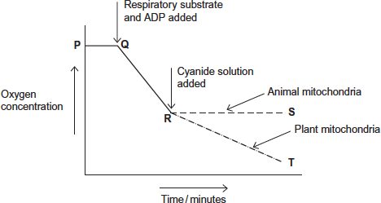

(a)     Explain the line between **P** and **Q**.

........................................................................................................................

........................................................................................................................

........................................................................................................................

........................................................................................................................

**(2)**

(b)     (i)      Explain the line between **Q** and **R**.

...............................................................................................................

...............................................................................................................

...............................................................................................................

...............................................................................................................

**(2)**

(ii)     The respiratory substrate and ADP added after 5 minutes (**Q**) were part of a buffered isotonic solution.

What other substance would the buffer or solution have to contain?

...............................................................................................................

...............................................................................................................

**(1)**

(c)     Describe and explain the difference between line **R** to **S** (animal mitochondria) and line **R** to **T** (plant mitochondria).

........................................................................................................................

........................................................................................................................

........................................................................................................................

........................................................................................................................

........................................................................................................................

........................................................................................................................

........................................................................................................................

........................................................................................................................

**[Extra space]** .................................................................................................

........................................................................................................................

**(4)**

**(Total 9 marks)**

**Q2.**          (a)     During respiration where, exactly, in a cell does each of the following occur?

(i)      Glycolysis

.............................................................................................................

**(1)**

(ii)     Electron transfer chain

.............................................................................................................

**(1)**

(b)     Without oxygen, less ATP is produced by respiration. Explain why.

......................................................................................................................

......................................................................................................................

......................................................................................................................

......................................................................................................................

**(2)**

**(Total 4 marks)**

**Q3.**          (a)     In respiration in cells,

(i)      where does glycolysis take place

.............................................................................................................

**(1)**

(ii)     where, exactly, is the electron transfer chain found?

.............................................................................................................

**(1)**

(b)     Scientists kept kidney cells in a liquid culture. They investigated the effect of the gas nitric oxide on oxygen consumption by these cells. They recorded the oxygen concentration in the culture medium over a period of time. At intervals they added a small volume of nitric oxide to the culture medium. Nitric oxide affects the functioning of a protein in the electron transport chain.

The graph shows their results.

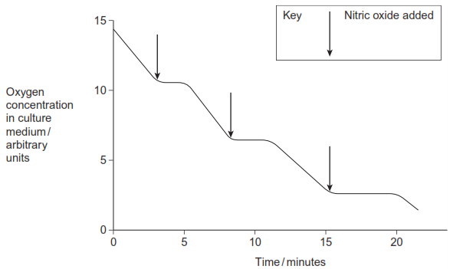

Explain the effect of nitric oxide.

......................................................................................................................

......................................................................................................................

......................................................................................................................

......................................................................................................................

......................................................................................................................

......................................................................................................................

*(Extra space)*  ...............................................................................................

......................................................................................................................

......................................................................................................................

**(3)**

**(Total 5 marks)**

**Q4.**          **S**       The diagram shows apparatus used to measure the oxygen uptake of snails that live on the seashore. The apparatus was kept at a constant temperature.

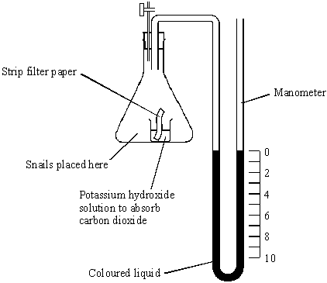

(a)     (i)      Explain the purpose of the strip of filter paper in the potassium hydroxide solution.

.............................................................................................................

.............................................................................................................

**(1)**

(ii)     The level of liquid in the right-hand side of the manometer went down during the experiment. Explain why.

.............................................................................................................

.............................................................................................................

.............................................................................................................

.............................................................................................................

**(2)**

(iii)     What measurements are needed to calculate the rate of oxygen uptake by the snails in mm3 g–1 h–1?

.............................................................................................................

.............................................................................................................

.............................................................................................................

**(3)**

(b)     Two experiments were carried out using the apparatus shown in the diagram.

1     The oxygen uptake of batches of 10 seashore snails kept in moist air was measured at temperatures between 5 °C and 35 °C.

2     Experiment 1 was repeated but with batches of 10 seashore snails covered by aerated seawater.

The experiments were repeated several times and means and standard deviations calculated. The results are shown in the table. The values given are means plus or minus one standard deviation.

|  |  |  |
| --- | --- | --- |
| **Temperature / °C** | **Oxygen uptake of snails kept in moist air / mm3 g–1 h–1** | **Oxygen uptake of snails kept in seawater / mm3 g–1 h–1** |
| 5 | 35 ± 2 | 28 ± 8 |
| 10 | 34 ± 6 | 32 ± 3 |
| 15 | 36 ± 3 | 35 ± 3 |
| 20 | 86 ± 8 | 52 ± 10 |
| 25 | 141 ± 13 | 96 ± 15 |
| 30 | 132 ± 14 | 108 ± 9 |
| 35 | 120 ± 16 | 79 ± 21 |

(i)      Describe **one** similarity and **one** difference between the pattern of mean oxygen uptake of the snails kept in moist air and those covered by seawater.

.............................................................................................................

.............................................................................................................

.............................................................................................................

.............................................................................................................

**(2)**

(ii)     Explain why valid conclusions cannot be drawn about the trends in oxygen uptake at temperatures of 25 °C and above.

.............................................................................................................

.............................................................................................................

.............................................................................................................

.............................................................................................................

**(2)**

**(Total 10 marks)**

**Q5.**          (a)     Mitochondria in muscle cells have more cristae than mitochondria in skin cells. Explain the advantage of mitochondria in muscle cells having more cristae.

......................................................................................................................

......................................................................................................................

......................................................................................................................

......................................................................................................................

**(2)**

(b)     Substance **X** enters the mitochondrion from the cytoplasm. Each molecule of substance **X** has three carbon atoms.

(i)      Name substance **X**.

.............................................................................................................

**(1)**

(ii)     In the link reaction substance **X** is converted to a substance with molecules effectively containing only two carbon atoms. Describe what happens in this process.

.............................................................................................................

.............................................................................................................

.............................................................................................................

.............................................................................................................

**(2)**

(c)     The Krebs cycle, which takes place in the matrix, releases hydrogen ions. These hydrogen ions provide a source of energy for the synthesis of ATP, using coenzymes and carrier proteins in the inner membrane of the mitochondrion.

Describe the roles of the coenzymes and carrier proteins in the synthesis of ATP.

......................................................................................................................

......................................................................................................................

......................................................................................................................

......................................................................................................................

......................................................................................................................

......................................................................................................................

**(3)**

**(Total 8 marks)**

**Q6.**          Pea plants are leguminous and have nodules on their roots which contain bacteria that are able to fix nitrogen. The diagram shows some of the processes involved in nitrogen fixation by these bacteria.

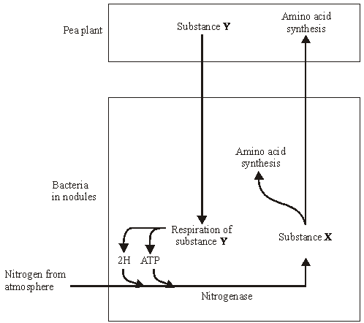

(a)     Name

(i)      substance **X**;

.............................................................................................................

**(1)**

(ii)     substance **Y**.

.............................................................................................................

**(1)**

**S**       (b)     Pea plants respire aerobically, producing ATP which can be used for amino acid synthesis. Describe the role of oxygen in aerobic respiration.

......................................................................................................................

......................................................................................................................

......................................................................................................................

......................................................................................................................

**(2)**

**S**       (c)     The bacteria respire anaerobically. This produces hydrogen and ATP used in nitrogen fixation. The hydrogen comes from reduced NAD. Explain how the regeneration of NAD in this way allows ATP production to continue.

......................................................................................................................

......................................................................................................................

......................................................................................................................

......................................................................................................................

**(2)**

**S**       (d)     The enzyme nitrogenase is specific to the reaction shown. Explain how **one** feature of the enzyme would contribute to this specificity.

          Feature

......................................................................................................................

          Explanation

......................................................................................................................

......................................................................................................................

......................................................................................................................

**(2)**

**S**       (e)     Sodium ions act as a non-competitive inhibitor of the enzyme nitrogenase. Explain how the presence of a non-competitive inhibitor can alter the rate of the reaction catalysed by nitrogenase.

......................................................................................................................

......................................................................................................................

......................................................................................................................

......................................................................................................................

......................................................................................................................

......................................................................................................................

**(3)**

**(Total 11 marks)**

**Q7.**          When one mole of glucose is burned, 2800 kJ of energy are released. However, when one mole of glucose is respired aerobically, only 40% of the energy released is incorporated into ATP. Each mole of glucose respired aerobically produces 38 moles of ATP.

(a)     (i)      Calculate how much energy is incorporated into each mole of ATP. Show your working.

Answer ................................................. kJ

**(2)**

(ii)     When glucose is respired what happens to the energy which is **not** incorporated into ATP?

.............................................................................................................

**(1)**

(b)     (i)      When one mole of glucose is respired anaerobically, only 2 moles of ATP are produced. Explain why less energy is released in anaerobic respiration.

.............................................................................................................

.............................................................................................................

**(1)**

(ii)     At the end of a sprint race, a runner continues to breathe rapidly for some time. Explain the advantage of this.

.............................................................................................................

.............................................................................................................

.............................................................................................................

.............................................................................................................

**(2)**

**(Total 6 marks)**

**Q8.**          Gas exchange in an aquatic plant was investigated by placing shoots in tubes containing bromothymol blue indicator solution. Bromothymol blue indicator is yellow below pH 6, green between pH 6.1 and 7.5, and blue at pH 7.6 and above. Into each of four tubes, **A**, **B**, **C** and **D**, 10 cm3 of bromothymol blue solution were placed. Each tube was closed with a bung and left for 10 minutes. Similar-sized shoots of an aquatic plant were then placed into each of tubes **A**, **B** and **C**. The tubes were treated as shown in the diagram.

They were then placed at equal distances from a 60 watt lamp and left for one hour.

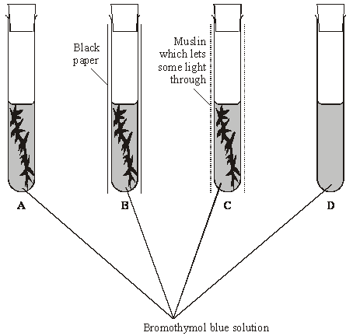

The table shows the initial and final colours of the indicator in the four tubes.

|  |  |  |  |
| --- | --- | --- | --- |
| **Tube** | **Treatment** | **Initial colour of indicator** | **Colour of indicator after one hour** |
| **A** | Uncovered | Green | Blue |
| **B** | Covered with black paper | Green | Yellow |
| **C** | Covered with muslin | Green | Green |
| **D** | Uncovered | Green | Green |

(a)     Explain the results for

tube **A**;

......................................................................................................................

......................................................................................................................

......................................................................................................................

......................................................................................................................

tube **B**;

......................................................................................................................

......................................................................................................................

......................................................................................................................

......................................................................................................................

tube **C**.

......................................................................................................................

......................................................................................................................

......................................................................................................................

......................................................................................................................

**(4)**

(b)     (i)      Explain how the results from tube **D** help to confirm that the explanations for the other tubes are valid.

.............................................................................................................

.............................................................................................................

**(1)**

(ii)     Explain why all the tubes were placed the same distance from the lamp.

.............................................................................................................

.............................................................................................................

**(1)**

**(Total 6 marks)**

**Q9.**          The diagram shows a summary of the light-independent reaction of photosynthesis.

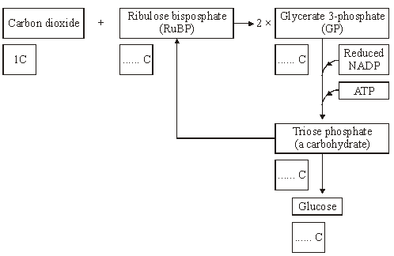

(a)     (i)      Complete the boxes to show the number of carbon atoms in the molecules.

**(2)**

(ii)     In which part of a chloroplast does the light-independent reaction occur?

.............................................................................................................

**(1)**

(iii)     Which process is the source of the ATP used in the conversion of glycerate  
3-phosphate (GP) to triose phosphate?

.............................................................................................................

**(1)**

(iv)    What proportion of triose phosphate molecules is converted to ribulose bisphosphate (RuBP)?

.............................................................................................................

**(1)**

(b)     Lowering the temperature has very little effect on the light-dependent reaction, but it slows down the light-independent reaction. Explain why the light-independent reaction slows down at low temperatures.

......................................................................................................................

......................................................................................................................

......................................................................................................................

......................................................................................................................

**(2)**

**(Total 7 marks)**

**Q10.**          In an investigation, the effects of caffeine on performance during exercise were measured. One group of athletes (**A**) was given a drink of decaffeinated coffee. Another group (**B**) was given a drink of decaffeinated coffee with caffeine added. One hour later the athletes started riding an exercise bike and continued until too exhausted to carry on. Three days later the same athletes repeated the experiment, with the drinks exchanged.

(a)     (i)      The researchers added caffeine to decaffeinated coffee. Explain why they did not just use normal coffee.

.............................................................................................................

.............................................................................................................

**(1)**

(ii)     The performance of the athletes might have been influenced by how they expected the caffeine to affect them. How could the researchers avoid this possibility?

.............................................................................................................

.............................................................................................................

**(1)**

During the exercise the concentrations of glycerol and fatty acids in the blood plasma were measured. The results are shown in the table.

|  |  |  |  |
| --- | --- | --- | --- |
| **Drink** | **Mean time to exhaustion /minutes** | **Mean  concentration of blood glycerol/ mmol dm–3** | **Mean concentration of blood fatty acids/ mmol dm–3** |
| With caffeine | 90.2 | 0.20 | 0.53 |
| Without caffeine | 75.5 | 0.09 | 0.31 |

(b)     (i)      Describe the effect of caffeine on exercise performance.

.............................................................................................................

.............................................................................................................

**(1)**

(ii)     Suggest **one** explanation for the higher glycerol and fatty acid concentrations in the blood plasma of the athletes after they were given caffeine.

.............................................................................................................

.............................................................................................................

.............................................................................................................

.............................................................................................................

**(2)**

(c)     The researchers measured the volumes of carbon dioxide exhaled and oxygen inhaled during the exercise. From the results they calculated the respiratory quotient (RQ), using the formula



When a person is respiring carbohydrate only, RQ = 1.0

When a person is respiring fatty acids only, RQ = 0.7

(i)      The basic equation for the respiration of glucose is

C6H12O6 + 6O2 → 6CO2 + 6H2O

Explain why the RQ for glucose is 1.0.

.............................................................................................................

.............................................................................................................

.............................................................................................................

.............................................................................................................

**(2)**

(ii)     The researchers found that, when the athletes were given the drink containing caffeine, their mean RQ was 0.85. When given the drink without caffeine their mean RQ was 0.92.

The researchers concluded that when the athletes had caffeine they used glycogen more slowly than when they did not have caffeine, and that the store of glycogen in their muscles was used up less quickly during the exercise.

Explain the evidence from the information above and from the table which supports these conclusions.

.............................................................................................................

.............................................................................................................

.............................................................................................................

.............................................................................................................

.............................................................................................................

.............................................................................................................

**(3)**

**(Total 10 marks)**

**Q11.**          The boxes in the diagram represent substances in glycolysis, the link reaction and the Krebs cycle.

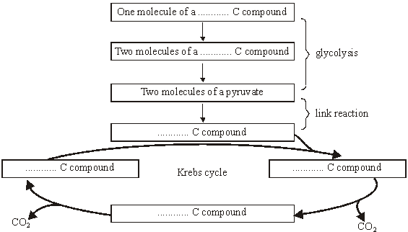

(a)     Complete the diagram to show the number of carbon atoms present in **one** molecule of each compound.

**(2)**

(b)     Other substances are produced in the Krebs cycle in addition to the carbon compounds shown in the diagram. Name **three** of these other products.

1 ...................................................................................................................

2 ...................................................................................................................

3 ...................................................................................................................

**(3)**

**(Total 5 marks)**

**Q12.**          Seals are aquatic mammals. They use lungs as organs of gas exchange so they do not breathe when they are under water during a dive.

The graph shows changes in oxygen and lactate concentration in the blood of a seal before, during and after a dive.

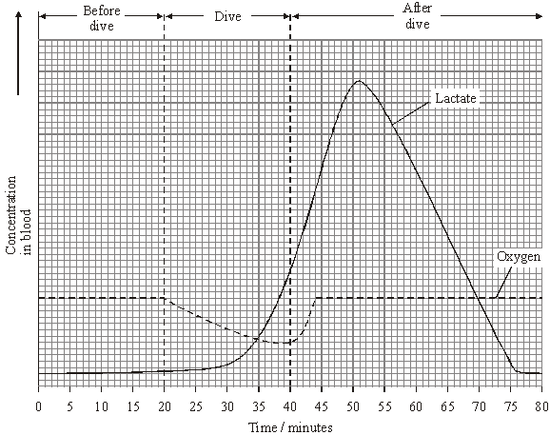

(a)     The concentration of oxygen in the blood fell during the dive. Explain why.

......................................................................................................................

......................................................................................................................

**(1)**

(b)     Use information in the graph to calculate how long it took from the end of the dive for the seal to recover fully.

Answer .......................................... minutes

**(1)**

(c)     Explain what causes the concentration of blood lactate to fall after a dive.

......................................................................................................................

......................................................................................................................

......................................................................................................................

......................................................................................................................

**(2)**

(d)     Reducing the volume of blood pumped out by the heart reduces the rate of blood flow to the diaphragm muscles.

(i)      Give **one** other way in which blood flow into the diaphragm muscles may be reduced.

.............................................................................................................

.............................................................................................................

**(1)**

(ii)     During a dive, blood flow to the diaphragm muscles of a seal is reduced. Suggest the advantage to the seal of maintaining some blood supply to the diaphragm muscles during a dive.

.............................................................................................................

.............................................................................................................

.............................................................................................................

.............................................................................................................

**(2)**

**(Total 7 marks)**

**Q13.**          The diagram shows some of the stages in two processes that produce ATP.

**Process 1**

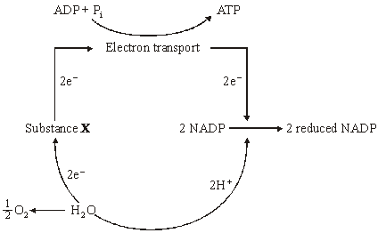

**Process 2**

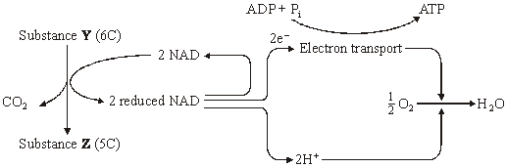

(a)     In **Process 1**, what causes substance **X** to lose electrons (e–)?

......................................................................................................................

......................................................................................................................

**(1)**

(b)     Where precisely, within a cell, does electron transport take place in **Process 2**?

......................................................................................................................

......................................................................................................................

**(1)**

**(Total 2 marks)**

**Q14.**          The diagram shows the structure of a mitochondrion.

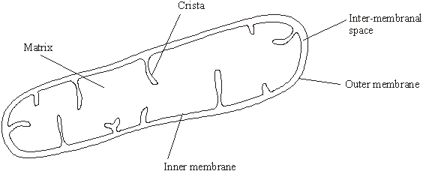

(a)     In which part of the mitochondrion does the Krebs cycle take place?

......................................................................................................................

**(1)**

(b)     Name **two** substances for which there would be net movement into the mitochondrion.

1 ...................................................................................................................

2 ...................................................................................................................

**(2)**

(c)     The mitochondria in muscles contain many cristae. Explain the advantage of this.

......................................................................................................................

......................................................................................................................

......................................................................................................................

......................................................................................................................

**(2)**

**(Total 5 marks)**

**Q15.**          (a)     The table contains some statements relating to biochemical processes in a plant cell. Complete the table with a tick if the statement is true or a cross if it is not true for each biochemical process.

|  |  |  |  |
| --- | --- | --- | --- |
| **Statement** | **Glycolysis** | **Krebs cycle** | **Light-dependent reaction of photosynthesis** |
| NAD is reduced |  |  |  |
| NADP is reduced |  |  |  |
| ATP is produced |  |  |  |
| ATP is required |  |  |  |

**(4)**

(b)     An investigation was carried out into the production of ATP by mitochondria. ADP, phosphate, excess substrate and oxygen were added to a suspension of isolated mitochondria.

(i)      Suggest the substrate used for this investigation.

.............................................................................................................

**(1)**

(ii)     Explain why the concentration of oxygen and amount of ADP fell during the investigation.

.............................................................................................................

.............................................................................................................

.............................................................................................................

.............................................................................................................

**(2)**

(iii)     A further investigation was carried out into the effect of three inhibitors, **A**, **B** and **C**, on the electron transport chain in these mitochondria. In each of three experiments, a different inhibitor was added. The table shows the state of the electron carriers, **W–Z**, after the addition of inhibitor.

|  |  |  |  |  |
| --- | --- | --- | --- | --- |
| **Inhibitor added** | **Electron carrier** | | | |
| **W** | **X** | **Y** | **Z** |
| **A** | oxidised | reduced | reduced | oxidised |
| **B** | oxidised | oxidised | reduced | oxidised |
| **C** | reduced | reduced | reduced | oxidised |

Give the order of the electron carriers in this electron transport chain. Explain your answer.

Order      ..............      ..............      ..............      ..............

Explanation .........................................................................................

.............................................................................................................

.............................................................................................................

**(2)**

**(Total 9 marks)**

**Q16.**          (a)     The biochemical pathway of aerobic respiration involves a number of different steps.

Name **one** step in which carbon dioxide is produced.

......................................................................................................................

**(1)**

In an investigation, scientists transferred slices of apple from air to anaerobic conditions in pure nitrogen gas. They measured the rate of carbon dioxide production.

(b)     The scientists kept the temperature constant throughout the investigation. Explain how a decrease in temperature would affect the rate of carbon dioxide production.

......................................................................................................................

......................................................................................................................

......................................................................................................................

......................................................................................................................

......................................................................................................................

**(2)**

(c)     When the apple slices were transferred to nitrogen, the following biochemical pathway took place.

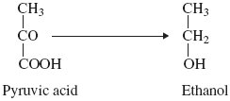

Use this pathway to explain the part played by reduced NAD when the apple slices were transferred to nitrogen.

......................................................................................................................

......................................................................................................................

......................................................................................................................

......................................................................................................................

**(2)**

(d)     The rate of carbon dioxide production was higher when the apple slices were in nitrogen than when they were in the air. Explain why.

......................................................................................................................

......................................................................................................................

......................................................................................................................

......................................................................................................................

......................................................................................................................

......................................................................................................................

**(3)**

**(Total 8 marks)**

**Q17.** The graph shows dissociation curves for human oxyhaemoglobin at rest and during exercise.

**Table 1** gives information about conditions in the body at rest and during exercise.

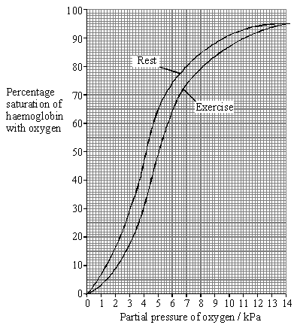

|  |  |  |
| --- | --- | --- |
|  | **Rest** | **Exercise** |
| **Plasma pH** | 7.4 | 7.2 |
| **Blood temperature / °C** | 37.0 | 39.0 |
| **Alveolar partial pressure of oxygen / kPa** | 13.3 | 13.3 |
| **Tissue partial pressure of oxygen / kPa** | 5.0 | 4.0 |

**Table 1**

(a)     What is meant by the term *partial pressure*?

......................................................................................................................

......................................................................................................................

**(1)**

(b)     Use **Table 1** and the graph to calculate the difference in the percentage saturation of haemoglobin in the tissues between rest and exercise.

Answer ............................ %

**(1)**

(c)     Explain the differences between the figures shown in **Table 1** for rest and exercise.

......................................................................................................................

......................................................................................................................

......................................................................................................................

......................................................................................................................

......................................................................................................................

......................................................................................................................

......................................................................................................................

......................................................................................................................

**(4)**

(d)     Explain the advantage of the difference in position of the dissociation curve during exercise.

......................................................................................................................

......................................................................................................................

......................................................................................................................

......................................................................................................................

**(2)**

**Table 2** shows how the oxygen concentration in the blood going to and from a muscle changes from rest to heavy exercise.

|  |  |  |  |
| --- | --- | --- | --- |
|  | | **Oxygen concentration / cm3 per 100 cm3 blood** | |
|  | | **Blood in arteries** | **Blood in veins** |
| **At rest** | **In solution** | 0.3 | 0.2 |
| **As oxyhaemoglobin** | 19.5 | 15.0 |
| **Total oxygen** | 19.8 | 15.2 |
| **During heavy exercise** | **In solution** | 0.3 | 0.1 |
| **As oxyhaemoglobin** | 20.9 | 5.3 |
| **Total oxygen** | 21.2 | 5.4 |

**Table 2**

(e)     By how many times is the volume of oxygen removed from the blood by the muscle in **Table 2** during heavy exercise greater than the volume removed at rest?

Show your working.

Answer ..................................... times

**(2)**

(f)      Does enriching inspired air with oxygen have any effect on the amount of oxygen reaching the tissues? Support your answer with evidence from the graph and **Table 2**.

......................................................................................................................

......................................................................................................................

......................................................................................................................

......................................................................................................................

......................................................................................................................

......................................................................................................................

**(3)**

**S** (g)     The change to the dissociation curve is one of a number of ways in which the total oxygen supplied to muscles is increased during exercise. Give **two** other ways in which the total oxygen supplied to muscles during exercise is increased.

1 ...................................................................................................................

......................................................................................................................

2 ...................................................................................................................

......................................................................................................................

**(2)**

**(Total 15 marks)**

**Q18.**          (a)     Pyruvate is formed in the breakdown of glucose during respiration. When there is sufficient oxygen, this pyruvate is fully broken down. Name **two** substances formed from the pyruvate.

1 ...................................................................................................................

2 ...................................................................................................................

**(1)**

(b)     (i)      If there is a shortage of oxygen in muscle cells during exercise, some pyruvate is converted into lactate. Explain why muscles become fatigued when insufficient oxygen is available.

.............................................................................................................

.............................................................................................................

.............................................................................................................

.............................................................................................................

**(2)**

(ii)     Some of the lactate is oxidised to pyruvate by muscles when they are well-supplied with oxygen. Suggest an advantage of the lactate being oxidised in the muscles.

.............................................................................................................

.............................................................................................................

.............................................................................................................

.............................................................................................................

**(2)**

**(Total 5 marks)**

**Q19.** The diagram gives an outline of the process of aerobic respiration.

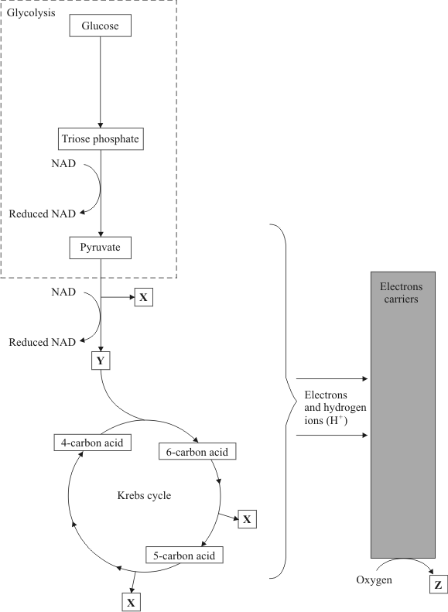

(a)     Name substances **X**, **Y** and **Z**.

**X** ...................................................................................................................

**Y** ...................................................................................................................

**Z** ...................................................................................................................

**(3)**

(b)     Give the location of each of the following in a liver cell.

(i)      Glycolysis ............................................................................................

(ii)     The Krebs cycle ..................................................................................

**(2)**

(c)     (i)      Write the letter **A** on the diagram to show **one** step where ATP is used.

(ii)     Write the letter **B** on the diagram at **two** steps where ATP is produced.

**(3)**

(d)     Apart from respiration, give **three** uses of ATP in a liver cell.

1 ...................................................................................................................

2 ...................................................................................................................

3 ...................................................................................................................

**(3)**

(e)     Human skeletal muscle can respire both aerobically and anaerobically. Describe what happens to pyruvate in anaerobic conditions and explain why anaerobic respiration is advantageous to human skeletal muscle.

......................................................................................................................

......................................................................................................................

......................................................................................................................

......................................................................................................................

......................................................................................................................

......................................................................................................................

......................................................................................................................

......................................................................................................................

**(4)**

**(Total 15 marks)**

**Q20.**          (a)     The main stages in anaerobic respiration in yeast are shown in the diagram.

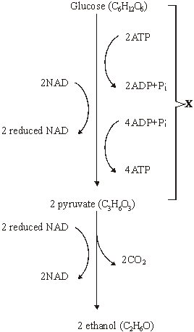

(i)      Name process **X**.

.............................................................................................................

**(1)**

(ii)     Give **one** piece of evidence from the diagram which suggests that the conversion of pyruvate to ethanol involves reduction.

.............................................................................................................

.............................................................................................................

**(1)**

(iii)     Explain why converting pyruvate to ethanol is important in allowing the continued production of ATP in anaerobic respiration.

.............................................................................................................

.............................................................................................................

.............................................................................................................

.............................................................................................................

**(2)**

(b)     Give **two** ways in which anaerobic respiration of glucose in yeast is

(i)      similar to anaerobic respiration of glucose in a muscle cell;

1 ..........................................................................................................

.............................................................................................................

2 ..........................................................................................................

.............................................................................................................

**(2)**

(ii)     different from anaerobic respiration of glucose in a muscle cell.

1 ..........................................................................................................

.............................................................................................................

2 ..........................................................................................................

.............................................................................................................

**(2)**

(c)     Some students investigated the effect of temperature on the rate of anaerobic respiration in yeast. The apparatus they used is shown in the diagram. The yeast suspension was mixed with glucose solution and the volume of gas collected in five minutes was recorded.

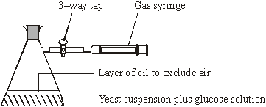

(i)      Each student repeated the experiment and the results were pooled. Explain the advantages of collecting a large number of results.

.............................................................................................................

.............................................................................................................

.............................................................................................................

.............................................................................................................

**(2)**

(ii)     At 30 °C, one student obtained the following results.

|  |  |  |  |  |
| --- | --- | --- | --- | --- |
|  | Volume of gas collected in 5 minutes / cm3 | Result 1 | Result 2 | Result 3 |
|  | 38.3 | 27.6 | 29.4 |

Calculate the mean rate of gas production. Give your answer in cm3 s–1.

Answer ............................... cm3 s–1

**(2)**

(iii)     If aerobic respiration had been investigated rather than anaerobic respiration, how would you expect the volumes of gas collected at 30°C to differ from these results?

Explain your answer.

.............................................................................................................

.............................................................................................................

.............................................................................................................

.............................................................................................................

.............................................................................................................

.............................................................................................................

**(3)**

**(Total 15 marks)**

**Q21.**          The diagram summarises the process of anaerobic respiration in yeast cells.

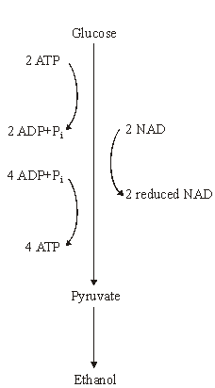

(a)     (i)      In anaerobic respiration, what is the net yield of ATP molecules per molecule of glucose?

.............................................................................................................

**(1)**

(ii)     Give **two** advantages of ATP as an energy-storage molecule within a cell.

1 ..........................................................................................................

.............................................................................................................

2 ..........................................................................................................

.............................................................................................................

**(2)**

(b)     Describe how NAD is regenerated in anaerobic respiration in yeast cells.

......................................................................................................................

......................................................................................................................

**(1)**

**(Total 4 marks)**

**Q22.**          (a)     The flow chart shows the main stages in aerobic respiration.

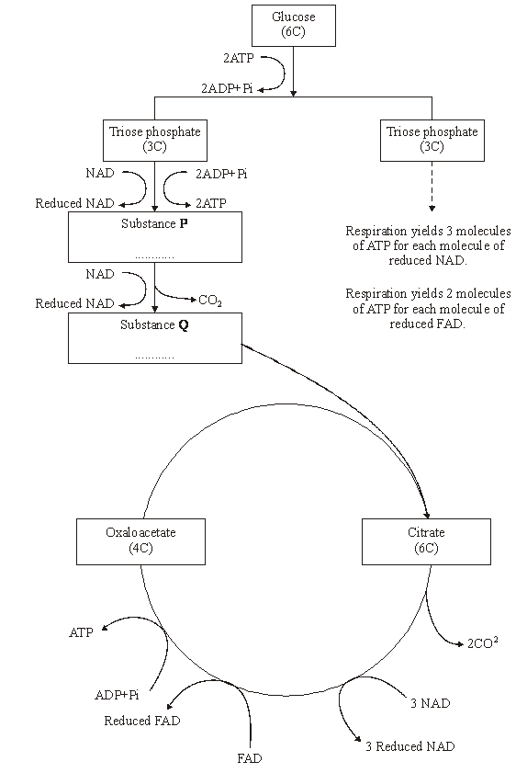

(i)      Complete the flow chart by writing, in the appropriate boxes, the number of carbon atoms in substance **P** and the name of substance **Q**.

**(2)**

(ii)     Some ATP is formed in the cytoplasm and some in the mitochondria. Use the information given to calculate the number of molecules of ATP formed in a mitochondrion from one molecule of glucose in aerobic respiration. Show how you arrived at your answer.

Answer.....................................

**(2)**

(iii)     In the presence of oxygen, respiration yields more ATP per molecule of glucose than it does in the absence of oxygen. Explain why.

.............................................................................................................

.............................................................................................................

.............................................................................................................

.............................................................................................................

.............................................................................................................

.............................................................................................................

**(3)**

(b)     Anabaena is a prokaryote found inside the leaves of a small fern. Anabaena can produce ammonia from nitrogen (nitrogen fixation). This reaction only takes place in the anaerobic conditions found in cells called heterocysts. Heterocysts are thick-walled cells that do not contain chlorophyll. The drawing shows the relationship between *Anabaena* and the fern.

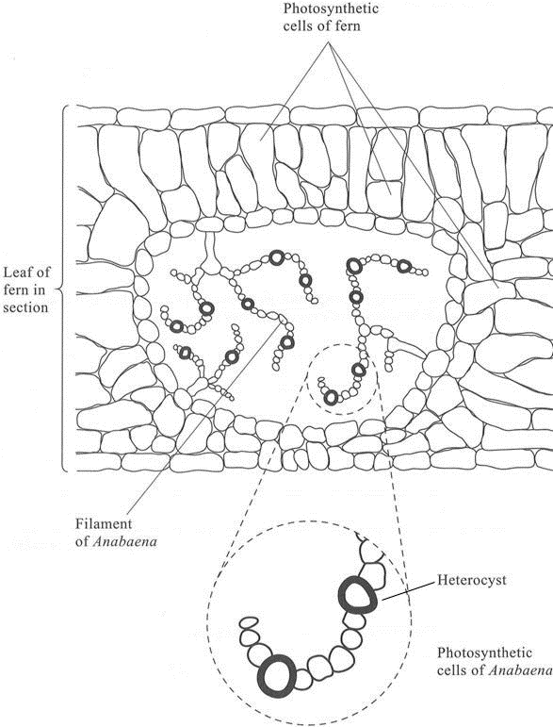

(i)      Suggest how the features of the heterocysts improve the efficiency of the process of nitrogen fixation.

.............................................................................................................

.............................................................................................................

.............................................................................................................

.............................................................................................................

.............................................................................................................

.............................................................................................................

**(3)**

(ii)     In China, the fern is cultivated and ploughed into fields to act as an organic fertiliser. Explain how ploughing the fern plants into the soil results in an improvement in the growth of the rice crop grown in these fields.

.............................................................................................................

.............................................................................................................

.............................................................................................................

.............................................................................................................

.............................................................................................................

.............................................................................................................

.............................................................................................................

.............................................................................................................

.............................................................................................................

.............................................................................................................

**(5)**

**(Total 15 marks)**

**Q23.**          (a)     Discs of carrot were placed in a solution containing potassium ions (K+). The concentration of oxygen in air bubbled through the solution was changed and the rates of respiration and uptake of potassium ions were measured. The results are shown in the table.

|  |  |  |  |
| --- | --- | --- | --- |
|  | **Concentration of oxygen / %** | **Rate of respiration / arbitrary units** | **Rate of uptake of potassium ions /  arbitrary units** |
|  | 2.7 | 31 | 29 |
|  | 12.2 | 69 | 72 |
|  | 20.8 | 90 | 80 |

Describe and explain the link between oxygen concentration, rate of respiration and rate of uptake of potassium ions.

......................................................................................................................

......................................................................................................................

......................................................................................................................

......................................................................................................................

......................................................................................................................

......................................................................................................................

......................................................................................................................

......................................................................................................................

......................................................................................................................

......................................................................................................................

**(4)**

(b)     Cylinders of potato were cut using a cork borer. Their initial lengths were measured.  Each cylinder was then put in a different concentration of sucrose solution for 12 hours. The graph shows the changes in length of the potato cylinders in the different sugar solutions.

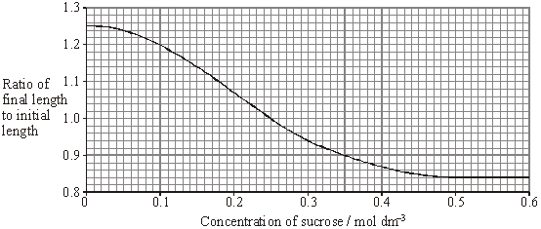

(i)      In what concentration of sucrose did the length of the potato cylinder remain the same?

.............................................................................................................

**(1)**

(ii)     The initial length of the potato cylinder in the solution of concentration 0.1 mol dm–3 was 90 mm. Calculate its final length. Show your working.

Final length = .................................... mm

**(2)**

(iii)     Explain the change in length which occurs in a sucrose solution of concentration 0.5 mol dm–3.

.............................................................................................................

.............................................................................................................

.............................................................................................................

.............................................................................................................

**(2)**

**(Total 9 marks)**

**Q24.**The kangaroo rat is a small desert mammal. It takes in very little water in its food and it rarely drinks. Its core body temperature is 38 °C.

The kangaroo rat takes in some water by feeding and drinking. Describe another method by which the kangaroo rat could obtain water.

.................................................................................................................................

.................................................................................................................................

.................................................................................................................................

.................................................................................................................................

**(Total 2 marks)**

**Q25.**          (a)     Gas exchange in fish takes place in gills. Explain how **two** features of gills allow efficient gas exchange.

1 ...................................................................................................................

......................................................................................................................

2 ...................................................................................................................

......................................................................................................................

**(2)**

(b)     A zoologist investigated the relationship between body mass and rate of oxygen uptake in four species of mammal. The results are shown in the graph.

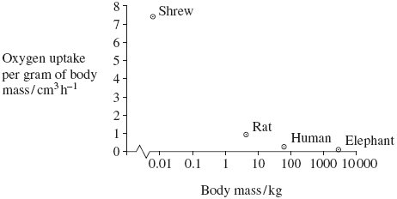

(i)      The scale for plotting body mass is a logarithmic scale. Explain why a logarithmic scale was used to plot body mass.

.............................................................................................................

.............................................................................................................

**(1)**

(ii)     Describe the relationship between body mass and oxygen uptake.

.............................................................................................................

.............................................................................................................

**(1)**

(iii)     The zoologist measured oxygen uptake per gram of body mass. Explain why he measured oxygen uptake per gram of body mass.

.............................................................................................................

.............................................................................................................

.............................................................................................................

.............................................................................................................

**(2)**

**(Total 6 marks)**

**Q26.**          The diagram represents two of the stages of aerobic respiration that take place in a mitochondrion.

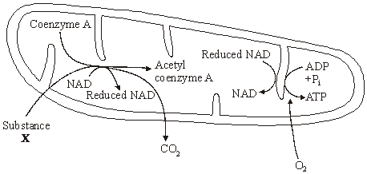

(a)     Name substance **X**.

......................................................................................................................

**(1)**

(b)     Which stage of aerobic respiration takes place inside a mitochondrion and is **not** represented on the diagram?

......................................................................................................................

**(1)**

(c)     Explain why oxygen is needed for the production of ATP on the cristae of the mitochondrion.

......................................................................................................................

......................................................................................................................

......................................................................................................................

......................................................................................................................

......................................................................................................................

......................................................................................................................

**(3)**

**(Total 5 marks)**

**Q27.**The diagram shows a mitochondrion.

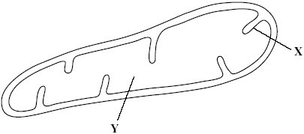

(a)     Name the parts labelled **X** and **Y**.

(i)      **X** .............................................................

(ii)     **Y** ..............................................................

**(2)**

Scientists isolated mitochondria from liver cells. They broke the cells open in an ice-cold, isotonic solution. They then used a centrifuge to separate the cell organelles. The diagram shows some of the steps in the process of centrifugation.

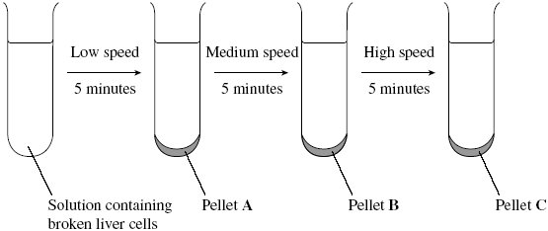

(b)     Suggest which pellet, **A**, **B** or **C** contained the mitochondria.



**(1)**

(c)     Explain why the solution used was

(i)      ice-cold

.............................................................................................................

.............................................................................................................

**(1)**

(ii)     isotonic.

.............................................................................................................

.............................................................................................................

.............................................................................................................

.............................................................................................................

**(2)**

(d)     People with mitochondrial disease have mitochondria that do not function properly.

Some people with mitochondrial disease can only exercise for a short time. Explain why a person with mitochondrial disease can only exercise for a short time.

......................................................................................................................

......................................................................................................................

......................................................................................................................

......................................................................................................................

**(2)**

**(Total 8 marks)**

**Q28.**          (a)     Describe the part played by the inner membrane of a mitochondrion in producing ATP.

......................................................................................................................

......................................................................................................................

......................................................................................................................

......................................................................................................................

......................................................................................................................

......................................................................................................................

**(3)**

(b)     A scientist investigated ATP production in a preparation of isolated mitochondria. He suspended the mitochondria in an isotonic solution and added a suitable respiratory substrate together with ADP and phosphate. He bubbled oxygen through the preparation.

(i)      Why was the solution in which the mitochondria were suspended isotonic?

.............................................................................................................

.............................................................................................................

**(1)**

(ii)     Explain why the scientist did **not** use glucose as the respiratory substrate.

.............................................................................................................

.............................................................................................................

.............................................................................................................

.............................................................................................................

.............................................................................................................

**(2)**

(iii)     Explain why the oxygen concentration would change during this investigation.

.............................................................................................................

.............................................................................................................

**(1)**

**(Total 7 marks)**

**Q29.Introduction**

**Resource A – D** relate to a single investigation.

Scientists investigated the effect of supplying extra carbon dioxide on the yield of tomatoes growing in a glasshouse. They compared the mean yield of tomatoes from 1995 to 1997 when no extra carbon dioxide was supplied with the mean yield of tomatoes from 1998 to 2000 when extra carbon dioxide was supplied.

**Resource A**

Tomato plants were grown in two glasshouses, each with an area of 2000 m2. Figure 1 shows the mean number of hours of sunshine per month during fruit production.

**Figure 1**

|  |  |  |  |
| --- | --- | --- | --- |
|  |  | **1995 - 1997  (no extra carbon dioxide)** | **1998 - 2000  (extra carbon dioxide)** |
|  | Mean number of hours of sunshine per month | 148.91 | 147.00 |

•        The scientists used heating to maintain the tempera ture inside the glasshouses above 18 °C. They opened the windows to keep the tempera ture below 30 °C.

•        From 1998 to 2000 they maintained the carbon dioxide concentration between 0.06 % and 0.08 % when the windows were closed and between 0.04 % and 0.05 % when the windows were open.

•        The carbon dioxide concentra tion in the air outside the glasshouse was 0.04 %.

**Resource B**

**Figure 2** shows the mean difference between the yield of tomatoes with extra carbon dioxide and the yield with no extra carbon dioxide for each week during the harvesting period.

If the yield is greater when extra carbon dioxide is supplied, the difference in yield is shown as an increase. If the yield is lower when extra carbon dioxide is supplied, the difference is shown as a decrease.

**Figure 2**

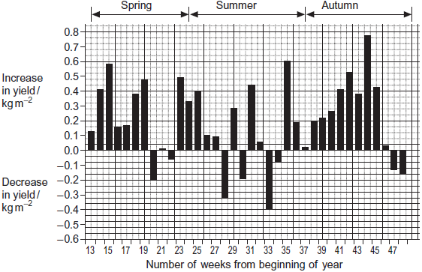

**Resource C**

**Figure 3** shows the relationship between the time when the tomatoes were harvested and the yield.

**Figure 3**

|  |  |  |  |
| --- | --- | --- | --- |
|  | **Number of weeks from  beginning of year** | **Mean yield per week with  extra carbon dioxide / kg m–2** | **Mean yield per week without  extra carbon dioxide / kg m–2** |
|  | 13 – 19 | 1.25 | 0.83 |
|  | 20 – 25 | 1.62 | 1.47 |
|  | 26 – 48 | 1.23 | 1.06 |

The commercial price for tomatoes varies with the time of year. The highest price is paid for tomatoes between weeks 13 and 19. The lowest price is paid between weeks 26 and 48.

**Resource D**

Whiteflies are an important insect pest of tomatoes. The adults can fly from plant to plant. Their young do not have wings. The adults and young feed on the plant sap and introduce viruses into the tomato plants. Feeding and the introduction of viruses both reduce the yield of tomatoes. The scientists controlled the number of whitefly in the glasshouses by releasing parasitic wasps. The wasps lay their eggs in the young of the whitefly. The wasp eggs hatch and feed on the young whitefly, killing them.

(a)     (i)      An increase in carbon dioxide concentration affected the yield of tomatoes in week 35. Use **Figure 2** to describe how.

...............................................................................................................

...............................................................................................................

**(1)**

(ii)     There was a decrease in yield when extra carbon dioxide was supplied during some weeks of the year. Use information from **Resource A** to suggest why.

...............................................................................................................

...............................................................................................................

**(1)**

(b)     Using **Figure 3**, calculate the percentage increase in yield when extra carbon dioxide was added for weeks 13 to 19. Show your working.

Percentage increase ......................................

**(2)**

(c)     Additional information is required for tomato growers to decide whether it is economically profitable to add extra carbon dioxide to produce very early tomatoes.

Give **two** pieces of information that the growers would require.

1 .....................................................................................................................

........................................................................................................................

2 .....................................................................................................................

........................................................................................................................

**(2)**

(d)     Adding extra carbon dioxide during the summer (weeks 24 – 36) is unlikely to be profitable. Use data from the resource sheet explain why.

........................................................................................................................

........................................................................................................................

........................................................................................................................

........................................................................................................................

**(2)**

(e)     The control experiment in this investigation was when data were collected with no extra carbon dioxide added. Some scientists said this control experiment was not satisfactory. Explain how you could improve the control experiment.

........................................................................................................................

........................................................................................................................

........................................................................................................................

........................................................................................................................

**(2)**

**(Total 10 marks)**

**Q30.**Doctors compared two tests for lactase deficiency.

Doctors investigated three groups of people. The people in all three groups were not allowed to eat or drink for 8 hours before the test. They each then drank a solution containing 50 g of lactose made with a radioactive form of carbon called 14C.

•        Group **A** were the control group

•        Group **B** were lactase deficient

•        Group **C** had irritable bowel syndrome (IBS)

Both lactase deficieny and irritable bowel syndrome have similar symptoms.

**The carbon dioxide breath test**

In this test the doctors measured the amount of 14C in the carbon dioxide breathed out. The doctors took measurements at intervals for 8 hours after each volunteer had drunk the lactose solution. The following figure shows the mean results for each group.

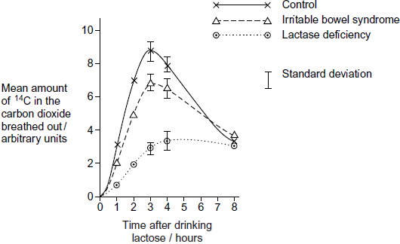

(a)     Describe the common trend shown by **all** the curves in the figure.

........................................................................................................................

........................................................................................................................

........................................................................................................................

**(1)**

(b)     Explain why the doctors stopped measuring the amounts of 14C in the carbon dioxide breathed out after 8 hours.

........................................................................................................................

........................................................................................................................

........................................................................................................................

........................................................................................................................

**(2)**

(c)     Carbon dioxide in the breath contained the radioactive form of carbon, 14C. Explain how 14C in carbon dioxide came from 14C in glucose in the blood.

........................................................................................................................

........................................................................................................................

........................................................................................................................

........................................................................................................................

**(2)**

(d)     The doctors concluded that measuring the amount of 14C in the carbon dioxide in the breath after 3 hours was a better way of diagnosing lactase deficiency than the lactose tolerance test. Do you agree with the doctors’ conclusion? Give the reasons for your answer.

........................................................................................................................

........................................................................................................................

........................................................................................................................

........................................................................................................................

........................................................................................................................

**(2)**

**(Total 7 marks)**

**Q31.**(a)     ATP is useful in many biological processes. Explain why.

........................................................................................................................

........................................................................................................................

........................................................................................................................

........................................................................................................................

........................................................................................................................

........................................................................................................................

........................................................................................................................

........................................................................................................................

*(Extra space)* .................................................................................................

........................................................................................................................

........................................................................................................................

........................................................................................................................

**(4)**

(b)     Describe how ATP is made in mitochondria.

........................................................................................................................

........................................................................................................................

........................................................................................................................

........................................................................................................................

........................................................................................................................

........................................................................................................................

........................................................................................................................

........................................................................................................................

........................................................................................................................

........................................................................................................................

........................................................................................................................

........................................................................................................................

*(Extra space)* .................................................................................................

........................................................................................................................

........................................................................................................................

........................................................................................................................

........................................................................................................................

........................................................................................................................

**(6)**

(c)     Plants produce ATP in their chloroplasts during photosynthesis. They also produce ATP during respiration. Explain why it is important for plants to produce ATP during respiration in addition to during photosynthesis.

........................................................................................................................

........................................................................................................................

........................................................................................................................

........................................................................................................................

........................................................................................................................

........................................................................................................................

........................................................................................................................

........................................................................................................................

........................................................................................................................

........................................................................................................................

*(Extra space)* .................................................................................................

........................................................................................................................

........................................................................................................................

........................................................................................................................

........................................................................................................................

**(5)**

**(Total 15 marks)**

**Q32.**          (a)     A student measured the rate of aerobic respiration of a woodlouse using the apparatus shown in the diagram.

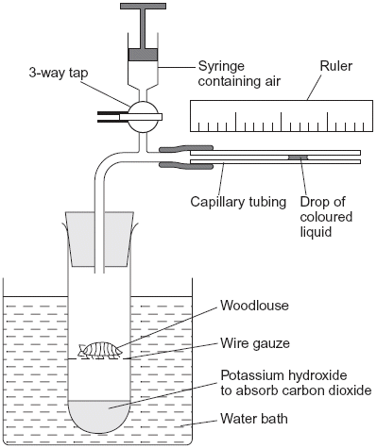

(i)      The student closed the tap. After thirty minutes the drop of coloured liquid had moved to the left. Explain why the drop of coloured liquid moved to the left.

.............................................................................................................

.............................................................................................................

.............................................................................................................

.............................................................................................................

.............................................................................................................

.............................................................................................................

**(3)**

(ii)     What measurements should the student have taken to calculate the rate of aerobic respiration in mm3 of oxygen g–1 h–1?

.............................................................................................................

.............................................................................................................

.............................................................................................................

.............................................................................................................

.............................................................................................................

.............................................................................................................

**(3)**

(b)     DNP inhibits respiration by preventing a proton gradient being maintained across membranes. When DNP was added to isolated mitochondria the following changes were observed

•        less ATP was produced

•        more heat was produced

•        the uptake of oxygen remained constant.

Explain how DNP caused these changes.

......................................................................................................................

......................................................................................................................

......................................................................................................................

......................................................................................................................

......................................................................................................................

......................................................................................................................

**(3)**

**(Total 9 marks)**

**Q33.**          The diagram shows the life cycle of a fly.

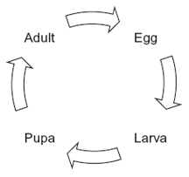

When the larva is fully grown, it changes into a pupa. The pupa does not feed. In the pupa, the tissues that made up the body of the larva are broken down. New adult tissues are formed from substances obtained from these broken-down tissues and from substances that were stored in the body of the larva.

(a)     Hydrolysis and condensation are important in the formation of new adult proteins.  
Explain how.

......................................................................................................................

......................................................................................................................

......................................................................................................................

......................................................................................................................

**(2)**

(b)     Most of the protein stored in the body of a fly larva is a protein called calliphorin.  
Explain why different adult proteins can be made using calliphorin.

......................................................................................................................

......................................................................................................................

**(1)**

The table shows the mean concentration of RNA in fly pupae at different ages.

|  |  |  |
| --- | --- | --- |
|  | **Age of pupa as percentage of total time spent as a pupa** | **Mean concentration of RNA / μg per pupa** |
|  | 0 | 20 |
|  | 20 | 15 |
|  | 40 | 12 |
|  | 60 | 17 |
|  | 80 | 33 |
|  | 100 | 20 |

(c)     Describe how the concentration of RNA changes during the time spent as a pupa.

......................................................................................................................

......................................................................................................................

......................................................................................................................

......................................................................................................................

**(2)**

(d)     (i)      Describe how you would expect the number of lysosomes in a pupa to change with the age of the pupa. Give a reason for your answer.

.............................................................................................................

.............................................................................................................

.............................................................................................................

.............................................................................................................

**(2)**

(ii)     Suggest an explanation for the change in RNA concentration in the first 40% of the time spent as a pupa.

.............................................................................................................

.............................................................................................................

.............................................................................................................

.............................................................................................................

.............................................................................................................

**(2)**

(e)     Suggest an explanation for the change in RNA concentration between 60 and 80% of the time spent as a pupa.

......................................................................................................................

......................................................................................................................

......................................................................................................................

......................................................................................................................

......................................................................................................................

**(2)**

(f)      The graph shows changes in the activity of two respiratory enzymes in a fly pupa.

•        Enzyme **A** catalyses a reaction in the Krebs cycle

•        Enzyme **B** catalyses the formation of lactate from pyruvate

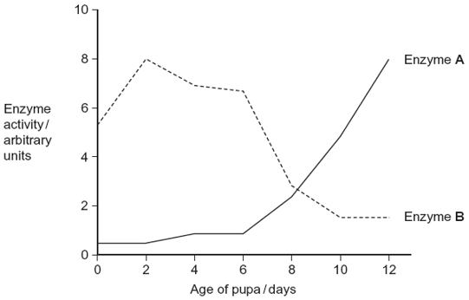

During the first 6 days as a pupa, the tracheae break down. New tracheae are formed after 6 days. Use this information to explain the change in activity of the two enzymes.

......................................................................................................................

......................................................................................................................

......................................................................................................................

......................................................................................................................

......................................................................................................................

......................................................................................................................

*(Extra space)* ................................................................................................

......................................................................................................................

......................................................................................................................

......................................................................................................................

**(4)**

**(Total 15 marks)**

**Q34.**          Intensive rearing of livestock produces large quantities of waste. Some farmers use an anaerobic digester to get rid of the waste.

In an anaerobic digester, microorganisms break down the large, organic molecules in the waste. This produces methane, which is a useful fuel. It also produces organic substances that can be used as a natural fertiliser.

The diagram shows an anaerobic digester.

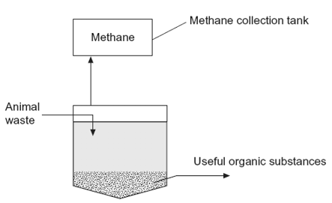

(a)     (i)      Suggest **two** advantages of processing waste in anaerobic digesters rather than in open ponds.

1 ..........................................................................................................

.............................................................................................................

2 ..........................................................................................................

.............................................................................................................

**(2)**

(ii)     The anaerobic digester has a cooling system, which is not shown in the diagram.

Without this cooling system the digester would soon stop working. Explain why.

.............................................................................................................

.............................................................................................................

.............................................................................................................

.............................................................................................................

.............................................................................................................

**(2)**

(b)     (i)      The over-application of fertiliser increases the rate of leaching. Explain the consequences of leaching of fertiliser into ponds and lakes.

.............................................................................................................

.............................................................................................................

.............................................................................................................

.............................................................................................................

.............................................................................................................

.............................................................................................................

(*Extra Space)* ......................................................................................

.............................................................................................................

.............................................................................................................

**(3)**

(ii)     Give **one** advantage of using natural fertiliser produced in the digester rather than an artificial fertiliser.

.............................................................................................................

.............................................................................................................

.............................................................................................................

**(1)**

**(Total 8 marks)**

**Q35.**(a)     The table contains statements about three biological processes.

Complete the table with a tick if the statement in the first column is true, for each process.

|  |  |  |  |  |
| --- | --- | --- | --- | --- |
|  |  | **Photosynthesis** | **Anaerobic respiration** | **Aerobic respiration** |
|  | ATP produced |  |  |  |
|  | Occurs in organelles |  |  |  |
|  | Electron transport chain involved |  |  |  |

**(3)**

(b)     Write a simple equation to show how ATP is synthesised from ADP.

......................................................................................................................

**(1)**

(c)     Give **two** ways in which the properties of ATP make it a suitable source of energy in biological processes.

1 ...................................................................................................................

......................................................................................................................

2 ...................................................................................................................

......................................................................................................................

**(2)**

(d)     Humans synthesise more than their body mass of ATP each day. Explain why it is necessary for them to synthesise such a large amount of ATP.

......................................................................................................................

......................................................................................................................

......................................................................................................................

......................................................................................................................

......................................................................................................................

**(2)**

**(Total 8 marks)**

**Q37.**A scientist investigated the use of a new source of carbohydrate in the production of ethanol for biofuel. He wanted to find the optimum time to leave a mixture of yeast and this carbohydrate to produce ethanol. The scientist set up an airtight container containing yeast and this carbohydrate. He then measured the oxygen, carbon dioxide and ethanol concentrations over 8 hours.  
The results of his investigation are shown in the graph below.

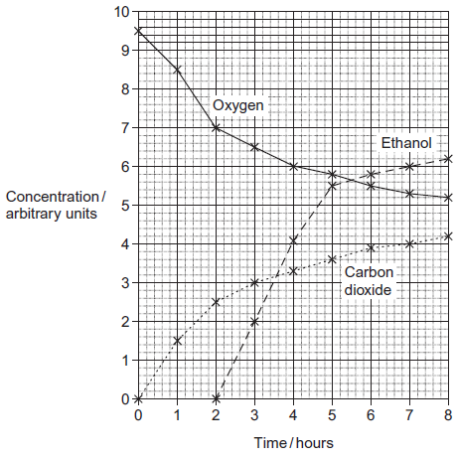

(a)     The scientist used a container that was airtight.  
Give **two** explanations why the container had to be airtight.

1 ......................................................................................................................

.........................................................................................................................

.........................................................................................................................

.........................................................................................................................

2 ......................................................................................................................

.........................................................................................................................

.........................................................................................................................

.........................................................................................................................

**(4)**

(b)     Explain the relationship between the concentration of oxygen and the concentration of carbon dioxide between 0 and 3 hours.

.........................................................................................................................

.........................................................................................................................

.........................................................................................................................

.........................................................................................................................

.........................................................................................................................

.........................................................................................................................

**(2)**

(c)     The scientist concluded that yeast starts to respire anaerobically when the oxygen concentration falls below a certain concentration. What is the oxygen concentration when the yeast starts to respire anaerobically? Explain your answer.

.........................................................................................................................

.........................................................................................................................

.........................................................................................................................

.........................................................................................................................

.........................................................................................................................

**(2)**

(d)     (i)      The scientist worked for a biofuel company. Give **two** suggestions for further work he should do to make sure that the results he presented to the company were reliable.  
Explain how each of your suggestions would make the results more reliable.

Suggestion ............................................................................................

...............................................................................................................

Explanation ...........................................................................................

...............................................................................................................

Suggestion ............................................................................................

...............................................................................................................

Explanation ...........................................................................................

...............................................................................................................

**(4)**

(ii)     The scientist recommended that when the ethanol is produced commercially as biofuel the reaction should be stopped at 6 hours. Use the graph to suggest why.

...............................................................................................................

...............................................................................................................

...............................................................................................................

...............................................................................................................

...............................................................................................................

**(2)**

(iii)    The scientist’s work was funded by a biofuel company. Explain why the source of funding can cause problems with scientific work.

...............................................................................................................

...............................................................................................................

...............................................................................................................

...............................................................................................................

...............................................................................................................

**(2)**

**(Total 16 marks)**

**Q38.**Mountains are harsh environments. The higher up the mountain, the lower the temperature becomes. The diagram shows a forest growing on the side of a mountain.  
The upper boundary of the forest is called the tree line. Trees do not grow above the tree line.

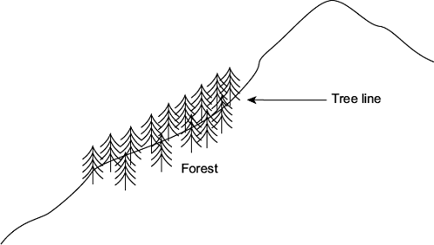

(a)     (i)      The position of the tree line is determined by abiotic factors.  
What is meant by an abiotic factor?

...............................................................................................................

...............................................................................................................

**(1)**

(ii)     Other than temperature, suggest **one** abiotic factor that is likely to affect the position of the tree line on the mountain.

...............................................................................................................

**(1)**

(b)     Scientists measured the concentration of carbon dioxide in the air in one part of the forest. They took measurements at different times of day and at two different heights above the ground. Their results are shown in the bar chart.

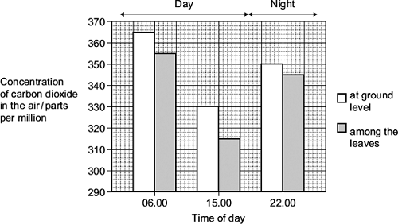

Use your knowledge of photosynthesis and respiration to explain the data in the bar chart.

........................................................................................................................

........................................................................................................................

........................................................................................................................

........................................................................................................................

........................................................................................................................

........................................................................................................................

........................................................................................................................

........................................................................................................................

*(Extra space)* .................................................................................................

........................................................................................................................

........................................................................................................................

........................................................................................................................

**(4)**

(c)     The population of trees in the forest evolved adaptations to the mountain environment.  
Use your knowledge of selection to explain how.

........................................................................................................................

........................................................................................................................

........................................................................................................................

........................................................................................................................

........................................................................................................................

........................................................................................................................

*(Extra space)* .................................................................................................

........................................................................................................................

........................................................................................................................

**(3)**

**(Total 9 marks)**

**Q39.**          A student investigated the rate of gas exchange in aerobically respiring seeds using the apparatus shown in the diagram. She carried out two experiments.

•        In Experiment **1**, she put potassium hydroxide solution in the beaker. Potassium hydroxide solution absorbs carbon dioxide.

•        In Experiment **2**, she put water in the beaker.

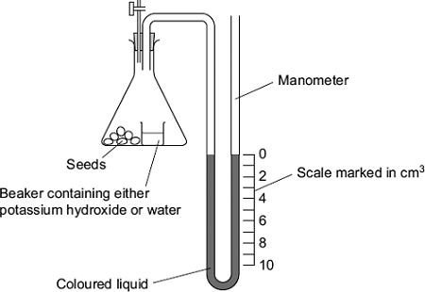

(a)     Both experiments were carried out at the same temperature. Explain why.

........................................................................................................................

........................................................................................................................

........................................................................................................................

........................................................................................................................

........................................................................................................................

**(2)**

(b)     (i)      The level of coloured liquid in the right-hand side of the manometer tube went down during Experiment **1**. Explain why.

...............................................................................................................

...............................................................................................................

...............................................................................................................

...............................................................................................................

...............................................................................................................

...............................................................................................................

*(Extra space)* .......................................................................................

...............................................................................................................

...............................................................................................................

**(3)**

The results from both experiments are shown in the table.

|  |  |  |
| --- | --- | --- |
| **Experiment** | **Solution in beaker** | **Fall in volume of coloured liquid in right-hand side of manometer / cm3** |
| **1** | Potassium hydroxide | 5 |
| **2** | Water | 1 |

(ii)     Use these results to calculate the volume of carbon dioxide produced during Experiment **1**.

                                                  Answer = ..................................... cm3

**(1)**

(c)     The student repeated Experiment 1 using seeds which were respiring anaerobically.  
What would happen to the level of coloured liquid in the right-hand side of the manometer tube? Explain your answer.

........................................................................................................................

........................................................................................................................

........................................................................................................................

........................................................................................................................

........................................................................................................................

**(2)**

**(Total 8 marks)**

**Q40.**CREB is a transcription factor in the mitochondria of neurones.

(a)     What is a **transcription factor**?

........................................................................................................................

........................................................................................................................

........................................................................................................................

........................................................................................................................

**(2)**

(b)     CREB leads to the formation of a protein that removes electrons and protons from reduced NAD in the mitochondrion.

Huntington’s disease (HD) causes the death of neurones. People with HD produce a substance called huntingtin. Some scientists have suggested that binding of huntingtin to CREB may lead to the death of neurones.

Suggest how binding of huntingtin to CREB may lead to the death of neurones.

........................................................................................................................

........................................................................................................................

........................................................................................................................

........................................................................................................................

........................................................................................................................

........................................................................................................................

*(Extra space)* .................................................................................................

........................................................................................................................

........................................................................................................................

**(3)**

(c)     CREB is a protein synthesised in the cytoplasm of neurones. Transport of CREB from the cytoplasm into the matrix of a mitochondrion requires two carrier proteins.

Use your knowledge of the structure of a mitochondrion to explain why transport of CREB requires **two** carrier proteins.

........................................................................................................................

........................................................................................................................

........................................................................................................................

........................................................................................................................

**(2)**

**(Total 7 marks)**

**Q41.**(a)    The table contains statements about three stages of respiration.

Complete the table with a tick if the statement in the first column is true for each stage of respiration in an animal.

|  |  |  |  |  |
| --- | --- | --- | --- | --- |
|  |  | **Glycolysis** | **Link reaction** | **Krebs cycle** |
|  | Occurs in mitochondria |  |  |  |
|  | Carbon dioxide produced |  |  |  |
|  | NAD is reduced |  |  |  |

**(3)**

(b)     The following reaction occurs in the Krebs cycle.



A scientist investigated the effect of the enzyme inhibitor malonate on this reaction. The structure of malonate is very similar to the structure of succinate. The scientist added malonate and the respiratory substrate, pyruvate, to a suspension of isolated mitochondria. She also bubbled oxygen through the suspension.

(i)      Explain why the scientist did not use glucose as the respiratory substrate for these isolated mitochondria.

...............................................................................................................

...............................................................................................................

...............................................................................................................

...............................................................................................................

...............................................................................................................

**(2)**

(ii)     Explain how malonate inhibits the formation of fumarate from succinate.

...............................................................................................................

...............................................................................................................

...............................................................................................................

...............................................................................................................

...............................................................................................................

**(2)**

(iii)    The scientist measured the uptake of oxygen by the mitochondria during the investigation. The uptake of oxygen decreased when malonate was added. Explain why.

...............................................................................................................

...............................................................................................................

...............................................................................................................

...............................................................................................................

...............................................................................................................

**(2)**

**(Total 9 marks)**

**Q42.**Many sports drinks contain water, sodium chloride and carbohydrates. The manufacturers of the sports drinks claim that carbohydrates provide an energy boost. The sodium chloride is used to increase absorption of glucose in the small intestine.

Scientists investigated the effect of a sports drink on the performance of runners in 5 km races.

They recruited 100 runners who had previously run a 5 km race in similar times. During this race, Race 1, they had water they could drink.

The scientists divided the runners into two equal groups, **P** and **Q**. Both groups ran a second 5 km race, Race 2. During this race:

•        group **P** had water available

•        group **Q** had the sports drink available.

The scientists recorded the mean time for each group to complete this race.

**Figure 1** shows their results.

**Figure 1**

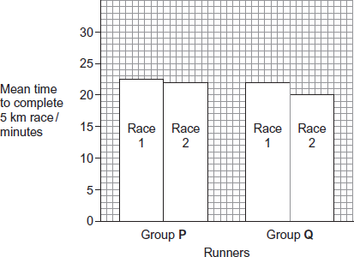

The glycaemic index (GI) is a measure of the increase in blood glucose concentration after eating a given mass of a food compared with eating the same mass of pure glucose. The GI of pure glucose has a value of 100.

The GI of a food depends on several factors such as how much starch and sugars it contains. High GI foods include those containing lots of simple sugars or white flour. The carbohydrates in these foods are rapidly digested and absorbed. Low GI foods include wholegrain bread and breakfast cereals that contain a lot of fibre. The carbohydrates in these foods are digested and absorbed more slowly.

**Figure 2** shows changes in blood glucose concentration after eating meals of high GI food and meals of low GI food.

**Figure 2**

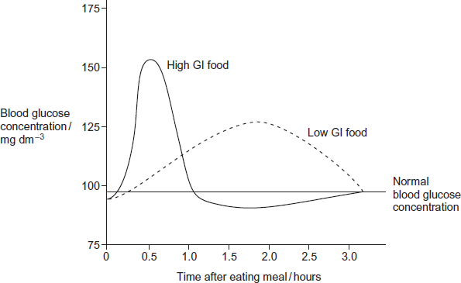

Explain how a sports drink could provide an energy boost when running.

.................................................................................................................................

.................................................................................................................................

.................................................................................................................................

.................................................................................................................................

.................................................................................................................................

.................................................................................................................................

(Extra space) ..........................................................................................................

.................................................................................................................................

.................................................................................................................................

.................................................................................................................................

.................................................................................................................................

**(3)**

**(Total 3 marks)**

**Q43.**Scientists measured the rate of respiration in **three** parts of an ecosystem.

They did this by measuring carbon dioxide released into the air by:

•        leaves of plants

•        stems and roots of plants

•        non-photosynthetic soil organisms.

The table below shows the scientists’ results for these three parts of the ecosystem.

|  |  |  |  |
| --- | --- | --- | --- |
|  | **Part of ecosystem** | **Mean rate of carbon dioxide production / cm3 m−2 s−1** | **Percentage of total carbon dioxide production measured by the scientists** |
|  | Leaves of plants | 0.032 | 25.0 |
|  | Stems and roots of plants | 0.051 |  |
|  | Non- photosynthetic soil organisms | 0.045 |  |

(a)     Complete the table to show the percentage of total carbon dioxide production by each part of the ecosystem.

Show your working.

**(2)**

(b)     A student who looked at the data in the table concluded that plants carry out more respiration than non-photosynthetic organisms in the ecosystem.

Use the information provided to suggest why these data may **not** support the student’s conclusion.

........................................................................................................................

........................................................................................................................

........................................................................................................................

........................................................................................................................

**(2)**

(c)     What measurements would the scientists have made in order to calculate the rate of carbon dioxide production?

........................................................................................................................

........................................................................................................................

........................................................................................................................

........................................................................................................................

**(2)**

(d)     The scientists calculated the mean rate of carbon dioxide production of the leaves using measurements of carbon dioxide release in the dark.

Explain why they did **not** use measurements taken in the light.

........................................................................................................................

........................................................................................................................

........................................................................................................................

........................................................................................................................

**(2)**

Another group of scientists measured the mean rate of respiration in soil under trees and soil not under trees in the same wood. They also measured the mean rate of photosynthesis in the trees.

They took measurements at different times of day during the summer.

The figure below shows the scientists’ results.

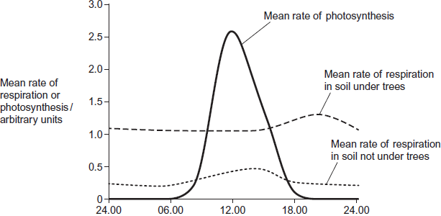  
          Time of day

(e)     (i)      Describe **two** ways in which the mean rate of respiration in soil under trees is different from soil not under trees.

1 ............................................................................................................

...............................................................................................................

2 ............................................................................................................

...............................................................................................................

**(2)**

(ii)     Suggest **one** explanation for the differences in the mean rate of respiration in soil under trees and soil not under trees between 06.00 and 12.00.

...............................................................................................................

...............................................................................................................

...............................................................................................................

...............................................................................................................

**(2)**

(f)     The scientists suggested that the rise in the mean rate of photosynthesis was the cause of the rise in the mean rate of respiration in soil under trees.

(i)      Suggest how the rise in the mean rate of photosynthesis could lead to the rise in the mean rate of respiration in soil under trees.

...............................................................................................................

...............................................................................................................

...............................................................................................................

...............................................................................................................

**(2)**

(ii)     Suggest why there is a delay between the rise in the mean rate of photosynthesis and the rise in the mean rate of respiration.

...............................................................................................................

...............................................................................................................

**(1)**

**(Total 15 marks)**

**Q44.**A student investigated the rate of anaerobic respiration in yeast. She put 5 g of yeast into a glucose solution and placed this mixture in the apparatus shown in the figure below.  
She then recorded the total volume of gas collected every 10 minutes for 1 hour.

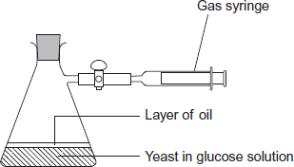

(a)     Explain why a layer of oil is required in this investigation.

........................................................................................................................

........................................................................................................................

**(1)**

(b)     The student’s results are shown in the following table.

|  |  |  |
| --- | --- | --- |
|  | **Time / minutes** | **Total volume of gas collected / cm3** |
|  | 10 | 0.3 |
|  | 20 | 0.9 |
|  | 30 | 1.9 |
|  | 40 | 3.1 |
|  | 50 | 5.0 |
|  | 60 | 5.2 |

(i)      Calculate the rate of gas production in cm3 g–1 min–1 during the first 40 minutes of this investigation. Show your working.

Answer = ................... cm3 g–1 min–1

**(2)**

(ii)     Suggest why the rate of gas production decreased between 50 and 60 minutes.

...............................................................................................................

...............................................................................................................

**(1)**

(iii)    Yeast can also respire aerobically. The student repeated the investigation with a fresh sample of yeast in glucose solution, but without the oil. All other conditions remained the same.  
Explain what would happen to the volume of gas in the syringe if the yeast were only respiring aerobically.

...............................................................................................................

...............................................................................................................

...............................................................................................................

...............................................................................................................

**(2)**

(c)     Respiration produces more ATP per molecule of glucose in the presence of oxygen than it does when oxygen is absent. Explain why.

........................................................................................................................

........................................................................................................................

........................................................................................................................

........................................................................................................................

**(2)**

**(Total 8 marks)**

**Q45.**The figure below shows the apparatus used for measuring the rate of oxygen consumption in aerobic respiration by seeds.

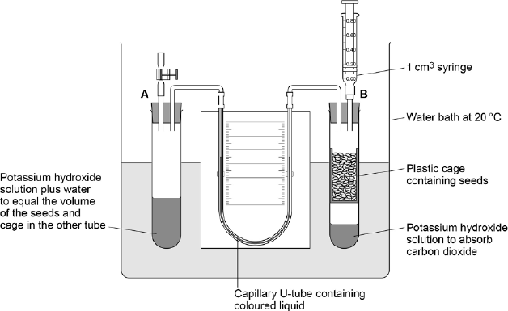

(a)     For the first 10 minutes, the tap attached to tube **A** was left open and the syringe from tube **B** was removed.

Suggest **three** reasons why the apparatus was left for 10 minutes.

1 .....................................................................................................................

........................................................................................................................

2 .....................................................................................................................

........................................................................................................................

3 .....................................................................................................................

........................................................................................................................

**(3)**

(b)     Suggest and explain why the chosen temperature was 20 °C for this experiment.

........................................................................................................................

........................................................................................................................

........................................................................................................................

........................................................................................................................

**(2)**

After 10 minutes, the tap attached to tube **A** was closed and the syringe was attached to tube **B**. Every minute, the syringe plunger was moved until the levels in the U-tube were the same. The reading on the syringe volume scale was then recorded.

The results are shown in the table below.

|  |  |  |
| --- | --- | --- |
|  | **Time / minutes** | **Reading on syringe  volume scale / cm3** |
|  | 0 | 0.84 |
|  | 1 | 0.81 |
|  | 2 | 0.79 |
|  | 3 | 0.76 |
|  | 4 | 0.73 |
|  | 5 | 0.70 |
|  | 6 | 0.68 |
|  | 7 | 0.66 |
|  | 8 | 0.63 |
|  | 9 | 0.62 |
|  | 10 | 0.58 |

(c)     During the experiment, the coloured liquid in the tubing moved towards tube **B**.  
Explain what caused this.

........................................................................................................................

........................................................................................................................

........................................................................................................................

........................................................................................................................

........................................................................................................................

........................................................................................................................

**(Extra space)** ................................................................................................

........................................................................................................................

........................................................................................................................

**(3)**

(d)     The mass of the seeds was 1.6 g. Use the information in the table above to calculate the rate of oxygen consumption in cm3 g–1 hour–1 by the seeds.

Show your working.

Rate = .................................................................................. cm3 g–1 hour–1

**(2)**

**(Total 10 marks)**

**Q46.**Read the following passage carefully.

|  |  |  |
| --- | --- | --- |
|  | A large and growing number of disorders are now known to be due to types of mitochondrial disease (MD). MD often affects skeletal muscles, causing muscle weakness. |  |
|  | We get our mitochondria from our mothers, via the fertilised egg cell. Fathers do not pass on mitochondria via their sperm. Some mitochondrial diseases are caused by mutations of mitochondrial genes inside the mitochondria. Most mitochondrial diseases are caused by mutations of genes in the cell nucleus that are involved in the functioning of mitochondria. These mutations of nuclear DNA produce recessive alleles. | 5 |
|  | One form of mitochondrial disease is caused by a mutation of a mitochondrial gene that codes for a tRNA. The mutation involves substitution of guanine for adenine in the DNA base sequence. This changes the anticodon on the tRNA. This results in the formation of a non-functional protein in the mitochondrion. | 10 |
|  | There are a number of ways to try to diagnose whether someone has a mitochondrial disease. One test involves measuring the concentration of lactate in a person’s blood after exercise. In someone with MD, the concentration is usually much higher than normal. If the lactate test suggests MD, a small amount of DNA can be extracted from mitochondria and DNA sequencing used to try to find a mutation. | 15 |

Use information in the passage and your own knowledge to answer the following questions.

(a)     Mitochondrial disease (MD) often causes muscle weakness (lines 1–3). Use your knowledge of respiration and muscle contraction to suggest explanations for this effect of MD.

........................................................................................................................

........................................................................................................................

........................................................................................................................

........................................................................................................................

........................................................................................................................

........................................................................................................................

**(Extra space)** ................................................................................................

........................................................................................................................

........................................................................................................................

**(3)**

Two couples, couple **A** and couple **B**, had one or more children affected by a mitochondrial disease. The type of mitochondrial disease was different for each couple.

None of the parents showed signs or symptoms of MD.

•        Couple **A** had four children who were all affected by an MD.

•        Couple **B** had four children and only one was affected by an MD.

(b)     Use the information in lines 5–9 and your knowledge of inheritance to suggest why:

•        all of couple **A**’s children had an MD

•        only one of couple **B**’s children had an MD.

Couple **A** ........................................................................................................

........................................................................................................................

........................................................................................................................

........................................................................................................................

Couple **B** ........................................................................................................

........................................................................................................................

........................................................................................................................

........................................................................................................................

**(Extra space)** ................................................................................................

........................................................................................................................

........................................................................................................................

........................................................................................................................

**(4)**

(c)     Suggest how the change in the anticodon of a tRNA leads to MD (lines 10–13).

........................................................................................................................

........................................................................................................................

........................................................................................................................

........................................................................................................................

........................................................................................................................

........................................................................................................................

**(Extra space)** ................................................................................................

........................................................................................................................

........................................................................................................................

**(3)**

(d)     If someone has MD, the concentration of lactate in their blood after exercise is usually much higher than normal (lines 15–17). Suggest why.

........................................................................................................................

........................................................................................................................

........................................................................................................................

........................................................................................................................

........................................................................................................................

........................................................................................................................

**(Extra space)** ................................................................................................

........................................................................................................................

........................................................................................................................

**(3)**

(e)     A small amount of DNA can be extracted from mitochondria and DNA sequencing used to try to find a mutation (lines 18–19).

From this sample:

•        how would enough DNA be obtained for sequencing?

•        how would sequencing allow the identification of a mutation?

........................................................................................................................

........................................................................................................................

........................................................................................................................

........................................................................................................................

**(2)**

**(Total 15 marks)**

**Q47.**(a)     On islands in the Caribbean, there are almost 150 species of lizards belonging to the genus *Anolis*. Scientists believe that these species evolved from two species found on mainland USA. Explain how the Caribbean species could have evolved.

**(6)**

(b)     *Anolis sagrei* is a species of lizard that is found on some of the smallest Caribbean islands. Describe how you could use the mark-release-recapture method to estimate the number of *Anolis sagrei* on one of these islands.

**(4)**

(c)     Large areas of tropical forest are still found on some Caribbean islands. The concentration of carbon dioxide in the air of these forests changes over a period of 24 hours and at different heights above ground.

Use your knowledge of photosynthesis and respiration to describe and explain how the concentration of carbon dioxide in the air changes:

•        over a period of 24 hours

•        at different heights above ground.

**(5)**

**(Total 15 marks)**

**Q48.**(a)     Describe how acetylcoenzyme A is formed in the link reaction.

........................................................................................................................

........................................................................................................................

........................................................................................................................

........................................................................................................................

........................................................................................................................

**(2)**

(b)     In the Krebs cycle, acetylcoenzyme A combines with four-carbon oxaloacetate to form six-carbon citrate. This reaction is catalysed by the enzyme citrate synthase.

(i)      Oxaloacetate is the first substrate to bind with the enzyme citrate synthase. This induces a change in the enzyme, which enables the acetylcoenzyme A to bind.

Explain how oxaloacetate enables the acetylcoenzyme A to then bind to the enzyme.

...............................................................................................................

...............................................................................................................

...............................................................................................................

...............................................................................................................

...............................................................................................................

**(2)**

(ii)     Another substance in the Krebs cycle is called succinyl coenzyme A. This substance has a very similar shape to acetylcoenzyme A.

Suggest how production of succinyl coenzyme A could control the rate of the reaction catalysed by citrate synthase.

...............................................................................................................

...............................................................................................................

...............................................................................................................

...............................................................................................................

...............................................................................................................

**(2)**

(c)     In muscles, pyruvate is converted to lactate during anaerobic respiration.

(i)      Explain why converting pyruvate to lactate allows the continued production of ATP during anaerobic respiration.

...............................................................................................................

...............................................................................................................

...............................................................................................................

...............................................................................................................

...............................................................................................................

**(2)**

(ii)     In muscles, some of the lactate is converted back to pyruvate when they are well supplied with oxygen. Suggest **one** advantage of this.

...............................................................................................................

...............................................................................................................

...............................................................................................................

...............................................................................................................

**(1)**

**(Total 9 marks)**

**M1.**(a)     1.      No aerobic respiration / electron transfer / oxidative phosphorylation;

*Reject reference to anaerobic respiration.*

2.      (Because) no (respiratory) substrate / nothing to respire;

*Reject idea of ‘little’ or ‘less’ − this would result in a change in oxygen concentration.*

*Accept the idea of no residual respiratory substrate in the mitochondria.*

**2**

(b)     (i)      (Oxygen concentration falls because)

1.      Aerobic respiration (uses oxygen);

*Accept ‘oxidative phosphorylation / electron transfer takes place’.*

2.      Oxygen is terminal / electron acceptor;

3.      (oxygen combines with) protons / H+ **and** electrons / e- **to form** water / H2O;

*All aspects are required to gain mark.*

**2 max**

(ii)     Phosphate (ions) / inorganic phosphate / PI;

*Reject ‘phosphorus’ or ‘P’.*

*Accept ‘PO4’.*

**1**

(c)     1.      Oxygen concentration continues to fall in plants but stays constant  
         in animals;

*For ‘plants’ accept ‘line R to T’, for ‘animals’ accept ‘line R to S’.*

*MP1 and MP2. Accept answers in terms of ‘use’ of oxygen rather than change in concentration.*

2.      (Oxygen concentration) falls more slowly in plants than before  
          cyanide added;

3.      (Because aerobic) respiration continues in plant (mitochondria);

*Accept (because aerobic) respiration stops in animal (mitochondria).*

4.      (Because) electron transfer / oxidative phosphorylation continues in plant (mitochondria);

*Accept (because) electron transfer stops in animal (mitochondria).*

*Accept for* ***one additional mark***

*(up to 4 max) use of Resource A i.e: idea that plant cytochrome oxidase is (more) resistant to cyanide*

*OR*

*idea that animal cytochrome oxidase not resistant to cyanide.*

**4**

**[9]**

**M2.**          (a)     (i)      Cytoplasm;

*Accept - cytosol*

**1**

(ii)     Inner membrane of mitochondrion Icristae;

*Reject ‒ crista/ particle*

**1**

(b)     Oxygen is the termina/ acceptor;(No) electron transfer chain / proton transfer / no oxidative phosphorylation;

*Accept ETC abbreviation*

Which produces most of the ATP (in aerobic respiration);Only glycolysis takes place;Pyruvate used to make lactate;

*Accept lactic acid*

Only produces (net) 2 ATP (per molecule of glucose);

*Accept only 4 ATP are made*

**2 max**

**[4]**

**M3.**          (a)     (i)      Cytoplasm (of cell);

*Accept sarcoplasm/cytosol*

**1**

(ii)     In membranes/cristae (of mitochondria);

*Reject matrix of mitochondria*

**1**

(b)     NO stops uptake/use of oxygen (by cells);

**1**

Stops (electron transport chain of) respiration;

*Accept ‒ stops oxidative phosphorylation*

**1**

NO changes shape of protein (in chain);

**1**

Oxygen no longer required as final electron acceptor (however stated);

*Accept ‒ protein denatured or description*

**1**

As oxygen conc. gets lower effect of NO lasts longer, because  
NO more likely to interact with protein;

*Reject accepts hydrogen from etc in 3rd marking point*

**1**

**3 max**

**[5]**

**M4.**          (a)     (i)      to increase surface area (for carbon dioxide absorption);

**1**

(ii)     oxygen is used / carbon dioxide emitted is absorbed;   
so decrease in volume / pressure;

**2**

(iii)     change of level of (manometer) liquid over time;  
bore of tube;  
mass of snails;  
time interval;

**3 max**

(b)     (i)      *valid* *similarity taking into account SD e.g. between 5 and 15 °C*both show little effect of temperature / intakes similar  
between 5 and 15 °C;

**1**

*valid difference taking into account SD above 15 °C e.g.*rise at 20 °C and above is less when snails kept in sea water;

**1**

(ii)     standard deviations high;  
means unreliable;

*(accept 25 °C being out of normal range for snail /   
not enough temperature readings for 1 mark)*

**2**

**[10]**

**M5.**          (a)     (more cristae / larger surface area) for electron transport chain /   
more enzymes for ATP production / oxidative phosphorylation;  
muscle cells use more ATP (than skin cells)(not just more respiration);

**2**

(b)     (i)      pyruvate;

**1**

(ii)     carbon dioxide formed / decarboxylation;  
hydrogen released / reduced NAD formed;  
acetyl coenzyme A produced;

**2 max**

(c)     NAD / FAD reduced / hydrogen attached to NAD / FAD;  
H+ ions / electrons transferred from coenzyme to coenzyme /   
carrier to carrier / series of redox reactions;  
energy made available as electrons passed on;  
energy used to synthesise ATP from ADP and phosphate /   
using ATPase;  
H+ / protons passed into intermembrane space;  
H+ / protons flow back through stalked particles / enzyme;

**3 max**

**[8]**

**M6.**          (a)     (i)      ammonia / ammonium ions / compound;

**1**

(ii)     glucose;

**1**

(b)     final acceptor for hydrogen:  
to form water;

**2**

(c)     glycolysis can continue;  
NAD can accept more hydrogen;

**2**

(d)     secondary / tertiary structure;  
produces particular shape of active site;  
*or*(shape of) active site;  
complementary to shape of substrate;

**2**

(e)     sodium ions / non-competitive inhibitor binds to enzyme  
at a site other than active site;  
resulting in change of shape of active site / no longer complementary;  
substrate can no longer bind with the enzyme / enzyme-substrate  
complexes no longer formed;

**3**

**[11]**

**M7.**          (a)     (i)      29.47(29.5);

*(2 marks for correct answer)*

40% / 0.4 of 2800 / 38;

**2**

(ii)     released as heat;

**1**

(b)     (i)      glucose only partly broken down / only broken down to lactate;

**1**

(ii)     lactate / lactic acid has built up / been produced;  
oxygen used to break down lactate / convert it back to  
pyruvate / glucose / glycogen;

**2**

**[6]**

**M8.**          (a)     adding CO2 decreases pH / makes more acid   
OR removing CO2 increases pH / makes more alkaline;

*(credit anywhere but do not credit this mark if  
stated that oxygen is an alkaline gas)*

rate of photosynthesis > rate of respiration in **A**;  
respiration only in **B**;  
rate of photosynthesis = rate of respiration in **C**;

**4**

(b)     (i)      shows that indicator alone does not change colour in light;

**1**

(ii)     so that all tubes receive same amount of heat

**1**

**[6]**

**M9.**          (a)     (i)      RuBP – 5; GP – 3; TP – 3; Glucose – 6;

*(all correct = 2 marks; 3 or 2 correct = 1 mark)*

**2**

(ii)     stroma;

**1**

(iii)     light-dependent reaction / (photo)phosphorylation;

*(accept photolysis)*

**1**

(iv)    5 out of 6 / 83% / equivalent;

**1**

(b)     enzymes involved / not a photochemical reaction;  
slow rate of enzyme / chemical reaction at low temperature /   
less kinetic energy / fewer collisions;

**2**

**[7]**

**M10.**          (a)     (i)      in case normal coffee differs in some other way /   
to control concentration of caffeine;

**1**

(ii)     not telling them what the drink contained / purpose of experiment;

**1**

(b)     (i)      able to continue for longer; *(not just increases performance)  
(disqualify if also refers to fatty acids and glycerol)*

**1**

(ii)     breakdown of fats;  
at increased rate / by mobilisation of fat stores;

**2**

(c)     (i)      idea that volumes of oxygen and carbon dioxide the same;  
reference to equal moles, or quotient as 1 divided by 1 / or 6 by 6;

**2**

(ii)     glycogen is a carbohydrate / broken down to glucose, linked to RQ;  
with no caffeine, RQ nearer 1.0 / less carbon dioxide exhaled and  
more oxygen inhaled (or vice versa) / with caffeine higher proportion of fats / fatty acids respired;  
increased time to exhaustion suggests slower use of glycogen:

**3**

**[10]**

**M11.**          (a)

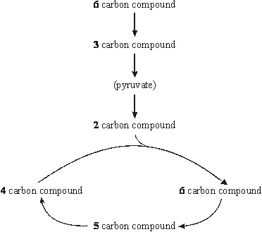

*(1 mark for three correct answers)  
(2 marks for six correct answers)*

**2**

(b)     reduced NAD / NADH / NADH2;  
reduced FAD / FADH / FADH2;  
ATP;

**3**

**[5]**

**M12.**          (a)     used in (aerobic) respiration / to provide energy / ATP  
(and not replaced by breathing) / used up by muscle and not replaced;

*(reject used up and used up and not replaced)*

**1**

(b)     36;

**1**

(c)     converted back to pyruvate / glycogen / glucose / CO2 and H2O;  
reacted with oxygen / oxidised;

*(reject “breaking down” with respect to glycogen and glucose)*

**2**

(d)     (i)      vasoconstriction / contraction of muscles in arteries / arterioles /   
arteries / arterioles close;

*(reject contraction of arteries / arterioles / capillaries)*

**1**

(ii)     supplies oxygen / glucose or removal of carbon dioxide / lactate;  
so cells can respire when not contracting / breathing;

**2**

**[7]**

**M13.**          (a)     (Absorption of) light;

**1**

(b)     Inner membrane / cristae / stalked particles of mitochondria;

**1**

**[2]**

**M14.**          (a)     matrix;

**1**

(b)     pyruvate;

ADP;

P / inorganic phosphate;

reduced NAD;

oxygen;

**2 max**

(c)     larger surface area for electron carrier system / oxidative  
phosphorylation; provide ATP / energy for contraction;

**2**

**[5]**

**M15.**          (a)     ** x;  
x        x        ;  
              
      x        x

**4**

(b)     (i)      pyruvate / succinate / any suitable Krebs cycle substrate;

**1**

(ii)     ADP and phosphate forms ATP;  
oxygen used to form water / as the terminal acceptor;

**2**

(iii)     Y X W Z;  
order of carriers linked to sequence of reduction / reduced  
carriers cannot pass on electrons when inhibited;

**2**

**[9]**

**M16.**          (a)     Krebs cycle / link reaction / pyruvate to acetylcoenzyme A;

***Q*** *Accept valid alternative for any of these steps.*

**1**

(b)     (Respiratory reactions controlled by) enzymes;

Rate decreases as less kinetic energy / fewer collisions (between substrate and active site) fewer E-S complexes formed;

**2**

(c)     Requires hydrogen / electrons / is reduction;

Hydrogens from reduced NAD / reduced NAD reduces (pyruvic acid) / reduced NAD oxidised;

*Information may be on diagram*

**2**

(d)     Respiring anaerobically;

(Anaerobic respiration / respiration with nitrogen) less efficient / produces less ATP;

More anaerobic respiration / more glucose / substrate must be respired to produce same amount of ATP (so more carbon dioxide produced);

**3**

**[8]**

**M17.**          (a)     It is a measure of the concentration of a gas  
(in a mixture of gases or a liquid);

**1**

(b)     37-38%

*Accept 36 – 39*

(c)     muscle contraction causes increased respiration;  
increased CO2 production lowering blood pH / lactate released  
lowering blood pH;  
increased heat released therefore increased temperature;  
increased O2 consumption lowering tissue *P*O2;

**4**

(d)     haemoglobin has a lower affinity for oxygen;  
more O2 for respiration;

**2**

(e)     **3.4 times = 2 marks**(incorrect answer in which candidate shows amount of oxygen removed at rest is 4.6 and amount removed during exercise is 15.8 = 1 mark)

**2**

(f)      Nearly all O2 is transported by haemoglobin / v. little transported in plasma;  
**EITHER**Haemoglobin is (nearly) fully saturated with O2 at the alveoli both at  
rest and when exercising;  
Therefore no (very little) further increase is possible;  
**OR**Haemoglobin is only 95% saturated with oxygen at the alveoli;  
Therefore enriching inspired / air with oxygen will raise this to 100%;

**3**

(g)     increased depth / rate / pulmonary ventilation;  
increase stroke volume / heart rate / Q increases blood flow rate;  
arterioles [*Accept* artery] supplying the muscles  
dilate / vasodilation / greater proportion of blood flow to the muscles;

**max 3**

**[15]**

**M18.**          (a)     CO2, water, ATP, reduced NAD / FAD;

*(accept creatine phosphate)(any 2 - one tick)*

**1**

(b)     (i)      build up / increased concentration of lactate lowers  
pH / increases H+ / increases acidity;  
enzymes / named protein inhibited(*not denatured);*

**2**

(ii)     lactate / pyruvate is an energy source;  
muscles have increased / immediate energy or ATP supply;  
*(accept lactate replenishes glycogen or glucose)*restores pH levels;

**2 max**

**[5]**

**M19.**          (a)     X = Carbon dioxide;  
Y = Acetyl coenzyme A;

*(ACCEPT Acetyl CoA)*

Z = Water;

**3**

(b)     (i)      Cytoplasm;

**1**

(ii)     Mitochondrion;

*(IGNORE named part)*

**1**

(c)     On the diagram:

(i)      ‘**A**’ (ATP used) – between glucose and triose phosphate;

**1**

(ii)     ‘**B**’ Any **two** from:

(ATP produced)  –  between triose phosphate and pyruvate;  
      in Krebs cycle;  
      from electron carriers  
      (to right of bracket & not below grey box);

**max 2**

(d)     Any **three** from:

Source of energy / of phosphate;  
Active transport;  
Phagocytosis / endo- / exocytosis / pinocytosis;  
Bile production;  
Cell division / mitosis;  
Synthesis of:   glycogen;  
                        protein / enzymes;  
                        DNA / RNA;  
                        lipid / cholesterol;  
                        urea;

**max 3**

(e)     Any **four** from:  
Forms lactate; [extras – C2H5OH / CO2 – *CANCEL*]

Use of reduced NAD / NADH;

Regenerates NAD;

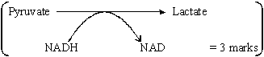

NAD can be re-used to oxidise more respiratory substrate / correct e.g. /   
allows glycolysis to continue;  
Can still release energy / form ATP   
when oxygen in short supply / when no oxygen;

**max 4**

**[15]**

**M20.**          (a)     (i)      glycolysis;

**1**

(ii)     oxygen removed from pyruvate / reduced NAD is oxidised / donates hydrogen / donates electrons;

**1**

(iii)     allows NAD to be recycled / re-formed;  
so that glycolysis / described / candidates answer to (i) can proceed / so that (more) glucose can be converted to pyruvate / so that process X can continue;

**2**

(b)     (i)      ATP formed / used;  
pyruvate formed / reduced;  
NAD / reduced NAD;  
glycolysis involved / two stage process;

**2 max**

(ii)     ethanol / alcohol formed by yeast, lactate (*allow lactic acid)*by muscle cell; CO2 released by yeast but not by muscle cell;

*(note: need both parts of the comparison for the mark)*

**2**

(c)     (i)      allows anomalies to be identified / increases reliability (of means /   
averages / results);  
allows use of statistical test;

**2**

(ii)      = 31.8 / 31.76 / 31.77;

*(units not required)*

÷ (5 × 60) = 0.106 / 0.11 / 0.1;

*(correct answer scores two marks, however derived.)  
(correct mean volume (31.8 cm3) however derived scores 1 mark)*

**2**

(iii)     Volume(s) less / no gas evolved;  
So (volume) CO2 evolved = (volume of) O2 taken in;

**3**

**[15]**

**M21.**         (a)     (i)      2 (molecules)

**1**

(ii)     Cannot pass out of cell;  
Quickly / easily broken down (hydrolysed) / broken  
down in a on-step reaction / immediate source of energy;  
Stores / releases small amounts of energy;  
*Do not credit “producing energy”*

**max 2**

(b)     Formed when reduced NAD used to reduce / donate H ions  
to pyruvate / convert pyruvate to ethanol;

**1**

**[4]**

**M22.**          (a)     (i)      **P** = 3;

**Q** = acetylcoenzyme A;

**2**

(ii)     36 ATP, however derived = 2 marks

30 ATP, however derived = 1 mark

**2**

(iii)     *Correct statement in the context of aerobic respiration or  
anaerobic respiration concerning*:

Oxygen as terminal hydrogen / electron acceptor allowing operation of electron transport chain / oxidative phosphorylation;

Fate of pyruvate;

Significance of ATP formed in glycolysis;

**3**

(b)     (i)      Thick walls exclude oxygen;

Produced by photosynthetic cells (of fern and *Anabaena*);

Contain no chlorophyll so do not photosynthesise;

Do not produce oxygen;

Oxygen would inhibit nitrogen fixation process;

**max. 3**

(ii)     Decomposers / bacteria / fungi / saprobionts (in fields);

Convert protein / organic nitrogen (in cells of fern) into  
ammonium ions (*allow ammonia*);

Ammonium ions (ammonia) converted to nitrite, then converted to nitrate;

*Allow 1 mark for NH3 / NH NO3*

By nitrifying bacteria / correctly named;

Nitrate used to form protein / amino acids in rice;

**5**

**[15]**

**M23.**          (a)     greater rate of oxygen consumption / leads to greater rate of respiration and greater rate of uptake;

*(allow this mark even if spread through account but cause and effect must be within the correct context)*

oxygen required for respiration;  
respiration produces ATP / releases energy;  
*(ignore ref to producing or making energy)*potassium ions taken up by active transport / against concentration gradient;

**4**

(b)     (i)      0.25 (mol dm–3);

**1**

(ii)     1 mark        Incorrect answer but derived from ratio of 1.2 and initial  
                   length of 90 mm  
2 marks      Correct answer of 108 mm;

**2**

(iii)     water potential inside potato higher / less negative than in solution;  
water moves out by osmosis;

**2**

**[9]**

**M24.**metabolic water / from respiration;

*allow condensation reactions. Ignore 'oxidation'.*

aerobic / use of oxygen;          ('From aerobic respiration' = 2 marks)

**[2]**

**M25.**          (a)     Filaments / lamellae provide large surface area;

Thin / flattened epithelium / one / two cell layers so short diffusion pathway (between water and blood);

Countercurrent / blood flow maintains concentration / diffusion gradient;

***Q*** *Do not credit thin cell walls / membranes*

**2 max**

(b)     (i)      Large / wide range of values (so can fit on graph);

**1**

(ii)     Decrease in uptake with increase in mass / negative correlation;

**1**

(iii)    Enables comparison;

As animals differ in size / mass;

**2**

**[6]**

**M26.**          (a)     pyruvate;

**1**

(b)     Krebs cycle;

**1**

(c)     ATP formed as electrons pass along transport chain;  
oxygen is terminal electron acceptor / accepts electrons from electron  
transport chain / electrons cannot be passed along electron transport   
chain if no O2 to accept them;  
forms H2O / accepts H+ from reduced NAD / FAD / oxidises reduced   
NAD / FAD;

**3**

**[5]**

**M27.**(a)     (i)      Crista / inner membrane;

**1**

(ii)     Matrix;

**1**

(b)     B;

**1**

(c)     (i)      Reduce / prevent enzyme activity;

**1**

(ii)     Prevents osmosis / no (net) movement of water;

So organelle / named organelle does not burst / shrivel;

***Q*** *Allow reference to cell rather than organelle for first mark point only.*

*Regard damage as neutral*

**2**

(d)     (Mitochondria) use aerobic respiration;

Mitochondria produce ATP / release energy required for muscles (to contract);

***Q*** *Do not accept reference to making / producing energy.*

**2**

**[8]**

**M28.**          (a)     Electrons transferred down electron transport chain;

Provide energy to take protons / H+ into space between membranes;

Protons / H+ pass back, through membrane / into matrix / through  
ATPase;

Energy used to combine ADP and phosphate / to produce ATP;

*Accept: alternatives for electron transport chain.*

**3 max**

(b)     (i)      Prevent damage to mitochondria caused by  
water / osmosis / differences in water potential;

*Accept: other terms that imply damage e.g. shrink / burst*

**1**

(ii)     Glucose is used / broken down during glycolysis in cytoplasm / not in mitochondria;

*Accept: ‘glucose is converted to pyruvate’ for description of breakdown*

Glucose cannot cross mitochondrial membrane / does not  
enter mitochondria;

*Accept: only pyruvate can*

**2**

(iii)    Terminal / final acceptor (in electron transport chain) / used to  
make water;

*Could be shown by symbols*

**1**

**[7]**

**M29.**(a)     (i)      Yield increases by 0.6 kg m–2 (when extra carbon dioxide present);

**1**

(ii)     Temperature / light intensity so could be lower in these weeks (as temperature / light insensity not fully controlled / monitored) (over period 1998 – 2000);

**1**

(b)     Two marks for correct answer of 50.6%;;  
One mark for incorrect answer in which candidate has shown clearly that calculation based on an increase / 0.42 and original mass / 0.83

**2**

(c)     Cost of supplying carbon dioxide;  
Price of (very early) tomatoes;

**2**

(d)     Lowest price paid for tomatoes;  
Some carbon dioxide lost as windows open in summer;  
Little / no mean increase in yield in summer;

**2 max**

(e)     Grow with extra carbon dioxide in one glasshouse and without carbon dioxidein other glasshouse at same time;  
So all environmental conditions / light and temperature same for experiment and control;

**2**

**[10]**

**M30.**(a)     Increase in the first 3 – 4 hours and then decrease;

**1**

(b)     Little / no difference (at 8 hours);

Between all groups;

**2**

(c)     Respiration ( produce CO2);

By cells / tissues;

**2**

(d)     Clear differences between the lactose deficient and IBS / control group;

No overlap in SD;

*Accept between all groups*

**2**

**[7]**

**M31.**          (a)     1.      Releases energy in small / manageable amounts;

*1. Accept less than glucose*

2.      (Broken down) in a one step / single bond broken immediate energy compound / makes energy available rapidly;

*2. Accept easily broken down*

3.      Phosphorylates / adds phosphate makes (phosphorylated substances) more reactive / lowers activation energy;

*3. Do not accept phosphorus or P on its own*

4.      Reformed / made again;

*4. Must relate to regeneration*

**4**

(b)     1.      Substrate level phosphorylation / ATP produced in Krebs cycle;

*Accept alternatives for reduced NAD*

2.      Krebs cycle / link reaction produces reduced coenzyme / reduced NAD / reduced FAD;

*2. Accept description of either Krebs cycle or link reaction*

3.      Electrons released from reduced / coenzymes / NAD / FAD;

4.      (Electrons) pass along carriers / through electron transport chain / through series of redox reactions;

5.      Energy released;

*5. Allow this mark in context of electron transport or chemiosmosis*

6.      ADP / ADP + Pi;

*6. Accept H+ or hydrogen ions and cristae*

7.      Protons move into intermembrane space;

*7. Allow description of movement through membrane*

8.      ATP synthase;

*8. Accept ATPase. Reject stalked particles*

**6 max**

(c)     1.      In the dark no ATP production in photosynthesis;

*1. In context of in photosynthetic tissue / leaves*

2.      Some tissues unable to photosynthesise / produce ATP;

3.      ATP cannot be moved from cell to cell / stored;

4.      Plant uses more ATP than produced in photosynthesis;

5.      ATP for active transport / synthesis (of named substance);

**5**

**[15]**

**M32.**         (a)     (i)      1.      Oxygen taken up / used (by woodlouse);

2.      Carbon dioxide (given out) is absorbed by solution / potassium hydroxide;

3.      Decrease / change in pressure;

*Reference to vacuum negates last marking point*

*Reject reference to pressure increasing inside tube*

**3**

(ii)     1.      Distance (drop moves) and time;

2.      Mass of woodlouse;

3.      Diameter / radius / bore of tubing / lumen / cross-sectional area;

*If answer refers to measuring volume using the syringe allow 2 max –*

*one mark for measuring volume;*

*one mark for mass of woodlouse;*

**3**

(b)     1.      Less / no proton / H+ movement so less / no ATP produced;

2.      Heat released from electron transport / redox reactions / energy not used to produce ATP is released as heat;

3.      Oxygen used as final electron acceptor / combines with electrons (and protons);

**3**

**[9]**

**M33.**          (a)     1.      Hydrolysis breaks proteins / hydrolyses proteins / produces amino acids (from proteins);

2.      Protein synthesis involves condensation;

**2**

(b)     Amino acids (from calliphorin) can be joined in different sequences /   
rearranged;

**1**

(c)     1.      Fall, rise and fall;

2.      Rise after 40 and fall after 80;

*Ignore concentration values.*

**2**

(d)     (i)      Fall / increase then fall;

Lysosomes associated with tissue breakdown;

**2**

(ii)     1.      Tissues / cells are being broken down;

2.      RNA is digested / hydrolysed / broken down;

3.      By enzymes from lysosomes;

4.      New proteins not made / no new RNA made;

**2 max**

(e)     1.      (RNA) associated with making protein;

2.      New / adult tissues are forming;

**2**

(f)      1.      In the first 6 days no / little oxygen supplied / with breakdown of tracheae, no / little oxygen supplied;

2.      (Without tracheae) respire anaerobically;

3.      Anaerobic respiration involves reactions catalysed by enzyme **B**  / conversion of pyruvate to lactate / involves lactate production;

4.      Enzyme **A** / Krebs cycle is part of aerobic respiration;

*Or, with emphasis on aerobic respiration:*

*1. Tracheae supply oxygen / after 6 days oxygen supplied;*

*2. (With tracheae) tissues can respire aerobically.*

**4**

**[15]**

**M34.**          (a)     (i)      1.      Gases / correct named gas not released;

2.      Conditions (in digester) can be controlled;

3.      Products / named product can be collected;

4.      Open ponds associated with health risk / environmental damage / eutrophication;

*Correct named gases include: methane, carbon dioxide, hydrogen sulphide, nitrogen oxides*

*1. Allow substance = product*

*4. Accept ‘pond’ in any context*

**2 max**

(ii)      1.      Respiration causes temperature increase / release of heat;

2.      Enzymes would be denatured / microorganisms killed;

**2**

(b)     (i)      1.      Increase algae / algal bloom causes light to be blocked out;

2.      Plants can’t photosynthesise / plants and / or algae die;

3.      Bacteria / saprobionts / EW feed off / breakdown dead organisms using up oxygen / bacteria respire / BOD rises;

**3**

(ii)     1.      Acts as soil conditioner / improves drainage / aerates soil / increases organic content of soil;

2.      Contains other elements / named element / wider range of elements;

3.      Production of artificial fertiliser energy-consuming;

4.      Less leaching / slow release (of nutrient);

*Unspecified answers relate to natural fertiliser. Ignore references to cost / eutrophication*

*2. i.e. elements other than nitrogen, phosphorus and potassium*

**1 max**

**[8]**

**M35.**(a)

|  |  |  |  |  |
| --- | --- | --- | --- | --- |
|  |  | Photosynthesis | Anaerobic respiration | Aerobic respiration |
|  | ATP produced |  |  |  |
|  | Occurs in organelles |  |  |  |
|  | Electron transport chain involved |  |  |  |

*1 mark per column*

*Mark ticks only. Ignore anything else if different symbols such as crosses are used as well.*

*If crosses are used instead of ticks allow cross as equivalent to a tick.*

*Reject tick with a line through*

**3**

(b)     ADP + Pi → ATP;

*Both sides correct, but allow other recognised symbols or words for phosphate ion. Reject P unless in a circle.*

*Accept = as equivalent to arrow*

*Accept reversible arrow*

*Ignore any reference to kJ / water*

**1**

(c)     1.      Energy released in small / suitable amounts;

2.      Soluble;

3.      Involves a single / simple reaction;

*1. In context of release, not storage. Ignore producing energy / manageable amounts.*

*2. Reject "broken down easily / readily". Reject "quickly / easily resynthesised".*

**2 max**

(d)     1.      ATP cannot be stored / is an immediate source of energy;

2.      ATP only releases a small amount of energy at a time;

**2**

**[8]**

**M36.**(a)     1.      Carbohydrate / sugar / named carbohydrate;

2.      Minerals / named mineral ion;

*Accept alternatives for mineral such as inorganic substances / ions. Accept symbol for ion. Accept incorrect symbols providing that answers are not ambiguous.*

3.      Amino acids / protein;

4.      Vitamins;

**2 max**

(b)     1.      Shake / stir / mix;

2.      Even distribution of yeast / cells;

*Accept other terms with a similar meaning for both points*

**2**

(c)     Two marks for correct answer of 20 / 20.2 / 20.22;;

One mark for incorrect answer in which student clearly shows increase as 8.912 – 7.413 or as 1.499;

*Ignore references to 106*

**2**

(d)     1.      More competition;

2.      Less oxygen;

3.      Less glucose / sugar / carbohydrate / respiratory substrate;

4.      Ethanol / alcohol becomes toxic / inhibits respiration / inhibits reproduction;

5.      Fall in pH;

**2 max**

**[8]**

**M37.**(a)     1.      No oxygen can enter;

2.      Ethanol produced during anaerobic respiration;

***OR***

3.      No ethanol / carbon dioxide can escape;

4.      Allows accuracy of measuring;

***OR***

5.      To prevent entry of / contamination with microorganisms;

6.      Prevent competition with yeast;

*Any two pairs of answers*

*Second mark of each pair must be related to the first point of the pair.*

**4 max**

(b)     1.      Yeast respiring aerobically;

2.      Oxygen used equal to carbon dioxide produced;

**2**

(c)     1.      7.0 / 7;

2.      Ethanol production starts;

**2**

(d)     (i)      1.      Repeat;

2.      Identify anomalies / see if results are similar / enough results for statistical test / give more reliable mean;

3.      Carry out statistical test / statistical analysis;

4.      Ensure results are significant / find probability of results being due to chance;

5.      Peer review;

6.      Allows procedure to be checked / see if other scientists get similar results;

*Two pairs of linked points, each pair a suggestion and an explanation. The explanation must relate to the suggestion to gain the second point of the pair.*

**4**

(ii)     1.      Curve levelling off / rate of increase is decreasing / very little extra ethanol produced;

2.      Becomes less cost effective / less profit;

*2. Accept a description of cost effectiveness*

**2**

(iii)    1.      (Funding agency) might want particular results;

2.      Results may be withheld / results may not be published / results may be confidential;

**2 max**

**[16]**

**M38.**         (a)     (i)     Non-living / physical / chemical factor / non biological;

*Do not accept named factor unless general answer given.*

**1**

(ii)     Accept an abiotic factor that may limit photosynthesis / growth;

*Reject altitude / height*

Water

Named soil factor

*Not “soil” / “weather”*

Light

Carbon dioxide

*Accept Oxygen*

Incline / aspect

Wind / wind speed

**1**

(b)     1.      Correct explanation for differences between day and night e.g.  
photosynthesises only during the daytime / no photosynthesis / only respiration at night;

2.      Net carbon dioxide uptake during the day / in light

***OR***

         No carbon dioxide taken up at night / in dark / carbon dioxide released at night / in dark;

3.      At ground level more respiration / in leaves more photosynthesis;

4.      Carbon dioxide produced at ground level / carbon dioxide taken up in leaves;

*Principles*

***Comparing day and night / light and dark***

*1. Explanation in terms of photosynthesis / respiration*

*2. Effect on carbon dioxide production / uptake*

***Comparing leaves with ground level***

*3. Explanation in terms of photosynthesis / respiration*

*4. Effect on carbon dioxide production / uptake*

*2 and 4 must relate to why the change occurs*

**4**

(c)     1.      Variation in original colonisers / mutations took place;

2.      Some better (adapted for) survival (in mountains);

*2. Allow “advantage so able to survive”*

3.      Greater reproductive success;

4.      Allele frequencies change;

*4. Reject gene / genotype*

**3 max**

**[9]**

**M39.**          (a)     1.      Affects enzymes;

*‘respiration involves enzymes’ = two marks*

2.      Affects respiration;

*Ignore reference to controlling a variable*

                 Or

3.      Affects volume / pressure of gases;

*Mark point 4 can only be awarded if mark point 3 has been credited*

4.      Affects readings;

**2 max**

(b)     (i)     1.      Oxygen taken up / used (by seeds);

*Reject air is taken up for mark point 1*

2.      Carbon dioxide (given out) is absorbed by solution / potassium hydroxide;

3.      Decrease in volume / pressure (inside flask);

*Reference to vacuum negates mark point 3*

**3**

(ii)     4;

**1**

(c)     1.      Remains the same;

2.      No oxygen uptake / used;

*Any reference to ‘carbon dioxide* ***not*** *being produced’ disqualifies mark point 2*

**2**

**[8]**

**M40.**(a)     1.      (Protein / molecule) that moves from cytoplasm to DNA;

*Accept ‘it’ as TF.*

*Accept moves into nucleus*

2.      (TF) binds to specific gene / genes / to specific part of / site on DNA / binds to promoter / RNA polymerase;

*Accept regulator / enhancer region*

3.      Leads to / blocks (pre)mRNA production / allows / blocks binding of RNA polymerase (to DNA) / allows RNA polymerase to work;

*Ignore translation unless context wrong*

*Max 1 if refer to oestrogen as a transcription factor*

**2 max**

(b)     1.      (Binding to CREB) prevents transcription / mRNA formation;

*Accept that lack of protein leaves NAD reduced*

2.      (Binding of huntingtin) prevents production / translation of protein (that removes electrons / protons from NAD);

3.      Fewer electrons to electron transport chain / electron transport chain slows / stops / stops / slower oxidative phosphorylation;

4.      Fewer protons for proton gradient;

5.      Not enough ATP produced / energy supplied to keep cells alive / anaerobic respiration not enough to keep cell alive;

*Accept neurones require ATP for active transport of ions*

*Ignore references to resting potential*

**3 max**

(c)     1.      Mitochondrion has two membranes / inner and outer membranes;

*Accept cristae for inner membrane*

2.      For each (different) membrane a (different) carrier required;

*Ignore reference to channel proteins*

**2**

**[7]**

**M41.**(a)

|  |  |  |  |  |
| --- | --- | --- | --- | --- |
|  |  | **Glycolysis** | **Link reaction** | **Krebs cycle** |
|  | Occurs in mitochondria |  | √ | √ |
|  | Carbon dioxide produced |  | √ | √ |
|  | NAD is reduced | √ | √ | √ |

Mark horizontally

**3**

(b)     (i)      1.      Glucose is used / broken down during glycolysis / in cytoplasm;

*1. Accept: glucose to pyruvate or glucose not converted to pyruvate for one mark*

2.      Glucose cannot cross mitochondrial membrane(s) / pyruvate can cross mitochondrial membrane(s);

**2**

(ii)     1.      Is a competitive inhibitor / attaches to active site;

*1 Accept: inhibitor / malonate attaches to active site to form an enzyme-substrate complex*

2.      Reduces / prevents enzyme-substrate / E-S complex forming;

*2 Accept: substrate / succinate cannot bind to enzyme*

*2 Accept mark point 2, but not mp1 in context of non-competitive inhibition*

**2**

(iii)    1.      Krebs cycle inhibited as NAD / Coenzyme / FAD not / less reduced;

2.      Hydrogens not passed to ETC therefore oxygen not used as (much as a) final / terminal (electron) acceptor;

**2**

**[9]**

**M42.**1.      (Drink) contains carbohydrates / sugars **so** High GI / (drink) contains carbohydrates / sugars **so** raises blood glucose concentration quickly;

*Each alternative requires both aspects for credit*

*The second alternative requires a reference to speed eg ‘quickly’ or ‘immediately’*

2.      Contains salt so glucose more rapidly absorbed;

3.      Increases glucose to muscles for respiration;

4.      More / faster respiration so more / faster energy release;

*Reject reference to energy production*

*Accept more ATP produced*

**[3]**

**M43.**(a)

|  |  |  |  |
| --- | --- | --- | --- |
|  | **Part of ecosystem** | **Mean rate of carbon dioxide production /  cm3 m−2 s−1** | **Percentage of total carbon dioxide production measured by the scientists** |
|  | Leaves of plants | 0.032 | 25.0 |
|  | Stems and roots of plants | 0.051 | **39.8** |
|  | Non- photosynthetic soil organisms | 0.045 | **35.2** |

2 correct = 2 marks;;

Adding rates to get 0.128 = 1;

*If rounded to 40 and 35 in table;*

*•    but working shows decimal points, then award 2 marks   
•    but no working shown, then 1 max*

**2 max**

(b)     1.      Data only include (heterotrophic) soil organisms;

2.      Doesn’t include animals (above ground) / other (non-soil) organisms;

3.      Doesn’t take into account anaerobic respiration;

*Award points in any combination*

*Accept for 1 mark idea that CO2 for leaves doesn’t take into account photosynthesis – not told in dark until part (d)*

**2 max**

(c)     **All three** of following = 2 marks;;

**Two** of them = 1 mark;

Volume of carbon dioxide given off

(From known) area / per m2 / m-2

In a known / set time

*Ignore ‘amount’ / concentration of CO2*

*Accept per second / per unit time*

**2**

(d)     1.      (In the light) photosynthesis / in the dark no photosynthesis;

2.      (In light,) carbon dioxide (from respiration) being used / taken up (by photosynthesis);

**2**

(e)     (i)      (Rate of respiration)

*Assume “it” means soil under trees*

1.      In soil under trees (always) higher;

*Accept converse for soil not under trees*

*Accept ‘in the shade’ means under the trees*

2.      In soil under trees does not rise between 06.00 and 12.00 / in the middle of the day / peaks at 20:00-21.00 / in the evening;

3.      In soil **not** under trees, peaks at about 14:00-15:00 / in middle of day;

*2. and 3. No mm grid, so accept ‘between 18.00 and 24.00’ or ‘between 12.00 and 18.00’*

**2 max**

(ii)     (Between 06.00 and 12.00, (No Mark))

Respiration higher in soil under tree, (No mark)

*Do not mix and match mark points*

*No list rule*

1.      Tree roots carry out (a lot of) respiration;

2.      More / there are roots under tree;

*Accept converse for soil not under trees*

***OR***

3.      More food under trees;

4.      So more active / greater mass of / more organisms (carrying out respiration);

*Accept converse for soil not under trees*

***OR***

Soil not under trees respiration increases (No mark)

5.      Soil in sunlight gets warmer;

6.      Enzymes (of respiration) work faster;

*Accept converse for soil under trees*

**2 max**

(f)      (i)      1.      Photosynthesis produces sugars;

2.      Sugars moved to roots;

*Do not penalise named sugars other than sucrose*

3.      (Sugars) are used / required for respiration;

**2 max**

(ii)     Takes time to move sugars to roots;

*Look for movement idea in (i) – can carry forward to (ii)*

**1**

**[15]**

**M44.**(a)     Prevents oxygen being taken up / entering / being absorbed;

*Accept: any idea of no contact with oxygen.*

*Neutral: for anaerobic respiration / anaerobic conditions.*

*Neutral: prevents entry of air.*

*Reject: prevents entry of oxygen and another named gas.*

**1**

(b)     (i)      0.0155 / 0.016 = 2 marks;;

0.0775 / 0.077 / 0.078 / 0.08 = 1 mark

/ 0.62 = 1 mark

**2**

(ii)     Glucose decreases / is a limiting factor / increase in ethanol / yeast / cells die / toxins build up;

*Accept: glucose is used up.*

**1**

(iii)    1.      (Stays the) same / level / (relatively) constant;

2.      Same volume / amount of oxygen uptake and carbon dioxide release;

*Note: if m.p.1 is awarded m.p 2 can be obtained without referring to ‘same volume / amount’.*

**2**

(c)     1.      Oxygen is final / terminal (electron) acceptor / oxygen combines with electrons and protons;

2.      Oxidative phosphorylation / electron transport chain provides (most) ATP / only glycolysis occurs without oxygen / no Krebs / no link reaction;

**2**

**[8]**

**M45.**(a)     1.      Equilibrium reached.

*Accept equilibrate*

2.      Allow for expansion / pressure change in apparatus;

3.      Allow respiration rate of seeds to stabilise.

*Ignore seeds acclimatise*

**3**

(b)     1.      Optimum temperature / temperature for normal growth of seeds;

2.      (Optimum temperature) for enzymes involved in respiration.

**2**

(c)     1.      Oxygen taken up / used by seeds;

2.      CO2 given out is absorbed by KOH (solution);

3.      Volume / pressure (in **B**) decreases.

**3**

(d)     0.975 / 0.98.

*If incorrect,*

*0.26 × 6 / or incorrect numbers divided by 1.6 for 1 mark*

**2**

**[10]**

**M46.**(a)      1.      Reduction in ATP production by aerobic respiration;

2.      Less force generated because fewer actin and myosin interactions in muscle;

3.      Fatigue caused by lactate from anaerobic respiration.

**3**

(b)     Couple **A**,

1.      Mutation in mitochondrial DNA / DNA of mitochondrion affected;

2.      All children got affected mitochondria from mother;

3.      (Probably mutation) during formation of mother’s ovary / eggs;

Couple **B**,

4.      Mutation in nuclear gene / DNA in nucleus affected;

5.      Parents heterozygous;

6.      Expect 1 in 4 homozygous affected.

**4 max**

(c)     1.      Change to tRNA leads to wrong amino acid being incorporated into protein;

2.      Tertiary structure (of protein) changed;

3.      Protein required for oxidative phosphorylation / the Krebs cycle, so less / no ATP made.

**3**

(d)     1.      Mitochondria / aerobic respiration not producing much / any ATP;

2.      (With MD) increased use of ATP supplied by increase in anaerobic respiration;

3.      More lactate produced and leaves muscle by (facilitated) diffusion.

**3**

(e)     1.      Enough DNA using PCR;

2.      Compare DNA sequence with ‘normal’ DNA.

**2**

**[15]**

**M47.**(a)     1.      Geographic(al) isolation;

2.      Separate gene pools / no interbreeding / gene flow (between populations);

*Accept: reproductive isolation*

*This mark should only be awarded in context of during the process of speciation. Do not credit if context is after speciation has occurred.*

3.      Variation due to mutation;

4.      Different selection pressures / different abiotic / biotic conditions / environments / habitats;

*Neutral: different conditions / climates if not qualified*

*Accept: named abiotic / biotic conditions*

5.      Different(ial) reproductive success / selected organisms (survive and) reproduce;

*Accept: pass on alleles / genes to next generation as equivalent to reproduce*

6.      Leads to change / increase in allele frequency.

*Accept: increase in proportion / percentage as equivalent to frequency*

**6**

(b)     1.      Capture / collect sample, mark and release;

2.      Method of marking does not harm lizard / make it more visible to predators;

3.      Leave sufficient time for lizards to (randomly) distribute (on island) before collecting a second sample;

4.      (Population =) number in first sample × number in second sample divided by number of marked lizards in second sample / number recaptured.

**4**

(c)     1.      High concentration of / increase in carbon dioxide linked with respiration at          night / in darkness;

2.      No photosynthesis in dark / night / photosynthesis only in light / day;

*Neutral: less photosynthesis*

3.      In light net uptake of carbon dioxide / use more carbon dioxide than produced / (rate of) photosynthesis greater than rate of respiration;

4.      Decrease in carbon dioxide concentration with height;

*More carbon dioxide absorbed higher up*

*Accept: less carbon dioxide higher up / more carbon dioxide lower down*

5.      (At ground level)

         less photosynthesis / less photosynthesising tissue / more respiration / more micro-organisms / micro-organisms produce carbon dioxide.

*Neutral: less leaves unqualified or reference to animals*

**5**

**[15]**

**M48.**(a)     1.      Oxidation of / hydrogen removed from pyruvate and carbon dioxide released;

2.      Addition of coenzyme A.

*Accept: NAD reduced for oxidation*

**2**

(b)     (i)      1.      Change (in shape) of active site / active site moulds around the substrate;

*Reject: reference to inhibitor*

*Accept: change in tertiary structure affecting active site*

2.      (Substrate / active site) now complementary.

*Neutral: references to two active sites*

**2**

(ii)     1.      Is a competitive inhibitor / attaches to active site;

*Neutral: reference to inhibitor forming an enzyme-substrate complex*

2.      Reduces / prevents enzyme-substrate / E-S complex forming.

*Accept: Reduces / prevents acetylcoenzyme A binding to enzyme / citrate synthase*

**2**

(c)     (i)      1.      Regenerates / produces NAD / oxidises reduced NAD;

2.      (NAD used) in glycolysis.

*Accept: description of glycolysis*

*Accept: glycolysis can continue / begin*

**2**

(ii)     (Pyruvate used) in aerobic respiration / (lactate / lactic acid) is toxic / harmful / causes cramp / (muscle) fatigue.

*Accept: (pyruvate) can enter link reaction*

*Accept: reduces cramp / (muscle) fatigue*

*Neutral: ‘reduces muscle aches’*

**1**

**[9]**

**E1.**(a)     Most students achieved mark point 2 but mark point 1 needed reference to ‘aerobic’ respiration before the mark point could be awarded.

(b)     (i)      Again, mark point 1 needed reference to aerobic respiration, not just respiration. Good answers incorporated all three possible mark points.

(ii)     The vast majority of students achieved this mark.

(c)     Some very good answers were seen to this question. Mark point 4 was uncommon but several students achieved the additional mark point by linking this to the information in Resource A; for example, by suggesting that cyanide did not bind so strongly to plant cytochrome oxidase, so had less inhibitory effect on this enzyme.

**E2.**          (a)     In (i), most candidates scored one mark but about a quarter could not place glycolysis in the cytoplasm.

In (ii), only about half of candidates correctly referred to the inner membrane of the mitochondrion. Quite a large number made reference to chloroplasts, or parts of the chloroplast.

(b)     This question proved a good discriminator. Nearly forty percent obtained all three marks but a third scored nothing. Many tried to include unnecessary and often incorrect details about the whole of aerobic respiration. The best answers focused on oxygen as the final electron acceptor of the electron transport chain, associated with oxidative phosphorylation (or described) which produces a lot of ATP.

**E3.**          (a)     In (i), about two thirds of candidates knew that glycolysis takes place in the cytoplasm. In (ii), slightly fewer candidates were able to state where the electron transfer chain is found. It was disappointing to find a number of candidates writing about chloroplasts, when the stem of the question relates to respiration.

(b)     This question was an A grade discriminator. The question required the application of knowledge with understanding and many displayed poor understanding of the role of oxygen as the terminal electron acceptor at the end of the electron transport chain. About two thirds of candidates scored one or two marks for partial answers, usually noting that nitric oxide reduces oxygen uptake by cells and then linking this to stopping respiration (oxidative phosphorylation). Only the best candidates deduced that nitric oxide must stop the functioning of the protein in the electron transfer chain and thus stop the transport of electrons and remove the requirement for oxygen as the terminal electron acceptor. Weaker candidates often thought that nitric oxide ‘took the place of oxygen in respiration’.

**E4.**          (a)     In part (a)(i), a majority of candidates answered in terms of pH. Only the best candidates made any reference to increasing surface area for carbon dioxide absorption. In part (a)(ii), the majority of candidates realised that the snails took in oxygen, but only the better candidates made reasonable reference to changes in pressure or volume. In part (a)(iii) most of the candidates realised that the mass of the snails and time should be measured but comparatively few referred to the bore of the tube or to the distance moved by the manometer liquid.

(b)     Very few of the candidates analysed the data and therefore most did not realise that there was no significant increase in oxygen consumption between 5 °C and 15 °C,and no significant difference between the oxygen uptake of the two sets of snails between 5 °C and 15 °C. Most of the candidates were content with generalised statements such as 'The snails kept in air took in more oxygen than the snails kept in seawater'. In part (ii), only a handful of candidates realised that with large standard deviations, means would be unreliable.

**E5.**          (a)     Many candidates could relate the cristae to the electron transport chain. Some of these failed to complete the answer by going on to explain that this would satisfy the greater requirement for ATP for muscle activity. Weaker candidates often just gave vague answers about there being a greater surface area or the mitochondria providing more energy.

(b)     Again, there were many good answers gaining full marks. The formation of acetyl coenzyme A was mentioned by most, but carbon dioxide and reduced NAD formation were quite often omitted. Weaker candidates often showed a dubious grasp of chemistry, with carbon atoms being ‘lost’ and hydrogen ‘picked up’, while many referred to pyruvate forming ‘acetyl’ which combined with coenzyme A.

(c)     More able candidates clearly understood this well and often gave comprehensive answers easily gaining maximum marks. Quite often candidates referred to the reduction of the coenzymes and transfer of electrons from carrier to carrier, but failed to link this to energy being made available for the synthesis of ATP from ADP and phosphate. Frequently there was no mention of energy at all, or energy was described as being ‘created’. Some candidates, who were obviously aware that movements across the inner membrane were involved, omitted basic points and gave confusing or inaccurate accounts which were difficult to credit.

**E6.**          (a)     (i)      Few candidates identified substance X as ammonium ions or ammonia. Nitrate was the most common incorrect answer.

(ii)     Most candidates correctly identified substance Y as gluscose.

(b)     Only the more able candidates successfully described the role of oxygen as the final hydrogen acceptor, producing water; many weaker candidates merely cited the equation for aerobic respiration. A surprising number of candidates responded incorrectly by discussing the role of oxygen in Krebs cycle or its use in lactic acid removal in muscles.

(c)     This question was not well answered. Candidates failed to read the question and few realised that only glycolysis is operating during anaerobic respiration. The importance of NAD in allowing glycolysis to continue was missed and candidates concentrated instead on the production of ATP in the electron transfer chain.

(d)     Most candidates recognised the active site as a feature of an enzyme that would contribute to its specificity; fewer scored the second mark explaining the significance of the active site by referring to its complementary shape.

(e)     This was generally well answered, with most candidates aware of the action of non-competitive inhibitors.

**E7.**          Whilst many candidates scored maximum marks on this question, there was a surprising number of very weak answers.

(a)     Many candidates gained maximum marks in part (i) and were able to calculate the energy released from one mole of ATP. A common error was to calculate the energy released from one mole of glucose (40% of 2800) and to fail to divide this by the number of moles of ATP produced from one mole of glucose (38).

In part (ii) many correctly identified that the energy not incorporated into ATP is released as heat, but references to food storage were common errors.

(b)     In part (i) better candidates were able to explain the low ATP production in anaerobic respiration in terms of the partial breakdown of glucose. Although there were many excellent answers to part (ii), clearly explaining how oxygen is used to breakdown lactate, there were many vague and often incorrect references to oxygen debt.

**E8.**          Whilst a full range of marks was seen on this question, marks of seven or eight were comparatively rare. Most candidates scored between three and five marks.

(a)     Whilst most candidates recognised that the experiment was about the effect of light intensity on the rate of photosynthesis, many candidates did not appreciate that the addition or removal of carbon dioxide would affect the colour of the indicator. Only the best candidates compared rates of respiration and photosynthesis in tube A. A large proportion of candidates ignored the uptake of carbon dioxide in tube A and looked for an explanation in terms of alkaline properties of oxygen. With tube B, many saw that photosynthesis had stopped but either ignored respiration, or stated that the plant had switched to respiration. There was quite a large proportion of correct answers with regard to tube C.

(b)     In part (i), weaker candidates gave vague answers about a ‘control experiment’. A large number gained the mark by making reference to proving that the plant caused any changes. Only a small minority answered in terms of showing that light did not affect the indicator. In part (ii), very few correct answers were seen. Weak candidates thought that this would make it ‘a fair test’. Most candidates thought that it was to give equal light intensity to each tube but very few mentioned heat or temperature.

**E9.**          (a)     Many candidates completed this very well. On the other hand, weaker candidates often appeared simply to guess wildly, and quite often the number of carbon atoms in glucose was completely inaccurate, with ‘one’ being a surprisingly common answer. In part (i), many could not work out that triose phosphate must have three carbon atoms. The proportion of the triose phosphate molecules converted to ribulose bisphosphate was the least well done part of the question.

(b)     There were many good answers gaining both marks, but some, such as ‘enzymes are less efficient’, were too vague. Misconceptions that were quite common included ‘enzymes are denatured at low temperatures’, and the idea that the light-independent reaction takes place at night after the daytime light-dependent reaction finishes.

**E10.**          It was pleasing to find a higher proportion of candidates performing well on this question than had been anticipated, and a considerable number gained at least 6 or 7 marks. In particular, an encouraging number managed to get to grips with part (c), although often the weakest candidates made no attempt.

(a)     Most candidates answered both parts well.

(b)     (i)      The majority gained a mark, but a significant number merely stated that caffeine improved performance without describing how. Some recited all the results from the table, including the glycerol and fatty acid concentrations, and were disqualified from the mark.

(ii)     A good proportion recognised that the glycerol and fatty acids would have been derived from the breakdown of fats, for which they gained credit. Very few appreciated that the fats would be likely to have come from fat stores in the body rather than from, for example, the caffeine. A number proposed explanations in terms of more fats or fatty acids being ‘needed’ in order to be able to exercise for longer.

(c)     (i)      Many realised that the equation showed that the volume of oxygen absorbed was the same as the volume of carbon dioxide given out. Not all went on to explain how this ratio gave an RQ value of 1.0. It was encouraging, however, to see that many candidates explained their answer in terms of moles. Inevitably, a proportion of candidates ignored the equation altogether and suggested, for example, that a value of 1.0 was chosen because glucose is what is normally used in respiration.

(ii)     Many of the better candidates provided good explanations, citing the evidence that the RQ being closer to 0.7 when caffeine was taken, showed that fatty acids were being respired. Fewer actually pointed out that glycogen would be broken down to glucose, and that an RQ closer to 1.0 would suggest that the glycogen stores would be used more rapidly. Credit was awarded for those who pointed out that the longer time to exhaustion would in itself suggest that glycogen stores were being used more slowly. Weaker candidates often ignored reference to the data and tried to offer explanations based on time spent on anaerobic respiration, or the overall rate of respiration being slower after drinking coffee. Many confused glycerol and glycogen, or assumed they were the same substance.

**E11.**          This question caused few problems for most candidates.

(a)     Many candidates scored full marks; those who made errors usually had the Krebs cycle part correct. There was a wide variety of incorrect answers which did not follow a logical pattern.

(b)     The majority of candidates also scored full marks on this question. The most common incorrect answers were reduced NADP, water and hydrogen.

**E12.**          (a)     Most candidates gave more in their answer than just “oxygen is used up” and many correctly referred to respiration as the process in which oxygen is used. Some, who failed to mention respiration, were still able to gain the mark if they said oxygen is used in muscles and not replaced because this demonstrated a clear understanding of the concept in the context of a seal’s dive.

(b)     The correct answer was given by the majority of candidates. However, it was not uncommon to find candidates considering full recovery is achieved when the blood oxygen is stabilised rather than when blood lactate is brought back to the level recorded before the dive was undertaken.

(c)     For many candidates, knowledge is thin about the fate of blood lactate when exercise is completed so many could not achieve two quite straightforward marks. There was a strong centre-dependent element to this, with the candidates from some centres giving lengthy accounts of the relevant ideas. Some incorrectly believe the lactate is oxidised before it is transported to the liver.

(d)     (i)      Many candidates failed to appreciate that this question was testing their understanding of blood circulation beyond heart function. This meant relatively few managed to achieve the mark. When the idea of vasoconstriction was considered, some candidates failed to be sufficiently precise with their answer: saying blood vessels constrict, which implies capillaries may be involved, rather than focusing on the action of arterioles or arteries.

(ii)     It was disappointing to see so few candidates adequately apply their understanding of the need to continue supplying blood to a tissue in the context of this question. Many failed to consider the requirement of muscle tissue for oxygen or the removal of carbon dioxide from it, and very few went further to suggest the advantage of doing this while the seal is not breathing during a dive. Many candidates considered the advantages to the muscles when the seal surfaced after a dive: for example, ‘it prepares the muscles for when they are needed’; ‘it ensures the diaphragm can contract when the seal surfaced’. These were not credited. One misconception observed was from the candidates who believe energy is transported by blood.

**E13.**          Many candidates were able to recognise process **1** and process **2** as stages of photosynthesis and aerobic respiration, respectively.

(a)     Nearly all candidates recognised substance **X** as chlorophyll and so knew that light was responsible for the emission of electrons.

(b)     Most gave the correct answer of inner membrane of the mitochondrion or cristae, but a significant minority thought that the reactions of the electron transport system take place in the mitochondrial matrix.

**E14.**          This question was generally well answered, the majority of candidates gaining at least two marks.

(a)     The majority of candidates correctly gave the matrix as the site of the Krebs cycle.

(b)     Most candidates gained one mark for naming pyruvate, oxygen or reduced NAD. ATP and glucose were the most frequent incorrect responses. Better candidates had little difficulty in obtaining both marks.

(c)     Many candidates gained a mark for linking ATP production to the electron carrier system but few provided further details such as the large surface area provided by the many cristae.

**E15.**          Although this question produced a wide range of marks, few candidates gained maximum marks, often due to an inadequate explanation in part (b) (iii).

(a)     Few candidates obtained all four marks. Most candidates gained two marks, usually for identifying where NADP is reduced and where ATP is produced. A common error was to indicate NAD is reduced in the light-dependent reaction of photosynthesis.

(b)     (i)      Most candidates incorrectly suggested glucose as a substrate for this investigation. However, there was a significant number of correct answers usually suggesting pyruvate or acetylcoenzyme A.

(ii)     Many candidates referred to the phosphorylation of ADP to produce ATP but the fate of oxygen was less well known. A common misconception was to suggest that oxygen is used in the production of carbon dioxide.

(iii)     Although some candidates gave the correct order of the electron carriers, many candidates got the order the wrong way round. Very few candidates could provide an adequate explanation although there were some excellent exceptions to this. It was not uncommon for candidates to simply describe the electron transport chain in mitochondria.

**E16.**          The weighting of the assessment objectives limits the number of marks that can be awarded for recall of basic factual information and this question sought to test understanding of the principles underpinning respiration. It became clear in marking the scripts that although many candidates had considerable knowledge of the appropriate technical language, they lacked fundamental understanding.

(a)     Although there were occasional references to glycolysis, most candidates correctly named either the Krebs cycle or the link reaction.

(b)     Although most candidates recognised the role of enzymes, the examiners were left with the impression that many of those who made the basic error of linking decreasing temperature to enzyme denaturation were responding with prepared answers. A disturbing number of candidates revealed here, and elsewhere in the question, confusion between respiration and photosynthesis.

(c)     Apart from predictable and confusion between oxidation and reduction, and between NAD and NADP this question was answered well.

(d)     Although this part of the question was targeted at those candidates likely to be awarded higher grades, it was disappointing to note that relatively few were able to make use of the information provided, that the apple slices were transferred to anaerobic conditions in pure nitrogen gas. Many wrote about nitrogen fixation, bacterial decomposition or the need for nitrogen in photosynthesis. Better candidates generally identified respiration as anaerobic even if they failed to discuss the relative inefficiency of the process.

**E17.**          (a)     A wide range of descriptions was accepted, though some candidates failed to be precise enough to be awarded a mark.

(b)     Few candidates answered this question correctly and, from the working given and marks made on the graphs, there was clear evidence that many were not comfortable with analysing information presented graphically.

(c)     The question clearly required consideration of the differences shown in the table. This caused problems for the candidates because only three values in the table showed differences, therefore responses should have been restricted to explaining these three differences. Very few candidates scored four marks for this question because they simply gave an explanation for the four factors in the table and did not provide the additional depth required on any of the three differences.

(d)     The principle of the Bohr shift was well explained and two marks were commonly awarded. Some candidates made an attempt to relate affinity to curve position but failed to show real understanding of the processes involved.

(e)     It was good to see many candidates recording their working clearly. They were able to score a mark for working despite in some cases producing incorrect answers. The most common error was only to take into account oxygen transported as oxyhaemoglobin.

(f)      There were few answers worthy of credit given in response to this question. In general candidates failed to appreciate that haemoglobin is saturated with oxygen in the lungs whilst exercising and breathing normal atmospheric air. Failure to start from this point meant few scored marks here.

(g)     A well answered question. References to veins redistributing blood flow were common, particularly from weaker candidates.

**E18.**          (a)     This was well answered by most candidates. However, a large number failed to read the question correctly. Although the question clearly states that pyruvate is fully broken down when there is sufficient oxygen, many candidates incorrectly gave lactate as their answer.

(b)     (i)     Surprisingly, this question was badly answered by many candidates, with only the better candidates able to relate the build up of lactate to an increase in acidity and hence inhibition of enzymes. There were many very vague references to oxygen debt and many students appear confused by the terms ‘lactate’ and ‘lactic acid’.

(ii)     Most candidates were able to explain that the lactate is an energy source. More able candidates recognised that the advantage of oxidation of lactate in muscle tissue is that muscle has an immediate or increased supply of energy. Very few candidates were able to explain the advantage in terms of restoring pH levels.

**E19.**          This was a high scoring question, indicating that many candidates were sufficiently conversant with the details of respiration.

(a)     Most candidates identified the three compounds, carbon dioxide, acetylcoenzyme A and water, successfully. The most common error was to suggest ‘ATP’ instead of carbon dioxide. Some had problems with the term acetylcoenzyme A.

(b)     Similarly, most knew that glycolysis occurred in the cytoplasm and the Krebs cycle in the mitochondrion.

(c)     Most knew the correct locations of ATP use and production in the process. Some did not read the question carefully and indicated only one site of ATP production rather than the *two* required. A few appeared to skim over this question as they offered no answer.

(d)     Many knew that ATP could provide energy or phosphate for use in the liver cell. Many gave specific processes which would have occurred in a liver cell, such as protein synthesis, DNA synthesis, glycogen synthesis and active transport. Cell division, or mitosis, was another common correct answer.

(e)     In this section, candidates were frequently confused over details. Many did not restrict their answer to human skeletal muscle, as required – hence, ‘alcohol’ and ‘carbon dioxide’ were often given as the products of anaerobic respiration. Better candidates knew that NAD was used up in glycolysis and that it could be regenerated from reduced NAD by reducing pyruvate to lactate, thus enabling glycolysis to continue. Many did realise that anaerobic respiration meant that at least some energy could be released even if oxygen were in short supply.

**E20.**          (a)     Many candidates scored full marks on this section. They were able to identify process **X** as glycolysis and to cite evidence from the diagram, such as the loss of oxygen from pyruvate, to support the suggestion that the conversion from pyruvate to ethanol involves reduction. In part (iii), most realised that the conversion of pyruvate to ethanol regenerates NAD, which can then be used again in glycolysis. The formula for pyruvate was quoted incorrectly in the diagram. There was no evidence from the scripts that candidates were disadvantaged by this.

(b)     Most candidates were able to suggest two similarities between anaerobic respiration in yeast and anaerobic respiration in a muscle cell, but were less well able to suggest two differences. Whilst a good number knew that a muscle cell produces lactate rather than ethanol, far fewer knew that muscle cells do not produce carbon dioxide during anaerobic respiration.

(c)     (i)      Many responses made clear that repeating the experiment and pooling results would increase reliability and minimise the impact of anomalies. However, some confused reliability with accuracy, whilst others thought that anomalous results would be eliminated altogether.

Disappointingly, very few suggested that a large data set would allow a valid statistical analysis.

(ii)     Many candidates were able to calculate the mean rate of gas production and, of those who did not get this far, most were able to at least calculate the mean volume produced.

(iii)     Many candidates did not read the question carefully enough and based their answers on the amount of carbon dioxide produced rather than on the amount of gas collected. Good candidates realised that, because the RQ of glucose is 1.0, the volume of carbon dioxide produced would be matched by an equal volume of oxygen taken in; there would, therefore, be no net change in volume, so no gas would be collected.

**E21.**          (a)     (i)      Nearly all candidates either knew or were able to calculate the net yield of ATP molecules per molecule of glucose (2) in anaerobic respiration. A few candidates, of varying abilities, did not read the question, or the flowchart, carefully and produced an answer of 38.

(ii)     Although most candidates knew that ATP is readily hydrolysed, fewer were able to give a second advantage, although good candidates knew that the energy is released in small amounts and that the molecule cannot pass out of a cell.

(b)     Only good candidates knew that NAD is regenerated when molecules of reduced NAD are oxidised by molecules surrendering pyruvate, reducing it to form ethanol. Some exceptional candidates actually knew that it is, in fact, ethanal that is reduced, rather than pyruvate itself, but the specification does not insist on this level of understanding.

**E22.**          (a)     Too many candidates saw two empty boxes in the flowchart in (i) and either wrote the names of both substances in the boxes or the number of carbon atoms in each substance. This clearly is the result of not reading the question carefully. Those who did answer the question set, usually scored both marks. In part (ii) good candidates realised that all ATP is produced in mitochondria, except that produced in glycolysis. They therefore arrived at the correct answer of 36 ATP by deducting 2 from the net total yield of 38 ATP per molecule of glucose, or by deducting 4 from the total production of 40 ATP. Others did arrive at the correct answer by working out where each molecule of ATP was produced, but many attempting this method did so in a disorganised way and so made errors in calculation. In (iii) most candidates knew that, in the absence of oxygen, some of the reactions of respiration could not take place, but many were unable to describe the extent of anaerobic respiration. Well prepared candidates were able to state clearly that only glycolysis would take place and, therefore, the ATP production of the Krebs cycle and electron transport chain would be lost. They also often

(b)     Despite being given specific information in part (i) concerning the features of the heterocysts (thick walls and the absence of chlorophyll), and the requirements of nitrogen fixation (anaerobic conditions) candidates too often invented other features and reasons other than maintaining anaerobic conditions for those features. Disappointingly few candidates confined themselves to answers based on excluding oxygen and not producing oxygen, which would inhibit the process of nitrogen fixation. There were some excellent answers to part (ii) from candidates who appreciated that nitrogen-containing compounds in the rice plants would be the starting point for the reactions of the nitrogen cycle, and duly described the roles of decomposition and nitrification accurately and logically. Some realised that the decomposers would produce carbon dioxide as a result of their respiration and that this could be used in photosynthesis by the leaves of the rice plants. However, too many just assumed that the ammonia produced by the heterocysts would be released into the soil, apparently unused by the fern and, in their answers, took this as the starting point for the nitrogen cycle. This clearly shows less appreciation of the situation as described.

**E23.**          (a)     There were many candidates sitting this unit who displayed an excellent knowledge of the facts and principles contained in the module, but who revealed an inability to describe and interpret the data presented in the table in this part of the question. The descriptions revealed that such candidates often failed to appreciate that the experimenters had changed the concentration of oxygen bubbled through the mixture. They also occasionally referred to a decrease in the rate of uptake of potassium ions from 90 to 80 arbitrary units at a 20.8 % concentration of oxygen, further suggesting unfamiliarity with tabulated data. Candidates who recognised the table as relating to active transport, were generally able to produce a convincing interpretation of the figures. Others frequently suggested that potassium ions were used as a respiratory substrate, or combined with ADP to produce ATP.

(b)     An understanding of water potential should have resulted in candidates being able to interpret the graph, even if they experienced difficulties with understanding the ratio on the *y*-axis. They should also have appreciated that the *x*-axis represented sucrose concentration, not time.

(i)      Evidence that this was not the case came from the many who suggested that the length of the potato remained the same at a concentration of 0.5 mol dm–3, presumably identifying the point where the graph levelled out.

(ii)     An understanding of ratio was required. Answers based on 180 presumably reflected those who thought that 1.2 represented a ration of 1:2 but other responses suggested incorrect reading of the graph, or the inability to calculate the required length from the correct ratio.

(iii)     Answers need reference to water potential. Responses based simply on concentration were unable to gain maximum credit.

**E24.**Metabolic water was a term well known to candidates. Some excellent answers here included the equation for aerobic respiration, although just the name of this process would have been sufficient. Many candidates typically scored just 1 mark as they failed to point out that the process was aerobic.

**E25.**(a)     Most candidates gained at least one mark often by explaining that filaments and/or lamellae in the gills provide a large surface area allowing efficient gas exchange. The failure of many candidates to gain both marks was often due to poor use of terminology particularly in relation to the short diffusion pathway between the blood and water and the countercurrent flow mechanism.

(b)     (i)      Approximately half the candidates obtained this mark appreciating that a logarithmic scale enabled the plotting of a large range of values.

(ii)     The vast majority of candidates correctly described the relationship between body mass and oxygen uptake.

(iii)     It was surprising that only one in every five candidates obtained both marks for this question. Many candidates obtained a mark for indicating that measuring oxygen uptake per gram of body mass would enable a comparison to be made. However, only better candidates linked this to the difference in body mass or size of the animals.

**E26.**(a)     Most candidates realised that substance X must be pyruvate, although some thought it was glucose and others suggested acetylcoenzyme A

(b)     Again, most knew that this was the Krebs cycle, but all three other stages of aerobic respiration were suggested.

(c)     Some answers here were disappointing and did not really get beyond a GCSE appreciation of aerobic respiration. Others saw the phrase “production of ATP” and gave a detailed account of reduction and oxidation along the electron transfer chain, often including the chemi-osmotic theory of ATP production. Those who read the question carefully realised that this wasn’t required and confined themselves to describing the role of oxygen as the terminal electron acceptor, making possible the oxidation of reduced NAD. They explained that if this did not happen, the transfer of electrons along the electron transfer chain, with the associated production of ATP, would come to a halt.

**E27.**(a)     (i) Rather disappointingly only approximately half the candidates correctly named part **X** as a crista or as an inner membrane. Common incorrect responses included ‘fold’ ‘villi’ and ‘microvilli’.

(ii)     Even fewer candidates correctly named part **Y** as the matrix. A common incorrect response was ‘cytoplasm’.

(b)     The majority of candidates correctly suggested that pellet **B** would contain mitochondria.

(c)     (i)      Most candidates realised that using an ice-cold solution would reduce or prevent enzyme activity. However, a significant minority of candidates suggested that this denatured enzymes.

(ii)     Many candidates started by providing a definition of the term isotonic and then explained that using an isotonic solution prevents net movement of water.  
However, most of these candidates referred to water movement into or out of ‘cells’ and did not obtain the second mark for explaining that organelles would not burst or shrivel.

(d)     Very few candidates obtained both marks for this question. Although many candidates gained a mark for stating that mitochondria produce ATP or release energy, a significant number referred to ‘energy being produced’. Few candidates referred to aerobic respiration or linked exercise to muscles. There were a number misconceptions concerning respiration particularly in relation to ‘energy being used’ in respiration and to mitochondria providing oxygen during respiration.

**E28.**(a)     This question separated candidates into those who had a general idea about electron transfer and those who appreciated the role of membranes in this process. A common error was to describe protons as moving into or out of the membrane, rather than across it. Although this question was largely based on factual recall, a significant proportion showed a lack of adequate preparation or clearly did not appreciate the level of detail expected.

(b)     (i)      A large proportion of candidates appeared not to understand what was meant by ‘isotonic’. Many believed the term to be associated with control of pH. Where answers were related to the control of water movement, many erroneously related osmotic damage to the cell rather than the organelles in question.

(ii)     Mitochondria were under investigation so glucose was not used as the respiratory substrate since it does not enter mitochondria. Glycolysis occurs in the cytoplasm. Surprisingly few candidates were able to explain this adequately.

(iii)     It was to be expected that rather more candidates would appreciate the role of oxygen as the terminal acceptor in the electron transfer chain than was the case. Many failed to make the necessary link suggesting that it was required for ATP production in some way.

**E29.**(a)     (i)      This was correctly answered by the vast majority, although some candidates simply stated that the yield increased. This was incorrectly given credit by some centres.

(ii)     This was well understood by the vast majority and marked at the correct level. Some candidates did not answer the question and wrote about differences in mean monthly values rather than in some weeks of the year.

(b)     This was well answered and marked at the correct level, two marks being scored frequently. Centres tended to be over-generous in awarding one mark, accepting either of the figures in the marking guidelines instead of requiring both to be present. Incorrect responses usually involved candidates expressing a response based on 0.42 / 1.25, giving an answer of 33.6%.

(c)     Most candidates indicated that the addition of extra carbon dioxide would incur costs and realised that the price of tomatoes would also have to be taken into account. A smaller but significant number of candidates realised that customer demand would also be important. This question was generally marked at the correct level.

(d)     Many candidates realised that the lowest price was paid for tomatoes during this period. They also observed that there were weeks when there were decreased yields. The more discerning candidates recognised that the yield showed little or no increase in the summer. These candidates also successfully linked the opening of windows to reduce temperature and improved ventilation with the reduced carbon dioxide levels.

(e)     Most candidates failed to appreciate that the control would be improved if the experiment took place at the same time. When candidates did appreciate that it would be sensible to ensure that the plants experienced the same growing or environmental conditions, they unfortunately did not express this clearly enough, or failed to mention specific conditions of light and temperature. This question was often too generously marked, with credit being awarded for answers which were below the standard expected by the marking guidelines.

**E30.**(a)     This was answered well with most candidates scoring the mark. Those who did not offered vague descriptions of trend, referring only to the shape of the curve. This should have been supported with data from the axes.

(b)     This was a very straightforward question and candidates scored well. The commonest error was to refer to curves levelling off without any reference to this happening at the *same* value.

(c)     There were some really good answers here with many candidates scoring the mark for respiration. Better candidates linked this idea to cells but others often confused ventilation and respiration. Statements such as glucose goes to the lungs and gets breathed out were not uncommon.

(d)     Many candidates score the first mark stating there was a clear difference between the lactose deficient group and the IBS or control group. Good candidates achieved the second marking point of there being no overlap between the standard deviations. Candidates appeared to understand that a small standard deviation indicated reliable data. However, they were often uncertain of the implications of overlapping values.

**E31.**(a)     Some good answers were given to this question, with candiates being confident in their understanding of the way in which ATP rapidly releases small, manageable amounts of energy in a single hydrolytic reaction. Marking points 5 and 6 were the least often seen, and the use of ATP to lower activation energy was very rarely seen, although answers frequently referred to activation of glucose in glycolysis.

(b)     Many excellent answers were given in this section that included six or more of the marking points and showed excellent understanding of the processes involved in ATP formation, including chemiosmosis. A significant number gave an account of the whole process of respiration, including glycolysis, using up the space provided and indicating that the answer continued on a separate sheet. One or two included the digestion and absorption of carbohydrates. Weaker students often gained marking points 1, 2 and 6. There was confusion over protons and electrons and hydrogen ions/atoms and molecules. Some students confused the processes of respiration and the light-independent reaction of photosynthesis. Glycerate 3-phosphate (GP) and triose phosphate (TP) were sometimes said to be involved in the Krebs cycle, as was NADP. The movement of protons through the inner mitochondrial membrane into the intermembrane space was often only loosely described, with protons passing into the membrane, along the membrane, or out of the mitochondrion.

(c)     Many students did not appear to have any real understanding of the relationship between photosynthesis and respiration. Statements such as ‘plants have to respire so they can make the carbon dioxide so they can photosynthesise’ were not atypical. The weakest students completely reversed the roles of the two processes. Most commonly, students gained two marks, for referring to the uses of ATP in active transport and synthesis. Marking points 1 and 4 were seen rather less often and marking points 2 and 3 were fairly rarely made. Some students demonstrated good knowledge but not the ability to be selective, giving accounts in some detail of both photosynthesis and respiration which failed to address the question fully.

**E32.**(a)     (i)      Most candidates gained one mark for use of oxygen by the woodlouse. Candidates failing to gain any marks for this question often referred to ‘air being absorbed’. Many also gained a second mark by indicating that the carbon dioxide released by the woodlouse would be absorbed by the potassium hydroxide. Very few candidates obtained the final marking point by indicating that the pressure inside the tube would decrease. Answers such as ‘a vacuum is created’ were not credited.

(ii)     Over a third of candidates failed to gain any marks on this question. Reference to how far the bubble travelled and time was the only mark point for most candidates. Approximately one in five candidates obtained a second mark usually for referring to the radius or diameter of the capillary tubing. Very few candidates referred to the mass of the woodlouse. Candidates who realised that mass was one of the required measurements often referred to measuring the mass of oxygen, carbon dioxide or the apparatus.

(b)     As expected this proved to be a challenging question. Nevertheless, it was surprising that forty percent of candidates failed to obtain any marks. Considering the information provided it was disappointing to see some candidates describing details of photosynthesis. Although there were some excellent answers gaining maximum credit, these were a rarity with most candidates gaining a single mark. Usually, this mark was awarded for linking less ATP production to less or no proton movement. However, a number of candidates incorrectly referred to ATP being used to transport protons across membranes. Many candidates also mistakenly interpreted the fact that oxygen uptake remained constant as an indication that no oxygen was being used. Very few candidates linked the increase in heat production to the electron transport chain. Many interpreted this increase as an indication that respiration was occurring at a faster rate.

**E33.**This question was intended to be synoptic and as such required a basic understanding of principles established in other units. There were some outstanding answers but it was also disappointing to note that there were many candidates who clearly had little idea of the functions of cell organelles or of the role of ribosomes and RNA in protein synthesis.

(a)     There were, perhaps inevitably, candidates who confused condensation and hydrolysis but most were able used the terms appropriately in the context of protein digestion and synthesis.

(b)     Those who understood protein structure usually gained credit, but almost two-thirds of all candidates made no progress here. While the most frequent problems stemmed from confusing amino acids with bases, others appeared uncertain that proteins could be digested.

(c)     Most, but by no means all, candidates identified the overall trend of decrease, increase, decrease but rather fewer supported this with data from the table relating to the age of the pupa. Where the age was quoted, it was not uncommon to see it given in days or years. A little common sense might have excluded the latter.

(d)     Answers to part (i) might have been better had more candidates distinguished between the roles of lysosomes and ribosomes. There were many responses associating an increase in lysosomes with increased protein synthesis towards the end of the time spent as a pupa.

Others linked lysosomes with disease and answered in terms of increased exposure to bacterial infection. A major misconception in the answers to part (ii) was that protein synthesis would decrease RNA concentration as it was “used up” in the process.

(e)     Although some of the candidates answering this part of the question were unable to identify the trend in the table, most recognised that tissue formation involved protein synthesis and hence the increase in RNA.

(f)      This question discriminated very effectively over the range of available marks but, at all levels of ability, candidates appeared to find difficulty with spelling the words aerobic and anaerobic. Examiners try to avoid being unnecessarily pedantic over the spelling of technical terms but the onus is on candidates to make their intentions clear, particularly when the words concerned are closely similar. A considerable number of candidates failed to equate tracheae with insect gas exchange and wrote of breathing and the lungs.

**E34.**(a)     Apart from the few candidates in part (i) who discussed the recycling of „animal‟, this question seemed to pose few problems. Where candidates interpreted 'open pond' as a natural pond containing wildlife and associated processing of waste with environmental damage, they were given credit. In part (ii), better candidates explained the effect of heat on enzymes and, thus, on microorganisms if it were not dissipated. Weaker candidates tended to do no more than repeat the stem of the question.

(b)     In part (i), the effects of leaching of nitrates into watercourses were well known and many candidates gained full marks on this section. Part (ii) was answered less convincingly, with many candidates referring to the low cost or easy availability of animal waste, rather than identifying the high energy demands and carbon dioxide emissions associated with the production of artificial fertiliser.

**E35.**(a)     The column for aerobic respiration was usually correct, but the other two contained a variety of errors that suggested that these processes were less well understood.

(b)     Most candidates gained this mark, but a number did not through the use of P, the symbol for the element phosphorus, rather than one of the many accepted abbreviations for phosphate.

(c)     There were some good answers here where candidates showed a sound understanding of ATP releasing energy in small amounts in a single reaction. However, a large number of responses were very vague, simply stating that the production of ATP was quick or easy.

(d)     Few candidates understood the significance of ATP being too unstable to be stored within cells. A larger number understood that a high turnover of ATP balances its continuous use within cells. Weaker candidates gained one of the marks by showing that they knew of specific processes that required ATP, such as active transport or muscle contraction. Marks were not given for imprecise terms such as growth.

**E38.**(a)      Part (i) was correctly answered by many as a non-living factor, and most students gave a suitable example for part (ii).

(b)     Answers to this question were frequently very disorganised, with students wasting many lines describing the data before attempting an explanation. The first marking point was often gained, usually for no photosynthesis at night, but students did not then develop the idea and explain that this resulted in no carbon dioxide being taken up at night. The production of carbon dioxide in respiration, and therefore that the uptake in the light was a net movement, was also very rarely mentioned. A few students tried to include the detail of the Calvin cycle to explain the reduction in carbon dioxide levels. Marking point 4 was often awarded for carbon dioxide taken in by leaves. The higher concentration of carbon dioxide at ground level was sometimes explained as being because it is denser than oxygen.

(c)     There were many excellent answers where all four marking points were clearly understood and explained using the correct terminology. Many students could clearly explain that advantageous characteristics allowed trees to survive and reproduce successfully. They gained two marks. The change in allele frequency was also often correctly explained with fewer incorrect references to genes. There was some apparent misunderstanding of germination which seemed to be taken by some students to mean reproduction. There was the occasional account of succession or descriptions of features advantageous to survival in the mountains. Weaker students could say little more than that the trees with an advantage were more likely to survive. There were frequent references to directional and stabilising selection.

**E39.**(a)      A significant number of students failed to explain adequately why both experiments were carried out at the same temperature. Their responses were often limited to having a ‘fair test’ or controlling a variable. Students who provided more details often gained a mark for mentioning that temperature affects enzyme-controlled reactions. Better students specifically referred to respiration and obtained the second mark point.

(b)     (i)      This question provided a good spread of marks. The most common scoring point was the absorption of carbon dioxide by potassium hydroxide. Many students gained a second mark for the uptake of oxygen by the seeds. Better students obtained maximum marks by stating that a decrease in volume or pressure in the flask would cause the level of the coloured liquid to go down in the right-hand side of the manometer tube. However, a significant number of students failed to gain this mark as they only referred to a change in pressure or stated that a vacuum was produced. Some students suggested that photosynthesis was taking place with the seeds absorbing carbon dioxide and producing oxygen.

(ii)     Rather surprisingly relatively few students provided the correct answer of 4. The most common incorrect answer was 5, although a full range of numerical values from 0 to 15 was noted by examiners.

(c)      Approximately one in four students gained both marks. These students often clearly explained that no oxygen would be used by the seeds and, as any carbon dioxide produced would be absorbed by the potassium hydroxide, the level of liquid would not change. A third of students gained one mark often for stating that no oxygen uptake would occur. Some students negated this mark point by suggesting that carbon dioxide is not produced during anaerobic respiration. A minority of students suggested ethanol would affect the level of coloured liquid in the tube.

**E40.**(a)    In this part, many students expressed themselves unsatisfactorily and there were a number of misconceptions; almost half failed to score. Some simply said that a transcription factor affects transcription. Others attempted to use oestrogen as an example of a transcription factor, rather than a hormone that binds to a receptor to form a transcription factor. Yet others failed to state that a transcription factor binds to a *specific* site (or sites) on DNA (however expressed). Only about 20% of students obtained both marks.

(b)     There were some very good, clear and concise answers to this part that obtained all three marks. All the points on the mark scheme were seen but perhaps the commonest observations were that binding of huntingtin to CREB stops production of the protein (that removes protons and electrons from reduced NAD). This stops / slows the electron transfer chain. This leads to not enough ATP being produced and the nerve cells die. A lot of students did not read the stem carefully and thought that CREB removes electrons and protons. Others made general references to respiration slowing but did not mention the electron transfer chain, or proton gradients, or ATP production.

(c)     It was pleasing in this part to find many students connecting the requirement for two carriers for CREB to the two membranes of a mitochondrion; just over 50% obtained both marks. Some students had problems expressing themselves and others seemed genuinely confused about the membranes of the mitochondrion; for example, some wrote about a membrane round the cytoplasm and then the cristae.

**E41.**(a)     Over ninety percent of students obtained at least one mark, usually by identifying which reactions occur in mitochondria. The majority also knew the stages of respiration during which NAD is reduced. However, the stages of respiration during which carbon dioxide is produced were less well known.

(b)     (i)       Most students obtained a mark for stating that glucose is used in glycolysis or that it is broken down in the cytoplasm. Very few students gained the second mark, as they failed to explain that glucose could not pass through mitochondrial membranes.

(ii)     The vast majority of students obtained a mark for suggesting that malonate attaches to the active site of an enzyme, or that it is a competitive inhibitor. Most of these students then gained credit for explaining that this would reduce the formation of enzyme-substrate complexes. However, weaker responses were very confused, with malonate, fumarate or succinate having an active site. Some students referred to non-competitive inhibition.

(iii)     Almost forty percent of students gained both marks in this question, which produced some excellent answers. These students referred to the inhibition of the Krebs cycle, reduced production of reduced co-enzymes and the role of oxygen as the terminal electron acceptor. Students obtaining a single mark often referred to the Krebs cycle being inhibited. A common misconception in weaker responses was that oxygen is used directly in the Krebs cycle.

**E42.**This question was not answered well and, in some cases, not marked well either. Students and assessors alike did not consider responses in the context of an energy *boost*. Words like ‘quickly’, ‘rapidly’, ߢmore’ or ‘respiration’ were frequently lacking. It is vital that assessors appreciate both what a question is asking and the essence of the marking points.

**E43.**(a)    About three quarters of students obtained both marks for the calculation in this part. Some students only scored one mark because of incorrect rounding of numbers in their calculations or answers.

(b)     This part proved far more challenging than intended. It was hoped that students would note that only (plants and) non-photosynthetic soil organisms are mentioned in the study and point out that there are lots of other organisms / animals that are not mentioned. The examiners accepted statements that carbon dioxide from leaves did not take into account effects of photosynthesis, because students were not told until (d) that measurements were taken in the dark. Quite a few students treated the leaves of plants and the stems and roots of plants as separate organisms, rather than different parts of the same organisms. Nearly three quarters of students failed to score any marks.

(c)     To obtain two marks in this part, students had to identify three measurements: volume of carbon dioxide, from a given / known area, in a set time. If they identified two of these, they obtained one mark. A quarter of students obtained two marks and about half failed to score. There were many vague references to *amount* of carbon dioxide and *time* unqualified and many students missed out area altogether.

(d)     This part was done well by many students and three quarters obtained both marks. They were able to state that there is no photosynthesis in the dark and photosynthesis would take up carbon dioxide. Some students were confused about whether it was photosynthesis or respiration that produces carbon dioxide, or uses it.

(e)    (i)       Most students noted that respiration in soil under trees is always higher in this part. Over a third went on to describe a difference in the peak times of respiration in soil under trees and soil not under trees. Although a 2 mm grid was not given on the graph, the examiners expected some attempt to describe time frames, rather than just *earlier* or *later*.

(ii)     Correct answers to this part usually revolved around respiration in soil not under trees increasing because the soil gets warmer in sunshine and this leads to faster enzyme activity. Very few looked back to the table and noted the high rate of respiration in roots of plants, of which there would be a lot under trees. Many students thought that photosynthesis by the trees would make more oxygen available in the soil under the trees. Others thought that photosynthesis by the soil not under the trees would increase during the day.

(f)      As the final interpretive question on the final paper, this part was intended to be challenging and so it proved. Very few students appear to appreciate the relationship between photosynthesis and respiration in plants in terms of respiratory substrate. This was tested last year and proved challenging then. Students should appreciate that plants make their own respiratory substrates via photosynthesis. Those students who did score in this part did understand this. Given that many students treated leaves and roots of plants as separate organisms in (b), it was perhaps not surprising that very few students suggested it takes time for sugars to travel from leaves to roots. Some got ‘close’ by suggesting it took time for oxygen from photosynthesis to travel to the roots.

**E44.**(a)    Almost three out of four students appreciated that the layer of oil prevented the entry of oxygen. Answers which simply stated that this layer prevented aerobic respiration taking place were not credited as this was not considered to be a full explanation.

(b)    (i)      Only a third of students provided a fully correct answer for two marks. Approximately 20% of students gained one mark for carrying out a partially correct calculation, which did not include the step of dividing by five to obtain the rate per gram. Other errors included adding together the four volumes of gas at 10, 20, 30 and 40 minutes before the total was divided by 40, or students noted the volume of gas of 0.3 cm3 produced at 10 minutes and subtracted this from the 3.1 cm3 produced after 40 minutes, before any division was attempted.

(ii)     The majority of students gained this mark by stating that glucose was decreasing in the flask. The increase in ethanol killing the yeast cells was also often stated. Incorrect responses usually referred to lack of oxygen or, less often, the yeast being used up.

(iii)    Approximately one out of every three students gained both marks by stating that the oxygen used was equal to the carbon dioxide produced and that the volume in the syringe would remain the same. However, not all students explained why the volume would remain the same and were awarded one mark. Invariably, students who stated that the volume would change, by either increasing or decreasing, scored zero.

(c)     Many students gained one mark for stating that only glycolysis would occur in the absence of oxygen. Three out of every five students then explained the specific role of oxygen in the electron transport system, or described where ATP is produced in aerobic respiration. Some responses gave a full, detailed account of the Krebs cycle, electron transport chain and how ATP is produced. These answers often required additional pages.

**E47.**(a)     This question proved to be a very effective discriminator despite similar questions on speciation occurring previously in this component. The vast majority of students obtained the mark for geographical isolation / separation. However, many students only referred to the lack of interbreeding after the new species had been formed rather than during the process of speciation. These responses did not obtain the equivalent mark point. Variation and mutation were not always linked or one of these was omitted. Mutations were occasionally caused by the environment or by variation. Different selection pressures were well known although sometimes there were vague references to ‘different conditions’ or ‘different climates’. Most students understood that differential reproductive success resulted in a change in allele frequency although weaker students referred to ‘alleles reproducing’. Less than five percent of students managed to miss every marking point, sometimes after writing a whole page in response. These answers often described succession or directional selection.

(b)     As expected this question was very well answered with over seventy percent of students obtaining three out of the four marks available and just over a third obtaining maximum marks. Although there was some variation in which marking points were omitted, a significant number of students did not mention leaving time for lizards to distribute randomly in the population before obtaining a second sample. Other common errors included omitting any reference to releasing the lizards after they were initially captured and / or providing an incorrect equation for calculating the final population. Most students appreciated that the method of marking the lizards should not cause harm or make them conspicuous to predators.

(c)     This was another question which proved to be a good discriminator and provided a good spread of marks. There were some excellent answers with these students providing a detailed account of the relative effects of photosynthesis and respiration on the concentration of carbon dioxide in a forest over a period of 24 hours and at different heights above the ground. These answers included reference to the greater rate of photosynthesis than respiration during the day, a concept that was not found in the vast majority of scripts. At the other end of the range ability, students often only gained credit for linking an increase in concentration of carbon dioxide at night to respiration. Better answers did refer to ‘no photosynthesis’ at night for a second mark but a surprising number of students referred to ‘less photosynthesis’ at night, suggesting that it was still occurring. The information about heights above ground tended to be less clear and often failed to include more or less (respiration or photosynthesis). A surprising number of students suggested there was a greater carbon dioxide concentration higher up linked with more photosynthesis, despite previously giving correct descriptions of carbon dioxide uptake for photosynthesis and its release from respiration and gaining some of the earlier marking points. References to microorganisms were rare. A minority of answers described and explained changes in oxygen levels. Some students believed that the light-independent reaction could occur at night. A few responses described carbon dioxide levels in the upper layers of the atmosphere (troposphere, stratosphere).

**E48.**(a)     Most students obtained one mark and almost fifty percent obtained both marks in this question. Oxidation of pyruvate by removal of hydrogen (or the use of hydrogen to reduce NAD), and the removal of carbon dioxide were described to gain mark point one. Sometimes the release of carbon dioxide or the removal of hydrogen was omitted. There were many good descriptions of the remaining acetyl group combining with coenzyme A to form acetylcoenzyme A. A word equation was quite often included as well as a description. Common errors included; using reduced NAD rather than forming it, using NADP rather than NAD, reducing pyruvate and / or using ATP.

(b)     (i)      Most students showed a good understanding of this example of induced fit by describing the change in shape of the active site so that it became complementary to the acetylcoenzyme A. Fifty percent of students gained both marks. A significant number incorrectly suggested that oxaloacetate was an inhibitor. Marks were also missed when either the term ‘active site’ or ‘complementary’ was not used. There were frequent references to binding sites both on the enzyme and acetylcoenzyme A. The binding of the oxaloacetate to the enzyme also was thought by a significant number of students to change the primary structure of the enzyme.

(ii)     There were many excellent explanations of this example of competitive inhibition with over two thirds of students gaining both marks. However, weaker answers often referred to an active site on succinyl coenzyme A and / or described succinyl coenzyme A binding with acetylcoenzyme A rather than with the enzyme citrate synthase.

(c)     (i)      Surprisingly, although fifty percent of students obtained both marks in this question, almost a third of students scored zero. The best responses provided accurate details of the use of hydrogen from reduced NAD to reduce pyruvate to lactate, the regeneration of NAD, and its use in glycolysis. Incorrect responses included a wide variety of misconceptions including; the formation of reduced NAD in the conversion of pyruvate to lactate, formation of NADP, pyruvate providing phosphate for the formation of ATP and the use of reduced NAD in the electron transport chain despite this question asking about anaerobic respiration.

(ii)     Over seventy percent of students obtained the mark in this question. Many answers referred to the use of pyruvate in aerobic respiration or outlined that its formation prevented the build-up of toxic lactate / lactic acid, preventing cramp. The build-up of lactic acid and the effect on pH on denaturing enzymes was also described. Some students suggested that pyruvate directly entered the Krebs cycle or that it was produced to ‘create energy’.