**Q1.**Scientists investigated the control of blood glucose concentration in mice. They kept a group of normal mice without food for 48 hours. After 48 hours, the blood glucose concentrations of the mice were the same as at the start of the experiment.

(a)     Explain how the normal mice prevented their blood glucose concentration falling when they had **not** eaten for 48 hours.

........................................................................................................................

........................................................................................................................

........................................................................................................................

........................................................................................................................

........................................................................................................................

........................................................................................................................

**[Extra space]** ................................................................................................

........................................................................................................................

........................................................................................................................

**(3)**

The scientists then investigated mice with a mutation that prevents their liver cells making glucose. They kept a group of these mice without food for 48 hours. After 48 hours, the mean blood glucose concentrations of the mutant mice and the normal mice were the same.

The scientists investigated how blood glucose concentration is controlled in these mutant mice. An enzyme required for synthesis of glucose is coded for by a gene called *PCK*1. The scientists measured the mean amount of mRNA produced from this gene in cells from the kidneys and intestines of normal mice and mutant mice. They did this with mice that had previously been without food for 48 hours.

The scientists’ results are shown in the graph.

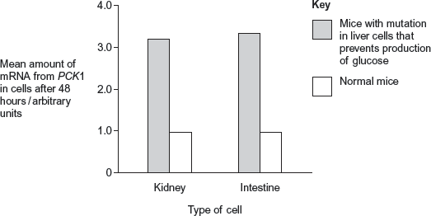

(b)     Use information from the graph to suggest how blood glucose concentration is controlled in the mutant mice, compared with the normal mice.

........................................................................................................................

........................................................................................................................

........................................................................................................................

........................................................................................................................

........................................................................................................................

........................................................................................................................

**[Extra space]** ................................................................................................

........................................................................................................................

........................................................................................................................

**(3)**

(c)     The scientists performed statistical tests on the data shown in the graph, to see whether the differences in the amount of mRNA in cells from normal and mutant mice were significant. Both the probability values they obtained were p<0.01.

Explain what this means about the differences in the amounts of mRNA produced.

........................................................................................................................

........................................................................................................................

........................................................................................................................

........................................................................................................................

........................................................................................................................

**[Extra space]** ................................................................................................

........................................................................................................................

**(2)**

**(Total 8 marks)**

**Q2.**The release of a substance called dopamine in some areas of the brain increases the desire to eat.

Scientists measured increases in the release of dopamine in the brains of rats given different concentrations of sucrose solution to drink.

Sucrose stimulates taste receptors on the tongue.

The graph shows their results. Each point is the result for one rat.

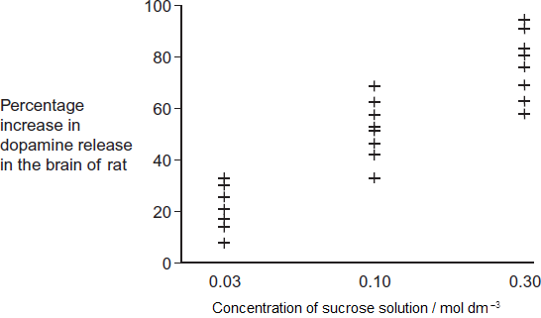

(a)     The scientists concluded that drinking a sucrose solution had a positive feedback effect on the rats’ desire to eat.

How do these data support this conclusion?

........................................................................................................................

........................................................................................................................

........................................................................................................................

........................................................................................................................

........................................................................................................................

........................................................................................................................

*(Extra space)*..................................................................................................

........................................................................................................................

........................................................................................................................

**(3)**

(b)     In this investigation, the higher the concentration of sucrose in a rat’s mouth, the higher the frequency of nerve impulses from each taste receptor to the brain.

If rats are given very high concentrations of sucrose solution to drink, the refractory period makes it impossible for information about the differences in concentration to reach the brain. Explain why.

........................................................................................................................

........................................................................................................................

........................................................................................................................

........................................................................................................................

........................................................................................................................

**(2)**

(c)     In humans, when the stomach starts to become full of food, receptors in the wall of the stomach are stimulated. This leads to negative feedback on the desire to eat. Suggest why this negative feedback is important.

........................................................................................................................

........................................................................................................................

........................................................................................................................

........................................................................................................................

........................................................................................................................

*(Extra space)*..................................................................................................

........................................................................................................................

........................................................................................................................

**(3)**

**(Total 8 marks)**

**Q3.**          Different substances are involved in coordinating responses in animals.

(a)     Synapses are unidirectional. Explain how acetylcholine contributes to a synapse being unidirectional.

......................................................................................................................

......................................................................................................................

......................................................................................................................

......................................................................................................................

......................................................................................................................

**(2)**

(b)     Cells in the stomach wall release gastric juice after a meal. The graph shows how the volumes of gastric juice produced by nervous stimulation and by hormonal stimulation change after a meal.

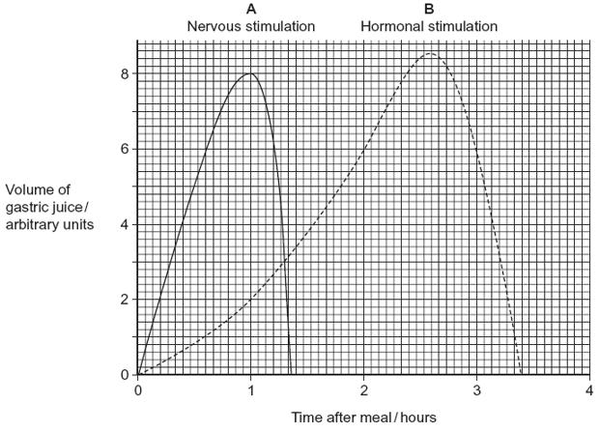

(i)      Describe the evidence from the graph that curve **A** represents the volume of gastric juice produced by nervous stimulation.

.............................................................................................................

.............................................................................................................

.............................................................................................................

.............................................................................................................

**(2)**

(ii)     Complete the table to show the percentage of gastric juice produced by nervous stimulation at the times shown.

|  |  |  |  |  |
| --- | --- | --- | --- | --- |
|  |  | **Time after meal / hours** | | |
|  |  | **1** | **2** | **3** |
|  | Percentage of gastric juice produced by nervous stimulation |  |  |  |
|  |  |  |  |  |

**(1)**

**(Total 5 marks)**

**Q4.**          (a)     **Figure 1** shows the structure of a molecule of glycerol and a molecule of fatty acid.

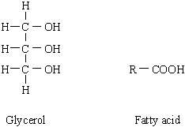

**Figure 1**

Draw a diagram to show the structure of a triglyceride molecule.

**(2)**

(b)     Explain why triglycerides are **not** considered to be polymers.

......................................................................................................................

......................................................................................................................

**(1)**

(c)     **Figure 2** shows two types of fat storage cell. Mammals living in cold conditions have more brown fat cells than mammals living in tropical conditions.

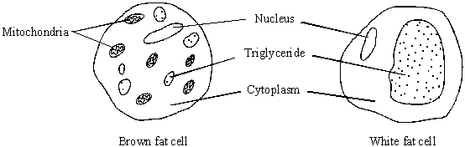

**Figure 2**

Using evidence from **Figure 2** to support your answer, suggest how the function of brown fat cells differs from that of white fat cells.

......................................................................................................................

......................................................................................................................

......................................................................................................................

......................................................................................................................

......................................................................................................................

......................................................................................................................

**(3)**

**(Total 6 marks)**

**Q5.**          The body temperature of desert-living lizards is greatly affected by the temperature of their environment. A lizard was placed in a chamber where one half was maintained at 20 °C and the other at 40 °C. The lizard was free to move from one half to the other. The lizard’s behaviour was observed using an infra-red camera, which records 20 °C surfaces as black and 40 °C surfaces as white. Temperatures between 20 °C and 40 °C appear as shades of grey. A series of photographs was taken.

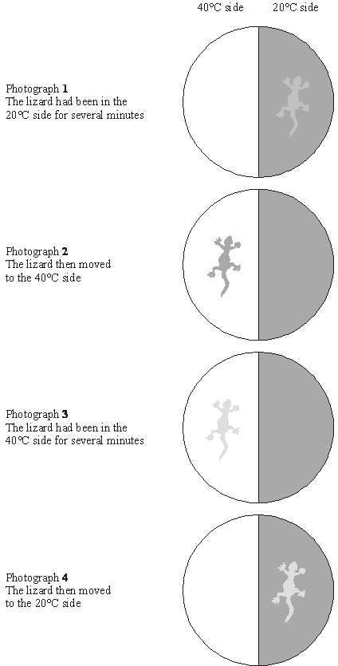

(a)     The position and appearance of the lizard, as recorded by the infra-red camera, changed during the experiment. Describe and explain these changes.

......................................................................................................................

......................................................................................................................

......................................................................................................................

......................................................................................................................

......................................................................................................................

......................................................................................................................

**(3)**

(b)Suggest the advantage to the lizard of the behaviour shown.

......................................................................................................................

......................................................................................................................

......................................................................................................................

......................................................................................................................

**(2)**

**(Total 5 marks)**

**Q6.**          (a)     (i)      What is meant by homeostasis?

.............................................................................................................

.............................................................................................................

**(1)**

(ii)     Giving **one** example, explain why homeostasis is important in mammals.

.............................................................................................................

.............................................................................................................

.............................................................................................................

.............................................................................................................

**(2)**

(b)     Cross-channel swimmers may suffer from muscle fatigue during which the contraction mechanism is disrupted. One factor thought to contribute to muscle fatigue is a decrease in the availability of calcium ions within muscle fibres. Explain how a decrease in the availability of calcium ions could disrupt the contraction mechanism in muscles.

......................................................................................................................

......................................................................................................................

......................................................................................................................

......................................................................................................................

......................................................................................................................

......................................................................................................................

**(3)**

**(Total 6 marks)**

**Q7.**          (a)     *Salmonella typhimurium* causes food poisoning in humans but not in other mammals. Explain why these bacteria attach to human cells but not to the cells of other mammals.

......................................................................................................................

......................................................................................................................

......................................................................................................................

......................................................................................................................

**(2)**

**S**       (b)     Salmonella bacteria release toxins that cause the body temperature to rise. Although a small increase in body temperature can be beneficial, a large increase can cause serious harm.

Explain how a large increase in a person’s body temperature can cause harm.

......................................................................................................................

......................................................................................................................

......................................................................................................................

......................................................................................................................

**(2)**

**S**       (c)     Some species of bacteria, which live in soil and decompose organic material, release exotoxins. Suggest how the release of exotoxins benefits the bacteria.

......................................................................................................................

......................................................................................................................

**(1)**

(d)     Washing hands with anti-bacterial soap reduces the risk of transmission of the bacteria that cause food poisoning. Tea tree oil is a plant extract used in soaps. It is claimed to have anti-bacterial properties. Outline a method for investigating this claim.

......................................................................................................................

......................................................................................................................

......................................................................................................................

......................................................................................................................

......................................................................................................................

......................................................................................................................

......................................................................................................................

......................................................................................................................

**(4)**

**(Total 9 marks)**

**Q8.**(a)     What is homeostasis?

........................................................................................................................

........................................................................................................................

**(1)**

(b)     Describe the role of the hormone glucagon in the control of blood sugar concentration.

........................................................................................................................

........................................................................................................................

........................................................................................................................

........................................................................................................................

........................................................................................................................

........................................................................................................................

........................................................................................................................

**(4)**

(c)     The kidney removes various substances from the blood plasma. The clearance value for a substance is the volume of blood cleared of that substance by the kidney in one minute. This clearance value can be calculated using the equation.



|  |  |  |
| --- | --- | --- |
|  | where the concentration of a substance in the blood is  the concentration of a substance in the urine is  the volume of urine produced is | P g cm-3 U g cm-3 V cm3 per minute |

(i)      Use the equation to work out the clearance value of glucose.

...............................................................................................................

...............................................................................................................

**(1)**

(ii)     Explain how the activity of the kidney results in this clearance value for glucose.

...............................................................................................................

...............................................................................................................

...............................................................................................................

...............................................................................................................

...............................................................................................................

...............................................................................................................

**(3)**

**(Total 9 marks)**

**Q9.**          Homeostatic mechanisms maintain a constant environment in the body.

(a)     The graph shows changes in plasma glucose concentration that occurred in a person who went without food for some time.

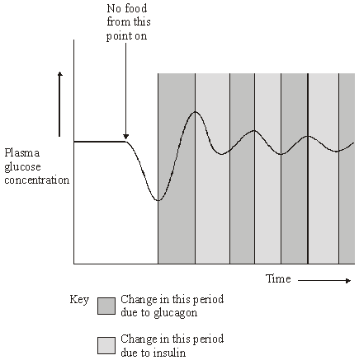

Use evidence from the graph to explain the role of negative feedback in the control of plasma glucose concentration.

......................................................................................................................

......................................................................................................................

......................................................................................................................

......................................................................................................................

......................................................................................................................

......................................................................................................................

......................................................................................................................

......................................................................................................................

......................................................................................................................

......................................................................................................................

......................................................................................................................

**(5)**

(b)     How does maintaining a constant body temperature allow metabolic reactions in cells to proceed with maximum efficiency?

......................................................................................................................

......................................................................................................................

......................................................................................................................

......................................................................................................................

......................................................................................................................

......................................................................................................................

......................................................................................................................

......................................................................................................................

......................................................................................................................

......................................................................................................................

**(5)**

**(Total 10 marks)**

**Q10.**          (a)     Technicians in a hospital laboratory tested urine and blood samples from a girl with diabetes at intervals over a one-year period. Each time the technicians tested her urine, they also measured her blood glucose concentration. Their results are shown in the graph.

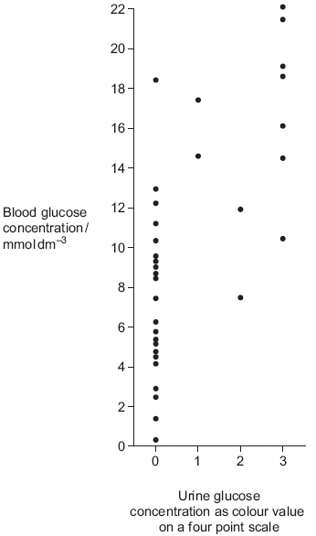

(i)      The girl who took part in this investigation was being successfully treated with insulin. The graph shows that on some occasions, the concentration of glucose in her blood was very high. Suggest why.

.............................................................................................................

.............................................................................................................

.............................................................................................................

.............................................................................................................

**(2)**

(ii)     Use the graph to evaluate the use of the urine test as a measure of blood glucose concentration.

.............................................................................................................

.............................................................................................................

.............................................................................................................

.............................................................................................................

.............................................................................................................

.............................................................................................................

**(3)**

(b)     Diabetic people who do not control their blood glucose concentration may become unconscious and go into a coma. A doctor may inject a diabetic person who is in a coma with glucagon. Explain how the glucagon would affect the person’s blood glucose concentration.

......................................................................................................................

......................................................................................................................

......................................................................................................................

......................................................................................................................

**(2)**

**(Total 7 marks)**

**Q11.**(a)     The control of water balance in the body involves negative feedback.

(i)      Describe what is meant by *negative feedback*.

...............................................................................................................

...............................................................................................................

...............................................................................................................

**(1)**

(ii)     Water is removed from the body via the kidneys. Give **two** other ways in which water is removed from the body.

1 ............................................................................................................

2 ............................................................................................................

**(2)**

(iii)    Name the part of the brain which acts as the coordinator in the control of water balance.

...............................................................................................................

**(1)**

(b)     **Figure 1** shows the cells lining the collecting duct in a human kidney. ADH molecules bind to the receptor proteins and this triggers the vesicles containing aquaporins to bind with the plasma membrane next to the lumen. **Figure 2** shows an aquaporin which is a large channel protein.

**Figure 1**

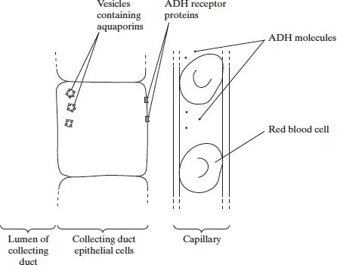

**Figure 2**

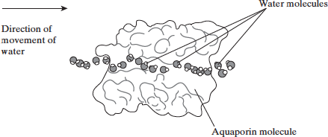

(i)      From which gland is ADH released?

...............................................................................................................

**(1)**

(ii)     Use the information given to explain how ADH increases the movement of water from the lumen of the collecting duct into the blood.

...............................................................................................................

...............................................................................................................

...............................................................................................................

...............................................................................................................

...............................................................................................................

...............................................................................................................

...............................................................................................................

...............................................................................................................

**(4)**

(c)     The gene for the ADH receptor proteins is found on the X chromosome. One allele of this gene causes a non-functioning receptor protein to be made. This allele is recessive and is one cause of the condition called diabetes insipidus.

(i)      What would be the most obvious symptom of diabetes insipidus?

...............................................................................................................

**(1)**

(ii)     Suggest why diabetes insipidus is more common in males.

...............................................................................................................

...............................................................................................................

...............................................................................................................

...............................................................................................................

**(2)**

(iii)    A recessive allele which has harmful effects is able to reach a higher frequency in a population than a harmful dominant allele. Explain how.

...............................................................................................................

...............................................................................................................

...............................................................................................................

...............................................................................................................

...............................................................................................................

...............................................................................................................

**(3)**

**(Total 15 marks)**

**M1.**(a)     1.      Release of glucagon;

2.      Leads to formation of glucose in liver (cells);

*Reject: glucagon breaks down glycogen, or any other biological molecule*

3.      From non-carbohydrates / amino acids / fatty acids.

*Accept: gluconeogenesis / references to glycogen as source of glucose*

**3**

(b)     1.      Mutant mice (mRNA suggests) make a lot of (the) enzyme;

*Accept: PCK1 made (for enzyme made)*

2.      Mutant mice use kidney / intestine (cells) to make glucose;

*Accept: use other organ (than liver)*

3.      Normal mice do this much less / normal mice use liver cells.

**3**

(c)     1.      Differences significant;

*Reject: references to results being significant once*

2.      Probability of difference being due to chance less than 0.01 / 1% / 1 in 100 / probability of difference not being due to chance more than 0.99 / 99% / 99 in 100.

*Ignore: references to 0.05 / 5% / 5 in 100*

**2**

**[8]**

**M2.**(a)     1.      Positive correlation between sucrose and dopamine concentrations / higher concentration of sucrose, more dopamine;

***Q*** *NB question is ‘How do these ...’, not ‘Do these ....*

*1. Ignore simple statements of numbers from graph without description of trend*

2.      So (dopamine) makes them want to drink / eat more (sucrose);

3.      Positive feedback because drinking / eating leads to wanting to drink / eat (even) more;

*3. It must be a clear statement of why this example is positive feedback, not inferred from points 1 and 2*

**3**

(b)     1.      (Refractory period) leads to discrete / separate nerve impulses / time when another nerve impulse can’t happen;

***OR***

(Refractory period) limits number of impulses per second / frequency of nerve impulses;

2.      When maximum frequency reached / exceeded, no further increase in information / all (higher) concentrations of sucrose seem the same;

**2**

(c)     1.      (Negative feedback) stops desire / wish to eat / appetite;

*1. Accept stops dopamine release (in this context)*

*1. Accept makes them feel full*

2.      (This) limits amount eaten / stops eating;

*2. Accept prevents constant eating*

3.      Prevents / reduces risk of obesity / too much energy intake;

*3. Accept prevents vomiting*

*Accept descriptions based on what would happen in absence of the feedback mechanism - or if stomach empty for points 1 and 2*

**3**

**[8]**

**M3.**          (a)     1.      (Acetylcholine) released from / in presynaptic side;

2.      Receptors in postsynaptic (side) / binds on postsynaptic (side);

*2. Mark for diffusion only awarded in context of unidirectional movement.*

**2**

(b)     (i)      1.      Rapid response;

2.      Short duration;

*Specific wording is not important. It is the principles that matter here.*

*Points may be made by referring to figures.*

**2**

(ii)

|  |  |  |  |
| --- | --- | --- | --- |
|  | 1 | 2 | 3 |
| Percentage | 80 | 0 | 0 |

*Ignore % sign.*

**1**

**[5]**

**M4.**          (a)     3 fatty acids attached;   
ester bond correct;

*(H on glycerol component, O attached to carbon, R at other end)*

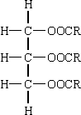

**2**

(b)     not made of monomers / many repeating units;

**1**

(c)     (many) mitochondria present in brown fat cells;   
mitochondria release heat / energy;(*ignore ATP*)  
white fat cells for fat storage / reduced fat storage in brown fat cells;

**3**

**[6]**

**M5.**          (a)     moves to 40 °C side, then later to 20 °C;  
gets lighter in hot side and darker in cool side;  
lighter as it absorbs heat / darker as it loses heat;  
by conduction / convection / radiation;

**3 max**

(b)     lizard finds favourable environment;  
(helps it to) maintain constant body temperature;  
advantage of this, e.g. for enzyme activity;

**2 max**

**[5]**

**M6.**          (a)     (i)      maintaining a constant internal environment;

**1**

(ii)     *one mark for example of factor kept constant; one mark for  
explaining its importance;*

e.g.  
temperature / pH; optimum for enzymes / effect of pH /   
temperature on enzyme activity;

*OR*

water potential / blood glucose;  
effect of osmotic / blood glucose imbalance on cells;

**2 max**

(b)     cannot interact with / move tropomyosin from binding sites on actin;  
*(reject active sites)*myosin(heads) do not bind / actinomyosin not formed;  
does not activate ATPase / energy not released from ATP;

**3**

**[6]**

**M7.**          (a)     bacteria have ligands / antigens / proteins / glycoproteins / polysaccharides (on membrane / wall);

**1**

complementary to receptors / fits / binds / attaches to specific receptor

**1**

(b)     enzymes denatured / tertiary / secondary structure altered / altered  
active sites / breaks hydrogen bonds;

**1**

prevents named chemical reactions / metabolic pathways;

**1**

(c)     inhibits / kills other bacteria / fungi / decomposers / reduces competition;

**1**

(d)     1       prepare a bacterial lawn / culture / sample;  
         *(accept mix bacteria with agar / medium)*2with oil and one with control / water / range of concentrations;  
3       appropriate method of standardising how sample applied,  
         e.g. discs / wells;  
4       appropriate measure of effectiveness / size / diameter of clear zone;  
5       the larger the zone the greater the effectiveness;  
6       use of aseptic technique;

*(ignore haemocytometer)*

**4 max**

**[9]**

**M8.**(a)     Maintaining a constant internal environment;

**1**

(b)     Binds to (specific) receptor;

On muscle / liver cell;

Activation of enzymes (in liver);

Hydrolysis of glycogen;

(Facilitated) diffusion of glucose out of (liver cells) cells;

Increases blood glucose levels;

**4**

(c)     (i)      0 / zero;

**1**

(ii)     1.      Filtration, out of blood (plasma) / into renal capsule;

2.      (Hydrostatic) pressure ;

3.      PCT;

4.      All reabsorbed;

5.      Active transport;

**3 max**

**[9]**

**M9.**          **Quality of Communication**

The answers to all sections of this question require the use of continuous prose.  
Quality of language should be considered in crediting points in the scheme. In order to gain credit, answers should be expressed logically and unambiguously, using scientific terminology where appropriate.

(a)     1.      Deviation of a value from norm initiates corrective mechanisms;

2.      fluctuations in plasma glucose concentration detected by hypothalmus / islet cells in pancreas;

3.      initial decrease, no food given (in plasma glucose) stimulates (increased) secretion of glucagon;

4.      increases (in plasma glucose) stimulate (increased) secretion of insulin from β cells as secretors;

5.      correct ref. to interconversion of glycogen / glucose / increased / decreased uptake of glucose by cells (as appropriate) / correct ref to change in membrane permeability;

**5**

(b)     1.      Body temp. / 37 °C  is optimum temp for enzymes;

2.      excess heat denatures enzymes / alters tertiary structure / alters shape of active site / enzyme so substrate cannot bind / eq;

3.      reactions cease / slowed;

4.      too little reduces kinetic energy of molecules / moleculesmove more slowly;

5.      fewer collisions / fewer ES complexes formed’

**5**

**[10]**

**M10.**          (a)     (i)      Eaten;

Containing carbohydrate / sugar;

Glucose absorbed from intestine / into blood;

Long time after insulin injection / needs more insulin / has not taken insulin;

Does not convert glucose to glycogen / glucose not taken up from blood;

**2 max**

(ii)     Shows positive correlation / directly proportional;

A range of results for a particular value / values (for different colours) overlap;

Urine test only an arbitrary scale / not directly related to concentration / colour is subjective / few colour values;

*Accept description*

**3**

(b)     Glycogen to glucose / glycogenolysis by activating enzymes;

*If name incorrect this disqualifies.*

Gluconeogenesis;

*Allow explanation in terms of glucose from a non-carbohydrate / named non-carbohydrate source.*

**2**

**[7]**

**M11.**(a)     (i)      where a change triggers a response which reduces the effect of a change;

**1**

(ii)     e.g. sweating, breathing, defaecating, other valid example;

*(reject respiration  
evaporation not acceptable as a 2nd mark if sweating or breathing given)*

**2 max**

(iii)    hypothalamus;

**1**

(b)     (i)     pituitary;

*(ignore anterior pituitary)*

**1**

(ii)     1.       ADH causes vesicles containing aquaporins / aquaporins to be inserted into membrane / collecting duct wall / plasma;

2.       water enters cell through aquaporins;

3.       by osmosis / diffusion / down a water potential gradient;

4.       (from cell) to capillary;

5.       via interstitial fluid;

**4 max**

(c)     (i)     excessive urination / drinking / diluted urine / thirst;

**1**

(ii)     because males only have one X chromosome / do not have Y chromosome;

a single copy of the recessive allele will be expressed;

**2**

(iii)     recessive alleles can be carried by individuals without showing effects / dominant allele always expressed;

organism that are carriers more likely to reproduce / affected organism less likely to reproduce;

therefore recessive alleles are more likely to be passed on / dominant alleles less likely to be passed on;

**3**

**[15]**

**E1.**(a)     About a third of students correctly explained how glucagon would be involved in regulation of blood glucose concentrations in the mice and obtained 3 marks. Some students failed to mention what glucagon does, or where it acts. There were some students who got very confused between glucagon and glycogen and others who wrote about glucagon either acting on glycogen to break it down, or had glucagon broken down into glucose. This question showed weaknesses in use of language and terminology by many students.

(b)     This was marked by a very large number of students who wrote about large amounts of mRNA but did not link this to large amounts of the enzyme PCK1. These answers were simply describing the results shown in the graph, not giving a suggestion about how the process is controlled. The examiners required students to show understanding that large amounts of mRNA would (probably) mean large amounts of the enzyme. It should be noted that quite a large number of students wrote about mRNA breaking down glycogen (as an enzyme), or being broken down into glucose. Many students did write about the role of the enzyme in kidney and intestinal cells in producing glucose. However, many of these did not compare this with what happens in the normal mice referred to in the question. Some weak answers simply involved attempts to use rote-learned material about control of blood glucose concentration with no reference to the information in the question.

(c)     This again had students writing about the results / data being significant, rather than the difference in the amounts of mRNA, as given in the stem. Quite a few ignored the ‘less than’ symbol, or read it as ‘more than’. Others ignored the 0.01 and wrote entirely about less than 5%, which did not gain credit.

**E2.**(a)     The question asks *‘How do* these data support this conclusion?’ A significant number of students appeared to re-write the question as, ‘Do these data support the conclusion?’, or ‘Evaluate the conclusion.’ In either event, they tended to launch into rote *How Science Works* responses about correlation not proving causation, not enough rats in the study, only one study, the spread of the data, etc. This approach did not gain credit. Many (fifty percent) did obtain one mark for noting the positive correlation between concentration of sucrose and increase in dopamine release. A third of students then obtained a second mark for linking the increase in dopamine to an increased desire to eat. Only a minority obtained the third mark for clearly stating that this was positive feedback because drinking the sucrose leads to wanting to drink more.

(b)     About a third of candidates scored 0 because they could not say what the refractory period is, or what it does. Those who had some idea usually wrote about it leading to discrete nerve impulses, or being a time when no new impulse could form, and scored one mark. Under twenty percent of students were able to link this to a limit on the frequency of nerve impulses, or to a limit in information about concentration that could reach the brain.

(c)     Few students failed to score on this question; about a third scored one mark and just over forty percent obtained two marks. Marking points 1 and 2 were the ones most commonly awarded. Only a minority obtained a third mark by making a reasonable suggestion about the importance of limiting eating. A high number of students thought that the stomach, or person would burst.

**E3.**          (a)     Those candidates who focused clearly on the relevant aspects of synaptic transmission produced excellent answers. Others, however, produced lengthy accounts that included much that was of, at best, marginal relevance.

(b)     Although candidates encountered few problems in extracting the relevant information from the graph in part (i), they experienced much greater difficulty in expressing 8 as a percentage of 10 despite, in some cases, identifying clearly on the graph the relevant numbers.

**E4.**          (a)     Most candidates made an attempt to add three fatty acids to the glycerol but fewer could then draw the correct bonds.

(b)     The concept of a monomer was generally poorly understood, with glycerol and fatty acids often referred to as the only two monomers making up the triglyceride. Many candidates referred to the presence of different R groups being the reason for the molecule not being considered a polymer.

(c)     Very few candidates appreciated the white fat cell’s involvement in fat storage. Although most noted the mitochondria in the brown fat cell and associated this with respiration, the process was not linked to energy or heat release but often to active transport. Some candidates were confused over basic concepts involving energy, referring to ‘creating’ or ‘making’ energy.

**E5.**          (a)    Most candidates scored one or two marks here. Almost all got the simple mark for describing the movements of the lizard from 20°C to 40 °C and back again. Somewhat fewer got a second mark for referring to the idea that the lizard gained or lost heat from or to its environment, depending upon where it was. A minority of candidates got a third mark for noting the changes in shades of grey of the lizard. Very few made any reference to the way in which heat might be lost or gained by the lizard.

(b)     A majority of candidates obtained one mark for the idea of the lizard’s behaviour allowing it to control or maintain its body temperature. Many then obtained a second mark for linking this to enzyme activity or some aspect of metabolic rate.

**E6.**          This question produced a wide range of marks. Nevertheless, it was generally well answered by the majority of candidates.

(a)     (i)      Although many candidates obtained this mark, there were a number of vague definitions which did not clearly link homeostasis to the internal environment.

(ii)     Candidates had little difficulty giving one example of homeostasis, usually referring to thermoregulation or control of the blood glucose concentration. Most candidates who obtained a second mark referred to the effect of change of temperature on enzyme activity.

(b)     There were many excellent descriptions of the role of calcium in muscle contraction. However, there were a few common errors and omissions. There were frequent references to ‘active site’ rather than ‘binding site’ and a significant number of candidates did not mention actin. A minority of candidates attempted to answer this question in terms of the role of calcium in synaptic transmission.

**E7.**          (a)     Answers were generally good but some candidates confused the position of ligands and receptors. Some candidates did not know that humans are mammals.

(b)     Most candidates gained the mark for enzymes being deactivated but then failed to describe a specific relevant effect.

(c)     Some candidates appreciated the use of exotoxins. Incorrect responses suggested that they digested organic material as an aid to nutrition.

(d)     This question was well answered across the whole ability range. Most candidates had seen or done a similar experiment and described the method well.

**E8.**This topic area seems generally well understood and many candidates were able to apply their knowledge effectively and gained credit. Careless use of terminology and lack of detail marred the answers of weaker candidates.

(a)     The definition was well learnt by the majority of candidates although some missed the idea of keeping conditions constant or gave a named example rather than the definition.

(b)     Generally this question was well answered but lack of precision in some answers cost candidates marks, for example, by failing to refer to receptors and/or identifying their location. Common misconceptions included the involvement of the pituitary and the hormone directly catalysing the conversion of glycogen to glucose thereby acting as an enzyme.

Weaker candidates confused glucagon with glycogen and usually scored only one mark for the idea of raising blood glucose levels. Diffusion of glucose out of cells into the blood was rarely seen.

(c)     A surprisingly high proportion of candidates correctly used the information given in the stem of the question and their own knowledge to work out the clearance value for glucose and go on to obtain full marks. Many of those unsure of the maths did explain the mechanism of reabsorption of glucose in the kidney and gained two or three marks. The most common omission was to the principle of all the glucose being reabsorbed and weaker candidates were also unsure of the precise location in the tubule where this process actually occurs.

**E9.**          **BYA6**

          (a)     Many candidates understood the control of plasma glucose concentration in great detail and were able to reproduce this. However, the question did not simply ask ‘how is plasma glucose concentration maintained?’, but required an explanation of the role of negative feedback in this control. Better candidates realised the distinction and began their answers by explaining the concept of negative feedback and then related this concept to the events shown in the graph. Naturally, they included the method of action of the hormones, but their responses showed a better balance between supplying detail and explaining principles than those who simply answered, once again, the question they assumed had been asked on the basis of one or two key words. Candidates failed to gain marks through confusion between glucagon and glycogen, despite the former being clearly named on the graph. There was also some confusion between what detected the changes in plasma glucose concentration and what subsequently secreted the hormones. Only better candidates were aware of the effect of insulin in stimulating the absorption of glucose from the plasma.

(b)     In this question nearly all candidates knew that enzymes have an optimum temperature, but too many failed to relate this specifically to core body temperature. They were also frequently careless in their description of the effect of temperature on enzymes. The phrase ‘enzymes are denatured by extremes of temperature’ was all too common. Clearly an extreme temperature of –10°C does not denature enzymes. Candidates also need to be more precise in their descriptions of how and why reactions take place. Reactions, in this context, take place because *molecules* of the enzyme and substrate have sufficient kinetic energy to collide frequently and with sufficient energy. Finally, some candidates re-used the term ‘maximum efficiency’ used in the question, without explaining what this meant in terms of rate of reaction.

**BYA7**

(a)     Most candidates were able to state that the release of insulin was triggered by increased plasma glucose concentrations and glucagon was triggered by a decrease. The more able then correctly identified the sites of secretion and their effects on the interconversions between glucose and glycogen. It was disappointing to see few candidates using the graph as instructed by the question and many candidates scored one less mark than perhaps they would have if they had used the graph more. As is often the case, frequent instances of imaginative intermediate spelling of glycogen and glucagon were observed and these were usually too ambiguous to be credited by the examiners.

(b)     This question produced some very comprehensive answers. Candidates had a good knowledge of thermoregulation. Examiners did not credit the term ‘cold centre’ and this term tended to be used only by the weaker candidates. The detail of vasoconstriction was explained very clearly by approximately 50% of candidates. The other 50% had muddled thought on this topic, with constriction of capillaries and veins and movement of capillary networks towards the centre of the body appearing in their answers.

Candidates who did not realise that the question was about enzymes struggled to score marks. The majority of candidates gained some credit. One common error was to refer to the effects of temperature on enzyme activity without direction. Better answers gave the effects of low temperatures quite separately from the effects of high temperatures.

**E10.**          (a)     In part (i), the simple statement that the girl may have eaten a meal rich in carbohydrate gained marks for many; others were able to relate high blood glucose concentration to insulin concentration. Given the scatter of points on the graph, it was perhaps unsurprising that relatively few candidates, in answering part (ii), commented on the positive correlation between the results of the two tests. Many, however, referred to the wide range of glucose concentrations corresponding to individual urine measurements. Candidates should be aware that when required to evaluate it is only fair that the information provided genuinely allows candidates to judge the worth of a particular data set or conclusion. As such, they should consider both how the argument is supported and how it fails to be supported.

(b)     Quality of Written Communication proved a challenge in the final part of this question. The more able candidates gained credit with succinct answers referring to glycogenolysis and gluconeogenesis. Others used the terms but were clearly confused by their meanings, or suggested rather predictably that glucagon could be converted into glucose.

**E11.**(a)     Although the definition in (i) produced a variety of responses, ranging from the short and precise to the lengthy and rambling, most were acceptable. Part (ii) was straightforward but two common errors were made, sometimes by good candidates. These were to give respiration or urination as responses. The hypothalamus was correctly identified by most candidates.

(b)     Part (i) was well answered though it appeared some candidates may not have noticed the presence of this question at the bottom of the page. Candidates did not usually find (ii) easy. Many used almost all the space writing about ADH without using the required information from **Figure 1**. Where the role of the aquaporins was understood it was not always made explicit in answers. Osmosis was usually considered and most candidates also appreciated that the aquaporins are bound to the membrane facing the lumen of the collecting duct. However, answers which detailed the whole process were few and far between.

(c)     Unfortunately, some candidates gave the impression of applying a prepared answer relating to the presence of glucose in the urine to this question and, obviously, gained no credit. The mark scheme allowed for all the major obvious symptoms and many of the better candidates obtained the mark.

Part (ii) produced good responses from the stronger candidates but very commonly weaker candidates did not appear to know that males had one X and one Y chromosome while females had two X chromosomes. The responses to (iii) were reasonable. The most common shortcoming was a failure to write in terms of probabilities with many candidates stating no more than that carriers of a recessive allele would reproduce while most of those with a dominant allele definitely would not reproduce. A handful of candidates thought that the question was looking for heterozygote advantage and answered in these terms.