**Q1.**Answers should be written in continuous prose, where appropriate.  
Quality of Written Communication will be assessed in these answers.

The kidney plays an important part in the regulation of blood water potential. This involves control of the amount of water reabsorbed from the filtrate produced in the kidney tubules. The amount of water reabsorbed affects the volume of urine produced, the rate at which the bladder fills and how often it has to be emptied.

(a)     Explain how the loop of Henle maintains the gradient of ions which allows water to be reabsorbed from filtrate in the collecting duct.

........................................................................................................................

........................................................................................................................

........................................................................................................................

........................................................................................................................

........................................................................................................................

........................................................................................................................

........................................................................................................................

........................................................................................................................

........................................................................................................................

........................................................................................................................

**(5)**

(b)     Explain how ADH is involved in the control of the volume of urine produced.

........................................................................................................................

........................................................................................................................

........................................................................................................................

........................................................................................................................

........................................................................................................................

........................................................................................................................

........................................................................................................................

........................................................................................................................

**(4)**

(c)     The diagram shows the systems involved in controlling the emptying of the bladder. In babies, emptying of the bladder is controlled by an autonomic reflex involving the internal sphincter muscle. Conscious control is learnt between the ages of two and three and involves the external sphincter as well.

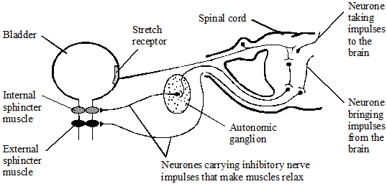

Using information in the diagram,

explain how the autonomic reflex arc is different from a simple reflex arc involving voluntary muscle;

........................................................................................................................

........................................................................................................................

........................................................................................................................

........................................................................................................................

**(2)**

**(Total 11 marks)**

**Q2.**A biologist investigated the stimulation of a Pacinian corpuscle in the skin of a fingertip.  
She used microelectrodes to measure the maximum membrane potential of a Pacinian corpuscle and its sensory neurone when different pressures were applied to the fingertip.

The figure below shows the Pacinian corpuscle, its sensory neurone and the position of the microelectrodes.

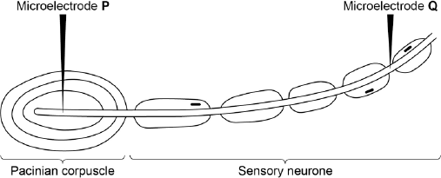

The table below shows some of the biologist’s results.

|  |  |  |  |
| --- | --- | --- | --- |
|  | **Pressure applied to the  fingertip** | **Membrane potential at P /  millivolts** | **Membrane potential at Q /  millivolts** |
|  | None | –70 | –70 |
|  | Light | –50 | –70 |
|  | Medium | +30 | +40 |
|  | Heavy | +40 | +40 |

(a)     Explain how the resting potential of –70 mV is maintained in the sensory neurone when no pressure is applied.

........................................................................................................................

........................................................................................................................

........................................................................................................................

........................................................................................................................

**(2)**

(b)     Explain how applying pressure to the Pacinian corpuscle produces the changes in membrane potential recorded by microelectrode **P**.

........................................................................................................................

........................................................................................................................

........................................................................................................................

........................................................................................................................

........................................................................................................................

........................................................................................................................

........................................................................................................................

........................................................................................................................

**(Extra space)** ................................................................................................

........................................................................................................................

........................................................................................................................

**(3)**

(c)     The membrane potential at **Q** was the same whether medium or heavy pressure was applied to the finger tip. Explain why.

........................................................................................................................

........................................................................................................................

........................................................................................................................

........................................................................................................................

**(2)**

(d)     Multiple sclerosis is a disease in which parts of the myelin sheaths surrounding neurones are destroyed. Explain how this results in slower responses to stimuli.

........................................................................................................................

........................................................................................................................

........................................................................................................................

........................................................................................................................

**(2)**

**(Total 9 marks)**

**Q3.**Multiple sclerosis (MS) is a disease that involves damage to the myelin sheaths of neurones. Movement in MS sufferers may be jerky or slow.

(a)     Damage to the myelin sheaths of neurones can lead to problems controlling the contraction of muscles.

Suggest **one** reason why.

........................................................................................................................

........................................................................................................................

........................................................................................................................

........................................................................................................................

........................................................................................................................

**[Extra space]** ................................................................................................

........................................................................................................................

**(2)**

Scientists investigated the use of substances called cannabinoids to control muscle problems caused by MS.

(b)     Cannabinoids are hydrophobic molecules. In the body, they easily pass into neurones.  
Explain why.

........................................................................................................................

........................................................................................................................

........................................................................................................................

**(1)**

(c)     Cannabinoid receptors are found in the **pre-synaptic** membrane of neuromuscular junctions. When a cannabinoid binds to its receptor, it closes calcium ion channels.

Suggest how cannabinoids could prevent muscle contraction.

........................................................................................................................

........................................................................................................................

........................................................................................................................

........................................................................................................................

........................................................................................................................

........................................................................................................................

........................................................................................................................

........................................................................................................................

**[Extra space]** ................................................................................................

........................................................................................................................

........................................................................................................................

........................................................................................................................

**(4)**

(d)     Cannabinoids include substances found in cannabis that can enter brain tissue. Scientists are developing artificial cannabinoids that can enter neuromuscular junctions but cannot enter brain tissue.

Suggest why these artificial cannabinoids would be better to use than cannabis when treating someone with MS.

........................................................................................................................

........................................................................................................................

........................................................................................................................

........................................................................................................................

**[Extra space]** ................................................................................................

........................................................................................................................

**(2)**

**(Total 9 marks)**

**Q4.**Malaria is a disease that is spread by insects called mosquitoes. In Africa, DDT is a pesticide used to kill mosquitoes, to try to control the spread of malaria.

Mosquitoes have a gene called *KDR*. Today, some mosquitoes have an allele of this gene, *KDR minus*, that gives them resistance to DDT. The other allele, *KDR plus*, does not give resistance.

Scientists investigated the frequency of the *KDR minus* allele in a population of mosquitoes in an African country over a period of 10 years.

The figure below shows the scientists’ results.

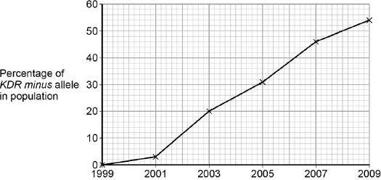

          Year

(a)     Use the Hardy–Weinberg equation to calculate the frequency of mosquitoes heterozygous for the *KDR* gene in this population in 2003.

Show your working.

Frequency of heterozygotes in population in 2003 ...................................

**(2)**

(b)     Suggest an explanation for the results in the figure above.

........................................................................................................................

........................................................................................................................

........................................................................................................................

........................................................................................................................

........................................................................................................................

........................................................................................................................

........................................................................................................................

........................................................................................................................

**(Extra space)** ................................................................................................

........................................................................................................................

........................................................................................................................

........................................................................................................................

........................................................................................................................

**(4)**

The *KDR plus* allele codes for the sodium ion channels found in neurones.

(c)     When DDT binds to a sodium ion channel, the channel remains open all the time.  
Use this information to suggest how DDT kills insects.

........................................................................................................................

........................................................................................................................

........................................................................................................................

........................................................................................................................

**(2)**

(d)     Suggest how the *KDR minus* allele gives resistance to DDT.

........................................................................................................................

........................................................................................................................

........................................................................................................................

........................................................................................................................

**(2)**

**(Total 10 marks)**

**Q5.**          (a)     Describe how calcium ions are involved in synaptic transmission.

......................................................................................................................

......................................................................................................................

......................................................................................................................

......................................................................................................................

**(2)**

Cocaine changes the way some synapses function.  
**Figure 1** shows a synapse in part of the brain. This synapse uses a neurotransmitter called dopamine.

**Figure 1**

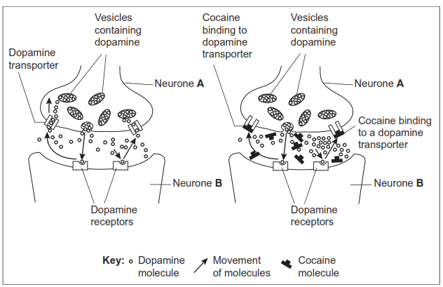

(b)     This synapse only transmits information from neurone **A** to neurone **B** and not from **B** to **A**. Give **one** reason why.

......................................................................................................................

......................................................................................................................

**(1)**

(c)     **Figure 2** shows the structures of molecules of dopamine and cocaine.

**Figure 2**

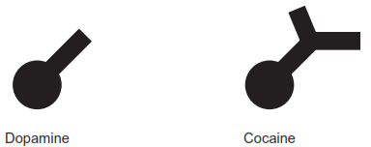

(i)      Explain why cocaine is able to bind to the dopamine transporter, as shown in **Figure 1**.

.............................................................................................................

.............................................................................................................

.............................................................................................................

.............................................................................................................

**(2)**

(ii)     Dopamine is released at synapses in parts of  the brain where pleasure is perceived.

Using information from **Figures 1** and **2**, explain how the use of cocaine can result in feelings of pleasure.

.............................................................................................................

.............................................................................................................

.............................................................................................................

.............................................................................................................

.............................................................................................................

.............................................................................................................

(*Extra space*) ......................................................................................

.............................................................................................................

.............................................................................................................

**(3)**

**(Total 8 marks)**

﻿

**Q6.**          (a)     **Figure 1** shows the changes in membrane potential at one point on an axon when an action potential is generated.

**Figure 1**

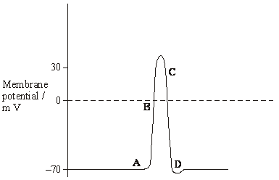

The changes shown in **Figure 1** are due to the movement of ions across the axon membrane. Complete the table by giving the letter (**A** to **D**) that shows where each process is occurring most rapidly.

|  |  |
| --- | --- |
| **Process** | **Letter** |
| Active transport of sodium and potassium ions |  |
| Diffusion of sodium ions |  |
| Diffusion of potassium ions |  |

**(2)**

(b)     **Figure 2** shows the relationship between axon diameter, myelination and the rate of conduction of the nerve impulse in a cat (a mammal) and a lizard (a reptile).

**Figure 2**

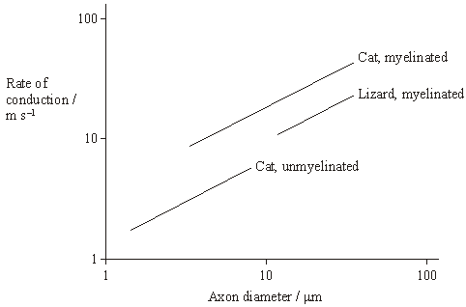

(i)      Explain the effect of myelination on the rate of nerve impulse conduction.

.............................................................................................................

.............................................................................................................

.............................................................................................................

.............................................................................................................

**(2)**

**S**       (ii)     For the same diameter of axon, the graph shows that the rate of conduction of the nerve impulse in myelinated neurones in the cat is faster than that in the lizard. Suggest an explanation for this.

.............................................................................................................

.............................................................................................................

.............................................................................................................

.............................................................................................................

.............................................................................................................

**(2)**

**Figure 3** shows how a stimulating electrode was used to change the potential difference across an axon membrane. Two other electrodes, **P** and **Q**, were used to record any potential difference produced after stimulation. The experiment was repeated six times, using a different stimulus potential each time. In experiments **1** to **4**, the stimulating voltage made the inside of the axon less negative. In experiments **5** and **6**, it made the inside of the axon more negative.

**Figure 3**

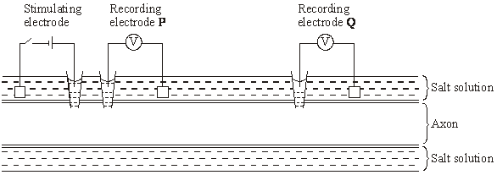

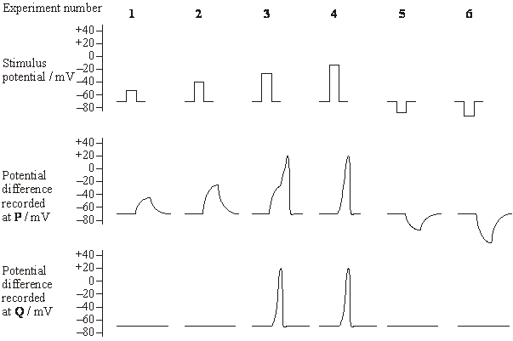

(c)     Explain the results of experiments **1** to **4**.

......................................................................................................................

......................................................................................................................

......................................................................................................................

......................................................................................................................

......................................................................................................................

......................................................................................................................

......................................................................................................................

......................................................................................................................

......................................................................................................................

**(5)**

(d)     **Figure 4** shows two neurones, **X** and **Y**, which each have a synapse with neurone **Z**.

**Figure 4**

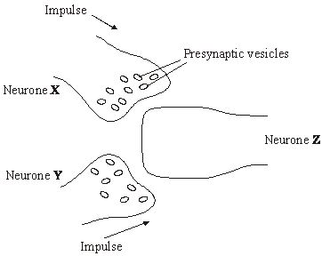

Neurone **X** releases acetylcholine from its presynaptic vesicles. Neurone **Y** releases a different neurotransmitter substance which allows chloride ions (Cl‑) to enter neurone **Z**. Use this information, and information from **Figure 3**, to explain how neurones **X** and **Y** have an antagonistic effect on neurone **Z**.

......................................................................................................................

......................................................................................................................

......................................................................................................................

......................................................................................................................

......................................................................................................................

......................................................................................................................

......................................................................................................................

......................................................................................................................

**(4)**

**(Total 15 marks)**

**Q7.**          Secretion of neurotransmitters into a synaptic cleft may produce an action potential in a postsynaptic neurone.

(i)      Explain how the release of acetylcholine at an excitatory synapse reduces the membrane potential of the postsynaptic membrane.

......................................................................................................................

......................................................................................................................

......................................................................................................................

......................................................................................................................

**(2)**

(ii)      Explain what causes transmission at a synapse to occur in only one direction.

......................................................................................................................

......................................................................................................................

......................................................................................................................

......................................................................................................................

**(2)**

(iii)     GABA is a neurotransmitter which inhibits the production of action potentials.  
The diagram and the graph show how the release of GABA from a presynaptic membrane affects the membrane potential of a postsynaptic membrane.

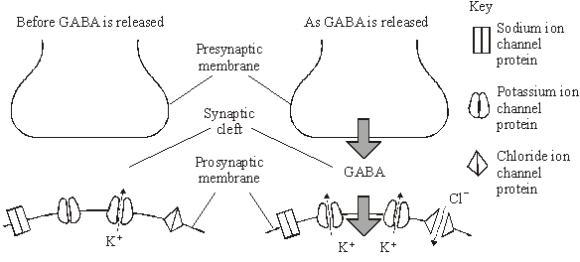

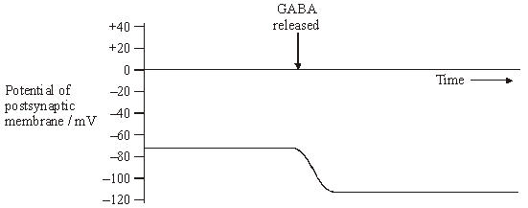

When the postsynaptic membrane is stimulated by acetylcholine, an action potential is less likely if GABA is released at the same time. Explain why.

......................................................................................................................

......................................................................................................................

......................................................................................................................

......................................................................................................................

......................................................................................................................

......................................................................................................................

......................................................................................................................

......................................................................................................................

**(4)**

**(Total 8 marks)**

**Q8.**          Different substances are involved in coordinating responses in animals.

(a)     Synapses are unidirectional. Explain how acetylcholine contributes to a synapse being unidirectional.

......................................................................................................................

......................................................................................................................

......................................................................................................................

......................................................................................................................

......................................................................................................................

**(2)**

(b)     Cells in the stomach wall release gastric juice after a meal. The graph shows how the volumes of gastric juice produced by nervous stimulation and by hormonal stimulation change after a meal.

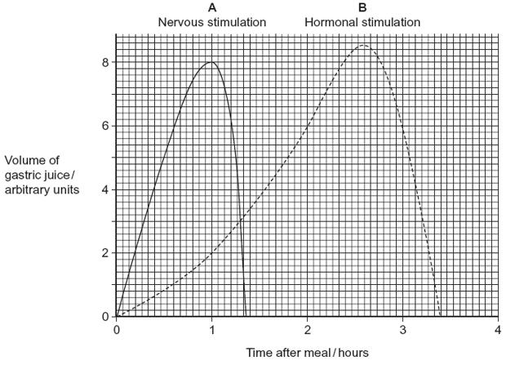

(i)      Describe the evidence from the graph that curve **A** represents the volume of gastric juice produced by nervous stimulation.

.............................................................................................................

.............................................................................................................

.............................................................................................................

.............................................................................................................

**(2)**

(ii)     Complete the table to show the percentage of gastric juice produced by nervous stimulation at the times shown.

|  |  |  |  |  |
| --- | --- | --- | --- | --- |
|  |  | **Time after meal / hours** | | |
|  |  | **1** | **2** | **3** |
|  | Percentage of gastric juice produced by nervous stimulation |  |  |  |
|  |  |  |  |  |

**(1)**

**(Total 5 marks)**

**Q9.**          The black mamba is a poisonous snake. Its poison contains a toxin.

The table shows the base sequence of mRNA that codes for the first two amino acids of this toxin.

|  |  |  |  |  |  |  |  |
| --- | --- | --- | --- | --- | --- | --- | --- |
|  | Base sequence of anticodon on tRNA |  |  |  |  |  |  |
|  | Base sequence of mRNA | **A** | **C** | **G** | **A** | **U** | **G** |
|  | Base sequence of DNA |  |  |  |  |  |  |

Complete the table to show

(a)     (i)      the base sequence of the anticodon on the first tRNA molecule that would bind to this mRNA sequence

**(1)**

(ii)     the base sequence of the DNA from which this mRNA was transcribed.

**(1)**

(b)     The length of the section of DNA that codes for the complete toxin is longer than the mRNA used for translation. Explain why.

........................................................................................................................

........................................................................................................................

........................................................................................................................

**(1)**

(c)     A mutation in the base sequence of the DNA that codes for the toxin would change the base sequence of the mRNA.

Explain how a change in the base sequence of the mRNA could lead to a change in the tertiary structure of the toxin.

........................................................................................................................

........................................................................................................................

........................................................................................................................

**(1)**

(d)     The black mamba’s toxin kills prey by preventing their breathing. It does this by inhibiting the enzyme acetylcholinesterase at neuromuscular junctions. Explain how this prevents breathing.

........................................................................................................................

........................................................................................................................

........................................................................................................................

........................................................................................................................

........................................................................................................................

........................................................................................................................

*(Extra space)* .................................................................................................

........................................................................................................................

........................................................................................................................

**(3)**

**(Total 7 marks)**

**Q10.**(a)     Describe the roles of calcium ions and ATP in the contraction of a myofibril.

........................................................................................................................

........................................................................................................................

........................................................................................................................

........................................................................................................................

........................................................................................................................

........................................................................................................................

........................................................................................................................

........................................................................................................................

........................................................................................................................

........................................................................................................................

**(Extra space)** ................................................................................................

........................................................................................................................

........................................................................................................................

........................................................................................................................

........................................................................................................................

**(5)**

(b)     ATP is an energy source used in many cell processes. Give **two** ways in which ATP is a suitable energy source for cells to use.

1 .....................................................................................................................

........................................................................................................................

2 .....................................................................................................................

........................................................................................................................

**(2)**

**(Total 7 marks)**

**Q11.**          Cocaine is a highly addictive and illegal drug.

The release of the neurotransmitter dopamine in specific synapses in the brain leads to feelings of pleasure. Dopamine is removed from synapses by dopamine transporter proteins in the plasma membrane of neurones. Cocaine binds to the dopamine transporter protein.

**Figure 1** shows a dopamine transporter protein and molecules of cocaine and dopamine.

**Figure 1**

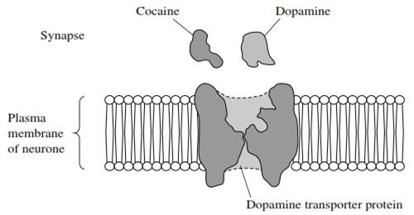

(a)     Using all of the information, suggest how cocaine leads to feelings of pleasure.

.......................................................................................................................

.......................................................................................................................

.......................................................................................................................

.......................................................................................................................

.......................................................................................................................

.......................................................................................................................

*(Extra space) ................................................................................................*

.......................................................................................................................

.......................................................................................................................

**(3)**

(b)     (i)      Scientists isolated a mutated gene for the dopamine transporter protein.

Name **one** method that the scientists could have used to produce many copies of the mutated gene in the laboratory.

.............................................................................................................

**(1)**

(ii)     Copies of the gene were then inserted into early embryos of mice. When these mice were born, samples of their DNA were tested using DNA probes to make sure that the mutated gene was present in the mice.

What is a DNA probe?

.............................................................................................................

.............................................................................................................

.............................................................................................................

.............................................................................................................

**(2)**

(c)     **Figure 2** shows dopamine transporter proteins produced from the normal gene and from the mutated gene.

**Figure 2**

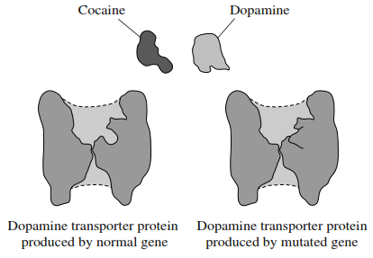

Explain how the mutation leads to the production of a protein that transports dopamine but is **not** affected by cocaine.

.......................................................................................................................

.......................................................................................................................

.......................................................................................................................

.......................................................................................................................

.......................................................................................................................

.......................................................................................................................

*(Extra space) ................................................................................................*

.......................................................................................................................

.......................................................................................................................

**(3)**

**(Total 9 marks)**

**Q12.**          **Figure 1** shows changes in the membrane potential of a neurone during one action potential.

**Figure 1**

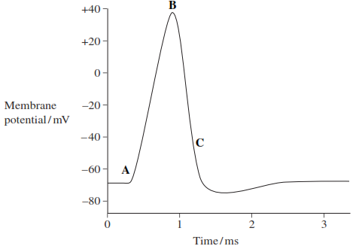

(a)     What happens in the membrane to cause the change in membrane potential at time **B**?

.......................................................................................................................

.......................................................................................................................

.......................................................................................................................

.......................................................................................................................

**(2)**

(b)     No further action potential can be produced between times **A** and **C**.

What is the name given to the period between times **A** and **C**?

.......................................................................................................................

**(1)**

(c)     **Figure 2** shows the force generated by a muscle when it was stimulated by different frequencies of nerve impulse.

**Figure 2**

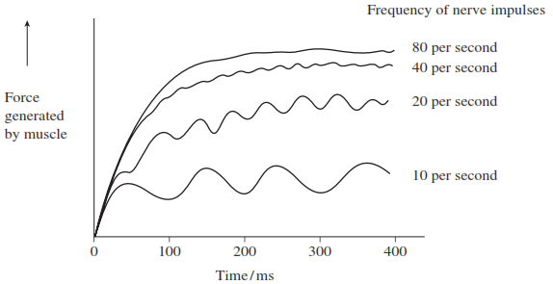

A taser is a device used by the police to arrest violent suspects. It fires electrical impulses very similar to action potentials into a suspect. The frequency of the impulses is between 15 and 20 per second.

(i)      Suggest the effect a taser has on a suspect’s muscles.

.............................................................................................................

.............................................................................................................

.............................................................................................................

.............................................................................................................

**(2)**

(ii)     Tasers with frequencies of between 40 and 80 per second are not used, because they are considered too dangerous. Suggest how they might be dangerous to a suspect.

.............................................................................................................

.............................................................................................................

.............................................................................................................

.............................................................................................................

**(2)**

**(Total 7 marks)**

**Q13.**          Scientists investigated the effect of different frequencies of stimulation on the production of action potentials by a neurone.

(a)     **Figure 1** shows a recording of the action potentials produced when the frequency of stimulation was 160 per second. At this frequency, each stimulus produced one action potential.

**Figure 1**

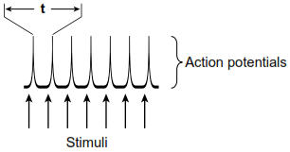

The time needed to complete one action potential is **t**, as shown in **Figure 1**. Calculate the value of **t**. Give your answer in milliseconds.

Show your working.

**t** = ............................. milliseconds

**(2)**

(b)     **Figure 2** shows the results when the frequency of stimulation was 200 per second.

**Figure 2**

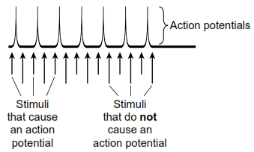

Not every stimulus in **Figure 2** produced an action potential.  
Explain why.

......................................................................................................................

......................................................................................................................

......................................................................................................................

......................................................................................................................

......................................................................................................................

......................................................................................................................

*(Extra space)*  ...............................................................................................

......................................................................................................................

......................................................................................................................

**(3)**

**(Total 5 marks)**

**Q14.**          The graph shows changes in membrane potential that occur during an action potential.  
It also shows changes in the permeability of the axon membrane to sodium and potassium ions.

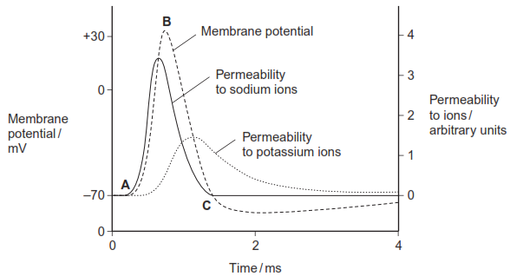

(a)     Explain what causes

(i)      the change in membrane potential between points **A** and **B**,

.............................................................................................................

.............................................................................................................

.............................................................................................................

.............................................................................................................

 .............................................................................................................

(ii)     the change in membrane potential between points **B** and **C**.

 .............................................................................................................

 .............................................................................................................

 .............................................................................................................

 .............................................................................................................

 .............................................................................................................

**(4)**

(b)     When a neurone transmits a series of impulses, its rate of oxygen consumption increases. Explain why.

......................................................................................................................

......................................................................................................................

......................................................................................................................

......................................................................................................................

......................................................................................................................

......................................................................................................................

*(Extra space)  ..............................................................................................*

......................................................................................................................

......................................................................................................................

**(3)**

**(Total 7 marks)**

**Q15.**          This question should be written in continuous prose, where appropriate.

(a)     Explain how a resting potential is maintained in a neurone.

......................................................................................................................

......................................................................................................................

......................................................................................................................

......................................................................................................................

......................................................................................................................

......................................................................................................................

......................................................................................................................

......................................................................................................................

**(4)**

(b)     In an investigation, an impulse was generated in a neurone using electrodes. During transmission along the neurone, an action potential was recorded at one point on the neurone. When the impulse reached the neuromuscular junction, it stimulated a muscle cell to contract. The force generated by the contraction was measured. The results are shown in the graph.

The distance between the point on the neurone where the action potential was measured and the neuromuscular junction was exactly 18 mm.

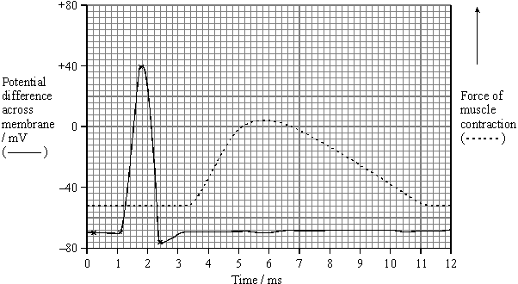

(i)      Use the graph to estimate the time between the maximum depolarisation and the start of contraction by the muscle cell.

Time ................................ ms

**(1)**

(ii)     Use your answer to part (i) to calculate the speed of transmission along this neurone to the muscle cell. Give your answer in mm per second.

Show your working.

Speed .................................. mm s–1

**(2)**

(iii)     Give **one** reason why the value calculated in part (ii) would be an underestimate of the speed of transmission of an impulse along a neurone.

.............................................................................................................

.............................................................................................................

**(1)**

Acetylcholine is the neurotransmitter at neuromuscular junctions.

(c)     Describe how the release of acetylcholine into a neuromuscular junction causes the cell membrane of a muscle fibre to depolarise.

......................................................................................................................

......................................................................................................................

......................................................................................................................

......................................................................................................................

......................................................................................................................

......................................................................................................................

**(3)**

(d)     Use your knowledge of the processes occurring at a neuromuscular junction to explain each of the following.

(i)      The cobra is a very poisonous snake. The molecular structure of cobra toxin is similar to the molecular structure of acetylcholine. The toxin permanently prevents muscle contraction.

.............................................................................................................

.............................................................................................................

.............................................................................................................

.............................................................................................................

**(2)**

(ii)     The insecticide DFP combines with the active site of the enzyme acetylcholinesterase. The muscles stay contracted until the insecticide is lost from the neuromuscular junction.

.............................................................................................................

.............................................................................................................

.............................................................................................................

.............................................................................................................

**(2)**

**(Total 15 marks)**

**Q16.**          The diagram shows the change in the charge across the surface membrane of a non-myelinated axon when an action potential is produced.

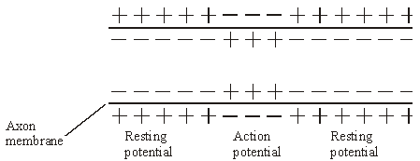

(a)     Describe how the change shown in the diagram occurs when an action potential is produced.

......................................................................................................................

......................................................................................................................

......................................................................................................................

......................................................................................................................

**(2)**

(b)     Explain what causes the conduction of impulses along a non-myelinated axon to be slower than along a myelinated axon.

......................................................................................................................

......................................................................................................................

......................................................................................................................

......................................................................................................................

......................................................................................................................

......................................................................................................................

**(3)**

**(Total 5 marks)**

**Q17.**Acetylcholine is a neurotransmitter which binds to postsynaptic membranes and stimulates the production of nerve impulses. GABA is another neurotransmitter. It is produced by certain neurones in the brain and spinal cord. GABA binds to postsynaptic membranes and inhibits the production of nerve impulses. The diagram shows a synapse involving three neurones.

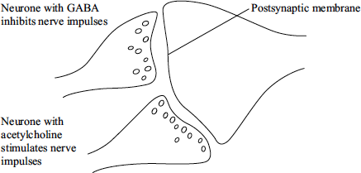

(a)     Describe the sequence of events leading to the release of acetylcholine and its binding to the postsynaptic membrane.

........................................................................................................................

........................................................................................................................

........................................................................................................................

........................................................................................................................

........................................................................................................................

........................................................................................................................

........................................................................................................................

........................................................................................................................

**(4)**

(b)     The binding of GABA to receptors on postsynaptic membranes causes negatively charged chloride ions to enter postsynaptic neurones. Explain how this will inhibit transmission of nerve impulses by postsynaptic neurones.

........................................................................................................................

........................................................................................................................

........................................................................................................................

........................................................................................................................

........................................................................................................................

........................................................................................................................

**(3)**

(c)     Epilepsy may result when there is increased neuronal activity in the brain.

(i)      One form of epilepsy is due to insufficient GABA. GABA is broken down on the postsynaptic membrane by the enzyme GABA transaminase. Vigabatrin is a new drug being used to treat this form of epilepsy. The drug has a similar molecular structure to GABA. Suggest how Vigabatrin may be effective in treating this form of epilepsy.

...............................................................................................................

...............................................................................................................

...............................................................................................................

...............................................................................................................

**(2)**

(ii)     A different form of epilepsy has been linked to an abnormality in GABA receptors. Suggest and explain how an abnormality in GABA receptors may result in epilepsy.

...............................................................................................................

...............................................................................................................

...............................................................................................................

...............................................................................................................

...............................................................................................................

...............................................................................................................

**(3)**

(d)     During an epileptic seizure muscular contractions may occur. In which part of the brain would neuronal activity produce muscular contractions of the right leg?

........................................................................................................................

........................................................................................................................

........................................................................................................................

**(2)**

**(Total 14 marks)**

**Q18.**          When a finger accidentally touches a hot object, a reflex action occurs. The biceps muscle contracts, causing the arm to be flexed and the finger is pulled away. The diagram shows the arrangement of the bones in the arm, the muscles used for flexing and straightening the arm and the nervous pathways associated with the contraction of these muscles.

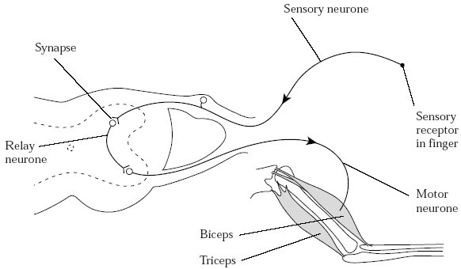

(a)     Explain the importance of reflex actions.

......................................................................................................................

......................................................................................................................

......................................................................................................................

......................................................................................................................

......................................................................................................................

......................................................................................................................

**(3)**

(b)     (i)      Describe the sequence of events which allows information to pass from one neurone to the next neurone across a cholinergic synapse.

.............................................................................................................

.............................................................................................................

.............................................................................................................

.............................................................................................................

.............................................................................................................

.............................................................................................................

.............................................................................................................

.............................................................................................................

.............................................................................................................

.............................................................................................................

.............................................................................................................

.............................................................................................................

**(6)**

(ii)     Give **two** differences between a cholinergic synapse and a neuromuscular junction.

1 ..........................................................................................................

.............................................................................................................

2 ..........................................................................................................

.............................................................................................................

**(2)**

**(Total 11 marks)**

**Q19.** The resting potential of a neurone is maintained by the unequal distribution of ions inside and outside the plasma membrane. The diagram shows the plasma membrane of a neurone and the three different proteins that are involved in maintaining the resting potential.

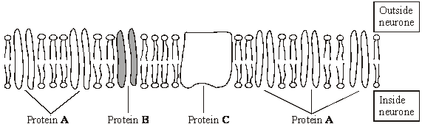

(a)     Protein **C** requires ATP to function. Describe the role of protein **C**.

......................................................................................................................

......................................................................................................................

......................................................................................................................

......................................................................................................................

**(2)**

**S** (b)     (i)      Proteins **A** and **B** differ from each other. Explain why different proteins are required for the diffusion of different ions through the membrane.

.............................................................................................................

**(2)**

(ii)     The plasma membrane of the neurone is more permeable to potassium ions than to sodium ions. Give the evidence from the diagram that supports this observation.

.............................................................................................................

.............................................................................................................

.............................................................................................................

.............................................................................................................

**(1)**

**(Total 5 marks)**

**Q20.**          (a)     The table shows the membrane potential of an axon at rest and during the different phases of an action potential. Complete the table by writing in each box whether the sodium ion (Na+) channels and potassium ion (K+) channels are open or closed.

|  |  |  |  |  |
| --- | --- | --- | --- | --- |
|  |  | **Resting** | **Starting to depolarise** | **Repolarising** |
|  | **Membrane potential/mV** | –70 | –50 | –20 |
|  | **Na+ channels in axon membrane** |  |  |  |
|  | **K+ channels in axon membrane** |  |  |  |

**(2)**

(b)     Describe how the resting potential is established in an axon by the movement of ions across the membrane.

......................................................................................................................

......................................................................................................................

......................................................................................................................

......................................................................................................................

**(2)**

**S**       (c)     Sodium and potassium ions can only cross the axon membrane through proteins.

Explain why.

......................................................................................................................

......................................................................................................................

......................................................................................................................

......................................................................................................................

**(2)**

**(Total 6 marks)**

**Q21.**The body loses heat quickly in cold water. A researcher investigated the effect of length of time in a bath of ice-cold water on the reaction times of 20 healthy people aged between 21 and 23 years of age.

She measured each person’s reaction time after being left in ice-cold water for 15, 30 or 45 seconds. She also recorded each person’s reaction time before being placed in the ice-cold water (0 seconds).

The table shows her results.

|  |  |  |  |
| --- | --- | --- | --- |
|  | **Length of time in bath of ice-cold water / seconds** | **Mean reaction time / seconds** | **Standard error** |
|  | **0** | 0.395 | 0.0124 |
|  | **15** | 0.301 | 0.0105 |
|  | **30** | 0.297 | 0.0212 |
|  | **45** | 0.326 | 0.0183 |

(a)     (i)      One reason that reaction time is slower when body temperature falls is because nerve impulse conduction is slower. Explain how a lower temperature leads to slower nerve impulse conduction.

...............................................................................................................

...............................................................................................................

...............................................................................................................

...............................................................................................................

**(2)**

(ii)     Other than temperature, give **two** factors that affect the speed of nerve impulse conduction.

1 .............................................................................................................

2 .............................................................................................................

**(2)**

(b)     Suggest the conditions that the researcher used when obtaining her data for 0 seconds.

........................................................................................................................

........................................................................................................................

........................................................................................................................

**(1)**

(c)     Explain how the researcher could use her **raw** data to find

(i)      the mode ...............................................................................................

...............................................................................................................

(ii)     the range ...............................................................................................

...............................................................................................................

**(2)**

(d)     A student reading the researcher’s report concluded that the difference between the results for 30 seconds and 45 seconds was significant. Do you agree with his conclusion? Explain your answer.

........................................................................................................................

........................................................................................................................

........................................................................................................................

........................................................................................................................

........................................................................................................................

........................................................................................................................

(Extra space) .................................................................................................

........................................................................................................................

........................................................................................................................

**(3)**

**(Total 10 marks)**

**Q22.**          During an action potential, the permeability of the cell-surface membrane of an axon changes. The graph shows changes in permeability of the membrane to sodium ions (Na+) and to potassium ions (K+) during a single action potential.

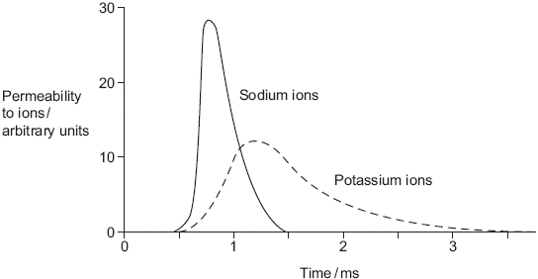

(a)     Explain the shape of the curve for sodium ions between 0.5 ms and 0.7ms.

......................................................................................................................

......................................................................................................................

......................................................................................................................

......................................................................................................................

......................................................................................................................

......................................................................................................................

**(3)**

(b)     During an action potential, the membrane potential rises to +40 mV and then falls. Use information from the graph to explain the fall in membrane potential.

......................................................................................................................

......................................................................................................................

......................................................................................................................

......................................................................................................................

......................................................................................................................

......................................................................................................................

**(3)**

(c)     After exercise, some ATP is used to re-establish the resting potential in axons. Explain how the resting potential is re-established.

......................................................................................................................

......................................................................................................................

......................................................................................................................

......................................................................................................................

**(2)**

**(Total 8 marks)**

**Q23.**Serotonin is a neurotransmitter released in some synapses in the brain. It is transported back out of the synaptic gap by a transport protein in the pre-synaptic membrane.

(a)     Serotonin diffuses across the synaptic gap and binds to a receptor on the post-synaptic membrane.

Describe how this causes depolarisation of the post-synaptic membrane.

........................................................................................................................

........................................................................................................................

........................................................................................................................

........................................................................................................................

........................................................................................................................

**(2)**

(b)     It is important that a neurotransmitter such as serotonin is transported back out of synapses. Explain why.

........................................................................................................................

........................................................................................................................

........................................................................................................................

........................................................................................................................

........................................................................................................................

**(2)**

(c)     Scientists investigated the effect of a drug called MDMA on movement of mice. They measured the amount of movement of three groups of mice, **K,** **L** and **M.**

•        Group **K,** mice not given MDMA.

•        Group **L,** mice given MDMA.

•        Group **M,** mutant mice that did not produce a serotonin receptor on their  
post-synaptic membranes and were given MDMA.

The graph shows their results.

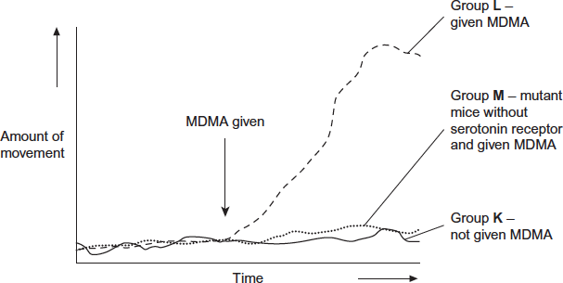

The scientists concluded that MDMA affects movement by binding to serotonin receptors.

How do these results support this conclusion?

........................................................................................................................

........................................................................................................................

........................................................................................................................

........................................................................................................................

........................................................................................................................

........................................................................................................................

*(Extra space)*.................................................................................................

........................................................................................................................

........................................................................................................................

**(3)**

**(Total 7 marks)**

**Q24.**(a)     A myelinated axon conducts impulses faster than a non-myelinated axon.  
Explain this difference.

........................................................................................................................

........................................................................................................................

........................................................................................................................

........................................................................................................................

........................................................................................................................

........................................................................................................................

**(3)**

Doctors investigated the relationship between myelin in brain tissue and different types of dementia. All types of dementia involve loss of mental ability.

The doctors measured the mean amount of myelin in samples of brain tissue from:

•        a control group of 12 people without dementia

•        20 people with vascular dementia (VaD)

•        19 people with Alzheimer's dementia (AD)

•        31 people with Lewy body dementia (LD).

The doctors’ results are shown in the figure. The vertical bars show standard errors.

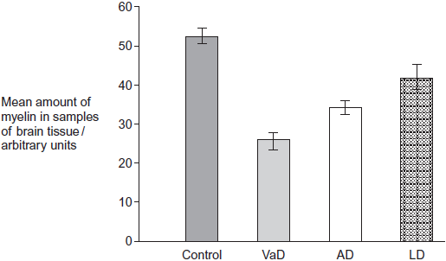

Group of people

(b)     The doctors used a statistical test to compare the results for AD and LD.  
They obtained a value for P of 0.047.

What does this result show about the difference between the means for AD and LD?

Use the words **probability** and **chance** in your answer.

........................................................................................................................

........................................................................................................................

........................................................................................................................

........................................................................................................................

**(2)**

(c)     A student who read this investigation concluded that there was a relationship between the amount of myelin in a person’s brain and whether or not they had dementia.

Do these data support this conclusion? Give reasons for your answer.

........................................................................................................................

........................................................................................................................

........................................................................................................................

........................................................................................................................

........................................................................................................................

........................................................................................................................

........................................................................................................................

........................................................................................................................

*(Extra space)* .................................................................................................

........................................................................................................................

........................................................................................................................

........................................................................................................................

**(4)**

**(Total 9 marks)**

**M1.**(a)     (epithelial cell) of tubule cells carry out active transport;

transport chloride / sodium ions out (of filtrate);

against concentration gradient;

into surrounding tissue / tissue fluid;

creates / maintains water potential gradient for water reabsorption;

countercurrent multiplier;

**5 max**

(b)     if water potential of blood falls, detected by receptors in hypothalamus;

leads to ADH released from pituitary gland;

ADH makes cells of collecting duct / distal convoluted tubule permeable to water;

*(accept DCT)*

water leaves filtrate by osmosis;

smaller volume of urine produced;

*(accept converse if water potential of blood rises)*

**4 max**

(c)     (autonomic reflex),  
autonomic ganglion involved;

extra synapse outside the spinal cord;

inhibitory rather than excitatory neurone;

more neurones involved;

**2 max**

**[11]**

**M2.**(a)     1.      Membrane more permeable to potassium ions and less permeable to sodium ions;

2.      Sodium ions actively transported / pumped out and potassium ions in.

**2**

(b)     1.      (Pressure causes) membrane / lamellae to become deformed / stretched;

2.      Sodium ion channels in membrane open and sodium ions move in;

3.      Greater pressure more channels open / sodium ions enter.

**3**

(c)     1.      Threshold has been reached;

2.      (Threshold or above) causes maximal response / all or nothing principle.

**2**

(d)     1.      Less / no saltatory conduction / action potential / impulse unable to ‘jump’ from node to node;

2.      More depolarisation over length / area of membranes.

**2**

**[9]**

**M3.**(a)     One suitable suggestion; explained;

E.g.

1.      Action potentials travel more slowly / don’t travel;

*Accept: fewer / no saltatory movement of potentials*

2.      So delay in muscle contraction / muscles don’t contract / muscles contract slow(er);

***OR***

3.      Action potentials / depolarisation ‘leaks’ to adjacent neurones;

*Accept: neurones not insulated*

4.      So wrong muscle (fibres) contract.

**2 max**

(b)     Lipid-soluble / pass through phospholipid bilayer.

*Not just ‘pass through membranes’*

**1**

(c)     1.      Prevents influx of calcium ions (into pre-synaptic membrane);

*Need idea of moving into pre-synaptic membrane / synaptic knob*

*Accept Ca++ / Ca2+*

2.      (Synaptic) vesicles don’t fuse with membrane / vesicles don’t release neurotransmitter;

*Accept vesicles don’t release acetylcholine*

3.      Neurotransmitter does not diffuse across synapse / does not bind to receptors (on post-synaptic membrane);

*Accept: sarcolemma / muscle membrane for post-synaptic membrane*

4.      No action potential / depolarisation (of post-synaptic membrane) / sodium (ion) channels do not open / prevents influx of sodium ions.

*Accept Na+*

*Accept prevents depolarisation of muscle cell*

*Ignore: descriptions of events at post-synaptic membrane involving calcium ions and muscle contraction*

**4**

(d)     1.      They won’t affect synapses in brain;

2.      They won’t cause problems with the brain’s function / won’t damage brain;

*Accept: suitable named problem e.g. hallucination*

*Ignore: unqualified references to ‘side effects’*

*Accept: reference to addiction / harm of smoking (cannabis)*

3.      (So only the) muscle / neuromuscular junctions treated / affected.

**2 max**

**[9]**

**M4.**(a)      0.32.

*Correct answer = 2 marks*

*Accept 32% for 1 mark max*

*Incorrect answer but identifying 2pq as heterozygous = 1 mark*

**2**

(b)     1.      Mutation produced *KDR minus* / resistance allele;

2.      DDT use provides selection pressure;

3.      Mosquitoes with *KDR minus* allele more likely (to survive) to reproduce;

4.      Leading to increase in *KDR minus* allele in population.

**4**

(c)     1.      Neurones remain depolarised;

2.      So no action potentials / no impulse transmission.

**2**

(d)     1.      (Mutation) changes shape of sodium ion channel (protein) / of receptor (protein);

2.      DDT no longer complementary / no longer able to bind.

**2**

**[10]**

**M5.**          (a)     (Nerve impulse causes) Ca2+ to enter presynaptic neurone/membrane;

(Ca2+ entry) causes fusion of vesicles with presynaptic membrane /  
causes exocytosis / release of transmitter;

**2**

(b)     Vesicles / neurotransmitter / dopamine (only) in / from A;

***OR***

Receptors (only) on B;

**1**

(c)     (i)      Dopamine and cocaine have similar shapes (in part);

Cocaine can fit transporter;

*Reject ref. to ‘active site’*

**2**

(ii)     Cocaine blocks transport of dopamine out of gap / into A;

Dopamine concentration rises / is maintained / remains;

*Ignore ref. to ‘active site’*

Continues to stimulate/bind to receptors;

Causes continued firing of impulses (in B);

**3 max**

**[8]**

**M6.**          (a)     In table:

|  |  |
| --- | --- |
| **D** | *All 3 correct = 2 marks;;* |
| **B** | *2 correct = 1 mark;* |
| **C** | *0 or 1 correct = 0 marks* |

**2**

(b)     (i)      myelin insulates / prevents ion movement; saltation / described   
re leaping node to node;

**2**

(ii)     cat has higher body temperature;  
*ignore references to homoiothermy’ / warm-blooded*faster diffusion of ions / faster opening of ion pores / gates / channels;

**2**

(c)     1       increasing stimulus (potential) causes decrease in potential  
difference / rise in potential at P;

2       1 or 2 is sub-threshold / 1 or 2 does not give action potential / 3 or 4 is above threshold / 3 or 4 does give an action potential;

3       influx of Na+ ions; *(not just Na / sodium)*

4       voltage-gated channels (in axon membrane) opens / opens Na+channels / membrane more permeable to Na+*(NOT just Na / sodium)*;

5       sufficient for stimulation of adjacent region of axon therefore impulse propagated (from P to Q);

**5**

(d)     1       X / Acetylcholine → opening of Na+ channels / increases  
Na+ permeability and Na+ ion entry into Z;

2       Y / Cl– entry - lowers potential / increases potential  
difference / makes potential more negative;

3       X stimulates and Y inhibits (Z);

4       balance of impulses from X and Y determines whether Z  
fires action potential / determines whether potential rises  
above threshold;

**4**

**[15]**

**M7.**          (i)      Binds to receptor / proteins; and opens Na+  channels;  
Na+  enter and make membrane potential less negative / depolarised

**2**

(ii)      (Vesicles containing) neurotransmitter only in presynaptic membrane /   
neurone;  
receptor / proteins only in postsynaptic membrane / neurone;

**2**

(iii)     GABA opens K+ and Cl– channels so K+  passes out and Cl–  passes in;  
Membrane potential more negative / hyperpolarised;  
Requires increased stimulation / must open more Na+ channels / allow  
more Na+ to enter;  
To reach threshold;

**4**

**[8]**

**M8.**          (a)     1.      (Acetylcholine) released from / in presynaptic side;

2.      Receptors in postsynaptic (side) / binds on postsynaptic (side);

*2. Mark for diffusion only awarded in context of unidirectional movement.*

**2**

(b)     (i)      1.      Rapid response;

2.      Short duration;

*Specific wording is not important. It is the principles that matter here.*

*Points may be made by referring to figures.*

**2**

(ii)

|  |  |  |  |
| --- | --- | --- | --- |
|  | 1 | 2 | 3 |
| Percentage | 80 | 0 | 0 |

*Ignore % sign.*

**1**

**[5]**

**M9.**         (a)     (i)     UGC;

**1**

(ii)     TGCTAC;

**1**

(b)     (DNA) contains introns / non-coding bases / mRNA only contains exons / coding bases;

*Assume that ‘it’ refers to DNA*

*Neutral: DNA contains introns and exons*

*Neutral: ‘splicing’*

*Neutral: pre-mRNA contains introns*

*Ignore refs. to start and stop codons*

**1**

(c)     Different primary structure / amino acid sequence / amino acid coded for;

*Reject: different amino acids produced / formed*

*Neutral: refs. to bonds*

**1**

(d)     1.      Acetylcholine not broken down / stays bound to receptor;

2.      Na+ ions (continue to) enter / (continued) depolarisation / Na+ channels (kept) open / action potentials / impulses fired (continuously);

3.      (Intercostal) muscles stay contracted / cannot relax;

*‘Muscles contract’ is not enough*

*Accept: diaphragm stays contracted / cannot relax*

**3**

**[7]**

**M10.**(a)     1.      Calcium ions diffuse into myofibrils from (sarcoplasmic) reticulum;

2.      (Calcium ions) cause movement of tropomyosin (on actin);

3.      (This movement causes) exposure of the binding sites on the actin;

4.      Myosin heads attach to binding sites on actin;

5.      Hydrolysis of ATP (on myosin heads) causes myosin heads to bend;

6.      (Bending) pulling actin molecules;

7.      Attachment of a new ATP molecule to each myosin head causes myosin heads to detach (from actin sites).

**5 max**

(b)     1.      Releases relatively small amount of energy / little energy lost as heat;

*Key concept is that little danger of thermal death of cells*

2.      Releases energy instantaneously;

*Key concept is that energy is readily available*

3.      Phosphorylates other compounds, making them more reactive;

4.      Can be rapidly re-synthesised;

5.      Is not lost from / does not leave cells.

**2 max**

**[7]**

**M11.**         (a)     Cocaine (binding) changes shape of transporter/prevents dopamine binding;

*Reject references to active site*

Transporter cannot move (bound) dopamine (through membrane / protein /  
into cell);  
Dopamine remains / builds up in synapses (leading to feelings of pleasure);

**3**

(b)     (i)      Polymerase chain reaction / PCR;

**1**

(ii)     Single-stranded DNA;

*Reject reference to a single strand of DNA*

Bases / sequence complementary to DNA / gene to be identified;

(Radioactively / fluorescent) labelled so that it can be detected;

**2 max**

(c)     Mutation changes base sequence of gene / DNA;

*Accept references to active site*

(Thus) changing amino acid sequence;  
Changes tertiary structure / shape of protein/transporter;  
Cocaine binding site changes/cocaine cannot bind;  
Dopamine can still bind (and be transported);

**3 max**

**[9]**

**M12.**          (a)     Potassium channels open (and K+ ions diffuse out);

*Accept references to sodium channels opening;*

Sodium channels close (and stops Na+ ions diffusion in);

*Leading to depolarisation;*

*Accept sodium pump (starts) to pump out sodium ions*

**2**

(b)     (Absolute) refractory (period);

**1**

(c)     (i)      Causes them to contract;

And relax;

Rapidly/twitch;

**2 max**

(ii)     Cause continuous muscle contraction;

*Accept a reasonable suggestion of harm ‒ linked  
to muscle contraction*

At high force;

Causing failure to breathe/heart stops pumping/  
damage to bones or joints;

**2 max**

**[7]**

**M13.**          (a)     Correct answer: 6 / 6.25 / 6.3;

*Ignore working*

*Allow 1 mark if decimal point in wrong position*

***OR***

   /   

*Allow 1 mark*

**2**

(b)     Ref. to ‘refractory period’;

Requires greater stimulation;To reach threshold / threshold cannot be reached / to cause depolarisation;

K + channels are open / more negative potential than resting potential /  
membrane is hyperpolarised;

Na + channels are inactive/are closed / sodium channels will not open;

**3 max**

**[5]**

**M14.**          (a)     (i)      A to B:

*Mark (i) and (ii) as a whole*

Sodium channels open / membrane more permeable to  
sodium (ions);

*Max 3 for each section*

Sodium ions enter;By diffusion / from high to low concentration;

*Allow ‘diffusion’ point ONCE only*

Ref. sodium ions have positive charge / cause change  
from negative to positive potential;

*Accept refs to sodium and potassium*

(ii)     After B:

Sodium channels close;Potassium channels open / membrane more permeable to  
potassium ions;Potassium ions leave;By diffusion / from high to low concentration (ONCE only);

**4 max**

(b)     (More) respiration;

*Reject anaerobic respiration*

(More) energy supplied / (more) ATP supplied;

*Reject ‘produce’ energy*

For active transport of ions / ‘sodium (-potassium) pump’ / pumping  
out sodium ions / for neurotransmitter synthesis / for vesicle movement;

*Accept named e.g.*

**3**

**[7]**

**M15.**          (a)     membrane relatively impermeable / less permeable to sodium ions / gated channels are closed / fewer channels;  
sodium ions pumped / actively transported out;  
by sodium ion carrier / intrinsic proteins;   
inside negative compared to outside / 3 sodium ions out for two potassium ions in;

*(if sodium mentioned but not in context of ions, negate 1 mark)*

**4**

(b)     (i)      1.6;

**1**

(ii)     18 ÷ 1.6 = 11.25;  
multiply by 1000 to convert from ms to s / 11 250;

*(correct method = 1 mark, i.e.  or × 1000)*

*(correct answer based on (b)(i) = 2 marks)*

**2**

(iii)     time for transmission / diffusion across the neuromuscular junction / synapse;  
time for muscle (fibrils) to contract;

**1 max**

(c)     movement by diffusion;  
binding to receptors on (post-synaptic) membrane;  
causing sodium channels to open / sodium ions to move in to muscle (cell);

**3**

(d)     (i)      toxin binds to / competes for / blocks the acetylcholine receptors;  
acetylcholine can not depolarise the membrane / the toxin does not cause depolarisation;

*(allow references to generating action potentials instead of depolarisation, do not allow references to impulses in muscles)*

**2**

(ii)     acetylcholinesterase is unable to breakdown acetylcholine;  
acetylcholine still available to depolarise the membrane /   
generate action potentials in the membrane;

**2**

**[15]**

**M16.**          (a)     sodium gates or channels open / increase in permeability of axon membrane to sodium ion;  
sodium ions enter axon;

**2**

(c)     non-myelinated – next section of membrane depolarised / whole  
membrane;  
myelinated – depolarisation / ion movement only at nodes;  
impulse jumps from node to node / saltatory conduction;

**3**

**[5]**

**M17.**          (a)     action potential arrives / depolarisation occurs;  
calcium ions enter synaptic knob;  
vesicles fuse with membrane;  
acetylcholine diffuses (across synaptic cleft);  
binds to receptors;

**4 max**

(b)     inside becomes more negatively charged / hyperpolarised; stimulation  
does not reach threshold level / action potential not produced;   
depolarisation does not occur / reduces effect of sodium ions entering;

**3**

(c)     (i)      inhibits enzyme (which breaks down GABA);  
more GABA available (to inhibit neurone);

*OR*

binds to (GABA) receptors;  
inhibits neuronal activity / chloride ions enter (neurone);

**2 max**

(ii)     receptors have different tertiary / 3D structure / shape not  
complementary;  
GABA cannot bind; inhibition of neuronal activity does not occur /   
chloride ions do not enter;

**3**

**[12]**

**M18.**         (a)     1. automatic (adjustments to changes in environment) / involuntary;  
2. reducing / avoiding damage to tissues / prevents injury / named injury  
    e.g. burning;  
3. role in homeostasis / example;  
4. posture / balance;  
5. finding / obtaining food / mate / suitable conditions;  
6. escape from predators;

*(ignore ‘danger’ or ‘harm’ unless qualified)*

**3 max**

(b)     (i)      1. (impulse causes) calcium ions / Ca++ to enter axon;  
2. vesicles move to / fuse with (presynaptic) membrane;  
3. acetylcholine (released);  
4. (acetylcholine) diffuses across synaptic cleft / synapse;  
5. binds with receptors on (postsynaptic) membrane;

*(reject active sites, disqualify point)*

6. sodium ions / Na+ enter (postsynaptic) neurone;

7. depolarisation of (postsynaptic) membrane;

8. if above threshold nerve impulse / action potential produced

**6 max**

(ii)     neurone to neurone and neurone to muscle;  
action potential in neurone and no action potential in muscle /   
sarcolemma;  
no summation in muscle;  
muscle response always excitatory (never inhibitory);  
some neuromuscular junctions have different neurotransmitters;

*(penalise ‘nerve’ once)*

**2 max**

**[11]**

**M19.**          (a)     Transports Na+ and K+ ;  
By active transport / pump / against concentration gradient;  
Restores ion balance after an action potential;  
[*reject* K+ out and Na+ in]

**2**

(b)     (i)     each protein has a specific tertiary structure / shape;  
because the ions have different sizes / shape / charge;  
[*reject* receptors binding]

**2**

(ii)     fewer protein B molecules, which transport sodium ions / more   
protein A molecules, which transport potassium ions;

**1**

**[5]**

**M20.**          (a)     closed open closed;  
closed closed open;

**2**

(b)     active transport / pump of Na+ out of axon;  
diffusion of K+ out of axon / little diffusion of Na+ into the axon;

**2**

(c)     can not pass through phospholipid bilayer;  
because water soluble / not lipid soluble / charged / hydrophilic /   
hydrated;

**2**

**[6]**

**M21.**(a)     (i)      1.      Slower diffusion;

*Accept description of diffusion eg ‘movement down concentration gradient’ but concept of slower is required*

2.      (Of) ions / Na+ / K+;

*Reference to ions is required. Reject other named ions, eg calcium ions*

*Ignore references to synaptic transmission or rates of respiration*

**2**

(ii)     1.      Myelination / saltatory conduction;

*Accept reference to presence of nodes of Ranvier*

2.      Axon diameter;

**2**

(b)     Keep everything the same but not in bath / at room temperature / same clothing as for immersion / sitting in empty bath / sitting in water at room temperature;

*Accept ‘normal’ or ‘comfortable’ as equivalent to room temperature*

*Ignore reference to body temperature*

**1**

(c)     (i)      (Find) the most common result / time / the result / time that occurs the most;

**1**

(ii)     Highest and lowest result / time;

*Accept ‘difference between highest and lowest results / times’*

**1**

(d)     1.      (Which is based on) mean of 20 people / large (enough) sample;

*This point is possible for students that suggest the difference is significant*

2.      (But) SE bars / confidence limits overlap;

*This point applies whether 1 × SE or 2 × SE is used*

3.      Reference to 0.297 ± 0.0424 / 0.326 ± 0.0366 / confidence limits = 2 × SE;

*This point rewards knowledge of use of 2 × SE (as per Students’ Statistics Sheet)*

4.      (So) difference is **not** significant;

*This point is only awarded after marking point 2 or marking point 3 has been given*

**3 max**

**[10]**

**M22.**          (a)     (Ion) channel proteins open, sodium in;

Changes membrane potential / makes inside of axon less  
negative / positive / depolarisation / reaches threshold;

More channels open / positive feedback;

*Accept other phrases for ion channel proteins providing that it is clear that it is something through which ions pass.  
Reject carrier.*

*First marking point relates to opening.  
Third point must relate to more (channels) opening.*

**3**

(b)     Potassium channels open;

Potassium out;

Sodium channels close;

*Do not penalise candidate who refers to sodium or potassium. Ions are mentioned in question.  
Reject pump*

**3**

(c)     Pump / active transport / transport against concentration gradient;

Of sodium from axon / sodium out / of potassium in;

*Do not penalise candidate who refers to sodium or potassium. Ions are mentioned in question*

**2**

**[8]**

**M23.**(a)     1.      Causes sodium ion channels to open;

*1. Reject if wrong sequence of events*

2.      Sodium ions enter (cell and cause depolarisation);

*Reject sodium on its own only once*

**2**

(b)     1.      (If not removed) keeps binding (to receptors);

*Accept answers based on what happens if it is transported out − ie what should happen*

2.      Keeps causing action potentials / depolarisation (in post-synaptic membrane);

*2. Accept keeps Na + channels open(ing)*

**2**

(c)     1.      Movement in all groups (about) same before MDMA;

***Q***

2.      MDMA increases movement in Group **L**;

*2. Accept normal mice for* ***L***

3.      Group **K** shows MDMA causes movement;

*3. Accept* ***K*** *is a control*

4.      No / little increase in mice without receptor / Group **M**;

**3 max**

**[7]**

**M24.**(a)     1.      (In myelinated) action potential / depolarisation only at node(s);

2.      (In myelinated, nerve impulse) jumps from node to node / saltatory;

3.      (In myelinated) action potential / impulse does not travel along whole length;

*The question is about speed of transmission, not repolarisation or related matters*

*Accept converse for non-myelinated*

**3**

(b)     1.      Probability of obtaining this difference by chance;

*Reject ‘results’ once only*

*This statement often split round 2.*

2.      Is less than 5% / less than 0.05 / less than one in twenty;

*Accept is 4.7% / 0.047 but reject less than 4.7% / 0.047*

*Accept correct greater than 95% / greater than 0.95 arguments*

3.      Difference is significant;

*Reject ‘results’ once only*

**2 max**

(c)     1.      (All) dementia results lower (than control group) / non-dementia result higher;

2.      Error bars do not overlap so differences are (possibly) significant;

*Neutral results*

*Accept not due to chance / statistically significant*

*In this context, accept references to standard deviation*

3.      Dementia may be due to other factors / not only due to a lack of myelin;

*Accept suitable named factor e.g. genetic*

4.      (Because) big / significant differences in myelin in different dementia;

*Not just ‘different’*

5.      Only small sample sizes / only one study / more data required;

**4 max**

**[9]**

**E1.**(a)     This question was a good discriminator, producing a full range of marks but relatively few candidates with all five. Many candidates displayed confusion about which processes occur in the loop of Henle and where. In addition, many ignored the instruction to explain how the loop maintains a gradient of ions and entered into general descriptions of the functions of the kidney tubule. Some candidates confused the functions of the loop of Henle and the collecting duct. Terminology was also a problem for some candidates, especially with regard to failure to refer to water potentials.

(b)     This question was a good discriminator, producing a full range of marks but relatively few candidates with all four. Many candidates obtained one or 2 two marks, usually for references to release of ADH from the pituitary gland, the resulting increase in permeability of the collecting duct, or the reduced volume of urine produced (or the converse). There were good answers which followed the whole train of events, starting with the stimulus of a lowering of the water potential of the blood (or a rise, or a change in blood volume and pressure) and its detection by appropriate named receptors. These answers then linked these events to the roles of the hypothalamus and pituitary glands and the release (or reduced release) of ADH.

(c)     This was not answered very well by most candidates, primarily because they did not appear to be able to compare the information in the diagram to what they were supposed to know about a simple reflex. It was particularly surprising how few made any reference to the autonomic ganglion shown in the diagram.

**E3.**(a)     Most students realised that damage to myelin sheaths would adversely affect transmission of nerve impulses / action potentials and about 50 percent of students scored 1 mark for this. Many failed to relate this effect to effects on muscle contraction; they just said that movement would be affected. As a result, only 30 percent obtained both marks. Some answers were marred by references to ‘signals’ or ‘messages’, rather than impulses.

(b)     This required some basic synoptic knowledge of membrane structure. Just over 40 percent of students correctly observed that the hydrophobic cannabinoids were lipid soluble, or would pass through the phospholipid bilayer.

(c)     Many answers to this part illustrated the importance of reading the stem of a question very carefully. The word ‘pre-synaptic’ was emboldened in the question. Despite this, a significant number of students saw ‘calcium ions’ and ‘muscle’ and wrote about muscle contraction, often in great detail. The examiners ignored this material. Amongst those who did read the question carefully, 30 percent obtained all 4 marks. Those who failed to score all the marks often got confused about where calcium ions flowed to, or what was released into the synapse; whether it was vesicles or neurotransmitter.

(d)     Most students focused on harmful effects of cannabis on brain tissue or function in this part and obtained 1 mark. Only just over 20 percent obtained a second mark by pointing out that the cannabinoids would only treat the muscle problems.

**E5.**          (a)     There was some imprecision and confusion over where calcium ions actually went when they triggered synaptic transmission. For some, this appeared to be into the synaptic cleft rather than into the presynaptic neurone. Others thought vesicles of neurotransmitter actually left the presynaptic neurone rather than fusing with its membrane. A substantial proportion confused synaptic transmission and muscle contraction, and phrased their answers in terms of the displacement of tropomyosin from actin.

(b)     Given the details shown in the diagram –clearly showing vesicles of neurotransmitter in one neurone and receptors on the other – it should have been relatively straightforward to explain why the transmission of information could only be in one direction. A substantial proportion of candidates ignored the diagram completely and constructed their answers in terms of the effect of the refractory period. Only just over half of the candidates got this right.

(c)     Nearly all candidates noticed the similarity in structure between the molecules of dopamine and cocaine, as shown in the diagram. Attempts at explaining complementarity, or ‘fit’, between the cocaine molecule and the dopamine transporter were sometimes rather weak – some merely repeated the question by referring to ‘binding’ while others chose incorrect terminology, suggesting that cocaine would fit into the ‘receptor’ rather than into the dopamine transporter.

In part (ii), most candidates scored 2 of the 3 marks available. They often had the right idea but did not necessarily express it with sufficient precision. Some could see from the diagram that the cocaine became bound to the dopamine transporter but did not explain the consequential failure of dopamine transport back into the presynaptic neurone and hence the accumulation of dopamine in the synaptic cleft. Others wrote rather loosely about stimulation of the postsynaptic neurone by dopamine without mentioning the receptors with which it combined or explaining that impulses would continue to be transmitted along the second neurone.

**E6.**          **Unit 6**

(a)     In order to answer this question, candidates needed to consider carefully when, during the course of an action potential, each of the processes of diffusion and active transport of Na+ and K+ ions was occurring most rapidly, rather than simply taking place. Many candidates were able to demonstrate their knowledge and understanding of these phenomena.

(b)     In (i), although nearly all candidates were aware of the process of saltatory conduction in increasing the rate of impulse transmission, fewer emphasised that the myelin sheath served to insulate the axon prevented the passage of ions. In (ii), there was much use of the terms ‘endotherm’ and ‘ectotherm’ with respect to the cat and the lizard but candidates frequently omitted to emphasise that the body temperature of the cat would generally be higher than that of the lizard.   Relatively few then went on to emphasise that the rate of diffusion of ions was increased at higher temperatures. Active transport and metabolic processes needed for the redistribution of ions were considered irrelevant to the rate of passage of a single impulse. (Although they were often referred to by candidates).

(c)     Given the diagrammatic representation of the effect of different-sized stimulus potentials on the potential difference recorded at two points along an axon, many candidates immediately recognised that stimuli 1 and 2 were sub-threshold whereas 3 and 4 did produce an action potential. More able candidates went on to explain how this worked with reference to opening ion-channels which allowed the influx of Na+ ions. Some explained that an action potential would then be propagated along the axon to the second recording electrode in accordance with the all-or-nothing nature of nerve impulse transmission. Common errors included mis-use of the terms potential and potential difference and which was increasing or decreasing, and the sudden appearance of the impulse at the second electrode with no reference to its transmission along the axon.

(d)     A major problem for many candidates in this section was the presupposition that acetylcholine, being the neurotransmitter of the parasympathetic nervous system, was essentially ‘inhibitory’ in its action. It is not. More astute candidates were able to explain in detail how acetylcholine released from neurone X would cause the opening of Na+ channels in the postsynaptic membrane, causing an influx of Na+ ions, whereas impulses in neurone Y would cause entry of Cl “ ions into neurone Z. Hence X was stimulatory and Y was inhibitory upon Z. Very few candidates went on to explain how the balance of impulses from X and Y could then modulate activity in neurone Z. Some candidates thought that X and Y would be antagonistic due to Cl” ions released from Y blocking the acetylcholine-binding sites on the postsynaptic membrane.

**Unit 7**

(a)     It was common to see B and C correctly identified but many candidates thought A represented active transport of sodium and potassium ions rather than D.

(b)     There were some pleasing descriptions of saltatory conduction but few candidates made reference to the insulating effect of myelin. However, the synoptic nature of part (ii) provoked an array of responses. The majority selecting to discuss ‘warm blooded’ versus ‘cold blooded’ failed to realise that this was irrelevant unless the lizard was actually colder. Other incorrect responses which were common included the facts that the cat was a predator and so needed faster actions, that natural selection had led to faster impulses and that the cat had more fat in its diet and so had more myelin. Several failed to register the same diameter of axon had been used and gave wider axon as their answer. Most of those who did correctly state that the cat would be warmer here did not explain the impact on the rate of ion movement but merely stated that temperature did have an effect.

(c)     It was pleasing to find many candidates were able to assimilate the large amount of data provided and use their own knowledge to explain the results. There was a wide appreciation of the threshold value needing to be reached for an action potential to be developed. Many candidates also included references to the opening of sodium ion channels and the entry of sodium ions into the axon, although these responses were often of a general nature rather than an explanation of the experimental data. Also, several failed to gain marks here because they failed to refer to ions. Generally, it was only the better candidates who referred to the ‘all-or-none’ principle and the propagation of an impulse. The failure to treat experiments 1 and/or 2 separately to 3 and/or 4 was a common error; many also referred to summation. Poor use of scientific terminology was common when explaining depolarisation; candidates confused less negative with there being a ‘greater potential difference’.

(d)     Most candidates tackled this question at length but responses contained a number of errors. Despite the term ‘antagonistic’ being used in the stem, several candidates described summation; many others explained that neurone X would be inhibitory because acetylcholine is the neurotransmitter of the parasympathetic system’. Several had the effects of neurone X and Y reversed and it was common to read about chloride ions being described as the neurotransmitter released from neurone Y. Some candidates believed that chloride ions released from Y would block the acetylcholine-binding sites on the membrane of Z. The direct effects of acetylcholine were often omitted; candidates described the occurrence of an action potential and propagation of an impulse instead. Good answers often included extra information about events before the release of neurotransmitter. The marks most commonly gained were those for acetylcholine causing entry of sodium ions into Z and chloride ion entry causing hyperpolarisation.

**E7.**          Better candidates were still able to score high marks. The failure to gain marks often resulted from a misreading of questions, rather than any apparent lack of knowledge

In part (i), some candidates thought that acetylcholine acts as an inhibitor and blocks the receptor protein sites of other neurotransmitters. Most candidates, however, knew that acetylcholine binds with receptor proteins in the postsynaptic membrane and that this leads to the opening of sodium ion channels allowing sodium ions to enter the postsynaptic neurone. It was pleasing to note an increase in the number of candidates specifically referring to *sodium ions*, rather than just sodium. In (ii), most knew that the neurotransmitter is produced in vesicles only found in the presynaptic knob and that receptor proteins are only found in the postsynaptic membrane. Some, however, just saw the phrase ‘transmission in one direction’ and disregarded the qualification ‘at a synapse’ and described how unidirectionality is maintained along an axon. In section (iii), most candidates could see that release of GABA at a synapse causes the potential of the postsynaptic membrane to become more negative, or hyperpolarised. A good number also noticed that GABA causes an increase in the number of potassium ion channels that are open and, as a result, an increase in the efflux of potassium ions. Fewer, however, noticed the opening of the chloride ion channels and the consequent influx of chloride ions. Candidates who had made these observations and deductions then, usually, had no problem in suggesting that threshold stimulation would require an increased number of sodium ion channels to be opened.

**E8.**          (a)     Those candidates who focused clearly on the relevant aspects of synaptic transmission produced excellent answers. Others, however, produced lengthy accounts that included much that was of, at best, marginal relevance.

(b)     Although candidates encountered few problems in extracting the relevant information from the graph in part (i), they experienced much greater difficulty in expressing 8 as a percentage of 10 despite, in some cases, identifying clearly on the graph the relevant numbers.

**E9.**         (a)      (i)      Most students correctly gave the base sequence of the anticodon as **UGC**.

(ii)     Almost all students correctly gave the base sequence of DNA as **TGCTAC**. However, a minority of weaker students failed to read the stem of the question carefully enough. They replaced the thymine bases in this sequence with uracil.

(b)     Most students were aware that DNA contains introns or mRNA only contains exons. Weaker students were often let down by vague answers, such as ‘mRNA contains exons’ and ‘mRNA is spliced’.

(c)     It was widely appreciated that a change in the base sequence of mRNA could result in different amino acids being coded for or would produce a change in the primary structure of the toxin. A common response seen by a minority of weaker students was ‘different amino acids are produced’. This was not credited.

(d)     Most students gained at least one mark for stating that acetylcholine would not be broken down. However, the ability to tell the rest of the story correctly proved to be a good discriminator. Weaker students often thought that depolarisation would be prevented, resulting in the muscles not being able to contract. Some students attempted to explain this in terms of the inability to reabsorb acetylcholine into the presynaptic membrane. They thought that this would prevent any further release of acetylcholine. It was usually only better students who went on to describe the opening of sodium ion channels. Similarly, the importance of the ‘continuous’ aspect of muscle contraction was only appreciated by the best students.

**E11.**          This question was answered well by many candidates. It was pleasing to see that most were able to interpret the information presented in the diagrams. In (a), about a fifth of candidates obtained all three marks and three fifths obtained one or two marks. Weaker candidates appeared not to have read the stem of the question carefully and some seemed to think that the transporter protein was an enzyme that made dopamine. Others thought that cocaine entered the cell instead of dopamine and produced the same effect as dopamine inside the cell. Part (c) was particularly well answered and over a third of candidates obtained all three marks.

**E12.**          In (a), the examiners allowed descriptions of depolarisation or the start of repolarisation of the membrane. Some candidates were confused between sodium, calcium, chloride and potassium ions. Others got the direction of movement of ions in the wrong direction, or by the wrong mechanism. It was not uncommon to see references to membrane potentials being due to sodium ions entering by facilitated diffusion, using energy from ATP. In (b), nearly two thirds of candidates correctly identified the refractory period. There were many good answers to (c)(i). It was pleasing to see that many candidates were able to predict the effect of the taser from the graph. Answers to (c)(ii) were often spoiled by a failure to state how high frequency tasers might be *too dangerous* to use. Many candidates wrote vaguely about damage to muscles, or it being very unpleasant. Better candidates suggested effects such as paralysis of breathing due to continuous contraction of muscles.

**E13.**          (a)     There were many bizarre calculations of the time taken for an action potential to be completed. Given that the frequency was 160 per second then, logically, each should have taken 11160 second which, when converted to milliseconds, gave an answer of 6.25 ms. Only about a tenth of candidates got this far, although as many more ended up with these digits but with the decimal point in the wrong position. The most improbable answer was in excess of 6 hours.

(b)     Over two-thirds of candidates made at least some headway with this question. Many knew the term refractory period and 1 or appreciated that greater stimulation was required to overcome the threshold if the axon were hyperpolarised. However, very few were able to give correct details regarding the closure or opening of Na+ and K+ channels in the axon membrane. Many candidates were side-tracked into extolling the benefits of the refractory period in terms of it preventing impulse transmission in the wrong direction which was irrelevant and scored no marks.

**E14.**          (a)     This question was well answered by the majority of candidates. Most had no problem in relating the changes in ion permeabilities to the changes in membrane potential shown in the graph. Some became a little confused by attempting to introduce the concept of a refractory period which was not really relevant to the portions of the graph referred to in the question. One prevalent error was the idea that K+ ions ‘entered’ the neurone rather than *leaving* it to cause a lowering of the membrane potential.

(b)     Most candidates linked the increased oxygen consumption to the increased energy use of the neurone during impulse transmission. Active transport of Na+ and K+ ions was often given as the main use of such energy, although some gained this mark for stating that re-synthesis of the neurotransmitter would consume energy. A point frequently overlooked was that *respiration* was the process that consumed the oxygen and released the energy.

**E15.**          (a)     Most candidates appreciated that the charge inside the neurone would be negative compared with the charge outside and they often gave a clear explanation about the pumping movement of sodium ions being the cause of this difference. The impermeable nature of the neurone membrane to the movement of sodium ions was less well understood and very few candidates gave an adequate explanation which compared the relative amounts of sodium ions on both sides of the membrane.

(b)     (i)      Surprisingly few candidates used the graph accurately to give the correct time between depolarisation and the beginning of muscle contraction; 1. 5 ms was a common error, which suggested candidates used the scale on the x axis carelessly. Those candidates who constructed lines on the graph to identify the time period usually got the right answer.

(ii)     Most candidates understood that speed was calculated as distance over time, but very few correctly converted ms to s.

(iii)     This proved to discriminate well. Many candidates gave a valid suggestion about the role of a neuromuscular junction or the time it takes for muscle filaments to move. Unfortunately, a significant number missed the point of the question and discussed different types of neurone, the presence of a myelin sheath, the diameter of neurones, or the distance between nodes of Ranvier.

(c)     A significant number of candidates began the description too early by including the detail about the movement of vesicles containing neurotransmitter towards the presynaptic membrane. Also, some failed to gain a mark by referring to the location of neurotransmitter receptors on the motor end plate rather than on a sarcolemma or a cell membrane. The depolarisation of a muscle fibre by the movement of calcium ions is a common misconception.

(d)     Both parts of this question were answered well by a large proportion of candidates.

**E16.**          (a)     Most candidates scored both marks. Some candidates missed marks because they failed to mention in which direction the sodium ions moved, or gave poor descriptions in which it was not clear where the ions moved to.

(b)     This was less well answered. Nearly all candidates scored at least one mark but only the best gave a full description of the differences in conduction of impulses along the two types of axon. Description of transmission along a myelinated axon was often limited to a reference to the impulse jumping from node to node. Weaker candidates often referred to the myelin sheath insulating the nerve, or charges leaking out of unmyelinated axons. Many did not make a comparison and wrote about one type of axon only.

**E17.**          Although this question provided fewer high scoring marks than Question 8, it was still well answered by the majority of candidates

(a)     Synaptic transmission is clearly well known by the vast majority of candidates and many of them obtained maximum marks. However, there were still a few misconceptions or errors by weaker candidates. ‘vesicles moving across the synaptic cleft’ and references to ‘receptor cells’ appeared quite often.

(b)     This proved to be the most difficult part of Question 9 and proved to be an excellent discriminator. Only the best candidates gained all three marks displaying a full understanding of the inhibitory effect of negatively charged ions on the transmission of nerve impulses. Most candidates did not refer to the inside of the neurone becoming *more* negative although they often gained a mark for realising that depolarisation would not occur. However, only better candidates referred to the threshold level not being reached or to an action potential not being produced.

(c)     (i)      There were two acceptable suggestions on how the drug vigabatrin could be effective in treating epilepsy. Most candidates gained one mark for describing how this may occur, i.e. by the drug inhibiting the enzyme GABA transaminase or by binding to GABA receptors. However, fewer candidates provided a full explanation for the second mark.

(ii)     Most candidates gained one mark for stating that GABA would not be able to bind to the receptors. However, many candidates referred to GABA having the ‘same shape ‘ rather than ‘complementary shape’ to the receptor. Another very common error was to refer to a receptor possessing ‘an active site’. Many candidates did appreciate that chloride ions would not enter the postsynaptic neurones.

**E18.**          (a)     Generally the question was well answered with most candidates scoring more than half marks.

Most candidates scored two marks for referring to the absence of conscious control and preventing damage to tissue. Often answers were too vague to be given credit, such as ‘preventing harm or danger’ without more explanation. The majority limited their answers to the example given, and so did not answer the question set, as they made no reference to other types of reflex. Of those who did develop their answer, posture and escape from predators were the most commonly discussed.

(b)     (i)      There were some excellent answers with many candidate scoring full marks. There were also many confused and inaccurate answers. Many candidates stated that vesicles move across the cleft or did not mention the neurotransmitter. Sometimes pre- and post- synaptic parts of the synapse were not clear. Ion movement was often poorly described, with the direction of movement often omitted or ions being moved into the membrane. Many candidates incorrectly referred to movement of chlorine or sodium ions at the presynaptic knob. The last part of the sequence was often poorly described, with no mention of binding to receptors on the postsynaptic membrane and many references to depolarisation of the neurone rather than the membrane. Production of an impulse in the postsynaptic neurone was often poorly understood, with many candidates failing to mention the need for the change in charge across the postsynaptic membrane having to reach a threshold value before an action potential could be produced.

(ii)     Poorly answered, with little knowledge of the differences being shown. Although many correctly described the neurone/neurone and neurone/muscle difference, few were able to give a second difference. Many stated that the transmitter would be different, with noradrenaline being used at all neuromuscular junctions rather than some of them.

**E19.**          **BYA6**

(a)     Surprisingly, less than 25% of the candidates scored both marks here. Generally candidates were aware that the protein was involved in active transport but only the better ones then went on to explain its role in restoring the resting potential or the movement of sodium and potassium ions.

(b)     (i)      Again few candidates scored both marks. They usually described the difference in either different ions or different proteins, but rarely both.

(ii)     Most candidates had no trouble relating the numbers of proteins to the differential permeability.

**BYA7**

(a)     Most candidates realised that protein C must be involved in the active transport of ions across the axon membrane and a good number of these were able to identify it as the sodium/potassium ion pump.

(b)     (i)      Too many candidates tried to explain their answers in terms of ions binding to the proteins rather than passing through the ion channels. Good candidates realised that different ions have different sizes and charges and so would need proteins with different tertiary shapes to transport them across the membrane.

(ii)     Disappointingly few candidates correctly related the relative abundance of protein A and scarcity of protein B to the differential permeability of the membrane to sodium and potassium ions. Some even suggested that, because of this relative abundance, protein A must be the sodium ion transport protein.

**E20.**          **Unit 6**

(a)     This part of the question was well answered with many candidates gaining full credit.

(b)     More than half the candidates correctly identified Na+ ions as being pumped out of the axon.

There were many detailed responses which referred to the three out to two in ratio of Na+ and K+ pumped across the membrane for each molecule of ATP hydrolysed, but as these failed to mention the diffusion of K+, they only scored one of the two marks available.

(c)     Approximately half of the candidates referred to the phosphophid bilayer and gained one mark.

The ‘large size of ions’ was the most frequently given property of ions that necessitated the involvement of proteins. This answer was incorrect.

**Unit 7**

(a)     Many understood how the membrane potential was related to the opening and closing of ion channels for Na+ and K+. A common error was to assume that the condition of the ion channel for K+ was simply the converse of the ion channel for Na+.

(b)     Many gave an incomplete account of how the resting potential was established with answers relating to either the active pumping of Na+ out of the axon or the passive diffusion of K+ out due to the greater permeability of the membrane to the latter.

(c)     Some thought this section related to active transport of ions through proteins rather than to facilitated diffusion. Others thought Na+ and K+ ions were too large to pass through the membrane (although the same candidates sometimes believed, in question **7**, that chylomicrons could diffuse through the cell membrane). Better candidates related the polar or charged nature of the ions to their inability to pass through the phospholipid bilayer.

**E21.**(a)     (i)      Most students correctly stated that there would be slower diffusion, but only the higher-scoring students scored the second mark for ions. Some students referred to events at the synapse, which was not credited.

(ii)     The effect of myelination on transmission speed was well known, but the effect of axon diameter less so. Lower-scoring students suggested the factor to be the diameter or thickness of the axon membrane.

(b)     This was answered well by many students. The Marking Guidelines caused a few problems for assessors who had difficulty with the position and meaning of the solidus.

(c)     Overall, this question was answered well. Few candidates had difficulty with explaining how to find either the mode or the range.

(d)     Many students calculated standard error, stated that the bars overlapped and so understood that the difference was not significant. Thus, they achieved all three marks. Quite a few students did not appreciate that confidence limits are found from twice the standard error.

**E22.**          (a)     The high standard of the answers to this part of the question indicated that many candidates had an excellent understanding of the role of sodium ions in creating an action potential. Such errors that arose were generally over the direction of ion movement, or concerned the perceived role of active transport in this process. Regrettably, marks were missed through poor Quality of Written Communication as the phrase, “sodium ions enter the membrane” could refer to ions going into or coming out of the axon.

(b)     Candidates were also handicapped by their written expression in this part of the question. Here the common error was to write of an influx of ions out the axon. Clearly a contradictory statement of this nature cannot be awarded credit. There were, however, many sound answers that gained significant credit.

(c)     Most candidates recognised the importance of ATP in active transport but some either failed to refer to the ions involved or were confused over the directions of their movement.

**E23.**(a)     There were many good answers and half of students obtained both marks. There were quite a number of incomplete answers; for example, writing about sodium ion channels opening but not saying that the ions move into the post-synaptic cell. Some students wrongly wrote about calcium ion and others were penalised once for writing about sodium, rather than sodium ions.

(b)     There were many good answers, with students writing about serotonin always binding to its receptor and thus causing continuous depolarisation, or action potentials. Some only scored one mark, because they overlooked the continuous binding. Others strayed into accounts of how neurotransmitters are recycled at the pre-synaptic membrane.

(c)     Almost all students scored at least one mark but only a fifth obtained all three marks. There were various elements here that support the conclusion. All of the groups showed the same levels of movement before MDMA was given. This was only noted by a small minority. Most noted the increase in movement in group **L**.Group **K** was a control group that demonstrated that MDMA caused the change observed in group **L**,thus supporting the conclusion. Group **M** showed no change in movement (and had no serotonin receptors), again supporting the conclusion. The question asks ‘*How do* these results support this conclusion?’ Quite a large number of students treated this as ‘Evaluate this conclusion’. and launched into rote *How Science Works* responses about correlation not proving causation, not enough mice in the study, only one study, the results wouldnߢt apply to people, there could be other factors, etc. No credit was given for this approach.

**E24.**(a)    The powers of expression of many students were challenged in this part. Most could express the idea of the nerve impulse jumping from node to node in myelinated axons. They found it harder to express the idea of action potentials or depolarisation taking place only at nodes. The most difficult thing was expressing the idea that it takes longer for nerve impulses / action potentials to travel along the whole length of non-myelinated axons. Some students made no reference to non-myelinated axons at all.

(b)     Just under half of students obtained both marks and nearly 40% got one mark. A fairly common wrong statement was that the P value showed there was a less than 4.7% probability of getting the difference by chance. This showed a misunderstanding of the less than 5% concept.

(c)     There was an almost normal distribution of marks for this part. It tended to be a case of how far a student got in their argument. This was a context where they could write about sample sizes, or only one study having been done, because the stem gives information about the small sample sizes. The examiners allowed references to standard deviations in this case but students should understand the difference between standard error and standard deviation. In next question, this was quite important.