**Q1.**A biologist investigated the stimulation of a Pacinian corpuscle in the skin of a fingertip.  
She used microelectrodes to measure the maximum membrane potential of a Pacinian corpuscle and its sensory neurone when different pressures were applied to the fingertip.

The figure below shows the Pacinian corpuscle, its sensory neurone and the position of the microelectrodes.

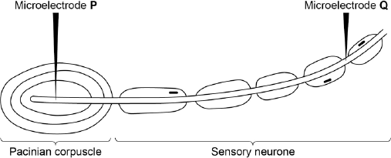

The table below shows some of the biologist’s results.

|  |  |  |  |
| --- | --- | --- | --- |
|  | **Pressure applied to the  fingertip** | **Membrane potential at P /  millivolts** | **Membrane potential at Q /  millivolts** |
|  | None | –70 | –70 |
|  | Light | –50 | –70 |
|  | Medium | +30 | +40 |
|  | Heavy | +40 | +40 |

(a)     Explain how the resting potential of –70 mV is maintained in the sensory neurone when no pressure is applied.

........................................................................................................................

........................................................................................................................

........................................................................................................................

........................................................................................................................

**(2)**

(b)     Explain how applying pressure to the Pacinian corpuscle produces the changes in membrane potential recorded by microelectrode **P**.

........................................................................................................................

........................................................................................................................

........................................................................................................................

........................................................................................................................

........................................................................................................................

........................................................................................................................

........................................................................................................................

........................................................................................................................

**(Extra space)** ................................................................................................

........................................................................................................................

........................................................................................................................

**(3)**

(c)     The membrane potential at **Q** was the same whether medium or heavy pressure was applied to the finger tip. Explain why.

........................................................................................................................

........................................................................................................................

........................................................................................................................

........................................................................................................................

**(2)**

(d)     Multiple sclerosis is a disease in which parts of the myelin sheaths surrounding neurones are destroyed. Explain how this results in slower responses to stimuli.

........................................................................................................................

........................................................................................................................

........................................................................................................................

........................................................................................................................

**(2)**

**(Total 9 marks)**

**Q2.**(a)     Describe how a Pacinian corpuscle produces a generator potential when stimulated.

........................................................................................................................

........................................................................................................................

........................................................................................................................

........................................................................................................................

........................................................................................................................

........................................................................................................................

**[Extra space]** ................................................................................................

........................................................................................................................

........................................................................................................................

**(3)**

Doctors investigated the relationship between heart rate and arterial blood pressure. They recruited healthy volunteers. For each volunteer, they recorded their normal arterial blood pressure at rest. With each volunteer, they then carried out the following experiments.

|  |  |  |
| --- | --- | --- |
|  | **Experiment 1 Experiment 2  Experiment 3** | They recorded heart rate at different blood pressures. They repeated **experiment 1** after injecting a drug that inhibited the parasympathetic nervous system. They repeated **experiment 1** after injecting a drug that inhibited the sympathetic nervous system. |

The graph shows the results for one volunteer.

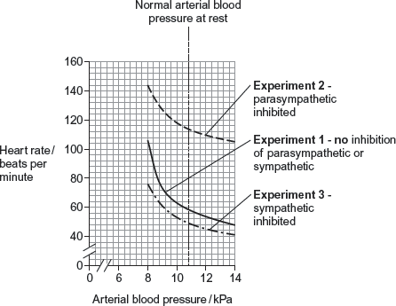

(b)     Calculate the ratio of heart rate in **experiment 2** to heart rate in **experiment 3** at an arterial blood pressure of 10 kPa.  
Show your working.

Answer = ................................

**(2)**

(c)     What do these data suggest about the control of heart rate by the parasympathetic and sympathetic nervous systems in response to changes in arterial blood pressure?

........................................................................................................................

........................................................................................................................

........................................................................................................................

........................................................................................................................

........................................................................................................................

........................................................................................................................

**[Extra space]** ................................................................................................

........................................................................................................................

........................................................................................................................

**(3)**

**(Total 8 marks)**

**Q3.**          When a person looks directly at an object, its image is focused on the fovea.

(a)     When the image is focused on the fovea, the person sees the object in colour.  
Explain why.

......................................................................................................................

......................................................................................................................

......................................................................................................................

......................................................................................................................

......................................................................................................................

......................................................................................................................

(*Extra space*) ...............................................................................................

......................................................................................................................

......................................................................................................................

**(3)**

(b)     Vision using the fovea has high visual acuity but low sensitivity to light compared with vision using other parts of the retina.

(i)      Explain why vision using the fovea has high visual acuity.

.............................................................................................................

.............................................................................................................

**(1)**

(ii)     Explain why vision using other parts of the retina has high sensitivity to light.

.............................................................................................................

.............................................................................................................

.............................................................................................................

.............................................................................................................

.............................................................................................................

.............................................................................................................

*(Extra space)* ......................................................................................

.............................................................................................................

.............................................................................................................

**(3)**

**(Total 7 marks)**

**Q4.**Answers should be written in continuous prose, where appropriate.  
Quality of Written Communication will be assessed in these answers.

The kidney plays an important part in the regulation of blood water potential. This involves control of the amount of water reabsorbed from the filtrate produced in the kidney tubules. The amount of water reabsorbed affects the volume of urine produced, the rate at which the bladder fills and how often it has to be emptied.

(a)     Explain how the loop of Henle maintains the gradient of ions which allows water to be reabsorbed from filtrate in the collecting duct.

........................................................................................................................

........................................................................................................................

........................................................................................................................

........................................................................................................................

........................................................................................................................

........................................................................................................................

........................................................................................................................

........................................................................................................................

........................................................................................................................

........................................................................................................................

**(5)**

(b)     Explain how ADH is involved in the control of the volume of urine produced.

........................................................................................................................

........................................................................................................................

........................................................................................................................

........................................................................................................................

........................................................................................................................

........................................................................................................................

........................................................................................................................

........................................................................................................................

**(4)**

(c)     The diagram shows the systems involved in controlling the emptying of the bladder. In babies, emptying of the bladder is controlled by an autonomic reflex involving the internal sphincter muscle. Conscious control is learnt between the ages of two and three and involves the external sphincter as well.

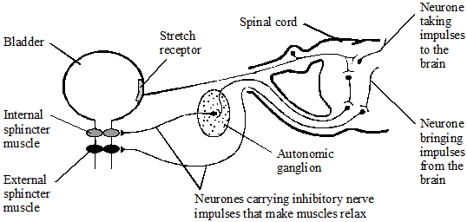

Using information in the diagram,

explain how the autonomic reflex arc is different from a simple reflex arc involving voluntary muscle;

........................................................................................................................

........................................................................................................................

........................................................................................................................

........................................................................................................................

**(2)**

**(Total 11 marks)**

**Q5.**          The graph shows the distribution of rod cells and cone cells across the retina of a human eye.

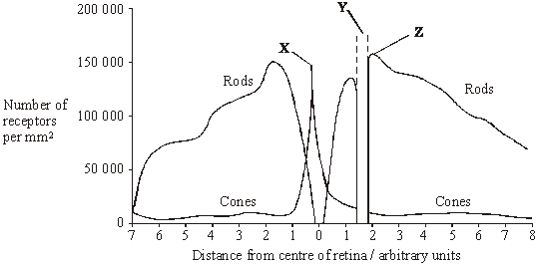

          Use the diagram to explain why

(i)      no image is perceived when light is focused on the retina at **Y**;

......................................................................................................................

......................................................................................................................

**(1)**

(ii)      an image formed at **X** is perceived in more detail than an image formed at **Z**.

......................................................................................................................

......................................................................................................................

......................................................................................................................

......................................................................................................................

**(2)**

**(Total 3 marks)**

**Q6.**          The diagram shows part of the retina in a human eye.

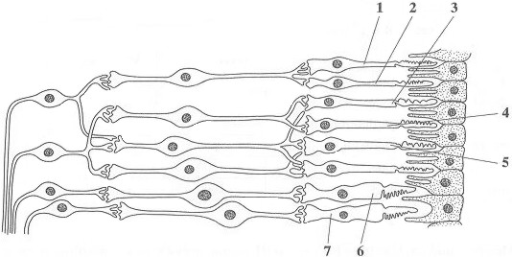

(a)     Explain each of the following observations.

(i)      When light falls on cells **1** and **2**, only one spot of light is seen. But, when light falls on cells **2** and **3**, two spots of light are seen.

.............................................................................................................

.............................................................................................................

**(1)**

(ii)     When one unit of light energy falls on cell **3**, no light is seen. But, when one unit of light energy falls on cell **3**, one unit falls on cell **4** and one unit falls on cell **5**, light is seen.

.............................................................................................................

.............................................................................................................

.............................................................................................................

.............................................................................................................

.............................................................................................................

.............................................................................................................

**(3)**

(b)     Cells of the same type as cells **6** and **7** are found in large numbers at the fovea. This results in colour vision with high visual acuity.

Explain what causes vision using the fovea.

(i)      to be in colour;

.............................................................................................................

.............................................................................................................

**(1)**

(ii)     to have high visual acuity.

.............................................................................................................

.............................................................................................................

**(1)**

**(Total 6 marks)**

**Q7.**          After moving from bright light into darkness, it takes several minutes for the rod cells to recover their sensitivity. Researchers measured the ability of the rod cells to detect small spots of light of different colours and intensity after a person moved into darkness. The results are shown in **Figure 1**.

**Figure 2** shows the amount of light of different wavelengths that rhodopsin absorbs.

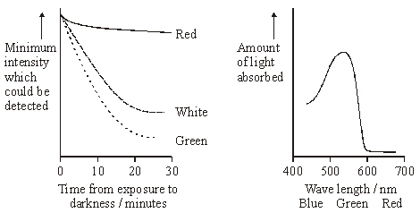

**Figure 1**                                                    **Figure 2**

(i)      Explain why it takes time for the rod cells to recover their sensitivity to light after moving into darkness.

......................................................................................................................

......................................................................................................................

......................................................................................................................

......................................................................................................................

**(2)**

(ii)      Use information in **Figures 1** and **2** to explain the differences in sensitivity of rod cells to red and green light.

......................................................................................................................

......................................................................................................................

......................................................................................................................

......................................................................................................................

**(2)**

(iii)     Suggest an explanation for the difference in sensitivity of rod cells to the white and green spots after 30 minutes.

......................................................................................................................

......................................................................................................................

**(1)**

**(Total 5 marks)**

**Q8.**          The diagram shows the distribution of cone cells across the retina of a human eye.

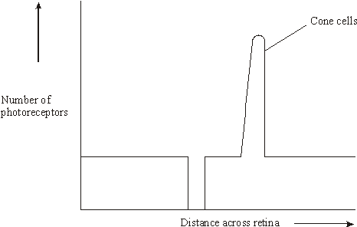

(a)     On the diagram draw a line to show the distribution of rod cells across the retina.

**(2)**

(b)     Nocturnal mammals are active at night. Describe how the number and distribution of rods and cones across the retina would differ in a nocturnal mammal from the number and distribution in a human. Explain your answer.

......................................................................................................................

......................................................................................................................

......................................................................................................................

......................................................................................................................

......................................................................................................................

......................................................................................................................

**(3)**

**(Total 5 marks)**

**M1.**(a)     1.      Membrane more permeable to potassium ions and less permeable to sodium ions;

2.      Sodium ions actively transported / pumped out and potassium ions in.

**2**

(b)     1.      (Pressure causes) membrane / lamellae to become deformed / stretched;

2.      Sodium ion channels in membrane open and sodium ions move in;

3.      Greater pressure more channels open / sodium ions enter.

**3**

(c)     1.      Threshold has been reached;

2.      (Threshold or above) causes maximal response / all or nothing principle.

**2**

(d)     1.      Less / no saltatory conduction / action potential / impulse unable to ‘jump’ from node to node;

2.      More depolarisation over length / area of membranes.

**2**

**[9]**

**M2.**(a)     1.      (Increased pressure) deforms / changes stretch-mediated sodium (ion) channel;

2.      (Sodium channels open and) sodium ions flow in;

*Accept Na+*

3.      Depolarisation (leading to generator potential).

*Accept correct description of depolarisation*

**3**

(b)     Value between 2.17:1 and 2.29:1;

*Accept rounding up to 2.2 or 2.3*

*Accept: number without : 1*

*Correct working showing answer but incorrect rounding in answer line = 1*

Values between 117 to 119 and between 52 to 54 found but ratio wrong way round = 1 mark.

*Wrong way round gives answer between 0.35:1 and 0.46:1*

**2**

(c)     1.      Parasympathetic greater effect than sympathetic;

*Ignore: descriptions of graph*

2.      Parasympathetic keeps heart rate down / lower / decreases heart rate (as blood pressure increases);

3.      Sympathetic keeps heart rate up / higher / increases heart rate (as blood pressure increases);

*2. and 3. Accept converse for blood pressure decreases*

4.      Parasympathetic greatest / greater effect at high blood pressure / sympathetic greatest effect at low blood pressure.

**3 max**

**[8]**

**M3.**         (a)     Colour detected by cone cells;Fovea contains (only / mainly) cone cells;Three types of cone / cells described / each sensitive to different  
wavelength / to red or green or blue;

*Max 2 if ‘rods‘ and ‘cones‘ confused consistently*

**3**

(b)     (i)      Each receptor (in fovea)/each cone connected to separate  
neurone / rods/cells in other parts share a neurone;

*Accept nerve cell / nerve fibre*

**1**

(ii)     Many rods in other parts of retina;Rhodopsin / pigment in receptors / rod cells very sensitive to light/works in low light;Receptors / rods connected in groups to ganglion cell / neurone;Summation;Description of summation, eg if enough light above threshold  
hits any cells in the group, then get nerve impulses to brain/along  
optic nerve;

**3 max**

**[7]**

**M4.**(a)     (epithelial cell) of tubule cells carry out active transport;

transport chloride / sodium ions out (of filtrate);

against concentration gradient;

into surrounding tissue / tissue fluid;

creates / maintains water potential gradient for water reabsorption;

countercurrent multiplier;

**5 max**

(b)     if water potential of blood falls, detected by receptors in hypothalamus;

leads to ADH released from pituitary gland;

ADH makes cells of collecting duct / distal convoluted tubule permeable to water;

*(accept DCT)*

water leaves filtrate by osmosis;

smaller volume of urine produced;

*(accept converse if water potential of blood rises)*

**4 max**

(c)     (autonomic reflex),  
autonomic ganglion involved;

extra synapse outside the spinal cord;

inhibitory rather than excitatory neurone;

more neurones involved;

**2 max**

**[11]**

**M5.**          (i)      no (photo)receptor cells at **Y** / no rods and cones;

**1**

(ii)      **X** has many / only cones  / more cones than **Z**;  
which each synapse to a single neurone / bipolar cell / no  
retinal convergence;  
*OR***Z** has mainly rods / more rods than cones;  
which share / converge on neurones / bipolar cells;

**2**

**[3]**

**M6.**          (a)     (i)      1 and 2 share neurone but 2 and 3 have separate neurones (to brain);

*Ignore wrong names of neurones*

**1**

(ii)     1 unit is sub-threshold / 3 units are above threshold / give sufficient  
depolarisation;  
(1 unit) No impulses / no action potential / in (sensory) neurone /   
does not stimulate (sensory) neurone / 3 units → impulses;  
(Spatial) summation / sufficient neurotransmitter released / from  
3 receptors / insufficient N-T from one;  
*Reject ‘temporal’*

**3**

(b)     (i)      (Three) different types of (cone) cells / types 6 and 7 sensitive  
to different wavelengths / different frequencies / different colours;

(ii)     Impulses along separate neurone from each receptor cell / each  
receptor cell connects to separate neurone;

**2**

**[6]**

**M7.**          (i)      rhodopsin bleached / broken down by light;  
time for resynthesis;

**2**

(ii)      rhodopsin / pigment absorbs green light more readily than red / is  
more sensitive to green light;  
(after resynthesis) less (intense) green light needed to break down  
rhodopsin (than red);

**2**

(iii)     white has (high proportion of) wavelengths to which rhodopsin not  
sensitive;

**1**

**[5]**

**M8.**          (a)     no rods at blind spot or fovea;

greater distribution of rods at edge;

**2**

(b)     more rods and no / fewer cones present;

rods at the fovea / rods not mainly at periphery;

rods have high sensitivity / show retinal convergence /   
converse for cones;

rhodopsin ‘bleached’ at low light intensities / iodopsin ‘bleached’;

at high light intensities;

**3 max**

**[5]**

**E2.**(a)     Just over a third of students obtained 3 marks. The examiners were looking for a reference to stretch-mediated sodium channels. This is the term used in the specification and is appropriate for this pressure receptor. Some students wrote about movement of sodium, rather than sodium ions, or did not state that they moved / diffused / flowed in. Others failed to note that this produces depolarization.

(b)     About 30 percent of students obtained 2 marks in this part. As has been noted in other examinations, ratios seem to pose problems for many students. Many do not realize that a ratio should be given as something : 1. Other students did not realize that it mattered in which order the numbers were given when they were asked to give the ratio of heart rate in experiment 2 to that in experiment 3. These problems resulted in about 30 percent obtaining one mark. Many students had no idea how to calculate a ratio.

(c)     Nearly 50 percent obtained 2 marks for stating that the parasympathetic slows heart rate and the sympathetic speeds it up. Very few noted from the graph that the parasympathetic has a much greater effect / influence on heart rate than the sympathetic; resulting in only 10 percent obtaining all 3 marks.

**E3.**          (a)     This question was a good discriminator. Most candidates knew that cones were found at the fovea and that they were involved in colour vision. Fewer candidates were able to explain that there were three different types of cone, each characterised by its possession of a different pigment which was sensitive to a particular range of wavelengths (‘colour’) of light. In many cases, candidates’ weak powers of expression made it appear that any one cone possessed all three pigments.

(b)     In (i), many appeared not to understand that high visual acuity is associated with individual cones each being connected to a separate neurone. Some appeared not to appreciate the difference in meaning between *acuity* and *sensitivity*.

Part (ii) was another good discriminator. Most candidates knew that other parts of the retina, outside the fovea, contained rod cells and that these were generally connected in groups to a ganglion cell or neurone. Fewer were able to go on to explain how summation could then make it more likely that the threshold for an action potential could be reached even with little individual stimulation of the rods involved.

**E4.**(a)     This question was a good discriminator, producing a full range of marks but relatively few candidates with all five. Many candidates displayed confusion about which processes occur in the loop of Henle and where. In addition, many ignored the instruction to explain how the loop maintains a gradient of ions and entered into general descriptions of the functions of the kidney tubule. Some candidates confused the functions of the loop of Henle and the collecting duct. Terminology was also a problem for some candidates, especially with regard to failure to refer to water potentials.

(b)     This question was a good discriminator, producing a full range of marks but relatively few candidates with all four. Many candidates obtained one or 2 two marks, usually for references to release of ADH from the pituitary gland, the resulting increase in permeability of the collecting duct, or the reduced volume of urine produced (or the converse). There were good answers which followed the whole train of events, starting with the stimulus of a lowering of the water potential of the blood (or a rise, or a change in blood volume and pressure) and its detection by appropriate named receptors. These answers then linked these events to the roles of the hypothalamus and pituitary glands and the release (or reduced release) of ADH.

(c)     This was not answered very well by most candidates, primarily because they did not appear to be able to compare the information in the diagram to what they were supposed to know about a simple reflex. It was particularly surprising how few made any reference to the autonomic ganglion shown in the diagram.

**E5.**          **Unit 6**

The question in part (i) was well answered. Only those referring to area **Y** as the ‘blind spot’ failed to gain a mark. In (ii), generally candidates realised the importance of there being cones at **X** and rods at **Z.** Marks were not given when candidates failed to specify which area they were writing about, **X** or **Z**, when explaining that there were more cones. About a third of the candidates failed to gain the second mark. Candidates appeared to be aware of the greater acuity of cones but did not relate this to the neural connections.

**Unit 7**

In (i), although most were able to explain that region **Y** lacked receptors, some fell short by just describing it as the ‘blind spot’ or as the point where the optic nerve was joined to the retina.

Descriptions of the two types of photoreceptors were sometimes less than precise, with some candidates hinting that there were some rods present at **X** (the fovea) or that there were no cones at point **Z**. In (ii), while most understood about retinal convergence of rods, or lack of it for cones, some had a fundamental lack of understanding and thought that the reason cones gave more precise vision was due to the way they differentiated between different colours of light.

Some candidates included the term ‘acuity’ in their answers but did not explain the basis of this.

Others used inaccurate terminology and referred to cones each being connected to a single ‘nerve’.

**E6.**          **Unit 6**

(a)     In (i), some told only half the story and others were clearly muddled, particularly concerning the distinction between a neurone and a nerve (inappropriate terminology was not rewarded). Most, however, were able to deduce from the diagram which pair of rod cells shared a single sensory neurone and which pair was connected via separate neurones.  
In (ii), the phenomenon of summation appeared to be well understood, although essential details, such as the attainment of the necessary threshold potential, were sometimes omitted.

(b)     Very few candidates were able to express their ideas unambiguously regarding the sensitivity of different cone cells to different ranges of wavelength: many gave the impression that each cone cell was able to respond to a full range of wavelengths of light. Greater success was enjoyed in explaining that visual acuity was achieved via the stimulation of separate neurones leading from the individual cone cells, as illustrated in the diagram.

**Unit 7**

(a)     Part (i) asked for an explanation of two events. Many candidates gave a good description of stimulation of only one or of two bipolar cells and obtained the mark. Some responses only gave an account of the one event and therefore could not obtain the mark. Part (ii) was answered well and many candidates obtained the three marks. In this instance the term bipolar neurone was not demanded though it is worth noting that these cell were variously described as ‘neurones’, ‘nerve cells’, ‘sensory nerves’, ‘interneurones’, ‘relay cells’ and ‘motor neurones’. Candidates should have knowledge that the bipolar cells are sensory neurones.

(b)     The most common response to part (i) was the inadequate statement that ‘the fovea has cones’. Better answers referred to the absorption of different wavelengths by different cones. Part (ii) was answered much better and most candidates obtained the available mark.

**E7.**          (i)      Most candidates knew that the rhodopsin is broken down in the light and that there is a delay while it is resynthesised after moving into darkness. Some confused their explanation with acuity and the neuronal connections of rod cells.

(ii)      This part and the next were designed to test a candidate’s ability to analyse more complex data, and not surprisingly they proved quite demanding. Only the best candidates gave an explanation in terms of the intensity of light required to break down rhodopsin. Many merely described the data, although quite often the sensitivity to red and green light was the wrong way round. Weaker candidates often referred to cones and the trichromatic theory despite the information given, sometimes insisting that rods are only sensitive to ‘black and white’. The idea that rods could be sensitive to a range of wavelengths without distinguishing colour was obviously confusing to many.

(iii)     A rather larger number did realise that white light contains a high proportion of wavelengths to which rhodopsin is not particularly sensitive, whereas it has high sensitivity to green light.

**E8.**          This question produced a wide range of marks and proved to be an effective discriminator.

(a)     Although many candidates indicated a lack of rods at the blind spot, far fewer appreciated that there would be either a reduction or an absence of rods at the fovea.

(b)     Many candidates gained up to two marks for suggesting that there would be a greater number of rods and fewer cones across the retina of a nocturnal mammal. Very few candidates gained a third mark by referring to retinal convergence or the breakdown of rhodopsin at low light intensities.