**Q1.**(a)     Give **one** similarity and **one** difference between a taxis and a tropism.

Similarity.........................................................................................................

........................................................................................................................

........................................................................................................................

Difference ......................................................................................................

........................................................................................................................

........................................................................................................................

**(2)**

Scientists investigated tropisms in the roots of tomato plants. They grew tomato plants from seeds on vertical agar plates, as shown in **Figure 1**. The top of each plate was made of agar gel containing **no** salt. The bottom of each plate was made of one of the following:

•        agar gel containing **no** salt

•        agar gel containing salt.

Typical results for growth of the roots are shown in **Figure 1**.

**Figure 1**

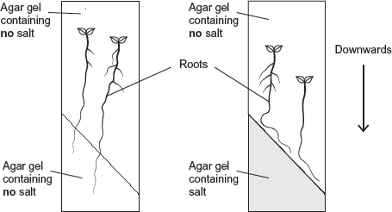

(b)     What do these results show about the responses of the roots of tomato plants to gravity and salt?

........................................................................................................................

........................................................................................................................

........................................................................................................................

........................................................................................................................

........................................................................................................................

........................................................................................................................

**[Extra space]** ................................................................................................

........................................................................................................................

........................................................................................................................

**(3)**

(c)     In root tips of tomatoes, IAA is transported **out** of the cells by a carrier protein. In roots of tomatoes, high concentrations of IAA inhibit cell elongation.

The scientists’ hypothesis was that salt causes a change in the number of IAA carrier proteins in cells in different parts of the root tip.

**Figure 2** shows two cells, **L** and **R**, in the root tip of a tomato plant.

**Figure 2**

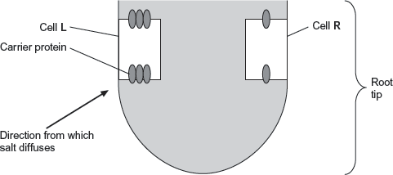

Explain why this root tip would grow away from salt.

........................................................................................................................

........................................................................................................................

........................................................................................................................

........................................................................................................................

........................................................................................................................

........................................................................................................................

**[Extra space]** ................................................................................................

........................................................................................................................

........................................................................................................................

**(3)**

**(Total 8 marks)**

**Q2.**Woodlice use gills for gas exchange. These gills are situated on the outside of the animal so water loss occurs from the gill surface. When a number of woodlice occur together they often form a ‘clump’ with individual woodlice touching each other.

A student investigated the effect of clumping on the rate of water loss from the woodlice. The student divided the 12 woodlice into two groups. He allowed the woodlice in group A to clump together, but kept the woodlice in group B separate from each other.

The following table shows the mean mass of the woodlice in each group.

|  |  |  |  |
| --- | --- | --- | --- |
|  | **Time / minutes** | **Mean mass of woodlice / g** | |
|  | Group **A** | Group **B** |
|  | 0 | 0.180 | 0.175 |
|  | 20 | 0.170 | 0.130 |
|  | 40 | 0.165 | 0.110 |
|  | 60 | 0.160 | 0.090 |
|  | 80 | 0.160 | 0.080 |

(a)     (i)      Calculate the percentage loss in the mean mass of the woodlice in Group **A** during the investigation. Show your working.

Answer ......................................

**(2)**

(ii)     Woodlice in Group **B** had a greater percentage loss in mean mass during the investigation than woodlice in Group **A**. Explain why.

...............................................................................................................

...............................................................................................................

...............................................................................................................

...............................................................................................................

...............................................................................................................

...............................................................................................................

(Extra space) ........................................................................................

...............................................................................................................

...............................................................................................................

**(3)**

(iii)    It would be useful to give the loss in mean mass as a percentage in this investigation.  
Explain why.

...............................................................................................................

...............................................................................................................

**(1)**

**(Total 6 marks)**

**Q3.**          When a finger accidentally touches a hot object, a reflex action occurs. The biceps muscle contracts, causing the arm to be flexed and the finger is pulled away. The diagram shows the arrangement of the bones in the arm, the muscles used for flexing and straightening the arm and the nervous pathways associated with the contraction of these muscles.

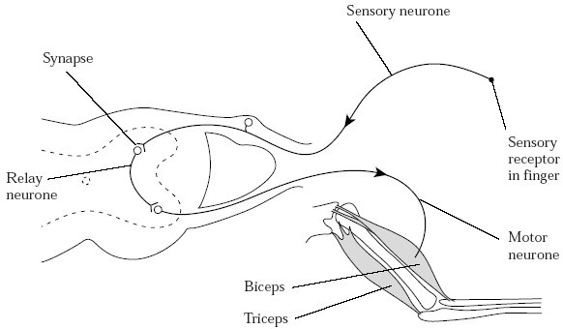

(a)     Explain the importance of reflex actions.

......................................................................................................................

......................................................................................................................

......................................................................................................................

......................................................................................................................

......................................................................................................................

......................................................................................................................

**(3)**

(b)     (i)      Describe the sequence of events which allows information to pass from one neurone to the next neurone across a cholinergic synapse.

.............................................................................................................

.............................................................................................................

.............................................................................................................

.............................................................................................................

.............................................................................................................

.............................................................................................................

.............................................................................................................

.............................................................................................................

.............................................................................................................

.............................................................................................................

.............................................................................................................

.............................................................................................................

**(6)**

(ii)     Give **two** differences between a cholinergic synapse and a neuromuscular junction.

1 ..........................................................................................................

.............................................................................................................

2 ..........................................................................................................

.............................................................................................................

**(2)**

**(Total 11 marks)**

**Q4.**          **S**       Students investigated the response of beetle larvae to light. They marked sectors on a large circular sheet of cardboard. A lamp with a 100 W bulb was placed close to the cardboard sheet at position **X**. The larvae were released, one at a time, in the centre of the sheet. The direction in which each larva moved was determined by recording the sector into which it first crawled.

The results of 300 trials are shown in the diagram. The length of the bars indicates the number of larvae moving into each sector.

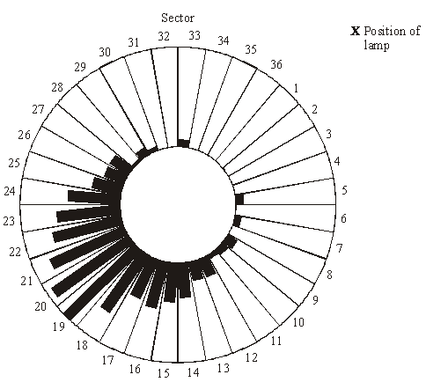

(a)     The students concluded that the larvae respond by moving away from light.

(i)      What is the evidence for this conclusion?

.............................................................................................................

.............................................................................................................

**(1)**

(ii)     Suggest **one** precaution that would ensure the response really was due to light.

.............................................................................................................

.............................................................................................................

**(1)**

(iii)     The larvae moved to a wide range of different sectors. Suggest an explanation for this.

.............................................................................................................

.............................................................................................................

**(1)**

(b)     The sector which gave the median result was sector 20. Explain how the median result would be calculated.

......................................................................................................................

......................................................................................................................

......................................................................................................................

......................................................................................................................

......................................................................................................................

**(2)**

**(Total 5 marks)**

**Q5.**         A gardener accidentally pricks a finger on a thorn. She quickly pulls the finger away. This reaction results from a simple reflex arc involving three neurones.

The diagram shows part of the pathway involved in this reaction.

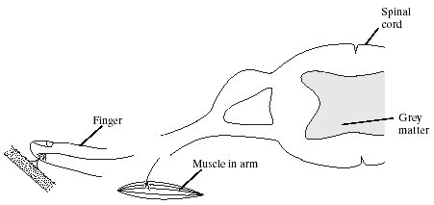

(i)      Complete the diagram to show the rest of the simple reflex arc.

**(1)**

On your diagram

(ii)     name and label the **three** neurones;

(iii)     label the effector.

**(2)**

**(Total 3 marks)**

**Q6.**          **S**       In an investigation by a student into the responses of maggots, the bottom of a large box was marked with six coloured segments, as shown in the diagram.

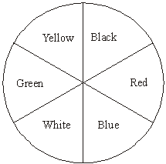

30 maggots were placed on each segment in the box. A transparent cover was put on the box and light bulbs were positioned so that the segments were evenly illuminated. The positions of the maggots were recorded after one hour. The intensity of the light reflected by each segment was measured.

The experiment was repeated three more times. The total number of maggots in each segment from the four experiments is shown in the table.

|  |  |  |
| --- | --- | --- |
| **Colour of segment** | **Intensity of reflected light / arbitrary units** | **Total number of maggots** |
| Black | 4 | 154 |
| Red | 25 | 229 |
| Blue | 10 | 178 |
| White | 44 | 47 |
| Green | 25 | 48 |
| Yellow | 40 | 64 |

(a)     Give **one** conclusion about the responses of maggots which is supported by these results.

......................................................................................................................

......................................................................................................................

Give the evidence from the table for your conclusion.

......................................................................................................................

......................................................................................................................

**(2)**

(b)     The chi-squared test was used to analyse the data. For the results obtained, suggest **one** null hypothesis which might be analysed by a chi-squared test.

......................................................................................................................

......................................................................................................................

**(1)**

(c)     It was suggested that the movement of the maggots might have been influenced by the Earth’s magnetic field. Suggest **one** simple way of repeating the investigation which would avoid this possibility.

......................................................................................................................

......................................................................................................................

**(1)**

**(Total 4 marks)**

**Q7.**          **S**       A large number of roots from many genetically identical bean plants were cut into short pieces. The pieces were sorted into groups, depending upon their distance from the root tip. Some pieces from each group were used to find the mean dry mass of their cells. Thin sections cut from other pieces were examined with a light microscope to find the proportion of dividing cells and the mean volume of the cells.

The graph shows the results. The diagrams below the graph show the appearance of cells in light microscope sections at different distances from the root tip.

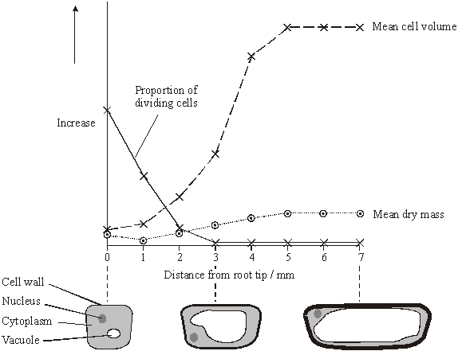

(a)     Suggest **two** variables, other than genotype, which need to be controlled to ensure similar root growth in different plants. In each case give the reason for your answer.

1 ...................................................................................................................

......................................................................................................................

......................................................................................................................

2 ...................................................................................................................

......................................................................................................................

......................................................................................................................

**(2)**

(b)     Suggest how the proportion of dividing cells in a thin section could be determined.

......................................................................................................................

......................................................................................................................

......................................................................................................................

......................................................................................................................

**(2)**

(c)     Explain the change in the proportion of dividing cells with increasing distance from the root tip.

......................................................................................................................

......................................................................................................................

......................................................................................................................

......................................................................................................................

**(2)**

(d)     Using the graph and diagrams, suggest how a root tip gets longer.

......................................................................................................................

......................................................................................................................

......................................................................................................................

......................................................................................................................

......................................................................................................................

......................................................................................................................

......................................................................................................................

......................................................................................................................

**(3)**

**(Total 9 marks)**

**Q8.**          The human body-louse is an insect which lives and feeds on the surface of the skin. A louse was placed in a chamber, half of which was kept at 35 °C and half at 30 °C. The diagram shows the pattern of movement of the louse.

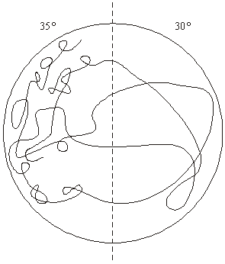

(a)     Name the type of behavioural response shown by the body-louse in this investigation.

Give evidence for your answer.

......................................................................................................................

......................................................................................................................

......................................................................................................................

......................................................................................................................

**(2)**

(b)     Suggest and explain **one** advantage of this behaviour to the human body-louse.

......................................................................................................................

......................................................................................................................

......................................................................................................................

......................................................................................................................

**(2)**

**(Total 4 marks)**

**Q9.** A flatworm is a simple soft-bodied animal. The diagram shows the movements of an aquatic flatworm in light and in shade. The path followed by the flatworm over a period of three minutes was traced on the side of a tank.

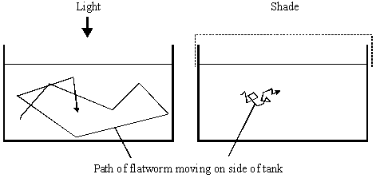

(i)      Name the type of behaviour shown. Give a reason for your answer.

Type of behaviour .........................................................................................

Reason .........................................................................................................

......................................................................................................................

**(2)**

(ii)      Suggest **one** advantage of the behaviour shown in the diagram.

......................................................................................................................

......................................................................................................................

**(1)**

**(Total 3 marks)**

**Q10.**A biologist investigated the behaviour of a species of worm that lives in soil.

He cultured three samples of worms in three separate trays of soil for many days.  
Each culture:

•        contained a food supply

•        was kept at a different temperature.

The temperatures of the cultures were 17 °C, 20 °C and 23 °C.

The biologist then removed food from the trays for several hours. Then he transferred each sample of worms onto a glass surface where there was **no food**. Each surface had a temperature gradient across it. After 1 hour, the biologist recorded the position of each worm.

The figure below shows his results. On each diagram,  marks where he released the worms onto the glass surface.

Temperature gradient  
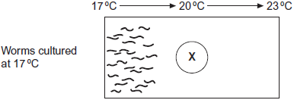

Temperature gradient  
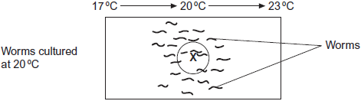

Temperature gradient  
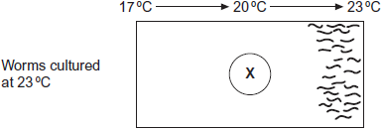

(a)     The biologist concluded that the worms’ behaviour demonstrated taxis.  
How do these results support this conclusion?

........................................................................................................................

........................................................................................................................

........................................................................................................................

........................................................................................................................

**(2)**

(b)     Using the information provided, suggest an explanation for the worms’ behaviour on the glass surfaces in the absence of food.

........................................................................................................................

........................................................................................................................

........................................................................................................................

........................................................................................................................

........................................................................................................................

........................................................................................................................

*(Extra space)* .................................................................................................

........................................................................................................................

........................................................................................................................

**(3)**

(c)     In each experiment, the biologist exposed the surfaces to light that was dim and even, so he could see where the worms went.

Apart from seeing where the worms went, suggest **two** reasons why it was important that the light was dim and even.

1 .....................................................................................................................

........................................................................................................................

2 .....................................................................................................................

........................................................................................................................

**(2)**

**(Total 7 marks)**

**Q11.**          The diagram shows a seahorse. A seahorse is a fish. Mating in seahorses begins with courtship behaviour. After this, the female transfers her unfertilised eggs to the male’s pouch. Most male fish fertilise eggs that have been released into the sea. However, a male seahorse fertilises the eggs while they are inside his pouch. The fertilised eggs stay in the pouch where they develop into young seahorses.

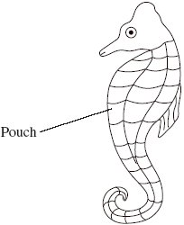

(a)     Give **two** ways in which courtship behaviour increases the probability of successful mating.

1 ...................................................................................................................

......................................................................................................................

2 ...................................................................................................................

......................................................................................................................

**(2)**

(b)     Give **one** way in which reproduction in seahorses increases the probability of

(i)      fertilisation

.............................................................................................................

.............................................................................................................

**(1)**

(ii)     survival of young seahorses.

.............................................................................................................

.............................................................................................................

**(1)**

          Scientists investigated the effect of total body length on the selection of a mate in one Australian species of seahorse. The scientists used head length as a measure of total body length.

(c)     (i)      Use the diagram to suggest why the scientists measured head length rather than total body length.

.............................................................................................................

.............................................................................................................

**(1)**

(ii)     Suggest why the scientists were able to use head length as a measure of total body length.

.............................................................................................................

.............................................................................................................

**(1)**

The scientists measured the head lengths of the female and male of a number of pairs.  
The results are shown in the graph.

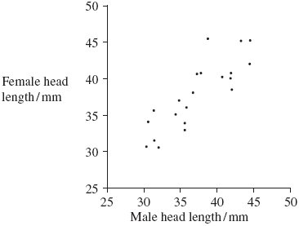

(d)     The scientists concluded that total body length affects the selection of a mate.  
Explain how the results support this conclusion.

......................................................................................................................

......................................................................................................................

**(1)**

(e)     A female with a head length of 50 mm selected a mate. Explain how you could use the graph to predict the total head length of the mate selected.

......................................................................................................................

......................................................................................................................

......................................................................................................................

......................................................................................................................

**(2)**

(f)      Scientists studied two species of North American seahorse. They thought that these two species are closely related. Describe how comparisons of biological molecules in these two species could be used to find out if they are closely related.

......................................................................................................................

......................................................................................................................

......................................................................................................................

......................................................................................................................

......................................................................................................................

......................................................................................................................

......................................................................................................................

......................................................................................................................

......................................................................................................................

......................................................................................................................

......................................................................................................................

......................................................................................................................

**(6)**

**(Total 15 marks)**

**Q12.**          Termites are insects. Some species live in colonies in the soil. Although most termites are wingless, winged termites are sometimes produced. The winged termites fly from the soil, mate and start new colonies.

A scientist studied the behaviour of winged termites. He divided these termites into three groups.

•        Group **A** had their eyes covered.

•        Group **B** had their antennae removed.

•        Group **C** was the control group.

He put individual winged termites on a sloping board that was illuminated from one side. The diagram shows the direction of movement of a typical termite from each of the three groups.

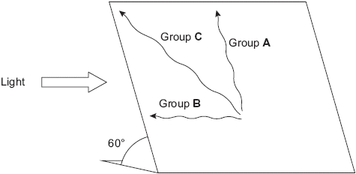

(a)     (i)      What type of behaviour was shown by the termite from group **B**?

.............................................................................................................

**(1)**

(ii)     Give the evidence for your answer.

.............................................................................................................

.............................................................................................................

**(1)**

(b)     Explain what the results from group **A** suggest about the factors controlling the behaviour of winged termites.

......................................................................................................................

......................................................................................................................

......................................................................................................................

......................................................................................................................

......................................................................................................................

......................................................................................................................

**(3)**

(c)     Suggest **one** advantage to the termites from group **C** of the behaviour shown in the investigation.

......................................................................................................................

......................................................................................................................

......................................................................................................................

......................................................................................................................

**(2)**

**(Total 7 marks)**

**Q13.**Scientists investigated the effect of relative humidity on the activity of woodlice. They set up a Petri dish as shown in **Figure 1**.

In the bottom half they put a substance which absorbs water. Different concentrations of this substance produced different humidities in the air above the mesh.

**Figure 1**

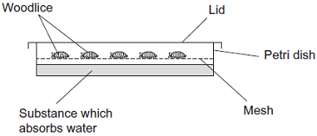

The scientists

•        placed 10 woodlice in the top half of the dish

•        replaced the lid and left the apparatus for 15 minutes in the laboratory

•        recorded the number of woodlice **not** moving during the next 30 seconds

•        repeated the experiment to obtain data for 100 woodlice

•        repeated the experiment at different humidities.

The results are shown in **Figure 2**.

**Figure 2**

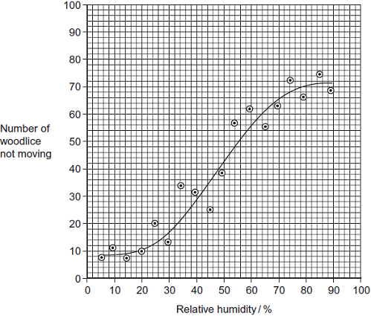

The movement of the woodlice in low relative humidity is an advantage to their survival.  
Explain how.

.................................................................................................................................

.................................................................................................................................

.................................................................................................................................

.................................................................................................................................

.................................................................................................................................

**(Total 2 marks)**

**Q14.**Stemborers are insect pests that feed on maize plants. Scientists investigated the effect of **push-pull** stimuli on the control of these pests.

For this investigation, the scientists divided a large field into plots measuring 50 m × 50 m. They then designated each plot as a control plot or a test plot. The following figure shows what they planted in each type of plot.

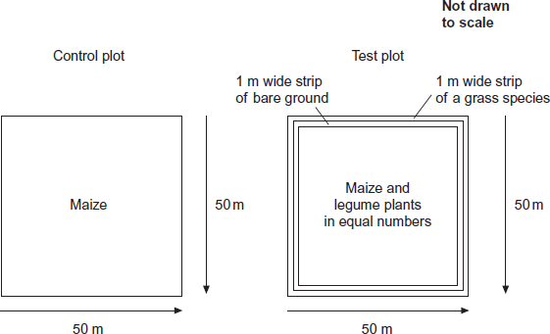

The legumes planted with the maize drive stemborers away.

The grass species attracts stemborers.

The table below shows the scientists’ results.

|  |  |  |  |  |  |
| --- | --- | --- | --- | --- | --- |
|  | **Plots** | **Mean percentage damage to maize plants** | **Mean maize grain yield / tonnes per hectare (± standard deviation)** | **Mean production costs per farmer / $ per hectare (± standard deviation)** | **Mean total income for farmer / $ per hectare (± standard deviation)** |
|  | Control | 29.6 | 1.5 (±0.2) | 250 (±0.7) | 329 (±5.9) |
|  | Test | 6.7 | 3.7 (±0.3) | 278 (±1.1) | 679 (±10.2) |

(a)     In the test plot of land, identify the push stimulus and the pull stimulus.

Push stimulus ..............................................................................................

Pull stimulus .................................................................................................

**(1)**

(b)     When measuring the mean percentage damage to maize plants, 60 plants from each test plot were selected at random and examined.  
Describe how the maize plants could be selected at random.

........................................................................................................................

........................................................................................................................

........................................................................................................................

........................................................................................................................

........................................................................................................................

........................................................................................................................

(Extra space) .................................................................................................

........................................................................................................................

........................................................................................................................

**(3)**

(c)     In the test plot, bare ground was left between the maize and the grass species.  
Suggest an explanation why.

........................................................................................................................

........................................................................................................................

........................................................................................................................

........................................................................................................................

........................................................................................................................

**(2)**

(d)     The legume plants have nodules containing nitrogen-fixing bacteria on their roots.  
Explain how nitrogen-fixing bacteria could increase the growth of the maize.

........................................................................................................................

........................................................................................................................

........................................................................................................................

........................................................................................................................

........................................................................................................................

**(2)**

(e)     A year after this investigation, the government of one country decided that their farmers should use these **push-pull** stimuli.  
How do these data support this decision?

........................................................................................................................

........................................................................................................................

........................................................................................................................

........................................................................................................................

........................................................................................................................

........................................................................................................................

(Extra space) .................................................................................................

........................................................................................................................

........................................................................................................................

**(3)**

**(Total 11 marks)**

**Q15.**Scientists investigated the effect of relative humidity on the activity of woodlice. They set up a Petri dish as shown in **Figure 1**.

In the bottom half they put a substance which absorbs water. Different concentrations of this substance produced different humidities in the air above the mesh.

**Figure 1**



The scientists

•        placed 10 woodlice in the top half of the dish

•        replaced the lid and left the apparatus for 15 minutes in the laboratory

•        recorded the number of woodlice **not** moving during the next 30 seconds

•        repeated the experiment to obtain data for 100 woodlice

•        repeated the experiment at different humidities.

The results are shown in **Figure 2**.

**Figure 2**



(a)     The woodlice were left for 15 minutes before their movement was recorded. Give **two** reasons for this.

1 .....................................................................................................................

........................................................................................................................

2 .....................................................................................................................

........................................................................................................................

**(2)**

(b)     It is **not** possible to conclude that the change in the behaviour of the woodlice shown in **Figure 2** is caused by changes in humidity. Explain why.

........................................................................................................................

........................................................................................................................

........................................................................................................................

........................................................................................................................

........................................................................................................................

**(2)**

(c)     The points in **Figure 2** do not all fall on the curve. Suggest why.

........................................................................................................................

........................................................................................................................

........................................................................................................................

........................................................................................................................

........................................................................................................................

........................................................................................................................

(Extra space) .................................................................................................

........................................................................................................................

........................................................................................................................

**(3)**

**(Total 7 marks)**

**Q16.**A student investigated the effect of distance from a forced turn on the direction woodlice turned when next given a choice. The following figure shows her results.

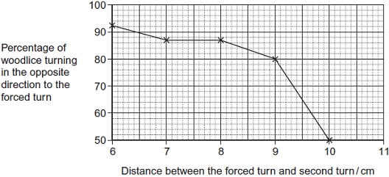

(a)     Describe the response of woodlice to increased distance between turns.

........................................................................................................................

........................................................................................................................

........................................................................................................................

........................................................................................................................

........................................................................................................................

**(2)**

(b)     Can you conclude that woodlice show turn alternation behaviour when the distance between the forced turn and the second turn was 10 cm?  
Explain your answer.

........................................................................................................................

........................................................................................................................

........................................................................................................................

........................................................................................................................

........................................................................................................................

**(2)**

(c)     The student suggested that the difference in turning behaviour of the woodlice in her investigation was due to the distance between the first and second turn. Her friend suggested that it was due to the time taken to get from the first to the second turn and **not** the distance. Suggest how you could investigate which of these two possibilities is more likely.

........................................................................................................................

........................................................................................................................

........................................................................................................................

........................................................................................................................

........................................................................................................................

........................................................................................................................

(Extra space) .................................................................................................

........................................................................................................................

........................................................................................................................

**(3)**

(d)     Woodlice usually live in areas where stones and twigs form obstacles. Obstacles in the path of woodlice cause them to make forced turns. The more obstacles there are in the path, the shorter the distance between the forced turns.

Use the data in the figure above to explain how the behaviour of woodlice results in them moving rapidly out of unfavourable areas.

........................................................................................................................

........................................................................................................................

........................................................................................................................

........................................................................................................................

........................................................................................................................

**(2)**

**(Total 9 marks)**

**Q17.**          Plant physiologists attempted to produce papaya plants using tissue culture. They investigated the effects of different concentrations of two plant growth factors on small pieces of the stem tip from a papaya plant. Their results are shown in the table.

|  |  |  |  |  |
| --- | --- | --- | --- | --- |
|  | **Concentration of auxin / μmol dm–3** | **Concentration of cytokinin / μmol dm–3** | | |
|  | 5 | 25 | 50 |
|  | 0 | No effect | No effect | Leaves produced |
|  | 1 | No effect | Leaves produced | Leaves produced |
|  | 5 | No effect | Leaves produced | Leaves and some plantlets produced |
|  | 10 | Callus produced | Leaves and some plantlets produced | Plantlets produced |
|  | 15 | Callus produced | Callus and some leaves produced | Callus and some leaves produced |

Callus is a mass of undifferentiated plant cells. Plantlets are small plants.

(a)     Explain the evidence from the table that cells from the stem tip are totipotent.

......................................................................................................................

......................................................................................................................

......................................................................................................................

......................................................................................................................

......................................................................................................................

**(2)**

(b)     Calculate the ratio of cytokinin : auxin that you would recommend to grow papaya plants by this method.

Answer .........................................................

**(2)**

(c)     (i)      Papaya plants reproduce sexually by means of seeds. Papaya plants grown from seeds are very variable in their yield. Explain why.

.............................................................................................................

.............................................................................................................

.............................................................................................................

.............................................................................................................

.............................................................................................................

**(2)**

(ii)     Explain the advantage of growing papaya plants from tissue culture rather than from seeds.

.............................................................................................................

.............................................................................................................

.............................................................................................................

**(1)**

**(Total 7 marks)**

**Q18.**Scientists investigated the response of lateral roots to gravity. Lateral roots grow from the side of main roots.

The diagrams show four stages, **A** to **D**, in the growth of a lateral root and typical cells from the tip of the lateral root in each stage. All of the cells are drawn with the bottom of the cell towards the bottom of the page.

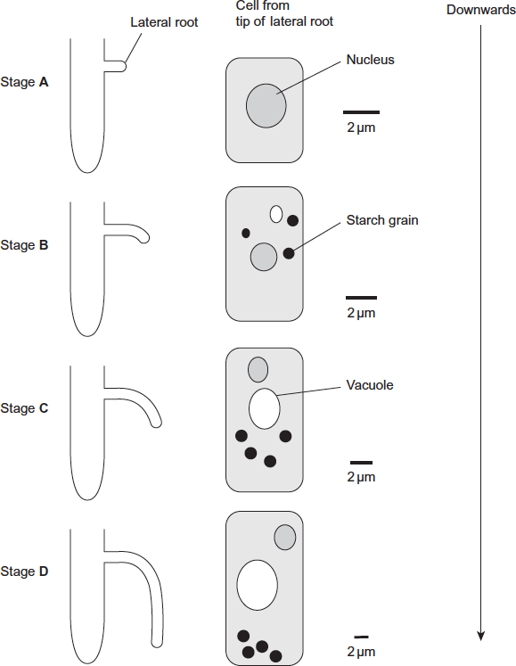

(a)     Describe **three** changes in the root tip cells between stages **A** and **D.**

1.....................................................................................................................

........................................................................................................................

2......................................................................................................................

........................................................................................................................

3......................................................................................................................

........................................................................................................................

**(3)**

(b)     The scientists’ hypothesis was that there was a relationship between the starch grains in the root tip cells and the bending and direction of growth of lateral roots.

Does the information in the diagram support this hypothesis? Give reasons for your answer.

........................................................................................................................

........................................................................................................................

........................................................................................................................

........................................................................................................................

........................................................................................................................

........................................................................................................................

*(Extra space)*.................................................................................................

........................................................................................................................

........................................................................................................................

**(3)**

(c)     The diagram shows the distribution of indoleacetic acid (IAA) in the lateral root at Stage **B.**

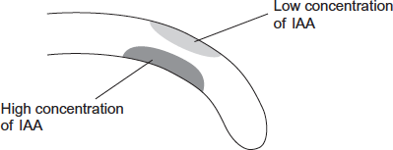

Explain how this distribution of IAA causes the root to bend.

........................................................................................................................

........................................................................................................................

........................................................................................................................

........................................................................................................................

........................................................................................................................

**(2)**

**(Total 8 marks)**

**Q19.**          IAA is a specific growth factor.

(a)     Name the process by which IAA moves from the growing regions of a plant shoot to other tissues.

......................................................................................................................

**(1)**

(b)     When a young shoot is illuminated from one side, IAA stimulates growth on the shaded side. Explain why growth on the shaded side helps to maintain the leaves in a favourable environment.

......................................................................................................................

......................................................................................................................

......................................................................................................................

......................................................................................................................

**(2)**

NAA is a similar substance to IAA. It is used to control the growth of cultivated plants. Plant physiologists investigated the effect of temperature on the uptake of NAA by leaves. They sprayed a solution containing NAA on the upper and lower surfaces of a leaf. The graph shows their results.

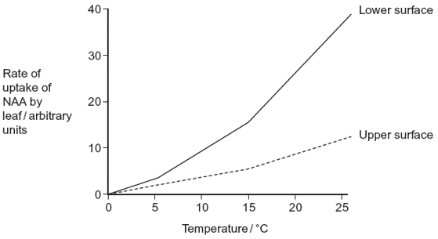

(c)     Explain the effect of temperature on the rate at which NAA is taken up by the lower surface of the leaf.

......................................................................................................................

......................................................................................................................

......................................................................................................................

......................................................................................................................

......................................................................................................................

**(2)**

(d)     There are differences in the properties of the cuticle on the upper and lower surfaces of leaves.

(i)      Suggest how these differences in the cuticle might explain the differences in rates of uptake of NAA by the two surfaces.

.............................................................................................................

.............................................................................................................

.............................................................................................................

.............................................................................................................

.............................................................................................................

**(2)**

(ii)     In this investigation, the physiologists investigated the leaves of pear trees.

Explain why the results might be different for other species.

.............................................................................................................

.............................................................................................................

.............................................................................................................

**(1)**

**(Total 8 marks)**

**Q20.**          Scientists investigated the response of the roots of pea seedlings to gravity.

They took three samples of seedlings, **A**, **B**, and **C**, and placed them so that their roots were growing horizontally. The root tips of each sample had been given different treatments. After a set time, the scientists recorded whether the roots of the seedlings had grown upwards or downwards and the amount of curvature. The table shows the treatment they gave to each sample and their results.

|  |  |  |
| --- | --- | --- |
| **Treatment** | **Results** | |
| **Direction of growth** | **Mean amount of curvature / degrees** |
| **A** None | Downwards | 60 |
| **B** Root tip removed | Continues to grow horizontally | 0 |
| **C** Upper half of root tip removed | Downwards | 30 |

(a)     The pea seedlings were kept in the dark after each treatment. Explain why this was necessary.

........................................................................................................................

........................................................................................................................

........................................................................................................................

**(1)**

(b)     What conclusion can be made from the results for treatment **B**?

........................................................................................................................

........................................................................................................................

........................................................................................................................

**(1)**

(c)     Suggest how indoleacetic acid (IAA) could have caused the results for

(i)      treatment **A**

...............................................................................................................

...............................................................................................................

...............................................................................................................

...............................................................................................................

...............................................................................................................

**(2)**

(ii)     treatment **C**.

...............................................................................................................

...............................................................................................................

...............................................................................................................

...............................................................................................................

...............................................................................................................

**(2)**

**(Total 6 marks)**

**M1.**(a)     1.      Similarity − directional response (to a stimulus) / movement  
         towards / away from a stimulus;

2.      Difference − taxis (whole) organism moves and tropism a growth (response).

*Must be clear which one, taxis or tropism, they are referring to*

*Taxis occurs in animals / motile organisms and tropism occurs in plants*

**2**

(b)     1.      Grow in direction of / towards (pull of) gravity;

*Accept: tropism for growth*

*Ignore: pulled by gravity*

*Accept: positively geotropic / gravitropic*

2.      Grow away from salt;

*Accept: negatively chemotropic / halotropic*

*1 and 2. Ignore: references to bends / moves*

3.      Salt has more effect (than gravity).

*Accept: converse statement for gravity*

*Note: all three points may appear in one sentence*

**3**

(c)     1.      More carriers in (cell) **L** / lower in **R**;

*Accept: left for* ***L*** *and right for* ***R*** */ side nearer salt for* ***L***

2.      (So) less IAA in (cell) **L** / more IAA in (cell) **R**;

*Accept: more IAA moves out of* ***L*** */ less IAA moves out of* ***R***

3.      (So) more (elongation) growth in **L** / less (elongation) growth in **R**.

*Accept: less inhibition of growth in* ***L*** */ more inhibition of growth in* ***R****;*

**3**

**[8]**

**M2.**(a)     11.1;;

Allow one mark for calculating loss in mass as 0.02g and calculating a percentage;

*Accept 11.11 / 11 but not 11.0*

**2**

(b)     1.      (More mass loss) linked to losing more water;

2.      Gills (more) exposed to air / covered (less) by other woodlice so greater surface area (exposed);

3.      (Not clumped) so lower humidity (around each woodlouse) so greater evaporation / diffusion (of water);

*Assume ‘They’ refers to woodlice in group B*

**3**

(c)     Initial masses different;

**1**

**[6]**

**M3.**         (a)     1. automatic (adjustments to changes in environment) / involuntary;  
2. reducing / avoiding damage to tissues / prevents injury / named injury  
    e.g. burning;  
3. role in homeostasis / example;  
4. posture / balance;  
5. finding / obtaining food / mate / suitable conditions;  
6. escape from predators;

*(ignore ‘danger’ or ‘harm’ unless qualified)*

**3 max**

(b)     (i)      1. (impulse causes) calcium ions / Ca++ to enter axon;  
2. vesicles move to / fuse with (presynaptic) membrane;  
3. acetylcholine (released);  
4. (acetylcholine) diffuses across synaptic cleft / synapse;  
5. binds with receptors on (postsynaptic) membrane;

*(reject active sites, disqualify point)*

6. sodium ions / Na+ enter (postsynaptic) neurone;

7. depolarisation of (postsynaptic) membrane;

8. if above threshold nerve impulse / action potential produced

**6 max**

(ii)     neurone to neurone and neurone to muscle;  
action potential in neurone and no action potential in muscle /   
sarcolemma;  
no summation in muscle;  
muscle response always excitatory (never inhibitory);  
some neuromuscular junctions have different neurotransmitters;

*(penalise ‘nerve’ once)*

**2 max**

**[11]**

**M4.**          (a)     (i)      majority of larvae move to sectors on opposite side to lamp;  
*(reject largest number / most in sector 19)*

**1**

(ii)     use heat filter in front of lamp

*(allow lamp not too close);*

*rotate card and lamp to eliminate magnetic field;  
alter direction of larval head when releasing;  
(reject general references to keeping variables constant)*

**1 max**

(iii)     wide beam from lamp;  
variability of organisms;  
positioning of larvae variable;

**1 max**

(b)     idea of middle value;  
method of determining middle value in rank order, e.g. sector in which  
300 / 2 occurs;

**2**

**[5]**

**M5.**          (i)      arc shows 3 neurones;

*(3 distinct neurones, one of which is in the grey matter, with correct route through dorsal and ventral roots and indication of synapses. Ignore position of cell bodies.)*

**1**

(ii)     neurones labelled sensory, relay / intermediate, motor;

**1**

(iii)     muscle labelled as effector;

**1**

**[3]**

**M6.**          (a)     *one mark for conclusion:*maggots move to / respond to / prefer / like / red rather than green;

*(reject ‘most prefer red’)*

maggots move to / prefer / like areas of lower light intensity (except green);  
maggots respond more to colour than light intensity / do not respond to  
differences in light intensity;

*(reject conclusion relating to single result)*

*one mark for:*evidence matching conclusion:  
more in red than green, but light intensity the same;  
more in segments with lower light intensity;  
more differences in different colours, little difference in light intensity;  
large difference in number of maggots on segments with 25 a.u.  
light intensity;

**2 max**

(b)     valid statement expressed as null hypothesis, i.e. in negative  
form, e.g. no difference in response to different colours / light intensities;

*(must relate to a possible hypothesis)*

**1**

(c)     rotate box (so segments in different direction) / change order of coloured  
segments;  
place magnets around box / create alternative magnetic field;

**1 max**

**[4]**

**M7.**          (a)     *two environmental or developmental variables and explanation;*

*examples*,

all plants of the same age, so same time for cell divisions / differentiation;  
all plants given the same watering, so same amount of water for  
cell expansion;  
*(reject reference to photosynthesis)*all plants given same light, so same rate of photosynthetic;  
same temperature, so enzymes / named metabolic process at  
optimum temperature;  
same named ion / minerals in soil(e.g. nitrate),  
so same available for a named function,  
(e.g. amino acid / protein synthesis);

**2 max**

(b)     count cells using microscope;  
count number of cells in cell division / where chromosomes visible;  
and then the total number of cells in field of view;

**2 max**

(c)     only cells at tip have ability to divide / cells further back don’t divide;  
cells further back differentiating / named example of  
*(accept reference to loss of totipotent cells)*differentiated tissue / too old / reduction in plant hormone;  
cell wall too thick / vacuole too large to allow division;

**2 max**

(d)     new cells added at tip;  
cells increase in volume / larger;  
increase in length (of cells);  
as vacuole s get larger;  
due to uptake of water (by osmosis);

**3 max**

**[9]**

**M8.**          (a)     kinesis;  
*(ignore ‘ortho-’ / ‘klino-’, allow ‘thermo-’, reject ‘photo-’ / ‘chemo-’ / etc)*

*random movements = 1 mark, eg  
/* degree of turning / number of turns depends on strength of stimulus /   
on temperature / allow specific ref. to more turning at 35° than at 30° /   
non-directional stimulus / response;

*ignore ‘speed’*

**2**

(b)     stays longer in warmer area / at 35° / tends to leave cooler area /   
to leave 30°   / stays in favourable conditions ;

remains near food source / on host;

**2**

**[4]**

**M9.**          (i)      kinesis;  
movement is random / rate of turning changes /   
does not move towards / away from light;

**2**

(ii)      advantage related to light / shade;  
e.g. remains in shade so avoids predators

**1**

**[3]**

**M10.**(a)     1.      (Taxis is) movement towards / away from a stimulus / a directional response / movement (to a stimulus);

2.      (Move towards) temperature they were used to / cultured in;

*Movement towards temperature they were used to = 2 marks*

**2 max**

(b)     1.      Hungry, so seeking food / in absence of food respond to temperature;

*Ignore references to temperature and enzymes*

*Must be stated not inferred from other statements*

2.      Move towards temperature they were used to / cultured in;

3.      Associate (this temperature) with food;

*Accept they think food is here*

*Stated not inferred*

4.      (Then) stay in this temperature;

**3 max**

(c)     1.      (Dim) worms live in soil / dark / affected by bright light / dim light is like normal environment / what they are used to;

2.      (Even) because worms might move towards / away from bright light / to avoid creating light gradient / prevent worms showing phototaxis / all parts of surface exposed to same light;

*Accept to avoid kinesis due to light*

3.      (Dim light) ensures heat from light not a variable / heat from lamp could kill / dry out worms;

*Not just to control variables / factors*

**2 max**

**[7]**

**M11.**          (a)     Recognition of same species;

Stimulates release of gametes;

Recognition of mate / opposite gender;

Indication of sexual maturity / fertility;

**2 max**

(b)     (i)      Internal fertilisation / fertilisation occurs in pouch / limited area;

***Q*** *The term fertilisation is not required in the answer but must be implied.*

**1**

(ii)     Protection from predators (developing in pouch);

**1**

(c)     (i)      Less stress caused to seahorse / quicker / more accurate method / body is curved / head is linear;

***Q*** *Do not accept “easier” unless qualified.*

**1**

(ii)     Head length proportional to body length / or described;

**1**

(d)     Positive correlation between head / body lengths of male and female / female and male with similar head / body lengths pair together;

**1**

(e)     Use line of best fit;

And extrapolate / extend line as required;

**2**

(f)      (Compare) DNA;

Sequence of bases / nucleotides;

Compare same / named protein;

Sequence of amino acids / primary structure;

Immunological evidence – not a mark

Inject (seahorse) protein / serum into animal;

(Obtain) antibodies / serum;

Add protein / serum / plasma from other (seahorse) species;

Amount of precipitate indicates relationship;

***Q*** *The marks awarded for reference to DNA and sequence of bases / nucleotides must be in a different context to DNA hybridisation.*

**6 max**

**[15]**

**M12.**          (a)     (i)      Taxis;

*Ignore references to positive and negative, and prefixes such as photo-  
Accept taxes / tactic  
Allow phonetic spelling*

**1**

(ii)     Moves towards stimulus / towards light;

*Direction must be correct.*

**1**

(b)     Gravity;

Antennae involved;

Doesn’t show light is involved / doesn’t respond to light as they are  
unable to see / as eyes are covered;

*Accept geotaxis*

**3**

(c)     Helps them to leave the soil / ground / reach the surface;

Disperse / produce new colonies;

Avoid competition;

**2 max**

**[7]**

**M13.**Low humidity results in more woodlice moving;

So increased movement increased chance of leaving dry / unfavourable environment so reduce water loss / reduce evaporation;

**[2]**

**M14.**(a)     Push – legume

Pull – grass;

*Both needed for mark*

**1**

(b)     1.      Set up tape measures on two sides of the plot / make grid of plot;

*Allow ‘Number each plant’. With this approach mp3 cannot be awarded.*

2.      Use random number table / calculator / generator;

*Allow ‘Select from a hat’ idea.*

3.      To generate coordinates;

**3**

(c)     1.      To prevent competition between the maize and the grass;

2.      For light / nutrients / water;

***OR***

3.      Idea of limits movement of pest (between grass and maize);

4.      Only eating / damaging grass;

**2 max**

(d)     1.      Nitrogen-fixing bacteria convert nitrogen (in the air) into ammonium compounds (in the soil) which are converted into nitrates / nitrification occurs;

*Accept 'ammonia' for 'ammonium compounds'.*

2.      Maize uses nitrates (in soil) for amino acid / protein / ATP / nucleotide production;

*2. Must be in the context of maize.  
Ignore ionic formulae unless only these are given.*

**2**

(e)     1.      Reduced % damage to maize plants / increased maize grain yield;

2.      Calculation to justify mp 1;

3.      Standard deviation shows no overlap but need stats to show significance of this difference;

4.      More profit / net income / greater income than additional cost (with push-pull);

5.      $322 extra / 408% more / $401 v $79 profit;

*Accept ‘$350 extra income compared to $28 extra spend’.*

*Mp5 gains credit for both mp4 and 5*

**3 max**

**[11]**

**M15.**(a)     Time to establish humidity to that required / time for substance to absorb water;

So that behaviour typical of humidity;

Woodlice no longer affected by handling;

*Allow acclimatisation idea*

**2 max**

(b)     Correlation does not show causal link;

May be due to other factors / named factor;

*Do not accept casual*

**2 max**

(c)     1.      It is a line of best fit;

2.      Variation in woodlice / a named difference in woodlice;

*E.g. age, species, sex*

3.      Variation in environmental conditions / change in a named environmental condition;

*E.g. Temperature / vibration / sound / light*

**3**

**[7]**

**M16.**(a)     Decrease (woodlice turning in opposite direction to forced turn with increasing distance between turns) then more rapid decrease;

(Rapid decrease) when distance between turns is 9cm / 80% woodlice turning in opposite direction;

*Accept ‘after 9cm’ or between 9 and 10cm’ but not at 10cm*

**2**

(b)     No (no mark)

Equal numbers / 50% turn each way;

(Would expect this) by chance / at random;

**2**

(c)     1.      Keep distance same;

2.      Increase time / delay woodlice / decrease speed of woodlice

3.      (Increase time) between forced and second turns;

*Allow one mark for measure time taken for stated / set distance*

**3**

(d)     Short distances result in more (woodlice showing) turn alternation;

Keeps woodlice going in one direction / stops them going round in circles;

**2**

**[9]**

**M17.**          (a)     1.      Gives rise to new plants / plantlets;

2.      So must be able to develop into different tissues / other specialised cell types / differentiate;

*1. Ignore references to leaves / callus*

**2**

(b)     Two marks for 5 : 1/50 : 10/1 : 0.2;;

*One mark for ratio correctly identified but expressed incorrectly as 1 : 5 / 10 : 50 / 0.2 : 1;*

**2**

(c)     (i)      1.      Meiosis / independent assortment / crossing over;

2.      (Fusion of) genetically different gametes / random fertilisation;

**2**

(ii)     Will be clones / produced by mitosis / will be genetically identical / less variation / all plants will have desired characteristics;

*If the reference is to identical must be genetically identical, but allow less variation without the reference to genetical.*

**1**

**[7]**

**M18.**(a)     Three changes described;;;

*Neutral nucleus shrinks, since it doesn’t*

Eg

1.      Formation / growth of vacuole;

2.      Formation of starch grains / amyloplasts;

*2. Accept starch grains get bigger*

3.      Movement of grains / amyloplasts towards bottom of cell;

*Note − list rule applies*

4.      Cells get longer / wider / larger;

**3 max**

(b)     1.      Grows sideways before starch grains form;

***Q***

2.      Bending starts when / as grains form;

3.      More bending as grains increase in number;

*3. Ignore starch grain growth references*

4.      More elongation (of cells) / growth (of roots) downwards as starch grains increase / move;

5.      Bending starts before grains move down;

6.      Could be related to vacuole;

*6. Ignore references to nucleus*

**3 max**

(c)     1.      (IAA) at bottom of root / where IAA concentration high inhibits expansion / elongation (of cells);

*2 and 3 need reference to expansion / elongation, not just growth*

2.      (IAA) at top of root / where IAA concentration low leads to expansion / elongation (of cells);

*2. Accept less inhibition*

**2**

**[8]**

**M19.**          (a)     Diffusion;

*Ignore references to simple / facilitated*

*Accept active transport*

**1**

(b)     1.      Causes plant to bend / grow towards light / positive phototropism;

2.      (Light) required for photosynthesis;

**2**

(c)     1.      More kinetic energy / faster movement of molecules;

2.      More diffusion;

*Ignore references to opening stomata.*

*Answer should be in context of more but comparative statement only necessary once.*

**2**

(d)     (i)      1.      Thick cuticle on upper surface / thin cuticle on lower surface / few stomata on upper surface / no stomata on upper surface;

2.      More diffusion / shorter diffusion pathway (on lower surface);

*1. Ignore cuticle only on upper surface. Ignore references to more or less waxy.*

*2. If candidate writes about stomata accept ref to greater area for diffusion.*

**2**

(ii)     Different species have different (qualified) properties;

*Eg cuticle thickness*

*Leaf size*

*Number of stomata*

**1**

**[8]**

**M20.**          (a)     1.      (Seedlings) respond to light / are phototropic;

*Reject: roots are positively phototropic / grow towards light*

***OR***

*Neutral: ‘to control a variable’*

2.      (Only) measuring the effect of gravity / response to gravity;

*Neutral: light affects growth / results*

**1**

(b)     1.      (Cells in) root tip detect gravity / respond to gravity;

*Must refer to root tip and not just the root*

***OR***

2.      IAA / auxin is produced in the root tip;

**1**

(c)     (i)     1.      IAA / auxin moves to lower side / more IAA / auxin on lower side;

*Accept: references to ‘cell elongation’ instead of ‘growth’*

2.      Lower side grows less / slower / upper side grows more / faster / inhibits growth on lower side;

*Note: if auxin is placed at upper side, mark point 2 can still be awarded*

*Need idea of ‘less / slower’ or ‘more / faster’ for mark point 2*

**2**

(ii)     1.      Less IAA / auxin (produced);

2.      Lower side grows more / faster / less inhibition of growth on lower side;

*Must refer to the lower side*

**2**

**[6]**

**E1.**(a)     This proved more challenging than anticipated. Many got a similarity between taxis and tropism as both being directional responses. Some wrongly thought it was a response to a directional stimulus, with no reference to the type of response. The difference proved much more problematic. Most of the students who obtained a mark did so because the examiners decided to accept the generalisation that tropism occurs in plants and taxis in animals. Very few indeed referred to tropism involving growth and taxis whole-organism movement.

(b)     It was pleasing in this part to see that most students could use figure 1 to determine that the roots grew towards gravity and away from salt. Only a small number attempted any statement about the relative effects of the two stimuli.

(c)     Students who read the stem carefully and looked at Figure 2 carefully scored well in this part. Just over half of students obtained 3 marks. All of the information needed to answer the question was given in the stem and figure. Weaker answers included references to carriers bringing IAA into cells, or greater elongation of R causing growth away from the salt. A significant minority saw the reference to ‘salt’, ignored all the information in the stem and wrote about osmotic effects and cells shrinking. No credit was given for this approach.

**E2.**(a)     Most candidates could complete this calculation correctly although errors in rounding and missing out the division by the original were seen.

(b)     Most candidates gave good responses with three marks not uncommon. Errors observed included discussion of temperature / respiratory rate / gas exchange changing due to clumping, and woodlice taking in water from other woodlice. Some candidates tried to use their knowledge of spiracles to answer this question rather than use the information they had been given about woodlice having gills.

(c)     Answers were often not related to differences in the initial mass.

**E3.**          (a)     Generally the question was well answered with most candidates scoring more than half marks.

Most candidates scored two marks for referring to the absence of conscious control and preventing damage to tissue. Often answers were too vague to be given credit, such as ‘preventing harm or danger’ without more explanation. The majority limited their answers to the example given, and so did not answer the question set, as they made no reference to other types of reflex. Of those who did develop their answer, posture and escape from predators were the most commonly discussed.

(b)     (i)      There were some excellent answers with many candidate scoring full marks. There were also many confused and inaccurate answers. Many candidates stated that vesicles move across the cleft or did not mention the neurotransmitter. Sometimes pre- and post- synaptic parts of the synapse were not clear. Ion movement was often poorly described, with the direction of movement often omitted or ions being moved into the membrane. Many candidates incorrectly referred to movement of chlorine or sodium ions at the presynaptic knob. The last part of the sequence was often poorly described, with no mention of binding to receptors on the postsynaptic membrane and many references to depolarisation of the neurone rather than the membrane. Production of an impulse in the postsynaptic neurone was often poorly understood, with many candidates failing to mention the need for the change in charge across the postsynaptic membrane having to reach a threshold value before an action potential could be produced.

(ii)     Poorly answered, with little knowledge of the differences being shown. Although many correctly described the neurone/neurone and neurone/muscle difference, few were able to give a second difference. Many stated that the transmitter would be different, with noradrenaline being used at all neuromuscular junctions rather than some of them.

**E4.**          Many candidates performed well on this question, although it also discriminated quite well in showing those who had not fully absorbed how the investigation was carried out before embarking on their answers.

(a)     (i)      The majority of candidates recognised that most of the larvae had moved to sectors in the opposite direction to the light. Those who carelessly stated that the majority had moved to sector 19 were not credited.

(ii)     Many candidates merely suggested ‘controls’, such as repeating the experiment in the dark or moving the light to other side, or general procedures, such as turning off other lights. These measures, however, would not eliminate the possibility that some other factor than the light itself was the stimulus for the movement. Better candidates did recognise that a heat filter would rule out heat from the lamp as a possible factor.

(iii)     A large number of candidates had not appreciated that the larvae were released one at a time in 300 separate trials. Consequently they suggested that the larvae were being forced into neighbouring sectors by overcrowding. The most common acceptable explanation was based on the idea of variability between larvae. None suggested the practical point that a lamp would give a wide beam.

(b)     It was pleasing to discover that a good number of candidates did understand in principle how to find a median. Some found difficulty in expressing their answer, and many chose a very laborious method involving writing down the results of all 300 trials and then crossing out from either end of their list until they got to the middle. Weaker candidates proposed a wide range of unsuitable mathematical procedures, such as subtracting ‘the highest sector from the lowest and dividing by two’. One candidate’s method even involved multiplying by the wattage of the lamp.

**E5.**         Considering that this topic would probably have been covered at GCSE, answers were surprisingly poor. Many candidates were unable to complete the diagram of the reflex arc, and even the better candidates frequently failed to show the relay neurone as being in the grey matter. A number tried to show the relay neurone apparently aiming out of the spinal cord towards the brain. The names of the neurones were generally better known, and these were credited wherever a reasonable attempt at a diagram had been made. Most correctly identified the effector, but some mistakenly labelled the receptor. It would help if candidates could be trained to label structures with clear (preferably straight) guidelines which actually touch the relevant structures.

**E6.**          (a)     Better candidates often gave good answers which showed that they had examined the data carefully, but many answers were very vague and frequently were incompatible with the data.

The most plausible conclusions related to the results for red and green, where the intensity of reflected light was the same but the number of maggots was very different. This enabled candidates to suggest that the maggots respond more to red than green, or that light intensity does not affect their movement. It was also reasonable to conclude that the maggots generally move to areas of lower light intensity, since the other results generally bear this out. Weaker candidates often failed to process the information from both columns, or referred to one result only. ‘Most maggots prefer red’ was a common answer, even though as a proportion of the total this was not true. Quite often the conclusions were inappropriate, such as the maggots ‘preferred the right side’ or ‘moved to the dark’. Some simply restated some of the results, without drawing any general conclusion.

(b)     Any statement relating to a single hypothesis and expressed in a negative form was acceptable. Quite often candidates failed to give any hypothesis or relevant factor, and, for example, just stated that was no difference in the number of maggots on each segment. It was surprising to find considerable numbers of candidates who appeared to be totally unfamiliar with the idea of a null hypothesis.

(c)     Many candidates were able to provide a sensible suggestion, most often involving either rotating the box or the order of the colours, or producing an alternative magnetic field with judiciously (but sometimes strangely) placed magnets. Quite often, however, this question was left blank. There were also several unrealistic suggestions, such as doing the experiment in space, at the equator or in a vacuum. It was often thought that carrying out the experiment in a metal box would eliminate the Earth’s magnetic field.

**E7.**          This proved to be the most difficult question for most candidates. It appeared that many were uncertain about how to find dry mass. Many also appeared to be unfamiliar with looking at thin sections under a microscope and interpreting what is seen.

(a)     The best answers seen related to light, temperature, or carbon dioxide concentration and rates of photosynthesis. Some good answers were also seen that related to nitrates in the soil and amino acid or protein synthesis. Some candidates identified variables that should be controlled but gave no reason for their answers, or inaccurate reasons. Many weaker candidates resorted to very general answers in terms of, for example, ‘The same light, so that the plants grow the same.’

(b)     The candidates who scored two marks were those who appreciated that the thin sections referred to in the question would be looked at with a microscope and that counts of cells would be made. Some who suggested using a microscope failed to gain one or both marks, because they wrote about observing cells dividing rather than counting them. Some candidates wrongly suggested using haemocytometers or dilution plating; apparently trying to use techniques from BYB7/A used to determine growth in populations of cells.

(c)     Many candidates were awarded one mark for demonstrating that they understood the decrease in the proportion of dividing cells further away from the root tip to mean that fewer cells were dividing. Very few candidates suggested a suitable explanation for this reduction. Correct suggestions included an increase in the number of differentiated cells (or a named example) and a decrease in hormones or 'chemicals' that promote cell division.

(d)     This was well answered by many candidates who used the graphs and diagrams. They obtained marks for ideas of new cells being added at the tip, cells getting longer, cell vacuoles increasing in size and the uptake of water by osmosis. Weak answers made no reference to the information provided.

**E8.**          (a)     Opinions were fairly evenly divided amongst candidates over whether the body louse’s behaviour pattern was a kinesis or a taxis. Even those who specified ‘taxis’ cited evidence more appropriate to it being a kinesis. Many thought they could detect a difference in ‘speed’ of movement in the data, even in the absence of any time scale. The main correct answer related to the apparent randomness of movement and only a few mentioned differences in the degree of turning between the two temperatures.

(b)     A correct advantage given for the body louse’s behaviour was mainly expressed in terms of remaining in a favourable area. The idea of moving ‘towards’ this was not credited. Opinions were again divided over whether 35 °C or 30 °C was the favoured temperature. Better candidates assimilated the information given in the stem of the question and related 35°C to being a temperature likely to be found on human skin but hardly any mentioned that this might be where its food would also be present. Others imagined that the louse was trying to find an area of optimum temperature for its enzymes.

**E9.**          (i)     There were many good answers by candidates who showed that they were familiar with identifying types of behaviour. Some candidates clearly lacked familiarity with the basic terms involved, though some of these were still able to score a mark for good explanations of the behaviour shown.

(ii)     The principle of maintaining the organism in a desirable area was well understood by candidates though many produced very simple statements of this principle and did not relate their answers to the light and shade conditions shown in the diagram. A surprising number of candidates failed to recognise that the diagram showed tanks containing water and wrote about “moving to the surface of the soil” in their answers.

**E10.**Most students found this question accessible and scored quite highly.

(a)     Over 50% obtained both marks and very few scored zero. Those who obtained one mark often correctly defined taxis but failed to refer to the worms in this investigation.

(b)     The commonest points scored in this part were those relating to the worms associating the temperature they were raised in to food and moving towards it; nearly 50% scored two marks. Relatively few noted that there was no food and the worms would be hungry, or would move in response to temperature in the absence of food.

(c)     50% of students scored one mark and a third got both marks. Any problems tended to arise because students did not appear to separate ‘dim’ and ‘even’ light in their minds before answering the question. This frequently produced answers where it was difficult to decide which they were writing about. Many also used ‘heat’ and ‘temperature’ as exact equivalents when writing about the possible heating effects of a bright light.

**E11.**          (a)     Most candidates had little difficulty obtaining at least one mark often for stating that courtship behavior enables recognition of the same species. Over a third of candidates gained a second mark. These candidates often linked courtship behaviour to sexual maturity or to the release of gametes. Most candidates failing to gain two marks often provided only one suggestion or there was a lack of clarity in their answers.

(b)     (i)      Almost two thirds of candidates gained this mark. Most candidates used the information in the stem of the question to explain that fusion between gametes would be more likely within a limited area.

(ii)     Less than half the candidates obtained this mark by indicating that developing within the pouch protected young seahorses from predators.

(c)     (i)      Most candidates gained this mark often by stating that the curved tail made it difficult to obtain an accurate measurement of body length.

(ii)     This proved slightly more difficult with a number of candidates providing the same answer as in (c)(i). Nevertheless, over 60% of candidates did obtain the mark by suggesting that body length is proportional to head length.

(d)     The vast majority of candidates obtained this mark by describing the trend of seahorses with similar head/body lengths pairing together.

(e)     This was generally well answered with most candidates obtaining the first marking point by referring to drawing a line of best fit. Over 50% of candidates gained the second mark by explaining how extrapolation of the graph could be used to predict the total head length of selected mate.

(f)      This question proved an excellent discriminator. The vast majority of candidates described how DNA hybridisation could be used to find out if the two species of seahorses are closely related. Not surprisingly, the quality of the descriptions of DNA hybridisation varied considerably and a variety of alternative methods were credited. Most candidates gained a couple of marks for naming the technique and for the principle of mixing the DNA strands of the two species. Many candidates also appreciated that a higher temperature would be required to separate hybrid strands from closely related species. A maximum of four marks was available for a full description of DNA hybridisation.

Other methods described included; comparing DNA base sequences, comparing amino acid sequences and immunological studies. There was considerable confusion between the first two methods with many candidates referring to ‘amino acid sequences of DNA’. Few candidates appreciated that the same or a named protein should be studied when comparing amino acid sequences. Descriptions of immunological investigations were relatively infrequent and apart from some notable exceptions, were generally of poor quality displaying little understanding of even the basic principles. Nevertheless, over a third of candidates obtained four or more marks for this question with many providing outstanding detailed descriptions of the various methods involved.

**E12.**          (a)     Although many candidates correctly identified the behaviour shown as a taxis, there were other responses including both kinesis and tropism. Those candidates who identified the type of behaviour correctly were generally able to provide the necessary evidence in part (ii). Those who failed to gain credit usually offered a general reason for their choice rather than select the specific evidence required from the information provided.

(b)     Poor examination technique often limited the marks that could be awarded. Many candidates ignored the responses of the termites in group A while others answered generally and offered a largely irrelevant interpretation of the responses of all three groups. Many of those who gained credit correctly recognised the importance of gravity as the stimulus. Few, however, linked detection of this stimulus to the antennae.

(c)     Although less able candidates failed to link the behaviour to the habitat of the termites, many were able to gain full credit for the idea that the winged insects would, thus, be able to leave the soil and found new colonies.

**E13.**Many candidates were confused about low relative humidity environments and whether they were dry or moist. Also, many did not use the data from **Resource B** to state that more woodlice move in a low humidity environment. Several candidates linked low humidity to water on the gills and so decreased gas exchange.

**E14.**(a)     This question was intended as a gentle introduction to ensure the students had read and thought through the resource material and 95% of students gained this mark.

(b)     This was a high-scoring question, with 65% of students gaining all three marks and 95% gaining two or more. Students who failed to obtain a third mark usually numbered each individual plant, rather than using a coordinate system, or missed out the first step of generating a grid.

(c)     Students struggled to suggest why bare ground was left. If they thought about competition, they generally answered successfully and scored marking points 1 and 2. The idea of there being less movement of the pest between the maize and grass was rarely expressed clearly.

(d)     Very poor understanding of the nitrogen cycle was frequently seen. Many students had the N-fixing bacteria providing ‘the plant’ with proteins, demonstrated poor understanding of nitrogen fixation and the use of nitrates by plants or failed to distinguish between the legume and the maize.

(e)     Most students achieved marking point 1, for identifying a trend in the data. Fewer went on to use the data in a calculation to justify the trend they had reported. Many had the idea of an improved profit, although some expressed this very poorly, but few used the data to calculate the actual increase in profit in order to gain marking point 5. Virtually no students made reference to the standard deviations shown in the data.

**E15.**(a)     Poor levels of expression spoilt some responses – allowing time for ‘adaptation’ or ‘equilibration’ of woodlice to humidity was not uncommon. Several candidates did not appreciate that the humidity was uniform in the Petri dish so suggested that it gave woodlice time to ‘find’ an appropriate humidity.

(b)     The majority of candidates achieved the second mark point, that correlation may be the result of other factors. Surprisingly few candidates made the statement that correlation does not mean that there is a causal link.

(c)     Very few candidates scored all three marks here, the most common mark awarded was for the curve of best fit. Many candidates appreciated that the woodlice show variation but very few could describe how environmental factors may vary or change.

**E16.**(a)     Candidates were surprisingly poor at describing a trend accurately enough to gain credit.

(b)     Some processing of the data was required to score marks here. Many candidates quoted that 50% turned one way not making it clear that, therefore, 50% turned the other way. Very few candidates could then relate this to the values expected by chance.

(c)     The alternative mark point was the most commonly awarded. Better candidates gave good descriptions to gain full marks.

(d)     Candidates often used the figure to gain the first mark point and related the distance between turns to the frequency of turn alternation. Few could go on to describe how this affected the overall direction of the woodlice.

**E17.**          (a)     Most candidates were able to explain that totipotent cells were able to differentiate but could not link this satisfactorily to the evidence in the table. Many of the less able candidates either attempted to link totipotency to callus, or considered callus, leaves and plantlets to be different sorts of cells.

(b)     Simple numbers and a generous mark scheme should have enabled most candidates to gain full credit for their answers to this question. The fact that only just over half did so emphasises the difficulty candidates have in working with ratios.

(c)     Part (i) was answered very poorly and many candidates ignored the reference to reproducing sexually in the question to write about mutation and environmental factors. Many of those who did approach the question appropriately demonstrated confusion between seeds and gametes and between mitosis and meiosis. The answers to part (ii) were rather better with many pointing out that plants derived from tissue culture would be clones or would be genetically identical. However, there were inappropriate responses relating to the procedure being “quicker” or “less expensive”.

**E18.**(a)     The vast majority of students obtained two or three marks for the description. Those who obtained three usually noted the growth / formation of the vacuole and the appearance and movement of starch grains. A smaller number noted the elongation of the cells. Change in size of the nucleus was treated as neutral; if the scales are used, the nucleus does not diminish in size.

(b)     The question asked about *the information in the diagram.* Students who used the diagram scored quite well. How many marks they got depended on how many of the possible points they identified. Some students drifted into rote How Science Works answers about there being only one cell, or one study, or correlation not proving causation and did not get credit for these.

(c)     This question produced some very good answers from students who used the diagram. About forty percent of students obtained one mark for noting that there was less growth on the lower side of the root (or more on the top). The twenty percent who got two marks linked this to cell elongation. The forty percent who got nought displayed a variety of misconceptions and often displayed poor logic. For example, some stated that the high concentration of IAA produced greater growth and this caused the root to grow upwards and others introduced light as a factor.

**E19.**          (a)     Although diffusion of auxin from the growing regions of a shoot is included in the specification, a considerable number of candidates failed to gain what should have been a readily accessible mark. Incorrect answers were broadly spread between inappropriate processes such as osmosis and behavioural responses such as tropism and kinesis.

(b)     Those candidates who recognised that a growth response was involved recognised that the shoot would gain light for photosynthesis. There were, however, many vague answers that simply referred back to the favourable environment mentioned in the question.

(c)     Most of the candidates who attempted to explain rather than describe the data appreciated that a rise in temperature would result in an increase in the rate of diffusion. Few, however, related this to an increase in kinetic energy or to faster movement. Many phrased their answers in terms of stomatal closure at higher temperatures, contradicting information supplied in the graph.

(d)     Many of the candidates answering part (i) failed to heed the information given in the question stem and attributed the difference in rates of uptake to the absence of a cuticle on the upper surface. Of those who did take note of this information, a significant few confused cuticle and stomata, often writing of fewer cuticles being present through which water could pass. However, there were some excellent responses which attributed the difference in rate of uptake to either a thicker cuticle on the upper surface of the leaf or fewer stomata. Most candidates recognised that features and characteristics differed between species and offered realistic answers to part (ii).

**E20.**          (a)     Weaker students typically gave vague answers such as ‘light would affect the results’, ‘to control a variable’ or ‘roots grow underground so it must be kept dark’. A minority thought that roots are positively phototropic or that light would allow photosynthesis to occur.

(b)     Just under half of students appreciated that the results indicated the root tip responds to gravity or that IAA is produced in the root tip. Weaker students usually gave vague answers that did not refer to the root tip.

(c)     (i)      Half of the students answering this question scored at least one mark for the idea that the upper side of the root grew faster than the lower side. Weaker students often failed to appreciate that both sides of the root grew and therefore did not give a comparative statement. The specification content for BIOL5 requires that students should understand ‘the role of IAA in controlling tropisms in flowering plants’. Despite this, it was clear that some students had no knowledge of geotropism. Some answers referred to ‘weaker’ and ‘stronger’ gravity, or that gravity only acts on the lower side of the root. Similarly, it was very clear that some students did not know that IAA inhibits growth in roots. Students who made these errors could still gain one mark for the idea that the upper side of the root grew faster than the lower side. Indeed, this mark was frequently awarded to students who located IAA on the upper side of the root and thought that IAA stimulated growth in roots.

(ii)     Over one third of students were aware that removing part of the root tip would result in less IAA being produced. However, it was only the very best students who linked this to faster growth or less inhibition of the lower side of the root.