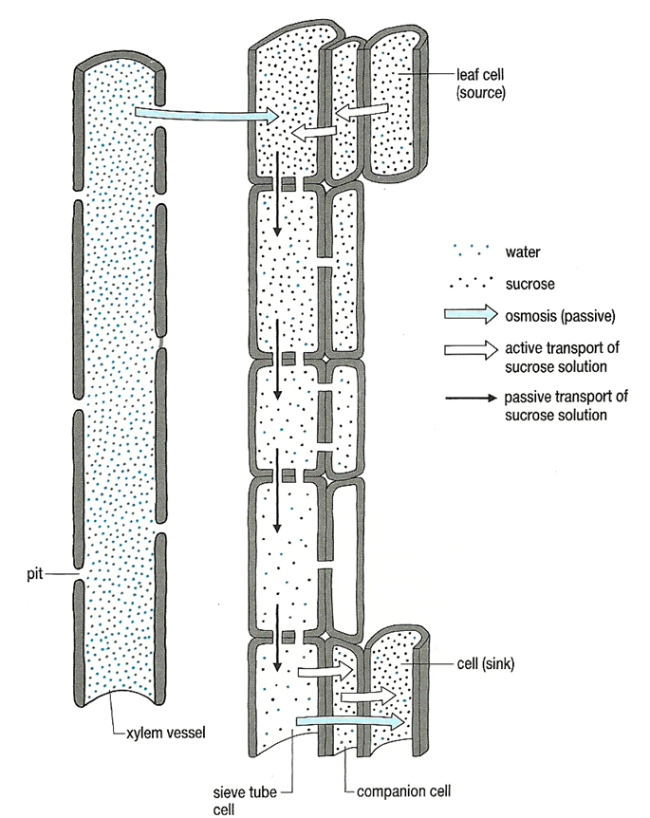Mass Transport in plants

**Unloading to a sink**

* As solutes are pushed down a pressure gradient, they are surrounded by cells with a lower solute concentration
* Solutes leave the phloem into these cells, lowering their water potential
* Water leaves the phloem by osmosis, returned to the surrounding xylem and is re-circulated
* Cells in the sink use, or store, the solutes

**Pressure flow from source to sink**

* Entry of solutes into sieve tube elements lowers their water potential (makes the water potential more negative)
* As a result, water enters the sieve tube elements from the surrounding xylem vessels
* This increases the pressure within the sieve tube elements, pushing their contents through the pores in the sieve plates

**Loading from source**

* In the leaves, solutes are passed from photosynthesising cells into the companion cells of the phloem
* The companion cells then load the solutes into the sieve tube elements via plasmodesmata
* ATP hydrolysis is involved in this transfer