**Q1.**          Lemmings are small mammals which live in the Arctic. Their main predator is the stoat, a small carnivorous mammal, which feeds almost entirely on lemmings. The graph shows the changes in the numbers of lemmings and stoats from 1988 to 2000.

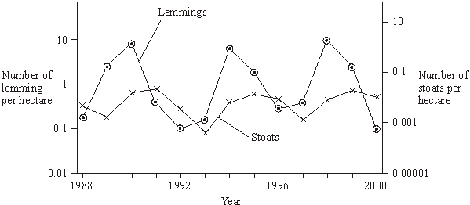

(a)     Describe and explain the changes which occur in the lemming and stoat populations.

......................................................................................................................

......................................................................................................................

......................................................................................................................

......................................................................................................................

......................................................................................................................

......................................................................................................................

......................................................................................................................

......................................................................................................................

......................................................................................................................

......................................................................................................................

......................................................................................................................

......................................................................................................................

**(6)**

**S**       (b)     Lemmings often live in isolated populations. From time to time some lemmings move and join other populations. Explain how this movement is important in maintaining genetic variability in lemming populations which have large fluctuations in size.

......................................................................................................................

......................................................................................................................

......................................................................................................................

......................................................................................................................

**(2)**

**S**       (c)     James Bay is a large ocean bay in northern Canada. It was formed by the melting of glaciers. One species of lemming inhabits the eastern side of James Bay and another species of lemming inhabits the western side. Before the glaciers melted there was only one species of lemming present. Explain how two species of lemming evolved from the original species.

......................................................................................................................

......................................................................................................................

......................................................................................................................

......................................................................................................................

......................................................................................................................

......................................................................................................................

......................................................................................................................

**(4)**

**(Total 12 marks)**

**Q2.**          (a)     Explain what is meant by

(i)      succession;

.............................................................................................................

.............................................................................................................

.............................................................................................................

.............................................................................................................

**(2)**

(ii)     a climax community.

.............................................................................................................

.............................................................................................................

**(1)**

Heather plants are small shrubs. Heather plants are the dominant species in the climax community of some moorlands. The structure and shape of a heather plant changes as it ages. This results in changes in the species composition of the community. A large area of moorland was burnt leaving bare ground. The table shows four stages of succession in this area.

|  |  |  |  |
| --- | --- | --- | --- |
| **Time after burning / years** | **Appearance of heather plant** | **Mean percentage cover of heather** | **Other plant species present** |
| 4 |  | 10 | Many |
| 12 |  | 90 | Few |
| 19 |  | 75 | Several |
| 24 |  | 30 | Many |

(b)     Explain why the number of other plant species decreases between 4 and 12 years after burning.

......................................................................................................................

......................................................................................................................

......................................................................................................................

......................................................................................................................

**(2)**

**S**       (c)     The rate at which a heather plant produced new biomass was measured in g per kg of heather plant per year. This rate decreased as the plant aged. Use the information in the table to explain why.

......................................................................................................................

......................................................................................................................

......................................................................................................................

......................................................................................................................

......................................................................................................................

**(3)**

**(Total 8 marks)**

**Q3.**          A Sri Lankan scientist investigated the effect of human disturbance on the organisms living on a rocky seashore. He chose three areas for the study. These areas had different amounts of human disturbance.

The scientist measured human disturbance by walking from one end of the beach to the other. He recorded the number of people he encountered. **Figure 1** shows his results.

**Figure 1**

|  |  |  |  |
| --- | --- | --- | --- |
|  | Site **R** | Site **G** | Site **U** |
| Mean number of people encountered per hour (± standard deviation) | 2.2 (± 2.1) | 17.6 (± 9.6) | 34.6 (± 11.6) |
|  |  |  |  |

(a)     (i)      What conclusions can you draw about the number of people visiting Site **R** compared with the number of people visiting the other two sites? Give evidence from **Figure 1** to support your answer.

.............................................................................................................

.............................................................................................................

.............................................................................................................

.............................................................................................................

.............................................................................................................

**(2)**

(ii)     The scientist reported that the difference between the number of people visiting Site **R** and the number visiting the other two sites differed significantly (p < 0.05).

Use the words probability and chance to explain the meaning of *differed significantly (p < 0.05).*

.............................................................................................................

.............................................................................................................

.............................................................................................................

.............................................................................................................

.............................................................................................................

**(2)**

(b)     The scientist used quadrats to find the number of species at each of the three sites. He carried out a preliminary investigation and recorded the total number of species in an increasing number of quadrats. **Figure 2** shows the results.

**Figure 2**

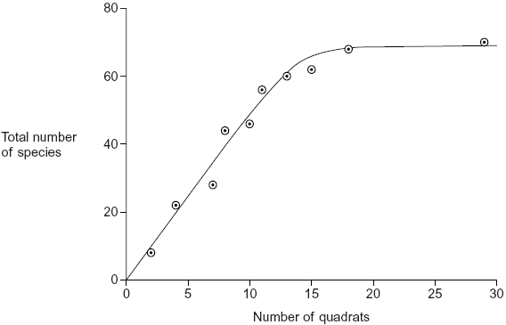

(i)      Use **Figure 2** to explain why 10 would **not** be an appropriate number of quadrats to use.

.............................................................................................................

.............................................................................................................

.............................................................................................................

**(1)**

(ii)     Use **Figure 2** to explain why 25 would **not** be an appropriate number of quadrats to use.

.............................................................................................................

.............................................................................................................

.............................................................................................................

**(1)**

          The scientist measured the dry biomass of seaweeds at each of sites **R**, **G** and **U**. He collected all the organisms of a particular species in a quadrat and incubated them in an oven at a temperature of 80 °C.

(c)     The scientist incubated the seaweeds at 80 °C. Suggest why incubating them at a higher temperature would **not** produce valid results.

......................................................................................................................

......................................................................................................................

......................................................................................................................

**(1)**

As well as measuring the dry biomass of the seaweeds, the scientist measured the dry mass of the animals present. He also measured the abundance of each species. **Figure 3** shows the data he collected.

**Figure 3**

|  |  |  |  |
| --- | --- | --- | --- |
|  | Site **R** | Site **G** | Site **U** |
| Mean number of people per hour | 2.2 | 17.6 | 34.6 |
| Mean number of species of seaweed per quadrat | 4.2 | 2.1 | 1.3 |
| Ratio of dry biomass of animals to dry biomass of seaweeds | 0.15 | 0.06 | 0.03 |
| Ratio of dry biomass of animals to abundance of animals | 0.20 | 0.10 | 0.09 |
| Ratio of dry biomass of seaweeds to abundance of seaweeds | 0.79 | 1.57 | 3.24 |

(d)     The ratio of the dry biomass of animals to the dry biomass of seaweeds is always a lot less than one. Explain why.

......................................................................................................................

......................................................................................................................

......................................................................................................................

......................................................................................................................

......................................................................................................................

**(2)**

(e)     (i)      Conservation officers were working on the beaches used in this investigation. They noticed that there were fewer larger seaweeds on beaches used by a large number of people than on beaches visited by only a few people. Explain how the data in **Figure 3** support this.

.............................................................................................................

.............................................................................................................

.............................................................................................................

.............................................................................................................

.............................................................................................................

**(2)**

(ii)     What conclusions can you draw from the data in **Figure 3** about the effect of human disturbance on the animals living on the seashore? Explain your answer.

.............................................................................................................

.............................................................................................................

.............................................................................................................

.............................................................................................................

.............................................................................................................

.............................................................................................................

.............................................................................................................

.............................................................................................................

**(4)**

**(Total 15 marks)**

**Q4.**          (a)     Blue tits are small birds that live in woods. An ecologist estimated the size of the blue tit population visiting gardens near a wood in November.

•        She trapped 28 blue tits. She marked all of these birds with small metal rings on their legs.

•        Two weeks later, she trapped another sample of blue tits. Of these birds, 18 were marked and 20 were not marked.

Use the data to estimate the size of the blue tit population. Show your working.

Size of population ....................................

**(2)**

(b)     The diagram shows some features of blue tit behaviour at different times of the year.

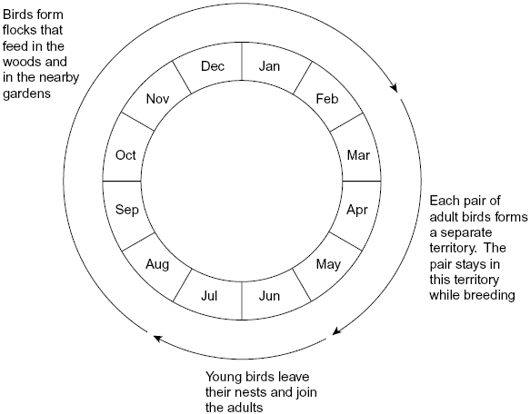

(i)      Using mark-release-recapture to estimate the size of a blue tit population in June would **not** give reliable results. Explain why.

.............................................................................................................

.............................................................................................................

.............................................................................................................

.............................................................................................................

.............................................................................................................

**(2)**

(ii)     Using mark-release-recapture to estimate the size of a blue tit population in March would **not** give reliable results. Explain why.

.............................................................................................................

.............................................................................................................

.............................................................................................................

.............................................................................................................

.............................................................................................................

**(2)**

(c)     Whales spend most of their time deep in the sea but they come to the surface to breathe. When they are at the surface, scientists obtain small samples of their skin. The scientists find the base sequence in some of the DNA from these samples. The base sequence is different in each whale.

You could use the information about the base sequence to estimate the size of the whale population by using mark-release-recapture. Explain why.

......................................................................................................................

......................................................................................................................

......................................................................................................................

......................................................................................................................

......................................................................................................................

**(2)**

**(Total 8 marks)**

**Q5.**          Ecologists investigated succession in some abandoned crop fields. The data that they collected are shown in the graph. The curves show the trends that occurred over a period of 60 years.

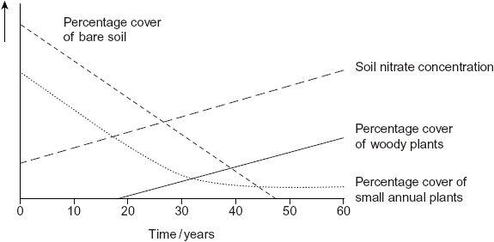

(a)     Explain the change in soil nitrate concentration shown on the graph.

......................................................................................................................

......................................................................................................................

......................................................................................................................

......................................................................................................................

......................................................................................................................

**(2)**

(b)     The pioneer plants had different characteristics from the plants that colonised the fields after 50 years.

(i)      The pioneer plants had seeds that germinate better when the temperature fluctuates.

Explain the advantage of this to these pioneer plants.

.............................................................................................................

.............................................................................................................

.............................................................................................................

.............................................................................................................

.............................................................................................................

**(2)**

(ii)     Explain the advantage to a plant that colonises after 50 years of having a high rate of photosynthesis at low light intensities.

.............................................................................................................

.............................................................................................................

**(1)**

(c)     Conservation of grassland habitats involves management of succession. Use the data in the graph to explain why.

......................................................................................................................

......................................................................................................................

......................................................................................................................

......................................................................................................................

......................................................................................................................

**(2)**

**(Total 7 marks)**

**Q6.**Lettuce is classified in the same family as dandelions. Dandelions commonly grow on roadside verges and may accidentally be sprayed with salt when salt is added to the road in winter.

Describe how you could use a transect to investigate whether the distribution of dandelions changed with increased distance from the road.

..................................................................................................................................

..................................................................................................................................

..................................................................................................................................

..................................................................................................................................

..................................................................................................................................

..................................................................................................................................

..................................................................................................................................

..................................................................................................................................

*(Extra space)* ...........................................................................................................

..................................................................................................................................

..................................................................................................................................

..................................................................................................................................

**(Total 4 marks)**

**Q7.Resource A**

Lettuce growers investigated the best conditions for germinating lettuce seeds. They soaked lettuce seeds for 8 hours in distilled water at different temperatures. They then germinated some of the seeds at 20 °C and some at 35 °C. The table shows their results.

|  |  |  |
| --- | --- | --- |
| **Temperature at which seeds were soaked / °C** | **Percentage of seeds which germinated** | |
|  | **at 20 °C** | **at 35 °C** |
| 20 | 100 | 89 |
| 25 | 100 | 43 |
| 30 | 41 | 1 |
| 35 | 21 | 0 |

**Resource B**

Scientists investigated the effects of different concentrations of sodium chloride on the germination of the seeds of two varieties of barley. The seeds were soaked for one hour in different concentrations of sodium chloride solutions and then germinated in distilled water at 25 °C. The scientists found the percentage of germinated seeds after 4 days and again after 8 days.

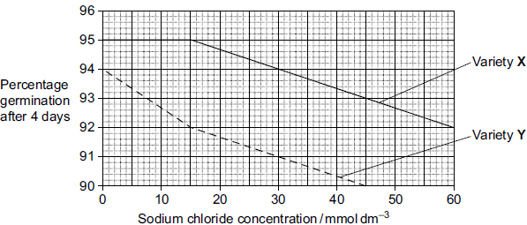

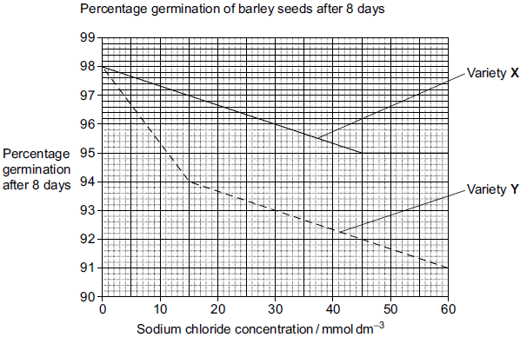

**Resource C**

The Food and Agriculture Organisation is investigating the effect of salt on plant growth. In some countries the water used to irrigate crops contains sodium chloride. The graph shows the effect of sodium chloride on the growth of some grasses and crop plants.

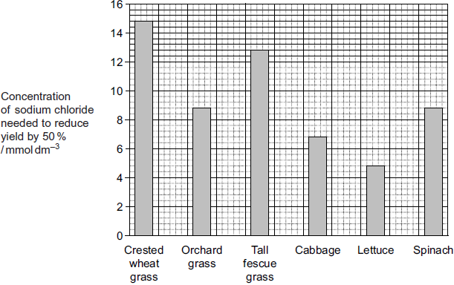

**Resource D**

Salt is used frequently on the roads in Canada during the winter months. The Highways Agency wants to plant salt-tolerant trees on roadside verges. They surveyed a range of roadside trees to determine how salt-tolerant they were. In the survey each tree was growing in soil with a similar salt concentration.

|  |  |  |  |  |  |  |
| --- | --- | --- | --- | --- | --- | --- |
|  | **Tree Species** | **Number of  trees  surveyed** | **Percentage of trees in each class** | | |  |
|  | **Healthy** | **Slightly  injured** | **Moderately to  severely  injured** | **Mean  concentration of  chloride ions  in the tissues of  roadside trees /  arbitrary units** |
|  | Red oak | 108 | 100 | 0 | 0 | 0.02 |
|  | Paper birch | 3 | 100 | 0 | 0 | 1.15 |
|  | Black cherry | 36 | 92 | 8 | 0 | 0.09 |
|  | Basswood | 54 | 57 | 41 | 2 | 0.90 |
|  | Red maple | 282 | 63 | 11 | 26 | 1.01 |
|  | Red pine | 140 | 9 | 15 | 76 | 1.08 |

(a)     The scientists concluded that red oak and paper birch are salt-tolerant but that the other species of tree are not. Use the data in **Resource D** to evaluate their conclusion.

........................................................................................................................

........................................................................................................................

........................................................................................................................

........................................................................................................................

........................................................................................................................

........................................................................................................................

........................................................................................................................

........................................................................................................................

(Extra Space) .................................................................................................

........................................................................................................................

........................................................................................................................

........................................................................................................................

**(4)**

(b)     Farmers have suggested that using salt on the roads in winter is damaging the yield from their land. Do the data in the resources above support this claim?

........................................................................................................................

........................................................................................................................

........................................................................................................................

........................................................................................................................

........................................................................................................................

........................................................................................................................

........................................................................................................................

........................................................................................................................

(Extra Space) .................................................................................................

........................................................................................................................

........................................................................................................................

........................................................................................................................

**(4)**

**(Total 8 marks)**

**Q8.**          Snow geese fly north to the Arctic in the spring and form breeding colonies. Different colonies form at different latitudes. The greater the latitude, the further north is the colony. The further north a breeding colony forms, the colder the temperature and the greater the risk of snow.

(a)     There is a positive correlation between the size of snow geese and how far north they breed. A large size results in snow geese being adapted for breeding in colder conditions. Explain how.

......................................................................................................................

......................................................................................................................

......................................................................................................................

......................................................................................................................

......................................................................................................................

**(2)**

Snow geese are either white or blue in colour. The table shows the percentage of white snow geese in colonies at different latitudes at different times over a 40-year period. The blank cells in the table are years for which no figures are available.

|  |  |  |  |  |  |
| --- | --- | --- | --- | --- | --- |
| **Colony** | **Latitude in degrees north** | **Percentage of white snow geese each year** | | | |
| **1930** | **1950** | **1960** | **1970** |
| **A** | 72 | 100 |  | 100 | 100 |
| **B** | 71 |  | > 99 | > 99 | > 99 |
| **C** | 66 | 95 | 85 | 76 |  |
| **D** | 63 | 86 | 75 | 67 | 65 |
| **E** | 55 |  | 62 |  | 28 |

(b)     (i)      Describe how the percentage of white snow geese varies with distance north.

.............................................................................................................

.............................................................................................................

.............................................................................................................

**(1)**

(ii)     The further north, the greater the risk of snow. Use this information to explain how natural selection might have accounted for the effect of latitude on the percentage of white snow geese.

.............................................................................................................

.............................................................................................................

.............................................................................................................

.............................................................................................................

.............................................................................................................

.............................................................................................................

**(3)**

(c)     The percentage of white snow geese in these colonies changed over the period shown in the table. Use your knowledge of climate change to suggest an explanation.

......................................................................................................................

......................................................................................................................

......................................................................................................................

......................................................................................................................

......................................................................................................................

**(2)**

(d)     Snow geese breed in large colonies. Scientists studied the nests in one colony. For each nest, they recorded the day on which the first egg hatched. They also recorded the number of young that survived from the nest. They used the data to plot a graph.

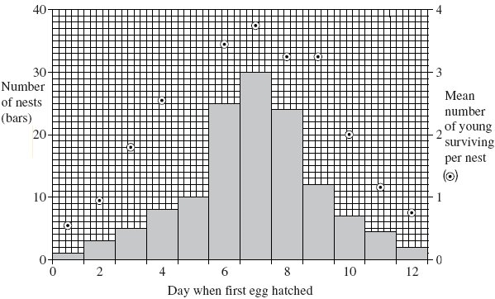

(i)      What type of natural selection is shown in the graph?

.............................................................................................................

**(1)**

(ii)     Describe the evidence for your answer.

.............................................................................................................

.............................................................................................................

**(1)**

**(Total 10 marks)**

**Q9.**Tomato plants were grown in two glasshouses, each with an area of 2000 m2. The table shows the mean number of hours of sunshine per month during fruit production.

|  |  |  |  |
| --- | --- | --- | --- |
|  |  | **1995 – 1997  (no extra carbon dioxide** | **1998 – 2000  (extra carbon dioxide)** |
|  | Mean number of hours of  sunshine per month | 148.91 | 147.00 |

•        The scientists used heating to maintain the tempera ture inside the glasshouses above 18 °C. They opened the windows to keep the tempera ture below 30 °C.

•        From 1998 to 2000 they maintained the carbon dioxide concentration between 0.06 % and 0.08 % when the windows were closed and between 0.04 % and 0.05 % when the windows were open.

•        The carbon dioxide concentra tion in the air outside the glasshouse was 0.04 %.

(a)     The scientists monitored the number of hours of sunshine per month. Explain why they monitored the number of hours of sunshine.

........................................................................................................................

........................................................................................................................

........................................................................................................................

........................................................................................................................

........................................................................................................................

........................................................................................................................

**(2)**

(b)     The temperature, the use of fertiliser and the number of insect pests were controlled during this investigation. Name one other factor which should have been controlled during the investigation. Explain why variation in this factor would affect yield.

Factor .............................................................................................................

Explanation .....................................................................................................

........................................................................................................................

**(2)**

**(Total 4 marks)**

**Q10.**During the last 50 years, there have been changes in the climate of the UK. One of the main changes is temperature. The data in the following resources all relate to southern England.

**Figure 1** shows the mean temperatures for January and February combined.

**Figure 1**

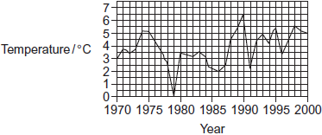

**Figure 2** shows the mean temperatures for March.

**Figure 2**



Birds, such as chaffinches, have been recorded as breeding earlier. Chaffinches build nests. When the nest is complete, the female lays eggs until she has produced a full clutch of 4 to 6 eggs. After the eggs hatch, the parent birds feed the young on insects.

**Figure 3** shows the mean date on which chaffinches laid their first egg.

**Figure 3**

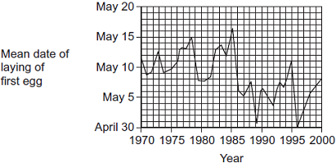

The data from which this graph was drawn were collected by volunteers. They used standard record cards. The volunteers used one record card for each nest they found. Each card was used to record

•        the geographical location

•        the habitat in which the nest site was situated

•        the date of each visit to the nest by the volunteer

•        the number of eggs present in the nest at each visit.

Visits were made to the nests at least once every 5 days.

(a)     Do the data in **Figure 1** and **Figure 2** support the idea that there has been a rise in the mean temperatures in southern England between 1970 and 2000? Explain your answer.

........................................................................................................................

........................................................................................................................

........................................................................................................................

........................................................................................................................

........................................................................................................................

**(2)**

(b)     Describe briefly how you would use a statistical test to find whether there is a significant correlation between mean March temperature and the date when chaffinches laid their first egg.

........................................................................................................................

........................................................................................................................

........................................................................................................................

........................................................................................................................

........................................................................................................................

........................................................................................................................

(Extra space) .................................................................................................

........................................................................................................................

........................................................................................................................

**(3)**

(c)     In chaffinches, the date of laying the first egg is determined by a number of factors. These include day length and temperature. What is the advantage to the bird of egglaying being determined by

(i)      daylength

...............................................................................................................

...............................................................................................................

...............................................................................................................

...............................................................................................................

...............................................................................................................

**(2)**

(ii)     temperature?

...............................................................................................................

...............................................................................................................

...............................................................................................................

...............................................................................................................

...............................................................................................................

**(2)**

(d)     Scientists found that there was a correlation between mean annual temperature and the date when chaffinches laid the first egg. Can you conclude that higher temperatures cause earlier laying of the first egg?  
Explain your answer.

........................................................................................................................

........................................................................................................................

........................................................................................................................

........................................................................................................................

........................................................................................................................

**(2)**

(e)     How does the way in which the data were collected affect the conclusions which can be drawn from **Figure 3**?

........................................................................................................................

........................................................................................................................

........................................................................................................................

........................................................................................................................

........................................................................................................................

**(2)**

**(Total 13 marks)**

**Q11.**          The diagram shows some of the components of a pond ecosystem.

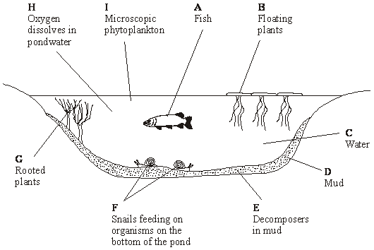

(a)     (i)      What is an ecosystem?

.............................................................................................................

.............................................................................................................

**(1)**

(ii)     List the letters that represent those components that are part of the pond community.

.............................................................................................................

**(1)**

(b)     New Zealand pygmy weed has been introduced into many garden ponds and has spread to some natural ponds. Here, it competes with naturally occurring plants. Suggest how the introduction of pygmy weed may lead to a reduction in the diversity of the community in a natural pond.

......................................................................................................................

......................................................................................................................

......................................................................................................................

......................................................................................................................

......................................................................................................................

......................................................................................................................

**(3)**

**(Total 5 marks)**

**Q12.**          Woods can be coppiced to provide a continuous supply of useful logs and poles. Coppicing involves cutting down some trees in a wood to leave stumps. New shoots grow from the stumps. After about 15 years, these trees can be coppiced again.

Because coppicing produces a wood with patches of light and shade, the diversity of plants and animals in a coppiced wood is high.

Ecologists investigated the effect of coppicing on the flowering of wild daffodils growing in a wood in Cumbria. Some areas of the wood were coppiced and some areas were not. The graph shows some results from this investigation.

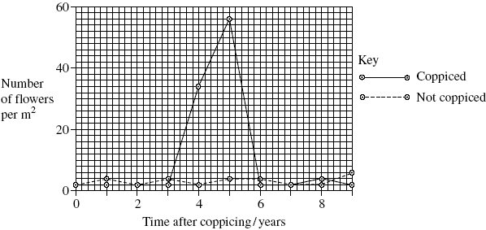

(a)     You could collect data for the coppiced plots by using quadrats.

(i)      Describe how you would place the quadrats at random.

.............................................................................................................

.............................................................................................................

.............................................................................................................

.............................................................................................................

**(2)**

(ii)     Describe how you would decide the number of quadrats to use in order to collect representative data.

.............................................................................................................

.............................................................................................................

.............................................................................................................

.............................................................................................................

**(2)**

(b)     Members of the public visit this wood to see wild daffodils in flower. Explain how the information in the graph could help the owners to manage the wood so that there were many wild daffodils in flower every year.

.............................................................................................................

.............................................................................................................

.............................................................................................................

.............................................................................................................

.............................................................................................................

**(2)**

(c)     The ecologists analysed the relationship between the number of daffodils in flower in the whole wood and data collected from a nearby weather station for the previous year.

They used the Spearman rank correlation test. The table shows their results.

|  |  |  |  |
| --- | --- | --- | --- |
| **Month** | **Climatic factor** | **Correlation coefficient** | **Statistical significance** |
| July | Total rainfall | + 0.65 | significant |
| August | Total rainfall | + 0.74 | significant |
| July | Monthly mean temperature | – 0.78 | significant |
| August | Monthly mean temperature | – 0.65 | significant |

The ecologists concluded that a wet, cool summer produces good flowering the following spring. Do you support this conclusion? Use the data in the table to explain your answer.

......................................................................................................................

......................................................................................................................

......................................................................................................................

......................................................................................................................

......................................................................................................................

**(2)**

**(Total 8 marks)**

**Q13.**          The graph shows the effects of light intensity on the rate of photosynthesis of three species of tree, **X**, **Y** and **Z**. Each of these species occurs at a different stage in succession.

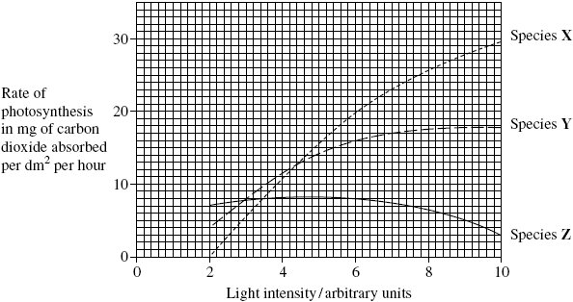

(a)     Species **X** is the first tree to become established in the succession. Use the graph to explain why it is likely to become established earlier in the succession than **Y** or **Z**.

......................................................................................................................

......................................................................................................................

......................................................................................................................

......................................................................................................................

......................................................................................................................

......................................................................................................................

**(3)**

(b)     Species **X** may change the environment so that it becomes more suitable for species **Z**.

Use the graph to explain why.

......................................................................................................................

......................................................................................................................

......................................................................................................................

......................................................................................................................

......................................................................................................................

**(2)**

**(Total 5 marks)**

**Q14.**          In the activated sludge method of sewage treatment, organic matter in untreated sewage supplies nutrients to bacteria in the treatment tank. These bacteria include decomposers and nitrifying bacteria. The bacteria are eaten by ciliated protoctistans, which are, in turn, eaten by carnivorous protoctistans.

(a)     (i)      Explain the roles of the decomposers and the nitrifying bacteria in converting nitrogen in organic compounds in the sewage into a soluble, inorganic form.

.............................................................................................................

.............................................................................................................

.............................................................................................................

.............................................................................................................

.............................................................................................................

.............................................................................................................

**(3)**

(ii)     Nitrifying bacteria are one kind of bacteria that are important in the nitrogen cycle; nitrogen-fixing bacteria are another kind. Describe the part played by nitrogen-fixing bacteria in the nitrogen cycle.

.............................................................................................................

.............................................................................................................

.............................................................................................................

.............................................................................................................

**(2)**

(b)     The organic matter in untreated sewage consists of small particles, which are suspended in water. Activated sludge consists of solid lumps (flocs) of organic matter and bacteria. When the two are mixed in the treatment tank, bacteria from the flocs become dispersed in the water and feed on the suspended organic matter, converting it to flocs. Different types of ciliated protoctistans feed on the bacteria.

•        Free-swimming protoctistans are able to move throughout the tank.

•        Crawling protoctistans can only move over the surface of the flocs.

The diagram shows the change in the nature of the organic matter in the treatment tank and the changes in the numbers of the different types of organisms present.

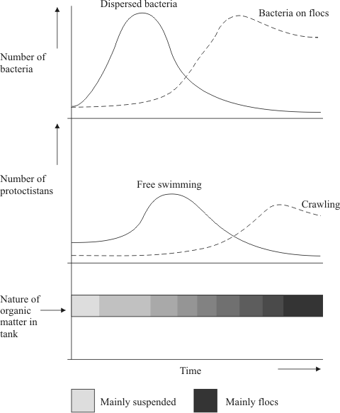

(i)      Explain the changes in the numbers of dispersed bacteria and the numbers of free-swimming protoctistans.

.............................................................................................................

.............................................................................................................

.............................................................................................................

.............................................................................................................

.............................................................................................................

.............................................................................................................

**(3)**

(ii)     Explain how the changes that occur in the treatment tank illustrate the process of succession.

.............................................................................................................

.............................................................................................................

.............................................................................................................

.............................................................................................................

.............................................................................................................

.............................................................................................................

.............................................................................................................

.............................................................................................................

**(4)**

**(Total 12 marks)**

**Q15.**          Shrews are small mammals. Three species of shrew live in mainland Britain. The table shows some features of these shrews.

|  |  |  |  |
| --- | --- | --- | --- |
| **Species** | **Mean body mass / g** | **Mean length of head and body / mm** | **Food** |
| Common shrew | 10 | 79 | Mainly insects and |
| Pygmy shrew | 5 | 58 | other small |
| Water shrew | 13 | 85 | invertebrates |

A team of biologists investigated a method of estimating the abundance of shrews. They used plastic tubes, called hair tubes. Some of the hairs from a shrew that enters one of these tubes stick to glue in the tube. These hairs can be used to identify the species of shrew. The diagram shows a set of these hair tubes.

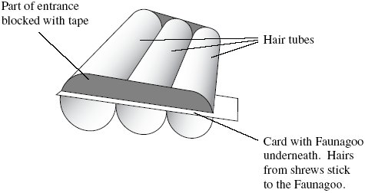

(a)     (i)      Faunagoo is a glue that remains sticky after wetting and drying. Explain the advantage of using Faunagoo in these hair tubes.

.............................................................................................................

.............................................................................................................

**(1)**

(ii)     The diagram shows that the biologists partly blocked the entrances to the tubes with tape. Suggest why they partly blocked the entrances.

.............................................................................................................

.............................................................................................................

**(1)**

(b)     The biologists needed to find a way of distinguishing between the hairs of the three species of shrew. They collected hairs from shrews of each species. For each species, they selected hairs at random and made different measurements.

Explain why the biologists selected the hairs at random.

......................................................................................................................

......................................................................................................................

**(1)**

(c)     Repeatable measurements are measurements of the same feature that are very similar.

In this investigation, each measurement was made by two observers. This helped the team to check the repeatability of these measurements.

(i)      Explain why it was important to check the repeatability of the measurements.

.............................................................................................................

.............................................................................................................

.............................................................................................................

.............................................................................................................

.............................................................................................................

**(2)**

(ii)     You could use a scatter diagram to check the repeatability of measurements made by two observers. Describe how.

.............................................................................................................

.............................................................................................................

.............................................................................................................

.............................................................................................................

.............................................................................................................

**(2)**

(d)     The biologists used hair tubes to find the abundance of shrews along the edges of some fields. They also used traps that caught shrews without harming them. They selected areas where all three species of shrew were present.

•        They put sets of hair tubes at 5 m intervals along the edges of the fields. They inspected the tubes one week later and recorded the number of sets of tubes that contained shrew hairs. They called this the hair tube index.

•        At each site where they used hair tubes, they set traps immediately after using the hair tubes. They recorded the number of different shrews caught in these traps.

(i)      The research team found the hair tube index. Explain why they could not use the hair tubes to find the total number of shrews present.

.............................................................................................................

.............................................................................................................

.............................................................................................................

**(1)**

(ii)     The research team set the traps immediately after using the hair tubes. Explain why setting the traps immediately after using the hair tubes would make comparisons between the two methods more reliable.

.............................................................................................................

.............................................................................................................

.............................................................................................................

.............................................................................................................

.............................................................................................................

**(2)**

The graphs are types of scatter diagram called bubble plots. They show hair tube index plotted against the number of shrews caught in traps. The area of the bubble is proportional to the number of records plotted.

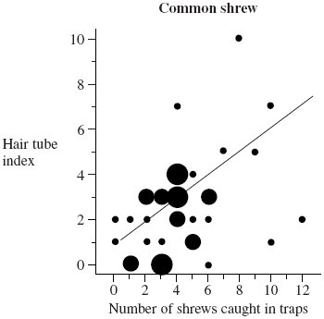

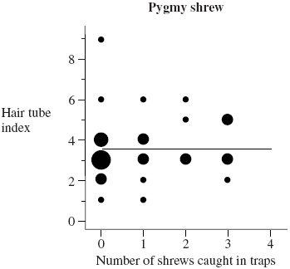

(e)     Explain why a statistical test was necessary in analysing the results for the common shrew. Use the terms chance and probability in your answer.

......................................................................................................................

......................................................................................................................

......................................................................................................................

......................................................................................................................

......................................................................................................................

**(2)**

(f)      (i)      The biologists concluded that hair tubes were a reliable way of measuring the abundance of common shrews. Give evidence from the graph to support this conclusion.

.............................................................................................................

.............................................................................................................

**(1)**

(ii)     Use information in this question to evaluate the use of hair tubes as a way of measuring the abundance of pygmy shrews.

.............................................................................................................

.............................................................................................................

.............................................................................................................

.............................................................................................................

.............................................................................................................

**(2)**

**(Total 15 marks)**

**Q16.**          Tigers inhabit forests where they feed mainly on large prey animals. Over the past fifty years, there has been extensive deforestation in many areas where tigers are found.

The graph shows the relationship between the prey biomass of an area and the tiger population that the area can support.

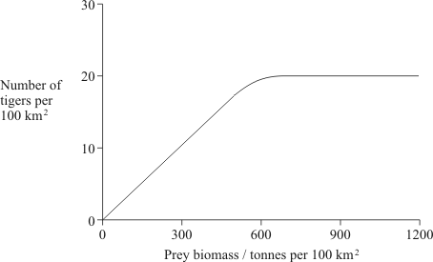

(i)      What is meant by the ecological term *population*?

......................................................................................................................

......................................................................................................................

**(1)**

(ii)      Use the graph to explain how deforestation might cause a reduction in the number of tigers in an area.

......................................................................................................................

......................................................................................................................

......................................................................................................................

......................................................................................................................

......................................................................................................................

......................................................................................................................

**(3)**

**(Total 4 marks)**

**Q17.**          Biologists studied the process of succession in an area of wasteland over a period of ten years. They calculated the index of diversity of the area every year. After three years, the index of diversity was 1.6. After ten years, it had risen to 4.3.

(a)     What information concerning the organisms present in the area is suggested by the increase in the index of diversity?

......................................................................................................................

......................................................................................................................

......................................................................................................................

......................................................................................................................

**(2)**

(b)     The increase in the index of diversity is one indication that a biological succession is taking place in the area. Describe those features of a succession that would bring about an increase in the index of diversity.

......................................................................................................................

......................................................................................................................

......................................................................................................................

......................................................................................................................

......................................................................................................................

......................................................................................................................

......................................................................................................................

**(3)**

**(Total 5 marks)**

﻿

**Q18.**         Some students investigated the effect of light intensity in the environment on the size of leaves of nettles. They measured leaves on sixty plants in each of two sites. The results are summarised in the table.

|  |  |  |
| --- | --- | --- |
| **Dimensions of leaves / mm** | **Site with high light intensity** | **Site with low light intensity** |
| Length of longest leaf | 113 | 116 |
| Length of shortest leaf | 41 | 42 |
| Mean length | 86 | 92 |
| Mean maximum width | 68 | 74 |

|  |  |  |
| --- | --- | --- |
| Standard deviation of lengths | 11 | 16 |
| Standard deviation of maximum widths | 7 | 11 |

(a)     Each leaf to be measured was selected in the following way.

•        The top left hand corner of a quadrat frame was placed at coordinates given by a random number table; the nettle plant nearest the centre of the quadrat was selected,

•        The sixth leaf from the tip of the plant was selected.

Explain the importance of

(i)      the method of selecting the nettle plant;

.............................................................................................................

.............................................................................................................

.............................................................................................................

.............................................................................................................

**(2)**

(ii)     measuring the sixth leaf.

.............................................................................................................

.............................................................................................................

.............................................................................................................

.............................................................................................................

**(2)**

(b)      Use the data about the length of leaves in the two sites to explain why standard deviation is more useful than range as a measure of variation within a population.

......................................................................................................................

......................................................................................................................

......................................................................................................................

......................................................................................................................

......................................................................................................................

......................................................................................................................

......................................................................................................................

......................................................................................................................

**(4)**

(c)     The area of a nettle leaf can be estimated using the formula

area   =   length × maximum width × 0.5

Calculate the ratio of the mean area of the leaves from the site with low intensity to the mean area of the leaves from the site with high light intensity. Show your working.

Answer .....................................

**(2)**

**(Total 10 marks)**

**Q19.**          Detritivorous insects feed on the dead remains of plants. Some students estimated the numbers of detritivorous insects at two different sites in an ecosystem. They also obtained data about the net primary production of the sites to see if this influenced the numbers of insects present. Net primary production is a measure of plant biomass formed per year. The results are shown in the table.

|  |  |  |  |
| --- | --- | --- | --- |
|  | **Site** | **Number of insects per m2** | **Net primary production / g m–2 y–1** |
|  | **A** | 316 | 1440 |
|  | **B** | 90 | 550 |

(a)     Explain how the students could use the mark-release-recapture technique to estimate the numbers of insects.

......................................................................................................................

......................................................................................................................

......................................................................................................................

......................................................................................................................

......................................................................................................................

......................................................................................................................

......................................................................................................................

......................................................................................................................

**(4)**

(b)     The students used the chi-squared (χ2) test to test the hypothesis that there was no significant difference between the numbers of insects per square metre at sites **A** and **B**. The value they obtained was 125.8. They checked this value in χ2 tables.

(i)      How many degrees of freedom should they check against?

.............................................................................................................

**(1)**

(ii)     What level of probability is normally used to judge whether a difference is statistically significant?

.............................................................................................................

**(1)**

(iii)     The value of χ2 for the 0.001 level of probability for this number of degrees of freedom is 10.8. What does the value obtained by the students suggest about the difference in numbers of the insects per square metre between the two sites?

Explain your answer.

.............................................................................................................

.............................................................................................................

.............................................................................................................

.............................................................................................................

**(2)**

(c)     (i)      Explain why the net primary production of an area does not represent the total amount of plant biomass formed per year by photosynthesis.

.............................................................................................................

.............................................................................................................

.............................................................................................................

.............................................................................................................

**(2)**

(ii)     Suggest how the difference in net primary production of sites **A** and **B** might explain the difference in the number of insects between the sites.

.............................................................................................................

.............................................................................................................

**(1)**

**(Total 11 marks)**

**Q20.**          Since 1965 there has been a steady rise in the phosphate concentration in the water of Lake Windermere. Scientists have monitored the phosphate concentration and plant biomass over a period of time. The results are shown in the graphs.

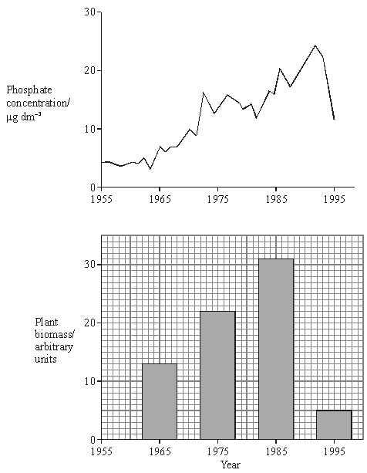

(a)     Suggest **one** source of the phosphate in the lake.

......................................................................................................................

......................................................................................................................

**(1)**

(b)     Calculate the percentage decrease in plant biomass between 1985 and 1995. Show your working.

Answer ............................................

**(2)**

(c)     From these graphs, a student concluded that changes in phosphate concentration caused changes in plant biomass. Explain why this conclusion may not be valid.

......................................................................................................................

......................................................................................................................

......................................................................................................................

......................................................................................................................

**(2)**

(d)     Between 1982 and 1992 the number of fish in the lake decreased. Explain how the change in phosphate concentration may have resulted in this decrease in the fish population.

......................................................................................................................

......................................................................................................................

......................................................................................................................

......................................................................................................................

......................................................................................................................

......................................................................................................................

......................................................................................................................

......................................................................................................................

......................................................................................................................

......................................................................................................................

......................................................................................................................

......................................................................................................................

**(6)**

**(Total 11 marks)**

**Q21.**          (a)     Explain the meaning of these ecological terms.

Population ....................................................................................................

......................................................................................................................

Community ...................................................................................................

......................................................................................................................

**(2)**

(b)     Some students used the mark-release-recapture technique to estimate the size of a population of woodlice. They collected 77 woodlice and marked them before releasing them back into the same area. Later they collected 96 woodlice, 11 of which were marked.

(i)      Give **two** conditions necessary for results from mark-release-recapture investigations to be valid.

1 ……...................................................................................................

.............................................................................................................

2 ……...................................................................................................

.............................................................................................................

**(2)**

(ii)     Calculate the number of woodlice in the area under investigation. Show your working.

Answer ......................................................

**(2)**

(c)     Explain how you would use a quadrat to estimate the number of dandelion plants in a field measuring 100 m by 150 m.

......................................................................................................................

......................................................................................................................

......................................................................................................................

......................................................................................................................

......................................................................................................................

......................................................................................................................

**(3)**

(d)     Two similar species of birds (species **A** and species **B**) feed on slightly different sized insects and have slightly different temperature preferences. The diagram represents the response of each species to these factors.

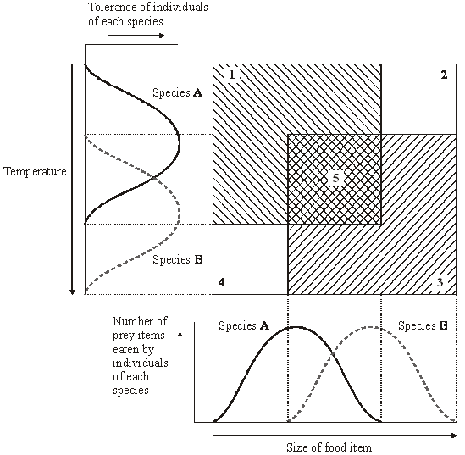

(i)      Which of the numbered boxes describes conditions which represent

the niche of species **A**;                                                                              .............

the niche of species **B**;                                                                              .............

insects too small for species **B** and temperature too warm for species **A**; .............

insects too large for species **A** and temperature too cool for species **B**?  .............

**(2)**

(ii)     These two species are thought to have evolved as a result of sympatric speciation. Suggest how this might have occurred.

.............................................................................................................

.............................................................................................................

.............................................................................................................

.............................................................................................................

.............................................................................................................

.............................................................................................................

.............................................................................................................

**(4)**

**(Total 15 marks)**

**Q22.** When coal is mined by open-cast mining, the top layer of soil is first scraped off and stored in a large heap. Once mining has finished, the area can be reclaimed. Soil from this store is then spread back over the surface.

Some of the bacteria living in the soil store respire aerobically and some respire anaerobically. **Table 1** shows the numbers of aerobic and anaerobic bacteria found at different depths in a soil store.

|  |  |  |  |  |
| --- | --- | --- | --- | --- |
| **Depth / cm** | **Mean number of bacteria per gram of soil (× 107)** | | | |
| Aerobic bacteria | | Anaerobic bacteria | |
| after 1 month | after 6 months | after 1 month | after 6 months |
| 0 | 12.0 | 12.1 | 0.6 | 0.8 |
| 50 | 10.4 | 8.6 | 0.8 | 1.3 |
| 100 | 10.1 | 6.1 | 0.7 | 4.1 |
| 150 | 10.0 | 3.2 | 0.7 | 7.9 |
| 200 | 11.6 | 0.8 | 0.7 | 8.4 |
| 250 | 11.9 | 0.7 | 0.8 | 8.8 |
| 300 | 11.0 | 0.8 | 0.6 | 9.1 |

**Table 1**

(a)     Some of the soil used to determine bacterial numbers was collected from the surface of the soil store. Describe how you would ensure that this soil was collected at random.

......................................................................................................................

......................................................................................................................

......................................................................................................................

......................................................................................................................

**(2)**

(b)     (i)      Describe how the numbers of aerobic bacteria after 6 months change with depth.

.............................................................................................................

.............................................................................................................

.............................................................................................................

.............................................................................................................

**(2)**

(ii)     Explain the difference in the numbers of aerobic bacteria at a depth of 300 cm between 1 and 6 months.

.............................................................................................................

.............................................................................................................

.............................................................................................................

.............................................................................................................

**(2)**

(c)     Explain how the changes in bacterial numbers which take place at 150 cm illustrate the process of succession.

......................................................................................................................

......................................................................................................................

......................................................................................................................

......................................................................................................................

......................................................................................................................

......................................................................................................................

**(3)**

Dehydrogenase is an enzyme involved in aerobic respiration. Dehydrogenase activity in a soil sample can be used as a measure of the activity of aerobic bacteria. The graph shows the mean dehydrogenase activity of soil samples taken from the same depth in a soil store at different times. The bars on the graph represent two standard errors above and below the mean.

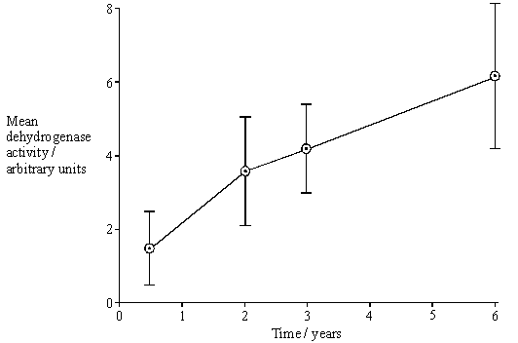

(d)     (i)      From what depth in the soil store would you expect these soil samples to have been taken? Use information from **Table 1** to explain your answer.

.............................................................................................................

.............................................................................................................

.............................................................................................................

.............................................................................................................

**(2)**

(ii)     How would you expect dehydrogenase activity to vary with depth after 6 months?

Use information from **Table 1** to explain your answer.

.............................................................................................................

.............................................................................................................

.............................................................................................................

.............................................................................................................

.............................................................................................................

.............................................................................................................

**(3)**

(e)     What do the error bars tell you about the difference between the mean dehydrogenase activity at 6 months and 3 years? Explain your answer in terms of probability and chance.

......................................................................................................................

......................................................................................................................

......................................................................................................................

......................................................................................................................

......................................................................................................................

......................................................................................................................

**(3)**

(f)      **Table 2** shows the dehydrogenase activity and the number of aerobic bacteria present in some soil samples.

|  |  |
| --- | --- |
| **Dehydrogenase activity / arbitrary units** | **Number of aerobic bacteria per gram of soil (× 107)** |
| 13.1 | 12.0 |
| 9.2 | 8.7 |
| 5.5 | 6.5 |
| 3.0 | 4.6 |
| 2.2 | 2.7 |
| 0.4 | 0.6 |

**Table 2**

A sample of soil was found to have dehydrogenase activity of 8.7 arbitrary units. Explain how you would use the data in **Table 2** to predict the likely number of aerobic bacteria in 1 g of this soil sample.

......................................................................................................................

......................................................................................................................

......................................................................................................................

......................................................................................................................

......................................................................................................................

......................................................................................................................

**(3)**

**(Total 20 marks)**

**Q23.**          A student investigated whether the abundance of the orange star lichen on the walls of a building was influenced by the direction the wall faced. The student recorded the number of colonies within a 50 cm2 quadrat, placed one metre above the ground on each of three walls.  
A 2 test was applied to the results.

(a)     Give a null hypothesis for this investigation.

......................................................................................................................

......................................................................................................................

**(1)**

(b)     Complete the following table.

|  |  |  |  |
| --- | --- | --- | --- |
|  | **Number of colonies on a wall facing** | | |
| **North** | **South** | **West** |
| Observed | 21 | 33 | 54 |
| Expected |  |  |  |

**(1)**

(c)     How many degrees of freedom were in this 2 test?

......................................................................................................................

**(1)**

(d)     A 2 value of 15.5 was calculated from these results. This 2 value has a probability of less than 0.001. Explain what this means when applied to this investigation.

......................................................................................................................

......................................................................................................................

......................................................................................................................

......................................................................................................................

......................................................................................................................

......................................................................................................................

**(3)**

       (e)     Algae are green protoctists. Lichens consist of a fungus and an alga living together in a relationship where both organisms benefit. Suggest how the relationship between the alga and the fungus allows the lichen to survive on an inorganic surface such as a wall.

......................................................................................................................

......................................................................................................................

......................................................................................................................

......................................................................................................................

**(2)**

**(Total 8 marks)**

**Q24.**          (a)     Explain what is meant by stabilising selection and describe the circumstances under which it takes place.

......................................................................................................................

......................................................................................................................

......................................................................................................................

......................................................................................................................

......................................................................................................................

......................................................................................................................

......................................................................................................................

......................................................................................................................

......................................................................................................................

**(5)**

(b)     Some European clover plants can produce cyanide. Those plants that can produce cyanide are called cyanogenic; those that cannot produce cyanide are called acyanogenic. Cyanide is toxic to the cells of animals and plants.

When the leaves of cyanogenic plants are damaged by slugs, or exposed to low temperatures, membranes within the cells are broken. This causes the release of the enzymes that control the reactions which produce cyanide.

The proportions of cyanogenic and acyanogenic plants in clover populations were determined in different parts of Europe. These are shown in the diagram below, together with the mean minimum winter temperatures. Slugs are not usually active at temperatures below 0 °C.

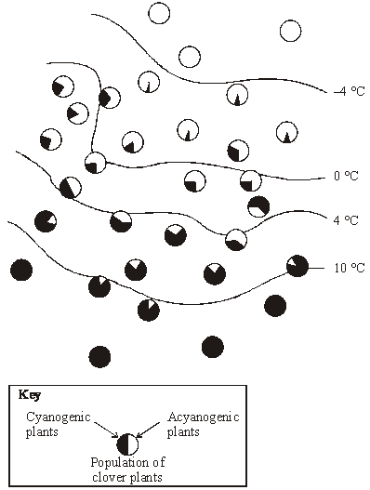

Explain the proportions of cyanogenic and acyanogenic plants in clover populations growing in the area where the mean minimum winter temperature is below –4°C and in the area where it is above 10 °C.

......................................................................................................................

......................................................................................................................

......................................................................................................................

......................................................................................................................

......................................................................................................................

......................................................................................................................

......................................................................................................................

......................................................................................................................

......................................................................................................................

**(5)**

**(Total 10 marks)**

**Q25.**          In a sand dune succession the pioneer community (**A**) colonises bare sand. This community is replaced over time by other communities (**B** and **C**) until a climax community of woodland (**D**) is formed.

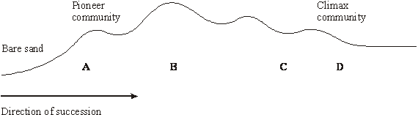

(a)     The communities **A** to **D** are composed of different species. Explain how the change in species composition occurs in a succession.

......................................................................................................................

......................................................................................................................

......................................................................................................................

......................................................................................................................

**(3)**

(b)     Which community, **A** to **D**, is the most stable? Explain what makes this the most stable community.

......................................................................................................................

......................................................................................................................

......................................................................................................................

......................................................................................................................

**(2)**

**S**       (c)     Many species in the pioneer community are xerophytes. Suggest and explain how having sunken stomata is an advantage to these plants.

......................................................................................................................

......................................................................................................................

......................................................................................................................

......................................................................................................................

......................................................................................................................

......................................................................................................................

**(3)**

(d)     Explain why it would be more appropriate to use a transect rather than random quadrats when investigating this succession.

......................................................................................................................

......................................................................................................................

**(1)**

**(Total 9 marks)**

**Q26.**          The diagrams show three types of plant distribution.

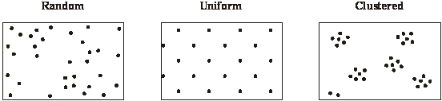

(a)     Describe how you would use quadrats to determine whether a particular plant species has a clustered or a random distribution.

......................................................................................................................

......................................................................................................................

......................................................................................................................

......................................................................................................................

......................................................................................................................

**(3)**

(b)     Some plants in a dry, hot desert have a uniform distribution and are widely spaced. Suggest how this type of distribution is an advantage to the plants.

......................................................................................................................

......................................................................................................................

......................................................................................................................

......................................................................................................................

**(2)**

**(Total 5 marks)**

**Q27.**          (a)     An ecosystem supports a certain size of population of a species.  
Predation is one biotic factor that can cause the size of this population to change.

Give **one** other biotic factor that can cause the size of a population to change.

......................................................................................................................

......................................................................................................................

**(1)**

(b)     Ecologists investigated predation by 555 domestic cats whose owners lived in different types of housing. They asked cat owners to record the number of mammals, birds and frogs that their cats brought home over a five-month period.

The graph shows their results.

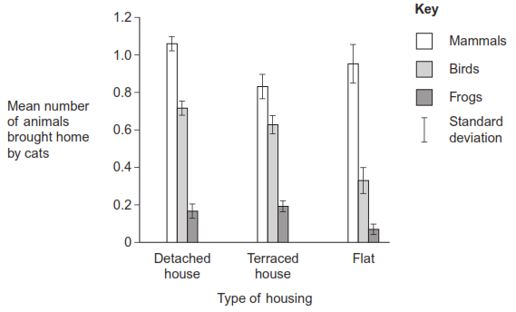

(i)      What do these data suggest about predation by domestic cats?

.............................................................................................................

.............................................................................................................

.............................................................................................................

.............................................................................................................

**(2)**

(ii)     Some scientists thought that the results of this investigation were **not** very reliable.

Suggest **one** reason why they might have thought that the results were **not** reliable.

.............................................................................................................

.............................................................................................................

.............................................................................................................

.............................................................................................................

**(2)**

(c)     The ecologists investigated the effect of putting a bell on a cat’s collar on its probability of catching prey. As in the first investigation, they asked cat owners to record the prey brought home by their cats. Half of the cats in this study had bells on their collars.

The graph shows the results.

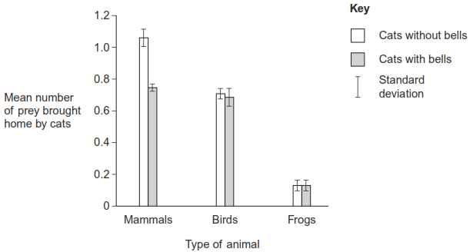

(i)      What was the hypothesis that the ecologists were investigating?

.............................................................................................................

.............................................................................................................

**(1)**

(ii)     What do these data suggest about the effect of putting a bell on a cat’s collar?

.............................................................................................................

.............................................................................................................

.............................................................................................................

.............................................................................................................

**(2)**

**(Total 8 marks)**

**Q28.**          The Solomon Islands are situated in the Pacific Ocean. The nearest large land mass is Australia, which is about 1500 km away. The biggest islands are mountainous, with large areas of tropical forest and a wide range of habitats. Some islands have a very high species diversity, and many species are endemic, that is they occur only in the Solomon Islands.

The table shows the total number of species on the islands in four vertebrate classes and the percentage which are endemic.

|  |  |  |
| --- | --- | --- |
| **Vertebrate class** | **Total number of species** | **Endemic species / %** |
| Mammals Birds Reptiles Amphibians | 53 223 61 17 | 36 20 16 53 |

(a)     How many reptile species are endemic?

......................................................................................................................

**(1)**

**S** (b)     Suggest an explanation for the high proportion of endemic species on the Solomon Islands.

......................................................................................................................

......................................................................................................................

......................................................................................................................

......................................................................................................................

......................................................................................................................

......................................................................................................................

**(3)**

**(Total 4 marks)**

**Q29.**          (a)     The diagram shows a number of stages in an ecological succession in a lake.

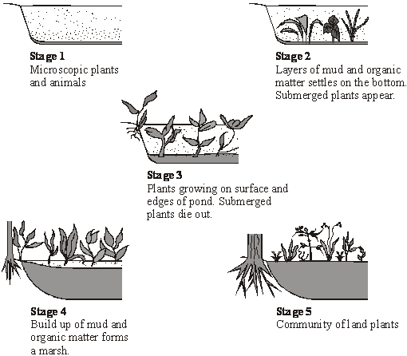

Explain how the diagrams illustrate the features of an ecological succession.

......................................................................................................................

......................................................................................................................

......................................................................................................................

......................................................................................................................

......................................................................................................................

......................................................................................................................

......................................................................................................................

......................................................................................................................

......................................................................................................................

......................................................................................................................

......................................................................................................................

......................................................................................................................

**(6)**

(b)     Several small rivers flow into this lake. These rivers flow through forested areas.  
Explain how deforestation might affect the process of succession in the lake.

......................................................................................................................

......................................................................................................................

......................................................................................................................

......................................................................................................................

**(2)**

**S**       (c)     **Stage 5** illustrates the final stage of succession which is known as the climax community. During this stage the number of different species in the habitat and the size of each population remain fairly constant. Explain what limits the size of populations in a climax community.

......................................................................................................................

......................................................................................................................

......................................................................................................................

......................................................................................................................

......................................................................................................................

......................................................................................................................

......................................................................................................................

......................................................................................................................

......................................................................................................................

......................................................................................................................

......................................................................................................................

......................................................................................................................

**(5)**

**(Total 13 marks)**

**Q30.**          The mesquite tree grows in dry areas which have soils with low concentrations of ions.  
Its roots grow down to 25 metres and contain nitrogen-fixing bacteria. It is considered a pest in areas where farm animals graze because it out-competes grass. In some areas, young mesquite trees are cut down and then ploughed into the ground. This is expensive but makes the soil slightly more fertile for a few years.

(a)     Using the information given, explain **one** way in which mesquite trees are adapted for survival.

.............................................................................................................

.............................................................................................................

**(1)**

**S**       (b)     Name the type of competition occurring between mesquite and grass.

.............................................................................................................

**(1)**

**S**       (c)     Explain how ploughing the mesquite into the soil makes it more fertile.

.............................................................................................................

.............................................................................................................

.............................................................................................................

.............................................................................................................

.............................................................................................................

.............................................................................................................

**(3)**

**(Total 5 marks)**

**Q31.**          A hormone has been shown to switch on a gene in fish, leading to the increased production of an enzyme. Experiments were carried out to investigate the effects of heavy metal ions on the production of this enzyme, with and without the hormone. The table shows the results.

|  |  |  |
| --- | --- | --- |
|  | **Amount of enzyme produced / percentage of maximum** | |
| **Heavy metal ion present** | **Without hormone** | **With hormone** |
| None | 16 | 100 |
| Cadmium | 15 | 55 |
| Zinc | 17 | 94 |
| Copper | 16 | 100 |

Explain how the results suggest that cadmium affects the action of the hormone.

...............................................................................................................................

...............................................................................................................................

...............................................................................................................................

...............................................................................................................................

**(Total 2 marks)**

**Q32.**          The vegetation on a large heap of waste from an old mine was investigated. The table shows the results of the measurements of certain factors in 1m2 frame quadrats placed on the south-facing slope.

|  |  |  |  |  |
| --- | --- | --- | --- | --- |
| **Quadrat** | **Angle of slope / °** | **Vegetation cover / %** | **Moisture content of soil / %** | **pH of soil** |
| 1  2  3  4  5  6 | 45  30  25  12  7  1 | 60  70  68  100  85  100 | 17.2  14.6  20.3  23.5  21.0  21.2 | 5.6  4.2  5.2  7.1  5.4  6.8 |

(a)     Which of the factors measured are abiotic?

......................................................................................................................

**(1)**

(b)     Describe how the investigators could obtain the value for vegetation cover in each quadrat.

......................................................................................................................

......................................................................................................................

......................................................................................................................

......................................................................................................................

**(2)**

(c)     The correlation between vegetation cover and soil moisture content was tested statistically. These two factors were found to be positively correlated, and p < 0.05. Explain what this result means.

......................................................................................................................

......................................................................................................................

......................................................................................................................

......................................................................................................................

**(2)**

**S** (d)     At first the waste heap had no plants growing on it. Some of the first plants to colonise it were small herbaceous plants. Explain **one** way in which colonisation by herbaceous plants could change the physical environment.

......................................................................................................................

......................................................................................................................

......................................................................................................................

......................................................................................................................

**(2)**

**(Total 7 marks)**

**Q33.**          (a)     (i)      What is meant by an *abiotic* factor?

.............................................................................................................

.............................................................................................................

**(1)**

(ii)     Do abiotic factors exert a density-dependent or a density-independent effect on a population? Using an example, explain your answer.

Effect ...................................................................................................

Explanation ..........................................................................................

.............................................................................................................

**(1)**

(b)     Describe how you would collect the necessary data to estimate the size of a population by the mark-release-recapture technique.

......................................................................................................................

......................................................................................................................

......................................................................................................................

......................................................................................................................

......................................................................................................................

......................................................................................................................

**(3)**

**(Total 5 marks)**

**Q34.**          Answers should be written in continuous prose, where appropriate.

Quality of Written Communication will be assessed in these answers.

The waste material from coal mines is deposited in pit heaps. A particular mine closed and the colonisation of an area of its pit heap was studied for a period of 80 years. Species of plants that were found growing on the pit heap were recorded in two categories, short-lived plants that grow for one or two years before dying and long-lived plants that continue to grow for several years. The graph shows the percentages of short-lived and long-lived plants on the pit heap.

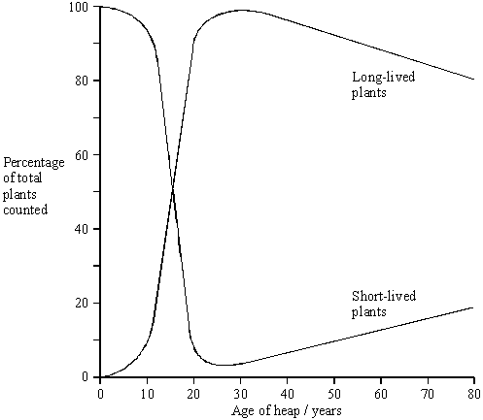

(a)     Using your knowledge of succession, suggest explanations for the changes in the percentages of short-lived and long-lived plants

(i)      over the first 20 years;

.............................................................................................................

.............................................................................................................

.............................................................................................................

.............................................................................................................

.............................................................................................................

.............................................................................................................

.............................................................................................................

.............................................................................................................

(ii)     between 30 and 80 years.

.............................................................................................................

.............................................................................................................

.............................................................................................................

.............................................................................................................

.............................................................................................................

.............................................................................................................

.............................................................................................................

.............................................................................................................

**(6)**

**S** (b)     Mine waste often contains metal ions at concentrations that are toxic to plants. Populations of two species of grass, red fescue and common bent, have been found on pit heaps contaminated with zinc ions.

Describe an experiment you would carry out in order to determine which of the two species has the greater tolerance to zinc ions in the soil.

......................................................................................................................

......................................................................................................................

......................................................................................................................

......................................................................................................................

......................................................................................................................

......................................................................................................................

......................................................................................................................

......................................................................................................................

**(3)**

**(Total 9 marks)**

**Q35.**          A species of moth occurs in forests in Switzerland. The moth larvae feed on the needle-shaped leaves of larch trees that grow in the forests. The graph shows the numbers of larvae and the mean length of leaves over a period of 20 years.

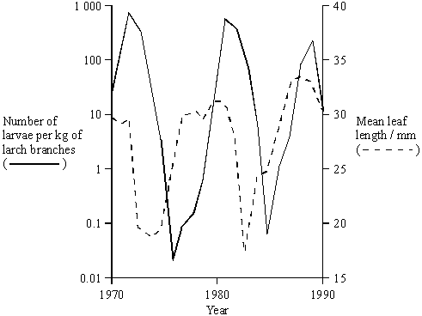

(i)      Describe how the population size of a species of bird that fed mainly on the moth larvae would be likely to change between 1970 and 1980.

......................................................................................................................

......................................................................................................................

......................................................................................................................

......................................................................................................................

**(2)**

**S** (ii)      Larch trees lose their leaves in autumn. When numbers of larvae are large in one year, the leaves in the following year are shorter. Suggest an explanation for this.

......................................................................................................................

......................................................................................................................

......................................................................................................................

......................................................................................................................

**(2)**

**(Total 4 marks)**

**M1.**          (a)     1       4 year cycles;  
2       predator / stoat peaks after prey / lemming;  
3       lemmings increase due to low numbers of stoats / available food;  
4       more food for stoats so numbers increase;  
5       increased predation reduces number of lemmings;  
6       number of stoats decreases due to lack of food / starvation;

**6**

(b)     smaller populations have fewer different alleles / more homozygosity / less  
heterozygosity / smaller gene pool / lower genetic variability;  
migrants bring in new alleles / increase gene pool;

**2**

(c)     geographical isolation of populations;  
variation present in population(s);  
different environmental conditions / different selection pressures / different   
phenotypes selected;  
change in genetic constitution of populations / gene pools / allele frequency;

**4**

**[12]**

**M2.**          (a)     (i)      change in community over time;  
either due to change environmental / abiotic factors / change is due to species present;

**2**

(ii)     stable community / no further succession / final community;

**1**

(b)     (increased) interspecific competition;  
for light / nutrients / named nutrient / water;

**2**

(c)     fewer leaves / lower surface area / shading of leaves so less photosynthesis to produce new biomass / glucose / growth; competition with other species for nitrates / named nutrients so reduced synthesis of protein or named compound; ratio of leaves to woody parts and roots decreases so higher respiration relative to photosynthesis;

**3**

**[8]**

**M3.**          (a)     (i)      Fewest people at site R as mean is lowest;

*Accept use of mean values to show 2.2 is the lowest*

Standard deviations do not overlap so significant / not due to chance;

*Accept use of values / description of standard deviation even in wording ‘standard deviation’ is not used*

**2**

(ii)     There was a probability of less than 0.05 / 5 in a hundred / 5%;

*In the context of less than  
Accept converse: probability of more than 95%*

That the difference was due to chance;

*Look for idea of difference (between sites)*

**2**

(b)     (i)      (Would not be reliable as) number of species is still increasing;

*Accept: has not reached peak / maximum or if shown by values*

**1**

(ii)     Idea of curve has flattened / no more species found so no benefit / no point / takes unnecessary time / takes unnecessary  
effort / can get same results with fewer quadrats;

*Basic idea is of minimising effort.*

*If values used reward idea rather than accuracy of numbers*

**1**

(c)     Combustion / would burn / cause loss of substances (other than water) / named substance / cause loss of dry mass;;

*Accept: only want water to be lost*

*Ignore: reference to decomposition*

**1**

(d)     Seaweeds / plants are producers / lower / first trophic level / animals are consumers / higher trophic level / feed on seaweeds;

*Accept relevant position in food chain as trophic level*

Loss of energy between trophic levels as a result of respiration / as heat;

*Accept: energy transfer is inefficient*

*Accept: description of trophic levels  
Accept: not all seaweed / eaten*

**2**

(e)     (i)      The site / site U with most people / 34.6 has the largest ratio / 3.24;

*Accept: as number of people increases, ratio increases*

(Large value of ratio due to) large biomass ÷ small number / large  
size ÷ small number / biomass greater than abundance;

*Explanation of seaweed ratio*

**2**

(ii)     1.      Fewer larger animals / more smaller animals where more people / more disturbance;

*Principle*

2.      0.09 linked to 34.6 / appropriate link between row 4 and row 1;:

*Use of data*

3.      Larger animals affected by human activity;

*Accept: converse*

4.      Smaller animals are young animals;

*Accept: converse*

5.      Fewer species of seaweed (with disturbance);

*Accept if shown by figures*

6.      (So) fewer niches / habitats (for large animals);

*Accept idea of disturbance / damage to niche / habitat*

**4 max**

**[15]**

**M4.**          (a)     Two marks for correct answer of 59 / 60;;

One mark for incorrect answer clearly derived from figures of 18, 28  
and 38;

*Ignore: any figures after decimal point.*

**2**

(b)     (i)      Population changes;

*Reject: population decreases*

As young birds leave nest / join population;

*Reject first point if (young) birds are leaving population / migrating*

**2**

(ii)     (Would be likely to) catch all birds (again) in second sample / sample sizes are the same;

*Neutral: references to breeding*

Birds (in territories and) not mixing with population;

*Accept: idea of the population is divided*

Accept only estimates number of birds in territories sampled / territory sample not representative (of population) for 1 mark

**2**

(c)     (Recording) DNA / base sequence is like marking (animal) / wouldn’t need to mark;

(Finding identical / same base sequence) would show animal has been caught / recorded before;

**2**

**[8]**

**M5.**          (a)     (Increase in) dead organisms / humus / decomposition;

Leading to (increase in) nitrification / ammonia to nitrate / activity of nitrifying bacteria;

**2**

(b)     (i)      Bare soil temperatures fluctuate;

*Reject: environmental temperature  
Accept: converse*

More bare soil, early / at start of succession / when few plants;

**2**

(ii)     Plant will grow / survive in the shade / when overshadowed  
(by taller plants) / when receiving less light;

*Effect on plant with reason for effect  
Ignore reference to competition*

**1**

(c)     (Grassland consists of) small / annual plants which will be replaced by / outcompeted by woody plants;

*Must be in the context of grassland*

*Need idea of replaced not just an increase in percentage cover*

So these (woody plants) must be removed / have growth checked / grazed;

**2**

**[7]**

**M6.**Lay tape / rope at right angle / perpendicular to road;  
Take samples at regular / stated intervals;  
Using a quadrat;  
Count numbers / percentage cover of dandelions;  
Use several transects;

**4 max**

**[4]**

**M7.**(a)     1.      Evidence for red oak is reliable because 100% healthy and large sample size / evidence for paper birch unreliable because sample size too small;

2.      Other species show injury so may not be tolerant;

3.      Amount of injury is subjective so not reliable;

4.      Paper birch is 100% healthy with high chloride in tissues so may be tolerant;

**4**

(b)     (Resource B suggests that) sodium chloride decreases the percentage germination (of barley);

(Resource C suggests that) sodium chloride decreases the yield of some grasses / named grasses / named crops;

(Resource D suggests that) the damage in susceptible plants / trees is associated with chloride accumulating in the tissues;

Some plants / trees are able to prevent chloride from entering the tissues and are not damaged;

**4**

**[8]**

**M8.**          (a)     Small surface area to volume ratio / more fat;

Lose less heat (to the environment) / for insulation when they are sitting on eggs;

**2**

(b)     (i)      The further north / higher the latitude, the higher the percentage (of white snow geese);

**1**

(ii)     Snow lying longer / melts slower further north / at greater latitudes;

White geese better camouflaged (further north);

Predation linked to survival / reproductive success;

***Q*** *In order to gain the last marking point, candidates must explain how survival or reproductive success is affected.*

**3**

(c)     Snow melts earlier / snow melts further north / less snow;

White geese decreasing as less well camouflaged / at disadvantage / blue geese increasing as better camouflaged / at an advantage;

**2**

(d)     (i)      Stabilising;

*Do not accept stable*

**1**

(ii)     Few geese survive at the extremes / most survive from the middle of the range;

**1**

**[10]**

**M9.**(a)     To see if a difference in hours of sunshine was present / because it is necessary to monitor factors which cannot be controlled;  
So that they could eliminate this factor from affecting the yield (with /without extra carbon dioxide);  
OR  
Duration of light influences length of time for photosynthesis / temperaturein glasshouse;  
Higher photosynthesis results in higher yield / more carbohydrates /sugars / proteins produced;

**2 max**

(b)     Named factor;  
Explanation of why the factor is important;  
E.g.  
Density of planting;  
Competition for named resource;  
or  
Same variety of tomato;   
Yield will vary with different varieties / with different genotypes;  
or  
Water (application);  
Water needed for expansion of fruit / maintain leaf turgidity / maintain stomatal opening / replace water lost in transpiration / water used in photosynthesis;

*For named resourceaccept ‘nutrient’ but not ‘food’*

**2**

**[4]**

**M10.**(a)     Shows trend of mean temperature rise;  
Higher temperatures more frequent since 1984 (in January and February);  
Considerable variation in temperature from year to year;  
Which may be due to chance;

*No mark for yes or no Do not penalise candidates who state there is no trend*

**2 max**

(b)     Construct null nypothesis;  
Use Spearman rank (and calculate test statistic);  
Look up in table (to find critical value of P = 0.05 / 5 %);  
Use figure (in table) to accept or reject null hypothesis;

**3 max**

(c)     (i)      (Particular daylength) always occurs at same time of year / valid example;  
Birds do not start laying eggs when period of warm weather occurs early in year;  
Synchronises breeding behaviour;  
Sufficient foraging time for food collection for young;

**2 max**

(ii)     Birds able to respond to changing climate;  
Food availability (mainly) determined by temperature;  
As insect / invertebrate development temperature-dependent;

**2 max**

(d)     A correlation does not indicate a causal relationship;  
As may be due to another factor / named factor;

**2**

(e)     Visits could be up to 5 days apart;  
Date of egg-laying may be inaccurate by 5+ days;

**2**

**[13]**

**M11.**          (a)     (i)      ecosystem is (self-supporting) system in which all organisms / community interact with physical environment / community + environment / biotic + abiotic;

**1**

(ii)     A + B + E + F + G + I;

**1**

(b)     pygmy weed competes for CO2 / light / nutrients; reduction in numbers of original plants;  
some of original plant species lost;  
loss of habitats / niches / shelter / food sources;  
consumers die / some migrate;

**3 max**

**[5]**

**M12.**          (a)     (i)      Method of positioning quadrats,  
E.g.   Find direction and distance from specified point / find coordinates on a grid / split area into squares;

Method of generating random numbers;

E.g.   From calculator / telephone directory / numbers drawn from a hat;

*Last point represents minimum answer*

***Q*** *Do not credit any method that relies on throwing a quadrat*

**2**

(ii)     Calculate running mean / description of running mean;

When enough quadrats, this shows little change / levels out (if plotted as a graph);

Enough to carry out a statistical test;

A large number to make sure results are reliable;

*Ignore terms that are not incorrect  
Regards large numbers as 10 / 10% +*

Need to make sure work can be carried out in the time available;

**2 max**

(b)     Coppice different parts of the wood at different times;

As data show many daffodils flowering 4 / 5 years after coppicing;

***Q*** *Second point needs specific reference to the graph, numbers and time after coppicing. Accept any correct answer that does this.*

**2**

(c)     Positive correlation between rainfall and flowering / the higher the rainfall, the more daffodil flowers;

Negative correlation / the higher the temperature the fewer daffodils in flower;

All statistically significant so not likely to be / not due to chance;

**2 max**

**[8]**

**M13.**          (a)     Vegetation consists mainly of low growing species / herbs / annuals / no / few trees;

Species **X** has high rate of photosynthesis at high light intensity;

*Do not credit Species* ***X*** *is first tree*

Species **X** grow fastest at high rate of photosynthesis / at high light intensities and will outcompete other species **Y** / **Z**;

**3**

(b)     Produces shade / reduces light intensity;

Species **Z** grows best / photosynthesis best / in low light intensity /   
Species **Z** does not grow well / low rate of photosynthesis in high light intensity;

*Accept answers in terms of CO2 absorption*

**2**

**[5]**

**M14.**          (a)     (i)      decomposers convert (nitrogen in organic compounds) into ammonia / ammonium; suitable example of “organic nitrogen” - protein / urea / amino acid etc. (e.g. linked to process); nitrifying bacteria / correctly named convert ammonium to nitrate; via nitrite;

**3**

(ii)     convert nitrogen (gas) into ammonium / ammonia / amino acids;  
add usable / available nitrogen to an ecosystem / eq.;

**2**

(b)     (i)      1.      numbers of dispersed bacteria increase as they feed on organic matter;

2.      numbers of free-swimming protoctistans increase because number of bacteria increase;

3.      dispersed bacteria decrease as amount of dispersed organic matter decreases / due to lack of food / as organic matter is converted to flocs / are preyed on by free-swimming protoctistans;

**3**

(ii)     1.      (in a succession) organisms (enter an area and) change the environment / conditions creating new niches / habitats;

2.      allows different species / different types of organisms to enter / be successful;

3.      dispersed bacteria change dispersed organic matter to flocs;

4.      presence of flocs allows crawling protoctistans to enter / to increase / to be successful;

**4**

**[12]**

**M15.**          (a)     (i)      Will work in all weather conditions / hairs will stick to it even if shrew / animal is wet / withstand rain;

**1**

(ii)     So shrews come into contact with glue;

**1**

(b)     Avoids bias / allows statistical tests to be carried out;

*Allow description*

**1**

(c)     (i)      Increases the reliability of the measurements;

If measurements are repeatable, differences less likely to be due to measurement / personal error / anomalies unlikely;

*Accept advantages of repeatable results. E.g. identifying anomalies / remove errors*

**2**

(ii)     Plot graph / scatter diagram of one set of results against the other;

***Q*** *To gain first marking point, candidates must say what has been plotted.*

Expect to see points lying close to line / Line should slope upwards / show positive correlation;

*If what is being plotted is not clear, second point cannot be awarded.*

OR

Plot measurement against hair number;

Look for overlying / corresponding points;

**2**

(d)     (i)      One mark for a valid explanation based on individual shrews entering more than one hair tube / many hairs from same shrew / shrews enter without leaving hair;

**1**

(ii)     Rules out differences due to changes in population / changes in environmental conditions;

That could be produced by births / deaths / migration / specific example of environmental conditions affects results;

**2**

(e)     (A statistical test) determines the probability of results being due to chance;

Enables null hypothesis / description of null hypothesis to be accepted / rejected / determines whether correlation / result is significant;

**2**

(f)      (i)      (Curve / line of best fit shows) positive correlation / description of positive correlation;

**1**

(ii)     Curve / line of best fit (almost) parallel to x-axis / horizontal / level / no correlation / index is independent of number of shrews;

Hair tubes with positive results when no shrews trapped;

Small size of shrews means shrews may not trigger traps;

**2 max**

**[15]**

**M16.**          (i)      Population is the total number of organisms / individuals of a  
species / tigers in an area (at a given time);

**1**

(ii)      (Deforestation involves) habitat destruction / destruction of niches;

          Some prey animals move out or die / fewer suitable prey for tiger /   
less food for tiger; Reduces tiger population if prey biomass  
falls below 600 (tonnes per km2);

**3**

**[4]**

**M17.**          (a)     Increase in number of species;

Increase in numbers of some species;

**2**

(b)     Initial environment hostile / few organisms adapted;

These organisms change the environment / suitable example;

More niches / more habitats;

Allowing other organisms to become established;

**max. 3**

**[5]**

**M18.**          (a)     (i)      *Selecting the nettle plant*:  
Random number table avoids bias in placing of quadrat;  
‘Nearest centre’ avoids bias in choosing plant to measure;

*1 mark for “method avoids bias”*

**2**

(ii)     *Measuring the sixth leaf:*

To allow valid comparison / so as not to introduce another variable;

Reduces / avoids influence of growth / age / light / shading;

**2**

(b)     Definition of range + SD / effect of outliers on range + SD;

Ranges are similar in both areas;

Suggests that variation within populations is similar;

SD smaller in area of high light intensity;

Shows that area of high light intensity is a more uniform population;

**4**

(c)     1.164 / 1.16 / 1.2 , however derived = 2 marks  
0.83 – 0.86 / 1.1, however derived = 1 mark

*Evidence of correct use of both sets of figures, but inappropriate answer = 1 mark*

**2**

**[10]**

**M19.**          (a)     collect a sample (of insects in each area) and mark unobtrusively / in a way not harmful to insects;  
release and allow time to re-integrate with rest of population / eq.;  
collect second sample and count number marked;  
number in population estimated by:





**4**

(b)     (i)      1;

**1**

(ii)     (p =) 0.05 / 5%;

*(ignore 95%)*

**1**

(iii)     value for χ2 exceeds critical value / 125.8 > 10.8 ;  
Results unlikely to be due to chance / have a biological cause;  
P < 0.1% / < 5% ;

**2 max**

(c)     (i)      biomass respired / GPP – respiration = NPP;  
biomass lost as CO2;

**2**

(ii)     more food for insects;

**1**

**[11]**

**M20.**          (a)     Fertilisers / detergents / slurry / manure / sewage / faeces;

**1**

(b)     (31 – 5) / 31 x 100% / single error in otherwise correct method;  
83.87 / 83.9 / 84%;

**2**

(c)     Have continuous data for phosphate but not for biomass;  
Effect of named factor explained;

**2**

(d)     1.      Increased phosphate causes increase in plant growth / algal bloom;

2.      Plants (cover surface and) block out light so plants (under surface) die;

3.      Increase in (aerobic) bacteria / decomposers (which break down plants);

4.      Bacteria / decomposers use up oxygen / reduce oxygen conc. in water;

5.      In respiration;

6.      Plants unable to photosynthesise so less oxygen produced;

**max 6**

**[11]**

**M21.**          (a)     Population – organisms of one species in an ecosystem / habitat / area;  
Community – organisms of all species / all populations in an  
ecosystem / habitat / area;

**2**

(b)     (i)      No immigration / migration (Ignore references to emigration);  
No reproduction *(Ignore references to death)*;  
Idea of mixing;  
Marking does not influence behaviour / increase vulnerability  
to predation;  
Sample / population large enough;

**max 2**

(ii)     ; 672;

*Correct answer (however derived) scores 2 marks  
Incorrect answer with evidence of correct method scores 1 mark.*

**2**

(c)     Principle of randomly placed quadrats and method of producing random  
quadrats; *(Reject ‘throwing’)*Valid method of obtaining no. dandelions in given area (mean per  
quadrat / total no. in many quadrats);  
Multiply to give estimate for total field area;

**3**

(d)     (i)      Niche of A – 1;  
Niche of B – 3;  
Too small for B / too hot for A – 4;  
Too large for A / too cold for B – 2;  
*All four correct = 2 marks; any 2 correct = 1 mark*

**2**

(ii)     Original population living in one area / 2 species evolved in  
the area;  
Idea of genetic variability;  
Concept of reproductive isolation;  
Possible mechanism;  
Gene pools become increasingly different;  
Until interbreeding does not produce fertile offspring;

**max 4**

**[15]**

**M22.**          (a)     Tapes / string / axes laid out at right angles / grid area;  
Method of obtaining random co-ordinates;  
*Do not allow “Use random number generator”*

**2**

(b)     (i)      Decrease then remain constant;  
From 200 cm / over 150 cm;

**2**

(ii)     Oxygen decreasing because soil becomes more compacted / not  
replaced;  
Decrease in oxygen leads to fewer aerobes surviving;

**2**

(c)     Anaerobic bacteria replace aerobic as oxygen decreased by aerobic bacteria;  
Remove competition;  
Aerobic bacteria no longer able to survive in these conditions;

**3**

(d)     (i)      Near the surface / in top 50 cm;  
Table shows decrease with time at greater depths;

**2**

(ii)     Decrease;  
Fewer aerobic bacteria with depth;  
Oxygen concentration decreases / less oxygen at depth;

**3**

(e)     Probability greater than 95% / 0.95;  
Results are not due to chance / results are significant;  
Because bars do not overlap;

**3**

(f)      Plot as graph;  
Draw line of best fit;  
Read off appropriate value;

**3**

**[20]**

**M23.**          (a)     there is no difference between the number of lichens growing on the walls (facing different directions);

**1**

(b)     36, 36, 36;

**1**

(c)     2;

**1**

(d)     p less than 0.05 so reject the null hypothesis;  
the difference is not due to chance / significant difference;  
the direction the wall faces does have an effect on the population of lichens;

**3 max**

(e)     algae photosynthesise / produce organic molecules / named;  
fungus anchors the lichen / absorbs water which is available to the algae / prevents dehydration of alga / absorbs mineral ions / phosphates / nitrates;

**2**

**[8]**

**M24.**         (a)     1.      Occurs in an unchanging environment;

**1**

+

2.      Selection against extremes / selection for the mean / mean / median / mode unaltered

3.      Range / S.D is reduced

4.      Increasing proportion of populations becomes well adapted to environment;

**4**

(b)     1.      All plants are acyanogenic below –4 °C and (most) cyanogenic above +10 °C;

2.      Cyanogenic plants’ cells freeze below –4°;

3.      Releasing cyanide (into their own tissues) / damaging / killing plants / disrupting metabolism;

4.      Selective advantage not to produce cyanide at –4 °C;

5.      Slugs present at higher temperatures / not usually present / inactive at lower temperatures and cyanide production kills / deters slugs;

**5**

**[10]**

**M25.**          (a)     species present change the habitat / named change;

other species able to colonise;

new species better competitors;

**3**

(b)     D - as more species present;

more complex food webs;

or

change in one species will have little effect on others;  
as alternative food sources;

**2 max**

(c)     sand drains easily / low water retention;

(sunken stomata) reduce transpiration;

as pocket pf saturated air trapped near stomatal pore;

this reduces diffusion / water potential gradient;

**3 max**

(d)     series of changes over a distance / gradient of environmental  
factor / named environmental factor / cline present / ensures  
sampling of each community;

**1**

**[9]**

**M26.**          (a)    use of random numbers to place quadrats;

number of individuals counted in large number of quadrats;

little variation random, large variation - clustered;

**3**

(b)     less competition;

for water / nutrients;

**2**

**[5]**

**M27.**          (a)     Competition described / named biotic factor (that they might compete for);

*Reject ref. to predation or abiotic factors*

**1**

(b)     (i)      Not many animals brought home during this period;Overall, detached bring in most animals;Mostly mammals, (fewer birds) and fewest frogs;

*Idea of ‘preference’, not just restating data*

Cats prefer mammals to birds / find mammals easier to catch;

*Idea of ‘preference’/’availability’, not just restating data*

Cats do not prefer frogs / have fewer frogs to catch;Cats in flats take very few birds or frogs;Suitable use of standard deviations;

**2 max**

(ii)     Suggestion; with explanation;

*Note that sample size is large ‒ reject ref. to small / sample sizes.*

Examples,

Method underestimates prey;(Because) cats don’t bring some prey home/eat it before seen;

Cats may kill other animals;But don’t bring them home/eat them;

Don’t know how many cats in each type of housing;So comparisons difficult;

Overlap of SDs (in some cases);So no significant differences between means / named examples where this is so;

Don’t know details of housing;May have different amounts of prey / types of prey around;

Number of prey not large;So, possible large variability in results;

**2 max**

(c)     (i)      Wearing a bell reduces/affects/changes a cat’s probability of  
catching prey;

*Accept statements of ‒ Null hypothesis that wearing a  
bell makes no difference to probability of catching prey*

**1**

(ii)     No (significant) difference for birds and frogs;(Significant) fall in mammals caught;Suitable ref. to standard deviations;

*Reject mammals and birds fall*

**2 max**

**[8]**

**M28.**          (a)     10

*(reject: 9.76)*

**1**

(b)     isolation (on islands);  
variety of habitats / conditions different from origin / other islands;  
differing pathways of natural selection;  
leading to organisms too different to interbreed.

**3 max**

**[4]**

**M29.**          (a)     1.      colonisation / pioneering;

2.      microscopic plants at start;

3.      death / decomposition;

4.      named change in environment e.g. increase in organic matter / stabilisation;

5.      new species colonise once there is a change;

6.      increase in number of species / diversity / increase in total amount of living material / biomass / more niches / increase in nutrient availability / change from more extreme conditions / more stability;

**6**

(b)     marking principles:  
one mark – direct result of removing forest cover;  
e.g. soil erosion / leaching  
one mark – specific effect on organisms in lake;  
e.g. more sediment / nutrients (for plants to grow)

**2**

(c)     1.      named nutrient availability;

2.      numbers of producers providing energy (for a food chain) / light intensity affecting the rate of photosynthesis;

3.      disease killing (weaker) members of species / predation described;

4.      space for nest building / niches;

5.      competition for a named limited resource / (intra and interspecific) competition explained;

**5**

**[13]**

**M30.**          (a)    very long / deep roots, to reach water deep in the soil / nitrogen-fixing bacteria, to provide a source of nitrogen for growth in poor soil;

**1**

interspecific;

**1**

(b)     (mesquite) proteins / amino acids (ploughed) into soil / nodules ploughed in and (decomposers) bacteria / fungi feed on these;  
excrete ammonia;  
nitrifying bacteria convert these to nitrites / nitrates;  
absorbed by roots of grasses and increase their growth;  
*accept increases recycling of other ions / phosphate / potassium;*

**3**

(c)     control organism a parasite / predator;  
specific to pest;  
population varies with population of pest;  
controls size of pest population but does not kill all;  
keeps pest population low enough to prevent significant (economic) damage;

**3 max**

**[8]**

**M31.**         With hormone (third column) cadmium produces large /   
significant / 45% fall in enzyme production;  
without hormone (second column) no significant effect  
on enzyme production with cadmium;.

**2 max**

**[2]**

**M32.**          (a)     angle, moisture and pH

*(all required)*

**1**

(b)     system for subdividing quadrat into, e.g. many squares;  
method of estimating cover in small squares, e.g. counting those where cover over 50%, or cover at points (of intersection);

*(not just ‘count squares with vegetation’ unless very small)*

**2**

(c)     increasing vegetation cover is related to increasing moisture content

*(allow ‘affects‘ moisture content or vice versa, not ‘causes);*

correlation is significant / not due to chance / can reject null hypothesis  
/ only 1 in 20 / 5% probability that the correlation is due to chance;

**2**

(d)     factor; and linked effect e.g.  
wind-blown particles trapped;  
accumulation of soil;  
OR  
accumulation of organic / dead / decomposed matter / humus;  
increase in mineral ions / improved water retention / improved  
soil structure;  
OR  
nitrogen fixation;  
increased nitrate concentration / improved soil fertility;

**2 max**

**[7]**

**M33.**          (a)     (i)      the non-living / physical part (of an ecosystem / environment);

**1**

(ii)     density-independent, with named abiotic factor and a specific effect;

**1**

(b)     capture, count and release;  
carefully mark to avoid detection;  
recapture, count marked and unmarked;

*(information from an equation is valid)*

**3**

**[5]**

**M34.**          (a)     (i)      tips colonised by short-lived plants / short lived plants are pioneers;  
short-lived plants fast growing / spreading / distribute seeds quickly;  
short-lived plants change the environment e.g. make conditions  
more favourable for long-lived plants;  
valid reference to competition;

(ii)     long-lived plants compete with each other;  
death of some long-lived plants;  
more niches / leaving spaces / areas for growth of short-lived  
plants; short-lived plants recolonise;

**6 max**

(b)     control of named variable e.g. light, water-content, nutrients;  
large numbers of both species / 10+ individuals;  
range of different concentrations of zinc;   
valid measurement of growth, height / leaf area / root   
growth / numbers / mass / % germination;  
statistical analysis / correlation between the two sets of data;  
OR  
large number of samples taken (in the field);  
principle of determining zinc concentration of soil;  
valid measurement of growth, height / leaf area / root  
growth / numbers / mass / % germination;  
statistical analysis / correlation between the two sets of data;

**3 max**

**[9]**

**M35.**          (i)      idea of rise and fall;  
peak and trough later than those of larvae / idea of time lag;  
(*allow correct line drawn on the graph*)

**2**

(ii)      reduction in leaf area / size decreases photosynthesis;  
less food reserves available for production of new needles;   
OR  
feeding larvae damage more growing points;  
takes time for tree to recover / less growing time for needles;

**2**

**[4]**

**E1.**          This question discriminated well and produced the full range of marks.

(a)     This was generally well answered with many candidates scoring four or more marks. Explanations of the changes in lemming and weasel numbers were generally done well, and many candidates also mentioned the lag between the changes in the two species. The 4-year cycle was only mentioned by a minority of candidates.

(b)     Many candidates did not answer the question set, and instead concentrated on the isolation aspect and how the movement of animals prevented speciation. Many of those that did answer in terms of variation did not mention the large fluctuations in size, stating that any isolated population would have a small gene pool. Many explained why variation was important rather than how it was maintained. The two points in the mark scheme were therefore only scored by the better candidates.

(c)     Answers to this part were disappointing with only the best candidates scoring full marks. Although the majority of candidates stated that the two populations had been separated into different environments, many did not mention that were geographically isolated and often incorrectly referred to two species being present at the time of separation. Changes in the two populations were often attributed solely to mutation, with no discussion of the importance of natural selection in the process. Definitions of species were also poor, with many candidates referring to individuals producing infertile offspring, or failing to produce viable offspring.

**E2.**          Failure to use the correct ecological terms was a major problem in this question.

(a)     Succession was only explained well by a minority of candidates. The term ‘community’ was seldom used – instead candidates referred to one species replacing another, or just stated that the ‘plants’ or ‘organisms’ would change. Many candidates described succession purely in terms of an increase in the number of species. Specific changes in environmental factors or the role of species in changing these factors were seldom mentioned. Climax community was described more accurately with most candidates stating that it was the end point of succession.

(b)     Most candidates correctly explained the changes in the number of other species in terms of interspecific competition for light or nutrients. There were many vague references to ‘resources’ or ‘space’ which could not be given credit.

(c)     Only a minority of candidates answered in terms of biomass production, i.e., the balance between photosynthesis and respiration. Most did not use the information given in the table about the appearance of the heather, and just discussed the changes in terms of competition.

**E3.**          (a)     (i)      It could be concluded from the evidence in Figure 1 that fewer people visited site R because the mean value was lower than that for the other two sites. Although most candidates made reference to this, relatively few commented on the values of the standard deviations. All that was expected from the question about probability values was recognition that there was a probability of less than 5% that the difference was due to chance. It was clear in the answers to this part of the question that many candidates lack an understanding of the principles underlying statistical tests.

(b)     (i)      Candidates were more successful with part (b). Most appreciated that using only 10 quadrats was inappropriate because the number of species was still increasing.

(ii)     Similarly, using 25 was inappropriate since the curve on the graph had levelled out and the same result could be obtained using fewer quadrats.

(c)     Incubation at a high temperature would result in combustion and the loss of dry mass. Weaker candidates responded inappropriately to the reference to temperature and offered explanations based on enzyme denaturation.

(d)     Candidates who were successful with subsequent questions appeared to have spent some time interpreting the data first. Weaker candidates tended to plunge straight into questions, a strategy that resulted in limited credit. The ratio of dry biomass of animals to dry biomass of seaweeds is less than one because the animals feed on seaweeds. It is the loss of energy between trophic levels, due to respiration or as heat for example, that results in a ratio of less than one. Relatively few candidates were able to explain this.

(e)     The better candidates could show how the data in Figure 3 supported the view that a smaller number of larger seaweeds were found on frequently visited beaches. They appreciated that the site with most people (U) had the largest ratio for dry biomass of seaweeds to abundance of seaweeds, although they could not always justify this. The difficulty for many continued into the final part of this question, but better candidates could draw some conclusions. Rows one and four revealed that fewer larger animals were found where there was more human disturbance and credit was given where the data were used to support this idea. Row two showed that the number of plant species also fell where there was more disturbance.

**E4.**          (a)     The majority of candidates completed the calculation successfully. A few failed to recognise that 18 marked and 20 unmarked birds produced a total of 38 birds trapped in the second sample. Collectively, there were various permutations of the three numbers with some candidates arriving at a population size that, on careful thought, could not have been right.

(b)     In the remaining parts of the question, better responses were seen from candidates who could apply their understanding of the limitations of mark-release-recapture with specific information.

(i)      In June, there is an increase in population size when young birds leave their nests to join the adult population. It was not appropriate to describe this as migration.

(ii)     In March, birds in territories would not mix within the population and sampling would result in capturing the same birds.

(c)     Recording the DNA base sequence of whales would be similar to marking the animals. If the base sequence were identified again, then it would be known that the same ‘marked’ animal had been recaptured.

Although many candidates clearly understood the technique of mark-release-recapture, a large number could not apply what they knew when presented with an unfamiliar context.

**E5.**          (a)     A large number of candidates did not associate an increase in soil nitrate concentration with the process of nitrification or with the activity of nitrifying bacteria. This was despite identification of dead organisms and the process of decomposition as the starting point for formation of nitrates.

(b)     (i)      The graph showed that when pioneer plants first colonised abandoned crop fields there was a high percentage cover of bare soil. Few made use of the data and used the graph to help answer this question. Discussions of fluctuations in air temperature gained little credit.

(ii)     Similarly candidates also failed to recognise from the graph that, after 50 years, there was greater cover of woody plants. Those that appreciated this were able to explain the advantage for new colonisers of an ability to survive in the shade of taller woody plants.

(c)     In the final part of the question, candidates were reminded to use the graph and many did appropriately. They were able to explain that small annual plants would be outcompeted by woody plants unless these were removed or had their growth managed.

**E6.**More sophisticated answers were required to gain credit here. Those students who wrote ‘food source’ rarely went on to state ‘food source for the plant-eating fish’. Similarly, those who wrote ‘shelter’ rarely went on to describe why this would be important for reducing stress or avoiding predators. Some gave acceptable alternative answers relating to plants providing a place for fish to lay eggs.

**E7.**(a)     Most candidates picked up on the idea that three paper birch trees was too small a sample, although the idea was often poorly expressed. Surprisingly, very few commented on the subjective nature of the descriptions. Many misunderstood the data, confusing the ion concentration inside the tissues with the ion concentration in the outside soil, even though they were told that the trees were all in similar soil conditions. Many did not realise that the high salt concentration in paper birch could indicate that it could tolerate salt or that the low concentration in red oak meant it may be able to prevent ions entering. Many stated that the “experiment” was invalid as different numbers of trees had been used or because they were not all healthy, failing to realise it was salt making them unhealthy. Very few candidates commented on the other trees and the conclusions that they were salt intolerant.

(b)     Most candidates could link the data in resource B with that in D but weaker candidates became sidetracked over the effects of temperature in resource A. Resource C was used by most candidates but weaker ones failed to gain credit because they either did not read the graph carefully enough or gave a vague response. No candidates referred to the ability of some species to prevent salt entering the tissues.

**E8.**          This question was targeted at candidates of more modest ability and tested section 3.4.8 of the specification. It built unavoidably on foundations laid in Unit Biol 2.

(a)     The many candidates who focused correctly on heat loss were generally able to gain full credit. Some confusion was demonstrated over the relationship between size and surface area to volume ratio. This concept is specifically mentioned in the list of biological principles given at the end of Unit 2.

(b)     Part (i) was answered well although a few candidates clearly did not recognise that a percentage is not the same as an actual number. Answers relating to more geese being found further north did not gain credit. In part (ii) most candidates appreciated that this question related to selection and responded in terms of camouflage and predation. However, a significant number of responses failed to offer an explanation of the specific situation described. These answers were frequently worded in general terms or were, in some cases, related to the size of the geese or to other organisms entirely.

(c)     Although there were many excellent answers to this part of the question, there were also responses phrased in unacceptable anthropomorphic language relating to geese “not liking warm conditions” and “feeling happier further north”. Other candidates incorporated material outside the requirements of the question and gave lengthy accounts of the perceived causes of climate change.

(d)     Many candidates correctly identified the graph as illustrating stabilising selection but relatively few were able to explain the evidence with sufficient clarity to gain the mark in part (ii).

**E9.**(a)     Considerable confusion was evident between light duration and light intensity in candidate responses. There seemed to be little appreciation that light intensity would affect the rate of photosynthesis and light duration would only affect the time available for photosynthesis. It was not possible to credit references to light intensity although many centres did so.

Many candidates correctly recognised that it was essential to monitor the number of hours of sunshine to check that both crops were experiencing similar levels.

(b)     All factors were seen in responses. The explanations were often weak and were not sufficiently precise to award the mark correctly. Light intensity, light and carbon dioxide were regularly seen but were ~~these~~ often incorrectly awarded marks by the centre.

**E10.**(a)     Candidates recognised that temperatures were generally higher and also suggested that the temperature fluctuated. This question was usually marked at the correct level. It was less common for candidates to identify that the trend in the data may have been due to chance.

(b)     This was well understood with the vast majority scoring two or more marks. It was marked at the correct level by most centres. Most commonly the null hypothesis was absent in responses. Many accounts provided extensive unnecessary detail about calculating the test statistic. This was often incorrectly given credit.

(c)     (i)      Only a very small number of candidates established valid links between egg-laying and daylength. Very few candidates realised that daylength was related to a particular time of year. Too many answers which did not correspond to points on the marking guidelines were credited by centres. Credit was also often incorrectly given for synchronising egg-laying rather than breeding behaviour.

(ii)     Candidates had more success with the relationship of egg-laying and temperature. They established links with availability of food and an increase in insect numbers. Many candidates, however, discussed body temperature and survival of young and this was incorrectly credited by some centres. Others answered in terms of temperature affecting egg hatching.

(d)     This was well answered by the vast majority and marked at the correct level.

(e)     Many candidates were able to use the data supplied to suggest that the date of egg-laying would be imprecise. Many answers were linked to the collection of data by volunteers, candidates considering that as a consequence the data were unreliable and the conclusions that could be drawn were debatable. Again answers not meeting the requirements of those in the marking guidelines, such as ‘don’t know when the eggs were laid’, were credited.

**E11.**          (a)     There was a lack of precision to many answers to part (i) of this question. Disappointingly few made clear that an ecosystem comprises the community or all the populations (not communities) together with all the abiotic factors in an area. Nearly everyone answered section (ii) correctly.

(b)     Most candidates began their answers promisingly by suggesting that the pygmy weed would compete for a named resource. Many also explained that this could result in the reduction in numbers of the naturally occurring plants. Good candidates than went on to explain that this would reduce habitats for consumers, whose numbers would also decrease, reducing the diversity of the pond community. However, a sizeable minority erroneously suggested that the success of the pygmy weed would lead to eutrophication and that animals would die as a result of a lack of oxygen.

**E12.**          The first part of the question was based the requirement for candidates to carry out fieldwork as detailed in the section titled Investigative and practical skills. The question progressed to consider the application of elementary statistical analysis to the results obtained from such an investigation.

(a)     Part (i) was targeted at grade E candidates and there were many correct answers involving some method of creating a grid and the use of a random number generator. Those who did not gain full credit usually failed to indicate how they might turn the random points that they had obtained into areas that would be sampled. Two approaches to part (ii) were acceptable. Some of the best candidates had clearly encountered the use of a running mean and were able to describe the underlying principles with sufficient clarity to gain both of the available marks. The other approach was to discuss the compromise between reliability and time available. Many answers, however, ignored the question requirements and simply suggested what they considered would be a suitable number of quadrats to “collect representative data”.

(b)     Many of the less able candidates demonstrated either an inability to make use of information provided or a failure to apply common sense. Thus there were significant references both to coppicing the daffodils and to felling the whole wood at improbably frequent intervals. Those who understood the concept did not always read the graph with sufficient accuracy and described daffodil numbers rising to a peak at 3 years or there being more plants between 3 and 6 years.

(c)     The requirement for candidates to be able to apply elementary statistical analysis to the results of ecological investigations should have ensured a degree of familiarity with the concepts of a correlation coefficient and statistical significance. All that was really required here was to identify the positive correlation between the number of daffodils in flower and total rainfall, and the negative correlation with monthly mean temperature. Some candidates foundered because they misinterpreted the correlation coefficients as mean values. Others failed to link the climatic factors with the flowering of daffodils with the result that many of the statements made were vague and imprecise.

**E13.**          This question was directly related to the section on succession and required candidates to interpret data relating to a specific situation. Many responses reflected poor examination technique with candidates persistently failing to follow the instructions given and make use of the graph.

(a)     Candidates should be encouraged to take time to understand data given in the form of graphs or tables before attempting the questions. It appeared to the examiners that many considered the figure to represent data that they had previously encountered, and interpreted it as representing changes in population with time. Better candidates were, however, able to recognise that Species **X** had a higher rate of photosynthesis at higher light intensities and some were able to link this to competition and establishment at an early stage in succession.

(b)     Those candidates who had interpreted the graph successfully were usually able to point out that species **X** would produce shade and under these conditions species **Z**, with its higher rate of photosynthesis at lower light intensities, would be able to grow. There were many answers, however, based on Species **X** growing, dying and adding nutrients to the soil. Such an answer may have been partly correct but it made no use of the data provided, an essential prerequisite to gaining credit.

**E14.**          (a)     In this question, it was a relatively common failing for candidates to be unable to write about the relevant part of the nitrogen cycle without also trying to include other aspects. In (i), some candidates failed to distinguish between the roles of decomposers and nitrifying bacteria in their answers, phrasing their responses along the lines of “the decomposers and nitrifying bacteria convert the organic substances into ammonia and then to nitrates”. It was also disappointing to read the number of answers that included references to lightning and the Haber process. However, candidates who understood the nitrogen cycle well usually had little problem with this question. There was a general understanding in (ii) that nitrogen-fixing bacteria convert nitrogen gas into a form that is more readily available; however, there was also a widespread misconception that they convert the gas directly into nitrate ions.

(b)     In (i), a disappointing number of candidates did not read the question carefully and described changes in the populations of both types of bacteria and both types of protoctistans, usually without really explaining the reasons for any of the changes. Good candidates recognised the predator-prey relationship between the dispersed bacteria and the free-swimming protoctistans in the way the numbers increased and then declined slightly out of phase with each other. In (ii), candidates who understood the process of succession were generally able to recognise the changes in the environment in the treatment tank that resulted in changes in the community inhabiting that environment. A common failing was not to make clear that it is the activities of the organisms that inhabit an area that change the environment and so make it suitable for colonisation by other species.

**E15.**          Unit 4 will test the principles underlying *How Science Works* with a question that will be similar in format to this. In order to provide a genuine test of the objectives involved and the appropriate degree of stretch and challenge, candidates must expect to encounter investigations with which they are unfamiliar. While it was encouraging to note that most candidates responded well to the unfamiliar, many failed to gain credit for those parts of the question that depended rather more heavily on basic factual knowledge.

(a)     Many candidates appreciated the way in which the hair traps worked and offered sensible suggestions to both parts of this question.

(b)     The importance of random selection in avoiding bias was appreciated by many.

(c)     Most candidates clearly had some appreciation of the importance of checking the repeatability of the measurements. There were frequent, and acceptable, references in part (i) to reliability. Better candidates also wrote of avoiding measurement and personal errors. Part (ii) created more in the way of difficulties, partly because it was unclear in many instances as to precisely what had been plotted. Very few candidates appeared to have encountered scatter diagrams with many responses being based on plotting the two sets of measurements and then comparing the positions of the pairs of points that resulted. An alternative approach, suggested by many, was to construct histograms and compare these. As the question specifically called for using a scatter diagram, this approach could not be given credit.

(d)     The many candidates who answered part (i) in terms of the difficulty of establishing the relationship between the number of hairs and the number of visits by a shrew were able to gain credit. Part (ii) proved more challenging and a considerable number of candidates misinterpreted the question. They considered “setting traps immediately after using the hair tubes” in a geographical rather than a temporal sense. Others embarked on lengthy discussions of the advantages of using the mark-release-recapture technique and produced responses which had little if any relevance to the question asked. The very best candidates, however, linked time to population change and produced appropriate answers.

(e)     Although many candidates discussed specific statistical tests in their answers to this question, it was clear that they had little understanding of the role of such tests in determining the probability of an event being due to chance. There were frequent references to greater accuracy and reliability and even to the use of statistical tests being “more scientific. It was also disappointing to note the many responses that referred to neither or only a single one of the terms specifically required in the response.

(f)      It was clear from the many correct answers to part (i) that candidates had clearly understood the bubble plots despite their unfamiliarity. A significant number, however, introduced the term “correlation” without making it clear that in this case a positive correlation existed between the hair tube index and the number of shrews trapped. The absence of correlation in the case of the pygmy shrews was usually indicated, and better candidates pointed out that the hair tube index indicated that hairs were present even when shrews had not been caught in the traps.

**E16.**          (i)      Most candidates knew the meaning of the term "population". However, imprecise language, as ever, cost marks. A population is *all* the organisms of one species in a particular area (at a particular time). It is *not* all the organisms of a species, or a group of organisms of one species in a particular area.

(ii)      Most candidates explained that deforestation destroys habitats and this reduces the prey numbers/biomass. However, few used the graph to say that only if the prey biomass fell below 600 tonnes per 100 km2 would the tiger population decrease.

**E17.**          Candidates were not always selective in choosing the material to answer this question. They sometimes wrote at length about succession in part (a) (which concerned diversity), and then found they had nothing new to say in part (b), which did concern succession.

(a)     Good candidates were able to state, clearly and unequivocally, that an increase in the index of diversity means that the number of species has increased, as has the number of individuals within each species. Weaker candidates sometimes wrote all they knew about succession here or sometimes just wrote about “an increase in the organisms“, failing to distinguish between new species and existing species.

(b)     Most candidates were able to describe the role of pioneer species in colonising a harsh environment and the ways in which they might change this environment. Better candidates then went on to say that these changes allowed new species to become established with the creation of new habitats for still other species. However, too many could not resist following the development right through to the climax and describing the nature of this condition. Clearly, given the question, this was not necessary and could have wasted valuable time for some candidates.

**E18.**          Several parts of this question elicited responses that displayed a basic understanding of principles, but which lacked real detail and depth of understanding

(a)     In (i) many candidates understood that the importance of removing bias in sampling, but most only referred specifically to the random placing of quadrats and made no mention of the systematic sampling of the nettle plants within the quadrats. In (ii) Too many candidates did not get beyond saying “to make it a fair test“. Good candidates, however, wrote about the need to control as many variables as possible and that plants at different heights could be different sizes simply because of age or could be subject to different shading effects.

(b)     Part (b) was another instance of candidates failing to take note of the requirements of the question and producing a response to similar, but more general, questions that have been asked in the past. This question required candidates to use the data to explain the preference for standard deviation over range when comparing variation in two populations. Those candidates who did take note of the requirement had no problem in pointing out that, although the ranges were similar, suggesting similar populations, the standard deviations were different, suggesting a different degree of variation about the mean.

(c)     Most candidates could calculate the actual areas, using the formula supplied, producing the answers of 3404 mm2 (low light intensity) and 2924 mm2 (high light intensity). Too many, however, simply wrote the ratio as 3404 : 2924 or just reduced it to 851 : 731 by dividing by 4. They should appreciate that the actual ratio of 1.16 : 1 immediately conveys the information of a 16% larger leaf area in the site with low light intensity, whereas the unresolved ratios do not do this.

**E19.**          (a)     Most candidates knew the mark-release-recapture technique, and were able to describe the various steps. However, they did not always explain the reasons behind the steps. For example, they did not always explain that the released insects should be left for a suitable period of time to allow them to re-integrate with the rest of the population.

(b)     (i)      Nearly all candidates knew that there would be only one degree of freedom.

(ii)     Most candidates knew that the 0.05 level of probability is that most commonly used in biological analysis to judge statistical significance.

(iii)     Responses to this section were generally disappointing. Most candidates were unable to reason that, because the value for χ2 is greater than the critical value, then there is a probability of less than one in one thousand that the results are due to chance. They were uncertain as to whether the difference in values of χ2 implied that the differences in results are due to chance or due to some biological cause. They wrote about rejecting a null hypothesis which had not been stated and also merely that ‘the results are statistically significant’. Candidates should be aware of the logic that, if *χ*2 is greater than the critical value, there is only a probability of (usually one in twenty) that the results are due to chance as the basis for rejecting any null hypothesis and accepting the experimental hypothesis.

(c)     (i)      A number of candidates realised that some of the biomass produced in photosynthesis would be respired by the plant, but very few actually explained that biomass is lost in the form of carbon dioxide. Most of those who involved respiration in their answers suggested that energy is lost, which is true, but loss of energy does not account for the difference in biomass between gross primary production and net primary production.

(ii)     Nearly all knew that a higher net primary production would lead to more dead plants and so more food for the detritivorous insects.

**E20.**          (a)     Fertiliser was the most frequently seen answer but many attributed dying plants with the ability to release significant volumes of phosphate.

(b)     The calculation was well done by many and some credit was given even to those who chose the wrong denominator or misread the graph. Some used the wrong graph or calculated the 1995 level as the difference.

(c)     It was good to see most candidates attempting this question, many appreciating that other factors might be involved. The second mark was only rarely given, usually for a comment on the validity of the information or for an explanation of the effect of the factor.

(d)     Whilst many candidates were easily able to gain maximum credit here, a number performed badly and failed to recognise the idea of the question. References to phosphate killing fish directly or to plants giving out lethal levels of carbon dioxide were often seen. The main points missed were reference to *increased* phosphate and development of the lack of light aspect in reducing photosynthesis and thus oxygen output.

**E21.**          (a)     Most candidates were able to explain the meanings of the two terms correctly, but again, a lack of precision cost marks for some candidates. It is insufficient to describe a population as ‘a group of organisms of the same species’ or ‘all the organisms of a species’. It is, similarly, insufficient to describe a community as ‘ a group of populations’.

(b)     (i)      Most candidates were able to quote suitable conditions necessary to ensure the validity of the mark-release-recapture technique. They were also usually able to calculate the size of the woodlice population.

(ii)     Most candidates were able to quote suitable conditions necessary to ensure the validity of the mark-release-recapture technique. They were also usually able to calculate the size of the woodlice population.

(c)     Most candidates knew that the quadrats must be placed randomly and many were able to describe a method of achieving this. They usually realised that the number of dandelion plants per quadrat must be counted (although some suggested estimating percentage cover, which is *not* suitable in this instance) and the count repeated. However, rather fewer went on to say that one could then calculate the mean number per quadrat and, from this, estimate the number in the field by multiplying by the ratio of area of field to area of quadrat.

(d)     (i)      A majority of candidates was able to interpret the unfamiliar diagram to establish both the niches of the two species and the areas from which they were excluded. Some established the ‘exclusion areas’ correctly but not the basic niches.

(ii)     Some candidates confused sympatric and allopatric speciation, but the majority answered along the right lines. Most were able to establish the principle of reproductive isolation and could usually suggest a suitable mechanism that would bring this about. However, candidates frequently confused species and populations in their answers, which led to confusion about when the processes they were describing had occurred. For instance, many wrote about ‘gene pools of the two *species* becoming more and more different until they could no longer interbreed’ when what they should have been describing was gene pools of the *populations*. However, a good number established the principle that the two would be distinct species when they could no longer interbreed to produce fertile (rather than viable) offspring.

**E22.**          (a)     Most candidates clearly appreciated that the samples would best be obtained by using random numbers to determine co-ordinates, although they were not always specific as to how these numbers would be generated. There were, however, frequent references to “throwing” a quadrat, a technique which does not give rise to a genuinely random distribution.

(b)     In part (i), candidates revealed considerable difficulty in recognising the trend of a decrease followed by stabilisation from a depth of around 200 cm. The most frequent response was to ignore the change in gradient and refer simply to the population falling. Where a genuine attempt was made to offer an explanation for the difference in numbers in part (ii), answers were usually correctly related to the decreasing concentration of oxygen available for respiration.

(c)     There was obvious confusion in the minds of some between the concepts of ecological succession and natural selection. While some of those who made this distinction produced excellent answers, others lost their way in rambling anthropomorphic accounts of bacteria “not finding conditions to their liking” or being “happier” with conditions at other depths. There were also many general references to “bacteria”. These lacked the necessary precision to gain significant credit.

(d)     Part (i) was generally well answered and there were many accounts based on correct references to the surface layers being the only ones where numbers of aerobic bacteria increased. Part (ii) also produced some sound responses although candidates were inclined to embellish their answers with irrelevant detail relating to the anticipated change with time. Once again, a failure to gain marks most commonly stemmed from imprecise use of the word “bacteria”. In both parts (c) and (d) there was a need to refer them as being either aerobic or anaerobic.

(e)     There was encouraging evidence of a good understanding of standard error and many candidates were able to show some appreciation of this demanding concept. However, answers were seldom targeted at explaining what the error bars revealed about the difference in activity at the times given. In spite of the wording of the last sentence of the question, the terms probability and chance were seldom incorporated into the explanation.

(f)      The most frequent approach to this part of the question was to produce a mass of figures supporting a complex but inappropriate calculation. With these data the best approach was to construct a graph and draw a line of best fit. The likely number of bacteria could then have been established by reading off the appropriate value from the curve.

**E23.**          It was pleasing to see so many good answers to a statistics question with many clearly understanding the basic principles.

(a)     Most could give a good working null hypothesis. Those that did not usually stated a hypothesis instead.

(b)     Most could give the expected values.

(c)     Most candidates gave the correct number of degrees of freedom as 2.

(d)     The chi-squared value was well explained. Many candidates were able to relate the information to the difference not being due to chance and being significant, so that the null hypothesis could be rejected.

(e)     Many realised that the algae photosynthesised and would therefore supply the fungus with carbohydrates. Few could give the role of the fungus in this relationship; for example, supplying water, minerals or giving anchorage.

**E24.**          Much of the material in this question was unfamiliar and required careful analysis to score highly. Even so, candidates across the ability range scored highly on the question, although it was mainly able candidates who did so.

(a)     Many answers to this question, which demanded only straight recall, were disappointing. Most candidates did not get beyond saying that stabilising selection acts against the extremes and results in a smaller range or standard deviation. They often cited the example of human birth mass. Better candidates were able to explain that this occurred because those individuals showing the mean value were best adapted to the environment and that, as a consequence, the mean would not change as the process repeated itself generation after generation. However, only a few of those took notice of the question and explained that stabilising selection occurs in an unchanging or stable environment.

(b)     Candidates who made the link between temperature, the activity of slugs and the proportions of cyanogenic and acyanogenic clover plants usually went on to score well by explaining the selective advantage of producing cyanide when slugs are active and not producing cyanide when temperatures are so low that the cyanide would be released into the plant’s own tissues.  
Those who did not make this link often pursued an inappropriate line of reasoning concerning the effect of temperature on enzyme kinetics and developed highly teleological answers.

**E25.**          (a)     Many candidates described examples they had learned rather than applying their understanding to answer the question set.

(b)     Most candidates were only able to score two marks, as they did not realise the importance of competition in the process. There were many vague references to different ‘plants’ rather than ‘species’.

(c)     Few candidates understood what makes an ecosystem stable, most just referring to the features of a climax community.

(d)     There were some very good answers, with many candidates scoring full marks.

**E26.**          (a)    A large number of candidates just described what random sampling involves and so failed to answer the question set. Many used transects instead of quadrats, and many determined percentage cover rather than the density. Only a minority scored the mark for how to distinguish between the two types of distribution. There were many vague and incomplete answers which did not state what they would measure or how the data would show the type a particular type of distribution.

(b)     Most candidates were able to score both marks.

**E27.**          To obtain full credit in various parts of this question, it was important for candidates to appreciate significant and non-significant differences between means. They were helped in this by the inclusion of standard deviations.

(a)     This proved to be a very accessible question.

(b)     In (i), nearly a third failed to score and fewer than twenty percent obtained two marks. The examiners were looking for the identification of trends relating to predation in the data. Many candidates produced rather imprecise descriptions of the data.

Part (ii) was better done, with just over fifty percent obtaining both marks. Most noted the requirement for owners to spot and identify prey, or the idea that cats might not bring back all they catch.

(c)     Part (i) was well done. The examiners accepted statements of either an experimental hypothesis or a null hypothesis.

Part (ii) discriminated well, with around twenty percent failing to score and equal         percentages obtaining one or two marks. A large number of candidates failed to note that the difference in the means for birds was not significant as indicated by the standard deviations.

**E28.**          (a)     A surprisingly high proportion of candidates failed to calculate the percentage correctly, and those who did often did not round off their answer, thus suggesting that a fraction of a species existed.

(b)     Few candidates showed appreciation of the role of isolation in the production of new species that would be unique to the Solomon Islands. Most focused on one aspect only. For example, some described adaptation to the range of habitats without discussing speciation. Others pointed out the problems of interbreeding without considering how the endemic species might have arisen in the first place.

**E29.**          (a)     This question was answered well by many candidates, with many relating their answers to the diagram and giving a good explanation of succession. Explanations were often rambling, using very superficial language, but managed to include enough to gain the marks.

(b)     Few could explain how deforestation would affect the process of succession by soil erosion, run off or leaching. Various explanations were offered for high and low levels of nutrients entering the lake, which included bits of dead trees ending up in the lake. Most suggested that as more water would enter the lake this would speed up or slow down succession.

(c)     This was poorly answered with very few knowing factors that limit the size of a population. The explanations that were given were often vague, with poor use of technical terms. Most candidates simply listed factors, e.g. competition, predation, disease, but offered no explanation.

**E30.**          (a)     Almost all of the candidates cited the long roots of the plant.

(b)     Almost every candidate correctly identified inter-specific competition.

(c)     Most candidates thought that the nitrogen-fixing bacteria in the root nodules of the mesquite would remain active somehow after the plant was dead. There were few attempts to relate the increase in fertility to the decomposition of the plants.

**E31.**         Most obtained one mark for noting that cadmium reduced the amount of enzyme produced with the hormone present. Few made any reference to the data without the hormone, showing that cadmium has an effect on the action of the hormone.

**E32.**          (a)     The majority of candidates showed that they were aware of what is meant by an abiotic factor and many correctly identified all three.

(b)     Candidates showed little evidence of having actually carried out fieldwork. Several misread the question and simply gave the standard answer relating to the random positioning of quadrats. Few could give a reasonable description of how to obtain a measure of the percentage cover. Better answers suggested subdividing the large quadrat into smaller squares, or counting whether vegetation was present at a large number of points. Several candidates merely subdivided the quadrat into 10 small squares, and candidates then recorded presence or absence of vegetation, which clearly could only at best give a value to the nearest 10%.

(c)     Most candidates were aware that the correlation was unlikely to be due to chance, and several expanded their answer to point out there was only a 1 in 20 probability of its being a chance result. Some, however, stated that the result showed that moisture in the soil caused the increase in vegetation, or vice versa.

(d)     Most could suggest some factor that might change, such as increase in humus, but few gave a clear explanation of how the physical environment would be changed as a consequence.

**E33.**          (a)     (i)      The definition of an abiotic factor is well known. Most candidates achieved this mark and they usually went further than required by supporting their definition with suitable examples.

(ii)     This proved to be a good discriminating question. Relatively few candidates achieved the mark because most failed to give an example of an abiotic factor or, if one was quoted, the candidate often described how it is affected by the size of the population; this was a common misconception.

(b)     Most candidates achieved at least two marks for this question, often for providing a valid description of the formula used because this clearly indicated the type of counting taken at two time points. Many candidates did not gain a mark by failing to state that the organisms captured in the first sample are counted before they are released. Some lengthy answers achieved no marks by effectively only repeating the detail given in the stem of the question. It appeared that in some centres candidates had not studied this technique.

**E34.**          Candidates gave variable answers. Most students recognised the question was concerned with succession but often failed to achieve good marks by not clearly interpreting the data or by simply giving an account of succession not linked to the information given.

(a)     (i)      Usually students gained marks by appreciating that the short-lived plants were the colonisers and that competition with the long-lived plants resulted in the changes observed. Fewer gave good explanations of how or why these changes occurred.

(ii)     This was answered less well with students often failing correctly to link the time period with the data in the graph and many referring to competition between the short and long-lived plants. Few appreciated that the death of long-lived plants enabled recolonisation by short-lived plants.

(b)     Most gained one or two marks but the expression of ideas was generally poor and few gave a good account of a controlled experiment which generated valid data. There were vague references to ‘adding varying amounts of zinc’ or ‘seeing when the plants died.‘

**E35.**          This question produced a range of answers with most candidates interpreting the graph correctly. The synoptic questions were less well answered, although most candidates gained some marks.

(i)      Most gained one mark for correctly stating there would be a rise and fall; fewer gained the second mark for appreciating there would be a time lag in the pattern.

(ii)      Few scored well on this question with a significant number gaining no marks. Most that achieved marks, appreciated that there would be less food or energy reserves. A number suggested that there would be fewer leaves decomposing and therefore less nutrients available, which was not credited. There was a disappointing number of references to evolution (occurring in one year) or suggestions of responses by the plant to the larvae, such as reducing leaf growth to avoid damage.