**Q1.Essay**

You should write your essay in continuous prose.

Your essay will be marked for its scientific accuracy.

It will also be marked for your selection of relevant material from different parts of the specification and for the quality of your written communication.

The maximum number of marks that can be awarded is

|  |  |  |
| --- | --- | --- |
|  | Scientific  Breadth of knowledge  Relevance  Quality of written communication | 16  3  3  3 |

Write an essay on the following topic:

Using DNA in science and technology

**(Total 25 marks)**

**Q2.**          A gene was broken into fragments using enzyme **Z**. The mixture of fragments produced was then separated by electrophoresis.

(a)     What type of enzyme is enzyme **Z**?

......................................................................................................................

**(1)**

The table shows the number of base pairs present in the fragments.

|  |  |
| --- | --- |
| **Fragment** | **Number of base pairs (× 103)** |
| 1 | 4.65 |
| 2 | 5.72 |
| 3 | 10.71 |
| 4 | 2.39 |
| 5 | 5.35 |
| 6 | 7.53 |

The diagram shows the electrophoresis gel used. The mixture of fragments was placed at the start point marked **S** and the process started. The boxes indicate the positions reached by the different fragments.

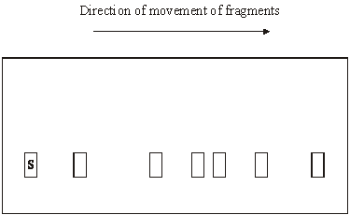

(b)     Explain why base pairs are a suitable way of measuring the length of a piece of DNA.

......................................................................................................................

......................................................................................................................

......................................................................................................................

......................................................................................................................

**(2)**

(c)     (i)      Write **6** above the appropriate box on the diagram to show the position you would expect fragment **6** to have reached.

**(1)**

(ii)     Explain how you arrived at your answer.

.............................................................................................................

.............................................................................................................

**(1)**

(d)     Enzyme **Z** recognises a particular sequence of bases in the gene. How many times does this sequence appear in the DNA of this gene?

......................................................................................................................

**(1)**

**(Total 6 marks)**

**Q3.**          *Hin*dlll is an enzyme that cuts DNA into smaller fragments.  
The enzyme cuts DNA at the specific base sequence shown in **Figure 1**.

**Figure 1**

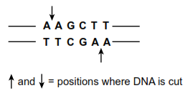

(a)     What general name is given to enzymes such as *Hin*dlll?

......................................................................................................................

**(1)**

(b)     *Hin*dlll produces DNA fragments with sticky ends.

(i)      Use information from **Figure 1** to give the base sequence of one of these sticky ends.

.............................................................................................................

**(1)**

(ii)     Sticky ends are useful in genetic engineering. Explain how.

.............................................................................................................

.............................................................................................................

.............................................................................................................

.............................................................................................................

**(2)**

(c)     Scientists prepared a sample containing many identical molecules of DNA.  
The DNA molecules were linear (non-circular).

They divided the sample into two portions.  They treated one portion with *Hin*dlll but did not treat the other portion. They then carried out gel electrophoresis on each portion.

The results are shown in **Figure 2.**

**Figure 2**

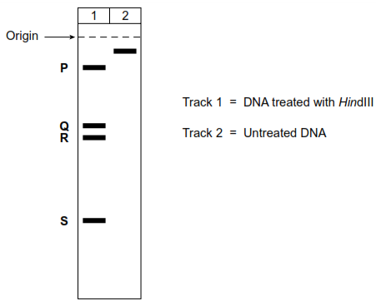

(i)      The lengths of the fragments produced from the DNA treated with *Hin*dIII were 287, 1232, 1550 and 4943 base pairs.  
How many base pairs are there in fragment **P**?

**P** = ............................................  base pairs

**(1)**

(ii)     How many times did the base sequence, **AAGCTT** occur in the DNA?  
                                                                  **TTCGAA**

.............................................................................................................

**(1)**

(iii)     In a certain genetic condition, **one** of these **AAGCTT** sequences is changed.

**TTCGAA**

Predict what effect this would have on the appearance of the gel in Track **1** of **Figure 2**.

.............................................................................................................

.............................................................................................................

.............................................................................................................

.............................................................................................................

**(2)**

**(Total 8 marks)**

**Q4.**          Cocaine is a highly addictive and illegal drug.

The release of the neurotransmitter dopamine in specific synapses in the brain leads to feelings of pleasure. Dopamine is removed from synapses by dopamine transporter proteins in the plasma membrane of neurones. Cocaine binds to the dopamine transporter protein.

**Figure 1** shows a dopamine transporter protein and molecules of cocaine and dopamine.

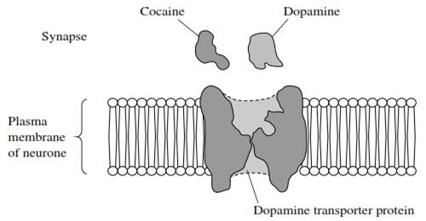**Figure 1**

(a)     Using all of the information, suggest how cocaine leads to feelings of pleasure.

.......................................................................................................................

.......................................................................................................................

.......................................................................................................................

.......................................................................................................................

.......................................................................................................................

.......................................................................................................................

*(Extra space) ................................................................................................*

.......................................................................................................................

.......................................................................................................................

**(3)**

(b)     (i)      Scientists isolated a mutated gene for the dopamine transporter protein.

Name **one** method that the scientists could have used to produce many copies of the mutated gene in the laboratory.

.............................................................................................................

**(1)**

(ii)     Copies of the gene were then inserted into early embryos of mice. When these mice were born, samples of their DNA were tested using DNA probes to make sure that the mutated gene was present in the mice.

What is a DNA probe?

.............................................................................................................

.............................................................................................................

.............................................................................................................

.............................................................................................................

**(2)**

(c)     **Figure 2** shows dopamine transporter proteins produced from the normal gene and from the mutated gene.

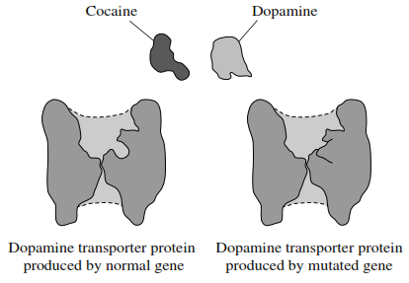**Figure 2**

Explain how the mutation leads to the production of a protein that transports dopamine but is **not** affected by cocaine.

.......................................................................................................................

.......................................................................................................................

.......................................................................................................................

.......................................................................................................................

.......................................................................................................................

.......................................................................................................................

*(Extra space) ................................................................................................*

.......................................................................................................................

.......................................................................................................................

**(3)**

**(Total 9 marks)**

**Q5.**          (a)     *Agrobacterium* is a bacterium used in genetic engineering of plants. The diagram shows stages in the transfer of a gene into a plant.

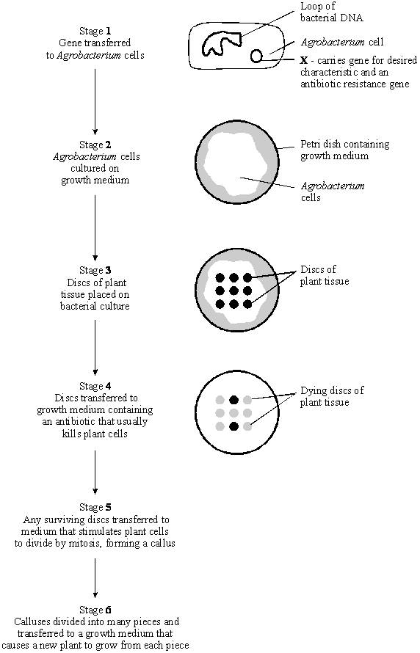

(i)      Name structure **X** in stage **1**.

.............................................................................................................

**(1)**

(ii)     In stage **2**, explain why the bacteria are cultured before the plant tissue is added.

.............................................................................................................

.............................................................................................................

**(1)**

(iii)     In stage **4**, explain why the growth medium contains antibiotic.

.............................................................................................................

.............................................................................................................

.............................................................................................................

.............................................................................................................

**(2)**

(iv)    Suggest why stages **5** and **6** are necessary for the commercial production of genetically engineered plants.

.............................................................................................................

.............................................................................................................

.............................................................................................................

.............................................................................................................

**(2)**

(b)     (i)      A toxin that kills insects can be sprayed directly onto the leaves of crop plants. A gene has now been transferred into crop plants that makes their leaves produce this toxin.

Explain **one** advantage to farmers of growing the genetically engineered crop plants, rather than spraying leaves with the toxin.

.............................................................................................................

.............................................................................................................

**(1)**

(ii)     Suggest **one** reason why some people are concerned that the toxin gene might get transferred to wild plants that are related to the crop plants.

.............................................................................................................

.............................................................................................................

**(1)**

**(Total 8 marks)**

**Q6.**          Scientists manufactured large quantities of human insulin using genetic engineering.  
They started by isolating mRNA from pancreas cells. From this they produced DNA which coded for insulin.

(a)     (i)      Suggest **two** reasons why it was better to start with mRNA from pancreas cells rather than with the DNA from these cells.

1 ..........................................................................................................

.............................................................................................................

2 ..........................................................................................................

.............................................................................................................

**(2)**

(ii)     The scientists used two enzymes, **Enzyme 1** and **Enzyme 2**, to produce DNA from mRNA.

The reactions catalysed by these enzymes are shown below.

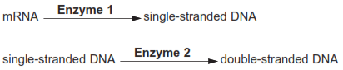

Name enzymes **1** and **2**.

**Enzyme 1** .......................................................................................

**Enzyme 2** .......................................................................................

**(2)**

(iii)     In a double-stranded DNA molecule, the two strands are held together by weak bonds.

Name this type of bond.

.............................................................................................................

**(1)**

(b)     The scientists used the polymerase chain reaction (PCR) to make copies of the DNA.

The diagram shows the stages of the PCR.

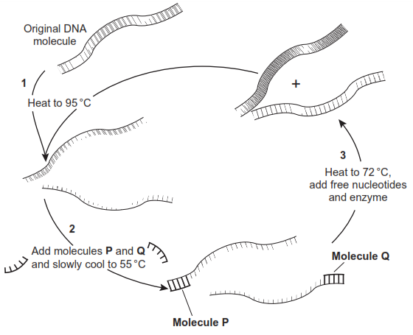

(i)      **P** and **Q** are short lengths of  single-stranded DNA.

What name is given to molecules such as **P** and **Q**?

.............................................................................................................

**(1)**

(ii)     The mixture is cooled from 95°C to 55°C at step **2**.

Explain why.

.............................................................................................................

.............................................................................................................

**(1)**

(iii)     Explain the function of  molecules **P** and **Q.**

.............................................................................................................

.............................................................................................................

.............................................................................................................

.............................................................................................................

(*Extra space*) ......................................................................................

.............................................................................................................

**(2)**

(iv)    How many copies of  each original DNA molecule would be present after 5 cycles of  PCR?



**(1)**

**(Total 10 marks)**

**Q7.**          Research scientists can increase the nutritional value of potatoes by genetically engineering potato plants. A gene which results in increased protein production has been removed from cells of an amaranth plant and inserted into cells of a potato plant.

(a)     Describe how a gene could be removed from cells of an amaranth plant and inserted into cells of a potato plant.

......................................................................................................................

......................................................................................................................

......................................................................................................................

......................................................................................................................

......................................................................................................................

......................................................................................................................

......................................................................................................................

......................................................................................................................

......................................................................................................................

......................................................................................................................

......................................................................................................................

......................................................................................................................

**(6)**

(b)     Whole potato plants can be produced from genetically identical potato cells grown in a tissue culture. Use your knowledge of genes to suggest how different cells, such as leaf and root cells, can develop from genetically identical cells.

......................................................................................................................

......................................................................................................................

......................................................................................................................

......................................................................................................................

......................................................................................................................

......................................................................................................................

**(2)**

**(Total 8 marks)**

**Q8.**          (a)     Describe how a gene can be isolated from human DNA.

......................................................................................................................

......................................................................................................................

......................................................................................................................

......................................................................................................................

**(2)**

(b)     Describe how an isolated gene can be replicated by the polymerase chain reaction (PCR).

......................................................................................................................

......................................................................................................................

......................................................................................................................

......................................................................................................................

......................................................................................................................

......................................................................................................................

......................................................................................................................

......................................................................................................................

**(4)**

(c)     (i)      Describe how a harmless virus, genetically engineered to contain a CFTR gene, can be used to insert the gene into a cystic fibrosis sufferer.

.............................................................................................................

.............................................................................................................

.............................................................................................................

.............................................................................................................

**(2)**

(ii)     A virus used in gene therapy has RNA as its genetic material and has an enzyme called reverse transcriptase. Inside a human cell, reverse transcriptase uses viral RNA to make viral DNA.

Explain why the enzyme is called *reverse transcriptase*.

.............................................................................................................

.............................................................................................................

.............................................................................................................

**(1)**

**(Total 9 marks)**

**Q9.**          (a)     Plasmids can be modified by genetic engineering and inserted into bacteria. These bacteria can then make useful substances normally made by another organism. Explain how modified plasmids are made by genetic engineering and how the use of markers enable bacteria containing these plasmids to be detected.

......................................................................................................................

......................................................................................................................

......................................................................................................................

......................................................................................................................

......................................................................................................................

......................................................................................................................

......................................................................................................................

......................................................................................................................

......................................................................................................................

......................................................................................................................

......................................................................................................................

......................................................................................................................

......................................................................................................................

......................................................................................................................

**(6)**

(b)     In gene therapy, genes are introduced into a person who has defective genes which do not produce an important substance. Three experiments were done to compare techniques for introducing an important substance into a person with defective genes.

1.   The substance was injected directly.  
2.   Harmless viruses carrying genes coding for the substance were injected.  
3.   The genes were put into a protein capsule which was inserted into the tissues.

The graph shows results of the experiments.

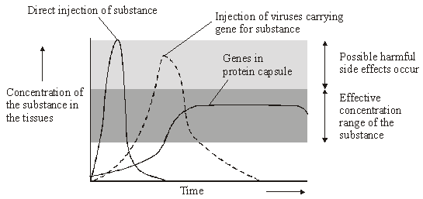

*Takahiro Ochiya et al, Biomaterials for Gene Delivery: Studies on Metastasis,   
(National Cancer Centre, Research Institute, Tokyo, Japan) 1999*

(i)      Describe the results of the three experiments.

.............................................................................................................

.............................................................................................................

.............................................................................................................

.............................................................................................................

.............................................................................................................

.............................................................................................................

**(3)**

(ii)     Using the information in the graph, suggest **one** advantage and **one** disadvantage of the capsule method compared to the others.

Advantage ...........................................................................................

.............................................................................................................

Disadvantage ............................................................................….......

.............................................................................................................

**(2)**

**(Total 11 marks)**

**Q10.**          Gene therapy is used to treat the genetic disorder, ADA deficiency. Affected individuals are unable to produce the enzyme adenosine deaminase (ADA). Without this enzyme, T lymphocytes, a type of white blood cell, cannot provide immunity to infection. The diagram shows the processes involved in the treatment of ADA deficiency by gene therapy.

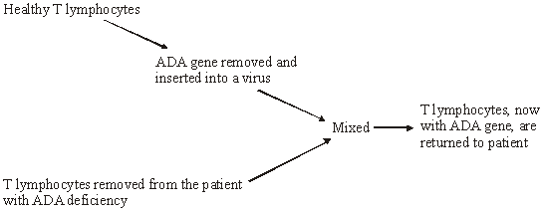

(a)     What is meant by *gene therapy*?

......................................................................................................................

......................................................................................................................

**(1)**

(b)     The ADA gene is inserted into a virus. Give **two** advantages of using a virus in gene therapy.

1 ...................................................................................................................

......................................................................................................................

2 ...................................................................................................................

......................................................................................................................

**(2)**

(c)     Individuals who have been treated by this method of gene therapy do not pass on the ADA gene to their children. Explain why.

......................................................................................................................

......................................................................................................................

**(1)**

(d)     T lymphocytes are produced in bone marrow. A bone marrow transplant from a genetically matched donor can provide a permanent cure for ADA deficiency.

(i)      Suggest why bone marrow for a transplant is obtained from a genetically matched donor.

.............................................................................................................

.............................................................................................................

**(1)**

(ii)     Explain why treatment of ADA deficiency by gene therapy must be repeated at regular intervals, whereas a single bone marrow transplant can provide a permanent cure.

.............................................................................................................

.............................................................................................................

.............................................................................................................

.............................................................................................................

**(2)**

**(Total 7 marks)**

**Q11.**          (a)     An antigen in a vaccine leads to the production of antibodies. Describe the part played by B lymphocytes in this process.

......................................................................................................................

......................................................................................................................

......................................................................................................................

......................................................................................................................

......................................................................................................................

......................................................................................................................

......................................................................................................................

**(4)**

   (b)     Hepatitis B vaccine contains a viral antigen produced by genetically modified bacteria. Describe how the isolated gene that codes for a protein in the virus’s coat could be transferred to the bacterial cells.

......................................................................................................................

......................................................................................................................

......................................................................................................................

......................................................................................................................

......................................................................................................................

......................................................................................................................

......................................................................................................................

**(3)**

**(Total 7 marks)**

**Q12.**          (a)     Cystic fibrosis can be caused by any one of several mutant alleles of the cystic fibrosis gene. The most common of these mutant alleles accounts for about 70% of cases of cystic fibrosis. The use of gene probes can identify individuals carrying this allele. Gene probes are single strands of DNA which are radioactively labelled. They have a base sequence that is complementary to a mutant allele. The main stages in using a gene probe are shown in the diagram.

|  |
| --- |
| Sample of DNA extracted from a person’s tissue and heated to separate the strands |

**↓**

|  |
| --- |
| Radioactive gene probe added to the DNA |

**↓**

|  |
| --- |
| Excess probe washed away |

**↓**

|  |
| --- |
| Sample tested for radioactivity |

Using the information given, explain how the use of a gene probe could enable the presence of a mutant allele of the cystic fibrosis gene to be detected.

......................................................................................................................

......................................................................................................................

......................................................................................................................

......................................................................................................................

......................................................................................................................

......................................................................................................................

......................................................................................................................

......................................................................................................................

**(4)**

(b)     Sheep have been genetically engineered to produce alpha-1-antitrypsin which is used to treat cystic fibrosis. Use your knowledge of this process to explain **one** argument for and **one** against using sheep in this way.

For

......................................................................................................................

......................................................................................................................

Against

......................................................................................................................

......................................................................................................................

**(2)**

**(Total 6 marks)**

**Q13.**          A protein produced by a species of bacterium is toxic to caterpillars. The gene coding for this protein was removed and transferred into a crop plant.

(a)     (i)      Describe how the gene could have been removed from the bacterial DNA.

.............................................................................................................

.............................................................................................................

.............................................................................................................

.............................................................................................................

**(2)**

(ii)     Many copies of the isolated gene were required. Name the process used in a laboratory to produce many copies of DNA from a small amount.

.............................................................................................................

**(1)**

(b)     The gene was injected into isolated cells from the crop plant. These cells were then cloned and new plants grown from the cloned cells. Explain the advantage of inserting the gene into isolated plant cells rather than directly into cells within a whole plant.

......................................................................................................................

......................................................................................................................

......................................................................................................................

......................................................................................................................

......................................................................................................................

......................................................................................................................

**(3)**

**(Total 6 marks)**

**Q14.**          (a)     Plasmids are often used as vectors in genetic engineering.

(i)      What is the role of a vector?

.............................................................................................................

.............................................................................................................

**(1)**

(ii)     Describe the role of restriction endonucleases in the formation of plasmids that contain donor DNA.

.............................................................................................................

.............................................................................................................

.............................................................................................................

.............................................................................................................

**(2)**

(iii)     Describe the role of DNA ligase in the production of plasmids containing donor DNA.

.............................................................................................................

.............................................................................................................

**(1)**

(b)     There are many different restriction endonucleases. Each type cuts the DNA of a plasmid at a specific base sequence called a restriction site. The diagram shows the position of four restriction sites, **J**, **K**, **L** and **M**, for four different enzymes on a single plasmid. The distances between these sites is measured in kilobases of DNA.

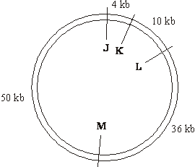

1 kb = 1 kilobase

The plasmid was cut using only two restriction endonucleases. The resulting fragments were separated by gel electrophoresis. The positions of the fragments are shown in the chart below.

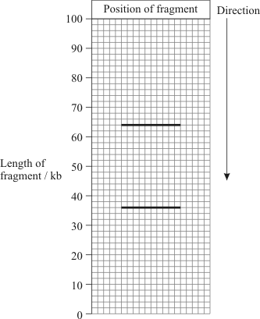

(i)      Which of the restriction sites were cut?

.............................................................................................................

**(1)**

(ii)     Explain your answer.

.............................................................................................................

.............................................................................................................

**(1)**

**(Total 6 marks)**

**Q15.** Read the following passage.

Malaria is a disease so deadly that it has devastated armies and destroyed great civilisations.  
It has been estimated that in the course of history malaria has been responsible for the death  
of one out of every two people who have ever lived. Even today, with all the advantages of  
modern technology, it is still responsible for some three million deaths a year.

5     The first half of the twentieth century was a time of hope for malarial control. The drugs

chloroquine and proguanil had just been discovered and there seemed a real possibility of a  
malaria-free world. Unfortunately, this honeymoon ended almost as soon as it had started,  
with the emergence of drug-resistant parasite populations. Scientists now accept that whatever  
new drug they come up with, it is likely to have a very limited effective life. As a result, they

10   are increasingly looking at combinations of drugs.

The approach to malaria control which holds the best hope is the production of a vaccine. One  
of these is being developed by a researcher in South America. His vaccine is based on a small  
synthetic polypeptide called SPf66 which is dissolved in a saline solution and given as an  
injection. A series of early trials on human volunteers produced confusing results. In one trial

15   the effectiveness of the vaccine was claimed to be 80% while, in others, the results were

statistically insignificant. Not only were the results inconclusive but the methods used were  
challenged by other scientists. In particular, the controls were considered inappropriate.

Another, possibly more promising, approach has been the development of a DNA-based  
vaccine. In theory, all that is required is to identify the DNA from the parasite which encodes

20   key antigens. Unfortunately, scientists have hit snags. Although they have succeeded in

sequencing the human genome, the genome of the malarial parasite has created major  
difficulties. This is partly because of the very high proportion of the bases adenine and  
thymine. In some places these two bases average 80%, and on chromosomes 2 and 3 nearly  
100% of the bases present are adenine and thymine. Because of this, it has proved impossible

25   to cut the relevant DNA with the commonly available restriction enzymes into pieces of a

suitable size for analysis.

          Use information from the passage and your own knowledge to answer the following questions.

(a)     Explain how a resistant parasite population is likely to arise and limit the life of any new anti-malarial drug (lines 8 - 9).

......................................................................................................................

......................................................................................................................

......................................................................................................................

......................................................................................................................

......................................................................................................................

......................................................................................................................

**(3)**

(b)     A person has a 1 in 500 probability of being infected by a chloroquine-resistant strain of malarial parasite and a 1 in 500 probability of being infected by a proguanil-resistant strain. Use a calculation from these figures to explain why scientists are “increasingly looking at combinations of drugs” (lines 9 - 10).

......................................................................................................................

......................................................................................................................

......................................................................................................................

......................................................................................................................

**(2)**

(c)     (i)      Explain why trials of the SPf66 vaccine needed a control.

.............................................................................................................

.............................................................................................................

**(1)**

(ii)     The controls for the SPf66 vaccine trials were considered inappropriate (line 17).

Suggest how the control groups in these trials should have been treated.

.............................................................................................................

.............................................................................................................

.............................................................................................................

.............................................................................................................

**(2)**

(d)     In some of the DNA of a malarial parasite, the proportion of adenine and thymine bases averages 80% (lines 22 - 23). In this DNA what percentage of the nucleotides would you expect to contain

(i)      phosphate; ..........................................................................................

(ii)     guanine? .............................................................................................

**(2)**

(e)     (i)      Use your knowledge of enzymes to explain why restriction enzymes only cut DNA at specific restriction sites.

.............................................................................................................

.............................................................................................................

.............................................................................................................

.............................................................................................................

.............................................................................................................

.............................................................................................................

**(3)**

(ii)     Restriction enzymes that can cut the DNA of chromosomes 2 and 3 produce pieces that are too small for analysis. Explain why these restriction enzymes produce small DNA fragments.

.............................................................................................................

.............................................................................................................

.............................................................................................................

.............................................................................................................

**(2)**

**(Total 15 marks)**

**Q16.** ‘Take-all’ is a disease of wheat caused by a fungus. It can cause serious damage to the crop.

There is no gene for resistance to this fungus in wheat. There is, however, a gene for resistance to this fungus present in oats.

The diagram shows how this gene might be transferred to wheat.

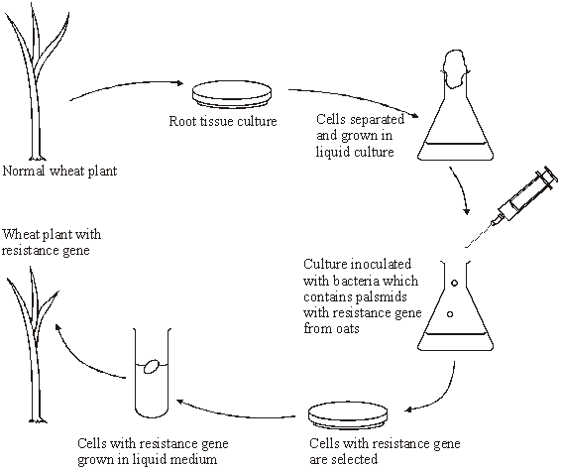

(a)     (i)      The wheat plant with the resistance gene contains recombinant DNA. What is *recombinant* DNA?

.............................................................................................................

.............................................................................................................

**(1)**

(ii)     The plasmids act as vectors for the resistance gene. What is a *vector*?

.............................................................................................................

.............................................................................................................

**(1)**

(iii)     Suggest how cells with the resistance gene might be selected.

..............................................................................................................

.............................................................................................................

.............................................................................................................

.............................................................................................................

**(2)**

(b)     A laboratory has oat plants containing the resistance gene and a supply of plasmids.

Describe how bacteria may be produced which have the resistance gene in their plasmids.

......................................................................................................................

......................................................................................................................

......................................................................................................................

......................................................................................................................

......................................................................................................................

......................................................................................................................

......................................................................................................................

......................................................................................................................

......................................................................................................................

......................................................................................................................

......................................................................................................................

......................................................................................................................

**(6)**

**(Total 10 marks)**

**Q17.**          Read the following passage.

Soon a single drop of blood might be enough to reveal, at a very early stage, if a patient has  
cancer. It could also tell us what type of cancer it is and whether it is treatable. Fragments of  
DNA from body cells are present in blood plasma. Some of these fragments may be from  
cancer cells. The fragments can be detected by a new test in which a test strip containing

5     nucleic acid binds to sections of altered DNA.

Other cancer-detecting techniques involve removing a tissue sample from a patient. The  
tissue sample is used to obtain mRNA. By examining the mRNA, scientists can discover   
whether cancer is present.

Use information from the passage and your own knowledge to answer the questions.

(a)     Describe how altered DNA may lead to cancer.

......................................................................................................................

......................................................................................................................

......................................................................................................................

......................................................................................................................

......................................................................................................................

......................................................................................................................

......................................................................................................................

......................................................................................................................

......................................................................................................................

......................................................................................................................

......................................................................................................................

......................................................................................................................

**(6)**

(b)     Explain why fragments of DNA from cancer cells may be present in blood plasma   
(lines 3-4).

......................................................................................................................

......................................................................................................................

......................................................................................................................

......................................................................................................................

**(2)**

(c)     Explain why the nucleic acid on the test strip will only bind to altered DNA (lines 4-5).

......................................................................................................................

......................................................................................................................

......................................................................................................................

......................................................................................................................

**(2)**

(d)     This test strip will allow cancers to be detected at a very early stage. Explain why cancer is more likely to be treated successfully if the disease is detected at a very early stage.

......................................................................................................................

......................................................................................................................

......................................................................................................................

......................................................................................................................

**(2)**

(e)     Explain how examining mRNA (line 7) enables scientists to discover whether cancer is present.

......................................................................................................................

......................................................................................................................

......................................................................................................................

......................................................................................................................

......................................................................................................................

......................................................................................................................

**(3)**

**(Total 15 marks)**

**Q18.**          (a)     (i)      Some human DNA was cut into separate pieces using a restriction enzyme which produced a staggered cut. A scientist wanted to insert these pieces of DNA into plasmids and used the same restriction enzyme to cut the plasmids. Explain why the pieces of human DNA would be able to join to the cut DNA of the plasmids.

.............................................................................................................

.............................................................................................................

.............................................................................................................

.............................................................................................................

**(2)**

(ii)     Which other enzyme must the scientist have added to the mixture to form recombinant plasmids?

.............................................................................................................

.............................................................................................................

**(1)**

(b)     A plasmid may be used as a vector. Explain what is meant by a *vector* in this context.

......................................................................................................................

......................................................................................................................

......................................................................................................................

......................................................................................................................

**(2)**

(c)     Molecular biologists often use plasmids which contain antibiotic resistance genes.

Explain the reason for this.

......................................................................................................................

......................................................................................................................

......................................................................................................................

......................................................................................................................

**(2)**

**(Total 7 marks)**

**Q19.**          (a)     (i)      Some human DNA was cut into separate pieces using a restriction enzyme which produced a staggered cut. A scientist wanted to insert these pieces of DNA into plasmids and used the same restriction enzyme to cut the plasmids. Explain why the pieces of human DNA would be able to join to the cut DNA of the plasmids.

.............................................................................................................

.............................................................................................................

.............................................................................................................

.............................................................................................................

**(2)**

(ii)     Which other enzyme must the scientist have added to the mixture to form recombinant plasmids?

.............................................................................................................

.............................................................................................................

**(1)**

(b)     A plasmid may be used as a vector. Explain what is meant by a *vector*.

......................................................................................................................

......................................................................................................................

......................................................................................................................

......................................................................................................................

**(2)**

(c)     Molecular biologists often use plasmids which contain antibiotic resistance genes.

Explain the reason for this.

......................................................................................................................

......................................................................................................................

......................................................................................................................

......................................................................................................................

**(2)**

**(Total 7 marks)**

**Q20.**          Read the following passage.

Shark-fin soup is an expensive delicacy. To provide the basic ingredient, fishermen catch the  
sharks, hack the fins off and throw the dead bodies back into the ocean. But sharks are slow  
to mature and produce only a few offspring at a time, so they are vulnerable to overfishing.  
Monitoring the shark-fin trade is difficult, as once a fin has been cut off, it can be extremely

5     difficult to work out precisely from which species it was taken.

The DNA from different species of sharks shows some differences in base sequence. This has  
enabled a new genetic fingerprinting technique to be developed. This technique would allow  
conservationists and fisheries managers to assess which of the 400 shark species are most  
threatened by the trade in shark fins.

10   An identification process has been developed using a range of “primers”. These are short

pieces of single-stranded DNA that are complementary to a particular sequence of DNA.  
Each primer is specific to the DNA of one shark species.

The primers are added to DNA taken from a shark’s fin and the polymerase chain reaction is  
carried out. Only two primers, one at each end of a certain piece of DNA, will bind. The piece

15   of DNA between the primers is replicated by the polymerase chain reaction. The primers that

bind are specific to a particular species of shark and the length of the DNA fragment  
replicated differs for each species. When this DNA is run in an electrophoresis gel it produces  
a single band, enabling the researchers to identify which species of shark is involved.

Use information from the passage and your own knowledge to answer the questions.

(a)     (i)      Explain why the DNA for each species of shark shows differences in base sequence (line 6).

.............................................................................................................

.............................................................................................................

.............................................................................................................

.............................................................................................................

**(2)**

(ii)     Each primer is specific to the DNA of one shark species (line 12).

Explain why a particular primer will only bind to the DNA of one species.

.............................................................................................................

.............................................................................................................

.............................................................................................................

.............................................................................................................

**(2)**

(iii)     The length of the replicated DNA fragment is different for each species.

Explain why this is important in identifying the shark species involved.

.............................................................................................................

.............................................................................................................

.............................................................................................................

.............................................................................................................

.............................................................................................................

.............................................................................................................

**(3)**

(b)     In conventional DNA fingerprinting, a series of bands is produced on the electrophoresis gel, resembling the rungs of a ladder. When the DNA in this new genetic fingerprinting technique is run in an electrophoresis gel it produces just one of these ‘rungs’.

Explain the reason for the difference in the number of ‘rungs’ produced.

......................................................................................................................

......................................................................................................................

......................................................................................................................

......................................................................................................................

**(2)**

(c)     Describe the polymerase chain reaction.

......................................................................................................................

......................................................................................................................

......................................................................................................................

......................................................................................................................

......................................................................................................................

......................................................................................................................

......................................................................................................................

......................................................................................................................

......................................................................................................................

......................................................................................................................

......................................................................................................................

......................................................................................................................

**(6)**

**(Total 15 marks)**

**Q21.**          Scientists are working to produce a genetically modified bacterium to treat patients suffering from a disease of the digestive system. They plan to collect mRNA from human cells. This will be used to produce the DNA of the gene for the protein interleukin. They will then transfer this human gene into the bacterium *Lactococcus*. The scientists intend patients to swallow the genetically modified bacteria. These bacteria will release interleukin inside the digestive system to treat the disease.

(a)     (i)      Name the type of enzyme which will be used to produce the DNA from the mRNA.

.............................................................................................................

**(1)**

(ii)     It is easier to obtain the interleukin gene from mRNA rather than directly from the DNA removed from human cells. Explain why.

.............................................................................................................

.............................................................................................................

**(1)**

(b)     The scientists propose to put the gene directly into the DNA of *Lactococcus*.  
Describe the role of the enzyme ligase in this process.

......................................................................................................................

......................................................................................................................

**(1)**

**(Total 3 marks)**

**Q22.**          β-thalassaemia is a genetic condition in which abnormal haemoglobin is produced. In one form, the recessive allele for β-thalassaemia, **t**, differs from the normal allele, **T**, by a single base-pair. A radioactive DNA probe was used to investigate the genotypes of four members of one family. The flowchart summarises the technique involved.

|  |
| --- |
| DNA samples extracted and cut into fragments using a restriction enzyme |

**↓**

|  |
| --- |
| Fragments separated from each other by electrophoresis |

**↓**

|  |
| --- |
| One region of the resulting gel was blotted with two pieces of filter paper. The first was soaked in a solution containing a radioactive DNA probe for the normal allele. The second was soaked in a solution containing a radioactive DNA probe for the β-thalassaemia allele. |

**↓**

|  |
| --- |
| Surplus probe washed off |

The diagram belowshows the appearance of the two pieces of filter paper which resulted from the investigation.

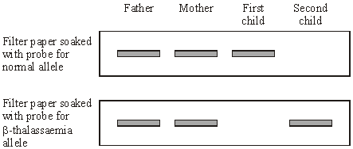

(a)     What is the probability that the next child that this couple have is a girl who has β-thalassaemia? Explain your answer.

......................................................................................................................

......................................................................................................................

......................................................................................................................

......................................................................................................................

......................................................................................................................

......................................................................................................................

**(3)**

(b)     (i)      The fragment of DNA containing the normal allele and the fragment with the β-thalassaemia allele moved the same distance on the gel. Explain why.

.............................................................................................................

.............................................................................................................

.............................................................................................................

.............................................................................................................

**(2)**

(ii)     The allele for β-thalassaemia differs from the normal allele by only one base-pair. Explain why the probe used to identify these alleles consists of a piece of DNA twenty bases in length and not just one base.

.............................................................................................................

.............................................................................................................

.............................................................................................................

.............................................................................................................

**(2)**

**(Total 7 marks)**

**Q23.**          Plasmids can be used as vectors to insert lengths of foreign DNA into bacteria. The diagram shows how this is achieved.

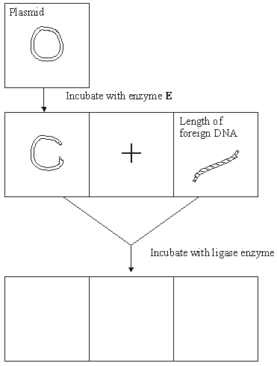

(a)     Name enzyme **E**.

......................................................................................................................

**(1)**

(b)     Cut plasmids and lengths of foreign DNA can join. What features of their ends allows them to join?

......................................................................................................................

......................................................................................................................

......................................................................................................................

......................................................................................................................

**(2)**

(c)     Draw **three** different structures that could be formed by incubating cut plasmids and lengths of foreign DNA with ligase. Use the spaces provided on the diagram.

**(3)**

**(Total 6 marks)**

**Q24.**          Read the following passage.

Herpes viruses cause cold sores and, in some cases, genital warts. Scientists are well  
on the way to producing an antibody which will counteract herpes infection. This antibody works  
by sticking to the virus and blocking its entry into cells. It has proved very effective in animal  
tests.

5       One drawback with this approach, however, is that antibodies are at present produced using  
hamster ovary cells. This method is expensive and only produces limited amounts. A new  
technique is being developed to produce antibodies from plants. It involves introducing the  
DNA which codes for the required antibody into crop plants such as maize.

          Use information from the passage and your own knowledge to answer the questions.

(a)     (i)      What is an antibody?

.............................................................................................................

.............................................................................................................

.............................................................................................................

.............................................................................................................

**(2)**

(ii)     Describe how antibodies are produced in the body following a viral infection.

.............................................................................................................

.............................................................................................................

.............................................................................................................

.............................................................................................................

.............................................................................................................

.............................................................................................................

.............................................................................................................

.............................................................................................................

.............................................................................................................

.............................................................................................................

.............................................................................................................

**(6)**

(b)     Describe how the antibody gene could be isolated from an animal cell and introduced into a crop plant such as maize (lines 7-8).

......................................................................................................................

......................................................................................................................

......................................................................................................................

......................................................................................................................

......................................................................................................................

......................................................................................................................

......................................................................................................................

......................................................................................................................

**(4)**

(c)     Taking a course of these antibodies from plants to treat a herpes infection would not produce long-term protection against disease. Explain why.

......................................................................................................................

......................................................................................................................

......................................................................................................................

......................................................................................................................

**(2)**

(d)     Explain **one** advantage of using antibodies from plants to treat a disease, rather than antibodies produced in an experimental animal (lines 5-6).

......................................................................................................................

......................................................................................................................

**(1)**

**(Total 15 marks)**

**Q25.**          DNA probes may be used to identify the presence of specific genes associated with human diseases. The flow chart summarises the way in which they are used.

|  |
| --- |
| **Stage 1** DNA is cut into fragments |



|  |
| --- |
| **Stage 2** Electrophoresis separates the DNA fragments |



|  |
| --- |
| **Stage 3** Radioactive DNA probes are used to locate specific DNA fragments |

(a)     Name the enzyme used in **Stage 1**.

......................................................................................................................

**(1)**

(b)     Explain how electrophoresis separates the fragments of DNA in **Stage 2**.

......................................................................................................................

......................................................................................................................

......................................................................................................................

......................................................................................................................

**(2)**

(c)     (i)      What is a *DNA probe*?

.............................................................................................................

.............................................................................................................

.............................................................................................................

.............................................................................................................

**(2)**

(ii)     Explain why *radioactive* DNA probes are used to locate specific DNA fragments.

.............................................................................................................

.............................................................................................................

.............................................................................................................

.............................................................................................................

**(2)**

**(Total 7 marks)**

**Q26.**(a)     Scientists can use protein structure to investigate the evolutionary relationships between different species. Explain why.

........................................................................................................................

........................................................................................................................

........................................................................................................................

........................................................................................................................

........................................................................................................................

**(2)**

(b)     Comparing the base sequence of genes provides more evolutionary information than comparing the structure of proteins. Explain why.

........................................................................................................................

........................................................................................................................

........................................................................................................................

........................................................................................................................

........................................................................................................................

**(2)**

**(Total 4 marks)**

**Q27.**          Huntington’s disease is a genetic condition that leads to a loss in brain function. The gene involved contains a section of DNA with many repeats of the base sequence CAG. The number of these repeats determines whether or not an allele of this gene will cause Huntington’s disease.

•        An allele with 40 or more CAG repeats will cause Huntington’s disease.

•        An allele with 36 – 39 CAG repeats may cause Huntington’s disease.

•        An allele with fewer than 36 CAG repeats will not cause Huntington’s disease.

The graph shows the age at which a sample of patients with Huntington’s disease first developed symptoms and the number of CAG repeats in the allele causing Huntington’s disease in each patient.

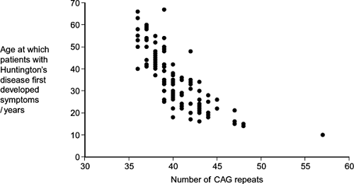

(a)     (i)      People can be tested to see whether they have an allele for this gene with more than 36 CAG repeats. Some doctors suggest that the results can be used to predict the age at which someone will develop Huntington’s disease.

Use information in the graph to evaluate this suggestion.

...............................................................................................................

...............................................................................................................

...............................................................................................................

...............................................................................................................

...............................................................................................................

...............................................................................................................

*(Extra space)* ........................................................................................

...............................................................................................................

...............................................................................................................

**(3)**

(ii)     Huntington’s disease is always fatal. Despite this, the allele is passed on in human populations. Use information in the graph to suggest why.

...............................................................................................................

...............................................................................................................

...............................................................................................................

...............................................................................................................

...............................................................................................................

**(2)**

(b)     Scientists took DNA samples from three people, **J**, **K** and **L**. They used the polymerase chain reaction (PCR) to produce many copies of the piece of DNA containing the CAG repeats obtained from each person. They separated the DNA fragments by gel electrophoresis. A radioactively labelled probe was then used to detect the fragments. The diagram shows the appearance of part of the gel after an X-ray was taken. The bands show the DNA fragments that contain the CAG repeats.

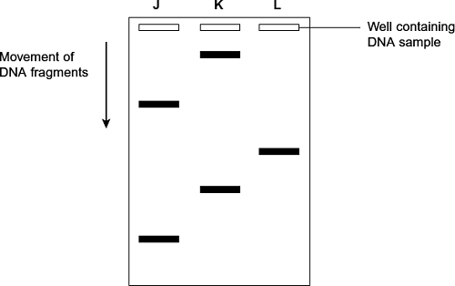

(i)      Only one of these people tested positive for Huntington’s disease. Which person was this? Explain your answer.

Person ..................................................................................................

Explanation ...........................................................................................

...............................................................................................................

...............................................................................................................

...............................................................................................................

**(2)**

(ii)     The diagram only shows part of the gel. Suggest how the scientists found the number of CAG repeats in the bands shown on the gel.

...............................................................................................................

...............................................................................................................

...............................................................................................................

**(1)**

(iii)    Two bands are usually seen for each person tested. Suggest why only one band was seen for Person **L**.

...............................................................................................................

...............................................................................................................

...............................................................................................................

**(1)**

**(Total 9 marks)**

**Q28.**          (a)     Adrenaline binds to receptors in the plasma membranes of liver cells. Explain how this causes the blood glucose concentration to increase.

........................................................................................................................

........................................................................................................................

........................................................................................................................

........................................................................................................................

........................................................................................................................

*(Extra space)* .................................................................................................

........................................................................................................................

**(2)**

(b)     Scientists made an artificial gene which codes for insulin. They put the gene into a virus which was then injected into rats with type I diabetes. The virus was harmless to the rats but carried the gene into the cells of the rats.

The treated rats produced insulin for up to 8 months and showed no side-effects. The scientists measured the blood glucose concentrations of the rats at regular intervals. While the rats were producing the insulin, their blood glucose concentrations were normal.

(i)      The rats were not fed for at least 6 hours before their blood glucose concentration was measured. Explain why.

...............................................................................................................

...............................................................................................................

...............................................................................................................

**(1)**

(ii)     The rats used in the investigation had type I diabetes. This form of gene therapy may be less effective in treating rats that have type II diabetes. Explain why.

...............................................................................................................

...............................................................................................................

...............................................................................................................

**(1)**

(iii)    Research workers have suggested that treating diabetes in humans by this method of gene therapy would be better than injecting insulin. Evaluate this suggestion.

...............................................................................................................

...............................................................................................................

...............................................................................................................

...............................................................................................................

...............................................................................................................

...............................................................................................................

...............................................................................................................

...............................................................................................................

*(Extra space)* ........................................................................................

...............................................................................................................

...............................................................................................................

...............................................................................................................

...............................................................................................................

...............................................................................................................

**(4)**

**(Total 8 marks)**

**Q29.**Haemophilia is a genetic condition in which blood fails to clot. Factor IX is a protein used to treat haemophilia. Sheep can be genetically engineered to produce Factor IX in the milk produced by their mammary glands. The diagram shows the stages involved in this process.

|  |  |  |
| --- | --- | --- |
|  | Stage **1** |  |
|  |  |  |
|  | Stage **2** |  |
|  |  |  |
|  | Stage **3** |  |
|  |  |  |
|  | Stage **4** |  |
|  |  |  |
|  | Stage **5** |  |
|  |  |  |
|  | Stage **6** |  |

(a)     Name the type of enzyme that is used to cut the gene for Factor IX from human DNA (Stage **1**) .

........................................................................................................................

**(1)**

(b)     (i)      The jellyfish gene attached to the human Factor IX gene (Stage **2**) codes for a protein that glows green under fluorescent light. Explain the purpose of attaching this gene.

...............................................................................................................

...............................................................................................................

...............................................................................................................

...............................................................................................................

...............................................................................................................

**(2)**

(ii)     The promoter DNA from sheep (Stage **3**) causes transcription of genes coding for proteins found in sheep milk.

Suggest the advantage of using this promoter DNA.

...............................................................................................................

...............................................................................................................

...............................................................................................................

...............................................................................................................

...............................................................................................................

*(Extra space)* ........................................................................................

...............................................................................................................

**(2)**

(c)     Many attempts to produce transgenic animals have failed. Very few live births result from the many embryos that are implanted.

(i)      Suggest **one** reason why very few live births result from the many embryos that are implanted.

...............................................................................................................

...............................................................................................................

...............................................................................................................

...............................................................................................................

...............................................................................................................

*(Extra space)* ........................................................................................

...............................................................................................................

**(2)**

(ii)     It is important that scientists still report the results from failed attempts to produce transgenic animals. Explain why.

...............................................................................................................

...............................................................................................................

...............................................................................................................

...............................................................................................................

...............................................................................................................

**(2)**

**(Total 9 marks)**

**Q30.**Some species of crop plant produce a substance called glycinebetaine (GB).

Scientists transferred the gene for GB into a species of crop plant that does not normally produce GB. These genetically modified plants then produced GB.

The scientists grew large numbers of the same crop plant with and without the gene at different temperatures. After 3 days, they found the increase in dry mass of the plants.

**Figure 1** shows their results.

**Figure 1**

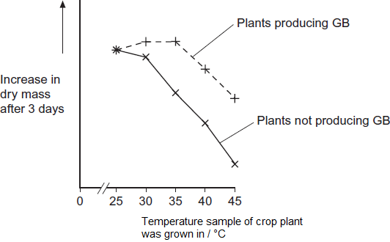

(a)     Describe the effect on growth of transferring the gene for GB into this plant.

........................................................................................................................

........................................................................................................................

........................................................................................................................

........................................................................................................................

........................................................................................................................

**(2)**

(b)     The scientists measured the rate of photosynthesis in plants that produce GB and plants that do not produce GB at 25°C, 35°C and 45°C.

**Figure 2** shows their results.

**Figure 2**

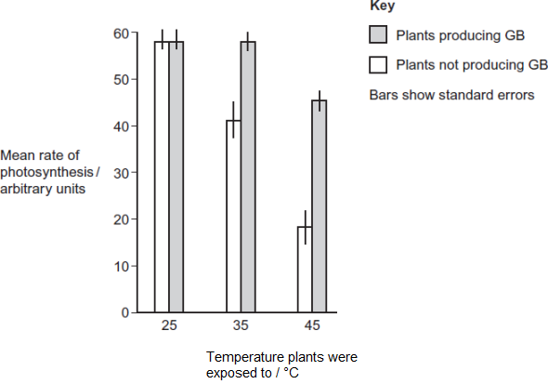

(i)      The scientists concluded that the production of GB protects photosynthesis from damage by high temperatures.

Use these data to support this conclusion.

...............................................................................................................

...............................................................................................................

...............................................................................................................

**(1)**

(ii)     Use the data from **Figure 2**  for plants that do not produce GB to explain the effect of temperature on changes in dry mass of the plants shown in **Figure 1.**

...............................................................................................................

...............................................................................................................

...............................................................................................................

...............................................................................................................

...............................................................................................................

...............................................................................................................

...............................................................................................................

...............................................................................................................

*(Extra space)*........................................................................................

...............................................................................................................

...............................................................................................................

...............................................................................................................

**(4)**

Rubisco activase is an enzyme found in chloroplasts. It activates the light-independent reaction of photosynthesis.

The scientists discovered that, as temperature increased from 25°C to 45°C, rubisco activase began attaching to thylakoid membranes in chloroplasts and this stopped it working.

(c)     Rubisco activase stops working when it attaches to a thylakoid.

Use your knowledge of protein structure to explain why.

........................................................................................................................

........................................................................................................................

........................................................................................................................

........................................................................................................................

........................................................................................................................

**(2)**

(d)     The scientists investigated the effect of GB on attachment of rubisco activase to thylakoid membranes at different temperatures.

**Figure 3** shows their results.

**Figure 3**

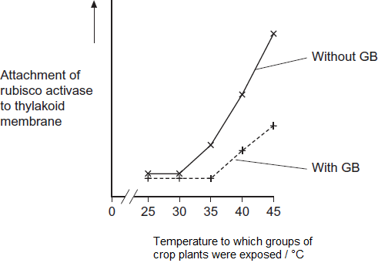

Use information from **Figure 2** and **Figure 3** to suggest how GB protects the crop plant from high temperatures.

........................................................................................................................

........................................................................................................................

........................................................................................................................

........................................................................................................................

........................................................................................................................

........................................................................................................................

........................................................................................................................

........................................................................................................................

*(Extra space)*..................................................................................................

........................................................................................................................

........................................................................................................................

........................................................................................................................

**(4)**

(e)     The scientists’ hypothesis at the start of the investigation was that crop plants genetically engineered to produce GB would become more resistant to high environmental temperatures.  
The scientists developed this hypothesis on the basis of previous research on crops that are grown in hot climates.

Suggest how the scientists arrived at their hypothesis.

........................................................................................................................

........................................................................................................................

........................................................................................................................

........................................................................................................................

........................................................................................................................

**(2)**

**(Total 15 marks)**

**Q31.**Silkworms secrete silk fibres, which are harvested and used to manufacture silk fabric.

Scientists have produced genetically modified (GM) silkworms that contain a gene from a spider.

The GM silkworms secrete fibres made of spider web protein (spider silk), which is stronger than normal silk fibre protein.

The method the scientists used is shown in the figure below.

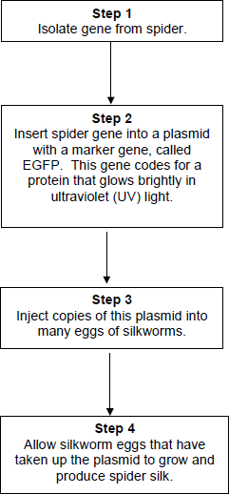

(a)     Suggest why the plasmids were injected into the eggs of silkworms, rather than into the silkworms.

........................................................................................................................

........................................................................................................................

........................................................................................................................

........................................................................................................................

**(2)**

(b)     Suggest why the scientists used a marker gene and why they used the EGFP gene.

........................................................................................................................

........................................................................................................................

........................................................................................................................

........................................................................................................................

**(2)**

The scientists ensured the spider gene was expressed only in cells within the silk glands.

(c)     What would the scientists have inserted into the plasmid along with the spider gene to ensure that the spider gene was only expressed in the silk glands of the silkworms?

........................................................................................................................

**(1)**

(d)     Suggest **two** reasons why it was important that the spider gene was expressed only in the silk glands of the silkworms.

1 .....................................................................................................................

........................................................................................................................

2 .....................................................................................................................

........................................................................................................................

**(2)**

**(Total 7 marks)**

**Q32.**Some populations of flies are becoming resistant to insecticides intended to kill them.

Scientists developed a method for finding out whether a fly was carrying a recessive allele, **r**, that gives resistance to an insecticide. The dominant allele, **R**, of this gene does not give resistance.

The scientists:

•        crossed flies with genotype **RR** with flies with genotype **rr**

•        obtained DNA samples from the parents and offspring

•        used the same restriction endonuclease enzymes on each sample, to obtain DNA fragments.

(a)     Explain why the scientists used the same restriction endonuclease enzymes on each DNA sample.

........................................................................................................................

........................................................................................................................

........................................................................................................................

........................................................................................................................

**(2)**

The scientists added two different primers to each sample of DNA fragments for the polymerase chain reaction (PCR).

•        Primer A3 only binds to a 195 base-pair fragment from allele **r**.

•        Primer A4 only binds to a 135 base-pair fragment from allele **R**.

The scientists separated the DNA fragments produced by the PCR on a gel where shorter fragments move further in a given time.

Their results are shown in **Figure 1**.

**Figure 1**

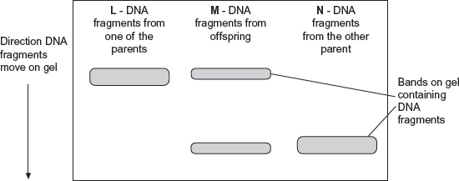

(b)     Explain why primer A3 and primer A4 only bind to specific DNA fragments.

........................................................................................................................

........................................................................................................................

........................................................................................................................

........................................................................................................................

**(2)**

(c)     Use all the information given to explain the results in **Figure 1**.

........................................................................................................................

........................................................................................................................

........................................................................................................................

........................................................................................................................

........................................................................................................................

........................................................................................................................

**[Extra space]** ................................................................................................

........................................................................................................................

........................................................................................................................

**(3)**

(d)     The scientists wanted to know on which chromosome the gene with alleles **R** and **r** was located. From the flies with genotype **RR**, they obtained cells that were in mitosis and added a labelled DNA probe specific for allele **R**. They then looked at the cells under an optical microscope.

Explain why they used cells that were in mitosis.

........................................................................................................................

........................................................................................................................

........................................................................................................................

........................................................................................................................

**(2)**

(e)     Another group of scientists thought that pesticide resistance in some flies was related to increased activity of an enzyme called P450 monooxygenase (PM).  
This enzyme breaks down insecticides.

The scientists obtained large numbers of resistant and non-resistant flies. They then set up the following experiments.

•        Non-resistant flies exposed to insecticide.

•        Resistant flies exposed to insecticide.

•        Resistant flies treated with an inhibitor of PM and then exposed to insecticide.

They then determined the percentage of flies that were dead at different times after being exposed to insecticide.

**Figure 2** shows their results.

**Figure 2**

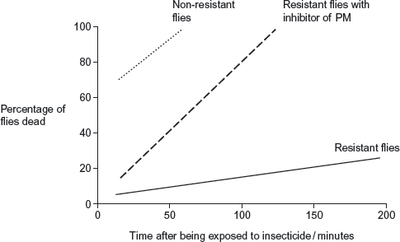

(i)      Explain why the scientists carried out the control experiment with the non-resistant flies.

...............................................................................................................

...............................................................................................................

...............................................................................................................

...............................................................................................................

...............................................................................................................

**(2)**

(ii)     The scientists concluded that the resistance of the flies to the insecticide is partly due to increased activity of PM but other factors are also involved.

Explain how these data support this conclusion.

...............................................................................................................

...............................................................................................................

...............................................................................................................

...............................................................................................................

...............................................................................................................

...............................................................................................................

**[Extra space]** .......................................................................................

...............................................................................................................

...............................................................................................................

...............................................................................................................

**(4)**

**(Total 15 marks)**

**Q33.**Scientists wanted to measure how much mRNA was transcribed from allele **A** of a gene in a sample of cells. This gene exists in two forms, **A** and **a**.

The scientists isolated mRNA from the cells. They added an enzyme to mRNA to produce cDNA.

(a)     Name the type of enzyme used to produce the cDNA.

........................................................................................................................

**(1)**

The scientists used the polymerase chain reaction (PCR) to produce copies of the cDNA. They added a DNA probe for allele **A** to the cDNA copies. This DNA probe had a dye attached to it. This dye glows with a green light **only** when the DNA probe is attached to its target cDNA.

(b)     Explain why this DNA probe will only detect allele **A**.

........................................................................................................................

........................................................................................................................

........................................................................................................................

........................................................................................................................

**(2)**

(c)     The scientists used this method with cells from two people, **H** and **G**.  
One person was homozygous, **AA**, and the other was heterozygous, **Aa**.  
The scientists used the PCR and the DNA probe specific for allele **A** on the cDNA from both people.

The figure shows the scientists’ results.

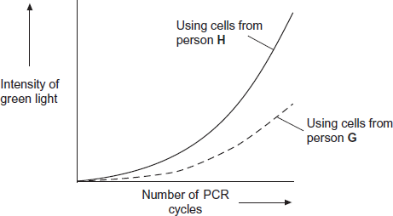

(i)      Explain the curve for person **H**.

...............................................................................................................

...............................................................................................................

...............................................................................................................

...............................................................................................................

...............................................................................................................

...............................................................................................................

*(Extra space)* ........................................................................................

...............................................................................................................

...............................................................................................................

**(3)**

(ii)     Which person, **H** or **G**, was heterozygous, **Aa**? Explain your answer.

...............................................................................................................

...............................................................................................................

...............................................................................................................

...............................................................................................................

**(2)**

**(Total 8 marks)**

**M1.**          **Essay Using DNA in science and technology**

**DNA and classification**

2.2 Structure of DNA

2.3 Differences in DNA lead to genetic diversity

2.9 Comparison of DNA base sequences

**Genetic engineering and making useful substances**

2.5 Plasmids

5.8 The use of recombinant DNA to produce transformed organisms that benefit humans

**Other uses of DNA**

2.5 Cell cycle and treatment of cancer

5.8 Gene therapy;

      Medical diagnosis and the treatment of human disease;

      The use of DNA probes to screen patients for clinically important genes.

**M2.**          (a)     Endonuclease / restriction enzyme;

**1**

(b)     DNA made of base pairs;  
Each base pair is same length / occupies same distance  
along backbone;

**2**

(c)     (i)      Second blank box from left labelled 6;

**1**

(ii)     Distance moved depends on length / number of base pairs /   
second longest fragment / second shortest distance identified;

**1**

(d)     5;

**1**

**[6]**

**M3.**          (a)     Restriction enzyme / restriction endonuclease;

**1**

(b)     (i)      A-G-C-T  /  T-C-G-A;

*Allow A-G-C-T-T / T-T-C-G-A*

**1**

(ii)     Joining two pieces of DNA;

By complementary binding/complementary base-pairing;

**2**

(c)     (i)      4943;

**1**

(ii)     3;

**1**

(iii)     2 bands disappear / only 3 bands;

New band formed at heavier position/nearer to origin/higher up;

**2**

**[8]**

**M4.**         (a)     Cocaine (binding) changes shape of transporter/prevents dopamine binding;

*Reject references to active site*

Transporter cannot move (bound) dopamine (through membrane / protein /  
into cell);  
Dopamine remains / builds up in synapses (leading to feelings of pleasure);

**3**

(b)     (i)      Polymerase chain reaction / PCR;

**1**

(ii)     Single-stranded DNA;

*Reject reference to a single strand of DNA*

Bases / sequence complementary to DNA / gene to be identified;

(Radioactively / fluorescent) labelled so that it can be detected;

**2 max**

(c)     Mutation changes base sequence of gene / DNA;

*Accept references to active site*

(Thus) changing amino acid sequence;  
Changes tertiary structure / shape of protein/transporter;  
Cocaine binding site changes/cocaine cannot bind;  
Dopamine can still bind (and be transported);

**3 max**

**[9]**

**M5.**          (a)     (i)      plasmid;

**1**

(ii)     the bacteria divide / grow, producing many copies of desired   
gene / plasmid;  
OR  
the bacteria divide / grow to cover the agar;

**1**

(iii)     plant tissue that has antibiotic resistance survives;  
identifies plant tissue which has desired gene / plasmid;

**2**

(iv)    to clone plants / produce genetically identical plants with   
gene / characteristic;  
and produce large numbers / quickly;

**2**

(b)     (i)      (*one reasonable suggestion*),  
e.g. toxin present all the time;  
save costs of buying / application of spray;  
no spray drift onto other fields / insects;

**1 max**

(ii)     (*one reasonable suggestion*),  
e.g. killing of harmless / useful insects that feed on wild plants;  
damage to food chains starting with wild plants;

**1 max**

**[8]**

**M6.**          (a)     (i)      Amount of mRNA > amount of DNA / multiple copies of mRNA;

Insulin mRNA/the specific mRNA is found in pancreas cells;

Introns / non-coding information present in DNA / these removed  
in mRNA / corr. ref. post-transcriptional modification;

**2 max**

(ii)     Enzyme 1 = reverse transcriptase;

Enzyme 2 = (DNA)-polymerase;

**2**

(iii)     Hydrogen (bonds) / H-(bonds);

**1**

(b)     (i)      Primers;

**1**

(ii)     To allow H-bond re-formation / to allow joining of primers/P  
(and Q) to (single-stranded) DNA / converse re. high temp.  
breaks H-bonds / prevents joining;

**1**

(iii)     To mark region of DNA to be ‘copied’ / to show enzyme where  
to start;

(Enzyme) needs starting strand onto which to attach nucleotides;

*Allow idea of extending pre-existing chain*

**2**

(iv)    32;

**1**

**[10]**

**M7.**          (a)   (cut out gene using an) endonuclease / restriction enzyme;  
reference to specificity / recognition site;  
sticky ends;  
use the same enzyme to cut;  
plasmid / virus / potato DNA;  
fixed by ligase;  
method of introducing vector e.g. micropipette / virus injects DNA /   
remove plant cell wall;

**6 max**

(b)     different genes are expressed;  
producing different enzymes / proteins;

**2**

**[8]**

**M8.**          (a)     use restriction enzyme / endonuclease / named, e.g. Bam / Eco;  
to cut DNA in specific place / base sequence;

**2**

(b)     heat DNA to 90 – 95 °C;  
strands separate;  
add primers;  
and nucleotides;  
cool so that primers bind to DNA;  
(DNA) polymerase forms new strands / joins nucleotides;

**4 max**

(c)     (i)      virus is inhaled / sprayed into the lungs;  
gets into cells, inserting the healthy gene;

**2**

(ii)     makes DNA from RNA

*rather than other way round*

**1**

**[9]**

**M9.**          (a)     isolate wanted gene / DNA from another organism / mRNA from cell / organism;  
using restriction endonuclease / restriction enzyme / reverse transcriptase to get DNA and produce sticky ends;  
use ligase to join wanted gene to plasmid;  
also include marker gene e.g. antibiotic resistance;  
add plasmid to bacteria to grow (colonies)then (replica) plate onto medium where the marker gene is expressed;  
bacteria / colonies not killed have antibiotic resistance gene and (probably) the wanted gene;

**6**

(b)     (i)      injection, rapid rise and fall;  
virus, slower rise and longer in effective / harmful range;  
capsule slowest rise, longest in effective / harmful range;  
injection and virus give harmful concentrations but capsule does  
not;

**3 max**

(ii)     advantage e.g.:  
substance never reaches harmful levels / no side effect / less likely to harm the organism, longer relief from symptoms / less frequent treatment needed / longer effective range / longer but without harmful side effects;

**1 max**

disadvantage e.g.:  
takes longer to take effect;

**1**

**[11]**

**M10.**          (a)     introduction of healthy gene / ‘replacement’ of defective gene;

**1**

(b)     can enter cells / infect cells / inject DNA into cells;  
targets specific cells;  
replicates (in cells);

**2**

(c)     reproductive cells / gamete cells do not contain ADA allele / gene;

**1**

(d)     (i)      to ‘prevent’ rejection / immune response;

**1**

(ii)     T lymphocytes have a limited life span / die off / do not reproduce;  
bone marrow provides continual supply of T lymphocytes /   
(ADA) gene enzyme;

**2**

**[7]**

**M11.**          (a)     1       macrophages present antigens to B lymphocytes;  
2       antigen binds to / is complementary to receptors on lymphocyte;  
3       binds to a specific lymphocyte;  
4       lymphocytes become competent / sensitised;  
5       (B) lymphocytes reproduce by mitosis / (B) lymphocytes cloned;  
6       plasma cells secrete antibodies;

**4 max**

(b)     1       restriction enzyme / endonuclease;  
2       to cut plasmid / to form sticky ends in plasmid;  
3       (use) ligase(to join) gene to plasmid;  
4       culture bacteria with (in medium containing) plasmids  
5       to allow uptake of plasmids / transformation;  
6       use of cold shock / chemical treatment (to enhance uptake) / heat  
         shock;  
*(ignore bullets / electroporation / microinjection)*

**3 max**

**[7]**

**M12.**          (a)     probe will attach (to mutant allele);  
attaches to one DNA strand;  
as a result of complementary base pairing;  
radioactivity detected on film / X-ray / by autoradiography  
(if mutant allele present);

**4**

(b)     *for*gene is only active in mammary cells / only affects milk / easy to  
obtain product / product produced in large amounts / gene passed to  
offspring;

**1**

*against*long term effects not known / qualified reference to animal exploitation  
e.g. use of embryos / effect of inserted gene on other sheep  
tissues / genes;

**1**

**[6]**

**M13.**          (a)     (i)      restriction (endonuclease) enzyme;

cuts DNA at specific / restriction points / after specific base sequence;

**2**

(ii)     PCR / polymerase chain reaction;

**1**

(b)     isolated cells divide by mitosis;  
can get many plants (producing toxin) / rapid production of   
(toxin producing) plants;

all cells (in the new plant / clone) will produce the toxin;

**3**

**[6]**

**M14.**          (a)     (i)      transfer / carry genes from one organism to another / into  
bacteria / cells;

**1**

(ii)     cut open plasmid;  
cut donor DNA, to remove gene / length of DNA;  
cut donor DNA and plasmid with the same enzyme / enzyme  
that cuts at the same base sequence;  
sticky ends / (overhanging) ends with, single strand / bases exposed;  
association / attachment / pairing of complementary strand;

**2 max**

(iii)     annealing / splicing / backbones joined / phosphodiester bonds;

**1**

(b)     (i)      L and M;

**1**

(ii)     fragments 64 and 36(kilobases obtained)

**1**

**[6]**

**M15.**          (a)     Presence of resistant and non-resistant varieties / mutation produces resistant variety;  
Resistant ones survive / non-resistant ones killed by treatment;  
These will reproduce and produce more resistant parasites / pass on resistance allele;

**3**

(b)     Likelihood of being infected (by strain resistant to both drugs) is less;  
1/500 × 1/500/1/250 000;  
Drug has longer effective life;

**max 2**

(c)     (i)      As comparison / to show that nothing else in the treatment was responsible;

**1**

(ii)     Given injections of saline / injection without SPf66;  
(otherwise) treated the same as experimental group;

**2**

(d)     (i)      100%;

**1**

(ii)     10%;

**1**

(e)     (i)      Different lengths of DNA have different base sequences / cut at specific sequence;  
Results in different shape / different shape of active site;  
Therefore (specific sequence) will only fit active site of enzyme;

**3**

(ii)     Recognition sites contain only AT pairs;  
Which would occur very frequently;

**2**

**[15]**

**M16.**          (a)     (i)      contains genes / nucleotides / sections of DNA / artificial  
DNA from two species / 2 types of organisms;

**1**

(ii)     carries gene / DNA (into the other organism / gene carrier);

**1**

(iii)     expose cells to the fungus;  
non-resistant ones die, resistant ones survive;  
OR identify by adding marker gene / gene probe / (qualified)  
marker probe; description of positive result  
e.g. radioactivity / fluorescence / complementary base pairing;

**2**

(b)     EITHER      1 cut desired gene (from DNA) of oat plant;  
                   2 using restriction endonuclease / restriction enzyme;  
OR             1 use mRNA from oat which will code for resistance;  
                   2 and use reverse transcriptase to form desired DNA;  
OR             1 make artificial DNA with correct sequence of bases;  
                   2 using DNA polymerase;  
                   3 cut plasmid open;  
                   4 with (same) restriction endonuclease / restriction enzyme;  
                   5 ref. sticky ends / unpaired bases attached;  
                   6 use (DNA) ligase to join / ref. ligation;  
                   7 return plasmid to (bacterial) cells;  
                   8 use of Ca2+ / calcium salts / electric shock;  
                   (if ref. to ‘insulin’ allow 5 max.)

**max 6**

**[10]**

**M17.**          (a)     1  (DNA altered by) mutation;  
2  (mutation) changes base sequence;  
3  of gene controlling cell growth / oncogene / that monitors cell division;  
4  of tumour suppressor gene;  
5  change protein structure / non-functional protein / protein not formed;  
6  (tumour suppressor genes) produce proteins that inhibit cell division;  
7  mitosis;  
8  uncontrolled / rapid / abnormal (cell division);  
9  malignant tumour;

**max 6**

(b)     cancer cells die / break open;  
releasing DNA;

**2**

(c)     normal DNA and changed DNA have different sequences;  
DNA only binds to complementary sequence;

**2**

(d)     fewer abnormal / cancerous cells / smaller tumours;  
less cell damage / less spread / fewer locations to treat;

**2**

(e)     mRNA base sequence has changed;  
gene / DNA structure is different / has mutated;  
cancer gene active / tumour suppressor gene inactive;

**3**

**[15]**

**M18.**          (a)     (i)      Sticky ends / description;  
Reference to complementary base-pairing

**2**

(ii)     Ligase;

**1**

(b)     Carrier of DNA / gene; *(context of foreign DNA)*Into cell / other organism / host;

**2**

(c)     Act as marker gene;  
Allows detection of cells containing plasmid / DNA;

**2**

**[7]**

**M19.**          (a)     (i)      Sticky ends / description;  
Reference to complementary base-pairing

**2**

(ii)     Ligase;

**1**

(b)     Carrier of DNA / gene; *(context of foreign DNA)*Into cell / other organism / host;

**2**

(c)     Act as marker gene;  
Allows detection of cells containing plasmid / DNA;

**2**

**[7]**

**M20.**          (a)     (i)      Different genes / characteristics / features;  
Reference to mutations;  
Or  
Base sequence determines protein;  
Different species have different protein sequences;

**max 2**

(ii)     Primer has different DNA sequence;  
DNA specific / complementary base-pairing;

**2**

(iii)     Electrophoresis separates DNA;  
(So they can be) identified by position on gel;  
Smaller / shortest fragments travel furthest / quicker / or  
reverse argument;

**3**

(b)     (*conventional*) Many lengths / all DNA / (*new*) one length;  
Each rung is DNA of one / specific length;

**2**

(c)     1 Heat DNA;  
2 Breaks hydrogen bonds / separates strands;  
3 Add primers;  
4 Add nucleotides;  
5 Cool;  
6 (to allow) binding of nucleotides / primers;  
7 DNA polymerase;  
8 Role of (DNA) polymerase;  
9 Repeat cycle many times;

**max 6**

**[15]**

**M21.**          (a)     (i)      Reverse transcriptase;

**1**

(ii)     Idea that mRNA is present in large amounts in cell making  
the protein / mRNA has been edited / does not contain  
introns / mRNA codes for single protein;

**1**

(b)     (Ligase) splices / joins two pieces of DNA / “sticky ends”;

**1**

**[3]**

**M22.**          (a)     Mother and father both heterozygotes / Tt / carriers;  
Probability of thalassaemia 1/4 and female 1/2;  
Probability of both 1/8;

**3**

(b)     (i)      Cut at same base sequence as same enzyme used;  
Fragments are same length / size / have same charge;

**2**

(ii)     Single base occurs many times;  
Sequence of 20 unlikely to occur elsewhere;  
*Allow one mark for establishing the principle where neither marking  
point* *clearly made.*

**2**

**[7]**

**M23.**          (a)     restriction (enzyme) / endonuclease / named example;

**1**

(b)     unpaired bases / sticky ends / staggered;  
complementary / explained;

**2**

(c)     *1 mark for each correct outcome*plasmid with foreign DNA joined in ring;  
ring with plasmid only; ring of foreign DNA only;  
*ignore linear structures*

**3**

**[6]**

**M24.**          (a)     (i)      protein / immunoglobulin;  
specific to antigen;  
idea of ‘fit’ / complementary shape;

**2 max**

(ii)     1. virus contains antigen;  
2. virus engulfed by phagocyte / macrophage;  
3. presents antigen to B-cell;  
4. memory cells / B-cell becomes activated;  
5. (divides to) form clones;  
6. by mitosis;  
7. plasma cells produce antibodies;  
8. antibodies specific to antigen;  
9. correct reference to T-cells / cytokines;

**6 max**

(b)     1. antibody gene located using gene probe;  
2. cut using restriction enzyme;  
3. at specific base pairs;  
4. leaving sticky ends / unpaired bases;  
5. cut maize / DNA / vector using same restriction enzyme;  
6. join using DNA ligase;  
7. introduce vector into maize / crop / recombinant DNA into maize;

**4 max**

(c)     passive / person is not making own antibodies / antibodies not replaced;  
memory cells not produced;

**2**

(d)     fewer ethical difficulties / less risk of infection;

**1**

**[15]**

**M25.**          (a)     Restriction (enzyme / endonuclease);

**1**

(b)     Move towards anode / move because charged;

Different rates of movement related to charge / size;

**2**

(c)     (i)      Piece of DNA;

Single stranded;

Complementary to / binds to known base sequence / gene;

**max 2**

(ii)     DNA invisible on gel / membrane;

Allows detection;

**2**

**[7]**

**M26.**(a)     1.      Closer the (amino acid) sequence the closer the relationship;

2.      (Protein structure) related to (DNA) base / triplet sequence;

*Amino acid sequence is related to (DNA) base / triplet sequence = two marks;*

**2**

(b)     1.      Reference to base triplets / triplet code / more bases than amino acids / longer base sequence than amino acid sequence;

*Different (base) triplets code for same amino acids = 2 marks;*

*Degeneracy of triplet code = 2 marks*

2.      Introns / non-coding DNA / degeneracy of code / more than one code for each amino acid;

*Ignore reference to codon.*

**2**

**[4]**

**M27.**         (a)     (i)      1.      Negative correlation;

*Accept: description for ‘negative correlation’*

*Neutral: ‘correlation’*

*Reject: positive correlation*

2.      Wide range;

3.      Overlap;

4.      (Graph suggests that) other factors may be involved (in age of onset);

*2 / 3 Accept the use of figures from the graph*

*2 / 3 Can refer to age of onset or number of CAG repeats*

*Ignore references to methodology*

**3 max**

(ii)     1.      Age of onset can be high / symptoms appear later in life;

*Accept: ‘gene’ for ‘allele’*

2.      (So) individuals have already had children / allele has been passed on;

***OR***

3.      Individuals have passed on the allele / already had children;

4.      Before symptoms occur;

**2 max**

(b)     (i)     1.      Person **K**;

2.      (As has) high(est) band / band that travelled a short(est) distance / (er) so has large(st) fragment / number of CAG repeats;

*Must correctly link distance moved and fragment size*

**2**

(ii)     Run fragments of known length / CAG repeats (at the same time);

*Accept: references to a DNA ladder / DNA markers*

*Do not accept DNA sequencing*

**1**

(iii)    Homozygous / (CAG) fragments are the same length / size / mass;

*Accept: small fragment has run off gel / travelled further*

**1**

**[9]**

**M28.**          (a)     1.      Adenylate cyclase activated / cAMP produced / second messenger produced;

2.      Activates enzyme(s) (in cell so) glycogenolysis / gluconeogenesis occurs / glycogenesis inhibited;

*2. Neutral: ‘glucose produced’ as given in the question stem*

*Accept: correct descriptions of these terms*

**2**

(b)     (i)     1.      Glucose / sugar in food would affect the results;

*1. Accept references to starch / carbohydrate*

*Or*

2.      Food / eating would affect blood glucose (level);

*Or*

3.      (Allows time for) blood glucose (level) to return to normal;

*3. Neutral: allows time for insulin to act*

**1 max**

(ii)     Type 2 diabetes is a failure to respond to insulin / still produces insulin / is not insulin-dependent;

**1**

(iii)    (For) – 3 max

*A maximum of three marks can be awarded for each side of the argument*

1.      Avoids injections / pain of injections;

2.      Long(er) lasting / permanent / (new) cells will contain / express gene;

*Ignore references to methodology e.g. sample size not known*

3.      Less need to measure blood sugar / avoids the highs and lows in blood sugar;

4.      Less restriction on diet;

(Against) – 3 max

5.      Rats are different to humans;

6.      May have side effects on humans;

*6. Accept: virus may be harmful / disrupt genes / cause cancer*

7.      Long(er) term effects (of treatment) not known / may have caused effects after 8 months;

8.      (Substitute) insulin may be rejected by the body;

**4 max**

**[8]**

**M29.**(a)     Restriction / endonuclease;

*Ignore specific names of restriction enzymes e.g. EcoR1*

**1**

(b)     (i)      1.      (Acts as a) marker gene to show that the (human) gene has been taken up / expressed;

*1. Accept: gene marker*

2.      (Only) implant cells / embryos that show fluorescence / contain the jellyfish gene;

**2**

(ii)     1.      Factor IX present in / extracted from milk;

2.      Gene only expressed in mammary glands / udder / gene not expressed elsewhere;

*2. Ignore references to milk*

*The ‘only’ aspect is important here.*

3.      Do not need to kill sheep (to obtain Factor IX);

**2 max**

(c)     (i)     1.      Mutation / nucleus / chromosomes / DNA may be damaged / disrupts genes;

*1. Neutral: cell may be damaged*

2.      May interfere with proteins (produced) / gene expression / translation;

*Ignore references to hormone levels or time of implantation*

***OR***

3.      Embryo / antigens foreign;

*3. Neutral: antigens change*

4.      Embryo is rejected / attacked by immune system;

*4. sNeed idea that the immune system is involved if mark point 3 has not been given*

*‘Embryo foreign so rejected’ = 2 marks*

*‘Embryo rejected by immune system’ = 1 mark*

*‘Embryo is rejected’ = 0 marks*

**2 max**

(ii)     1.      Saves time / money for others;

2.      Same work is not repeated / methods can be compared / improved / amended / same errors are not made;

**2**

**[9]**

**M30.**(a)     1.      No effect at 25°C

*The question only refers to plants with GB*

*1. Reject same mass*

2.      Keeps growing at 30°C and 35°C / up to 35°C (more than without GB);

3.      Above 35°C, falls but grows more than plant without GB;

*3. Accept at all temperatures above 25°C more growth than without GB*

**2 max**

(b)     (i)      Significantly different / SEs do not overlap ;

*Accept converse without GB*

**1**

(ii)     (As temperature increases,)

1.      Enzyme activity reduced / (some) enzymes denatured;

2.      Less photosynthesis, so fewer sugars formed;

3.      Less respiration / less energy / ATP for growth;

4.      Less energy for named function associated with growth

*4. Eg mitosis, uptake of mineral ions*

**4**

(c)     1.      (Rubisco activase attaches to thylakoid and) this changes shape / tertiary structure (of enzyme) / blocks active site / changes active site;

*Note - question states enzyme stops working when it attaches to thylakoid, not before*

*1. Accept rubisco in this context*

2.      (This) prevents substrate / RuBP entering active site / binding;

*2. Accept prevents ES complex forming*

*2. Accept no longer complementary to substrate / RuBP*

**2**

(d)     1.      GB prevents / reduces binding of rubiscoactivase to (thylakoid membrane);

*1. Accept enzyme instead of rubiscoactivase. Accept rubisco*

2.      (Prevents it) up to 35°C;

3.      (So) rubiscoactivase / enzyme remains active;

4.      (So) photosynthesis / light-independent stage still happens;

*4. Accept descriptions of light-independent stage*

5.      Above 35°C, some binding still occurs but less than without GB, so less reduction in growth;

**4 max**

(e)     1.      Looked for information / journals, on crop plants that grow at high temperatures;

*1. “other research” is minimum accepted*

*1. Accept previous experiments research with temperature resistant crops*

*Ignore simple references to looking at previous studies / other plants - need to relate to this context*

2.      (Crop plants cited in this research) contain / make GB;

3.      So assumed making plants produce GB makes them resistant to high temperatures;

**2 max**

**[15]**

**M31.**(a)     1.      (If injected into egg), gene gets into all / most of cells of silkworm;

2.      So gets into cells that make silk.

**2**

(b)     1.      Not all eggs will successfully take up the plasmid;

2.      Silkworms that have taken up gene will glow.

**2**

(c)     Promoter (region / gene).

**1**

(d)     1.      So that protein can be harvested;

2.      Fibres in other cells might cause harm.

**2**

**[7]**

**M32.**(a)     1.      Cut (DNA) at same (base) sequence / (recognition) sequence;

*Accept: cut DNA at same place*

2.      (So) get (fragments with gene) **R** / required gene.

*Accept: ‘allele’ for ‘gene’ / same gene*

**2**

(b)     1.      Each has / they have a specific base sequence;

2.      That is complementary (to allele r or R).

*Accept description of ‘complementary’*

**2**

(c)     1.      Fragments L from parent rr, because all longer fragments / 195  
         base pair fragments;

*Ignore: references to fragments that move further / less, require identification of longer / shorter or 195 / 135*

*Accept: (homozygous) recessive*

2.      Fragments N from parent RR, because all shorter fragments / 135 base pair fragments;

*1 and 2 Accept: A3 for 195 and A4 for 135*

*2. Accept: (homozygous) dominant*

3.      (M from) offspring heterozygous / Rr / have both 195 and 135 base pair fragments.

*Accept: have both bands / strips*

*Reject: primer longer / shorter*

**3**

(d)     1.      (Cells in mitosis) chromosomes visible;

2.      (So) can see which chromosome DNA probe attached to.

**2**

(e)     (i)      1.      For comparison with resistant flies / other (two) experiments  
        / groups;

*Ignore: compare results / data / no other factors*

2.      To see death rate (in non-resistant) / to see effect of insecticide in non-resistant / normal flies.

*Accept: ‘pesticide’ as ‘insecticide’*

*Accept to see that insecticide worked / to see effect of enzyme*

**2**

(ii)     (PM must be involved because)

1.      Few resistant flies die (without inhibitor);

2.      More inhibited flies die than resistant flies;

3.      (PM) inhibited flies die faster (than resistant flies);

(Other factors must be involved because)

4.      Some resistant flies die;

5.      But (with inhibitor) still have greater resistance / die slower than non-resistant flies.

*Accept: (with inhibitor) die slower than non-resistant flies*

**4 max**

**[15]**

**M33.**(a)     Reverse transcriptase;

**1**

(b)     1.      Probe (base sequence) complementary (to DNA of allele A / where A is (and) binds by forming base pairs / hydrogen bonds;

*Accept gene A*

2.      So (only) this DNA labelled / has green dye / gives out (green) light;

*Accept glows for green light*

**2**

(c)     (i)      1.      More probe binding / more cDNA / mRNA / more allele / gene A means more light;

2.      DNA (with **A**) doubles each (PCR) cycle;

3.      So light (approximately) doubles / curve steepens more and more (each cycle) / curve goes up exponentially / increases even faster;

**3**

(ii)     (**G** because)

1.      (Heterozygous) only has half the amount of probe for **A** attaching / only half the amount of DNA / allele A (to bind to);

*Accept only one A to bind to*

2.      (So,) only produced (about) half the light / glow / intensity (of **H**) (per cycle of PCR);

*If reference to ‘half’ for point 1, allow ‘less light’ in 2.*

**2**

**[8]**

**E1.**          **Using DNA in science and technology**

The very best essays from candidates who selected this option were outstanding. They reviewed, often in great detail, the relevant aspects of the specification although not always incorporating the role of DNA in the classification of organisms. Considering that much of the content of this essay could be drawn from this unit, it was surprising how poor many answers were. Understanding of techniques was often extremely limited, particularly *in vivo* gene cloning and the use of markers. Many essays presented no more than a broad overview either emphasising ethical issues at the expense of biological detail or failing to distinguish established practice from wishful thinking.

**E2.**          **Unit 2**

(a)     Most had no trouble here in identifying endonuclease.

(b)     This was badly done since few mentioned or implied that DNA was made of base pairs and that these occupied the same distance along the backbone. Many made it obvious that they meant the distance from one chain to the other or went on to write about the distances in the electrophoresis gel.

(c)     Although the correct box was often located, the second from the right was almost as commonly given. Appropriate justification for the choice was rewarded in (ii) although many candidates suggested fragment 6 was the fifth rather than the second largest.

(d)     All figures were given here with 5 only rarely chosen, 6 being most common.

**Unit 3**

In part (a), restriction enzyme was correctly identified by almost all candidates. However, part (b) attracted very poor answers. Few commented that DNA is composed of base pairs, or that all base pairs have the same length. Many simply re-stated the question. In (c) (i), most candidates correctly identified the box, but a significant number identified the penultimate box. These candidates explained in (c)(ii) that the *longest* fragments moved furthest. Although they had the correct idea that DNA separates according to length, they had the relationship the wrong way round. In (d), there were few correct answers. Most gave 6.

**E3.**          (a)     Just over two-thirds of candidates recognised that the type of enzyme involved in cutting the DNA was a *restriction enzyme*.

(b)     In (i), it was rather disappointing that only about half of the candidates were able to use information from the diagram to write out the base sequence of one of the sticky ends produced by the restriction enzyme. In (ii), rather more were successful in explaining the usefulness of sticky ends in genetic engineering as a means of rejoining two pieces of DNA, or for inserting a ‘gene’ into a ‘plasmid’. Relatively few emphasised that complementary base pairing was involved in the process. Some attempted to describe the use of probes in PCR, forgetting that only the ‘end’ of a double-stranded DNA molecule was the subject of the question.

(c)     Just over one-third of candidates identified band P in the electrophoresis pattern as being the largest. In part (ii), only about a tenth of the candidates could work out that a length of DNA would have to be cut three times in order to produce four fragments. In (iii), however, over a fifth were able to predict that there would be one less fragment following the mutation but very few of these could predict that this, being larger, would be nearer to the origin.

**E4.**          This question was answered well by many candidates. It was pleasing to see that most were able to interpret the information presented in the diagrams. In (a), about a fifth of candidates obtained all three marks and three fifths obtained one or two marks. Weaker candidates appeared not to have read the stem of the question carefully and some seemed to think that the transporter protein was an enzyme that made dopamine. Others thought that cocaine entered the cell instead of dopamine and produced the same effect as dopamine inside the cell. Part (c) was particularly well answered and over a third of candidates obtained all three marks.

**E5.**          This question produced a very wide spread of marks. Candidates frequently failed to gain marks for poor use of language and terminology. The question also caused problems for candidates who did not read the information given carefully. As an example, Stage 1 shows that a desired gene has already been introduced into *Agrobacterium* using a plasmid, so culturing of the bacterium produces bacteria with the gene.

(a)     (i)      Most candidates correctly described X as a plasmid.

(ii)     The specification refers to plasmids being used to incorporate genes into bacterial cells. It also refers to rapid reproduction of such bacteria then producing many copies of these genes. Relatively few candidates linked culturing of the bacteria to the idea of producing many with the already introduced gene for a desired characteristic. Credit was given to candidates who suggested that the reason was to cover the growth medium with bacteria, to ensure infection of discs of plant tissue.

(iii)     Many candidates got confused here and wrote about identifying bacteria with antibiotic resistance, rather than plant tissue that now had the gene for resistance. Those who did get this mark often failed to get a second mark, because they failed to note that such tissue was also likely to have the desired gene, which is linked to the marker antibiotic resistance gene.

(b)     (i)      Most candidates obtained this mark. Some candidates failed to score because of vague, non-specific answers, usually along the lines of, ‘It’s cheaper’. The examiners expected some explanation of why it might be cheaper.

(ii)     As with part (i), many candidates obtained this mark but others did not because of vague answers such as, ‘It is dangerous to the environment’.

**E6.**          (a)     An unexpected, and invalid, answer to part (i) was the suggestion that harvesting mRNA would cause less damage to cells than taking DNA from them. Thus, many candidates appeared not to realise that the cells would have been broken to pieces in a blender in order to extract their nucleic acids.

More sensible answers related to the relative abundance in pancreatic cells of mRNA molecules coding for the production of insulin and to the absence of introns in the mRNA. However, less than one-third of candidates were able to make even one of these points.

In part (ii), over three quarters of candidates were able to name one of the two enzymes, but only about one-third recognised the role of both *reverse transcriptase* and *DNA polymerase* in catalysing the given reactions.

In (iii), it was pleasing to find that the *hydrogen bond* was almost universally known as the force involved in holding the two strands of the DNA molecule together.

(b)     Around three quarters of candidates correctly stated that the short lengths of single- stranded DNA were known as *primers*. ‘Sticky ends’ was a common incorrect answer. Almost two-thirds knew, or could deduce from the diagram, that the purpose of cooling the reaction mixture at the given stage was to enable the primers to form hydrogen bond with the single-stranded lengths of DNA. Some answers were rather too imprecise and could equally have been interpreted as meaning that the primers were bonding to themselves.

In part (iii), around three quarters of candidates knew that the primers would mark the sections of DNA to be replicated in the PCR. Very few explained successfully that they also served as starting material onto which new nucleotides could be attached.

Finally, in part (iv), just under two-thirds of candidates successfully calculated that one DNA molecule would have produced 32 molecules after 5 cycles of PCR.

**E7.**          Generally this question was well answered with most candidates obtaining at least four marks. However, part (b) proved difficult for the majority.

(a)     Answers to this question provided the full range of marks. Better candidates gave a detailed description of genetic engineering and had little difficulty in obtaining five of the six marks available. A significant number obtained maximum marks. Weaker candidates referred to the use of a restriction endonuclease and the production of ‘sticky ends’. Many of these candidates also referred to the use of a plasmid but, unfortunately, not always in the correct context. There was also some confusion over the use of the enzyme ligase. Many candidates failed to realise that the gene was inserted into a plant cell but did not take the cell wall into consideration when describing the method of transfer. Nevertheless, the quality of answers to this question was pleasing.

(b)     This proved to be an effective discriminator, with only better candidates suggesting how different cells could be produced by different genes being expressed. The best candidates then linked this to the production of different enzymes or proteins. Many candidates referred to the use of hormones without displaying any understanding of how these may initiate gene expression.

**E8.**          This question gave many candidates the opportunity to display their knowledge of factual material from the specification. Candidates who had not learnt the material performed very badly.

(a)     Most candidates obtained one mark for reference to restriction enzymes. Many got a second mark for the idea that such enzymes target specific base sequences. Some were not awarded this second mark, because they stated that enzymes could be used which just cut out the required gene.

(b)     Many candidates scored two or three marks here, usually for references to heating to about 90 °C and adding primers and free nucleotides. Clear, coherent and correct answers about the whole process were relatively uncommon. There frequently seemed to be some confusion about why heating to 90 °C was carried out and why cooling to about 60 °C was necessary. It appeared that many candidates knew what went into PCR but did not have a clear appreciation of how it works.

(c)     (i)      Many candidates obtained one mark for the idea that the virus is inhaled into the lungs. Some then got the second mark for the idea that the virus carries the CFTR gene into target cells. Quite a few candidates failed to get these marks, because they introduced plasmids into their answer and tried to explain how they would be put into the virus, or how they would be inhaled or injected. This was despite the question stating that the virus had been genetically engineered and contained the required gene.

(ii)     Most candidates correctly explained that in this case mRNA was used in the production of DNA.

**E9.**          (a)     There were many good answers to this factual recall question and marks of 5 and 6 were common. Some candidates were confused between plasmids and bacteria and wrote about culturing plasmids on agar plates.

(b)     (i)      Many candidates displayed a rather poor ability to describe the results of the three experiments. Many candidates did obtain one mark for reference to the fact that the protein capsule method never produced harmful levels of the substance. Most candidates ignored the relative speed of rise into harmful concentrations between the direct injection and virus injection method. They also ignored the relative speeds of fall in concentration of the substance with the three methods.

(ii)     Many candidates were able to suggest an advantage and a disadvantage of the capsule method. Some failed to gain marks because of the vague ways in which they expressed their answers. For example, ‘It doesn’t give very high levels’ for an advantage, with no reference to concentrations with possible harmful side effects.

**E10.**          Although only a few candidates obtained maximum marks on this question, most were able to gain between two and four marks.

(a)     Most candidates correctly described what is meant by gene therapy, although many weaker candidates referred to the ‘removal of defective genes’ or provided a definition of genetic engineering.

(b)     Most candidates obtained one mark for stating that a virus can enter a cell or inject DNA into a cell. A minority of candidates gained a second mark by referring to viral replication or to viruses targeting specific cells.

(c)     Approximately half the candidates correctly explained that the gametes of treated individuals do not possess the ADA allele and consequently they cannot pass it on to their children.

(d)     Most candidates gained the mark in part (i) by suggesting that using a genetically matched donor would help prevent rejection. Part (ii) proved to be more discriminating. Better candidates appreciated that T lymphocytes would have a limited life span and gained one mark. However, very few candidates gained both marks by explaining that transplanted bone marrow provides a continual supply of T lymphocytes with the ADA allele.

**E11.**          Most candidates gained at least four marks in this question.

(a)     The majority of answers lacked detail and a clear understanding of the correct sequence of events. Candidates had to select the facts needed to answer the question. Many gained a mark for replication by mitosis/cloning. All the other marking points were seen, with stronger candidates gaining all the marks. Few mentioned the importance of specific B lymphocytes, or differentiation resulting in plasma cells that release antibodies.

Antigen, antibody and receptor were often confused. Many mentioned memory cells and T cells.

Many candidates gained more than half the marks because there were six points on the mark scheme.

(b)     A large number of students wasted time describing how to isolate the gene. The gene had already been isolated. Marks were gained for references to restriction endonuclease, plasmid and ligase. Few suggested how to transfer plasmid into bacteria.

**E12.**          Not surprisingly, this question produced a wide range of marks. There were some excellent answers but even the most able candidates had difficulty obtaining maximum marks in part (a).

The vast majority of candidates obtained one or two of the four marks available. The first mark gained was by indicating that the gene probe would attach to the mutant allele. Some of these candidates obtained a second mark by stating that autoradiography could be used to detect radioactivity. However, a number of candidates suggested that ‘firing X-rays’ at the sample would suffice. Another misconception was that the individual radioactive nucleotides would line up with the mutant allele rather than a single radioactive strand. Very few candidates appreciated that the gene probe would attach to one DNA strand and even fewer candidates explained that this would occur as a result of complementary base pairing, despite the cues given in the stem of the question.

Only better candidates used their knowledge of the process involved to explain one argument for the use of genetically engineered sheep to produce alpha-1-antitrypsin. Generally these candidates referred to the product being in the milk or being produced in large quantities. Many candidates simply stated that you could treat cystic fibrosis, which was stated in the stem of the question. Fewer candidates gained a mark for explaining one argument against the use of these sheep. It was disappointing to see a large number of candidates simply referring to ‘not playing God’. The most common correct response was to state that long-term effects are not known. Some candidates did refer to the low success rate of using sheep embryos in this process.

**E13.**          This proved to be a discriminating question with only the very best candidates gaining maximum marks.

(a)     (i)      The enzyme was correctly named by the substantial majority of candidates. Surprisingly, many then didn’t gain the second mark, either by failing to mention the cutting of the DNA or by missing the specificity of the place of action.

(ii)     A specification term, well answered.

(b)     There were very few answers worthy of credit. Most candidates could not apply the principles of mitosis to this question. The better candidates recognised the limited transfer of genes to cells within a whole plant but then could not link the cloning of individual cells to rapid production of many plants made of cells, all potentially able to express the gene.

**E14.**          There were some excellent answers to this question but very few maximum marks, as many candidates failed to describe the role of DNA ligase in sufficient detail.

(a)     The roles of vectors and restriction endonucleases were well known and described clearly by the majority of candidates. As with the polymerase enzymes, many candidates seem under the impression that DNA ligase catyalses complementary base pairing. The majority of candidates failed to mention the joining of the backbones or used imprecise terminology, which was too ambiguous to gain the mark.

(b)     The majority of candidates interpreted the information given to gain both marks.

**E15.**          (a)     Many candidates understood the basic principles of natural selection underlying this part of the question and better answers related these to the development of resistance in malarial parasites. Responses, however, were frequently marred by imprecise use of terms. Thus malarial parasites were variously described as developing resistance, immunity or, in some cases, allergies to the drugs concerned, while resistance was described as taking place in bacteria, the disease or even in the human population.

(b)     Evidence from BYA5 suggests that many candidates understand that probabilities are combined by multiplication. However, they were unable to apply this principle to the example in this part of the question. The most frequent response was to add the two figures. The resulting value of 1/250 then proved difficult to explain, and the simple idea that the probability of being infected by a strain of malarial parasite resistant to both drugs was much lower eluded most.

(c)     The concept of a control proved surprisingly unfamiliar to most candidates and even the best seldom progressed beyond explaining that a control offered a standard against which to compare the effectiveness of the vaccine. This idea should have given rise, in part (ii), to injection with saline only in an otherwise identically treated control group. Answers ranged from those who clearly failed to appreciate the nature of a control and discussed issues which were largely ethical in nature, to responses which were in varying degrees incomplete. Such responses included making sure that both groups “lived in the same place” or “were the same age”, ignoring the fact that these were only part of a whole range of factors which should have been kept constant. Evidence from this question and from the coursework suggests that the issue of controls is one that needs to be addressed by centres.

(d)     Better candidates experienced little apparent difficulty in identifying the correct percentages here. Incorrect answers fell into no set pattern and most responses which could conceivably be given arose at least once.

(e)     Many candidates were obviously of the opinion that restriction enzymes function in a way that is totally different from other enzymes, and attempted to explain their specificity in part (i) in terms of base pairing. Others clearly understood the principles involved but neglected to relate their understanding of enzyme action to this particular question. A lack of precision characterised many of the answers to part (ii). Thus there were frequent references to adenine and thymine but not to these bases forming the restriction sites. However, most candidates were able to equate the frequency of cutting to the small size of the resulting fragments.

**E16.**          (a)     Only the most able could explain that two species were required here for recombinant DNA although many could describe a vector. The third part elicited some thoughtful responses along the lines of exposing the cells to the fungus. Less able candidates wrote about exposure to the disease, and most went into antibiotic resistance without applying it to the situation here.

(b)     Many candidates were able to gain maximum credit here in a very few lines of script. However, there were still the misconceptions that genes are cut out of the plasmid and that this is ‘splicing’. Some failed to address the context, or discussed fermenters.

**E17.**          (a)     Many candidates gave a good account of the changes a mutation could produce and those with clear expression achieved full marks; many scored three or four marks. Uncontrolled cell division and malignant tumors were frequently referred to and some appreciated that genes which controlled cell division could have changed. References to benign tumours or cell mutations were irrelevant in the context of this question.

(b)     Very few candidates achieved marks here, mainly because they did not read the question. Whole cells in the blood were not required, but the understanding that cancer cells could burst or die and release their DNA was.

(c)     Few seemed to understand this and restated the question without reference to the changed base sequences to which the strip would bind.

(d)     This was generally well known. The main reason for failing to gain marks was a reference to an undefined ‘it’ which would be growing, dividing or spreading, causing undefined damage.

(e)     Here too some candidates who understood the problem found it hard to explain that changes in the mRNA would reflect mutations in the DNA and would show that a cancer gene was active.

**E18.**          (a)     Sticky ends were mentioned often but few candidates could describe them if the actual words were not used. The way sticky ends were used was badly explained. A large proportion of candidates suggested ligase as the enzyme but several improbable names were also mentioned.

(b)     Many candidates explained this quite well. The main pitfall was for those who discussed vectors of disease despite the clear indication that this was not required.

(c)     A common misconception appeared here, namely plasmids growing on agar, surviving and passing on their antibiotic resistance. It is gratifying that some candidates who recognized that the plasmids must be placed into bacteria went on to score both marks. Several thought putting antibiotic resistance in at this point would help to combat disease at some later stage.

**E19.**          Part (a) (i) was well answered by about half the candidates. Weaker candidates simply repeated material from the stem, using the term ‘staggered cuts’ rather than ‘sticky ends’, and omitted details about complementary base-pairing. In (a) (ii), almost everybody gained the mark for ligase, though there were references to polymerase, reverse transcriptase and even lipase. In (b), there was considerable confusion about the term ‘vector’. The commonest error was to describe the recipient bacterial cell as a vector. A few answered in terms of the mosquito which transmits malaria. While examiners found many excellent answers in (c) from better candidates, it is clear that many candidates believed that plasmids alone could be cultured on agar plates and ‘killed’ by antibiotics.

**E20.**          This question proved to be very demanding for many candidates, although better candidates were able to score all, or almost all, of the available marks. In (a) (i), many candidates recognised that different species of shark have different characteristics, but mostly failed to link these characteristics to proteins or to genes. In (a) (ii), some candidates did realise that each primer had a specific base sequence which would bind to the shark DNA by complementary base-pairing, but weaker candidates simply re-stated the information in the stem. In (a) (iii), many candidates limited their answers to stating that the DNA fragment had to be a different length in each species so it could be identified. How this enabled identification was not stated. On the other hand, good candidates wrote succinctly about electrophoresis separating DNA by size, and explained how the different length fragments would move different distances up the gel. Part (b) was poorly done by most candidates. It was common to find descriptions of genetic fingerprinting here. A few very weak students confused the ‘rungs’ with base pairs in the DNA molecule. Part (c) was the most accessible part of the question. A large proportion of candidates clearly knew the polymerase chain reaction and gave excellent accounts, often gaining full marks. A minority of very weak candidates confused PCR and transcription.

**E21.**          **Unit 2**

(a)     Reverse transcriptase was usually given, but the incorrect DNA polymerase or endonuclease figured frequently. The explanation in (ii) was elusive with many thinking the mRNA was more accessible as it was in the cytoplasm or in single strands.

(b)     Answers ranged here from the insufficient ‘ligation’ to lengthy but incorrect descriptions of joining DNA by means of hydrogen bonds on the base pairs. Those who considered more carefully gave a correct answer.

**Unit 3**

The enzyme in (a)(i) was well known, though a few simply referred to transcriptase. In (a)(ii), it was common to read that mRNA is easier to obtain because it is in the cytoplasm rather than the nucleus. However, a fair number gave a valid explanation, such as the idea that introns have been removed, or that the gene will only code for the protein required. In (b), there was some confusion with restriction enzymes. Some thought the ligase would cut the gene. Others saw it as a kind of filler, filling the gap between the sticky ends, rather than forming bonds.

**E22.**          (a)     Figure 2 showed that the male involved in this cross possessed two alleles and this should have alerted candidates to the fact that the gene concerned was not sex-linked. Most of those who identified it as being autosomal, were able to explain that the probability of the next child having thalassaemia was one in four. Rather less success was enjoyed, however, when it came to combining probabilities, and the mathematics of multiplying fractions was evidently beyond the ability of a number of candidates.

(b)     Part (i) was generally answered well by those candidates who distinguished between the processes of electrophoresis, chromatography and centrifugation. The basis of separation in this case is the difference in charge and, in DNA, this translates into differences in length. The numerous references to such features as solubility suggested that the distinction between these three processes was not always secure. The difficulties encountered by many in part (ii) stemmed largely from confusion between the terms allele, base and probe. There was, as a result, much inaccurate biology and little opportunity for awarding credit.

**E23.**          **Unit 2**

          (a)     This part was well answered by most candidates. Enzyme E was correctly named by almost all candidates, although a few ‘restrictive’ enzymes were seen.

(b)     This part was also well answered, and sticky ends were well known. A few weak candidates thought that sticky ends are complementary because they have the same shape rather than possessing complementary base sequences.

(c)     It was unusual for candidates to score full marks in this section. Some did not realise that the foreign DNA could join up or that the plasmid could re-form without any DNA being inserted. A common problem was that candidates offered more than three responses.

**Unit 3**

(a)     Most could name restriction enzymes but reverse transcriptase was a common error.

(b)     A weakness in expression often denied candidates access to both marks, but it was generally appreciated that complementary base pairing would be possible between the exposed sticky ends.

(c)     The request for drawings presented most candidates with a novel situation and tested their ability to apply understanding and follow their previous explanation. Given the concept that complementary sticky ends can join, it should have been possible to deduce that the plasmid ends could rejoin, the ends of the foreign DNA could join up or, the situation most were familiar with, the plasmid and foreign DNA could join together.

**E24.**          (a)     Few candidates scored two in the first part and vague references to ‘fighting infections’ were common as was confusion of antigens with antibiotics. In part (ii), some candidates appeared to know the sequence of events but in many cases limited marks were gained because of incorrect biology and discussion of previous infections which ‘the body remembers and is ready to fight off the second time’. B and T cells were confused, the exact role of mitosis was not well known and few explained the specific antibody synthesis by plasma cells. Some answers used bacteria as the infective agent.

(b)     This section scored the majority of the marks for the question in most scripts. Problems arose mainly where candidates failed to apply their knowledge to the situation. As a result, the gene was transferred to a plasmid which was put into maize or left in a test tube. In a few cases, the first part of the question led to suggestions of infecting the maize with various blood cells.

(c)     Several good answers referring to passive immunity were seen here but many failed to gain marks through lack of precision in their answer.

(d)     Examiners were looking for more than a simple response about cost here. Valid ideas on the ethics of this work or the possibility of transferring a disease were awarded marks.

**E25.**          (a)     Most identified the enzymes as restriction enzymes though the variety of spellings used meant that credit could not always be awarded.

(b)     This question showed the the idea of larger fragments moving slower or not as far was well understood although there was much incorrect biology relating to charge.

(c)     In (i) the idea of complementarity was understood and communicated well by many candidates although the fact the DNA probe is single stranded was not seen in many responses. In (ii) the majority of candidates obtained one of the available marks for the idea of detecting the location. Surprisingly few candidates stated that without a radioactive probe the location would not be visible. Many candidates had knowledge of fluorescent markers and gave a response based on this knowledge rather than answering the question. A common misconception was that radioactivity shows up when X-rayed.

**E26.**(a)     Over 40% of students failed to score on this question. Many of these students suggested that proteins consist of bases and the confusion between bases and amino acids pervaded their responses. Although a number of students did correctly refer to the sequence of amino acids, only better students linked the similarity of the amino acid sequence with a close evolutionary relationship between different species.

(b)     This question also proved challenging with less than 50% of students gaining any marks. However, a significant number of students did gain one mark for reference to the triplet code and students appreciating the degeneracy of this code were able to gain both marks. Some students gained credit by referring to introns or non-coding DNA.

**E27.**         (a)      (i)      Although the negative correlation was usually indicated, only the better students appreciated the wide range in the age of onset or the overlap in values. Very few students were aware that the wide range in age of onset for the same number of CAG repeats suggests that other factors may also be involved.

(ii)      A minority of weaker students gave answers that were out of context. Some thought that the allele for Huntington’s disease is recessive and would therefore be passed on to offspring without a person knowing. Others thought that people with Huntington’s disease would survive well into adulthood and then reproduce.

(b)     (i)       Most students correctly identified Person **K** as testing positive for Huntington’s disease. They went on to explain that this person has the fragment that moved the shortest distance and linked this to a greater number of CAG repeats. A minority of students failed to link correctly the distance moved with the length of the fragment.

(ii)      Students who failed to gain credit often referred to using DNA sequencing or probes to highlight sequences and ‘restriction mapping’.

(iii)     Misconceptions seen in responses by weaker students included partial digestion of DNA, Person **L** only having one allele of this gene and the probe not being able to attach to the other fragment.

**E28.**          (a)     This proved to be an excellent discriminator and just less than half of students gained full credit. This was usually for describing the production of cAMP and its effect on glycogenolysis or gluconeogenesis. Very few students were able to name the enzyme within the plasma membrane as adenylate cyclase. Similarly, there was sometimes confusion between the activation of this enzyme and intracellular enzymes. Some students thought that adenylate cyclase directly affects glycogenolysis or gluconeogenesis. This said, the correct use of scientific terms beginning with ‘g’ was generally good and only a minority of weaker students confused ‘glycogen’ and ‘glucagon’. The terms ‘glyconeogeneis’ and ‘glucogenolysis’ also appeared in weaker answers.

(b)     (i)      Most students were aware that glucose in food would affect the results or that eating would affect the blood glucose concentration. Very few students referred to the importance of allowing the blood glucose concentration to return to normal.

(ii)     Students who failed to score typically stated that type 2 diabetes is not a genetic disease.

(iii)    The most common advantages given for gene therapy were the avoidance of injections and the longer-lasting effect. The most common disadvantages given were the possible side effects, which were usually linked to the virus, and that the long- term effects are not known. Surprisingly, relatively few students made reference to the fact that rats are different from humans. Weaker students seemed to rely on ‘stock’ *How Science Works* answers to gain credit for the ‘against’ side of the evaluation. They typically referred to unknown sample sizes and the influence of unnamed ‘other factors’. These were not credited.

**E29.**(a)     Most students correctly described the type of enzyme as ‘restriction’ or ‘endonuclease’. The most common incorrect response seen was ‘DNA polymerase’.

(b)     (i)      The students who gained full credit appreciated that the jellyfish gene acted as a marker allowing scientists to identify the cells that had taken up the human gene. However, very few students knew the significance of this in terms of only implanting embryos which fluoresced into surrogate sheep. It was not uncommon for some weaker students to state that the *DNA* would fluoresce or be visible under a microscope. A minority thought that the *milk* would glow green if the human gene had been taken up. There were also some students who confused this marker gene with using two different marker genes for antibiotic resistance. They thought that the human gene would disrupt the jellyfish gene. Hence, cells that had taken up the human gene would not glow. Unfortunately, poor expression let down some students. Typical examples included ‘allow cells that have taken up the Factor IX protein to be identified’, ‘implant cells that glow into the *nucleus*’ and ‘the jellyfish gene acts as a *probe*’.

(ii)     Very few students appreciated that the promoter allowed the human gene to be expressed only in the mammary glands, or that sheep would not have to be killed in order to recover Factor IX. Weaker students were, again, often let down by poor expression, such as ‘the Factor IX gene will be in the milk’. Some simply repeated information given in the stem of the question regarding the promoter’s role in allowing transcription. This was sometimes followed by a brief account of translation. Similarly, a minority of students thought that haemophilia can be treated by drinking milk containing Factor IX.

(c)     (i)       Both routes through the mark scheme were frequently seen in scripts from better students. Students who failed to score typically fell into one of two camps. Some thought that the embryos had failed to implant or had not been fertilised. Others thought that the hormone levels of the surrogate sheep were too low for successful implantation or that insufficient nutrients were available to support the growth of the embryo.

(ii)     Most students scored one mark for the idea that reporting failed attempts would allow methods to be improved, or that the same work or errors would not be repeated. However, it was usually only the very best students who went on to explain that this would save time or money.

**E30.**As a whole, this question tested students’ understanding of the relationship between photosynthesis and the growth of plants. The questions were marked on outcome; this is to say that the examiners expected answers of A-level standard.

(a)     Many students failed to read the y axis carefully enough. All of the samples of plants increased in dry mass after 3 days, they all grew but some less than others. GB had no effect at 25°C, compared with plants without GB. Few students noted this and quite a number stated that GB produced more growth at all temperatures. Relatively few students made reference to the protection given to growth by GB up to 35°C. However, quite a few noted that growth was reduced less above 35°C with GB.

(b)     (i)      There was only one mark available for this question and, with this in mind, students were required to refer to the standard error bars not overlapping, or to state that there was a significant difference between plants producing GB and those that weren’t.

(ii)     Over a third of students obtained one mark, usually for linking a reduction in photosynthesis to a reduction in glucose (simple sugar) production. Some were also given credit for suggesting that the reduction could be linked to reduced enzyme activity. This was as far as most students went. Indeed, quite a large number wrote about reduced photosynthesis producing ‘less food for the plant’. This was disappointing at A-level. For most students, their statement about reduced glucose production was simply followed by ‘therefore growth falls’. There were very good answers that linked reduced glucose production to less respiratory substrate and thus less ATP / energy for growth. Others displayed understanding that sugars from photosynthesis form the basis for production of other organic substances and that these add to dry mass.

(c)     This was another question where some students failed to read the question carefully. A large majority correctly suggested that *when* the enzyme attaches to the thylakoid, this changes the shape of the enzyme, and / or its active site. They then went on to link this to a failure to bind to its substrate. Those who did not read carefully suggested that the enzyme was changed *before* binding to the thylakoid. This did not preclude them from scoring marks but made it less likely.

(d)     It was pleasing to see that the chain of evidence and logic was seen by most students. The number of marks they obtained tended to be a question of how much of the story they gave.

(e)     Many students ignored the statement in the stem that the hypothesis was developed on the basis of previous research. Instead, they reiterated the evidence from the study in the question. Good answers included the idea that research might have shown that crops in hot climates naturally produce GB.

**E32.**(a)     Over half of students managed to communicate the idea that the same restriction enzymes cut at the same place / recognition sequence on DNA. Only just over 10 percent considered the context of the question and went on to say that this would give fragments containing the same gene (R).

(b)     About half of students obtained both marks in this part and over 40 percent obtained 1. Most managed to convey the idea that there was binding between complementary base sequences on a primer and DNA from an allele. The better answers conveyed the idea of a specific base sequence for each primer.

(c)     Some very good and clear answers were seen to this part and a third of students obtained 3 marks. These students identified the genotypes of L, M and N and explained how they identified them on the basis of the sizes of primer attached to each and how far the bands moved. Quite a large number went on at length about the offspring as represented by M but failed to identify L and N. A few thought that there were two types of offspring because there were two bands for M; they clearly did not understand the simple genetics of the cross.

(d)     This proved far more challenging than expected. The examiners were looking for the idea that chromosomes would be visible (as separate structures) and thus the scientists could see to which chromosome the probe was attached. Fewer than 10 percent got both marks.

(e)     (i)      There were quite a large number of attempts at generic ‘How Science Works’ answers to this part. 50 percent of students obtained 1 mark, usually for suggesting that the control was to see the effect of the insecticide or that it was for comparison with resistant flies. However, only around 10 percent gave both of these.

(ii)     Most students focused on one aspect of the results and scored 2 marks. They frequently spotted that if the enzyme was the only factor in resistance, then the results for the controls and the resistant flies with the inhibitor would be the same. Others focused on evidence for the statement by comparing the resistant flies with resistant flies with the inhibitor added.

**E33.**(a)    About 80% of students identified the enzyme in this part as reverse transcriptase. The commonest wrong answer appeared to be restriction endonuclease.

(b)     Most students obtained one mark for stating that the DNA probe has a base sequence complementary to the DNA of allele A. A third obtained a second mark by going on to state that this allowed it to bind to the target DNA by base pairing, or that this meant only target DNA gives off green light.

(c)    (i)       About half of students obtained one mark in this part for noting that the more probe binding to allele A, the more green light there would be. Nearly a quarter obtained a second mark, usually for also noting that the light curve goes up exponentially (or described). Only a few, 14%, obtained all three marks. These students explained that this was because the amount of DNA doubles (approximately) with each PCR cycle.

(ii)     Answers to this part often made references to G being heterozygous because this person had *fewer* A alleles and thus *less* light was produced. The examiners were looking for more precise statements relating to half the amount of A with probe attached and half (approximately) the light produced (at any given time). A third of students obtained both marks.